Forest management alters the quantity and stability of soil carbon

Dominick Cifelli

Thesis submitted to
the Eberly College of Arts and Sciences
at West Virginia University

in partial fulfillment of the requirements for the degree of

Master of Science in
Biology

Edward Brzostek, Ph.D., chair
Brenden McNeil, Ph.D.
William Peterjohn, Ph.D.

Department of Biology
Morgantown, West Virginia
2024

Keywords: forest management; soil carbon cycling; mineral associated organic carbon; particulate organic carbon

Copyright 2024 Dominick Cifelli

Abstract

Forest management alters the quantity and stability of soil carbon

Dominick Cifelli

Forest carbon (C) credit markets have emerged as a tool to mitigate climate change by offsetting carbon emissions through improved forest management. However, the models used to estimate C gains in response to shifts in forest management focus on aboveground C pools while neglecting the role of changes in soil organic matter (SOM) pool. This absence of SOM dynamics in forest C markets is concerning given that soil holds nearly double the amount of carbon compared to vegetation. In addition, most research on the impacts of forest management on soil C has focused on bulk SOM concentrations. This focus overlooks recent research that shows that not all SOM has the same resiliency to future global change. As such, forest C projects that alter the distribution of particulate organic matter (POM), undecomposed litter that is more susceptible to microbial decomposition, vs. mineral associated organic matter (MAOM), microbial products that are protected from microbial decomposition by sorption to mineral surfaces, have the potential to build SOM that is less stable in the long-term. Given these omissions, the objective of this study was to quantify the impacts of different harvesting regimes on soil C stocks, MAOM, and POM. We sampled soils from long-term silviculture experiments at the Fernow Experimental Forest in WV including a recently harvested diameter-limit cut watershed, a single tree selection watershed last harvested a decade ago, and an unmanaged reference watershed. In each watershed we sampled the organic horizon, 0-20 cm mineral soil, and 20-40 cm mineral soil from 18 locations. For each sample, we measured root biomass, total soil C, total soil N content, and the distribution of POM vs. MAOM. In the recently harvested diameter-limit cut watershed, we found that there was little difference between it and the reference watershed in total soil C but there was more undecomposed plant detritus in the 0-20 cm depth. By contrast, in the single tree selection watershed, which was last harvested over a decade ago, there was significantly less soil C, and a greater proportion of MAOM-C to POM-C at the 20-40 cm depth than both the other watersheds. Overall, these differential results between the managed watersheds that varied in their time since last harvest suggest that the impacts of harvest on soil C vary with time. Initially, harvest may lead to a short-term pulse in undecomposed plant detritus that is lost as the forest recovers from disturbance leading to less total soil C and a higher MAOM-C to POM-C ratio.
Acknowledgments

I would like to thank my advisor, committee members, and professors for their mentorship, guidance, and immense support. Eddie, I appreciate all the time you have spent helping me become a well-rounded professional. You gave me an opportunity to achieve my goals and I hope you’re proud of what I did with that opportunity. I’ll miss talking about podcasts, meeting every Wednesday in the fall, and digging holes in the field. You’ve been a great mentor and friend to me. Dr. McNeil, thank you for teaching me all about GIS applications and environmental modeling. Your insights into how spatial patterns can teach us so much more about forest ecosystem dynamics have been so beneficial to my research. Dr. Peterjohn, thank you for being an excellent professor, taking us on a trip to SERC, telling the best stories, and hosting journal club. You’ve been such a great help providing insight into my research. Brooke, thank you for your help with quite literally everything; experimental design, field work, lab work, data analysis, writing, you’ve been my support beam throughout this and for that I am immensely grateful. I would also like to thank all the fine folks over at the Fernow who helped me in the field.

I am grateful for my fellow graduate students for their support, mentorship, and help with my research. Joanna, thank you for being the MVP of the lab, you taught me so much and I’m a better scientist because of it. Zoe, thank you for being my first mentor in the lab. If you had not been here, I don’t think I would have made it through the first year, your encouragement and advice are something I will always take with me, and I’ll be sure that I always keep my toes pointed. Emel, thank you for always being the light of the lab. Your support, encouragement, and positive attitude were always there when I needed it, and I needed it a lot. Hannah, thank you for being such a blast to have in the lab, whether it was picking papers to discuss for journal club, helping me interpret my data, or just talking baseball, you’ve been a great lab mate and friend. I would also like to thank Chris, Steph, and Justin for teaching me so much about data analytics and statistics. Your help with my data analysis has been invaluable.

I am beyond grateful for having the best undergraduate help. Jess, you have been such an important piece of my research, you literally helped with every field excursion and made Illinois much more fun. Lenord, I’ll miss talking ball in the lab with you. You’ve been a great help, and I am sure you’ll do great things in the future, but I’d like to remind you once again that life is much too short to take the under. Many thanks to Bryar, Arihant, Audery, Trey, Kaleigh, Cassidy, and Courtney for their help with my research.

Lastly, I owe a special thank you to my family and friends. To my parents and sister, thank you for paving the way for me to be here. Without seeing all the adversity you’ve overcome in your lives I wouldn’t have the drive or motivation to push myself just a little more when I think I can’t. To my niece Adrianna, I love you so much and I hope that this just goes to show that with a little hard work and whole lotta love you can do anything you set your mind to. To my friends, JT, Justin, Abhik, Jake, Sammy, Jack, Dylan, Dan, and Dom, thank you for being the best group of buddies a guy like me could ask for.
Contents
Abstract ii

List of Figures: v

Supplementary Information: vi

Introduction 1

Methods: 4

Results: 11

Discussion: 13

Conclusion: 18

Literature Cited: 20

Figures: 26

Supplementary Information: 31

List of Figures:

Figure 1. Mean fine root biomass across watersheds and depth in the (A) organic horizon, (B) 0-20 cm depth, and (C) in 20-40 cm depth. Error bars represent standard error..……………………………….……………………...……………………………………..25

Figure 2. Differences in the mean total C, N, and the ratio of C:N across watersheds and depth. Panels A-C: Organic horizon. D-F: 0-20 cm depth. G-I: 20-40 cm depth. Error bars represent the mean standard error………....……………………………………………………………………26

Figure 3. Differences in the mean total C, total N, and the ratio of C:N across watersheds. The data presented are the watershed mean of the sum across all three soil depths. Panel A: SOM C pool. Panel B: SOM N pool, Panel C: root C. Panel D: C:N ratio. Error bars represent standard error……………………………………………...……….………………………...…………….27

Figure 4. Differences in the mean SOM C fractions across watersheds and depth. Panels A-C: 0-20 cm depth. D-F: 20-40 cm depth. Error bars represent standard error……………………………………………………………………..…………………..……28

Figure 5. Differences in the mean ratio of MAOM C:POM C, across watersheds and depths. Panel A: 0-20 cm depth, Panel B: 20-40 cm depth. Error bars represent standard error………….....……………..………………………………………………….………………29

Supplementary Information:

SI Figure 1. Differences in the mean SOM-N fractions across watersheds and depth. Panels A-C: 0-20 cm depth. D-F: 20-40 cm depth. Error bars represent standard error………………..……………………………………………………………………………..30

SI Table 1. Summary statistics for total soil C, N, C:N ratio, and fine root biomass across watersheds and depth. Values represent mean and standard error in parentheses……………………………………………………………………………………….31

SI Table 2. Summary data of total mineral soil %C, %N, Bulk Density, total soil C, N, C:N ratio, fine root biomass, and fine root carbon. Data shown is from each mineral soil sample collected at each watershed, subplot, and depth………………………………………………………………32

SI Table 3: Summary data of SOM C and N fractions, and the MAOM-C:POM-C ratio for each watershed, plot, and depth………………………………………………………………...……..34

Introduction

Forest carbon (C) credits offer a market-based approach to mitigate climate change by enhancing C storage in vegetation biomass through sustainable forest management. Despite its potential, forests C credits face many challenges, particularly concerning their effectiveness in achieving climate change mitigation goals (Van der Gaast et al., 2016; Canham, 2014; Brown et al., 2024). Conventional forest C credit estimates rely on forest growth and yield models that primarily focus on vegetation C pools and largely ignore the impact of management on the below-ground soil C pool (Dixon, 2000). This methodology is problematic for two reasons: First, soil stores 2-3x the amount of C as vegetation and atmosphere combined (Gross and Harrison 2019; Ciais et al., 2013; Lehmann and Kleber, 2015). Second, there is considerable uncertainty in how forest management impacts soil C pools which leads to potential C gains or losses that may counteract vegetation C gains (Hoover 2011; Wangdue et al., 2018; Mayer 2020; Kern 2021). Given the size of the forest soil C pool and the uncertainty surrounding its response to management-induced disturbances, there is a critical need to evaluate the impact of different long-term forest management strategies on soil C stocks so that land managers can employ strategies that enhance C in both vegetation and soils.
Even in forest carbon programs that extend the harvesting rotation of forests, there are short-term and long-term effects of harvesting on soil C that can have both opposing and synergistic effects on soil C stocks. In the short term, timber harvests lead to C losses that tend to increase with harvesting intensity and the physical impact to the soil (Lal, 2013). Specifically, harvesting can increase soil compaction, soil temperature, and the mixing of organic materials from the forest floor into deeper mineral soils, all of which can increase decomposition (Richter & Markewitz, 1995; Cambi et al. 2015; Crawford et al., 2021). Additionally, some management guides suggest creating canopy gaps that provide adequate sunlight to fuel the successful recovery of vegetation by reducing competition and alleviating drought pressure (Family Forest Carbon Program, West Virginia Management Plan, 2022). However, sunlight that reaches the forest floor through canopy gaps can stimulate microbial decomposition, leading to soil C losses (Covington, 1981; Cory et al., 2013; Wang et al., 2022). In the long-term, harvesting can lead to an increase in coarse and fine root detritus to soils that can potentially enhance microbial decomposition (Magnússon et al., 2016; Harmon, 2021). Furthermore, it can alter competition for nutrients belowground. Initially, harvest likely reduces nutrient competition, but as the canopy closes nutrient competition resumes (Nave et al., 2010; Littke et al., 2020). This enhanced nutrient competition may lead to more C, allocated by trees, belowground which can lead to both soil C gains and losses (Terrer et al., 2018; Sokol et al., 2022). Collectively, these contrasting and uncertain short and long-term effects highlight the need to examine how forest management impacts influence soil C dynamics in long-term manipulation experiments.
In addition, there is also uncertainty in how harvesting impacts they way C is stored in soils. Recent research suggests that there are fundamental differences between different soil C forms in their residence time and susceptibility to global change (Schmidt et al., 2011; Cotrufo et al., 2013). Particulate organic matter (POM) comprises plant detritus in various stages of decay and is a relatively short-lived fraction of soil C that is protected from decomposition due to energetic constraints on microbial decomposition. Importantly, the POM fraction is susceptible to loss under future warming scenarios because increases in soil temperature reduce energetic barriers (Lavallee et al., 2020). By contrast, mineral associated organic matter (MAOM) is organic matter predominantly comprised of dead microbes and other microbial products that are bound to mineral surfaces which inhibit microbial access (von Lutzow et al., 2007; Sokol et al., 2019). As such, MAOM is thought to be the most stable form of SOM even under future warming scenarios (Puissant et al., 2017; Lavallee et al., 2020;). Despite these fundamental differences in stability, few studies have explored the link between forest management practices and the responses of different forms of soil C. Similar to total soil C pools, the time since the last harvest likely plays an important role in shaping the distribution and formation of POM relative to MAOM. Recent harvests may contribute to an increase in POM relative to MAOM, as enhanced slash and root inputs to the forest floor may increase POM while the mechanical disturbance to the soil may decrease MAOM (Angst et al., 2023). As such, understanding the extent to which harvesting promotes POM or MAOM formation is critical to determining the extent to which harvest alters the long-term stability and resistance of soil C in managed forests to future climate change.
It has been challenging to link forest management practices with soil C dynamics owing to the decadal time spans over which bulk SOM stocks and the distribution of SOM fractions respond to disturbance (Cook et al., 2014; Nave et al., 2019). The Fernow Experimental Forest, however, provides an ideal opportunity to assess the relationship between long-term management practices and SOM owing to numerous long-term forest management experiments. In the late 1950s, there was the establishment of watershed-scale, silvicultural experiments to examine the impact of different management strategies on timber production as well as water quality and quantity (Adams et al., 2012). Here, we leverage these long-term experiments to examine the impacts of different harvesting regimes on soil C stocks and fractions. We focused on three experimental watersheds. WS2 is managed with a diameter limit harvest (≥18 inches dbh) primarily conducted on a 15-year rotation, last harvested in 2020. WS5 is managed with a single-tree selection cut (≥11 inches dbh) primarily conducted on a 10-year rotation, last harvested in 2013. WS4 is an unmanaged reference watershed. Moving forward, these watersheds will be referred to as WS4-REF (uncut reference), WS2-DLC (diameter limit cut), and WS5-STS (single-tree selection), respectively. We conducted an intensive soil sampling campaign across these watersheds to test the following hypotheses: (1) management decreases total soil C stocks as initial increases in organic matter inputs are outweighed by long-term increases in soil decomposition (i.e., total soil C will be greater in WS4 than both WS2 and WS5) and (2) management decreases the stability of soil C by leading to increases in POM and decreases in MAOM (i.e., the MAOM to POM ratio will be greater in WS4-REF than both WS2-DLC and WS5-STS).

Methods:

Site description

The study was conducted at the Fernow Experimental Forest (herein Fernow), situated in the north-central Appalachian Mountain range within Tucker County, WV, USA (39.03°N, 79.67°W). The Fernow is a mixed-mesophytic forest comprised of a variety of experimental watersheds undergoing long-term silvicultural treatments (Madarish et al., 2002). The average elevation of the Fernow is 760 m and it is underlain by Devonian Hampshire limestone bedrock geology (Adams et al., 2012). The Fernow predominantly features soils of the Calvin series. Classified as Typic Hapludalfs, Calvin series soils exhibit a well-drained, silt loam texture and moderate to high fertility (NRCS Soil Survey 2002; Adams et al., 2012). The mean annual precipitation at the Fernow is 1458 mm and the mean annual temperature is 9.3°C with a growing season that lasts from May to October (Adams et al., 2012; Young et al., 2019).

Experimental watersheds
We focused on three experimental watersheds that varied in the intensity and frequency of disturbance: (1) WS2-DLC which has had diameter limit cut management, (2) WS4-REF which has been uncut since the early 1900s, and (3) WS5-STS which has undergone single tree selection harvests. All three watersheds, as detailed by Adams and Kochenderfer (2015), underwent initial logging and repeated burning between 1907 and 1915, preceding federal ownership establishment. Since 1934, the Fernow has been designated to showcase various levels of forest management intensities. For both WS2-DLC and WS5-STS, the first harvesting in each watershed occurred from 1957 to 1958, followed by subsequent treatments applied according to their respective harvesting rotations (Adams et al., 2012). WS2-DLC (approximately 15 hectares) underwent seven harvests of trees with diameters equal to or exceeding 17 inches between 1958 and 2020. Additionally, this watershed was subdivided into two compartments, WS2-DLC (A) and WS2-DLC (B), implementing the same silviculture methods but on different cutting cycles—15 years for WS2-DLC (A) and 20 years for WS2-DLC (B). Currently, the dominant trees species in WS2-DLC are American Beech (Fagus grandifolia), Red Maple (Acer rubrum), Sugar Maple (Acer saccharum), Fraser Magnolia (Magnolia fraseri), and Sweet Birch (Betula lenta). Similarly, WS5-STS (approximately 35 hectares) experienced eight harvests of sawlog-size trees with diameters equal to or exceeding 11 inches, on a ten-year cutting cycle between 1958 and 2013. This site was also partitioned into two compartments, WS5-STS (A) and WS5-STS (B), with WS5-STS (A) employing a more frequent 10-year cutting cycle compared to the less frequent 15-year cycle of WS5-STS (B). Currently, the dominant tree species in WS5-STS are American Beech (Fagus grandifolia), Sweet Birch (Betula lenta), Sugar Maple (Acer saccharum), Yellow Poplar (Liriodendron tulipifera), and Striped Maple (Acer pensylvanicum). Finally, the reference, uncut WS4-REF, is dominated by Sugar Maple (Acer saccharum), Red Maple (Acer rubrum), American Beech (Fagus grandifolia), Striped Maple (Acer pensylvanicum), and Northern Red Oak (Quercus rubra). WS4-REF, which is adjacent to WS5-STS, serves as a reference to the harvested watersheds due to the lack of harvest since the early 1900s as well as its similar site conditions and pre-treatment site disturbance history to the managed watersheds (Schuler et al., 2017).
Soil sampling
To measure the effects of long-term silviculture treatments on forest C balance and soil C accrual, we conducted an intensive soil sampling campaign in July of 2022. We collected samples at six previously established plots inside WS2-DLC and WS4-REF. In WS5-STS, we sampled five previously established plots and in 2022 we randomly established an additional sixth plot in the watershed. The locations of the six chosen plots are well-dispersed throughout each treatment site in order to ensure full representation of soil C response to each site’s respective treatment. We divided each of the six plots into three sub-plots where we collected three samples from three different depths: (1) organic horizon, (2) 0-20 cm, and (3) 20-40 cm. For the organic horizon, we removed the freshly fallen litter and sampled the organic horizon in a 20 cm by 20 cm area. Directly below where we sampled the organic horizon, we used a slide hammer with a 5 cm diameter by 20 cm depth core to sample mineral soils at 0-20 cm and 20-40 cm. In total, 162 soil samples were collected from a combination of three experimental watersheds, six growth plots, three subplots, and three depths.
While long-term study sites like the Fernow offer a unique opportunity to assess long-term ecosystem responses to various management practices, they also undergo changes over time. In the 1970s, subplots were introduced within WS2-DLC and WS5-STS to implement the same harvesting practice but on different rotations. Notably, one plot in each managed watershed was sampled from WS2-DLC (B) harvested on a 20-year rotation, while the other was from WS5-STS (B) harvested on a 15-year rotation. Since both samples were taken from their less frequently harvested sub-compartment, any potential bias is consistent across the managed watersheds.
Soil analyses
For the analysis of soil samples, we sieved the soil to remove rocks and fine roots (<3 mm). For organic horizon samples, we used an 8 mm sieve. For mineral soils, we used a 2 mm sieve. After removing the fine roots from the soil, each root sample was washed to remove soil particles, dried at 60 °C, and weighed. For the soils, we took a subsample from the homogenized sample, ground them, and wrapped them for %C and %Nitrogen (N) analysis. All %C and %N analyses on the soil were run at the Central Appalachian Stable Isotope Facility (CASIF) on a Carlo Erba NC2500 Elemental Analyzer in Frostburg, MD.
For the 0-20 cm and 20-40 cm mineral soil samples, we calculated bulk density for one core from a randomly chosen subplot from each plot. To determine bulk density, we used a displacement method to determine the volume of rocks in the core, followed by calculating the volume of soil, excluding rocks and roots. This process involved subtracting the volume of rocks from the total volume of the soil core, yielding the volume of soil. Finally, we computed bulk density by dividing the soil mass by the volume of soil in the core. These calculations can be expressed as follows:
$$Soil core volume= π*{\left(radius\right)}^{2}*\left(length\right)$$
$$Soil volume=Soil core volume-Rock volume$$
$$Bulk density=\frac{Soil mass}{Soil volume}$$
To calculate the total C and N in the soil on a g per m² basis, we used the bulk density to calculate the total soil in the 0-20 cm or 20-40 cm depth. We then calculated total C (g m⁻²) or N (g m⁻²) by multiplying the bulk density by the %C and %N from the elemental analyzer. For the organic horizon, we first converted the mass of the organic horizon in the 20 cm by 20 cm sample to a one m² basis. Then, we multiplied the %C and %N of each sample by the mass of the organic horizon in one m².
Fractionation procedure
Prior to conducting the density fractionation procedure, we pooled mineral soil samples for each plot by combining a subsample of the 0-20 cm or the 20-40 cm for each of the three subplots. It was necessary to pool the samples given time and logistical constraints of performing soil fractionations. This pooling resulted in six 0-20 cm samples and six 20-40 cm samples for each watershed. For a given sample from a plot, 5g (± 0.5g) of soil from each subplot was mixed together and vortexed to ensure proper homogenization of the soil sample.
To determine whether long-term management practices alter the distribution of SOM fractions, we followed a three-pool soil density fractionation protocol outlined by Lavallee et al., (2020). In short, SOM was separated into three pools based on their density, which is thought to represent the degree of organic C vulnerability (Gregorich et al., 2006). The POM fraction was separated into light and heavy POM, firstly 5.5-6.0 grams of dry soil samples were shaken for 15 minutes in DI water at ~100 oscillations per minute. Next, they were centrifuged at 3600 rpm for 15 minutes and then the supernatant was filtered through a 20µm nylon filter to catch the light POM referred to as the light fraction (LF-POM). The remaining LF-POM was then isolated by shaking the soil sample in sodium polytungstate (SPT) at a density of 1.85 g/cm³ for no less than 18 hours to diffuse soil macroaggregates. Once the macroaggregates were separated samples were centrifuged at 3600 rpm for 30 minutes, allowing for the remaining LF-POM to float on top of the dense SPT, which was then aspirated onto a 20 µm nylon filter and thoroughly rinsed.
The remaining heavy POM (H-POM), while still chemically plant-like, contains some mineral association or microbial byproducts that increase its density and may protect the SOM in soil aggregates. Therefore, the centrifuged soil pellets containing heavy fractions (1.85 g/ cm³ density) were thoroughly rinsed and centrifuged with DI water at least three times to remove excess SPT. The H-POM and MAOM that remained in the soil pellet were separated by size, suspending the pellet in DI water and wet sieving through a 53µm sieve. The material remaining on the sieve was considered the H-POM and sand (> 1.85 g/cm³ density and >53 µm in size), while the material that passed through the sieve was considered MAOM, silt and clay fraction (<53µm).
All soil fractions were then air dried in a drying oven for 16 hours at 65°C, and then weighed to determine fraction mass. We then used these masses to calculate the percentage of each soil sample that was composed of LF-POM, H-POM, and MAOM by dividing the mass of a given fraction by the total soil mass fractionated. After fractionation, all three fractions from each plot were ground, wrapped, and sent to CASIF to determine %C and %N. We then calculated the total C or N in the LF-POM, H-POM, or MAOM using the following equation:
$$Total SOM fraction \left(g m^{-2}\right)=(\% soil composition of fraction)*(soil g m^{-2})*(\%C or \%N)$$
Statistical analysis
In addition to calculating C and N metrics for each soil depth, we also calculated the total belowground C and N for each subplot sample. To do this, the data from each depth were summed together, encompassing the organic horizon, the 0-20 cm layer, and the 20-40 cm layer. Additionally, C from fine root biomass was included in the C pool by converting its mass into carbon equivalents (g) using a conversion factor of 0.48.
For statistical analysis, we used the statistical computing software R (version 4.3.2; R Core Team 2023) to examine differences between the management effects in our response variables that we measured. To do this, we performed one-way ANOVAs using the `aov()` function and used watershed as a fixed effect and our measurements of C and N pools as dependent variables (including fine root biomass, C, N, C:N ratio, LF-POM, H-POM, MAOM, and MAOM-C:POM-C ratio). Given logistical constraints and difficulties in resolving soil C and N pool differences, we considered p-values <0.05 as significant and p-values <0.1 as marginally significant for our ANOVA results.

Results:

Fine root biomass
The effect of forest management on fine root biomass varied with depth (Figure 1). In the organic horizon and 0-20 cm depths, there were no significant differences between the watersheds in fine root biomass (Figure 1AB). By contrast, in the 20-40 cm depth, there was a significant effect of management on fine root biomass (p=0.028; Figure 1C). WS4-REF had significantly less roots than the managed watersheds in the 20-40 cm depth. Overall, there were ~62% less fine roots in the 20-40 cm depth in WS4-REF than the managed watersheds.
Total soil C:N pools
Similar to fine roots, the effects of management on soil C and N varied by depth (Figure 2). In the organic horizon, there was a significant management effect on total C (p=0.0154) and N (p=0.0121; Figure 2AB). Specifically, the C and N mass (g C or N / m²) of the organic horizon was significantly higher in WS4-REF than in the managed watersheds. On average, WS4-REF had 98% more C and 85% more N than the managed watersheds. There were no observed differences in the C:N ratio in the organic horizon (Figure 2C). We observed similar management effects in the 0-20 cm depth. There was a marginally significant management effect on total C (p=0.083) and a significant effect on total N (p=0.032) in the 0-20cm (Figure 2DE). For soil C there was little difference between WS4-REF and WS2-DLC. However, WS5-STS had 28% less total C in the 0-20 cm than WS4-REF. There were no observed differences in the C:N ratio in the 0-20cm depth (Figure 2F). At the deepest depth we sampled, 20-40 cm, we observed an opposite pattern. There were no significant effects on management on total soil C and N. There was a significant effect of management on the C:N ratio of the soil (p=0.0109) with WS2-DLC>WS4-REF>WS5-STS (Figure 2I).
Total belowground C:N
There were marginally significant management effects on total C (p=0.068), N (p=0.0785) and the C:N ratio (p=0.077; Figure 3ABC). Total C was similar in WS4-REF and WS2-DLC. On average, total C in WS4-REF and WS2-DLC was 24% higher than WS5-STS (Fig3A; WS4-REF=WS2-DLC>WS5-STS). Total N had a different pattern with WS4-REF having 22% more N than both the managed watersheds (Fig3B; WS4-REF>WS2-DLC=WS5-STS). For total C:N ratio, WS2-DLC had the highest C:N ratio which was 11% higher on
average than WS4-REF and WS5-STS (Figure 3D; WS2-DLC>WS4-REF>WS5-STS).
Fractionated C:N pools
The effect of forest management on the amount of LF-POM, H-POM, and MAOM varied with depth. We observed no effect of forest management on any of the fractions in the 0-20cm depth (Figure 4ABC). By contrast, in the 20-40cm depth, there was a significant effect on LF-POM C (p=0.00561; Figure 4D) and N (p=0.00199; SI Table 2). On average, WS2-DLC had 1.5x more LF-POM C and 1.6x more LF-POM N compared to WS4-REF and WS5-STS. While there were no significant differences when comparing H-POM C and MAOM C we observed a similar pattern to the light fraction with WS5-STS with WS2-DLC>WS4-REF>WS5-STS (Figure 4EF). This pattern is also seen when observing H-POM N at the 20-40 cm depth, however, this pattern does not continue when observing MAOM N, where WS4-REF had the highest with WS4-REF=WS2-DLC>WS5-STS (SI Table 3).

MAOM C:POM C ratio
The effect of forest management on MAOM C:POM C varied with depth (Figure 5). In the 0-20 cm depths there were no significant differences. By contrast, in the 20-40 cm depths, there was a significant management effect on MAOM C:POM C (p=0.044; Figure 5B). WS5-STS had 2x greater MAOM C:POM C ratio compared to WS2-DLC and WS4-REF at the 20-40 cm depth.

Discussion:

Here, we use an intensive soil sampling campaign of long-term experimental watersheds to show that forest management alters soil C pools and the distribution of soil C in particulate and mineral associated forms. Specifically, we found that the timing of harvest disturbance may have an important impact on the amount and stability of soil C. WS5-STS and WS2-DLC have similar harvesting intensities but differ in time since harvest. In the recently harvested WS2-DLC, there is little difference between it and WS4-REF in the amount and stability of soil C (Figure 3A; Figure 4CF). By contrast, in WS5-STS, which was last harvested over a decade ago, there was significantly less soil C, and a greater proportion of MAOM C to POM C at the 20-40 cm depth than both WS2-DLC and WS4-REF. Coupled with WS5-STS having the lowest C:N ratio (Figure 3D), these results indicate that a larger fraction of the organic matter in WS5-STS is microbially processed whereas in WS2-DLC organic matter inputs outpace decomposition. Overall, our results suggest that the impacts of timber harvests on soil C vary with time. Initially, harvest may lead to a short-term pulse in POM that over time is decomposed and released back to the atmosphere by soil microbes. As such, management efforts that aim to maintain or increase C storage should consider the timing of harvest disturbances and their potential long-term effects on soil C.
In partial support of H1, we found that the single-tree selection management in WS5-STS led to the lowest overall soil C. However, the diameter limit cut management in WS2-DLC, and the lack of management in WS4-REF, led to similar soil C values (Figure 3A). These results suggest that the timing since the last harvest may be an important driver of these differences in soil C stocks between managed watersheds. In general, soil C stocks are dictated by a balance between new plant inputs and outputs derived from microbial decomposition. As such, one plausible mechanism for WS5-STS having the lowest total C content could be that ten years post-harvest the flush of fresh inputs due to the harvest disturbance (i.e., root litter and slash from harvested trees) is outweighed by sustained increases in microbial decomposition. In WS2-DLC, the similarity in soil C stocks with WS4-REF likely reflects the flush of fresh root and leaf litter still exceeding the decomposition capacity of soil microbes after four years post-harvest. Below, we walk though in more detail how our data supports this mechanism in both WS5-STS and WS2-DLC.
Any sustained increases in decomposition in WS5-STS are likely due to a resumption of rhizosphere priming (Gonzalez-Meler et al., 2014). There are multiple lines of evidence that support this rhizosphere priming as a driver of lower soil C stocks in WS5-STS ten years post-harvest. First, WS5-STS has the lowest soil N stock (Figure 3B) which could lead to trees actively priming decomposition through the transfer of root exudates to rhizosphere microbes to enhance root access to N (Phillips et al., 2012; Yin et al., 2014). Second, rhizosphere priming is an efficient mechanism for fueling the decomposition of POM and the production of microbial byproducts that can form MAOM (Sokol et al., 2019; Dijkstra et al., 2013; Bradford et al., 2008). In support of this mechanism, WS5-STS has the highest MAOM C to POM C ratio (Fig 5B) as well as the lowest C:N ratio (Fig 3C) at the 20-40 cm depth, which both indicate that the soil C has undergone substantial microbial processing. Finally, there is a clear contrast in LF-POM between WS2-DLC and WS5-STS (Fig. 4AD). Enhanced rhizosphere priming is consistent with WS5-STS having significantly less LF-POM or undecomposed root and leaf litter fragments than WS2-DLC. It is important to note that our evidence for this mechanism is correlative and not mechanistic which highlights a clear future research need to examine how rhizosphere priming varies across time as forest recover from harvest disturbance.
By contrast, in WS2-STS, it appears that root and leaf litter inputs exceed decomposition rates. Firstly, WS2-STS had a higher proportion of undecomposed organic matter, as shown by the low MAOM C to POM C ratio at the 20-40 cm depth (Fig. 5) and the highest overall C:N ratio (Fig. 3D). Both metrics indicate limited microbial processing (Prescott, 2010) and suggest that the soil C in WS2-DLC experiences slower decomposition, potentially due to limited microbial activity. Secondly, the higher abundance of the LF-POM C in WS2-DLC compared to WS5-STS (Fig. 4AD) implies a greater presence of organic matter inputs, which have yet to undergo decomposition. Collectively, these observations suggest that WS2-DLC is characterized by a legacy of additional litter and root inputs, tipping the scale to a point where rhizosphere priming, and subsequent decomposition are outpaced by accumulating litter and root inputs.
In WS4-REF, fine roots may be an important driver of why it had higher soil C and N stocks in the organic horizon and 0-20 cm depth of the mineral soil. Nearly 85% of the roots in WS4-REF were found in the two upper layers compared to only around two-thirds in the managed watersheds (Figure 1). This distribution suggests that roots are foraging for N in these layers where WS4-REF has higher soil N compared to the managed watersheds. However, the ability of roots to take up N and prime soil C decomposition raises the question of why it had the highest soil C and N stocks in these layers (Figure 2ABDE). One possible answer to this question may be that the roots and their associated mycorrhizae can build soil C and retain soil N at a greater rate than they are lost. Unmanaged forest ecosystems typically have higher levels of mycorrhizal colonization and nutrient cycling efficiency compared to disturbed ecosystems (Waltert et al., 2002; Newsome et al., 2012; Frouz et al., 2018). These greater levels of mycorrhizal colonization can lead to more fungal necro-mass that has been shown to comprise nearly 30% of soil C in forests (Liang et al., 2019). Given that both diameter limit and single-tree selection harvesting remove larger canopy trees that can harbor mycorrhizal diversity, our results coupled with the research highlighted above suggest that mycorrhizal associations that enhance nutrient retention are lost with management. We only found partial support for hypothesis 1b in the 20-40 cm depth with WS2-DLC having the highest proportion of LF-POM and the lowest MAOM C to POM C ratio (Figure 4D; Figure 5C). This localization of a management effect in the deeper soil but not the shallow soil may reflect differences in microbial biomass and decomposer capacity. Microbial activity in deeper soil layers is largely localized to irregular “hotspots” of fresh C inputs, such as roots (Rumpel et al., 2012). As a result, the distribution of microbial communities and their activity are both more limited and more spatially heterogenous in deeper soils (Nunan et al., 2003; Baldrian, 2014). Thus, the accumulation of new root detritus as a result of harvest disturbance within these localized "hotspots" in WS2-DLC could potentially surpass microbial decomposition rates or drive microbial N limitation. On the other hand, in the 0-20 cm depth, we did not find any differences across the watersheds (Figure 4ABC). The lack of differences in C fractions may be explained by the broader distribution of nutrients available to fuel microbial decomposition, leading to consistent and high levels of decomposer capacity in the shallower soil depths (Naylor et al., 2022).
The absence of significant differences in MAOM levels between unmanaged and managed watersheds may stem from the historical land-use patterns at the Fernow Experimental Forest. Following the cessation of forest exploitation in the early 20th century, the site remained untouched until 1948 when areas were designated for various forest management practices (Schuler et al., 2017). This period of natural recovery possibly allowed mineral surfaces in the soil to become saturated, reaching their capacity due to the absence of harvesting or burning. Given the stability and resilience of MAOM to disturbance (Cotrufo et al., 2013), it's plausible that the harvesting disturbance was not intense enough to significantly alter MAOM pools.
Like all long-term experiments that are over 70 years old, we acknowledge that there are some limitations to our methodological approach. First, we acknowledge that, similar to other watershed-scale experiments, the whole-watershed experiments in this study are pseudoreplicated (Hurlbert, 1984). However, given the duration and extent of the silviculture treatments applied, we attribute the observed differences in fine root biomass and soil C and N pools primarily to long-term management in each respective watershed. Second, our methods focused on measuring how pools of C and N differed between the watersheds but did not measure the fluxes that control the size of those pools. As such, our mechanistic understanding of why these differences in pool size occurred is limited and instead we focused on presenting plausible hypotheses for future research. Of those hypothesized mechanisms, we would like to highlight that investigating the extent to which forest management impacts belowground processes including rhizosphere priming and the function of mycorrhizal fungi is a fruitful avenue for future research. Third, changes in management approaches, such as the establishment of sub-compartments within the watersheds in the 1970s, may have influenced our results. As described in the methods, both managed watersheds had one plot located in another sub-compartment that received the same harvesting treatment in terms of timber removal but was done on a less frequent schedule. Given that both watersheds had the same sampling bias, it is unlikely that it influenced the results. Finally, differences in SOM pools are difficult to resolve owing to the general heterogeneity of SOM on the landscape. While we were able to resolve key differences in SOM pools across the watersheds, an even more intensive sampling scheme may have enabled us to resolve differences in pools where we observed marginally significant differences or trends.

Conclusion:

The results we observed at the Fernow may shed light on why there are disparities throughout the literature in how forest management and timber harvests impact SOM cycling. Previous studies have shown C responses that span from decreases in mineral soil C with no effect on the organic horizon C (Warren and Ashton, 2014) to minimal differences in mineral soil C (Hoover, 2011; Christophel et al., 2015; Puhlick et al., 2016) to increases in both the organic horizon C and mineral soil C post-harvest (Hendrickson et al., 1989). Our data suggest that the time since last harvest may explain in part some of the variability across these studies. In addition, our data indicates that management impacts on root processes including both their ability to prime and build SOM may be an important component of the variability we observed in soil C across all three watersheds. As such, future studies investigating forest SOC responses to management should include assays of root processes. In particular, root ingrowth cores that are filled with soils derived from C₄ photosynthetic plants (Keller et al., 2021) may be an effective strategy to estimate new root inputs from C₃ trees in the subsequent years post-harvest. Collectively, these findings have implications for the forest C credit market, highlighting the necessity for comprehensive assessments of soil C stocks and stability to ensure accurate C accounting and inform management decisions.

Literature Cited:
Adams, M.B, Kochenderfer, J.N. (2015). The Fernow Experimental Forest and Canaan Valley: A History of Research. Southeastern Naturalist, 14.7, 433-440.
Adams, Mary Beth. (2012). Fernow experimental forest: research history and opportunities. United States Department of Agriculture, Forest Service, 2012.
Angst, G., Mueller, K.E., Castellano, M.J. et al. (2023). Unlocking complex soil systems as carbon sinks: multi-pool management as the key, Nature Communications. 14.1, 1-8.
Bradford, M. A., Fierer, N., Jackson, R. B., Maddox, T. R., and Reynolds, J. F. (2008). Nonlinear root-derived carbon sequestration across a gradient of nitrogen and phosphorus deposition in experimental mesocosms. Global Change Biology, 14, 1113–1124.
Baldrian, P. (2014). Distribution of Extracellular Enzymes in Soils: Spatial Heterogeneity and Determining Factors at Various Scales. Soil Science Society of America Journal, 78.1, 11–18.
Brown, Michelle L., Charles D. Canham, Thomas Buchholz, John S. Gunn, and Therese M. Donovan. (2024). “Net Carbon Sequestration Implications of Intensified Timber Harvest in Northeastern U.S. Forests.” Ecosphere, 15.2, 1-17.
Cambi, M., Certini, G., Neri, F., & Marchi, E. (2015). The impact of heavy traffic on forest soils: A review. Forest Ecology and Management, 338, 124–138.
Canham, C.D. (2013). Carbon Cycle Implications of Forest Biomass Energy Production in the Northeastern United States. Wood-Based Energy in the Northern Forests, 61-78.
Christophel, D., Höllerl, S., Prietzel, J., Steffens, M. (2015). Long-term development of soil organic carbon and nitrogen stocks after shelterwood- and clear-cutting in a mountain forest in the Bavarian Limestone Alps. Eur. J. Forest Research, 134, 623–640.
Ciais, P., Sabine, C., Bala, G., Bopp, L., Brovkin, V., Canadell, J., Chhabra, A., DeFries, R.,Galloway, J., Heimann, M., et al. (2013). Carbon and other biogeochemical cycles. Climate Change 2013: The Physical Science Basis, 465–570.
Cook, R. L., Binkley, D., Mendes, J. C. T., & Stape, J. L. (2014). Soil carbon stocks and forest biomass following conversion of pasture to broadleaf and conifer plantations in southeastern Brazil. Forest Ecology and Management, 324, 37–45.
Cotrufo, M. F., Wallenstein, M. D., Boot, C. M., Denef, K., & Paul, E. (2013). The Microbial Efficiency-Matrix Stabilization (MEMS) framework integrates plant litter decomposition with soil organic matter stabilization: Do labile plant inputs form stable soil organic matter? Global Change Biology, 19(4), 988–995.
Cory, R. M., Crump, B. C., Dobkowski, J. A., & Kling, G. W. (2013). Surface exposure to sunlight stimulates CO2 release from permafrost soil carbon in the Arctic. Proceedings of the National Academy of Sciences of the United States of America, 110(9), 3429–3434.
Covington, W. W. (1981). Changes in forest floor organic matter and nutrient content following clear cutting in northern hardwoods. Ecology, 62, 41-48.
Crawford, L. J., Heinse, R., Kimsey, M. J., & Page-Dumroese, D. S. (2021). Soil Sustainability and Harvest Operations. USDA Forest Service RMRS, GTR-421, 1-39.
Dixon, G. E. (2000). Essential FVS: A User’s Guide to the Forest Vegetation Simulator. Internal Report. U.S. Department of Agriculture, Forest Service, Forest Management Service Center, 189.
Dijkstra, F. A., Carrillo, Y., Pendall, E., & Morgan, J. A. (2013). Rhizosphere priming: A nutrient perspective. Frontiers in Microbiology, 4.216, 1-8.
Family Forest Carbon Program Forest Management Plan for West Virginians. Family Forest Carbon Program, 2022.
Frouz, Jan, et al. (2018). Rough wave-like heaped overburden promotes establishment of woody vegetation while leveling promotes grasses during unassisted post mining site development. Journal of environmental management, 205, 50-58.
Gonzalez-Meler, M. A., Rucks, J. S., & Aubanell, G. (2014). Mechanistic insights on the responses of plant and ecosystem gas exchange to global environmental change: Lessons from Biosphere 2. Plant Science, 226, 14–21.
Gregorich, E G, et al. (2006). Chemical and Biological Characteristics of Physically Uncomplexed Organic Matter, Soil Science Society of America Journal, 70, 975–985.
Gross, C. D., & Harrison, R. B. (2019). The case for digging deeper: Soil organic carbon storage, dynamics, and controls in our changing world. Soil Systems, 3.2, 1–24.
Harmon, M. E. (2021). The role of woody detritus in biogeochemical cycles: past, present, and future. Biogeochemistry, 154.2, 349–369.
Hoover, C. M. (2011). Management Impacts on Forest Floor and Soil Organic Carbon in Northern Temperate Forests of the US. Carbon Balance and Management, 6.17, 1-8.
Hurlbert SH .(1984). Pseudoreplication and the design of ecological field experiments. Ecological Monographs, 54.2, 187–211.
Jandl, R., Lindner, M., Vesterdal, L., Bauwens, B., Baritz, R., Hagedorn, F., Johnson, D. W., Minkkinen, K., & Byrne, K. A. (2007). How strongly can forest management influence soil carbon sequestration? Geoderma, 137.3, 253–268.
Johnson, D.W., Curtis, P.S. (2001). Effects of forest management on soil C and N storage: meta analysis. For. Ecol. Manage. 10, 227–238.
Johnson, Dale & Curtis, Peter. (2001). Johnson DW, Curtis PS. Effects of forest management on soil C and N storage: meta analysis. Forest Ecology Management, 140: 227-238.
Keller, Adrienne B., et al. (2021). Root‐derived inputs are major contributors to soil carbon in temperate forests, but vary by mycorrhizal type. Ecology letters, 24.4, 626-635.
Kern, C. C., Kenefic, L. S., Kuehne, C., Weiskittel, A. R., Kaschmitter, S. J., D’Amato, A. W., Dey, D. C., Kabrick, J. M., Palik, B. J., & Schuler, T. M. (2021). Relative influence of stand and site factors on aboveground live-tree carbon sequestration and mortality in managed and unmanaged forests. Forest Ecology and Management, 493, 1-15.
Lal, R. (2013). Soil carbon management and climate change. Carbon Management, 4.4, 439–462.
Lavallee, J. M., Soong, J. L., & Cotrufo, M. F. (2020). Conceptualizing soil organic matter into particulate and mineral-associated forms to address global change in the 21st century. Global Change Biology, 26(1), 261–273.
Lehmann, J.; Kleber, M. (2015). The contentious nature of soil organic matter. Nature, 528, 60–68.
Liang, C., Amelung, W., Lehmann, J., & Kästner, M. (2019). Quantitative assessment of microbial necromass contribution to soil organic matter. Global Change Biology, 25.11, 3578–3590.
Littke, K. M., Harrington, T. B., Slesak, R. A., Holub, S. M., Hatten, J. A., Gallo, A. C., Littke, W. R., Harrison, R. B., & Turnblom, E. C. (2020). Impacts of organic matter removal and vegetation control on nutrition and growth of Douglas-fir at three Pacific Northwestern Long-Term Soil Productivity sites. Forest Ecology and Management, 468.
Magnússon, R., Tietema, A., Cornelissen, J. H. C., Hefting, M. M., & Kalbitz, K. (2016). Tamm Review: Sequestration of carbon from coarse woody debris in forest soils. Forest Ecology and Management 377, 1–15.
Mayer, M., Prescott, C. E., Abaker, W. E. A., Augusto, L., Cécillon, L., Ferreira, G. W. D., James, J., Jandl, R., Katzensteiner, K., Laclau, J. P., Laganière, J., Nouvellon, Y., Paré, D., Stanturf, J. A., Vanguelova, E. I., & Vesterdal, L. (2020). Influence of forest management activities on soil organic carbon stocks: A knowledge synthesis. Forest Ecology and Management, 466, 1-25.
Nave, L. E., DeLyser, K., Butler-Leopold, P. R., Sprague, E., Daly, J., & Swanston, C. W. (2019). Effects of land use and forest management on soil carbon in the ecoregions of Maryland and adjacent eastern United States. Forest Ecology and Management, 448, 34–47.
Nave, L. E., Vance, E. D., Swanston, C. W., & Curtis, P. S. (2010). Harvest impacts on soil carbon storage in temperate forests. Forest Ecology and Management, 259.5, 857–866.
Naylor, D., McClure, R., and Jansson, J. (2022). Trends in microbial community composition and function by soil depth. Microorganisms, 10.3, 540, 1-26.
Newsome, D., Moore S.A., Dowling R.K. (2012). Natural area tourism: Ecology, impacts and management." Channel View Publications, 58.
Nunan, N., et al. (2023). Spatial distribution of bacterial communities and their relationships with the micro-architecture of soil. FEMS Microbiology Ecology, 44.2, 203-215.
Phillips, R. P. et al. (2012). Roots and fungi accelerate carbon and nitrogen cycling in forests exposed to elevated CO2. Ecology Letters, 15, 1042–1049.
Prescott, C.E. (2010). Litter decomposition: what controls it and how can we alter it to sequester more carbon in forest soils? Biogeochemistry, 101, 133–149.
Puhlick, J.J., Fernandez, I.J., Weiskittel, A.R. (2016). Evaluation of forest management effects on the mineral soil carbon pool of a lowland, mixed-species forest in Maine, USA. Soil Science, 96, 207–218.
Puissant, J., Mills, R.T.E., Robroek, B.J.M. et al. (2017). Climate change effects on the stability and chemistry of soil organic carbon pools in a subalpine grassland. Biogeochemistry 132, 123–139.
R Core Team (2023). _R: A Language and Environment for Statistical Computing_. R Foundation for Statistical Computing, Vienna, Austria. <https://www.R-project.org//>.
Richter, D. D., & Markewitz, D. (1995). 1995 Richter Soil. BioScience, 45.9, 600–609.
Rumpel, Cornelia, Abad Chabbi, and Bernd Marschner. (2012). Carbon storage and sequestration in subsoil horizons: Knowledge, gaps and potentials. Recarbonization of the biosphere: Ecosystems and the global carbon cycle, 445-464.
Schmidt, M. W. I., Torn, M. S., Abiven, S., Dittmar, T., Guggenberger, G., Janssens, I. A., Kleber, M., Kögel-Knabner, I., Lehmann, J., Manning, D. A. C., Nannipieri, P., Rasse, D. P., Weiner, S., & Trumbore, S. E. (2011). Persistence of soil organic matter as an ecosystem property. Nature, 478.7367, 49–56
Schuler, T. M., Thomas-Van Gundy, M., Brown, J. P., & Wiedenbeck, J. K. (2017). Managing Appalachian hardwood stands using four management practices: 60-year results. Forest Ecology and Management, 387, 3–11.
Sokol, N. W., Slessarev, E., Marschmann, G. L., Nicolas, A., Blazewicz, S. J., Brodie, E. L., Firestone, M. K., Foley, M. M., Hestrin, R., Hungate, B. A., Koch, B. J., Stone, B. W., Sullivan, M. B., Zablocki, O., Trubl, G., McFarlane, K., Stuart, R., Nuccio, E., Weber, P., … Pett-Ridge, J. (2022). Life and death in the soil microbiome: how ecological processes influence biogeochemistry. Nature Reviews Microbiology, 20.7, 415–430
Sokol, N. W., Kuebbing, S. E., Karlsen-Ayala, E., & Bradford, M. A. (2019). Evidence for the primacy of living root inputs, not root or shoot litter, in forming soil organic carbon. New Phytologist, 221(1), 233–246.
Terrer, C., Vicca, S., Stocker, B. D., Hungate, B. A., Phillips, R. P., Reich, P. B., Finzi, A. C., & Prentice, I. C. (2018). Ecosystem responses to elevated CO2 governed by plant–soil interactions and the cost of nitrogen acquisition. New Phytologist, 217.2, 507–522.
van der Gaast, W., Sikkema, R., & Vohrer, M. (2018). The contribution of forest carbon credit projects to addressing the climate change challenge. Climate Policy, 18.1, 42–48.
Waltert, Bettina, et al. (2002). Disturbance of forest by trampling: Effects on mycorrhizal roots of seedlings and mature trees of Fagus sylvatica. Plant and Soil, 243, 143-154.
Wang, Qing-Wei, et al. (2022). Canopy structure and phenology modulate the impacts of solar radiation on C and N dynamics during litter decomposition in a temperate forest. Science of the Total Environment, 820, 153185.
Wangdue, B., Tiwari, K. R., Gurung, D. B., Bajracharya, R. M., Suberi, B., Gurung, D. B., Bajracharya, R. M., & Sitaula, B. K. (2018). People’s perception of climate change impacts and their adaptation practices in Khotokha valley. International Journal of Environment and Climate Change, 8.3, 152–164.
Warren, Kayanna L., and Mark S. Ashton. (2014). Change in soil and forest floor carbon after shelterwood harvests in a New England Oak-Hardwood Forest, USA. International Journal of Forestry Research, 2014.
Yin, H., Wheeler, E., & Phillips, R. P. (2014). Root-induced changes in nutrient cycling in forests depend on exudation rates. Soil Biology and Biochemistry, 78, 213–221.
Young, David, et al. (2019). Assessing streamflow sensitivity of forested headwater catchments to disturbance and climate change in the central Appalachian Mountains region, USA. Science of the Total Environment, 694, 133382.

Figures:

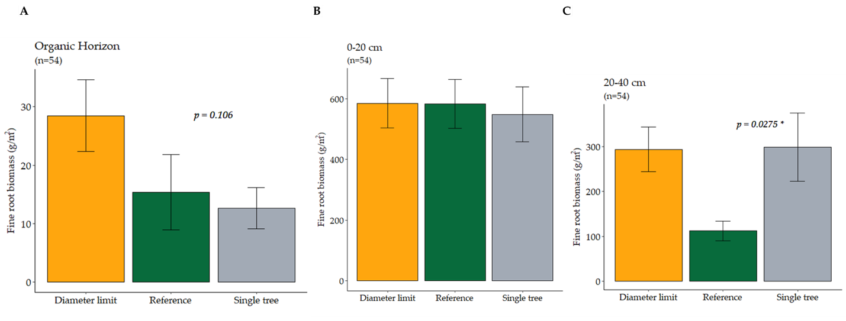

Figure 1. Mean fine root biomass across watersheds and depth in the (A) organic horizon, (B) 0-20 cm depth, and (C) in 20-40 cm depth. Error bars represent standard error.

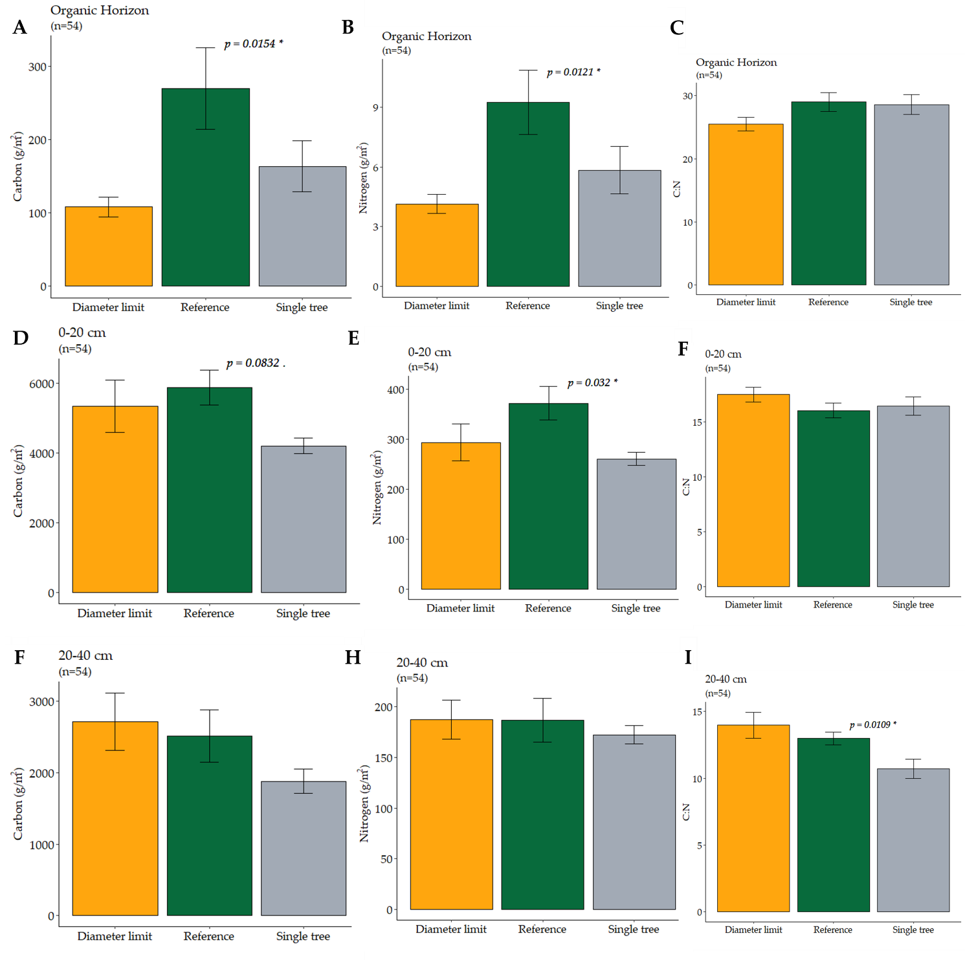
Figure 2. Differences in the mean total C, N, and the ratio of C:N across watersheds and depth. Panels A-C: Organic horizon. D-F: 0-20 cm depth. G-I: 20-40 cm depth. Error bars represent the mean standard error.

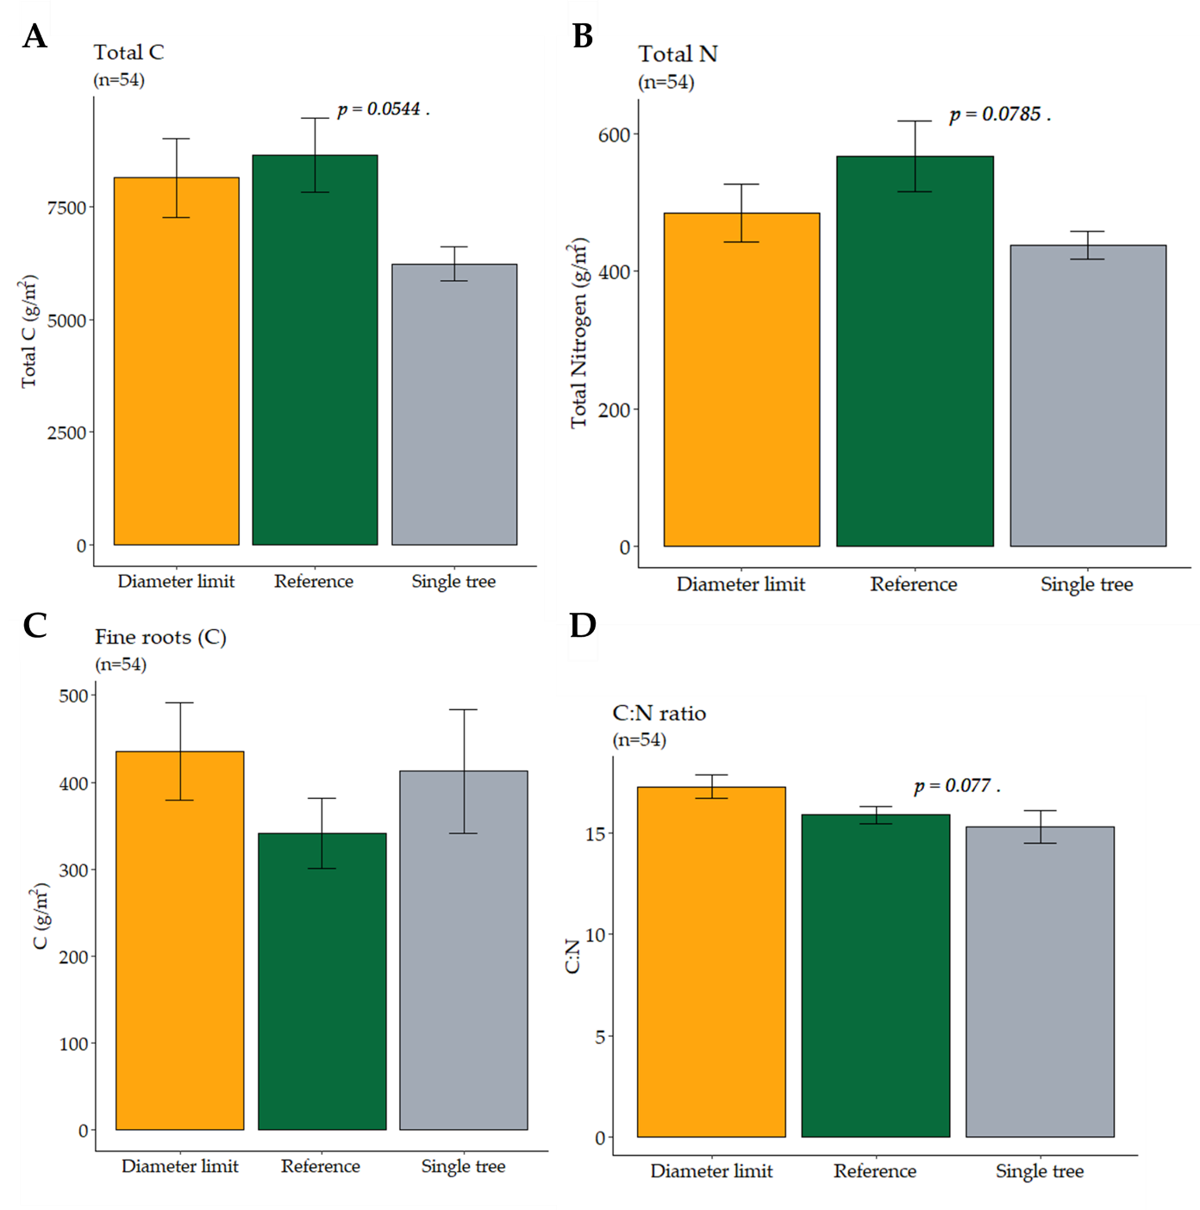
Figure 3. Differences in the mean total C, total N, and the ratio of C:N across watersheds. The data presented are the watershed mean of the sum across all three soil depths. Panel A: SOM C pool. Panel B: SOM N pool, Panel C: root C. Panel D: C:N ratio. Error bars represent standard error.

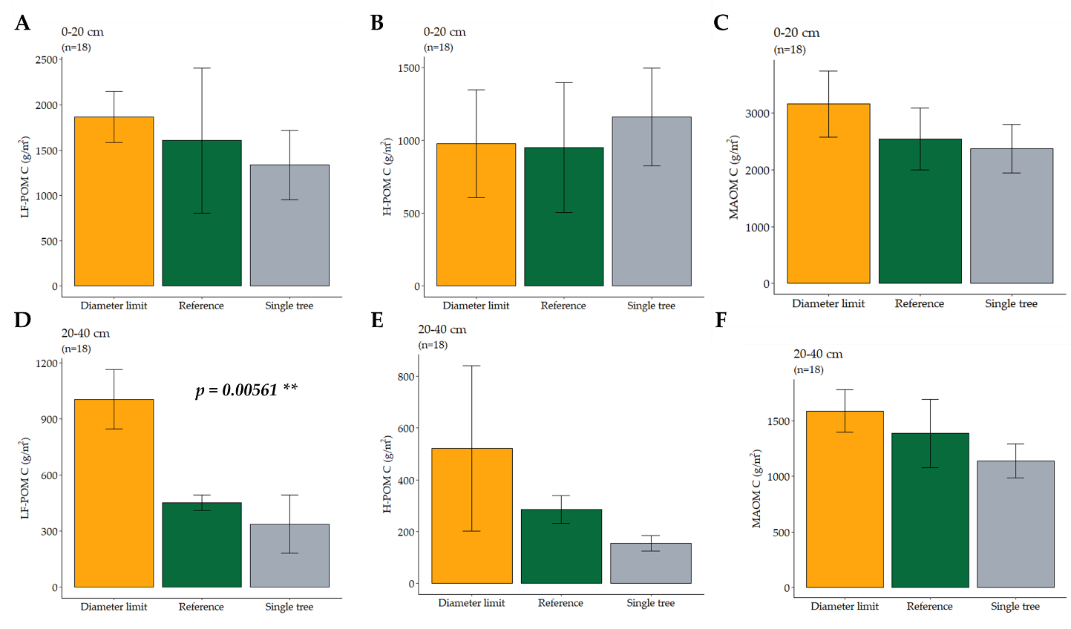
Figure 4. Differences in the mean SOM-C fractions across watersheds and depth. Panels A-C: 0-20 cm depth. D-F: 20-40 cm depth. Error bars represent standard error.

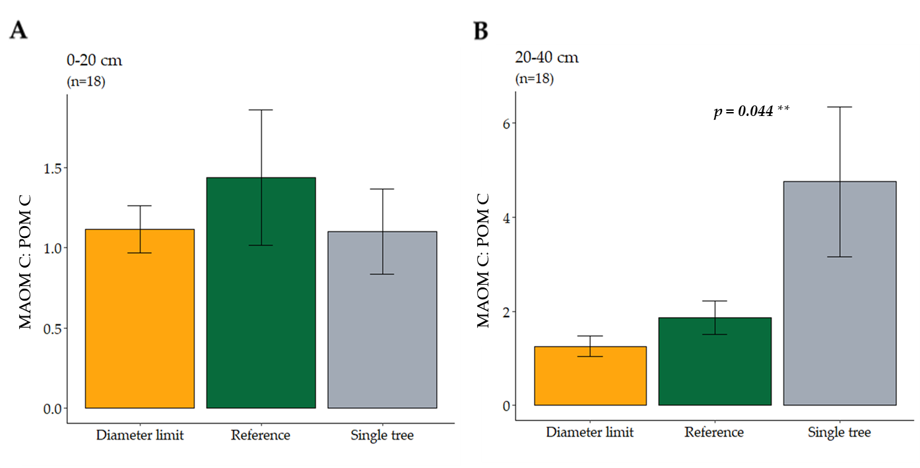

Figure 5. Differences in the mean ratio of MAOM-C:POM-C, across watersheds and depths. Panel A: 0-20 cm depth, Panel B: 20-40 cm depth. Error bars represent standard error.

Supplementary Information:

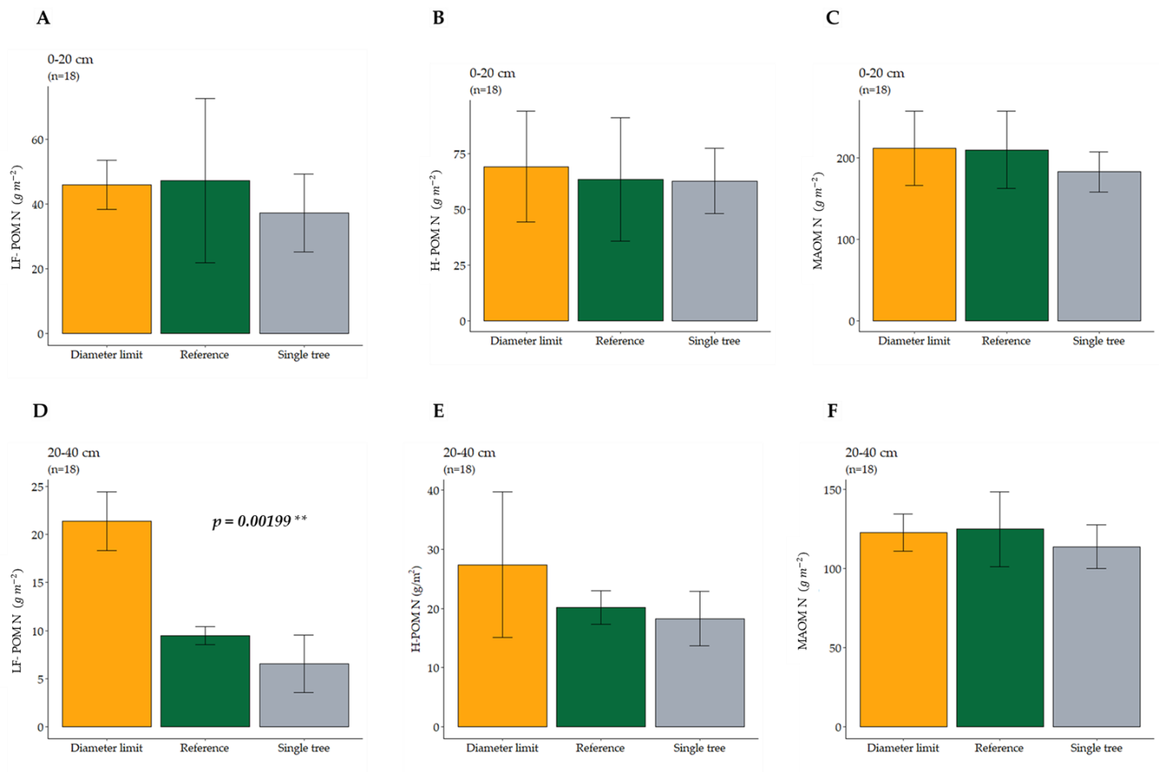
SI Figure 1. Differences in the mean SOM-N fractions across watersheds and depth. Panels A-C: 0-20 cm depth. D-F: 20-40 cm depth. Error bars represent standard error.

SI Table 1. Summary statistics for total soil C, N, C:N ratio, and fine root biomass across watersheds and depth. Values represent mean and standard error ().
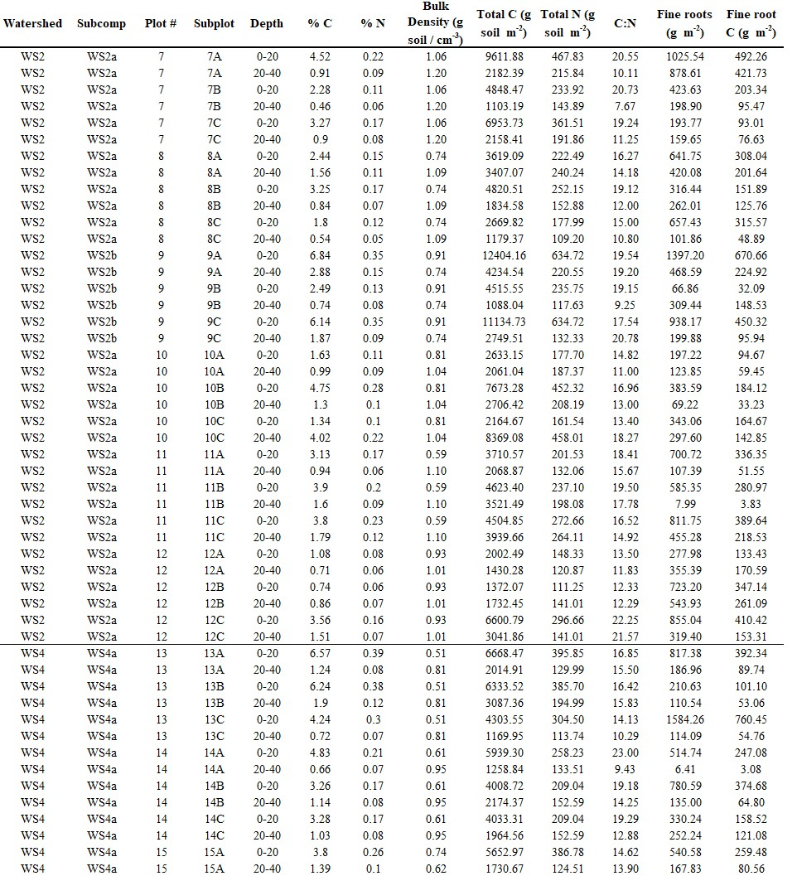
SI Table 2. Summary data of total mineral soil %C, %N, Bulk Density, total soil C, N, C:N ratio, fine root biomass, and fine root carbon. Data shown is from each mineral soil sample collected at each watershed, subplot, and depth.

SI Table 2. Continued
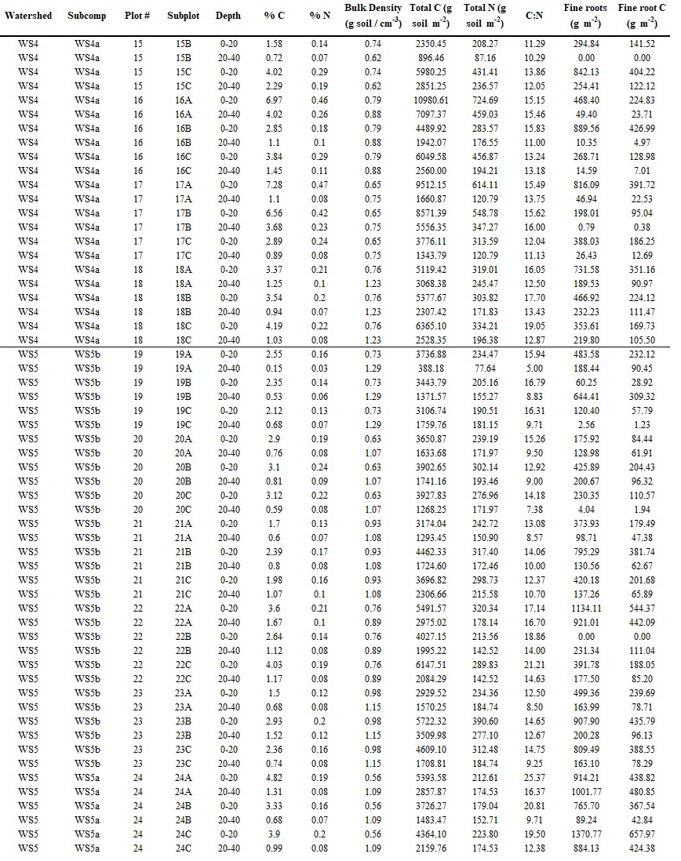

SI Table 3. Summary data of SOM C and N fractions, and the MAOC-C:POM-C ratio for each watershed, plot, and depth.

