|  |  |
| --- | --- |
| hkust_logo | **The Hong Kong University of Science and Technology**  **Department of Electronic and Computer Engineering** |

Elec2400 **ELECTRONIC CIRCUITS** Fall 2021-22

Lab Section No. : \_\_\_\_\_\_\_\_\_\_\_\_\_\_\_\_\_\_\_\_\_\_\_\_\_\_\_\_\_\_\_ Date : \_\_\_\_\_\_\_\_\_\_\_\_\_\_\_\_\_\_\_\_\_

Name : \_\_\_\_\_\_\_\_\_\_\_\_\_\_\_\_\_\_\_\_\_\_\_\_\_\_\_\_\_\_\_\_\_\_\_\_\_\_\_ Student Number : \_\_\_\_\_\_\_\_\_\_\_\_

**LAB 1(b) – Instrumentation and Measurement**

**Answer Sheet**

Q7. Show only the triangle wave on the scope, and capture it.

Q8. What is the frequency of the triangle wave measure in the scope? Frequency = \_\_\_\_\_\_\_\_Hz

Q9. Capture the resultant waveform of A-B.

Q10. What is the frequency of the resultant waveform? Frequency = \_\_\_\_\_\_\_\_\_\_\_\_\_\_\_Hz

Q11. What is **VDMM** (square)? \_\_\_\_\_\_\_\_\_\_\_\_\_\_\_\_\_\_\_\_ V rms

Q12. What is **VDMM** (triangular)? \_\_\_\_\_\_\_\_\_\_\_\_\_\_\_\_\_\_\_\_ V rms

Q13. What is **VDMM** (sine)? \_\_\_\_\_\_\_\_\_\_\_\_\_\_\_\_\_\_\_\_ V rms

Q14. What is **V**(square)? \_\_\_\_\_\_\_\_\_\_\_\_\_\_\_\_\_\_\_\_ V rms

Q15. What is **V**(triangular)? \_\_\_\_\_\_\_\_\_\_\_\_\_\_\_\_\_\_\_\_ V rms

Q16. What is **V**(sine)? \_\_\_\_\_\_\_\_\_\_\_\_\_\_\_\_\_\_\_\_ V rms

Q17. What is VA (DMM)? \_\_\_\_\_\_\_\_\_\_\_\_V

Q18. What is VB (DMM)? \_\_\_\_\_\_\_\_\_\_\_\_V

Q19. What is VA (x1)? \_\_\_\_\_\_\_\_\_\_\_\_V

Q20. What is VB (x1)? \_\_\_\_\_\_\_\_\_\_\_\_V

Q21. What is VA (x10)? \_\_\_\_\_\_\_\_\_\_\_\_V

Q22. What is VB (x10)? \_\_\_\_\_\_\_\_\_\_\_\_V

Q23. Explain briefly the results in Step 2, 3, and 4.

Q24. Sketch the VDMM versus frequency results obtained in step 2 and 3. Use log scale for the frequency. (You could use drawing tools in Microsoft Word to complete the plot, or you could use other software to plot the curve, like Excel, and insert the drawing below.)

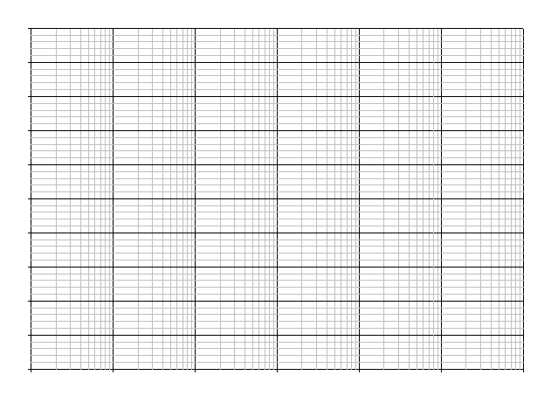

Q25. What is the estimated bandwidth of the DMM from the plot? \_\_\_\_\_\_\_\_\_\_\_\_\_\_\_Hz

Q26. Show all the circuits and waveform to TA. \_\_\_\_YES / NO\_\_\_\_\_