**LAPORAN PRAKTIKUM PEMROGRAMAN BEORIENTASI OBJEK**

“Tugas 06 ENKAPSULASI*”*



Oleh:

Nama : Dendy Anugrahi Rabbi

NPM : 4522210034

Kelas : A

Dosen:

Adi Wahyu Pribadi , S.Si., M.Kom

**S1-Teknik Informatika**

**Fakultas Teknik Universitas Pancasila**

**2023/2024**

1. Jubah.java

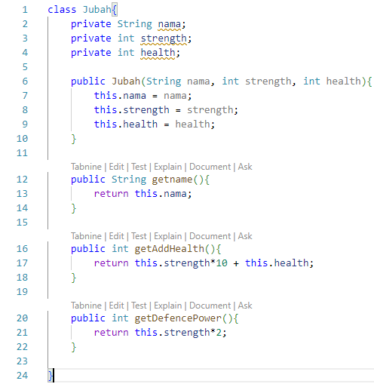

1. Senjata.java

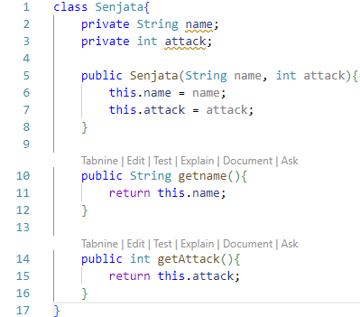

1. Jagoan.java

class Jagoan{

    private String nama;

    private int baseHealth;

    private int baseAttack;

    private int incrementHealth;

    private int incrementAttack;

    private int level;

    private int totalDamage;

    private boolean isAlive;

    // Ini adalah object member

    private Jubah armor;

    private Senjata weapon;

    public Jagoan(String nama){

        this.nama = nama;

        this.baseHealth = 100;

        this.baseAttack = 100;

        this.level = 1;

        this.incrementHealth = 20;

        this.incrementAttack = 20;

        this.isAlive = true;

    }

    public String getName(){

        return this.nama;

    }

    public int getHealth(){

        return this.maxHealth() - this.totalDamage;

    }

    public void display(){

        System.out.println("Nama Jagoan\t\t: " + this.nama);

        System.out.println("Jubah\t\t\t: " + this.armor.getname());

        System.out.println("Senjata\t\t\t: " + this.weapon.getname());

        System.out.println("Level\t\t\t: " + this.level);

        System.out.println("Kesehatan\t\t: " + this.getHealth() +"/" + this.maxHealth());

        System.out.println("Menyerang \t\t: " + this.getAttackPower());

        System.out.println("Masih Hidup\t\t: " + this.isAlive + "\n");

    }

    public void attack(Jagoan opponent){

        // hitung damage

        int damage = this.getAttackPower();

        // print event

        System.out.println(this.nama + " Menyerang " + opponent.getName() + " dengan kekuatan " + damage);

        // attack si opponent

        opponent.defence(damage);

        this.levelUp();

    }

    public void defence(int damage){

        // receive damage

        int defencePower = this.armor.getDefencePower();

        int deltaDamage;

        System.out.println(this.nama + " Kekuatan Pertahanan = "+ defencePower);

        if(damage > defencePower){

            deltaDamage = damage - defencePower;

        } else {

            deltaDamage = 0;

        }

        System.out.println("Kekalahan yang diperoleh = " + deltaDamage + "\n");

        // adding total damage

        this.totalDamage += deltaDamage;

        // check is alive

        if (this.getHealth() <= 0){

            this.isAlive = false;

            this.totalDamage = this.maxHealth();

        }

        this.display();

    }

    private int getAttackPower(){

        return this.baseAttack + this.level*this.incrementAttack + this.weapon.getAttack();

    }

    private void levelUp(){

        this.level++;

    }

    public void setArmor(Jubah armor){

        this.armor = armor;

    }

    public void setWeapon(Senjata weapon){

        this.weapon = weapon;

    }

    public int maxHealth(){

        return this.baseHealth + this.level*this.incrementHealth + this.armor.getAddHealth();

    }

}

RUNNING

