**Daniel Alejandro Cariel**

**ID: 1376938**

**May 5, 2017**

**Numerical Solution of the 2D Helmholtz Equation**

**MECE 5397: Scientific Computing for Mechanical Engineers**

**Professors:**

**Dr. Andrea Prosperetti & Dr. Amit Amritkar**

**Cullen College of Engineering | University of Houston**

# Abstract

The 2D Helmholtz equation is a time-independent case of the wave equation. In this document the solution to this equation is approximated through two different numerical solver: Gauss-Seidel method and Successive Over Relaxation. The purpose of this project is to study the convergence and the performance of these methods. The approximation of the solution is found using different number of nodes to show how this affects the accuracy of the solution. After several runs of the numerical solvers, it was found that the successive over relaxation method had a greater time performance than the Gauss-Seidel method. By increasing the step size, the number of iterations is significantly reduced and the convergence is reached faster.

# Mathematical statement of the project

The time-independent wave response over a rectangular region, is described by a 2-dimensinal partial differential equation as shown below. This equation is known as the 2D Helmholtz equation. Dirichlet boundary conditions have been prescribed on the boundaries 1, 2 and 4, while a Neumann boundary condition is applied on the bottom edge. The wave constant in the equation is given as, and a forcing function described below is applied to the system. Numerical solvers are used to approximate the solution to this differential equation. In this report the Gauss-Seidel method and the Successive Over Relaxation method are used to approximate the solution. There is a special case of the Helmholtz equation, where, and F(x,y) =0. This form of the equation is known as the 2-dimensional Laplace equation. Approximations for the Laplace equation will be provided in addition to the Helmholtz approximation.

|  |
| --- |
| Figure 1 |

The differential equation above can be approximated through discretization of the second derivatives in x and y. Discretizing the Helmholtz equation must be in order for the numerical methods to be applied. The second order centered-difference formula is used to approximate the second derivative terms in the equation above.

|  |  |
| --- | --- |
| Centered-difference Formula: |  |

These equation are found using the Taylor series expansion to determine an approximation of the second derivative that is described by three different consecutive points in the region. Substituting these equations into the main differential equation yields:

This is the discretized version of the given partial differential equation. The next step it is to collect all the similar terms in order to obtain a form of the discretized equation that allows the iterative approximation to the solution.

# Numerical Solvers

## Gauss-Seidel Method

The Gauss-Seidel method is a numerical solver that approximates the solution of the differential equation from an initial guess to the solution. This method modifies the initial guess through several iterations using the discretized form of the equation, until a certain tolerance is reached. Convergence of this method occurs when the tolerance or error is negligible.

Arranging the discretized form of the differential equation yields:

Where the wave is constant and h is the step in both spatial directions. This equation uses the initial guess of the solutions around a point to find a better approximation of the result at that point.

The pseudo code for the Gauss-Seidel method is shown in Figure 2.

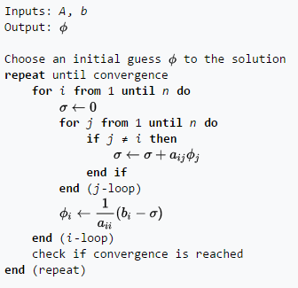

Figure 2

The Neumann boundary condition of the problem described in the problem is calculated used the ghost node method, and included into the loop. The code used in this exercise has a conditional while loop that stops iterations once the error is below a given tolerance:

The time performance of the code depends on the number of nodes used in the approximation. The error converges faster for a lower amount of nodes.

## Successive Over Relaxation

The concept behind the over relaxation method is to optimized the time performance of code by increase the step size at strategic portions of the approximation, thus speeding up the process. This is achieved by adding a multiplier (B) to the discretization equation that optimizes the code. However, the multiplier must fall within a range [1,2] in order for the code to converge. The discretized equation for the 2D Helmholtz problem is given as:

Here the constant B speeds up the step between iterations and has a correction for convergence. Similar to the Gauss-Seidel method the convergence of the numerical solution is determined by an error that must fall within a specific tolerance.

The pseudo code for this approximation method is shown in Figure 3.

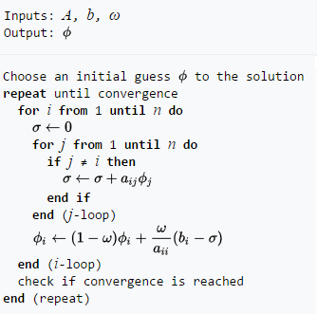

Figure 3

# Results

## Testing the effect of Λ

The Gauss-Seidel method along with the Successive Over Relaxation method were utilized to find different solutions to the 2D Helmholtz equation described above. It was found through experimentation that the value of Λ had an effect on the convergence of the solution. The initial value provided unsatisfactory results since the solution did not converge. Figure 4 demonstrates the results found for different values of

|  |  |
| --- | --- |
| Figure 4. 1: | Figure 4. 2 |
| Figure 4. 3 | Figure 4. 4 |
| Figure 4. 5 | Figure 4. 6 |

Figure 4

The figures above depict the contour and surface graphs of the solutions for several values of . When the solution does not converge and it ends after 11130 iterations. In the case where , a better contour and surface plot of the solution can be observed (Figure 4.5 and 4.6). The solution also converges for the case where as shown in Figures 4.3 and 4.4. It is important to note that the solution for converges faster than with any other value of

## Iteration Results

Table 1 contains the results found using the Gauss-Seidel method to solve the 2D Helmholtz equation. Several runs were conducted using a different mesh size to test the time performance of the code, as well as the effect of the mesh size on the accuracy of the results. It can be observed that as the size of the mesh increases the time used to approximate the solution increases exponentially.

Table 1: Gauss Seidel Method Results

|  |  |  |
| --- | --- | --- |
| Gauss Seidel Method for Helmholtz Equation | | |
| Number of nodes | Code running time [s] | Number of Iterations |
| 10 | 0.0263 | 20 |
| 50 | 0.8268 | 590 |
| 100 | 7.6419 | 2370 |
| 200 | 93.5897 | 10200 |
| 500 | 3.7290e+03 | 62360 |
| 1000 | Excessive time | N/A |

Table 2 shows the results for the Successive Over Relaxation Method. For optimal performance a value of 1.5 was used to increase the step. It can be observed that for this method the running time is significantly reduced compared to the Gauss-Seidel method. In the case of a small mesh any method is useful. However, for larger mesh sizes the successive over relaxation method is recommended.

Table 2: Successive Over Relaxation Results

|  |  |  |
| --- | --- | --- |
| Successive Over Relaxation Method ( | | |
| Mesh size | Code running time [s] | Number of Iterations |
| 10 | 0.0281 | 20 |
| 50 | 0.2493 | 200 |
| 100 | 2.2487 | 770 |
| 200 | 35.9985 | 3530 |
| 500 | 1.397e+03 | 21980 |
| 1000 | Excessive time | N/A |

|  |  |  |
| --- | --- | --- |
| Figure 5. 1: Helmholtz Mesh n=10 | Figure 5. 2: Helmholtz Mesh n=100 | https://raw.githubusercontent.com/dacariel/DanielCariel_2D-Helmholtz-/master/SRC/Gauss%20Saidel_Test_n_200.jpg  Figure 5. 3: Helmholtz Mesh n=500 |

Figure 5: 2D Helmholtz Solution for Mesh sizes of n=10, n=100, and n=200

Figure 5 illustrates the solutions for different mesh sizes. The overall shape of the solution is the same in all cases. However, as the number of nodes increases the approximation of the solution becomes more accurate and the surface plot becomes smoother.

# Verification

In order to verify the accuracy and convergence of the numerical approximation methods used for this project, and analysis of the error convergence was done for a mesh of size 50. As shown in Table 3, for the Gauss Seidel method the error decreases as the number of iterations increase and the solution finally converges.

Table 3: Gauss Seidel Convergence

|  |  |  |
| --- | --- | --- |
| Mesh size 50 | | |
| Iteration | Time | Error |
| 5 | 0.0120 | 160.9581 |
| 10 | 0.0214 | 1.7341e+03 |
| 50 | 0.0463 | 182.9049 |
| 500 | 0.4422 | 1.0744e-05 |
| 590 | 0.4795 | 1.0241e-06 |

Similarly, Table 4 depicts the convergence of the Successive Over Relaxation method. In this case the error decreases at a faster speed and the solution is approximated in a more efficient manner.

Table 4: Successive Over Relaxation Convergence

|  |  |  |
| --- | --- | --- |
| Mesh size 50 | | |
| Iteration | Time | Error |
| 5 | 0.0176 | 24.3157 |
| 10 | 0.0314 | 12.9967 |
| 50 | 0.0888 | 5.4560 |
| 100 | 0.1502 | 0.0100 |
| 200 | 0.2487 | 1.0378e-06 |

## Solution for Λ=0 and F(x,y)=0

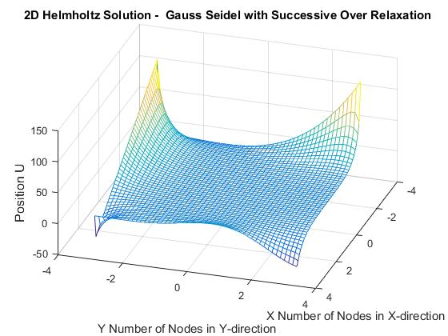

Figure 6: Laplace Equation Surface Plot Mesh 50

The plot below shows the solution obtain utilizing the successive over relaxation method. This curve shows less disturbances compared to the Helmholtz solution. As expected the solution converges faster and with less iterations