**Cite this: DOI: 10.1039/x0xx00000x**

Received 00th January 2012,

Accepted 00th January 2012

DOI: 10.1039/x0xx00000x

**www.rsc.org/**

**Biocatalytic conversion of ethylene to ethylene oxide using an engineered toluene monooxygenase**

D.A. Carlin,*a* S.J. Bertolani*b* and J.B. Siegel*b,c*

Mutants of toluene *o*-xylene monooxygenase are demonstrated to oxidize ethylene to ethylene oxide *in vivo* at yields of >99%. The best mutant increases ethylene oxidation activity by >5500-fold relative to the native enzyme. This is the first report of a recombinant enzyme capable of carrying out this industrially significant chemical conversion.

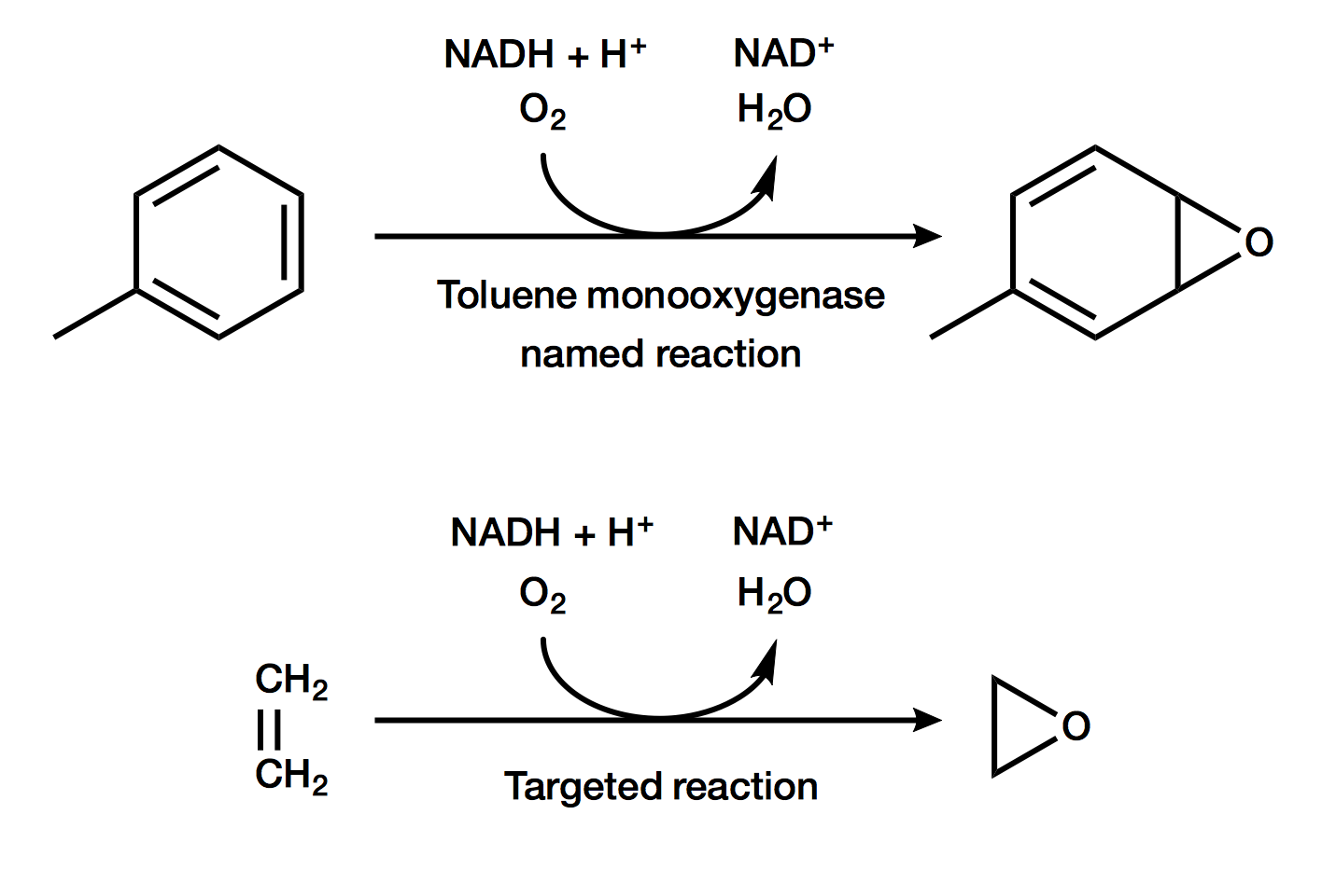

Figure 1. The named reaction of toluene to a *p*-cresol intermediate (top) and the targeted reaction of ethylene to ethylene oxide (bottom).

Ethylene oxide is an industrially important feedstock chemical with more than 20 million tons produced annually. Downstream products include polyester and automotive antifreeze.*1* Currently, ethylene oxide is produced through the oxidation of ethylene by a silver catalyst in high-pressure, high-temperature reactors with yields of up to 75%1. In order to develop a renewable alternative to this important transformation, it will be critical to develop methods that increase yields, are carried out under ambient temperatures and pressures, and do not generate toxic waste.

Enzymes are biology’s catalysts and are renowned for their ability to reduce the activation energy of chemical reactions, allowing mild reaction conditions. In nature, a class of enzymes called alkene monooxygenases (AOs) are known to oxidize alkenes, including ethylene.*2* The organisms where AOs are naturally found further utilize the oxidized alkenes, such as ethylene oxide, for growth. In addition, these organisms are not commonly used in laboratories or established to be amenable for use in industrial settings. Both of these factors prevent the practical use of AOs in the native host as a biocatalyst for the oxidation of ethylene to ethylene oxide. Unfortunately, attempts to recombinantly express functional AOs in organisms that are commonly used in laboratories and industry, such as *E. coli*, have proven elusive.*3* Therefore, we explored an alternative approach for the development of a biocatalyst for the conversion of ethylene to ethylene oxide.

Toluene *o*-xylene monooxygenase (TOM) from *Burkholderia cepacia G4* is a multi-component enzyme closely related to AOs, and is established to have a broad specificity for the oxidation of aromatic compounds via an epoxide intermediate.*4* Furthermore, TOM can be recombinantly produced in *E. coli*. Finally, TOM has been previously engineered to oxidize the structurally related compound trichloroethylene. Based on these three observations we hypothesized that either TOM, or variants of TOM, would be capable of oxidizing ethylene to ethylene oxide in *E. coli* (Figure 1).

We obtained TOM and a panel of eleven TOM mutants that had been previously engineered for the oxidation of trichloroethylene by Wood and colleagues.*5,6,7* Specifically, we obtained a set of mutants where small amino acids had been changed to large amino acids. Since ethylene is a significantly smaller molecule than toluene, we hypothesized that these mutants could potentially compensate for this change in substrate size. The one mutant that deviated from this targeted search was V106A, which was previously identified as the best mutant for oxidation of trichloroethylene.

The selected panel of eleven mutants, in addition to the wild type TOM, were each expressed in *E. coli* TG1. Cells were grown as overnight cultures in TB, and then resuspended in pH 7.4 phosphate buffered saline at an OD of 10. In gas-tight 1.5 mL vials 0.5 mL of cells were added, and the headspace was purged with 1.5% ethylene in air, resulting in 0.7 mM ethylene in the headspace. The cells were incubated at 37 ˚C while mixing for 24 hours, after which the headspace was analysed using GC-FID to detect the fraction of ethylene remaining and if ethylene oxide was produced. Results are illustrated in Figure 2. While the native TOM was not observed to oxidize ethylene, there were two mutants that oxidized >99% of the ethylene present. The major product detected in these biotranformations was ethylene oxide. Based on analytical standards, as little as 5 μM ethylene oxide in a whole cell biotransformation over a period of 24 hours could have been detected.

The most active mutants in the screen, A113F and V106F, were further characterized for ethylene oxide production. The equivalent procedure as described was carried out, however headspace was measured from a series of samples produced in parallel at 30, 100, and 220 minutes. As illustrated in Figure 3, mutant A113F quantitatively converted >99% of ethylene into ethylene oxide in less than 4 hours. Using a first-order rate equation, we calculated a steady-state rate of 19,000 ± 2,000 nM/min for this mutant. For mutant V106F, a rate of 600 ± 70 nM/min was determined using a linear fit. Since the wild type TOM was below our detection limit of 3.5 nM/min (i.e. 5 μM ethylene oxide over 24 hours), V106F and A113F enhanced activity by >170-fold and >5500-fold, respectively, relative to wild type TOM.

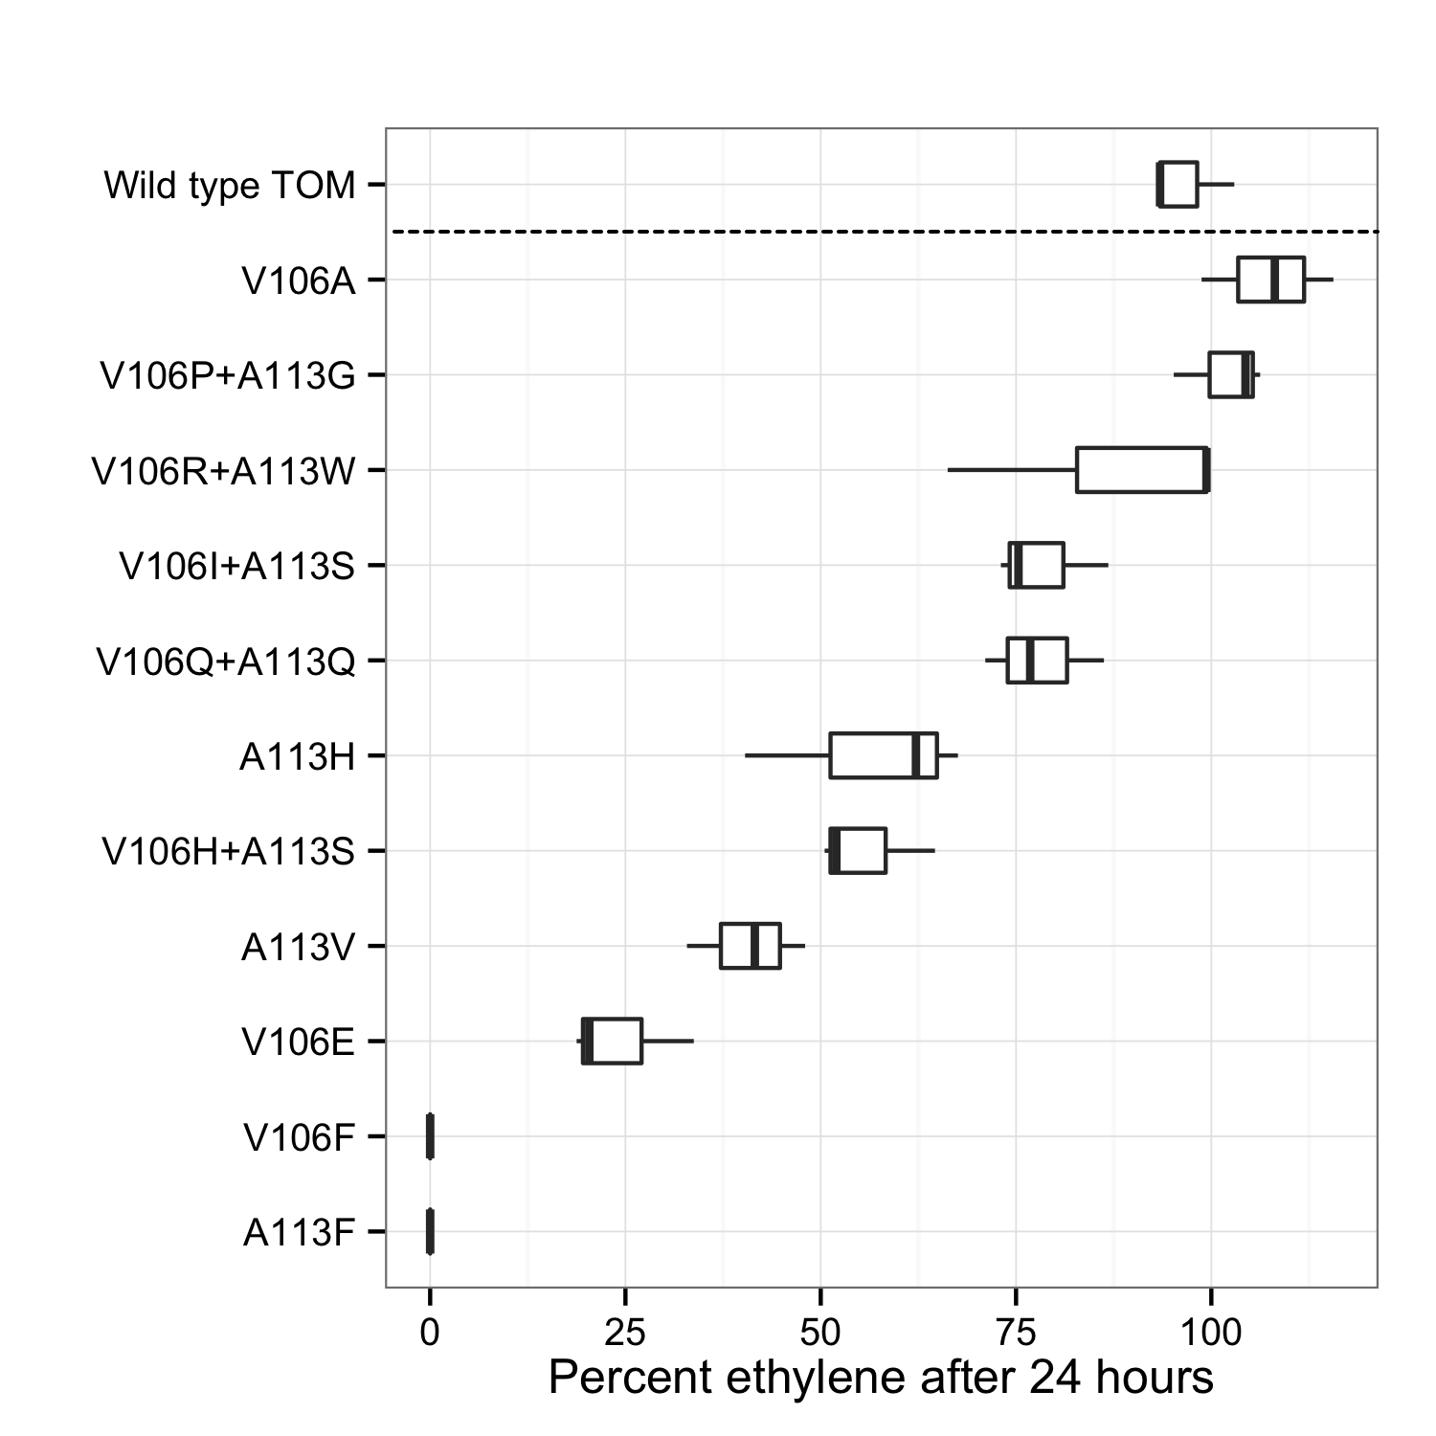

Figure 2. Ethylene remaining after a twenty-four hour incubation of whole cells expressing variants mutants of TOM. Three independent measurements were taken for each mutant.

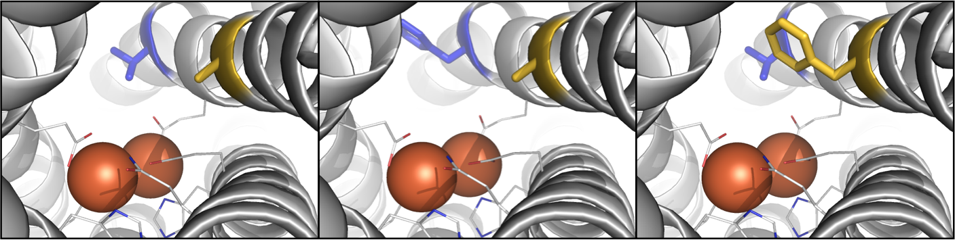

Figure 4. Molecular models of TOM (left) and mutants V106F (center) and A113F (right). Irons (orange spheres) are shown with coordinating residues. Mutated residues are colored blue (106) and gold (113). Figures were generated with PyMOL v1.7.0.310.

To better understand why these mutations had a significant effect on activity, we investigated how they were predicted to change the structure of the active site. Since a crystal structure of TOM is not available, we used Rosetta-CM to build molecular models of the catalytic domain for each mutant and TOM.*8* Three templates (PDB entries 3U52, 2INN, and 2INP) were used, each ~65% identical in sequence to TOM and the mutants. Next, we used RosettaLigand*9* with functional constraints derived from the geometry of the template crystal structures to dock the iron atoms into the models.

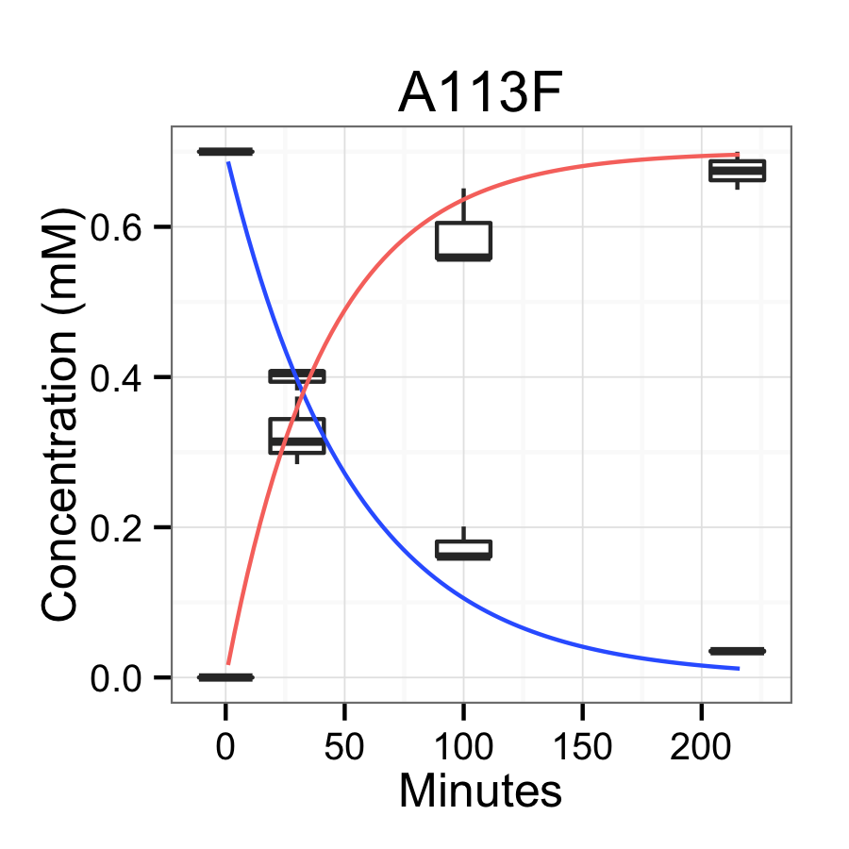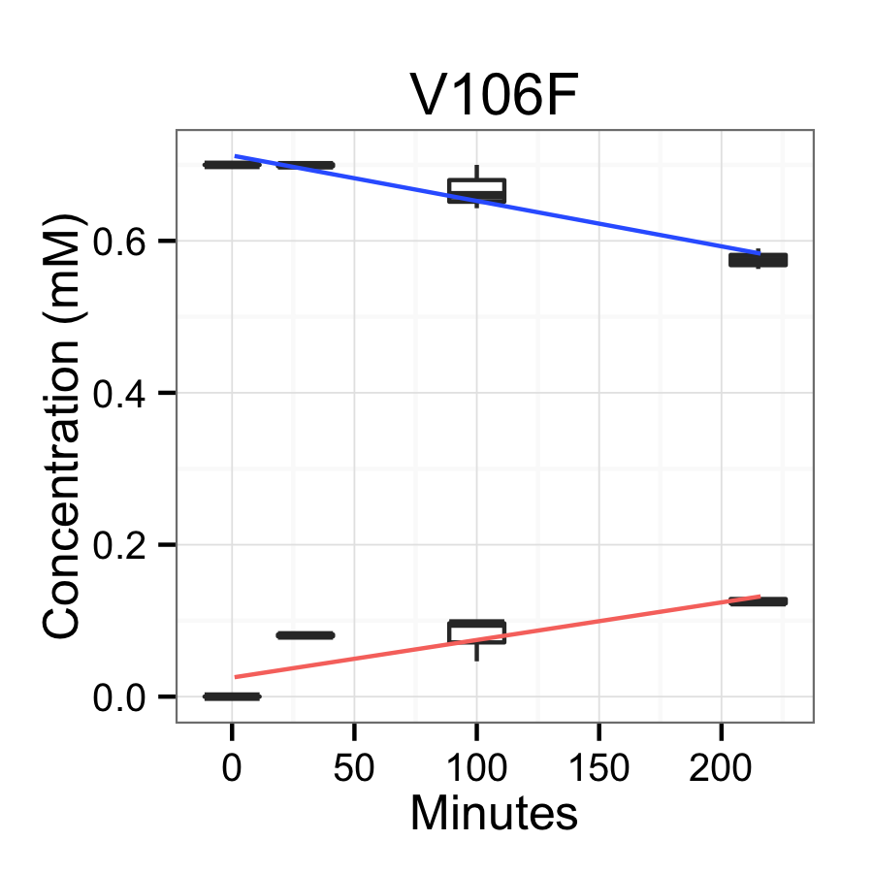

Figure 3. Time course of ethylene degradation (blue) and ethylene oxide production (red) for mutants V106F and A113F. Three independent measurements were taken for each time point. The data was fit to a first-order rate equation for A113F and a linear model for V106F.

The models reveal that both mutations are in the active site pocket above the open coordination sites of the diiron center in TOM (Figure 4). In the mutant A113F, the phenylalanine ring is predicted to be directly above the diiron center where we predict the substrate binds. However, the phenylalanine ring is not predicted to point directly into the binding site pocket for V106F, but instead into the tunnel leading to the pocket. While additional structural characterization of the mutants will be required to validate the predicted amino acid geometries, these structures are consistent with our initial hypothesis that by decreasing the molecular size of the active site a decrease in substrate size can be accommodated. This hypothesis is further supported by the 32-fold increase in activity for the mutation predicted to decrease the size of the active site pocket (A113F) relative to the mutant that decreases the size of the active site tunnel (V106F).

Conclusions

To the best of our knowledge this is the first report of an engineered biocatalyst capable of converting ethylene to ethylene oxide. This engineered protein was obtained from a repurposed directed evolution library originally developed for the oxidation of trichloroethylene, highlighting the importance of rescreening libraries of mutants against new target substrates.

The catalyst with the highest activity in this study was able to quantitatively convert >99% of ethylene to ethylene oxide in less than 4 hours at a relatively low temperature and pressure, in mild aqueous conditions, with no production of toxic waste. As the most active mutant was not explicitly developed for ethylene oxide production, further efforts to engineer the mutant TOM discovered here can likely improve activity. This novel renewable catalyst has the potential to transform the production of the industrially important chemical ethylene oxide.

Notes and references

*a* Biophysics Graduate Group, University of California Davis, Davis, California, USA.

*b* Department of Chemistry, University of California Davis, Davis, California, USA.

*c* Department of Biochemistry and Molecular Medicine, University of California Davis, Davis, California, USA.

*d* Genome Center, University of California Davis, Davis, California, USA.

† We are grateful to Thomas Wood, Sabina Islam, Brian Wai Kwan, and Michael McAnulty for the TOM and TOM mutants derived from their previous libraries. We would also like to thank Shota Atsumi and Michael Toney for insightful discussions. Finally, we would like to acknowledge ARPA-E DE-AR0000429 for support of this project.

1 Dever, J.P., George, K.F., Hoffman, W.C., and Soo, H. "Ethylene oxide." *Kirk-Othmer encyclopedia of chemical technology* 2004

2 Small, F.J., and Ensign, S.A. "Alkene monooxygenase from Xanthobacter strain Py2 purification and characterization of a four-component system central to the bacterial metabolism of aliphatic alkenes." *Journal of Biological Chemistry* 1997, 272.40, 24913-24920

3 Chan Kwo Chion, C.K., Askew, S.E., and Leak, D.J. "Cloning, expression, and site-directed mutagenesis of the propene monooxygenase genes from Mycobacterium sp. strain M156." *Applied and environmental microbiology* 2005, 71.4, 1909-1914

4 Whited, G.M., and Gibson D.T. "Toluene-4-monooxygenase, a three-component enzyme system that catalyzes the oxidation of toluene to p-cresol in Pseudomonas mendocina KR1." *Journal of bacteriology* 1991, 173.9, 3010-3016

5 Rui, L., Kwon, Y.M., Fishman, A., Reardon, K.F., and Wood, T.K. "Saturation mutagenesis of toluene ortho-monooxygenase of Burkholderia cepacia G4 for enhanced 1-naphthol synthesis and chloroform degradation." *Applied and environmental microbiology* 2004*,* 70.6, 3246-3252

6 Canada, K.A., Iwashita, S., Shim, H., and Wood, T.K. "Directed evolution of toluene ortho-monooxygenase for enhanced 1-naphthol synthesis and chlorinated ethene degradation." *Journal of bacteriology* 2002, 184.2, 344-349

7 Rui, L., Reardon, K.F., and Wood, T.K. "Protein engineering of toluene ortho-monooxygenase of Burkholderia cepacia G4 for regiospecific hydroxylation of indole to form various indigoid compounds." *Applied microbiology and biotechnology* 2005, 66.4, 422-429

8 Yifan S., DiMaio, F., Wang, R.Y, Kim, D., Miles, C., Brunette, T.J., Thompson, J., and Baker, D. "High-Resolution comparative modeling with RosettaCM." *Structure* 2013, 21.10, 1735-1742

9 Meiler, J. and Baker, D. "ROSETTALIGAND: Protein-Small Molecule Docking with Full Side-Chain Flexibility" *Proteins* 2006, 65, 538-548

10 The PyMOL Molecular Graphics System, Version 1.7.0.3 Schrödinger, LLC