**Cite this: DOI: 10.1039/x0xx00000x**

Received 00th January 2012,

Accepted 00th January 2012

DOI: 10.1039/x0xx00000x

**www.rsc.org/**

**Biocatalytic conversion of ethylene to ethylene oxide using an engineered toluene monooxygenase**

D.A. Carlin,*a* S.J. Bertolani*b* and J.B. Siegel*b,c*

Mutants of toluene o-xylene monooxygenase are demonstrated to oxidize ethylene to ethylene oxide in vivo at yields of >99%. The best mutant increases ethylene oxidation activity by >5500-fold relative to the native enzyme. This is the first report of a recombinant enzyme capable of carrying out this industrially significant chemical conversion.

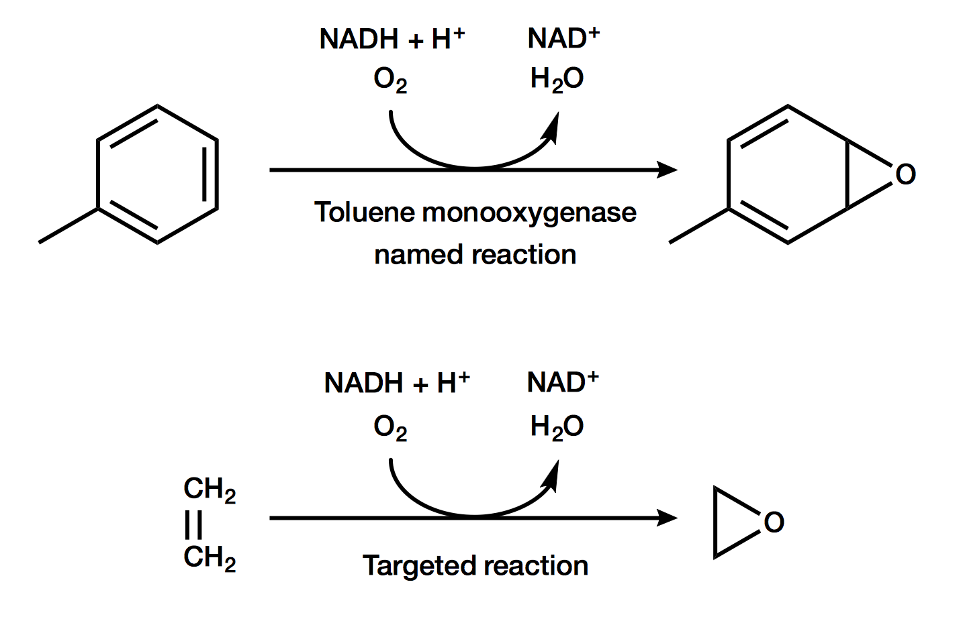

Figure 1. The named reaction of toluene to a *p*-cresol intermediate (top) and the targeted reaction of ethylene to ethylene oxide (bottom).

Ethylene oxide is an industrially important feedstock chemical with more than 20 million tons produced annually. Currently, ethylene oxide is produced through the oxidation of ethylene by a silver catalyst in high-pressure, high-temperature reactors with yields of up to 75% [1]. In order to develop a renewable alternative to this important transformation, it will be critical to develop methods that increase yields, are carried out under ambient temperatures and pressures, and do not generate toxic waste.

Enzymes are biology’s catalysts and are renowned for their ability to reduce the activation energy of chemical reactions, allowing mild reaction conditions. In nature, a class of enzymes called alkene monooxygenases (AOs) are known to oxidize alkenes, including ethylene [2]. The organisms where AOs are naturally found further utilize the oxidized alkenes, such as ethylene oxide, for growth and thus are not amenable for use in industrial settings. Therefore, for the development of an industrial biocatalyst to convert ethylene into ethylene oxide the recombinant production of AOs in an industrial organism, such as *E. coli*, is desired. However, expression of recombinant AOs in *E. coli* has proven elusive [3].

Toluene o-xylene monooxygenase (TOM) is an enzyme closely related to AOs, and has been shown to oxidize aromatic compounds such as toluene via an epoxide intermediate [4]. In addition, TOM can be recombinantly produced in *E. coli*. Furthermore, TOM has been previously engineered to oxidize the related compound trichloroethylene. Therefore, we hypothesized that either TOM, or variants of TOM, would be capable of oxidizing ethylene to ethylene oxide (Figure 1).

We obtained TOM and a panel of TOM mutants from previous efforts by Wood and colleagues [5; 6]. These mutants were derived from a series of libraries to reengineer TOM to oxidize trichloroethylene. Since ethylene is a significantly smaller molecule than toluene, we hypothesized that mutants from these previous studies where small amino acids had been changed to large amino acids could potentially compensate for this change in substrate size. The one mutant we tested that deviated from this targeted search was V106A, which was previously identified as the best mutant for oxidation of trichloroethylene.

A selected panel of 12 mutants were each grown in *E. coli* TG1 as overnight cultures, and then resuspended in pH 7.4 phosphate buffered saline at an OD of 10. In gas-tight 1.5 mL vials 0.5 mL of cells were added, and the headspace was purged with 1.5% ethylene in air, resulting in 0.7 mM ethylene in the headspace. The cells were incubated at 37 ˚C while mixing for 24 hours, after which the headspace was analysed using GC-FID to detect the fraction of ethylene remaining and if ethylene oxide was produced. As illustrated in Figure 2, while the native TOM did not utilize ethylene, there were two mutants that utilized >99% of the ethylene present. Furthermore, the major product detected in these biotranformations was ethylene oxide. Based on analytical standards, as little as 5 μM ethylene oxide in a whole cell biotransformation over a period of 24 hours could have been detected.

The most active mutants in the screen, A113F and V106F, were further characterized for ethylene oxide production. The equivalent procedure as described was carried out, however headspace was measured from a series of samples produced in parallel at 30, 100, and 220 minutes. As illustrated in Figure 3, mutant A113F quantitatively converted >99% of ethylene into ethylene oxide in less than 4 hours. Using a first-order rate equation, we calculated a steady-state rate of 19,000 ± 2,000 nM/min for this mutant. For mutant V106F, a rate of 600 ± 70 nM/min was determined using a linear fit. Therefore, the single mutant A113F enhanced activity by >5500-fold while the single mutant V106F enhanced activity >170-fold, relative to the native TOM which was below our detection limit of 3.5 nM/min (i.e. 5 μM ethylene oxide over 24 hours).

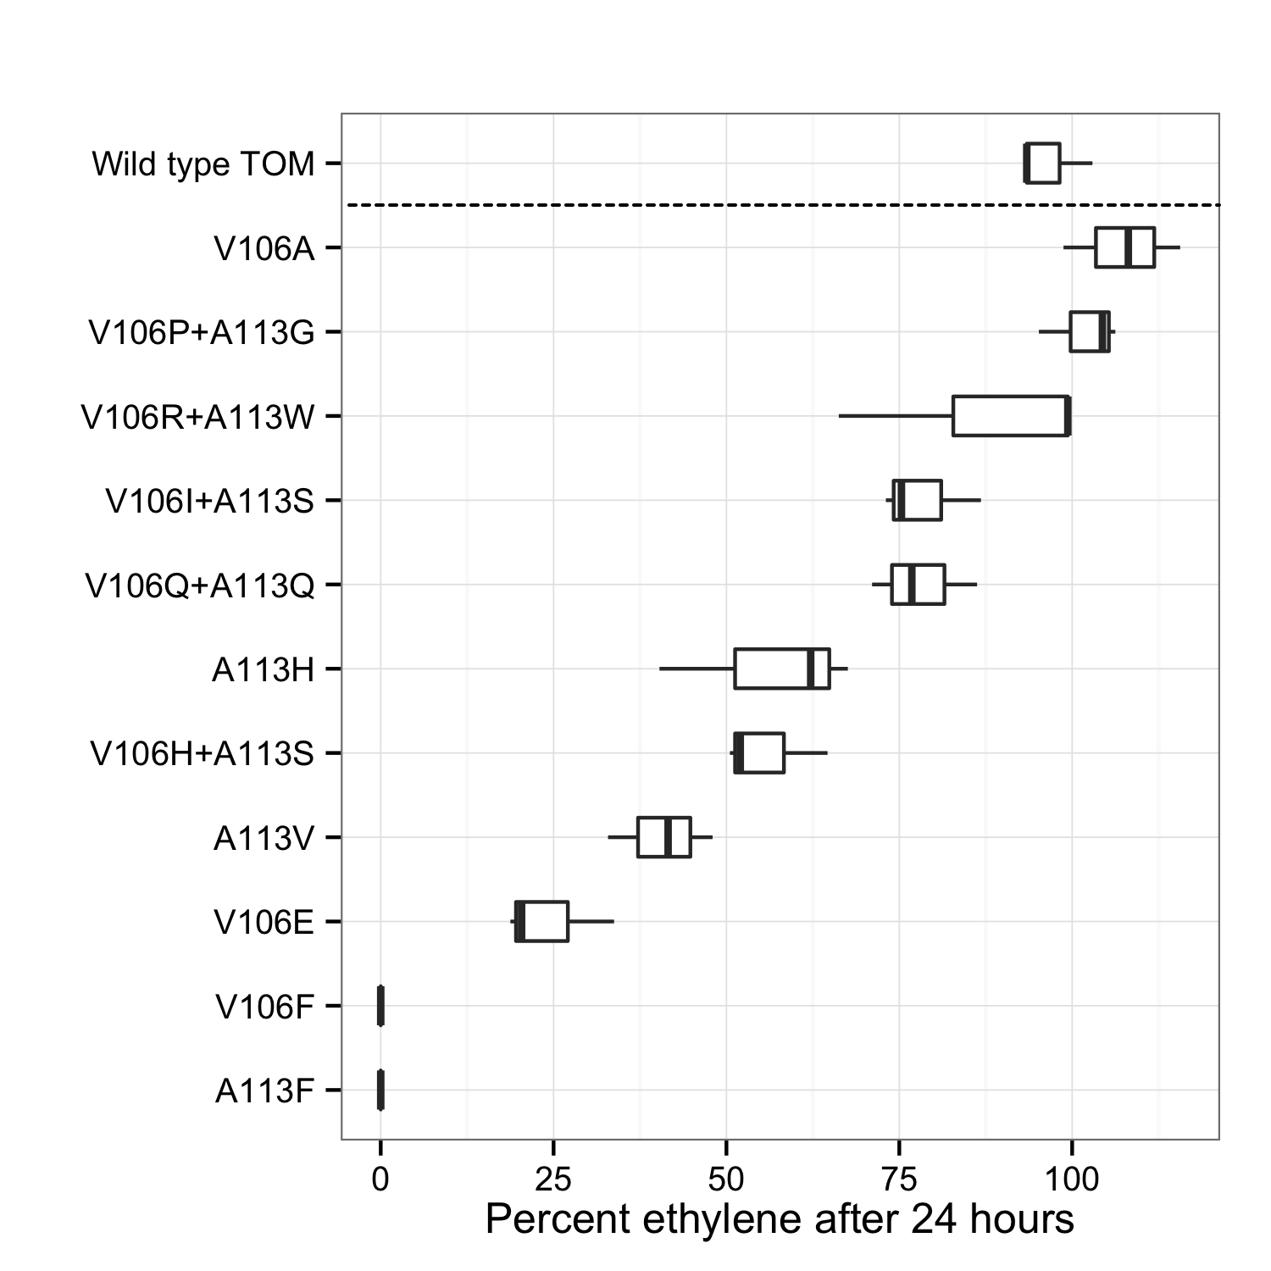

Figure 2. Ethylene remaining after a twenty-four hour incubation of whole cells expressing variants mutants of TOM.

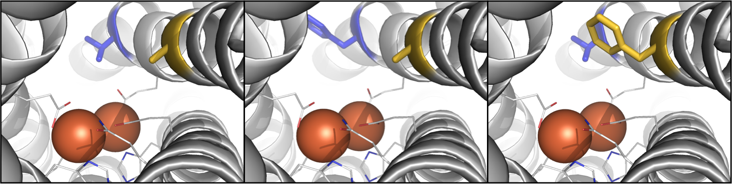

Figure 4. Molecular models of TOM (left) and mutants V106F (center) and A113F (right). Irons (orange spheres) are shown with coordinating residues. Mutated residues are colored blue (106) and gold (113). Figures were generated with PyMol v. XXX [Cite]

To better understand why these mutations had a significant effect on activity, we investigated how they were predicted to change the structure of the TOM active site. Since a crystal structure of TOM is not available we used Rosetta-CM to build molecular models of the catalytic domain for each mutant and TOM [7]. Three templates (PDB entries 3U52, 2INN, and 2INP) were used, each ~65% identical in sequence to TOM and the mutants. Next, we used RosettaLigand [8] with functional constraints to the conserved coordinating residues derived from the geometry of the template crystal structures to dock the iron atoms into the models.

The models show both mutations in the active site pocket above the open coordination sites of the diiron center in TOM (Figure 4). In the mutant A113F the phenylalanine ring is predicted to be directly above the diiron center where we predict the substrate is likely to bind. However, the phenylalanine ring is not predicted to point directly into the binding site pocket for V106F, but instead into the tunnel into the pocket. These structures are consistent with our initial hypothesis that by decreasing the molecular size of the active site the decrease in substrate size would be accommodated for. This hypothesis is further supported by the 32-fold increase in activity for the mutation predicted to decrease the size of the active site pocket (A113F) relative to the mutant that decreases the size of the active site tunnel (V106F).

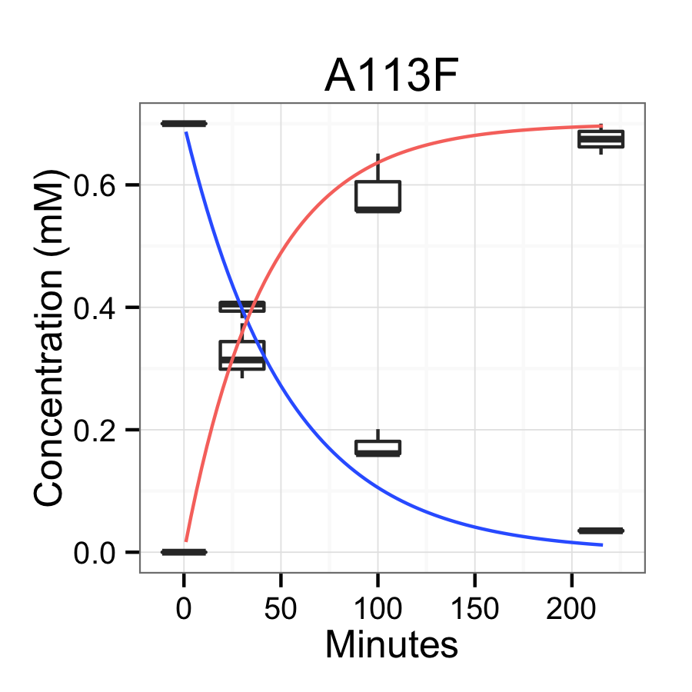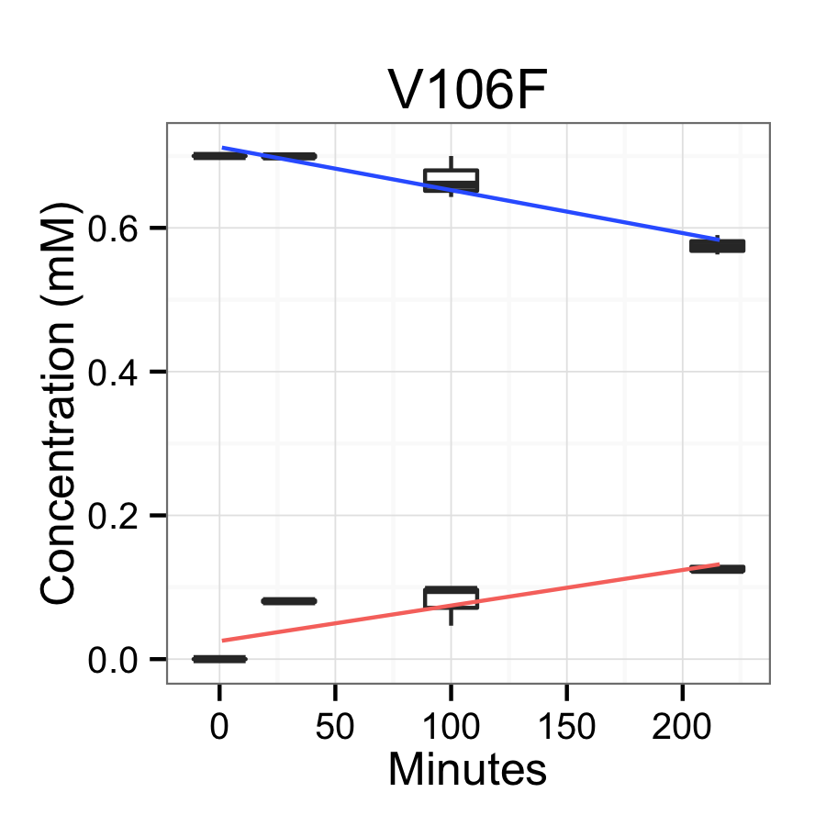

Figure 3. Time course of ethylene degradation (blue) and oxirane production (red) for mutants V106F and A113F.

Conclusions

To the best of our knowledge this is the first report of an engineered biocatalyst capable of converting ethylene to ethylene oxide. This engineered protein was obtained from a repurposed directed evolution library originally targeted at the oxidation of the related compound trichloroethylene. This finding highlights the importance of rescreening libraries of mutants against new target substrates.

Perhaps unsurprising, the best mutant on trichloroethylene (V106A) was not the best mutant on ethylene. Although the two compounds are of similar size, ethylene and trichloroethylene have vastly different electronic structures, which indicates that there may be a fundamentally different mechanism by which the two are oxidized.

The catalyst with the highest activity in this study was able to quantitatively convert >99% of ethylene to ethylene oxide in less than 4 hours at a relatively low temperature and pressure, in mild aqueous conditions, with no production of toxic waste. As the most active mutant was not explicitly developed for ethylene oxide production, further efforts to engineer the mutant TOM discovered here can likely improve activity. This novel renewable catalyst has the potential to transform the production of the industrially important chemical ethylene oxide.

Notes and references

*a* Biophysics Graduate Group, University of California Davis, Davis, California, USA.

*b* Department of Chemistry, University of California Davis, Davis, California, USA.

*c* Department of Biochemistry and Molecular Medicine, University of California Davis, Davis, California, USA.

*d* Genome Center, University of California Davis, Davis, California, USA.

† We are grateful to Thomas Wood, Sabina Islam, Brian Wai Kwan, and Michael McAnulty for the TOM and TOM mutants derived from their previous libraries. We would also like to thank Shota Atsumi and Michael Toney for insightful discussions. Finally, we would like to acknowledge ARPA-E DE-AR0000429 for support of this project.

1 Dever, J. P., K. F. George, W. C. Hoffman, and H. Soo. "Ethylene oxide." Kirk-Othmer encyclopedia of chemical technology, 2006

2 Small, Frederick J., and Scott A. Ensign. "Alkene monooxygenase from Xanthobacter strain Py2 purification and characterization of a four-component system central to the bacterial metabolism of aliphatic alkenes." Journal of Biological Chemistry, 1997, 272.40, 24913-24920

3 Chion, Chan K. Chan Kwo, Sarah E. Askew, and David J. Leak. "Cloning, expression, and site-directed mutagenesis of the propene monooxygenase genes from Mycobacterium sp. strain M156." Applied and environmental microbiology 71.4 (2005): 1909-1914.

4 Whited, GM, and Gibson DT. "Toluene-4-monooxygenase, a three-component enzyme system that catalyzes the oxidation of toluene to p-cresol in Pseudomonas mendocina KR1." Journal of bacteriology 1991, 173.9, 3010-3016

5 Iwashita, Sachiyo, Hojae Shim, and Thomas K. Wood. "Directed evolution of toluene ortho-monooxygenase for enhanced 1-naphthol synthesis and chlorinated ethylene degradation." Journal of bacteriology 2002, 184.2, 344-349

6 Rui, Lingyun, Kenneth F. Reardon, and Thomas K. Wood. "Protein engineering of toluene ortho-monooxygenase of Burkholderia cepacia G4 for regiospecific hydroxylation of indole to form various indigoid compounds." Applied microbiology and biotechnology 2005, 66.4, 422-429

7 Song Yifan, et al. "High-Resolution comparative modeling with RosettaCM." Structure 2013, 21.10, 1735-1742

8 Meiler, J. and Baker, D. "ROSETTALIGAND: Protein-Small Molecule Docking with Full Side-Chain Flexibility" Proteins 2006, 65, 538-548