Guidelines for measurement invariance and aligment methods using library(rd3c3)

Sandoval-Hernández, Carrasco & Eryılmaz

2025-04-16

Table of contents

# Preface

library(rd3c3) is A ***wrapper function library*** designed to fit model-based invariance models and alignment methods to assess cross cultural comparability of responses between countries and groups, on international large-scale assessments.

It helps researchers to write [Mplus](https://www.statmodel.com/) code, via [MplusAutomation](https://github.com/michaelhallquist/MplusAutomation) to implement invariance analysis.

It uses graded response models with a probit link (i.e., confirmatory factor analysis with ordinal indicators).



## How to install

# -----------------------------------------------  
# install rd3c3  
# -----------------------------------------------  
  
devtools::install_github(  
 'dacarras/rd3c3',  
 force = TRUE  
)

## How to cite the current document

Carrasco, Diego; Sandoval-Hernández, Andrés; Eryilmaz, Nurullah (2025). Guidelines for measurement invariance and aligment methods using library(rd3c3). figshare. Software. [https://doi.org/10.6084/m9.figshare.28028564](https://doi.org/10.6084/m9.figshare.28028564.v3)

## Acknowledgement

This work was supported by the IEA Research and Development Fund.

# 1. Introduction

Measurement invariance is a desired property of scales scores generated with measurement models fitted onto polytomous items responses, to allow comparisons among groups (Tse, Lai, & Chang, 2024). These groups often include meaningful factors such as sex, age, the language of the test or survey, and the participating country, among other groups of interest. Ideally, latent variable models can be used to provide evidence (or the lack of it) that comparisons among these groups can be made on the generated scale scores.

There are different approaches to assess if the assume comparability is tenable. The most popular approaches include differential item functioning (DIF), and factorial invariance (Thissen, 2024), two model based strategies to assess comparability among groups. The simplest version of differential item functioning is uniform DIF. Uniform DIF consist of the study of item location parameters conditional to group membership of the observations. DIF is a procedure to produce evidence that the expected response onto items, is equivalent among groups when the level of the attribute is the same among the contrasting groups. Thus, if two (or more) groups of the same attribute level do differ on the expected responses to an item, this scenario is taken as evidence of DIF (e.g., Wu et al., 2016). There are other forms of DIF such as non-uniform DIF that consist of group interactions involving, not only item location parameters, but also item slopes (or factor loadings depending on the measurement model parameterization) (Meulders & Xie, 2004), and more complex forms of DIF that account for variability on the measurement model parameters, not only due to groups (i.e., categorical variables), but conditional to continuous variables (Bauer, 2016).

On the other hand, factorial invariance or measurement invariance is also a model-based strategy, where different measurement models’ specifications are fitted onto the groups of interest, to assess the equivalence of the measurement model parameters besides group latent mean (Millsap, 2011). As such, comparisons of interest among groups includes not only location item paratemers, but also factor loadings, and residuals or item uniqueness (Kline, 2023). Traditionally, a descriptive model is specified (i.e. configural model), and a sequence of more constrained models are fitted, where different measurement model parameters are held equal among groups till the most equivalent model specification is fitted where factor loadings, item location and item uniques parameters are held equal, and only latent mean differences are allowed to vary (e.g., Dimitrov, 2010).

Current developments on factorial invariance, specifically developments in confirmatory factor analysis (CFA) fitted onto ordinal indicators have recommendations, that depart from traditional CFA measurement invariance (Wu & Estabrook, 2016; Svetina, Rutkowski & Rutkowski, 2020; Tse, Lai & Chang, 2024). Two points of contention are of special relevance for the present guideline. These are the order in which the different model specifications should be fitted; and if the different invariance model specifications described for CFA with continuous indicators are applicable for measurement models with ordinal indicators.

The present guideline is focused on the model specifications included in the library(rd3c3). This is an R library, with a collection of different wrapper functions that helps to speed up the process of writing syntax to fit different latent variable models onto large scale assessment studies. library(rd3c3) follows the work of Wu & Estabrook (2016) on model identification and starts first with item threshold invariance as the first step to build a model sequence to assess measurement invariance. It also follows Svetina et al. (2020), Tse et al. (2024) and Grimm et al. (2016) on model specification with delta parameterization, to fit scalar, and strict invariance model solutions.

Additionally, library(rd3c3) provides wrapper functions to fit alignment methods. These are invariance model specification that relaxes the models parameter constrains among groups in search of the least discrepant model estimates across the compared groups (Muthén & Asparouhov, 2014).

The present guideline is structure as follows: we first review measurement invariance model specifications with the graded response model [(section 1)](https://dacarras.github.io/rd3c3_guide/section_1_response_model.html); we then proceed to discuss the limitations of partially invariant models [(section 2)](https://dacarras.github.io/rd3c3_guide/section_2_partial.html); we described the library in general terms [(section 3)](https://dacarras.github.io/rd3c3_guide/section_3_rd3c3.html); we provide a full example of invariance analysis using the library [(section 4)](https://dacarras.github.io/rd3c3_guide/section_4_example.html); and finally we close the present guidelines with a section of intended uses [(section 5)](https://dacarras.github.io/rd3c3_guide/section_5_intended_use.html).

## 1.1 References

Bauer, D. J. (2016). A More General Model for Testing Measurement Invariance and Differential Item Functioning. Psychological Methods. https://doi.org/10.1037/met0000077

Dimitrov, D. M. (2010). Testing for Factorial Invariance in the Context of Construct Validation. Measurement and Evaluation in Counseling and Development, 43, 121–149. https://doi.org/10.1177/0748175610373459

Kline, R. B. (2023). Principles and Practice of Structural Equation Modeling (5th ed.). Guilford Press.

Millsap, R. E. (2011). Statistical Approaches to Measurement Invariance. New York, NY: Routledge.

Meulders, M., & Xie, Y. (2004). Person-by-item predictors. In P. De Boeck & M. Wilson (Eds.), Explanatory Item Response Models (pp. 213–240). Springer New York. https://doi.org/10.1007/978-1-4757-3990-9_7

Muthén, B., & Asparouhov, T. (2014). IRT studies of many groups: the alignment method. Supplemental Material. Frontiers in Psychology, 5, 23–31. https://doi.org/10.3389/fpsyg.2014.00978

Svetina, D., Rutkowski, L., & Rutkowski, D. (2020). Multiple-Group Invariance with Categorical Outcomes Using Updated Guidelines: An Illustration Using Mplus and the lavaan/semTools Packages. Structural Equation Modeling: A Multidisciplinary Journal, 27(1), 111–130. https://doi.org/10.1080/10705511.2019.1602776

Thissen, D. (2024). A Review of Some of the History of Factorial Invariance and Differential Item Functioning. Multivariate Behavioral Research, 0(0), 1–25. https://doi.org/10.1080/00273171.2024.2396148

Tse, W. W. Y., Lai, M. H. C., & Zhang, Y. (2024). Does strict invariance matter? Valid group mean comparisons with ordered-categorical items. Behavior Research Methods, 56(4), 3117–3139. https://doi.org/10.3758/s13428-023-02247-6

Wang, J., & Wang, X. (2020). Confirmatory Factor Analysis. In Structural Equation Modeling: Applications Using Mplus (pp. 33–117). John Wiley & Sons, Inc. https://doi.org/10.4324/9781315832746-25

Wu, H., & Estabrook, R. (2016). Identification of Confirmatory Factor Analysis Models of Different Levels of Invariance for Ordered Categorical Outcomes. Psychometrika, 81(4), 1014–1045. https://doi.org/10.1007/s11336-016-9506-0

Wu, M., Tam, H. P., & Jen, T.-H. (2016). Educational Measurement for Applied Researchers. Springer Singapore. https://doi.org/10.1007/978-981-10-3302-5

# 2. Response model

The present guideline is focused on measurement invariance models for confirmatory factor analysis for ordinal indicators. In particular, we are focusing on the graded response model with probit link (Bovaird & Koziol, 2012).

## 2.1 Graded Response Model

The graded response model (Samejima, 1968; 2016) is an item response theory model, fitted onto ordinal responses. Historically, it appears before the partial credit model (Masters, 1982), which is the most popular response model to generate scores across several large-scale assessment studies (Carrasco, Torres Irribarra & González, 2022). This model can be fitted using link functions, the logit function and the probit function (Bovaird & Koziol, 2012). This model is also referred to as a confirmatory factor analysis for ordinal indicators (e.g., Bovaird & Koziol, 2012, Wang & Wang, 2020).

We will review the formal presentation of these two variants, so is easier to make a bridge between polytomous item response theory models, and confirmatory factor models for ordinal indicators. The first variant, with the logit link can be formally expressed with the following equation:

A more concise version of the previous equation is the following formula, using the logit link function:

The GRM model with a logit link expressed the probability of responses to item from person . The higher the values , the higher the propensity to provide answers of higher categories. The parameter is often interpreted as a discrimination parameter, because the higher is its value, the higher is the separation between low and high trait persons in their expected response probability. The parameter can be interpreted as a location parameter to items responses and can help to distinguish the expected proportions of each response categories. Here we interpret as propensities without a particular meaning because polytomous scales in ILSA can include instruments aimed to measure other attributes beside abilities, including attitudes, beliefs, endorsement to norms, among other attributes. The meaning of the values θ_p are conditioned by the content of instrument eliciting the responses being model in the measurement model.

Graded response models (GRM) with logit link can be specified in similar way to the partial credit model (PCM). The parameter can be constrained to one, and then only the person locations ( ) and item locations ( ) are relevant in the measurement model. The main difference between these two models is the implied response probability category functions. While the PCM includes the adjacent logit function; the GRM relies on the cumulative logit function (Mellenbergh, 1994). Thus, for items with three ordered response categories, the item locations are the natural logarithms of the odds of answering 1 vs 2, and 2 vs 3 for the adjacent logit link; while for the cumulative link function consists of natural logarithms contrasting the odds of answering 1 vs 2, 3; and 1, 2 vs 3 (Carrasco et al., 2022). And additional property of the GRM parameters, is these parameters are ordered parameters. Formally this property can be expressed by . Such property is not shared with the PCM and its adjacent logits, where b_ik are not necessarily ordered (Adams et al., 2012). In summary GRM is an item response theory model applicable to polytomous ordered responses, using a cumulative response probability function.

An alternative formulation for the present model and the focus of the present guideline is the GRM with the probit link. Following Bovaird & Koziol (2012), we express this model with the next equation:

We can express the previous formula in a more concise manner by using the probit link in the equation:

We rely on this second formulation, to fit the different model specification to assess measurement invariance. In this formulation factor loadings ( ) and thresholds are included ( ) per item, and a term for the theoretical factor ( ). These terms can be used to retrieve and from the IRT parameterization, using the following expressions (Wang & Wang, 2020, p87):

Although the previous expressions do not include variance terms for each item or residual terms (i.e., uniqueness), these terms can be made part of the model in multigroup specifications (Asparouhov & Muthén, 2020). We can make this explicit if we review the GRM parameterizations and its latent scale formulation. The GRM model has two parameterizations, the theta parameterization and the delta parameterization. These two parameterizations reach identical model fit, and the estimated parameters can be considered rotations of one another (Grimm et al., 2016). The difference between two parameterizations are the fixed parameters included for model identification purposes. We used to the latent scale formulation of the GRM to describe this different model constraints. In a single factor model, the latent scale formulation can be expressed as follows:

In the theta formulation the variance of each e_pi is fixed to 1; while in the delta formulation this variance term is fixed to . Hence, the delta parameterization is a standardized solution (Grimm et al., 2016). The relationship between the two-model parameterization is a scale factor. For a single factor model where the latent factor variance is fixed 1, the estimates of factor loadings and thresholds in the theta parameterization are greater by a scale factor. This scale factor is .

The delta parameterization estimated solutions has been found to be more stable (Muthén & Asparouhov, 2002). The present version of the rd3c3 library implements different model specifications of the GRM using the delta parameterization.

## 2.2 Invariance model specifications with the GRM model

A measurement model can be considered invariant if all measurement model parameters can be held equal across groups, besides the group latent means. This general idea applies to measurement models fitted onto polytomous responses including confirmatory factor analysis with continuous indicators, graded response models (e.g., Wu & Estabrook, 2016; Tse et al., 2024) and to latent class models (e.g., Masyn, 2017; Torres Irribarra & Carrasco, 2021); that is latent variable models with latent factors that are discrete instead of normally distributed (Torres Irribarra, 2021). This is the most demanding form of measurement equivalence between groups, usually described as strict invariance across different measurement models.

A more relaxed version of invariance model specification is scalar invariance. In this model specification all measurement model parameters are held equal across groups, beside latent means, with varying item residuals. Although GRM does not include item residuals or item variance terms in its formulation, scale factors from the delta parameterization and item residuals in the theta parameterization can be made part of the model for multigroup specifications (Asparouhov & Muthén, 2020) and in longitudinal model specifications (Grimm et al., 2016). In the scalar invariance model specification with delta parameterization in the GRM scale factors are fix to one in the reference group and let free to vary in the rest of the contrasting groups (Grimm et al., 2016; Svetina et al., 2020; Tse et al., 2024).

In the case of GRM, model specifications where more parameters allow to vary freely between groups are not able to provide latent mean comparisons (Wu & Estabrook, 2016). These includes models with common factor loadings, but free thresholds, models with common thresholds but free factor loadings, and purely descriptive models where all measurement model parameters are allowed to vary freely.

Grouping variables can include sociodemographic variables such as age, students sex, and parents education. Yet, in large scale assessment, a popular grouping variable of interest is countries. Thus, if measurement model parameters can be considered invariant across countries besides their group means, one can assure that countries can be compared in a common scale.

A common practice in measurement invariance literature with CFA for continuous indicators is to start with the model with less constrains (e.g., Dimitrov, 2010) and continue further till the most constrained model (i.e., strict invariance). In essence, this is a model building sequence (Kline, 2023). In this sequence, different model specifications are included. The first, is the configural model specification where only the model structure is common, yet all measurement model parameters vary freely between groups. Then is followed by the metric model specification where only factor loadings are held equal. Yet, in this model specification there are no parameters in the multi-group model to compare latent means between groups (e.g. Wu & Estabrook, 2016). In this model, latent factors have centered latent means, latent means fixed to zero. In a third stage, the scalar model specification is included. In the scalar model, factor loadings, indicators intercepts, are held common among groups, while latent means are constrained (i.e., one group has a latent of mean zero and is used as a point of reference). This model allows for latent mean comparison among groups. Finally, the most constrained model specification is included, the strict model. In this model specification all measurement model parameters are held equal among groups, with the exemption of latent means. In the model building sequence, the new parameter that is held common among groups are uniqueness or error variances (Brown, 2006). This last model specification also allows to compare groups on latent means, while assuming residual error of the measurement model is common among groups.

Model specification sequence for assessing invariance on CFA with ordinal indicators, is different from CFA with continuous indicators. Wu & Estabrook (2016) asserts that invariance within the CFA for ordinal indicators common thresholds are needed before common factor loadings can be introduced in the model building sequence (Wu & Estabrook, 2016; Svetina, et al. 2020; Tse, et al., 2024). In practice, common factor loadings between group cannot be tested alone (Wu & Estabrook, 2016, p1023). Complementary, Tse et al. (2024) recommends assessing if strict invariance holds among groups, before relying on total scores (e.g., observed means) for group comparisons. Then, if strict invariance fails, then one should proceed to search for partially invariant solutions such as, partially strict invariance, and scalar invariance if latent means can be used instead of observed mean scores. Following Tse et al. (2024) one can alter the model sequence for a model trimming sequence instead (Kline, 2023). That is, instead of starting with the model with the most freely estimated parameters, one can start with the model with the most held equal parameters among groups (the most constrained). As such, the model sequence for GRM would be strict, scalar, configural (with common thresholds), and a base model (with freely estimated measurement model parameters).

In the following figure, we summarize the parameters of the measurement model that can be held equal between groups in each of the model specification for CFA with continuous and for CFA with ordinal indicators (i.e., GRM with delta parameterization).

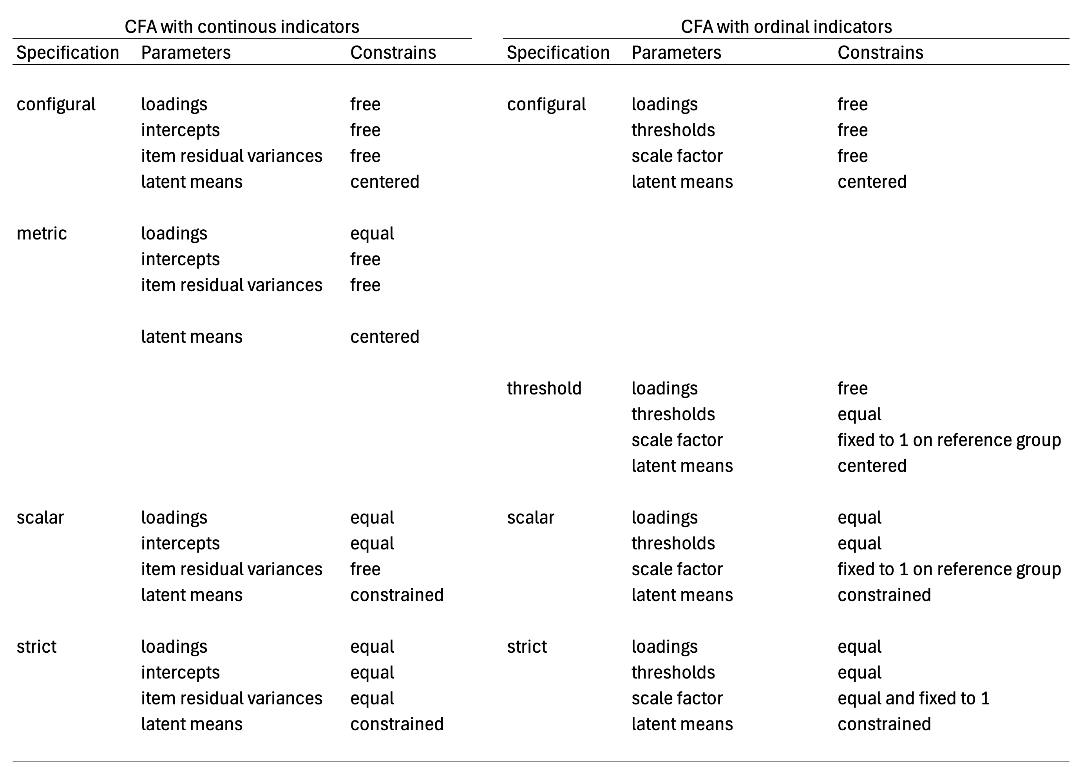

Figure 1: response model parameters being held equal in each model specification.

The present table is a summary of the different measurement model parameters that are held equal among groups to specify each model specification. For both measurement models, the configural model specification is a purely descriptive model, where all parameters are free to vary in both models, with the exemption of latent means and latent factor variances which are fixed to zero and one respectively. In contrast, the metric model specification described for CFA with continuous indicators doesn’t have the same interpretation for CFA with ordinal indicators. According to Wu & Estabrook (2016) thresholds needs to be held common across groups to assure models are nested in the modelling sequence: configural, threshold, scalar, strict. There is alternative model specifications discuss by Wu & Estabrook (2016), and by Tse et al. (2024) for the configural solution, in which factor loadings are held common between groups, and thresholds are held common for marker indicators instead of all items. In the present table, we are following Svetina et al. (2020) model specification for configural and threshold invariance models. The threshold invariant model is a baseline model from which model comparisons can be made in contrast to scalar and strict solutions of the GRM model. In the present guideline we will review these model specifications in more detail in section 4, following Svetina et al. (2020) using the delta parameterization, while using a model trimming sequence starting from the strict model specification with common thresholds. Model specification where only thresholds are held common for marker indicators are not covered. Interested readers on this option can consult Tse et al. (2024) for this alternative model specification.

It should be clear that not all model specifications propose for CFA with continuous indicators are equivalent for other measurement models. The weak invariance (e.g., Dimitrov, 2010) or metric invariance model specification (Wu & Estabrook, 2016) from CFA with continuous indicators, where common factor loadings are held equal across groups, do not reach a model specification that holds the same interpretation for CFA with ordinal indicators (Wu & Estabrook, 2016; Svetina, et al. 2020; Tse, et al., 2024) if thresholds are allow to vary freely. A similar observation can be done for the assumed interpretation of the metric model specification with latent class models (e.g., Hooghe & Oser, 2015; Hooghe et al., 2016). The metric model specification applied to latent class models is a special case of a non-invariant solution (Masyn, 2017) and doesn’t hold the same interpretation of the random term across groups, the configuration of the latent classes (Torres Irribarra, et al., 2021). In summary, model specifications to assess measurement invariance may not hold in the same way for all measurement models. The metric invariance model specification is an example on this regard.

If invariance holds, the purpose is to assert that group differences are on the random term of the measurement model with a common interpretation. For the case of continuous latent factors, the aim is to assert groups are different in terms of their location in the latent continuum, but not on their expected responses to items at equal levels of the latent factor. For the case of discrete latent factors, the aim is to asserts that groups can vary in size regarding the latent classes, but not on the response probabilities for each compared group if persons belong to the same latent class. If the model specification doesn’t provide group differences with a common interpretation, then substantive conclusions regarding group differences are not tenable as one expects because these do not have a common meaning across groups. In the following section (section 2) we will describe what are partially invariant solutions.

## 2.3 References

Adams, R. J., Wu, M. L., & Wilson, M. (2012). The Rasch Rating Model and the Disordered Threshold Controversy. Educational and Psychological Measurement, 72(4), 547–573. https://doi.org/10.1177/0013164411432166

Agresti, A. (2010). Analysis of Ordinal Categorical Data. John Wiley & Sons, Inc.

Asparouhov, T., & Muthén, B. (2020). IRT in Mplus. In Mplus Technical Appendix. https://www.statmodel.com/download/MplusIRT.pdf

Borsboom, D. (2005). Measuring the Mind. Cambridge University Press.

Bovaird, J. A., & Koziol, N. A. (2012). Measurement Models for Ordered-Categorical Indicators. In R. H. Hoyle (Ed.), Handbook of Structural Equation Modeling (pp. 495–511). Guilford Press.

Brown, T. A. (2006). Confirmatory factor analysis for applied research. Guilford Press.

Carrasco, D., Irribarra, D. T., & González, J. (2022). Continuation Ratio Model for Polytomous Items Under Complex Sampling Design. In Quantitative Psychology (pp. 95–110). https://doi.org/10.1007/978-3-031-04572-1_8

De Boeck, P., & Wilson, M. (2004). Explanatory Item Response Models (P. De Boeck & M. Wilson (eds.)). Springer New York. https://doi.org/10.1007/978-1-4757-3990-9

Dimitrov, D. M. (2010). Testing for Factorial Invariance in the Context of Construct Validation. Measurement and Evaluation in Counseling and Development, 43, 121–149. https://doi.org/10.1177/0748175610373459

Engelhard, G. J., & Wind, S. A. (2018). Invariant Measurement with raters and rating scales. Routledge.

Farkas, G. (2003). Cognitive Skills and Noncognitive Traits and Behaviors in Stratification Processes. Annual Review of Sociology, 29, 541–562. https://doi.org/10.1146/annurev.soc.29.010202.100023

Grimm, K. J., & Liu, Y. (2016). Residual Structures in Growth Models With Ordinal Outcomes. Structural Equation Modeling, 23(3), 466–475. https://doi.org/10.1080/10705511.2015.1103192

Hooghe, M., & Oser, J. (2015). The rise of engaged citizenship: The evolution of citizenship norms among adolescents in 21 countries between 1999 and 2009. International Journal of Comparative Sociology, 56(1), 29–52. https://doi.org/10.1177/0020715215578488.

Hooghe, M., Oser, J., & Marien, S. (2016). A comparative analysis of ‘good citizenship’: A latent class analysis of adolescents’ citizenship norms in 38 countries. International Political Science Review, 37(1), 115–129. https://doi.org/10.1177/0192512114541562.

Kline, R. B. (2023). Principles and Practice of Structural Equation Modeling (5th ed.). Guilford Press.

Masters, G. N. (1982). A rasch model for partial credit scoring. Psychometrika, 47(2), 149–174. https://doi.org/10.1007/BF02296272

Masyn, K. E. (2017). Measurement Invariance and Differential Item Functioning in Latent Class Analysis With Stepwise Multiple Indicator Multiple Cause Modeling. Structural Equation Modeling: A Multidisciplinary Journal, 24(2), 180–197. https://doi.org/10.1080/10705511.2016.1254049

Mellenbergh, G. J. (1994). Generalized linear item response theory. Psychological Bulletin, 115(2), 300–307. https://doi.org/10.1037//0033-2909.115.2.300

Muthén, B., & Asparouhov, T. (2002). Latent variable analysis with categorical outcomes: Multiple-group and growth modeling in Mplus. Retrieved from http://www.statmodel.com/download/webnotes/ CatMGLong.pdf

Samejima, F. (1968). Estimation of latent Ability using a response pattern of graded scores. ETS Research Bulletin Series, 1968(1), i–169. https://doi.org/10.1002/j.2333-8504.1968.tb00153.x

Samejima, F. (2016). Graded Response Models. In W. J. van der Linden (Ed.), Handbook of Item Response Theory. Volume One. Models (pp. 95–107). CRC Press. https://doi.org/10.1201/9781315374512-16

Schulz, W., Carstens, R., Losito, B., & Fraillon, J. (2018). ICCS 2016 Technical Report (W. Schulz, R. Carstens, B. Losito, & J. Fraillon (eds.)). International Association for the Evaluation of Educational Achievement (IEA).

Skrondal, A., & Rabe-Hesketh, S. (2004). Generalized latent variable modeling: Multilevel, longitudinal, and structural equation models. Chapman & Hall CRC.

Torres Irribarra, D. (2021). A Pragmatic Perspective of Measurement. Springer International Publishing. https://doi.org/10.1007/978-3-030-74025-2

Torres Irribarra, D., & Carrasco, D. (2021). Profiles of Good Citizenship. In E. Treviño, D. Carrasco, E. Claes, & K. J. Kennedy (Eds.), Good Citizenship for the Next Generation. A Global Perspective Using IEA ICCS 2016 Data (pp. 33–50). Springer International Publishing. https://doi.org/10.1007/978-3-030-75746-5_3

Tse, W. W. Y., Lai, M. H. C., & Zhang, Y. (2024). Does strict invariance matter? Valid group mean comparisons with ordered-categorical items. Behavior Research Methods, 56(4), 3117–3139. https://doi.org/10.3758/s13428-023-02247-6

Von Davier, M. (2020). TIMSS 2019 Scaling Methodology: Item Response Theory , Population Models , and Linking Across Modes. In M. O. Martin, M. Von Davier, & I. V. S. Mullis (Eds.), Methods and Procedures: TIMSS 2019 Technical Report (pp. 11.1-11.25). TIMSS & PIRLS International Study Center, Lynch School of Education and Human Development, Boston College and International Association for the Evaluation of Educational Achievement (IEA).

Wang, J., & Wang, X. (2020). Confirmatory Factor Analysis. In Structural Equation Modeling: Applications Using Mplus (pp. 33–117). John Wiley & Sons, Inc. https://doi.org/10.4324/9781315832746-25

Wu, H., & Estabrook, R. (2016). Identification of Confirmatory Factor Analysis Models of Different Levels of Invariance for Ordered Categorical Outcomes. Psychometrika, 81(4), 1014–1045. https://doi.org/10.1007/s11336-016-9506-0

# 3. Partial invariance

Partially invariant models are model specifications that allows for some item indicators parameters to vary freely, while still having enough common parameters in the measurement model among groups. These models offer a way to generalize findings based on the invariant parameters while excluding those that exhibit non-invariance in the results generalization (Meredith, 1993; Millsap, 2011). Hence, the name partially invariant.

These models allow researchers to identify group differences or treatment effects reliably for responses to items that remain consistent across groups, while keeping non invariant indicators in the measurement model. For instance, in case of causal inference exercises such as experiments and intervention studies, where control and treated groups are compared, if a treatment effect holds equally for 10 out of 12 items within a scale, assertions between treated and non-treated can be made safely for these 10 items, while not making such claims onto the two non-invariant indicators (e.g., Gilbert, 2024).

However, if the number of non-invariant parameters in the measurement models is too large, then is less credible the ability of making claims that are applicable to all compared groups across all items. As a point reference, Muthén, & Asparouhov (2014) suggest that if 75% of the parameters between groups are held common (while 25% of the response parameters are non-invariant), latent means comparisons between groups are of good enough quality. Yet, such a threshold can be put to the test with Monte Carlo studies for the speficities of a measurement model, while taking into account the number of groups being compared (Muhen & Asparouhov, 2014, p3), and the research purpose.

There are few caveats to consider regarding partially invariant models when group comparisons are of interest. If non-invariant items are excluded, this selective exclusion can alter the meaning of the generated score. Exclusion of non-invariant items can narrow the scope of the attribute of interest. For example, if one has three groups, and twelve items, is possible to have a scenario in which the measurement model is invariant for two of the three groups. And simultaneously, the measurement equivalence could hold with only four out of the twelve items for the three groups. As such, researchers can have the dilemma of narrowing the amount of indicators at the cost of reliability and narrowing the meaning of the generated score; and compare the three groups. Or, to do comparison across all the items for only two of the three groups. Yet, with partially invariant model while is allowed to keep all indicators in the measurement model, the meaning of the group differences would partially generalize to the responses where the measurement model parameters are held equal. Restricting the comparison to only the common items among the three groups can restrict the scope of the intended interpretations. This a central problem for cross-cultural studies, where including more diverse groups can augment the chances of non-comparability (Van De Vijver & Matsumoto, 2011). In essence, partially invariant models can pose interpretive challenges. The treatment effects or group differences identified in these models may not fully represent the intended construct’s complexity. Researchers must exercise caution in claiming generalizability across indicators, ensuring transparency in reporting the extent of invariance and acknowledging the limitations of their results (Fischer et al., 2019; Van de Schoot et al., 2012).

In practical terms, the process of implementing partially invariant models is time-consuming and often requires significant manual intervention (Svetina et al., 2020; Robitzsch & Lüdtke, 2023). Arranging and adjusting the measurement model to exclude non-invariant items, or to freely estimate measurement model indicators between partially comparable groups, demands meticulous attention to detail and an iterative testing process. As a whole, is a procedure which can hinder efficiency. This labor-intensive aspect of the method underscores the need for more streamlined analytical tools or automated procedures to facilitate its application in large-scale studies.

Alignment methods (Muthén & Asparouhov, 2014; Asparouhov & Muthén, 2014; Asparouhov & Muthén, 2022) are a collection of procedures which are helpful in finding the least discrepant solution among groups for a given measurement model. This method searches for an optimal solution where the number of discrepant parameters (i.e., non-invariant) is minimized. Alignment is an approach that’s becoming a popular method for invariance studies in large-scale assessment research literature, with applications in different studies including Trends in International Mathematics and Science Study (TIMSS) (e.g., Yiğiter, 2024), International Civic and Citizenship Education Study (ICCS) (e.g., Ziemes, 2024), Program for International Student Assessment (PISA) (e.g., Wurster, 2022), Teaching and Learning International Survey (TALIS) (e.g., Fang et al., 2025), to name a few. Interested readers can consult Sandoval-Hernandez et al. (2025) for a scoping review on the topic.

Although is a procedure which helps to search partially invariant solutions, the resulting partially invariant solutions are conditional to the selection algorithm (Pokropek, Lüdtke, & Robitzsch, 2020). Thus, is not a method which would yield non debatable partially invariant solutions, but plausible partially invariant solutions. As such, is the researcher who would need to make a judgment call regarding if the reached solution is a useful model specification for their purposes, considering its limitations.

In conclusion, while partially invariant models offer a practical approach to addressing measurement invariance challenges, their limitations highlight the importance of careful interpretation and methodological rigor. Aligment methods offer an interesting tool to search for partially invariant model specification in cases where strict and scalar invariance is not held. Apart from aligment methods, there are other alternatives that are aim at addressing the challenges of comparing many groups such as bayesian aproximate invariance, measurement invariance via multilevel models, mixture multigroup factor analysis among others (see Leitgöb et al., 2023). These other alternatives, besides aignment methods are out of the scope of the present guidelines

In the following section (section 3), we describe what is in the library(rd3c3), and how it can help to fit model-based measurement invariance onto graded response models, and how it helps to fit alignment method optimization onto the same measurement models.

## 3.1 References

Asparouhov, T., & Muthén, B. (2014). Multiple-group factor analysis alignment. Structural Equation Modeling: A Multidisciplinary Journal, 21(4), 495–508. https://doi.org/10.1080/10705511.2014.919210

Asparouhov, T., & Muthén, B. (2022). Multiple group alignment for exploratory and structural equation models. Structural Equation Modeling: A Multidisciplinary Journal, 1–23. https://doi.org/10.1080/10705511.2022.2127100

Fang, G., Teo, T., & Chan, P. W. K. (2025). Testing for approximate measurement invariance of instructional quality in the Teaching and Learning International Survey (TALIS) 2018. Humanities and Social Sciences Communications, 12(1), 520. https://doi.org/10.1057/s41599-025-04870-4

Fischer, J., Praetorius, A. K., & Klieme, E. (2019). The impact of linguistic similarity on cross-cultural comparability of students’ perceptions of teaching quality. Educational Assessment, Evaluation and Accountability, 31, 201–220.

Gilbert, J. B. (2024). Modeling item-level heterogeneous treatment effects: A tutorial with the glmer function from the lme4 package in R. Behavior Research Methods, 56(5), 5055–5067. https://doi.org/10.3758/s13428-023-02245-8

Leitgöb, H., Seddig, D., Asparouhov, T., Behr, D., Davidov, E., De Roover, K., Jak, S., Meitinger, K., Menold, N., Muthén, B., Rudnev, M., Schmidt, P., & van de Schoot, R. (2023). Measurement invariance in the social sciences: Historical development, methodological challenges, state of the art, and future perspectives. Social Science Research, 110(October 2022). https://doi.org/10.1016/j.ssresearch.2022.102805

Meredith, W. (1993). Measurement invariance, factor analysis, and factorial invariance. Psychometrika, 58(4), 525–543. https://doi.org/10.1007/BF02294825

Millsap, R. E. (2011). Statistical Approaches to Measurement Invariance. New York, NY: Routledge.

Muthén, B., & Asparouhov, T. (2014). IRT studies of many groups: the alignment method. Supplemental Material. Frontiers in Psychology, 5, 23–31. https://doi.org/10.3389/fpsyg.2014.00978

Pokropek, A., Lüdtke, O., & Robitzsch, A. (2020). An extension of the invariance alignment method for scale linking. Psychological Test and Assessment Modeling, 62(2), 305–334.

Robitzsch, A., & Lüdtke, O. (2023). Why full, partial, or approximate measurement invariance are not a prerequisite for meaningful and valid group comparisons. Structural Equation Modeling, 30(2), 190–204. https://doi.org/10.1080/10705511.2023.2191292

Svetina, D., Rutkowski, L., & Rutkowski, D. (2020). Multiple-group invariance with categorical outcomes using updated guidelines: An illustration using Mplus and the lavaan/semTools packages. Structural Equation Modeling: A Multidisciplinary Journal, 27(1), 111–130. https://doi.org/10.1080/10705511.2019.1602776

Van de Schoot, R., Lugtig, P., & Hox, J. (2012). A checklist for testing measurement invariance. European Journal of Developmental Psychology, 9(4), 486–492. https://doi.org/10.1080/17405629.2012.686740

Van De Vijver, F.J.R., Matsumoto, D. (2011) Introduction to the methodological issues associated with cross-cultural research. In: Matsumoto, D., van de Vijver, F.J.R. (Eds.), Cross-Cultural Research Methods in Psychology, 1st ed.,. Cambridge University Press, pp. 1–14.

Wurster, S. (2022). Measurement invariance of non-cognitive measures in TIMSS across countries and across time. An application and comparison of Multigroup Confirmatory Factor Analysis, Bayesian approximate measurement invariance and alignment optimization approach. Studies in Educational Evaluation, 73, 101143. https://doi.org/10.1016/j.stueduc.2022.101143

Yiğiter, M. S. (2024). Cross-National Measurement of Mathematics Intrinsic Motivation: An Investigate of Measurement Invariance with MG-CFA and Aligment Method Across Fourteen Countries. Journal of Theoretical Educational Science, 17(1), 1–27. https://doi.org/10.30831/akukeg.1207350

Ziemes, J. F. (2024). Political trust among European youth: Evaluating multi -dimensionality and cross-national measurement comparability. Studies in Educational Evaluation, 73, 101321. https://doi.org/10.1016/j.stueduc.2023.101321

# 4. Library overview

## 4.1 Summary

* library(rd3c3) is a collection of wrapper functions
* these wrapper functions are included within template to produce item analysis reports
* the item analysis reports provide different statistical and psychometric results of interest to make judgments regarding the quality of scale scores

## 4.2 rd3c3 as a collection of wrappers

The library(rd3c3) is a collection of wrapper functions (Stanton, 2017) that helps to streamline the task of genereting code to fit different measurement model specifications. Wrapper functions are a way to call more complex functions and code into a simpler user interface. The main aim of the library is to ease the coding time needed when assessing measurement invariance of polytomous batteries of items from background questionnaires of large scale assessment studies. The different model specifications follow Wu & Estabrook (2014), Svetina, Rutkowski & Rutkowski (2020) and Tse, Lai & Chang (2024) recommendations to fit different multigroup models of the graded response model with probit link, to fit strict, scalar, common threshold and base (i.e., descriptive) multigroup models. Moreover, the library also contains functions to apply alignment methods onto the same measurement model among groups. It relies on MplusAutomation (Hallquist & Wiley, 2018), to fit measurement models using Mplus (Muthén & Muthén, 2017), so all fitted models can take into account sample design features of large-scale assessment studies such as stratification variables, clustering variables, and survey weights (e.g., Stapleton, 2013).

The handler name of the library is rd3c3. This handler stems from the research development call number 3 (rd3), focused on cross cultural comparison (c3).

## 4.3 Code applicable to a set of items

Most of the wrapper functions included in library(rd3c3) are not intended to be use onto sole objects, such as vectors or data frames. These are design to be fitted onto a set of elements, define in a table. Once the table, which we call generally scale_info, is filled-in and is called into the R session, the wrapper functions can resolve which items are subject to an analysis, within a define data object a particular data frame. We illustrate the general logic of the wrapper functions with the following diagram.

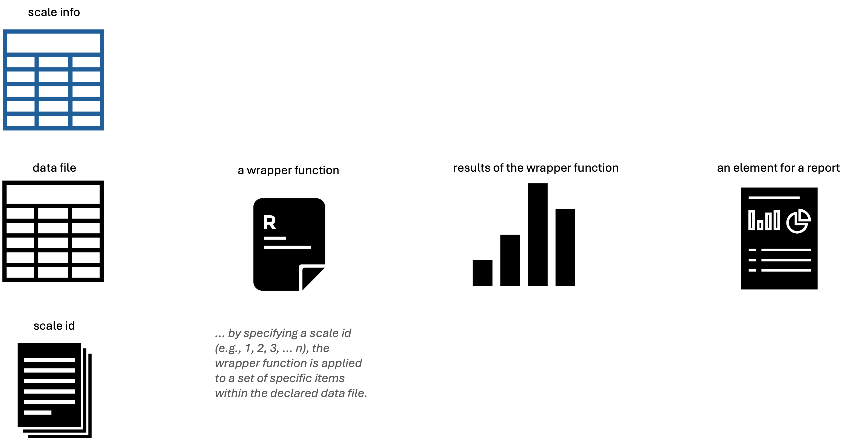

Figure 2: wrapper function logic

For the wrapper functions to work, one needs to provide:

* a scale_info table
* to specify within the table the data_file name with the responses of interest
* choose a particular scale, via a scale_id

As such, the library contains different wrapper functions that have the same arguments. These arguments usually present the following form:

rd3c3::name_of_the_function(  
 data = data_responses,   
 scale_num = scale_id,   
 scale_info = scales_data  
)

This is the case for different functions within rd3c3. For example, to name a few:

* rd3c3::get_descriptives()
  + is a wrapper function to produce nominal descriptives of items
* rd3c3::missing_summary()
  + it generates a summary of missing data across items, distinguishing complete, partial and missing response patterns by observations
* rd3c3::fit_grm2()
  + is a wrapper function that fits a graded response model with probit link onto a set of items declared in the scale_info table
* rd3c3::ctt_table()
  + it produces classical test theory statistics such as biserial correlations and alpha if deleted for set of items declared in the scale_info table

For example, the rd3c3::get_descriptives() function generates item descriptives including means, standard deviations, and histograms; and instead of being applicable to a matrix of responses is applied onto a whole data object. Thanks to the additional arguments included in the wrapper function, the code is able to select the items that are indexed with a scale_id number within the scale_info table. Thus, just by specifing the desired scale_id the user can get the results for these collection of items contained in a particular data file.

#------------------------------------------------------------------------------  
# descriptives  
#------------------------------------------------------------------------------  
  
# -----------------------------------------------  
# scale id  
# -----------------------------------------------  
  
rd3c3::silent(library(dplyr))  
  
# -----------------------------------------------  
# scale id  
# -----------------------------------------------  
  
scale_id <- 1  
  
# -----------------------------------------------  
# scales info  
# -----------------------------------------------  
  
scales_data <- readxl::read_xlsx(  
 'guideline_scale_info_example.xlsx',   
 sheet = 'scales_data'  
 )  
  
# -----------------------------------------------  
# data file  
# -----------------------------------------------  
  
data_file <- scales_data %>%  
dplyr::filter(scale_num == scale_id) %>%  
dplyr::select(data_file) %>%  
unique() %>%  
dplyr::pull()   
  
# -----------------------------------------------  
# response matrix  
# -----------------------------------------------  
  
data_responses <- readRDS(data_file)  
  
# -----------------------------------------------  
# descriptives  
# -----------------------------------------------  
  
rd3c3::get_descriptives(  
 data = data_responses,   
 scale_num = scale_id,   
 scale_info = scales_data) %>%  
dplyr::select(var, missing, complete, n, mean, sd, skew, kurt, hist) %>%  
knitr::kable(.,   
 digits = 2,  
 caption = 'Table 1: descriptives example')

Table 1: descriptives example

| var | missing | complete | n | mean | sd | skew | kurt | hist |
| --- | --- | --- | --- | --- | --- | --- | --- | --- |
| BSBG13A | 0.04 | 0.96 | 7480 | 2.13 | 0.84 | 0.61 | 2.97 | ▃▁▇▁▁▂▁▁ |
| BSBG13B | 0.04 | 0.96 | 7480 | 1.82 | 0.77 | 0.78 | 3.34 | ▆▁▇▁▁▂▁▁ |
| BSBG13C | 0.05 | 0.95 | 7480 | 1.84 | 0.83 | 0.83 | 3.16 | ▇▁▇▁▁▂▁▁ |
| BSBG13E | 0.04 | 0.96 | 7480 | 1.88 | 0.85 | 0.81 | 3.12 | ▇▁▇▁▁▂▁▁ |

The generated results are the descriptives of items BSBG13A, BSBG13B, BSBG13C, BSBG13E from the “Sense of School Belonging” scale, present in TIMSS 2019, for Chile and England.

## 4.4 *Template based workflow*

The library(rd3c3) is intended to produce **item analys reports** of polytomous scales, in the spirit of dynamic reports (Xie, 2017). These are reproducible statistical analysis, that fills-in a define template. For any scale_id, a collection of items, one can generate an **item analys report** that include different sets of results.

This is in stark contrast to a *manually coded workflow*, where the user needs to code every function to a set of specific items within a data frame, many times to build a single item analysis report to every scale. In comparison, a *template based workflow* already contains an opinionated set of analysis (Parker, 2017) selected with a purpose. In this case, to make judgments of the quality of scale scores in terms of unidimensionality, reliability, comparability and inference limitations. The following diagram depicts the contrast between these two manners to reach the set of intended item analysis reports.

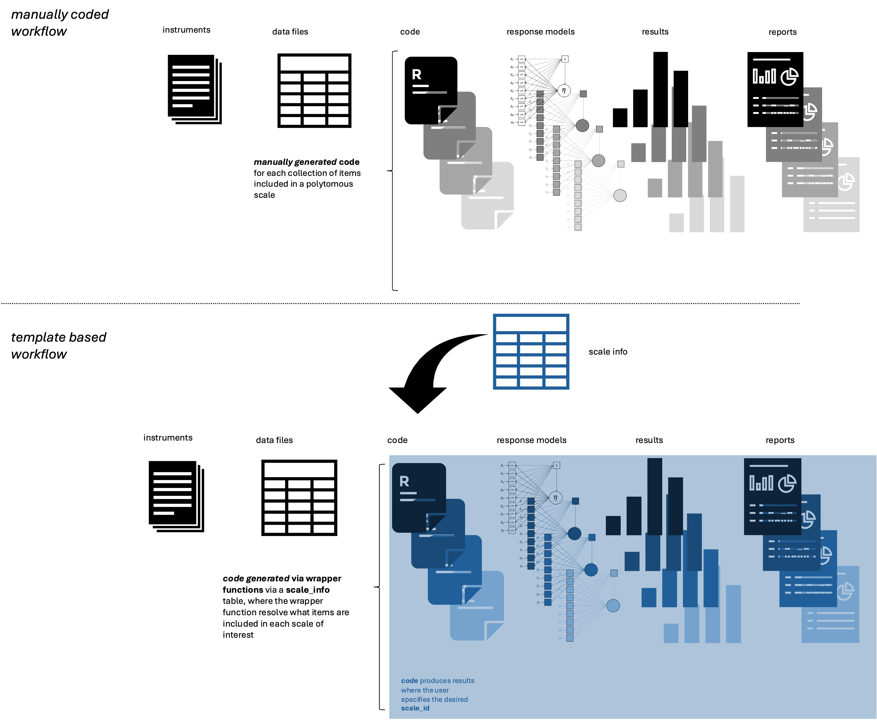

Figure 3: wrapper function logic within a dynamic report

In the *manually coded workflow* the user needs to code each set of analysis for each set of items. While in the second workflow, the *template based workflow*, the user just needs to choose the respective scale_id and can get the intended **item analys reports** that should be already planned.

The logic of a template is that allows a user to get a series of results regarding the responses to a collection of items that are intended to measure a known attribute (i.e., a construct). This templates includes a selection of the different results a researcher can use to make judgements regarding the quality of a total score from polytomous items scale.

A template for assessing the quality of scale scores should follow different design data analysis principles such as reproducibility and exhaustivity (McGowan et al., 2023). This template should be reproducible in the sense that other user, with the same data file, library, and needed software (i.e., Mplus), should reach the same results. Thus, such a template should be able to get the same results present in a generated report. Ideally a template for item analysis reports should follows the design principle of exhaustivity, in the sense of including different results that helps to make a judgment regarding the quality of the scale score one can produce with the responses to a set of indicators. Using library(rd3c3) the users can include results from a graded response models, under different model specifications (i.e., strict, scalar, configural, base), and alignment methods for graded response models.

In essence, to build a dynamic **item analysis report**, the user needs to define the scale_info, define the data_responses of interest, and by using library(rd3c3) within a define **template** the user can include all the statistical analysis relevant for its purpose. As a whole, the user can generate dynamic results reports per scale. The following diagram summarize the minimal elements to produce these dynamic reports.

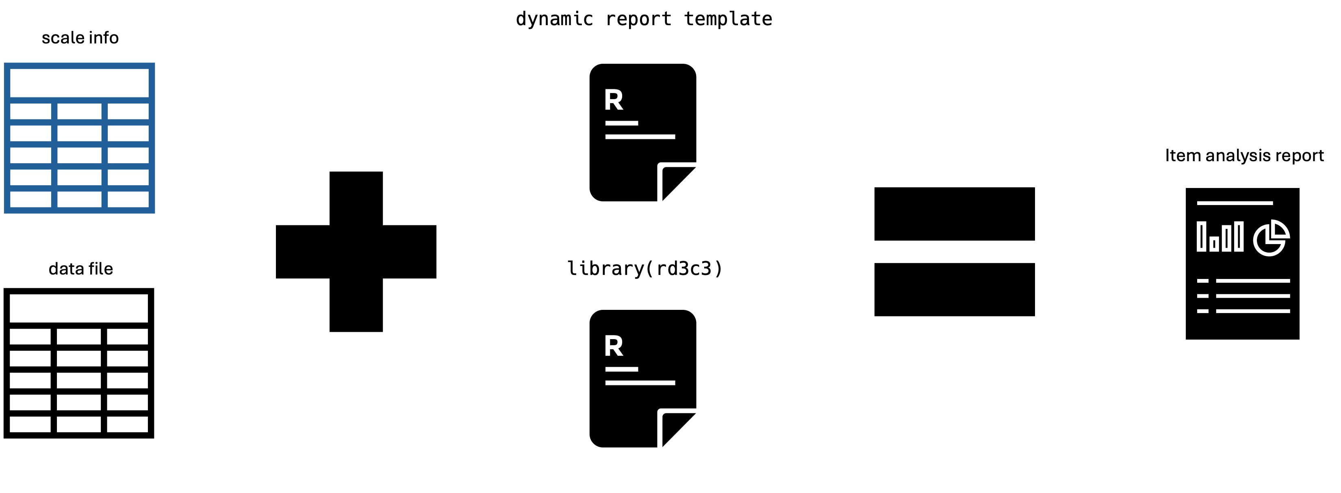

Figure 4: dynamic reports

## 4.5 Main pieces of evidence to judge the quality of scales scores

The main pieces of evidence that librar(rd3c3) can produce for item analysis reports are:

* Unidimensionality
* Reliability
* Comparability
* Inference limitations

**Unidimensionality** is judge based on parallel analysis for ordinal indicators (Lubbe, 2019).

**Reliability** of scale scores is judge by inspecting the distribution of errors of the latent factor of the GRM model, its summary via person separation reliability (Verhavert et al., 2018) and via the Cronbach’s alpha index (Cronbach, 1951).

**Comparability** among participating countries is assess via the results of the model based measurement invariance results (Wu & Estabrook, 2016; Svetina, Rutkowski & Rutkowski, 2020; Tse, Lai & Chang, 2024), and the complementary results from the alignment analysis (Muthén & Asparouhov, 2014).

**Inference limitations** can be made based on an holistic judgment of previous results, regarding to which locations of the latent continuum the scale score is more informative, via inspection of the person item map, and the distribution of standard errors of the theta realizations of the measurement model. For example if the distribution of item location is concentrated in one of the tails a researcher can identify possible ceiling or floor effects of the scale (e.g., Carrasco, Rutkowski, and Rutkowski, 2023). Moreover, the item analysis reports provides results of measurement invariance and alignment methods providing information regarding the tenability of assuming a common measurement model among the compared groups. Thus, the researcher can spot scales scores where the comparison among groups may not be guarantee and further research is needed. Further research could isolate points of support for comparisons, by iterating the decisions on item and group selections and exclusions.

In the following section (section 4), we illustrate the application of the library(rd3c3) to produce invariance analysis, and build an **item analysis report** with the described characteristics.

## 4.6 References

Carrasco, D., Rutkowski, D., & Rutkowski, L. (2023). The advantages of regional large-scale assessments: Evidence from the ERCE learning survey. International Journal of Educational Development, 102(May), 102867. https://doi.org/10.1016/j.ijedudev.2023.102867

Cronbach, L. J. (1951). Coefficient alpha and the internal structure of tests. Psychometrika, 16(3), 297–334. https://doi.org/10.1007/BF02310555

Hallquist, M. N., & Wiley, J. F. (2018). MplusAutomation: An R Package for Facilitating Large-Scale Latent Variable Analyses in Mplus. Structural Equation Modeling: A Multidisciplinary Journal, 25(4), 621–638. https://doi.org/10.1080/10705511.2017.1402334

Lubbe, D. (2019). Parallel analysis with categorical variables: Impact of category probability proportions on dimensionality assessment accuracy. Psychological Methods, 24(3), 339–351. https://doi.org/10.1037/met0000171

McGowan, L. D. A., Peng, R. D., & Hicks, S. C. (2023). Design principles for data analysis. Journal of Computational and Graphical Statistics, 32(2), 754-761.

Muthén, L. K., & Muthén, B. O. (2017). Mplus User’s Guide (8th ed.). Muthén & Muthén.

Parker, H. (2017). Opinionated analysis development (pp. 1–13). https://doi.org/10.7287/peerj.preprints.3210

Stanton, J. M. (2017). Reasoning with Data. An Introduction to Traditional and Bayesian Statistics Using R. Guilford Press.

Stapleton, L. M. (2013). Incorporating Sampling Weights into Single- and Multilevel Analyses. In L. Rutkowski, M. von Davier, & D. Rutkowski (Eds.), Handbook of International Large scale Assessment: background, technical issues, and methods of data analysis (pp. 363–388). Chapman and Hall/CRC.

Svetina, D., Rutkowski, L., & Rutkowski, D. (2020). Multiple-Group Invariance with Categorical Outcomes Using Updated Guidelines: An Illustration Using Mplus and the lavaan/semTools Packages. Structural Equation Modeling: A Multidisciplinary Journal, 27(1), 111–130. https://doi.org/10.1080/10705511.2019.1602776

Tse, W. W. Y., Lai, M. H. C., & Zhang, Y. (2024). Does strict invariance matter? Valid group mean comparisons with ordered-categorical items. Behavior Research Methods, 56(4), 3117–3139. https://doi.org/10.3758/s13428-023-02247-6

Verhavert, S., De Maeyer, S., Donche, V., & Coertjens, L. (2018). Scale separation reliability: What does it mean in the context of comparative judgment?. Applied Psychological Measurement, 42(6), 428-445.

Wu, H., & Estabrook, R. (2016). Identification of Confirmatory Factor Analysis Models of Different Levels of Invariance for Ordered Categorical Outcomes. Psychometrika, 81(4), 1014–1045. https://doi.org/10.1007/s11336-016-9506-0

Xie, Y. (2017). Dynamic Documents with R and knitr. CRC Press.

# 5. Applied Examples

## 5.1 Summary

* We use data from TIMSS 2019, from the student background questionnaire.
  + In particular we are using student responses to the items of the scale “Sense of School Belonging”, from Chile and England.
  + The data file includes 4115 students from Chile, and 3365 students from England, from 8th grade
  + We are using a tailor-made data file where we include specific clustering and survey design variables:
    - id_i = unique id number for students
    - id_j = unique id number for schools
    - id_s = unique id number for stratification factors (i.e., JKZONES)
    - id_k = unique id number for country samples
    - ws = scale survey weights to a constant of 1000
    - [data_ex1.rds](https://www.dropbox.com/scl/fi/aivrd2rw2lhw5o7ly06jn/data_ex1.rds?rlkey=3clglj3fdlh5o6myv3q8et9xz&dl=1)
* To install the library, a user can use the following code, to download the development version of the library:

# -----------------------------------------------  
# install rd3c3  
# -----------------------------------------------  
  
devtools::install_github(  
 'dacarras/rd3c3',  
 force = TRUE  
)

* We include three applied examples:
  + Invariance Analysis
    - Model based invariance analysis
    - Alignment method analsyis
  + Item report analysis
    - The item report analysis includes a larger set of analysis, besides Model based invariance analysis and Alignment method analsyis, such as item descriptives, missing data analysis, parallel analysis and reliability analysis among others.

## 5.2 Invariance analysis

### 5.2.1 Model based invariance analysis

Model based invariance analysis includes five model specifications:

* **pooled** is a graded response model with probit link, including survey design variables (i.e., stratification factors, primary sampling unit and student survey weights) (e.g., Stapleton, 2013). *Pooled* a single measurement model, fitted onto pooled sample of cases were sampling weights have been scale to a common constant so including countries contributes equally to estimates (Gonzalez, 2012).
* **strict** is a multigroup graded response model, where all response model parameters are held equal between compared groups, beside latent means for groups (Tse et al., 2024), while including the scale factors as part of the model.
* **scalar** is a multigroup graded response model, where all response model parameters are held equal among groups, with the exemption of scale factors. It follows model specifications described in Svetina et al. (2020, proposition 7), where scale factors are fix to one for the reference group, and let to vary free on the rest of the groups in the comparison.
* **threshold** is a multigroup graded response model, where thresholds are held common among the compared countries (i.e., threshold invariance). Is the baseline model for a model building sequence for assessing model-based measurement invariance (Wu & Estabrook, 2016). It follows model specifications described in Svetina et al. (2020, proposition 4).
* **configural** is a multigroup graded response model, where all measurement model parameters are freely estimated among the compare groups, while holding latent factor means fix to zero, and factor variances fixed to one across groups.

Simulations studies from Rutkowski & Svetina (2017) with the graded response model with probit link and a larger amount of compare groups (e.g., 10, 20) suggest that RMSEA < .055 serves as a rule of thumb to select well-fitting measurement models with invariant parameters among compared groups.

To fit the following models we use as inputs:

* data_responses [data_ex1.rds](https://www.dropbox.com/scl/fi/n4ioht1v4zg7gos2a4esj/data_ex1.rds?rlkey=0lxeaq44jfmaf0ub3g3w1kvyv&st=4lysfefy&dl=1)
* scale_info = [guideline_scale_info_example.xlsx](https://www.dropbox.com/scl/fi/ujsl6fpvsbjlor2ovc6pg/guideline_scale_info_example.xlsx?rlkey=yx2mwdxt6lr0exh24ddjkexdo&st=j2446g7r&dl=1)
* scale_id = 1
* and is using the functions:
  + rd3c3::fit_grm2 for the pooled model
  + rd3c3::fit_grm2_m01_strict for the strict model
  + rd3c3::fit_grm2_m02_scalar for the scalar model
  + rd3c3::fit_grm2_m03_threshold for the threshold model
  + rd3c3::fit_grm2_m04_config for the base model (i.e., descriptive model)

In the following section we include code (*folded*) to produce the invariance model fit indexes table (see Table 1).

#------------------------------------------------------------------------------  
# define objects  
#------------------------------------------------------------------------------  
  
# -----------------------------------------------  
# scale id  
# -----------------------------------------------  
  
rd3c3::silent(library(dplyr))  
  
# -----------------------------------------------  
# scale id  
# -----------------------------------------------  
  
scale_id <- 1  
  
# -----------------------------------------------  
# scales info  
# -----------------------------------------------  
  
scales_data <- readxl::read_xlsx(  
 'guideline_scale_info_example.xlsx',   
 sheet = 'scales_data'  
 )  
  
# -----------------------------------------------  
# data file  
# -----------------------------------------------  
  
data_file <- scales_data %>%  
dplyr::filter(scale_num == scale_id) %>%  
dplyr::select(data_file) %>%  
unique() %>%  
dplyr::pull()   
  
# -----------------------------------------------  
# response matrix  
# -----------------------------------------------  
  
data_responses <- readRDS(data_file) %>%  
mutate(grp = paste0(COUNTRY)) %>%  
mutate(grp = as.numeric(as.factor(COUNTRY))) %>%  
mutate(grp_name = paste0(COUNTRY))  
  
#------------------------------------------------------------------------------  
# response models  
#------------------------------------------------------------------------------  
  
# -----------------------------------------------  
# most centered  
# -----------------------------------------------  
  
grp_centered <- 'CHL'  
  
# -----------------------------------------------  
# pooled  
# -----------------------------------------------  
  
inv_0 <- rd3c3::silent(  
 rd3c3::fit_grm2(  
 data = data_responses,  
 scale_num = scale_id,  
 scale_info = scales_data  
 )  
 )  
  
# -----------------------------------------------  
# strict  
# -----------------------------------------------  
  
inv_1 <- rd3c3::silent(  
 rd3c3::fit_grm2_m01_strict(  
 data = data_responses,   
 scale_num = scale_id,   
 scale_info = scales_data,  
 grp_var = 'id_k',  
 grp_txt = 'grp_name',  
 grp_ref = grp_centered  
 )  
 )  
  
# -----------------------------------------------  
# scalar  
# -----------------------------------------------  
  
inv_2 <- rd3c3::silent(  
 rd3c3::fit_grm2_m02_scalar(  
 data = data_responses,   
 scale_num = scale_id,   
 scale_info = scales_data,  
 grp_var = 'id_k',  
 grp_txt = 'grp_name',  
 grp_ref = grp_centered  
 )  
 )  
  
# -----------------------------------------------  
# threshold  
# -----------------------------------------------  
  
inv_3 <- rd3c3::silent(  
 rd3c3::fit_grm2_m03_threshold(  
 data = data_responses,   
 scale_num = scale_id,   
 scale_info = scales_data,  
 grp_var = 'id_k',  
 grp_txt = 'grp_name',  
 grp_ref = grp_centered  
 )  
 )  
  
# -----------------------------------------------  
# configural  
# -----------------------------------------------  
  
inv_4 <- rd3c3::silent(  
 rd3c3::fit_grm2_m04_config(  
 data = data_responses,   
 scale_num = scale_id,   
 scale_info = scales_data,  
 grp_var = 'id_k',  
 grp_txt = 'grp_name',  
 grp_ref = grp_centered  
 )  
 )  
  
# -----------------------------------------------  
# retrieve fit indexes per model  
# -----------------------------------------------  
  
fit_0 <- rd3c3::get_inv_fit(inv_0, model_name = 'pooled')  
fit_1 <- rd3c3::get_inv_fit(inv_1, model_name = 'strict')  
fit_2 <- rd3c3::get_inv_fit(inv_2, model_name = 'scalar')  
fit_3 <- rd3c3::get_inv_fit(inv_3, model_name = 'threshold')  
fit_4 <- rd3c3::get_inv_fit(inv_4, model_name = 'configural')  
  
# -----------------------------------------------  
# general table  
# -----------------------------------------------  
  
fit_table <- dplyr::bind_rows(  
 dplyr::select(fit_0, model, RMSEA, CFI, TLI, SRMR, x2, df, p_val),  
 dplyr::select(fit_1, model, RMSEA, CFI, TLI, SRMR, x2, df, p_val),  
 dplyr::select(fit_2, model, RMSEA, CFI, TLI, SRMR, x2, df, p_val),  
 dplyr::select(fit_3, model, RMSEA, CFI, TLI, SRMR, x2, df, p_val),  
 dplyr::select(fit_4, model, RMSEA, CFI, TLI, SRMR, x2, df, p_val)  
 )  
  
  
# -----------------------------------------------  
# model fit  
# -----------------------------------------------  
  
fit_table %>%  
knitr::kable(.,   
 digits = c(0,3,2,2,2,2,0,2),  
 caption = 'Table 1: invariance model fit indexes between compared groups'  
 )

Table 1: invariance model fit indexes between compared groups

| model | RMSEA | CFI | TLI | SRMR | x2 | df | p_val |
| --- | --- | --- | --- | --- | --- | --- | --- |
| pooled | 0.034 | 1.00 | 1.00 | 0.01 | 18.61 | 2 | 0 |
| strict | 0.042 | 0.99 | 1.00 | 0.02 | 112.97 | 15 | 0 |
| scalar | 0.027 | 1.00 | 1.00 | 0.01 | 40.66 | 11 | 0 |
| threshold | 0.032 | 1.00 | 1.00 | 0.01 | 37.18 | 8 | 0 |
| configural | 0.044 | 1.00 | 0.99 | 0.01 | 31.78 | 4 | 0 |

Note: pooled = is the measurement model fitted onto the pooled sample. strict = is a multigroup measurement model with common thresholds, common loadings, and a common scale. This latent variable model suffices mean score comparisons (Tse et al., 2024). scalar = is a multigroup measurement model with common thresholds, common loadings, and free scales for each item. This model supports latent mean comparisons (Tse et al., 2024). threshold = is a multigroup measurement model with common thresholds. configural = is a multigroup descriptive model where all measurement model parameter are free to vary. Metric model specification is not identified under the graded response models (Wu & Estabrook, 2016), thus metric specifications are not included. A RMSEA of .055 or less has been found to be good threshold for fit for graded response models with many groups of 10 or 20 compared groups (see Rutkowski & Svetina, 2017).

### 5.2.2 Alignment

The alignment method is optimizing for the least discrepant measurement model parameters among the compared groups. Is fitting a graded response model with probit link, and using the most optimal group as a reference. We are using the statement ALIGNMENT = FIXED(*); within Mplus for these purposes. We rely on the *Measurement invariance explorer* (https://github.com/MaksimRudnev/MIE.package) to retrieve aligment results.

The following code (*folded*) is used as inputs:

* data_responses [data_ex1.rds](https://www.dropbox.com/scl/fi/n4ioht1v4zg7gos2a4esj/data_ex1.rds?rlkey=0lxeaq44jfmaf0ub3g3w1kvyv&st=4lysfefy&dl=1)
* scale_info = [guideline_scale_info_example.xlsx](https://www.dropbox.com/scl/fi/ujsl6fpvsbjlor2ovc6pg/guideline_scale_info_example.xlsx?rlkey=yx2mwdxt6lr0exh24ddjkexdo&st=j2446g7r&dl=1)
* scale_id = 1
* and is using the function rd3c3::fit_grm2_align_wlsmv() to run an alignment method analysis

#------------------------------------------------------------------------------  
# define objects  
#------------------------------------------------------------------------------  
  
# -----------------------------------------------  
# scale id  
# -----------------------------------------------  
  
rd3c3::silent(library(dplyr))  
  
# -----------------------------------------------  
# scale id  
# -----------------------------------------------  
  
scale_id <- 1  
  
# -----------------------------------------------  
# scales info  
# -----------------------------------------------  
  
scales_data <- readxl::read_xlsx(  
 'guideline_scale_info_example.xlsx',   
 sheet = 'scales_data'  
 )  
  
# -----------------------------------------------  
# data file  
# -----------------------------------------------  
  
data_file <- scales_data %>%  
dplyr::filter(scale_num == scale_id) %>%  
dplyr::select(data_file) %>%  
unique() %>%  
dplyr::pull()   
  
# -----------------------------------------------  
# response matrix  
# -----------------------------------------------  
  
data_responses <- readRDS(data_file) %>%  
mutate(grp = paste0(COUNTRY)) %>%  
mutate(grp = as.numeric(as.factor(COUNTRY))) %>%  
mutate(grp_name = paste0(COUNTRY))  
  
#------------------------------------------------------------------------------  
# alignment  
#------------------------------------------------------------------------------  
  
# -----------------------------------------------  
# aligned  
# -----------------------------------------------  
  
  
fitted_align <- rd3c3::silent(  
rd3c3::fit_grm2_align_wlsmv(  
data = data_responses,   
scale_num = scale_id,   
scale_info = scales_data)  
)  
  
# -----------------------------------------------  
# retrieve output  
# -----------------------------------------------  
  
scale_file <- scales_data %>%  
dplyr::filter(scale_num == scale_id) %>%  
dplyr::select(mplus_file) %>%  
unique() %>%  
dplyr::pull()   
  
  
alignment_out <- MIE::extractAlignment(paste0(scale_file,'_align.out'), silent = TRUE)  
  
# -----------------------------------------------  
# display  
# -----------------------------------------------  
  
alignment_table <- alignment_out$summary %>%  
 tibble::rownames_to_column("terms") %>%  
 tibble::as_tibble() %>%  
 rename(  
 term = 1,  
 a_par = 2,  
 R2 = 3,  
 n_inv = 4,  
 n_dis = 5,  
 inv_grp = 6,  
 dis_grp = 7  
 ) %>%  
 mutate(type = case_when(  
 stringr::str_detect(term, 'Threshold') ~ 'tau',  
 stringr::str_detect(term, 'Loadings') ~ 'lambda'  
 )) %>%   
 mutate(term = stringr::str_replace(term, '\\$', '_')) %>%  
 mutate(term = stringr::str_replace(term, 'Threshold', '')) %>%  
 mutate(term = stringr::str_replace(term, 'Loadings', '')) %>%  
 mutate(term = stringr::str_replace(term, 'ETA by ', '')) %>%  
 dplyr::select(  
 type, term, a_par, R2, n_inv, n_dis, inv_grp, dis_grp)  
  
# -----------------------------------------------  
# display  
# -----------------------------------------------  
  
alignment_table %>%  
knitr::kable(.,   
 digits = 2,  
 caption = 'Table 2: alignment comparisons'  
)

Table 2: alignment comparisons

| type | term | a_par | R2 | n_inv | n_dis | inv_grp | dis_grp |
| --- | --- | --- | --- | --- | --- | --- | --- |
| tau | I01_1 | NA | NA | 0 | 2 |  | 18 11 |
| tau | I01_2 | NA | NA | 0 | 2 |  | 18 11 |
| tau | I01_3 | 0.73 | 1.00 | 2 | 0 | 11 18 |  |
| tau | I02_1 | -1.89 | 0.94 | 2 | 0 | 11 18 |  |
| tau | I02_2 | -1.09 | 0.00 | 2 | 0 | 11 18 |  |
| tau | I02_3 | NA | NA | 0 | 2 |  | 18 11 |
| tau | I03_1 | -1.73 | 0.83 | 2 | 0 | 11 18 |  |
| tau | I03_2 | -1.00 | 0.91 | 2 | 0 | 11 18 |  |
| tau | I03_3 | 0.20 | 0.85 | 2 | 0 | 11 18 |  |
| tau | I05_1 | -1.64 | 0.88 | 2 | 0 | 11 18 |  |
| tau | I05_2 | -0.97 | 0.01 | 2 | 0 | 11 18 |  |
| tau | I05_3 | 0.23 | 0.93 | 2 | 0 | 11 18 |  |
| lambda | I01 | 0.72 | 0.00 | 2 | 0 | 11 18 |  |
| lambda | I02 | 0.77 | 0.20 | 2 | 0 | 11 18 |  |
| lambda | I03 | 0.84 | 0.26 | 2 | 0 | 11 18 |  |
| lambda | I05 | 0.80 | 0.00 | 2 | 0 | 11 18 |  |

## 5.3 Item report analysis

In the following section we include a **template** example, to produce **item analysis reports**. This template includes:

* **Scale description**
  + a presentation of the name of the collection of items (i.e., the scale name)
  + a presentation of items as these where presented to the participants
  + a table with the item text, with the public data file names, and the shortened variable names
* **Analysis of responses**
  + descriptives
  + missing data descriptives
* **Response model**
  + dimensionality analysis via parallel analysis for ordinal indicators (Lubbe, 2019)
  + response model parameters for a graded response model
  + reliability analysis
  + item person maps
* **Item analysis**
  + item test correlation
  + item fit based on partial credit model
* **Comparability**
  + model based measurement invariance
  + alignment analysis of GRM among groups

The following figure depicts an overview of the generated report.

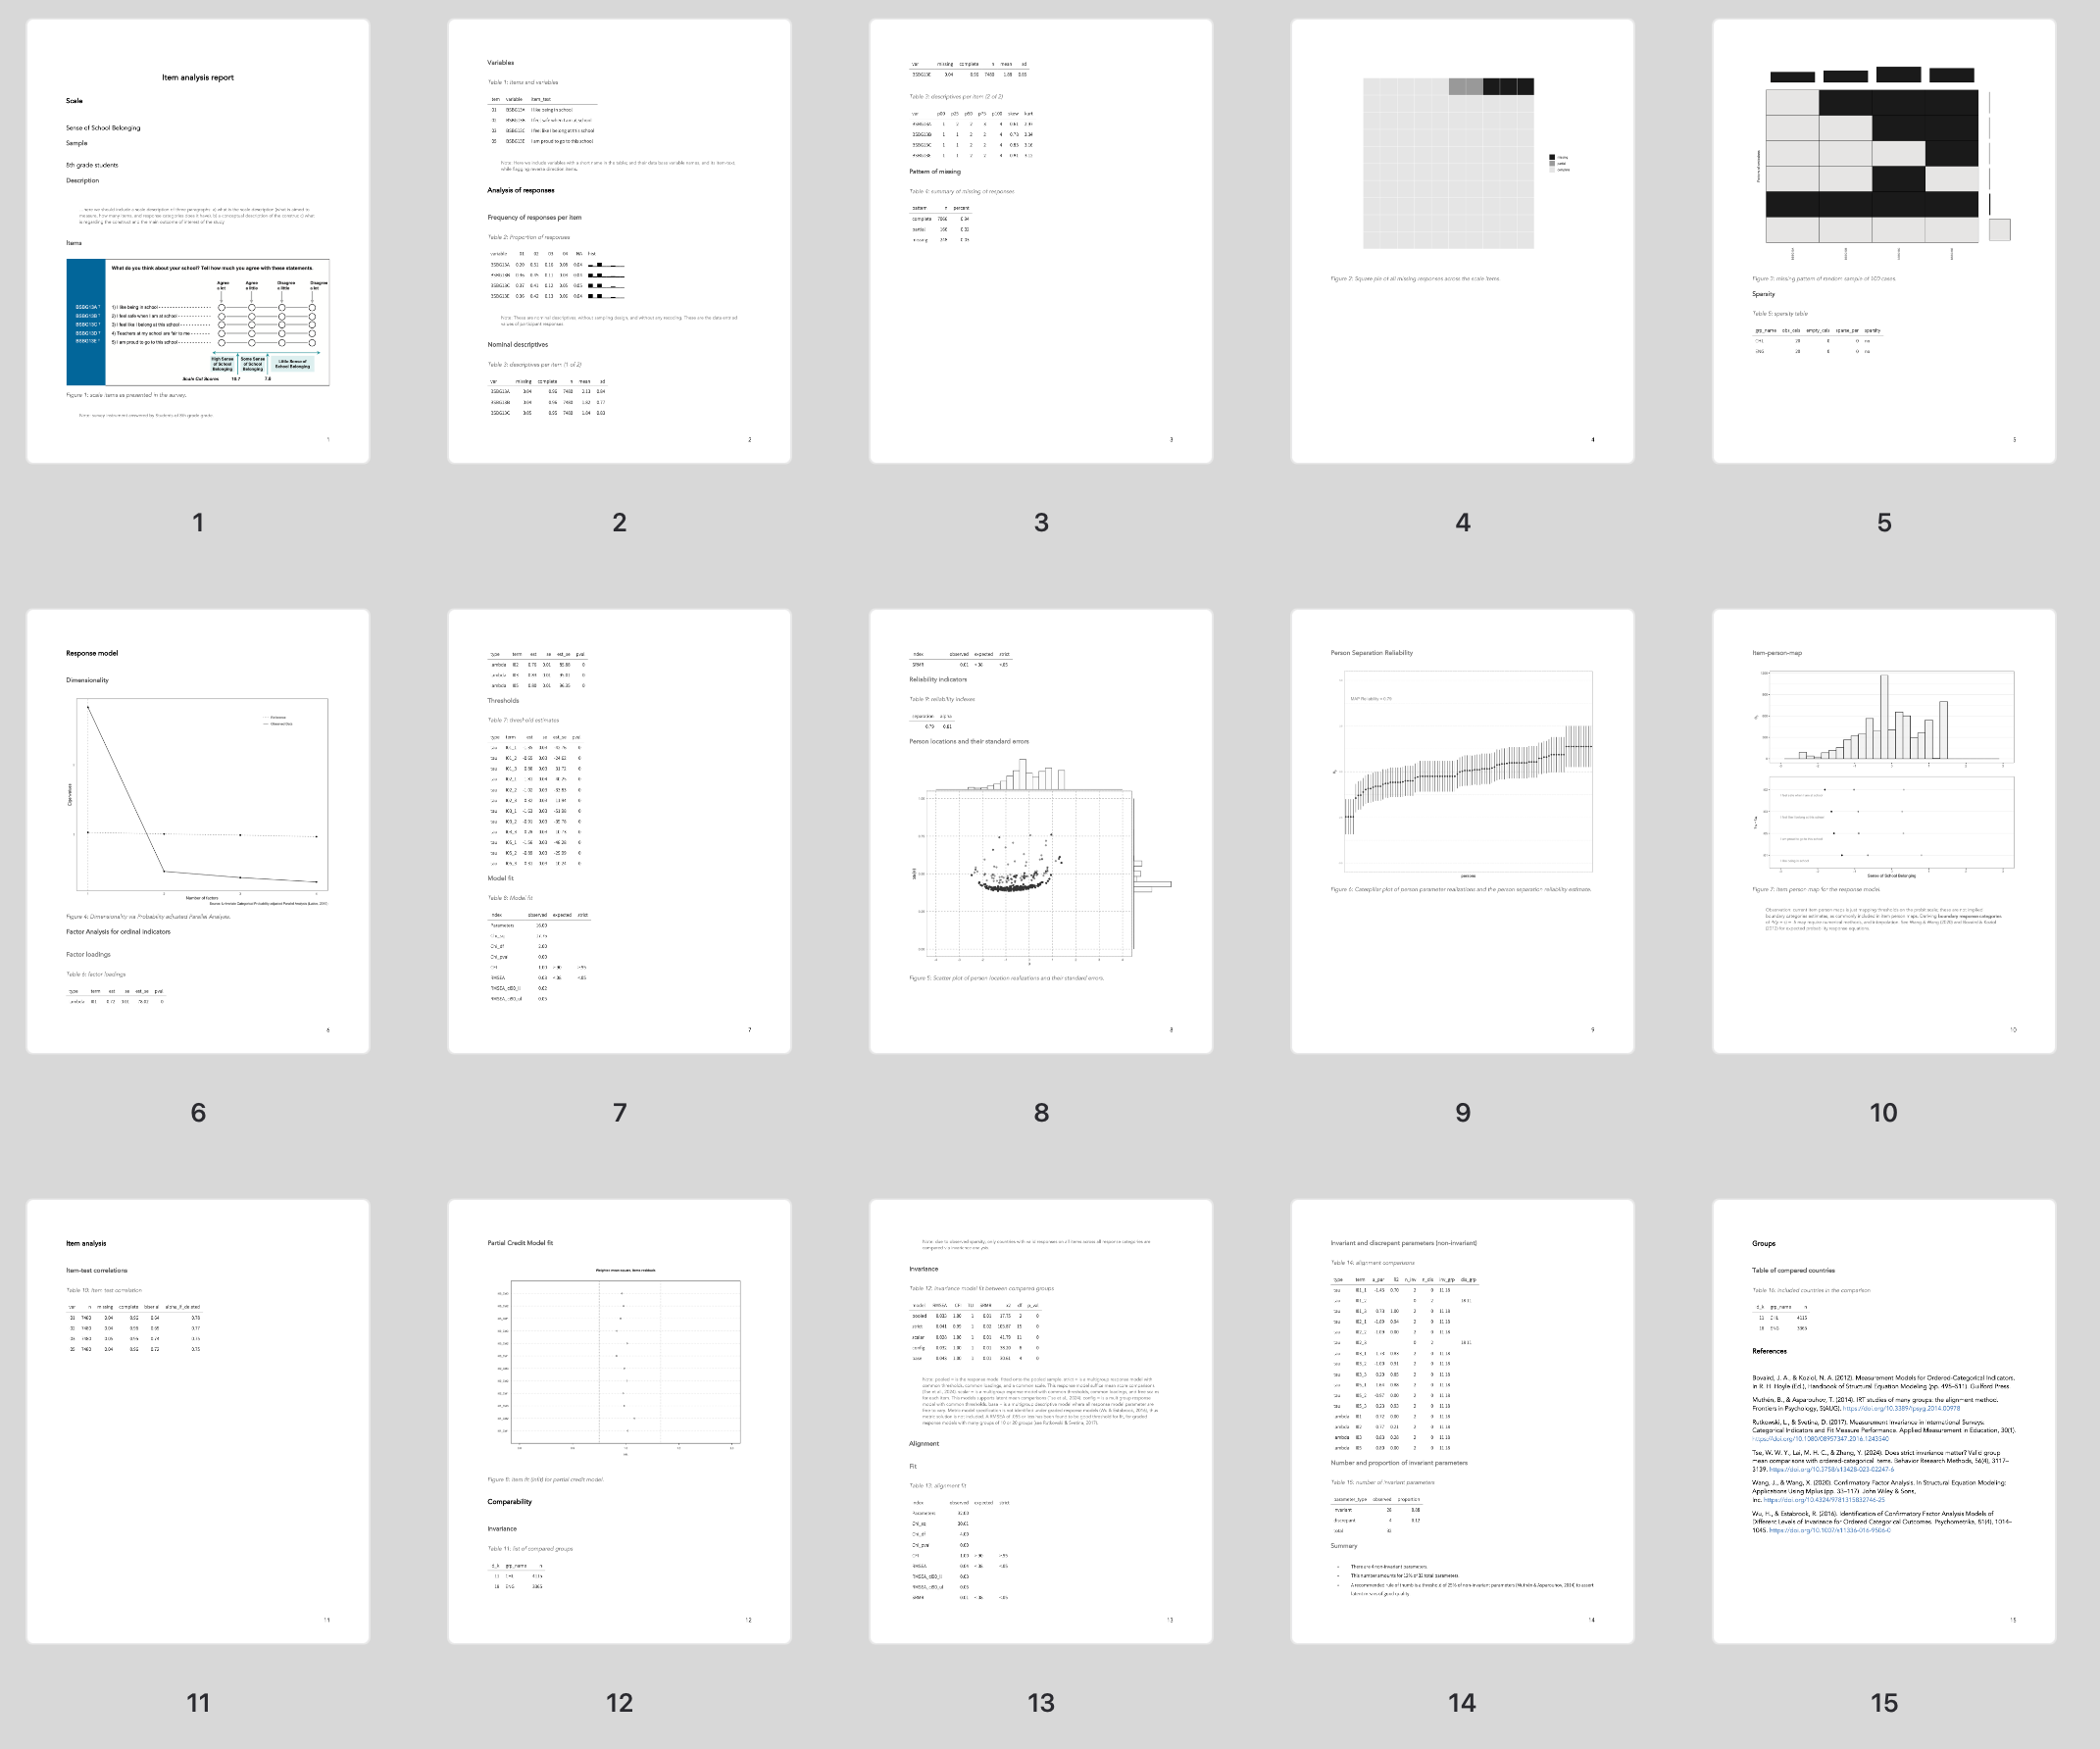

Figure 5: overview of a dynamic item report

To produce this examplary report the user needs as inputs:

* data_responses [data_ex1.rds](https://www.dropbox.com/scl/fi/n4ioht1v4zg7gos2a4esj/data_ex1.rds?rlkey=0lxeaq44jfmaf0ub3g3w1kvyv&st=4lysfefy&dl=1)
* scale_info = [guideline_scale_info_example.xlsx](https://www.dropbox.com/scl/fi/ujsl6fpvsbjlor2ovc6pg/guideline_scale_info_example.xlsx?rlkey=yx2mwdxt6lr0exh24ddjkexdo&st=j2446g7r&dl=1)
* scale_id = 1
* the template [guideline_item_report_example.rmd](https://www.dropbox.com/scl/fi/iyu8p1jdxclzfu3y220n7/guideline_item_report_example.rmd?rlkey=vamga7s12hcsi4wa9pyrv6awz&st=kzbbnc9y&dl=1)
  + and the word template [report_template.docx](https://www.dropbox.com/scl/fi/n4c5uf6f498z9v6qvg4xx/report_template.docx?rlkey=yc0b2914kn2clsxrebiz5etgt&st=bn2kl7ca&dl=1)

The end product of this procedure can be inspected in the following file [guideline_item_report_example.docx](https://www.dropbox.com/scl/fi/h7erj79fqhxs4rz6gv9b7/guideline_item_report_example.docx?rlkey=x6c816u9b87a5mudbzmpbhpdl&st=zgyid2hm&dl=1)

## 5.4 Additional examples

The current examples are just toy examples, to illustrate the basic capabilities of the library. We include two other data response files. One example with three countries, where is possible to see that three countries do not obtain strict invariance (example with “Sense of School Belonging” for three countries). And a third example of a template-based workflow, where we procede with a full fledge item analysis report including all participating countries (example with the “Bullying Scale” for all participating countries).

* Example with “Sense of School Belonging” for three countries
  + data: [data_example.rds](https://www.dropbox.com/scl/fi/1z7lt5f0jea7thz9xgbct/data_example.rds?rlkey=sl46n4owlgbjiguk1ou6sefym&st=dyfnlr5s&dl=1)
  + code template: [template_example_2.rmd](https://www.dropbox.com/scl/fi/1ujerb30tijxz3t3tgrme/template_example_2.rmd?rlkey=kwiirvitq3eo0ptav0znoc7o9&st=hvig6j6k&dl=1)
    - word template: [report_template.docx](https://www.dropbox.com/scl/fi/n4c5uf6f498z9v6qvg4xx/report_template.docx?rlkey=yc0b2914kn2clsxrebiz5etgt&st=bn2kl7ca&dl=1)
  + resulting report: [template_example_2.docx](https://www.dropbox.com/scl/fi/sis0bcfhvt0r5tl75tt8y/template_example_2.docx?rlkey=cd88m6p0qeuv5g3khcwtp32vk&st=u9ht2d8q&dl=1)
* Example with “Bullying Scale” for all participating countries
  + data: [survey_1_g8.rds](https://www.dropbox.com/scl/fi/2r759ij7gc1w8xeq34zv8/survey_1_g8.rds?rlkey=6ghx1wonw2mfbvy1p4l14ojgf&st=b9a170iz&dl=1)
  + code template: [template_example_3.rmd](https://www.dropbox.com/scl/fi/s3hl05llbdedi79f6nha3/template_example_3.rmd?rlkey=67y5wl45gg7k4snbf14lfrrga&st=f8k6d76n&dl=1)
    - word template: [report_template.docx](https://www.dropbox.com/scl/fi/n4c5uf6f498z9v6qvg4xx/report_template.docx?rlkey=yc0b2914kn2clsxrebiz5etgt&st=bn2kl7ca&dl=1)
  + resulting report [template_example_3.docx](https://www.dropbox.com/scl/fi/ps7o8z917cnswtswzkc7u/template_example_3.docx?rlkey=txtazzoz0ennstqurdgbrjlz4&st=mlc980t5&dl=1).

All example files can be downloaded from the following [link](https://www.dropbox.com/scl/fo/vn8n2bv3zpi76gpdcf4ii/ABD4kDEMNH5nX6u23HBOZY0?rlkey=xmyi11t4w5t60n0goohdey2fz&st=o3qd1ck6&dl=1).

## 5.5 References

Gonzalez, E. J. (2012). Rescaling sampling weights and selecting mini-samples from large-scale assessment databases. IERI Monograph Series Issues and Methodologies in Large-Scale Assessments, 5, 115–134.

Tse, W. W. Y., Lai, M. H. C., & Zhang, Y. (2024). Does strict invariance matter? Valid group mean comparisons with ordered-categorical items. Behavior Research Methods, 56(4), 3117–3139. https://doi.org/10.3758/s13428-023-02247-6

Stapleton, L. M. (2013). Incorporating Sampling Weights into Single- and Multilevel Analyses. In L. Rutkowski, M. von Davier, & D. Rutkowski (Eds.), Handbook of International Large scale Assessment: background, technical issues, and methods of data analysis (pp. 363–388). Chapman and Hall/CRC.

Svetina, D., Rutkowski, L., & Rutkowski, D. (2020). Multiple-Group Invariance with Categorical Outcomes Using Updated Guidelines: An Illustration Using Mplus and the lavaan/semTools Packages. Structural Equation Modeling: A Multidisciplinary Journal, 27(1), 111–130. https://doi.org/10.1080/10705511.2019.1602776

Wu, M., Tam, H. P., & Jen, T.-H. (2016). Educational Measurement for Applied Researchers. Springer Singapore. https://doi.org/10.1007/978-981-10-3302-5

Rutkowski, L., & Svetina, D. (2017). Measurement Invariance in International Surveys: Categorical Indicators and Fit Measure Performance. Applied Measurement in Education, 30(1). https://doi.org/10.1080/08957347.2016.1243540

# 6. Intended use

In this final section of the guidelines, we outlined the intended use of the library. We emphasize the responsibilities of the researcher in employing this tool. The primary goal of the library is to streamline and accelerate the process of generating results for multiple groups comparisons on item scales. By automating repetitive analytical tasks, the library facilitates the production of key outputs necessary for assessing the fit or misfit of measurement invariance models across various groups.

However, it is crucial to underscore that the library is not a substitute for sound judgment and expertise of the researcher and user. While it efficiently produces the primary results needed for evaluation, it does not draw definitive conclusions regarding whether models meet specific thresholds or satisfy measurement invariance criteria. This critical interpretive step remains the responsibility of the researcher and the library user, who must apply their expertise to analyze and contextualize the findings appropriately.

The library is specifically designed to assist users in generating foundational results for evaluating measurement invariance. It is not intended for purposes outside this scope. It should not be used to automate decision-making regarding the acceptability or applicability of measurement models. Users must approach the outputs with caution, ensuring that the analyses are tailored to the specific goals of their research and the nuances of their studies.

In conclusion, this library is a powerful tool to enhance efficiency in measurement invariance analyses, but it is not a substitute for thorough methodological understanding and critical interpretation of results. Researchers are encouraged to use this resource judiciously and within its intended purpose, recognizing its limitations and their own role in ensuring the quality of their conclusions.