System Requirements Statement (SRS)
CareConnect

- Introduction
- Functional Requirements
2.1 Donor Module
2.1.1 Donor Registration
2.1.2 Donor Login
2.1.3 Donation Process
2.2 Beneficiary Module
2.2.1 Beneficiary Registration
2.2.2 Request Creation
2.2.3 Request Tracking
2.3 Admin Module
2.3.1 Admin Login
2.3.2 Verification & Approval
2.3.3 Monitoring & Control
2.4 Notification & Verification Module
- Use Case Diagram

1. Introduction -
This document defines the system requirements and functional scope of the CareConnect Platform.
CareConnect is a digital system designed to connect Donors, Beneficiaries, and Administrators in a transparent and secure manner for managing donations and aid distribution.
The CareConnect system is structured into the following primary modules:
- Donor Module
- Beneficiary Module
- Admin Module
- Notification & Acknowledgement Module
This SRS describes the complete system behavior, processes, constraints, and interactions required to support donor registration, beneficiary request management, donation processing, verification, notifications, and administrative control.

2. FUNCTIONAL REQUIREMENTS
2. Functional Requirements

2.1 Donor Module
• A Donor can be an Individual or Organization
• Donors can view approved beneficiary requests
• Donors can donate resources to requests
• Donors can track donation status

2.1.1 Donor Registration
• Donors must register before donating
• Required data (as per DB):
- Email
- Mobile
- Password
- Role (Individual / Organization)
• Admin approval may be required before activation

2.1.2 Donor Login
• Donor provides:
- Email
- Password
• System validates:
- Credentials
- Role = Donor
- Account status = Active

2.1.3 Donation Process
• Donor selects an approved request
• Donor enters donation type & quantity
• Donation is stored in donations table
• Donation status is tracked (INITIATED, COMPLETED)

2.2 Beneficiary Module
• Beneficiaries can be:
- Old-Age Home
- Orphanage School
• Beneficiaries can create aid requests
• Beneficiaries must be verified by Admin

2.2.1 Beneficiary Registration
• Beneficiary provides:
- Organization name
- Contact person
- Address
- Certificate documents
• Data stored in beneficiary table

2.2.2 Request Creation
• Beneficiary creates request with:
- Request type
- Quantity
- Description
• Request status:
- OPEN
- APPROVED
- FULFILLED

2.2.3 Request Tracking
• Beneficiary can track:
- Approval status
- Fulfillment status

2.3 Admin Module
• Admin manages the entire platform

2.3.1 Admin Login
• Admin logs in using:
- Email
- Password

2.3.2 Verification & Approval
• Admin verifies:
- Beneficiary accounts
- Documents
- Requests
• Verification records stored in verification_log

2.3.3 Monitoring & Control
• Admin can:
- Activate / deactivate users
- Monitor donations
- View system records

2.4 Notification & Verification Module
• System sends notifications for:
- Registration approval
- Request approval
- Donation completion
• Notifications are logged for audit reference

2.5 Use Case Diagram
Actors:
- Donor
- 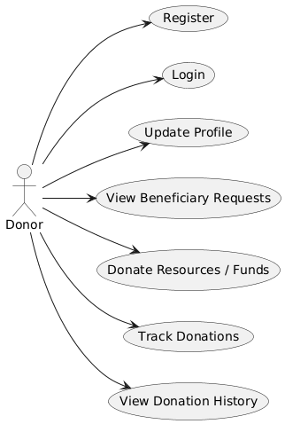

- Beneficiary

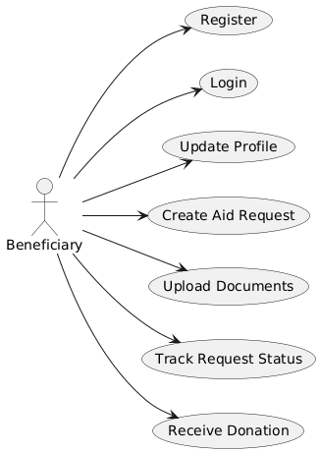

- Administrator

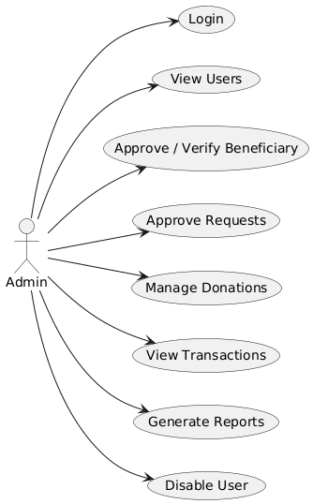

The diagram shows interactions for registration, request creation, donation, and approval.

