System Requirements Statement (SRS) -
LyfInk e-BloodBank Management System

1. Introduction
This document explains the system requirements and scope for developing the e-BloodBank Management System.

The e-BloodBank System is divided into four main parts:
Donor
Hospital
Blood Bank
Admin

This document describes the account and functional requirements for these parts
Separate registration page for every individual entity.
Separate login page for every individual entity (Hospital, Admin, Donor/User, Blood Bank).
Hospitals and Blood Banks can publish blood requests.
Donors can see blood requests and donate blood.
Admin can create accounts for hospitals and blood banks, define categories (blood groups), and view all requests and donors.

2. Functional Requirements
The LyfInk e-BloodBank System has four main modules, divided into several processes as described below.

No. | Module | Req. ID
2.1 | Donor Module
2.1.1 | F1 | Donor Registration Process
2.1.2 | F2 | Donor Login Process
2.1.3 | F3 | View Blood Requests
2.1.4 | F4 | Donate Blood / Pledge Donation
2.1.5 | F5 | View Other Donors
2.1.6 | F6 | Update Donor Profile & Change Password
2.2 | Hospital Module
2.2.1 | F7 | Hospital Login Process
2.2.2 | F8 | Publish Blood Request
2.2.3 | F9 | View Donor List
2.2.4 | F10 | Supply Blood / Record Issue
2.2.5 | F11 | Update Hospital Stock Information
2.3 Blood Bank Module
2.3.1 | F12 | Blood Bank Login Process
2.3.2 | F13 | View Donor List
2.3.3 | F14 | Publish Blood Donation Camp
2.3.4 | F15 | Register / Manage Camp Donations
2.3.5 | F16 | Update Blood Bank Stock Information
2.4 Admin Module
2.4.1 | F17 | Admin Login Process
2.4.2 | F18 | Create Hospital Account
2.4.3 | F19 | Create Blood Bank Account
2.4.4 | F20 | Create / Manage Blood Group Categories
2.4.5 | F21 | View All Requests
2.4.6 | F22 | View Donors & Accounts
2.4.7 | F23 | Enable / Disable Accounts

2.1 Donor Module
- A Donor is a user who donates blood through the system.
- The donor can view active blood requests, donate blood, and also view other donors.

2.1.1 F1 – Donor Registration Process
The system must provide a Donor Registration page.
Inputs required:
- Login Information
- User ID (unique)
- Password
- First Name
- Last Name
- Email Address
- Mobile Number
- Personal & Medical Information
- Date of Birth
- Gender
- Blood Group (selected from predefined categories)
- Permanent Address (State, City, Area)
- Any existing medical conditions (optional)
- Last donation date (optional)

Rules & Constraints:
- All fields marked mandatory must be filled.
- User ID must be unique (case-insensitive check). If already taken, the system rejects registration.
- Password must:
- Be 8–16 characters long
- Contain at least:
- One numeric digit
- One uppercase letter
- One lowercase letter
- One special character (#, $, %, &, etc.)
- Password is masked and stored encrypted.
- Security question and answer are mandatory and used for password recovery.
- After successful registration, donor receives a success acknowledgement.

2.1.2 F2 – Donor Login Process
The system should allow donors to log in from a dedicated login page.
Inputs:
- User ID
- Password
- Validation Steps:
- Check if User ID and Password combination exists and is correct.
- Ensure that the user type for this account is “Donor”.
- Ensure that the account is enabled (not disabled by admin).
- On success:
- Donor is redirected to Donor Dashboard, which contains:
- Logout trigger
- View / Update Profile & Change Password
- View Blood Requests
- Donate Blood / Pledge Donation
- View Other Donors

On failure:
- System shows appropriate error message (invalid credentials, account disabled, etc.).

2.1.3 F3 – View Blood Requests
From the Donor Dashboard, the donor can view all active blood requests.
Details shown per request:
- Request ID
- Requesting Entity (Hospital or Blood Bank)
- Required Blood Group
- Quantity
- Urgency level (Normal / Urgent)
- Location (State, City)
- Requested date & required-by date
- Contact information
- Search / filter options (optional):
- Filter by blood group
- Filter by city/state
- Filter by urgency

2.1.4 F4 – Donate Blood / Pledge Donation
After viewing a request, a donor can mark that they are willing to donate.
Process:
- Donor selects a specific blood request.
- Clicks “Donate / Pledge”.
- System records:
- Donor ID
- Request ID
- Approximate date of donation
- Preferred contact method (phone/email)
- System reduces available request quantity.
- Acknowledgement is sent to donor and requesting entity.
- This process does not perform medical/eligibility check; that happens offline at donation site.

2.1.5 F5 – View Other Donors
The donor can view a directory of other donors (with limited data for privacy).
Display:
- Donor First Name (or masked)
- Blood Group
- City/Area
- Last donation date (optional)
Filters:
- Blood group
- Location
- Contact details may be partially hidden depending on privacy policy (email/phone visible only to hospitals, etc.).
2.1.6 F6 – Update Donor Profile & Change Password
Donor can update:
- First Name, Last Name
- Email address
- Mobile number
- Address
- Last donation date
- Medical information
- Security question & answer
- All updated data is validated similar to registration.
- Donor can also change password.

Inputs:
- current password, new password, confirm new password.
- New password must follow same rules as in registration.
- Current password must match stored password.
- After change, system forces login again with the new password.

2.2 Hospital Module
- A Hospital uses the system to request blood units, view donors, and manage its own blood stock (if maintained).
- Hospitals typically have accounts created and approved by the Admin.

2.2.1 F7 – Hospital Login Process
The system must provide a dedicated Hospital Login page.
Inputs:
- Hospital User ID
- Password

Validation Steps:
- Check if credentials are correct.
- Confirm user type is “Hospital”.
- Check that hospital account is enabled by Admin.

On success:
- redirect to Hospital Dashboard with:
- Publish Blood Request
- View Donors
- Supply Blood / Record Issue
- Update Stock
- Logout

2.2.2 F8 – Publish Blood Request
Hospitals can post blood requirements to the system.
Inputs:
- Required Blood Group(s)
- Quantity (units)
- Urgency (Normal / Urgent / Critical)
- Required-by date
- Purpose (optional; e.g. surgery, emergency)
- Hospital location and contact details (auto-filled from profile where possible)
Business Rules:
- All mandatory fields must be filled.
- Request must have positive quantity.
- By default, new requests are active and visible to donors and blood banks.

2.2.3 F9 – View Donor List
Hospitals can view a list of donors relevant to their needs.
Search/Filter:
- Blood group
- Location (city/state)
- Availability (based on last donation date rule)
Information Displayed:
- Donor name (full or partial)
- Blood group
- City/Stat
- Contact details (email/phone, depending on privacy policy)
- Last donation date
- Hospital can contact donors outside the system.

2.2.4 F10 – Supply Blood / Record Issue
If the hospital also has its own blood storage, it can record issuing of blood to patients.
Inputs:
- Patient ID/Name (optional)
- Blood group
- Units supplied
- Date of issue

Effects:
- Decrease hospital’s stock record for that blood group.
- Generate transaction entry for reporting.

2.2.5 F11 – Update Hospital Stock Information
Hospital can maintain a local stock record (number of units per blood group).
Update operations:
- Increase stock (new units received)
- Decrease stock (units used or expired)
- System must validate that stock cannot become negative.

2.3 Blood Bank Module
A Blood Bank can publish requests, manage blood donation camps, view donors, and maintain stock.

2.3.1 F12 – Blood Bank Login Process
Similar to hospital login but for user type “Blood Bank”.
Inputs:
- User ID
- Password
On success:
- navigate to Blood Bank Dashboard with:
- Publish Blood Request
- View Donor List
- Publish Blood Donation Camp
- Register / Manage Camp Donations
- Update Stock
- Logout

2.3.2 F13 – View Donor List
- Same behavior as F9, but available from Blood Bank Dashboard.

2.3.3 F14 – Publish Blood Donation Camp
Blood bank can announce blood donation camps.
Inputs:
- Camp Name
- Venue
- Date & Time
- Organized by (Blood Bank)
- Contact person and details
- Special instructions (fasting/non-fasting, documents to carry, etc.)
- Once published, the camp becomes visible to donors on their dashboard.

2.3.4 F15 – Register / Manage Camp Donations
During or after a camp, staff can record donors who donated.
Inputs per donor:
- Donor ID or basic info (name, mobile, blood group)
- Date of donation
- Units collected
- Any remarks
- Stock for corresponding blood group is increased.

2.3.5 F16 – Update Blood Bank Stock Information
- Same as hospital’s stock update, but at blood bank level.

2.4 Admin Module
The Admin is responsible for managing all entities and overseeing system data.

2.4.1 F17 – Admin Login Process
Dedicated Admin Login page.
Inputs:
- Admin User ID
- Password
Validation:
- Credentials must match an admin account.
- User type must be “Admin”.
- Account must be enabled.
On success:
- open Admin Dashboard with:
- Create Hospital Account
- Create Blood Bank Account
- Manage Blood Group Categories
- View All Requests
- View Donors & Accounts
- Enable/Disable Accounts
- Logout

.4.2 F18 – Create Hospital Account
Admin can create accounts for hospitals.
Inputs:
- Hospital Name
- User ID
- Password (same rules as before)
- Contact Person Name
- Email
- Phone
- Address (State/City/Area)
- Hospital user type is set to “Hospital”. After creation, login details may be emailed to hospital.

2.4.3 F19 – Create Blood Bank Account
- Same as F19 but user type “Blood Bank”.

2.4.4 F20 – Create / Manage Blood Group Categories
- Admin defines and manages the list of blood groups used across the system.
- Add new blood group (e.g., rare groups)
- Edit label/description
- Enable/disable blood group (cannot be deleted if used in transactions)

2.4.5 F21 – View All Requests
Admin can view every blood request posted by hospitals and blood banks.
Filters:
- Entity type (Hospital / Blood Bank)
- Blood group
- Location
- Status (Active / Fulfilled / Cancelled)

2.4.6 F22 – View Donors & Accounts
Admin can view:
- List of donors
- List of hospitals
- List of blood banks
- With search and filter options (by location, blood group, status etc.).
- Admin can also view detailed info for any account.

2.4.7 F23 – Enable / Disable Accounts
Admin can change status of:
- Donor accounts
- Hospital accounts
- Blood bank accounts
- Disabled accounts cannot log in

2.5 Use Case Diagram
2.5.1. Donor Module
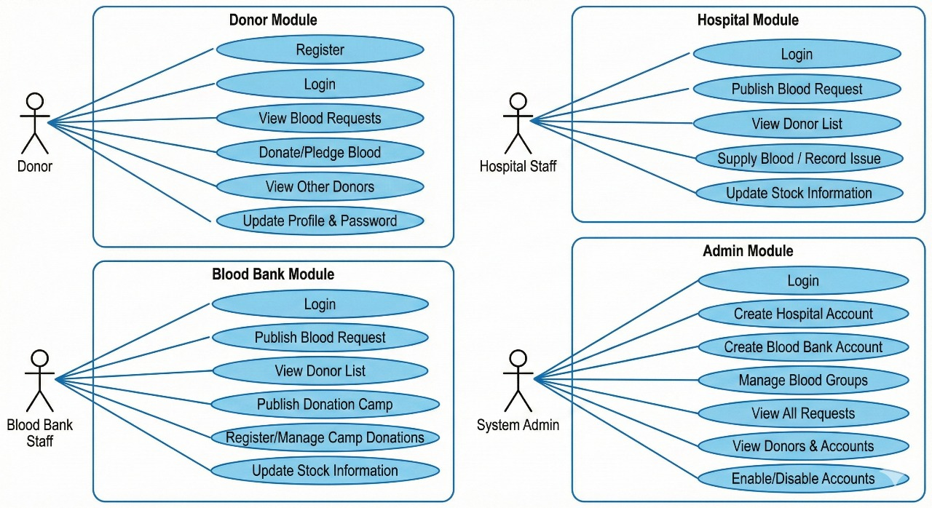
- In donor use case diagram donor is the actor.
- Donor can handle following use cases :
  - Registration
  - Login
  - View blood request
  - Donate blood
  - View other donors
  - Update profile and change password

2.5.2. Hospital Module
- In hospital use case diagram donor is the actor.
- Hospital can handle following use cases :
  - Login process
  - View donor list
  - Publish blood request
  - Supply blood records
  - Update Hospital stock info

2.5.3. Blood Bank Module
- In blood bank use case diagram donor is the actor.
- Blood bank can handle following use cases :
  - Login process
  - Publish blood request
  - Manage camp donation
  - Update blood bank stock info
  - View donor list

2.5.4. Admin Module
- In Admin use case diagram donor is the actor.
- Admin can handle following use cases :
  - Login process
  - Manage hospital
  - Manager blood bank
  - Manage donors
  - View all request

