System Requirements Statement (SRS) – Task-Flow

1. Introduction 3
2. Functional Requirements 4
2.1 manager Module 5
2.2 Employee Module 11
2.3 Admin Module 17
2.4 Team Leader Module 17
2.5 message acknoeledgement Module 21
2.6 Use Case Diagram.............................................................................................................................22

THIS DOCUMENT CONTAINS 23 NUMBERED PAGES

Introduction

Taskflow is a Kanban-based Project Management System designed to help organizations manage projects, tasks, and teams efficiently. The system supports four role-based modules: Admin, Manager, Team Leader, and Employee, where each role has specific responsibilities and access rights.
All users are created by the admin, and there is no public signup feature. Users log in using secure JWT-based authentication and can access only the features allowed for their assigned role and domain. The system uses Kanban boards to track task progress and supports task review, feedback, and communication between team members.
This document presents the Software Requirements Specification (SRS) for the Taskflow system.

2.Functional Requirements

The Task-Flow System has Four modules which are divided processes described as below.

No | BRS requirement ID | Description
2.1 | Manager Module
2.1.1 | M1 | Login Process
2.1.2 | M2 | Update Profile
2.1.3 | M3 | Change Password
2.1.4 | M4 | Create Task
2.1.5 | M5 | Create Team Leader
2.1.6 | M6 | Create Team
2.1.7 | M7 | Assign Task
2.1.8 | M8 | Track Progress
2.1.9 | M9 | Answer Queries
2.2 | Employee Module
2.2.1 | MB2 | Login Process
2.2.2 | MB4 | Change Password
2.2.3 | MB5 | Update Profile
2.2.4 | MB7 | View Assigned Tasks
2.2.5 | MB8 | Update Work / Task Progress
2.2.6 | MB9 | Send Queries
2.3 Admin Module
2.3.1 | A1 | Create profile
2.3.1 | A1 | Login Process
2.3.2 | A2 | Forgot Password
2.3.3 | A3 | Change Password
2.3.4 | A4 | Update Account
2.3.5 | A5 | Create Project
2.3.6 | A6 | Create Roles
2.3.6 | A6 | Create Domain
2.4 Team Leader
2.4.1 | T1 | Login
2.4.2 | T2 | Update Profile
2,4.3 | T3 | Create Subtask
2.4.4 | T4 | Assign Subtask
2.4.5 | T5 | Submit Task
2.4.6 | T6 | Track Employee progress
2.4.7 | T7 | Answer Employee Query
2.4.8 | T8 | Raise Queries
2.5 Message Acknowledgement Module
2.5.1 | A1 | Sends Messages of Acknowledgement

2.1 Manager Module
The Manager is a system user responsible for managing projects assigned by the Admin, creating and assigning tasks, forming teams, tracking progress, and handling queries raised by Employees and Team Leaders.
The Manager can access the system only after successful authentication and can perform operations based on assigned role and domain.

2.1.1 Login Process

• Taskflow System always enforces user authentication before allowing access to Manager functionalities.

• The Manager logs in using User Name and Password provided by the Admin.

- The authentication process verifies the following conditions:
- First, the User Name and Password must exist and be correct.
If the credentials are incorrect, user authentication is not provided.
- Second, the role linked to the User Name must be Manager.
Only users with Manager role are redirected to the Manager Home Page.
- Finally, the Manager account must be active.
If the account is suspended or inactive, access to the system is denied.
• Only when all the above checks are successfully completed, the Manager is allowed to access the system.

• The Manager Home Page provides the following options:

- Logout
- Update Profile
- Change Password
- Create Task
- Create Team
- Assign Task
- Track Progress
- Answer Queries

2.1.2 Update Profile Process
• Taskflow System provides the function which allows the Manager to update profile information after successful authentication.
• The Update Profile function is available only after the Manager logs into the system.
• The information that the Manager can update is described below:
- Personal Information
- Contact Information

• Personal Information
The Personal Information consists of the following items:
- First Name
- Last Name
- All items are compulsory, but updating them is optional.

• Contact Information
The Contact Information consists of the following items:
- Email Address
- Contact Phone Number
- Address
- All items are compulsory, but updating them is optional.
- Email Address must follow valid email format.

• The Manager can modify one or more fields and submit the changes.
• The system validates the updated information before saving it.
• On successful validation, the updated profile information is stored securely in the system database.
• If validation fails, the system does not update the profile and prompts the Manager to correct the entered details.

2.1.3 Change Password Process
• Taskflow System provides the Change Password function for the Manager after successful authentication.
• The Change Password function is available through the Settings option.
• The function demands the following information:
- Current Password
- New Password
- Re-enter New Password

- The current password and new password are masked using dummy characters.
- The new password must satisfy system security constraints:
- Minimum length of 8 characters
- Maximum length of 16 characters
- At least one numeric character
- At least one capital letter
- At least one small letter
- At least one special character
- The new password must be entered twice to avoid typing errors.

• The system verifies whether the current password entered by the Manager is correct.
• Only when the current password is correct, the password is updated successfully.
• After successful password change, the Manager is required to authenticate again using the new password.

2.1.4 Create Task Process
• Taskflow System should provide the function which allows the Manager to create tasks for projects assigned by the Admin.
• The Create Task function is available only after successful Manager authentication.
• When the Manager creates a new task, the function demands the following information described as below.
- Task Information
- Project Information

• Task Information
The Task Information consists of some items described as below.
- Task Name
- Task Description
- Task Status
- Start Date
- End Date
- All items are compulsory demanded.
- Task Name
Task Name should not be empty.
Task Name should be unique within a project.
- Task Description
Task Description provides detailed explanation of the task.
It supports collaboration and clarity for Team Leaders and Employees.
- Task Status
Task Status follows Kanban workflow stages described as below.
- Pending
- In Progress
- Done
- Start Date and End Date
Start Date defines the beginning of the task.
End Date defines the expected completion of the task.
• Project Information
The Project Information consists of the following item.
- Project ID
- Project ID must correspond to a project assigned to the Manager.

• The system validates all entered task information.
• Only when all required information is valid, the task is successfully created.
• After creation, the task details are stored in the task table.
• The created task becomes available for assignment to Team Leaders.

2.1.5 Create Team Leader Process
• Taskflow System should provide the function which allows the Manager to manage Team Leaders for assigned projects.
• Team Leaders are created in the system by the Admin.
• Manager cannot register a new Team Leader account, but can assign and manage Team Leaders for projects.
• When the Manager performs this function, the system demands the following information described as below.

- Team Leader Information
• Team Leader Information
The Team Leader Information consists of the following item.
- Team Leader User ID
- The User ID must correspond to an existing user in the system.
- The role linked to the User ID must be Team Leader.
- The Team Leader must belong to the same domain as the Manager.
• Project Information
The Project Information consists of the following item.
- Project ID
- Project ID must correspond to a project assigned to the Manager.
• The system validates the role and domain of the selected Team Leader.
• Only when validation is successful, the Team Leader is associated with the selected project.
• The assigned Team Leader becomes responsible for task coordination under that project.
• Assignment details are stored in the team table.

2.1.6 Create Team Process
• Taskflow System should provide the function which allows the Manager to create a team for a specific project.
• The Create Team function is available only after successful Manager authentication.
• A team represents a working group under a project, consisting of a Team Leader and Employees.
• When the Manager creates a new team, the function demands the following information described as below.
- Team Information
- Project Information
- Team Leader Information

• Team Information
The Team Information consists of the following item.
- Team ID
- Team ID is automatically generated by the Taskflow System.
- Each Team ID should be unique.

• Project Information
The Project Information consists of the following item.
- Project ID
- Project ID is compulsory demanded.
- Project ID must correspond to a project assigned to the Manager.
- A team cannot be created for a project that does not belong to the Manager.

• Team Leader Information
The Team Leader Information consists of the following item.
- Team Leader User ID
- The User ID must exist in the system database.
- The role linked to the User ID must be Team Leader.
- The Team Leader must belong to the same domain as the project.

• The system validates the Project ID and Team Leader User ID.
• The system ensures that the Team Leader is not already assigned to another team for the same project.
• Only when all validations are successful, the team is created.
• After successful creation, the team is associated with the selected project.
• Team details are stored in the team table of the system database.
• The created team becomes available for task assignment and tracking.

2.1.7 Assign Task Process
• Taskflow System should provide the function which allows the Manager to assign created tasks to Team Leaders.
• The Assign Task function is available only after successful Manager authentication.
• When the Manager assigns a task, the function demands the following information described as below.
- Task Information
- Team Leader Information
- Project Information

• Task Information
The Task Information consists of the following item.
- Task ID
- Task ID is compulsory demanded.
- Task ID must exist in the task table.
- The task must belong to a project assigned to the Manager.
• Team Leader Information
The Team Leader Information consists of the following item.
1.Team Leader User ID
- The User ID must exist in the system database.
- The role linked to the User ID must be Team Leader.
- The Team Leader must belong to the same domain as the project.
- Project Information
  - The Project Information consists of the following item.
- Project ID
- Project ID is compulsory demanded.
- Project ID must correspond to the selected task.

- The system validates the Task ID, Project ID, and Team Leader User ID.
- The system ensures that the task is not already assigned to another Team Leader.
- Only when all validations are successfully completed, the task is assigned.
- After assignment, the task becomes visible in the Team Leader dashboard.
- Task assignment details are updated in the task table.
2.1.8 Track Progress Process
• Taskflow System should provide the function which allows the Manager to track the progress of tasks and projects.
• The Track Progress function is available only after successful Manager authentication.
• The Manager can track progress using a Kanban-based workflow.
• When the Manager tracks progress, the system displays information described as below.
- Task Information
- Project Progress Information

• Task Information
The Task Information consists of the following items.
- Task Name
- Assigned Team Leader
- Task Status
- Task Status follows Kanban stages described as below.
- Pending
- In Progress
- Done
- Task Status is updated automatically based on task updates performed by Team Leaders and Employees.

• Project Progress Information
The Project Progress Information consists of the following items.
- Total number of tasks
- Number of completed tasks
- Number of pending tasks
- Overall project progress percentage

• The system displays task progress in a visual Kanban board format.
• The Manager can view real-time status changes of tasks.
• The Manager cannot directly modify task status during progress tracking.
• Progress data is fetched from the system database and updated continuously.

2.1.9 Answer Queries Process
• Taskflow System should provide the function which allows the Manager to view and respond to queries raised by Employees and Team Leaders.
• The Answer Queries function is available only after successful Manager authentication.
• Queries are raised by Employees or Team Leaders related to tasks or projects.
• When the Manager accesses this function, the system displays the following information described as below.
- Query Information
- Response Information

• Query Information
The Query Information consists of the following items.
- Query ID
- Query Description
- Raised By
- Project ID
- Query Status
- Query Status indicates the current state of the query.
- Query Status can be one of the following:
- Open
- Answered

• Response Information
The Response Information consists of the following item.
- Response Message
- Response Message should clearly address the raised query
• The Manager selects a query from the list of pending queries.
• The Manager enters a response for the selected query.
• The system validates the response input.
• Only when a valid response is provided, the query status is updated to Answered.
• The response is stored in the query table of the system database.
• The response becomes visible to the respective Employee or Team Leader who raised the query.
2.2 Employee Module
• Employee is a system user who performs assigned tasks under a Team Leader within a project.
• Employee can view assigned tasks, update task progress, and raise queries related to tasks.
• Employee can access the system only after successful authentication and can perform operations limited to their assigned role and domain.

2.2.1 Login Process
• Taskflow System always enforces user authentication before allowing access to Employee functionalities.
• The Employee logs in using User Name and Password provided by the Admin.
• The user authentication process checks the following conditions:
- First, the User Name and Password must exist and be correct.
If the entered User Name and Password do not match the registered information, user authentication is not provided.
- Second, the role linked to the User Name must be Employee.
When the role is Employee, the user is redirected to the Employee Home Page.
- Finally, the Employee account must be active.
The Administrator can decide whether the Employee account is active or suspended.
If the Employee account is suspended, authentication is not provided.
• The Employee account remains active for the duration defined by the Administrator.
• Only when all the above checks are successfully completed, the Employee is allowed to access the system.
• After successful authentication, the Employee Home Page provides the following options:
- Logout
- Update Profile
- Change Password
- View Assigned Tasks
- Update Task Progress
- Send Queries
2.2.2 Change Password Process
• Taskflow System should provide the function which allows the Employee to change the account password.
• The Change Password function is available only after successful Employee authentication.
• When the Employee requests to change the password, the function demands the following information described as below.
- Current Password
- New Password
- Re-enter New Password
• Current Password
- Current Password is compulsory demanded.
- The Current Password must match the password stored in the system database
- The Current Password is masked using dummy characters.
• New Password
- New Password is compulsory demanded.
- The New Password must satisfy system security constraints described as below:
- Minimum length of 8 characters
- Maximum length of 16 characters
- At least one numeric character
- At least one capital alphabet (A-Z)
- At least one small alphabet (a-z)
- At least one special character
- The New Password is masked using dummy characters.

• Re-enter New Password
- Re-enter New Password is compulsory demanded.
- The re-entered password must exactly match the New Password.

• The system validates the Current Password and New Password.
• Only when all validations are successfully completed, the password is changed.
• After successful password change, Taskflow System compels the Employee to authenticate again.

2.2.3 Update Profile Process
• Taskflow System should provide the function which allows the Employee to update account-related information.
• The Update Profile Process is available only after successful Employee authentication.
• When the Employee chooses to update the profile, the function demands the information described as below.
- Login Information
- User Information

1. Login Information
• The Login Information consists of the following items described as below.
- User Name
- Email Address
- All items are compulsory demanded.
- User Name
  - User Name should not be empty.
  - User Name must be unique in the system.
  - User Name comparison is not case-sensitive.
  - Updating User Name is optional.

- Email Address
  - Email Address should follow a valid email format.
  - Email Address must not be empty.
  - Updating Email Address is optional.

2.User Information
• The User Information consists of the following items described as below.
- First Name
- Last Name
- Contact Phone Number
- Permanent Address
- All items are compulsory demanded.
• The Employee can update one or more fields during the Update Profile process.
• The system validates all updated information before saving.
• Only when all entered information satisfies validation rules, the profile information is updated.
• Updated profile information is stored securely in the system database.
• If validation fails, the system does not update the profile and prompts the Employee to correct the entered information.

2.2.4 View Assigned Tasks Process
• Taskflow System should provide the function which allows the Employee to view tasks assigned by the Team Leader.
• The View Assigned Tasks function is available only after successful Employee authentication.
• When the Employee accesses this function, the system displays the task information described as below.
- Task Information
- Project Information

1.Task Information
• The Task Information consists of the following items described as below.
- Task Name
- Task Description
- Task Status
- Start Date
- End Date

- Task Name
Task Name should not be empty.
Task Name uniquely identifies the assigned task.
- Task Description
Task Description provides detailed explanation of the assigned work.
Task Description helps the Employee understand task requirements clearly.
- Task Name
Task Status indicates the current progress of the task.
Task Status follows Kanban workflow stages described as below.
- Pending
- In Progress
- Done

- Start Date and End Date
2.Project Information
• The Project Information consists of the following item.
- Project ID
- Project ID identifies the project to which the task belongs.

• The system ensures that the Employee can view only those tasks which are assigned to them.
• Tasks are displayed in Kanban format for easy tracking.
• The Employee is not allowed to modify task details while viewing assigned tasks.

2.2.5 Update Task Progress Process
• Taskflow System should provide the function which allows the Employee to update the progress of assigned tasks.
• The Update Task Progress function is available only after successful Employee authentication.
• Only tasks assigned to the Employee can be updated.
• When the Employee updates task progress, the function demands the information described as below.
- Task Identification
- Task Status Information

1.Task Identification
• The Task Identification consists of the following item.
- Task ID
- Task ID must exist in the system database.
- Task ID must be assigned to the logged-in Employee.
- The Employee cannot update tasks assigned to other users.

- Task Status Information
• The Task Status Information consists of the following item.
- Task Status
- Task Status represents the current stage of task completion.
- Task Status follows Kanban workflow stages described as below.
- Pending
- In Progress
- Done
• When the Employee updates the task status to In Progress, the system records the progress.
• When the Employee updates the task status to Done, the task is marked as completed by the Employee.
• The system validates the task status update.
• Only when validation is successful, the updated task status is stored in the task table.
• After a task is marked as Done, a notification is generated for the respective Team Leader for task review.

2.2.6 Send Queries Process
• Taskflow System should provide the function which allows the Employee to raise queries related to assigned tasks or projects.
• The Send Queries function is available only after successful Employee authentication.
• Queries are raised when the Employee requires clarification, support, or reports an issue related to a task.
• When the Employee raises a query, the function demands the information described as below.
- Query Information
- Task and Project Information

1.Query Information
• The Query Information consists of the following items described as below.
- Query Description
- Query Description should clearly describe the issue or concern raised by the Employee.
- Query Description should not be empty.
- The description helps the Team Leader or Manager understand the problem accurately.
- Task and Project Information
• The Task and Project Information consist of the following items.
- Task ID
- Project ID
1.Task ID
  - Task ID must exist in the system database.
  - Task ID must be assigned to the logged-in Employee.
2. Project ID
  - Project ID must correspond to the selected task.
  - Project ID identifies the project related to the query.
• The system validates the entered query information before submission.
• Only when all required information is valid, the query is successfully submitted.
• The submitted query is stored in the query table of the system database.
• The query is forwarded to the respective Team Leader or Manager.
• The initial status of the query is set to Open.
• The Employee can view responses and status updates for raised queries.

2.3 Admin Module
• Admin is the super user of the Taskflow system who is responsible for overall system administration.
• Admin manages users, roles, domains, and projects and controls access to the system.
• Admin is created in the system in advance and cannot be registered through any public signup process.
• Admin can access the system only after successful authentication.

2.3.1 Create Profile Process
• Taskflow System provides the function which allows the admin profile to be created in advance.
• Admin profile creation is performed only once during system setup.
• The admin profile contains the following information:
- User Name
- Password
- First Name
- Last Name
- Email Address
- Contact Phone Number
- Address
All items are compulsory demanded.
• Admin credentials are stored securely in encrypted form.

2.3.2 Forgot Password Process
• Taskflow System provides a password recovery mechanism for the Admin.
• When the Admin forgets the password, the recovery process is initiated.
• The process demands the following information:
- User Name
- Registered Email Address
• Only when the entered information is correct, a new password is generated by the system.
• The new password is sent to the registered email address.
• Admin is required to change the password after logging in with the new password.

2.3.3 Change Password Process
• Taskflow System provides the Change Password function for the admin after successful authentication.
• The function demands the following information:
- Current Password
- New Password
- Re-enter New Password
¬ Password fields are masked using dummy characters.
¬ The new password must satisfy system security constraints.
• Only when the current password is correct, the password is updated.
• After successful password change, the Admin is required to authenticate again.

2.3.4 Update Account Process
• Taskflow System provides the function which allows the Admin to update account information.
• The Update Account function is available only after successful authentication.
• The admin can update the following information:
- First Name
- Last Name
- Email Address
- Contact Phone Number
- Address
- All fields are compulsory, but updating is optional.
• Updated information is validated and stored securely in the system database

2.3.5 Create Project Process
• Taskflow System provides the function which allows the Admin to create projects.
• When creating a project, the Admin provides the following information:
- Project Name
- Project Description
- Domain
- Client Name
- Assign Date
- Deadline
- All items are compulsory demanded.
• Each project is associated with a specific domain.
• Created project details are stored in the project table.
2.3.6 Create Roles Process
• Taskflow System allows the Admin to manage system roles.
• The roles available in the system are:
- Admin
- Manager
- Team Leader
- Employee
• Roles define access permissions and system functionalities.
• Role details are stored in the role table.

2.3.7 Create Domain Process
• Taskflow System provides the function which allows the Admin to create and manage domains.
• Domain creation requires the following information:
- Domain Name
• Domain defines the functional area of projects and users.
• Created domain details are stored in the domain table.

2.4 Team Leader Module
• Team Leader is a system user responsible for coordinating tasks within a team and acting as an intermediate role between Manager and Employee.
• Team Leader assigns subtasks to Employees, monitors task progress, reviews completed work, and handles employee queries.
• Team Leader can access the system only after successful authentication and within the assigned role and domain.

2.4.1 Login Process
• Taskflow System always enforces authentication before allowing access to Team Leader functionalities.
• The Team Leader logs in using User Name and Password provided by the Admin.
• The authentication process checks the following conditions:
- First, the User Name and Password must exist and be correct.
- If credentials are incorrect, authentication is not provided.
- Second, the role linked to the User Name must be Team Leader.
- When the role is Team Leader, the user is redirected to the Team Leader Home Page.
- Finally, the Team Leader account must be active.
- If the account is suspended, access to the system is denied.
• Only when all checks are successfully completed, the Team Leader is allowed to access the system.

2.4.2 Update Profile Process
• Taskflow System should provide the function which allows the Team Leader to update profile information.
• The Update Profile function is available only after successful authentication.
• When updating profile, the function demands the following information:
- Personal Information
- Contact Information
• Personal Information
- First Name
- Last Name
- All items are compulsory demanded, but updating is optional.
• Contact Information
- Email Address
- Contact Phone Number
- Permanent Address
- All items are compulsory demanded, but updating is optional.
• The system validates updated information before saving.
• Updated profile details are stored securely in the system database.

2.4.3 Create Subtask Process
• Taskflow System provides the function which allows the Team Leader to create subtasks for tasks assigned by the Manager.
• The Create Subtask function is available only after successful authentication.
• When creating a subtask, the function demands the following information:
- Subtask Name
- Subtask Description
- Parent Task ID
- Start Date
- End Date
- Subtask must belong to a task assigned to the Team Leader.
- Subtask Description explains the work to be performed by the Employee.
• The system validates all entered subtask information.
• On successful validation, the subtask is created and stored in the task table.

2.4.4 Assign Subtask Process
• Taskflow System provides the function which allows the Team Leader to assign subtasks to Employees.
• The Assign Subtask function demands the following information:
- Subtask ID
- Employee User ID
- Project ID
- Employee must belong to the same team and domain.
- Subtask must be created by the Team Leader.
• The system validates subtask and employee details.
• Only when validation is successful, the subtask is assigned.
• Assigned subtask becomes visible in the Employee dashboard.

2.4.5 Submit Task Process
• Taskflow System allows the Team Leader to submit reviewed tasks to the Manager.
• Submission is possible only when all subtasks are completed.
• When submitting a task, the Team Leader can:
- Submit Task for Approval
- Add Comments
• Submitted tasks are forwarded to the Manager.
• Task status is updated accordingly in the system database.

2.4.6 Track Employee Progress Process
• Team Leader can track Employee progress using a Kanban-based workflow.
• The system displays:
- Employee Name
- Assigned Subtasks
- Task Status
• Task status includes:
- Pending
- In Progress
- Done
• Progress information is updated in real time.

2.4.7 Answer Employee Query Process
• Taskflow System provides the function which allows the Team Leader to respond to queries raised by Employees.
• The Team Leader can:
- View Query Details
- Provide Response
- Update Query Status
• Responses are stored in the query table.
• The response is visible to the respective Employee.

2.4.8 Raise Queries Process
• Taskflow System allows the Team Leader to raise queries related to tasks or projects.
• When raising a query, the Team Leader provides:
- Query Description
- Task ID
- Project ID
• The system validates the query details.
• On successful validation, the query is stored and forwarded to the Manager.
• Query status is initially set to Open.

2.5 Message Acknowledgement Module
• The Message Acknowledgement Module is responsible for notifying users about important system events and actions.
• This module ensures proper communication and confirmation between Admin, Manager, Team Leader, and Employee.
• Message acknowledgements help users stay informed about task status updates, approvals, rejections, and responses.

2.5.1 Sends Messages of Acknowledgement
• Taskflow System should provide the function which sends acknowledgement messages to users when specific actions are performed.
• Acknowledgement messages are generated automatically by the system.
• The acknowledgement message is sent when any of the following events occur:
- Task is assigned to a user
- Task status is updated
- Task is marked as completed
- Task is approved by Team Leader
- Task is rejected with comments
- Query is answered
- Project is assigned or updated
• Acknowledgement Message Information
The Acknowledgement Message consists of the following items:
- Message Content
- Sender Role
- Receiver Role
- Date and Time

- Message Content
  - Message Content describes the action performed in the system.
  - Message Content should be clear and understandable.
- Sender Role
  - Sender Role identifies the user who triggered the action.
  - Sender Role can be Admin, Manager, or Team Leader.
- Receiver Role
  - Receiver Role identifies the user who receives the acknowledgement message.
  - Receiver Role can be Manager, Team Leader, or Employee.
• The system validates the sender and receiver roles before sending the acknowledgement.
• After validation, the acknowledgement message is delivered to the respective user.
• Acknowledgement messages are visible in the user dashboard or notification section.
• All acknowledgement details are recorded for system reference.

2.5 Use Case Diagram

Admin:

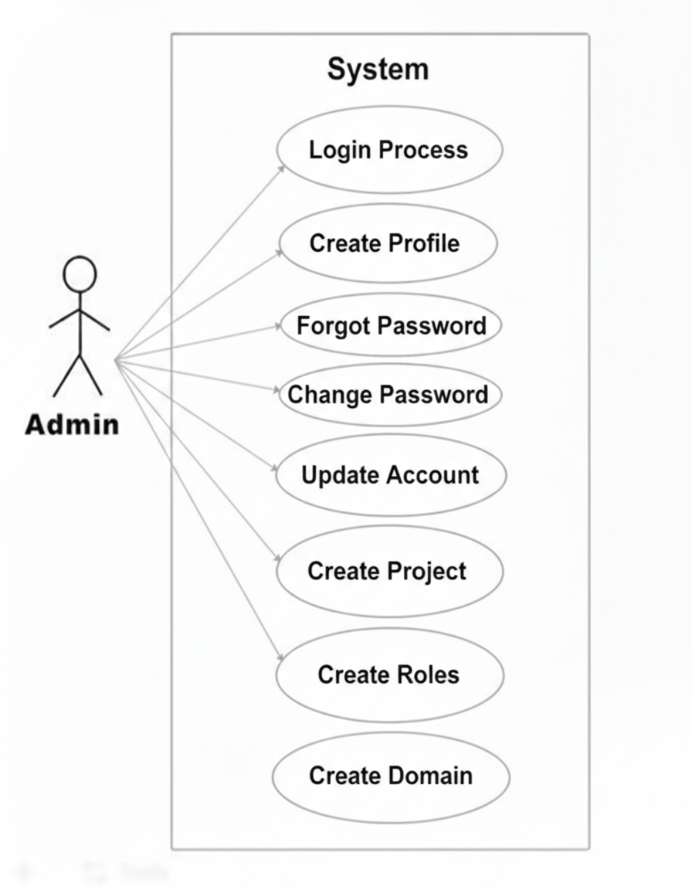
Fig. Use case diagram for admin

- Admin can handle following use cases:
- Create profile
- Login Process
- Forgot Password
- Change Password
- Update Account
- Create Project
- Create Roles
- Create Domain

MANAGER:

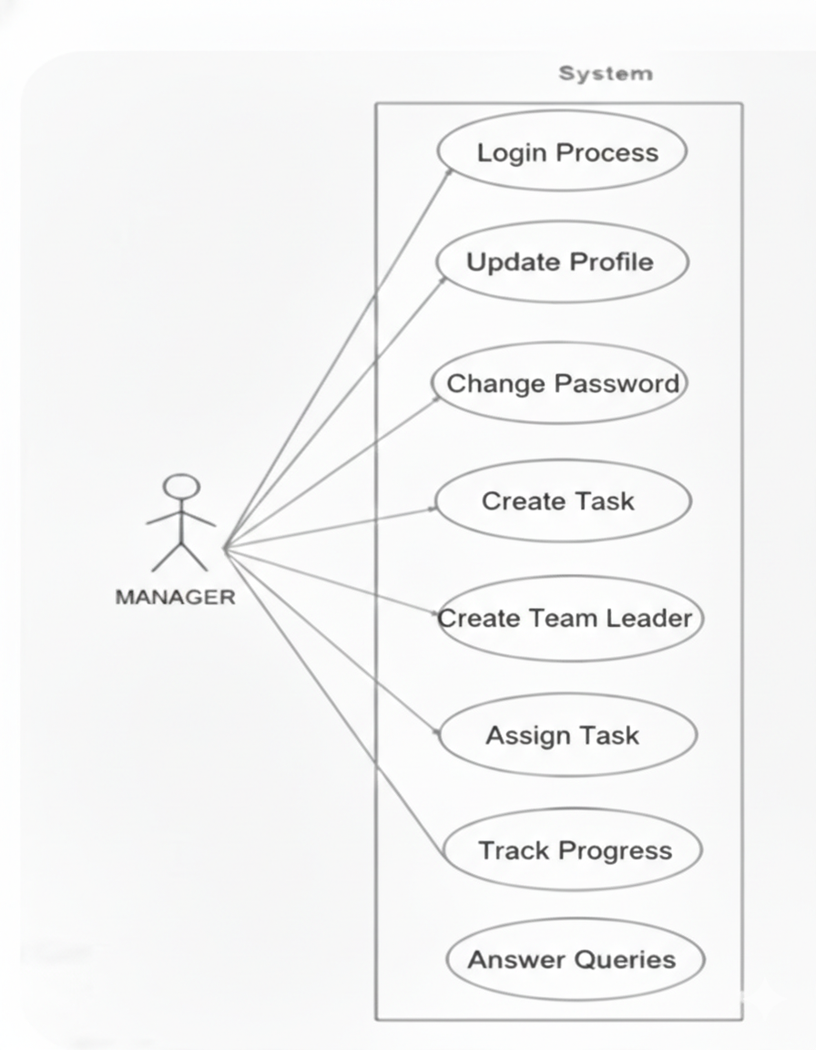
Fig. Use case diagram for Manager

- Manager can handle following use cases:
- Manager Module
- Login Process
- Update Profile
- Change Password
- Create Task
- Create Team Leader
- Create Team
- Assign Task
- Track Progress

TEAM LEADER:

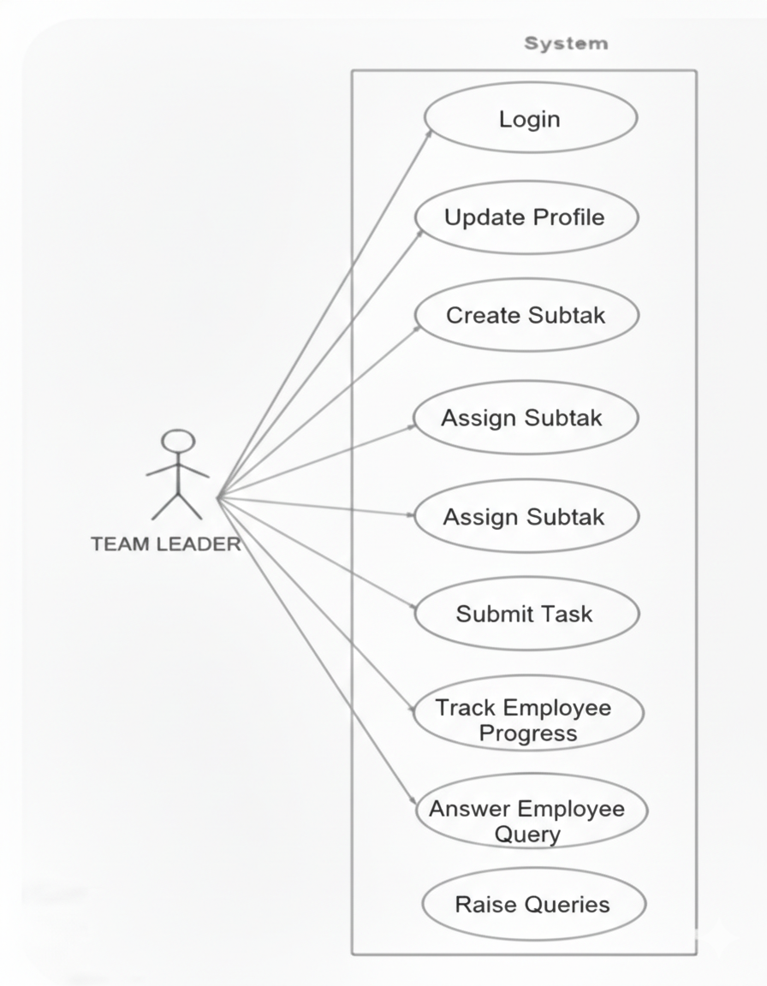
Fig. Use case diagram for Team Leader

- Team Leader can handle following use cases:
- Login
- Update Profile
- Create Subtask
- Assign Subtask
- Submit Task
- Track Employee progress
- Answer Employee Query
- Raise Queries

EMPLOYEE:

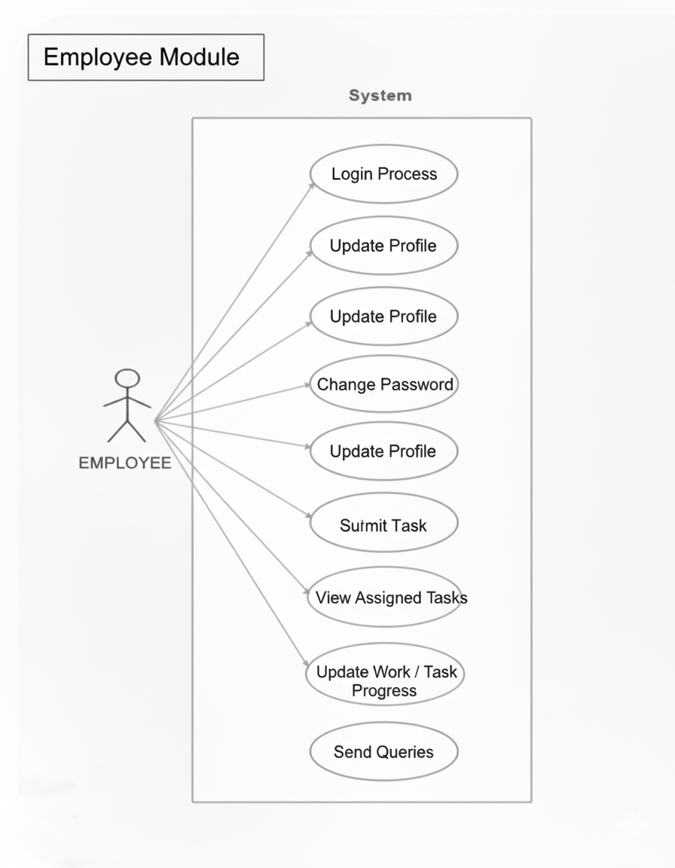
Fig. Use case diagram for Team Leader

- Employee can handle following use cases:
- Login Process
- Change Password
- Update Profile
- View Assigned Tasks
- Update Work / Task Progress
- Send Queries

