JDBC

(Java Database Connectivity)

JDBC is a Java API that is used to connect and execute query to the database. JDBC API uses jdbc drivers to connect to the database.

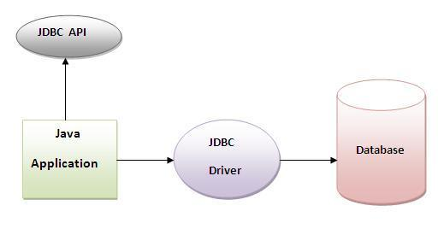

### Why use JDBC?

Before JDBC, ODBC API was used to connect and execute query to the database. But ODBC API uses ODBC driver that is written in C language which is platform dependent and unsecured. That is why Sun Microsystems has defined its own API (JDBC API) that uses JDBC driver written in Java language.

### JDBC Driver

JDBC Driver is a software component that enables java application to interact with the database. There are 4 types of JDBC drivers:

* JDBC-ODBC bridge driver
* Native-API driver (partially java driver)
* Network Protocol driver (fully java driver)
* **Thin driver (pure java driver)**

### 1) JDBC-ODBC bridge driver

The JDBC-ODBC bridge driver uses ODBC driver to connect to the database. The JDBC-ODBC bridge driver converts JDBC method calls into the ODBC function calls. This is now discouraged because of thin driver.

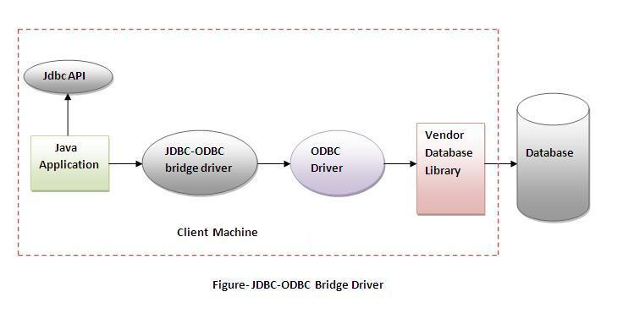**Advantages:**

* can be easily connected to any database.

### Disadvantages:

* Performance degraded because JDBC method call is converted into the ODBC function calls.
* The ODBC driver needs to be installed on the client machine.

### 2) Native-API driver

The Native API driver uses the client-side libraries of the database. The driver converts JDBC method calls into native calls of the database API. It is not written entirely in java.

### Advantage:

* Performance upgraded than JDBC-ODBC bridge driver.

### Disadvantage:

* The Native driver needs to be installed on the each client machine.
* The Vendor client library needs to be installed on client machine.

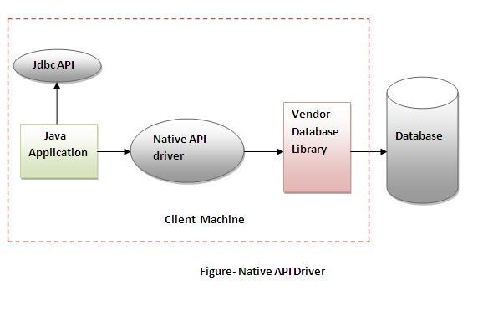

### 3) Network Protocol driver

The Network Protocol driver uses middleware (application server) that converts JDBC calls directly or indirectly into the vendor-specific database protocol. It is fully written in java.

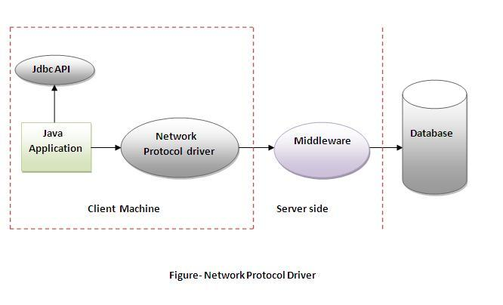

### Advantage:

* No client side library is required because of application server that can perform many tasks like auditing, load balancing, logging etc.

### Disadvantages:

* Network support is required on client machine.
* Requires database-specific coding to be done in the middle tier.
* Maintenance of Network Protocol driver becomes costly because it requires database-specific coding to be done in the middle tier.

### 4) Thin driver

| The thin driver converts JDBC calls directly into the vendor-specific database protocol. That is why it is known as thin driver. It is fully written in Java language. |
| --- |

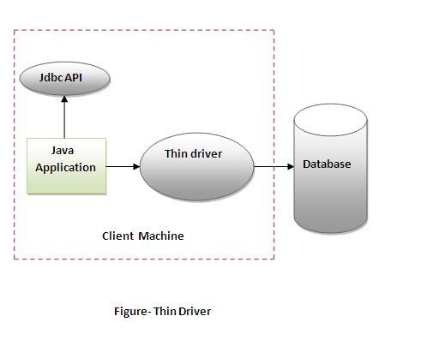

### Advantage:

* Better performance than all other drivers.
* No client side software is required or server side.
* Platform independent since it was written in Java language.

# Steps to connect to the database in java

There are 5 steps to connect any java application with the database in java using JDBC. They are as follows:

* **Register the driver class**
* **Creating connection**
* **Creating statement**
* **Executing queries**
* **Closing connection**

### 1) Register the driver class

The forName() method of **Class** **class** is used to register the driver class. This method is used to dynamically load the driver class.

**public** **static** **void** forName(String className) **throws** **ClassNotFoundException**

### 2) Create the connection object

The getConnection() method of **DriverManager** **class** is used to establish connection with the database.

1) **public** **static** Connection getConnection(String url)**throws** **SQLException**

2) **public** **static** Connection getConnection(String url,String username,String password)

**throws** **SQLException**

### 3) Create the Statement object

The createStatement() method of **Connection** **interface** is used to create statement. The statement object is responsible to execute queries with the database.

**public** Statement createStatement()**throws** **SQLException**

### 4) Execute the query

The executeQuery() method of **Statement interface** is used to execute queries to the database. This method returns the object of ResultSet that can be used to get all the records of a table.

**public** ResultSet executeQuery(String sql)**throws** **SQLException**

### 5) Close the connection object

By closing connection object, statement and ResultSet will be closed automatically. The close() method of Connection interface is used to close the connection.

**public** **void** close()**throws** **SQLException**

# JDBC API

# DriverManager class:

The DriverManager class acts as an interface between user and drivers. It keeps track of the drivers that are available and handles establishing a connection between a database and the appropriate driver. The DriverManager class maintains a list of Driver classes that have registered themselves by calling the method DriverManager.registerDriver().

### Commonly used methods of DriverManager class:

| 1) public static void registerDriver(Driver driver): | is used to register the given driver with DriverManager. |
| --- | --- |
| 2) public static void deregisterDriver(Driver driver): | is used to deregister the given driver (drop the driver from the list) with DriverManager. |
| 3) public static Connection getConnection(String url): | is used to establish the connection with the specified url. |
| 4) public static Connection getConnection(String url,String userName,String password): | is used to establish the connection with the specified url, username and password. |

# Connection interface:

A Connection is the session between java application and database. The Connection interface is a factory of Statement, PreparedStatement, and DatabaseMetaData i.e. object of Connection can be used to get the object of Statement and DatabaseMetaData. The Connection interface provide many methods for transaction management like commit(),rollback() etc.

#### By default, connection commits the changes after executing queries. (AutoCommit feature)

### Commonly used methods of Connection interface:

| 1) public Statement createStatement(): creates a statement object that can be used to execute SQL queries. |
| --- |
| 2) public Statement createStatement(int resultSetType,int resultSetConcurrency):Creates a Statement object that will generate ResultSet objects with the given type and concurrency. |
| 3) public void setAutoCommit(boolean status): is used to set the commit status.By default it is true. |
| 4) public void commit(): saves the changes made since the previous commit/rollback permanent. |
| 5) public void rollback(): Drops all changes made since the previous commit/rollback. |
| 6) public void close(): closes the connection and Releases JDBC resources immediately. |

# Statement interface

The **Statement interface** provides methods to execute queries with the database. The statement interface is a factory of ResultSet i.e. it provides factory method to get the object of ResultSet.

### Commonly used methods of Statement interface:

The important methods of Statement interface are as follows:

| 1) public ResultSet executeQuery(String sql): is used to execute SELECT query. It returns the object of ResultSet. |
| --- |
| 2) public int executeUpdate(String sql): is used to execute specified query, it may be create, drop, insert, update, delete etc. |
| 3) public boolean execute(String sql): is used to execute queries that may return multiple results. |
| 4) public int[] executeBatch(): is used to execute batch of commands. |

# ResultSet interface

The object of ResultSet maintains a cursor pointing to a particular row of data. Initially, cursor points to before the first row.

#### By default, ResultSet object can be moved forward only and it is not updatable.

But we can make this object to move forward and backward direction by passing either **TYPE_SCROLL_INSENSITIVE** or **TYPE_SCROLL_SENSITIVE** in createStatement(int,int) method as well as we can make this object as updatable.

### Commonly used methods of ResultSet interface

| 1) public boolean next(): | is used to move the cursor to the one row next from the current position. |
| --- | --- |
| 2) public boolean previous(): | is used to move the cursor to the one row previous from the current position. |
| 3) public boolean first(): | is used to move the cursor to the first row in result set object. |
| 4) public boolean last(): | is used to move the cursor to the last row in result set object. |
| 5) public boolean absolute(int row): | is used to move the cursor to the specified row number in the ResultSet object. |
| 6) public boolean relative(int row): | is used to move the cursor to the relative row number in the ResultSet object, it may be positive or negative. |
| 7) public int getInt(int columnIndex): | is used to return the data of specified column index of the current row as int. |
| 8) public int getInt(String columnName): | is used to return the data of specified column name of the current row as int. |
| 9) public String getString(int columnIndex): | is used to return the data of specified column index of the current row as String. |
| 10) public String getString(String columnName): | is used to return the data of specified column name of the current row as String. |

# PreparedStatement interface

The PreparedStatement interface is a sub interface of Statement. It is used to execute parameter query.

### Why use PreparedStatement?

**Improves performance**: The performance of the application will be faster if you use PreparedStatement interface because query is compiled only once.

### Methods of PreparedStatement interface

The important methods of PreparedStatement interface are given below:

| Method | Description |
| --- | --- |
| public void setInt(int paramIndex, int value) | sets the integer value to the given parameter index. |
| public void setString(int paramIndex, String value) | sets the String value to the given parameter index. |
| public void setFloat(int paramIndex, float value) | sets the float value to the given parameter index. |
| public void setDouble(int paramIndex, double value) | sets the double value to the given parameter index. |
| public int executeUpdate() | executes the query. It is used for create, drop, insert, update, delete etc. |
| public ResultSet executeQuery() | executes the select query. It returns an instance of ResultSet. |

# ResultSetMetaData Interface

The metadata means data about data i.e. we can get further information from the data.

If you have to get metadata of a table like number of columns, column name, column type, table name etc. , ResultSetMetaData interface is useful because it provides methods to get metadata from the ResultSet object.

## Commonly used methods of ResultSetMetaData interface

| Method | Description |
| --- | --- |
| public int getColumnCount()throws SQLException | it returns the total number of columns in the ResultSet object. |
| public String getColumnName(int index)throws SQLException | it returns the column name of the specified column index. |
| public String getColumnTypeName(int index)throws SQLException | it returns the column type name for the specified index. |
| public String getTableName(int index)throws SQLException | it returns the table name for the specified column index. |

DatabaseMetaData interface:

DatabaseMetaData interface provides methods to get meta data of a database such as database product name, database product version, driver name, name of total number of tables, name of total number of views etc.

DatabaseMetaData interface provides methods to get meta data of a database such as database product name, database product version, driver name, name of total number of tables, name of total number of views etc.

## Commonly used methods of DatabaseMetaData interface

| **public String getDriverName()throws SQLException:** it returns the name of the JDBC driver. |
| --- |
| **public String getDriverVersion()throws SQLException:** it returns the version number of the JDBC driver. |
| **public String getUserName()throws SQLException:** it returns the username of the database. |
| **public String getDatabaseProductName()throws SQLException:** it returns the product name of the database. |
| **public String getDatabaseProductVersion()throws SQLException:** it returns the product version of the database. |
| **public ResultSet getTables(String catalog, String schemaPattern, String tableNamePattern, String[] types)throws SQLException:** it returns the description of the tables of the specified catalog. The table type can be TABLE, VIEW, ALIAS, SYSTEM TABLE, SYNONYM etc. |

### Example of DatabaseMetaData interface that prints total number of tables :

import java.sql.*;

class Dbmd2{

public static void main(String args[]){

try{

Class.forName("oracle.jdbc.driver.OracleDriver");

Connection con=DriverManager.getConnection("jdbc:oracle:thin:@localhost:1521:xe","system","oracle");

DatabaseMetaData dbmd=con.getMetaData();

String table[]={"TABLE"};

ResultSet rs=dbmd.getTables(null,null,null,table);

while(rs.next()){

System.out.println(rs.getString(3));

}

con.close();

}catch(Exception e){

System.out.println(e);

}

}

}

### Example of DatabaseMetaData interface that prints total number of views :

import java.sql.*;

class Dbmd3{

public static void main(String args[]){

try{

Class.forName("oracle.jdbc.driver.OracleDriver");

Connection con=DriverManager.getConnection("jdbc:oracle:thin:@localhost:1521:xe","system","oracle");

DatabaseMetaData dbmd=con.getMetaData();

String table[]={"VIEW"};

ResultSet rs=dbmd.getTables(null,null,null,table);

while(rs.next()){

System.out.println(rs.getString(3));

}

con.close();

}catch(Exception e){

System.out.println(e);

}

}

}

Example to store image in Oracle database

You can store images in the database in java by the help of **PreparedStatement** interface.

The **setBinaryStream()** method of PreparedStatement is used to set Binary information into the parameterIndex.

### Signature of setBinaryStream method

The syntax of setBinaryStream() method is given below:

1) **public** **void** setBinaryStream(**int** paramIndex,InputStream stream)

**throws** SQLException

2) **public** **void** setBinaryStream(**int** paramIndex,InputStream stream,**long** length)

**throws** SQLException

For storing image into the database, BLOB (Binary Large Object) datatype is used in the table. For example:

CREATE TABLE  "IMGTABLE"

   (    "NAME" VARCHAR2(4000),

    "PHOTO" BLOB

   )

/

Let's write the jdbc code to store the image in the database. Here we are using d:\\d.jpg for the location of image. You can change it according to the image location.

**import** java.sql.*;

**import** java.io.*;

**public** **class** InsertImage {

**public** **static** **void** main(String[] args) {

**try**{

Class.forName("oracle.jdbc.driver.OracleDriver");

Connection con=DriverManager.getConnection(

"jdbc:oracle:thin:@localhost:1521:xe","system","oracle");

PreparedStatement ps=con.prepareStatement("insert into imgtable values(?,?)");

ps.setString(1,"sonoo");

FileInputStream fin=**new** FileInputStream("d:\\g.jpg");

ps.setBinaryStream(2,fin,fin.available());

**int** i=ps.executeUpdate();

System.out.println(i+" records affected");

con.close();

}**catch** (Exception e) {e.printStackTrace();}

}

}

If you see the table, record is stored in the database but image will not be shown. To do so, you need to retrieve the image from the database.

# Example to retrieve image from Oracle database

By the help of **PreparedStatement** we can retrieve and store the image in the database.

The **getBlob()** method of PreparedStatement is used to get Binary information, it returns the instance of Blob. After calling the **getBytes()** method on the blob object, we can get the array of binary information that can be written into the image file.

### Signature of getBlob() method of PreparedStatement

**public** Blob getBlob()**throws** SQLException

### Signature of getBytes() method of Blob interface

**public**  **byte**[] getBytes(**long** pos, **int** length)**throws** SQLException

Now let's write the code to retrieve the image from the database and write it into the directory so that it can be displayed.

In AWT, it can be displayed by the Toolkit class. In servlet, jsp, or html it can be displayed by the img tag.

**import** java.sql.*;

**import** java.io.*;

**public** **class** RetrieveImage {

**public** **static** **void** main(String[] args) {

**try**{

Class.forName("oracle.jdbc.driver.OracleDriver");

Connection con=DriverManager.getConnection(

"jdbc:oracle:thin:@localhost:1521:xe","system","oracle");

PreparedStatement ps=con.prepareStatement("select * from imgtable");

ResultSet rs=ps.executeQuery();

**if**(rs.next()){//now on 1st row

Blob b=rs.getBlob(2);//2 means 2nd column data

**byte** barr[]=b.getBytes(1,(**int**)b.length());//1 means first image

FileOutputStream fout=**new** FileOutputStream("d:\\srinivas.jpg");

fout.write(barr);

fout.close();

}//end of if

System.out.println("ok");

con.close();

}**catch** (Exception e) {e.printStackTrace();  }

}

}

Now if you see the d drive, srinivas.jpg image is created.

# Example to store file in Oracle database:

The setCharacterStream() method of PreparedStatement is used to set character information into the parameterIndex.

### Syntax:

| 1) public void setBinaryStream(int paramIndex,InputStream stream)throws SQLException |
| --- |
| 2) public void setBinaryStream(int paramIndex,InputStream stream,long length)throws SQLException |

For storing file into the database, CLOB (Character Large Object) datatype is used in the table. For example:

CREATE TABLE  "FILETABLE"

   (    "ID" NUMBER,

    "NAME" CLOB

   )

/

**import** java.io.*;

**import** java.sql.*;

**public** **class** StoreFile {

**public** **static** **void** main(String[] args) {

**try**{

Class.forName("oracle.jdbc.driver.OracleDriver");

Connection con=DriverManager.getConnection(

"jdbc:oracle:thin:@localhost:1521:xe","system","oracle");

PreparedStatement ps=con.prepareStatement(

"insert into filetable values(?,?)");

File f=**new** File("d:\\myfile.txt");

FileReader fr=**new** FileReader(f);

ps.setInt(1,101);

ps.setCharacterStream(2,fr,(**int**)f.length());

**int** i=ps.executeUpdate();

System.out.println(i+" records affected");

con.close();

}**catch** (Exception e) {e.printStackTrace();}

}

}

# Example to retrieve file from Oracle database:

The getClob() method of PreparedStatement is used to get file information from the database.

### Syntax of getClob method

**public** Clob getClob(**int** columnIndex){}

Let's see the table structure of this example to retrieve the file.

CREATE TABLE  "FILETABLE"

   (    "ID" NUMBER,

    "NAME" CLOB

   )

/

The example to retrieve the file from the Oracle database is given below.

**import** java.io.*;

**import** java.sql.*;

**public** **class** RetrieveFile {

**public** **static** **void** main(String[] args) {

**try**{

Class.forName("oracle.jdbc.driver.OracleDriver");

Connection con=DriverManager.getConnection(

"jdbc:oracle:thin:@localhost:1521:xe","system","oracle");

PreparedStatement ps=con.prepareStatement("select * from filetable");

ResultSet rs=ps.executeQuery();

rs.next();//now on 1st row

Clob c=rs.getClob(2);

Reader r=c.getCharacterStream();

FileWriter fw=**new** FileWriter("d:\\retrivefile.txt");

**int** i;

**while**((i=r.read())!=-1)

fw.write((**char**)i);

fw.close();

con.close();

System.out.println("success");

}**catch** (Exception e) {e.printStackTrace();  }

}

}

# CallableStatement Interface

To call the **stored procedures and functions**, CallableStatement interface is used.

We can have business logic on the database by the use of stored procedures and functions that will make the performance better because these are precompiled.

### What is the difference between stored procedures and functions.

The differences between stored procedures and functions are given below:

| Stored Procedure | Function |
| --- | --- |
| is used to perform business logic. | is used to perform calculation. |
| must not have the return type. | must have the return type. |
| may return 0 or more values. | may return only one value. |
| Procedure supports input and output parameters. | Function supports only input parameter. |

### How to get the instance of CallableStatement?

The **prepareCall()** method of Connection interface returns the instance of CallableStatement. Syntax is given below:

1. **public** CallableStatement prepareCall("{ call procedurename(?,?...?)}");

The example to get the instance of CallableStatement is given below:

### Example to call the stored procedure using JDBC

To call the stored procedure, you need to create it in the database. Here, we are assuming that stored procedure looks like this.

create or replace procedure "INSERTR"

(id IN NUMBER,

name IN VARCHAR2)

is

begin

insert into user420 values(id,name);

end;

/

The table structure is given below:

create table user420(id number(10), name varchar2(200));

In this example, we are going to call the stored procedure INSERTR that receives id and name as the parameter and inserts it into the table user420. Note that you need to create the user420 table as well to run this application.

**import** java.sql.*;

**public** **class** Proc {

**public** **static** **void** main(String[] args) **throws** Exception{

Class.forName("oracle.jdbc.driver.OracleDriver");

Connection con=DriverManager.getConnection(

"jdbc:oracle:thin:@localhost:1521:xe","system","oracle");

CallableStatement stmt=con.prepareCall("{call insertR(?,?)}");

stmt.setInt(1,1011);

stmt.setString(2,"Amit");

stmt.execute();

System.out.println("success");

}

}

Now check the table in the database, value is inserted in the user420 table.

### Example to call the function using JDBC

In this example, we are calling the sum4 function that receives two input and returns the sum of the given number. Here, we have used the **registerOutParameter** method of CallableStatement interface, that registers the output parameter with its corresponding type. It provides information to the CallableStatement about the type of result being displayed.

The **Types** class defines many constants such as INTEGER, VARCHAR, FLOAT, DOUBLE, BLOB, CLOB etc.

Let's create the simple function in the database first.

create or replace function sum4

(n1 in number,n2 in number)

**return** number

is

temp number(8);

begin

temp :=n1+n2;

**return** temp;

end;

/

Now, let's write the simple program to call the function.

**import** java.sql.*;

**public** **class** FuncSum {

**public** **static** **void** main(String[] args) **throws** Exception{

Class.forName("oracle.jdbc.driver.OracleDriver");

Connection con=DriverManager.getConnection(

"jdbc:oracle:thin:@localhost:1521:xe","system","oracle");

CallableStatement stmt=con.prepareCall("{?= call sum4(?,?)}");

stmt.setInt(2,10);

stmt.setInt(3,43);

stmt.registerOutParameter(1,Types.INTEGER);

stmt.execute();

System.out.println(stmt.getInt(1));

}

}

# Transaction Management in JDBC

Transaction represents **a logical unit of work done (LUW)**.

The ACID properties describes the transaction management well. ACID stands for Atomicity, Consistency, isolation and durability.

**Atomicity** means either all successful or none.

**Consistency** ensures bringing the database from one consistent state to another consistent state.

**Isolation** ensures that transaction is isolated from other transaction.

**Durability** means once a transaction has been committed, it will remain so, even in the event of errors, power loss etc.

#### Advantage of Transaction Management

**fast performance** It makes the performance fast because database is hit at the time of commit.

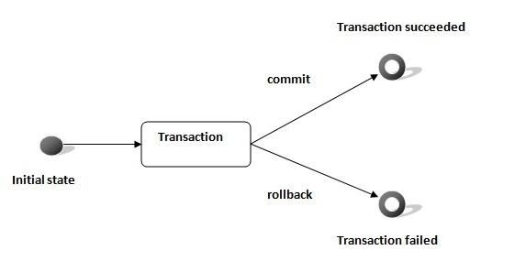

In JDBC, **Connection interface** provides methods to manage transaction.

| Method | Description |
| --- | --- |
| void setAutoCommit(boolean status) | It is true bydefault means each transaction is committed bydefault. |
| void commit() | commits the transaction. |
| void rollback() | cancels the transaction. |

### Simple example of transaction management in jdbc using Statement

Let's see the simple example of transaction management using Statement.

**import** java.sql.*;

**class** FetchRecords{

**public** **static** **void** main(String args[])**throws** Exception{

Class.forName("oracle.jdbc.driver.OracleDriver");

Connection con=DriverManager.getConnection("jdbc:oracle:thin:@localhost:1521:xe","system","oracle");

con.setAutoCommit(**false**);

Statement stmt=con.createStatement();

stmt.executeUpdate("insert into user420 values(190,'abhi',40000)");

stmt.executeUpdate("insert into user420 values(191,'umesh',50000)");

con.commit();

con.close();

}}

If you see the table emp400, you will see that 2 records has been added.

### Example of transaction management in jdbc using PreparedStatement

Let's see the simple example of transaction management using PreparedStatement.

**import** java.sql.*;

**import** java.io.*;

**class** TM{

**public** **static** **void** main(String args[]){

**try**{

Class.forName("oracle.jdbc.driver.OracleDriver");

Connection con=DriverManager.getConnection("jdbc:oracle:thin:@localhost:1521:xe","system","oracle");

con.setAutoCommit(**false**);

PreparedStatement ps=con.prepareStatement("insert into user420 values(?,?,?)");

BufferedReader br=**new** BufferedReader(**new** InputStreamReader(System.in));

**while**(**true**){

System.out.println("enter id");

String s1=br.readLine();

**int** id=Integer.parseInt(s1);

System.out.println("enter name");

String name=br.readLine();

System.out.println("enter salary");

String s3=br.readLine();

**int** salary=Integer.parseInt(s3);

ps.setInt(1,id);

ps.setString(2,name);

ps.setInt(3,salary);

ps.executeUpdate();

System.out.println("commit/rollback");

String answer=br.readLine();

**if**(answer.equals("commit")){

con.commit();

}

**if**(answer.equals("rollback")){

con.rollback();

}

System.out.println("Want to add more records y/n");

String ans=br.readLine();

**if**(ans.equals("n")){

**break**;

}

}

con.commit();

System.out.println("record successfully saved");

con.close();//before closing connection commit() is called

}**catch**(Exception e){System.out.println(e);}

}}

It will ask to add more records until you press n. If you press n, transaction is committed.

# Batch Processing in JDBC

Instead of executing a single query, we can execute a batch (group) of queries. It makes the performance fast.

The java.sql.Statement and java.sql.PreparedStatement interfaces provide methods for batch processing.

#### Advantage of Batch Processing

Fast Performance

#### Methods of Statement interface

The required methods for batch processing are given below:

| Method | Description |
| --- | --- |
| void addBatch(String query) | It adds query into batch. |
| int[] executeBatch() | It executes the batch of queries. |

### Example of batch processing in jdbc

Let's see the simple example of batch processing in jdbc. It follows following steps:

* Load the driver class
* Create Connection
* Create Statement
* Add query in the batch
* Execute Batch
* Close Connection

**import** java.sql.*;

**class** FetchRecords{

**public** **static** **void** main(String args[])**throws** Exception{

Class.forName("oracle.jdbc.driver.OracleDriver");

Connection con=DriverManager.getConnection("jdbc:oracle:thin:@localhost:1521:xe","system","oracle");

con.setAutoCommit(**false**);

Statement stmt=con.createStatement();

stmt.addBatch("insert into user420 values(190,'abhi',40000)");

stmt.addBatch("insert into user420 values(191,'umesh',50000)");

stmt.executeBatch();//executing the batch

con.commit();

con.close();

}}

If you see the table user420, two records has been added.

### Example of batch processing using PreparedStatement

**import** java.sql.*;

**import** java.io.*;

**class** BP{

**public** **static** **void** main(String args[]){

**try**{

Class.forName("oracle.jdbc.driver.OracleDriver");

Connection con=DriverManager.getConnection("jdbc:oracle:thin:@localhost:1521:xe","system","oracle");

PreparedStatement ps=con.prepareStatement("insert into user420 values(?,?,?)");

BufferedReader br=**new** BufferedReader(**new** InputStreamReader(System.in));

**while**(**true**){

System.out.println("enter id");

String s1=br.readLine();

**int** id=Integer.parseInt(s1);

System.out.println("enter name");

String name=br.readLine();

System.out.println("enter salary");

String s3=br.readLine();

**int** salary=Integer.parseInt(s3);

ps.setInt(1,id);

ps.setString(2,name);

ps.setInt(3,salary);

ps.addBatch();

System.out.println("Want to add more records y/n");

String ans=br.readLine();

**if**(ans.equals("n")){

**break**;

}

}

ps.executeBatch();

System.out.println("record successfully saved");

con.close();

}**catch**(Exception e){System.out.println(e);}

}}

It will add the queries into the batch until user press n. Finally it executes the batch. Thus all the added queries will be fired.

JDBC RowSet

The instance of **RowSet** is the java bean component because it has properties and java bean notification mechanism. It is introduced since JDK 5.

It is the wrapper of ResultSet. It holds tabular data like ResultSet but it is easy and flexible to use.

The implementation classes of RowSet interface are as follows:

* JdbcRowSet
* CachedRowSet
* WebRowSet
* JoinRowSet
* FilteredRowSet

#### It is the new way to get the instance of JdbcRowSet since JDK 7.

#### Advantage of RowSet

The advantages of using RowSet are given below:

It is easy and flexible to use

It is Scrollable and Updatable bydefault

**import** java.sql.Connection;

**import** java.sql.DriverManager;

**import** java.sql.ResultSet;

**import** java.sql.Statement;

**import** javax.sql.RowSetEvent;

**import** javax.sql.RowSetListener;

**import** javax.sql.rowset.JdbcRowSet;

**import** javax.sql.rowset.RowSetProvider;

**public** **class** RowSetExample {

**public** **static** **void** main(String[] args) **throws** Exception {

                 Class.forName("oracle.jdbc.driver.OracleDriver");

    //Creating and Executing RowSet

        JdbcRowSet rowSet = RowSetProvider.newFactory().createJdbcRowSet();

        rowSet.setUrl("jdbc:oracle:thin:@localhost:1521:xe");

        rowSet.setUsername("system");

        rowSet.setPassword("oracle");

        rowSet.setCommand("select * from emp400");

        rowSet.execute();

**while** (rowSet.next()) {

                        // Generating cursor Moved event

                        System.out.println("Id: " + rowSet.getString(1));

                        System.out.println("Name: " + rowSet.getString(2));

                        System.out.println("Salary: " + rowSet.getString(3));

                }

        }

}

### Full example of Jdbc RowSet with event handling

To perform event handling with JdbcRowSet, you need to add the instance of **RowSetListener**in the addRowSetListener method of JdbcRowSet.

The RowSetListener interface provides 3 method that must be implemented. They are as follows:

1) public void cursorMoved(RowSetEvent event);

2) public void rowChanged(RowSetEvent event);

3) public void rowSetChanged(RowSetEvent event);

**import** java.sql.Connection;

**import** java.sql.DriverManager;

**import** java.sql.ResultSet;

**import** java.sql.Statement;

**import** javax.sql.RowSetEvent;

**import** javax.sql.RowSetListener;

**import** javax.sql.rowset.JdbcRowSet;

**import** javax.sql.rowset.RowSetProvider;

**public** **class** RowSetExample {

**public** **static** **void** main(String[] args) **throws** Exception {

                 Class.forName("oracle.jdbc.driver.OracleDriver");

    //Creating and Executing RowSet

    JdbcRowSet rowSet = RowSetProvider.newFactory().createJdbcRowSet();

    rowSet.setUrl("jdbc:oracle:thin:@localhost:1521:xe");

    rowSet.setUsername("system");

    rowSet.setPassword("oracle");

        rowSet.setCommand("select * from emp400");

        rowSet.execute();

    //Adding Listener and moving RowSet

    rowSet.addRowSetListener(**new** MyListener());

**while** (rowSet.next()) {

                        // Generating cursor Moved event

                        System.out.println("Id: " + rowSet.getString(1));

                        System.out.println("Name: " + rowSet.getString(2));

                        System.out.println("Salary: " + rowSet.getString(3));

                }

        }

}

**class** MyListener **implements** RowSetListener {

**public** **void** cursorMoved(RowSetEvent event) {

                System.out.println("Cursor Moved...");

      }

**public** **void** rowChanged(RowSetEvent event) {

                System.out.println("Cursor Changed...");

     }

**public** **void** rowSetChanged(RowSetEvent event) {

                System.out.println("RowSet changed...");

     }

}