***Task:***

Create a React app containing Users widget. It should have two states:

1. First state shows the users list. By default it shows three items. If there are more than three it shows a “View all” button. Which expands the rest of the list when clicked on it. Each item has an avatar, short user information and a “View” button. Design example:

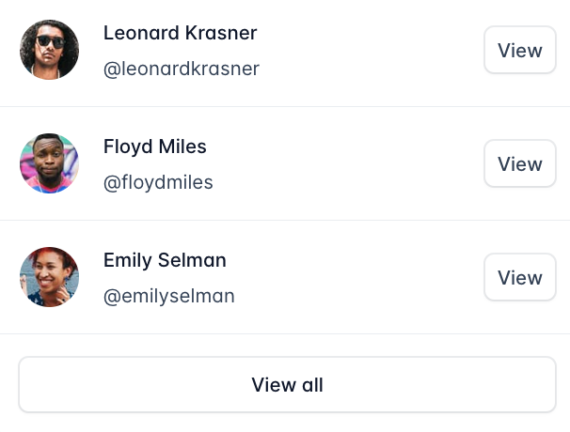

1. Second state shows full user information after clicking on “View” button. It has a “Close” button to go back to the Users list. Button “Send message” does nothing. Design example:

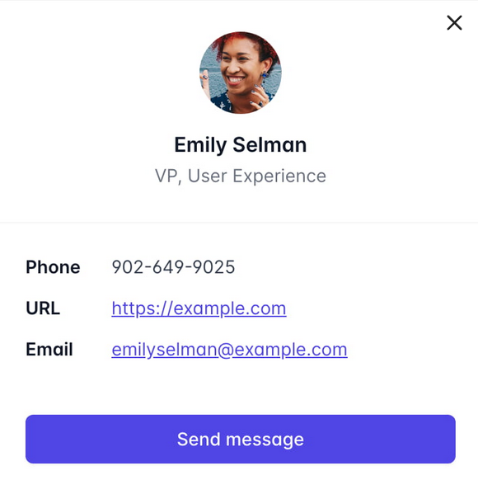

***Initial input data: initData.json***

***Requirements:***

* The Users data should be stored in the Redux.
* Widget should receive data through props.
* Widget should be adoptive - from fixed size on desktop to responsive on mobile devices.
* App builds with no warnings.
* Components and containers of the app covered with the tests.
* Important! It is not allowed to use any styles library.

***Frameworks:***

* React 18 (last possible version) with Typescript.
* Redux Toolkit.
* Jest and RTL for testing.
* Plain CSS3 / HTML5.

***Estimated time* - 3.5 h**

**Time available for sending results up to 5h after receiving Email.**

***Transfer of results:***

The candidate should send a link to Github/ Bitbucket source code no later than the available time. The company will check only the result provided before the available time ends.

Further improvement is nevertheless welcomed.

Please note, that your repo name should be *YouSurname FE  YYMMDD* (Example **arestovichfe220621**)  using VALU-X as a part of the repo name is not allowed.

***Before you transfer the result, please check:***

* You have a Read.me file with an explanation of how to start your app, how to test it etc.
* You have tested your app and it satisfies the requirements above.
* All used packages are inside package.json