Wine Shop & Delicatessen
Customer Behavior Analysis
Strategic Marketing Report
May 2026

404  Customers surveyed | 4  FM segments | €55.7  Average ticket

Business challenge: the store is perceived as a wine shop, not a delicatessen.
This report identifies customer segments and the targeted actions to grow cross-category sales.

Know Your Customer

Before segmenting, it helps to understand who walks through the door. The 404 surveyed customers are predominantly aged 31-40, split roughly 50/50 by gender, and visit most commonly 1-2 times per week. Average ticket is €55.7. Olives and nuts are the most popular deli purchases, and parties are the dominant drinking occasion - pointing to a social, occasion-driven customer base.
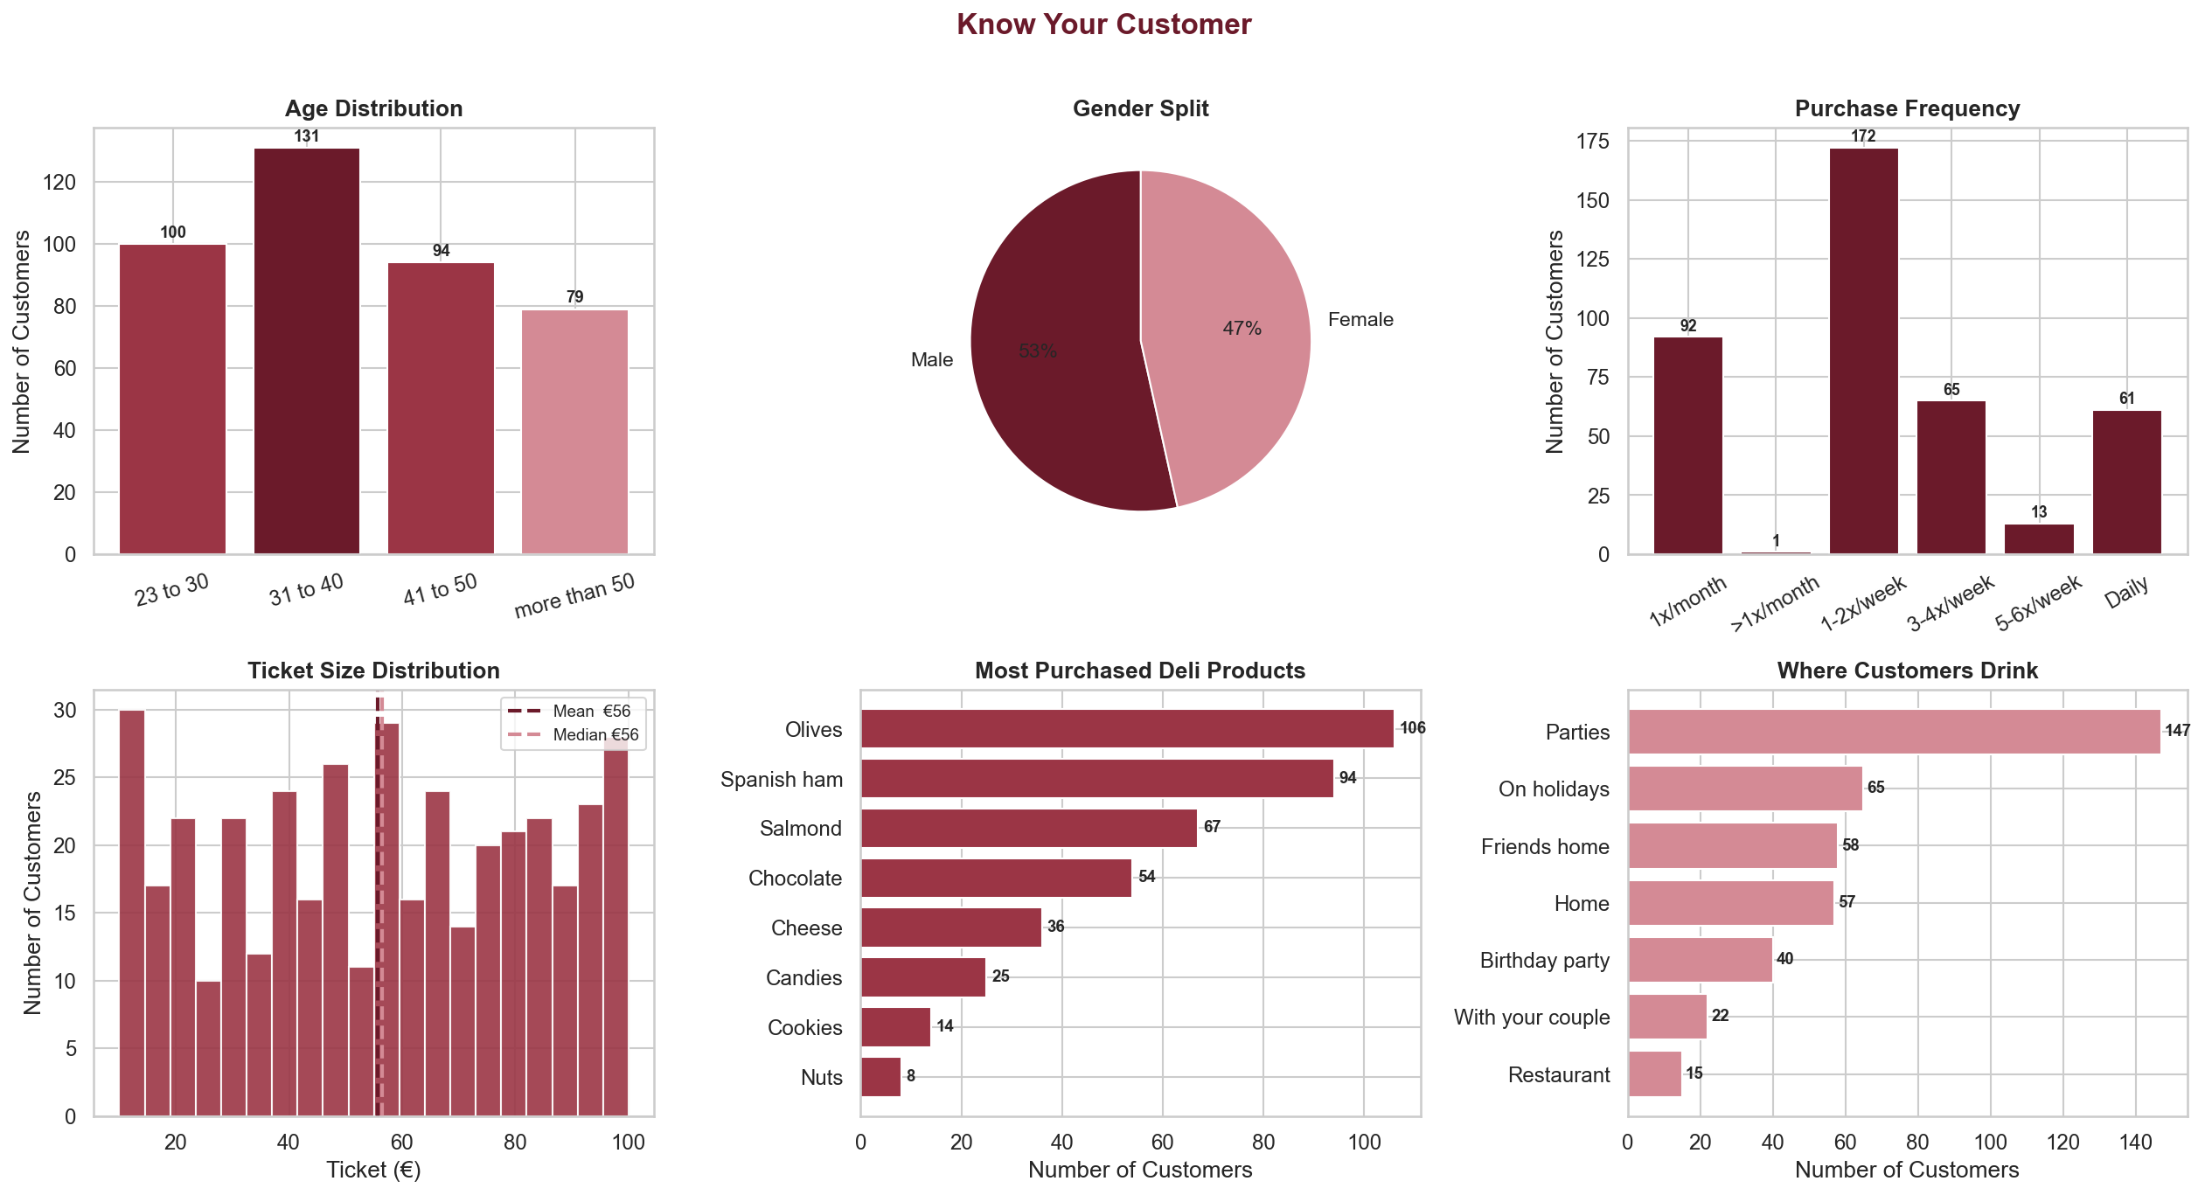

Executive Summary

This analysis segments 404 customers using the FM (Frequency x Monetary) framework, supported by K-Prototypes spend tier clustering. Four distinct customer groups emerge, each with a clear commercial action.
Key Findings
- Champions drive the business. 37% of customers generate an estimated 68% of annual revenue. They visit 1-2 times per week and spend an average of €78 per visit. Retaining this group is the single highest-priority action.
- Loyal Regulars are the largest segment - and undermonetised. 40% of the base visits frequently but spends modestly (avg €33). A structured upsell programme targeting premium deli products could materially shift average ticket.
- Spend level is the primary differentiator. K-Prototypes clustering identifies three clean spend tiers: Premium Buyers (avg €86), Core Buyers (avg €55), and Entry Buyers (avg €24). The FM segments map closely onto these tiers, confirming spend as the key dimension to act on.
- The delicatessen is underpenetrated. Entry-tier deli products (candies, cookies, nuts) dominate across all segments. No segment shows a majority choosing premium deli (cheese, ham, salmon). This is the principal cross-sell opportunity.
Priority Actions at a Glance
Segment | Priority | Action
Champions | High | Loyalty card, VIP tastings, exclusive previews
Loyal Regulars | High | Deli upsell at checkout, wine upgrade nudges
Occasion Splurgers | Medium | Seasonal hampers, event gift sets
Casual Visitors | Low | Social media activation, entry-level offers

FM Segmentation: Frequency x Monetary

In the absence of recency data, the FM framework uses two dimensions to classify customers: how often they visit (Frequency) and how much they spend per visit (Monetary). A median split on each dimension produces four segments. This is the primary actionable framework for targeted marketing.
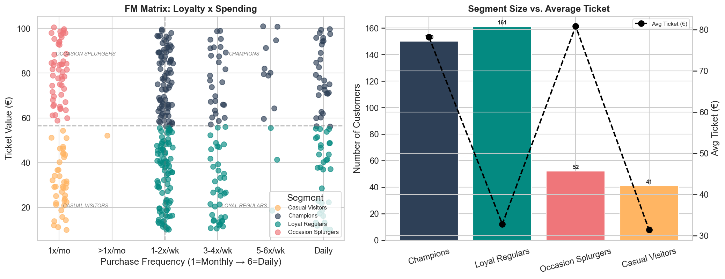
Segment Profiles
Segment | Customers | Avg Ticket | Rev Share | Top Deli
Champions | 150 (37%) | €78 | 68% | Olives
Loyal Regulars | 161 (40%) | €33 | 30% | Olives
Occasion Splurgers | 52 (13%) | €81 | 2% | Spanish ham
Casual Visitors | 41 (10%) | €31 | 1% | Spanish ham

Spend Tier Analysis: K-Prototypes Clustering

K-Prototypes clustering (K=3) identifies three distinct spending bands. Unlike K-Means, this algorithm correctly handles categorical data (occasion, product choice, payment mode) using Hamming distance, and applies Euclidean distance only to the ticket value. The three tiers align closely with the FM segmentation, reinforcing spend as the key dimension.
Spend Tier | Customers | Ticket Range | Avg Ticket
Premium Buyers | 138 | €71 - €100 | €86
Core Buyers | 138 | €40 - €70 | €55
Entry Buyers | 128 | €10 - €39 | €24

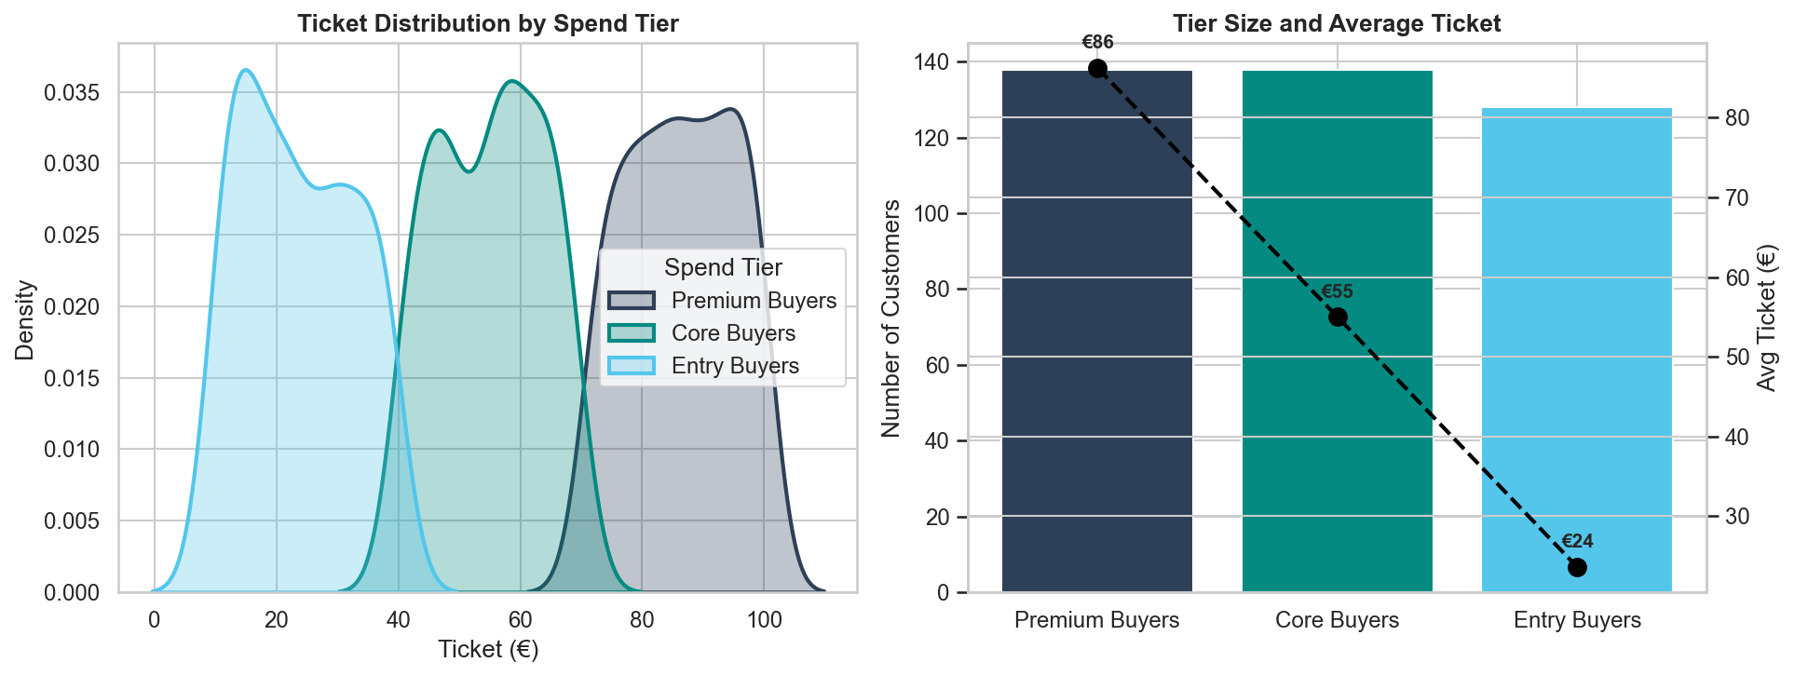
Revenue Contribution by Segment
Revenue is estimated as ticket value x monthly visit frequency x 12 months. Champions represent an outsized share of estimated annual revenue despite being outnumbered by Loyal Regulars - underlining the value of protecting high-frequency, high-spend customers.
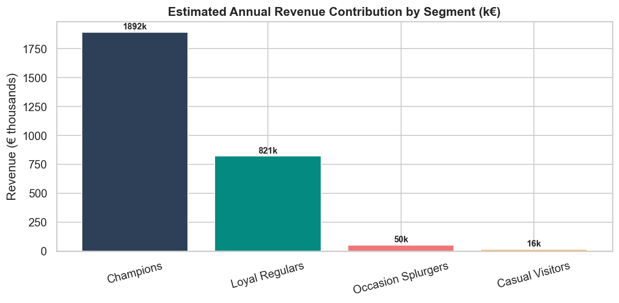

Customer Personas

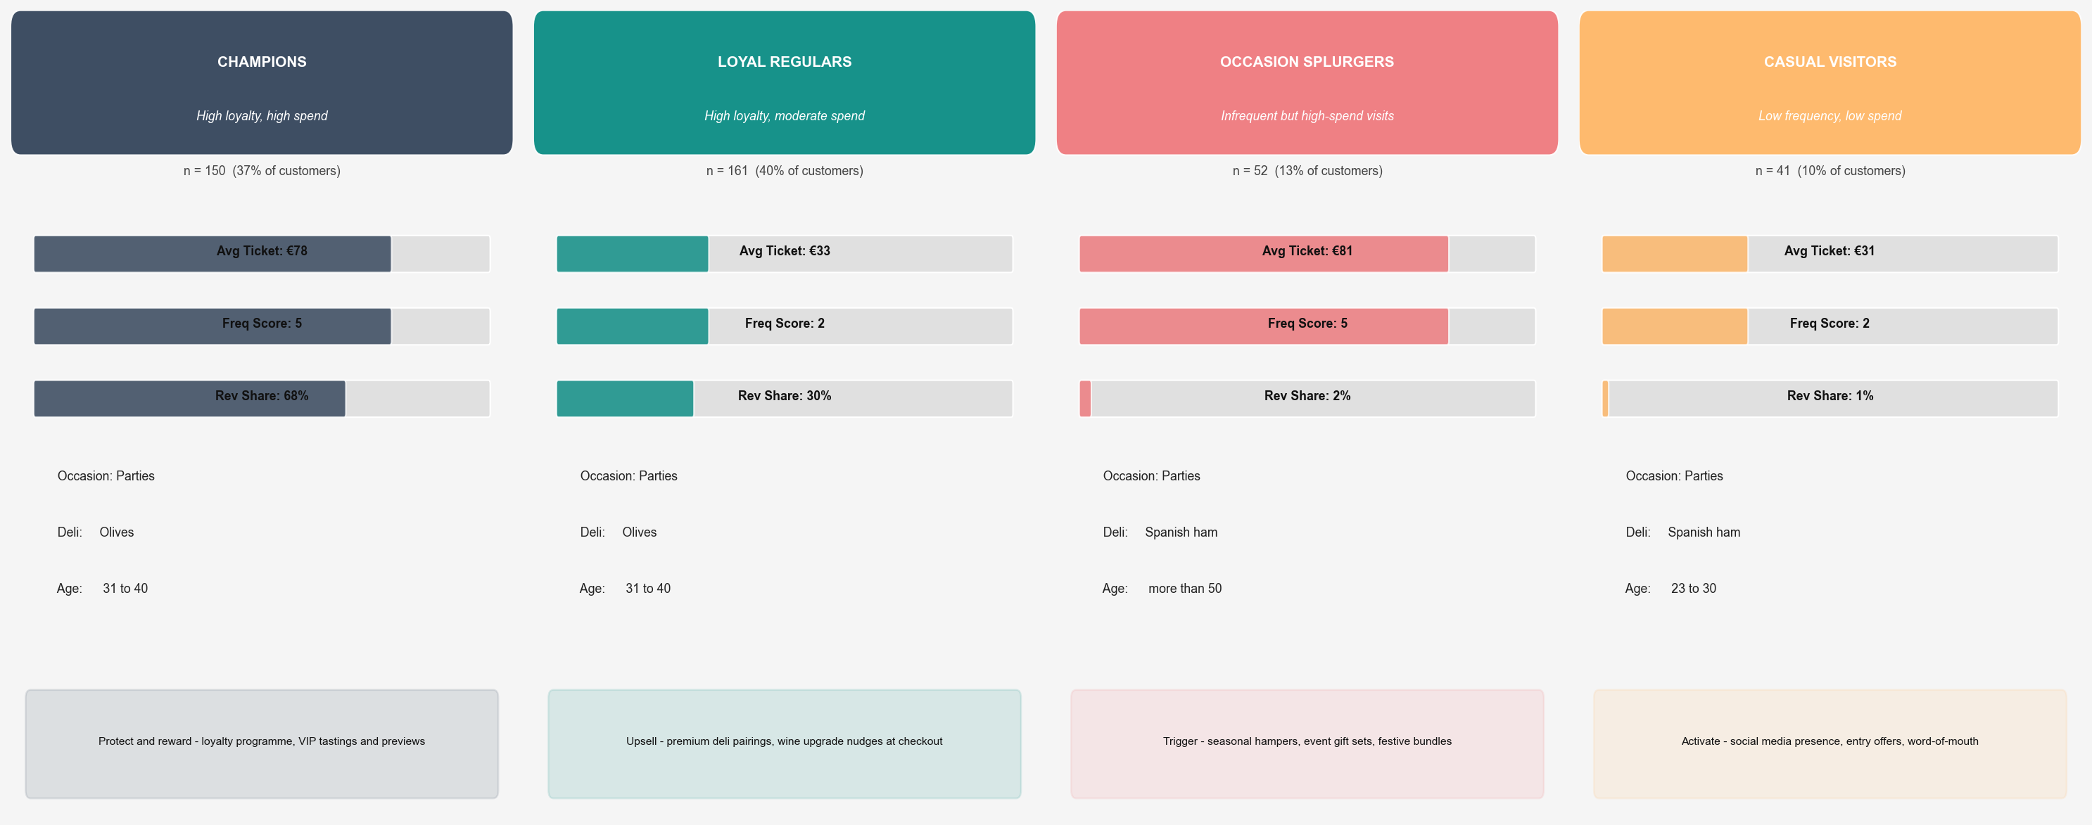
Strategic Recommendations by Segment
Champions
- Launch a named loyalty programme (e.g. "Cave Club") with a stamp card or digital membership.
- Invite to private tastings, new-arrival previews, and producer evenings.
- Offer premium hamper bundles (wine + Spanish ham or salmon) as a default upsell at checkout.
- Ensure consistent, high-quality in-store experience - this group is retention-sensitive.
Loyal Regulars
- Introduce a "Pair It" recommendation card at the till suggesting one deli item per wine.
- Run a "trade-up" mechanic: spend €10 more and receive a complimentary deli taster.
- Develop a monthly curated box (wine + 2-3 deli items) at a slight discount vs individual pricing.
- Highlight premium deli provenance in-store - this group visits frequently and will read signage.
Occasion Splurgers
- Build a seasonal hamper range (Christmas, Easter, summer) priced €60-100 to match their spend level.
- Create shareable social-media-ready gift packaging to encourage word-of-mouth gifting.
- Email/WhatsApp campaign before key occasions (Valentines, Mother's Day, festive season).
- Position the store as a one-stop gift destination, not just a wine shop.
Casual Visitors
- Activate on Instagram/social with accessible, entry-level content (wine tips, easy pairings).
- Offer a "first deli taster" with any wine purchase to lower the barrier to cross-category trial.
- Run a monthly Saturday tasting event - low ticket, social, and discovery-focused.
- Track conversion: if this group doesn't migrate to Loyal Regulars within 6 months, re-evaluate spend.

Cross-cutting priority: address the delicatessen perception gap. No segment defaults to premium deli. A simple "wine + deli" pairing display at eye level and staff trained to suggest one product match per purchase could shift the average basket within one quarter.

