**HW 3 REPORT -- WangZijia 1002885**

**Question 1**

* When kernel = 0:

optimization finished, #iter = 637

nu = 0.024407

obj = -0.903163, rho = 1.532559

nSV = 39, nBSV = 0

Total nSV = 39

**Accuracy = 84.375% (27/32) (classification)**

* When kernel = 1:

optimization finished, #iter = 186

nu = 0.026157

obj = -0.967852, rho = 0.276119

nSV = 62, nBSV = 0

Total nSV = 62

**Accuracy = 81.25% (26/32) (classification)**

* When kernel = 2:

optimization finished, #iter = 186

nu = 0.026157

obj = -0.967852, rho = 0.276119

nSV = 62, nBSV = 0

Total nSV = 62

**Accuracy = 81.25% (26/32) (classification)**

* When kernel = 3:

optimization finished, #iter = 39

nu = 0.945946

obj = -67.705765, rho = -0.697125

nSV = 71, nBSV = 69

Total nSV = 71

**Accuracy = 43.75% (14/32) (classification)**

**Question 2**

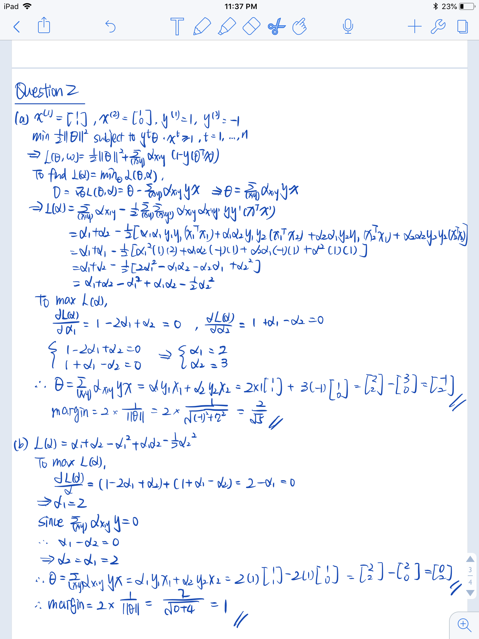

**Question 3**

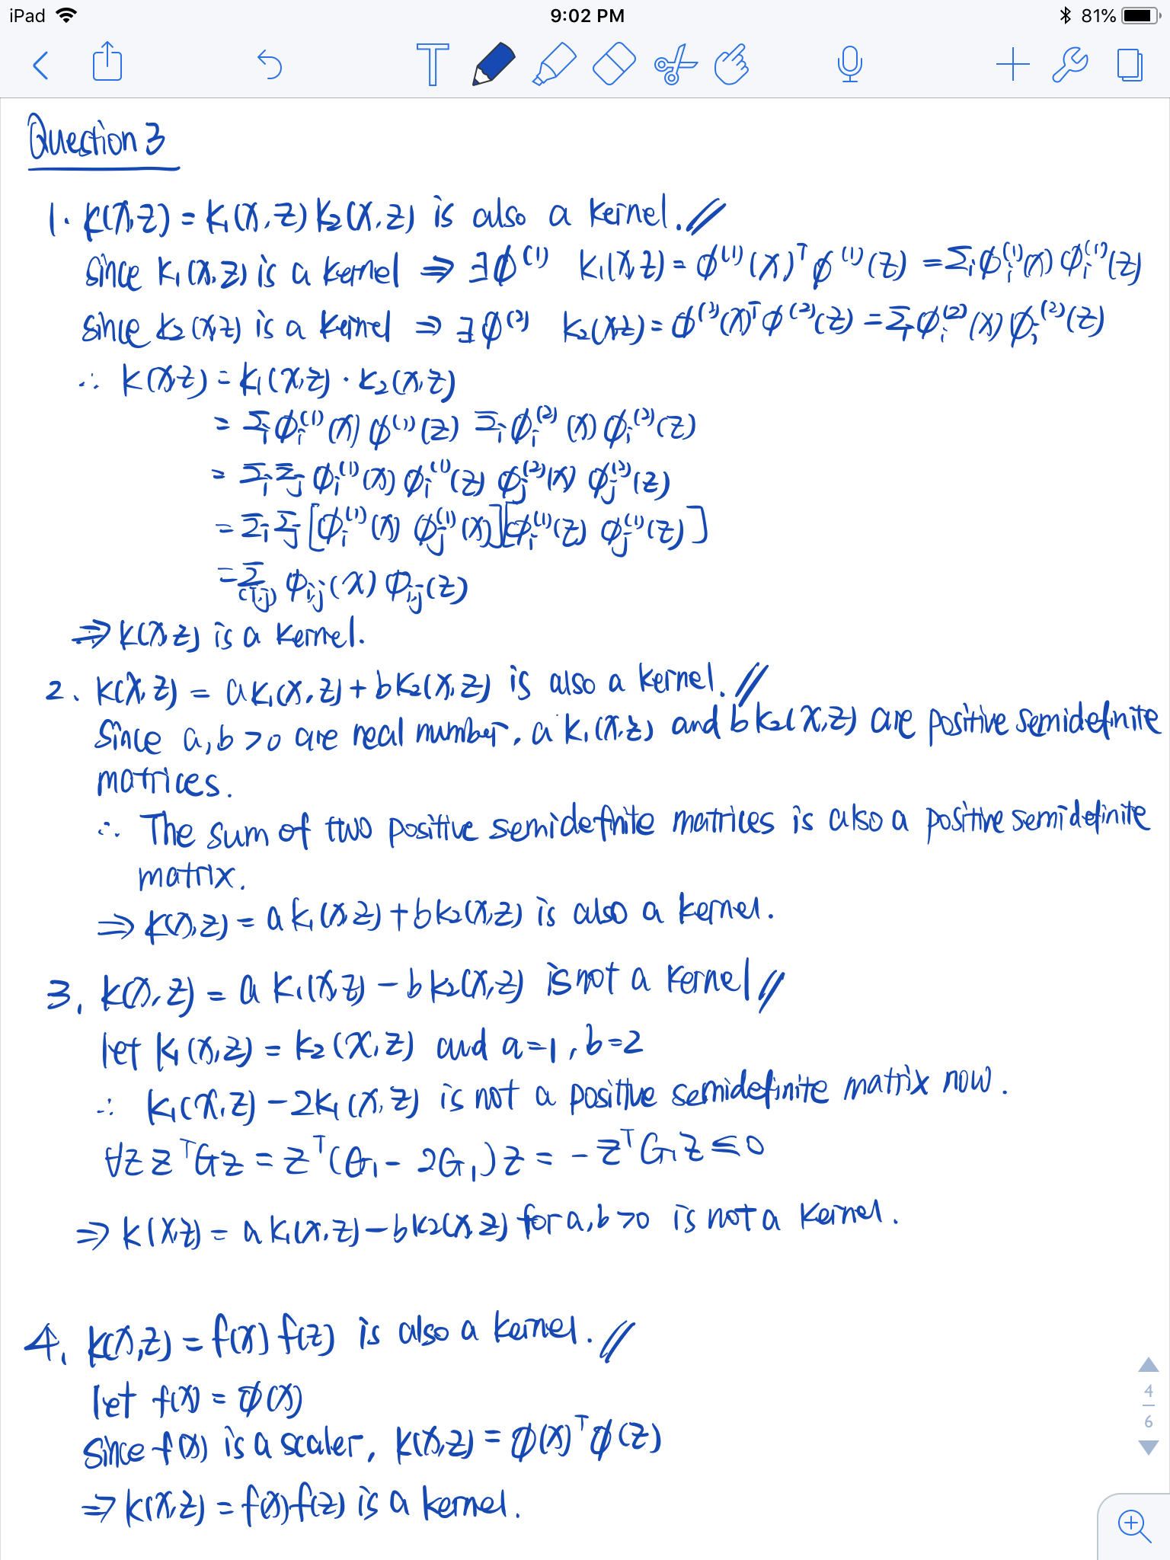

**Question 4**

The code is in jupyter notebook (ipynb).  
  
HOW TO RUN THE SCRIPT:  
1) Open it in jupyter notebook.

2) The only change you need to make before running the code is to change the file path.  
3) Run the cells in sequence.   
  
Thank you.

1. In equation 1, if the size of the training examples is large, the precise of the product of the probabilities will be violated and the result will be 0 since the value is quite small and it maybe even smaller than the smallest number that can be represented in python.
2. The result theta:



The graph of log-likelihood per 100 iterations:

