Lab 6 --- Wang Zijia 1002885

1. Create a table for addition and multiplication for GF(2^4), using (x^4 + x^3 + 1) as the modulus.

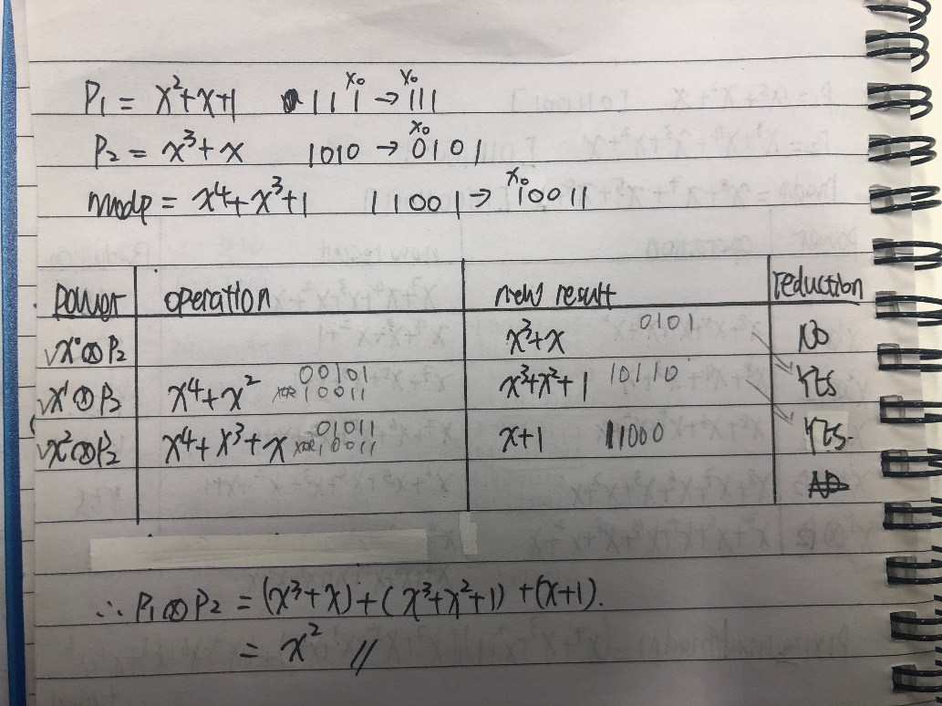

1. Create a table for addition and multiplication for GF(2^8), using (x^4 + x^3 + 1) as the modulus.

