Randall Da Costa

Kura Labs – Deployment 01

Notable Observations during the process of:

1. Forking the designated repository
2. Syncing the repository to ensure file base was up to date
3. Creating an EC2 Instance in AWS
4. SSH-ing into that EC2 instance via local WSL-Ubuntu terminal
5. Installing virtual environments to run Jenkins
6. Installing Jenkins to build and test Python application
7. Zipping successfully built application to create artifact that will be used by Elastic Beanstalk to Deploy web application

**Failures occurred when attempting to build [in Jenkins].**

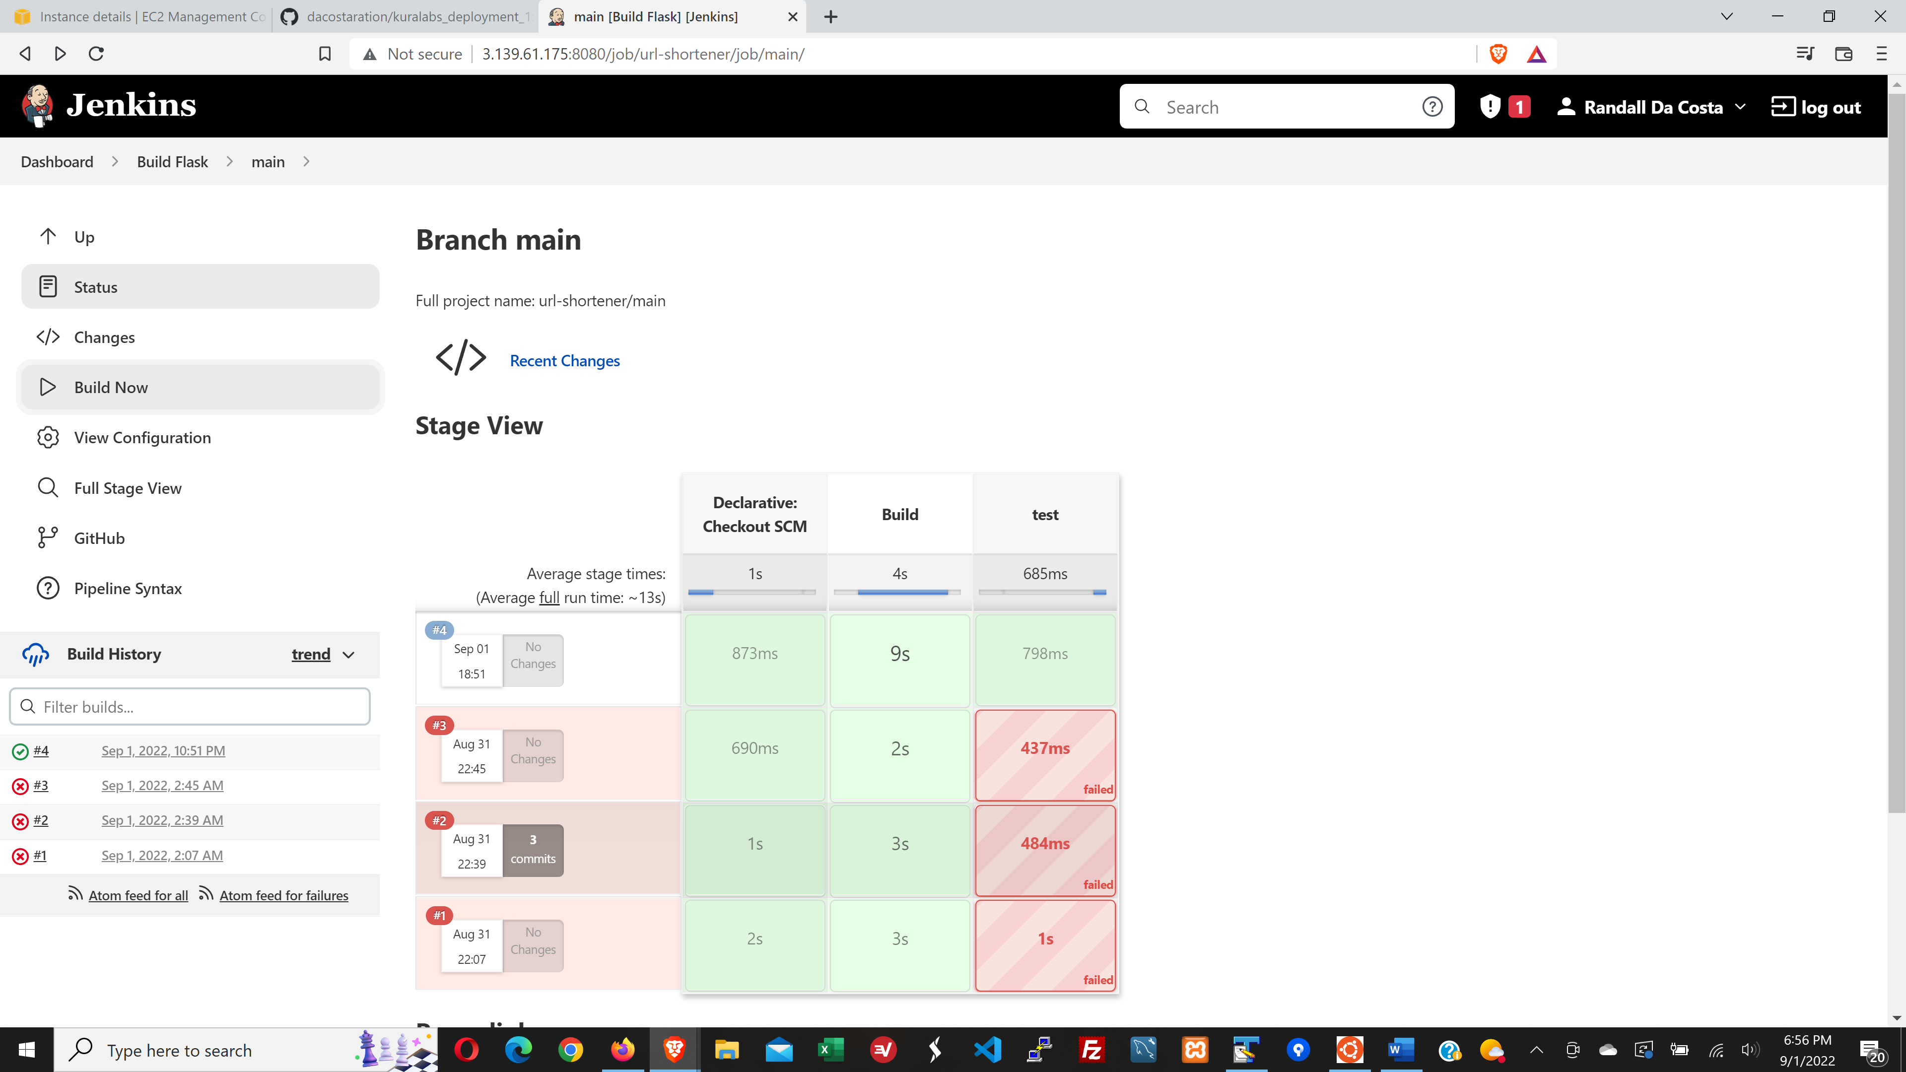

**Action taken:** Reviewed Console Output to hone in on what the problem could be (see output below).

After review, it was determined that the necessary Virtual Environment needed to be installed.

After proper Virtual Environment installation, the application build completed as expected.

(see Console Output Error below & highlighted in yellow)

Started by user [Randall Da Costa](http://3.139.61.175:8080/user/dacostar)

02:45:19 Connecting to [https://api.github.com](https://api.github.com/) using dacostar/****** (deployment01pipeline GitHub Token)

Obtained Jenkinsfile from f0e7dab62e6e06ff1e760c2bba8d89348b9e2368

[Pipeline] Start of Pipeline

[Pipeline] node

Running on [Jenkins](http://3.139.61.175:8080/computer/(built-in)/) in /var/lib/jenkins/workspace/url-shortener_main

[Pipeline] {

[Pipeline] stage

[Pipeline] { (Declarative: Checkout SCM)

[Pipeline] checkout

The recommended git tool is: NONE

using credential 296f866e-9d52-49e5-839e-5555ef17d302

> git rev-parse --resolve-git-dir /var/lib/jenkins/workspace/url-shortener_main/.git # timeout=10

Fetching changes from the remote Git repository

> git config remote.origin.url <https://github.com/dacostaration/kuralabs_deployment_1.git> # timeout=10

Fetching without tags

Fetching upstream changes from <https://github.com/dacostaration/kuralabs_deployment_1.git>

> git --version # timeout=10

> git --version # 'git version 2.34.1'

using GIT_ASKPASS to set credentials deployment01pipeline GitHub Token

> git fetch --no-tags --force --progress -- <https://github.com/dacostaration/kuralabs_deployment_1.git> +refs/heads/main:refs/remotes/origin/main # timeout=10

Checking out Revision f0e7dab62e6e06ff1e760c2bba8d89348b9e2368 (main)

> git config core.sparsecheckout # timeout=10

> git checkout -f f0e7dab62e6e06ff1e760c2bba8d89348b9e2368 # timeout=10

Commit message: "Delete hello.py"

> git rev-list --no-walk f0e7dab62e6e06ff1e760c2bba8d89348b9e2368 # timeout=10

[Pipeline] }

[Pipeline] // stage

[Pipeline] withEnv

[Pipeline] {

[Pipeline] stage

[Pipeline] { (Build)

[Pipeline] sh

The virtual environment was not created successfully because ensurepip is not

available. On Debian/Ubuntu systems, you need to install the python3-venv

package using the following command.

apt install python3.10-venv

You may need to use sudo with that command. After installing the python3-venv

package, recreate your virtual environment.

Failing command: ['/var/lib/jenkins/workspace/url-shortener_main/test3/bin/python3', '-Im', 'ensurepip', '--upgrade', '--default-pip']

/var/lib/jenkins/workspace/url-shortener_main@tmp/durable-767c9267/script.sh: line 3: test3/bin/activate: No such file or directory

Defaulting to user installation because normal site-packages is not writeable

Requirement already satisfied: pip in /var/lib/jenkins/.local/lib/python3.10/site-packages (22.2.2)

Defaulting to user installation because normal site-packages is not writeable

Requirement already satisfied: attrs==22.1.0 in /var/lib/jenkins/.local/lib/python3.10/site-packages (from -r requirements.txt (line 2)) (22.1.0)

Requirement already satisfied: click==8.1.3 in /var/lib/jenkins/.local/lib/python3.10/site-packages (from -r requirements.txt (line 3)) (8.1.3)

Requirement already satisfied: flask==2.2.2 in /var/lib/jenkins/.local/lib/python3.10/site-packages (from -r requirements.txt (line 4)) (2.2.2)

Requirement already satisfied: iniconfig==1.1.1 in /var/lib/jenkins/.local/lib/python3.10/site-packages (from -r requirements.txt (line 5)) (1.1.1)

Requirement already satisfied: itsdangerous==2.1.2 in /var/lib/jenkins/.local/lib/python3.10/site-packages (from -r requirements.txt (line 6)) (2.1.2)

Requirement already satisfied: jinja2==3.1.2 in /var/lib/jenkins/.local/lib/python3.10/site-packages (from -r requirements.txt (line 7)) (3.1.2)

Requirement already satisfied: markupsafe==2.1.1 in /var/lib/jenkins/.local/lib/python3.10/site-packages (from -r requirements.txt (line 8)) (2.1.1)

Requirement already satisfied: packaging==21.3 in /var/lib/jenkins/.local/lib/python3.10/site-packages (from -r requirements.txt (line 9)) (21.3)

Requirement already satisfied: pluggy==1.0.0 in /var/lib/jenkins/.local/lib/python3.10/site-packages (from -r requirements.txt (line 10)) (1.0.0)

Requirement already satisfied: py==1.11.0 in /var/lib/jenkins/.local/lib/python3.10/site-packages (from -r requirements.txt (line 11)) (1.11.0)

Requirement already satisfied: pyparsing==3.0.9 in /var/lib/jenkins/.local/lib/python3.10/site-packages (from -r requirements.txt (line 12)) (3.0.9)

Requirement already satisfied: pytest==7.1.2 in /var/lib/jenkins/.local/lib/python3.10/site-packages (from -r requirements.txt (line 13)) (7.1.2)

Requirement already satisfied: tomli==2.0.1 in /var/lib/jenkins/.local/lib/python3.10/site-packages (from -r requirements.txt (line 14)) (2.0.1)

Requirement already satisfied: werkzeug==2.2.2 in /var/lib/jenkins/.local/lib/python3.10/site-packages (from -r requirements.txt (line 15)) (2.2.2)

/var/lib/jenkins/workspace/url-shortener_main@tmp/durable-767c9267/script.sh: line 7: flask: command not found

[Pipeline] }

[Pipeline] // stage

[Pipeline] stage

[Pipeline] { (test)

[Pipeline] sh

/var/lib/jenkins/workspace/url-shortener_main@tmp/durable-cb853455/script.sh: line 2: test3/bin/activate: No such file or directory

/var/lib/jenkins/workspace/url-shortener_main@tmp/durable-cb853455/script.sh: line 3: py.test: command not found

Post stage

[Pipeline] junit

Recording test results

No test report files were found. Configuration error?

Error when executing always post condition:

hudson.AbortException: No test report files were found. Configuration error?

at hudson.tasks.junit.JUnitParser$ParseResultCallable.invoke(JUnitParser.java:184)

at hudson.FilePath.act(FilePath.java:1200)

at hudson.FilePath.act(FilePath.java:1183)

at hudson.tasks.junit.JUnitParser.parseResult(JUnitParser.java:118)

at hudson.tasks.junit.JUnitResultArchiver.parse(JUnitResultArchiver.java:159)

at hudson.tasks.junit.JUnitResultArchiver.parseAndSummarize(JUnitResultArchiver.java:253)

at hudson.tasks.junit.pipeline.JUnitResultsStepExecution.run(JUnitResultsStepExecution.java:63)

at hudson.tasks.junit.pipeline.JUnitResultsStepExecution.run(JUnitResultsStepExecution.java:29)

at org.jenkinsci.plugins.workflow.steps.SynchronousNonBlockingStepExecution.lambda$start$0(SynchronousNonBlockingStepExecution.java:47)

at java.base/java.util.concurrent.Executors$RunnableAdapter.call(Executors.java:515)

at java.base/java.util.concurrent.FutureTask.run(FutureTask.java:264)

at java.base/java.util.concurrent.ThreadPoolExecutor.runWorker(ThreadPoolExecutor.java:1128)

at java.base/java.util.concurrent.ThreadPoolExecutor$Worker.run(ThreadPoolExecutor.java:628)

at java.base/java.lang.Thread.run(Thread.java:829)

[Pipeline] }

[Pipeline] // stage

[Pipeline] }

[Pipeline] // withEnv

[Pipeline] }

[Pipeline] // node

[Pipeline] End of Pipeline

ERROR: script returned exit code 127

GitHub has been notified of this commit’s build result

Finished: FAILURE

**Successful Creation of Environment in AWS Elastic Beanstalk**

**Successfully Deployed Web Application**

**Additional Notes:**

When the zip [artifact] was created on the EC2, it was a bit challenging to retrieve as the remote EC2 instance was virtually disconnected from my local system

It was needed when setting up Elastic Beanstalk to build the application.

Options included:

1. Running the entire process over [locally] to obtain the zip file
2. Connecting to my remote Git repository to push the zip file there where it could then be retrieved and utilized in elastic beanstalk

I opted for (i)…with a quick script from a colleague !

The process could have been improved by originally generating the artifact where it would have been more readily accessible.