Alejandro Ruiz

**Project Proposal**

**Project Description**

My term project will be called “ShinDor Soccer” and it is essentially a game that imitates a game called “Head Soccer”. The game consists of two players and whoever scores the most goals wins.

**Structural Plan**

My code will be all in one file. I will send to my mentor the sprites and mp3 and wav files that I used for the term project.

**Algorithmic Plan**

The hardest algorithms of my project are when the soccer collides with the player and we elevate it giving it a physics like movement as well as my artificial intelligence code. My AI will evaluate the position of the soccer ball as well as whether the other player is hitting the ball. For example, if the AI sees that the soccer ball is in front of it and that the other player did not hit the ball it might start moving forward if it thinks it can score a goal. The AI will of course have multiple if statements and evaluate the best option since the if statements will be placed in a sorted order where the most important if’s are checked first. It will also contain some elifs which may or may not be implemented depending on the situation. Ideally for my hardest level AI I would use a algorithm to reduce the amount of if statements. My jump function for my player also contains a physics algorithm, which is using the kinematic equation y = ½ at^2. I also applied the frozen, superjump and move faster powers which can be picked up during the game. The frozen power is achieved by outperforming the rival by scoring 3 more goals and is only applicable once. I also added confetti when the game is won which is made up of the colors of the player that won, as well as implementing a single story mode.

**Timeline Plan**

Intend to implement an story for the game by the end of TP3, and finish up the project by adding more cool features.

**Shortcuts**

In the single player version please press ‘w’ (as in win) to make the player win and ‘l’ (as in lose) to make the AI win, which means that you the player lost. These both will take you to a different ending.

**TP3 Update**

Add confetti when a player wins, load a day or night background depending on what time it is when the user is playing. Adding a story to the game to make it more entertaining (implementing more graphics), as well as added one more player to be able to play with. Also finished fixing the leaderboard.

**Version Control Plan**

I am backing up my code on GitHub. I update my GitHub every hour when I work on my project to make sure if something unfortunate happens my code would not be deleted.

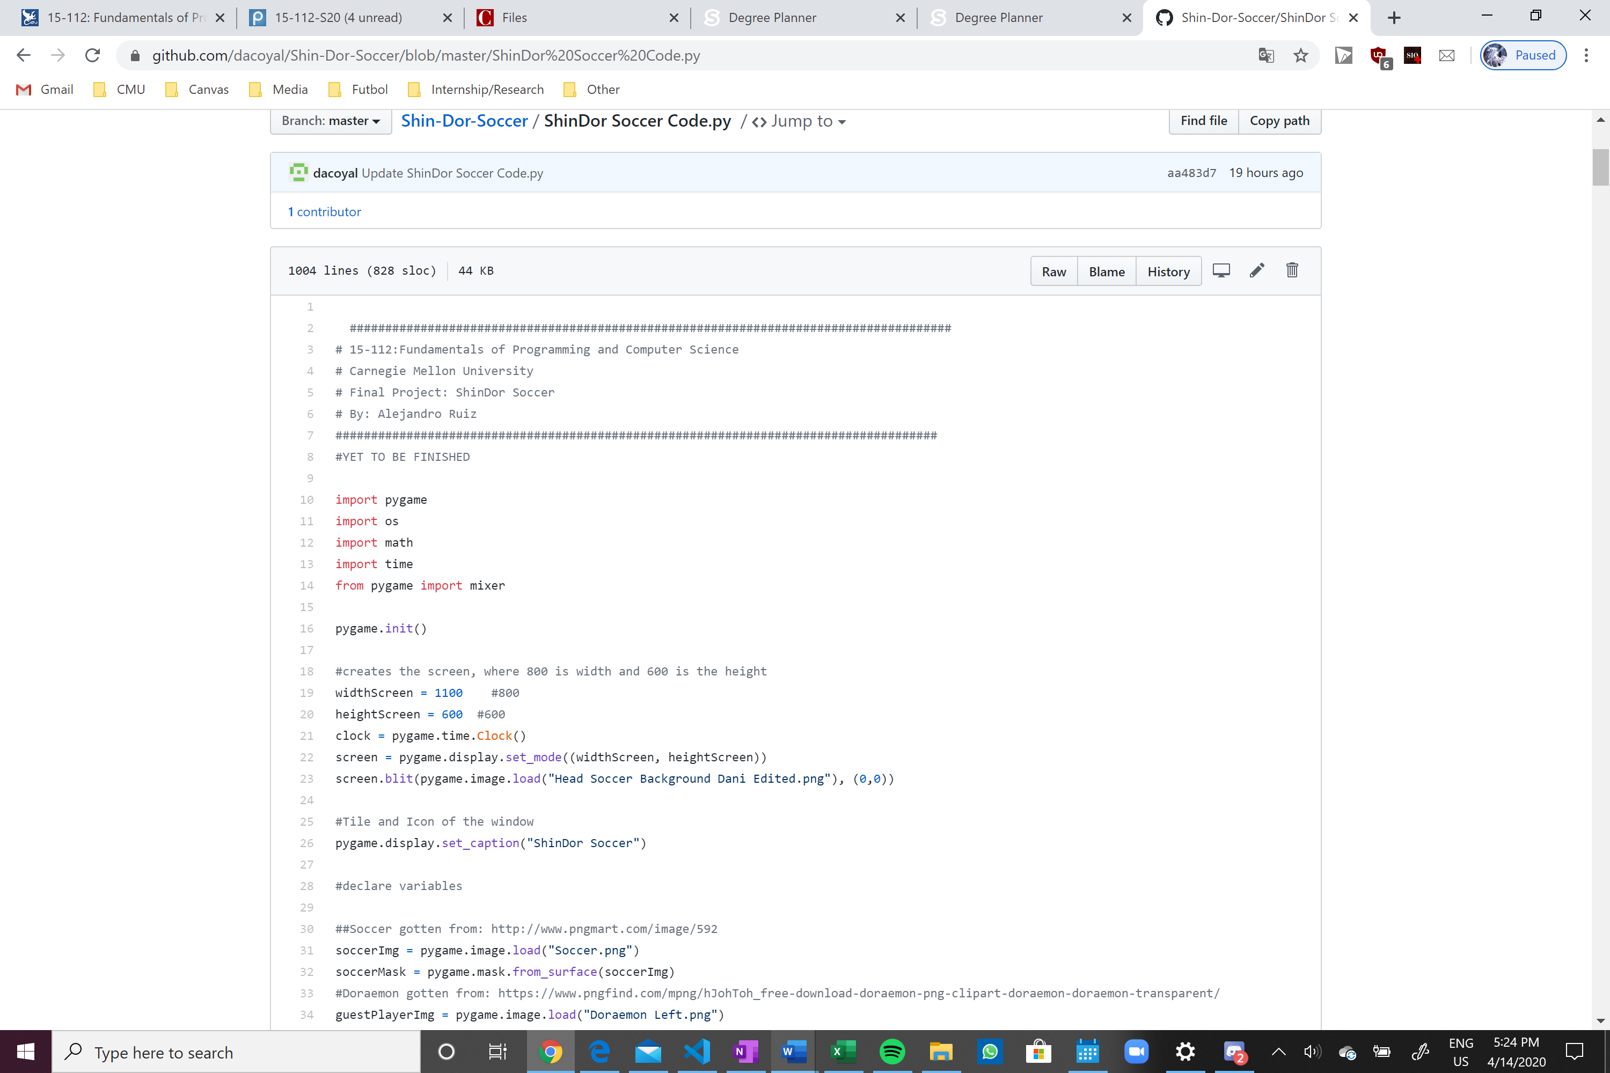

**Module List**

External modules that I am using are pygame. The reason why I chose pygame is because it is faster than Tkinter. I also imported math, os, random, datetime. To import datetime just put “from datetime import datetime”.

**Storyboard**

