Question 1:

After performing the experiments, it can be observed that there is a relationship between the output of our system and the Kp value chosen for the controller. In the first two tests (Kp = 0.5, 1) the output of the system did not move until the Kp value was increased to 1.5. The system overshot the reference trajectory but got to “steady-state” faster as Kp increased.

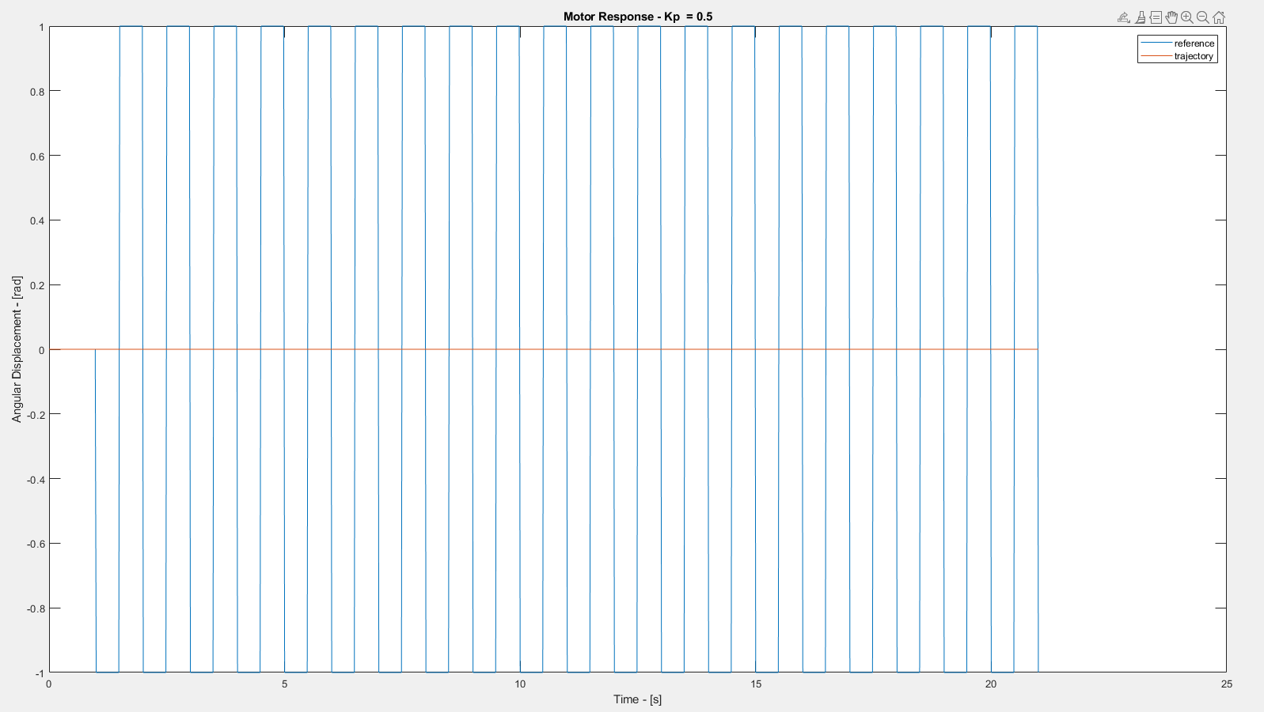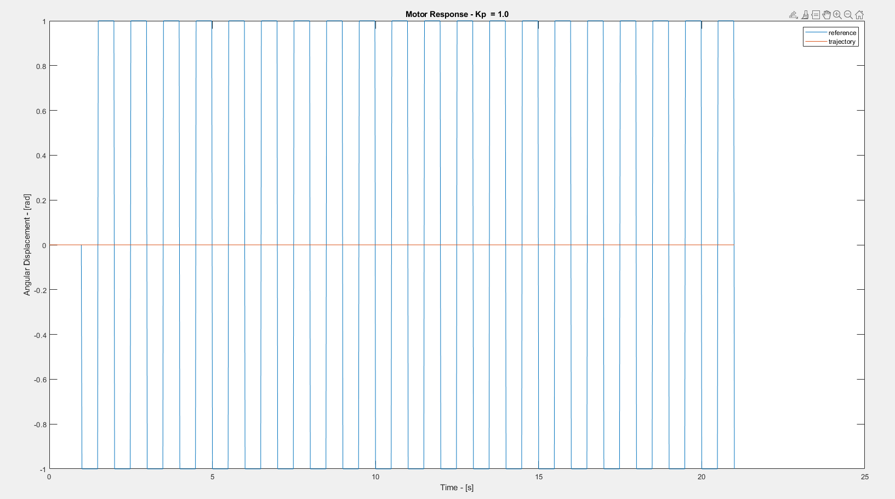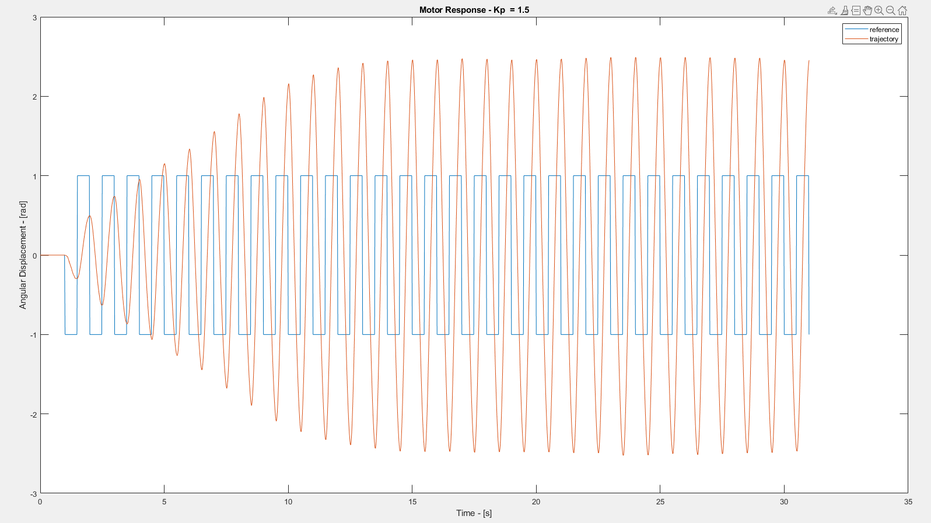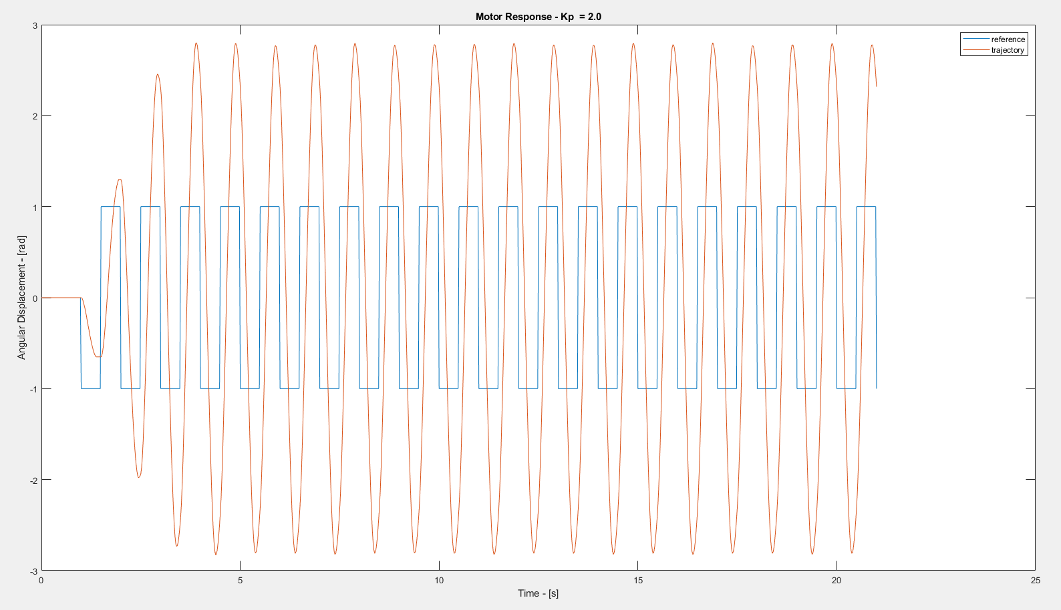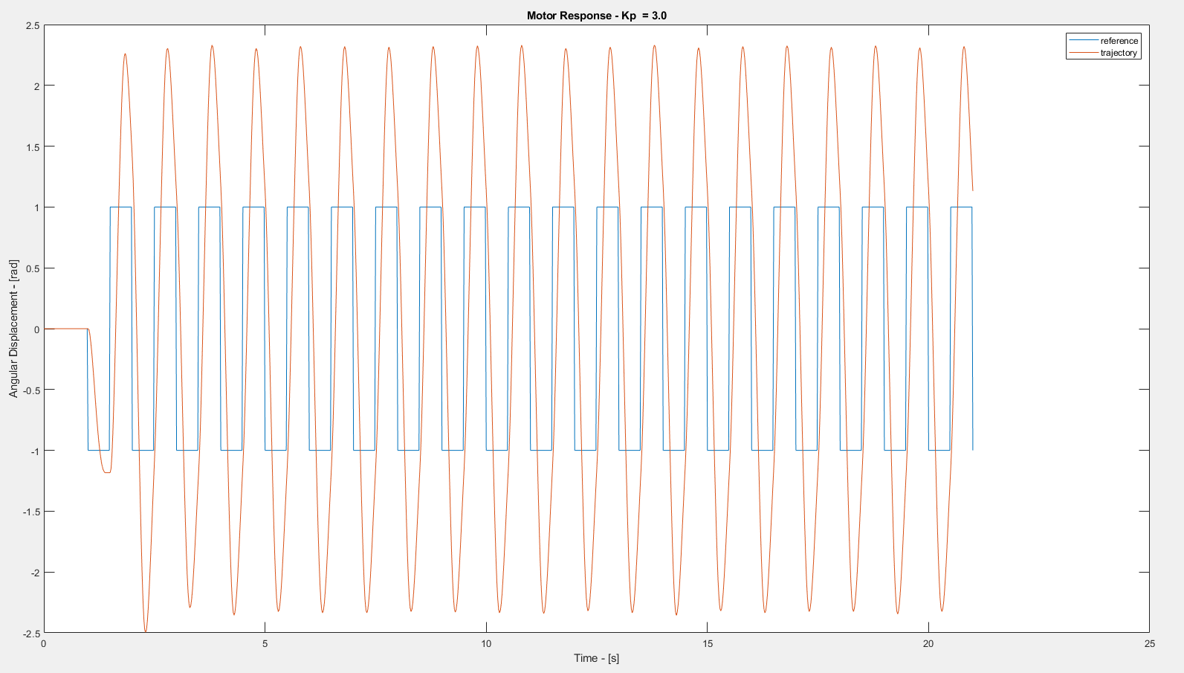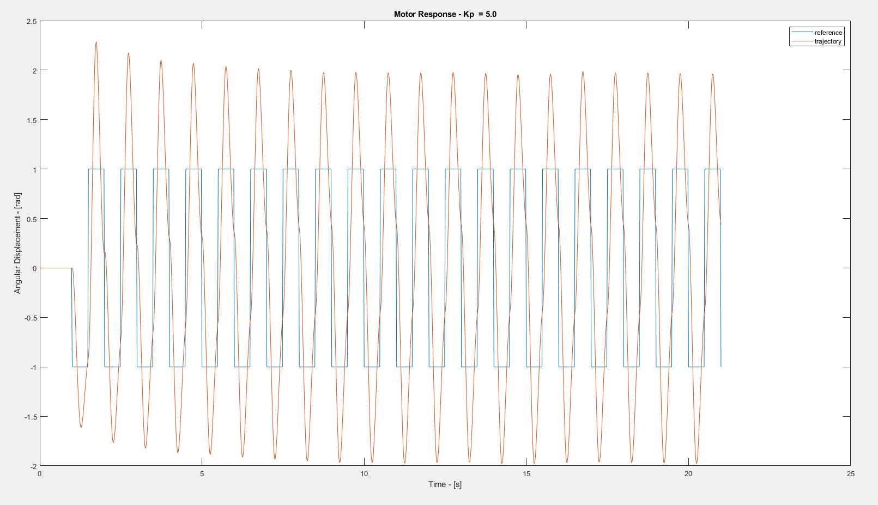

Question 2:

The closed looped amplification sounded better than the open-loop amplification. After some testing, I found G = 100000000 and β = 0.0000005 to be the best combination.