1. After running the experiment detailed in homework 3 and curve fitting my data, these are the parameters that I found.

|  |  |
| --- | --- |
| General model: | f(x) = (5*b)/a * (1-exp(-a*x)) |
| a | 2.625 |
| b | 19.2 |

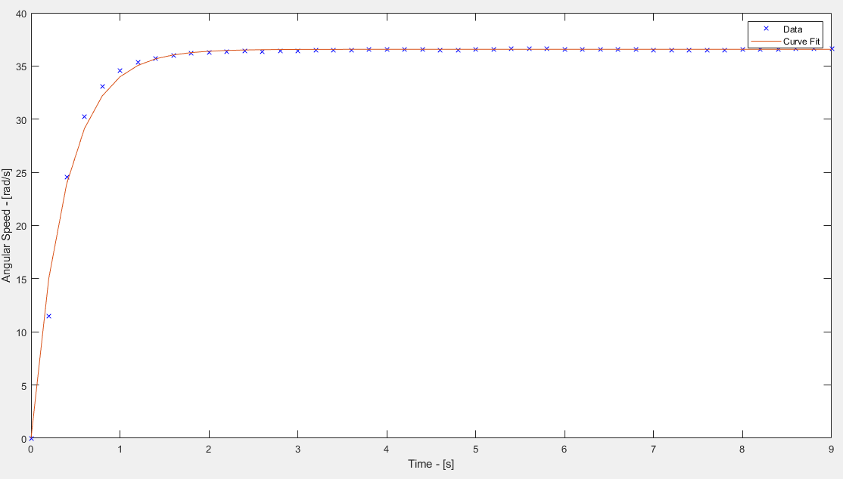

Bonus)

|  |  |
| --- | --- |
| General model: | f(x) = (10*b)/a * (1-exp(-a*x)) |
| a | 4.305 |
| b | 20.42 |

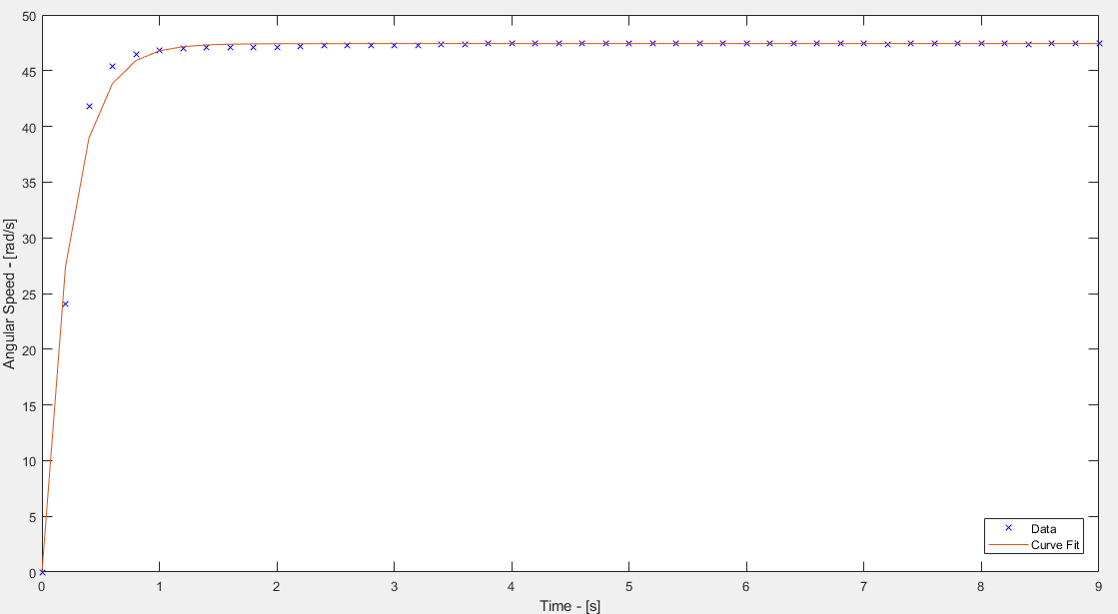

The values found for the second experiment are not the same as the values found during the first one. This makes sense because a DC motor is in realty a 2nd order system and we are modeling it as a first order. This simplification could introduce errors into the system parameters we are estimating.