

Civil Air Patrol Check-In Application
This document provides installation instructions, configuration guidance, and usage procedures for the Civil Air Patrol (CAP) Check-In Application. Sections marked as placeholders may be expanded or customized by the unit.

1. Overview
The CAP Check-In Application is a Windows-based application designed to streamline member attendance tracking at meetings, events, and activities. The application supports barcode scanning, manual CAPID input, member lookup, attendance logging, and reporting.

2. System Requirements
- Windows 10 or newer
- USB barcode scanner (Optional but preferred)
- Optional speakers for audio feedback
- Network access (optional, for update checks and usage tracking)

3. Installation

3.1 Installing the Application
1. Download the latest release from the official GitHub repository.
2. Save CAPCheckIn.exe is a dedicated folder.
3. Run CAPCheckIn.exe.
No Python installation is required.

3.2 First Launch Behavior
On first launch, the application will create required folders and files in the working directory. A splash screen will display while the application loads.

4. Configuration

4.1 Member Data
Member information is stored in Member.csv and is used to display the name of a known CAP member during checkin. This is optional but does reassures the scan worked as expected. This file may be imported from CAPWatch or Member Reports.

4.2 Event Setup
At startup, the user is prompted to enter or select an event name. This event name is used to generate attendance and error log files.
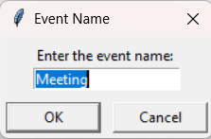

4.3 Sound and Visual Indicators
The application provides optional audio cues and color-coded counters to indicate successful check-ins, successful check-in that does not match a CAP ID in the member.csv file, and invalid scans that will not be copied into eServices.
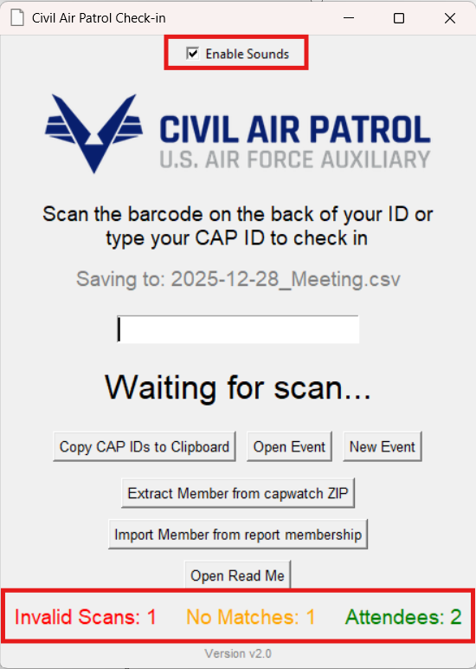

5. Using the Application

5.1 Starting an Event
1. Launch the application.
2. Enter or confirm the event name.
3. Verify the active output file shown on screen.

5.2 Scanning Members
Members may be checked in by scanning their CAPID barcode or manually entering their CAPID. The scan field automatically regains focus after each scan.

5.3 Counters and Indicators
- Attendees: Unique members successfully checked in
- Not Found: CAPIDs not present in the lookup file
- Invalid: Invalid scan formats

5.4 Opening Previous Events
Previously saved event files may be opened for review. Counters automatically update to reflect the selected file.

5.5 Upload attendance into eServices
NOTE: If doing this on a shared computers, open a GUEST profile so your password for eServices is not saved.
https://www.capnhq.gov/
Sign in with your CAP ID and password
Click on Menu – Personnel – Attendance Log
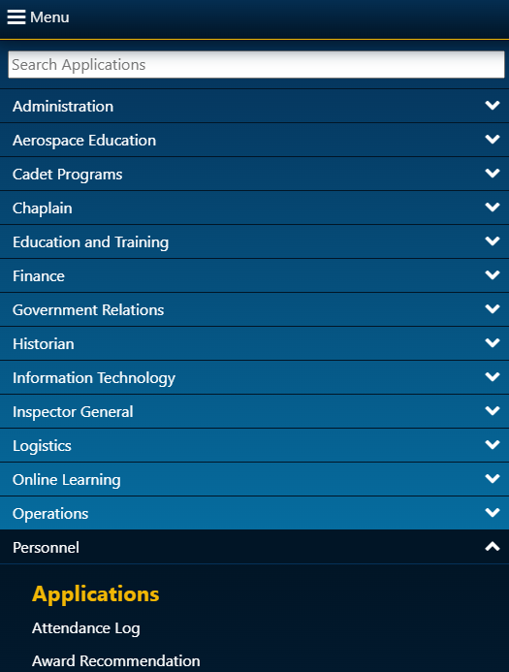
Click “New Meeting”
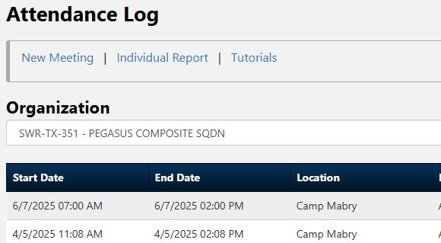
Pick Organization

Pick Meeting start and stop time
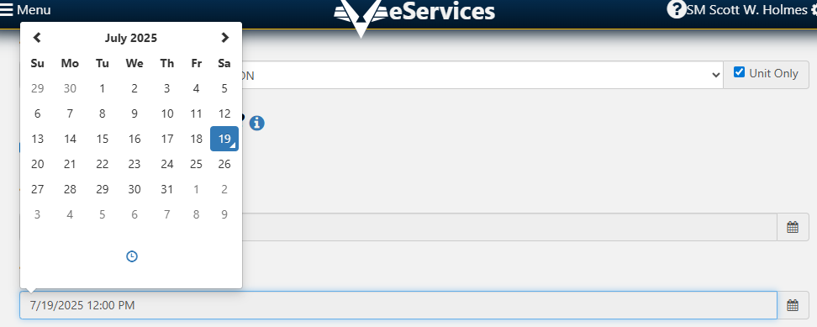
Select Member Type (normally All Members)
Location – You know where you are
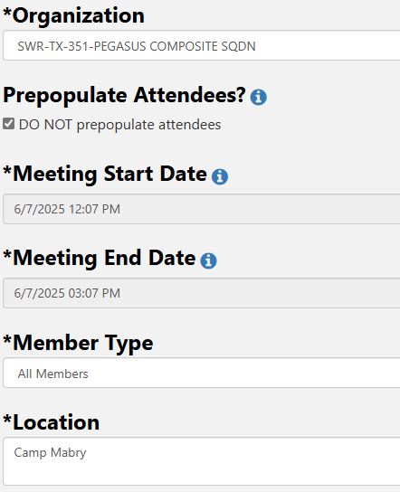
Select Topics for that meeting
Click Create
In the CAP Checkin App, click on Copy CAP IDs to clipboard. Go back to the eService in your browser.
Paste all the CAP IDs into the Bulk Entry field of the meeting you created
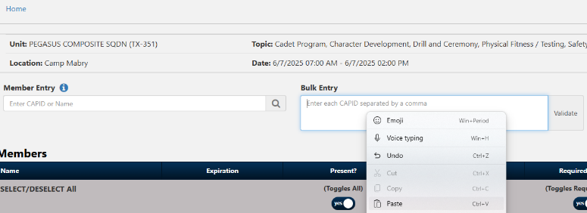
Click Validate
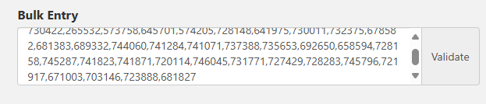
You should see people being checked in.
Click “Save Attendance” at the bottom
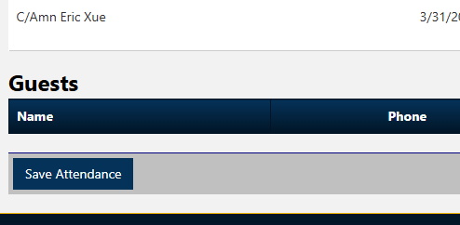
.

6. Files and Data Storage
The application stores attendance and error logs as CSV files named by date and event. Files are suitable for import into Excel or other reporting tools. These files can be found the the sub folders scans, yearly, and errors folders.

7. Updates and Versioning
The application checks for newer versions at startup and notifies the user when an update is available.
You can find the latest version here: https://hub.com/dad4holmes/CAPCheckin/releases/latest

8. Troubleshooting
- Application does not start: Verify antivirus did not block execution
- Scanner not working: Confirm focus of the computer is in the input box of the application. Confirm scanner is in keyboard mode and is programed to hit enter after each scan.

9. Security and Data Handling
You are responsible for securing CAP data.
CAPR 1-2
https://www.gocivilairpatrol.com/media/cms/R110_001_FE23FC8744B15.pdf
R_1101__25_January_2021_04C675E09D68B.pdf

10. Support and Maintenance
For updates, documentation, and issue reporting, refer to the official GitHub repository.

