# CIS 573

# SEASPrint Project

# Technical Documentation

Xin Dong

Siyong Liang

Tao Mo

Mingfei Shao

December 19, 2012

1. **Introduction**

This technical documentation is served as a detailed description about the related Activity classes, JUnit tests, and concerns (if any) for each screen of the SEASPrint application.

1. **The Login Screen**
2. **The Screenshot**

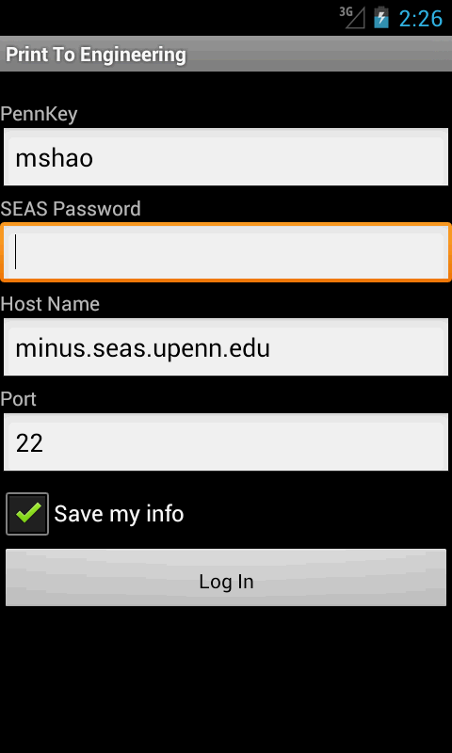

**Screenshot 1 The Login Screen**

1. **Related Activity Class**

* com.engineering.printer.AuthStep.java
* com.engineering.printer.EngineeringPrinter.java
* com.engineering.printer.EncryptUtil.java: the class that extracts the encryption functions of password for test purposes.
* com.engineering.printer.MicrosoftSink.java
* com.engineering.printer.ErrorCallback.java
* com.engineering.printer.ConnectionFactory.java
* com.engineering.printer.CommandConnection.java
* com.engineering.printer.FileUpload.java
* com.trilead.ssh2.Connection.java: provide the SSH connection ability.

1. **Related JUnit Test**

* EncryptUtilTest.java

1. **The Main Menu Screen**
2. **The Screenshot**

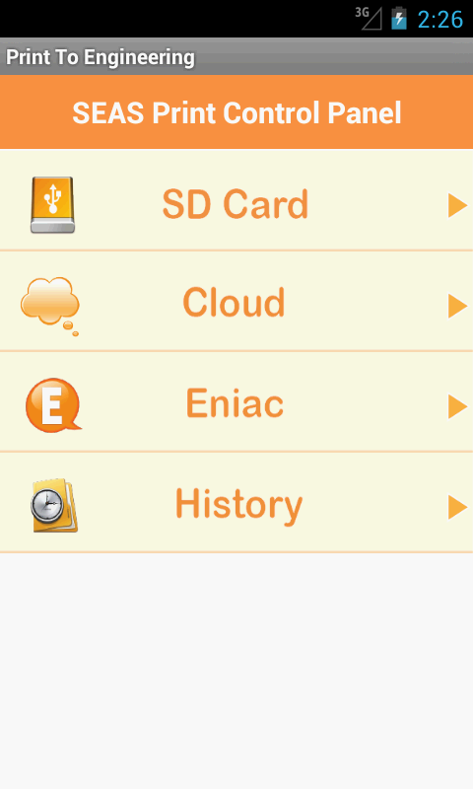

**Screenshot 2 The Main Menu Screen**

1. **Related Activity Class**

* com.engineering.printer.ControlPanelScreen.java

1. **Related JUnit Test**
2. **The SD File Picker Screen**
3. **The Screenshot**

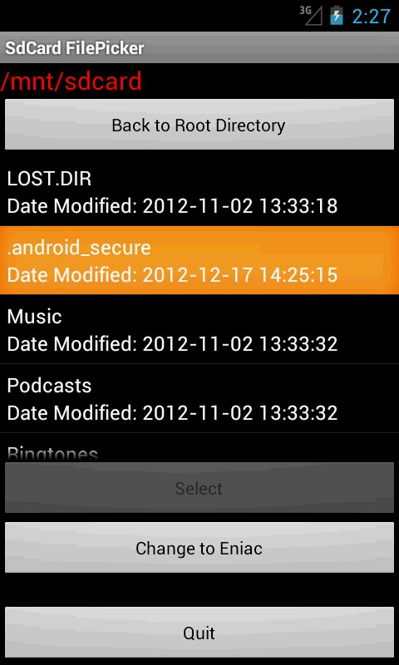

**Screenshot 3 The SD File Picker Screen**

1. **Related Activity Class**

* com.engineering.printer.SDFilePicker.java

1. **Related JUnit Test**
2. **The Eniac File Picker Screen**
3. **The Screenshot**

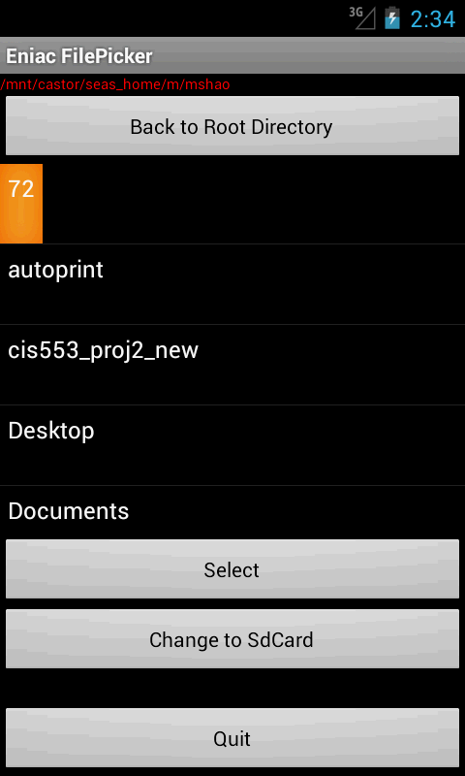

**Screenshot 4 The Eniac File Picker Screen**

1. **Related Activity Class**

* com.engineering.printer.EniacFilePicker.java

1. **Related JUnit Test**
2. **The Cloud File Picker Screen**
3. **The Screenshot**
4. **Related Activity Class**

* io.filepicker.FilePicker.java
* io.filepicker.FilePickerAPI.java

1. **Related JUnit Test**
2. **The Printer Preference Screen**
3. **The Screenshot**

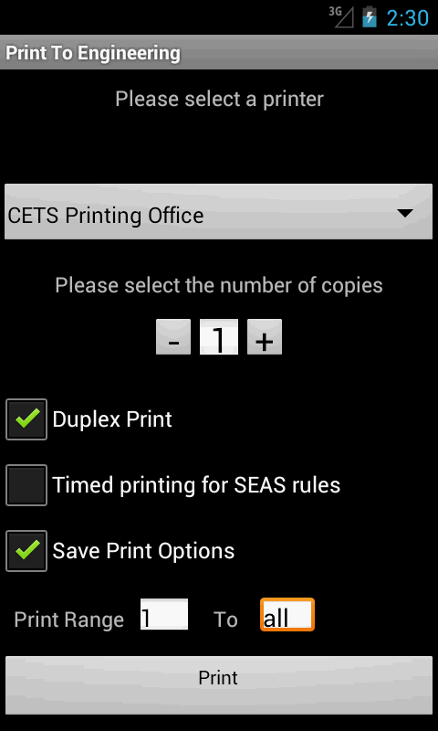

**Screenshot 5 The Printer Preference Screen**

1. **Related Activity Class**

* com.engineering.printer.PrinterSelectScreen.java
* com.engineering.printer.PrintCaller.java
* com.engineering.printer.NumberPicker.java

1. **Related JUnit Test**
2. **The Printing Progress Screen**
3. **The Screenshot**

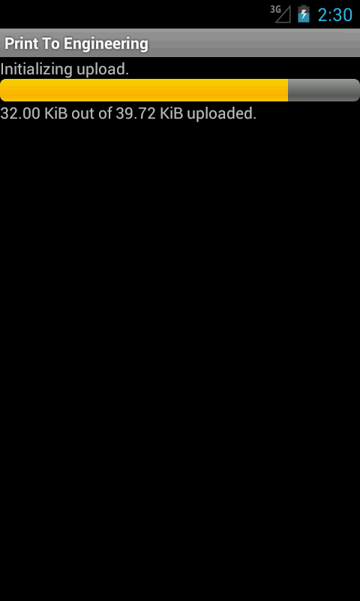

**Screenshot 7 The Printing Progress Screen**

1. **Related Activity Class**

* com.engineering.printer.LoadingStatusScreen.java
* com.engineering.printer.TimedPrintUtil.java
* com.engineering.printer.FileUpload.java

1. **Related JUnit Test**
2. **The Print History Screen**
3. **The Screenshot**
4. **Related Activity Class**

* com.engineering.printer.PrintHistoryScreen.java
* com.engineering.printer.Document.java

1. **Related JUnit Test**

* DocumentTest.java