# CIS 573

# SEASPrint Project

# User Manual

Xin Dong

Siyong Liang

Tao Mo

Mingfei Shao

December 19, 2012

1. **Introduction**

The SEASPrint project is an Android app that was developed during PennApps 2010. This app prints office documents from an android phone directly to a printer in SEAS. It requires a SEAS username (PennKey) and password to login and will print the document directly from user’s Android device.

As for the CIS573 project, our group was working on the existing code base since September. During our implementation on SEASPrint as a CIS573 project, we not only managed to get the code working, but also added a lot of new features into it. Functionalities we have implemented so far including:

* To print document in local SD card or remote SEAS directories;
* To print document from cloud side (e.g. Dropbox, Google Drive, or Evernote) by using existing Filepicker.io API;
* Newly implemented printer option page;
* “Duplex Print” option allows user to print on both side of the paper;
* “Time Print” option allows user to print the document with respect to SEAS’s “5 pages every 30 minutes” rule;
* “Save Print Option” allows user to save all print option including preferred printer for a convenient next-time use;
* “Page Range” option allows user to specify the number of pages he/she want to print;
* “Print History” page allows user to browser the documents that have benn printed by this application;
* Newly designed UI for better user experiences.

Now, the SEASPrint app is well-developed and can be used on any Android devices.

This user manual is served as a screen-by-screen instruction on how to work with this app.

Enjoy!

1. **Launch and Login**

First of all is to install the application on your Android device. The minimum Android version of the device is Android 2.1 (SDK 7) and we have tested this application on device running Android 4.2 (SDK 17).

Upon installation complete, the icon of SEASPrint will shows in your Apps as in **Screenshot 1**. Click it to run SEASPrint.

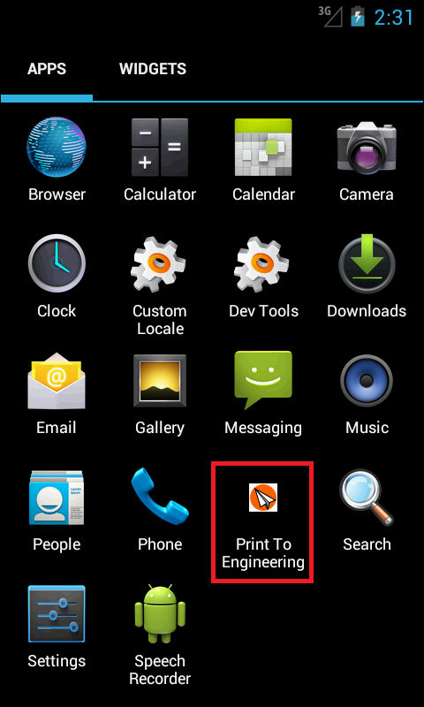

**Screenshot 1 Icon of SEASPrint App**

After launching the app, a login screen will appear (**Screenshot 2**). This screen requires you to input your SEAS username (PennKey) and password for authentication. You can change the Host Address or the Port Number when necessary. You can also saves your info (i.e. your PennKey) so you do not need to re-enter it next time.

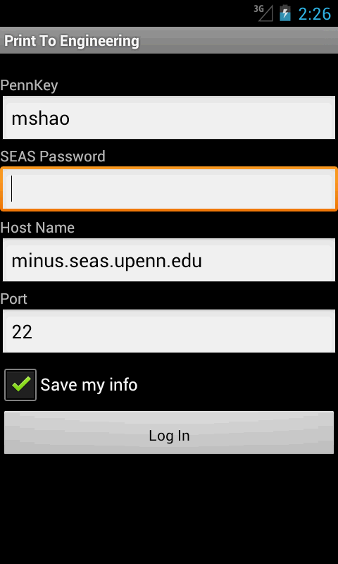

**Screenshot 2 The Login Screen**

If the authentication successes, the main menu screen will shows. From here, you can access all features of the SEASPrint application. Please refer to the following sections for detailed information.

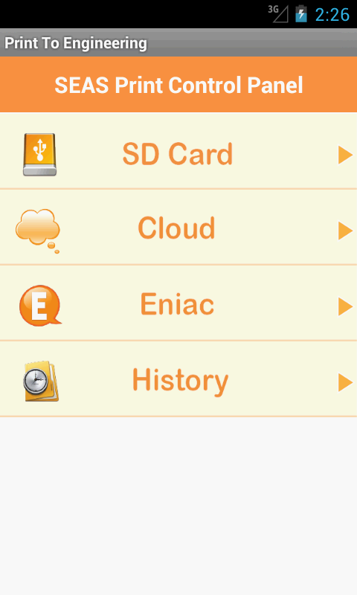

**Screenshot 3 The Main Menu**

1. **Select Document from SD Card or on Eniac**

To print files from your local SD card or remote Eniac machine, you need first to select “SD Card” or “Eniac” in the main menu screen accordingly.

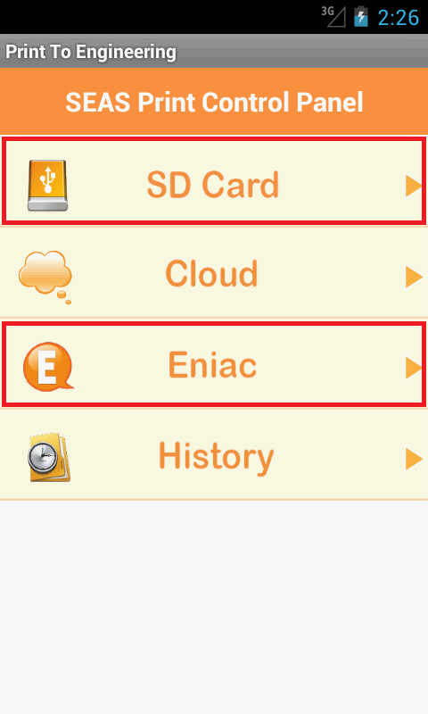

**Screenshot 4 Printing from SD Card or Eniac**

After that, a file-picker screen will appear. This screen allows user to browse files under the directory and to choose any documents he/she wants to print. User can also switch from SD Card to Eniac or vice-versa by using the “Change to Eniac” or “Change to SD Card” button on the page. The “Back to Root Directory” button will change the current path back to root in each scenario.

Once a valid file is selected (could be any .txt, .log, .pdf, or any Microsoft Office document formats), the “Select” button will enable. Otherwise, this button will remain disabled. Print the selected document by click on the “Select” button, which will lead you to the Printer Preference screen (discussed in section 5).

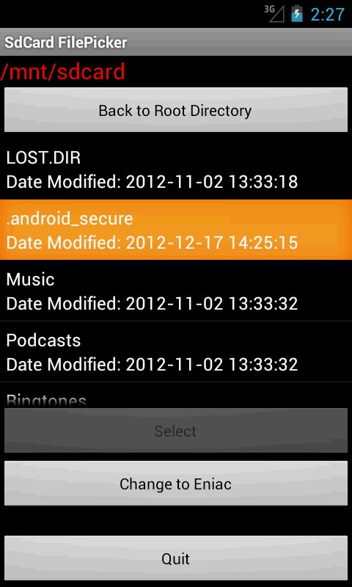 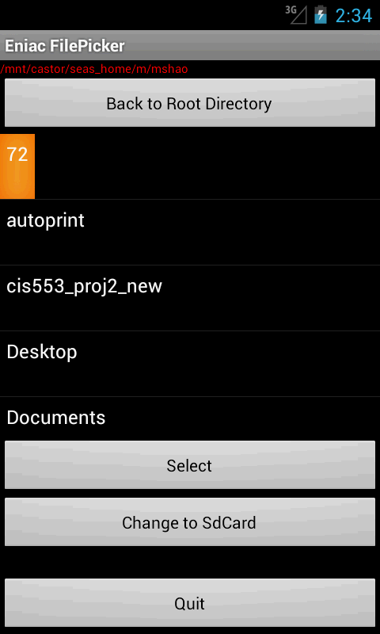

**Screenshot 5 Selecting Document on SD Card (Left) or Eniac (Right)**

1. **Select File from Cloud Side**
2. **Set Printer Preferences and Print**

You will be able to see this screen (**Screenshot 6**) after you have chosen the document you want to print.

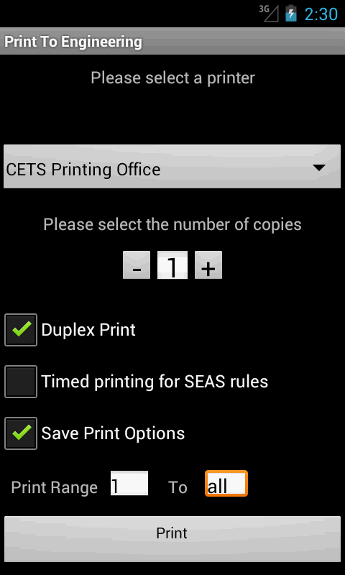

**Screenshot 6 The Printer Preference Setting Screen**

On the top is a printer chooser scroll bar, which will be addressed later. Blow it is a number picker field allows the user to specify the copies he/she wants to print, simple click on the “+” or “-” sign to increase or decrease it.

The three checkboxes below provides some advanced features for printing: “Duplex Print” allows user to print on both sides of the paper; “Timed Print” allows user to print with respect to SEAS’s printing policy (5 pages every 30 minutes); and “Save Options” will save all these preferences.

Under these checkboxes is a field allows user to specify the page range he/she wants to print. If the number entered is greater than the actual number of the last page of the document, it will only print until the last page of the document.

The user is also able to change the printer he/she wants to use by clicking the printer selector as in **Screenshot 7**. The default printer “CETS Printing Office” is the public CETS printer in Levine 164.

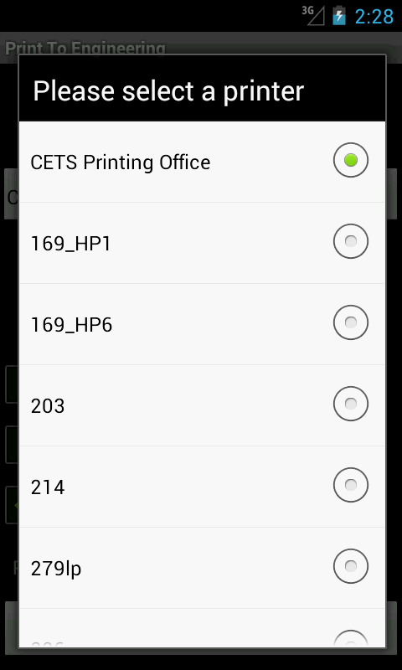

**Screenshot 7 The Printer Selector**

After setting up all these options, just simply click on the “Print” button and the task will be sent to the remote printer. A page will shows with a progress bar indicating how much the task has already be transferred. Then you can pick them at Levine 164 (assuming you are using the default printer) and enjoy the convenience of SEASPrint!

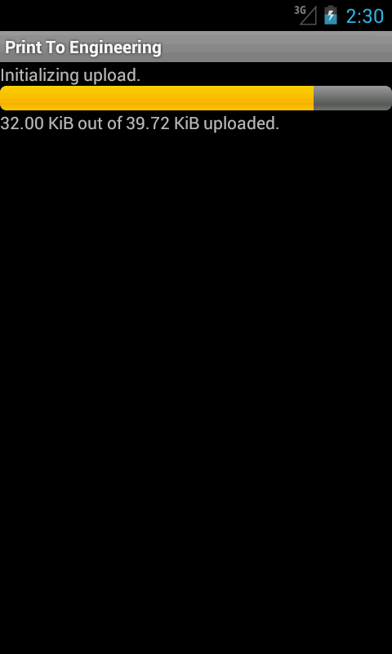

**Screenshot 8 The Printing Progress Screen**

1. **View Print History**