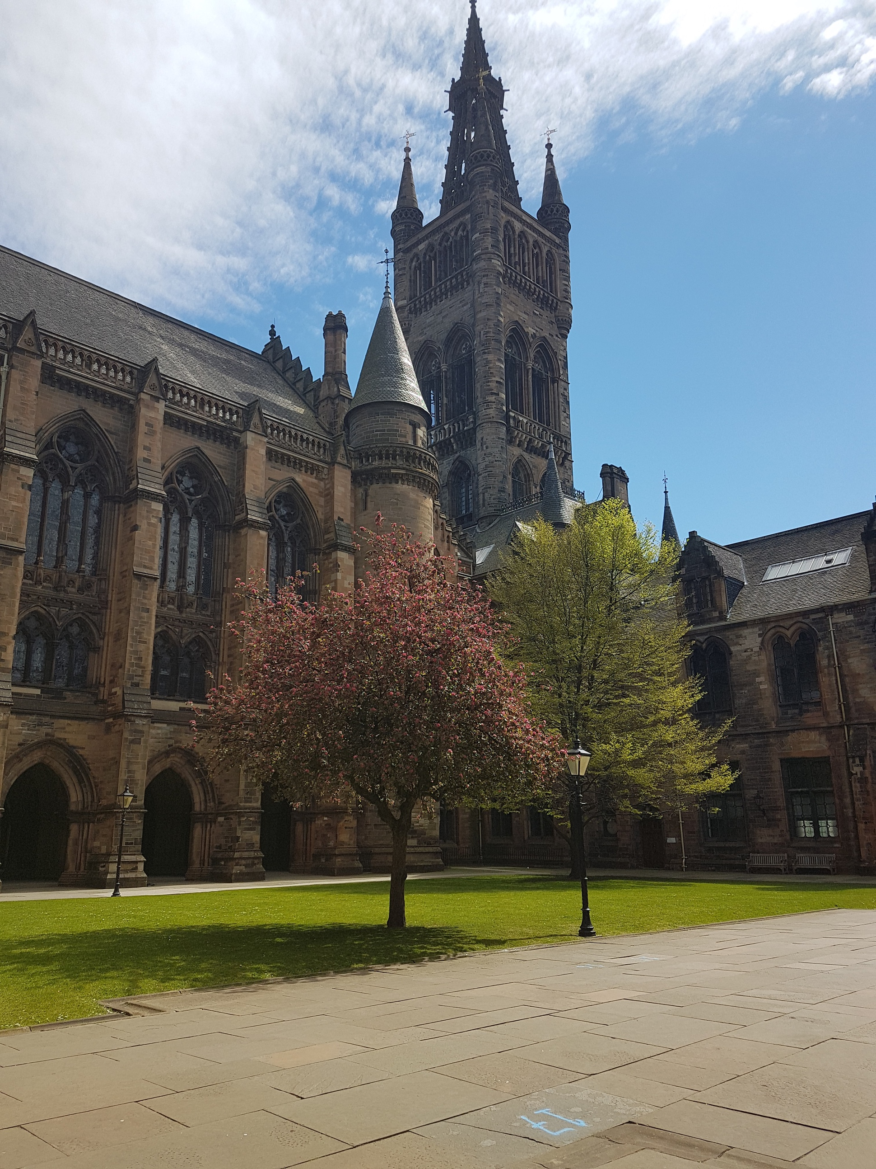



UESTC3030

**Contract Law coursework**

**Submission Template**

**2022/2023**

S

Table of contents

Declaration of Originality Form 2

The University of Glasgow Plagiarism Statement 3

Declaration of Contribution 4

Advice to Nazeem explain Legal Position as owner of Elite Motors in relation to Struan 4

Advice to Nazeem explain Legal Position as owner of Elite Motors in relation to Paul 4

Advice to Nazeem explain Legal Position as owner of Elite Motors in relation to Kirit 4

Advice on the Level of Remedies that can be awarded and why. 4

Do you see any issued raised regarding intellectual property rights? If so, justify what the issues are and their implications to the individuals concerned . 4

References 5

READ THE FOLOWING - DELETE SECTION BEFORE SUBMITTING YOUR ASSESSMENT 5

|  |  |  |
| --- | --- | --- |
|  | **[Insert School’s own header]** | |
| Declaration of Originality Form | | |
| This form **must** be completed and signed and submitted with all assignments. | | |
| Please complete the information below (using BLOCK CAPITALS). | | |
| Name  Student Number  Course Name  Assignment Number/Name | | |
| **An extract from the University’s Statement on Plagiarism is provided overleaf. Please read carefully THEN read and sign the declaration below.** | | |
| **I confirm that this assignment is my own work and that I have:** | | |
| Read and understood the guidance on plagiarism in the Student Handbook, including the University of Glasgow Statement on Plagiarism | | ⬜ |
| Clearly referenced, in both the text and the bibliography or references, **all sources** used in the work | | ⬜ |
| Fully referenced (including page numbers) and used inverted commas for **all text quoted** from books, journals, web etc. (Please check with the Department which referencing style is to be used) | | ⬜ |
| Provided the sources for all tables, figures, data etc. that are not my own work | | ⬜ |
| Not made use of the work of any other student(s) past or present without acknowledgement. This includes any of my own work, that has been previously, or concurrently, submitted for assessment, either at this or any other educational institution, including school (see overleaf at 31.2) | | ⬜ |
| Not sought or used the services of any professional agencies to produce this work | | ⬜ |
| In addition, I understand that any false claim in respect of this work will result in disciplinary action in accordance with University regulations | | ⬜ |
|  | |  |
| **DECLARATION:**  I am aware of and understand the University’s policy on plagiarism and I certify that this assignment is my own work**,** except where indicated by referencing, and that I have followed the good academic practices noted above  Signed | | |

# The University of Glasgow Plagiarism Statement

|  |
| --- |
| The following is an extract from the University of Glasgow Plagiarism Statement. The full statement can be found in the University Calendar at <http://www.gla.ac.uk/media/media_413985_en.pdf#page=53&view=fitH,225>.  This should be read in conjunction with the discipline specific guidance provided by the School at  https://www.gla.ac.uk/schools/engineering/students/courseinformation/studenthandbook/ug-handbook/academicconduct/#plagiarism |
| 31.1 The University's degrees and other academic awards are given in recognition of a student's **personal** **achievement**. All work submitted by students for assessment is accepted on the understanding that it is the student's own effort. |
| 31.2 Plagiarism is defined as the submission or presentation of work, in any form, which is not one's own, without **acknowledgement of the sources**. Plagiarism includes inappropriate collaboration with others. Special cases of plagiarism can arise from a student using his or her own previous work (termed auto-plagiarism or self-plagiarism). Auto-plagiarism includes using work that has already been submitted for assessment at this University or for any other academic award. |
| 31.3 The incorporation of material without formal and proper acknowledgement (even with no deliberate intent to cheat) can constitute plagiarism. |
| **Work may be considered to be plagiarised if it consists of:**   * a direct quotation; * a close paraphrase; * an unacknowledged summary of a source; * direct copying or transcription.   With regard to essays, reports and dissertations, the rule is: ifinformation **or ideas** are obtained from any source, that source must be acknowledged according to the appropriate convention in that discipline; and **any direct quotation must be placed in quotation marks** and the source cited immediately. Any failure to acknowledge adequately or to cite properly other sources in submitted work is plagiarism. Under examination conditions, material learnt by rote or close paraphrase will be expected to follow the usual rules of reference citation otherwise it will be considered as plagiarism. Departments should provide guidance on other appropriate use of references in examination conditions. |
| 31.4 Plagiarism is considered to be an act of fraudulence and an offence against University discipline. Alleged plagiarism, at whatever stage of a student's studies, whether before or after graduation, will be investigated and dealt with appropriately by the University. |
| 31.5 The University reserves the right to use plagiarism detection systems, which may be externally based, in the interests of improving academic standards when assessing student work. |

If you are still unsure or unclear about what plagiarism is or need advice on how to avoid it,

**SEEK HELP NOW!**

You can contact any one of the following for assistance:

**Lecturer   
Course Leader  
Dissertation Supervisor  
Adviser of Studies  
Student Learning Service**

## Declaration of Contribution

Declare which members of the team have not contributed to this work by overriding this statement.

## Advice to Nazeem explain Legal Position as owner of Elite Motors in relation to Struan

This is the font and its size (Arial Size 11) Paragraph spacing 2.0. Changing these settings will incur a 10% penalty. Type your answer over these guidelines.

## Advice to Nazeem explain Legal Position as owner of Elite Motors in relation to Paul

This is the font and its size (Arial Size 11) Paragraph spacing 2.0. Changing these settings will incur a 10% penalty. Tyhpe your answer over these guidelines.

## Advice to Nazeem explain Legal Position as owner of Elite Motors in relation to Kirit

In regard to Kirit, as a university student who was asked to "keep an eye on the business" while Nazeem was away, he was not acting as an employee of Elite Motors and therefore is not entitled to payment for his time. Nazeem may have appreciated the favour Kirit did in watching the dealership, but it was not a contractual agreement and Kirit was not hired to perform any specific duties or tasks.

Nazeem should explain this legal position to Kirit and make it clear that he is not entitled to payment for the time he spent at Elite Motors. Yet, as a family, Nazeem could still give certain money as thanks to his nephew, which is not obligatory at all.

## Advice on the Level of Remedies that can be awarded and why.

This is the font and its size (Arial Size 11) Paragraph spacing 2.0. Changing these settings will incur a 10% penalty. Type your answer over these guidelines.

## Do you see any issued raised regarding intellectual property rights? If so, justify what the issues are and their implications to the individuals concerned .

This is the font and its size (Arial Size 11) Paragraph spacing 2.0. Changing these settings will incur a 10% penalty. Type your answer over these guidelines.

## References

Your reference must be completed in Harvard Style.

This is the font and its size (Arial Size 11) Paragraph spacing of 2.0 is not applicable to this section of your work. Changing the fint and its size settings will incur a 10% penalty. Type your references over these guidelines. You may use Endnote to copy/paste your references.

## READ THE FOLOWING - DELETE SECTION BEFORE SUBMITTING YOUR ASSESSMENT

This assessment template contains XXX words. The overall word limit to this assessment is XXX. The work limit and the penalty is only applied to the given answers including their headings. There is no limit between different answers. References are not included in the final word count.