Subject: Adjust parameters for angle deflection

Date: 3.26

Author: Zhan Fuzhen

Main Contents:

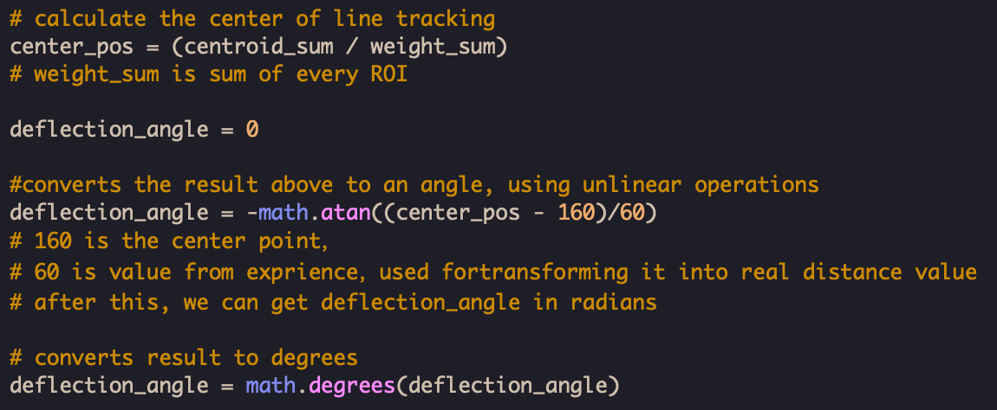

Initially, we choose center point of the view as (160, 120), where 320 is the length of view and 240 is the width of the view. The width and length are derived from openMV IDE.

Theoretically, it is supposed to be (160, 120). However, we modify the center point of view a little down to the bottom (from 120 to 60) which proves to achieve better performance.

Subject: Calculate deflection angle

Date: 4.6

Author: Zhan Fuzhen

Main Contents:

We set 4 Regions of Interest (ROI) evenly, dividing the captured image from the top to the bottom equally. In each part, find the most significant or biggest cluster of white dots.

By doing so, we could find 4 main blobs, or white-point clusters.

Weighted sum is then utilized to calculate the current center point of the tracking line

As a result, the **deflection angle** is formed between **center** **vertical line** and **line** connecting **2 center points (center point of view and current center point of line tracking )**.

And deflection angle is measured and calculated.

Subject: Structures of PID

Date: 4.15

Author: Zhan Fuzhen

Main Contents:

The formula for the whole PID controller is:

$$MV = K_{p} * e\left(t\right)+ K_{i} * \int{e\left(t\right)dt} + K_{d} *\frac{de\left(t\right)}{dt}$$

Where:

- is the manipulated variable (the output of the PID controller).

- are coefficients for the Proportional, Integral, and Derivative terms respectively.

- is the error = (desired set point) - (measured variable).

- is the integral of the error over time.

- is the derivative of the error, or the rate of change of the error.

Subject: Adjust coefficients of PID

Date: 4.20

Author: Zhan Fuzhen

Main Contents:

In patio 1 test, In practice, we improve the effects of the adjustment from output of PID by multiplying 1.5 in order to have better line tracking performance.

It turns out to be better.

Subject: Use ultrasonic sensors and create initial version of code

Date: 5.8

Author: Zhan Fuzhen

Main Contents:

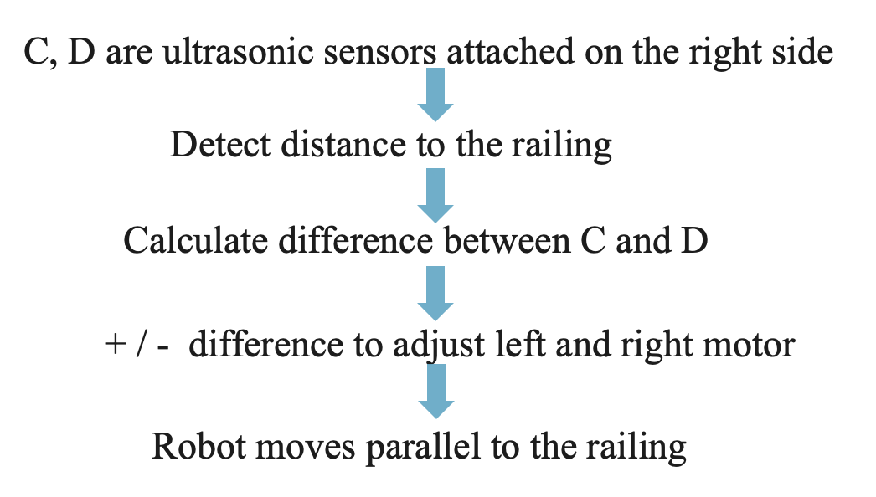

We initialize the sensors used for giving distance information.

Subject: Adjust power of both motors

Date: 5.8

Author: Zhan Fuzhen

Main Contents:

Due to the change of the ground, the resulting friction would change as well. We adjust the power to both motors from both 0.5 to 0.5 and 0.58 respectively for going straight.

And the last version of code in Patio 2

