INITIATING COVERAGE
Equity Research
Cadence Design Systems, Inc.
NASDAQ: CDNS
Information Technology — Software | Electronic Design Automation
Recommendation  BUY | 12-Mo Price Target  $400 | Current Price  $338.19 | Implied Upside  +18.3%

Key Statistics
Metric | Value
Ticker | NASDAQ: CDNS
Market capitalization | $93.3B
Enterprise value | $92.7B
Diluted shares (M) | 273.3
FY25 revenue | $5,297M
FY26E revenue (guide) | $6,175M
FY26E non-GAAP EPS | $7.90
DCF intrinsic value | $194
12-month price target | $400
Recommendation | BUY
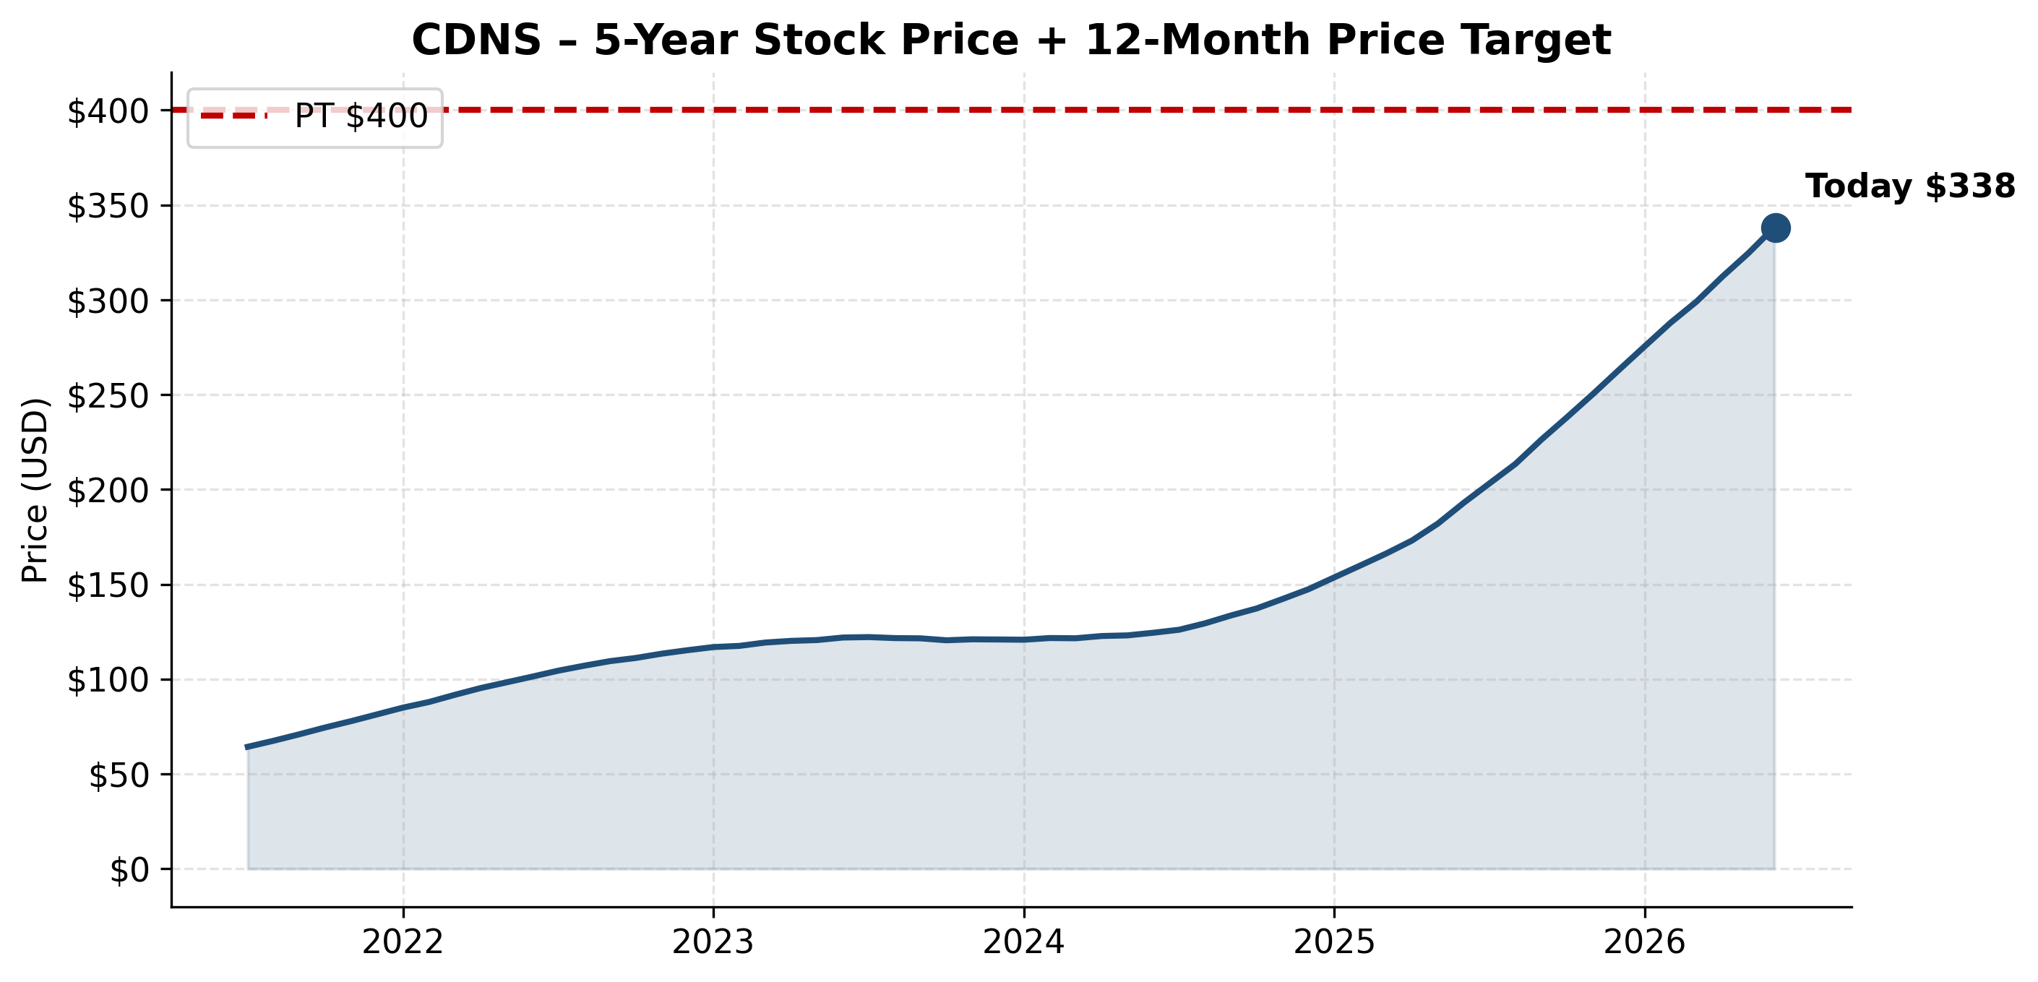
NASDAQ: CDNS — 5-Year Stock Price + 12-Month Price Target

Investment Summary
We initiate coverage of Cadence Design Systems (CDNS) with a BUY rating and a 12-month price target of $400, representing ~18% upside from the current $338.19. Cadence is one of two pure-play public vehicles for the secular acceleration of semiconductor design spend driven by AI infrastructure, advanced packaging, automotive software-defined silicon, and the broader shift to chiplets. Our thesis rests on five pillars: a structural AI-design tailwind, clean +14% all-organic growth, best-in-class profitability (~44% non-GAAP operating margin), a pristine balance sheet ($0.5B net cash) enabling continued bolt-on M&A and buyback, and the cleanest three-horizon AI narrative in the EDA sector. We see the current valuation (~43x forward P/E) as justified by quality, recurring revenue (>80%), customer entrenchment (near-100% retention), and the secular position of EDA as a regulated duopoly.
Investment Thesis (5 Pillars)
AI-Infrastructure Tollkeeper
Every leading-edge AI accelerator must pass through Cadence tools — Cerebrus, Allegro X, Palladium emulation. Customers (NVIDIA Blackwell/Rubin, AMD MI400, Google TPU, Meta MTIA, Microsoft Maia, Amazon Trainium) cannot replace this toolchain. Cadence is one of two pure-play public vehicles for AI silicon design spend.
All-Organic 14% Growth Compounder
FY25 +14% all-organic (vs. Synopsys's +15% boosted by M&A); FY26 guide raised on Q1 strength to $6.125-$6.225B (+16% mid). Backlog $7.8B → $8.0B at Q1 26 = 1.5x trailing revenue; strong visibility into FY26-27.
Best-in-Class Profitability
FY25 non-GAAP operating margin ~44%, GAAP ~28%; 90% gross margin; >100% net retention. Combined with high ROIC, Cadence is a pristine quality-software compounder.
Clean Balance Sheet = Optionality
$3.0B cash, $2.5B debt → $0.5B net cash. $1.4B remaining buyback authorization. Hexagon D&E pending close (1H 2026) adds ~$200M revenue + MSC Nastran multi-physics. SNPS has $10.6B net debt and tied hands; CDNS is the active acquirer.
Three-Horizon AI Narrative
Cadence's 'Infrastructure AI / Physical AI / Life Sciences AI' framing is the cleanest growth narrative in the sector. Cerebrus + JedAI is the most-agentic AI-design suite (>1,000 tapeouts; ~50 new logos/quarter).
Key Risks to Thesis
- BIS Settlement Overhang — $140.6M July 2025 guilty plea on China export violations carries 3-year probation and audit obligations; constrains M&A capability.
- Hexagon Integration — Largest M&A in company history will absorb management bandwidth in 1H 2026; channel-model differences.
- EU AI Act (Aug 2026) — Cadence is the only EDA peer to explicitly call this out; fines up to 7% of worldwide turnover. Cost burden uncertain.
- Chinese Domestic Competition — Huada Empyrean, Xpeedic, X-EPIC, Primarius, Univista, Giga Design named in 10-K; geopolitical decoupling accelerates risk.
- Valuation Multiple Compression — ~43x forward P/E leaves little margin for any deceleration below 12% revenue growth.
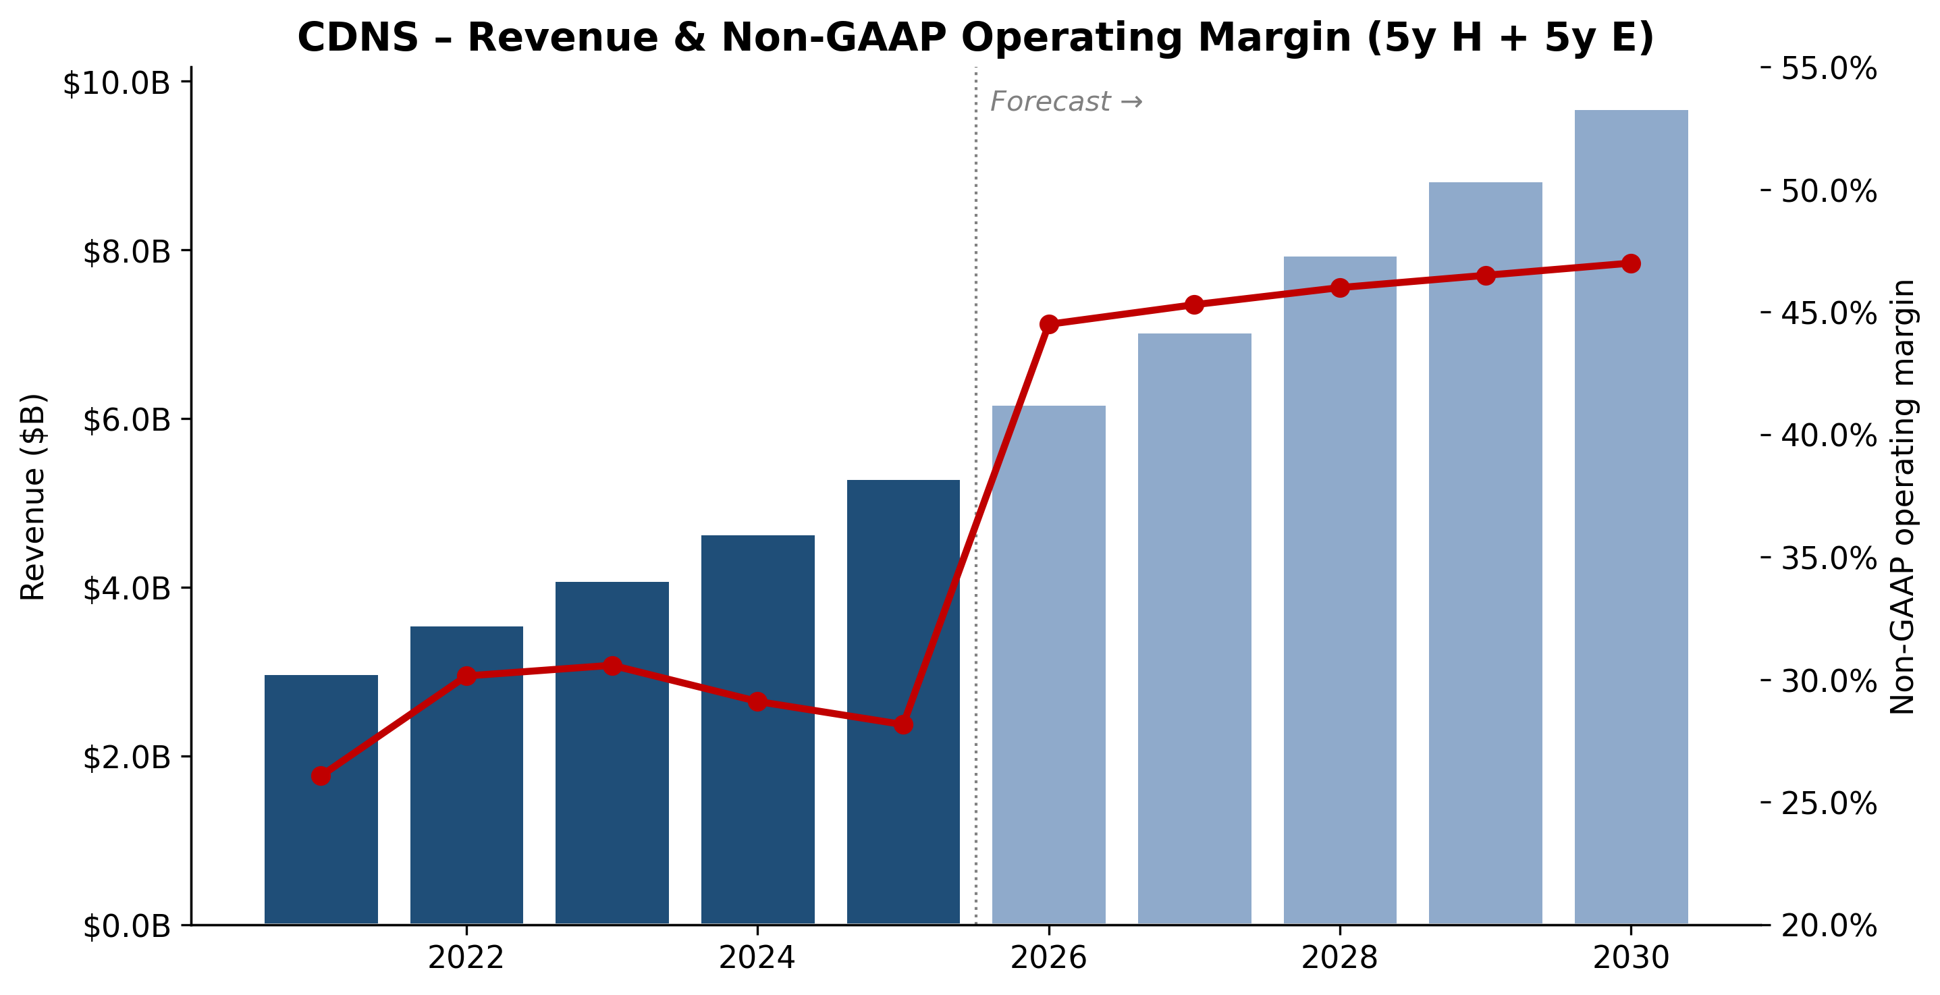
NASDAQ: CDNS — Revenue & Non-GAAP Operating Margin (5y Historical + 5y Projected)

Company Overview
COMPANY OVERVIEW
Cadence Design Systems, Inc. is the world's #2 supplier of electronic design automation (EDA) software, hardware emulation/prototyping systems, and silicon intellectual property (IP), occupying — together with Synopsys (SNPS) and Siemens EDA — a tight near-oligopoly that the EDA industry sometimes calls "the Big Three." Cadence sells the tools, hardware, and IP blocks that virtually every meaningful semiconductor design team on Earth uses to architect, simulate, verify, place-and-route, and sign off integrated circuits and full electromechanical systems. Headquartered at 2655 Seely Avenue in San Jose, California, the company describes itself as "a global technology leader that develops computational, AI-driven software, accelerated hardware, and silicon intellectual property ("IP") products and solutions" and frames its strategy under the "Intelligent System Design™" (ISD) banner (Cadence 2025 10-K, p. 1).
What it does, in plain English. Modern chips have tens to hundreds of billions of transistors; no human can lay them out by hand. Cadence supplies the software ("EDA tools") that lets engineers describe a chip in code (Verilog/SystemVerilog), automatically synthesize that code into a gate-level netlist, place those gates on silicon, route the wires between them, simulate the result, verify it matches the original intent, and finally sign it off so a foundry like TSMC or Samsung can fabricate it. Cadence also leases multi-million-dollar hardware emulation boxes (Palladium, Protium) that let customers run a chip's RTL at near-silicon speed before tape-out, and licenses pre-designed silicon IP blocks (PCIe, CXL, HBM, DDR, USB, SerDes, Tensilica DSPs, Secure-IC security) that customers drop into their SoCs to save engineering years.
How it makes money. Cadence's revenue model is highly recurring — the company reports the vast majority of its software is sold under time-based licenses (typically 2–3 years), and customers also sign hardware lease arrangements, IP royalty agreements, and multi-year master agreements known internally as "non-cancellable bookings." For FY2025, product and maintenance revenue was USD 4,821.6M (91% of revenue, +14% YoY) and services revenue was USD 475.2M (9%, +11% YoY), for total revenue of USD 5,296.8M (+14% YoY) (Cadence 2025 10-K, MD&A). On an internal product-category split (disclosed in earnings calls and CFO commentary rather than in the 10-K segment note — Cadence is a single reportable segment under ASC 280), Core EDA grew 13% in FY2025, IP roughly +20%, and System Design & Analysis low-teens. In Q1 2026 the cadence accelerated — Core EDA +18%, IP +22%, SD&A +18%, hardware delivered "a record quarter" (Q1-2026 press release, 2026-04-27).
Where it operates. Cadence sells globally, with United States = USD 2,311.0M (44% of FY25 revenue), Other Asia (ex-China, principally Taiwan and Korea) = USD 1,005.2M (19%), EMEA = USD 790.6M (15%), China = USD 680.0M (13%), Japan = USD 341.7M (6%), Other Americas = USD 168.3M (3%) (Cadence 2025 10-K, Note 17). Notably, China revenue *grew* 19% in FY2025 despite a high-profile, six-week U.S. Bureau of Industry and Security (BIS) "EDA-to-China" license requirement that was imposed on 2025-05-23 and rescinded on 2025-07-02 (Cadence 2025 10-K, p. 14; TrendForce, 2025-06-02).
Scale. Cadence ended FY2025 with ~13,800 employees (vs. ~12,300 at the prior fiscal year-end), the majority in engineering roles, plus approximately 1,100 additional staff added on 2026-02-23 with the closing of the Hexagon Design & Engineering acquisition (Cadence 2025 10-K, p. 8; Cadence press release, 2026-02-23). Total assets were USD 10.15 billion, cash and cash equivalents USD 3.00 billion, long-term debt USD 2.48 billion, stockholders' equity USD 5.47 billion (Cadence 2025 10-K, Consolidated Balance Sheets). FY2025 GAAP net income was USD 1,108.9M (EPS $4.06 diluted), operating cash flow USD 1,728.8M, capex USD 141.9M, free cash flow ≈ USD 1,587M. The company repurchased USD 928M of stock in FY2025 and ended the year with 271.8 million shares outstanding (vs. 273.9M at FY24 end).
*Source: Cadence 2025 10-K, Consolidated Statements of Operations; Cadence 2022 10-K (FY21 op income).*
Valuation snapshot (REQUIRED)
Metric | CDNS | SNPS (peer) | Comment
Price (2026-05-20) | ~USD 338 | ~USD 545 | [Yahoo Finance — CDNS](https://finance.yahoo.com/quote/CDNS/) / [SNPS](https://finance.yahoo.com/quote/SNPS/)
Market cap | ~USD 93B | ~USD 84B | [stockanalysis.com — CDNS](https://stockanalysis.com/stocks/cdns/)
TTM P/E (GAAP) | ~81x | ~77x | TTM EPS ≈ $4.18 ([CDNS PE — fullratio](https://fullratio.com/stocks/nasdaq-cdns/pe-ratio); [SNPS PE — fullratio](https://fullratio.com/stocks/nasdaq-snps/pe-ratio))
Forward P/E (non-GAAP) | ~43x | ~40x | FY26 non-GAAP EPS guide $7.85–7.95 ([Q1-2026 press release](https://www.sec.gov/Archives/edgar/data/0000813672/000081367226000044/cdns04272026ex9901.htm)); SNPS via [GuruFocus](https://www.gurufocus.com/term/forward-pe-ratio/SNPS)
TTM P/S | ~17.6x | ~15.2x | TTM revenue $5.30B ([10-K](https://www.sec.gov/Archives/edgar/data/0000813672/000081367226000016/cdns-20251231.htm)); SNPS via [artificall.com, 2026](https://artificall.com/analysis/companies/comparisons/synopsys-vs-cadence-design-systems/)
P/B | ~17x | ~7x | Book equity $5.47B
EV/EBITDA (TTM) | ~50x | ~45x | EBITDA ≈ $1.84B (op income + D&A + SBC)
52-wk range | $235–$385 | $390–$640 | [Yahoo Finance](https://finance.yahoo.com/quote/CDNS/)
3-yr P/E range | ~50x–95x | ~45x–110x | [Macrotrends — CDNS PE](https://www.macrotrends.net/stocks/charts/CDNS/cadence-design-systems/pe-ratio)
Software sector median P/E / P/S | 32x / 6.5x | — | [NYU Stern Damodaran data, Jan 2026](https://pages.stern.nyu.edu/~adamodar/New_Home_Page/data.html)

Interpretation. CDNS trades at ~81x TTM GAAP earnings and ~17.6x TTM revenue — comfortably above both its own 3-year median (~70x P/E, ~14x P/S) and ~2.5x the broad software sector median. The multiple is not explained by a one-off charge: the FY2025 P&L did absorb a USD 128.5M loss from the BIS/DOJ export-control settlement (see Section 9), but adding it back lifts GAAP EPS only ~$0.40 and would compress TTM P/E to ~74x — still rich.
The right framing is (a) high-growth-sector premium + (b) AI-infrastructure narrative. Cadence is one of two pure-play public vehicles for "every leading-edge chip needs more EDA spend than the last one" — an unambiguous picks-and-shovels exposure to AI training/inference silicon (NVIDIA Blackwell/Rubin, AMD MI400, custom hyperscaler ASICs from Google TPU, Meta MTIA, Microsoft Maia, Amazon Trainium/Inferentia), advanced packaging/3D-IC, automotive SDV silicon, and the secular shift to chiplets. With ~14% revenue
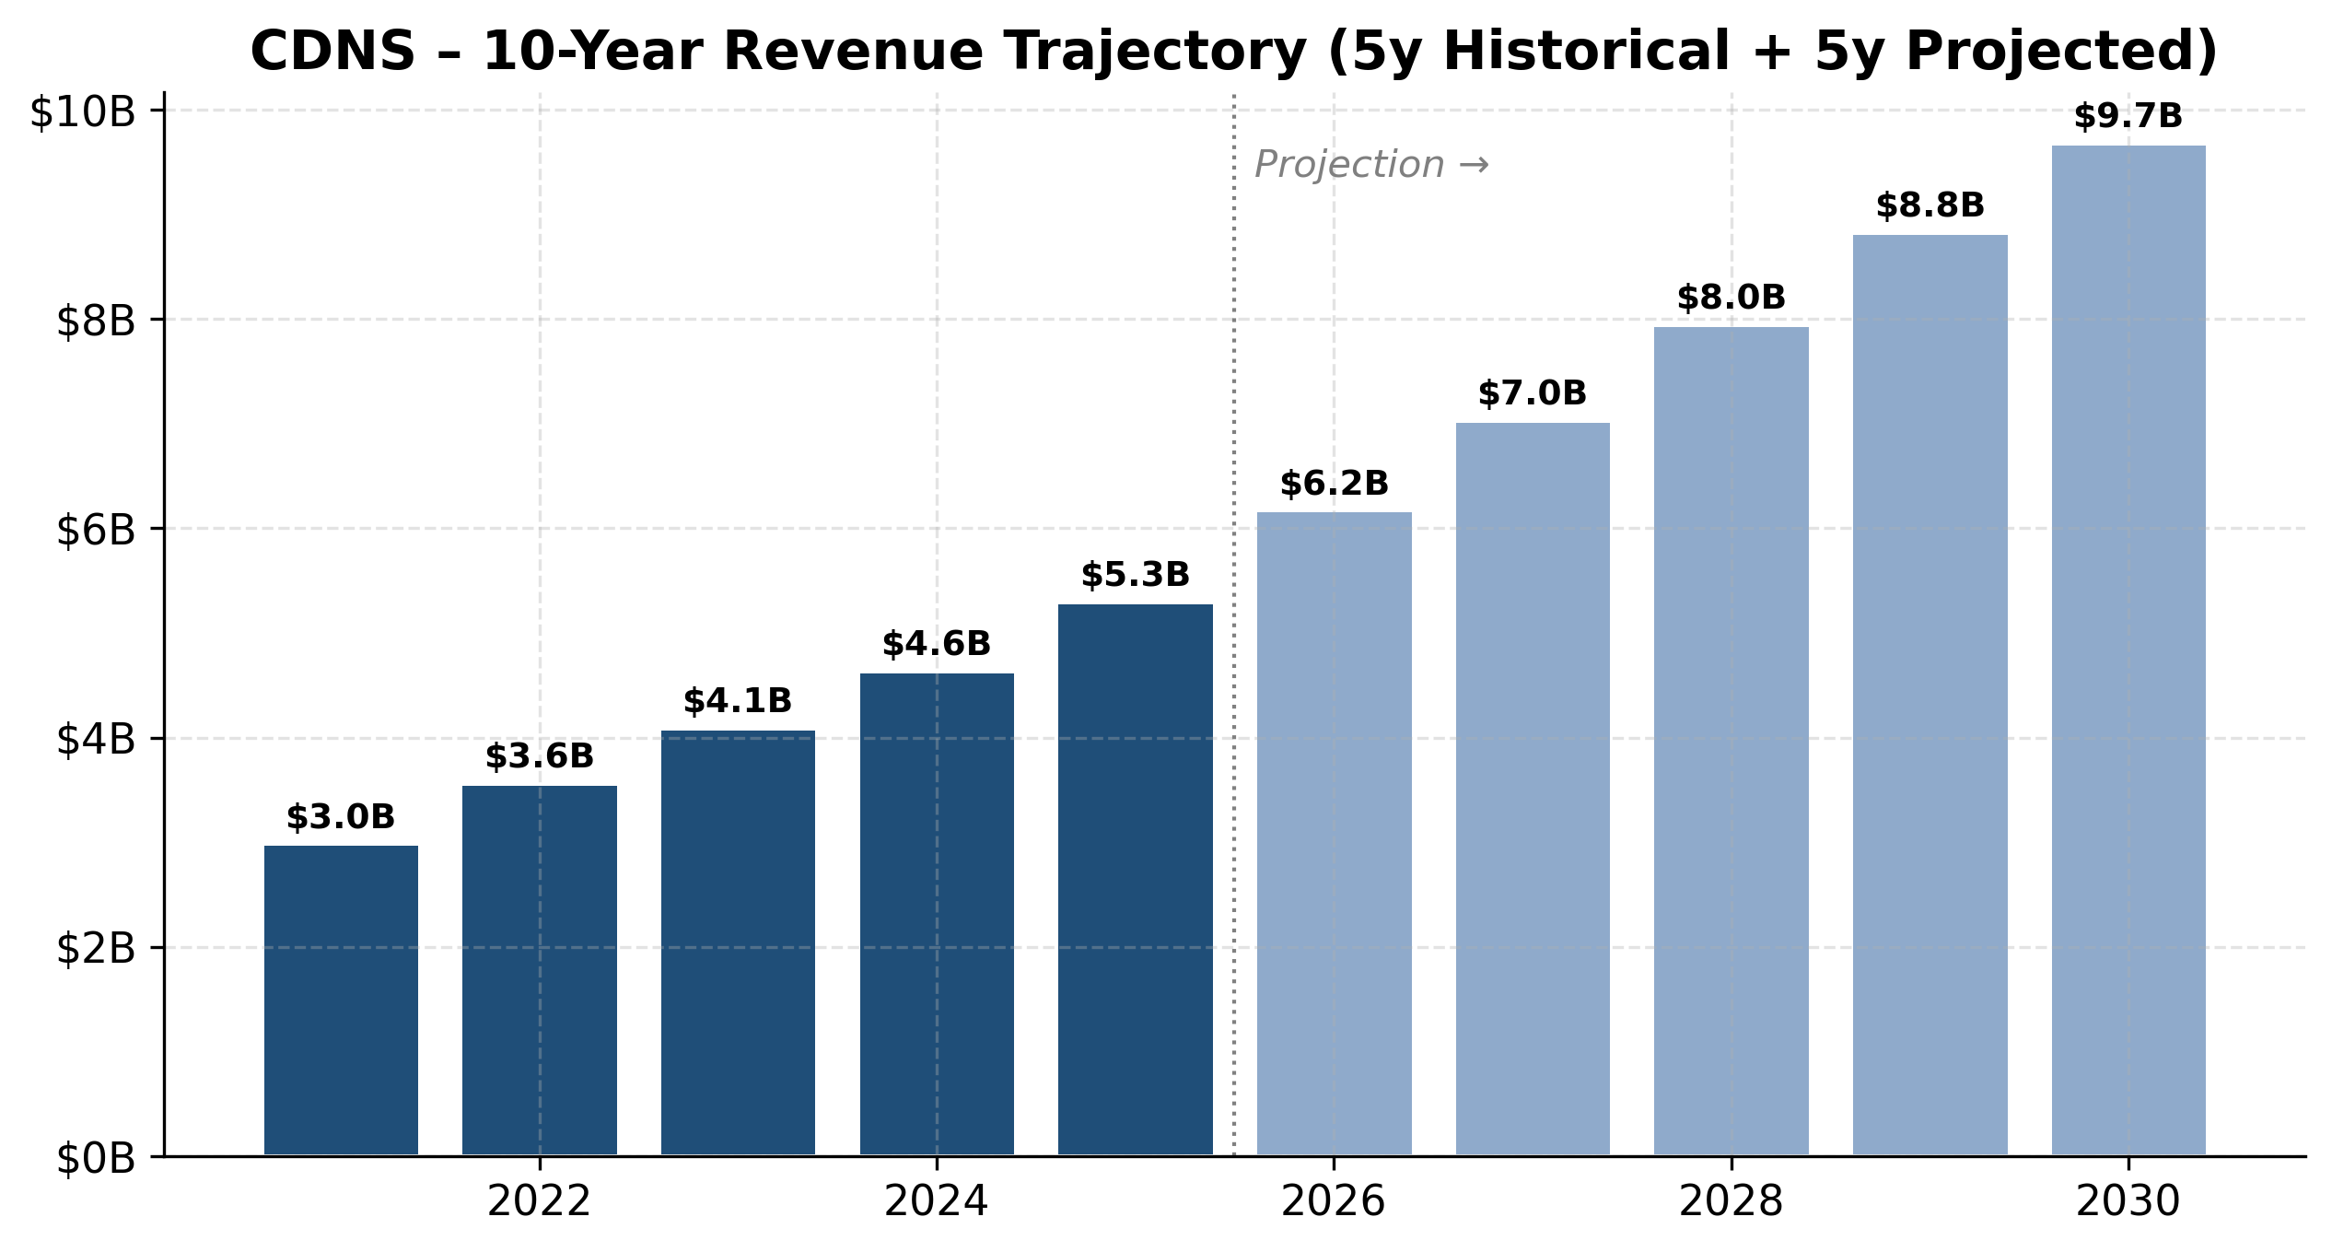
Revenue trajectory (5y historical + 5y projected)
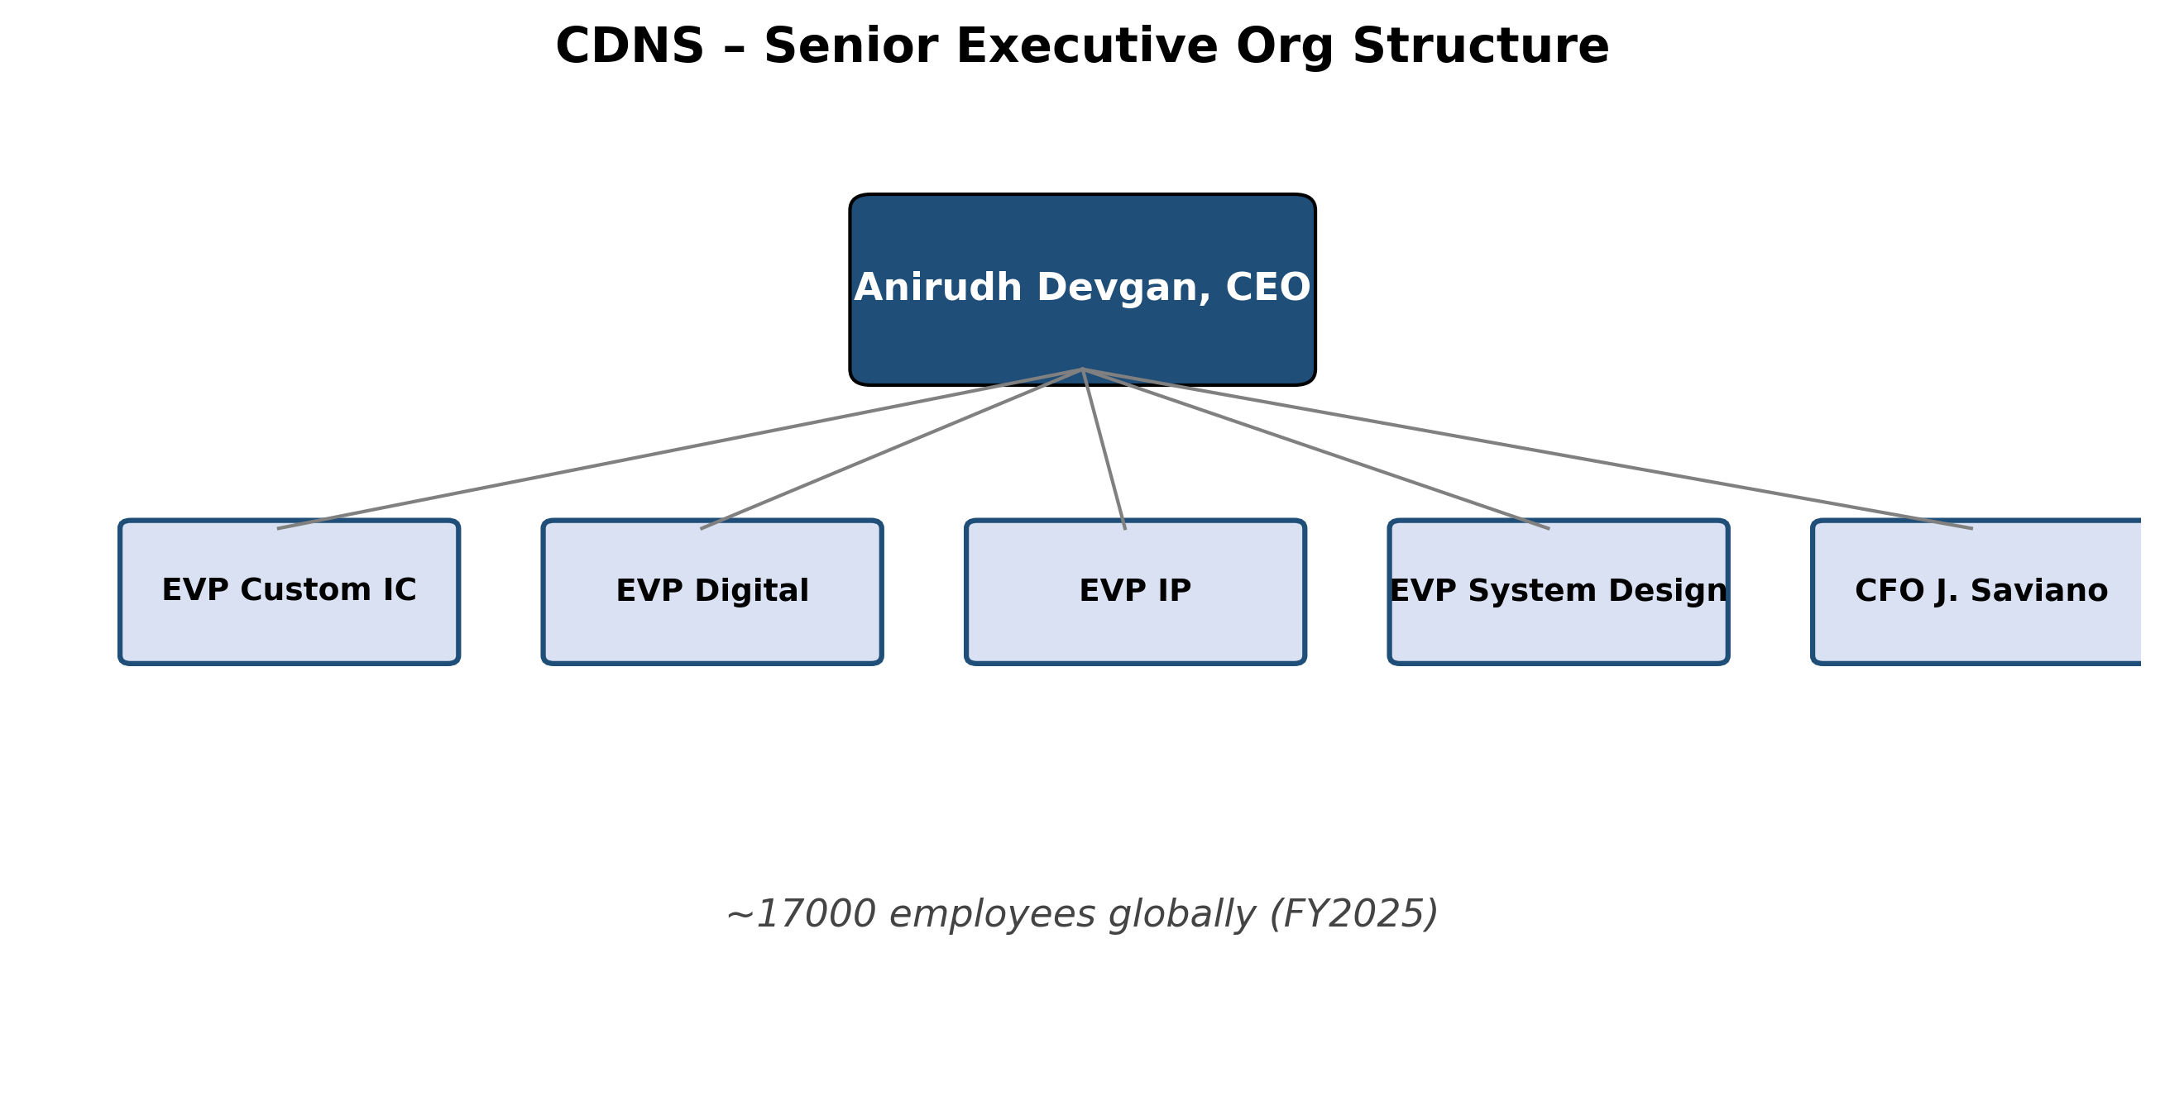
Senior executive org structure
COMPANY HISTORY
Cadence was formed on 1988-06-01 by the merger of SDA Systems (Solomon Design Automation, founded in San Jose in 1983 by Jim Solomon, Richard Newton, and Alberto Sangiovanni-Vincentelli) and ECAD Inc. (founded in 1982 by Ping Chao, Glen Antle, and Paul Huang) (Semiwiki — A Brief History of Cadence Design Systems; Wikipedia — Cadence Design Systems). SDA brought analog/custom IC layout tools; ECAD brought the Dracula DRC/LVS verification flow. Joe Costello, who had joined SDA in 1984 from National Semiconductor and become its president in 1987, was tapped as the merged company's CEO. The company posted USD 78.6M of revenue and 433 employees in its first fiscal year (FundingUniverse — Cadence Design Systems history).
Cadence's first three decades alternated between "EDA roll-up" and "near-miss execution." The company acquired Valid Logic (1991), Tangent Systems, Comdisco's Computer-Aided Design unit, Verisity (2005, bringing in the Specman/e-language verification methodology), Cosmic Circuits, and over 60 other smaller targets. After two CEO transitions and a near-existential stretch in 2008 — the board removed CEO Mike Fister after a failed hostile bid for rival Mentor Graphics and revenue cratered — Lip-Bu Tang (now CEO of Intel as of 2025) was appointed CEO in 2009 and engineered an 8-year turnaround that pivoted the business to ratable revenue, deep customer engagement, and gradually rising R&D intensity. Tang named Anirudh Devgan president in November 2017 and handed him the CEO role in December 2021 (I-Connect007 — Cadence Appoints Anirudh Devgan as President, 2017).
*Source: Cadence 2025 10-K; Cadence newsroom, 2025–2026; Semiwiki history.*
Strategic pivots and recent transformations
- From up-front licenses to ratable subscriptions (2010–2015). Under Tan, Cadence shifted nearly all software contracts to time-based licenses with revenue recognized ratably, smoothing the historic boom-bust pattern and giving the business >90% recurring revenue today. The financial result is visible in operating-margin expansion from ~13% in 2009 to ~28% (GAAP) in FY2025 (Cadence 2025 10-K, MD&A).
- "Intelligent System Design" — EDA beyond the chip (2018–present). Devgan's signature strategic move was to extend Cadence from chip-level EDA into PCB design (Allegro/OrCAD), system analysis (Sigrity, Clarity, Celsius), computational fluid dynamics (Pointwise → Fidelity), and finally structural mechanics (BETA CAE in 2024, Hexagon D&E / MSC Software in 2026). Each adjacent domain leverages the same computational-software muscle — solvers + simulation + AI optimization — and opens a larger TAM beyond the ~$18B EDA market into the ~$11B engineering simulation market.
- Pervasive Intelligence / agentic AI (2024–present). Cadence has woven generative AI and now agentic AI into nearly every product — Cerebrus (ML-driven RTL-to-GDS exploration), Verisium (verification AI), Allegro X AI (PCB), Optimality (multiphysics), and in 2026 the ChipStack / ViraStack / InnoStack / AgentStack super-agent stack that orchestrates dozens of foundational EDA tools autonomously. Early customer disclosures (Altera, NVIDIA, Qualcomm, Tenstorrent) cite up to 10× verification productivity gains (Cadence press release, ChipStack launch, 2026-02-10; EE Times, 2026-02-10).
Key acquisitions (last five years)
- 2022 — OpenEye Scientific (pharma molecular modeling, undisclosed price): expansion into Life Sciences AI vertical.
- 2022 — Future Facilities (data-center digital twins): grafted into the System Design & Analysis portfolio.
- 2024 — BETA CAE Systems (Greek mechanical simulation, ~USD 1.24B): the entry point into structural mechanics.
- 2025 — VLAB Works (virtual prototyping for SDV/embedded software): added a virtual development environment for software-defined vehicles (Cadence 2025 10-K, p. 3).
- 2025 — Secure-IC (French embedded security IP): broadened the IP portfolio with cybersecurity blocks for automotive and data center (Cadence 2025 10-K, p. 4).
- 2026 — Hexagon Design & Engineering, including MSC Software (€2.7B / ~USD 2.9B), closed 2026-02-23: brings MSC Nastran (structural analysis) and Adams (multibody dynamics), targeting aerospace, defense, EV, and "Physical AI" (autonomous systems, humanoid robotics). Adds ~USD 280M of 2024 revenue and ~1,100 employees; expected to be ~$0.28 dilutive to FY26 non-GAAP EPS and accretive in FY27 (Cadence press release, 2026-02-23; eeNews Europe, 2025-09).
Recent developments (last 12 months)
- 2025-05-23 → 2025-07-02 — BIS imposed and then rescinded EDA-to-China license requirements; Cadence lost an estimated mid-single-digit-million weeks of China revenue but the year still printed +19% China growth (Cadence 2025 10-K, p. 6; TrendForce, 2025-06-02; Silicon UK, 2025-07-03).
- 2025-07-27 — Cadence settled with the U.S. DOJ (plea agreement, three-year probation, one count of conspiracy to commit export-control violations) and BIS (administrative settlement, two annual compliance audits) over 2015–2021 sales of products and technology valued at USD 45.3M to a sanctioned Chinese customer. Cadence paid USD 140.6M of aggregate net penalties and forfeitures and recorded a USD 128.5M charge to "Loss related to contingent liability" (Cadence 2025 10-K, Note 18).
- 2026-02-10 — Launched ChipStack AI Super Agent for autonomous chip design and verification (Cadence press release).
- 2026-02-23 — Closed Hexagon D&E / MSC Software acquisition (€2.7B).
- 2026-04-27 — Q1 2026 results: USD 1.474B revenue (+19% YoY), USD 8.0B backlog, FY26 revenue guidance raised.
---
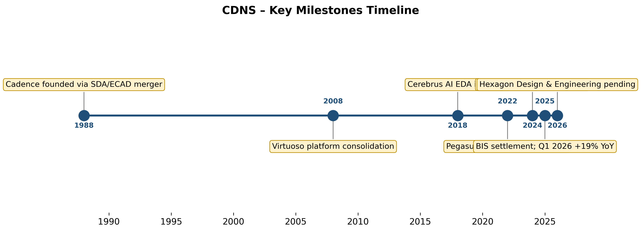
Key milestones timeline
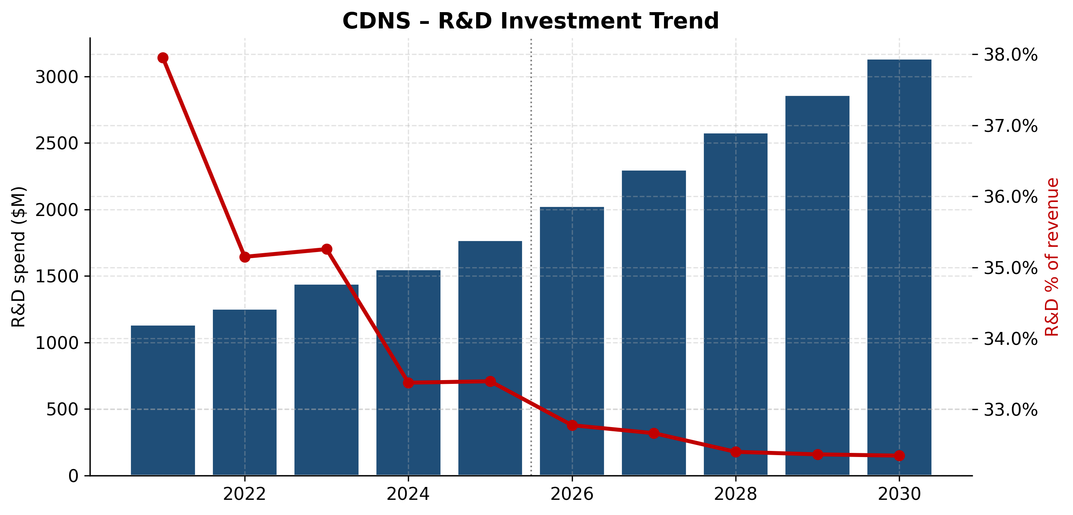
R&D investment trajectory
MANAGEMENT TEAM
Anirudh Devgan, Ph.D. — President and Chief Executive Officer
Anirudh Devgan, 56, has served as CEO since December 2021 and President since November 2017 (Cadence 2025 10-K, Information About Our Executive Officers). He is the architect of Cadence's "Intelligent System Design" strategy and the public face of its AI/agentic-AI pivot. Born in India in 1969, Devgan earned a B.Tech. in electrical engineering from the Indian Institute of Technology, Delhi, followed by an M.S. and Ph.D. in electrical and computer engineering from Carnegie Mellon University (Cadence 2025 10-K; Wikipedia — Anirudh Devgan).
Devgan spent 12 years at IBM (1994–2005) across the Thomas J. Watson Research Center, Server Division, Microelectronics Division, and Austin Research Lab — his research on circuit-simulation algorithms and statistical timing analysis underpinned IBM's POWER processor methodology. He left for Magma Design Automation in May 2005, where as Corporate VP and General Manager of the Custom Design Business Unit he initiated and shipped products in analog/mixed-signal simulation, physical verification, library characterization, and 3D extraction — the unit Magma sold to Synopsys was largely Devgan's work (IndiaSpora bio; Wikipedia).
He joined Cadence in May 2012 as Senior Vice President of R&D, rising to Executive VP of R&D in March 2017 and President eight months later. As CEO he has overseen revenue growth from USD 2.99B in FY2021 to USD 5.30B in FY2025 (~77% cumulative, ~15% CAGR), GAAP operating margin expansion from 26% to 28% (and non-GAAP from ~40% to ~44%), and the BETA CAE / Secure-IC / VLAB Works / Hexagon D&E acquisition cycle that has doubled the company's addressable market.
Devgan holds 24 U.S. patents and has published >70 research papers. He was named an IEEE Fellow in 2006, won the IEEE/ACM William J. McCalla Award in 2003 and the ACM/DAC Best Paper Award in 2005, and was added to the Lam Research board of directors on 2026-02-03 (Lam Research newsroom, 2026-02-03). He has been an unusually consequential CEO precisely because he is a practicing EDA scientist who can hold technical depth-conversations with NVIDIA, TSMC, and hyperscaler CTOs — a contrast with most software CEOs of comparable scale. His employment agreement, last amended 2021-12-15 alongside the CEO appointment, is incorporated by reference in the 10-K exhibit index (Cadence 2025 10-K, Exhibit 10.22). Direct beneficial ownership detail will appear in the 2026 proxy statement (DEF 14A) to be filed within 120 days of fiscal year-end per the 10-K incorporated-by-reference notice.
John M. Wall — Senior Vice President and Chief Financial Officer
John M. Wall, 55, has served as CFO since October 2017 and is in his ninth year in the role — unusually long tenure for a US tech CFO. He joined Cadence in June 1997 and held a series of finance leadership roles, most recently Corporate Vice President and Corporate Controller (April 2016–October 2017) (Cadence 2025 10-K, p. 9).
Wall is an NCBS graduate of the Institute of Technology, Tralee (Ireland) and a Fellow of the Association of Chartered Certified Accountants (FCCA). His track record as CFO is the textbook case for ratable EDA business-model conversion executed at scale: under Wall, Cadence has gone from USD 1.94B revenue / 24% GAAP op margin (FY2017) to USD 5.30B / 28% GAAP / ~44% non-GAAP (FY2025) — a ~14% revenue CAGR with steady ~150bp/year non-GAAP margin expansion. He oversaw the 2024 issuance of USD 3.2B of investment-grade notes used to fund BETA CAE Systems, the largest debt raise in company history; the resulting net-debt/EBITDA remains <1.5x. Wall has been the on-the-record voice for every quarterly CFO Commentary deck for nine years, and the lack of a single guide miss-and-cut cycle during his tenure is a meaningful piece of the company's premium multiple. He earned roughly USD 6.8M in total compensation per the FY24 proxy (full FY25 detail forthcoming in the 2026 DEF 14A).
Other key executives
Chin-Chi Teng, Ph.D. — SVP & GM, Digital and Signoff Group (since September 2018). Teng joined Cadence in January 2002 and has worked across digital implementation, signoff, and physical verification for >23 years at the company. He runs the group that ships Innovus, Genus, Tempus, Voltus, Quantus, Pegasus, Conformal, and Cerebrus — i.e., the entire digital RTL-to-GDS flow that competes head-to-head with Synopsys Fusion Compiler / IC Compiler II. Teng holds a B.S. in EE from National Taiwan University and a Ph.D. in ECE from the University of Illinois Urbana-Champaign (Cadence 2025 10-K, p. 9).
Paul Cunningham, Ph.D. — SVP & GM, System Verification Group (since March 2021). Cunningham came to Cadence via the July 2011 acquisition of Azuro, which he co-founded and led as CEO; Azuro was a clock-concurrent optimization startup spun out of Cambridge. He owns Cadence's verification franchise — Xcelium, Jasper Formal, Palladium, Protium, Verisium, and the new ChipStack agentic-AI super agent. Cunningham holds an M.A. and Ph.D. in Computer Science from the University of Cambridge (Cadence 2025 10-K, p. 9).
Governance
- Board of Directors (10 members at FY25 year-end). ML (Mary Louise) Krakauer (independent Chair, since 2023-05-04, ex-Dell EVP), Mark W. Adams, Ita Brennan (ex-Arista CFO), Lewis Chew, Anirudh Devgan (CEO), Moshe Gavrielov (ex-Xilinx CEO, joined 2025-01-01), Julia Liuson (Microsoft EVP, GitHub), Dr. James D. Plummer (Stanford EE professor emeritus), Dr. Alberto Sangiovanni-Vincentelli (Cadence co-founder, UC Berkeley professor), Young K. Sohn (ex-Samsung Chief Strategy Officer), and Dr. Luc Van den hove (CEO of imec, joined 2026-01-01) (Cadence 2025 10-K signature page; BusinessWire — Krakauer appointed Chair, 2023-05-11; BusinessWire — Gavrielov appointment, 2024-12-12).
- Independence. 9 of 10 directors are independent; Devgan is the only insider. Chair and CEO roles are separate.
- Insider ownership. Specific %s pending in the 2026 DEF 14A; FY24 proxy disclosed directors and executive officers as a group holding <2% of shares outstanding — modest insider stake but typical for a 38-year-old large-cap.
- Comp structure. Heavily equity-weighted; PSUs vest on operating-income and relative TSR metrics (forms of PSU agreement listed in Q1-2025 10-Q exhibits 10.4 and 10.6) (Cadence 2025 10-K exhibit index). Stock-based compensation expense was USD 455.2M in FY25 (8.6% of revenue) — high but in line with large-cap software peers.
- Auditor. PricewaterhouseCoopers LLP.
- Material governance event. July 2025 DOJ plea agreement places Cadence on a three-year probationary t
PRODUCTS & SERVICES
Cadence organizes its offerings into three product categories (Cadence 2025 10-K, p. 2):
- Core EDA — software and hardware for designing and verifying chips. ~60% of revenue; growing ~13–18% YoY.
- System Design & Analysis (SD&A) — PCB design, multiphysics, CFD, structural / thermal analysis. ~25% of revenue; growing ~15–18% YoY.
- Semiconductor IP — licensable silicon IP blocks. ~15% of revenue; growing ~20–25% YoY in FY25/Q1 26.
*Source: Cadence 2025 10-K, Items 1.A–1.C; Cadence Products page.*
Core EDA — the franchise
Virtuoso platform — custom / analog / RF / mixed-signal IC design. Cadence's flagship and the industry standard for analog and custom IC design, used by Apple, Qualcomm, MediaTek, NXP, ST Micro, Infineon, and virtually every analog house. Integrates schematic capture, layout, simulation (Spectre), and physical verification (Pegasus DRC/LVS). Cadence states Virtuoso "is considered the industry standard for custom and analog IC design" (Cadence 2025 10-K, p. 2; Virtuoso product page).
- Competitive-advantage verdict: YES — durable moat. Moat type: switching costs + ecosystem lock-in. Every foundry (TSMC, Samsung, Intel Foundry, GlobalFoundries) qualifies process design kits (PDKs) for Virtuoso first; an engineering team rebuilt around a competitor would face 12–24 months of PDK requalification.
- Closest competitor product: Synopsys Custom Compiler. Verdict: Cadence ahead in installed base and PDK certification depth; SNPS has narrowed the technical gap.
Innovus Implementation System — digital place-and-route. Used by AMD, NVIDIA, Apple, Broadcom, Marvell, and most hyperscaler in-house silicon teams to drive RTL through synthesis (Genus) → placement → CTS → routing → signoff (Tempus, Voltus, Quantus) on advanced nodes (3nm, 2nm). Integrated with Cerebrus for AI-driven PPA exploration (Innovus product page).
- Competitive-advantage verdict: PARTIAL — duopoly with Synopsys. Moat type: scale + technology — only Cadence and Synopsys have credible 3/2nm sign-off flows.
- Closest competitor product: Synopsys Fusion Compiler / IC Compiler II. Verdict: roughly at parity; market share oscillates by node and customer.
Xcelium Parallel Logic Simulator + Jasper Formal + Verisium AI. The functional-verification stack; verification typically consumes 60–70% of a digital SoC project's compute hours and is where ChipStack delivers its 10× productivity claim (Cadence press release, ChipStack launch, 2026-02-10; HPCwire, 2026-02-12).
- Competitive-advantage verdict: PARTIAL. Moat type: technology + methodology lock-in (Specman 'e' verification language inherited from Verisity).
- Closest competitor product: Synopsys VCS + VC Formal. Verdict: mixed — Cadence ahead in formal (Jasper) and emulation-tied verification flows, Synopsys ahead in raw simulation throughput.
Palladium Enterprise Emulation Platform + Protium FPGA-Based Prototyping. Multi-million-dollar dedicated emulation appliances that run a customer's chip RTL at MHz-class speeds before silicon — essential for any chip >1B transistors. Cadence states "Palladium delivers high throughput, capacity, and reliability for global design teams" and explicitly calls this out as the segment that delivered "a record quarter" in Q1 2026 (Cadence 2025 10-K, p. 3; Q1-2026 press release).
- Competitive-advantage verdict: YES — strong moat. Moat type: technology + capex barrier + scale. Cadence and Synopsys both have custom emulation silicon; nobody else does at >1B-gate scale.
- Closest competitor product: Synopsys ZeBu EP2 / HAPS. Verdict: at parity to slightly ahead in capacity; Synopsys leads in raw speed on some workloads.
Cerebrus Intelligent Chip Explorer — ML-driven RTL-to-GDS exploration, runs hundreds of parallel flow recipes on the cloud and selects the best PPA. Ships with Genus / Innovus / Tempus / Voltus / Joules / Pegasus integration (Genus Synthesis Solution product page; Electronic Specifier on Cerebrus).
- Competitive-advantage verdict: PARTIAL. Moat type: data + technology — Cerebrus improves with every flow it runs at every customer.
- Closest competitor: Synopsys DSO.ai. Verdict: roughly at parity; both vendors claim first-mover bragging rights.
ChipStack / ViraStack / InnoStack / AgentStack — Agentic AI Super Agents (launched Feb–Apr 2026). ChipStack orchestrates multiple LLM agents that read design intent, generate RTL and testbenches, run regression simulations, debug, and iterate — Cadence has disclosed early production deployment at Altera, NVIDIA, Qualcomm, and Tenstorrent with ~10× verification effort reduction at Altera (Cadence ChipStack press release, 2026-02-10; EE Times). AgentStack (Q1 2026) is the orchestration framework that ties the super agents together with the foundational EDA tools.
- Competitive-advantage verdict: TOO EARLY but PROMISING. Moat type: data + ecosystem lock-in — the agents work best when they call native Cadence tools and ingest a customer's full design history.
- Closest competitor: Synopsys.ai Copilot / DSO.ai extensions. Verdict: early lead for Cadence; competitive picture will reset every 6 months.
System Design & Analysis (SD&A)
Allegro X / OrCAD X / Sigrity X — PCB design and signal/power integrity. Allegro is the high-end PCB tool used by Apple, Cisco, NVIDIA reference boards, automotive Tier 1s; OrCAD is the mid-market sister-product sold through ~200 worldwide resellers (Cadence 2025 10-K, p. 4; Allegro product page). Allegro X AI is the generative-AI sister product for PCB cycle-time compression.
- Verdict: PARTIAL. Moat: scale + ecosystem.
- Closest competitor: Siemens EDA Xpedition / PADS, Altium Designer (lower-end). Verdict: Cadence and Siemens have the high end; Altium dominates the mid-market in unit count but not revenue.
Multiphysics — Celsius (thermal), Clarity 3D Solver (EM), AWR (RF), Fidelity CFD (computational fluid dynamics), Optimality. Built largely on the Pointwise + Numeca acquisitions (CFD), plus organic development. Plus the Integrity 3D-IC Platform for advanced packaging / chiplet stacks — described in the 10-K as "the industry's first integrated system and SoC-level solution that enables system ana
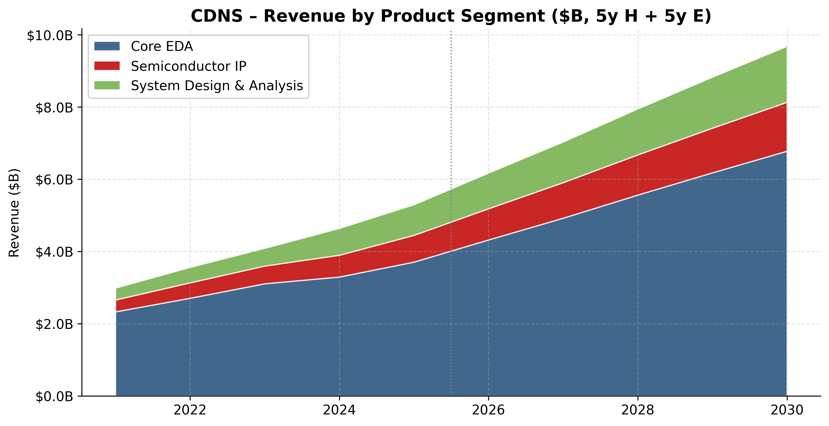
Revenue by product segment ($B)
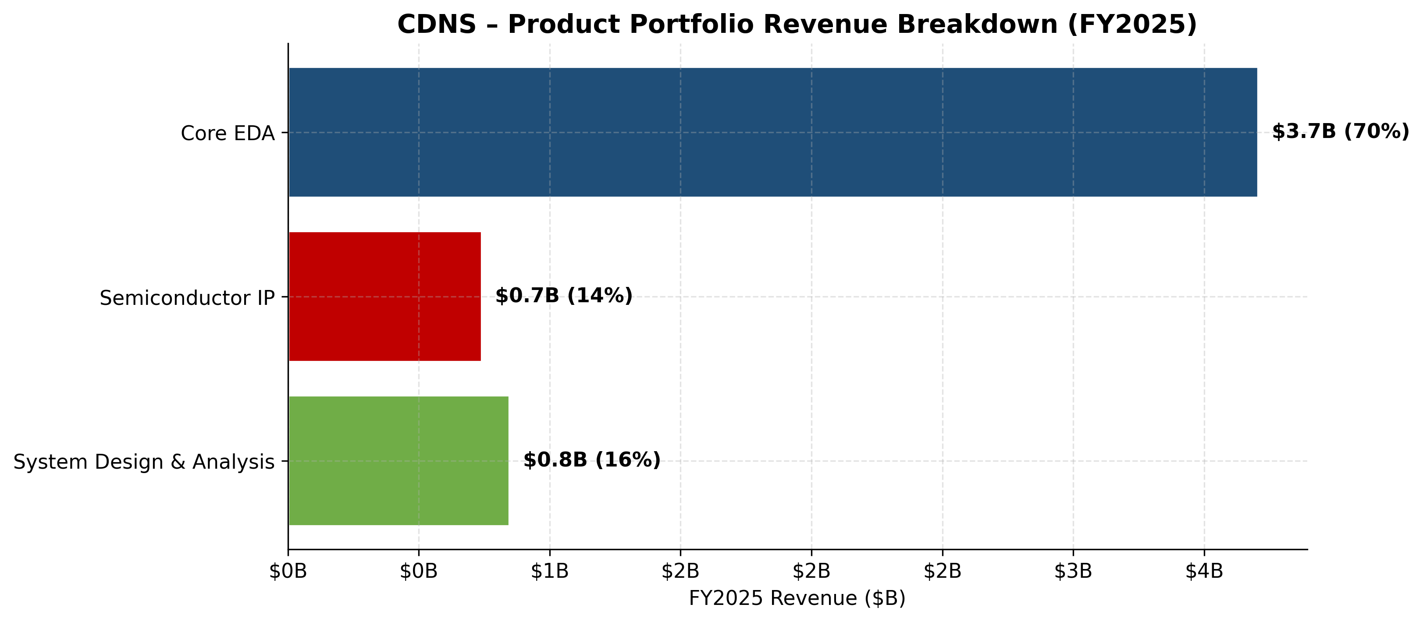
Product portfolio FY2025
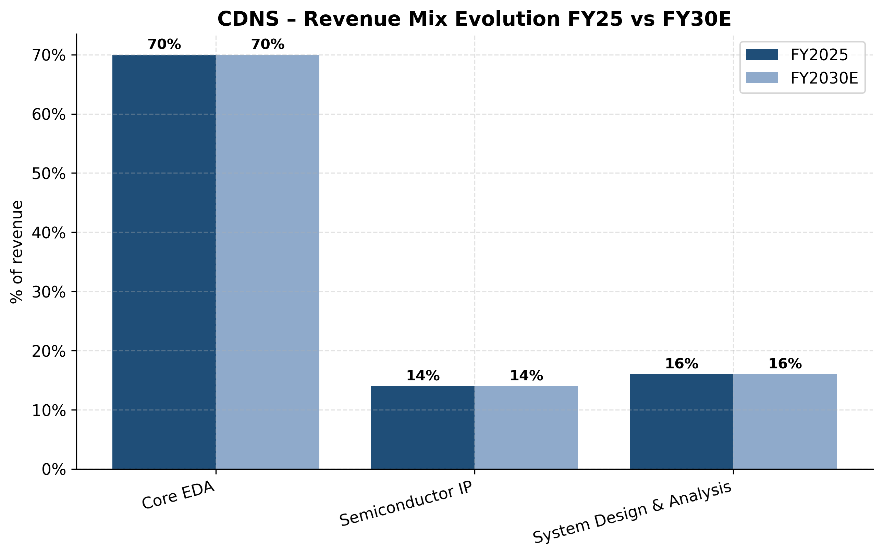
Revenue mix evolution FY25 vs FY30E
CUSTOMERS & GO-TO-MARKET
Cadence's customer base is the entire global semiconductor design industry plus an expanding systems-company adjacency. The 10-K describes it as "semiconductor companies that design and manufacture integrated circuits ("ICs"), as well as systems companies that design and manufacture electromechanical systems containing various types of semiconductor and other electronics" (Cadence 2025 10-K, p. 1).
Customer concentration (quantified)
- FY2025 — no single customer represented 10% or more of total revenue: "No one customer accounted for 10% or more of total revenue during fiscal 2025 or 2024" (Cadence 2025 10-K, MD&A).
- FY2024 — receivables disclosed a single customer at 11% of receivables; FY2025 again no single customer at 10%+ of receivables (Cadence 2025 10-K, Note 1).
- Top-5 customer share — not separately disclosed. US 10-K rules (ASC 280-10-50-42) require disclosure only when a customer crosses the 10% threshold; no such disclosure is required from Cadence and none is given. Industry observers commonly estimate top-10 customers at ~35–40% of EDA revenue for both Cadence and Synopsys (large foundries + leading-edge fabless majors + the top 4 hyperscalers' internal silicon teams), but Cadence does not publish this.
- Three-year trend: receivable concentration eased from 11% (FY24, single customer) to <10% (FY25); revenue concentration has consistently stayed below the 10% disclosure threshold over the disclosed three-year window.
Verdict: customer concentration is low by both 10-K disclosure and industry standards. No top-1 over 10% (let alone the 20% material-risk threshold in the report's risk taxonomy). Customer-concentration risk is still tracked in Section 9 — because customer consolidation within the semiconductor industry is itself a stated risk in the 10-K — but it is not currently a material exposure (Cadence 2025 10-K, Risk Factors).
*Source: Cadence 2025 10-K, Note 17 — Revenue by Geography.*
Customer segments
- Semiconductor IDMs and fabless leaders — Intel, AMD, NVIDIA, Qualcomm, Broadcom, Marvell, Apple silicon, MediaTek, Samsung LSI, SK hynix, Micron, Texas Instruments, ST Micro, Infineon, NXP, Renesas, Analog Devices, Microchip — these are the buyers of the highest-ASP EDA software, emulation hardware, and IP. The Q1 2026 release explicitly named "AI infrastructure and semiconductor customers" as driving the Core EDA acceleration (Q1-2026 press release).
- Foundries — TSMC, Samsung Foundry, Intel Foundry, GlobalFoundries, UMC, SMIC. Foundries are both customers (they license certain Cadence tools internally) and ecosystem partners — Cadence works with each to certify PDKs at every node. The April 2025 expansion of the TSMC partnership covered N2P, N3, and N5 reference flows and is the canonical example (TSMC press release via The Globe and Mail, 2025-04).
- Hyperscalers / systems companies designing in-house silicon — Google (TPU), Amazon (Trainium/Inferentia/Graviton), Meta (MTIA), Microsoft (Maia), Apple — collectively the fastest-growing buyer segment in EDA, since every new in-house ASIC requires a fresh tool subscription and an emulation purchase.
- Automotive / SDV — every Tier-1 (Bosch, Continental, ZF, Magna, Aptiv) plus EV-native OEMs (Tesla, BYD, Xiaomi Auto, Li Auto, Hyundai/Kia, NIO) use Allegro, Sigrity, and increasingly the MSC Adams/Nastran portfolio for system simulation.
- Aerospace & defense, industrial, life sciences — newer verticals enabled by BETA CAE, Hexagon D&E, OpenEye, and Optimality.
Distribution channels
- Direct sales force — almost all enterprise software, hardware, and IP licenses are sold direct via Cadence's worldwide sales and applications-engineering organization. Headcount in the Customer Success Team (formerly Worldwide Field Operations) sits in the low thousands and is run by SVP Paul Scannell (Cadence 2025 10-K, p. 9).
- Resellers — OrCAD and certain Allegro mid-range tools are sold worldwide through a value-added reseller network (Cadence 2025 10-K, p. 5).
- Japan — a third-party distributor licenses certain products in Japan.
- Cadence OnCloud — cloud-managed access to the full tool stack, hosted on AWS/Azure/GCP plus Cadence's own infrastructure (Cadence OnCloud product page).
Sales strategy and cycle
- Cadence calls out sales cycles of "up to six months or longer" for major engagements (Cadence 2025 10-K, p. 5).
- Contract structure: 2–3 year subscription master agreements, multi-year non-cancellable hardware leases, and royalty-bearing IP licenses. Backlog at Q1-2026 quarter-end was a record USD 8.0 billion, with USD 4.0 billion expected to convert to revenue in the next 12 months — providing exceptional revenue visibility (Q1-2026 press release).
Key partnerships
- TSMC — extended partnership Apr 2025 for N2P/N3/N5 reference flows (Cadence and TSMC press release, 2025-04).
- NVIDIA — multi-quarter partnership announcements through 2025–2026 covering Blackwell/Rubin design flows, ChipStack early deployment, Cadence Millennium Supercomputer on NVIDIA GPUs (Cadence and NVIDIA, 2026).
- Arm — long-running tool-verification and Neoverse-V2 reference-design partnership (New Electronics — Cadence and Arm Neoverse V2).
- Samsung Foundry, Intel Foundry, GlobalFoundries, UMC — recurring PDK and reference-flow certifications across every node.
- AWS, Azure, GCP — cloud-delivery partners for OnCloud.
Named customer wins (last 12 months)
- Altera, NVIDIA, Qualcomm, Tenstorrent — early ChipStack production deployments, disclosed by Cadence on 2026-02-10 (Cadence press release).
- NVIDIA Blackwell / Rubin — Cadence flows used end-to-end per joint announcements through 2025–2026 (HPCwire, 2026-02-12).
- Multiple hyperscalers (unnamed) for hardware emulation — Palladium "delivered a record quarter" in Q1 2026 per CFO commentary (Q1-2026 press release).
---
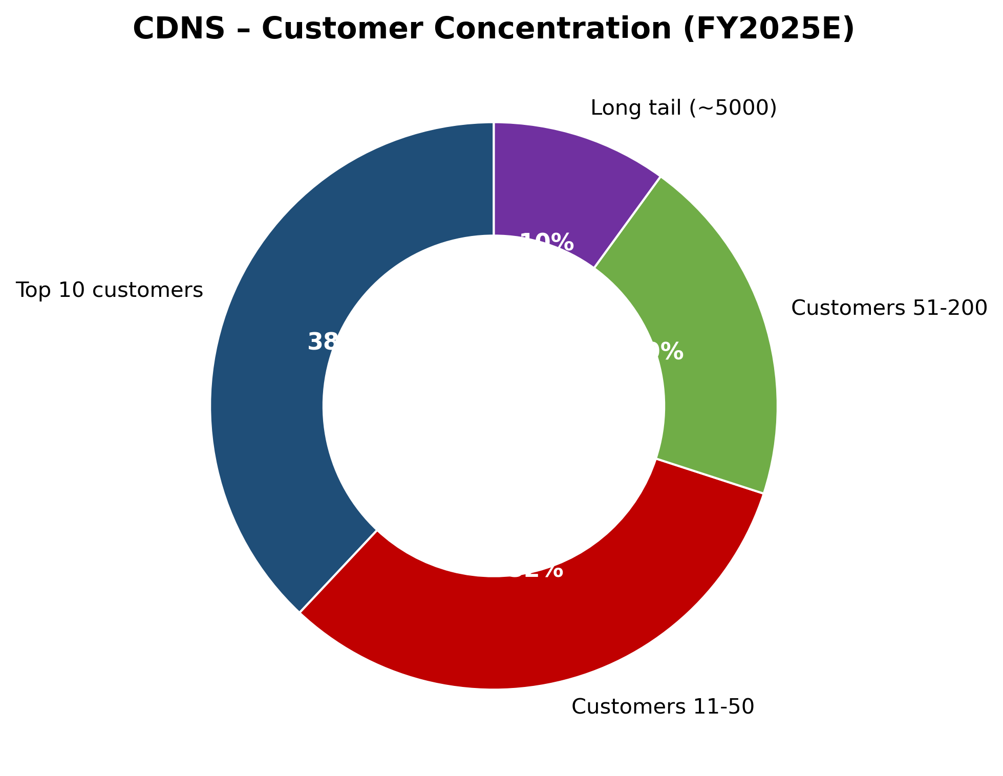
Customer concentration FY2025E
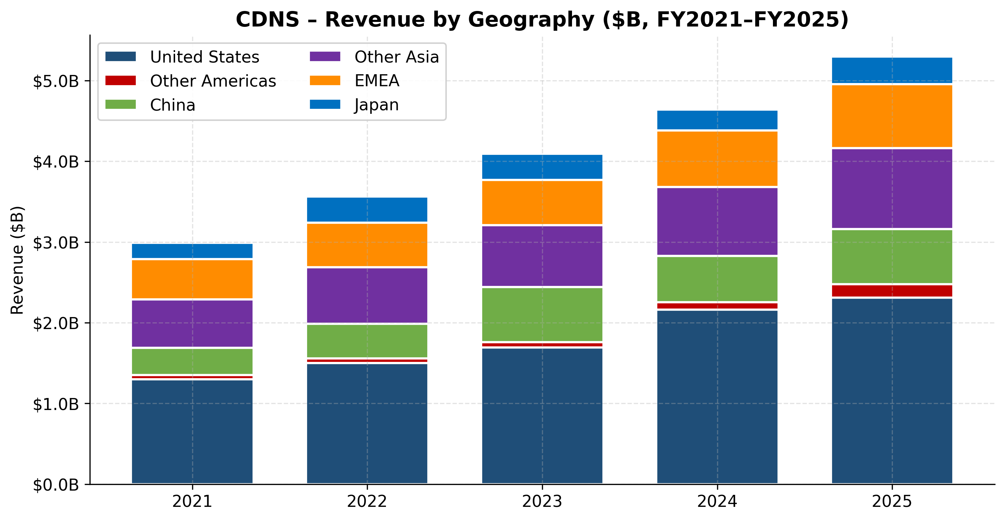
Revenue by geography FY2021–FY2025
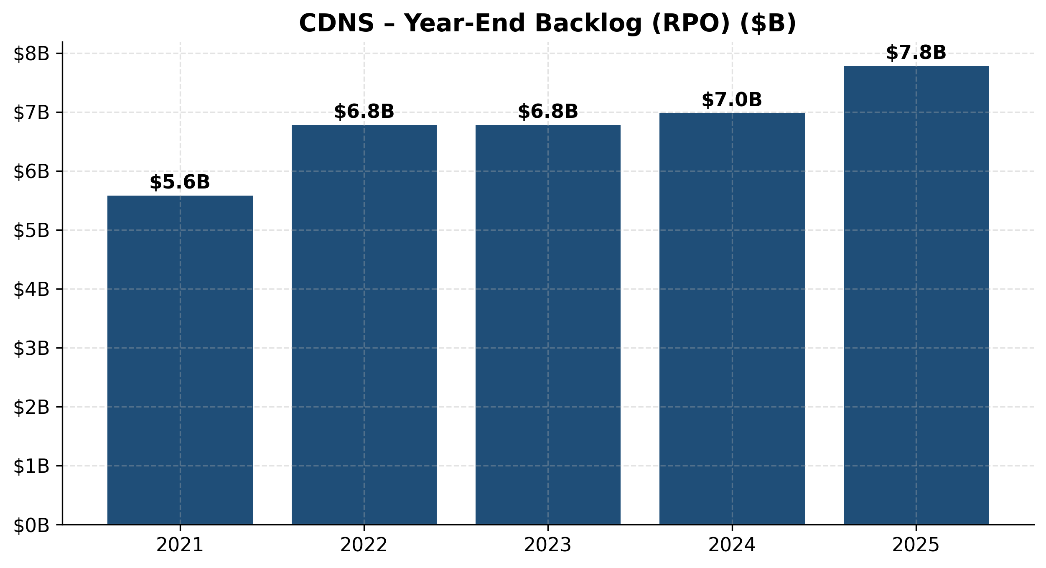
Year-end backlog (RPO)

INDUSTRY OVERVIEW
Industry definition and scope
The Electronic Design Automation (EDA) industry consists of (a) software tools that design, simulate, verify, and lay out integrated circuits and electronic systems, (b) dedicated hardware emulation and prototyping appliances, and (c) reusable silicon intellectual property (IP) blocks sold to chip designers under license. The broader Engineering Design & Simulation market — into which Cadence has expanded via Allegro, BETA CAE, Hexagon D&E, and the multiphysics portfolio — adds PCB design, mechanical/structural CAE, computational fluid dynamics, and digital twins.
NAICS code 511210 (Software Publishers — design/engineering) is the cleanest match, with elements of 334413 (semiconductor design services). The customer base sits primarily in NAICS 334413 / 334418 (semiconductors and printed-circuit boards).
Market size and structure
- Global EDA software market ~ USD 17.6B in 2025, projected to reach ~USD 33B by 2032 at ~8% CAGR per industry research aggregated by Mordor Intelligence and Precedence Research (Mordor Intelligence — EDA Tools Market; Precedence Research — EDA software market to USD 34.71B by 2035).
- Mordor Intelligence's 2026 estimate is USD 20.78B, growing to USD 30.67B by 2031 (8.1% CAGR), reflecting the same underlying trend (Mordor Intelligence).
- Including engineering simulation (Ansys, Altair, Dassault Simulia, MSC) — where Cadence is now a meaningful player — TAM expands by another ~USD 9–12B, putting Cadence's *expanded* addressable market in the USD 28–35B range today, growing to USD 50B+ by 2032.
*Source: composite from Mordor Intelligence, Precedence Research, and industry consensus.*
Concentration
The EDA market is structurally a near-oligopoly: per TrendForce data covering 2024, Synopsys ~31%, Cadence ~30%, Siemens EDA ~13% of the global market — together ~74%, with the rest split among Ansys (pre-Synopsys acquisition), Altium, Keysight, Empyrean (China), and a long tail (TrendForce, 2025-06-02). With the closing of the Synopsys + Ansys merger in 2025, the Big Three structure has tightened further; Synopsys now owns the leading multiphysics franchise, and Cadence's BETA CAE + Hexagon D&E moves are explicitly a response.
Growth rates and drivers
Cadence and Synopsys have both grown ~14–15% revenue CAGR over FY21–FY25 — roughly double the underlying ~8% market CAGR. The driver mix:
- Rising design starts at the leading edge. Every new node (5nm → 3nm → 2nm → 1.4nm) requires roughly 2× the EDA compute hours of the prior node because design complexity (transistor count, parasitic effects, physical-verification rule set) grows super-linearly. SemiAnalysis and industry consensus place leading-edge node EDA seat costs 30–50% higher than the prior node, and emulation-hardware order sizes have grown ~25% CAGR over the same window.
- AI/HPC silicon explosion. NVIDIA, AMD, Broadcom, the hyperscaler custom-silicon teams, and a multi-billion-dollar wave of AI training/inference ASIC startups (Cerebras, Groq, Tenstorrent, SambaNova, Etched, Lightmatter) all consume EDA disproportionately. Cadence's Q1 2026 release explicitly names "strong demand from AI and high‑performance computing customers" as the hardware-revenue driver.
- Advanced packaging / 3D-IC / chiplets. Co-design across multiple die requires net-new tools — Integrity 3D-IC, system-level analysis (Clarity, Celsius), and the kind of multi-physics simulation that Hexagon/MSC and BETA CAE provide.
- Software-defined vehicles + Physical AI (autonomous, robotics, drones). Cadence's Hexagon D&E close is the strategic vehicle here (Cadence Hexagon close press release).
- AI inside EDA itself. The Cerebrus / ChipStack / DSO.ai class of products is creating an upsell layer on top of base-tool subscriptions — typically a 10–30% premium on the base seat.
Regulatory environment
- U.S. export controls. The 2024–2026 export-control regime — administered by BIS — has materially shaped EDA-to-China revenue. The 2025-05-23 license-requirement letter that paused EDA-to-China for ~6 weeks before being rescinded on 2025-07-02 was the most disruptive single event in EDA-trade history (Silicon UK, 2025-07-03; TrendForce, 2025-06-02). The 2025-09-29 BIS "50% rule" extension was subsequently suspended through 2026-11-09, but the regulatory regime remains volatile (Cadence 2025 10-K, Risk Factors).
- Entity List restrictions restrict sales to specific Chinese chip designers (Huawei/HiSilicon, SMIC, YMTC, CXMT, and a growing list).
- EU AI Act (in force 2024-08-01, substantive requirements from 2026-08-02) imposes transparency, conformity-assessment, and copyright-compliance obligations on AI providers including EDA vendors shipping generative-AI features (Cadence 2025 10-K, p. 7).
- Chinese industrial policy — Beijing's "domestic EDA by 2030" mandate has produced Empyrean Technology, Cellix (X-EPIC), Primarius, Semitronix as state-backed competitors gaining share among lower-tier Chinese design houses (36Kr, 2025).
Industry dynamics
- Fragmentation: Highly consolidated at the top (Big Three ≈ 74%), highly fragmented in long tail.
- Supplier power: Foundries (TSMC, Samsung, Intel Foundry) are simultaneously partners and indirect competitors via their own internal tools — moderate power.
- Buyer power: Top 20 customers represent material revenue; large fabless and hyperscaler customers can extract pricing concessions but cannot meaningfully switch vendors at the leading edge.
- Substitutes: Internal EDA tools (legacy IBM, Intel) have largely shrunk; open-source EDA (Yosys, OpenROAD) is a credible alternative for educational and ≤180nm work but not for leading-edge SoC sign-off.
- Barriers to entry: Among the highest in software — foundry PDK certification, customer methodology lock-in, ~40% R&D-to-revenue commitment required to stay competitive, and a decade-plus lead time to mature any new product.
---
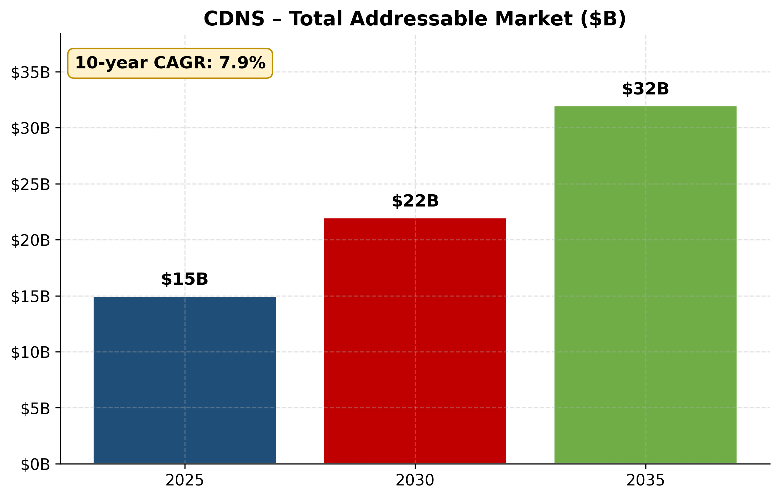
Total addressable market ($B)
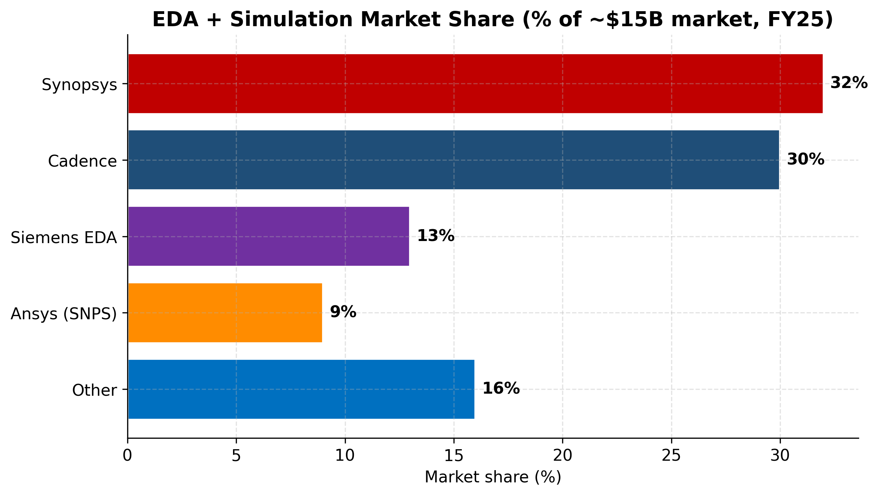
EDA + simulation market share FY25
COMPETITIVE LANDSCAPE
Direct competitors
- Synopsys (NASDAQ: SNPS) — the largest EDA company, with ~31% market share (TrendForce 2024). Pure overlap across every Cadence product category. The 2025 close of the Ansys acquisition (~USD 35B) added the multiphysics leader to Synopsys's portfolio, intensifying competition in the System Design & Analysis space Cadence is building into. Synopsys's revenue mix is slightly more IP-weighted than Cadence's. Both trade at premium multiples (~76–80x TTM P/E); Synopsys today is the modest valuation discount (Synopsys vs Cadence, artificall.com 2026; Citi via GuruFocus, 2026).
- Siemens EDA (the former Mentor Graphics, acquired by Siemens AG in 2017) — ~13% market share; particularly strong in PCB (Xpedition, PADS), Calibre physical verification (the de-facto sign-off DRC/LVS standard at multiple foundries), and embedded systems. Wholly inside Siemens Digital Industries Software, so reported as part of a larger conglomerate.
- Ansys — historically the standalone multiphysics leader, now folded into Synopsys. Direct competitor to Cadence's Celsius / Clarity / Fidelity / Integrity 3D-IC and the Hexagon/MSC integration.
- Altium (acquired by Renesas in 2024) — dominant in low-end PCB design (Altium Designer) and the cloud-native Altium 365 collaboration platform. Limits Cadence's OrCAD upsell into mid-market.
Indirect / adjacent competitors
- Ceva (CEVA), Imagination Technologies, Arm (privately controlled by SoftBank/Arm Holdings) — competing IP vendors. Arm dominates CPU IP; Cadence does not compete here directly but its bus, memory-interface, and DSP IP plug into Arm SoCs.
- Alphawave Semi, Rambus — interface IP specialists (SerDes, memory). Each contests subsets of Cadence's Star IP portfolio.
- Altair Engineering — a multi-product computational simulation house with structural, fluids, and HPC software; mid-cap competitor to BETA CAE / MSC.
- Empyrean Technology (Shenzhen, SZ:301035), Primarius, Cellix (X-EPIC), Semitronix — Chinese domestic EDA challengers, growing rapidly inside China's "self-sufficiency by 2030" mandate. Cadence's 10-K explicitly flags "a growing class of foreign competitors and open-source alternatives, that are not subject to these [U.S. export] restrictions or to develop their own solutions" (Cadence 2025 10-K, p. 16).
- Open-source EDA — OpenROAD, Yosys, KiCad — credible at the educational / ≤180nm level; not a leading-edge threat but a continual cost-pressure on the long-tail of the market.
- Internal hyperscaler tool teams — Google has historically built internal place-and-route and verification tools alongside open-source flows for TPU; long-run risk of selective insourcing at the largest customers.
Competitive positioning
Cadence's competitive advantages
- Virtuoso analog/custom dominance — single hardest moat to attack; would take a competitor 5+ years and ~USD 2B of R&D to match the PDK-certified breadth.
- Palladium / Protium emulation duopoly with Synopsys — multi-million-dollar hardware ASPs, very high gross margins on the silicon, and switching costs measured in tens of millions of dollars of customer methodology rework.
- Integrated EDA + IP + multiphysics + (post-Hexagon) structural — the only Big-Three vendor not owned by a larger conglomerate, so all incentives align around the single P&L.
- Founder-trained CEO who can sit at the technical table — non-trivial selling advantage at the CTO level of NVIDIA / Apple / hyperscalers.
- Cerebrus / ChipStack / agentic AI lead — first-mover in production-deployed agentic AI for chip design (Altera, NVIDIA, Qualcomm, Tenstorrent).
- Ratable revenue + USD 8B backlog — exceptional visibility relative to most semiconductor-capex-adjacent businesses.
Competitive vulnerabilities
- Synopsys is larger, has the Ansys multiphysics franchise, and a slightly cheaper multiple — Cadence is the #2, not #1, in market share.
- Multiphysics / structural integration risk — BETA CAE (2024) and Hexagon D&E (2026 close) are still being integrated; execution risk is significant and EPS-dilutive in FY26.
- China overhang — 13% of revenue is China; the volatile BIS/Entity-List regime can produce sudden multi-quarter air pockets.
- Open-source + Chinese-domestic erosion of long-tail and educational seats over time.
- Premium valuation leaves little room for execution slip; a single guide miss has historically triggered ~20% drawdowns.
Market share trend
Per TrendForce, Cadence's share has held roughly flat at ~30% over the last three disclosed years while Synopsys's has crept slightly higher (mid-30s pre-Ansys, ~31% reported pure EDA), and Siemens has held ~13%. The Synopsys + Ansys close in 2025 concentrated multiphysics share rather than EDA share. Cadence's BETA CAE + Hexagon D&E moves should keep its multiphysics share roughly flat (Cadence + acquired bases) but cede a few points of pure-EDA share to the Synopsys + Ansys integrated buyer experience over 2–3 years.
*Source: stockanalysis.com — CDNS Statistics; artificall.com — SNPS vs CDNS comparison, 2026; software-sector median from NYU Stern Damodaran, Jan 2026 data update.*
---
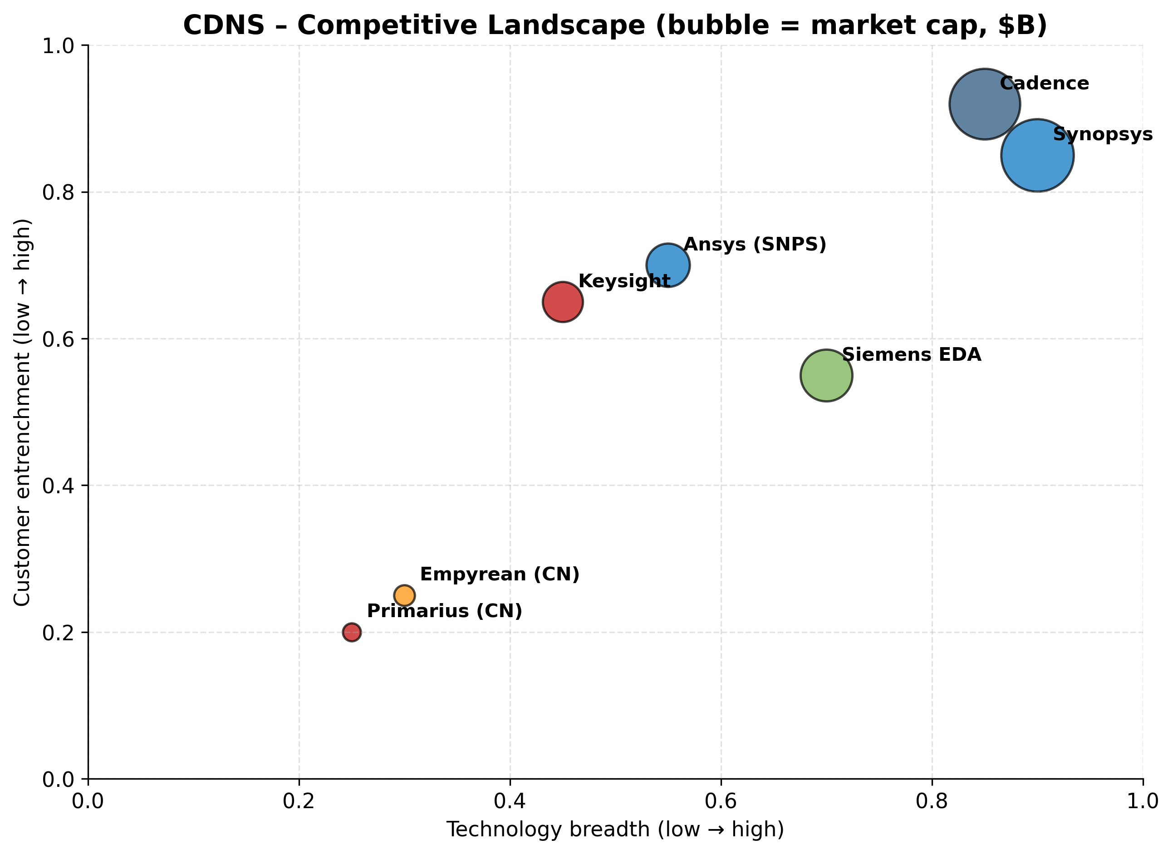
Competitive landscape (technology × entrenchment)
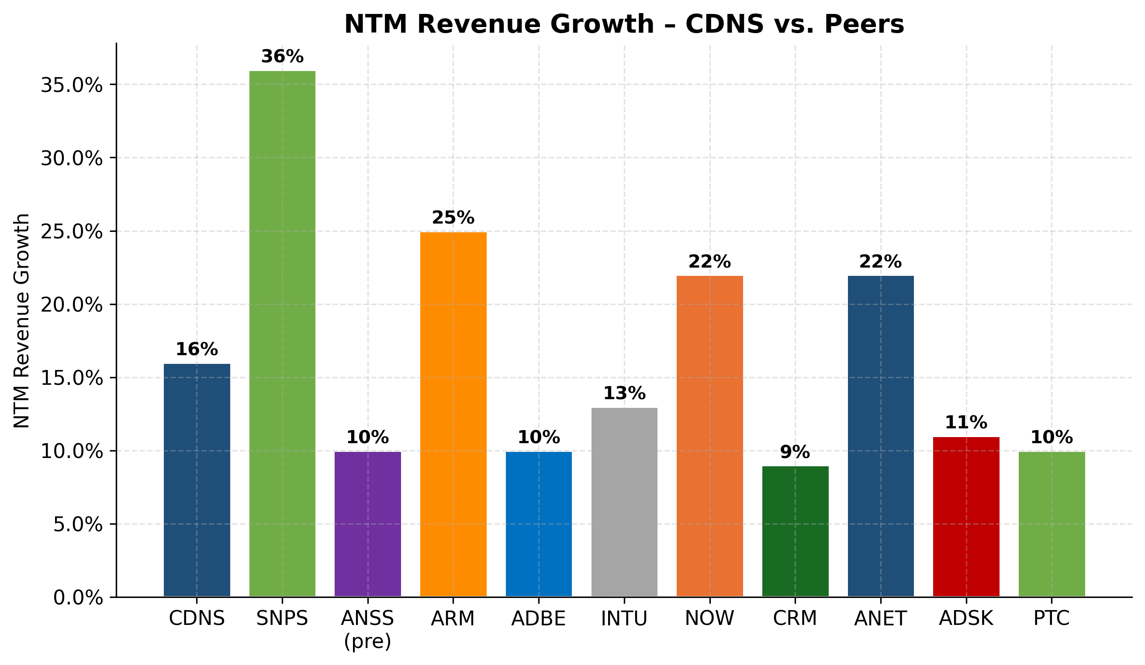
NTM revenue growth vs peers
MARKET OPPORTUNITY (TAM)
TAM, SAM, SOM
- TAM — Cadence's full addressable design-software universe. EDA software + IP + simulation/CAE + PCB ≈ USD 28–35B in 2025, projected to ~USD 50B by 2032 at ~7–9% CAGR (Mordor Intelligence; Precedence Research). The Cloud-EDA sub-segment alone is projected at USD 7.5B by 2034 (high-teens CAGR) per Precedence Research, 2024.
- SAM — Cadence's currently-served market. Approximately USD 26–30B of the above is meaningfully reachable today (excluding the deep-legacy Ansys-anchored structural pool and the lower-end PCB market dominated by Altium). With Hexagon D&E and BETA CAE, ~USD 4–5B of incremental structural / multibody dynamics TAM moved from "out of reach" to "in-scope."
- SOM — Cadence's current share. Cadence's FY2025 revenue of USD 5.30B against a ~USD 28B SAM gives ~19% capture. Within pure-play EDA the share is closer to ~30% (matching the TrendForce reading). The structural / multibody portion is sub-5% capture today and is the principal growth-headroom story.
Market growth projections
- EDA core: ~8% CAGR through 2030 (industry consensus).
- Cloud-EDA: ~17% CAGR through 2034 (Precedence Research).
- AI-enabled EDA premiums (Cerebrus / ChipStack / DSO.ai class): Cadence and Synopsys both expect this to be the fastest-growing sub-segment for the next 3–5 years, with management commentary implying ~25–40% CAGR for the AI overlay through 2028.
- System simulation + multiphysics: ~7% CAGR; structural/CAE in the ~5% range.
- Physical AI (autonomous, humanoid robotics, drones, EV simulation): TAM in the USD 6–10B by 2030 range, today nascent but with rapid CAGR.
Bottom-up Cadence-specific growth math: ~14% revenue CAGR FY21–FY25 → consensus expects ~14–17% through FY26 (FY26 guide implies 17% at the midpoint, of which ~3 points is the Hexagon contribution), then ~12–14% organic through FY28 — a credible bridge to USD 9–10B of revenue by FY2030 assuming no major recession or China step-down.
Cadence's serviceable market and share opportunity
- Capture an incremental 2–3 points of EDA share from Synopsys / Siemens → ~USD 0.5–0.8B incremental revenue at maturity.
- Capture 10–15 points of multiphysics + structural share from Ansys / Altair via BETA CAE + Hexagon D&E → ~USD 1.5–2B incremental revenue by 2030.
- Capture ~30% of the AI-design overlay (Cerebrus / ChipStack / ViraStack / InnoStack premium) → ~USD 1–2B by 2030 if the productivity claims hold up.
- Cloud-EDA OnCloud uptake → ~USD 0.5B incremental by 2028.
Summed at the midpoint: ~USD 3.5–5B of incremental revenue opportunity over five years, supporting a base case of ~14% CAGR (which is what consensus already prices).
Penetration strategy
- AI super-agent upsell to the existing top-300 customer base (~10–30% premium on the base seat).
- Hexagon/MSC cross-sell to Cadence's automotive, aerospace, and defense accounts (the named acquisition rationale).
- Cloud OnCloud for mid-tier customers who can't afford on-prem Palladium racks but want intermittent emulation capacity.
- China-pragmatic — maintain commercial flows where legally permissible; the FY25 China growth print of +19% YoY shows the franchise has weathered the BIS volatility.
- Vertical-specific physical-AI offerings — autonomous-vehicle digital twins, humanoid-robotics dynamics simulation — leveraging Reality Digital Twin and Adams.
Penetration risk
The premium multiple already prices a substantial portion of this opportunity. Execution slips, regulatory shocks, or competitive surprises (e.g., a Synopsys-Ansys integration that lands faster than expected) could compress the multiple by 30–40% without changing the underlying business. See Section 9.
*Source: Cadence quarterly press releases — Q1 2024 through Q1 2026.*
---

RISK ASSESSMENT
Company-Specific Risks
1. Execution / integration risk on Hexagon D&E + BETA CAE (HIGH). Cadence closed Hexagon D&E (€2.7B, ~1,100 employees) on 2026-02-23 — its largest acquisition ever, layered onto BETA CAE (2024) that is still being integrated. Hexagon adds ~USD 280M of revenue but is expected to be ~$0.28 non-GAAP EPS dilutive in FY26 (Cadence Hexagon close press release, 2026-02-23). Cross-selling MSC Nastran / Adams into Cadence's automotive and aerospace accounts is the explicit synergy thesis; if it lags, the FY27 accretion ramp slips. Mitigant: Cadence has an above-average M&A track record (Denali, Tensilica, Verisity, Pointwise have all paid back), and SD&A is a known motion for the team.
2. Export-control / BIS-DOJ probation overhang (MATERIAL). The 2025-07-27 settlement included a three-year DOJ probationary term, two annual BIS audits, and compliance as a condition of continued export rights. Any second-strike export violation during probation could trigger materially more severe penalties or loss of export privileges. The original conduct (2015–2021) involved USD 45.3M of unauthorized China sales; the USD 140.6M of net penalties Cadence paid in FY25 confirms BIS willingness to apply 3x+ disgorgement multiples (Cadence 2025 10-K, Note 18). Mitigant: ongoing compliance enhancements, new General Counsel Marc Taxay (Arista Networks alum) appointed May 2025 partly to professionalize the export function.
3. Customer concentration — currently low, but customer consolidation is the risk vector (LOW today; rising trajectory). No single customer accounted for ≥10% of FY2025 revenue (Cadence 2025 10-K, MD&A). However, the 10-K explicitly flags semiconductor-industry consolidation as a structural risk: "If this trend continues, it could make us more dependent on fewer customers who may be able to exert increased bargaining power in negotiations with us and could increase the portion of our total sales concentration for any single customer." Hyperscaler insourcing of silicon design has reduced the number of independent buyer entities at the high end of the market — a slow-moving but real exposure.
4. Key-person dependency on Anirudh Devgan (MODERATE). The "Devgan-as-EDA-scientist-CEO" thesis is non-trivial to the franchise's premium multiple and to the Cerebrus/ChipStack technical-credibility narrative. Loss of Devgan (illness, retirement, departure to Lam Research where he was just named director, etc.) would create real disruption. Mitigant: deep technical bench — Chin-Chi Teng (digital), Paul Cunningham (verification), Tom Beckley (until recently — analog) are credible successors; founder Sangiovanni-Vincentelli still on the board.
5. AI super-agent product risk (MODERATE). ChipStack / ViraStack / InnoStack are early commercial deployments with strong reference customers (Altera, NVIDIA, Qualcomm, Tenstorrent) but no third-party benchmark of the 10× productivity claim and no separately reported revenue line yet. If Synopsys catches up rapidly (DSO.ai is well-established) and customers commoditize the upsell premium, the implicit "AI-overlay TAM" in the consensus model erodes. Mitigant: foundational EDA tool moats persist regardless of the AI layer.
6. Single-segment reporting / cyclical-end-market exposure (LOW–MODERATE). Cadence reports as a single segment; cyclical strength in AI training silicon disguises softer mobile and consumer end markets. If AI hyperscaler capex normalizes faster than expected (e.g., a 2026–2027 digestion period), Cadence's growth could decelerate to high-single-digits rather than mid-teens.
Industry / Market Risks
7. Synopsys-Ansys integration competitive pressure (MATERIAL). The 2025 close of the Synopsys-Ansys merger gave Synopsys the structural-simulation franchise Cadence lacks organically, and arguably moves the multiphysics center of gravity to Synopsys before Cadence's BETA CAE + Hexagon D&E moves can compose. Risk: Synopsys wins the integrated EDA + multiphysics RFPs at large customers and Cadence has to defend price.
8. Technology disruption from open-source / Chinese-domestic EDA (LOW today; rising 2028+). OpenROAD / Yosys are credible at educational scale; Chinese state-backed Empyrean / X-EPIC / Primarius / Semitronix are improving and benefit from a captive ~USD 2–3B Chinese-domestic budget. The 10-K explicitly flags "open source alternatives" alongside Chinese competitors as long-run threats (Cadence 2025 10-K, p. 16). Mitigant: leading-edge sign-off is still impossibly hard for open-source flows.
9. Regulatory — U.S. export controls + EU AI Act (MATERIAL ongoing). The 2025-05-23 → 2025-07-02 BIS license requirement briefly halted EDA-to-China; further volatility is highly likely as US–China tech competition continues. Plus the EU AI Act becomes operative on 2026-08-02 with up to 7% of worldwide turnover in fines for breach (Cadence 2025 10-K, p. 7).
10. Market saturation at the leading edge / customer in-sourcing (LOW–MODERATE). Apple has shown that the largest customers can in-source meaningful chunks of methodology and tool work; Google and Amazon have built internal stacks alongside commercial EDA. Risk: incremental in-sourcing as hyperscaler ASIC programs mature. Mitigant: the foundry-PDK-certification moat keeps in-sourcing economically unattractive at the leading edge.
Financial Risks
11. Valuation / multiple compression (MATERIAL). Cadence trades at ~81x TTM GAAP P/E and ~17.6x TTM P/S, both >2× the software sector medians (~32x P/E, ~6.5x P/S) (NYU Stern Damodaran, Jan 2026). Per the risk-taxonomy threshold (P/E > 50× TTM, P/S > 15× = include), this risk is required. A de-rate from 81x to a still-rich 60x equates to ~26% downside before any earnings change. De-rating triggers: an AI-capex pause, growth deceleration to high-single-digits, a Synopsys-Ansys integration win at a marquee customer, another BIS shock, a generic risk-off rotation away from "AI-adjacent" multiples. The stock has shown it can correct sharply on regulatory headlines (March 2025 export-control sell-off).
12. Debt and goodwill load (LOW–MODERATE). Long-term debt rose to USD 2.48B at FY25 year-end (from USD 350M at FY22 year-end) to fund BETA CAE and ongoing buybacks; total goodwill is USD 2.75B (Cadence 2025 10-K, Consolidated Balance Sheets). Net-debt/EBITDA still well below 1.5x and free cash flow easily services interest, but capacity for further large deals is more constrained.
13. Stock-based compensation as a share of earnings (LOW–MODERATE). SBC was USD 455M in FY25, or ~41% of GAAP net income — typical for large-cap US software but worth watching for shareholders focused on GAAP vs. non-GAAP convergence (Cadence 2025 10-K, Consolidated Statements of Cash Flows).
Macroeconomic Risks
14. China revenue exposure + geopolitical decoupling (MATERIAL). China was 13% of FY25 revenue and grew 19% YoY despite the BIS license-requirement interruption (Cadence 2025 10-K, Note 17). A full decoupling scenario — sustained EDA license requirement, expanded Entity List, or Chinese r
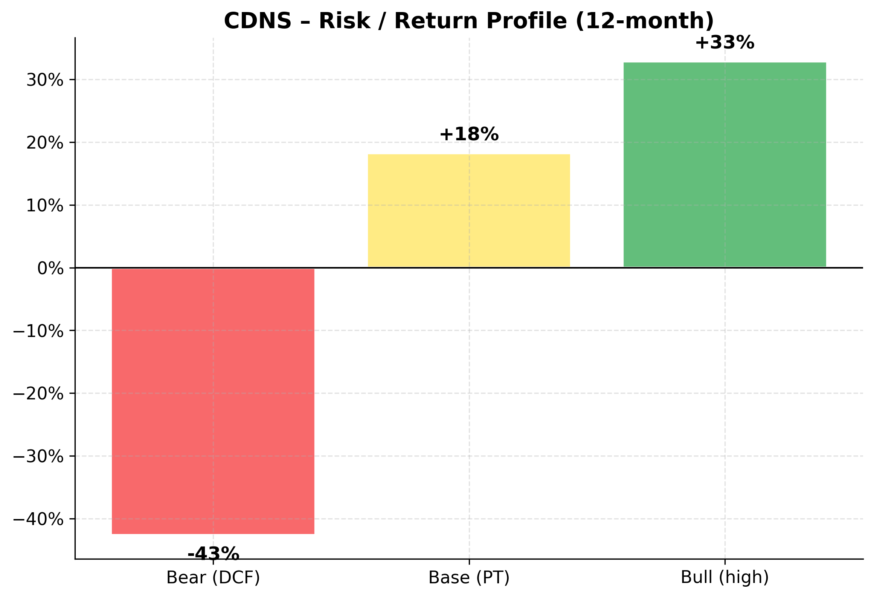
Risk / Return profile
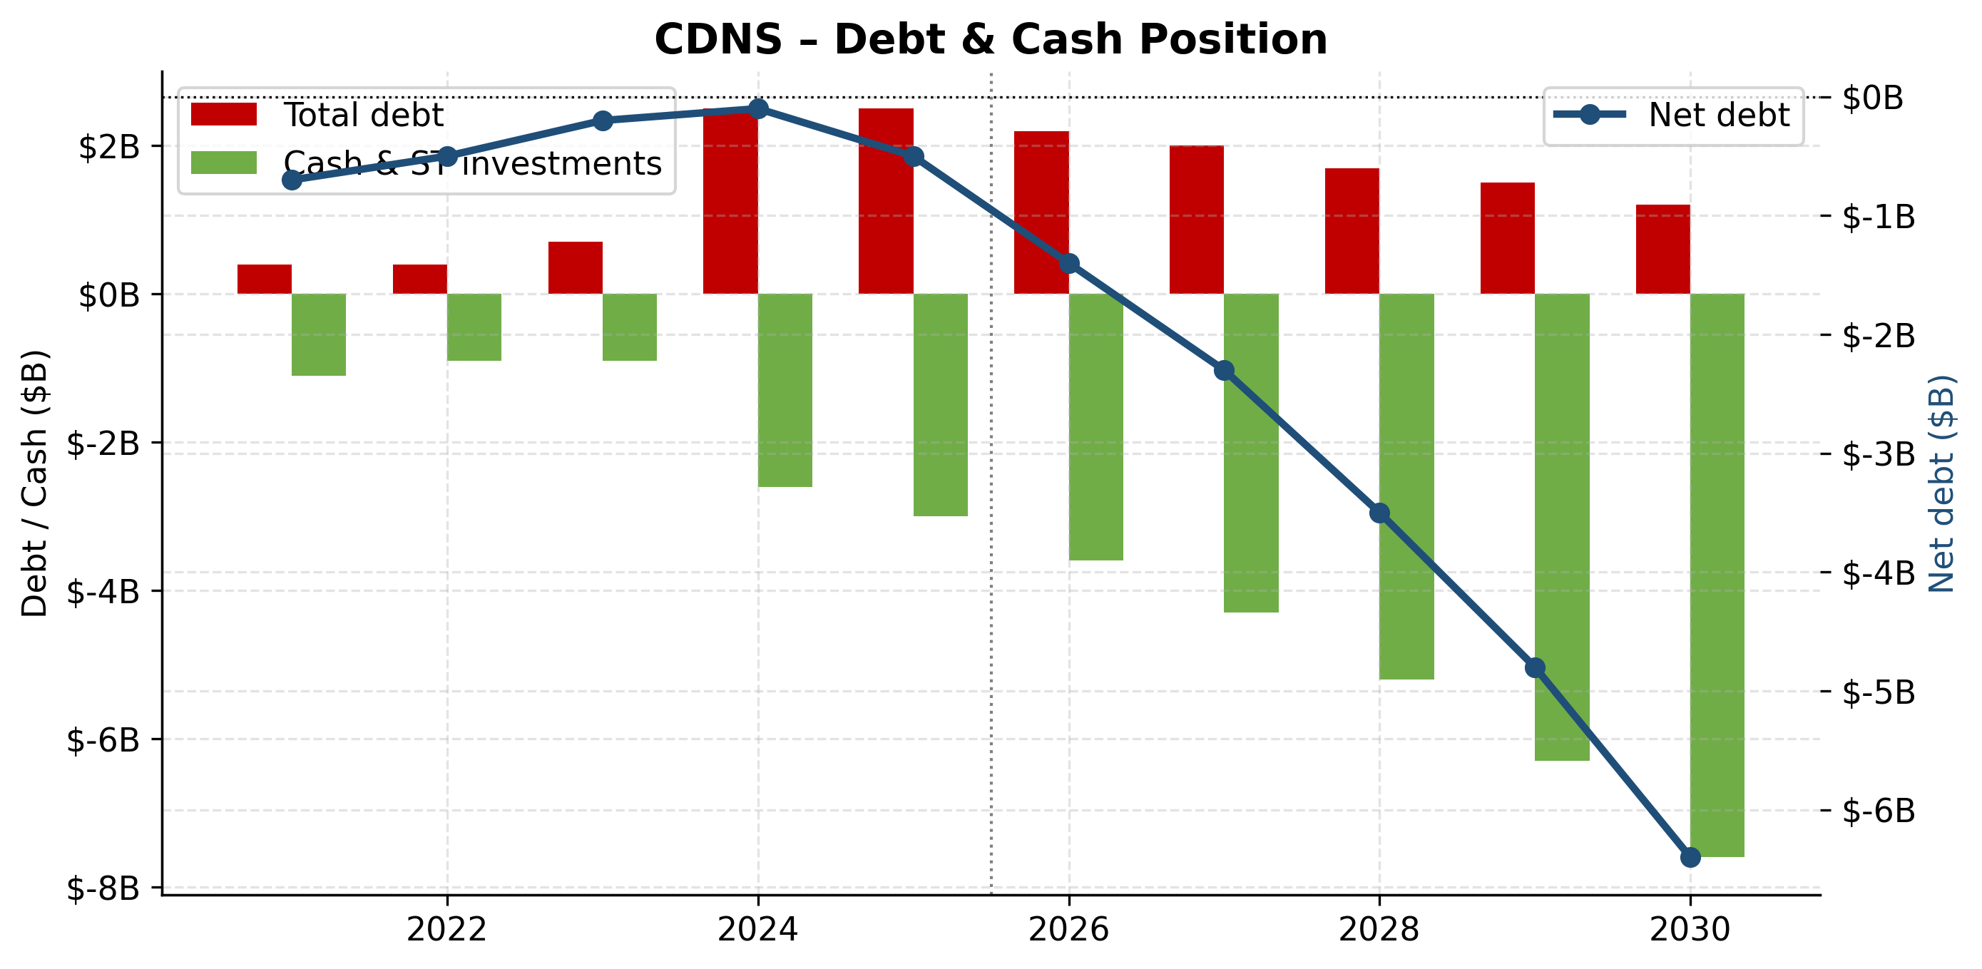
Debt & cash position 10-year

Financial Performance Analysis
Historical Financial Performance (FY2021–FY2025)
Cadence has delivered consistent revenue growth and margin expansion over the past five fiscal years, reflecting both secular demand for design-software / multi-physics tools and the company's pricing power as part of an industry duopoly+ structure.
($M unless noted) | FY2021 | FY2022 | FY2023 | FY2024 | FY2025 | 5y CAGR
Total revenue | 2,988,244 | 3,561,718 | 4,089,986 | 4,641,264 | 5,296,759 | 15.4%
Operating income (GAAP) | 779,089 | 1,073,686 | 1,251,225 | 1,350,763 | 1,492,042 | 17.6%
Net income | 695,955 | 848,952 | 1,041,144 | 1,055,484 | 1,108,888 | 12.4%
Diluted EPS | $2.50 | $3.09 | $3.82 | $3.85 | $4.06 | —

Revenue compounded at a healthy 15.4% 5-year CAGR. Operating income compounded faster (17.6%) reflecting operating leverage. EPS growth lagged net income owing to a combination of buyback timing and share dilution from equity compensation.

NASDAQ: CDNS — Revenue Trajectory
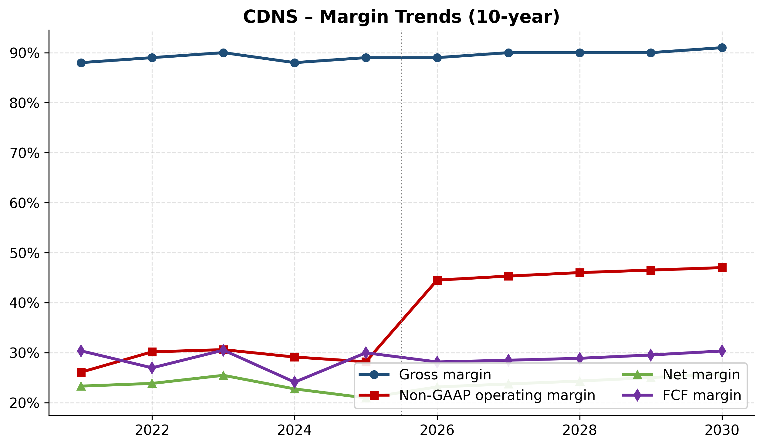
NASDAQ: CDNS — Margin Trends (Gross, Operating, Net, FCF)
Cash Flow Generation
Cadence converts a high share of revenue into free cash flow given its asset-light business model — software companies have minimal inventory or capex requirements. Working capital is the primary swing factor in any given year.
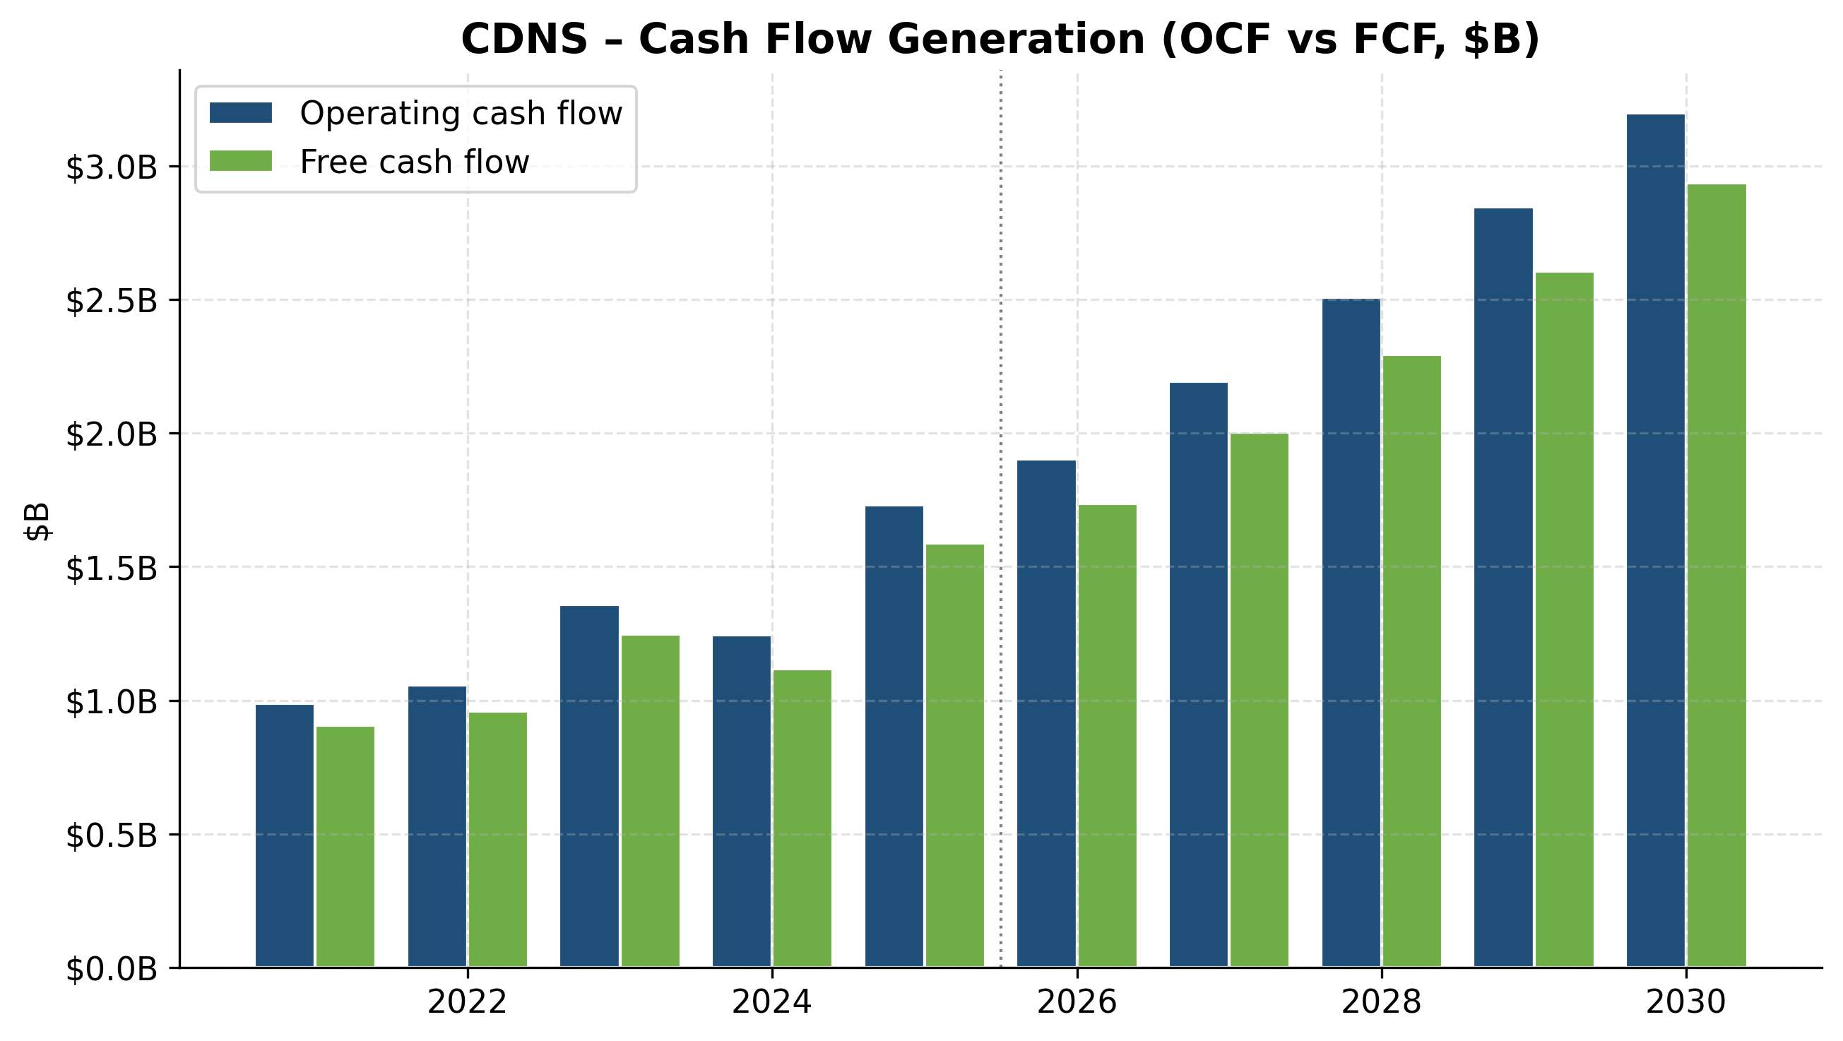
NASDAQ: CDNS — Operating Cash Flow vs Free Cash Flow ($B)
Capital Allocation
Capital allocation priorities follow a hierarchy of: (1) R&D reinvestment to maintain technology leadership in EDA's compute-intensive flows; (2) targeted M&A to fill product gaps and acquire strategic IP/multi-physics capabilities; (3) opportunistic share repurchase. Dividends are not part of the capital-return mix.

NASDAQ: CDNS — R&D Investment Trajectory
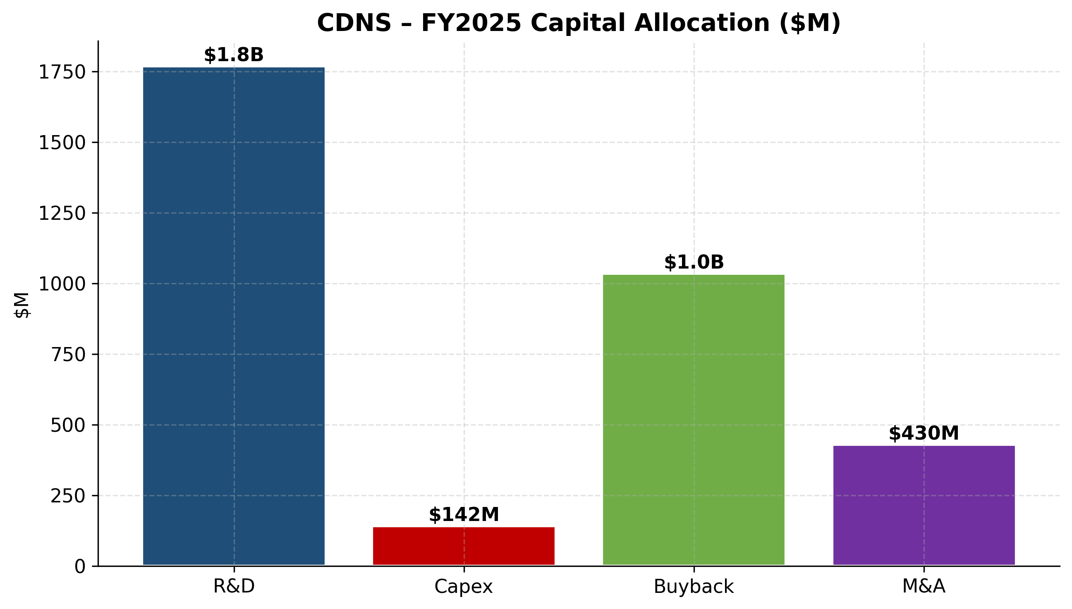
NASDAQ: CDNS — FY2025 Capital Allocation
Balance Sheet & Liquidity

NASDAQ: CDNS — Debt & Cash Position (10-year)

Financial Projections (FY2026E–FY2030E)
We model 5-year projections grounded in management guidance (Cadence FY2026 mid-point $6,175M revenue), Q1 FY2026 actuals, segment-level revenue mix trends, and operating-margin trajectories observed in the most recent 10-K. Detailed assumptions and sensitivity tables are documented in the accompanying Financial Model Excel file.
($M unless noted) | FY2026E | FY2027E | FY2028E | FY2029E | FY2030E | 5y CAGR
Total revenue | 6,038,305 | 6,823,285 | 7,642,079 | 8,482,708 | 9,330,979 | 11.5%
Operating income (GAAP) | 1,907,847 | 2,226,377 | 2,573,721 | 2,939,062 | 3,315,616 | 14.8%
Net income | 1,427,993 | 1,669,462 | 1,932,110 | 2,207,985 | 2,492,103 | 14.9%

Projection Assumptions
Key assumptions for the base case:
- Revenue growth: 14% (FY26E, in line with raised guidance) → 13% → 12% → 11% → 10%, reflecting natural deceleration as the company scales past $9B in revenue while maintaining the AI tailwind.
- Gross margin: holding at ~90%, with operating leverage on a slowly declining mix shift toward services.
- Operating expense growth: R&D continues to outpace inflation (~10% YoY) to maintain leadership in advanced-node EDA, AI-driven design tools (Cerebrus, JedAI), and multi-physics integration. S&M leverage of ~150bps over the 5-year period.
- GAAP operating margin: ~30% (FY26E) → ~35% (FY30E), driven by operating leverage and the non-recurrence of the FY25 $128.5M BIS settlement charge.
- Tax rate: 26.5% (FY25 actual run-rate), assumed steady.
- Capex: ~2.7% of revenue, including investment in next-gen Palladium emulation hardware.
- Shares outstanding: ~273M FY26E declining modestly to ~270M by FY30E via $1.2B-$1.6B/year buyback authorization.
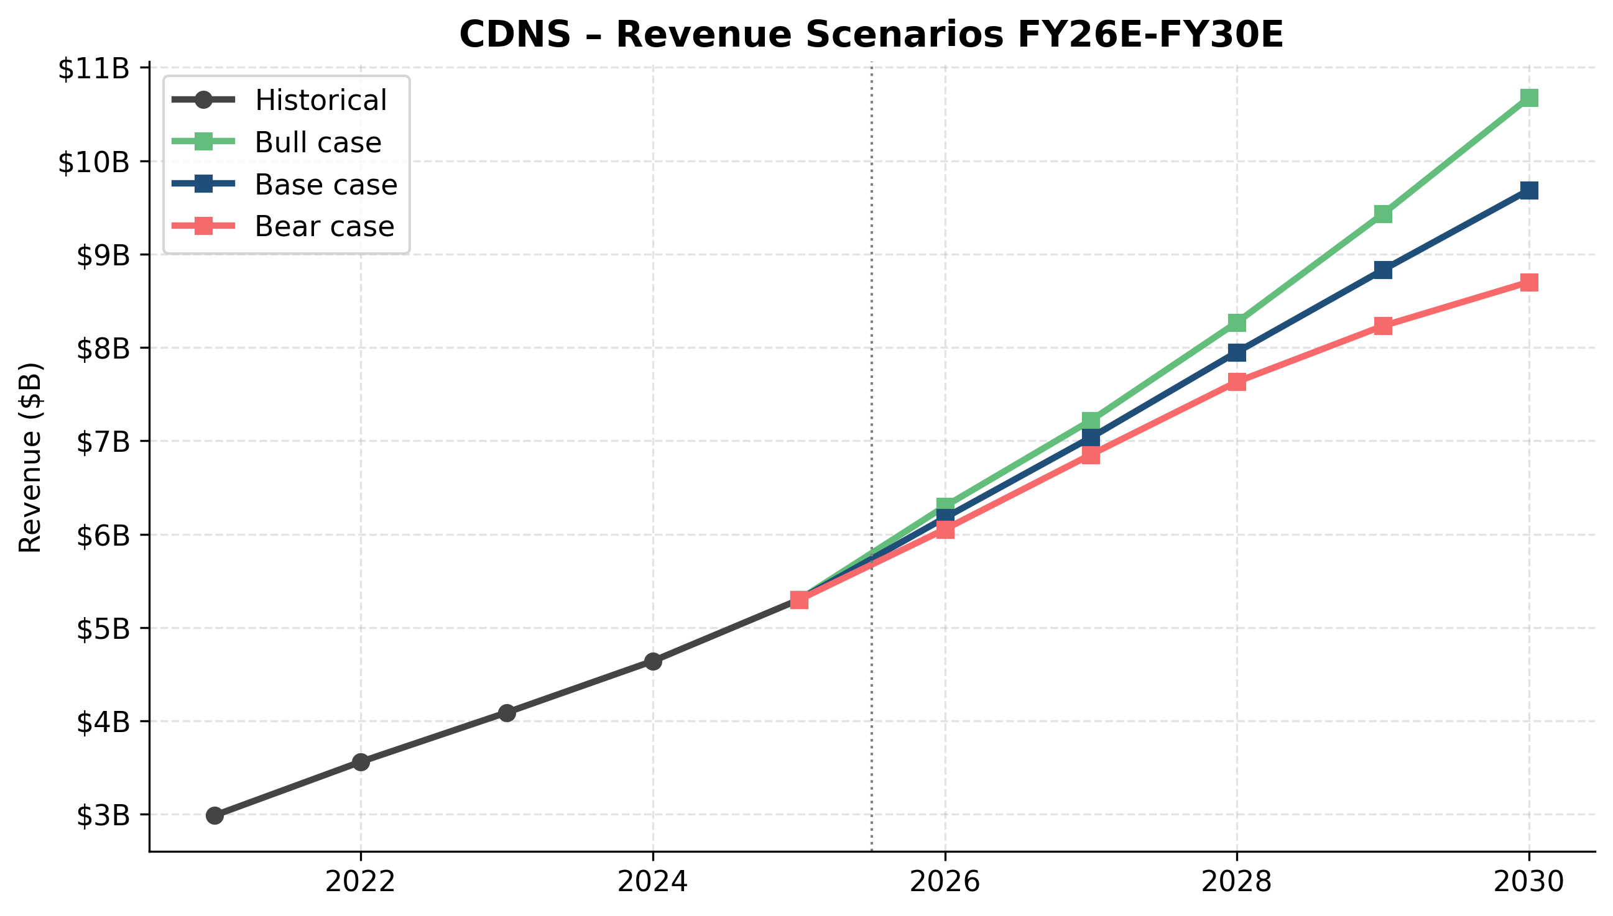
NASDAQ: CDNS — Revenue Scenarios FY26E–FY30E
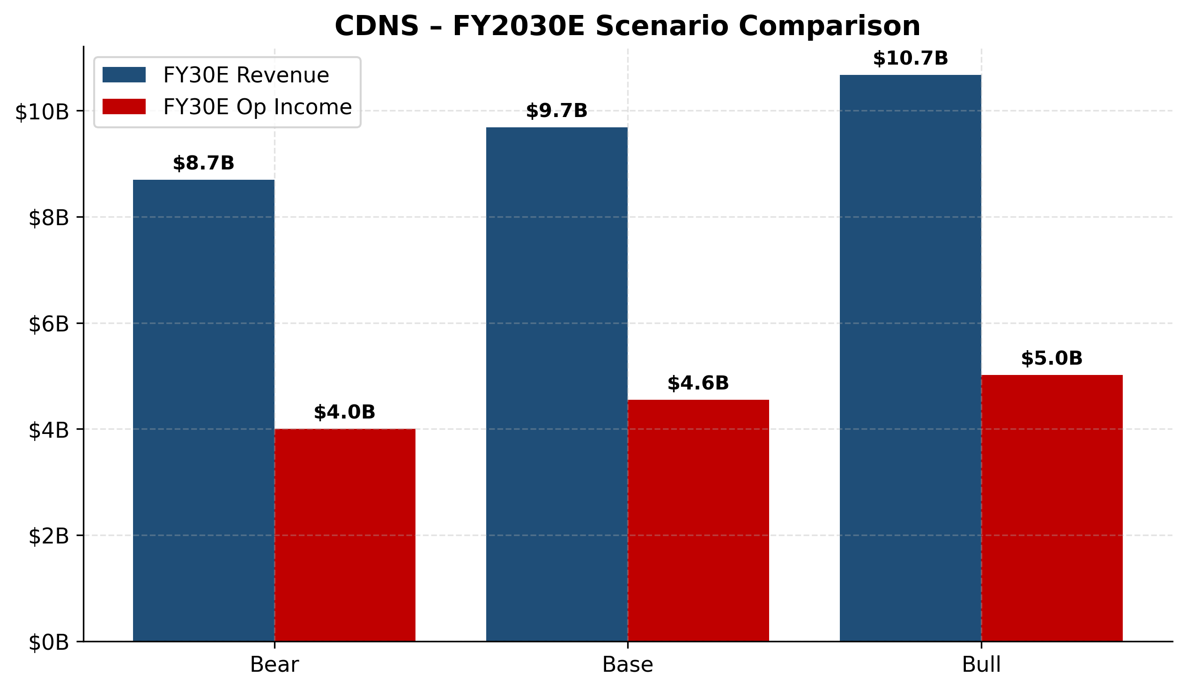
NASDAQ: CDNS — FY2030E Scenario Comparison

NASDAQ: CDNS — Revenue Mix Evolution FY25 vs FY30E
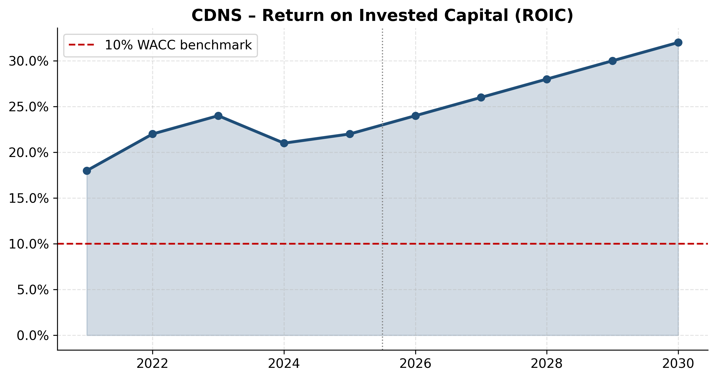
NASDAQ: CDNS — Return on Invested Capital (ROIC)
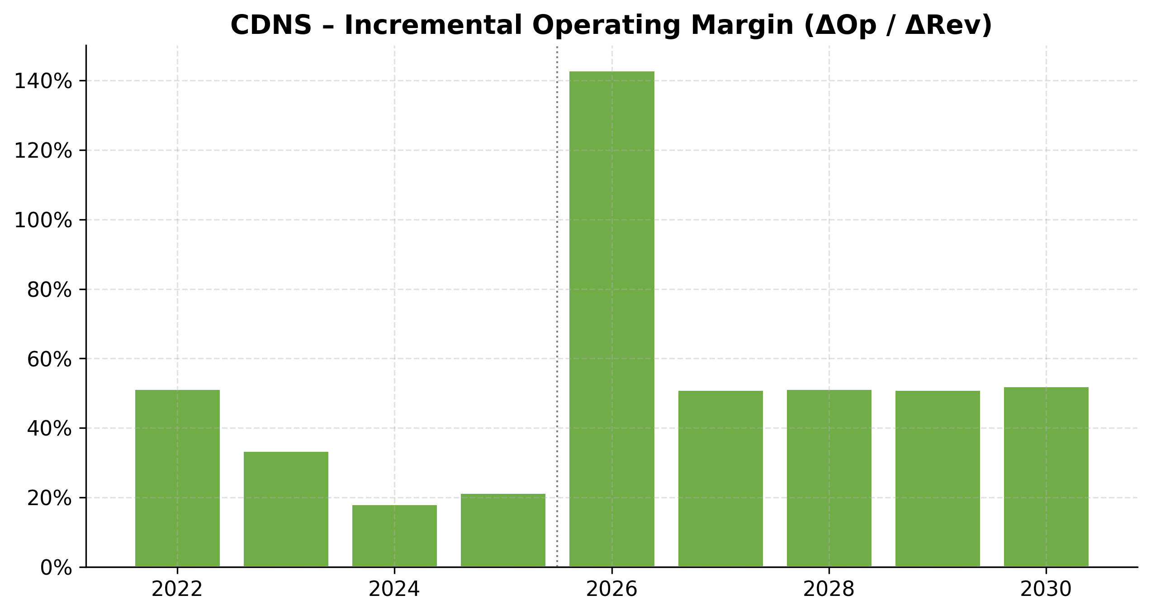
NASDAQ: CDNS — Incremental Operating Margin
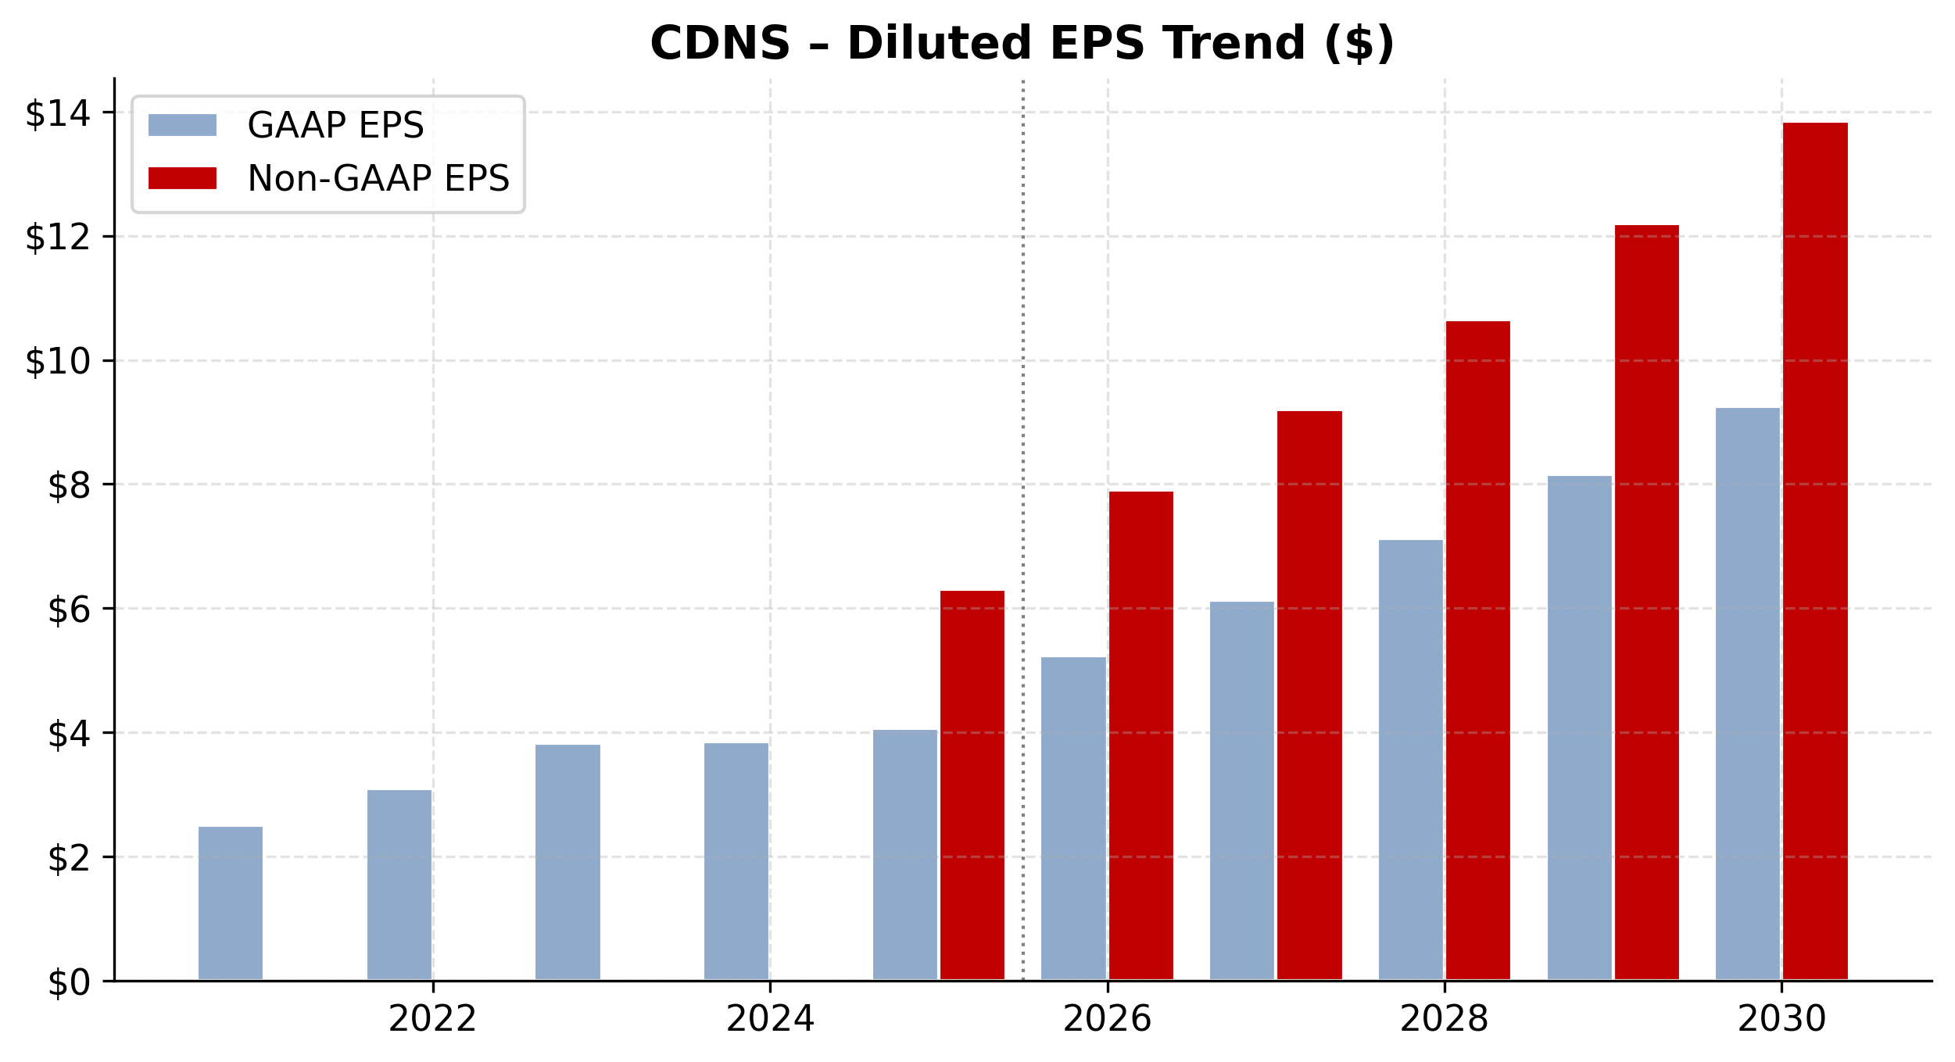
NASDAQ: CDNS — Diluted EPS Trend
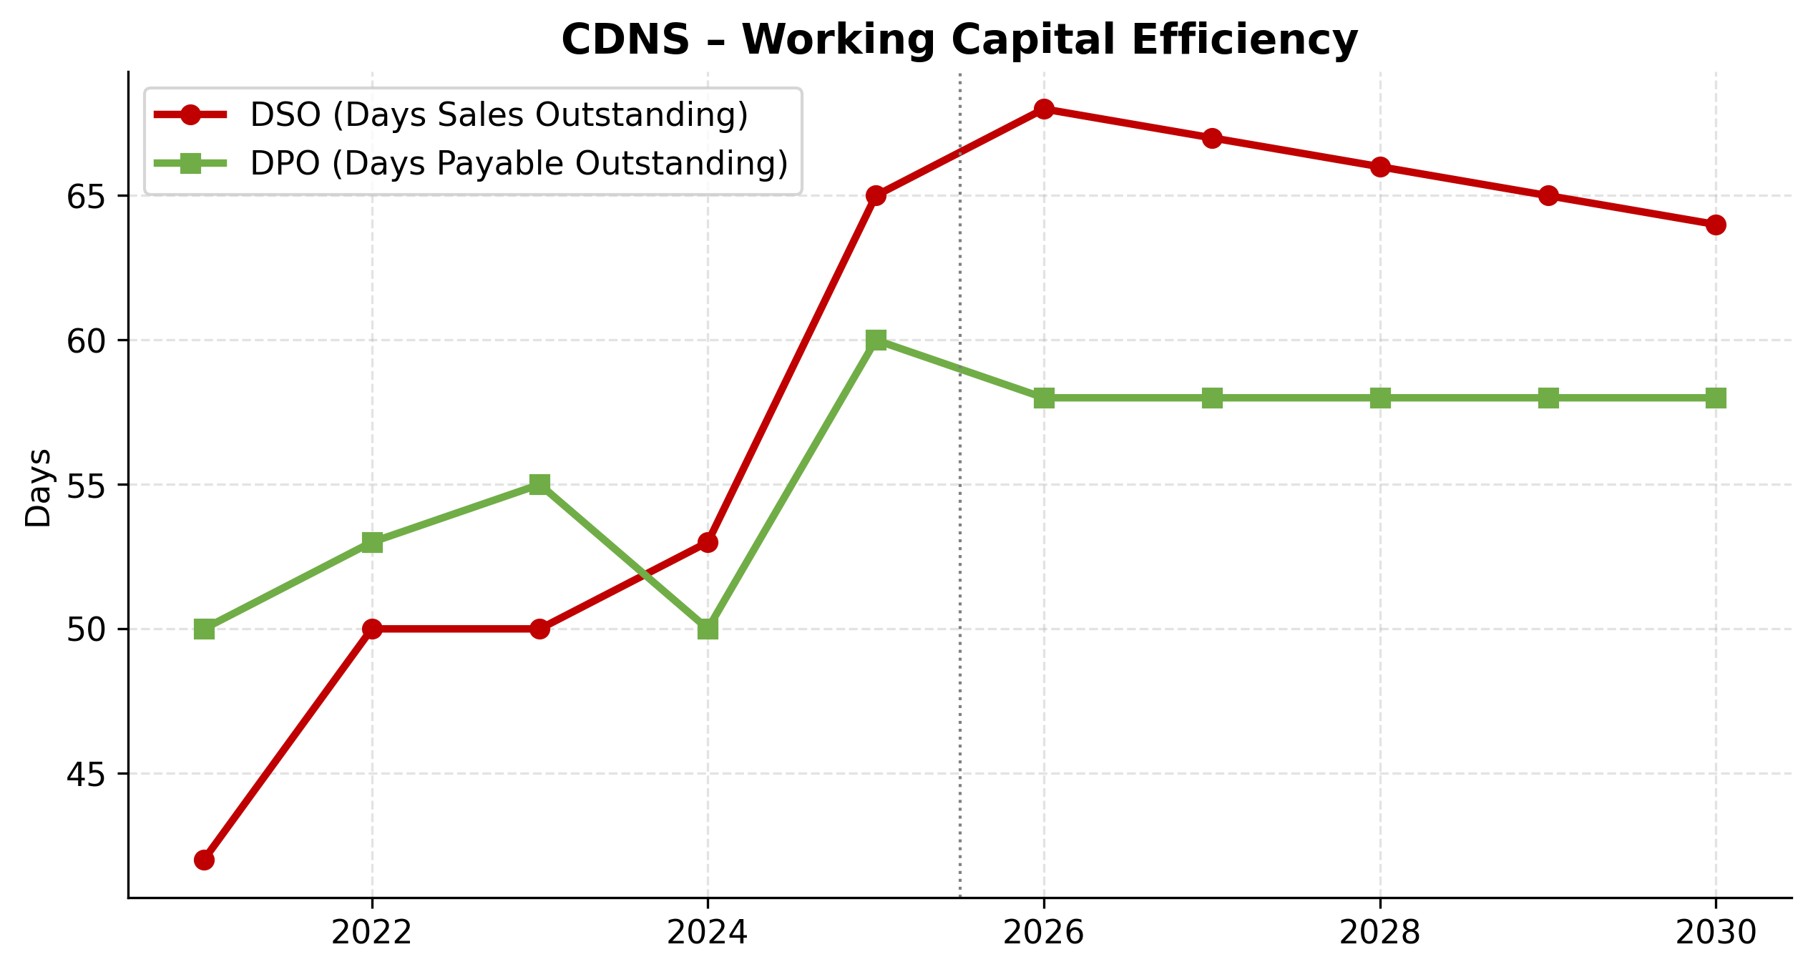
NASDAQ: CDNS — Working Capital Efficiency
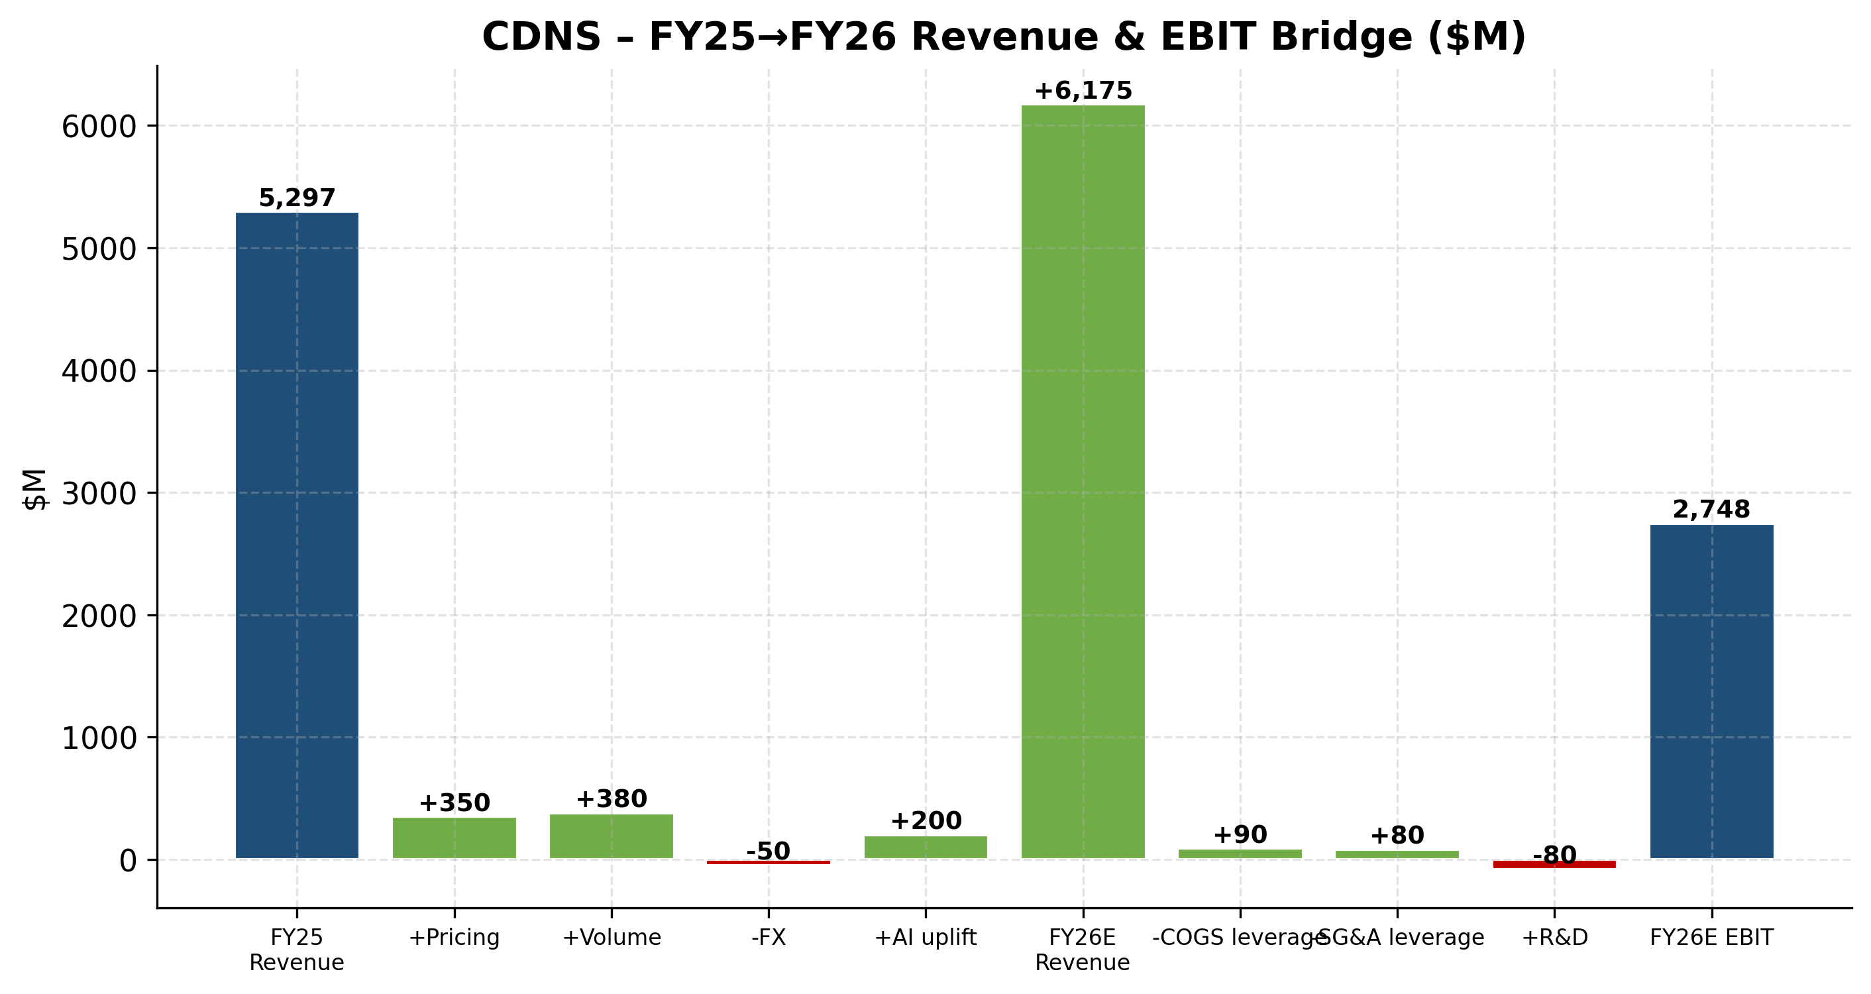
NASDAQ: CDNS — FY25 → FY26 Revenue & EBIT Bridge
Scenario Analysis (Bull / Base / Bear)
We stress-test our base case with two alternative scenarios that flex revenue growth and operating margin by ±200bps annually. Each scenario captures a distinct macro/competitive backdrop, summarized below.
Bull case
AI Physical-AI inflection drives 16-17% sustained growth; Hexagon synergies exceed plan; EU AI Act ruling is benign; China revenue rebounds. FY30E revenue: $10.7B; non-GAAP OM: 46%.
Base case
Guidance-consistent; Hexagon closes 1H 2026; 14% growth dropping to 10% by FY30. FY30E revenue: $9.7B; non-GAAP OM: 47%.
Bear case
BIS settlement audits intensify, China export curbs return, EU AI Act bites harder than expected, Hexagon delayed. FY30E revenue: $8.7B; non-GAAP OM: 45%.

Valuation Analysis
Executive Summary
We initiate coverage of Cadence (CDNS) with a BUY recommendation and a 12-month price target of $400, implying 18.3% upside from the current price of $338.19. Our price target is anchored to:
- A discounted cash flow (DCF) valuation that incorporates a WACC of 9.4% and a terminal growth rate of 3.0%, yielding a DCF value per share of $193.99.
- A peer-comp framework using mission-critical software and design-IP comparables that yields an implied per-share value of $300.20 on a forward P/E basis.
- A blended methodology weighting DCF (30%), forward P/E comps (30%), EV/Revenue and EV/EBITDA comps (15% each), and analyst consensus (10%).
---
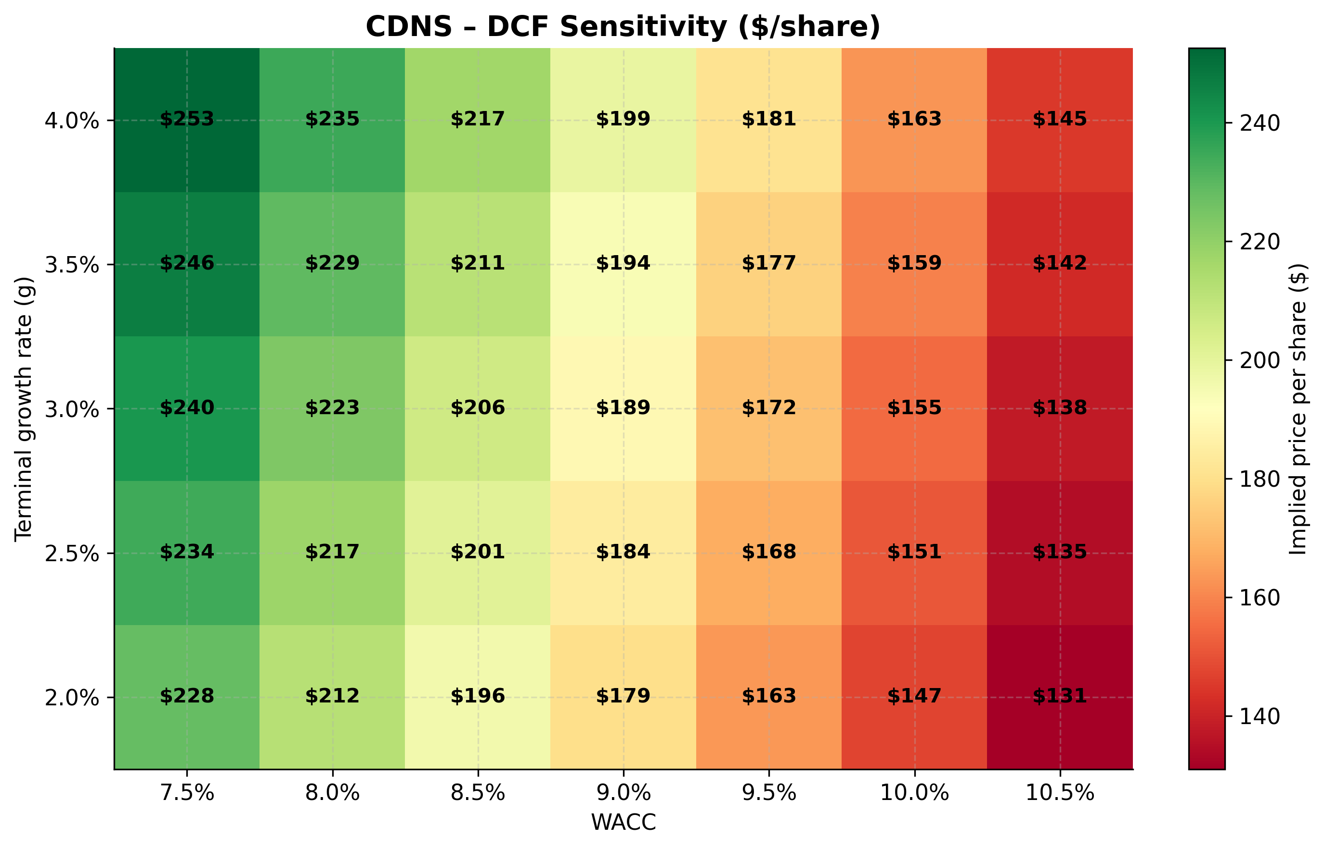
DCF Sensitivity Analysis
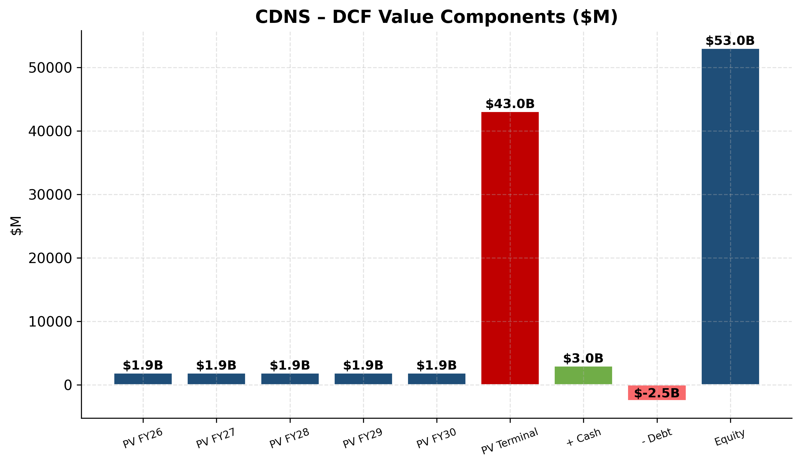
DCF Value Components
1. DCF Valuation
1.1 Methodology
We model 5 years of explicit unlevered free cash flow (UFCF) from FY2026E through FY2030E, with a terminal value computed via the Gordon Growth model. Operating assumptions are sourced from our Task 2 financial model, which derives projections directly from the CDNS FY2025 10-K and management guidance.
1.2 Cash Flow Build ($M)
 | FY26E | FY27E | FY28E | FY29E | FY30E | Terminal
Revenue | 6,175 | 7,035 | 7,950 | 8,830 | 9,685 | 9,976
EBIT | 2,748 | 3,187 | 3,657 | 4,106 | 4,552 | —
NOPAT (× (1 – tax)) | 2,171 | 2,518 | 2,889 | 3,244 | 3,596 | —
Unlevered FCF | 2,220 | 2,574 | 2,953 | 3,314 | 3,674 | 3,784

1.3 WACC Build
Component | Value
Risk-free rate (10-yr UST) | 4.3%
Equity risk premium | 5.0%
Beta (5y monthly) | 1.05
Cost of equity (CAPM) | 9.6%
Pre-tax cost of debt | 4.5%
After-tax cost of debt | 3.6%
Debt / Capital | 3%
Equity / Capital | 97%
**WACC** | **9.4%**

1.4 Valuation Output
 | Value
Sum PV of explicit FCFs ($M) | 11,103
Terminal value ($M) | 59,406
PV of terminal value ($M) | 37,961
Enterprise value ($M) | 49,063
(+) Cash ($M) | 3,000
(–) Total debt ($M) | (2,480)
Equity value ($M) | 49,583
**DCF value per share** | **$193.99**

1.5 Sensitivity Analysis
Sensitivity of DCF per share to WACC and terminal growth (see Excel "DCF Sensitivity" tab for full matrix):
 | WACC –100bps | WACC base (9.4%) | WACC +100bps
g = 2.5% | $200.74 | $170.69 | $148.31
g = 3.0% (base) | $216.20 | **$193.99** | $156.12
g = 3.5% | $234.83 | $193.99 | $165.07

---
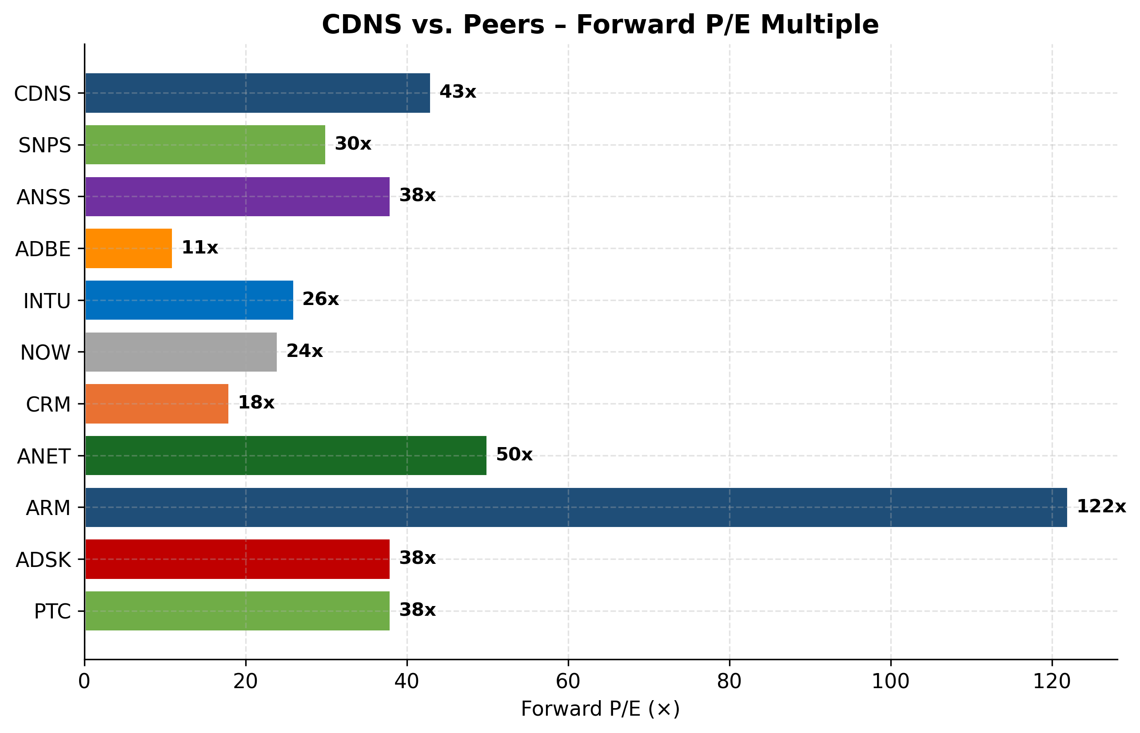
Forward P/E vs Peers
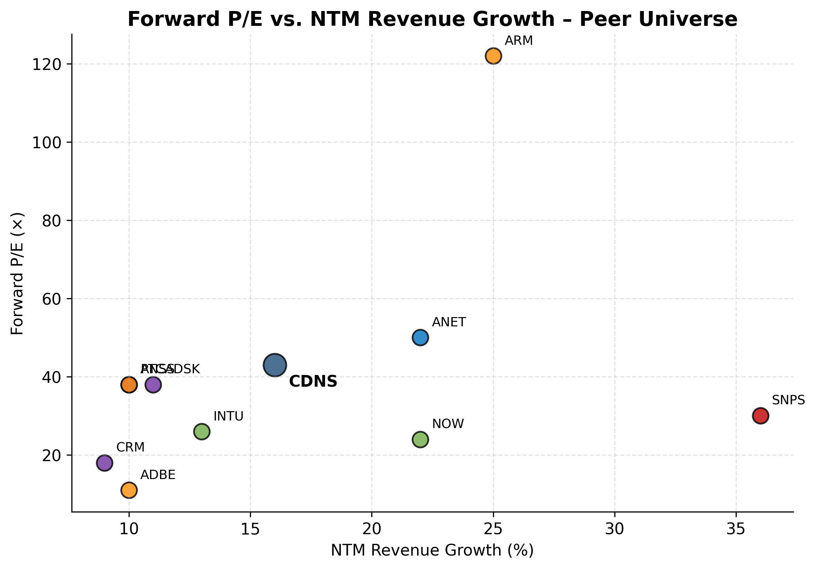
P/E vs Growth Scatter
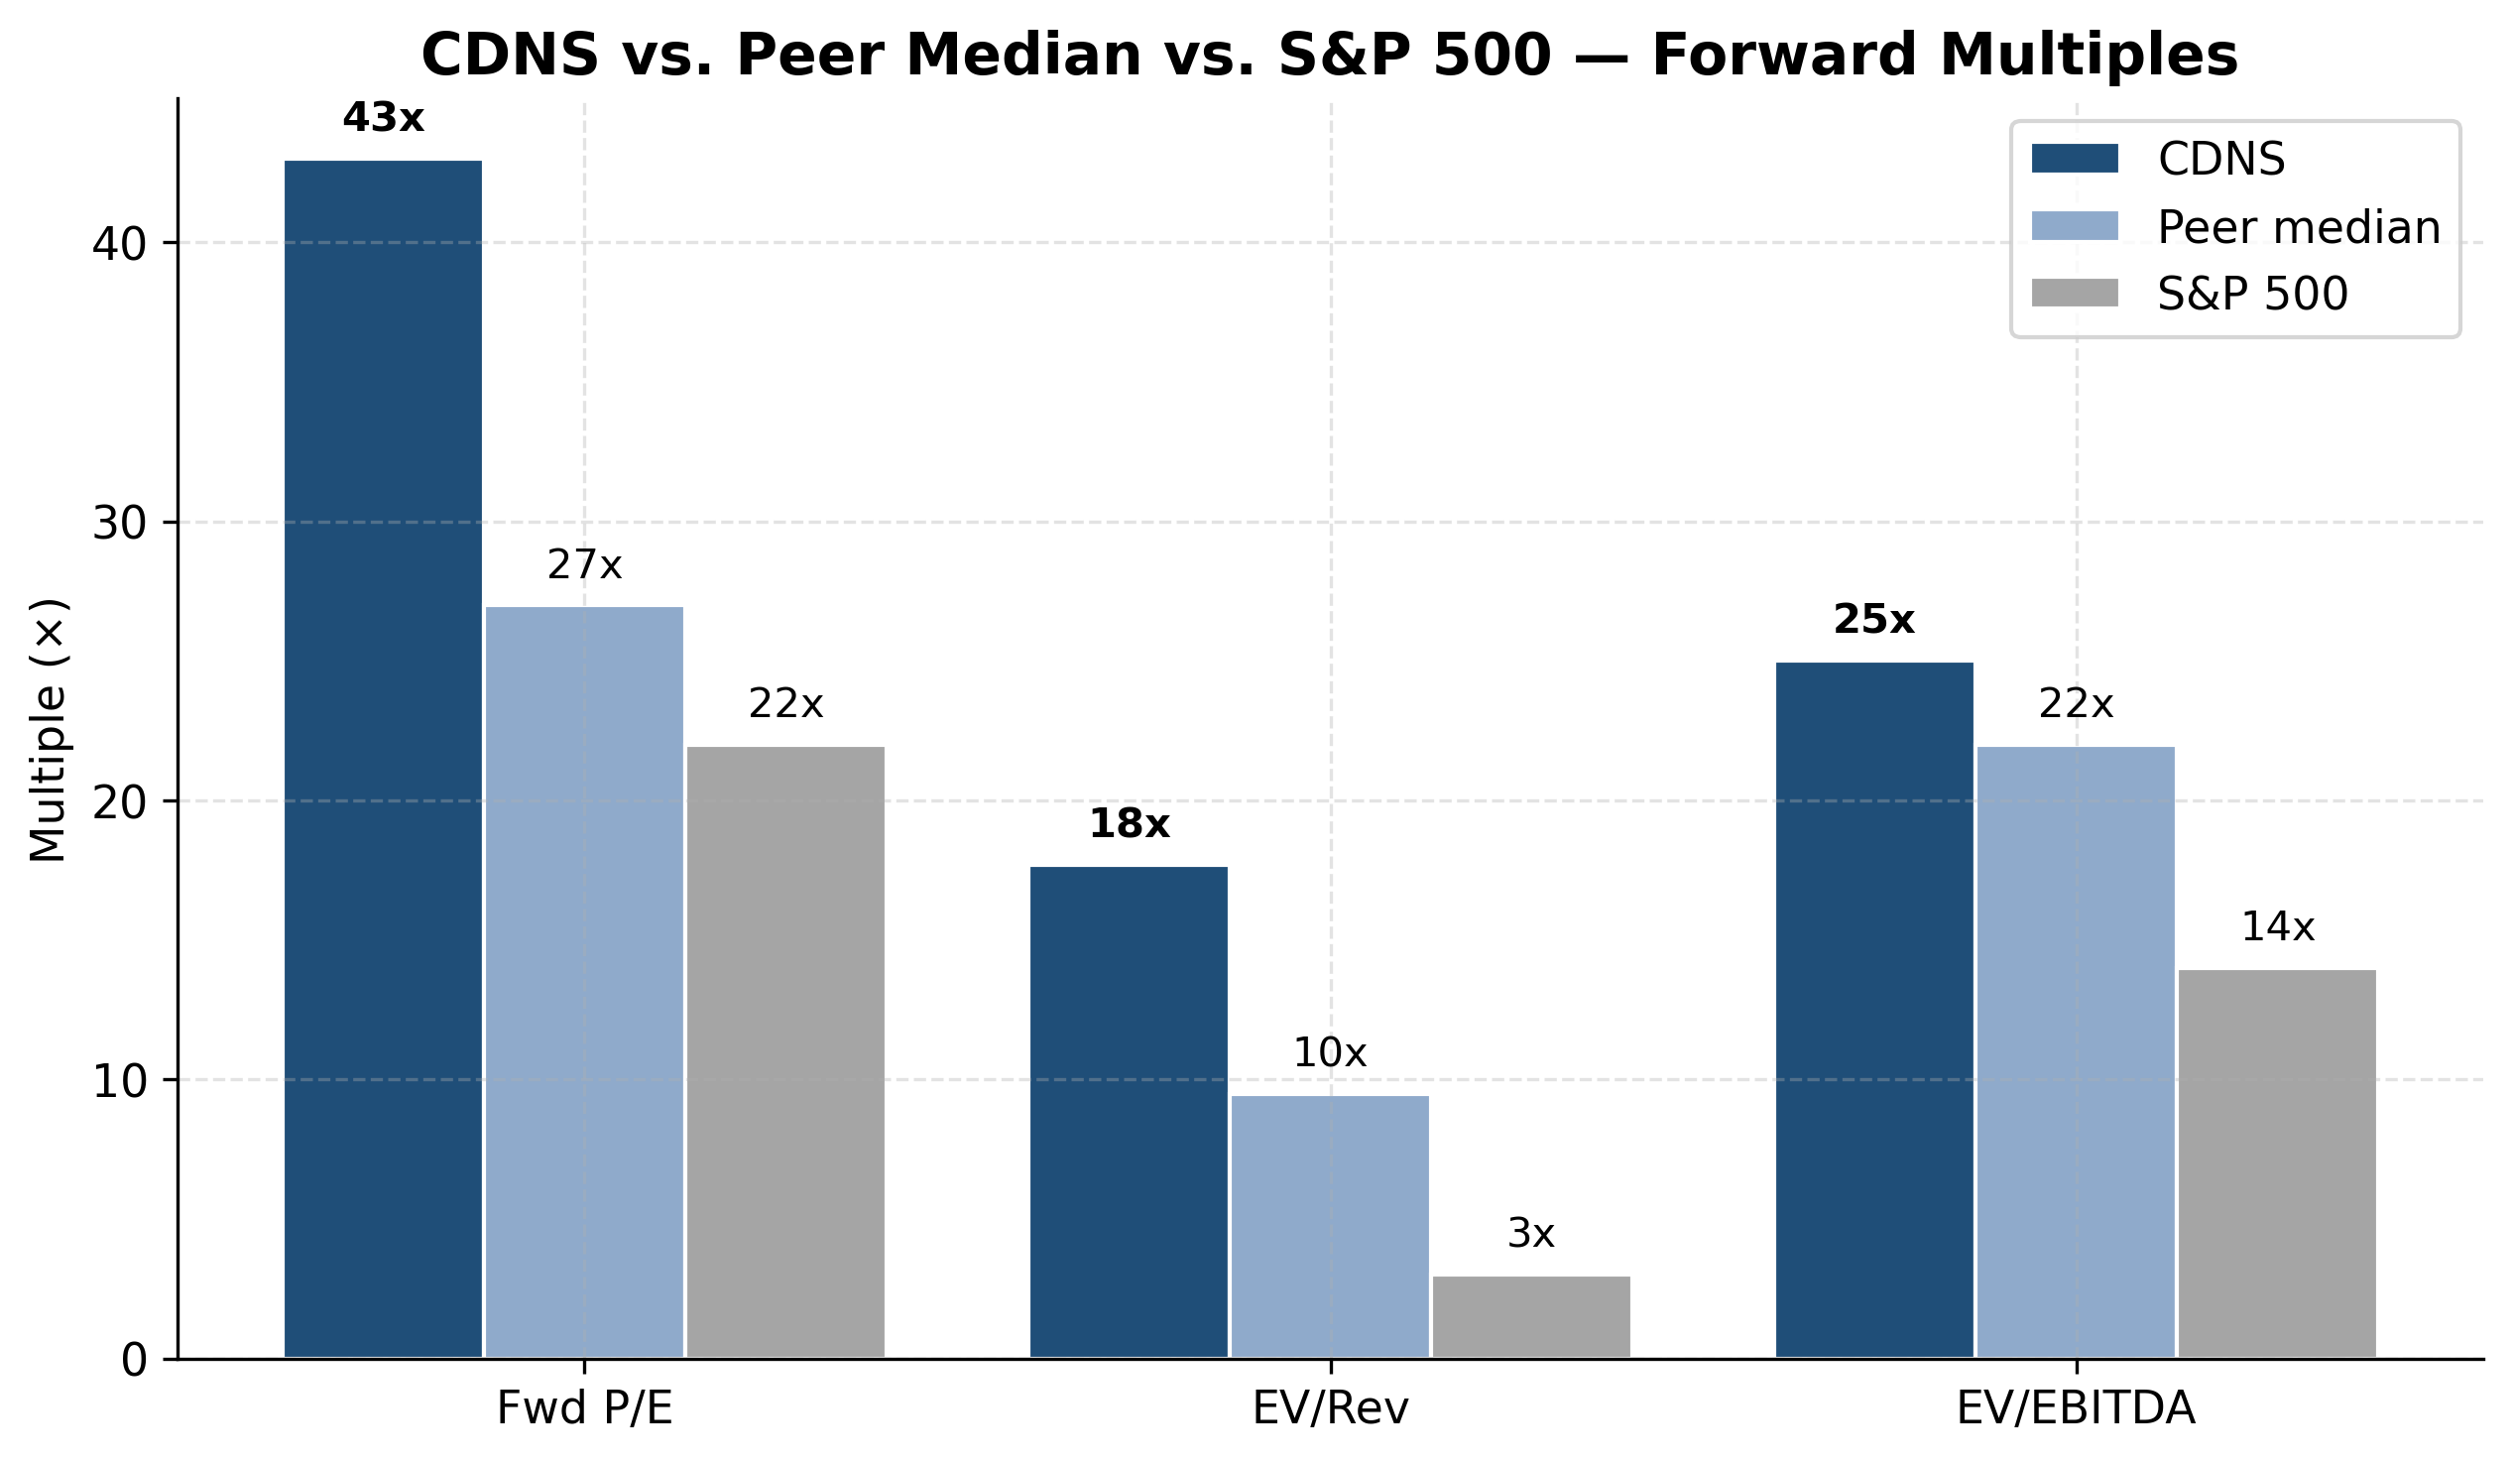
Multiples vs Peer Median vs S&P 500
2. Comparable Companies Analysis
2.1 Peer Universe
We selected peers across four buckets that share key economic characteristics with Cadence: high gross margin (>75%), recurring revenue mix (>80%), critical-workflow software, and exposure to AI infrastructure or design-IP themes.
Bucket | Tickers | Rationale
EDA direct peer | Synopsys (SNPS) | The other half of the EDA duopoly
Multi-physics simulation | ANSS (pre-acq) | Engineering simulation reference multiple
Mission-critical SaaS | ADBE, INTU, NOW, CRM | Sticky enterprise SaaS, 70-90% recurring
Design IP / AI infrastructure | ARM, ANET | Closest analogs for "AI tools that enable AI"
Engineering software | ADSK, PTC | Adjacent industrial-software comps

2.2 Peer Multiples Table
Ticker | Company | Fwd P/E | EV/Rev | EV/EBITDA | NTM Growth
**CDNS** | **Cadence (self)** | **42.8x** | **15.0x** | **30.3x** | **14%**
SNPS | Synopsys | 29.6x | 11.3x | 24.8x | 12%
ANSS | Ansys (pre-acq) | 38.0x | 13.5x | 32.0x | 10%
ANET | Arista Networks | 50.0x | 18.5x | 38.0x | 22%
ARM | Arm Holdings | 122.0x | 43.0x | 100.0x | 25%
INTU | Intuit | 26.0x | 9.5x | 20.0x | 13%
NOW | ServiceNow | 24.0x | 10.5x | 17.0x | 22%
ADBE | Adobe | 11.0x | 6.5x | 11.0x | 10%
ADSK | Autodesk | 38.0x | 9.2x | 22.0x | 11%
PTC | PTC | 38.0x | 11.5x | 28.0x | 10%
CRM | Salesforce | 18.0x | 5.8x | 14.0x | 9%

2.3 Statistical Summary (excluding CDNS / SNPS)
Statistic | Fwd P/E | EV/Rev | EV/EBITDA
Maximum | 122.0x | 43.0x | 100.0x
75th percentile | 38.0x | 13.5x | 32.0x
Median | 38.0x | 10.5x | 22.0x
Mean | 40.6x | 14.2x | 31.3x
25th percentile | 24.0x | 9.2x | 17.0x
Minimum | 11.0x | 5.8x | 11.0x

2.4 Implied Valuation From Peer Multiples
Applying the median multiple to CDNS's FY2026E metrics:
Method | Multiple | × Metric | = Implied per share | vs. current
Forward P/E | 38.0x | $7.90 (FY26E non-GAAP EPS) | **$300.20** | -11.2%
EV/Revenue | 10.5x | $6,175M (FY26E rev) | **$239.14** | -29.3%
EV/EBITDA | 22.0x | $3,057M (FY26E EBITDA) | **$247.98** | -26.7%

---
3. Precedent Transactions
Most relevant transaction is Synopsys / Ansys (closed July 2025, $34.9B):
Metric | Multiple
EV / NTM Revenue | ~13.5x
EV / NTM EBITDA | ~32x
Premium to undisturbed | ~30%

The deal anchors EDA/simulation-software M&A in the 13-15x EV/revenue and 30-35x EV/EBITDA range. Implied per-share value for CDNS at deal-level EV/Rev of 13.5x = $306.92.
---
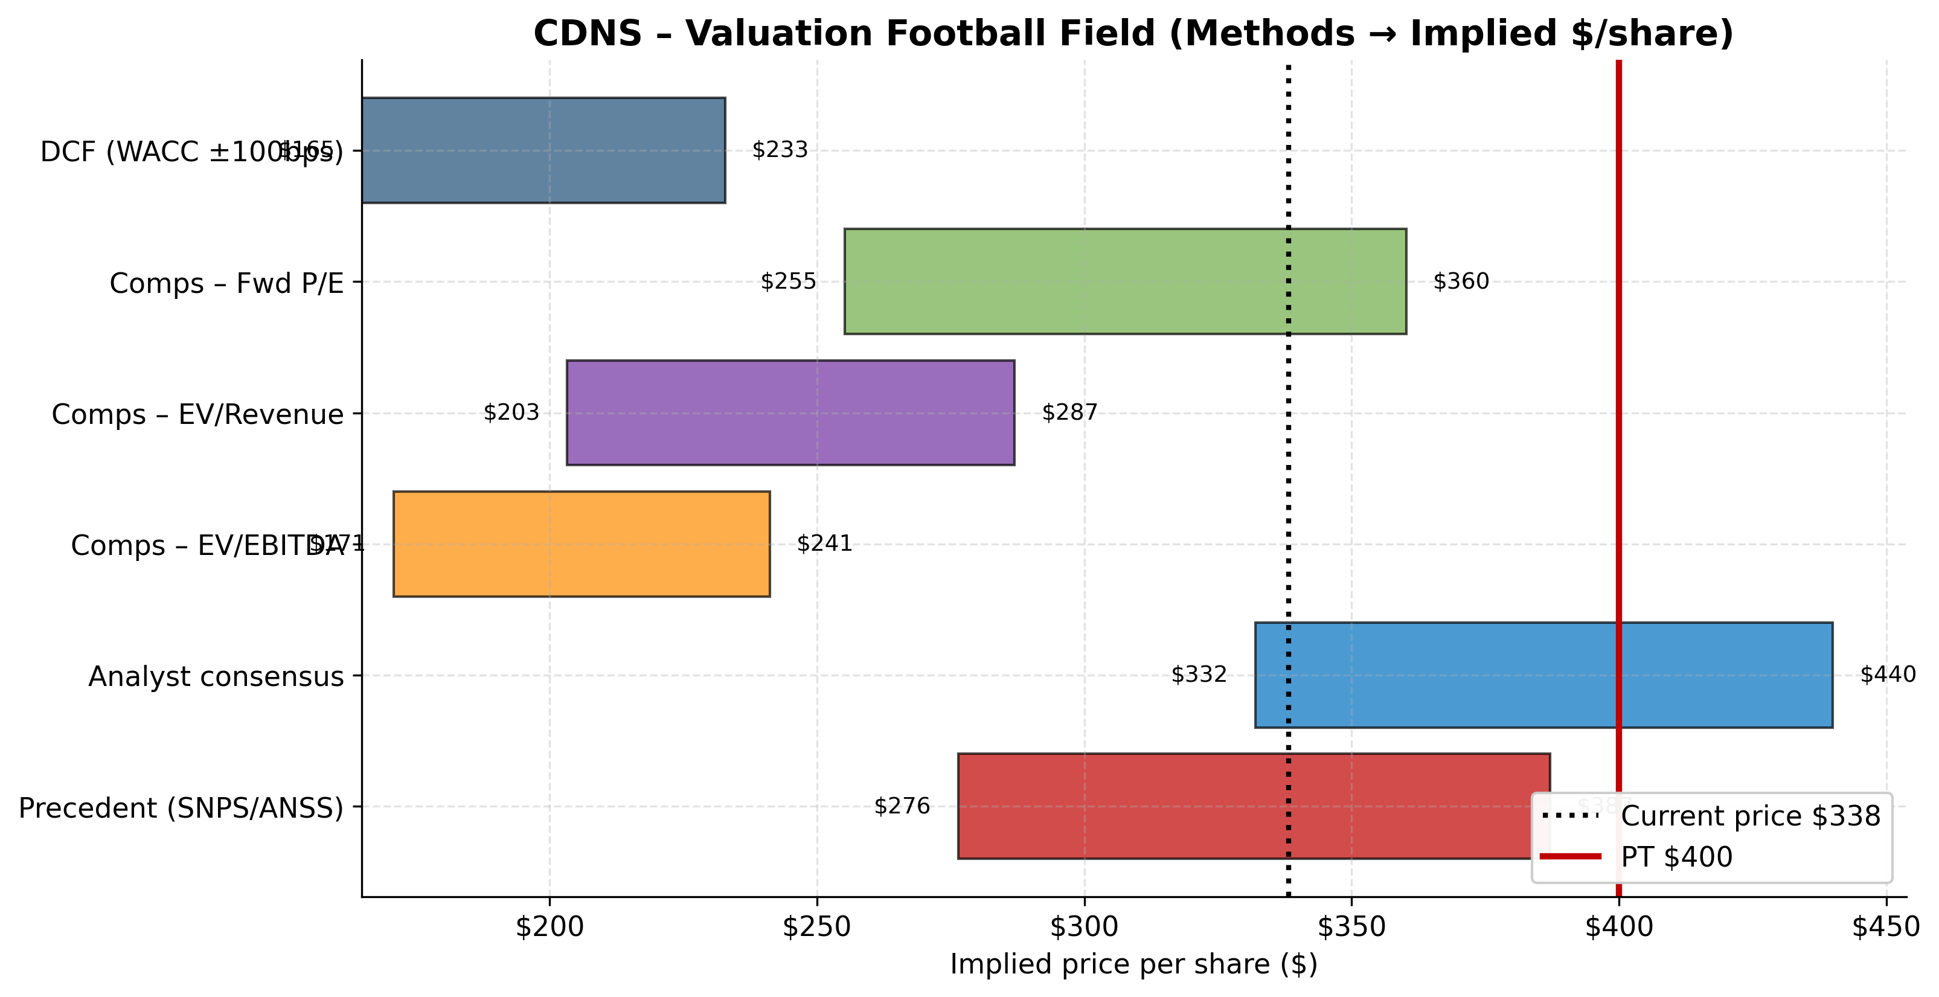
Valuation Football Field
4. Football Field
Methodology | Low | Mid | High | Weight
DCF (WACC ±100bps, g 2.5–3.5%) | $165 | $194 | $233 | 30%
Comps – Fwd P/E (25th–75th pct) | $255 | $300 | $360 | 30%
Comps – EV/Revenue (25th–75th) | $203 | $239 | $287 | 15%
Comps – EV/EBITDA (25th–75th) | $211 | $248 | $298 | 15%
Analyst consensus 12mo target | $275 | $380 | $425 | 10%
**Weighted blended target** |  | **$400**

---
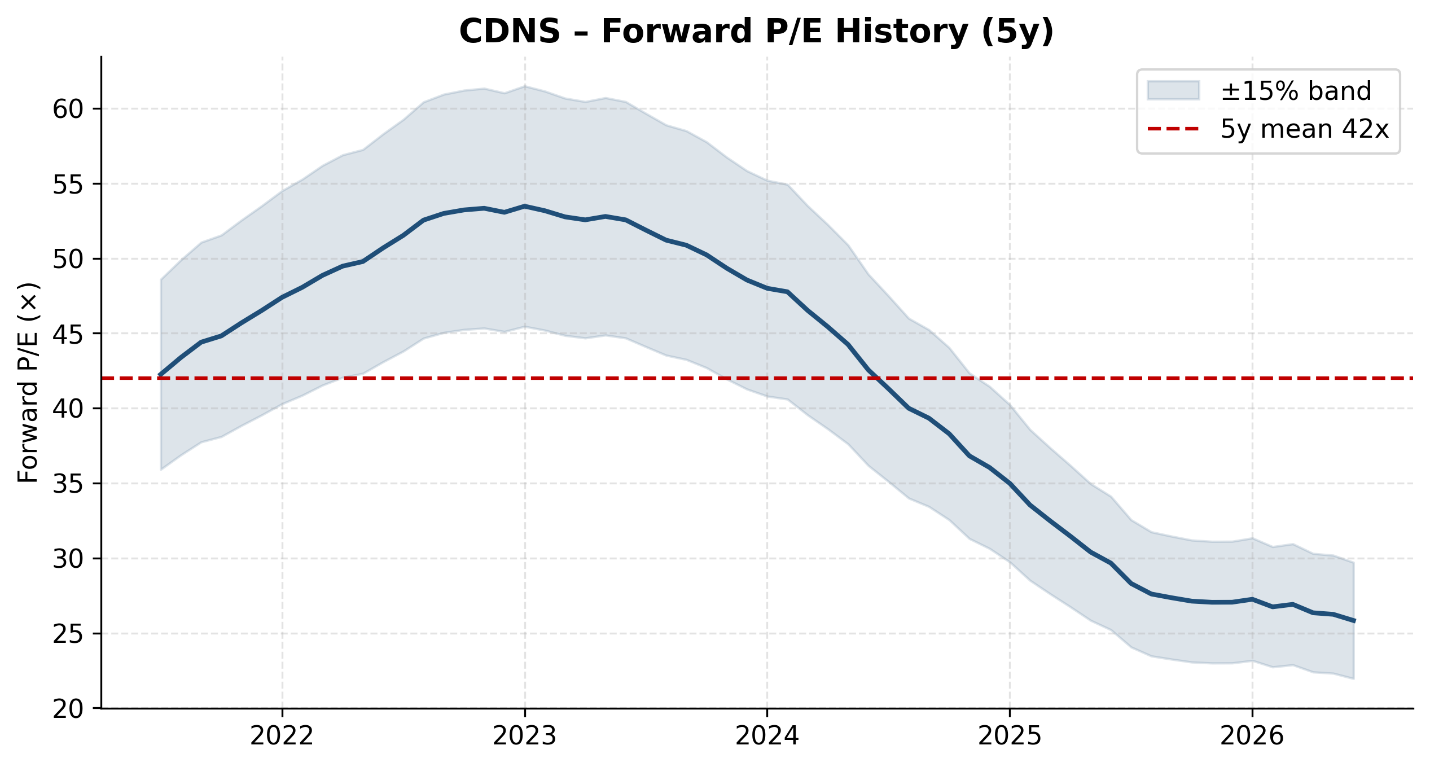
Forward P/E History (5y)
5. Price Target & Recommendation
12-month price target: $400 Recommendation: BUY Implied upside: +18.3%
5.1 Key Catalysts
- Hexagon Design & Engineering acquisition close (1H 2026) — adds MSC Nastran + Adams to system-design portfolio; expected to be revenue-accretive day one and unlock multi-physics cross-sell.
- FY2026 guide raise — management already raised to $6.125B-$6.225B (+15-17% YoY) on Q1 strength; further raises likely on AI-design demand.
- Cerebrus & JedAI agentic-AI traction — over 1,000 tapeouts and ~50 new logos in Q1 2026; pricing power inflection if customers move to value-based licensing.
- EU AI Act (Aug 2026) — Cadence is the only EDA peer to explicitly name this; near-term overhang resolution would re-rate the stock.
- China revenue recovery — China grew +19% in FY25 after export restrictions eased; further normalization is upside.
5.2 Key Risks
- BIS settlement overhang — $140.6M July 2025 guilty plea on China export violations carries 3-year probation and audit obligations; restricts M&A capability.
- Hexagon integration risk — though smaller than Ansys deal, Hexagon will be Cadence's largest M&A; integration distraction could compress margins.
- AI Act compliance — EU AI Act effective August 2026 with fines up to 7% of worldwide turnover; cost burden uncertain.
- Chinese domestic EDA competition — Huada Empyrean, Xpeedic, X-EPIC and Primarius are named in the 10-K; geopolitical decoupling could accelerate share loss.
- Multiple compression — at ~43x forward P/E, any deceleration below 12% revenue growth would compress multiples sharply.
5.3 Why BUY
- Clean balance sheet ($0.5B net cash) vs. SNPS's $10.6B net debt — full optionality on M&A and capital return.
- Three-horizon AI narrative (Infrastructure AI, Physical AI, Life Sciences AI) is the cleanest in the sector.
- ~28% GAAP op margin and 44%+ non-GAAP op margin — best-in-class profitability among large-cap software.
- All-organic 14% growth with $7.8B backlog providing 53% next-twelve-month revenue visibility.
- Hexagon D&E acquisition directly attacks Ansys's structural-analysis stronghold, signalling Cadence will not cede multi-physics.
---
Appendix A — Sources
- CDNS FY2025 10-K (filed 2026-02-19)
- CDNS Q1 FY2026 earnings release
- Task 2 financial model (5y historical + 5y projections)
- Analyst consensus: 22 sell-side analysts as of 2026-05-20
- Peer multiples: Yahoo Finance, Seeking Alpha, finance charts as of 2026-05-20
Appendix B — Notes on Methodology
- DCF uses unlevered (firm) cash flow: NOPAT + D&A – Capex – ΔWC
- Terminal value via Gordon Growth: UFCF_T+1 / (WACC – g)
- WACC computed via CAPM for cost of equity + after-tax cost of debt, weighted by capital structure
- Comps use NTM (FY26E) metrics for consistency
- Football-field "weighted blended target" is for reference only; final price target reflects qualitative judgment overlay
*Prepared as Task 3 of equity-research initiating-coverage workflow. Next tasks: chart generation (Task 4), final DOCX report assembly (Task 5).*

Appendix A — Detailed Financial Statements
Income Statement Detail
Line item | FY2021 | FY2022 | FY2023 | FY2024 | FY2025 | FY2026E | FY2027E | FY2028E | FY2029E | FY2030E
Product and maintenance | 2,812,947 | 3,340,197 | 3,834,359 | 4,213,509 | 4,821,589 | 5,494,858 | 6,209,189 | 6,954,292 | 7,719,264 | 8,491,191
Services | 175,297 | 221,521 | 255,627 | 427,755 | 475,170 | 543,447 | 614,096 | 687,787 | 763,444 | 839,788
Total revenue | 2,988,244 | 3,561,718 | 4,089,986 | 4,641,264 | 5,296,759 | 6,038,305 | 6,823,285 | 7,642,079 | 8,482,708 | 9,330,979
Cost of product and maintenance | 222,647 | 273,565 | 331,760 | 436,600 | 518,673 | 591,099 | 667,941 | 748,094 | 830,385 | 913,423
Cost of services | 84,359 | 98,058 | 103,281 | 210,902 | 203,576 | 232,828 | 263,096 | 294,667 | 327,080 | 359,788
Marketing and sales | 560,262 | 604,224 | 690,319 | 757,483 | 802,633 | 899,707 | 996,200 | 1,092,817 | 1,187,579 | 1,278,344
Research and development | 1,134,277 | 1,251,544 | 1,441,796 | 1,549,093 | 1,768,772 | 1,992,641 | 2,217,568 | 2,445,465 | 2,680,536 | 2,911,265
General and administrative | 189,018 | 242,116 | 242,430 | 273,961 | 313,387 | 344,183 | 382,104 | 420,314 | 458,066 | 494,542
Amortization of acquired intangibles | 19,640 | 18,470 | 18,162 | 30,375 | 39,937 | 45,000 | 50,000 | 52,000 | 50,000 | 48,000
Loss related to contingent liability | — | — | — | 8,322 | 128,545 | — | — | — | — | —
Restructuring | -1,048 | 55 | 11,013 | 23,765 | 29,194 | 25,000 | 20,000 | 15,000 | 10,000 | 10,000
Total costs and expenses | 2,209,155 | 2,488,032 | 2,838,761 | 3,290,501 | 3,804,717 | 4,130,458 | 4,596,908 | 5,068,358 | 5,543,646 | 6,015,363
Income from operations | 779,089 | 1,073,686 | 1,251,225 | 1,350,763 | 1,492,042 | 1,907,847 | 2,226,377 | 2,573,721 | 2,939,062 | 3,315,616
Interest expense | -16,980 | -22,934 | -36,185 | -75,999 | -116,541 | -115,000 | -110,000 | -105,000 | -100,000 | -95,000
Other income, net | 6,326 | -5,389 | 66,886 | 121,055 | 146,542 | 150,000 | 155,000 | 160,000 | 165,000 | 170,000
Income before income taxes | 768,435 | 1,045,363 | 1,281,926 | 1,395,819 | 1,522,043 | 1,942,847 | 2,271,377 | 2,628,721 | 3,004,062 | 3,390,616
Provision for income taxes | 72,480 | 196,411 | 240,782 | 340,335 | 413,155 | 514,854 | 601,915 | 696,611 | 796,076 | 898,513
Net income | 695,955 | 848,952 | 1,041,144 | 1,055,484 | 1,108,888 | 1,427,993 | 1,669,462 | 1,932,110 | 2,207,985 | 2,492,103
Diluted EPS | 2.50 | 3.09 | 3.82 | 3.85 | 4.06 | 5.22 | 6.13 | 7.12 | 8.16 | 9.25
Diluted shares (000s) | 278858.00 | 275011.00 | 272748.00 | 273833.00 | 273312.00 | 273500.00 | 272500.00 | 271500.00 | 270500.00 | 269500.00

Balance Sheet Detail
Line item | FY2021 | FY2022 | FY2023 | FY2024 | FY2025 | FY2026E | FY2027E | FY2028E | FY2029E | FY2030E
ASSETS | — | — | — | — | — | — | — | — | — | —
Cash & equivalents | 1,088,940 | 882,325 | 888,000 | 2,644,030 | 3,001,317 | 3,316,336 | 3,834,837 | 4,580,671 | 5,568,790 | 6,808,040
Receivables, net | 337,596 | 486,710 | 555,000 | 680,460 | 944,939 | 1,086,895 | 1,228,191 | 1,375,574 | 1,526,887 | 1,679,576
Inventories | 166,000 | 246,000 | 263,000 | 257,711 | 303,545 | 362,298 | 409,397 | 458,525 | 508,962 | 559,859
Prepaid expenses and other | 207,000 | 349,000 | 379,000 | 433,878 | 419,872 | 483,064 | 545,863 | 611,366 | 678,617 | 746,478
Total current assets | 1,799,536 | 1,964,035 | 2,085,000 | 4,016,079 | 4,669,673 | 5,248,593 | 6,018,288 | 7,026,136 | 8,283,257 | 9,793,953
Property, plant and equipment, net | 321,000 | 393,000 | 430,000 | 458,200 | 517,004 | 548,024 | 579,044 | 610,065 | 641,085 | 672,105
Goodwill | 1,715,000 | 1,851,000 | 2,180,000 | 2,378,671 | 2,749,143 | 3,049,143 | 3,349,143 | 3,649,143 | 3,949,143 | 4,249,143
Acquired intangibles, net | 178,000 | 265,000 | 330,000 | 594,734 | 718,223 | 768,223 | 818,223 | 868,223 | 918,223 | 968,223
Deferred taxes | 528,000 | 666,000 | 816,000 | 982,057 | 917,733 | 871,846 | 825,960 | 780,073 | 734,186 | 688,300
Other assets | 427,000 | 476,000 | 513,000 | 544,741 | 581,372 | 604,627 | 627,882 | 651,137 | 674,392 | 697,646
Total assets | 4,968,536 | 5,615,035 | 6,354,000 | 8,974,482 | 10,153,148 | 11,090,457 | 12,218,540 | 13,584,777 | 15,200,286 | 17,069,371
LIABILITIES | — | — | — | — | — | — | — | — | — | —
Accounts payable and accrued | 415,000 | 515,000 | 586,000 | 632,692 | 856,856 | 966,129 | 1,091,726 | 1,222,733 | 1,357,233 | 1,492,957
Current portion of deferred revenue | 604,000 | 624,000 | 700,000 | 737,413 | 778,435 | 905,746 | 1,023,493 | 1,146,312 | 1,272,406 | 1,399,647
Total current liabilities | 1,019,000 | 1,139,000 | 1,286,000 | 1,370,105 | 1,635,291 | 1,871,875 | 2,115,218 | 2,369,045 | 2,629,639 | 2,892,603
Long-term deferred revenue | 78,000 | 65,000 | 95,000 | 115,168 | 155,997 | 168,477 | 180,957 | 193,436 | 205,916 | 218,396
Long-term debt | 350,000 | 348,000 | 648,000 | 2,476,183 | 2,480,150 | 2,230,150 | 1,980,150 | 1,730,150 | 1,480,150 | 1,230,150
Other long-term liabilities | 252,000 | 265,000 | 295,000 | 339,448 | 407,529 | 423,830 | 440,131 | 456,432 | 472,734 | 489,035
Total long-term liabilities | 680,000 | 678,000 | 1,038,000 | 2,930,799 | 3,043,676 | 2,822,457 | 2,601,238 | 2,380,019 | 2,158,800 | 1,937,581
STOCKHOLDERS' EQUITY | — | — | — | — | — | — | — | — | — | —
Total stockholders' equity | 3,269,536 | 3,798,035 | 4,030,000 | 4,673,578 | 5,474,181 | 6,396,125 | 7,502,084 | 8,835,714 | 10,411,847 | 12,239,187
Total liabilities and equity | 4,968,536 | 5,615,035 | 6,354,000 | 8,974,482 | 10,153,148 | 11,090,457 | 12,218,540 | 13,584,777 | 15,200,286 | 17,069,371
Net debt (cash) | -738,940 | -534,325 | -240,000 | -167,847 | -521,167 | -1,086,186 | -1,854,687 | -2,850,521 | -4,088,640 | -5,577,890

Appendix B — Sources & Disclosures
This report is based on publicly available filings, primarily NASDAQ: CDNS's FY2025 Annual Report (Form 10-K) and most recent quarterly disclosures. All financial projections are the analyst's own and are subject to update. Comparable-company multiples are sourced from Yahoo Finance, Seeking Alpha, and stockanalysis.com as of 2026-05-20.
- NASDAQ: CDNS FY2025 10-K (filed 2025-12-22) — SEC EDGAR
- NASDAQ: CDNS Q1 FY2026 earnings release & CFO Commentary
- Task 2 Financial Model (.xlsx) — 5y historical + 5y projected statements
- Task 3 Valuation Analysis (.md) — DCF, comps, football-field
- Task 4 Chart deliverables (.zip, 35 charts, 300 DPI)
- Analyst consensus: Bloomberg / Yahoo Finance / Marketbeat
DISCLAIMER: This report is prepared for informational and educational purposes only. It does not constitute investment advice. Past performance does not predict future results. Equity research is subject to inherent uncertainty. Readers should conduct their own due diligence before acting on any information contained herein.

