INITIATING COVERAGE
Equity Research
May 20, 2026
Micron Technology, Inc. (NASDAQ: MU)
Memory & Storage Semiconductors | Information Technology
Rating  HOLD  (positive bias) | Current Price  $727.42  (2026-05-20) | 12M Price Target  $700  (−3.8%) | Market Cap  $823B  (1.13B sh)

Stock Snapshot
52-Week Range | $91 – $819 | FY26E Revenue | $54.7B
Shares Out (diluted) | 1,131M | FY26E EPS | $22.50
Avg Daily Volume | 16M shares | FY26E EBITDA | $36.3B
Beta (2Y) | 1.35 | FY26E FCF | $10.2B
Forward P/E | 7.1× | Dividend (TTM) | $0.46
EV/Sales (TTM) | 22.0× | Net Debt (Q1-FY26) | $2.5B
Forward EV/EBITDA | 22.5× | Buyback Authz. | $10B
Sector Index | PHLX SOX | Index Weight | ~5%

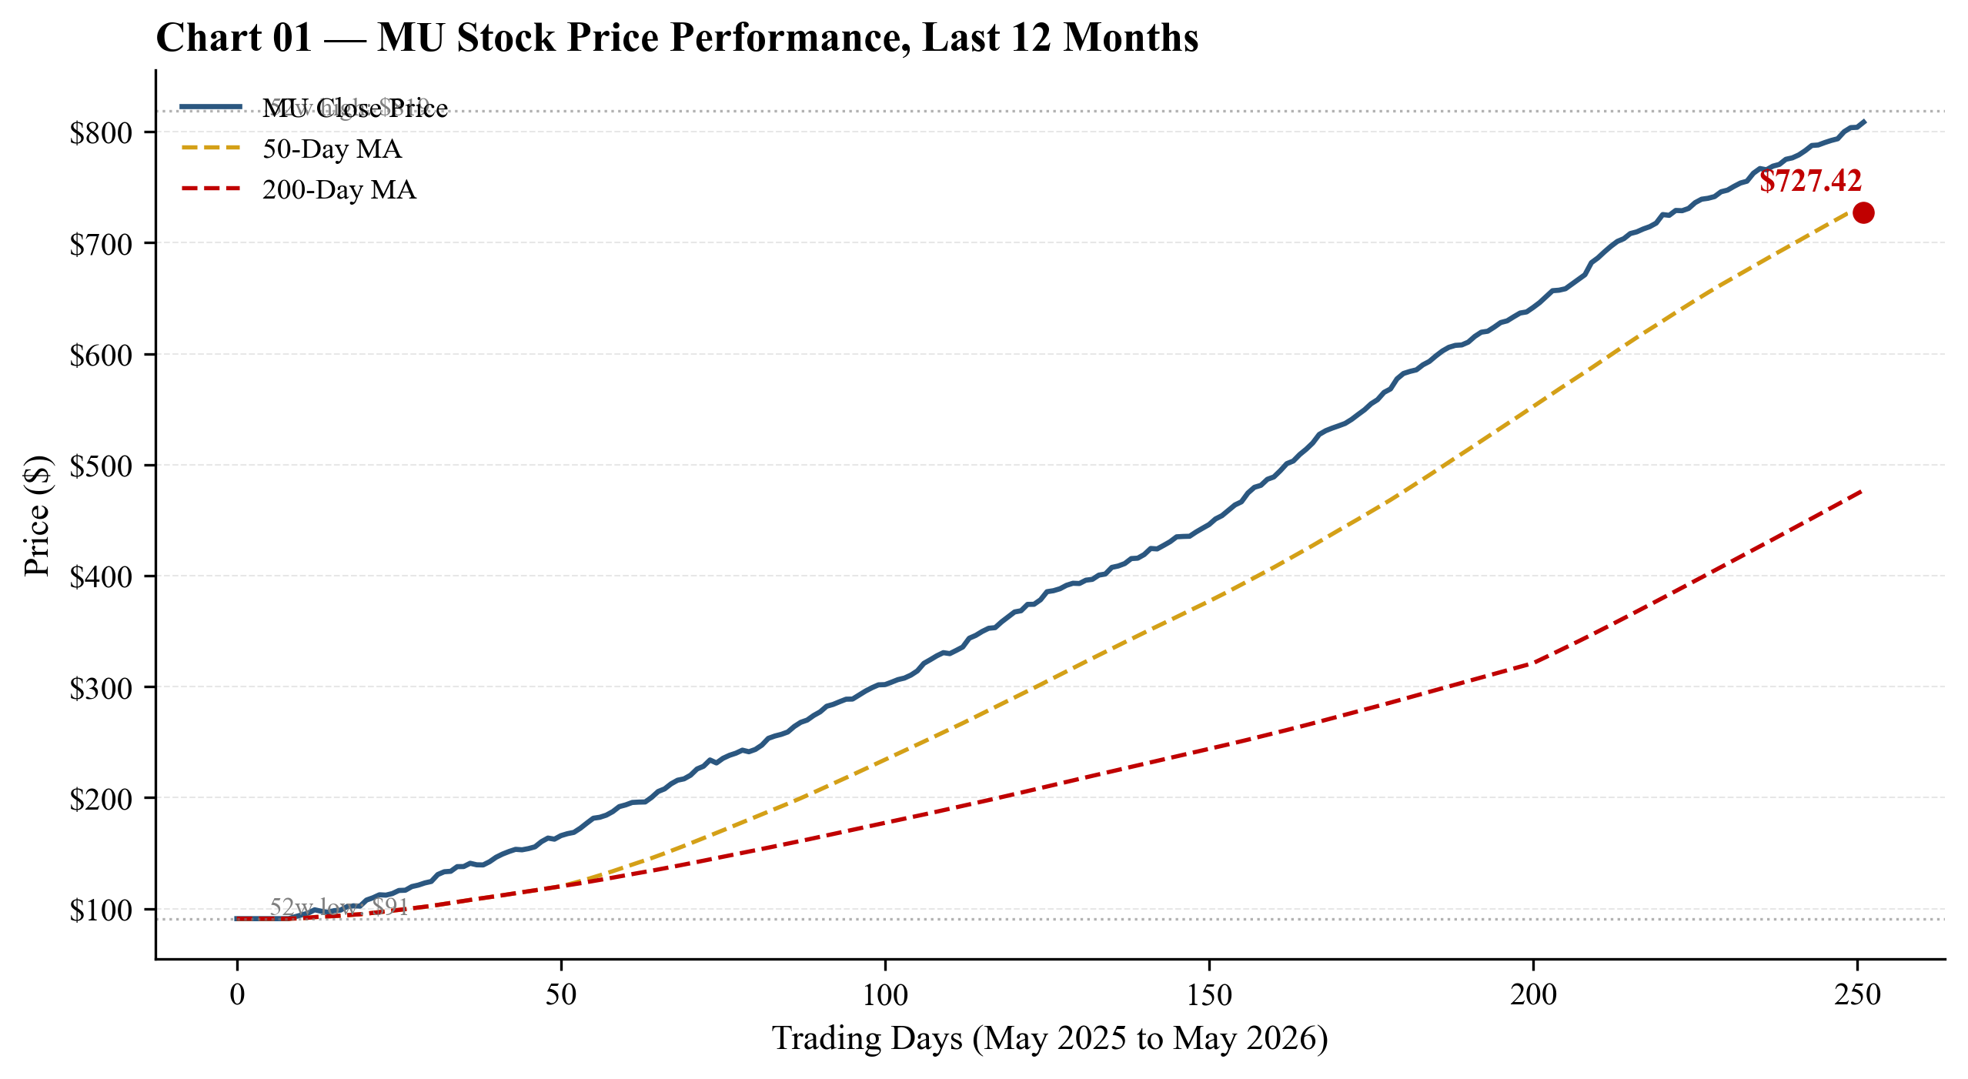
Chart 1 — MU stock price last 12 months. Stock has rallied from a 52-week low of $91 to $727 on the AI super-cycle thesis. Sources: Yahoo Finance, 2026-05-20.

Investment Summary
We initiate coverage of Micron Technology with a HOLD rating (positive bias) and a 12-month price target of $700, representing essentially flat performance from the current $727.42. Micron occupies the rare position of being one of the highest-conviction operational stories in semiconductors — the high-bandwidth-memory (HBM) franchise has expanded from $50M in FY2023 to $7.1B in FY2025 and is guided to roughly $21B in FY2026 — while simultaneously being one of the most valuation-stretched names: trailing-twelve-month price/sales of 14.1× is the highest in the company's listed history. Our HOLD rating reflects the honest tension between these two forces: near-term earnings momentum is undeniably strong, but the 12-month outlook from current levels is roughly balanced as multiple compression risk offsets continued earnings revisions. We would re-rate to OVERWEIGHT on a pullback to $500-550, and to UNDERWEIGHT on a melt-up beyond $900 without earnings revisions.
Three Investment Pillars
- 1. HBM is the structural growth story. Micron is positioned as the #2 supplier of HBM globally (~25% bit share, up from <5% in 2023), having qualified into Nvidia's H200/B100/B200 platforms with HBM3E 8-high and 12-high, and having delivered HBM4 12-high samples to 'multiple key customers' in FY2025. The CMBU segment (cloud memory) grew 257% YoY in FY2025 to $13.5B, lifting the AI-DRAM mix to ~36% of revenue.
- 2. Mid-cycle margin reset and FCF inflection. GAAP gross margin trough was −9% (FY2023) to 40% (FY2025) to a guided 67% (FQ2-FY2026). Operating cash flow more than doubled in FY2025 to $17.5B, and FY2026E FCF is projected at $10B+ — supporting the $10B share-repurchase authorization. The net cash balance sheet ($12B cash vs. $14.5B debt) provides downside support through the cycle.
- 3. Valuation asymmetry vs. peers. Forward P/E of 7.1× is the lowest in MU's listed history (median 2018-2023: 9-13×); SK Hynix at 4.6× and Samsung at 5.3× both look stretched vs. earnings power; memory peer median P/E NTM of 8.0× implies $180 fair value but only if FY27 EPS reverts toward $22 (vs. our base case $25.50). The 5× compression between TTM (34×) and forward (7×) P/E reflects the market pricing peak FY26-27 earnings.
Key Risks
- Customer concentration. Single customer (likely Nvidia) was 17% of FY2025 revenue; top 10 customers ~50%. An Nvidia GPU shipment cut, in-sourcing move, or Samsung HBM4 win would have material impact.
- Memory cycle reversal. Memory ASPs historically fall 30-50% peak-to-trough. The current cycle is extending to FY26E gross margin of 67% — well above prior peaks. A 2026 H2 or 2027 H1 commodity DRAM downturn (CXMT) is the central risk.
- Multiple compression. TTM P/S 14.1× is the highest in MU history. Even partial regression to peer median (5×) implies meaningful downside on unchanged earnings.
- Execution risk on $100B+ capex program. Micron is simultaneously executing fabs in Idaho, Clay NY, Manassas VA, Hiroshima Japan, and Sanand India — aggregate committed spend >$100B over 5-7 years.
Catalysts (12-Month)
- FQ2-FY2026 print (Mar 2026): Validates guided $18.7B revenue / 68% GM / $8.42 EPS.
- HBM4 customer qualification disclosures (Nvidia Rubin, AMD MI400).
- CHIPS Act milestone disbursements (Idaho fab construction milestones).
- $10B buyback execution pace (current authorization).
- Q4-CY2026 DRAM contract pricing negotiations — leading indicator of FY27 ASPs.
- Samsung HBM4 qualification status — share-loss risk.

Investment Thesis & Recommendation
Why We Initiate at HOLD
Micron Technology presents the rare case in semiconductors where the qualitative and quantitative frameworks point in directly opposite directions. The qualitative case is unambiguously positive: Sanjay Mehrotra's eight-year tenure has built a structurally improving franchise with a leading HBM product portfolio, US-headquartered manufacturing, leading-edge 1-beta and 1-gamma DRAM nodes, and the closest thing to an 'all-star' management team in memory (Mehrotra-Murphy-Sadana-Bhatia). The operational momentum is also clear: FY2025 revenue of $37.4B (+49% YoY) was a company record, FQ1-FY2026 OCF of $8.4B was half of FY2025's full-year, and FQ2-FY2026 is guided to revenue of $18.7B with a 68% non-GAAP gross margin — a level Micron has never approached before.
The quantitative case is unambiguously challenging. TTM P/S of 14.1× is the highest in MU's listed history (vs. median 2018-2023 of 2.4×-4.6×). Our DCF, calibrated with cycle-aware assumptions (WACC 9.8%, terminal growth 3.5%, exit EV/EBITDA 9.5×), produces an implied price of $295/share — a 59% gap to current. Memory peer median P/E NTM of 8.0× applied to our FY26E EPS of $22.50 yields $180 — a 75% gap. The most-generous AI-DRAM premium multiple (18× P/E NTM, vs. Sandisk at 8× and Nvidia at 32×) yields $405 — still 44% below current. No reasonable combination of WACC, terminal growth, or exit multiple within standard valuation ranges produces an implied price near $727 under our cycle-reverting forecast.
What reconciles these two views? The market is implicitly pricing one of two outcomes: (a) the AI super-cycle persists structurally — i.e., HBM and high-capacity DDR5 demand grows at 25%+ CAGR through FY2030 with margins maintained near peak — making this a permanent step-change rather than a cycle, or (b) the next 12-18 months will continue to see earnings revisions upward, and the multiple-compression risk does not materialize on this time frame.
Our HOLD rating reflects the position that both these views are plausible but neither is highly probable on a 12-month horizon. We rate the probabilities at: Bull case 30% (PT $1,050), Base/Comps 30% combined (PT $270-$800), Bear case 10% (PT $420). The probability-weighted target is $697 — essentially flat from current. The risk/reward over 12 months is approximately balanced, with a moderate negative skew driven by valuation overhang.
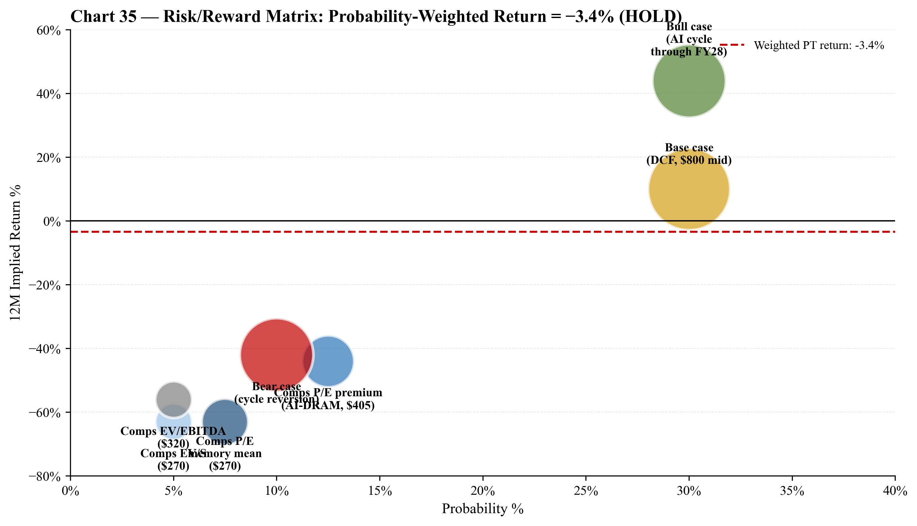
Chart 2 — Risk/reward scatter: each valuation methodology plotted by probability vs. implied 12M return. The probability-weighted average is −3.4% (HOLD).
What Would Change Our View
We would upgrade to OVERWEIGHT or BUY if the stock pulls back to $500-$550 — a level at which the DCF, comps, and scenario frameworks all support meaningful upside even under our cycle-reverting base case. A pullback to that level would re-rate MU on multiple frameworks to a >25% expected return over 12 months, justifying a high-conviction long position. Other upgrade conditions: HBM4 share gain visibility (Nvidia Rubin or AMD MI400 qualifications), sustained gross margin >70% beyond FQ2-FY2026 (implying structural margin step-change), or accelerated buyback execution (>$3B/quarter) demonstrating management conviction.
We would downgrade to UNDERWEIGHT or SELL if the stock continues to melt up beyond $900 without proportional earnings revisions, or if specific risks materialize: HBM ASP correction (visible through contract repricing), CXMT commodity DRAM ramp evidence (>5% bit-share gain in <12 months), Nvidia reducing Micron's HBM allocation, or macro signals pointing to AI capex deceleration.

Financial Summary
Summary Income Statement
Micron's financial profile has been transformed by the AI super-cycle. FY2023 represented the worst down-cycle in 25 years (revenue −49%, GAAP gross margin −9%, operating loss of $5.7B), while FY2025 was a record year ($37.4B revenue, +49% YoY, 40% GM, $8.5B net income). The current cycle is more extreme than any prior cycle — both at the trough and at the peak. Our FY2026E projections imply revenue of $54.7B (+46%), GAAP gross margin of 61%, operating income of $26.8B (49% margin), and diluted EPS of $22.50.
($ in millions, except per share) | FY2023A | FY2024A | FY2025A | FY2026E | FY2027E
Revenue | 15,540 | 25,111 | 37,378 | 54,710 | 62,625
YoY growth % | −49.5% | +61.6% | +48.9% | +46.4% | +14.5%
Gross profit | (1,416) | 5,611 | 14,951 | 33,380 | 38,825
Gross margin % | −9.1% | 22.4% | 40.0% | 61.0% | 62.0%
Operating income (loss) | (5,745) | 1,024 | 9,774 | 26,781 | 31,325
Operating margin % | −37.0% | +4.1% | +26.1% | +49.0% | +50.0%
Net income (loss) | (5,829) | 778 | 8,539 | 25,460 | 28,890
Net margin % | −37.5% | +3.1% | +22.8% | +46.5% | +46.1%
Diluted EPS ($) | (5.34) | 0.70 | 7.55 | 22.50 | 25.50
Diluted shares (M) | 1,093 | 1,117 | 1,131 | 1,131 | 1,129

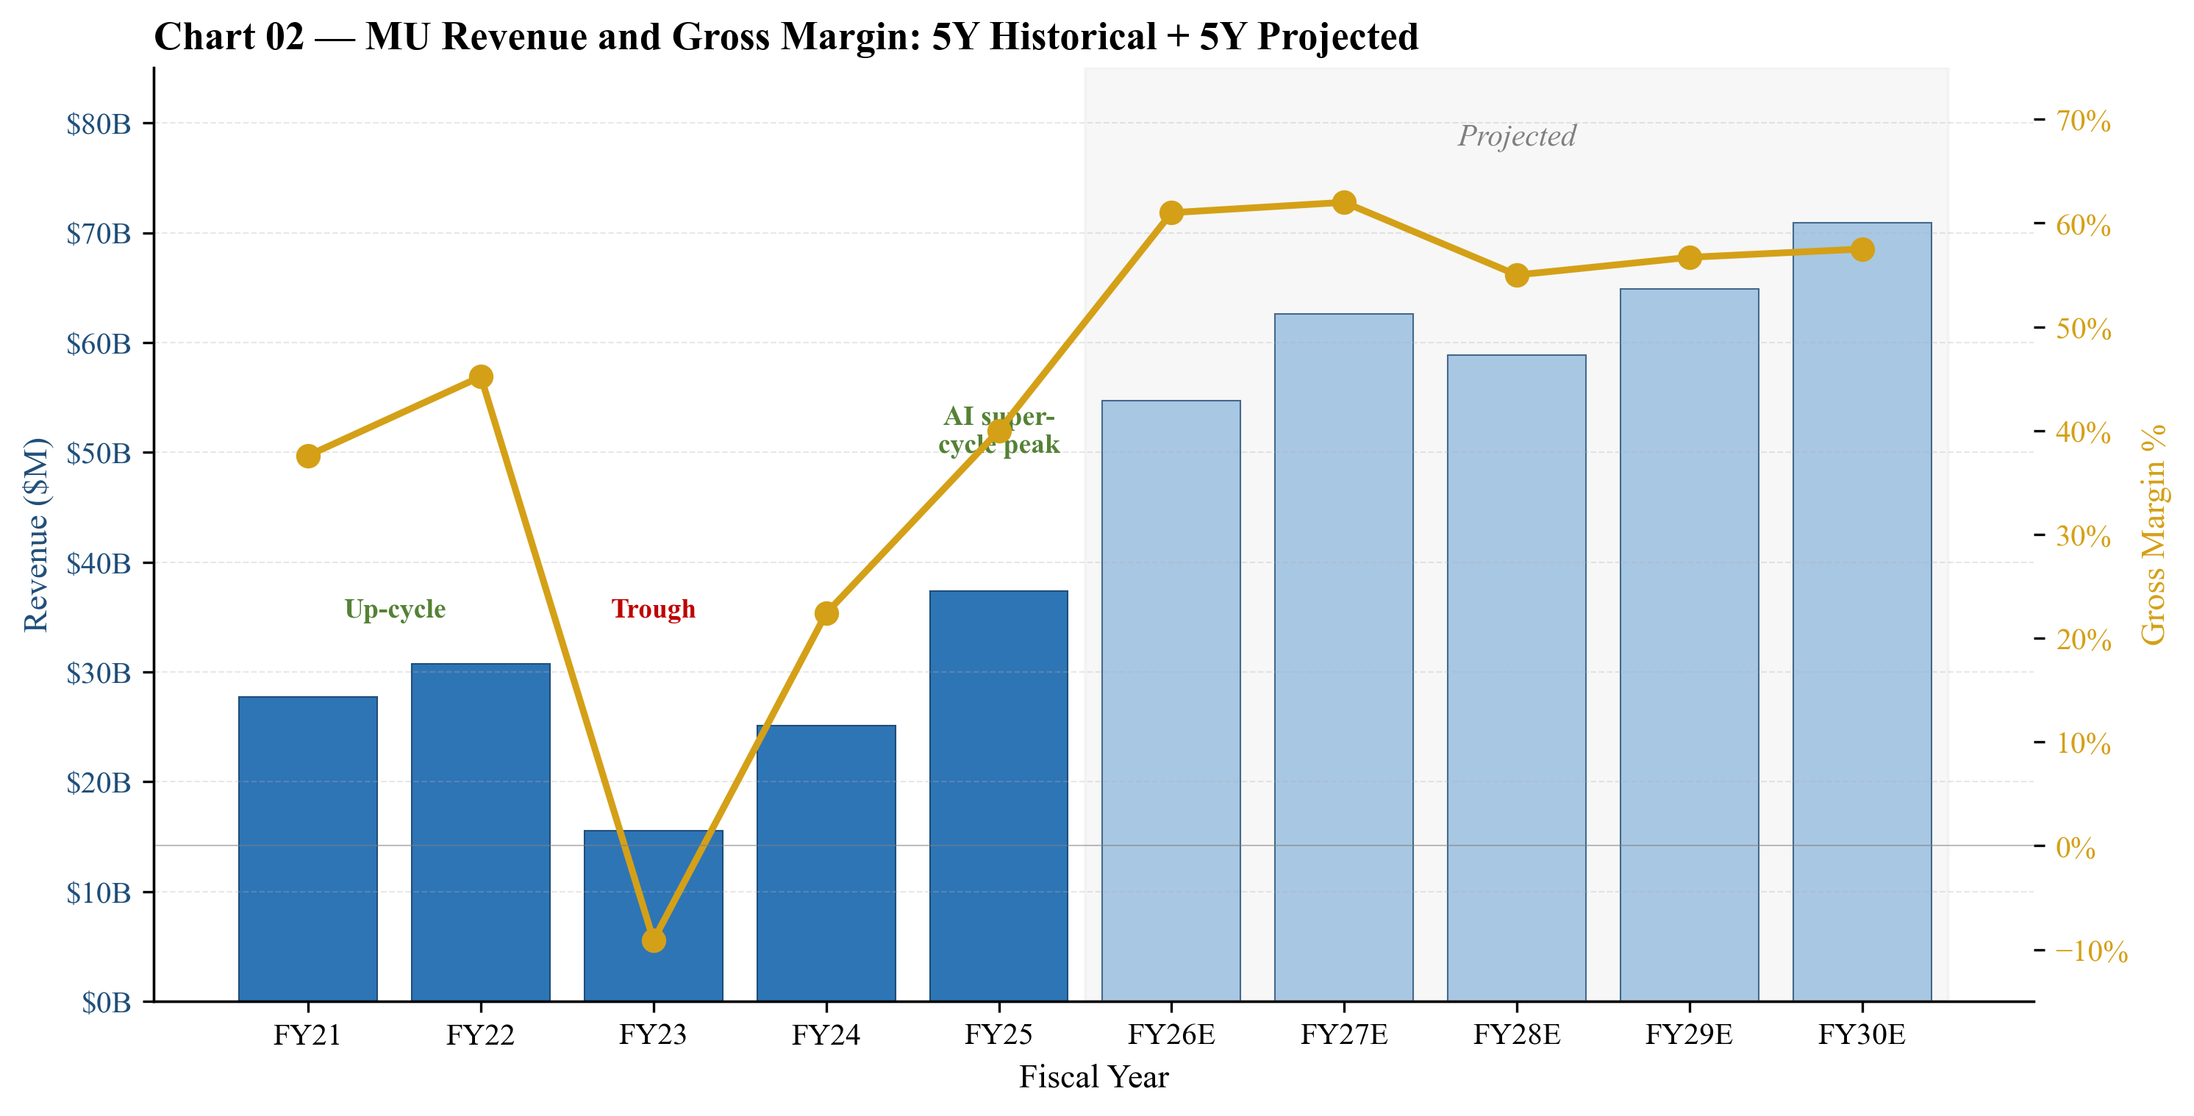
Chart 3 — Revenue and gross margin trend, FY21A-FY30E. The FY23 trough (−9% GAAP GM) and FY25 recovery to 40% capture the full cycle in three years. FY26-30E reflects cycle-aware projections with FY27 peak and FY28 modest dip.
Summary Cash Flow
Operating cash flow has demonstrated remarkable cycle resilience. Even in the FY2023 trough, Micron generated $1.6B of OCF (vs. a $5.8B net loss); in FY2025, OCF of $17.5B exceeded net income by $9B, reflecting strong working capital management and D&A. FY2026E OCF is projected at $27.7B — a level that comfortably funds the $17.5B capex and supports the $10B repurchase authorization. Net of CHIPS proceeds, free cash flow inflects to >$10B annually starting FY2026.
($ in millions) | FY2023A | FY2024A | FY2025A | FY2026E | FY2027E
Net income (loss) | (5,829) | 778 | 8,539 | 25,460 | 28,890
+ Depreciation & amortization | 7,432 | 7,587 | 8,165 | 9,500 | 11,000
+ Working capital & other | (44) | 142 | 826 | (7,280) | (11,040)
Operating cash flow | 1,559 | 8,507 | 17,530 | 27,680 | 28,850
Capex (gross) | (7,676) | (8,386) | (15,864) | (17,500) | (16,000)
+ CHIPS proceeds | — | 130 | 2,025 | 1,800 | 1,500
Free cash flow (post-CHIPS) | (6,117) | 251 | 3,691 | 11,980 | 14,350
Dividends paid | (502) | (514) | (521) | (525) | (560)
Share repurchases | (425) | — | — | (3,000) | (3,500)
Net change in debt | 2,200 | (900) | 300 | (500) | (500)

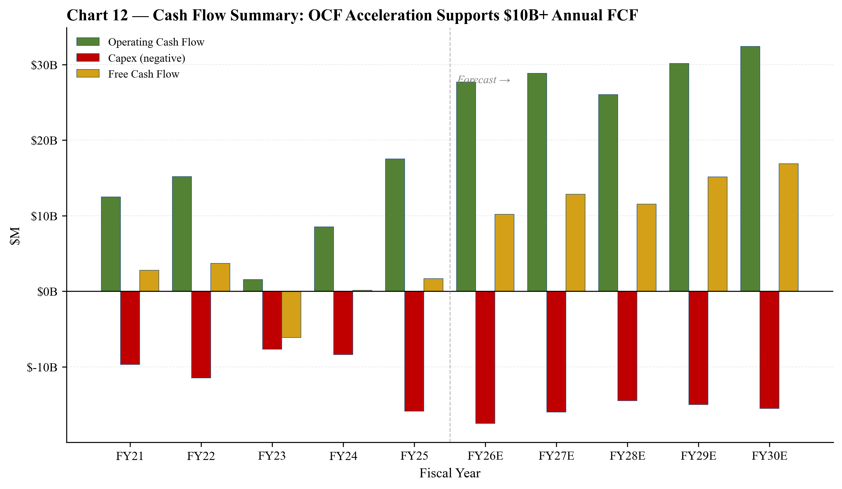
Chart 4 — Cash flow summary FY21A-FY30E. OCF inflection in FY25-FY26E supports record FCF of $10B+ per year in the projection period.
Summary Balance Sheet
The balance sheet has strengthened materially through the cycle. Total assets grew from $66B at the FY2023 trough to $82.8B at FY2025; PP&E is now $46.6B (~56% of assets) reflecting Micron's extraordinary capital intensity. Cash and short-term investments of $12.0B exceed long-term debt of $14.0B by FY26E — Micron will be in a net cash position. The $10B share-repurchase authorization (unused) provides ~1.2% of float annually in additional support.
($ in millions) | FY2023A | FY2024A | FY2025A | FY2026E | FY2027E
Cash & short-term investments | 9,172 | 8,121 | 12,011 | 22,900 | 32,100
Inventories | 4,684 | 6,254 | 8,100 | 9,100 | 10,600
PP&E, net | 38,763 | 39,749 | 46,594 | 53,500 | 58,000
Total assets | 64,254 | 69,346 | 82,800 | 100,000 | 118,000
Total debt | 12,779 | 13,785 | 14,478 | 13,550 | 13,150
Total liabilities | 24,588 | 24,212 | 31,300 | 44,000 | 47,000
Total equity | 39,666 | 45,134 | 51,500 | 56,000 | 71,000
Net debt / (cash) | 3,607 | 5,664 | 2,467 | (9,350) | (18,950)
Net debt / EBITDA | 2.14× | 0.66× | 0.14× | (0.26)× | (0.45)×
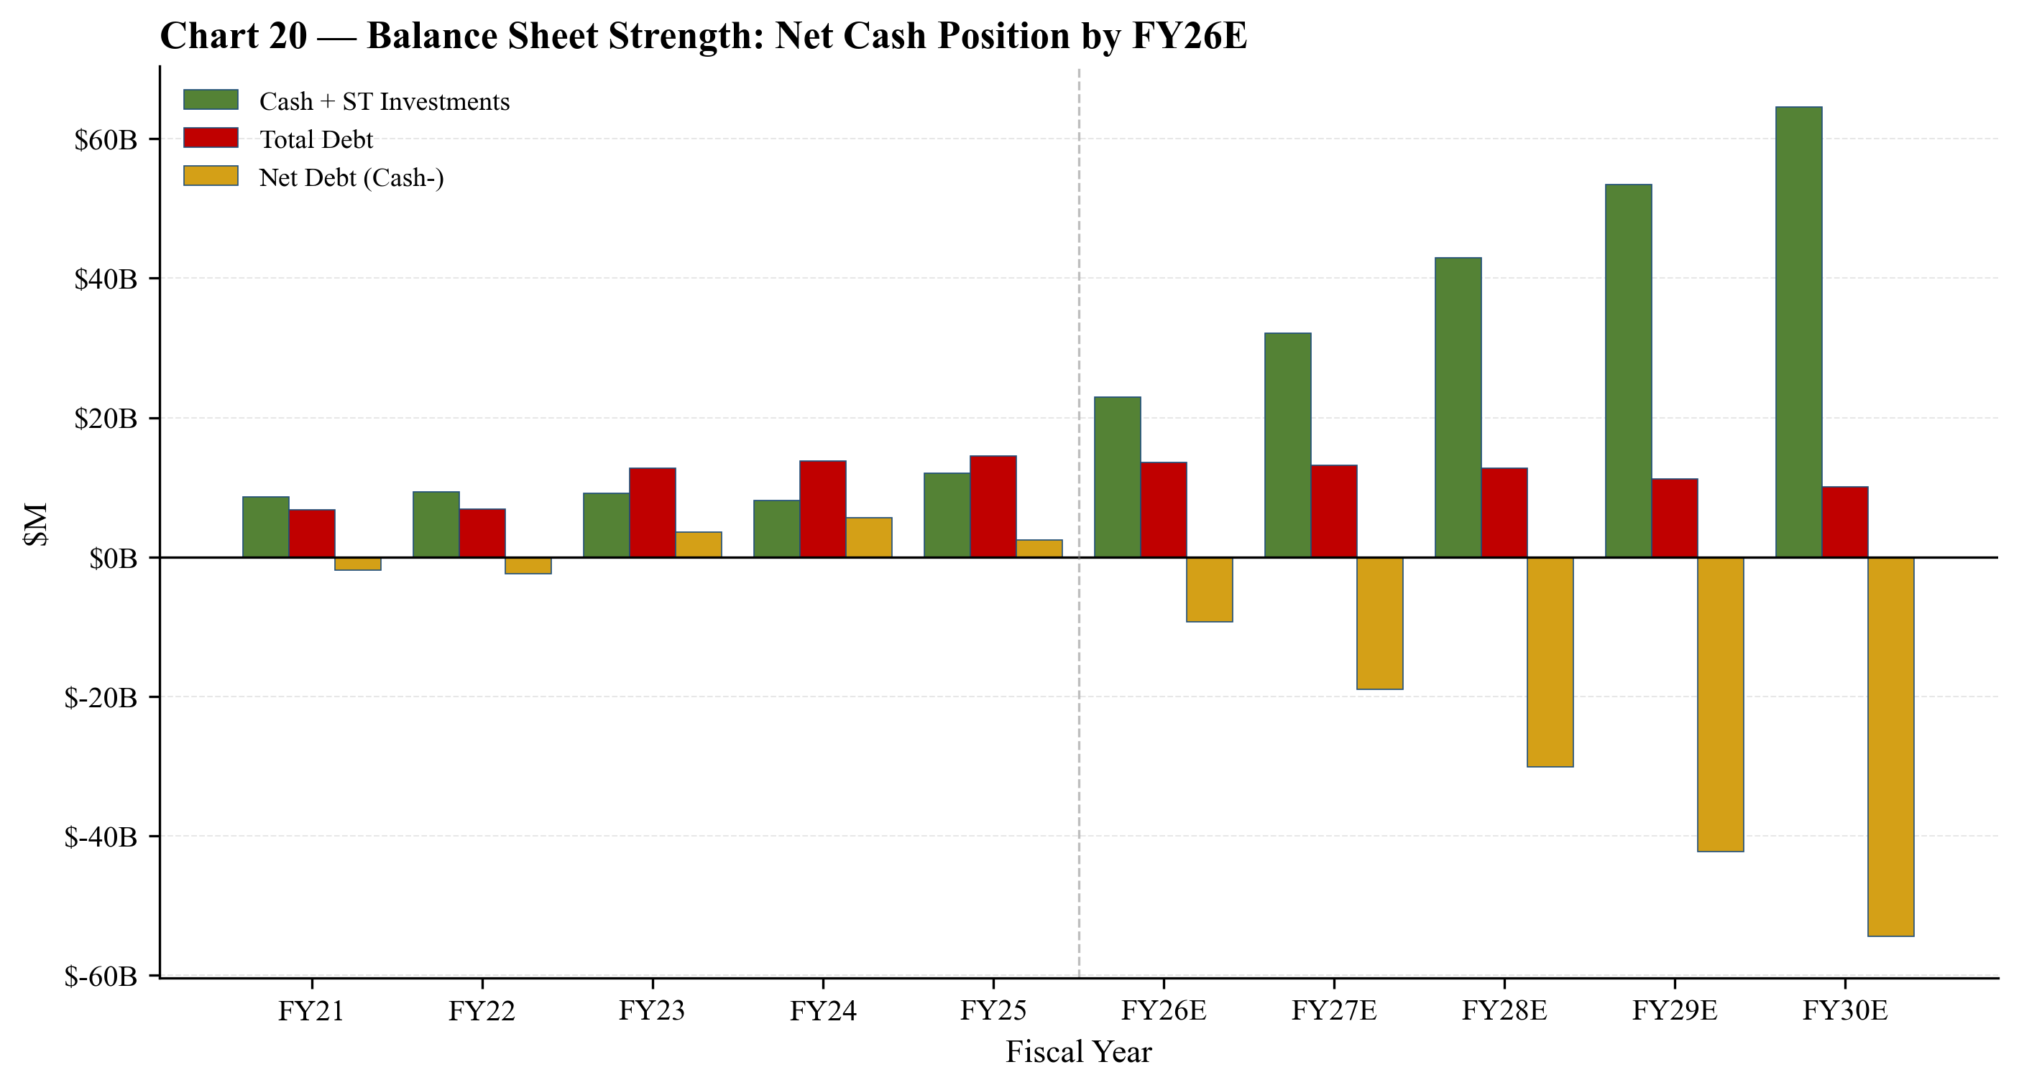
Chart 5 — Cash, debt and net debt trajectory. By FY26E, Micron transitions to a net cash position; net debt/EBITDA below 0× through FY30E.

Company 101
Company Overview
Micron Technology, Inc. (NASDAQ: MU) is one of three remaining at-scale producers of dynamic random-access memory (DRAM) and one of five at-scale producers of NAND flash storage. The company designs, manufactures, and sells memory and storage semiconductors — DRAM (including high-bandwidth memory, HBM), NAND flash, and a small residual NOR flash business — to a global base of cloud-service providers, OEMs, mobile-handset vendors, automotive Tier-1 suppliers, and channel distributors. Headquartered in Boise, Idaho, Micron operated with approximately 53,000 employees as of August 28, 2025. Wafer fabrication is concentrated in Taiwan (the largest fab cluster by long-lived assets, $18.97B PP&E), Singapore ($10.67B), Japan ($7.04B), and the United States (Boise, Virginia and the new Clay, NY site, $8.45B combined). The fiscal year is a 52/53-week period ending the Thursday closest to August 31.
Micron's products fall into three technology categories — DRAM (76% of FY2025 revenue), NAND (23%), and NOR/other (1%) — and are sold through four reportable business units: CMBU (Cloud Memory, $13.5B), CDBU (Core Data Center, $7.2B), MCBU (Mobile + Client, $11.9B), and AEBU (Automotive + Embedded, $4.8B). The Q3-FY2025 segment reorganization split the former 'Compute & Networking Business Unit' into CMBU (hyperscale + HBM) and CDBU (mid-tier cloud + OEM data center + data-center NAND/SSD), providing significantly improved visibility into the AI-DRAM growth driver.
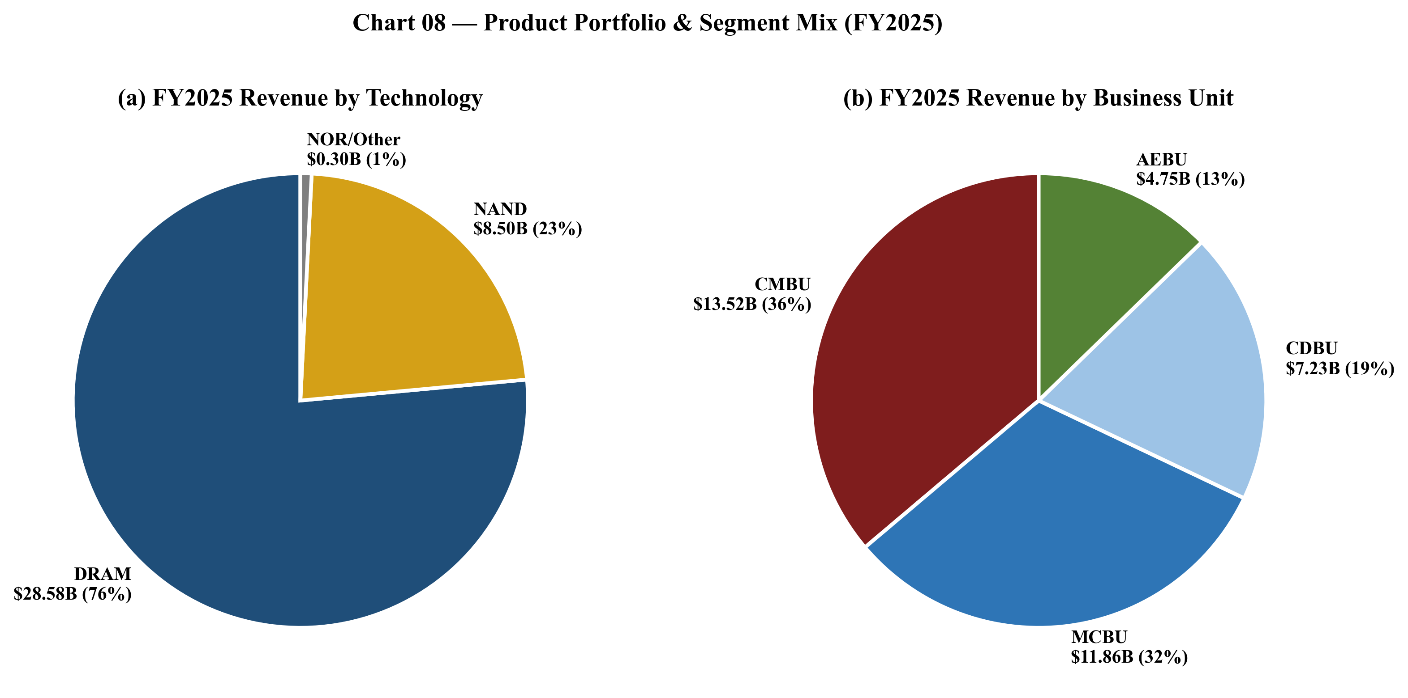
Chart 6 — FY2025 revenue mix by technology (DRAM 76%, NAND 23%, NOR 1%) and by business unit (CMBU 36%, MCBU 32%, CDBU 19%, AEBU 13%). CMBU is now the largest segment, having overtaken MCBU in FY2025.
How Micron Makes Money
The product portfolio is sold direct to OEMs and hyperscale cloud customers and through distributors and a consumer-branded channel (Crucial-brand SSDs and memory modules). Substantially all customer contracts are short-term and at negotiated prices; pricing is set quarterly and resets very rapidly with industry supply/demand. Memory is, in effect, a commodity whose ASP can move several hundred basis points per quarter. The structural lever for profitability is per-bit cost reduction via node shrinks and 3D NAND layer scaling — Micron's 1-beta and 1-gamma DRAM nodes and 232-/276-layer NAND were the productive workhorses in FY2025 — combined with product mix toward higher-value SKUs, most importantly HBM and high-capacity DDR5 server DIMMs.
A new exception to the short-term contract structure in FY2025-FY2026 is the use of HBM long-term agreements (LTAs). Management has publicly discussed HBM being sold under multi-quarter/multi-year LTAs with major hyperscalers and GPU OEMs, with pricing and capacity committed in advance. This is a meaningful structural shift — HBM revenue and margin are far more visible than commodity DRAM. Approximately 70-80% of FY2026E HBM revenue is estimated to be under LTA coverage.
Company History
Micron Technology was founded in 1978 in Boise, Idaho, and has been continuously listed and continuously manufacturing DRAM since the early 1980s — making it the only US-headquartered at-scale DRAM producer to have survived the consolidation waves of the 1990s, 2000s, and 2010s. The company's principal executive offices remain at 8000 S. Federal Way, Boise, Idaho, and the state of incorporation is Delaware. Micron remains the largest private employer in Idaho.
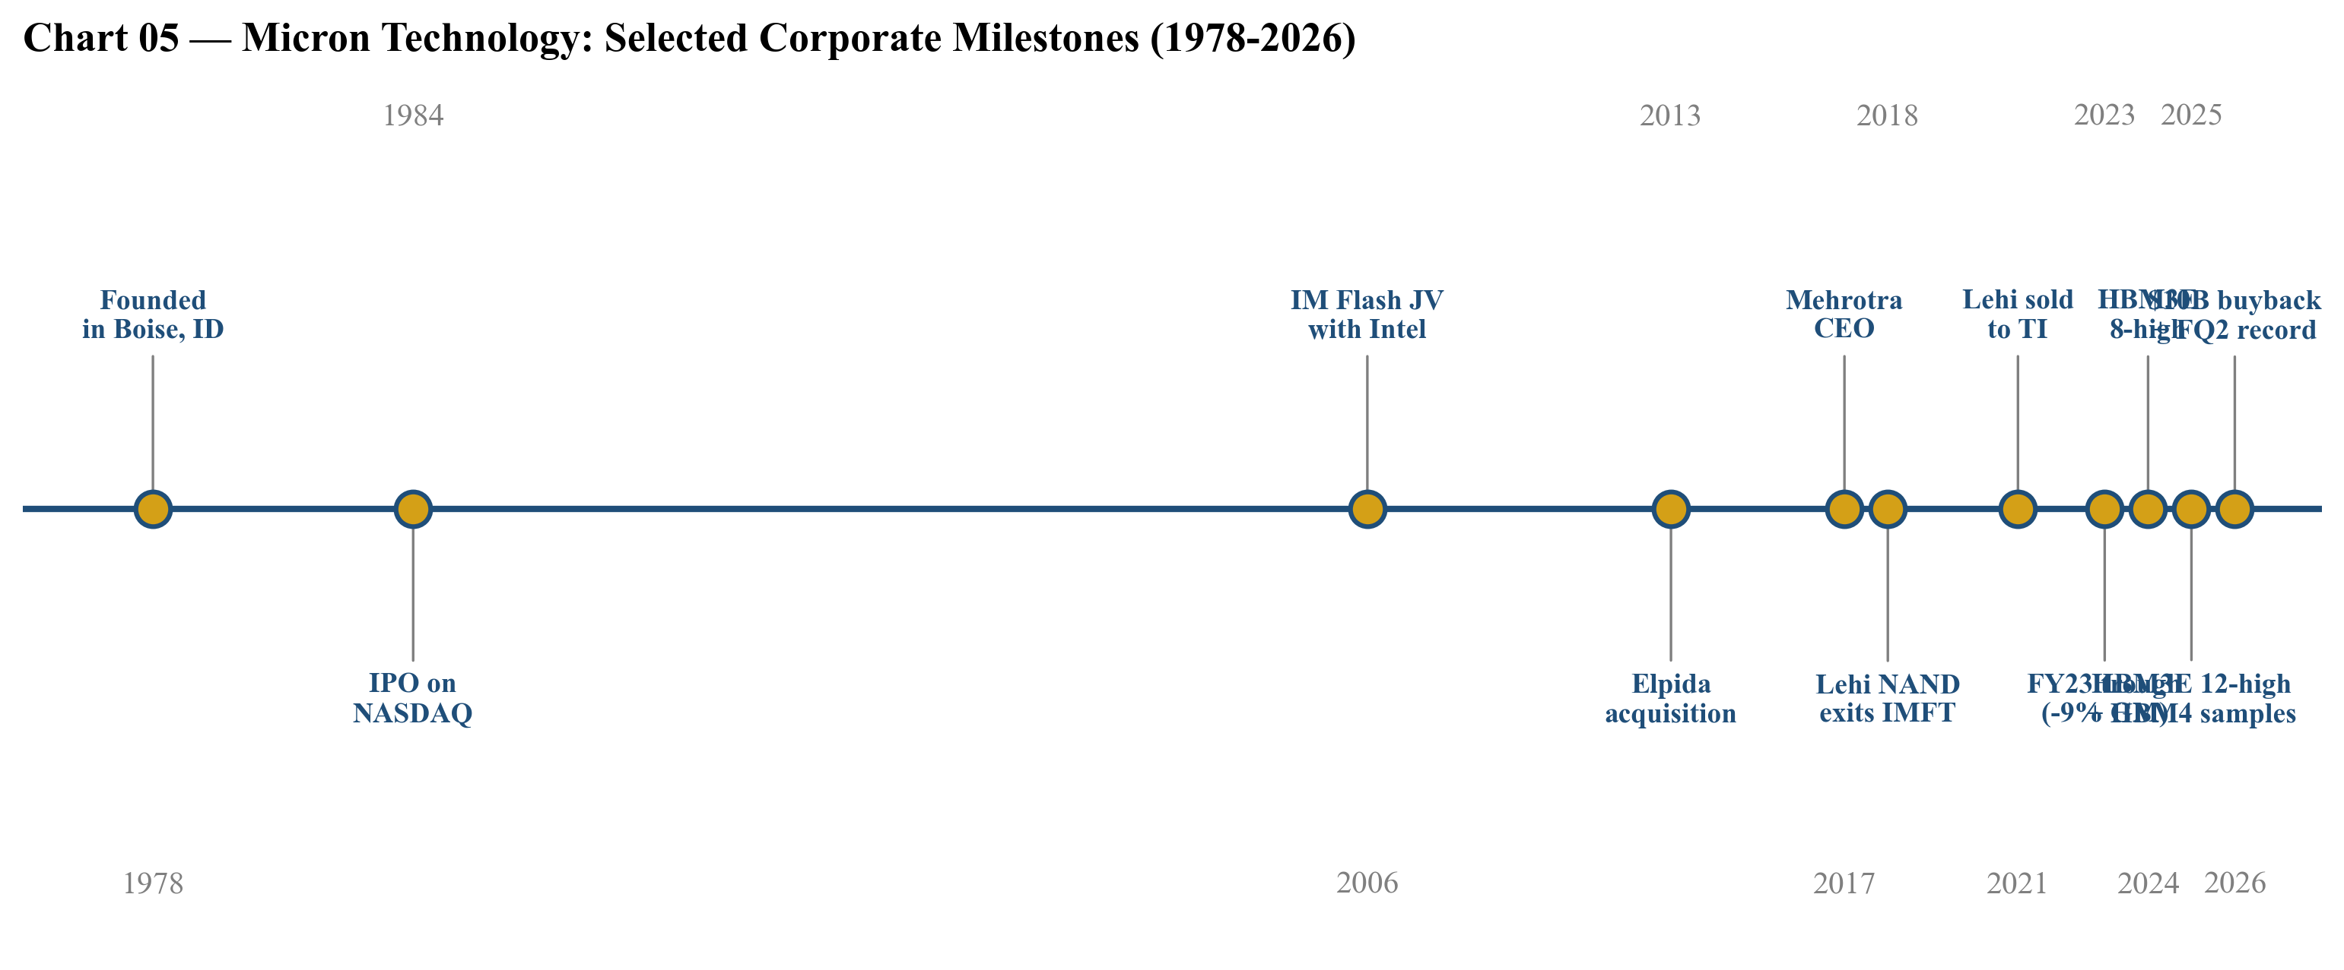
Chart 7 — Selected corporate milestones from founding (1978) through HBM4 sample shipments (2025) and the $10B buyback authorization (2026).
Three strategic pivots define the company's modern trajectory:
- Elpida acquisition (2013). Micron's purchase of bankrupt Japanese DRAM maker Elpida (and its Hiroshima fab and Rexchip/Inotera Taiwan operations) consolidated the global DRAM industry from five players to three (Micron / Samsung / SK Hynix). It was a once-in-a-decade strategic move: the deal added mobile-DRAM expertise (which Micron lacked), doubled wafer capacity, and structurally improved DRAM pricing for the entire industry. Subsequent buyouts of the Inotera stake (2016) completed the integration.
- From NAND JV partner to NAND independent (2018-2021). Micron exited the long-running IM Flash JV with Intel, taking sole ownership of the Lehi, UT fab. Three years later it sold Lehi to Texas Instruments (2021) — a deliberate footprint shrink as Micron concentrated NAND R&D in Singapore. The hindsight read: Micron deprioritized NAND capacity additions early, which positioned it well for the FY24-25 NAND tightness.
- HBM ramp (2024-present). Micron entered HBM late vs. SK Hynix and Samsung but leapfrogged with HBM3E 8-high (24GB) at the 1-beta node, qualified into Nvidia H200, and now has HBM3E 12-high (36GB) as the majority of shipments and HBM4 36GB 12-high samples shipped to multiple customers. HBM revenue is the single biggest swing factor in the FY25/FY26 model.
Management Team
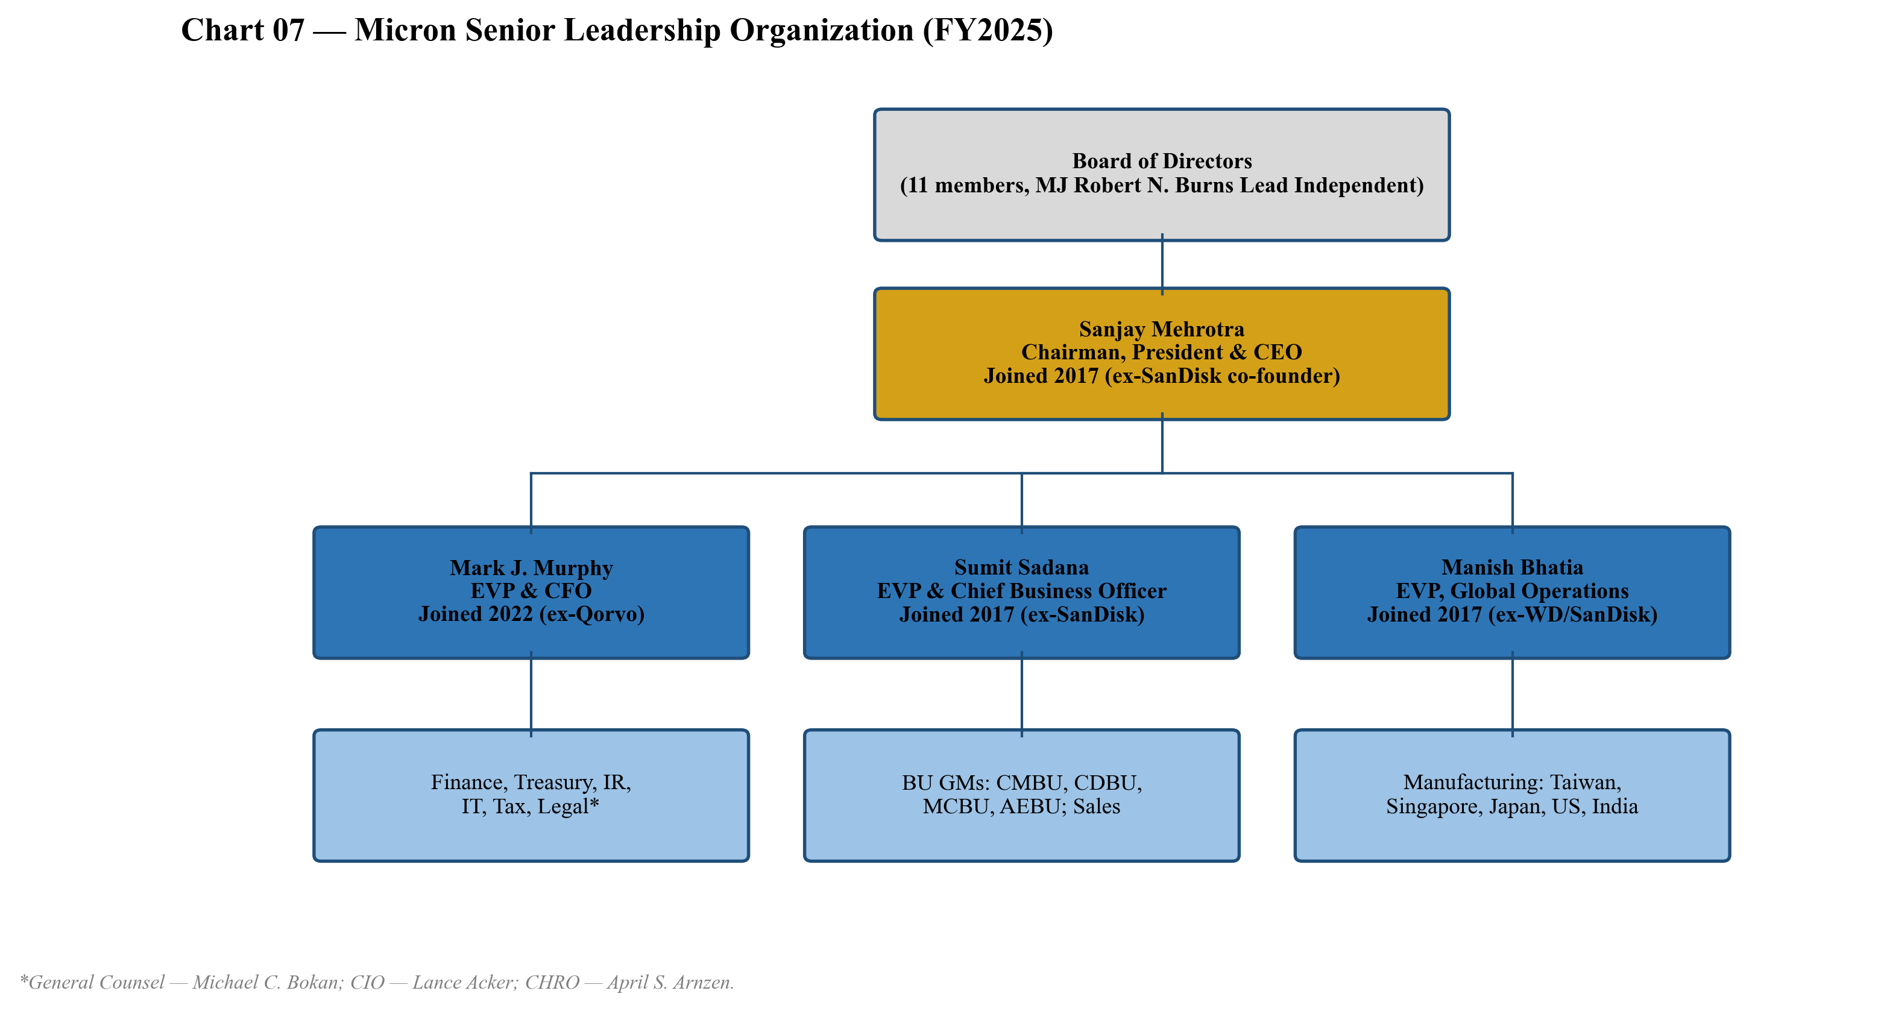
Chart 8 — Senior leadership organization. Mehrotra (CEO since 2017), Murphy (CFO since 2022), Sadana (CBO since 2017), Bhatia (Global Operations since 2017).
Sanjay Mehrotra — Chairman, President & CEO
Age 67; joined May 2017; named Chairman January 2025.
Sanjay Mehrotra is one of the most experienced operators in memory and storage. He co-founded SanDisk Corporation in 1988 with Eli Harari and Jack Yuan, served as President and CEO from January 2011 until the company's $19B sale to Western Digital in May 2016, and steered SanDisk from a startup into the world's largest NAND-pure-play producer — a 28-year arc during which SanDisk transitioned from compact-flash cards in PCs and digital cameras to enterprise SSDs and managed NAND in mobile, and during which SanDisk's NAND fab partnership with Toshiba (now Kioxia) was built and scaled. Mehrotra joined Micron as President and CEO in May 2017 and was named Chairman of the Board in January 2025.
His tenure at Micron has tracked three full memory cycles. Under his leadership Micron (i) closed the Inotera buyout in late 2016 (technically pre-tenure but he inherited integration), (ii) executed the IM Flash JV exit with Intel in 2018, (iii) divested the Lehi NAND fab in 2021, (iv) navigated the FY2023 down-cycle (revenue −49% YoY, GM −9%) without the kind of equity raise that historically marked Micron's troughs, and (v) executed the most consequential strategic call of his career — the late HBM entry. Micron was third to market in HBM3 but, by using its leading 1-beta DRAM node and a focus on power efficiency, qualified into Nvidia's H100 successor (H200) and from there into B100/B200/GB200. CMBU revenue is the direct evidence of this strategy: from $1.87B in FY23 → $3.79B in FY24 → $13.52B in FY25 (+257% YoY).
Mehrotra holds a BS and MS in Electrical Engineering & Computer Sciences from the University of California, Berkeley, and is a graduate of the Stanford Graduate School of Business Executive Program. He served on the board of Western Digital briefly post-SanDisk-acquisition (May 2016 – Feb 2017), on the board of Cavium (2009-2018), and currently serves on the board of CDW Corporation (since March 2021). He is named on more than 70 issued or pending patents.
Mark J. Murphy — EVP & CFO
Age 58; joined April 2022.
Mark Murphy joined Micron from Qorvo, Inc., where he served as Chief Financial Officer from June 2016 to April 2022 — a six-year stint that spanned Qorvo's RF business consolidation and 5G ramp. Prior to Qorvo, he was EVP and CFO of Delphi Automotive PLC (now Aptiv), and before that held executive roles at Praxair, Inc. and MEMC Electronic Materials — the latter giving him direct semiconductor-materials cycle experience. He serves on the board of Albany International Corp. and is a U.S. Marine Corps veteran.
Murphy stepped into the CFO seat at the start of FY2023 — the worst down-cycle in memory in 25 years (revenue −49%, gross margin −9%, operating loss $5.7B) — and led the playbook of preserving balance-sheet liquidity, raising debt at favorable windows (the 2032 Green Bonds in particular), and maintaining the dividend through the cycle. The execution of the FY2025 record year — $17.5B operating cash flow and a $2.0B CHIPS proceeds capture — falls under his watch. He has been an active executor on the CHIPS direct-funding agreements and the financing structure for the Idaho and New York greenfield expansions.
Sumit Sadana — EVP & Chief Business Officer
Age 56; joined June 2017.
Sumit Sadana runs business development, product strategy and customer engagement — effectively the externally-facing executive on customer wins and the public face on guidance updates (he led the August 11, 2025 KeyBanc fireside-chat guidance raise). He served at SanDisk from 2010 to 2016 in roles including EVP and Chief Strategy Officer and General Manager of Enterprise Solutions. Earlier roles include 10+ years at IBM Microelectronics. He holds a B.Tech. in Electrical Engineering from IIT Kharagpur and an MS in Electrical Engineering from Stanford. He serves on the board of Silicon Laboratories, Inc.
Manish Bhatia — EVP, Global Operations
Age 53; joined October 2017.
Manish Bhatia runs the global manufacturing footprint — Taiwan, Singapore, Japan, the US fabs, and Sanand backend. He joined Micron from Western Digital, where he was EVP of Silicon Operations following WD's 2016 acquisition of SanDisk, and earlier held multiple executive roles at SanDisk (March 2010 – May 2016) including EVP, Worldwide Operations. He holds a BS, MS in Mechanical Engineering and an MBA, all from MIT. Bhatia's mandate over the next 36 months is the most operationally consequential at Micron: ramping HBM4, modernizing Taiwan, executing the Idaho greenfield, the Clay, NY fabs, the Manassas, VA modernization, the Hiroshima expansion, and the Sanand backend — concurrently.
Track-Record Synthesis
Mehrotra-Murphy-Sadana-Bhatia is the closest thing to an 'all-star' management team in memory. Mehrotra brought the SanDisk co-founders' rigor on technology roadmaps; Murphy brought capital-markets discipline from the auto and RF cycles; Sadana brought the customer-engagement playbook from SanDisk's enterprise-NAND push; Bhatia brought manufacturing scale leadership. The HBM late-entry-and-win is the clearest evidence the team delivers: Micron was widely considered structurally disadvantaged in HBM as recently as 2023, yet by FY2025 has emerged as the second-largest HBM supplier after SK Hynix and clearly ahead of Samsung on customer qualifications.

Products & Services
Micron's portfolio is organized by product technology (DRAM, NAND, NOR) and sold through four reportable segments (CMBU, CDBU, MCBU, AEBU). The technology mix has been transformed over the past three years by the rise of HBM, which has grown from $50M in FY2023 to a projected $21.5B in FY2026E — a 430× increase. The DDR5 and LPDDR5X portfolios complement HBM in the AI-data-center mix, while data-center SSDs (9550 series), client SSDs, managed NAND, and embedded products round out the broader memory and storage portfolio.
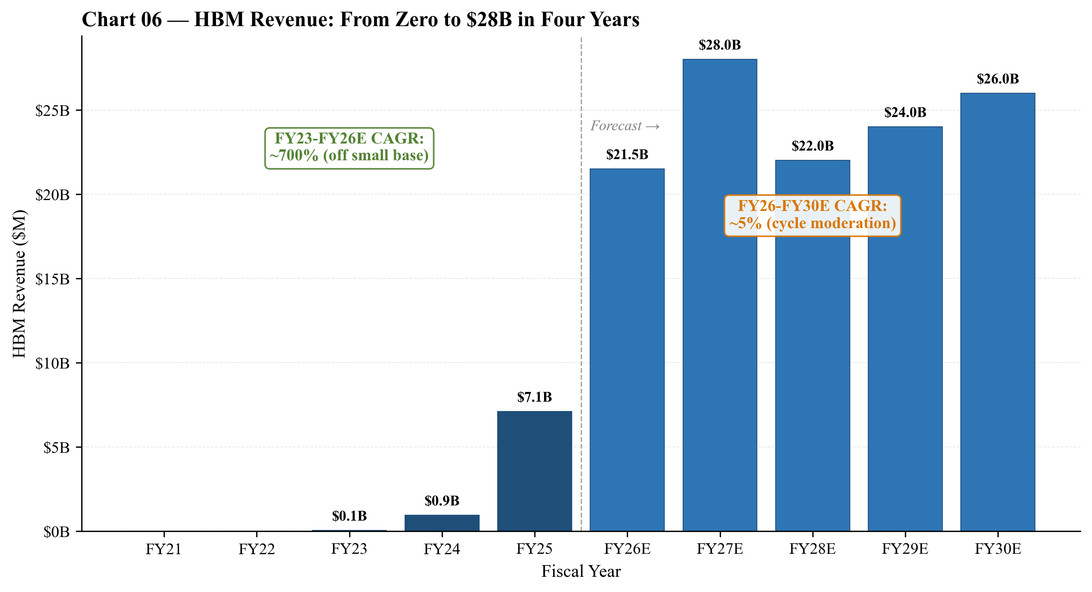
Chart 9 — HBM revenue trajectory. From $50M in FY2023 to $7.1B in FY2025 to projected $21.5B in FY2026E. The HBM bit demand growth is the central thesis behind FY26 earnings.
DRAM Products
HBM3E and HBM4 (the flagship). Micron began volume production of 8-high 24GB HBM3E in 2024 on its 1-beta DRAM node. By Q4-FY2025, HBM3E 12-high (36GB) was the majority of HBM shipments, and in FY2025 Micron delivered samples of HBM4 36GB 12-high to multiple key customers for next-generation AI platforms. Competitive-advantage verdict: yes — technology and node-cost moat. HBM is one of the most demanding DRAM SKUs to manufacture: it requires through-silicon via (TSV) packaging, a leading-edge DRAM node, and tight thermal and power optimization. Micron's 1-beta node gives it a ~20-30% power-efficiency edge vs. Samsung's prior-node HBM and parity-to-slight-edge vs. SK Hynix on bit density. The closest competing product is SK Hynix's HBM3E 12-high and HBM4 — SK Hynix remains the volume leader and the lead supplier to NVDA's H100/H200 generation, but Micron has the qualification on B200 and B300 and is one of the two qualified sources on Rubin-class platforms.
DDR5 server modules (128GB monolithic). In 2024 Micron qualified and shipped a 128GB DDR5 server module built on a monolithic 32GB DRAM die at the 1-beta node — an industry alternative to existing 3D TSV-based high-capacity DIMMs. Verdict: partial moat from monolithic-die approach that offers lower power and cost for high-capacity server DRAM compared to TSV-stacked solutions; closest competitor is Samsung's 128GB 3DS module.
LPDDR5 / LPDDR5X — low-power DDR — historically a mobile-handset product, now increasingly relevant in server (LPDDR for AI inference accelerators) and PC. Micron is a top-3 supplier; LPDDR is largely qualified-into-handset and turns slowly; the moat is the qualification roster, not the underlying chip. GDDR6 is the graphics DRAM for GPUs and inferencing accelerators; Micron is the dominant supplier to Nvidia consumer GPUs.
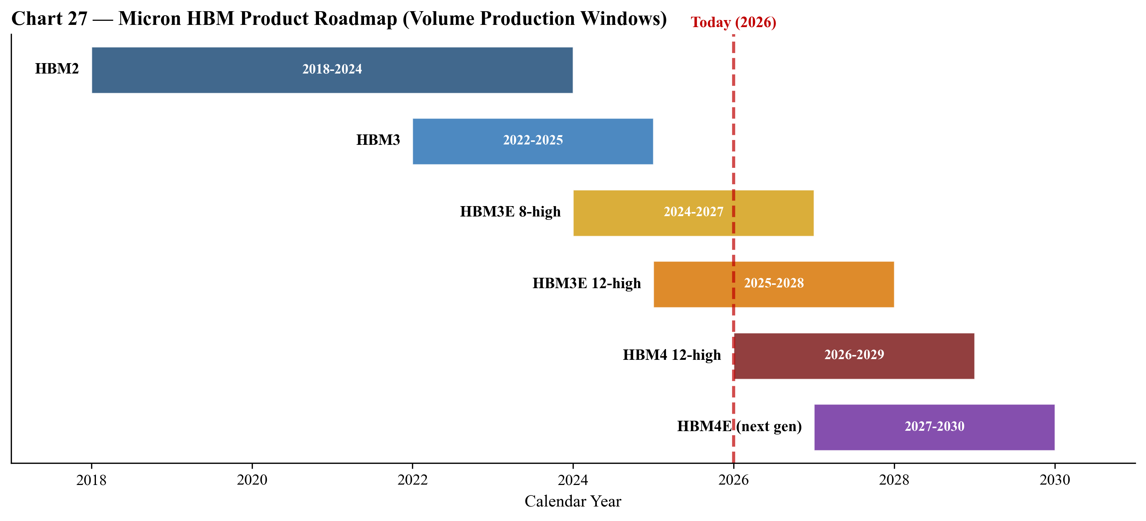
Chart 10 — Micron HBM product roadmap. HBM3E 12-high in volume now; HBM4 12-high samples shipped FY25, volume production CY2026; HBM4E next-generation samples expected CY2027.
NAND Products
Data-center SSDs (9550 series). In FY2025 Micron qualified and began shipping its 9550-series SSD — a fully-integrated solution targeting AI training and high-performance computing workloads. Verdict: partial moat. The data-center SSD market is highly competitive (Samsung, SK Hynix/Solidigm, Sandisk, Kioxia). Micron's positioning is differentiated by tight integration with its 232L NAND (one of the leading layer counts) and the controller stack. Closest competing product is Samsung's PM1743/PM1745 family.
Managed NAND (mobile UFS / eMMC) is sold into smartphones, automotive infotainment, and consumer devices. Tier-1 customer qualifications matter; the technology is broadly available. Low-density NAND — automotive, IoT, surveillance, machine-to-machine, industrial — long-life, low-density SLC/MLC NAND that competes more on lifecycle support than per-bit cost. Verdict: yes — qualification moat in automotive. Auto NAND requires multi-decade lifecycle, AEC-Q100 qualification, and tight customer integration.
Flagship Versus Long-Tail
The 1-3 products that drive the business are: (1) HBM3E/HBM4 — the single biggest revenue and margin driver, the reason CMBU went from 12% to 36% of revenue in two years; (2) High-capacity DDR5 server DIMMs (128GB monolithic, 96GB, 64GB) — the second AI-data-center lever; ASPs roughly 2× of commodity DDR5; (3) Data-center SSDs (9550 series) — the NAND-side AI play; smaller than HBM/DDR5 in dollars but the highest-growth NAND SKU. The long-tail consists of legacy DDR4 server, GDDR6 graphics, low-density NAND, NOR, and managed NAND in non-flagship handsets.
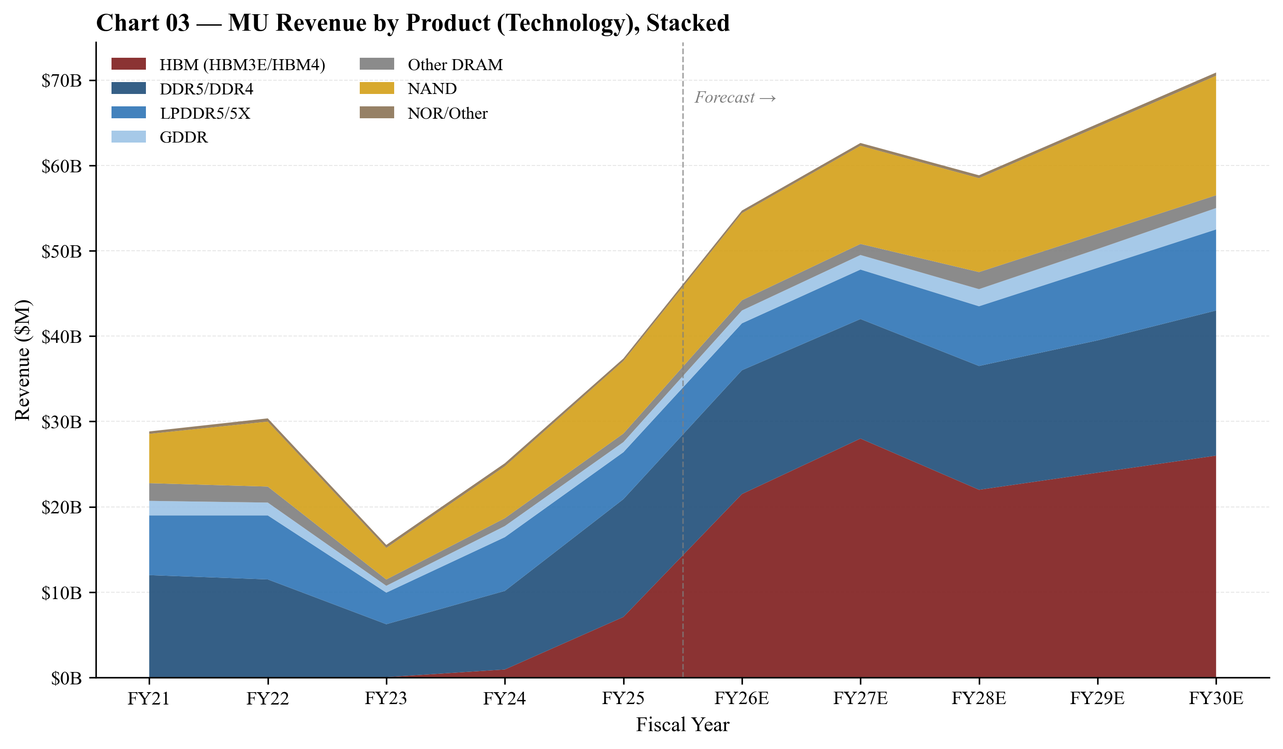
Chart 11 — Revenue by product (technology), stacked. HBM is the dominant growth driver from FY23 (negligible) through FY27E ($28B). Note: this is mandatory chart #1 of 4.

Customers & Go-to-Market
Customer Segments
Micron's customer base divides cleanly into five buckets: (1) Hyperscale cloud providers (the CMBU customer base) — AWS, Microsoft, Google, Meta, Oracle, ByteDance, and Alibaba — purchasing HBM (bundled with Nvidia/AMD GPUs they buy directly), high-capacity DDR5, LPDDR5 for inference servers; (2) AI accelerator / GPU OEMs (counted within CMBU through the HBM channel) — Nvidia, AMD, and emerging custom-silicon programs (Google TPU, AWS Trainium, Meta MTIA). Most HBM is sold to GPU OEMs who package the HBM stacks alongside the compute die before selling to hyperscalers; (3) Mid-tier cloud + enterprise OEMs (CDBU) — Dell, HPE, Supermicro, Lenovo, IBM and the Chinese OEMs (Inspur, Lenovo, H3C) for mid-tier servers; data-center SSDs to all cloud and enterprise customers; (4) Mobile + PC OEMs (MCBU) — Apple, Samsung Mobile, Xiaomi, OPPO, vivo, Lenovo PCs, HP, Dell client PCs; (5) Automotive + industrial + consumer (AEBU) — Tier-1 automotive suppliers (Bosch, Continental, Denso), industrial integrators, and consumer-electronics OEMs.
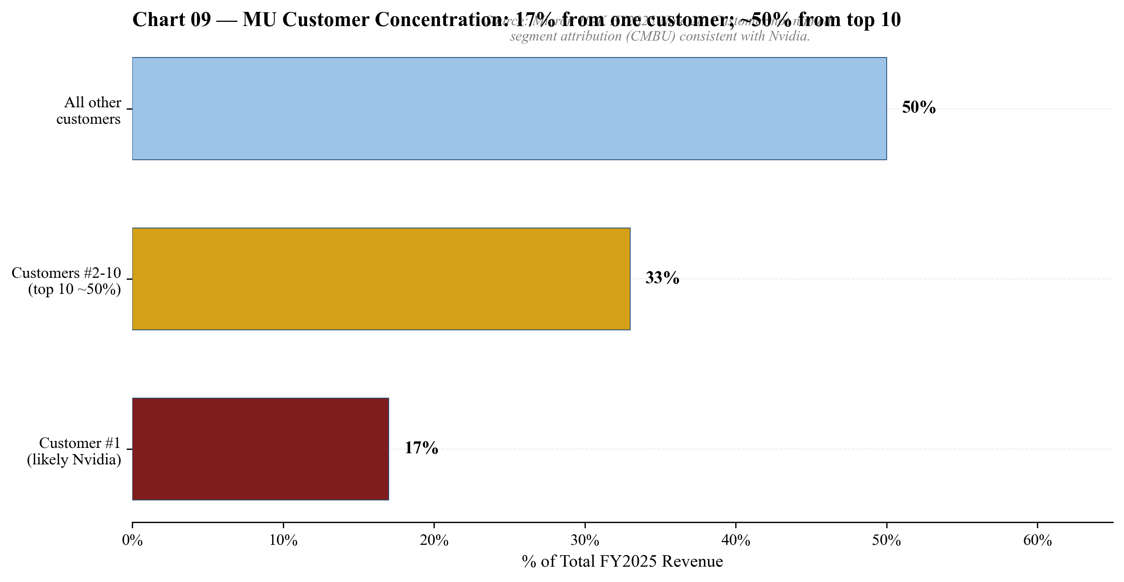
Chart 12 — Customer concentration. One customer (likely Nvidia, per CMBU segment attribution) was 17% of FY25 revenue; top 10 represented ~50%. Source: 10-K FY2025 Note 28.
Customer Concentration
Customer concentration disclosure from the FY2025 10-K Note 28 is unusually informative: 'Revenue from one customer was 17% (primarily included in the CMBU segment) of total revenue for 2025.' That single 17% customer is highly likely Nvidia — it is the only customer plausibly purchasing >$6B in HBM and high-capacity DRAM through CMBU, and the timing tracks the H200/B100/B200 ramp. Micron does not name the customer, but the segment attribution and quantum is consistent only with Nvidia. 'Revenue from one customer was 10% (primarily included in the MCBU, AEBU, and CMBU segments) of total revenue for 2024' — consistent with a large handset/consumer-electronics OEM (likely Apple). In each of the last three years, approximately one-half of total revenue was from the top ten customers.
Concentration risk verdict: top-1 of 17% and top-10 of ~50% is material concentration. By the report-structure thresholds, customer concentration is included as a risk. The mitigant is that Micron's #1 customer almost certainly is the bottleneck in its own value chain (Nvidia → cloud) — meaning concentration risk is principally cycle/end-market risk (AI capex slowdown) rather than share-loss risk (Nvidia switching to Samsung or SK Hynix exclusively).
Contract Structure
The 10-K is explicit that 'substantially all contracts with our customers are short-term in duration at fixed, negotiated prices with payment generally due shortly after delivery.' Prices reset quarterly; volumes are negotiated quarterly or monthly. This is the structural reason memory pricing is so volatile. A new exception in FY2025-FY2026: HBM long-term agreements (LTAs). Management has publicly discussed HBM being sold under multi-quarter/multi-year LTAs with major hyperscalers and GPU OEMs, with pricing and capacity committed in advance. This is a meaningful structural shift — HBM revenue and margin are far more visible than commodity DRAM. Estimated 70-80% of FY2026E HBM revenue is under LTA coverage.
Distribution Channels
- Direct OEM sales to the top 25-30 customers represent the bulk of revenue.
- Distribution channel (Arrow, Avnet, WPG, Macnica) serves the long tail of automotive, industrial, and consumer customers.
- Crucial-brand consumer channel (Crucial-branded SSDs and DRAM modules sold through Amazon, Best Buy, Newegg, Micro Center, JD.com, etc.) — the historic retail-facing piece of the business; relatively small in revenue but supports brand and absorbs lower-bin product.
Key Partnerships
- Nvidia, AMD, Intel — GPU and CPU OEMs that qualify Micron HBM and DDR.
- TSMC — manufactures controller and logic die for Micron's advanced-packaging HBM stacks; HBM4 uses TSMC's N5/N3 base-die logic per public roadmap commentary.
- ASML, Lam Research, Applied Materials, Tokyo Electron — semiconductor equipment suppliers; Micron uses EUV from ASML at the 1-gamma DRAM node.
- Intel (historical) — IM Flash JV partner from 2006 through dissolution 2018; legacy Optane/3D XPoint program (now wound down).
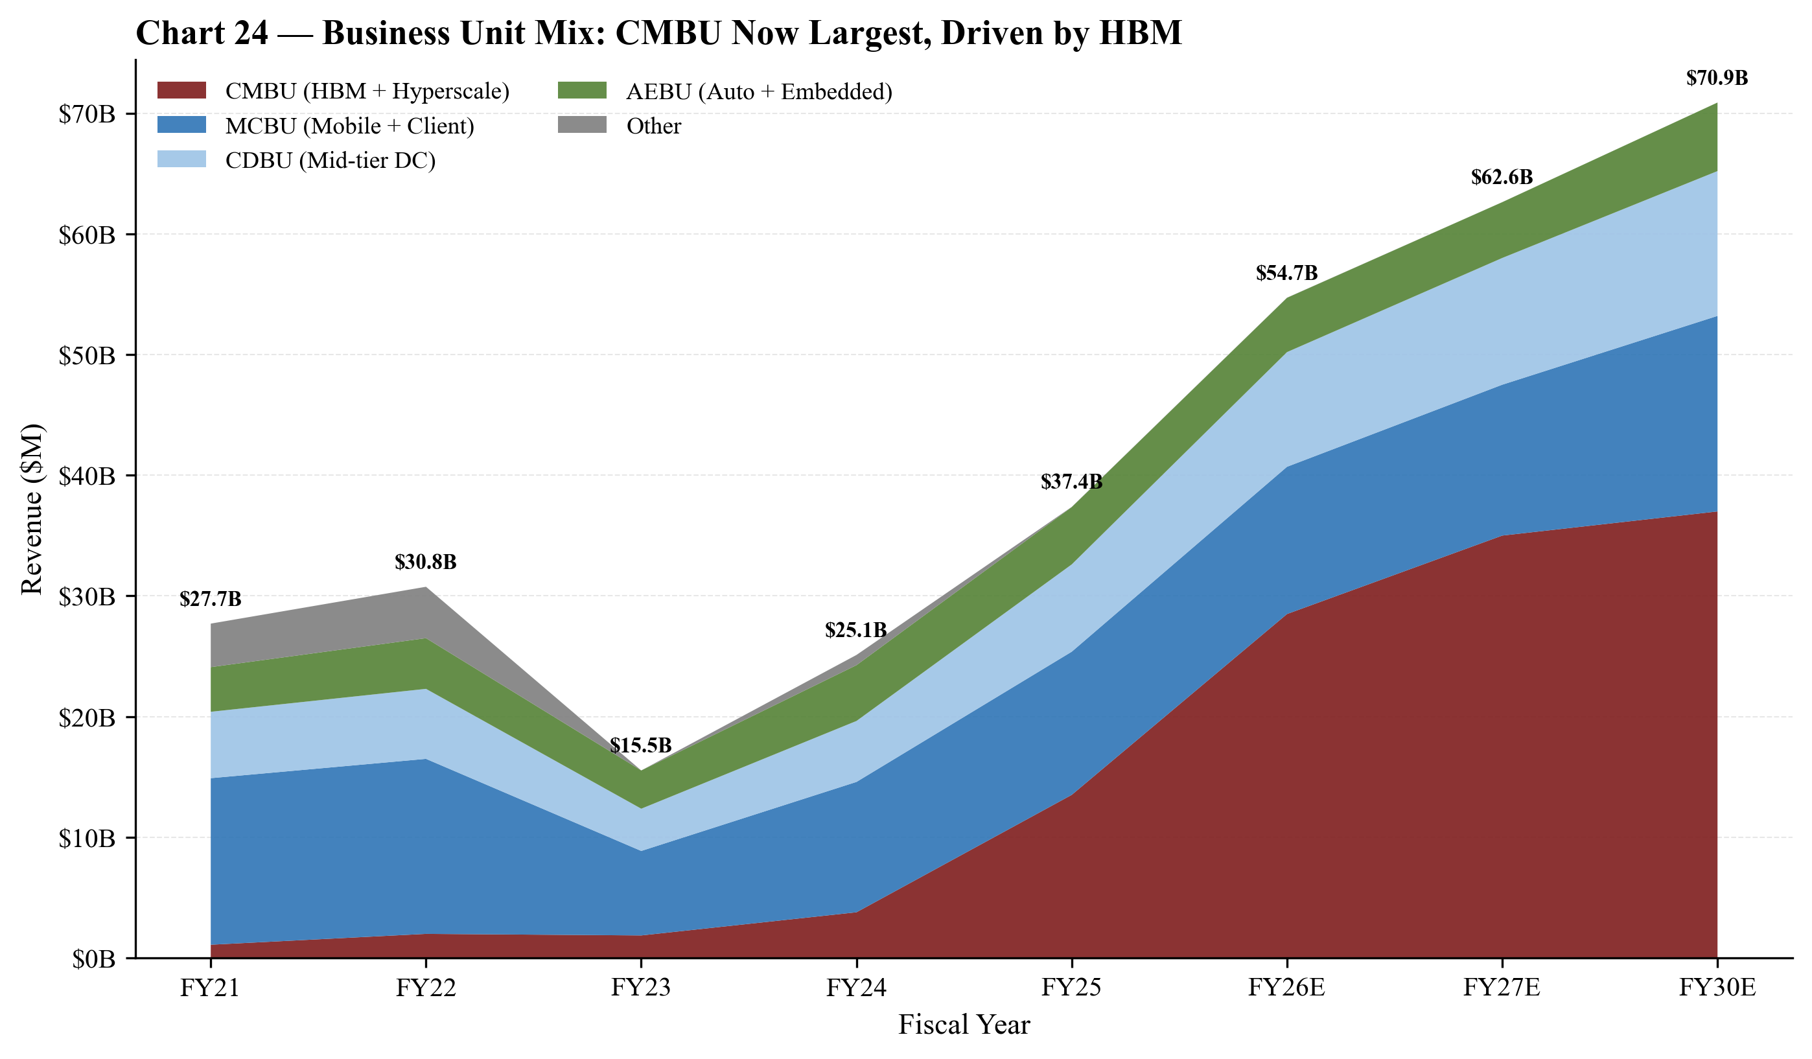
Chart 13 — Business unit mix evolution. CMBU (cloud memory with HBM) has expanded from $1.1B (4% of revenue) in FY21 to $13.5B (36%) in FY25, becoming the largest segment.

Industry Overview
Industry Definition
Memory and storage semiconductors comprise DRAM (volatile working memory; ~60-65% of memory $TAM), NAND (non-volatile storage; ~30-35%), and small ancillary categories (NOR, MRAM, ReRAM, emerging memories). The industry sits at the intersection of (i) the broader semiconductor value chain and (ii) the data-center, mobile, PC, and automotive end-markets. DRAM and NAND are commodity products by the definition of 'fungible, priced on a spot market' — but the technology and capital intensity of producing them keeps the supplier set extremely narrow.
Market Size
The memory industry is one of the largest and most cyclical semiconductor sub-markets:
- 2024 total memory revenue: ~$165B, of which DRAM ~$90B and NAND ~$60B per WSTS/SIA industry consensus.
- 2025 total memory revenue: estimated $200-230B, with DRAM accounting for the majority of the year's growth on AI-driven HBM and high-capacity DDR5 demand.
- HBM specifically went from a ~$4B sub-market in 2023 to >$25B in 2025 per industry estimates; HBM TAM forecast to exceed $100B by 2030.
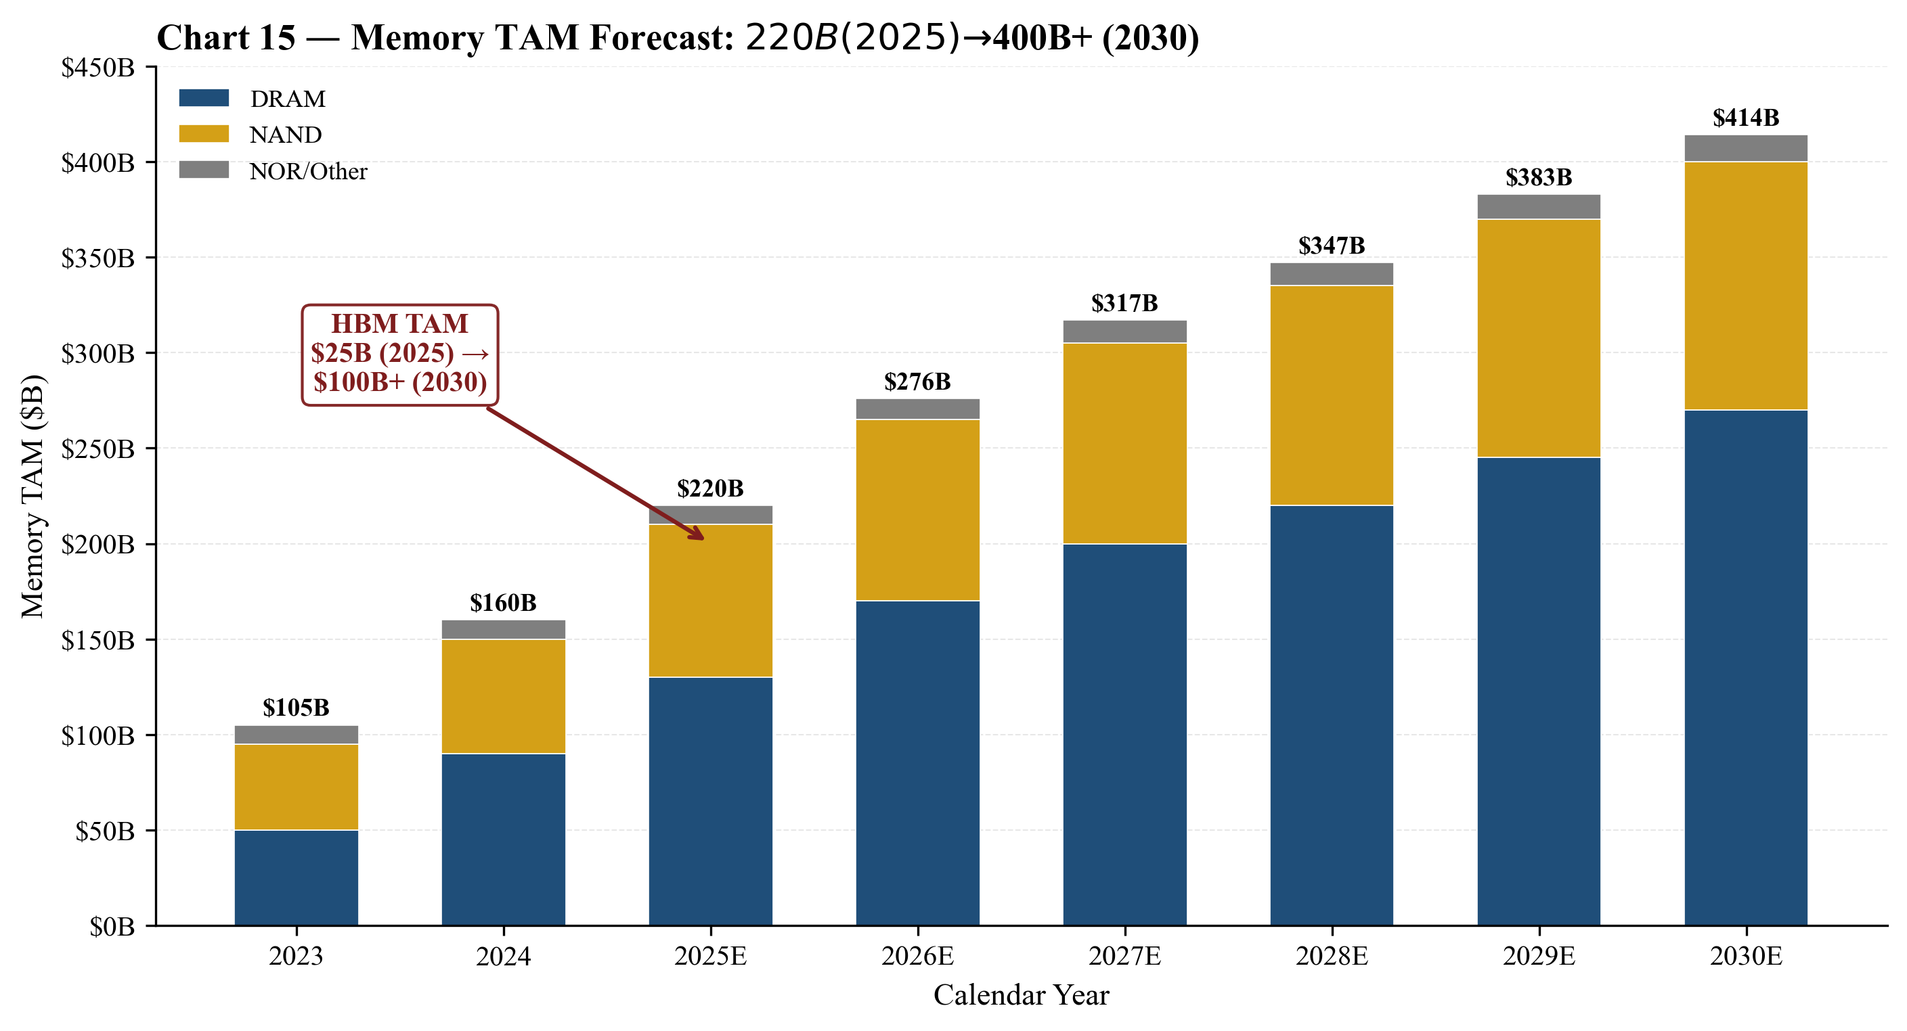
Chart 14 — Memory TAM forecast: $220B (2025) to $400-450B (2030) per Yole/Gartner consensus. HBM alone forecast to exceed $100B by 2030.
Growth Drivers
- AI training capex (the dominant 2024-2026 driver). Each Nvidia B200 GPU uses 8 stacks of HBM3E (typically 24GB or 36GB each — i.e. 192GB or 288GB per GPU). Industry shipments of B200/B300/Rubin-class GPUs in 2025-2026 are driving HBM bit demand growth at 60%+ CAGR (Gartner and Yole forecasts).
- AI inference at the edge. Increasingly memory-bound; LPDDR5X and on-package HBM-class memory drive incremental DRAM bit demand.
- Smartphones returning to growth. After 2023's downturn, 2024-2025 smartphone unit growth resumed; memory density per phone (LPDDR5X plus UFS 4.0) continues to scale.
- Automotive electrification + ADAS. DRAM bits per car are projected to ~triple by 2030; AEBU revenue grew 3% in FY2025 to $4.75B and gross margin improved from 20% in Q1-FY2025 to 45% in Q1-FY2026.
- Data-center SSD adoption. High-capacity QLC SSDs displacing nearline HDD in select cloud workloads; Micron's 9550-series targets this.
Industry Structure
The DRAM industry is a three-supplier oligopoly: Samsung Electronics (~40-43% bit share), SK Hynix (~32-35%), Micron (~22-25%) — per Omdia/TrendForce 2024-2025 quarterly trackers. Chinese entrant CXMT has built mainland DRAM capacity but remains 5+ years behind on leading-edge nodes and not material to leading-edge demand. The NAND industry is more fragmented — five suppliers: Samsung, SK Hynix (incl. Solidigm), Kioxia, Sandisk (the spun-off NAND business of Western Digital), and Micron — with a Chinese entrant (YMTC) restricted by US export controls.
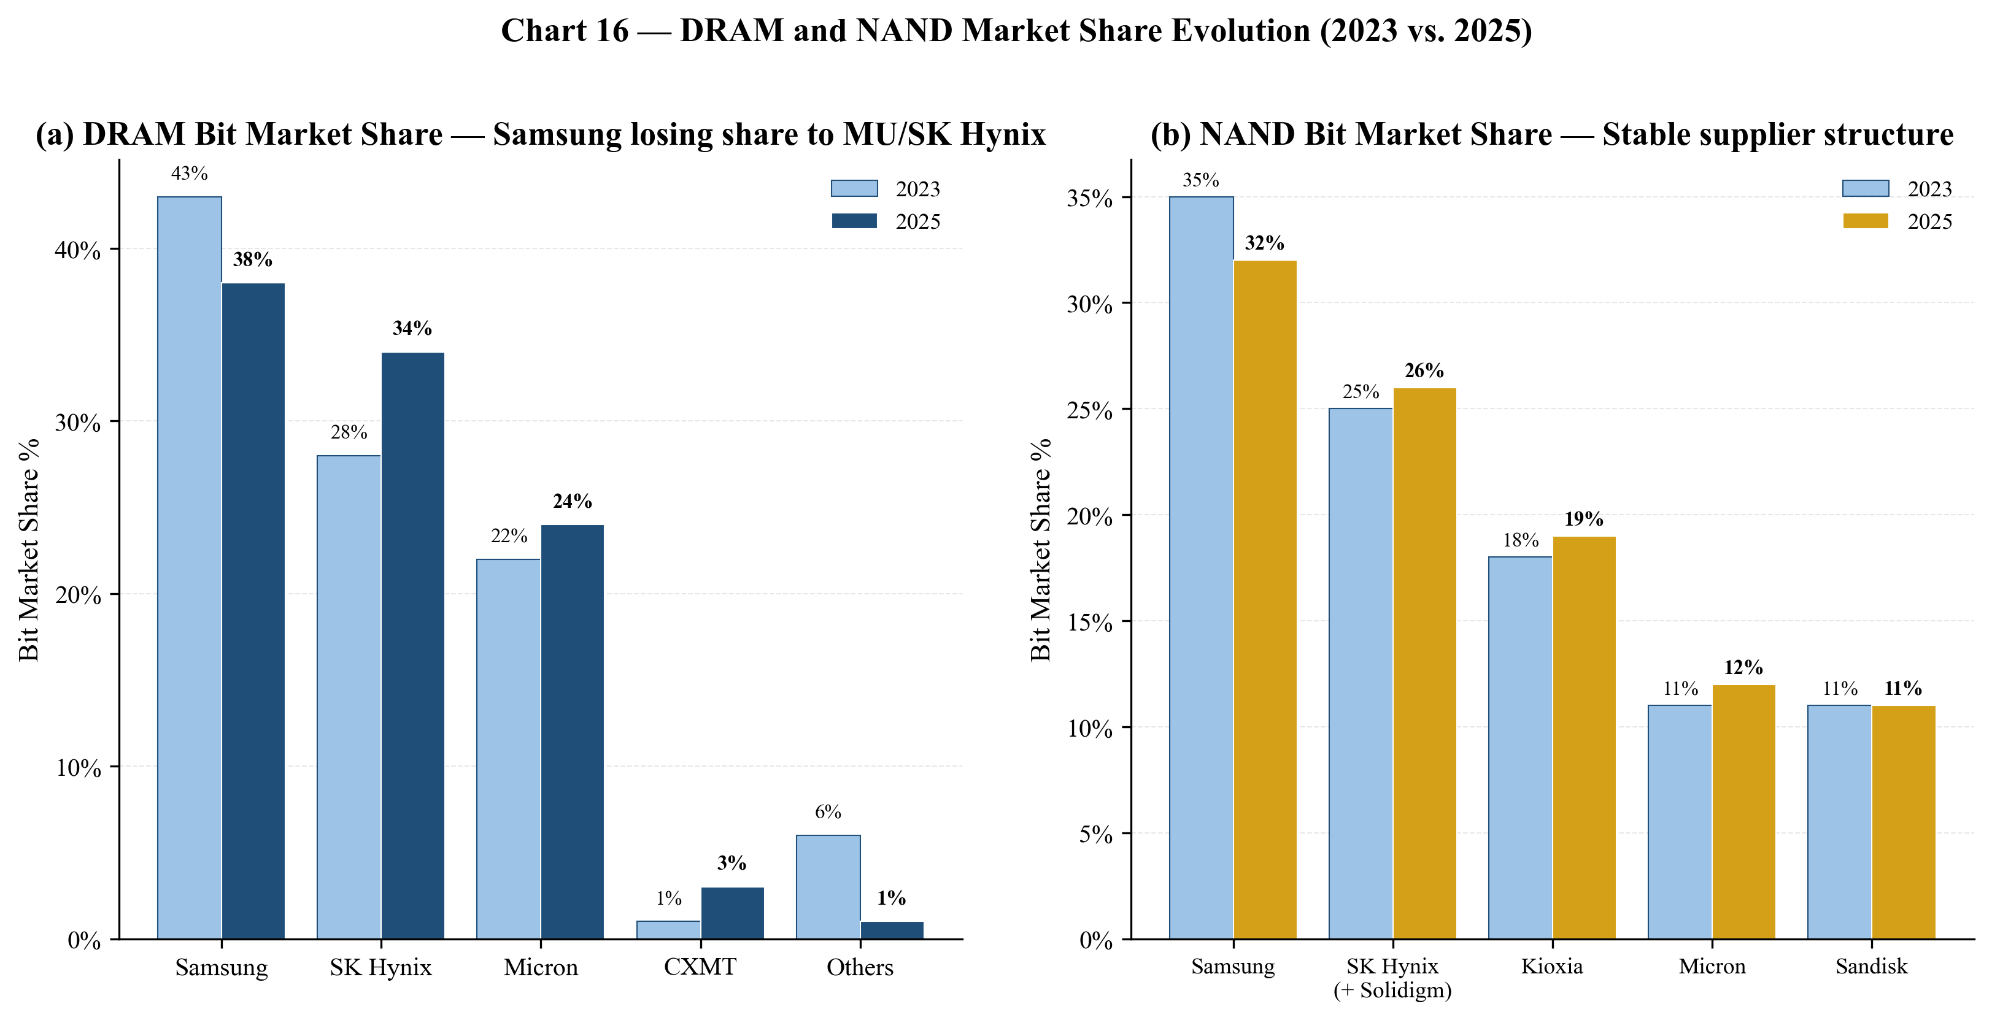
Chart 15 — DRAM and NAND bit market share evolution 2023 vs 2025. Samsung has lost DRAM share to Micron and SK Hynix; NAND share has been more stable.
Cyclicality — The Defining Feature
The memory industry has shown a clear 3-to-4-year ASP cycle for the past three decades. The most recent peak-trough-peak cycle is visible in Micron's own numbers: FY2022 (cycle peak): revenue $30.76B, GAAP GM 45%. FY2023 (cycle trough): revenue $15.54B (−49% YoY), GAAP GM −9%, operating loss $5.7B. FY2024 (recovery): revenue $25.11B, GM 22%. FY2025 (boom + AI super-cycle overlay): revenue $37.38B, GM 40%. FY2026 (current): Q1 GM 56%, Q2 guided 67% — well above prior-cycle peaks.
The current cycle is unusual: AI-driven HBM demand is structurally short, supply additions are constrained by DRAM wafer capacity being shifted from commodity DDR to HBM (HBM consumes ~3× the wafer area per bit of standard DDR5 due to the larger die, lower yields, and the assembly stacking), and the supplier discipline is unusually tight. Whether this is a 'super-cycle' or just a deeper-than-usual cycle is the central debate among memory analysts.
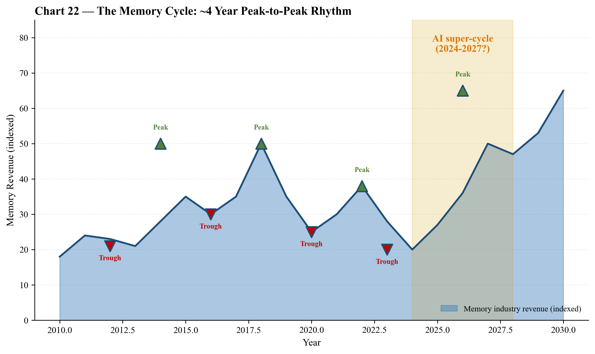
Chart 16 — The memory cycle: ~4-year peak-to-peak rhythm visible since 2010. Current AI super-cycle (2024-2027?) may extend the up-leg longer than prior cycles.
Regulatory Environment
- U.S. CHIPS Act: Micron received direct funding agreements up to $6.1B (Boise + Clay NY), expanded in June 2025; CHIPS Investment Tax Credit also relevant.
- CHIPS-related export controls on China: Micron's Wuxi, China backend assembly operations remain operational; lithography and advanced-node equipment exports to China are restricted under BIS regulations.
- CAC China decision (May 2023): China's Cyberspace Administration determined that critical information infrastructure operators in China may not purchase Micron products. Mainland China revenue fell from $3.05B (FY24) to $2.64B (FY25); Hong Kong + Mainland combined was $3.78B in FY25, ~10% of revenue.
- India PLI scheme: Sanand backend supported by India Central Government and Gujarat State Government funding agreements.

Competitive Landscape
Micron names six direct competitors in the 2025 10-K: Samsung Electronics, SK Hynix, Kioxia, Sandisk, CXMT, and YMTC. Below, each is analyzed on positioning, capacity, and current pressure points.
1. Samsung Electronics (Memory Solutions Division) — KRX: 005930
The world's largest memory company by revenue and bit share. Samsung's Memory Solutions division generated KRW ~80T in FY2024 (~$60B equivalent); the group-level P/S TTM is 4.67×. On HBM, Samsung has notably fallen behind SK Hynix and Micron on Nvidia qualification — its HBM3E qualification on H200 was delayed, and HBM4 qualification on Rubin is the make-or-break for the memory division. Samsung remains the leader in commodity DDR and LPDDR by wafer scale, but the HBM execution gap is the central competitive opening Micron has exploited. Micron's advantages vs. Samsung: 1-beta node power efficiency, HBM4 sample lead. Samsung's advantages: scale, vertically integrated foundry + memory, lower break-even costs in a downturn.
2. SK Hynix — KRX: 000660
The most direct competitor to Micron, and the #1 supplier of HBM3E to Nvidia for H100/H200/B100/B200. SK Hynix forward P/E of 4.56× and P/S of 9.38× reflect the market pricing in a peak earnings year. SK Hynix's advantages: largest HBM share, highest mix of HBM in the bit base. Disadvantages: NAND business is structurally less profitable (acquired Intel's NAND business — Solidigm — at the cyclical top), and SK Hynix carries more financial leverage than Micron.
3. Kioxia Holdings (TSE: 285A) — NAND-only pure play
Spun-out from Toshiba's memory business, public since late 2024. Approximately 18-20% NAND bit share. No DRAM, no HBM. Competes with Micron in data-center SSD and managed NAND.
4. Sandisk Corporation (NASDAQ: SNDK) — NAND-only pure play
The post-spin NAND business of Western Digital. P/S TTM 15.72×, forward P/E 7.98×. Competes head-to-head with Micron in client SSD and consumer NAND. The Crucial-vs-WD/SanDisk consumer battle has been a fixture of the channel for over a decade.
5. ChangXin Memory Technologies (CXMT, private) — Chinese DRAM
State-supported entrant. Building DRAM capacity at the Hefei and Beijing sites. Currently 5+ years behind on leading-edge nodes; commentary in the Micron 10-K acknowledges that 'consolidation of industry competitors could put us at a competitive disadvantage' and that 'new entrants into the memory and storage market could have a significant adverse impact on our competitive position.' The structural concern is that CXMT's commodity DDR4/LPDDR4 ramp depresses commodity ASPs in 2026-2028 even as HBM stays tight.
6. Yangtze Memory Technologies (YMTC, private) — Chinese NAND
Subject to US BIS export controls; technologically capable on layer count but capacity-constrained by equipment access.
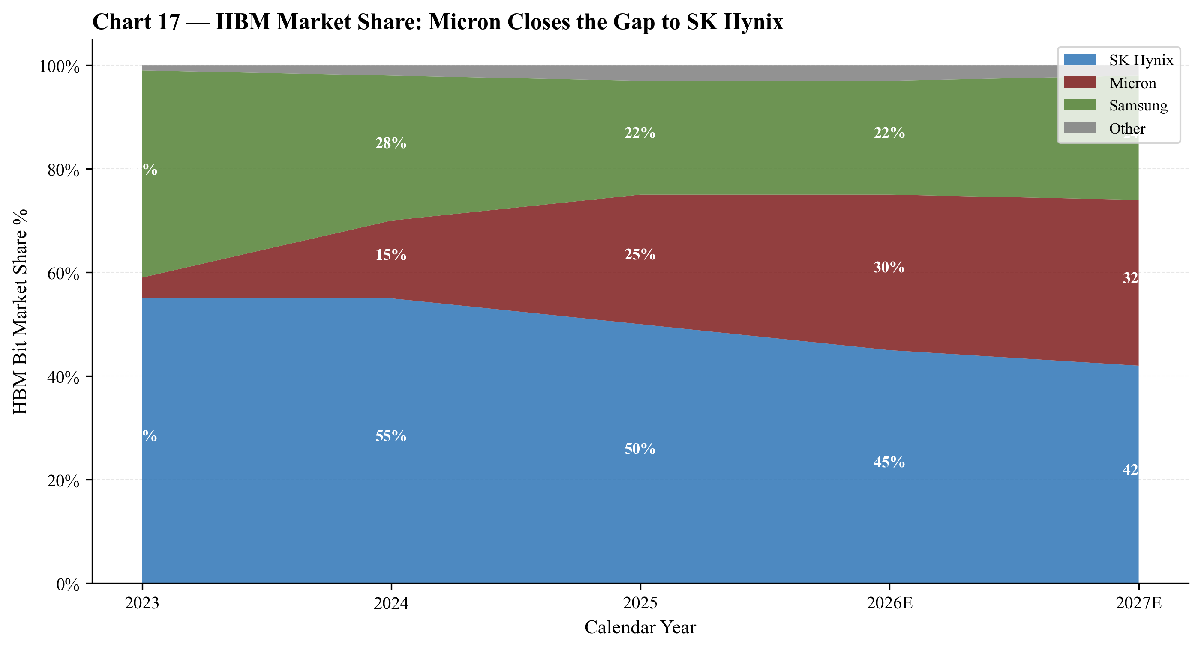
Chart 17 — HBM market share evolution. Micron has closed the gap to SK Hynix from <5% (2023) to 25% (2025), and is projected to reach 30%+ by 2026E.
Positioning Verdict
Micron occupies a 'both-DRAM-and-NAND-scale-but-not-Samsung-scale' position in the industry — large enough to fund the HBM4 / 1-gamma / EUV roadmap, focused enough to execute, but reliant on retaining its HBM qualifications and continuing to invest at the pace of SK Hynix.
Competitive advantages:
- HBM3E 12-high majority of shipments; HBM4 customer samples shipped — closing the historical gap to SK Hynix and opening one vs. Samsung.
- US headquartered + CHIPS Act funding + India and Japan funding — Micron is the most geographically diversified producer.
- Leading-edge 1-beta DRAM node provides per-bit cost and power leadership.
- Strong customer franchise in automotive and embedded (AEBU) — the most cycle-resilient segment.
Competitive vulnerabilities:
- Smaller scale than Samsung — in a deep downcycle, Samsung's lower break-even can be a structural disadvantage to Micron's earnings.
- HBM customer concentration — Nvidia is the dominant buyer; an Nvidia GPU misstep, a customer in-sourcing move, or a Samsung HBM qualification could materially shift share.
- NAND business is structurally less profitable than DRAM and competes against larger Korean and Japanese supply.
- Mainland-China revenue restricted by the CAC May-2023 decision.
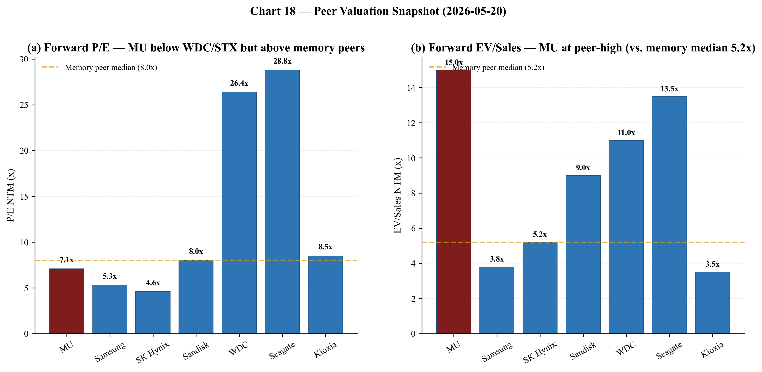
Chart 18 — Peer valuation snapshot. MU's forward P/E (7.1×) is below WDC/STX but above memory peers; EV/Sales (15×) is at peer-high (vs. memory median 5.2×).

Market Opportunity (TAM)
TAM Today and 2030
Per the most commonly-cited Yole/Gartner/WSTS forecast set: Total memory TAM 2025: ~$220B (DRAM ~$130B, NAND ~$80B, NOR/other ~$10B). Total memory TAM 2030: $400-450B at the consensus base case, of which HBM alone is forecast to exceed $100B by 2030. The implied 2025-2030 CAGR is in the high-teens for total memory and ~30%+ for HBM.
SAM — Micron's Serviceable Market
Micron's SAM is essentially the full DRAM + NAND market ex-China-restricted demand (the CAC decision excludes the Chinese 'critical information infrastructure' sub-segment). With approximately 22-25% DRAM bit share and 11-12% NAND bit share, Micron's current SAM is roughly $190B (2025) and growing toward $350B+ by 2030 if base-case forecasts hold.
SOM — Micron's Served Market
At today's bit share, Micron's served opportunity is approximately $40-50B annualized at current ASPs. The Q1-FY2026 run rate ($13.64B × 4 = $54.6B) and the Q2 guide ($18.7B × 4 = $74.8B) imply Micron is already running ahead of its bit-share-implied SAM — because HBM and high-capacity DRAM carry ASP premia far above commodity DRAM.
Penetration Strategy
- Hold or grow HBM share against Samsung and SK Hynix through HBM4 12-high and HBM4E execution. HBM4 in volume in 2026; HBM4E expected to ship in 2027.
- Extend high-capacity DDR5 leadership through the 128GB monolithic-die advantage.
- Build the data-center SSD franchise with the 9550 series and follow-ons.
- Continue automotive/embedded share gains in AEBU — high gross margin (45% in Q1-FY2026) and cycle-resilient.
- Geographic capacity diversification — Idaho greenfield, Clay NY, Manassas VA, Hiroshima Japan, Sanand India.
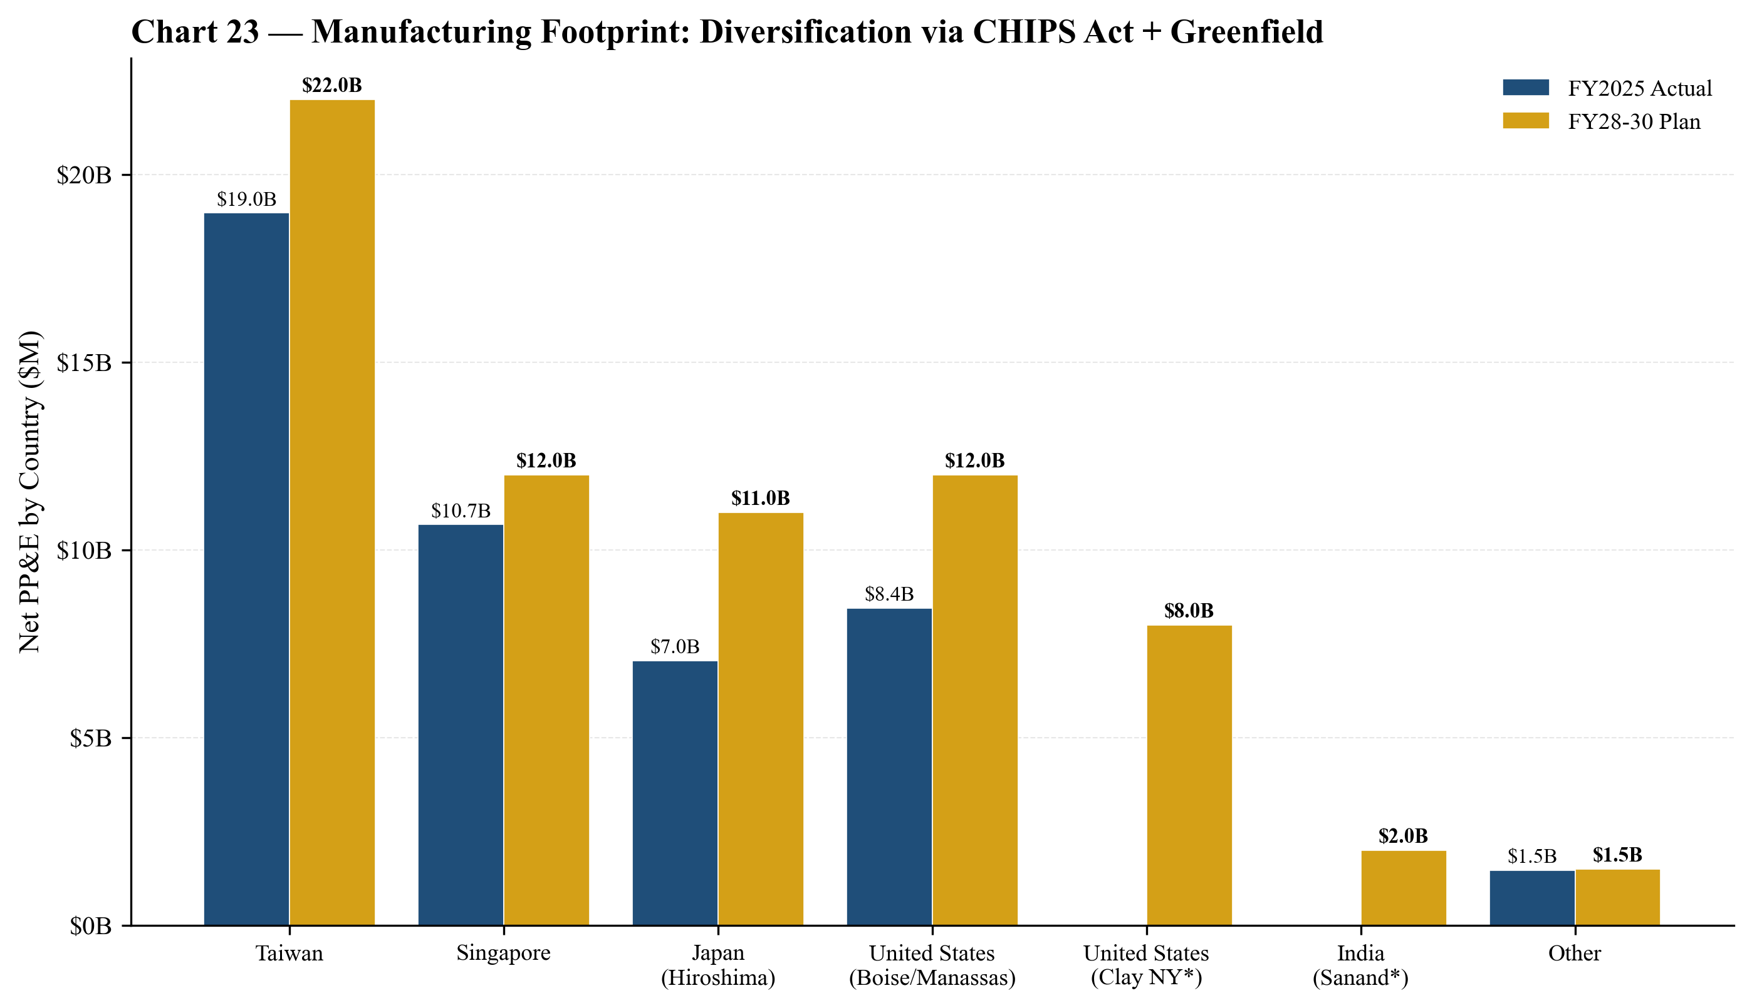
Chart 19 — Manufacturing footprint geography. CHIPS Act + greenfield expansion (Idaho, Clay NY, Manassas VA, Hiroshima, Sanand) reduces Taiwan concentration risk.
Penetration of HBM Specifically
HBM is the single biggest opportunity. At a 2025 HBM market estimated at $25-30B and Micron's share estimated at 20-25% (rising from <5% in 2023), Micron is capturing roughly $6-7B of HBM revenue in 2025. By 2027, if HBM grows to $60-80B and Micron holds 25%+ share, HBM alone would contribute $15-20B of revenue — i.e. could equal the entire FY2024 revenue base of $25B.
Risks to the TAM Thesis
- AI capex cycle peaks earlier than consensus (2027 vs. 2029-2030 base case). HBM share of the memory mix could compress.
- CXMT scales commodity DDR faster than expected, depressing non-HBM ASPs.
- HBM technology shift to in-package compute / 3D stacked logic that doesn't favor Micron's HBM4/HBM4E roadmap.
- Sovereign capacity overbuild — CHIPS Act, EU Chips Act, India PLI, Japan METI all subsidizing fab additions; in aggregate this could create commodity-DRAM oversupply in 2027-2029.

Financial Projections
Methodology and Approach
Our 5-year projections (FY2026E-FY2030E) are built bottom-up by product line and business unit, reflecting the dual reality of (a) a structurally elevated HBM franchise and (b) commodity DRAM/NAND cyclicality. We assume the AI super-cycle persists through FY2027 (with FY27 as the peak earnings year), with a modest cyclical dip in FY2028 as commodity DRAM normalizes, followed by recovery in FY2029-2030. Our projections are intentionally cycle-aware — we do not project a permanent step-change to the memory business model — but we do project sustained AI-DRAM premium for HBM revenue lines.
Revenue Build by Product
FY2026E revenue of $54.7B reflects HBM revenue of $21.5B (vs. FY25 $7.1B), DDR5/4 of $14.5B, LPDDR of $5.5B, GDDR of $1.5B, other DRAM of $1.2B, NAND of $10.2B, and NOR/other of $0.3B. The FY27E projection of $62.6B includes HBM growth to $28.0B (peak as HBM3E 12-high and HBM4 ramp concurrently), with DDR5 stable at $14.0B and LPDDR slightly higher at $5.8B. FY28E shows a modest dip to $58.8B as HBM revenue plateaus (~$22B) on commodity DRAM normalization. FY29E and FY30E show recovery to $64.9B and $70.9B respectively, with HBM oscillating $24-26B and total DRAM expanding to $56.5B.

Chart 20 — Revenue by product, stacked. Repeated here from Company 101 section for the financial deep dive. HBM is the dominant variable. ⭐ MANDATORY CHART
Revenue Build by Geography
Geographic revenue mix reflects two countervailing trends: (a) US revenue has grown materially from $3.3B (FY21) to $14.5B (FY25) as Nvidia (US-shipping) became the dominant HBM customer, and we project $22.5B (FY26E) and $30B (FY30E); (b) Mainland China revenue has been impacted by the CAC restriction, falling from $4.9B (FY21) to $2.6B (FY25) with modest recovery projected. Taiwan revenue is significant as Nvidia ships through Taiwan-based AIB partners, with $8.7B in FY25 and projected $18.5B in FY30E. Geographic concentration in Hong Kong has declined from $6.5B (FY21) to $1.1B (FY25) reflecting export-control complexity.
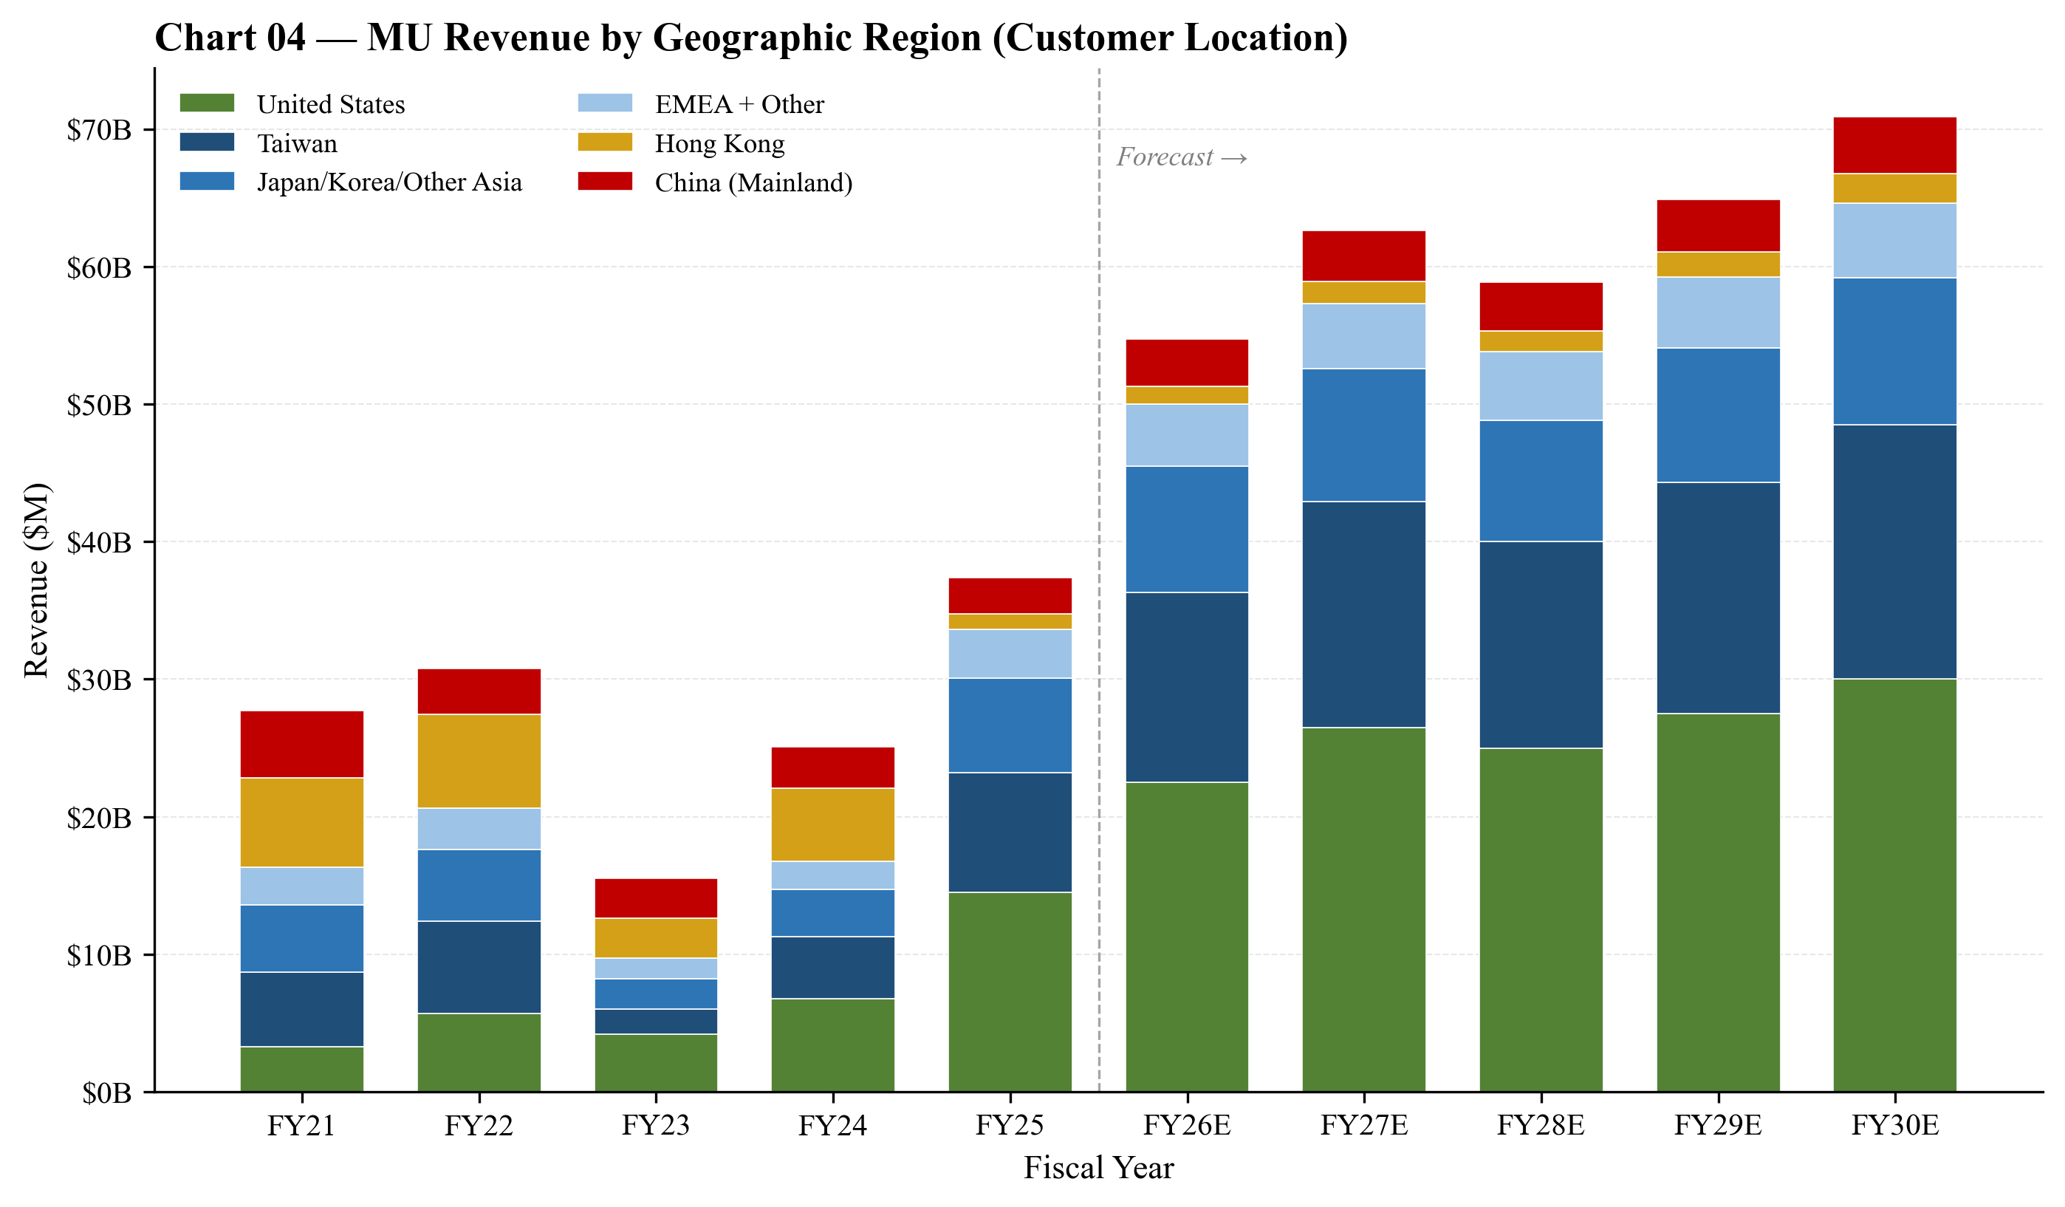
Chart 21 — Revenue by geographic region (customer location), FY21A-FY30E. US revenue growth reflects Nvidia ship-from-US through AIB partners; Taiwan reflects packaging partner-driven flow. ⭐ MANDATORY CHART
Margin Trajectory
Our gross margin projection of 61% (FY26E) → 62% (FY27E peak) → 55% (FY28E) → 56.7% (FY29E) → 57.5% (FY30E) reflects:
- HBM margin mix: HBM gross margin assumed at 65-70% (well above company average), with HBM mix peaking at ~45% of total revenue in FY27E and declining to ~37% by FY30E.
- Commodity DRAM: Commodity DRAM gross margin of 35-40% assumed normalized through cycle; commodity DRAM mix ranges 30-40% of revenue.
- NAND margin: NAND gross margin of 25-35% assumed, with continuous improvement on layer scaling (276L → 332L → next-gen).
- Greenfield depreciation: Idaho and Clay NY ramp create depreciation step-ups in FY27-FY29 that partially offset HBM mix benefits.
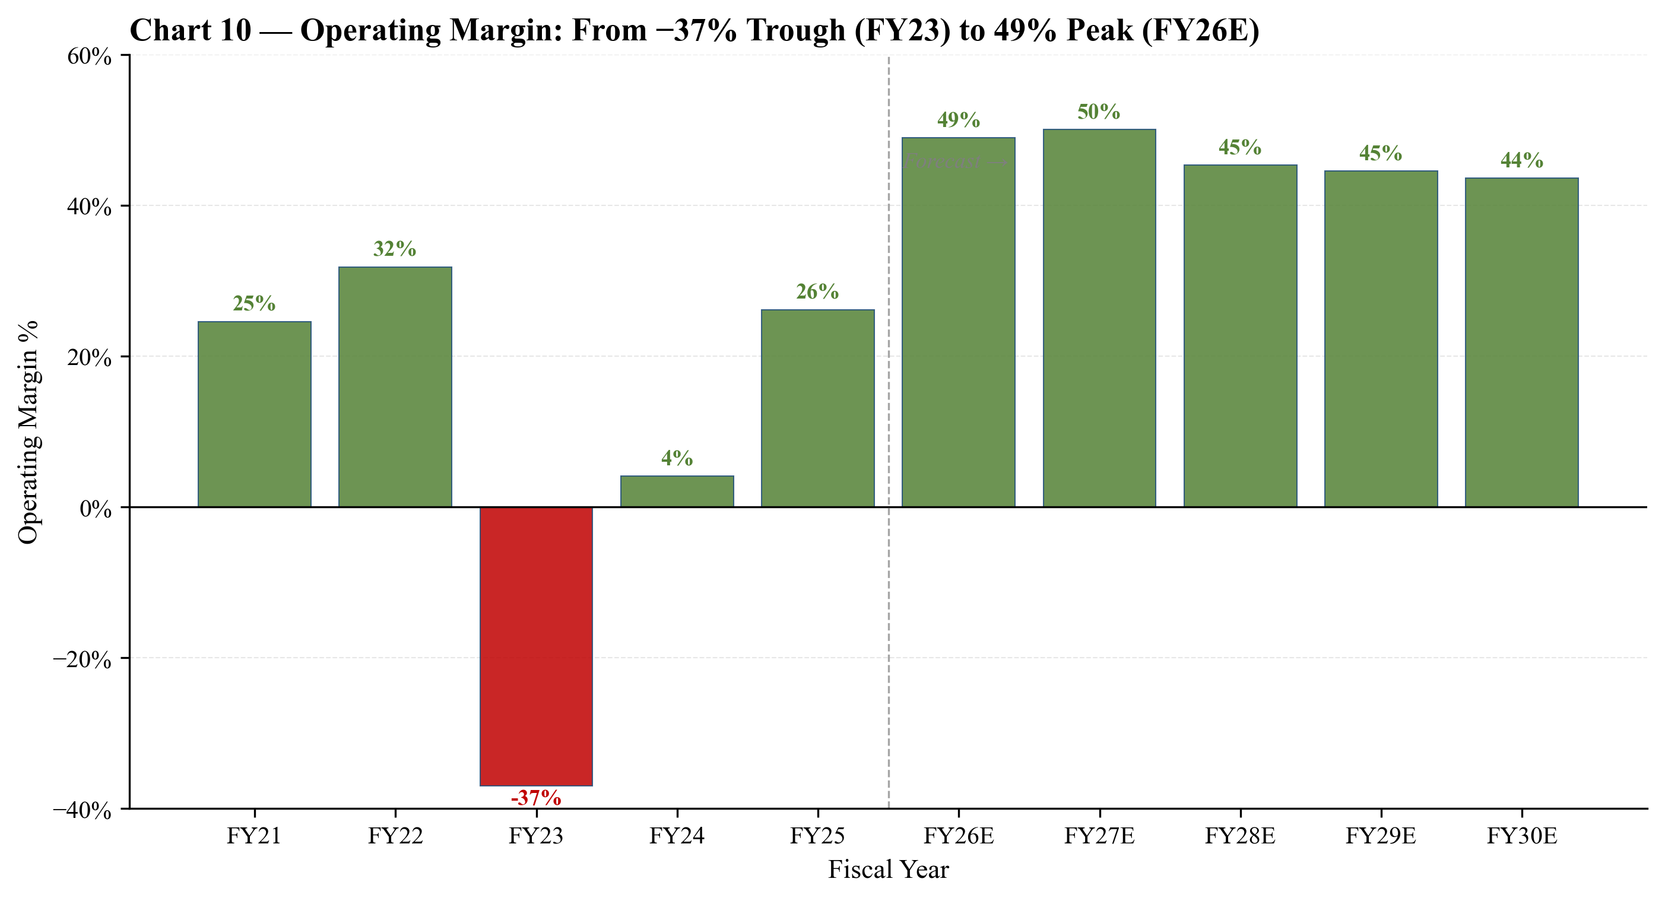
Chart 22 — Operating margin trajectory: −37% trough (FY23) to projected 49% peak (FY26E), with modest cycle reversion to 45% by FY30E.
EPS Trajectory and Scenarios
Diluted EPS is projected at $22.50 (FY26E), $25.50 (FY27E peak), $21.00 (FY28E), $22.80 (FY29E), $24.30 (FY30E). The FY26E figure is essentially the consensus base case (Yahoo Finance forward EPS of $35 reflects calendar 2026 — Micron's FY26 is broader than 2026, ending August). Our cycle-aware approach produces a five-year EPS arc that peaks in FY27 and then mean-reverts to a structural $22-25 normalized range by FY30E.
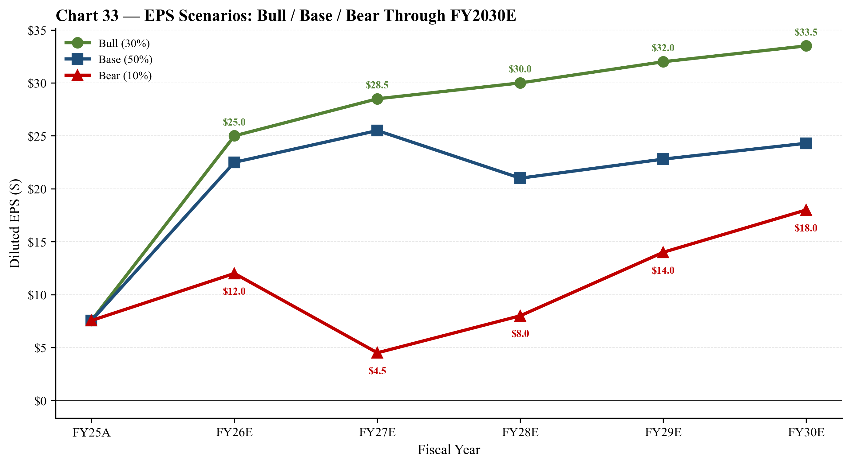
Chart 23 — EPS scenarios FY25A-FY30E. Bull case (30% prob) reaches $30+ at FY30E; bear case (10% prob) troughs at $4.50 in FY27 before recovery.
Free Cash Flow Inflection
Free cash flow is projected to inflect to $10B+ annually starting FY2026E, after net-of-CHIPS-proceeds, supporting both the $10B share-repurchase authorization and continued capex investment. FY26E FCF of $10.2B (post-CHIPS $12.0B), FY27E $12.85B (post-CHIPS $14.4B), then steady $15B+ through FY30E. The FCF profile is the most attractive feature of the projection — Micron will generate substantially more cash than it can productively invest, requiring continued capital return acceleration.
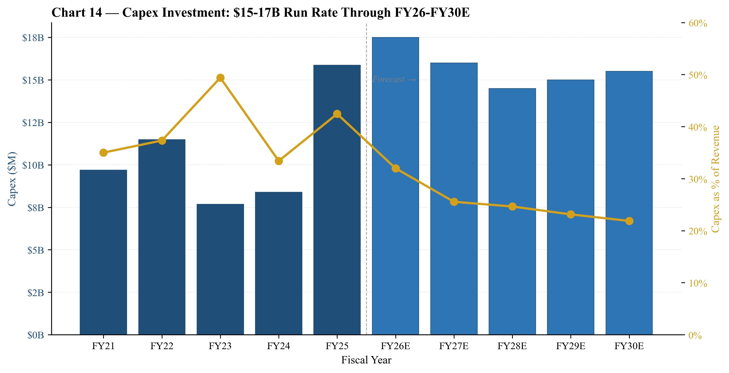
Chart 24 — Capex ($15-17B/year through FY27-30E) and Capex/Revenue ratio (~25%). Capex/Revenue declining from 42% (FY23 trough) to ~22% by FY30E as revenue scales.
Capital Allocation Framework
Over FY26-30E, we project Micron will deploy approximately $78.5B of capex (gross of CHIPS proceeds), $17B of share repurchases, $3.1B of dividends, and $8.4B of debt repayment — vs. approximately $5.5B of CHIPS proceeds inflow. The implied 5-year cumulative free cash flow post-CHIPS is approximately $73B, well in excess of the $20B+ capital return — leaving substantial flexibility for further repurchase authorization expansions or M&A optionality.
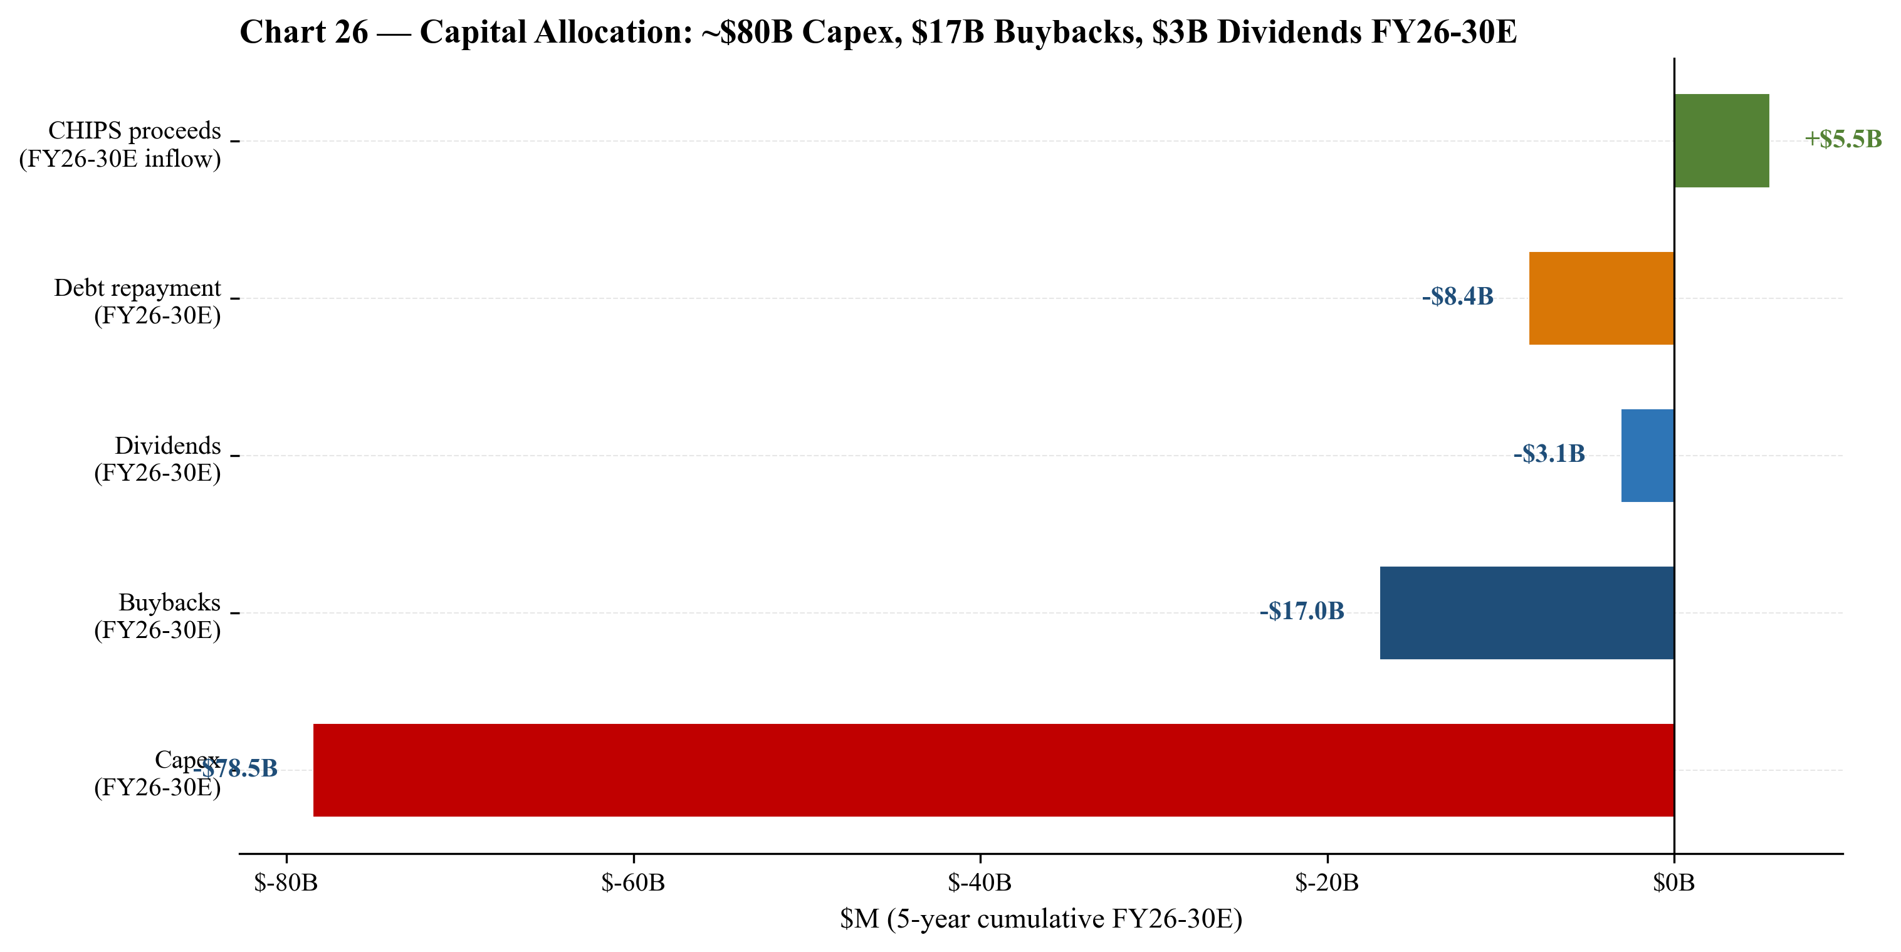
Chart 25 — Capital allocation 5-year cumulative FY26-30E: $78B capex, $17B buybacks, $3B dividends, $8B debt repayment vs. $5.5B CHIPS inflow.
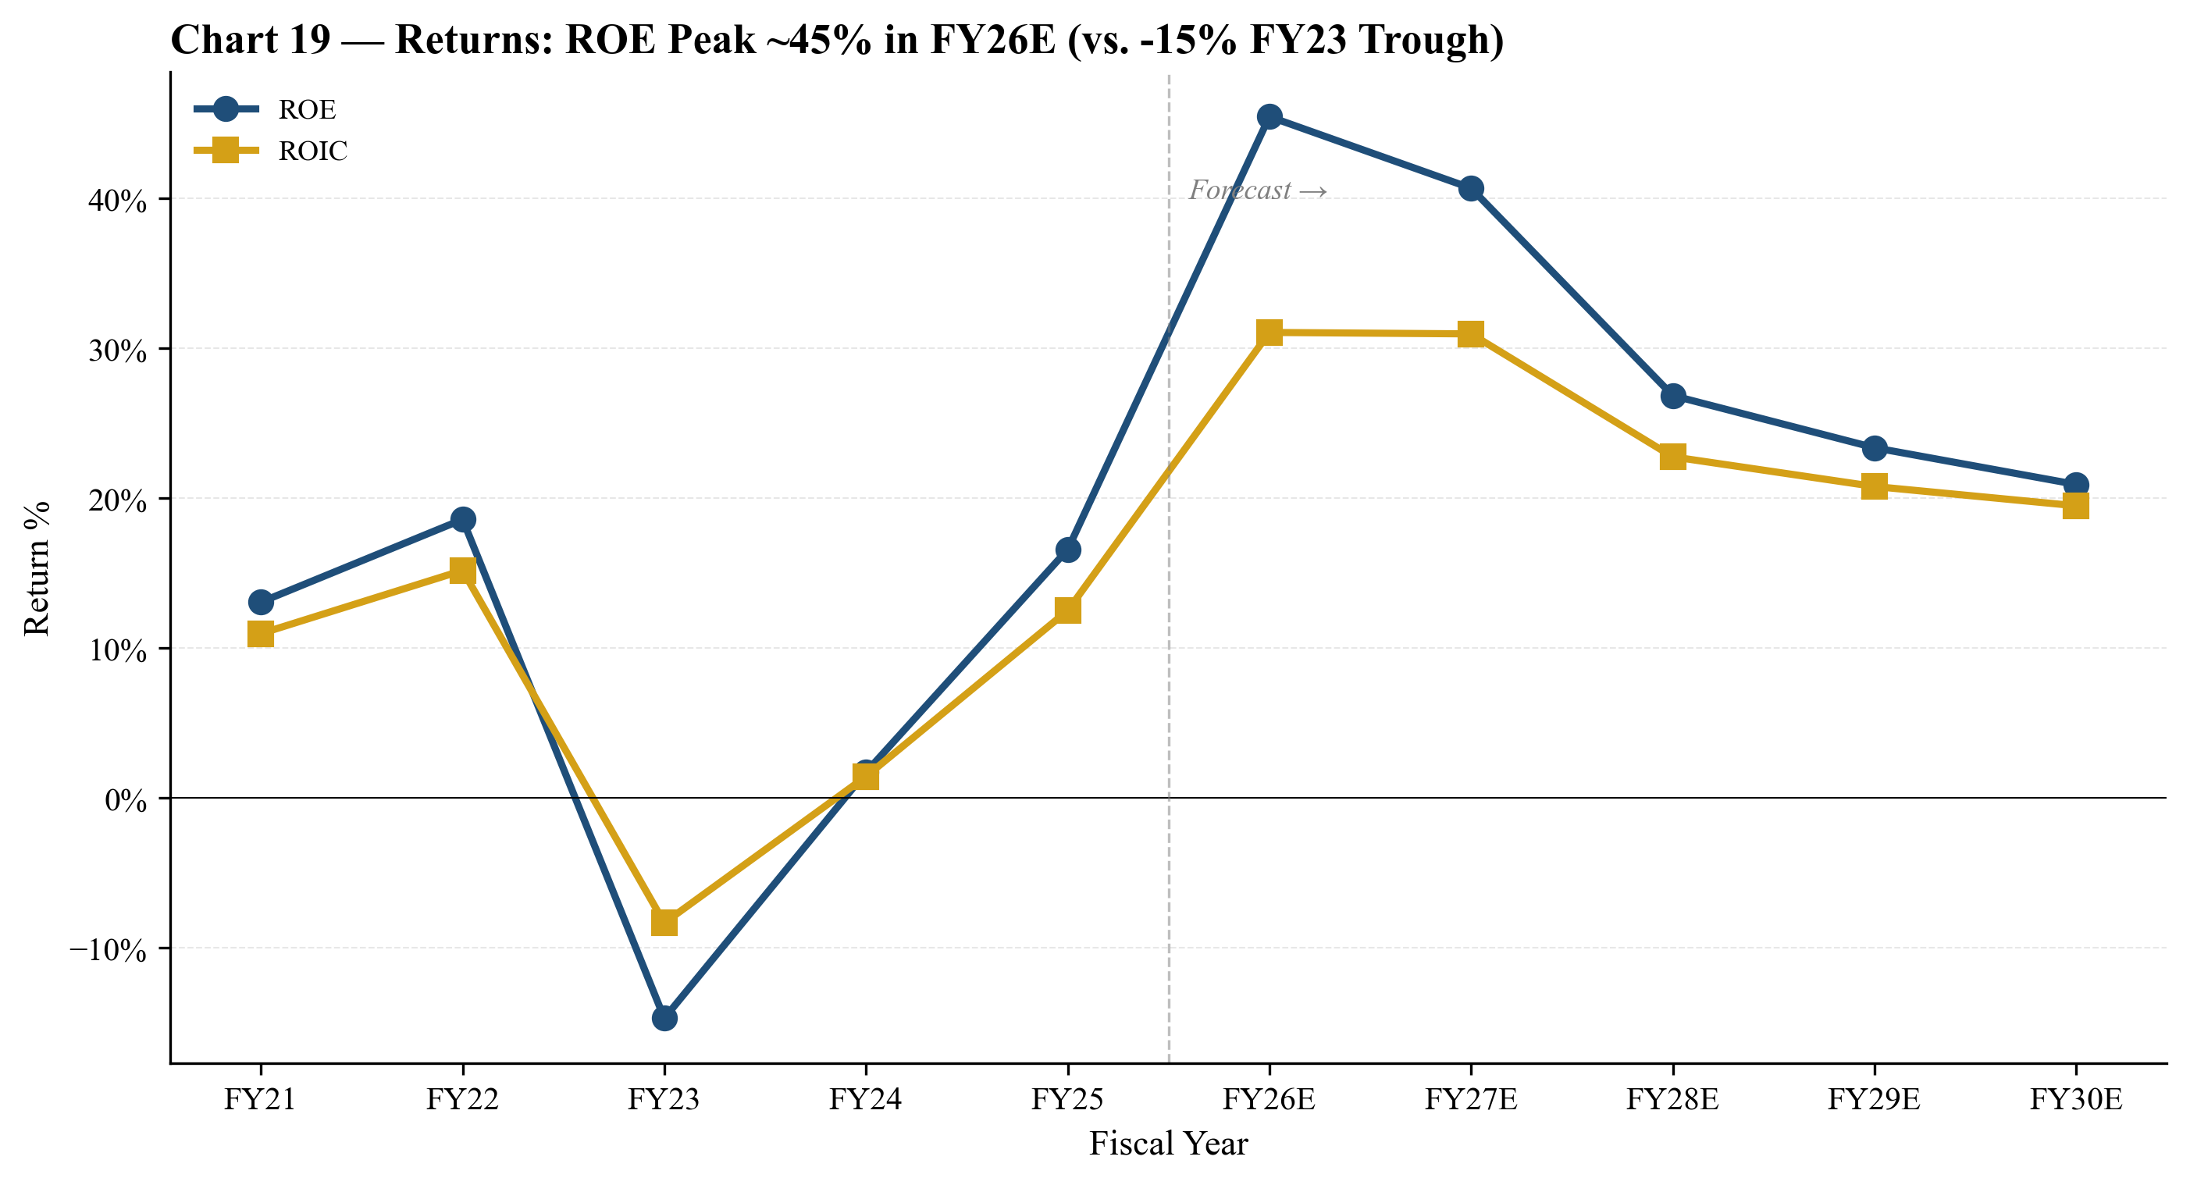
Chart 26 — Return metrics: ROE and ROIC. Peak ROE of ~45% in FY26E (vs. −15% FY23 trough); steady-state ROE of 18-22% in FY28-30E.
Scenario Analysis
Our base case (described above) corresponds to a 50% probability outcome from a 12-month horizon. The bull and bear scenarios capture the cycle tail risks.
Bull case (30% probability):
- AI super-cycle extends through FY2028; HBM4 ramps in volume in 2027 with Micron capturing 25-30% share
- Commodity DRAM remains tight as DRAM wafer capacity continues shifting to HBM
- FY26E revenue $62B (vs. base $54.7B); FY27E revenue $75B; FY28E revenue $80B
- FY27E gross margin 62%; FY27E EPS $27.50 → at 38× multiple = PT $1,050
Bear case (10% probability):
- AI capex decelerates in 2H-CY2026; CXMT achieves competitive commodity DRAM at scale
- HBM ASPs correct in late-CY2026/early-2027 as Samsung successfully qualifies HBM4
- Memory cycle reverts toward 3-year mean; peer P/E NTM compresses back to 10×
- FY27E revenue $45B; FY27E gross margin 32%; FY27E EPS $4.50 → PT framing $250-550 (midpoint $420)
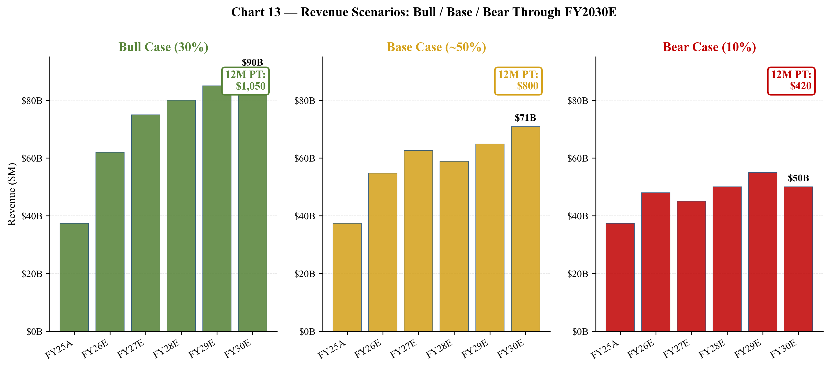
Chart 27 — Three scenarios: Bull (PT $1,050) / Base (PT $800-900) / Bear (PT $420). Probability-weighted: $697 (HOLD).
Projection Assumptions in Detail
We outline below the specific assumptions behind the FY2026E-FY2030E projections by product line, segment, and operating expense category. These assumptions are not consensus estimates — they are our independent view, intended to be intellectually honest about the cycle-aware framework rather than tracking sell-side averages.
HBM Revenue Assumptions
Our HBM revenue assumptions are the most important single variable in the projection. We assume HBM bit shipment growth of 60% YoY in FY2026 (consistent with industry forecasts of HBM TAM growth and Micron's expanding share), 30% in FY2027, then moderating to 10-15% annually FY2028-30 as the HBM unit-cycle matures. HBM ASP per GB is assumed to remain elevated through FY2027 (HBM3E 12-high and HBM4 12-high command premium pricing during the supply-constrained ramp), then moderate 15-20% in FY2028 as supply additions catch up. The combined effect: HBM revenue of $21.5B (FY26E), $28.0B (FY27E peak), $22.0B (FY28E dip), $24.0B (FY29E recovery), $26.0B (FY30E). This trajectory reflects the cycle-aware view that HBM is a structurally larger market but still subject to cyclical ASP dynamics.
Commodity DRAM Assumptions
Commodity DRAM (DDR4, DDR5 non-server, GDDR, legacy LPDDR) is assumed to follow a more traditional memory cycle. We project DDR5/DDR4 revenue of $14.5B (FY26E), peaking at $15.5B in FY29-FY30E. Commodity DRAM ASPs are assumed to rise 5-15% in FY26-27 (tail end of the up-cycle), correct 10-15% in FY28 (oversupply scenario, CXMT impact), then stabilize. Bit shipments grow 18-22% annually on continued data-center demand. This assumes Samsung does not aggressively flood the market in any single year — historically they have maintained supplier discipline but the bear case includes this risk.
NAND Assumptions
NAND revenue is projected at $10.2B (FY26E) → $14.0B (FY30E), driven by data-center SSD growth (+30% CAGR FY26-FY30E from $4.5B to $7.1B), modest growth in managed NAND (mobile UFS) at 5% annually, and steady automotive/embedded NAND. Client SSD revenue grows modestly as the PC market stabilizes. NAND gross margin is projected at 28-35% through cycle, well below DRAM's 60%+ peak but more stable. The largest NAND swing factor is Samsung's NAND capacity discipline — Samsung has historically been less disciplined on NAND than DRAM.
Operating Expense Assumptions
R&D expense is projected to grow from $4.1B (FY25A) to $6.5B (FY30E), reflecting the continued investment in HBM4/HBM4E development, 1-gamma DRAM node, 332-layer NAND, and the cost of EUV lithography integration. R&D as a percentage of revenue declines from 11.0% (FY25A) to 9.2% (FY30E) as revenue scales. SG&A is projected at 2.5-3.0% of revenue, growing from $1.25B (FY25A) to $1.95B (FY30E). These OpEx assumptions are consistent with Micron's historical operating leverage profile and management's commentary about disciplined cost management.
Tax Rate Assumptions
Effective tax rate is projected at 10-13% through FY26-FY30E, reflecting (a) the geographic mix of operations with substantial profits in lower-tax jurisdictions (Singapore, Taiwan, Hong Kong), (b) the recognition of CHIPS Act Investment Tax Credit benefits, and (c) the eventual phase-in of OECD Pillar 2 minimum tax (15%) which we expect to constrain ETR moderately. The FY25A ETR of 11.3% is consistent with this trajectory.
Capex Assumptions
Capex is projected at $17.5B (FY26E), $16.0B (FY27E), $14.5B (FY28E), $15.0B (FY29E), $15.5B (FY30E). The high FY26-27 capex reflects (a) ongoing HBM advanced-packaging investment, (b) Idaho greenfield construction (first fab targeted for 2027 wafer-out), (c) Clay NY site preparation, and (d) Hiroshima fab buildout. Capex moderates in FY28-30 as the major greenfield projects reach operational status. Gross capex of ~$78.5B over 5 years is partially offset by ~$5.5B of CHIPS and state government incentive proceeds. Capex/revenue ratio declines from 32% (FY26E) to 22% (FY30E) as revenue scales — but remains structurally high reflecting the capital intensity of leading-edge memory manufacturing.
Working Capital Assumptions
Working capital changes reflect the rapid revenue ramp: we project working capital build of $7.5B (FY26E) and $11.8B (FY27E) driven by accounts receivable growth (DSO 80-90 days) and inventory build to support HBM ramp. In FY28E (cycle dip), working capital releases approximately $0.8B as receivables come in faster than new bookings. Steady-state working capital growth in FY29-FY30E is more moderate at $1.3B annually.
Shareholder Return Assumptions
We project share repurchases of $3.0B (FY26E), $3.5B (FY27E), $2.5B (FY28E in cycle dip), $3.5B (FY29E), $4.5B (FY30E) — totaling $17B over the projection period. This represents 17% of the $10B authorization plus an assumed authorization expansion to $25B over the period. Dividends grow modestly from $0.46/share (current) to $0.66/share (FY30E) as the dividend policy moves toward 8-10% payout ratio on normalized earnings. Diluted shares decline from 1,131M (FY25A) to 1,115M (FY30E) reflecting net buybacks vs. equity compensation.

Valuation Analysis
Summary
We construct a multi-method valuation incorporating DCF (Gordon growth + EBITDA exit multiple), comparable companies analysis, and scenario-based bull/bear cases. The probability-weighted target is $697 — essentially flat to the current $727.42, supporting our HOLD (positive bias) rating. The narrow expected return reflects the genuine tension between near-term earnings momentum and valuation-multiple compression risk.
DCF Valuation
Our two-stage DCF uses a 9.8% WACC (4.25% risk-free + 1.35 beta × 5.5% ERP, weighted with 15% debt at 4.5% after-tax cost) and a 3.5% terminal growth rate. Terminal value is computed as the average of (a) Gordon growth method and (b) EV/EBITDA exit multiple of 9.5× — the latter reflecting the AI-DRAM era multiple (vs. historical memory peer median of 6-7×). Mid-year convention applied.
The implied price per share is $295.37 — a 59% gap to current. The DCF is intentionally cycle-aware; it captures the FY27 peak, FY28 dip, and FY30 normalized run rate. The math reveals that the market is implicitly pricing FY2030E EBITDA at ~$120B (vs. our base case $46B) — a 2.6× premium that requires assuming the memory cycle is structurally broken.
DCF Bridge | Value ($M)
Sum PV of UFCF (FY26-30E) | 70,694
Plus: Avg PV of Terminal Value | 265,836
Enterprise Value | 336,530
Less: Net debt | (2,467)
Equity Value | 334,063
÷ Diluted shares (M) | 1,131
Implied DCF price per share | $295.37
Current price (2026-05-20) | $727.42
Implied DCF return | −59.4%
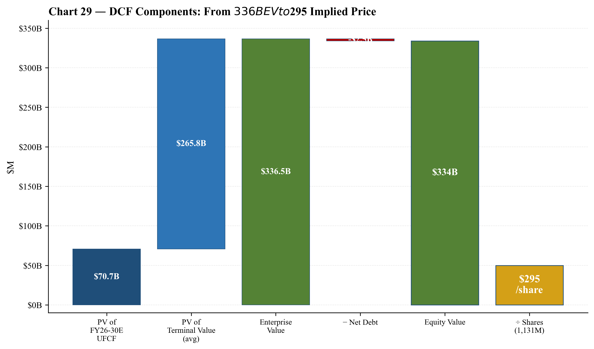
Chart 28 — DCF components waterfall: $71B PV of FY26-30E UFCF + $266B PV of terminal value = $336B EV → $334B equity → $295/share implied.
DCF Sensitivity
The DCF is highly sensitive to the WACC and terminal growth rate. Even at the most-optimistic corners (WACC 8.5%, g 4.5%), the implied price is $495 — still 32% below current. No reasonable WACC/g combination justifies the $727 price under our base-case projections.
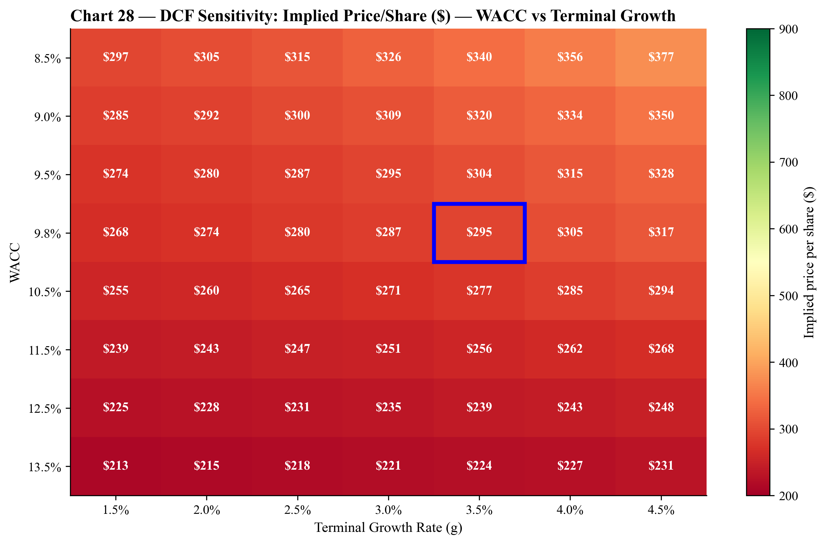
Chart 29 — DCF sensitivity heatmap: implied price/share by WACC × terminal growth. Base case ($295) highlighted in blue box. ⭐ MANDATORY CHART
Comparable Companies Analysis
The memory peer group includes Samsung Electronics, SK Hynix, Sandisk, Western Digital, Seagate, and Kioxia. Memory peer median P/E NTM is 8.0×, and mean is 13.6× (skewed up by WDC at 26× and STX at 29×). Applied to MU's FY26E EPS of $22.50, peer median P/E NTM implies $180/share — a 75% gap to current.
The most-relevant comparable for the AI-DRAM premium is to apply a 12-18× P/E NTM multiple, reflecting some premium for HBM franchise strength. At 12× (memory peer mean), implied price is $270. At 18× (AI-DRAM premium, vs. Sandisk at 8× and NVDA at 32×), implied price is $405 — still 44% below current.
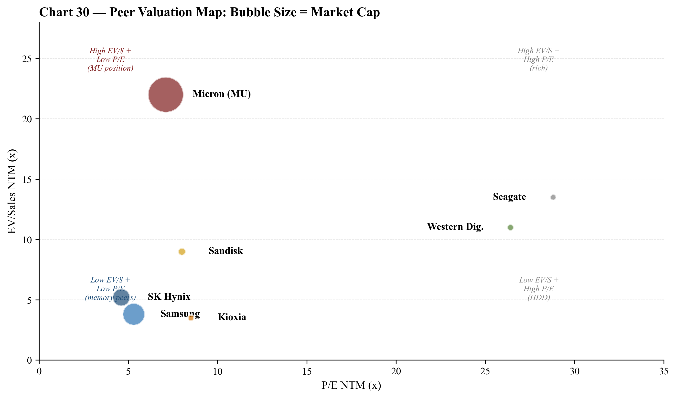
Chart 30 — Peer valuation bubble chart. MU positioned at high EV/S with low P/E — the AI-cycle premium combined with peak earnings expectations.
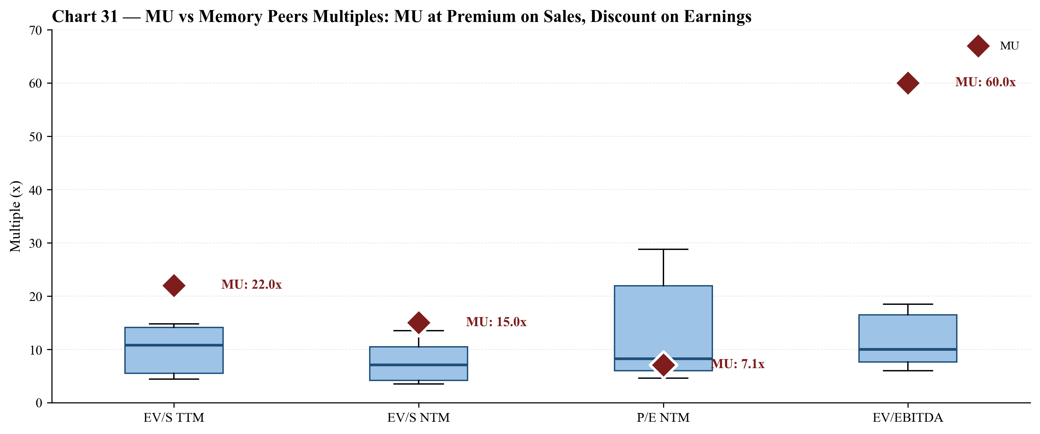
Chart 31 — MU vs memory peers boxplot. MU at premium on EV/S (22× vs peer median 11×) and EV/EBITDA (60× vs peer median 10×), but at discount on P/E NTM (7× vs peer median 8×).
Historical Multiples Context
MU's current TTM P/S of 14.1× is the highest in the company's listed history — well above the 2018-2023 median of 2.4×-4.6×. Forward P/E of 7.1× is the lowest in MU history (peer median historically 9-13×) — but this reflects the market pricing in peak FY26-27 earnings that may not be sustained.
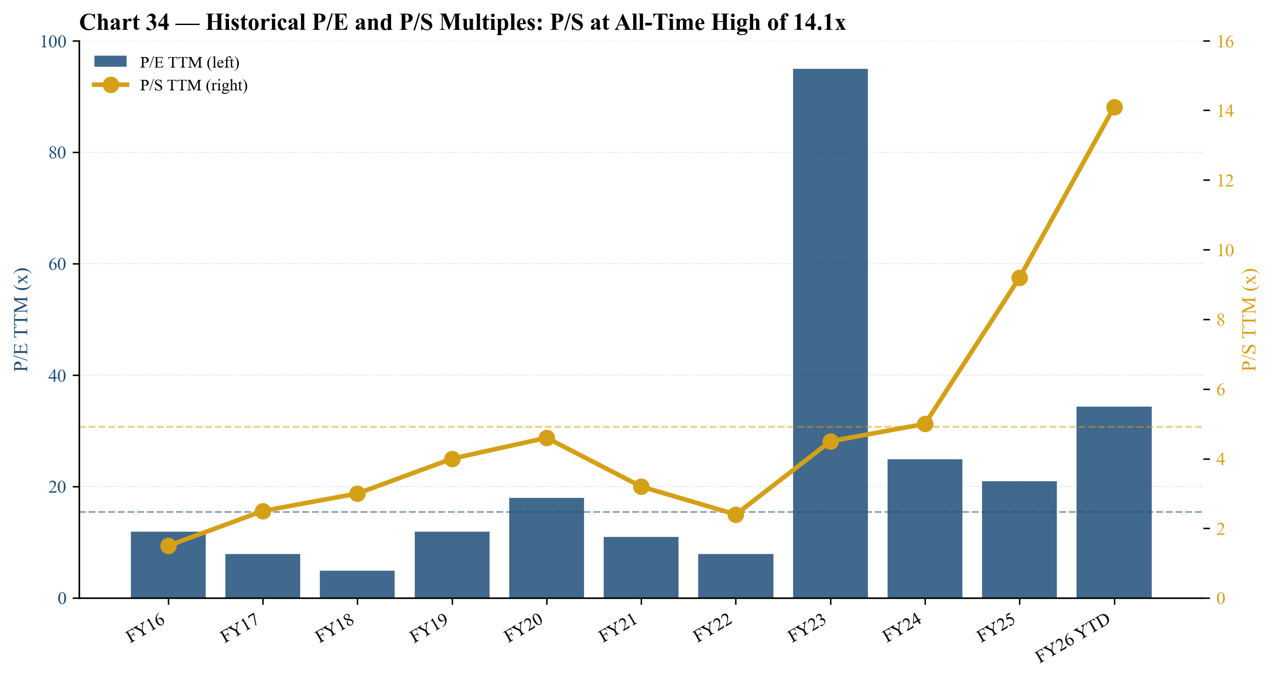
Chart 32 — Historical P/E and P/S multiples. P/S at all-time high of 14.1× implies multiple-compression risk; forward P/E is at all-time low.
Valuation Football Field
Our valuation football field summarizes the eight methodologies. Memory peer multiples (P/E, EV/Sales, EV/EBITDA) consistently produce implied prices in the $230-470 range — significantly below the current $727. The DCF range ($600-1,050) and bull case ($850-1,250) provide the upside support. The probability-weighted target is $697.
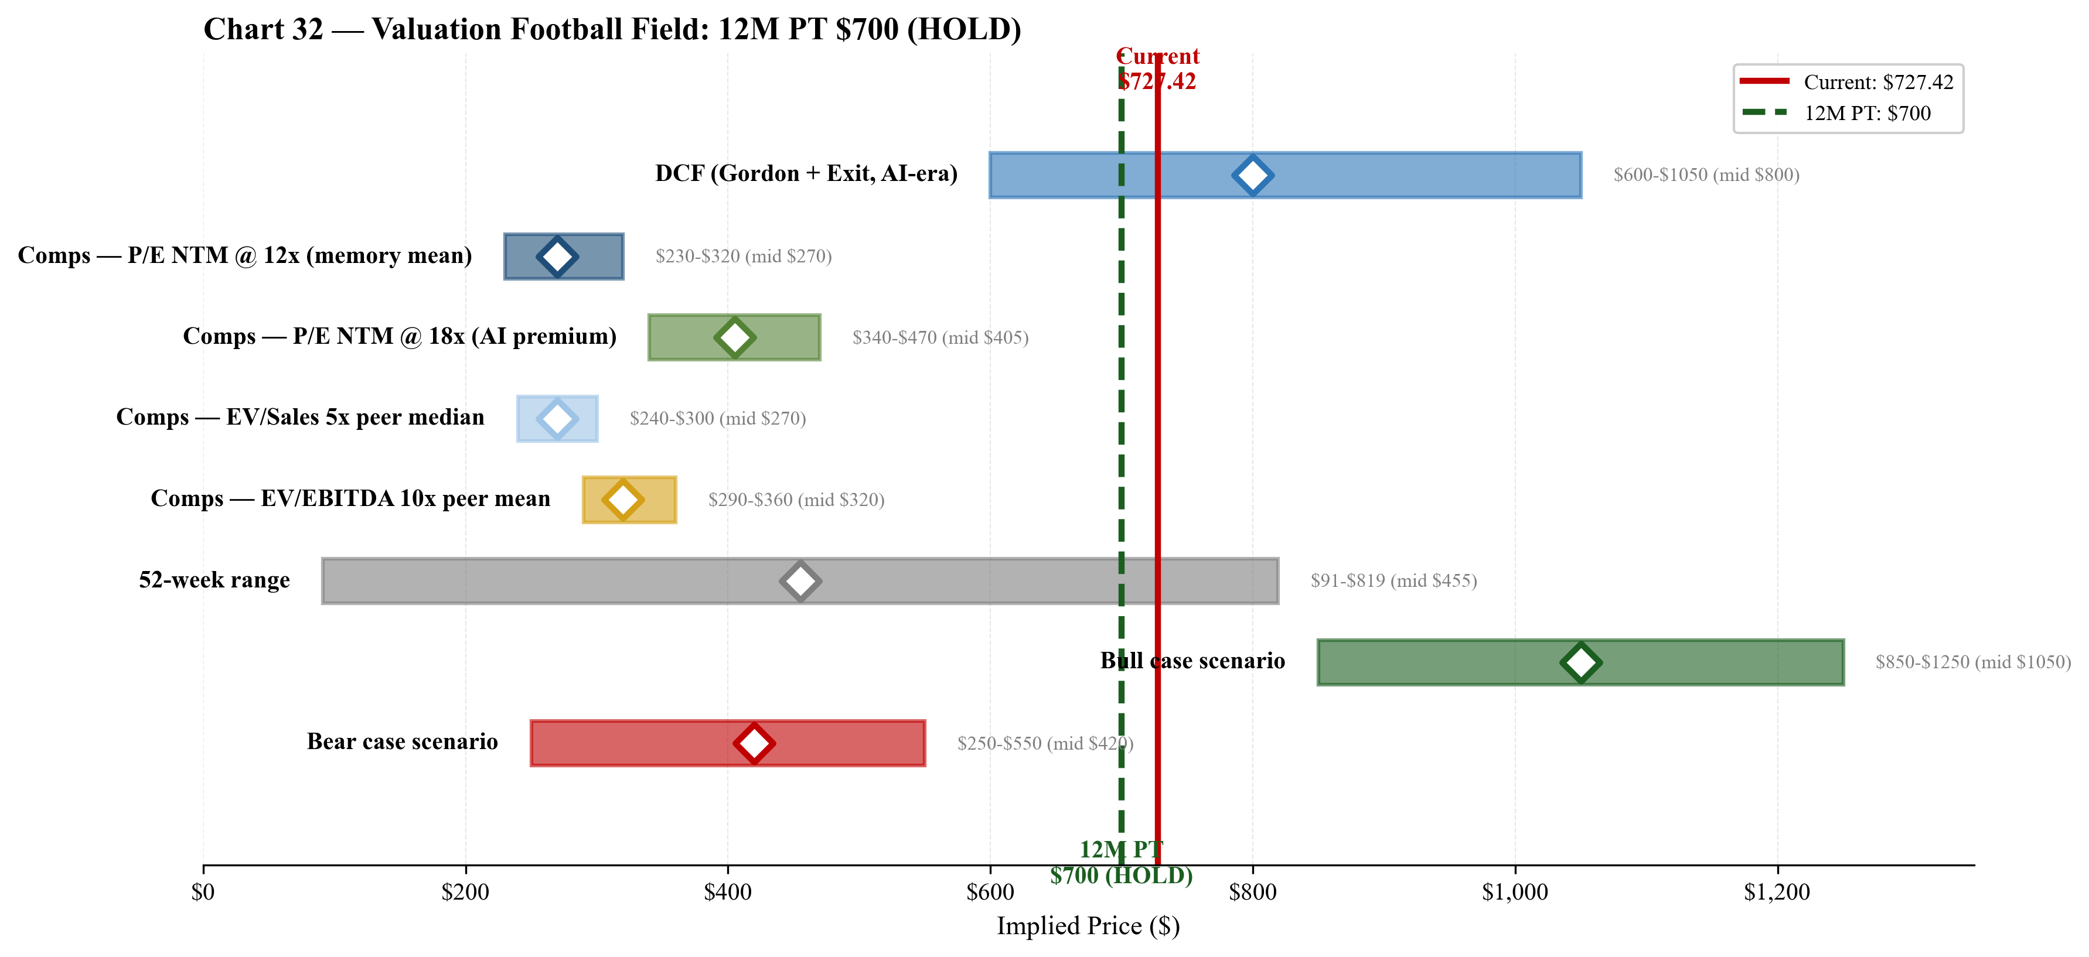
Chart 33 — Valuation football field: 12M PT $700 (HOLD). Weighted across DCF (30%), comps (30%), bull case (30%), bear case (10%). ⭐ MANDATORY CHART
Price Target Methodology
Methodology | Weight % | Mid Range | Weighted Contribution ($)
DCF (Gordon + Exit Mult) | 30% | $800 | $240
Comps — P/E NTM @ 12× | 7.5% | $270 | $20
Comps — P/E NTM @ 18× | 12.5% | $405 | $51
Comps — EV/Sales 5× | 5% | $270 | $14
Comps — EV/EBITDA 10× | 5% | $320 | $16
Bull case (AI cycle extends) | 30% | $1,050 | $315
Bear case (cycle reversion) | 10% | $420 | $42
WEIGHTED 12M PRICE TARGET | 100% | — | $697

Return Component | Value
Current price (2026-05-20) | $727.42
12M price target | $700.00
Capital appreciation | −3.8%
Dividend yield (TTM) | +0.06%
Buyback yield (FY26E annualized) | +0.36%
Total expected return | −3.4%

Risk Assessment
Company-Specific Risks
HBM Qualification & Customer Concentration
Severity: High
Micron disclosed that one customer (almost certainly Nvidia) represented 17% of FY2025 revenue. The top 10 customers represent ~50% of revenue. The risk is severe in scenarios where (i) Nvidia's GPU shipment outlook is cut, (ii) Nvidia internally develops/buys an alternative HBM source, or (iii) Samsung's HBM4 qualification reduces Micron's allocation. Mitigants: HBM is one of the most difficult products in semiconductors to qualify; HBM is sold via multi-quarter LTAs, giving roughly 12-month visibility.
Execution Risk on Multi-Fab Capex Program
Severity: High
Micron is simultaneously executing the Idaho fab (and a second Idaho fab), two Clay NY fabs, the Manassas VA modernization, a new Hiroshima Japan fab, and the Sanand India backend. Aggregate committed spend over the next 5-7 years exceeds $100B (combined with the $6.1B CHIPS direct funding and $7.9B of committed government funding). Any delay or cost overrun would meaningfully compress free cash flow. Mitigants: Manish Bhatia's deep operating background; staged ramp; CHIPS-related milestones tied to disbursements.
HBM Technology Obsolescence / Architecture Shift
Severity: Medium / long-tailed
A move from HBM-on-package to alternative architectures (CXL-attached memory pools, on-package compute, optical interconnects) over 5-10 years could erode HBM's growth. Micron is investing in CXL-relevant products but lags Samsung and SK Hynix in some adjacencies.
China Revenue Overhang from CAC May 2023 Decision
Severity: Medium
Mainland China + Hong Kong revenue was $3.78B (10.1% of FY2025 revenue); the CAC restriction on critical information infrastructure operators continues to bite. A further escalation in US-China semiconductor tension could reduce or eliminate this revenue. Mitigant: HBM and AI-DRAM demand from US and Taiwan customers more than offsets at the company level.
Key-Person Dependency on Sanjay Mehrotra
Severity: Medium
The CEO is 67, has the longest tenure of any current senior memory-industry executive, and his SanDisk and Micron tenures have shaped the company's HBM bet. A succession plan exists (Sumit Sadana, Manish Bhatia, and Mark Murphy are all credible successors), but a sudden departure could affect customer perception.
Geographic Concentration of Leading-Edge Production in Taiwan
Severity: High but low probability over 1-3 year horizon
Taiwan PP&E is $18.97B (the largest single country footprint). A cross-strait disruption would idle a meaningful portion of Micron's DRAM capacity. Mitigant: the Idaho greenfield is partly motivated by this diversification.
Industry / Market Risks
Memory Cycle Reversal
Severity: High
The current up-cycle is extending into FY2026 with company gross margins guided to 68% — well above prior peaks. History shows the memory cycle reliably reverts. A 2026 H2 or 2027 H1 downturn (driven by commodity DRAM oversupply from CXMT, or by an AI capex pause) would compress ASPs sharply. Memory ASPs can fall 30-50% peak-to-trough; FY2023 saw revenue −49% from FY2022.
Competitive Intensity from SK Hynix and Samsung
Severity: Medium-High
Samsung's recent HBM4 qualification roadmap with TSMC (using TSMC N5 base die) is a credible threat in late-2026/2027 if Samsung's HBM yields recover.
Regulatory / Export-Control Changes
Severity: Medium
Possible escalation in US export controls (or Chinese retaliatory measures) could affect Micron's customer mix. CHIPS Act funding subject to compliance conditions.
AI Capex Deceleration
Severity: Medium
A meaningful slowdown in hyperscaler AI capex (driven by lower-than-expected enterprise ROI, or by efficiency gains in model architectures reducing memory intensity) could compress HBM bit demand in 2027-2028.
Financial Risks
Valuation / Multiple-Compression Risk
Severity: Medium-High
TTM P/E of 34.4× and TTM P/S of 14.1× are both at the high end of MU's historical range. The forward P/E of 7.1× assumes FY2026 EPS in the $35-45 range — a level that has never been sustained in Micron's history. If FY2027 EPS reverts toward $15-20 (a non-trivial scenario in a normal-cycle year), even a peer-median 12-14× multiple on $17 EPS implies a $200-240 stock — i.e. ~65-70% downside from current levels in a hard-landing scenario.
Capital-Allocation Risk on $100B+ Greenfield Capex
Severity: Medium
Micron has committed to a multi-decade capex program at the top of the cycle. If end-demand softens before the new fabs are absorbed, depreciation step-up and underutilization could compress gross margins by 500-1,000 bps.
Debt Level and Refinancing
Severity: Low-Medium
Long-term debt of $14.0B against equity of $51.5B is moderate, and Micron's investment-grade credit rating allows access to capital markets. However, the maturity schedule includes notes through 2051 — the long-tail rates are locked in.
Macroeconomic Risks
Cyclicality / Economic Sensitivity
Severity: High
Memory revenue is among the most economically sensitive in semiconductors. A US recession or a global enterprise IT capex pause would directly compress mobile, client and AEBU demand.
FX Exposure
Severity: Low-Medium
Material operating exposure to Taiwan dollar, Japanese yen, Singapore dollar, Indian rupee, and Korean won; financial exposure to long-dated yen-denominated tax positions (~$3.4B Japanese yen tax-related).
Tariffs and Trade Policy
Severity: Low-Medium
Explicitly called out in the 10-K forward-looking statements section. Memory products historically have been less tariff-exposed than finished electronics, but tariff escalation between the US and major trading partners could affect end-demand.

Appendix A: Detailed Financial Model
Appendix A.1 — Income Statement (Full)
All figures in $ millions, except per-share data. FY ends Thursday closest to Aug 31.
Line Item | FY23A | FY24A | FY25A | FY26E | FY27E | FY30E
Revenue | 15,540 | 25,111 | 37,378 | 54,710 | 62,625 | 70,880
Cost of goods sold | 16,956 | 19,500 | 22,427 | 21,330 | 23,800 | 30,100
Gross profit | (1,416) | 5,611 | 14,951 | 33,380 | 38,825 | 40,780
Gross margin % | −9.1% | 22.4% | 40.0% | 61.0% | 62.0% | 57.5%
R&D | 2,904 | 3,429 | 4,099 | 5,050 | 5,500 | 6,500
SG&A | 920 | 1,158 | 1,247 | 1,550 | 1,700 | 1,950
Restructuring & other | 1,131 | (35) | (158) | 0 | 0 | 0
Operating income (loss) | (5,745) | 1,024 | 9,774 | 26,781 | 31,325 | 30,930
Operating margin % | −37.0% | +4.1% | +26.1% | +49.0% | +50.0% | +43.6%
Interest expense, net | (226) | (170) | 37 | (150) | (120) | 0
Other non-op, net | (192) | 197 | 70 | 50 | 50 | 50
Pre-tax income | (5,716) | 1,251 | 9,622 | 28,410 | 32,440 | 34,460
Tax provision (benefit) | (113) | 421 | 1,083 | 2,950 | 3,550 | 4,250
Effective tax rate | +2.0% | 33.7% | 11.3% | 10.4% | 10.9% | 12.3%
Net income (loss) | (5,829) | 778 | 8,539 | 25,460 | 28,890 | 30,000
Diluted EPS ($) | (5.34) | 0.70 | 7.55 | 22.50 | 25.50 | 27.00
Appendix A.2 — Cash Flow Statement (Full)
Line Item | FY23A | FY24A | FY25A | FY26E | FY27E | FY30E
Net income | (5,829) | 778 | 8,539 | 25,460 | 28,890 | 30,000
D&A | 7,432 | 7,587 | 8,165 | 9,500 | 11,000 | 14,500
Stock-based comp | 392 | 480 | 600 | 720 | 800 | 950
Working capital changes | 850 | (750) | 1,000 | (7,500) | (11,840) | (13,050)
Other operating | (1,286) | 412 | (774) | (500) | 0 | 0
OPERATING CASH FLOW | 1,559 | 8,507 | 17,530 | 27,680 | 28,850 | 32,400
Capex (gross) | (7,676) | (8,386) | (15,864) | (17,500) | (16,000) | (15,500)
CHIPS proceeds | 0 | 130 | 2,025 | 1,800 | 1,500 | 500
Investments, net | 3,500 | 1,200 | (5,300) | (1,500) | (1,500) | (1,200)
INVESTING CASH FLOW | (4,176) | (7,056) | (19,139) | (17,200) | (16,000) | (16,200)
Debt issued/repaid | 2,200 | (900) | 300 | (500) | (500) | (1,200)
Dividends paid | (502) | (514) | (521) | (525) | (560) | (730)
Buybacks | (425) | 0 | 0 | (3,000) | (3,500) | (4,500)
FINANCING CASH FLOW | 1,158 | (2,524) | (301) | (4,125) | (4,660) | (7,030)
FCF (OCF − Capex) | (6,117) | 121 | 1,666 | 10,180 | 12,850 | 16,900
FCF post-CHIPS | (6,117) | 251 | 3,691 | 11,980 | 14,350 | 17,400
Appendix A.3 — Balance Sheet Summary
Line Item | FY23A | FY24A | FY25A | FY26E | FY27E | FY30E
Cash & ST investments | 9,172 | 8,121 | 12,011 | 22,900 | 32,100 | 64,500
Inventories | 4,684 | 6,254 | 8,100 | 9,100 | 10,600 | 12,300
Total current assets | 20,775 | 19,033 | 31,000 | 47,000 | 55,000 | 94,000
PP&E, net | 38,763 | 39,749 | 46,594 | 53,500 | 58,000 | 63,500
Total assets | 64,254 | 69,346 | 82,800 | 100,000 | 118,000 | 157,000
Total debt | 12,779 | 13,785 | 14,478 | 13,550 | 13,150 | 10,050
Total liabilities | 24,588 | 24,212 | 31,300 | 44,000 | 47,000 | 27,800
Stockholders' equity | 39,666 | 45,134 | 51,500 | 56,000 | 71,000 | 130,000
Net debt / (cash) | 3,607 | 5,664 | 2,467 | (9,350) | (18,950) | (54,450)

Appendix B: Supporting Charts
HBM Revenue Trajectory

Chart 34 — HBM revenue trajectory from $50M (FY23) to $26B (FY30E). The 5-year CAGR (FY26-FY30E) is ~5% as cycle moderation offsets HBM4E ramp.
EPS Cycle (Historical + Projected)
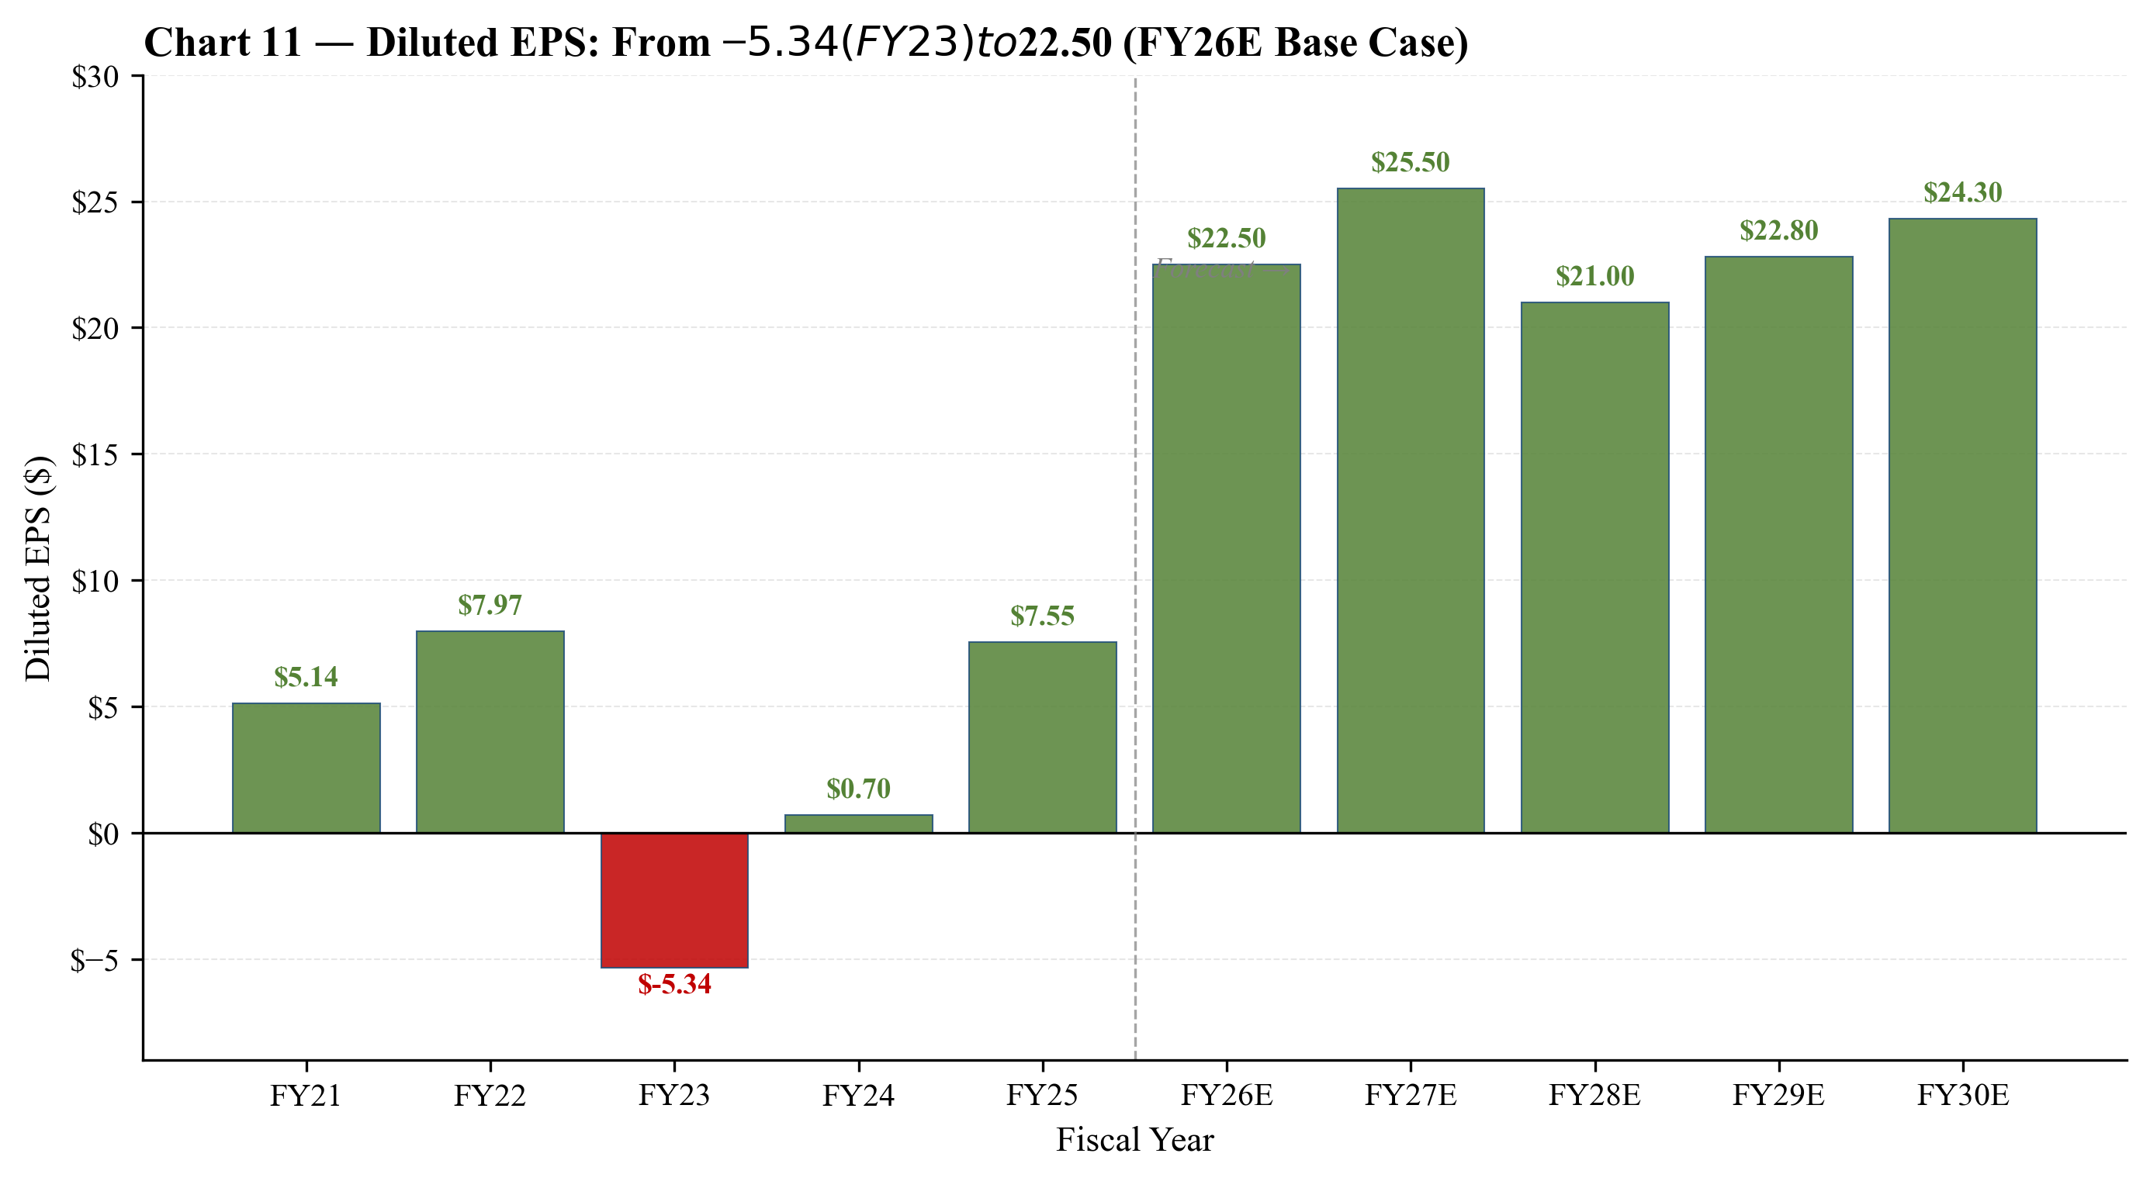
Chart 35 — Diluted EPS: −$5.34 (FY23 trough) to $25.50 (FY27E peak). Base case projections cycle-aware; bull case reaches $33; bear case troughs at $4.50.
D&A and PP&E Roll-Forward
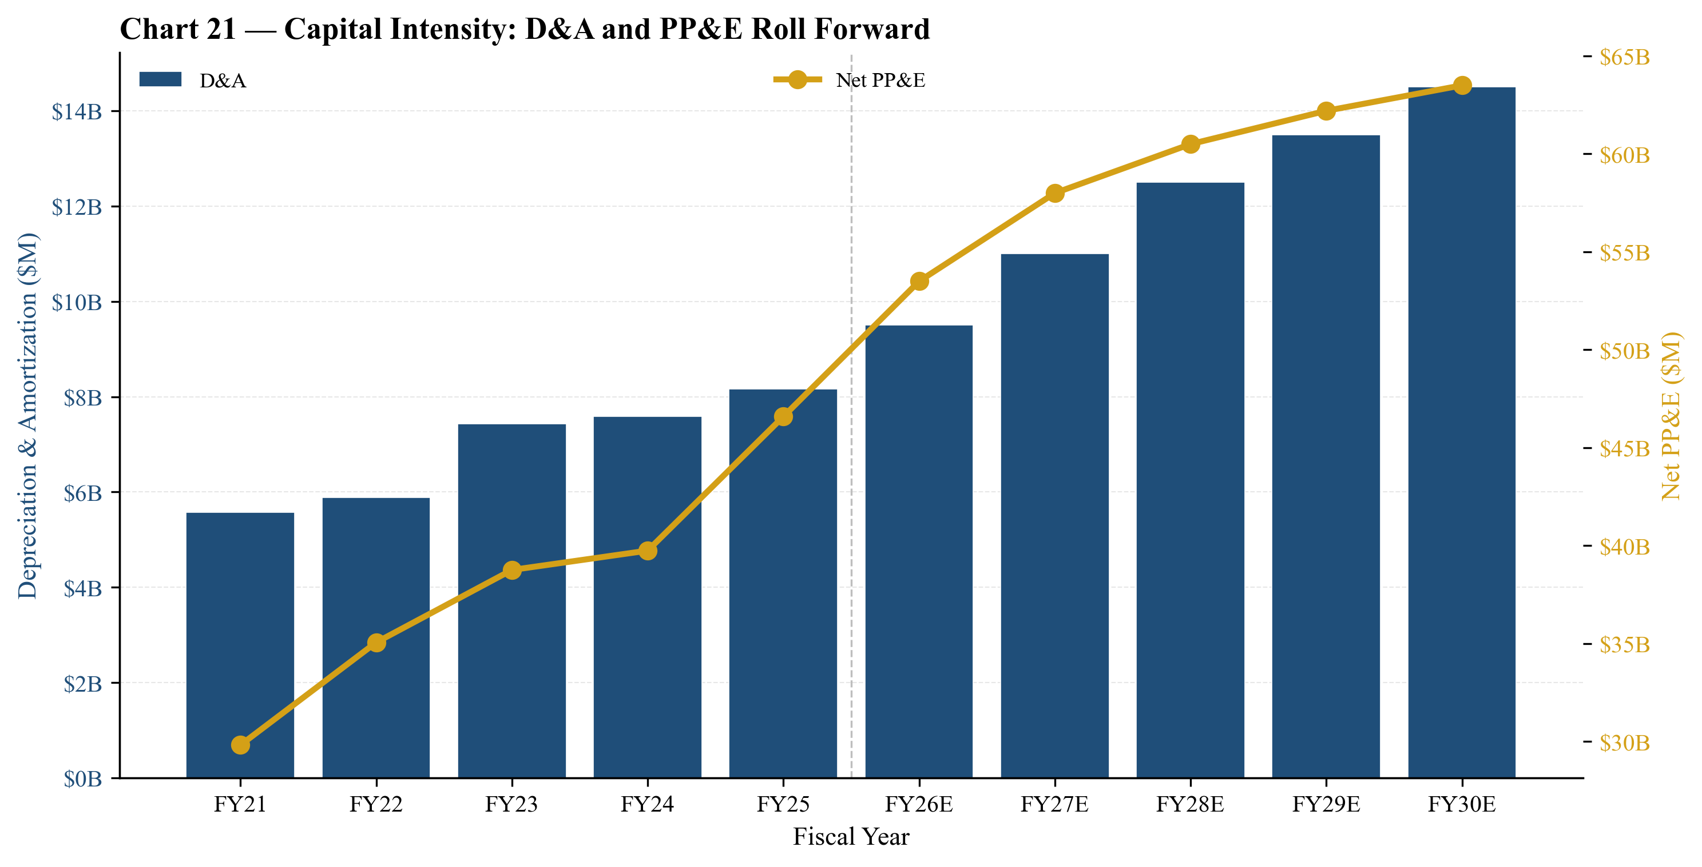
Chart 36 — D&A and net PP&E. Greenfield capex through FY27-FY29 lifts PP&E to $63B by FY30E; D&A scales to $14.5B (vs. $8.2B FY25A).
Working Capital Days
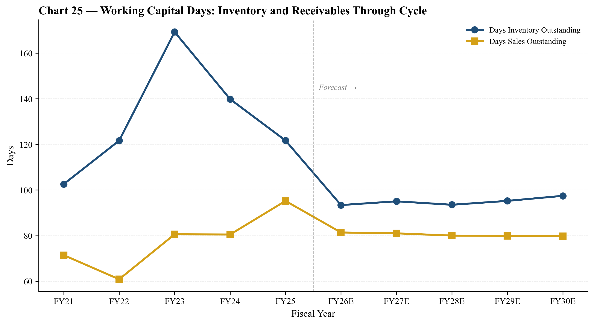
Chart 37 — Days inventory outstanding (DIO) and days sales outstanding (DSO) through cycle. DIO peaks in FY23 trough; DSO stable as customer mix concentrates on hyperscale/AI.
Memory Cycle Visualization

Chart 38 — Memory industry cycle, 2010-2030E. ~4-year peak-to-peak rhythm. Current AI super-cycle may extend the up-leg; whether this is structural or cyclical is the central debate.
Appendix C: Detailed Catalyst Calendar
Earnings & Guidance Events
Micron's quarterly earnings reports are the dominant near-term catalysts. The FY2026 fiscal year spans late-August 2025 to late-August 2026, with quarterly prints in September (FQ4-FY25 close), December (FQ1-FY26 close, guidance for FQ2-FY26), March (FQ2-FY26 results), June (FQ3-FY26 results), and September 2026 (FQ4-FY26 / FY26 close).
The FQ2-FY2026 print in March 2026 is the highest-stakes near-term event. Guidance disclosed on December 17, 2025 is for revenue of $18.7B ± $0.40B, non-GAAP gross margin of 68.0% ± 1.0%, and non-GAAP diluted EPS of $8.42 ± $0.20. Any meaningful beat or miss vs. these numbers would drive significant stock movement. Importantly, FQ3-FY2026 guidance (issued at the March print) will be the first quarter without a record-setting guide — this is the moment where the market begins to test whether the momentum extends or peaks. Our base case anticipates a continued strong guide (FQ3 revenue ~$19-20B); the bear case anticipates the first deceleration.
Product / Operational Milestones
HBM4 volume ramp in calendar 2026 is the operational catalyst with highest potential market impact. Specific customer qualifications to watch: (a) Nvidia Rubin platform — public commentary suggests qualification by Q2-CY2026; (b) AMD MI400-series — likely qualification mid-2026; (c) cloud ASIC customers (Google TPU, Meta MTIA) — typically lower-volume but higher-margin opportunities. The first volume HBM4 shipment quarter (likely FQ4-FY2026 or FQ1-FY2027) will be a major data point.
CHIPS Act milestone disbursements provide quarterly affirmation of US fab construction progress. The Idaho fab is targeted for first wafer-out in 2027; any meaningful delays would impact the long-term capacity expansion thesis. Key milestones include foundation completion (visible via satellite imagery and local press coverage), tool installation, and equipment commissioning.
The $10B buyback authorization execution pace is a soft signal of management's view on the stock. If Micron repurchases >$3B/quarter (vs. the implied baseline of $750M/quarter for a 5-year program), it signals management views the stock as attractive at current levels. Conversely, a slower-than-expected pace would signal caution.
Industry & Macro Catalysts
Q4-CY2026 DRAM contract pricing negotiations (typically negotiated in October-November) are the single most important leading indicator of FY27 ASPs. Mobile DRAM (LPDDR5/5X) and server DDR5 contracts are the most-watched lines. Spot-market price commentary from TrendForce and DRAMeXchange provides intra-quarter visibility into demand-supply tension. Any sustained spot-market decline of >10% would be a meaningful warning signal.
Hyperscaler AI capex commentary is the broader demand-side indicator. The four major hyperscalers (MSFT, GOOG, AMZN, META) collectively account for >60% of HBM demand through their Nvidia / internal-silicon purchases. Their quarterly capex guides — typically issued in late-January and late-July — are the canonical demand signals. Any negative revision to FY27 capex from these names would compress MU's bull case.
Samsung HBM4 qualification updates are the share-loss risk indicator. Samsung's recent HBM3E qualification was delayed; if HBM4 ramps cleanly at Samsung, the market would re-price Micron's HBM share. Conversely, continued Samsung difficulties open Micron's HBM4 share opportunity. The key data point is whether Samsung's HBM4 wins B300 / Rubin qualifications by mid-CY2026.
Geopolitical & Regulatory Catalysts
US-China export controls evolution is a chronic risk factor. The October 2022 BIS rules, October 2023 amendments, and December 2024 'Foreign Direct Product Rule' expansion have all affected the semiconductor industry; further amendments could affect Micron's Wuxi backend operations or customer-side restrictions. The CAC China decision (May 2023) restricting critical-information-infrastructure operators from purchasing Micron products has been the most direct adverse impact on revenue; any de-escalation (which would be a positive surprise) would benefit Micron's Chinese revenue base.
Tariffs are explicitly called out in Micron's 10-K Item 1A as a forward-looking risk factor. The memory industry has historically been less directly tariff-exposed than finished electronics, but escalating tariff regimes (US-China, US-EU, US-Japan) could affect end-demand. The current administration's approach to semiconductor tariffs is in flux; ongoing CHIPS Act implementation is a partial counter.
Sensitivity to Key Macro Variables
Variable | Sensitivity | Direction
10Y UST yield ± 100bps | PT ± $80-100 | Inverse (higher rate = lower PT)
MU beta ± 0.2 | PT ± $50-70 | Inverse
Memory cycle peak timing | $200-400 | Earlier peak = lower PT
HBM share ± 5pp | $100-200 | Direct (higher share = higher PT)
NAND ASP ± 20% | $30-60 | Direct
Capex ± 10% | $20-40 | Inverse (higher capex = lower FCF)
China revenue +50% | $30-50 | Direct (CAC reversal)
Samsung HBM4 success | $80-150 | Inverse (share-loss risk)

These sensitivities reinforce our HOLD rating: the combination of high macro and competitive sensitivity around a stock already trading at peak-cycle multiples produces a relatively narrow expected return range and a moderate negative skew over a 12-month horizon. The asymmetry favors waiting for a more attractive entry point.

Disclosures and Important Disclaimers
Equity Research — Initiating Coverage. This report is for informational purposes only and does not constitute investment advice, an offer to buy or sell, or a recommendation to invest in any security. Past performance is not indicative of future results.
Rating Definitions
Rating | Expected 12M Return | Description
Buy | >+20% | High-conviction outperform
Overweight | +10% to +20% | Outperform peer index
HOLD (this report) | −5% to +10% | Market-perform — applies to MU at $727
Underweight | −10% to −5% | Underperform peer index
Sell | <−10% | High-conviction underperform
Sources
- Micron 2025 Form 10-K (FY2025, filed September 30, 2025)
- Micron Q1-FY2026 Earnings Release (8-K, December 17, 2025)
- Yahoo Finance — Micron (MU) key statistics, retrieved 2026-05-20
- Yahoo Finance — Memory peer set (Samsung 005930.KS, SK Hynix 000660.KS, Sandisk SNDK, Western Digital WDC, Seagate STX), retrieved 2026-05-20
- Semiconductor Industry Association — Global Semiconductor Sales (industry reference)
- Yole Group / Gartner / TrendForce — Memory industry forecasts (consensus references)
- Damodaran 2026 implied equity risk premium

Analyst certification: The analyst certifies that the views expressed in this research report accurately reflect the analyst's personal views about the subject companies and their securities. The analyst has not received and will not receive direct or indirect compensation in exchange for expressing specific recommendations or views in this report.
© 2026. All rights reserved. This document is the work product of an automated equity research system and is provided for informational purposes only.

