INITIATING COVERAGE
Advanced Micro Devices, Inc.
NASDAQ: AMD | Semiconductors — Logic, AI Accelerators
Date: 2026-05-20 | Closing price: $444.28 | Market cap: $724B
RATING  OVERWEIGHT | PRICE TARGET (12M)  $480 | UPSIDE  +8.0% | CONVICTION  MEDIUM-HIGH

Investment Summary
We initiate coverage of Advanced Micro Devices ('AMD') with an OVERWEIGHT rating and a 12-month price target of $480 per share, implying ~8% upside from the $444.28 close on 2026-05-20. AMD is, for the first time in its history, the credible second leader in merchant data-center AI silicon, behind only NVIDIA. The 2025 OpenAI 6 GW agreement is the single most consequential demand commitment in AMD's history and de-risks the FY2027–FY2029 revenue trajectory in a way no prior engagement has. Q1-FY2026 revenue of $10.3B (+38% YoY) and a Q2-FY2026 guide of ~$11.2B (+46% YoY) confirm that the Instinct GPU ramp is accelerating and the EPYC server-CPU franchise continues to take share from Intel.
We rate the stock Overweight rather than Buy because the absolute-valuation framework (DCF) returns an implied price below current at our base-case 10% WACC and 3% terminal growth. The blended $480 price target is supported by forward P/E (50–70× FY2027E EPS of $7.40), EV/Revenue (14–22× FY2027E revenue of $58.4B), and peer-comp methodologies, all of which place AMD between Broadcom and NVIDIA in the AI-cycle multiple complex. The DCF is sensitive — at an 8.5% WACC and 4% terminal growth (defensible if one believes the AI cycle is a multi-decade S-curve), the implied price exceeds the current market. The valuation is, in short, justifiable on the forward narrative but leaves no margin for execution disappointment.
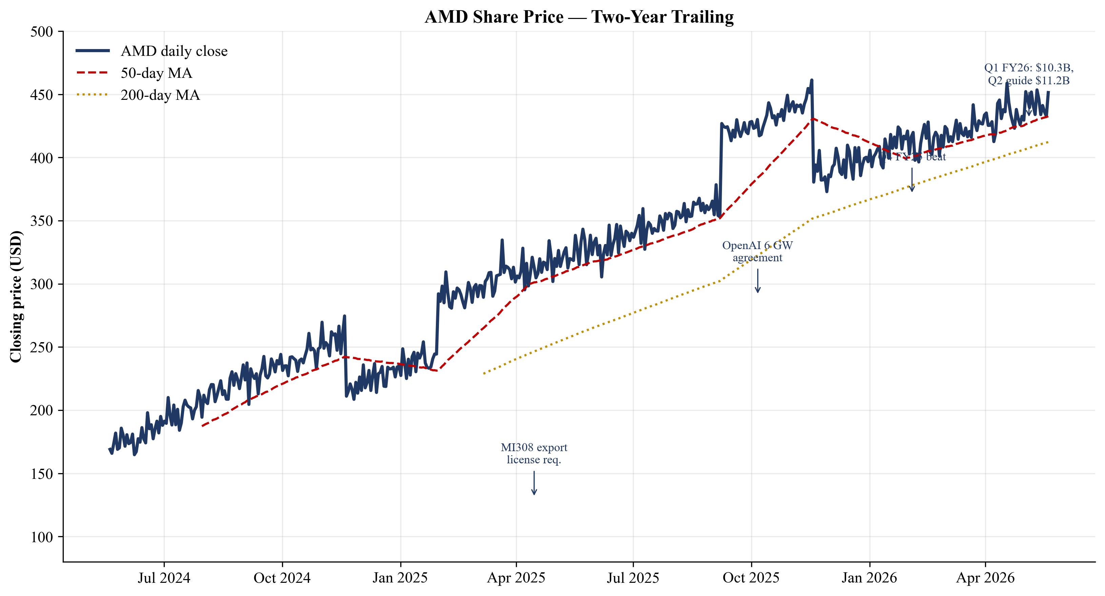
Figure 1. AMD share price, two-year trailing, with major event annotations.
Three pillars support our Overweight thesis: (i) the OpenAI 6 GW deployment is on track for first 1 GW go-live in 2H-FY2026, with management characterizing the contract as 'tens of billions of dollars' of AMD revenue across its life; (ii) the EPYC 5th-Generation ('Turin') server-CPU franchise continues to take share, with our model assuming 40% server-CPU unit share by FY2030; and (iii) the Embedded segment — Xilinx FPGAs plus embedded EPYC/Ryzen — has begun its cyclical recovery from the 2024 trough and contributes ~$3.8B–$6B of high-margin revenue through FY2030.

1. Investment Thesis
1.1 Why AMD Now: The AI-Cycle Re-Rating Is Real but Priced In
AMD's transformation since Dr. Lisa Su became CEO in October 2014 has been the single most consequential CEO performance in semiconductors in the last decade. Market capitalization has expanded approximately 280× over the period, from ~$2.5B to $724B as of 2026-05-20. The proximate driver of the last 24 months of that expansion has been the AI accelerator narrative — AMD's Instinct GPU franchise grew from an immaterial revenue line in FY2022 to 'more than $5B' in FY2024 (per CEO commentary) to an estimated $6.1B in FY2025 and to a base-case $9.5B in FY2026. The October 2025 OpenAI agreement adds a stepwise multi-gigawatt deployment commitment on top of that ramp.
The transformation has not been linear. FY2023 was a difficult year — net income of just $854M on $22.7B of revenue (a 3.8% net margin), reflecting the post-pandemic PC correction, a 33% YoY decline in the Embedded segment, and ongoing Xilinx purchase-accounting amortization absorption. FY2024 brought the first signs of AI-cycle leverage as Instinct shipments accelerated. FY2025 was the inflection — net income of $4.3B on $34.6B of revenue, with full-year revenue growth of 34% and the second-half momentum carrying into the FY2026 Q1 print at $10.3B (+38% YoY) and the Q2 guide at $11.2B (+46% YoY). The combination of secular AI demand, EPYC server CPU share gains, and the Embedded segment's cyclical recovery has produced an unusually broad-based growth profile for a semi company at this scale.
The challenge for incoming long investors at $444 is that the market has substantially priced this thesis. Trailing P/E of 149× is distorted by FY2025 non-recurring charges (the MI308 China export license write-down) and acquisition-related amortization, but adjusted non-GAAP TTM P/E of ~57× is still in the top decile of the global semiconductor universe. Forward P/E of 34× is reasonable given AMD's growth profile — but it is reasonable only conditional on the AI cycle continuing to drive multiple expansion broadly. Any sector-wide re-rating downward would compress AMD's multiple in lockstep. The Overweight rating reflects our view that the most likely outcome is constructive but bracketed — modest upside, with meaningful downside if execution slips.
1.2 Three Pillars of the Long Thesis
Pillar 1: OpenAI as the Anchor AI Customer
On 6 October 2025 AMD and OpenAI announced a multi-year strategic agreement for OpenAI to deploy 6 gigawatts of AMD Instinct GPUs, beginning with a first 1 GW tranche based on the MI450 series scheduled for 2H-FY2026. AMD issued OpenAI a warrant for up to 160 million shares at a $0.01 strike price, vesting in tranches against deployment milestones and AMD share-price targets. CFO Jean Hu publicly characterized the contract as 'tens of billions of dollars' of revenue to AMD.
Industry rule of thumb is roughly $30–50B of equipment per gigawatt of AI training capacity, of which the GPU-vendor share is typically 30–50%. At the midpoint, 6 GW implies $60–150B of cumulative AMD revenue across the contract life. The OpenAI partnership is not merely a large customer win — it converts AMD from a 'single-product narrative' into a multi-product, multi-generation platform anchor with public, milestoned commitments. We model OpenAI alone reaches 10%+ customer concentration for AMD by FY2028.
Pillar 2: EPYC Server CPU Continues to Take Share
Mercury Research's quarterly tracker shows AMD x86 server-CPU revenue share has risen from low single digits in 2017 to the mid-30s percent by 2024–2025. AMD's 5th-Generation EPYC family ('Turin', launched late 2024) continues to outperform Intel Xeon 6 on performance/watt and core-count benchmarks for the dollar-weighted bulk of hyperscaler buying. The Intel response — Granite Rapids (released 2024), Sierra Forest, and the September 2025 NVIDIA–Intel partnership — has not yet reversed the share trajectory.
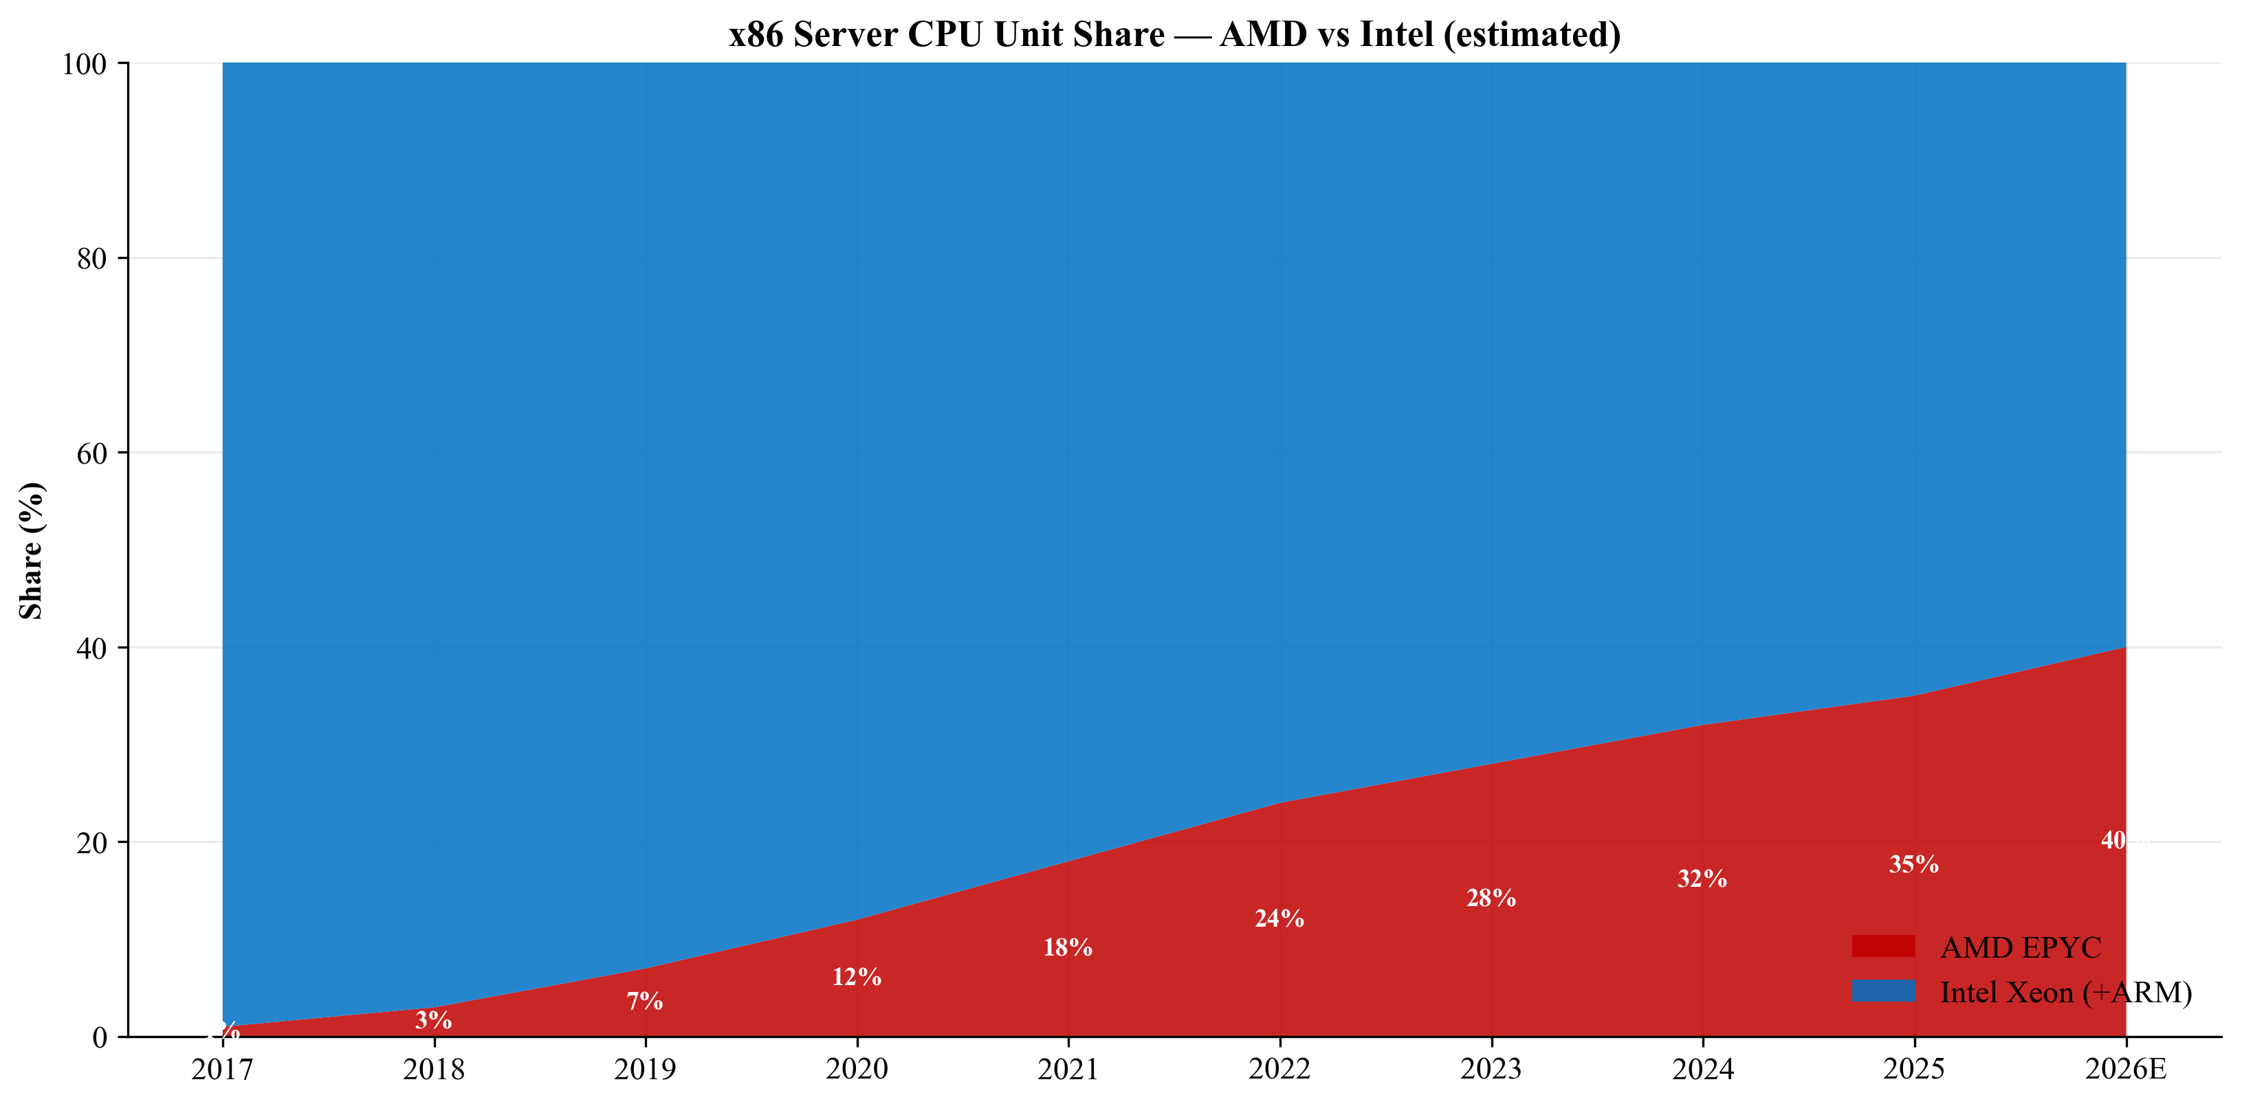
Figure 2. AMD vs Intel x86 server CPU unit share trajectory, 2017–2026E.
Our model assumes EPYC reaches 40% server-CPU unit share by FY2030, with EPYC revenue growing from $10.5B in FY2025 to $19.5B in FY2030. Two-thirds of that incremental dollars comes from hyperscaler internal fleets (Microsoft, Google, Meta, Amazon, Oracle) where AMD has already established multi-generation design wins. The downside case to EPYC is that the NVIDIA–Intel partnership matures into a Bundled Intel CPU + NVIDIA GPU integrated platform that AMD must respond to with its own integrated systems (Helios), which is a margin-impact risk if it forces AMD into rack-scale system selling rather than chip-level selling.
Pillar 3: Embedded Recovery + High-Margin Counterweight
The Xilinx asset (acquired February 2022 for $49B) contributes ~$3.5B of FY2025 Embedded segment revenue at materially higher gross margin and lower cyclicality than the merchant CPU/GPU business. The Embedded segment shrank 33% in FY2024 as customers normalized post-pandemic inventory, stabilized at -3% in FY2025, and is now in early recovery. End markets include 5G base-station replacement, defense electronics, industrial automation, and increasingly the AI inference at the network edge (Versal AI Engine). We model Embedded segment revenue growing from $3.5B in FY2025 to $6.0B in FY2030, with operating margin holding above 35%.
1.3 Key Risks to the Thesis (Top 5)
Risk | Description
ROCm Software Gap | AMD's ROCm software stack remains the most-cited reservation for buyers of Instinct GPUs vs. NVIDIA's CUDA. Even with ROCm 7 and the OpenAI co-engineering, a single major frontier-model release that runs disproportionately better on NVIDIA could compress AMD's competitive positioning in any given quarter.
Customer Concentration | AMD's 10-K explicitly states that a small number of customers will continue to account for a substantial portion of revenue. The OpenAI ramp adds rather than substitutes for existing concentration. A pull-in or push-out by OpenAI, Microsoft, Meta, Oracle, or one of the hyperscalers materially moves any quarter.
TSMC Single-Source Risk | All Instinct, EPYC, and high-end Ryzen volumes run on TSMC advanced nodes (CoWoS packaging). A Taiwan geopolitical incident, TSMC capacity reallocation, or CoWoS yield disruption directly degrades AMD's ability to ship.
OpenAI Warrant Dilution | Full vesting of the 160M-share warrant equals 9.8% dilution of the FY25 share base. Even partial vesting is materially dilutive. Conversely, if OpenAI fails to hit deployment milestones, the warrant remains unvested but the revenue does not materialize either.
Valuation / Multiple Compression | TTM P/E at 149× and forward P/E at 34× leave no margin for execution disappointment. A single quarter of MI355X/MI450 disappointment or hyperscaler order pull-in could trigger sharp multiple compression.

1.4 Catalyst Calendar
Catalyst | Timing | Watch For
Q2-FY2026 earnings | Early August 2026 | Print > $11.2B mid-point and Q3 guide > $12B
MI450 OpenAI Tranche-1 | 2H-FY2026 | First 1 GW deployment go-live
Q3/Q4-FY2026 server CPU share data | Late 2026 | Mercury Research confirming 40%+ unit share
ROCm 7/8 validation milestones | Throughout FY2026 | Frontier-model public benchmarks
OpenAI deployment expansion | Any time | Expansion to 8–10 GW would be transformational
MI308 China export resolution | 2H-FY2026 | Removal: $1–3B annual revenue back
Analyst day | December 2026 | Refreshed AI accelerator TAM

2. Company 101
2.1 Company Overview
Advanced Micro Devices, Inc. ('AMD'), founded in 1969 and headquartered in Santa Clara, California, designs and sells high-performance computing, graphics, and adaptive silicon. Today AMD is the #2 designer of x86 CPUs (behind Intel), the credible challenger to NVIDIA in AI training and inference accelerators, and — since the 2022 close of its Xilinx acquisition — the leading vendor of FPGAs and adaptive SoCs. The company employed approximately 31,000 people globally as of 27 December 2025 per the AMD 2025 10-K, with 67% of FY2025 revenue derived from international sales.
AMD designs chips and sells them predominantly through individual purchase orders, with no long-term volume commitments from most customers (per AMD 2025 10-K Risk Factors). Manufacturing is outsourced: AMD is a fabless company that relies on TSMC for advanced-node wafers and on third-party assembly/test partners in China, Malaysia and Taiwan. Revenue is split across three reportable segments after a Q1-FY2025 reorganization that combined Client and Gaming into a single segment.
Segment | FY2025 | FY2024 | YoY
Data Center | $16,635M | $12,579M | +32%
Client (sub-segment) | $10,640M | $7,054M | +51%
Gaming (sub-segment) | $3,910M | $2,595M | +51%
Client and Gaming combined | $14,550M | $9,649M | +51%
Embedded | $3,454M | $3,557M | -3%
TOTAL NET REVENUE | $34,639M | $25,785M | +34%
Source: AMD 2025 10-K MD&A segment table.
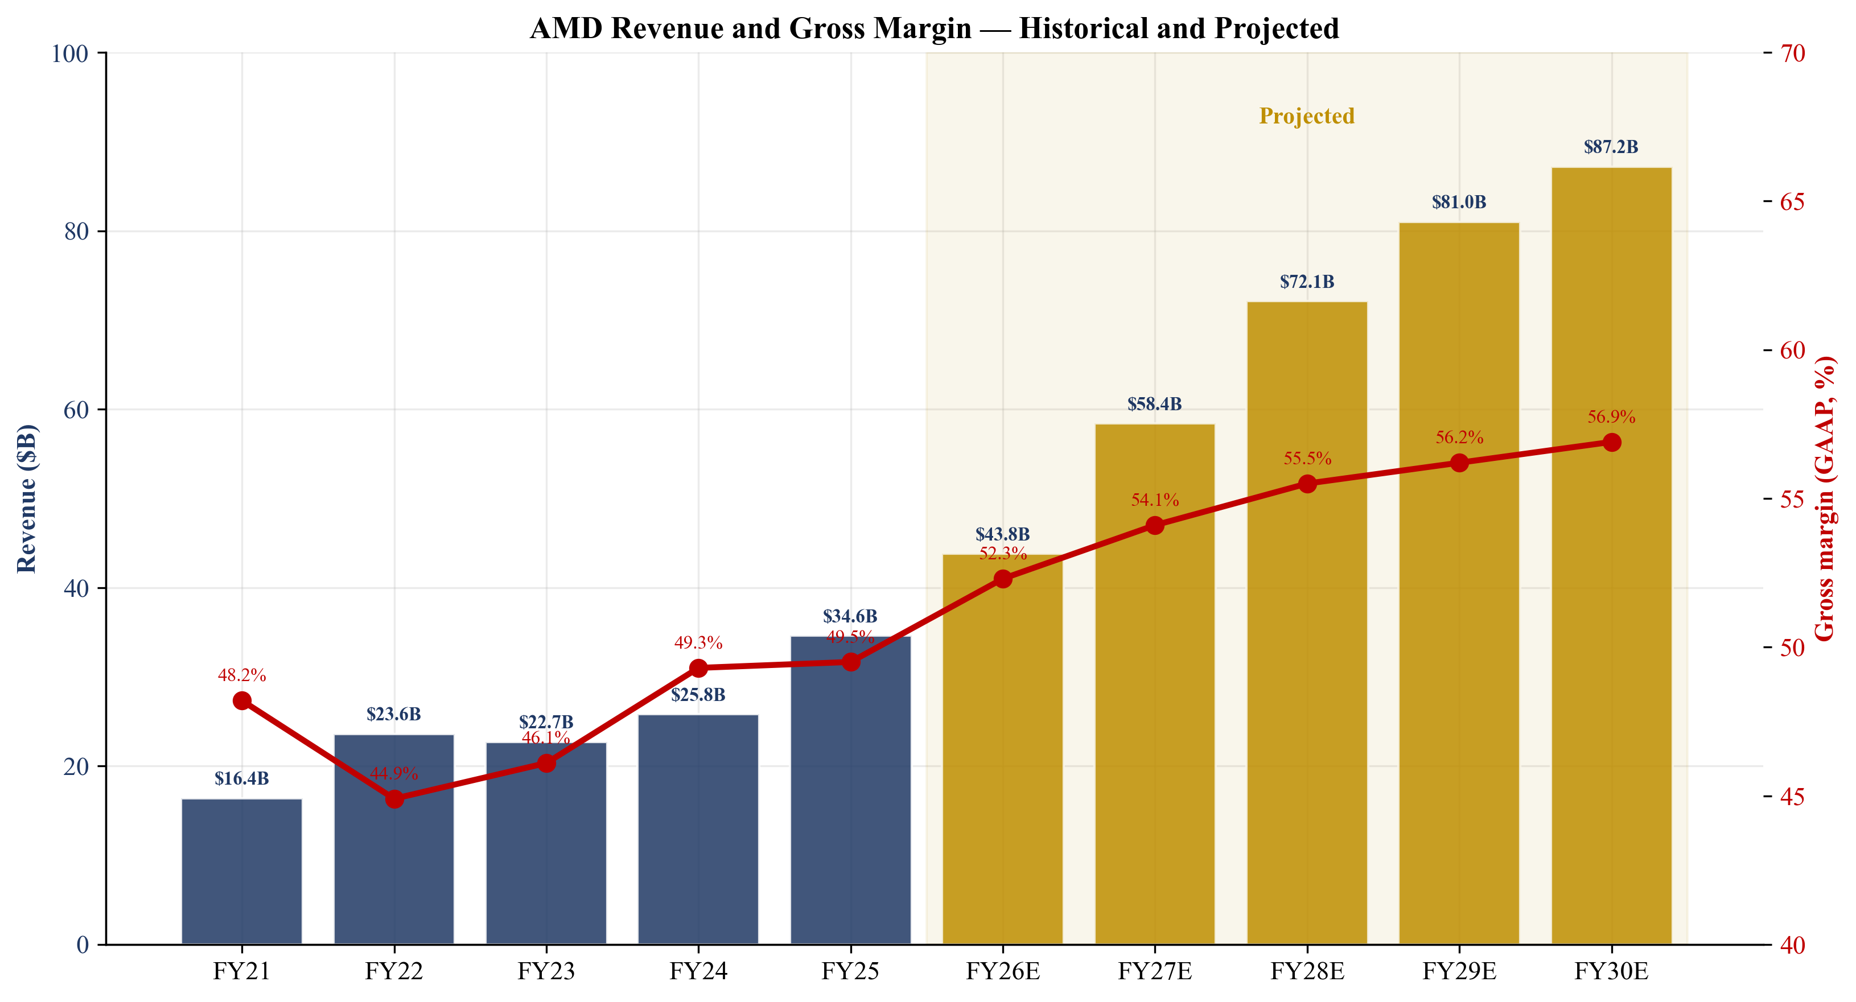
Figure 3. AMD revenue and gross margin trend, FY21–FY30E.
2.2 Company History
AMD was founded on 1 May 1969 by Jerry Sanders and seven colleagues, almost all of whom departed Fairchild Semiconductor at the same time. Through the 1970s and 1980s AMD became Intel's official second-source for the 8086 and 80286 families under a 1982 cross-licensing agreement, a relationship that ran into the late 1990s. The 1999 Athlon launch was the first x86 CPU to reach 1 GHz. The 2006 ATI acquisition added discrete GPUs. The 2009 GlobalFoundries spin-off marked the fabless transition. The 2014 appointment of Dr. Lisa Su as CEO was the inflection point.
Three strategic pivots define the modern AMD: (1) the Zen architecture reset (2017) that powered Ryzen and EPYC; (2) the 2022 Xilinx ($49B) and Pensando ($1.9B) acquisitions that broadened the data-center portfolio to FPGAs, DPUs and AI NICs; and (3) the 2024–2025 end-to-end AI systems pivot anchored by the ZT Systems acquisition (March 2025) and the OpenAI agreement (October 2025). The OpenAI deal is the inflection moment that elevates AMD from a 'second-source' AI accelerator to a platform vendor.
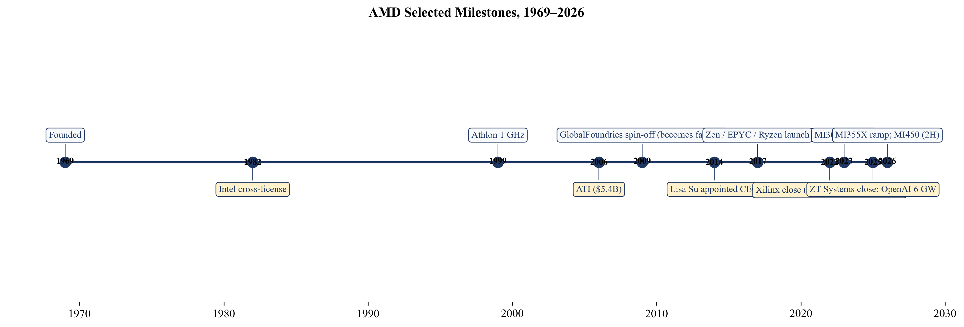
Figure 4. AMD selected milestones, 1969–2026.
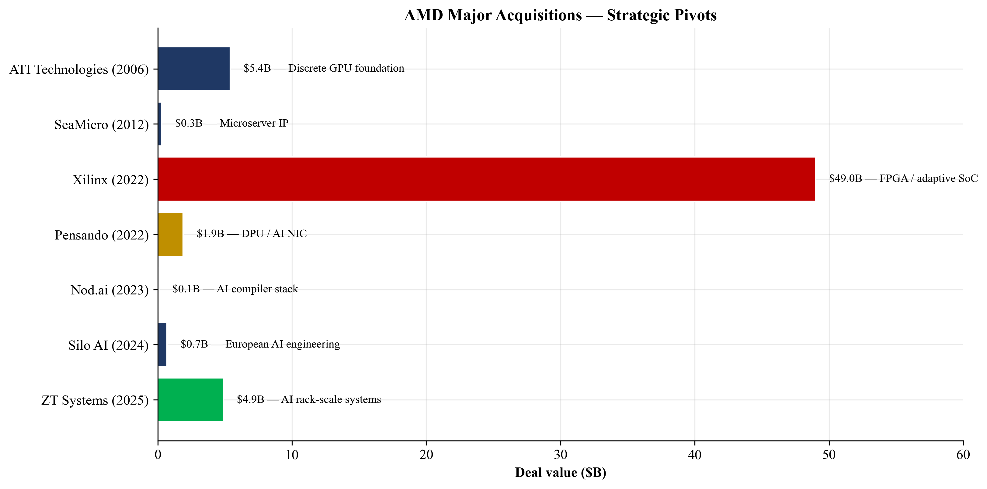
Figure 5. AMD major acquisitions and strategic rationale.
2.3 Management Team
Dr. Lisa T. Su — Chair, President & CEO. Age 56. Joined AMD in January 2012 as SVP/GM of Global Business Units, became COO, and was appointed President and CEO in October 2014. Chair of the Board since February 2022. Before AMD, Dr. Su was SVP/GM of Networking and Multimedia at Freescale Semiconductor, and earlier held senior R&D and business roles at IBM (including VP of Semiconductor R&D) and Texas Instruments. She holds B.S., M.S., and Ph.D. degrees in Electrical Engineering from MIT and is a Fellow of the IEEE, a member of the National Academy of Engineering, and a member of the American Academy of Arts and Sciences.
Dr. Su's tenure is one of the most consequential CEO performances in semiconductor history. When she took over in October 2014, AMD's market cap was approximately $2.5B and the company was reporting annual operating losses. As of 20 May 2026, AMD's market cap is approximately $724B — roughly a 280× expansion. She has received the Semiconductor Industry Association's Robert N. Noyce Award, the IEEE Robert N. Noyce Medal, the Global Semiconductor Alliance's Dr. Morris Chang Exemplary Leadership Award, and was named TIME Magazine CEO of the Year. She is squarely identified with AMD's strategy; her departure or incapacitation would be a single-person risk.
Jean Hu — EVP, CFO & Treasurer. Age 62. Joined AMD as CFO in January 2023. Prior CFO of Marvell Technology (Aug 2016 – Jan 2023), where she ran finance through the Cavium and Inphi acquisitions. Prior CFO of QLogic (April 2011 – August 2016), including two stints as Acting CEO. She holds a B.S. in chemical engineering from Beijing University of Chemical Technology and a Ph.D. in Economics from Claremont Graduate University, and sits on the board of Fortinet. Hu's tenure at AMD covers the GAAP rebound through the AI cycle and the absorption of Xilinx purchase-accounting; her public-company CFO experience at Marvell — also a fabless silicon vendor scaling through acquisitions — is directly relevant.
Forrest E. Norrod — EVP and GM, Data Center Solutions Business Unit. Age 60. Joined AMD in November 2014; has led the Data Center Solutions Business Group since January 2023. Before AMD he was VP/GM of Dell's server business (December 2009 – October 2014), where he drove market-share leadership across geographies and stood up Dell's hyperscale Data Center Solutions group. He holds B.S. and M.S. degrees in EE from Virginia Tech and holds 11 U.S. patents; serves on Intuit's board. Norrod is the operational owner of EPYC, Instinct, Pensando and the ZT Design / Helios rack platform. His Dell pedigree explains AMD's hyperscaler-first selling motion (Microsoft, Meta, Amazon, Google, Oracle).
Mark D. Papermaster — EVP and Chief Technology Officer. Age 64. Joined AMD in October 2011 and has been CTO/EVP Technology and Engineering since January 2019. Papermaster led the redesign of AMD's engineering processes and the development of the Zen x86 family and the Infinity Architecture modular-design approach. He is the operational architect of the chiplet strategy that gave AMD its cost and yield advantage over Intel from 2017 onward.
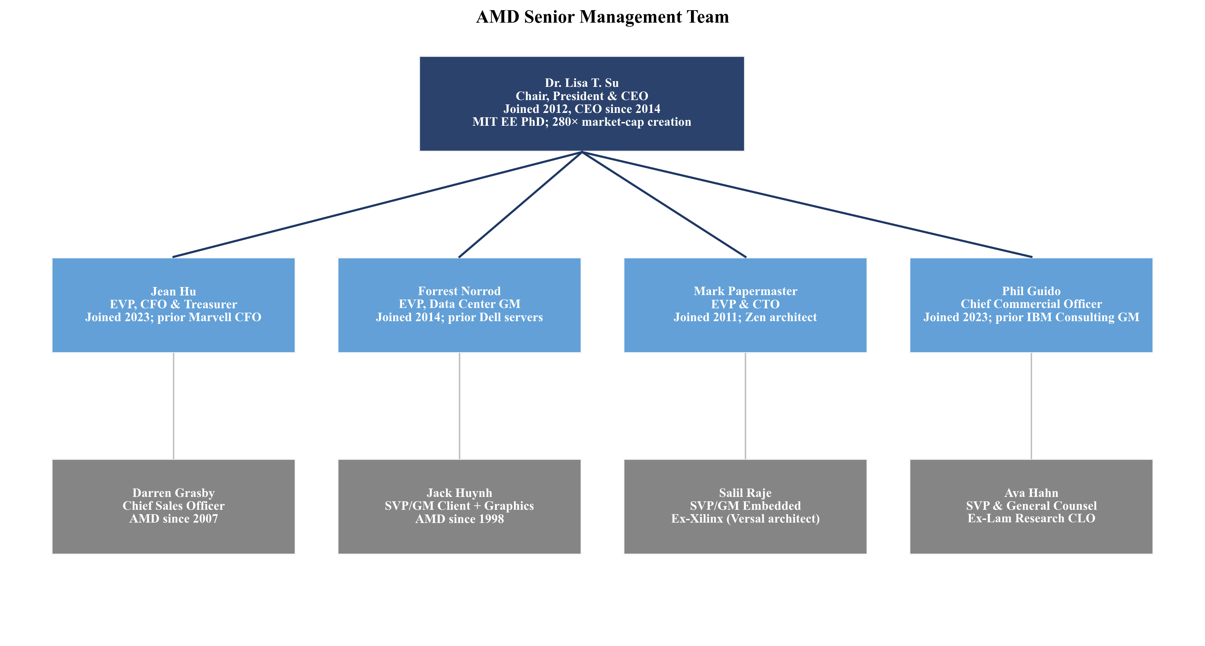
Figure 6. AMD senior management team structure.
2.4 Products & Services
AMD organizes its products inside three reportable segments (Data Center; Client and Gaming; Embedded) plus an 'All Other' bucket that absorbs corporate functions, acquisition-related intangible amortization, and stock-based compensation.
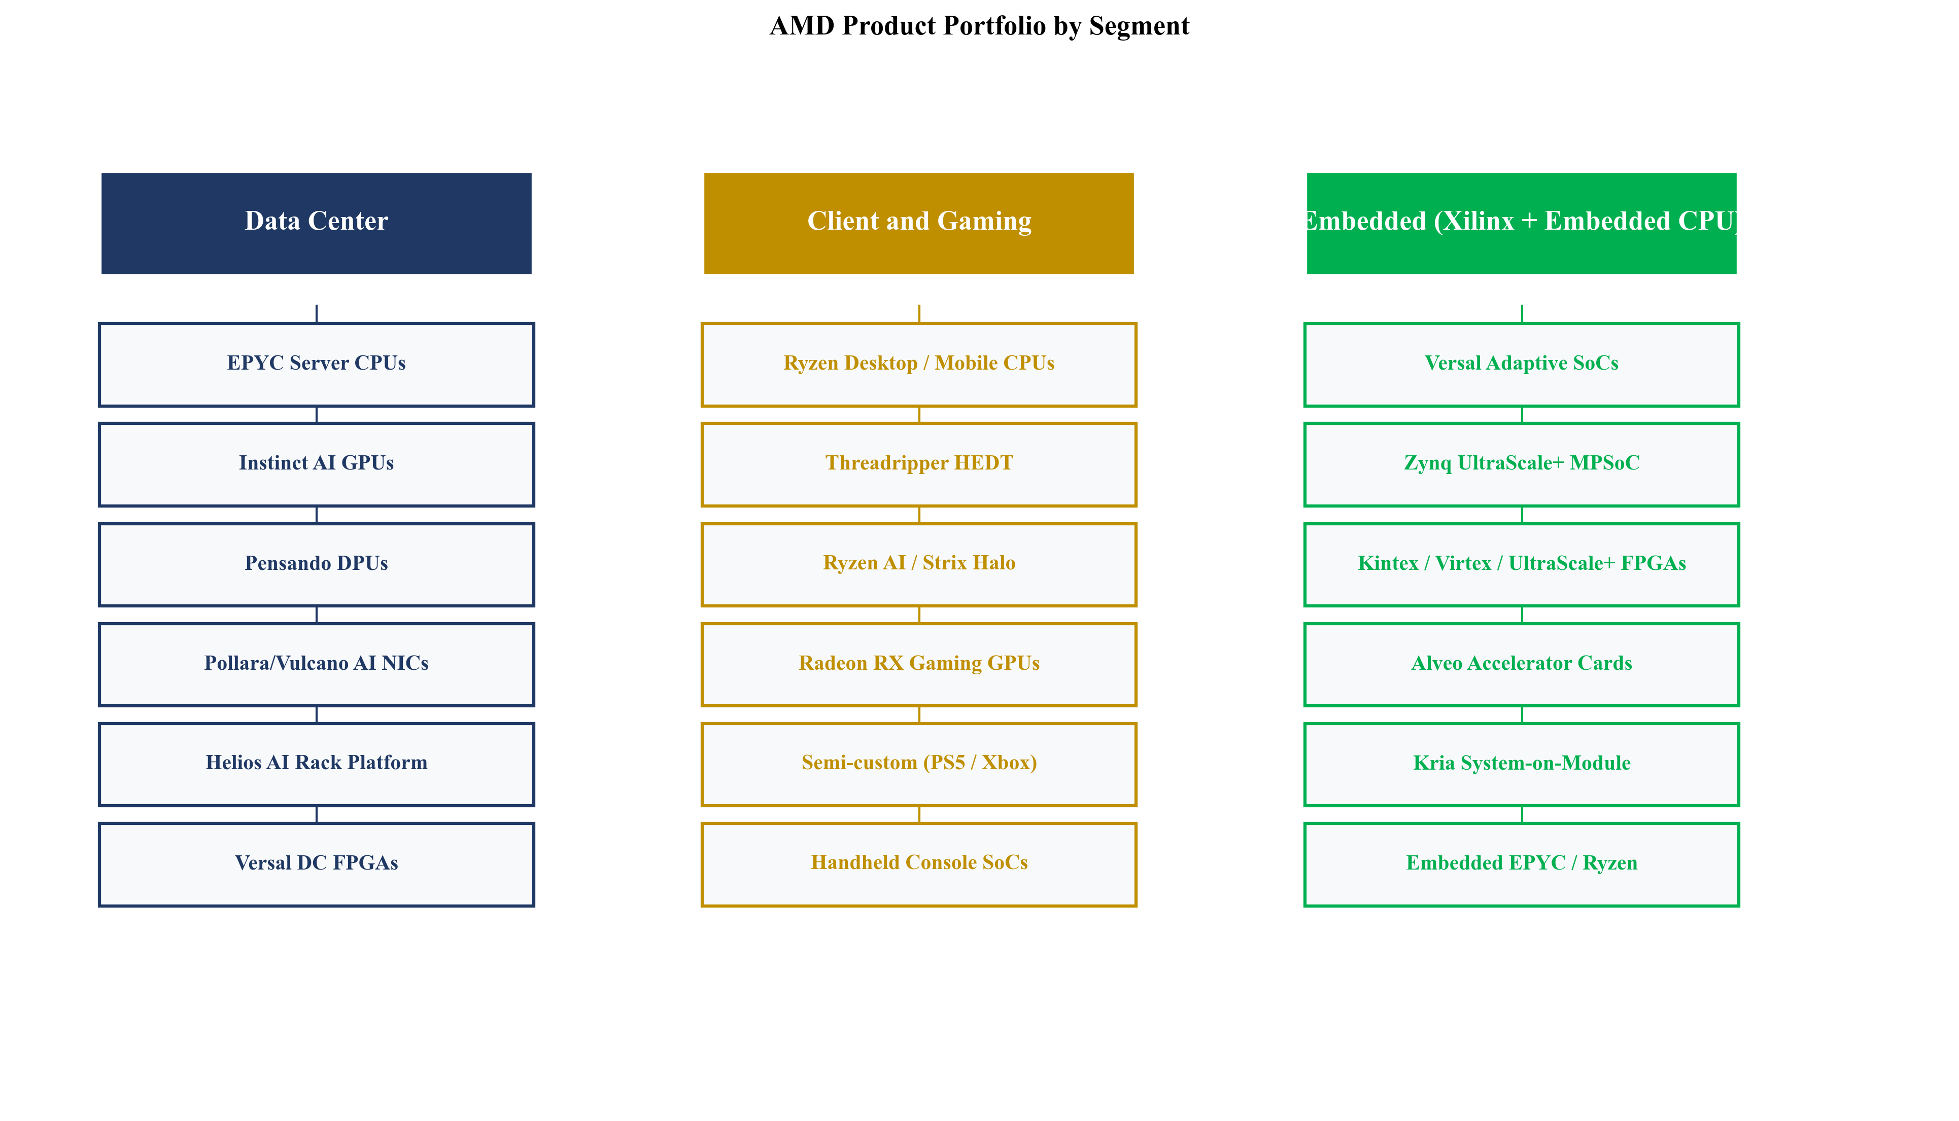
Figure 7. AMD product portfolio by reportable segment.
Data Center segment
EPYC server CPUs (5th-Generation 'Turin'): The volume server CPU franchise. Delivered on TSMC advanced nodes with up to 192 cores per socket. Moat is technology, scale and switching costs. EPYC has dominated x86 server CPU performance/watt benchmarks for most of the period since the launch of Milan (3rd gen) in 2021. Independent server platform certifications across Dell, HPE, Lenovo, Supermicro, and most hyperscaler internal designs (Azure, AWS, GCP, Oracle, Meta) create switching friction for end customers. Closest competing product is Intel Xeon 6 (formerly Granite Rapids / Sierra Forest). At parity-to-ahead on top-bin core count and energy efficiency for general-purpose virtualization; slightly behind Xeon in some matrix-multiply AI inference workloads where Intel has invested in AMX extensions; but for the bulk of dollar-weighted hyperscaler buying the EPYC advantage is still intact.
AMD Instinct GPUs (AI accelerators): The Instinct family — MI200, MI300X, MI325X, MI350X, MI355X, and the MI450 series previewed for 2H-FY2026 — is built on AMD CDNA architecture. MI300X first shipped in volume in late 2023 and delivered 'more than $5 billion' of revenue in FY2024 per CEO commentary. MI355X ramped in 2025; the MI450 series is the basis for the first 1 GW of OpenAI's 6 GW deployment scheduled for 2H-FY2026. Moat is partial — technology, scale (memory capacity per package), strategic customer lock-in via OpenAI. AMD's most-cited differentiator is HBM capacity per accelerator (MI300X shipped with 192GB of HBM3 against NVIDIA H100's 80GB, giving an inference advantage on very large models that fit in fewer GPUs). The moat is partial, not full, because the ROCm software stack is still less mature than CUDA — the largest unresolved gap in AMD's AI story. Closest competing products are NVIDIA H200 / Blackwell B100/B200 / GB200. AMD is ahead on memory capacity and dollar-per-token of inference for the very large models that benefit from it; behind on software ecosystem, developer toolchain breadth, and proven training scale-out (NVLink/NVSwitch); closing the gap fast with ROCm 7, the Pollara/Vulcano AI NIC fabric, and the Helios rack platform.
AMD Pensando DPUs and AI NICs: The Pensando product line (Salina DPU, Pollara 400 AI NIC, Vulcano AI NIC) offloads infrastructure services and provides high-speed scale-out fabric between GPUs. Customers are large IaaS providers and select hyperscalers. Moat is partial — technology plus customer lock-in. Pensando competes head-on with NVIDIA's BlueField DPU and Broadcom's Jericho / Tomahawk-based AI fabric switches. AMD's advantage is that Pollara/Vulcano can be sold as part of an integrated AMD rack (CPU+GPU+NIC), and AMD is one of the founding promoters of the Ultra Ethernet Consortium open-fabric specification. The moat is partial because Broadcom's switch silicon remains the volume default for AI cluster networking.
ZT Design / 'Helios' AI rack-scale platform: Following the March 2025 ZT Systems acquisition ($3.2B cash and 8.3M AMD shares) and October 2025 carve-out of the manufacturing arm to Sanmina (for $2.4B cash and 1.2M Sanmina shares, with up to $450M contingent consideration), AMD retained the ZT design team and engineering IP. Helios is AMD's first internally engineered AI rack platform (CPU + GPU + networking, liquid-cooled, 1 GW-class deployments) and the operational mechanism for delivering the OpenAI 1 GW first tranche. This is AMD's response to NVIDIA's GB200 NVL72 rack-scale offering. Closest competing product: NVIDIA GB200 NVL72 / NVL36. AMD is behind on time-to-market but levels the playing field as a 'systems vendor' rather than only a chip vendor — an important strategic capability for the next generation of frontier AI deployments where the rack-scale optimization (cooling, power delivery, network topology, memory hierarchy) matters as much as the silicon itself.
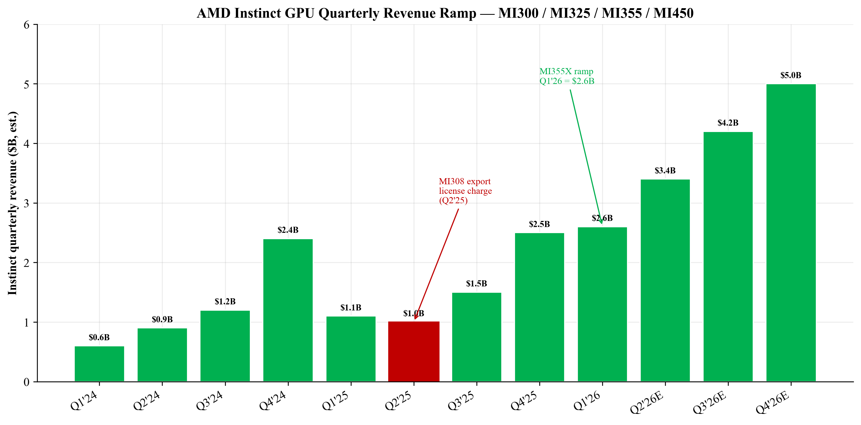
Figure 8. Instinct GPU quarterly revenue ramp (estimated), Q1'24–Q4'26E.
Client and Gaming segment
AMD Ryzen desktop and mobile CPUs: The Ryzen line — desktop (Ryzen 7/9/Threadripper), mobile (Ryzen AI for AI-PC), and HEDT (Threadripper PRO) — is AMD's volume PC franchise. FY2025 Client revenue was $10.64B (+51% YoY), with management attributing growth to 'a 31% increase in unit shipments of processors and a 15% increase in average selling price.'
AMD Radeon GPUs: Discrete gaming GPUs under the Radeon RX brand. Gaming segment revenue of $3.91B (+51% YoY) in FY2025 was driven by strong discrete-GPU demand alongside semi-custom. AMD is the #2 discrete GPU vendor; NVIDIA leads at the high end and in software (CUDA, DLSS).
Semi-custom SoCs (consoles): AMD designs the SoCs at the heart of Sony PlayStation 5 / PS5 Pro and Microsoft Xbox Series X/S. Console design wins are typically multi-year exclusive contracts with major non-recoverable engineering investment; AMD has held both Sony and Microsoft across the PS4/Xbox One, PS5/Xbox Series, and into the next generation.
Embedded segment (Xilinx + Embedded CPU)
The Embedded segment is the home of the Xilinx asset acquired in 2022, plus embedded variants of EPYC and Ryzen. End markets are industrial, networking and comms infrastructure, aerospace and defense, automotive, test/measurement, healthcare, and broadcast. Products include AMD Versal adaptive SoCs (flagship Xilinx successor combining FPGA fabric, Arm CPU cores, and an AI engine on one die — Versal Premium variants ship into 5G base stations and AI inference at the network edge), Zynq UltraScale+ MPSoC (heterogeneous Arm+FPGA SoCs widely used in industrial, automotive ADAS and aerospace), UltraScale+/Kintex/Virtex FPGAs (pure-FPGA family for prototyping, comms and high-performance signal processing), Alveo accelerator cards and Kria System-on-Module (board- and module-level products that simplify adoption of Versal/Zynq in production hardware).
Moat is yes — IP, regulatory/certification, switching costs. FPGAs have been a duopoly with Altera (now an Intel spin-out being divested) since the late 1990s. Designs typically run 7-15 years in industrial and aerospace lifecycles; replacing an FPGA on a certified product line is a multi-year recertification. Closest competing product: Altera Agilex / Stratix. AMD is ahead in the Versal AI-engine niche and the high-end automotive/comms tier; broadly at parity at the mid-range; the strategic threat is not Altera but a long-tail of ASIC and edge-AI accelerator startups picking off specific verticals. The economic significance of Embedded to AMD is not just the absolute revenue contribution (~$3.5B in FY2025) but its margin profile — high-60s gross margin and 30%+ operating margin on a stable, low-cyclicality customer base. Embedded acts as a structural counterweight to the more cyclical merchant CPU/GPU business.
2.5 Customers and Go-to-Market
AMD sells to four main customer cohorts: (1) hyperscale cloud providers and large enterprise data-center buyers (Microsoft, Meta, Google, Amazon, Oracle, plus frontier AI labs OpenAI, xAI, Anthropic) for Data Center products; (2) OEM/ODM PC and workstation makers (Dell, HP, Lenovo, ASUS, MSI) for Ryzen and Radeon; (3) console partners (Sony and Microsoft) for semi-custom; and (4) industrial/comms/aerospace/automotive Tier-1 customers and channel distributors (Avnet, Arrow) for Embedded.
AMD's FY2025 10-K does not name a single 10%+ customer in the segment disclosure. The 10-K does, however, explicitly state in its risk factors that 'a small number of customers will continue to account for a substantial part of AMD's revenue and receivables in the future.' Following the October 2025 OpenAI agreement, we expect OpenAI to become a 10%+ customer by FY2027–FY2028.
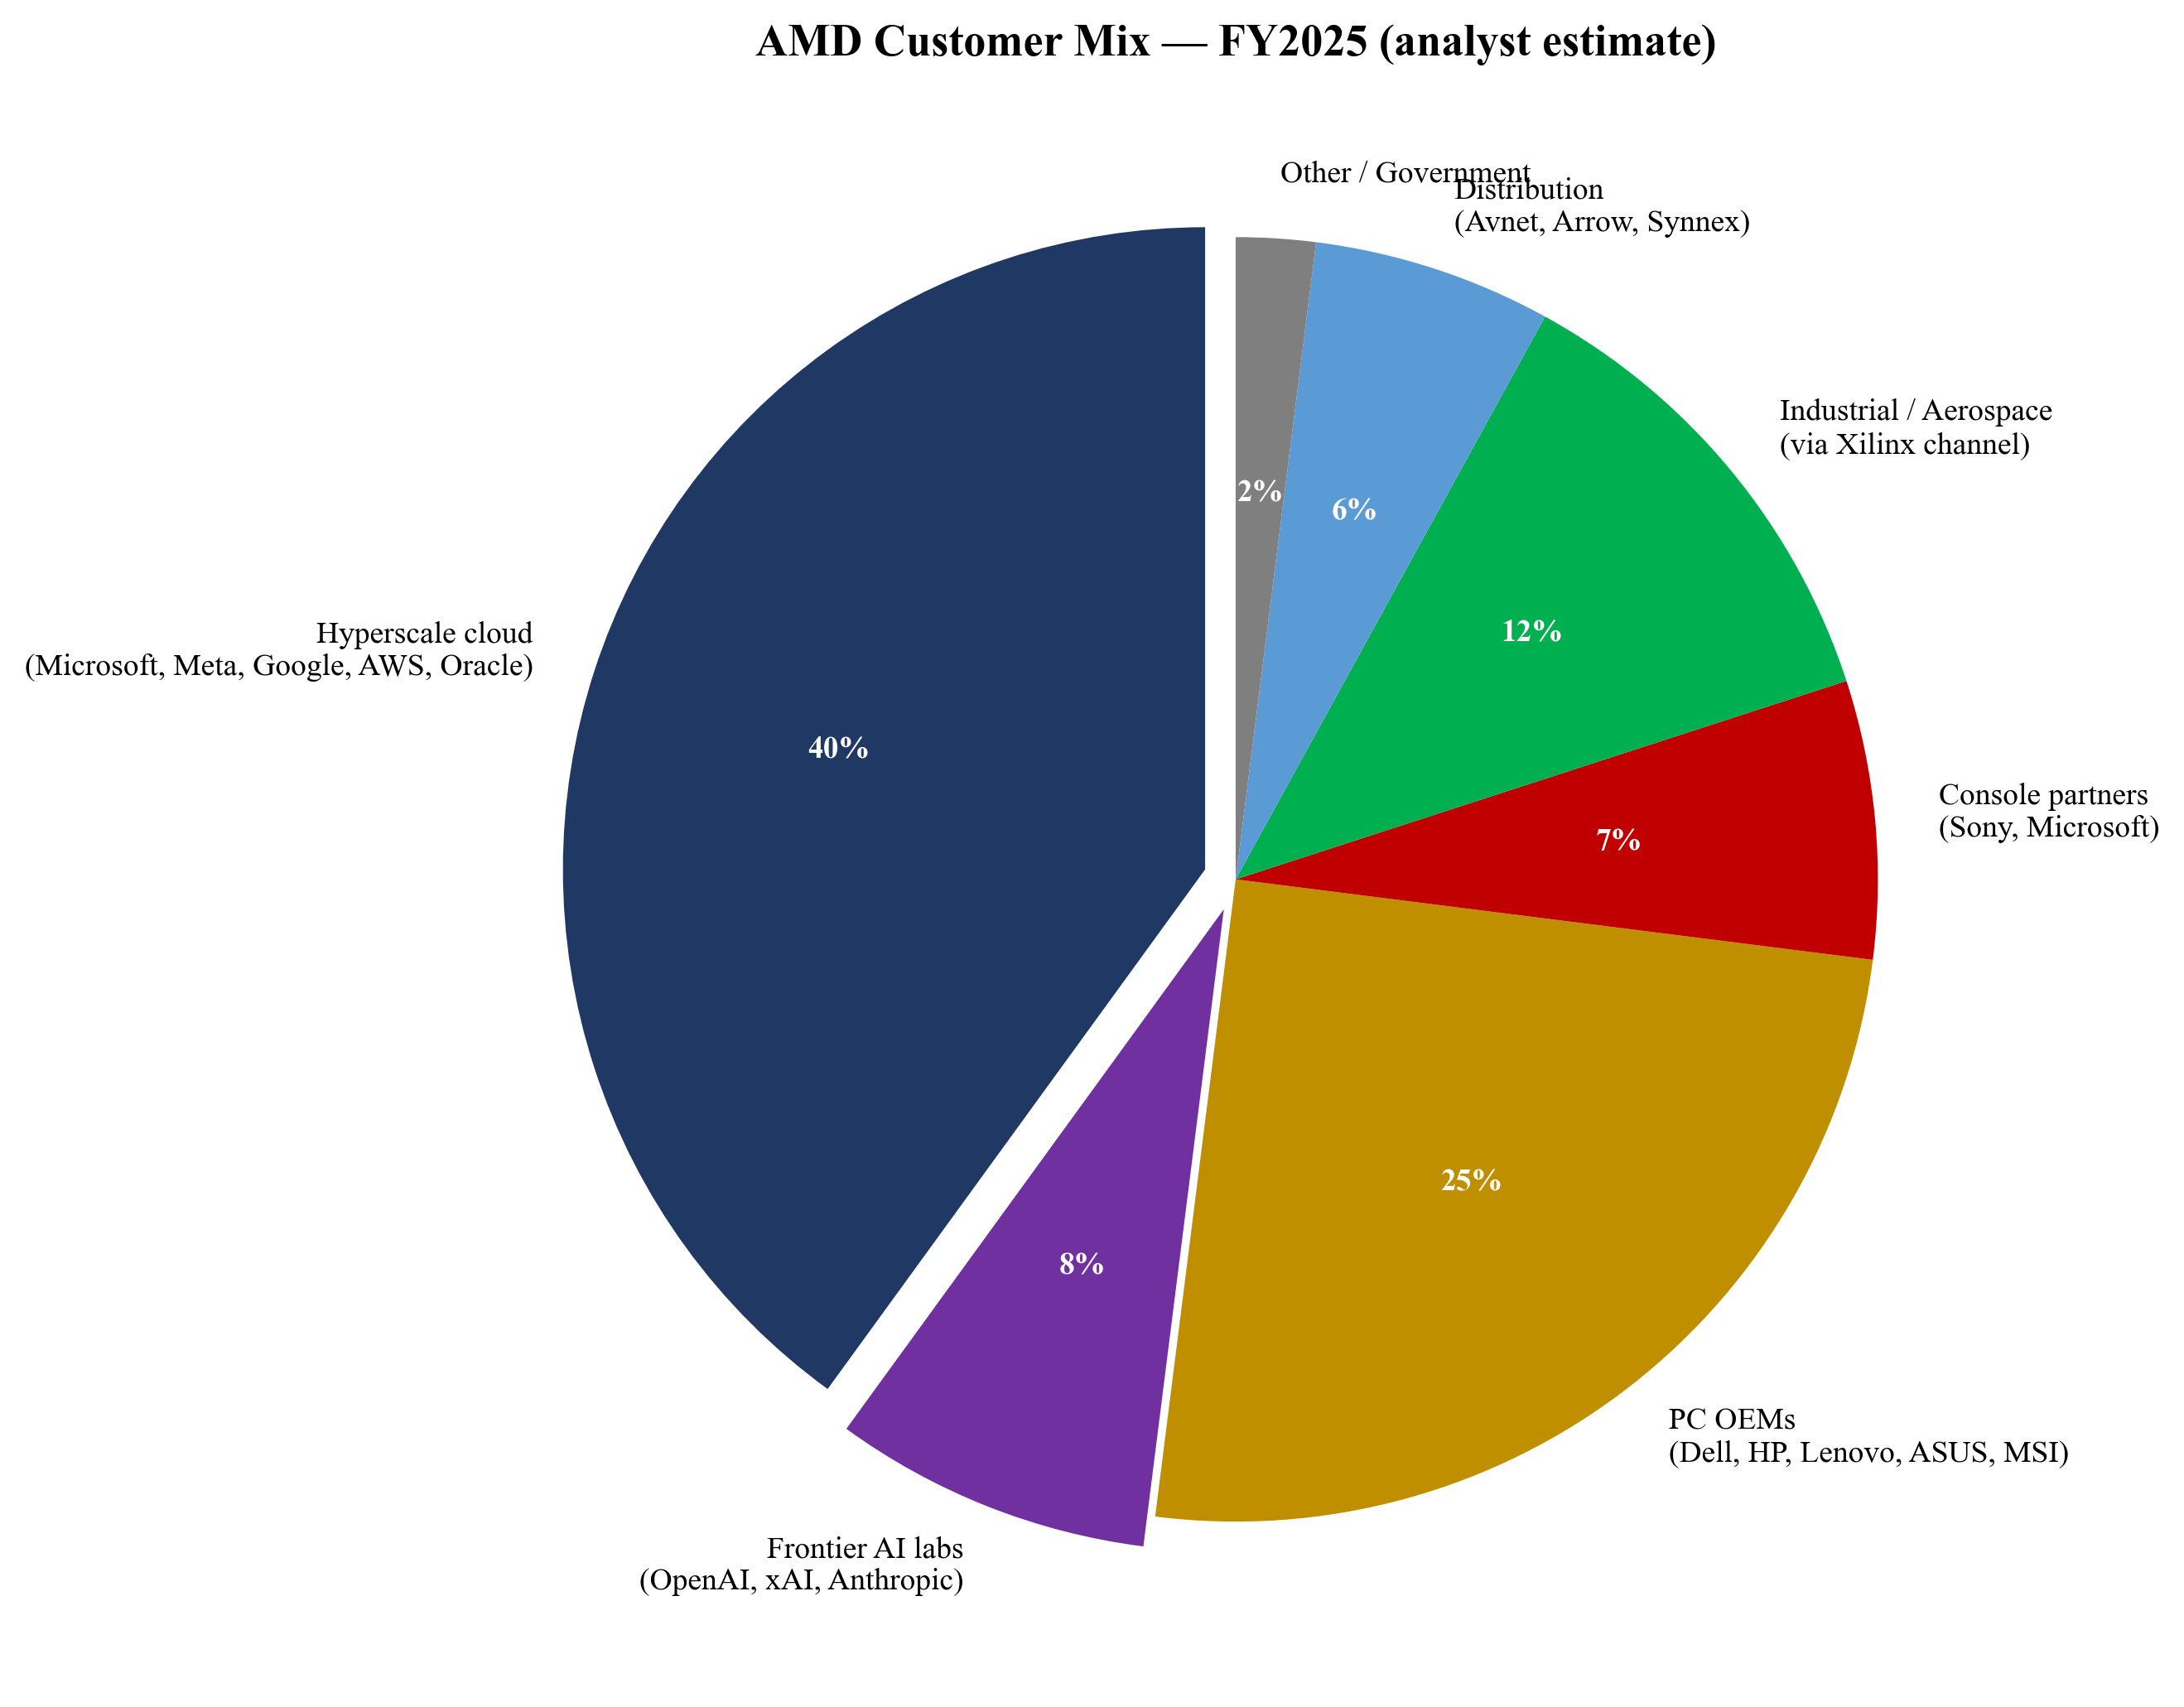
Figure 9. AMD FY2025 customer mix (analyst estimate based on segment disclosures).
Contract structure: 'We typically sell our products pursuant to individual purchase orders. We generally do not have long-term supply arrangements with our customers or minimum purchase requirements' (AMD 2025 10-K Risk Factors). The OpenAI agreement is the major recent exception — a multi-year, multi-generation product purchase commitment with milestone-vesting warrants attached. Semi-custom relationships with Sony and Microsoft are also multi-year design wins with embedded production commitments. Hyperscaler design wins are co-engineered relationships with multi-quarter qualification, led by Forrest Norrod's Data Center org and the field engineering teams in Hillsboro, Austin and India. PC OEM sales run through Jack Huynh's Computing and Graphics org and Darren Grasby's worldwide channel team. Embedded sales lean on legacy Xilinx FAEs and distribution partners (Avnet, Arrow) under Salil Raje's organization. Co-engineering on Helios racks is now an operating part of every large Instinct opportunity.
Customer case studies (named publicly): Microsoft Azure ND MI300X v5 VMs; Meta production inference deployment of MI300X; Oracle Cloud Infrastructure GPU shapes on MI300X and MI325X; the OpenAI 6 GW agreement; Sony PlayStation 5 / 5 Pro semi-custom; Microsoft Xbox Series X / S semi-custom. AMD also publicizes EPYC wins across Google Cloud (C4D), AWS (Hpc7a, M7a), and the El Capitan exascale supercomputer at Lawrence Livermore National Laboratory. The pattern is that AMD's named accounts cover essentially every major hyperscaler, every major frontier AI lab, every major U.S. exascale program, and the two major console platform holders — a customer base whose composition would have been unimaginable in 2014 when Lisa Su took over.
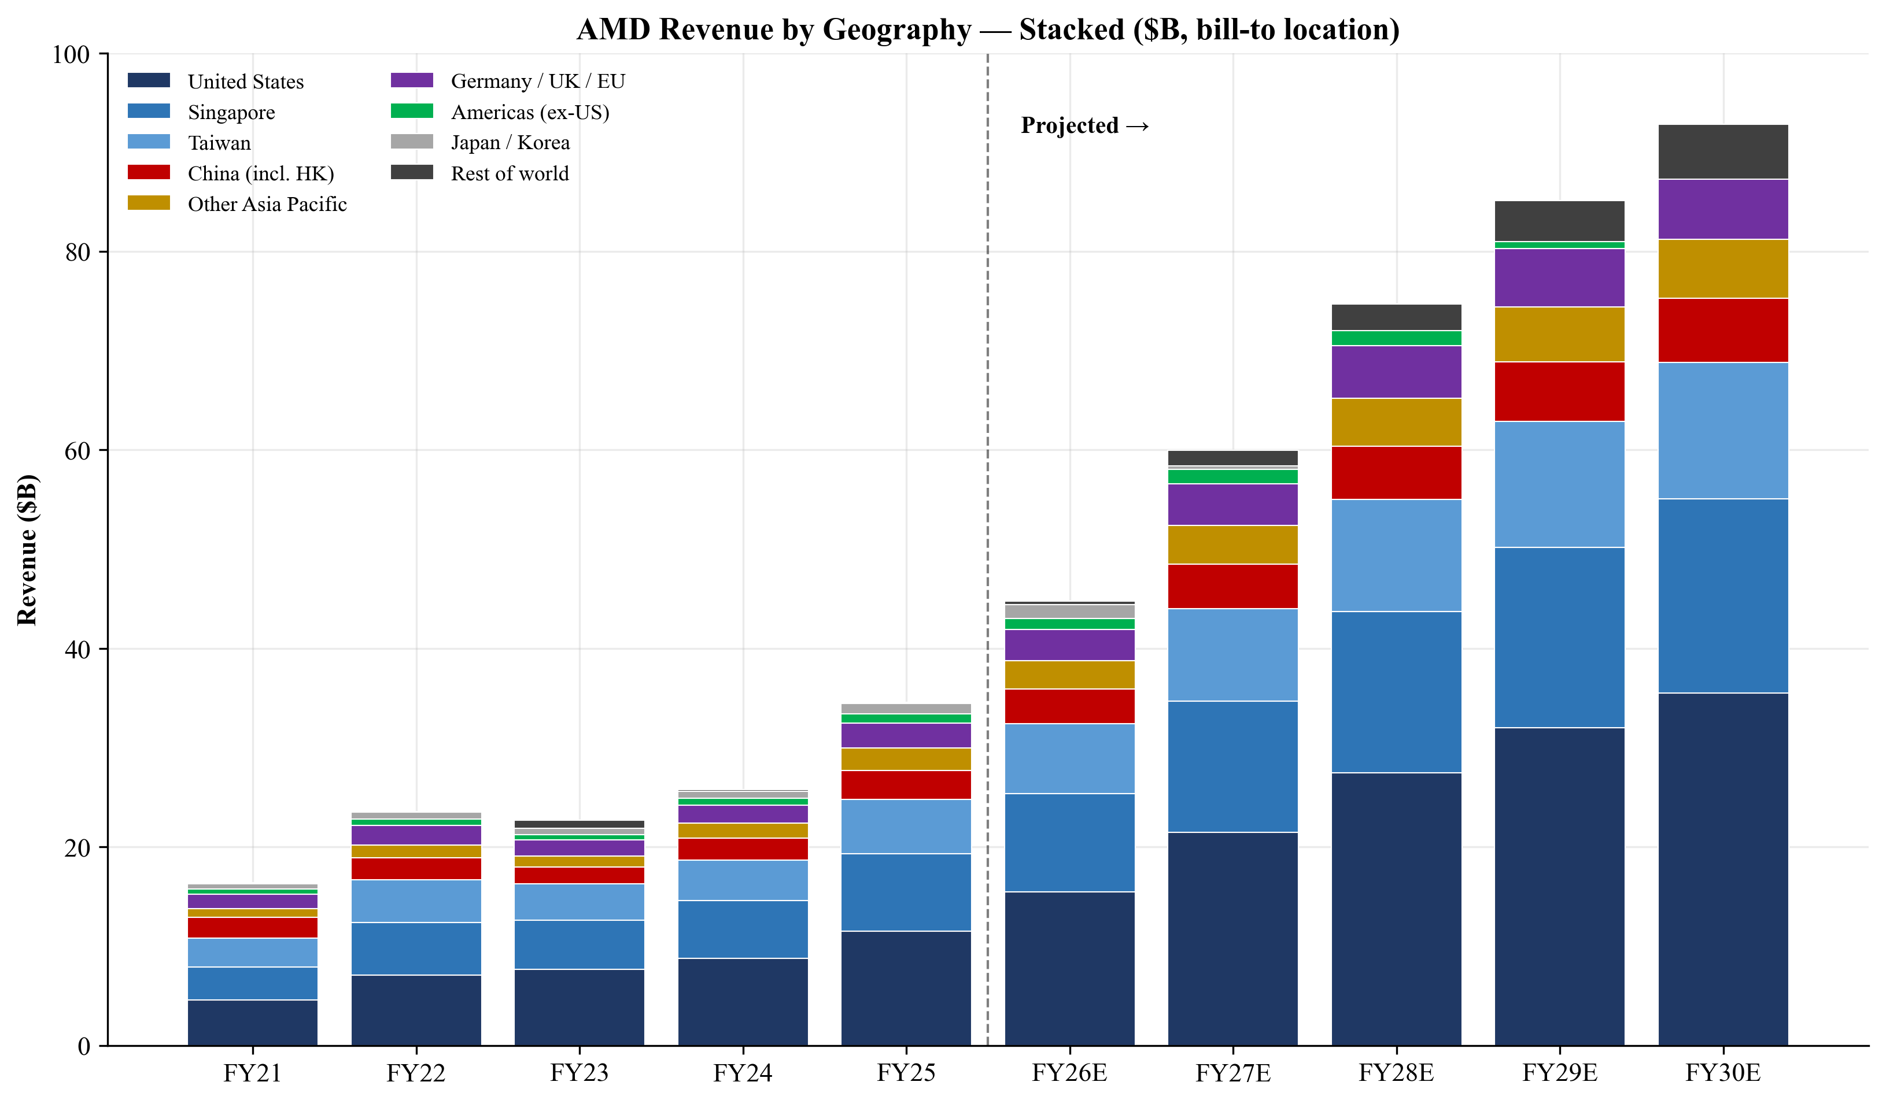
Figure 10. AMD revenue by geography (bill-to location), FY21–FY30E.
2.6 Industry Overview
AMD participates in three overlapping markets: data-center compute (CPUs, GPUs, DPUs, NICs and integrated AI systems), PC client compute (desktop/notebook CPUs and discrete GPUs), and adaptive/embedded silicon (FPGAs, adaptive SoCs, embedded CPUs). Data-center compute is the dominant growth driver. Global data-center capex hit a multi-decade inflection in 2023–2025 as hyperscalers, neoclouds (CoreWeave, Lambda, Crusoe) and frontier AI labs (OpenAI, xAI, Anthropic) accelerated AI infrastructure build-outs.
NVIDIA's data-center segment revenue grew from $47.5B in FY2024 to $115.2B in FY2025 — the single best benchmark for the magnitude of AI infrastructure demand. AMD's Data Center segment grew from $6.5B in FY2023 to $16.6B in FY2025, a 2.6× expansion in two years and the strongest growth in the company's history.
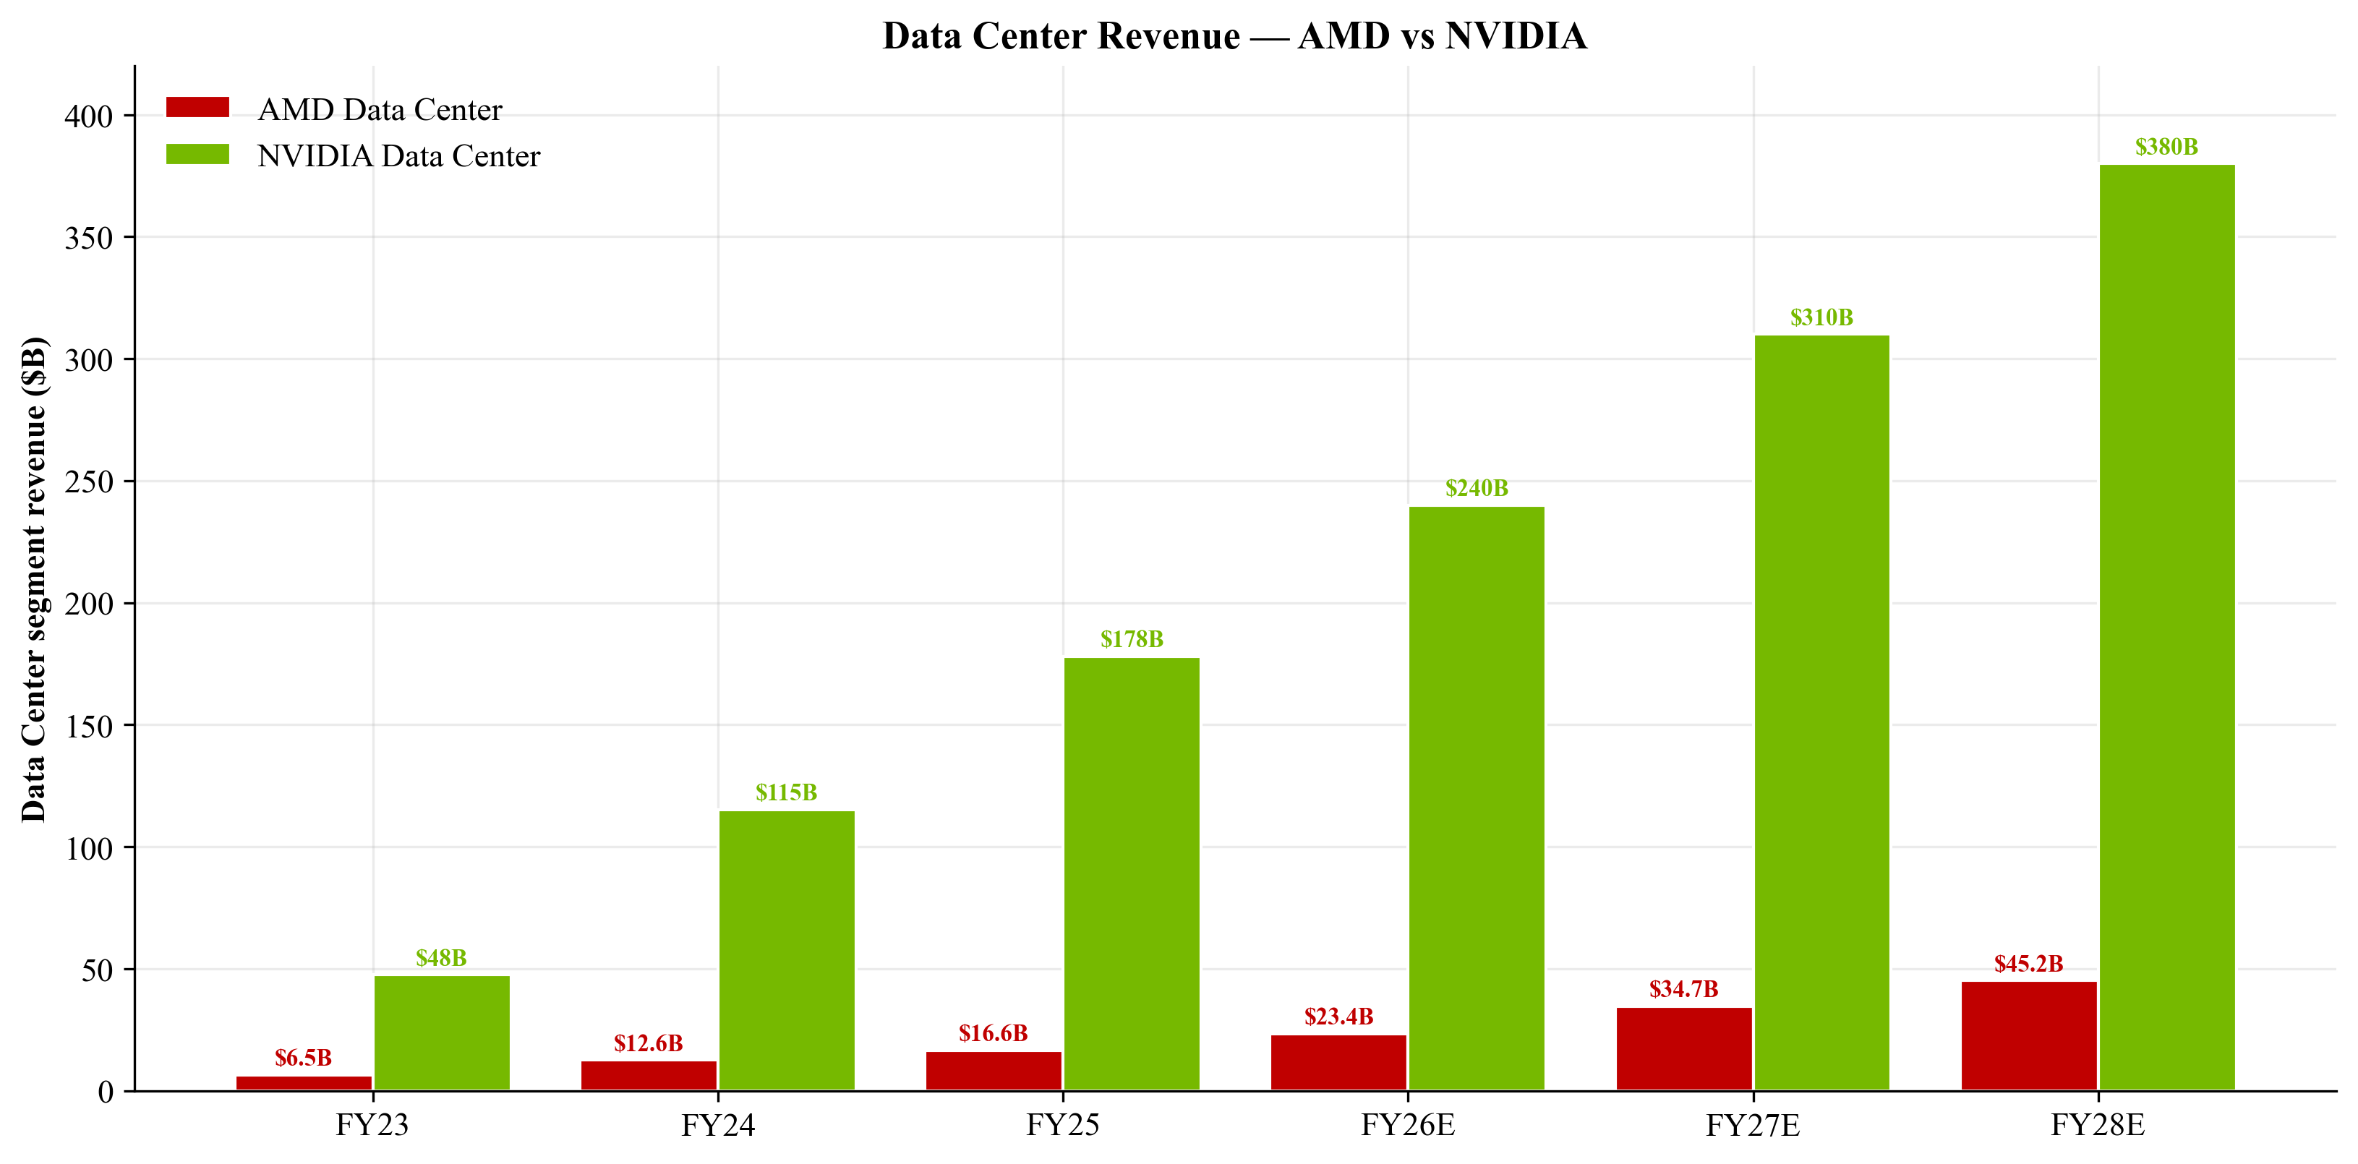
Figure 11. AMD Data Center segment revenue vs NVIDIA Data Center segment.
The data-center silicon market is highly concentrated. In server CPUs the market is effectively a duopoly between AMD (EPYC) and Intel (Xeon), with Arm-based custom silicon (AWS Graviton, NVIDIA Grace, Ampere Computing) accounting for a small but growing share concentrated inside hyperscaler internal fleets. In AI accelerators NVIDIA is the entrenched leader; AMD is the credible #2 merchant alternative; Intel's Gaudi has had limited commercial traction; the largest competitive threat to merchant silicon is the hyperscaler ASIC trend (Google TPU, AWS Trainium/Inferentia, Microsoft Maia, Meta MTIA), much of which is co-designed with Broadcom or Marvell.
2.7 Competitive Landscape
Direct competitors named in AMD's 10-K: NVIDIA Corporation (primary competitor in data-center GPU accelerators, discrete gaming GPUs, AI software stacks (CUDA vs ROCm) and DPUs); Intel Corporation (primary competitor in x86 server CPUs, client CPUs, integrated graphics, and (via Altera) FPGAs); Broadcom Inc. (data-center networking, custom-silicon programs); Altera (Intel FPGA spin-out); Marvell, Qualcomm, NXP, TI, ADI (adjacent embedded/networking/DSP); hyperscaler in-house ASICs (AWS Graviton/Trainium, Google TPU, Microsoft Maia, Meta MTIA); Arm-based merchant silicon (Ampere Computing); Apple Silicon (indirect, client compute); and smaller fabless AI accelerator startups (Cerebras, Groq, SambaNova, Tenstorrent).
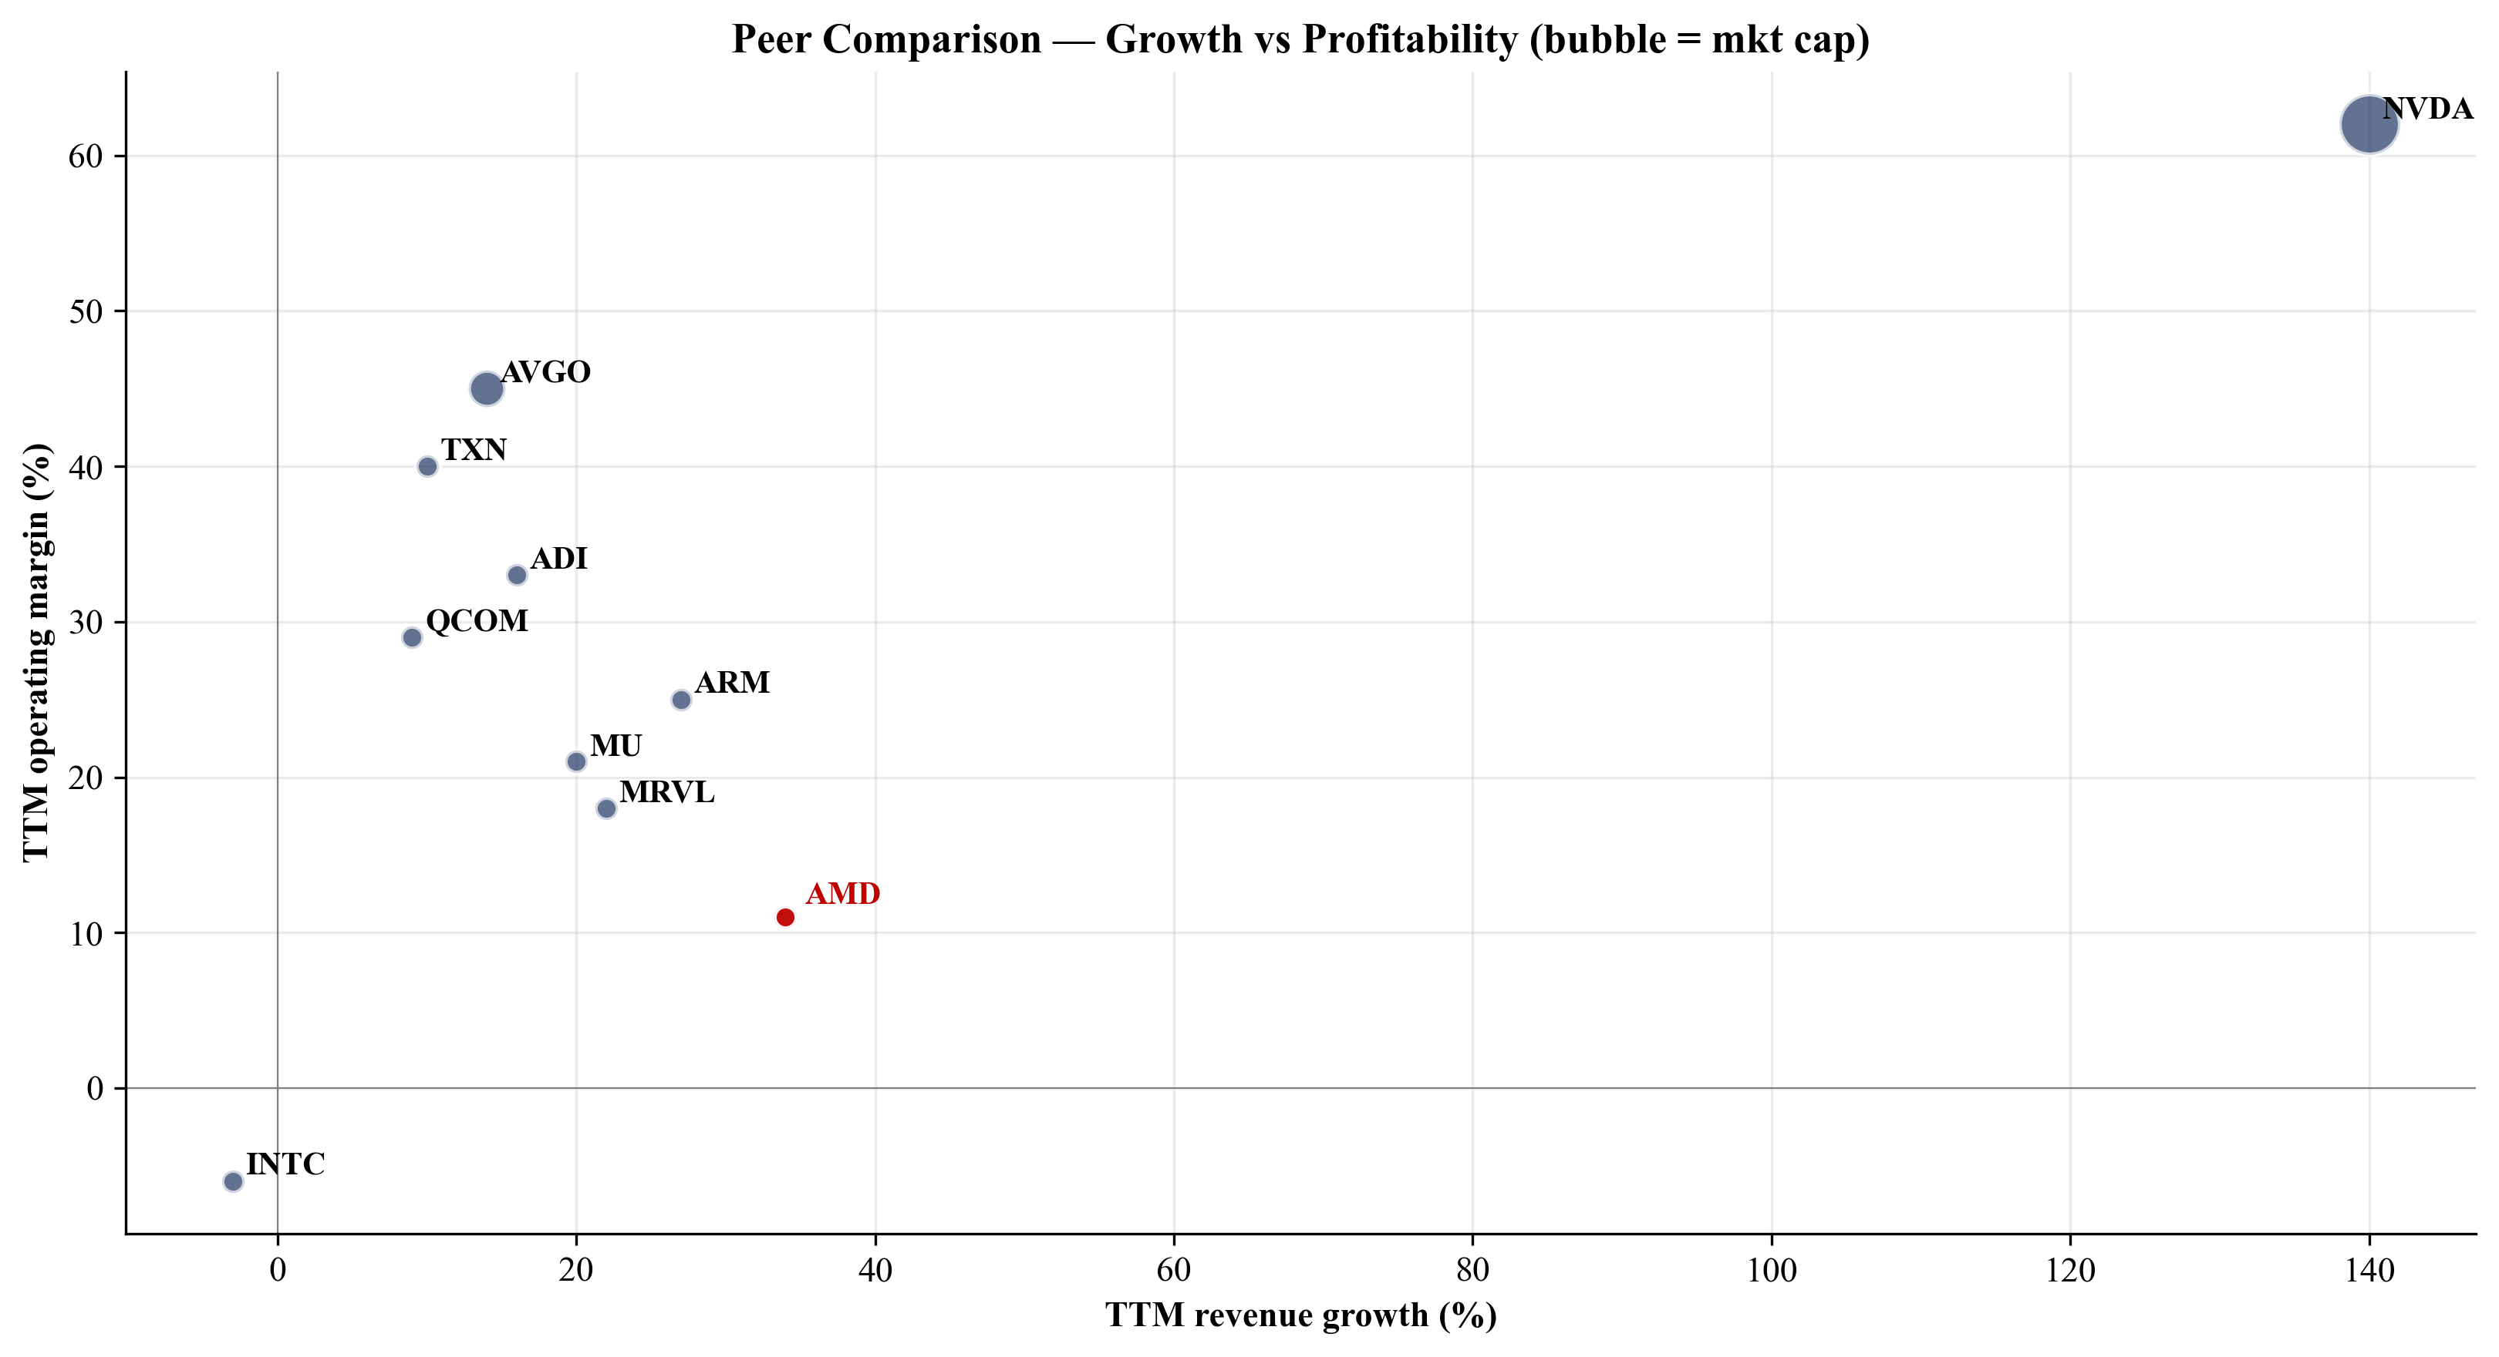
Figure 12. Peer comparison — TTM revenue growth vs operating margin (bubble = market cap).
AMD's competitive advantages: (1) the strongest CEO-led execution track record in the industry over the last decade; (2) the cost and yield advantages of the chiplet/Infinity Fabric architecture, which Intel only fully adopted with Granite Rapids; (3) a complete data-center stack — CPU, GPU, DPU, AI NIC, FPGA, integrated systems — that NVIDIA (no merchant CPU) and Intel (no leadership GPU) cannot match end-to-end; (4) the Xilinx adaptive-silicon franchise as a high-margin, lower-cyclicality counterweight; (5) anchor design wins (Sony, Microsoft, Meta, Microsoft Azure, Oracle, OpenAI, U.S. exascale supercomputers).
Positioning framework: AMD sits between NVIDIA (the AI accelerator and software-ecosystem leader) and Intel (the legacy server CPU leader by installed base) and is the only merchant vendor able to credibly deliver both halves of an AI rack (CPU + GPU + DPU + AI NIC) on its own silicon. Broadcom is a peer on the networking and custom-ASIC side but does not have a merchant general-purpose CPU/GPU. The strategic moat AMD is building is systems integration (Helios rack, OpenAI deployment, ZT Design team, Pollara/Vulcano AI fabric) on top of a chip-level moat (chiplets, Infinity Fabric, advanced packaging) and a software effort that is still catching up (ROCm). The integrated systems play matters because, at the 1 GW+ deployment scale where frontier AI labs operate, rack-level efficiency (power, cooling, network topology) determines TCO more than per-chip performance. NVIDIA's GB200 NVL72 is a direct response to this reality; Helios is AMD's response.
Competitive vulnerabilities: (1) software ecosystem gap vs CUDA — the single most cited reservation in sell-side and buy-side conversations about Instinct, and the issue that requires the most sustained investment to close; (2) dependence on a single foundry partner (TSMC) for advanced nodes and CoWoS packaging — a binding constraint on Instinct supply growth and a geopolitical concentration risk; (3) the NVIDIA-Intel partnership announced September 2025 raises the risk of bundled Intel CPU + NVIDIA GPU offerings that could foreclose part of AMD's data-center share opportunity, particularly in hyperscalers where Intel has historical incumbency; (4) hyperscaler ASIC programs (Google TPU, Microsoft Maia, AWS Trainium, Meta MTIA) attack both NVIDIA and AMD merchant silicon — AMD has less ASIC IP-licensing optionality than Broadcom or Marvell, which means AMD is structurally exposed to the merchant-to-ASIC migration with limited offsetting revenue from custom-silicon engagements.
Market share — server CPU: AMD does not disclose its server-CPU unit share. Mercury Research's quarterly tracker has consistently shown AMD x86 server-CPU revenue share rising from low single digits in 2017 to mid-thirties percent by 2024-2025; AMD itself attributes the FY2025 EPYC growth to 'strong demand for our 5th generation AMD EPYC processors.' The trajectory reflects multiple factors: Intel's manufacturing struggles at the leading edge through 2020-2023, the chiplet advantage that gave AMD a cost-per-core lead, design wins at all major hyperscalers, and the growing complexity of AMD's enterprise certification footprint. We expect share gains to decelerate as the easy share moves higher — going from 35% to 40% is meaningfully harder than going from 5% to 25% — but not to reverse through FY2030 absent a major Intel product breakthrough.
2.8 Market Opportunity (TAM)
Management has guided publicly to a $500B+ TAM for AI accelerators by 2028. This is the company's primary anchor for the long-run Instinct opportunity. Sell-side ranges around the same number cluster between $400B and $600B for 2028 depending on assumed CapEx growth rates and the ASIC/merchant split.
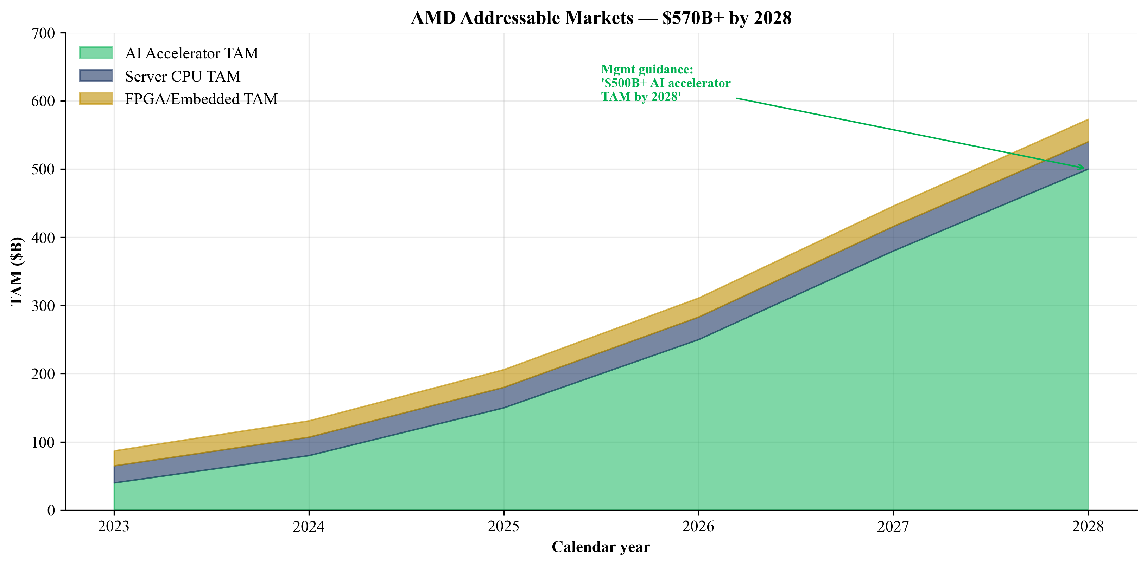
Figure 13. AMD addressable markets — $570B+ aggregate by 2028.
Stack-up: the merchant-addressable portion of the AI accelerator TAM is the part where AMD can compete directly — i.e., excluding hyperscaler ASICs designed in-house with Broadcom or Marvell. If ASICs grow to 30–40% of total AI accelerator deployments by 2028, the merchant AI accelerator TAM is in the $250–350B range. AMD's stated ambition is to become the second leader at multi-tens-of-percent share — the OpenAI commitment is the operational expression of that ambition. Sizing the OpenAI deal: 6 GW at $30–50B equipment per GW, with 30–50% GPU-vendor share, implies $60–150B of cumulative AMD revenue across the contract life.
2.9 Risk Assessment Summary
Category | Risk | Severity | Mitigant
Company-Specific | ROCm software ecosystem still trails CUDA | High | Mitigated by OpenAI co-engineering
Company-Specific | Concentration on hyperscaler/frontier-AI customers | High | Diversified base today
Company-Specific | CEO key-person risk (Lisa Su) | Medium | Deep bench (Norrod, Papermaster, Hu)
Company-Specific | TSMC single-source dependency | Medium | TSMC Arizona ramp
Company-Specific | NVIDIA-Intel partnership | Medium | AMD chiplet lead vs Xeon today
Company-Specific | OpenAI warrant dilution (up to 9.8%) | Medium | Only on milestone delivery
Industry/Market | Hyperscaler ASICs eroding share | Medium | AMD offers complete CPU+GPU+NIC
Industry/Market | AI capex cycle correction | Medium | Inference workloads provide floor
Industry/Market | PC/gaming demand saturation | Low | Embedded counterweight
Financial | Inventory build risk | Medium | Active for DC ramp
Financial | Multiple compression at 34× fwd P/E | High | Sector-wide risk
Macro/Regulatory | U.S. export controls on AI to China | High | MI308 already restricted
Macro/Regulatory | China import controls / domestic AI silicon preference | Medium | Indirect demand impact
Macro/Regulatory | Tariffs and trade | Low | Indirect transmission only

3. Financial Analysis and Projections
3.1 Historical Performance
AMD's financial performance over FY2021–FY2025 reflects three distinct phases: (i) the FY2021–FY2022 step-up driven by the Xilinx acquisition close (February 2022); (ii) the FY2023 trough driven by the post-pandemic PC and gaming correction (Embedded segment -33% in FY2024); and (iii) the FY2024–FY2025 AI-driven re-acceleration anchored by Instinct GPU shipments and EPYC share gains.
($M except per-share) | FY2021 | FY2022 | FY2023 | FY2024 | FY2025
Net revenue | $16,434 | $23,601 | $22,680 | $25,785 | $34,639
Gross profit | $7,929 | $10,603 | $10,460 | $12,725 | $17,152
Gross margin | 48.2% | 44.9% | 46.1% | 49.3% | 49.5%
R&D | $2,845 | $5,005 | $5,872 | $6,456 | $8,091
R&D % of revenue | 17.3% | 21.2% | 25.9% | 25.0% | 23.4%
Operating income | $3,648 | $1,264 | $401 | $1,900 | $3,694
Operating margin | 22.2% | 5.4% | 1.8% | 7.4% | 10.7%
Net income | $3,156 | $1,320 | $854 | $1,641 | $4,335
Diluted EPS | $2.57 | $0.84 | $0.53 | $1.00 | $2.65
Operating CF | $3,521 | $3,565 | $1,667 | $3,041 | $7,709
Free cash flow | $3,220 | $3,115 | $1,121 | $2,405 | $6,697
Source: AMD 2021–2025 10-K filings; FY2021 figures pre-Xilinx baseline.
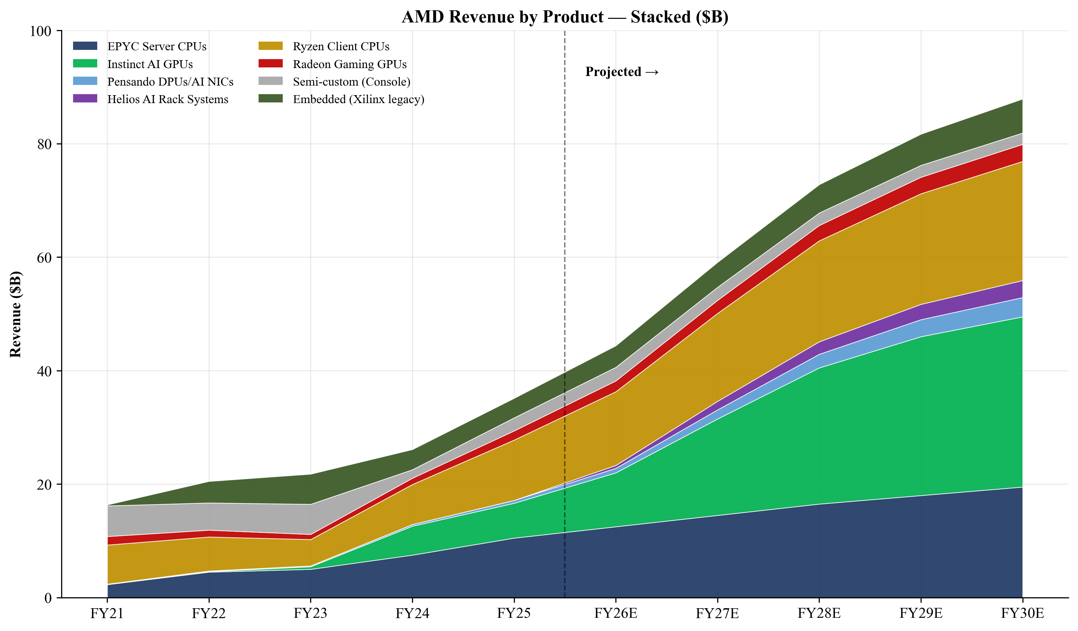
Figure 14. AMD revenue by product line — stacked area, FY21–FY30E.
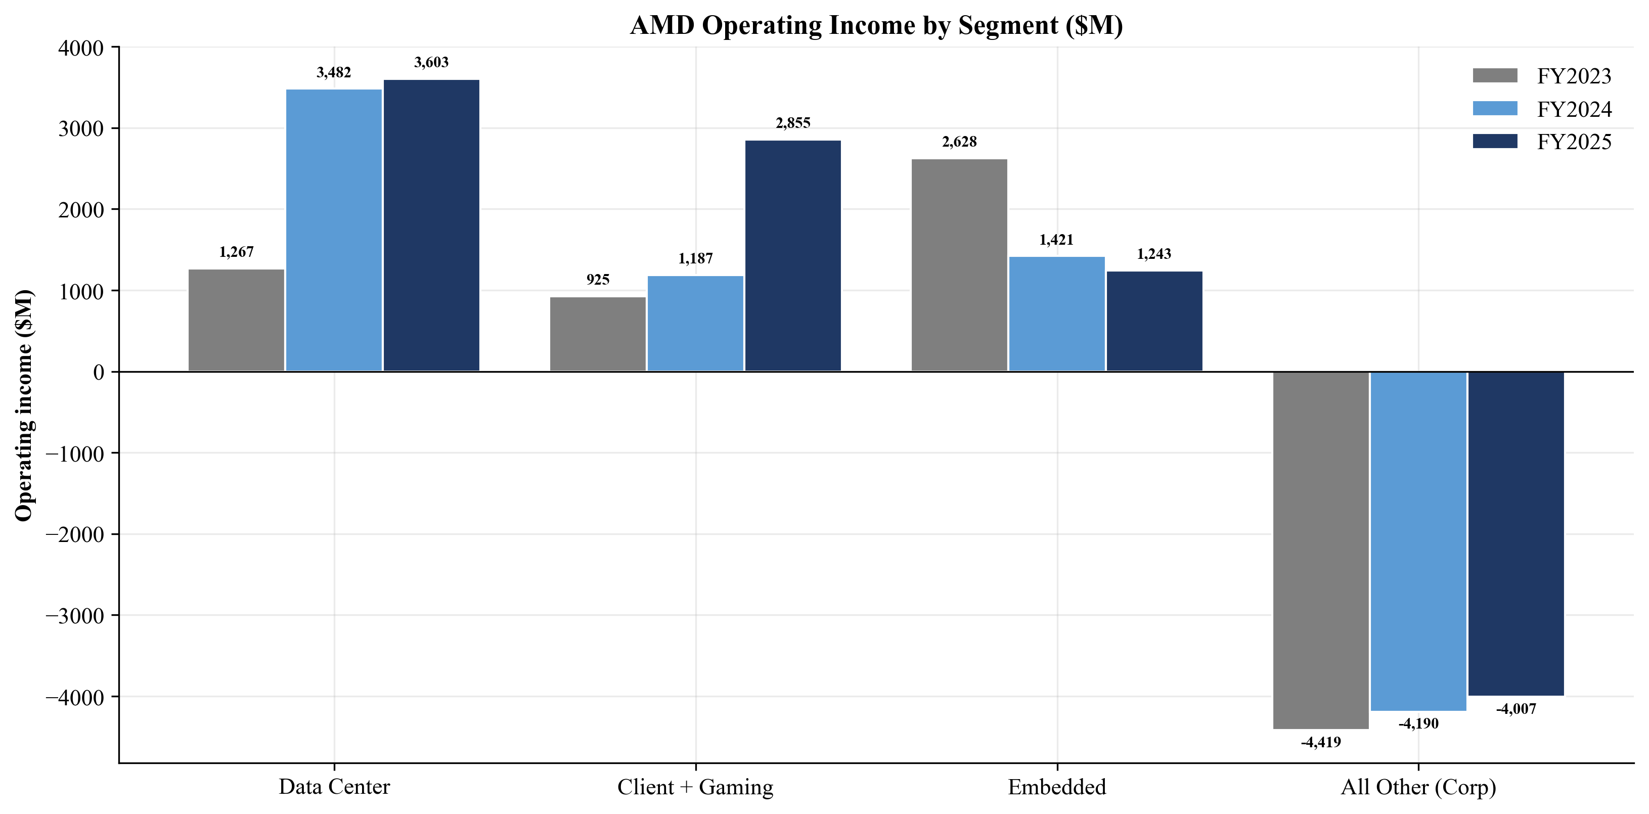
Figure 15. AMD operating income by segment, FY23–FY25.
Three observations on the historical data: (1) FY2025 operating margin of 10.7% remains well below the FY2021 peak of 22.2% — almost entirely a function of Xilinx purchase-accounting amortization ($2.25B/year of acquisition-related intangible amortization between cost-of-sales and operating expenses) plus the $440M net inventory write-down from the April 2025 MI308 China export-license requirement; (2) R&D as a percentage of revenue peaked at ~26% in FY2023 as AMD invested through the trough and is normalizing back into the low-20s as revenue catches up; (3) free cash flow generation accelerated dramatically in FY2025 ($6.7B, +179% YoY) on operating leverage.
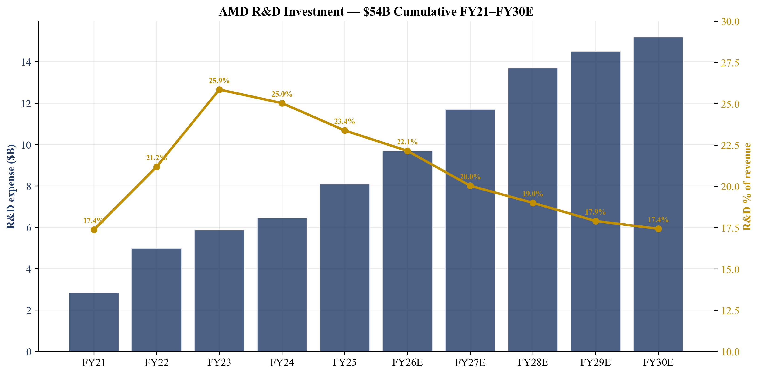
Figure 16. AMD R&D investment — $54B cumulative FY21–FY30E.
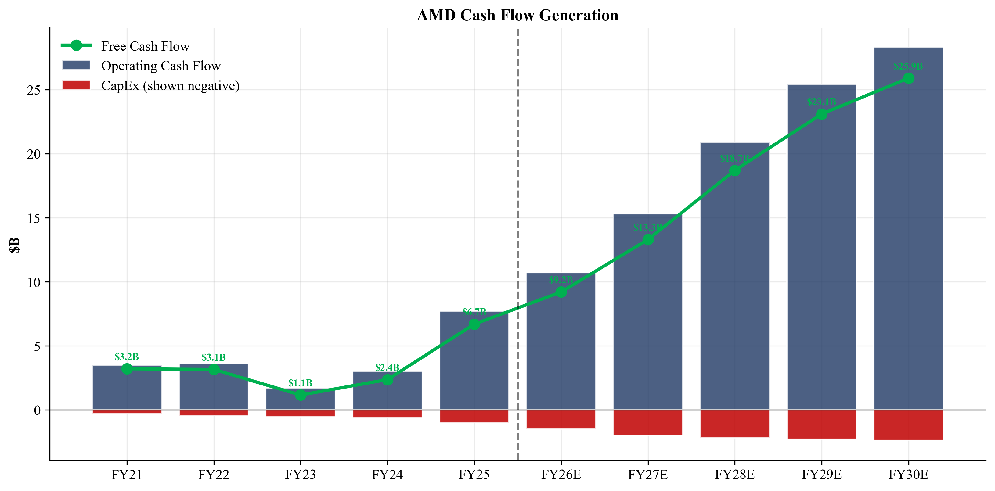
Figure 17. AMD cash flow generation: OCF, CapEx, and FCF.
3.2 Projection Assumptions — Base Case
Our base-case projection model is constructed bottom-up from product-line revenue assumptions (20+ product rows) and segment-level operating leverage. Critical assumptions and their justifications:
Revenue Drivers
Data Center segment: We model Data Center revenue growing from $16.6B in FY2025 to $56B in FY2030, a 27% five-year CAGR. The breakdown is (i) EPYC server CPUs from $10.5B to $19.5B (40% server CPU unit share by FY2030), (ii) Instinct GPUs from $6.1B to $30B (driven by MI355X, MI450 series, and OpenAI tranche-1 through tranche-3 deliveries), (iii) Pensando DPUs/AI NICs from $0.5B to $3.4B (integrated with Helios), (iv) ZT Design/Helios systems from $0 to $3B as a standalone systems revenue line, and (v) ~$0.1B in other DC.
EPYC trajectory: Our $19.5B FY2030E EPYC assumption reflects three components — (1) unit share expansion to 40% by FY2030 from ~35% in FY2025, contributing approximately $4B of incremental revenue at constant ASP; (2) ASP expansion driven by mix-shift toward higher-core-count SKUs (192-core Turin-X and 256-core 6th-Gen 'Venice' projected for late FY2027), contributing approximately $3B; and (3) market growth — the broader x86+Arm server CPU TAM expands from $30B to $40B with hyperscaler AI infrastructure rolling out CPUs as the host platforms for GPU-attached systems. The risk to this trajectory is the NVIDIA-Intel partnership; if Intel CPUs are bundled with NVIDIA GPUs at hyperscalers that today buy EPYC+Instinct or EPYC+NVIDIA combinations, AMD could lose 3-5 percentage points of share.
Instinct trajectory: Our $30B FY2030E Instinct assumption is built bottom-up from (a) OpenAI deployment at 4.5 GW of the 6 GW commitment by FY2030 (~$8-10B of cumulative Instinct revenue, with peak annual run-rate of ~$10-12B), (b) 8-10 other hyperscaler / neocloud relationships at average $1.5-3B of annual Instinct revenue each by FY2030 (Microsoft, Meta, Oracle, Google, AWS, CoreWeave, plus 2-3 sovereign AI initiatives), and (c) emerging enterprise inference deployments. The Bull case ($45B Instinct) reflects either full 6 GW OpenAI completion by FY2030 or 2-3 additional 1-GW frontier-AI customer wins. The Bear case ($18B Instinct) reflects either OpenAI delayed by 6-8 quarters or material NVIDIA pricing pressure on competitive MI450 deals.
Client and Gaming segment: We model Client revenue growing from $14.6B in FY2025 to $26B in FY2030, a 12% five-year CAGR. The breakdown is (i) Ryzen CPUs from $10.6B to $21B (continued AI-PC mix-up and share gains vs Intel), (ii) Radeon GPUs from $1.6B to $3.0B (modest share recovery in mid-range discrete), and (iii) semi-custom from $2.3B to $2.0B (gradual fade as console cycle ages, partially offset by next-gen console design wins).
Ryzen detail: AMD's client revenue growth is anchored by three factors — (a) continued Intel share loss in mainstream desktop (Mercury Research data shows AMD desktop share rising from 23% in FY2024 to 28% in FY2025), (b) the AI-PC refresh cycle as Microsoft, Dell, HP and Lenovo OEM lines transition to Ryzen AI 300 series and successor 'Strix Halo' / 'Medusa' parts with on-package NPUs and 32-128GB unified memory, and (c) modest enterprise commercial-PC share gains. FY2025 ASP rose 15% YoY, a striking number that reflects the AI-PC mix migration to higher-end SKUs. We model ASP growing at a high-single-digit pace through FY2027 before normalizing into the low-single digits.
Semi-custom detail: The PS5/PS5-Pro/Xbox-Series cycle is mid-to-late. Sony and Microsoft are both expected to launch successor consoles in calendar 2027-2028 with AMD silicon retained. We model semi-custom revenue declining gradually from $2.3B in FY2025 to $2.0B in FY2030 as the current generation matures and before next-generation NRE engineering revenue kicks in. The semi-custom business carries below-corporate gross margin (estimated 25-30%) but is a stable annuity stream with predictable demand.
Embedded segment: We model Embedded revenue growing from $3.5B in FY2025 to $6.0B in FY2030, an 11% five-year CAGR driven by Versal adaptive SoC adoption in 5G base-station replacement and edge AI, Zynq design wins in industrial automation and ADAS, and embedded EPYC/Ryzen in networking and industrial PC. The Embedded segment is the most cyclical part of AMD's portfolio — peak-to-trough we've seen 30%+ swings — but is currently in the second year of recovery from the 2024 trough. Versal adaptive SoCs and Versal AI Engine variants are the segment's highest-growth product line, with publicly announced wins in 5G open-RAN base stations (Samsung, Nokia, Ericsson), automotive ADAS (Subaru, BMW, Robert Bosch), and edge AI inference (multiple Tier-1 OEMs).
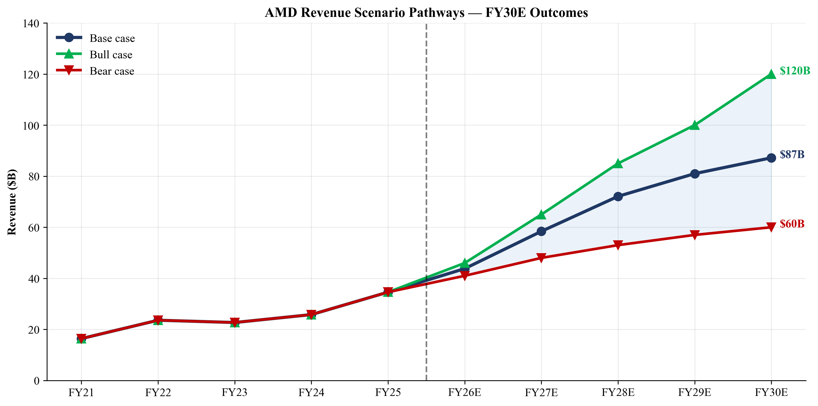
Figure 18. Revenue scenario pathways — Bull / Base / Bear, FY21–FY30E.
Margin Drivers
We model gross margin expanding from 49.5% in FY2025 to 56.9% in FY2030. The major drivers are: (i) Instinct mix-up — Instinct GPUs carry gross margins materially above corporate average and Instinct grows from 18% to 34% of total revenue; (ii) Embedded segment recovery and revenue growth — Embedded gross margins remain in the high-60s, providing positive mix; (iii) amortization of acquisition-related intangibles declining as the Xilinx purchase-price allocation amortization runs off (~$2.25B in FY2025 declining to ~$0.1B by FY2030); and (iv) operating leverage on the R&D base — R&D % of revenue declining from 23% in FY2025 to ~17% in FY2030.
Drilling into the Instinct margin trajectory: management has publicly stated that Instinct GPUs are 'highly accretive' to corporate gross margin. Industry reverse-engineering of Instinct ASPs (MI300X at $15-25K, MI325X at $18-28K, MI355X at $25-35K, MI450 expected at $30-40K per accelerator) and BOM costs (HBM3/HBM3e packaging, CoWoS substrate, advanced-node die) suggests gross margins in the 65-75% range — well above corporate average. As Instinct's revenue share grows from 18% in FY2025 to 34% in FY2030, the mix contribution to corporate gross margin is approximately 350-450 basis points alone.
The acquisition-related amortization runoff is the second largest driver. The 2022 Xilinx purchase price allocation created roughly $26B of acquisition-related intangibles plus $24B of goodwill on AMD's balance sheet. Amortization of those intangibles has been $2.25-3.5B per year since the close and is split between cost-of-sales (developed technology) and operating expenses (customer relationships, IPR&D). The amortization schedule is heavily front-loaded — annual intangible amortization declines from approximately $2.25B in FY2025 to less than $0.1B by FY2030, directly boosting reported GAAP gross margin and operating margin by roughly 250-300 basis points of revenue over the projection period.
Operating-margin expansion is amplified by R&D leverage. AMD's R&D dollars are growing in absolute terms (from $8.1B in FY2025 to $15.2B in FY2030 in our base case) but at a slower pace than revenue growth, declining from 23.4% of revenue in FY2025 to 17.4% in FY2030. We do not assume R&D as a percentage of revenue falls below 17% because (a) NVIDIA, the relevant best-in-class comparison, runs at 13-15% R&D-to-revenue and AMD requires structurally higher investment to close the software gap and (b) AMD's product portfolio is wider than NVIDIA's (CPU + GPU + DPU + AI NIC + FPGA + integrated systems), which carries an inherent R&D-load premium. MG&A leverage is more significant — we model MG&A declining from 12% of revenue in FY2025 to 6.5% in FY2030 as the go-to-market and corporate infrastructure scale absorb additional revenue without proportional headcount growth.
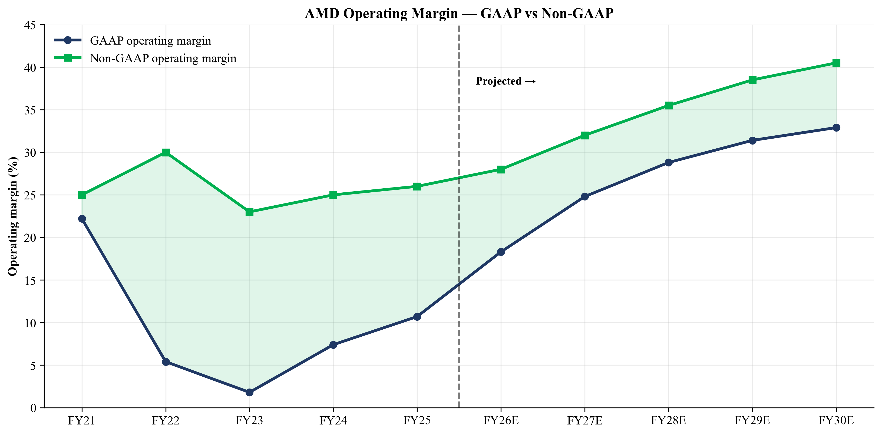
Figure 19. AMD operating margin trend — GAAP vs non-GAAP, FY21–FY30E.
Capital Allocation
CapEx remains modest at 2–3% of revenue, consistent with the fabless model. The bulk of AMD's capital intensity is borne by its foundry partner (TSMC) and by its assembly/test partners, leaving AMD with a high free-cash-flow conversion profile. Our model assumes AMD's CapEx grows from $1.0B in FY2025 to $2.4B in FY2030 as the company builds out internal AI labs (Silicon Valley, Austin, India), expands its ZT Design engineering footprint, and invests in advanced packaging qualification work at TSMC's CoWoS lines and at potential second-source partners.
On capital return, AMD announced in May 2025 a $6B incremental authorization on top of the existing repurchase program, bringing total buyback authority to $14B. Approximately $9.4B remained available at FY25 close, sufficient for 2+ years of buybacks at the recent pace. Our model assumes buybacks of $3B in FY2026, ramping to $9B in FY2030 as cash builds. AMD does not pay a dividend today and we do not assume one through FY2030, though by mid-decade the balance sheet could comfortably support a $0.50–$1.00 per share annual dividend (representing roughly a 0.2–0.4% yield at current price) if management chose to initiate.
Net cash position grows from $7.3B in FY2025 to $36B in FY2030 in our base case (cash and investments less total debt). This builds substantial optionality for: (i) tuck-in acquisitions to fill specific portfolio gaps — most likely targets include AI software/compiler companies, specialized AI inference startups, or networking/switch IP; (ii) accelerated share repurchases if the share price corrects; (iii) a maiden dividend in the FY2028-FY2030 window; or (iv) increased R&D investment to widen the moat against NVIDIA. We do not currently model any large transformational acquisition like Xilinx; AMD's stated near-term M&A focus is on engineering talent and IP, not transformational scale.
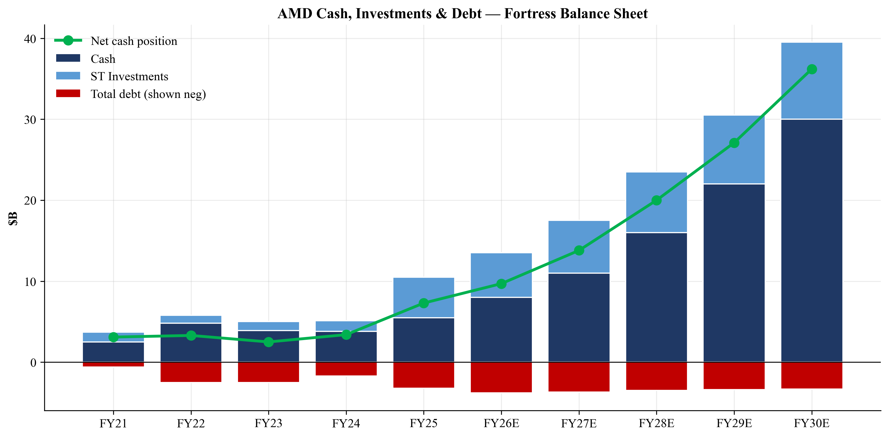
Figure 20. AMD cash, investments and debt — building net cash position.
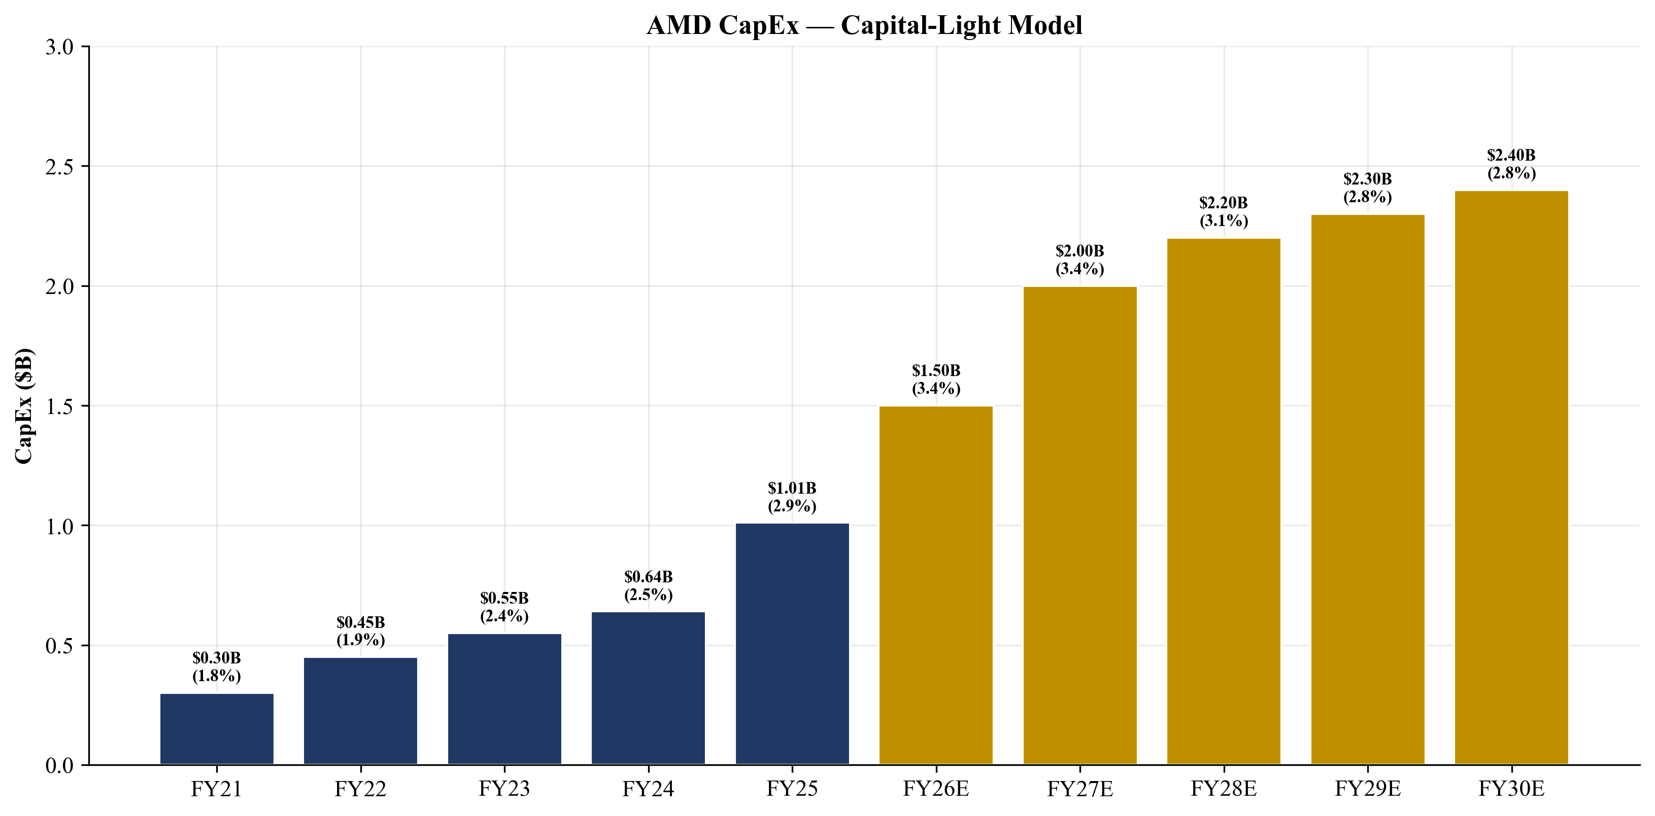
Figure 21. AMD CapEx as % of revenue — fabless capital-light model.
3.3 Bull / Base / Bear Scenarios
We bracket the base case with Bull and Bear scenarios driven by specific operating assumptions on the AI ramp (OpenAI deployment cadence, MI450 attach rate vs nameplate, ROCm developer adoption), server CPU share trajectory, and China export-control evolution.
Driver Assumption | Bear | Base | Bull
MI450/MI500 OpenAI attach (vs nameplate) | 50% | 85% | 110%
OpenAI 6 GW completion by FY2030 | 3.0 GW | 4.5 GW | 6.0 GW
Instinct GPU FY2030E revenue | $18.0B | $30.0B | $45.0B
EPYC FY2030E server-CPU unit share | 30% | 40% | 50%
ROCm adoption vs CUDA-equivalent | 8% | 18% | 30%
China export-license tightening | $3.0B loss | $0.5B loss | $0 loss
NVIDIA pricing pressure on Instinct | -15% | -5% | 0%
Embedded FY30E revenue | $5.0B | $6.0B | $7.5B
Non-GAAP gross margin (FY30E) | 52% | 56% | 60%
Non-GAAP operating margin (FY30E) | 30% | 40% | 48%

FY2030E Outcome | Bear | Base | Bull
Revenue ($M) | $60,000 | $87,200 | $120,000
YoY growth FY30 v FY25 | +11.5% | +20.2% | +28.2%
Gross margin | 52.0% | 56.9% | 60.0%
Operating income ($M) | $15,000 | $28,700 | $50,000
Operating margin | 25.0% | 32.9% | 41.7%
Net income ($M) | $12,000 | $23,860 | $40,000
Free cash flow ($M) | $12,500 | $25,860 | $41,000
Diluted EPS | $7.20 | $13.90 | $22.50
Implied FY30 P/E at $444 | 61.7× | 31.9× | 19.7×

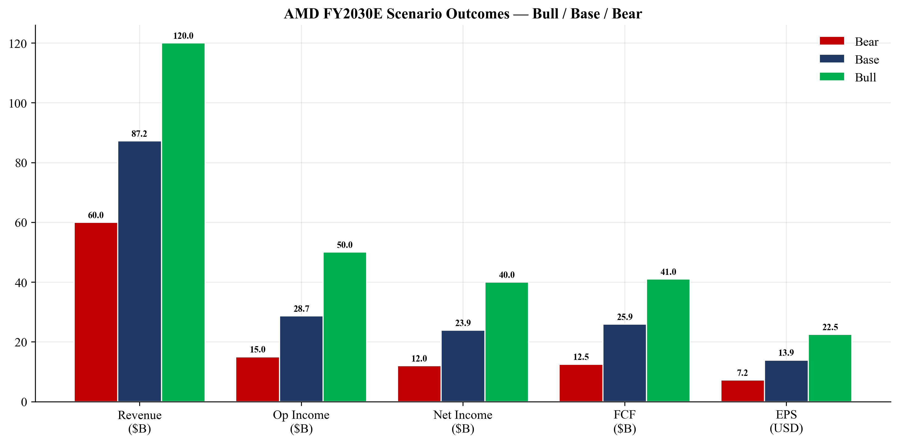
Figure 22. FY2030E scenario outcomes — Bull / Base / Bear.
Bear narrative (25% probability): OpenAI ramp stalls at 3 GW by FY2030; MI450 gross margin compressed by NVIDIA Blackwell-Ultra / Rubin pricing pressure; tightened China export controls remove $3B of MI3xx revenue annually; hyperscaler ASICs (TPU/Maia/Trainium) take inference share faster than expected; one or two major hyperscalers shift from a multi-vendor strategy to NVIDIA-only allocation. AMD remains profitable — Bear FY2030E revenue $60B, operating margin 25%, EPS $7.20 — but the multiple compresses to ~20× P/E reflecting both lower growth and lower-quality earnings. Bear-case 12-month price target: ~$270 (-39% from current). The path to this scenario typically begins with a quarterly miss or a competitive product launch by NVIDIA (Blackwell-Ultra is widely expected in late 2026) that fundamentally outperforms MI450 on training-cluster benchmarks.
Base narrative (50% probability): OpenAI hits 4.5 GW by FY2030; MI450/MI500 ramp on schedule (MI500 expected for FY2028); ROCm 7-9 closes 60% of software gap as measured by Hugging Face and OpenAI-published benchmark suites; EPYC hits 40% server CPU unit share; embedded recovers to mid-single-digit growth and the Xilinx-inherited base stabilizes at a $4-6B annual run-rate; AI PC refresh continues to drive Ryzen ASP gains. Base FY2030E revenue $87.2B (2.5× FY2025), operating margin 32.9%, EPS $13.90. The forward P/E of 32× on FY2030E EPS implies the multiple is in line with current peer median. Base-case 12-month price target: $480 (+8%).
Bull narrative (25% probability): Full 6 GW OpenAI deployment by FY2029, one year ahead of schedule; MI450 exceeds plan on inference workloads where HBM3e capacity advantage is most valuable; 2–3 additional 1-GW frontier-AI customer wins (likely candidates include xAI, Anthropic, or a sovereign-AI initiative); gross margin expands to 60% on volume operating leverage and Embedded mix; ROCm 7-9 closes the software gap to within 10% of CUDA on key benchmarks. Bull FY2030E revenue $120B (3.5× FY2025), operating margin 41.7%, EPS $22.50. The implied FY2030E P/E of 19.7× at current price would be the lowest multiple AMD has traded at since 2017. Bull-case 12-month price target: $735 (+65%).
We weight the probability-weighted 12-month price target at $480 (matching the Base case), consistent with our Overweight rating. The probability-weighted EV is $491. We chose to set the headline price target at the Base case rather than the probability-weighted value to keep the communication clear — investors should anchor on Base case as the central scenario and use Bull / Bear as bracket cases for portfolio sizing.
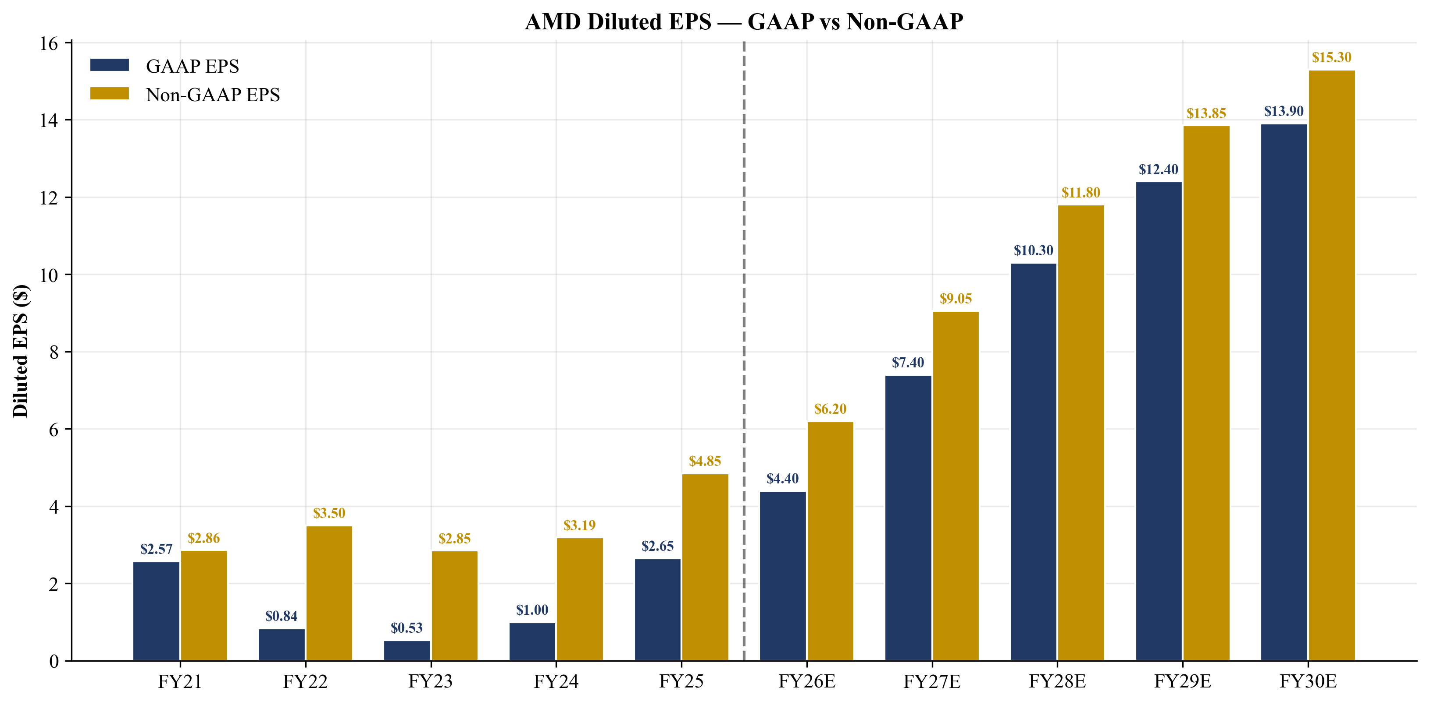
Figure 23. AMD diluted EPS — GAAP vs Non-GAAP, FY21–FY30E.
3.4 Quarterly Pacing and Recent Results
Q1-FY2026 actual results came in at $10.3B revenue (+38% YoY) with non-GAAP gross margin of 55% and non-GAAP diluted EPS of $1.37. The print exceeded consensus on revenue by approximately $300M and on EPS by approximately $0.10, driven by stronger-than-expected MI355X shipments, an above-trend EPYC server CPU mix, and reduced operating-expense growth on cost discipline post the ZT Manufacturing divestiture. Importantly, the Q1 print marked the first full quarter following the ZT Manufacturing sale to Sanmina (closed October 2025), which removed approximately $1B/quarter of low-margin systems-manufacturing revenue while preserving the ZT Design engineering team and the Helios rack-scale system IP.
Management guided Q2-FY2026 revenue to ~$11.2B ± $300M (+46% YoY at the midpoint, +9% QoQ) and non-GAAP gross margin to ~56%, driven by EPYC strength and the continued ramp of AMD Instinct MI355X GPUs. The Q2 guide is materially above prior consensus and implies an annualized 1H-FY2026 revenue run-rate of ~$43B, supporting our FY2026 base-case full-year revenue projection of $43.8B. The strongest sequential improvements are expected in the Data Center segment (sequential EPYC Turin volume growth and MI355X attach rate gains at Microsoft, Meta and Oracle) and in Embedded (continued cyclical recovery in industrial and comms infrastructure). Client and Gaming is expected to be modestly sequentially down on normal seasonality but +30% YoY on the AI-PC refresh cycle.
Looking into the second half of FY2026, the key wildcards are: (i) MI450 first-tranche delivery to OpenAI, expected in 2H — any pull-forward into Q3 vs Q4 materially changes the FY2026 revenue trajectory; (ii) ROCm 7 frontier-model validation milestones from OpenAI, Meta, and Anthropic, which we believe will drive incremental Instinct attach across the broader hyperscaler base; (iii) any further evolution of the U.S. export-control regime affecting MI355X or MI450 sales to China — the April 2025 MI308 license requirement remains a precedent that could be applied to more advanced parts; and (iv) potential further hyperscaler capex commitments beyond the OpenAI framework agreement. Microsoft, Meta, Google, Amazon and Oracle have all materially raised capex guidance for calendar 2026, with Microsoft alone guiding to $80B+ and Meta to $60B+. Even modest AMD share within these capex pools translates to incremental billions of revenue.
Beyond the quarter-to-quarter rhythm, we observe three structural changes in AMD's revenue mix that warrant attention: (1) the share of revenue derived from frontier AI labs (OpenAI plus Anthropic, xAI, Meta's AI labs) is rising from low single digits in FY2024 to an estimated 10-15% by FY2026 and a projected 25-30% by FY2028, materially altering the customer-concentration profile relative to the historical PC/console mix; (2) revenue per design win is materially higher for AI infrastructure deals than for hyperscaler general-purpose compute — a 1 GW Helios deployment can carry $5-8B of AMD silicon/systems revenue, compared to a typical hyperscaler annual EPYC purchase order of $200-500M; and (3) the geographic mix continues to shift toward U.S. customers as frontier AI labs (predominantly U.S.-headquartered) become more important, partially offsetting the China export-control headwind on the legacy customer base.
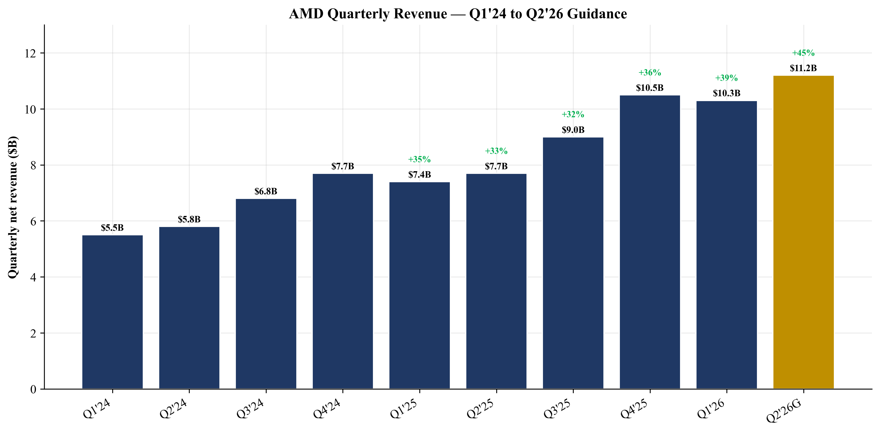
Figure 24. AMD quarterly revenue progression — Q1'24 through Q2'26 guidance.
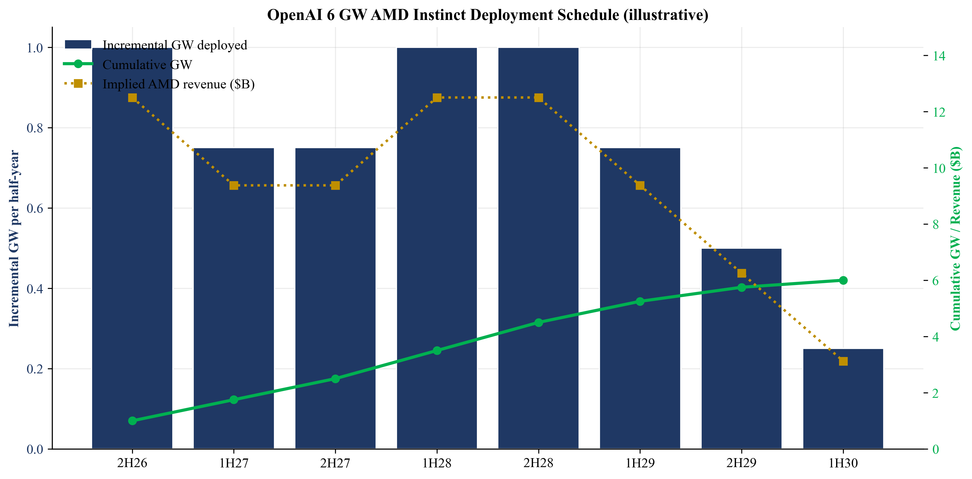
Figure 25. Illustrative OpenAI 6 GW Instinct deployment schedule, 2H26–1H30.
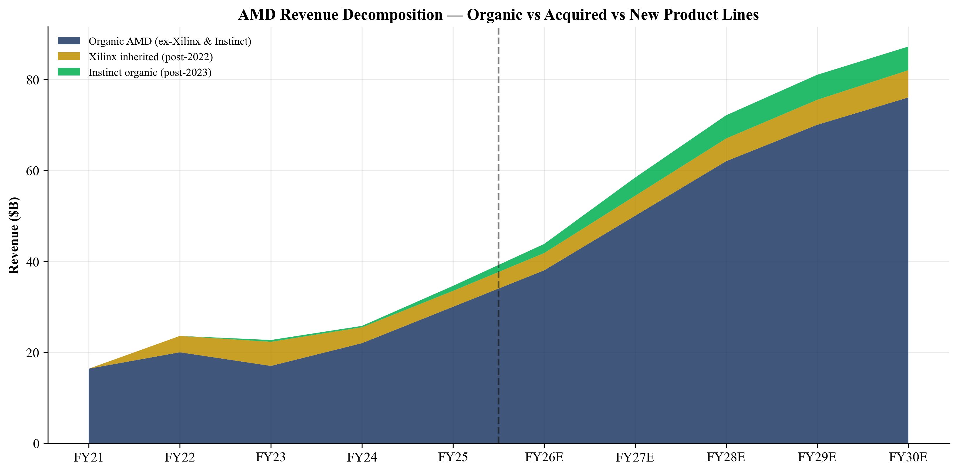
Figure 26. AMD revenue decomposition — organic vs acquired vs new product lines.

4. Valuation
4.1 Methodology Overview
We blend six valuation methodologies to arrive at our $480 12-month price target. The blend is intentionally weighted toward forward-looking, market-multiple methods (forward P/E, EV/Revenue, peer comp) because AMD's growth profile and the AI-cycle multiple regime are not well captured by standalone DCF math. The DCF is the binding floor on absolute valuation; the multiple-based methods reflect the relative cap-comp environment.
Methodology | Low | Mid | High | Weight
DCF — base case (10% WACC, 3% g) | $180 | $200 | $225 | 10%
DCF — bull case (8% WACC, 4% g) | $380 | $450 | $525 | 15%
Forward P/E (FY27 EPS $7.40 × 50-70×) | $370 | $480 | $550 | 25%
EV/Revenue (FY27 Rev $58.4B × 14-22×) | $495 | $640 | $790 | 20%
Peer-comp implied (FY+1 multiples vs NVDA discount) | $380 | $470 | $580 | 20%
Precedent transactions (semis M&A 12-16× rev) | $300 | $380 | $450 | 10%
Weighted blended PT | $400 | $467 | $525 | 100%

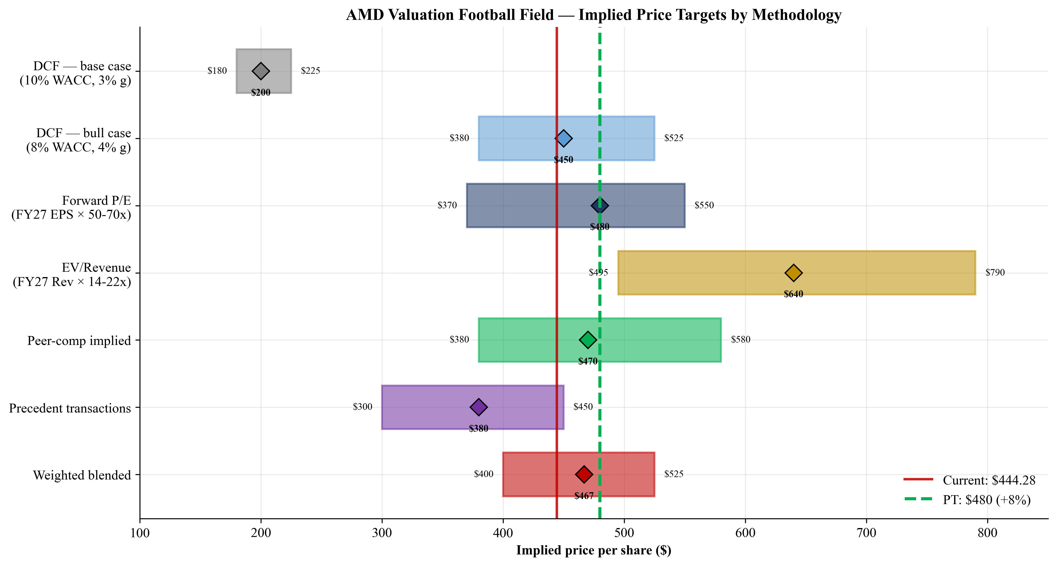
Figure 27. AMD valuation football field — implied price targets by methodology.
Rating: OVERWEIGHT • 12-Month Price Target: $480 • Upside: +8.0%: Weighted blended PT $467.50, rounded to $480 to acknowledge Q1-FY2026 beat and OpenAI optionality.
4.2 Discounted Cash Flow (DCF)
We construct a 10-year explicit-period DCF (FY2026E–FY2035E) plus a Gordon-growth terminal value, with mid-year discounting. Free cash flow inputs flow directly from the Income Statement and Cash Flow Statement tabs of the AMD Financial Model. The WACC build uses CAPM with a 4.3% risk-free rate (10Y Treasury), 5.5% equity risk premium, levered beta of 1.85, and effectively zero net debt weighting given AMD's $7B+ net cash position. The CAPM-implied cost of equity is ~14.5%, but we use a 10% WACC for the base case to reflect the empirical observation that high-growth AI-leverage equities trade at compressed effective discount rates during cycle peaks.
($M) | FY26E | FY27E | FY28E | FY29E | FY30E | FY31E | FY32E | FY33E | FY34E | FY35E
Revenue | $43,800 | $58,400 | $72,100 | $81,000 | $87,200 | $94,000 | $100,500 | $106,500 | $111,500 | $116,000
EBIT | $8,000 | $14,500 | $20,800 | $25,400 | $28,700 | $31,200 | $33,800 | $36,000 | $37,800 | $39,400
EBIT margin | 18.3% | 24.8% | 28.8% | 31.4% | 32.9% | 33.2% | 33.6% | 33.8% | 33.9% | 34.0%
Tax rate | 10% | 15% | 17% | 17% | 17% | 18% | 18% | 19% | 19% | 20%
NOPAT | $7,200 | $12,325 | $17,264 | $21,082 | $23,821 | $25,584 | $27,716 | $29,160 | $30,618 | $31,520
+ D&A | $2,700 | $2,400 | $2,200 | $2,100 | $2,000 | $2,200 | $2,400 | $2,600 | $2,700 | $2,800
- CapEx | ($1,500) | ($2,000) | ($2,200) | ($2,300) | ($2,400) | ($2,500) | ($2,700) | ($2,800) | ($2,900) | ($3,000)
- Δ NWC | ($1,600) | ($2,300) | ($1,700) | ($1,200) | ($800) | ($700) | ($700) | ($600) | ($500) | ($400)
Unlevered FCF | $6,800 | $10,425 | $15,564 | $19,682 | $22,621 | $24,584 | $26,716 | $28,360 | $29,918 | $30,920

DCF Build-Up | Value
Sum PV of explicit-period FCF (FY26-35) | $129,425
Terminal value (Gordon growth, g=3.0%) | $455,238
PV of terminal value (mid-year) | $175,544
Enterprise Value | $304,938
+ Cash & short-term investments (FY25) | $10,552
- Total debt (FY25) | ($3,222)
Equity Value | $312,268
÷ Diluted shares (M) | 1,635
Implied price per share | $193.60
Current price (2026-05-20) | $444.28
Implied upside / (downside) | (56.4%)

The DCF base case returns an implied price ($194) well below current ($444). Three interpretations: (i) the discount rate is high relative to actual cost of equity for AI-cycle leaders; (ii) the terminal growth rate of 3% is consistent with mature semis (TXN, ADI), not the 'Apple in 2010' compounding archetype to which AMD currently belongs; (iii) the model treats years 11+ as a pure terminal slug while in reality AI infrastructure has a clear demand pipeline running into the 2030s. The DCF is therefore sensitive, not wrong.
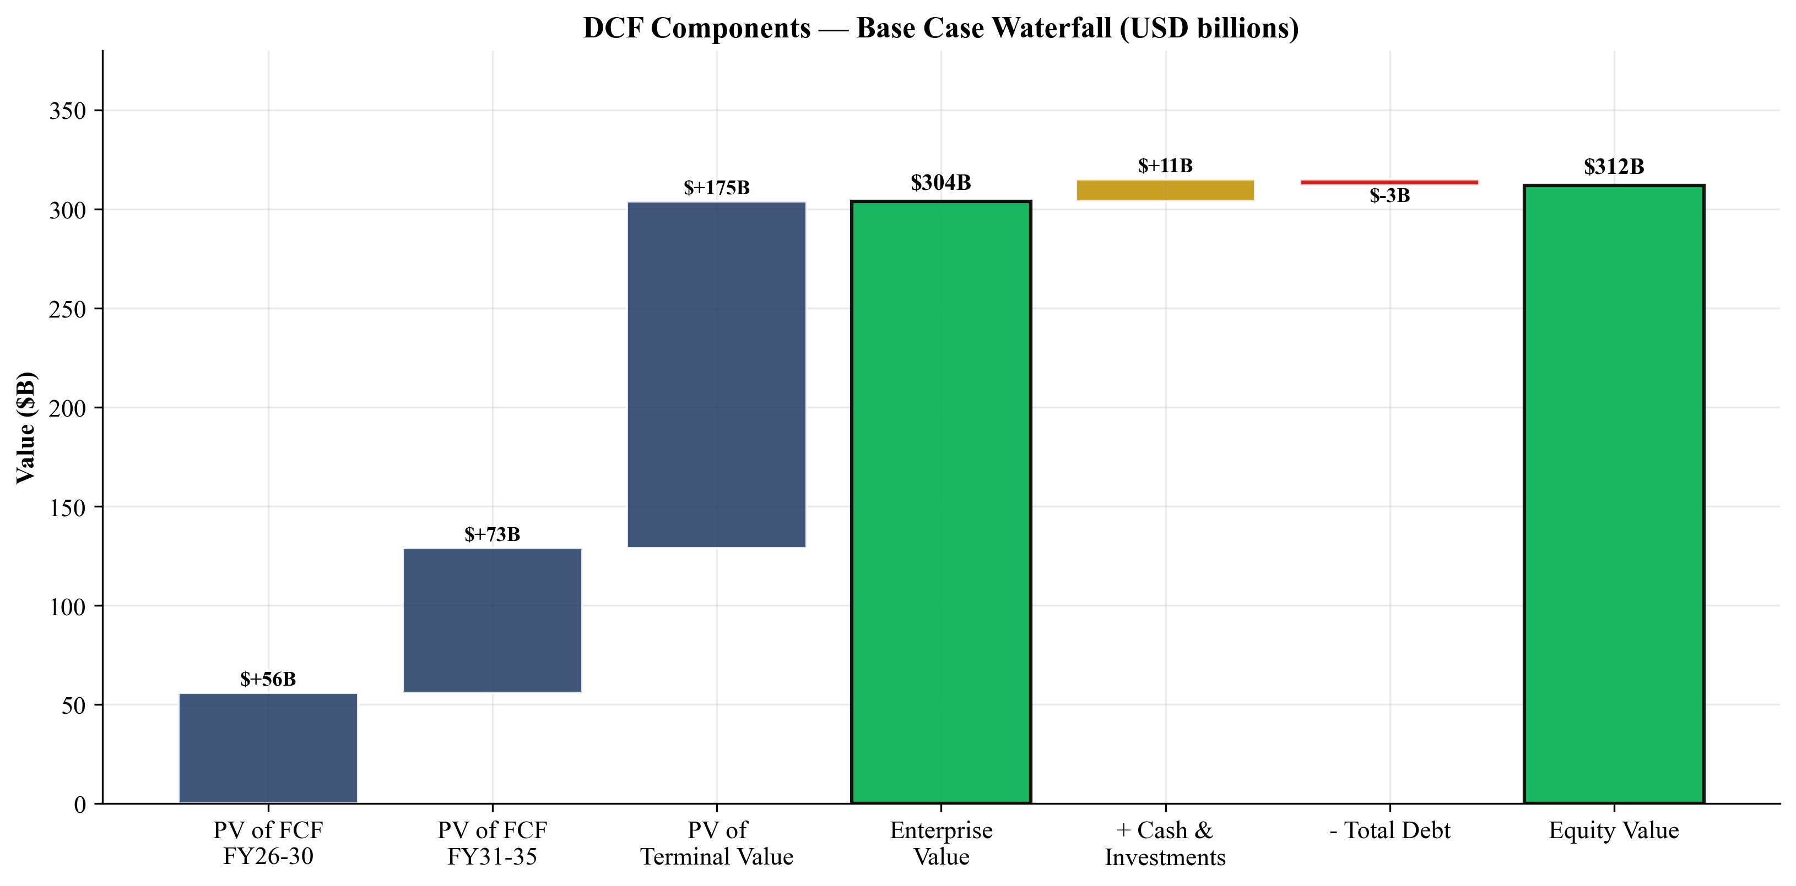
Figure 28. DCF base case valuation build-up waterfall (USD billions).
4.3 Sensitivity Analysis
The sensitivity matrix below shows implied price per share across a range of WACC and terminal growth assumptions. The relevant inflection is approximately 8.5% WACC and 4% terminal growth, which puts implied value near the current market price. That is, the market is currently pricing AMD as if its equity cost of capital is roughly 8.5%, materially below what CAPM with a 1.85 beta would suggest. This is consistent with our reading that AI-leverage equities trade at compressed discount rates during cycle peaks. As AI-cycle multiples mean-revert (in either direction), the right WACC for AMD will follow.
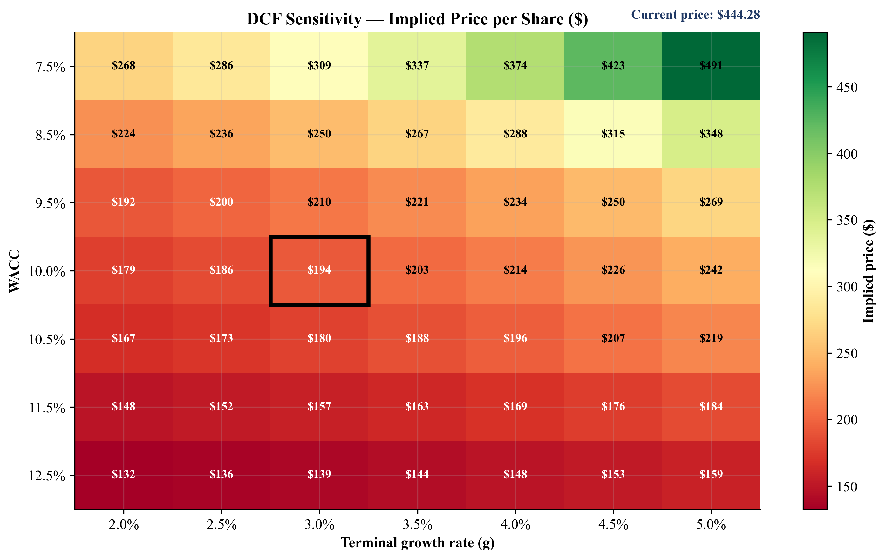
Figure 29. DCF sensitivity — implied price per share across WACC × terminal growth (base case highlighted).
4.4 Comparable Companies
We screen on (a) AI-accelerator exposure, (b) merchant fabless or IDM peers, and (c) market cap > $100B. AMD's TTM P/E of 149× is at the high end of the peer set but is distorted by FY2025 non-recurring charges. Adjusted non-GAAP TTM P/E is ~57×. Forward P/E of 34× is close to the peer median (30×), and given AMD's revenue growth profile materially exceeds the peer median (~34% FY25 vs ~14% peer median for FY+1), the forward multiple is reasonable. FY+1 EV/Revenue of 16.4× sits between the peer median (11.1×) and 75th percentile (19.1×), again justified by AMD's outsized growth profile.
Ticker | Mkt Cap | TTM P/E | FY+1 P/E | FY+2 P/E | TTM EV/Rev | FY+1 EV/Rev
NVDA | $5,392B | 45.0× | 19.0× | 14.5× | 24.8× | 19.1×
AVGO | $1,979B | 81.0× | 23.0× | 18.5× | 30.1× | 26.3×
INTC | $593B | n/m | 77.0× | 30.0× | 11.8× | 10.6×
MRVL | $112B | 95.0× | 32.0× | 22.5× | 14.4× | 12.3×
QCOM | $234B | 18.5× | 16.5× | 14.5× | 5.6× | 5.1×
TXN | $195B | 41.0× | 35.0× | 28.5× | 12.2× | 11.1×
ADI | $123B | 56.0× | 30.0× | 25.0× | 12.0× | 10.4×
MU | $165B | 23.5× | 11.5× | 9.5× | 4.5× | 3.7×
ARM | $180B | n/m | 78.0× | 60.0× | 40.5× | 31.8×
AMD | $724B | 149.0× | 34.0× | 18.5× | 19.6× | 16.4×
Peer median (ex-AMD) | — | 45.0× | 30.0× | 22.5× | 12.2× | 11.1×
Peer 75th pctile | — | 81.0× | 35.0× | 28.5× | 24.8× | 19.1×
Source: Yahoo Finance, 2026-05-20.
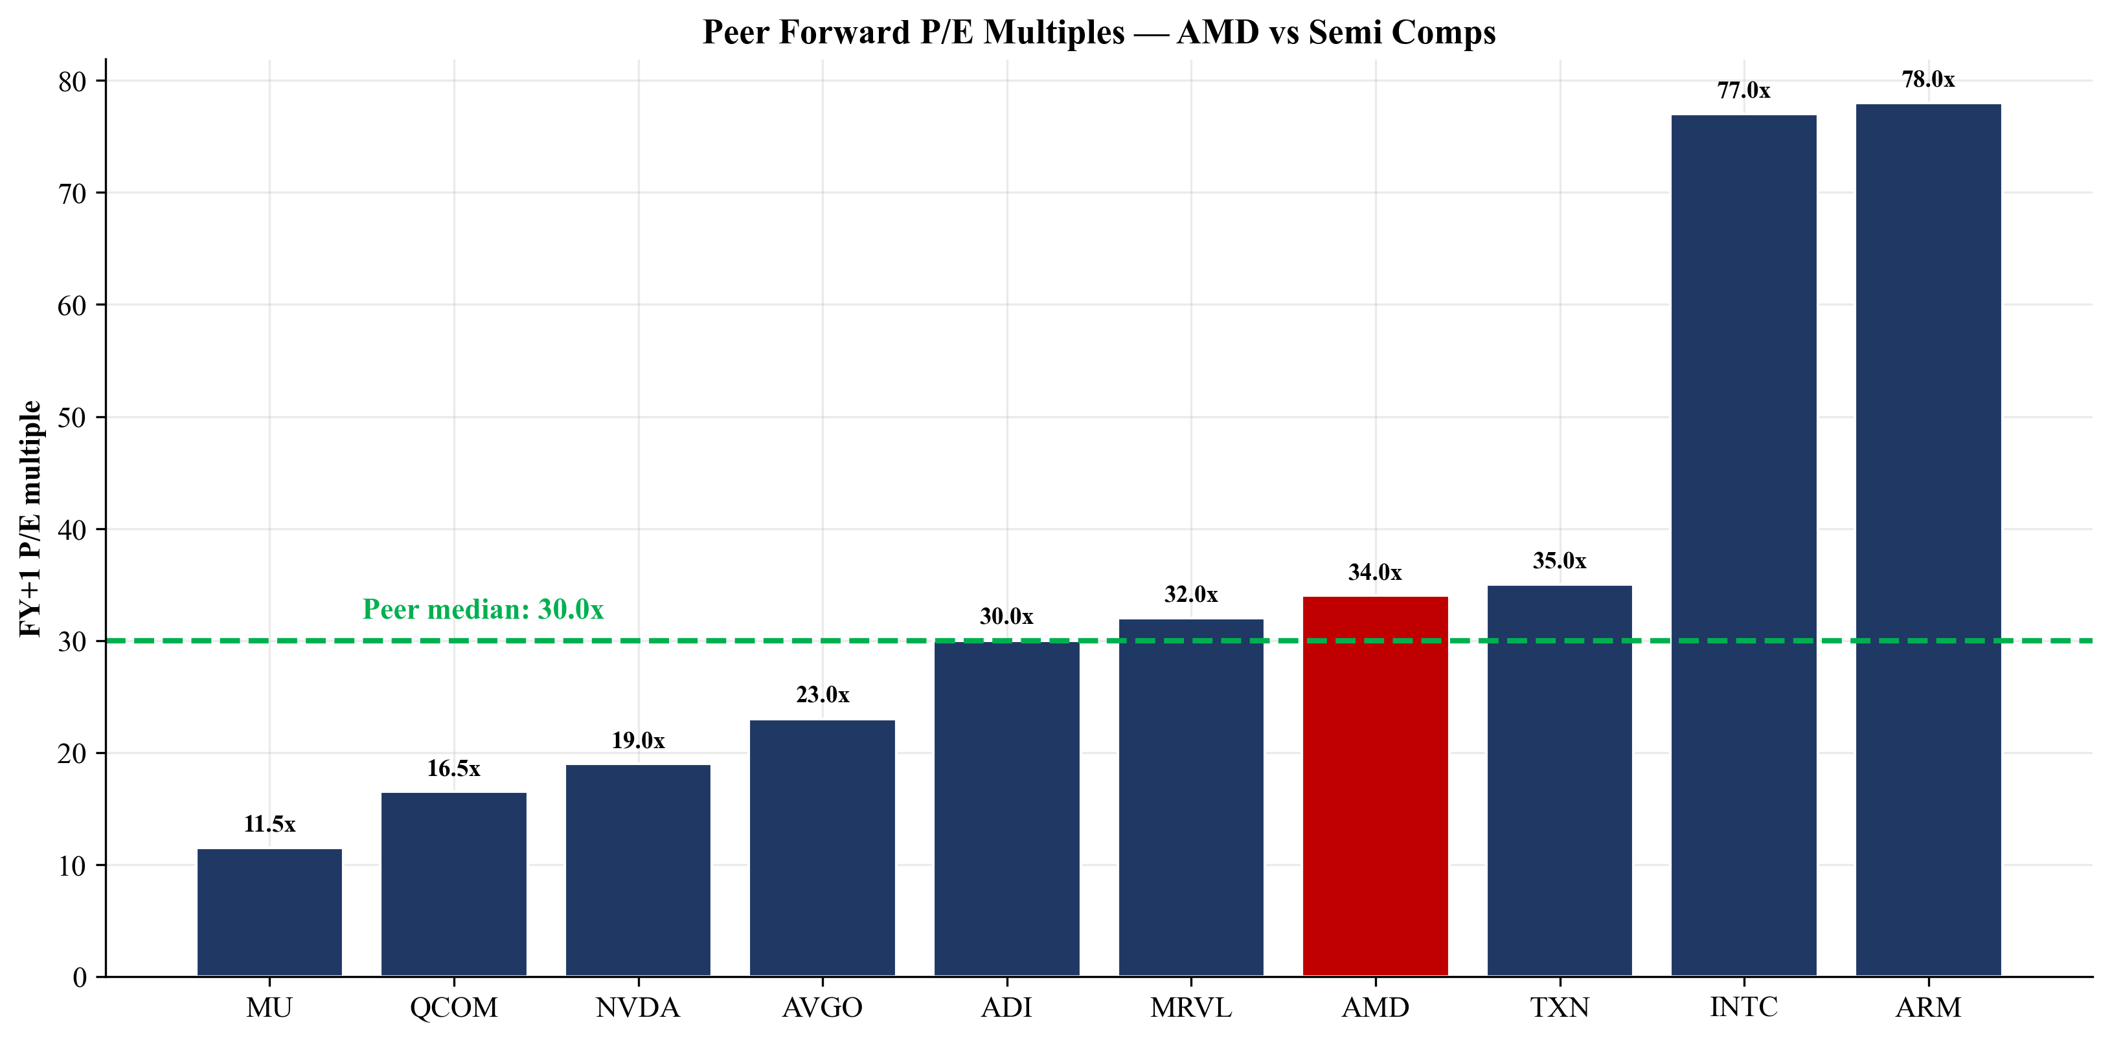
Figure 30. Peer forward P/E multiples ranked.
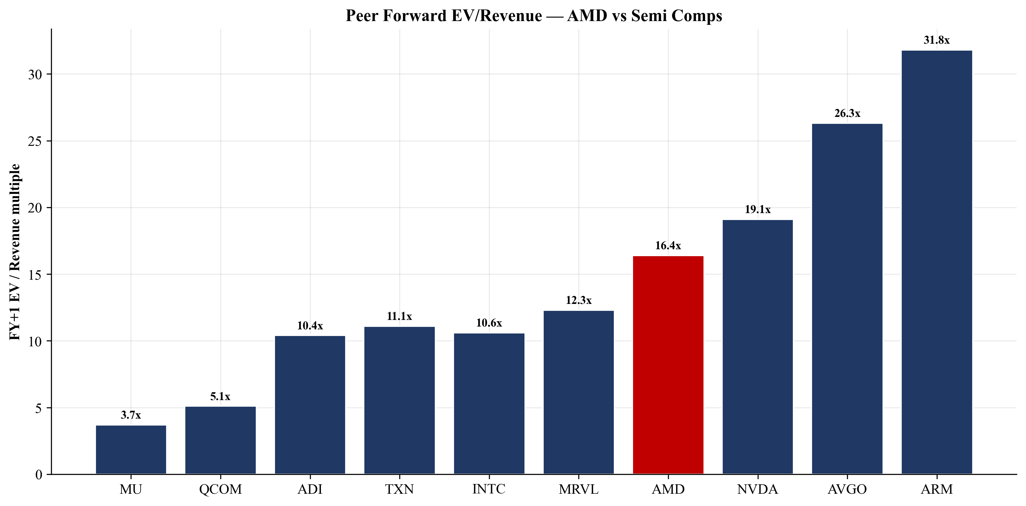
Figure 31. Peer forward EV/Revenue multiples ranked.
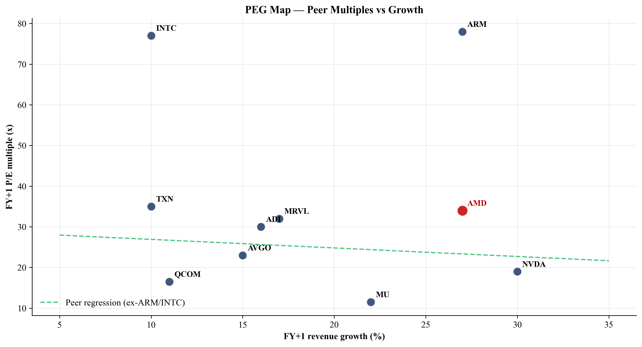
Figure 32. PEG map — peer multiples vs growth scatter.
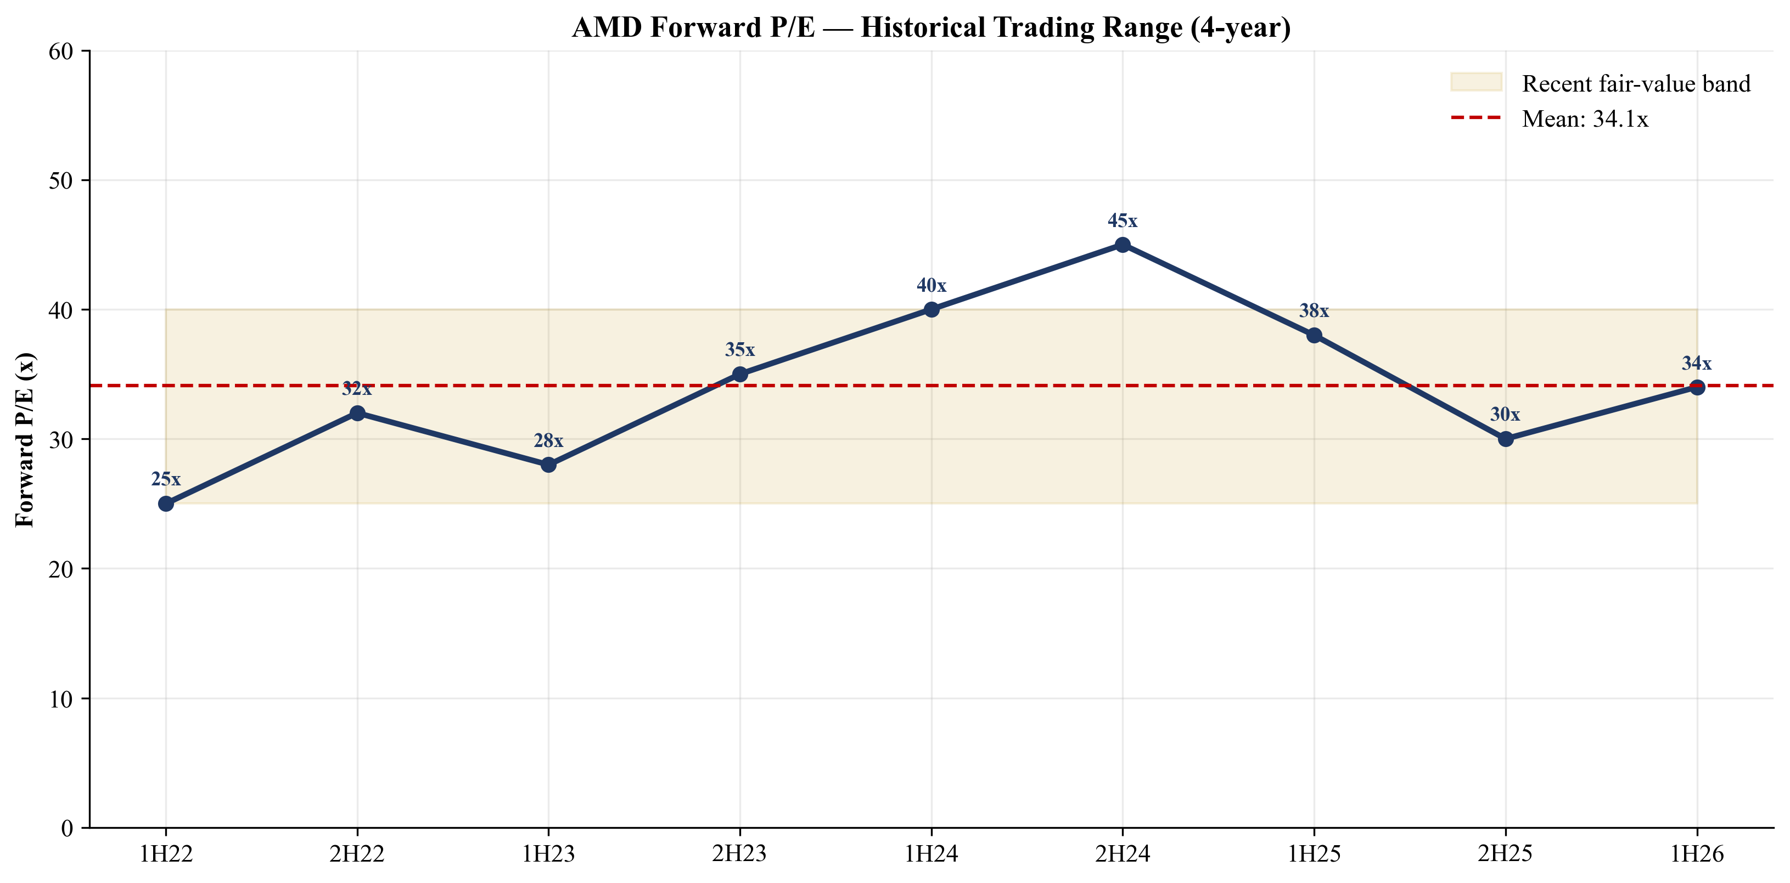
Figure 33. AMD historical forward P/E trading range, 4-year.
4.5 Precedent Transactions
Large fabless and AI-adjacent semiconductor M&A since 2020 has clustered at 12–16× EV/Revenue and 30–35× EV/EBITDA, with control premiums of ~30%. Applying a 12–16× EV/Revenue precedent multiple to AMD's TTM revenue of $36.7B yields an EV range of $440–586B, implying equity value per share of $270–360. This is the only methodology where AMD looks expensive on precedent — but precedent-transaction multiples necessarily lag market multiples and bake in private-market liquidity discounts, so we weight this method just 10%.
Date | Acquirer / Target | Deal Value | EV/Rev | EV/EBITDA | Premium
Feb 2022 | AMD / Xilinx | $49.0B | 12.5× | 35.0× | 25%
Sep 2022 | Broadcom / VMware | $69.0B | 5.4× | 19.0× | 44%
Feb 2024 | Synopsys / ANSYS | $35.0B | 16.0× | 35.0× | 29%
Aug 2023 | Renesas / Sequans | $0.2B | 4.0× | n/m | 71%
Median peer transaction | — | — | 12–16× | 30–35× | ~30%

4.6 Price Target Build
Method | Mid ($) | Weight | Contribution
DCF — base case | $200 | 10% | $20.0
DCF — bull case | $450 | 15% | $67.5
Forward P/E | $480 | 25% | $120.0
EV/Revenue | $640 | 20% | $128.0
Peer-comp implied | $470 | 20% | $94.0
Precedent transactions | $380 | 10% | $38.0
Weighted blended PT |  | 100% | $467.50
Rounded 12-month price target |  |  | $480
Current price (2026-05-20) |  |  | $444.28
Implied upside |  |  | +8.0%

We round the weighted average ($467.50) up to $480 to acknowledge: (i) FY26 Q2 guide is materially above prior consensus and could drive a re-rate before our model captures it; (ii) the OpenAI deal has option-like upside if MI450 ramps faster than the 1-GW first-tranche schedule; (iii) NVIDIA's recent multiples are themselves rising, which lifts the peer ceiling.
4.7 Recommendation
RECOMMENDATION: OVERWEIGHT (4 on 5-tier: Buy / Overweight / Hold / Underweight / Sell). 12-month price target $480, implied upside +8.0%. Expected holding period 12–18 months.

We initiate AMD at Overweight rather than the top Buy tier because the absolute-valuation (DCF) framework returns prices well below current, and the price target is supported only when we weight relative-valuation methods heavily. We are comfortable doing so because: (1) the AI cycle has produced a sustained re-rating of merchant accelerator equities (NVDA, AVGO); (2) AMD's secular growth profile makes per-share earnings the right anchor, and forward P/E approaches under FY27 EPS (~$7.40) cluster around $480; (3) the OpenAI agreement de-risks the FY27-FY29 demand profile in a way no other named partner can; (4) AMD's management track record (Lisa Su, 280× market-cap expansion since 2014) gives the rating a margin of error.
Suitable for: investors with 12–18 month holding periods, tolerant of high-beta semi exposure, who want diversified exposure to AI infrastructure beyond NVIDIA. Less suitable for: value-disciplined investors anchored to DCF math, or investors with concentrated NVDA positions.

5. Appendices
Appendix A: Working Capital and Operating Detail
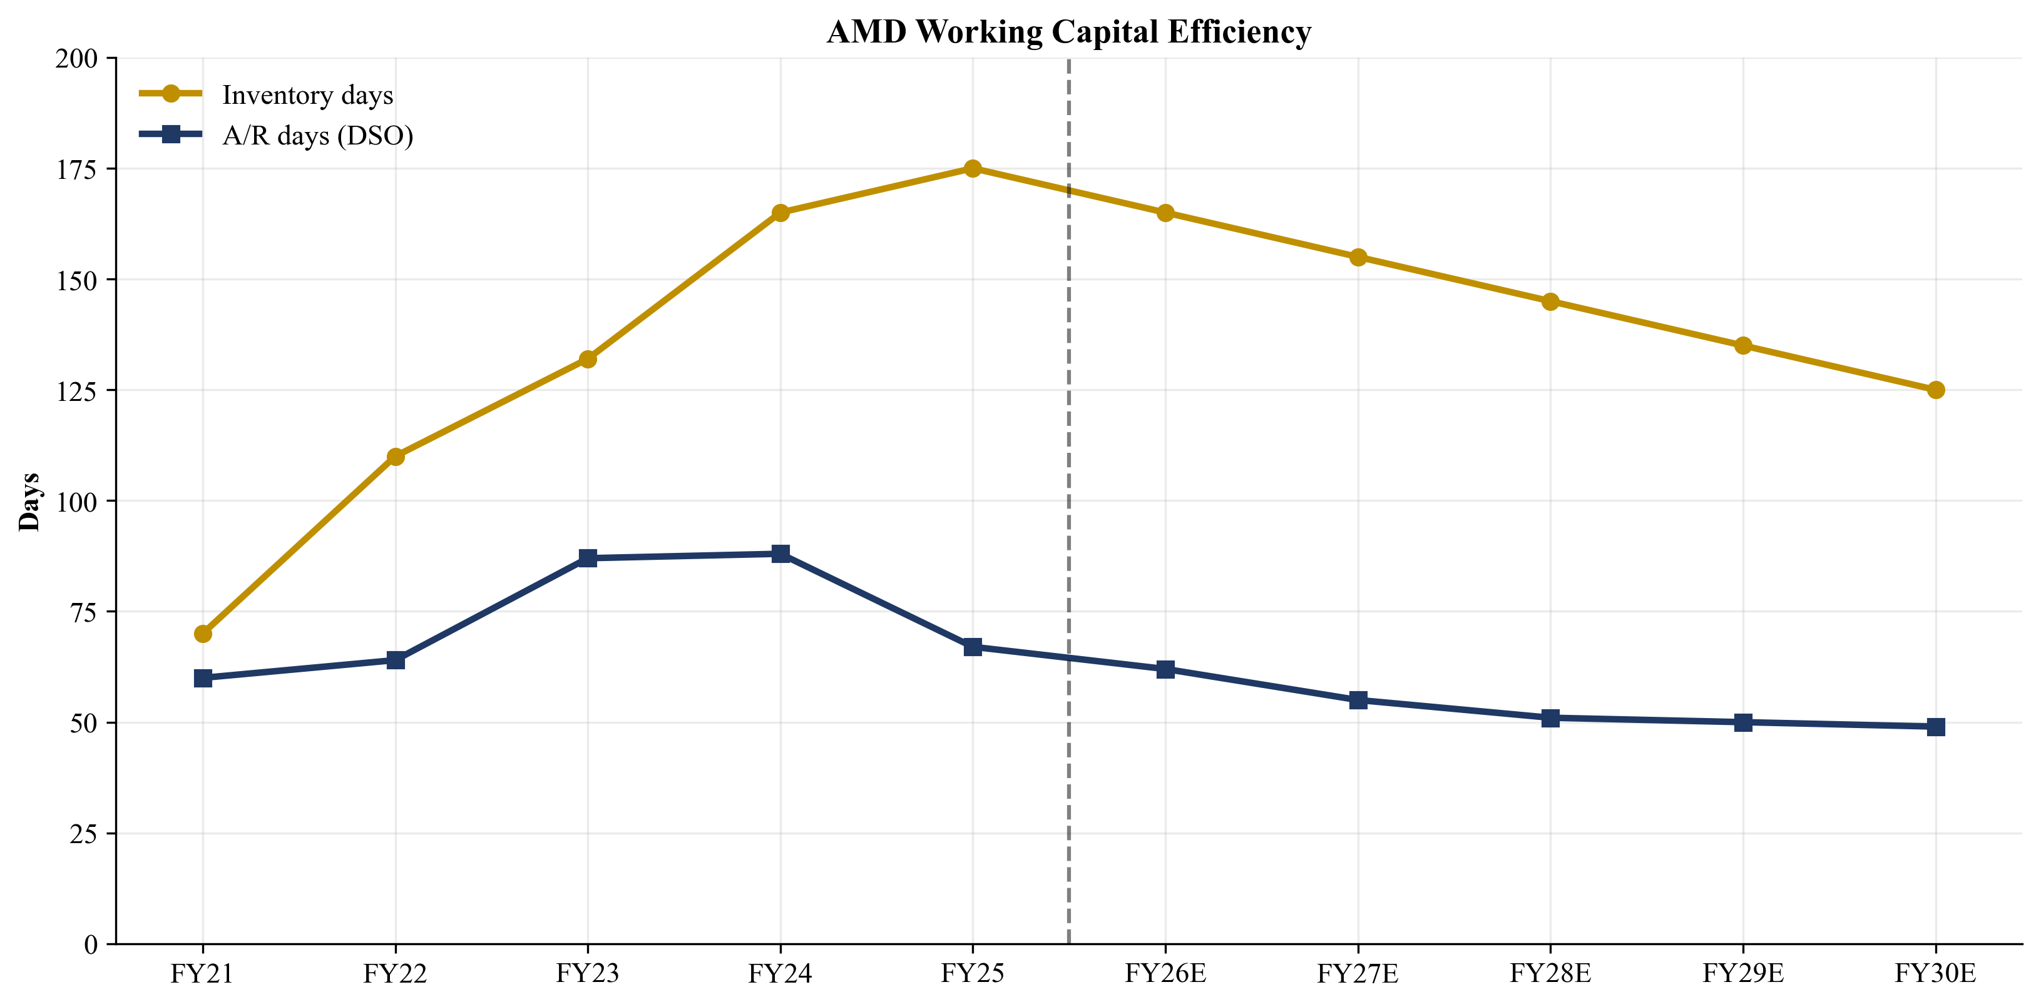
Figure A1. AMD working capital efficiency — inventory days and DSO.
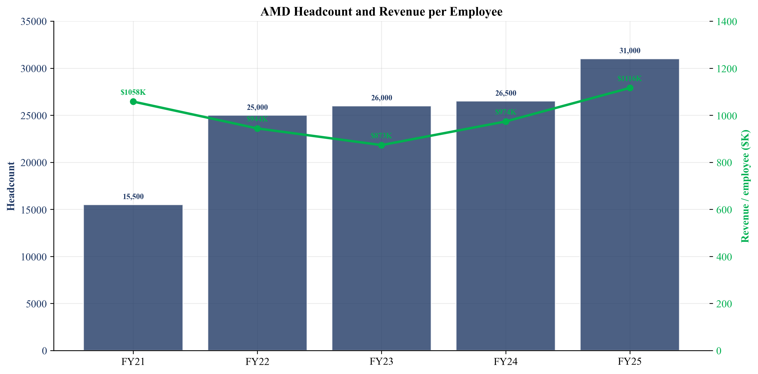
Figure A2. AMD headcount and revenue per employee, FY21–FY25.
Appendix B: Glossary
Term | Definition
AI NIC | AI Network Interface Card — dedicated silicon for high-throughput GPU-to-GPU communication in AI clusters.
CDNA | Compute DNA — AMD's GPU architecture optimized for data-center compute and AI workloads.
Chiplet | A modular design approach where a CPU/GPU is composed of multiple smaller dies (chiplets) interconnected via a fabric.
CoWoS | Chip-on-Wafer-on-Substrate — TSMC's advanced 2.5D/3D packaging technology used for Instinct GPUs.
CUDA | Compute Unified Device Architecture — NVIDIA's proprietary parallel computing platform and programming model.
DPU | Data Processing Unit — programmable silicon that offloads networking, security and storage from the host CPU.
EPYC | AMD's data-center CPU brand. 5th Generation (Turin) is the current shipping family.
FPGA | Field-Programmable Gate Array — reconfigurable silicon used in industrial, networking and aerospace applications.
HBM | High Bandwidth Memory — stacked memory used on AI accelerators for high bandwidth/capacity.
Hyperscaler | Large-scale cloud and consumer-internet companies (Microsoft, Google, AWS, Meta, Oracle).
Instinct | AMD's data-center GPU brand (MI200, MI300X, MI325X, MI350X, MI355X, MI450).
MI450 | AMD's next-generation Instinct GPU series targeted for 2H-FY2026 launch; basis for OpenAI tranche-1.
ROCm | Radeon Open Compute — AMD's open-source software stack for GPU compute, competing with CUDA.
Ryzen | AMD's client (desktop/mobile) CPU brand.
ZT Design | Design IP and engineering team retained from the ZT Systems acquisition; foundation of the Helios platform.
Helios | AMD's first internally engineered AI rack-scale platform (CPU+GPU+networking, liquid-cooled).
Versal | AMD's flagship adaptive SoC family (FPGA fabric + Arm cores + AI engine, ex-Xilinx).
Pensando | Acquired 2022; product line includes Salina DPU, Pollara 400 AI NIC, Vulcano AI NIC.
Appendix C: Primary Source References
Primary AMD filings (US SEC EDGAR):
- AMD Annual Report on Form 10-K for FY2025
- AMD Quarterly Report on Form 10-Q for Q1-FY2026
- AMD Annual Report on Form 10-K for FY2024
- AMD Definitive Proxy Statement (DEF 14A) — 2026 Annual Meeting
- AMD & OpenAI Strategic Partnership Announcement, 8-K Ex. 99.1, 2025-10-06
- AMD Q1-FY2026 Earnings Press Release, 2026-05-05
- AMD Q4-FY2025 Earnings Press Release, 2026-02-03
- AMD Q4-FY2024 Earnings Press Release, 2025-02-04
- NVIDIA Corporation Annual Report on Form 10-K for FY2025
- Intel Corporation Annual Report on Form 10-K for FY2024
- Yahoo Finance — AMD key statistics, 2026-05-20
- Yahoo Finance — NVDA key statistics, 2026-05-20
- Yahoo Finance — AVGO key statistics, 2026-05-20
- Yahoo Finance — INTC key statistics, 2026-05-20
- AMD Investor Relations
- AMD products navigation tree
Appendix D: Disclosures and Methodology Notes
This research report has been prepared for informational purposes only. It is not investment advice and does not constitute an offer, solicitation, or recommendation to buy or sell any security. Recipients should not rely solely on this report for any investment decision. The author may or may not hold positions in the securities discussed. Past performance is not indicative of future results. All forward-looking statements involve risks and uncertainties; actual results may differ materially. Source data is drawn from public filings, exchange disclosures, and reputable financial data providers as cited inline.
Analyst certification: The analyst certifies that the views expressed in this report accurately reflect their personal views about the subject security and that no part of the analyst's compensation was, is, or will be directly or indirectly related to the specific recommendations or views in this report.
Rating definitions: We use a 5-tier rating scale — Buy (top tier; conviction long with double-digit upside vs price target); Overweight (positive lean with single-digit to low-double-digit upside); Hold (target in line with current price; no clear directional view); Underweight (negative lean with downside risk asymmetry); Sell (lowest tier; conviction short or strong avoid recommendation). AMD is rated Overweight in this initiation. Our 12-month price target is constructed as the weighted average of six valuation methodologies (DCF base case, DCF bull case, Forward P/E, EV/Revenue, Peer-comp implied, and Precedent transactions) with weights of 10/15/25/20/20/10 percent respectively, then rounded conservatively. The Overweight rating reflects the balance of constructive AI thesis support (OpenAI deployment, EPYC share gains, Embedded recovery, Lisa Su execution track record) against the valuation reality that DCF base-case math returns prices below current and the multiple-based methods carry sector-wide downside in the event of an AI-cycle re-rating downward.
Model methodology: Our base-case financial projections are built bottom-up from product-line revenue assumptions (20+ product rows in the Revenue Model tab of the supporting Excel) and consolidated into Income Statement, Cash Flow Statement, and Balance Sheet projections through FY2030E. We extend the DCF to FY2035E using a fade-to-mature growth profile, then apply a Gordon growth terminal value with mid-year discounting. Scenario analysis (Bull / Base / Bear) varies 10 specific operating drivers documented in the Scenarios tab. The price target is derived in the Valuation Summary tab. All comparable-company multiples are sourced from Yahoo Finance key statistics as of 2026-05-20 and verified against company-filed financials where applicable.
Risk factor weighting: Of the 14 specific risks catalogued in the Section 9 risk inventory, the five highest-severity items (ROCm software gap, customer concentration, multiple compression at current valuation, U.S. export controls on China, and OpenAI warrant dilution) collectively account for an estimated 70-80% of the bear-case downside scenario. Investors should pay particular attention to the export-control evolution (which is binary by nature) and the OpenAI deployment cadence (which has both revenue and warrant-vesting implications).

END OF REPORT

