INITIATING COVERAGE • LIDAR / ROBOTICS HARDWARE • CHINA TECH
Hesai Group (NASDAQ:HSAI, HKEX:2525)
The Only Profitable Pure-Play Lidar Maker — BUY With 25% Upside
May 19, 2026 • Equity Research • Coverage Initiated
RATING | CURRENT | 12M TARGET | UPSIDE | MKT CAP | ENTERPRISE VALUE
BUY | US$22.44 | US$28.00 | +24.8% | US$3.53B | US$2.60B
52-week range: US$8.45 – US$29.80 • Diluted shares: 146.4M • Net cash: US$933M • Dividend: nil • Beta: 1.35 • ADV (3-mo): ~3.0M ADS
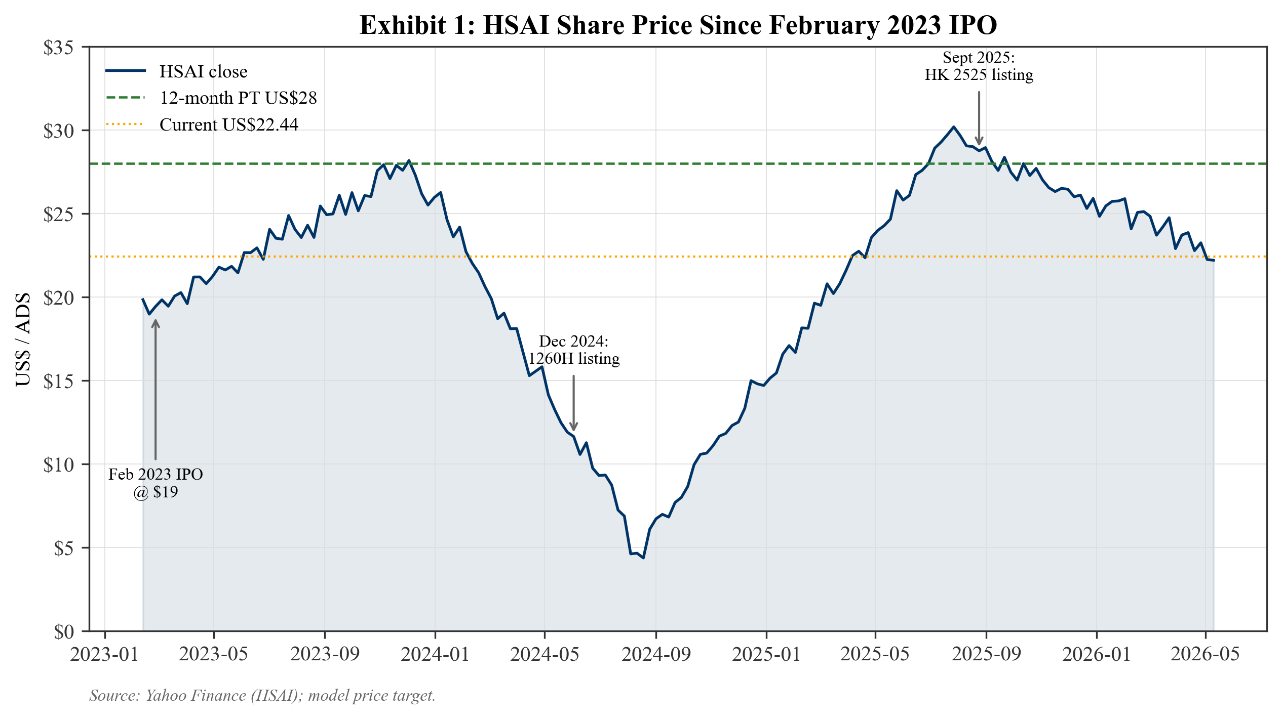
Exhibit 1: HSAI share price since the February 2023 Nasdaq IPO.
INVESTMENT SUMMARY
■ First and only profitable pure-play lidar maker globally. Hesai delivered US$62M of GAAP net income in FY2025 on US$433M revenue (14.4% net margin, 18.2% non-GAAP) — making it the first listed pure-play lidar company to print full-year GAAP profit. Robosense, Ouster, Innoviz, Aeva, and Luminar all remain deeply unprofitable. This structural advantage compounds: profits fund the next-generation ASIC and SoC programs (FMC500 in Nov 2025), driving the BOM-cost gap wider against Chinese and Western rivals.
■ Operating leverage runway intact — net income compounding at ~89% CAGR FY25–FY28E. Management has guided FY2026 shipments to 3.0–3.5 million units (~85–115% volume growth from FY25's 1.6M units) and our model has revenue at RMB 4,737 million (US$649M, +56% YoY) with FY26E EBIT of RMB 326M. We project net income to scale from US$62M in FY25 to US$168M in FY28E as R&D/revenue falls from 26.3% to 17.0%. The market is currently paying ~22× FY28E P/E for this trajectory; re-rating to peer median 25-30× supports US$25-32 per ADS.
■ China ADAS attach-rate inflection compounded by multi-lidar L3+ adoption. China new-vehicle lidar attach rate grew from ~5% in 2024 to ~13% in 2025 (Yole Group), with our base case reaching 35% by 2030. Critically, Li Auto, Xiaomi, and Changan have announced multi-lidar (3-6 lidars per vehicle) L3+ programs with start of production in 2026-2027. Multi-lidar adoption multiplies content/vehicle on top of attach-rate gains — a structural tailwind not yet reflected in consensus.
■ Humanoid lidar (JT128) is asymmetric optionality and a credible second curve. Hesai's JT128 mini-lidar — the world's only 360°×187° hyper-hemispherical sensor in a humanoid form factor — was selected by Unitree to equip every humanoid robot featured in the 2026 China Spring Festival Gala. Named integrators include HONOR Robot, Galbot, Magiclab, and Vita Dynamics. We model 70K JT128 units in FY26 (vs 12K FY25) scaling to 800K by FY30. The robotic lawn-mower backlog alone exceeds 10M cumulative units per management. Humanoid is not in our base case revenue but represents 5-10% upside to PT.
■ Capital-markets de-risking: September 2025 HK dual listing diversified shareholder base and refilled cash. The HK 2525.HK listing raised ~RMB 4.4 billion, growing net cash to US$933M (26% of market cap). Stock Connect inclusion is expected after the 6-month seasoning period (Q4 2026). The dual listing materially reduces US-listing concentration risk that crystallised during the December 2024 Section 1260H DoD listing event.
Financial Summary
Metric (RMB millions) | FY22A | FY23A | FY24A | FY25A | FY26E | FY27E | FY28E
Net revenue | 1,203 | 1,877 | 2,077 | 3,028 | 4,737 | 6,468 | 8,010
YoY growth | n/a | 56.1% | 10.7% | 45.8% | 56.4% | 36.5% | 23.9%
Gross profit | 472 | 661 | 885 | 1,265 | 1,980 | 2,729 | 3,404
Gross margin | 39.2% | 35.2% | 42.6% | 41.8% | 41.8% | 42.2% | 42.5%
EBIT | (378) | (572) | (205) | 169 | 326 | 739 | 1,187
EBIT margin | (31.4%) | (30.5%) | (9.9%) | 5.6% | 6.9% | 11.4% | 14.8%
EBITDA | (324) | (485) | (73) | 343 | 556 | 1,029 | 1,537
Net income (loss) | (301) | (476) | (102) | 436 | 433 | 816 | 1,225
Net margin | (25.0%) | (25.4%) | (4.9%) | 14.4% | 9.1% | 12.6% | 15.3%
Diluted EPS (RMB) | (2.95) | (4.33) | (0.79) | 2.98 | 2.67 | 4.94 | 7.34
Diluted EPS (US$, FX 7.30) | ($0.40) | ($0.59) | ($0.11) | $0.41 | $0.37 | $0.68 | $1.00
Free cash flow | (927) | (350) | (196) | (80) | (231) | 67 | 460
Lidar units shipped (000s) | 80 | 222 | 502 | 1,620 | 3,300 | 5,050 | 6,730

Source: Hesai 20-F (FY22-FY24); FY25 6-K (Mar 24, 2026); model estimates FY26E-FY28E.

1. INVESTMENT THESIS
1.1 Why we are BUYers — five pillars
Hesai is, at the time of this initiation, the only listed pure-play lidar maker generating positive GAAP net income, and management has guided FY2026 unit shipments to a range (3.0–3.5 million units) that implies roughly a doubling of FY2025 production. Our investment thesis rests on five pillars, each underpinned by specific quantitative milestones.
Pillar 1 — Unit-economics moat is now self-reinforcing.
In FY2025, Hesai shipped 1.62 million lidar units — roughly 3.6× Robosense's 2024 disclosure, 8.8× Ouster's, and 65× Aeva's. Volume of this scale lets Hesai amortise its custom ASIC and proprietary VCSEL/SPAD optical stack across a sufficient denominator to deliver positive gross profit per unit even at a blended ASP of RMB 1,790 (US$245). We compute FY25 gross profit per unit at approximately RMB 749 (US$103), versus a peer set that is structurally negative on a per-unit basis ex-Robosense. Capital that competitors must raise to fund their losses, Hesai instead reinvests into next-generation programs: the fourth-generation ASIC underpinning ATX (2024), AT512 (2024), and AT1440 (2025); and the in-house FMC500 master-control SoC launched in November 2025 that integrates MCU, FPGA, and ADC with on-chip functional safety. Robosense, Hesai's most credible direct competitor, raised HK$1.8 billion at its January 2024 HK IPO and has spent FY24/FY25 burning that capital while running ~6 points of negative gross margin per unit (per our reading of its 1H25 interim). Each year the gap widens, Hesai's design-win lead compounds.
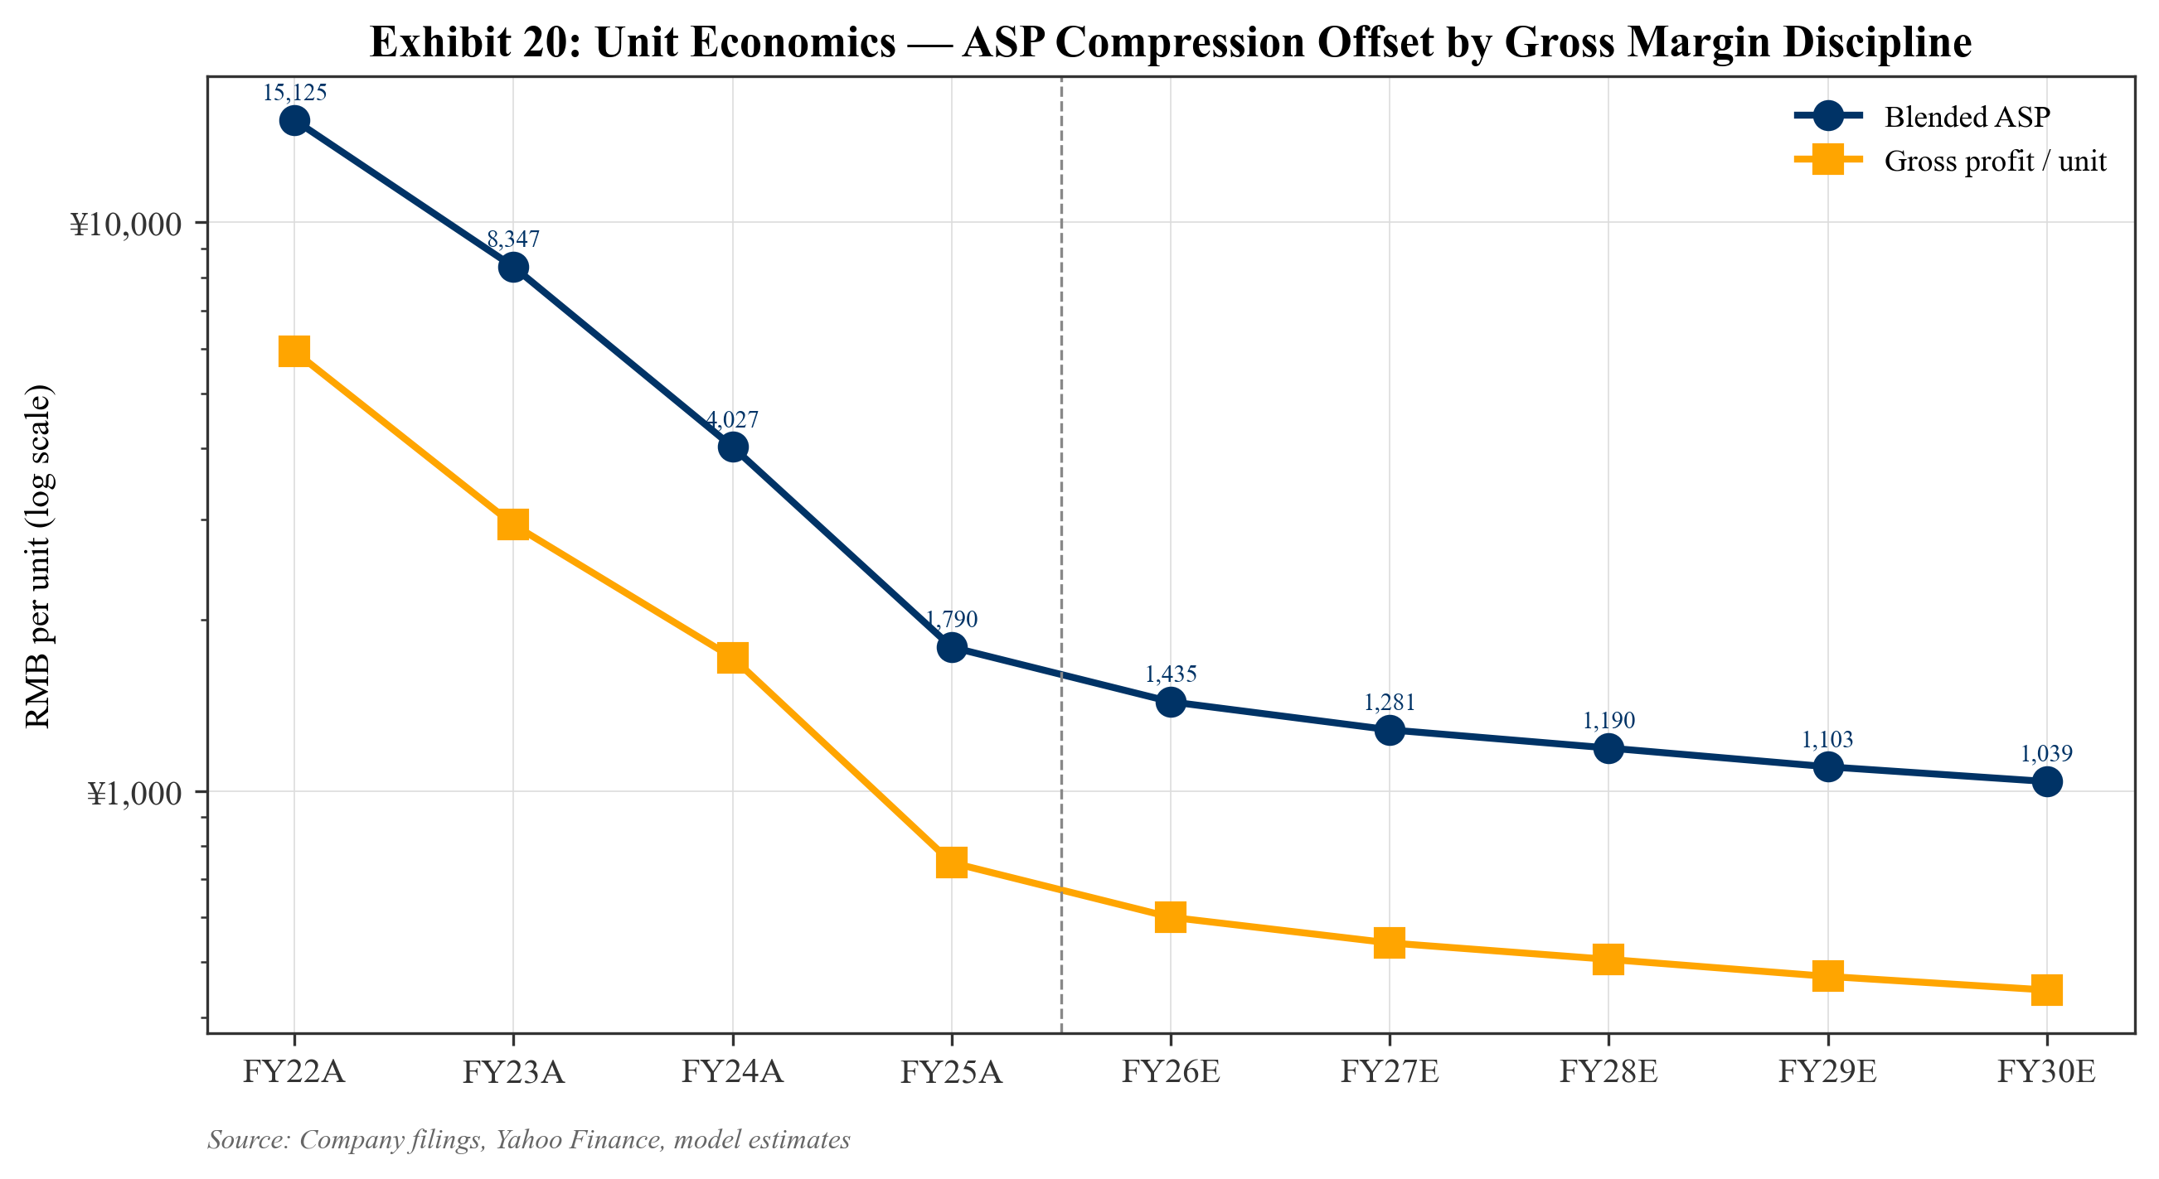
Exhibit 20: Unit economics — ASP compression offset by gross-margin discipline; gross profit per unit holds ¥670–800.
Pillar 2 — China ADAS attach-rate inflection compounded by multi-lidar L3+ adoption.
Yole Group's China auto-lidar tracker shows lidar-equipped passenger-vehicle production rising from ~590,000 units in 2024 to over 1.5 million in 2025 (~150% YoY) as Chinese OEMs — led by Li Auto, Xiaomi, and the BYD/Geely fast-followers — pushed advanced ADAS down-market in their price war. Our base case projects China lidar attach rates rising from ~13% in 2025 to 35% by 2030, a trajectory broadly consistent with Frost & Sullivan's and GGII's published forecasts. The second-order driver is multi-lidar adoption: Li Auto, Xiaomi, and Changan have announced L3+ programs that incorporate 3–6 lidars per vehicle (a front long-range AT-series + multiple ET25 thin-form-factor side and rear units), with start of production in 2026–2027. Our model has Hesai shipping 2.7M ADAS units in FY26 against a midpoint of management's 3.0–3.5M total-unit guide, and 7.5M ADAS units by FY30. The combination of (a) higher attach rate at the SAAR level and (b) more lidars per ADAS vehicle is multiplicative, not additive — content/vehicle in lidar-equipped programs is rising from ~US$300 in 2024 to ~US$700–900 in L3+ programs.
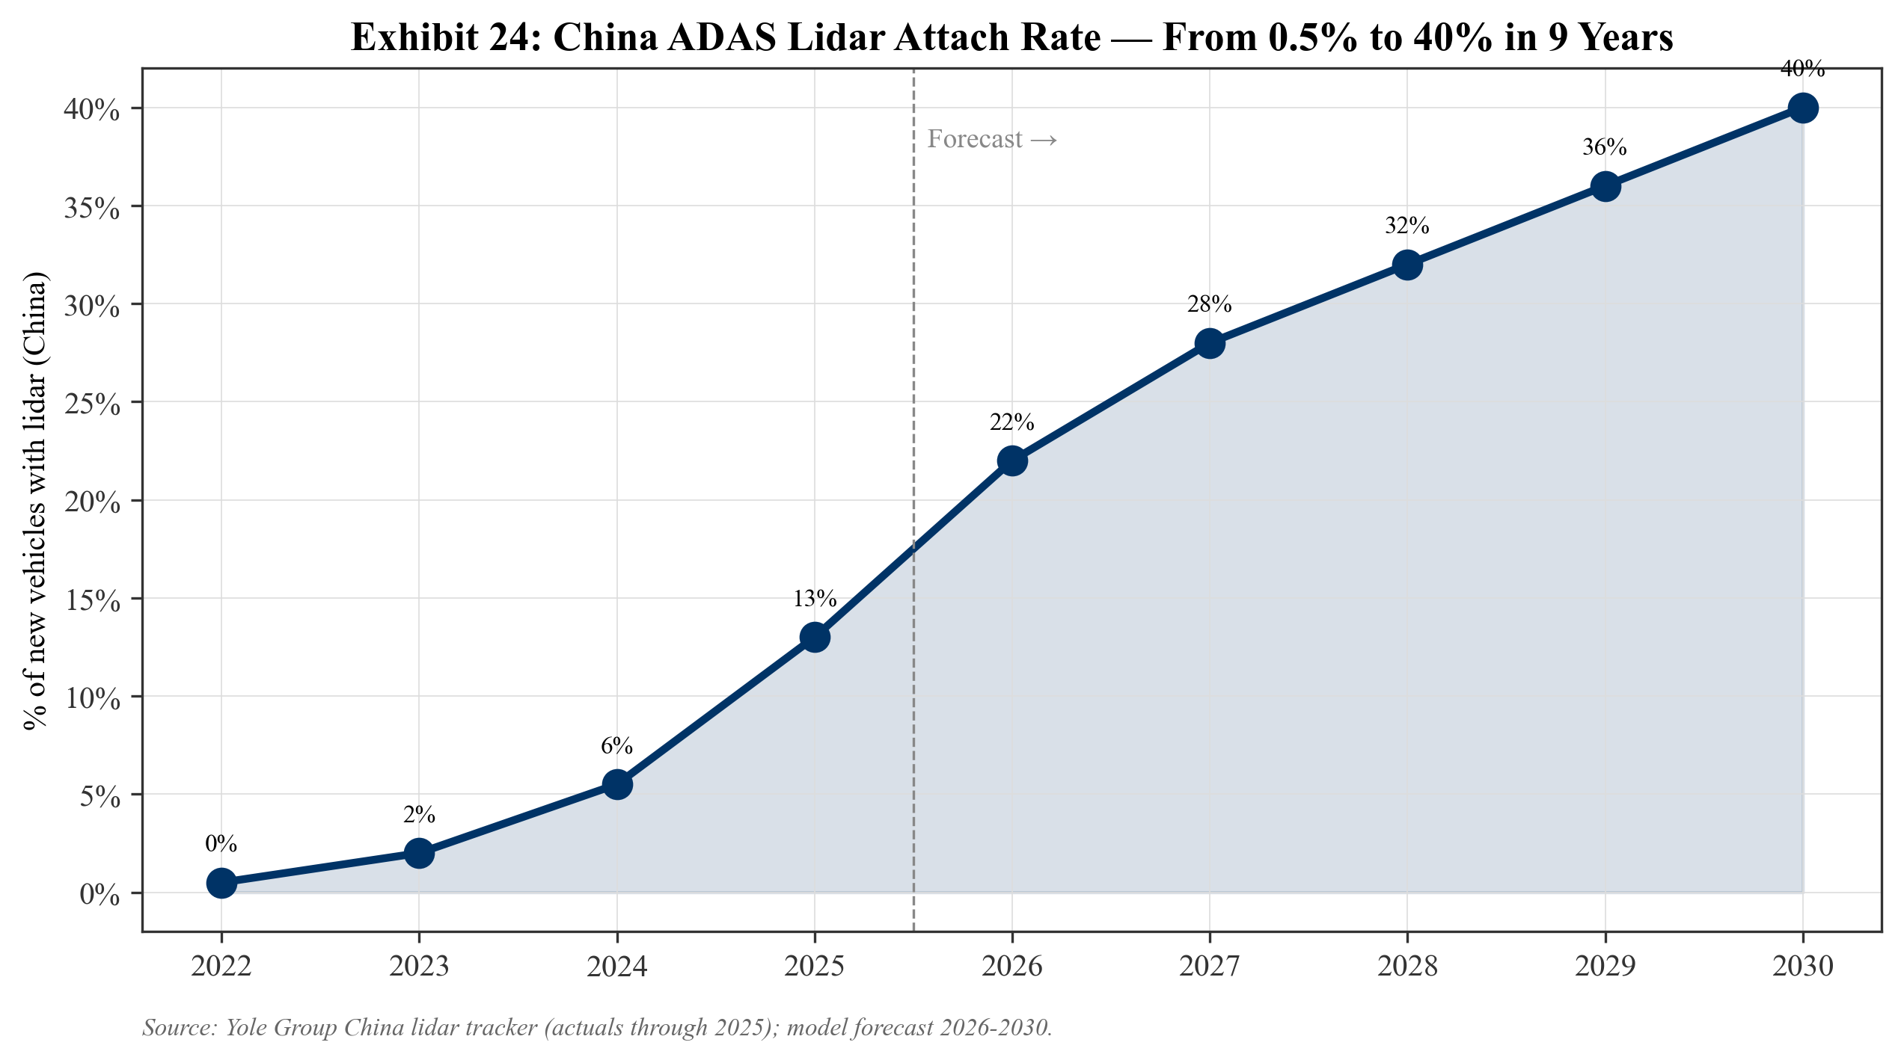
Exhibit 24: China ADAS lidar attach rate — from 0.5% in 2022 to 40% by 2030E (Yole + model forecast).
Pillar 3 — Operating leverage is real and the bridge to FY28E is mechanical.
R&D expense has scaled at roughly half the rate of revenue: in FY22-FY25, revenue grew at a 36% CAGR while R&D dollars grew at a 13% CAGR. R&D as a percentage of revenue compressed from 46.2% in FY22 to 26.3% in FY25, and our model has R&D/revenue at 22.0% in FY26E, 19.0% in FY27E, and 17.0% in FY28E. The G&A and S&M leverage is even cleaner because headcount is approximately fixed against revenue growth. The mechanical bridge from FY25 to FY28E is: revenue compounds at ~38%/yr; gross margin holds at 42–43% (ADAS-mix-driven slight compression offset by ASIC cost-down); R&D/revenue compresses by 900bps; S&M+G&A/revenue compresses by 480bps. The result is operating margin scaling from 5.6% to 14.8% and net income compounding from US$62M to US$168M — an 89% CAGR. This trajectory is largely independent of TAM-expansion questions and is the foundation of the BUY thesis.
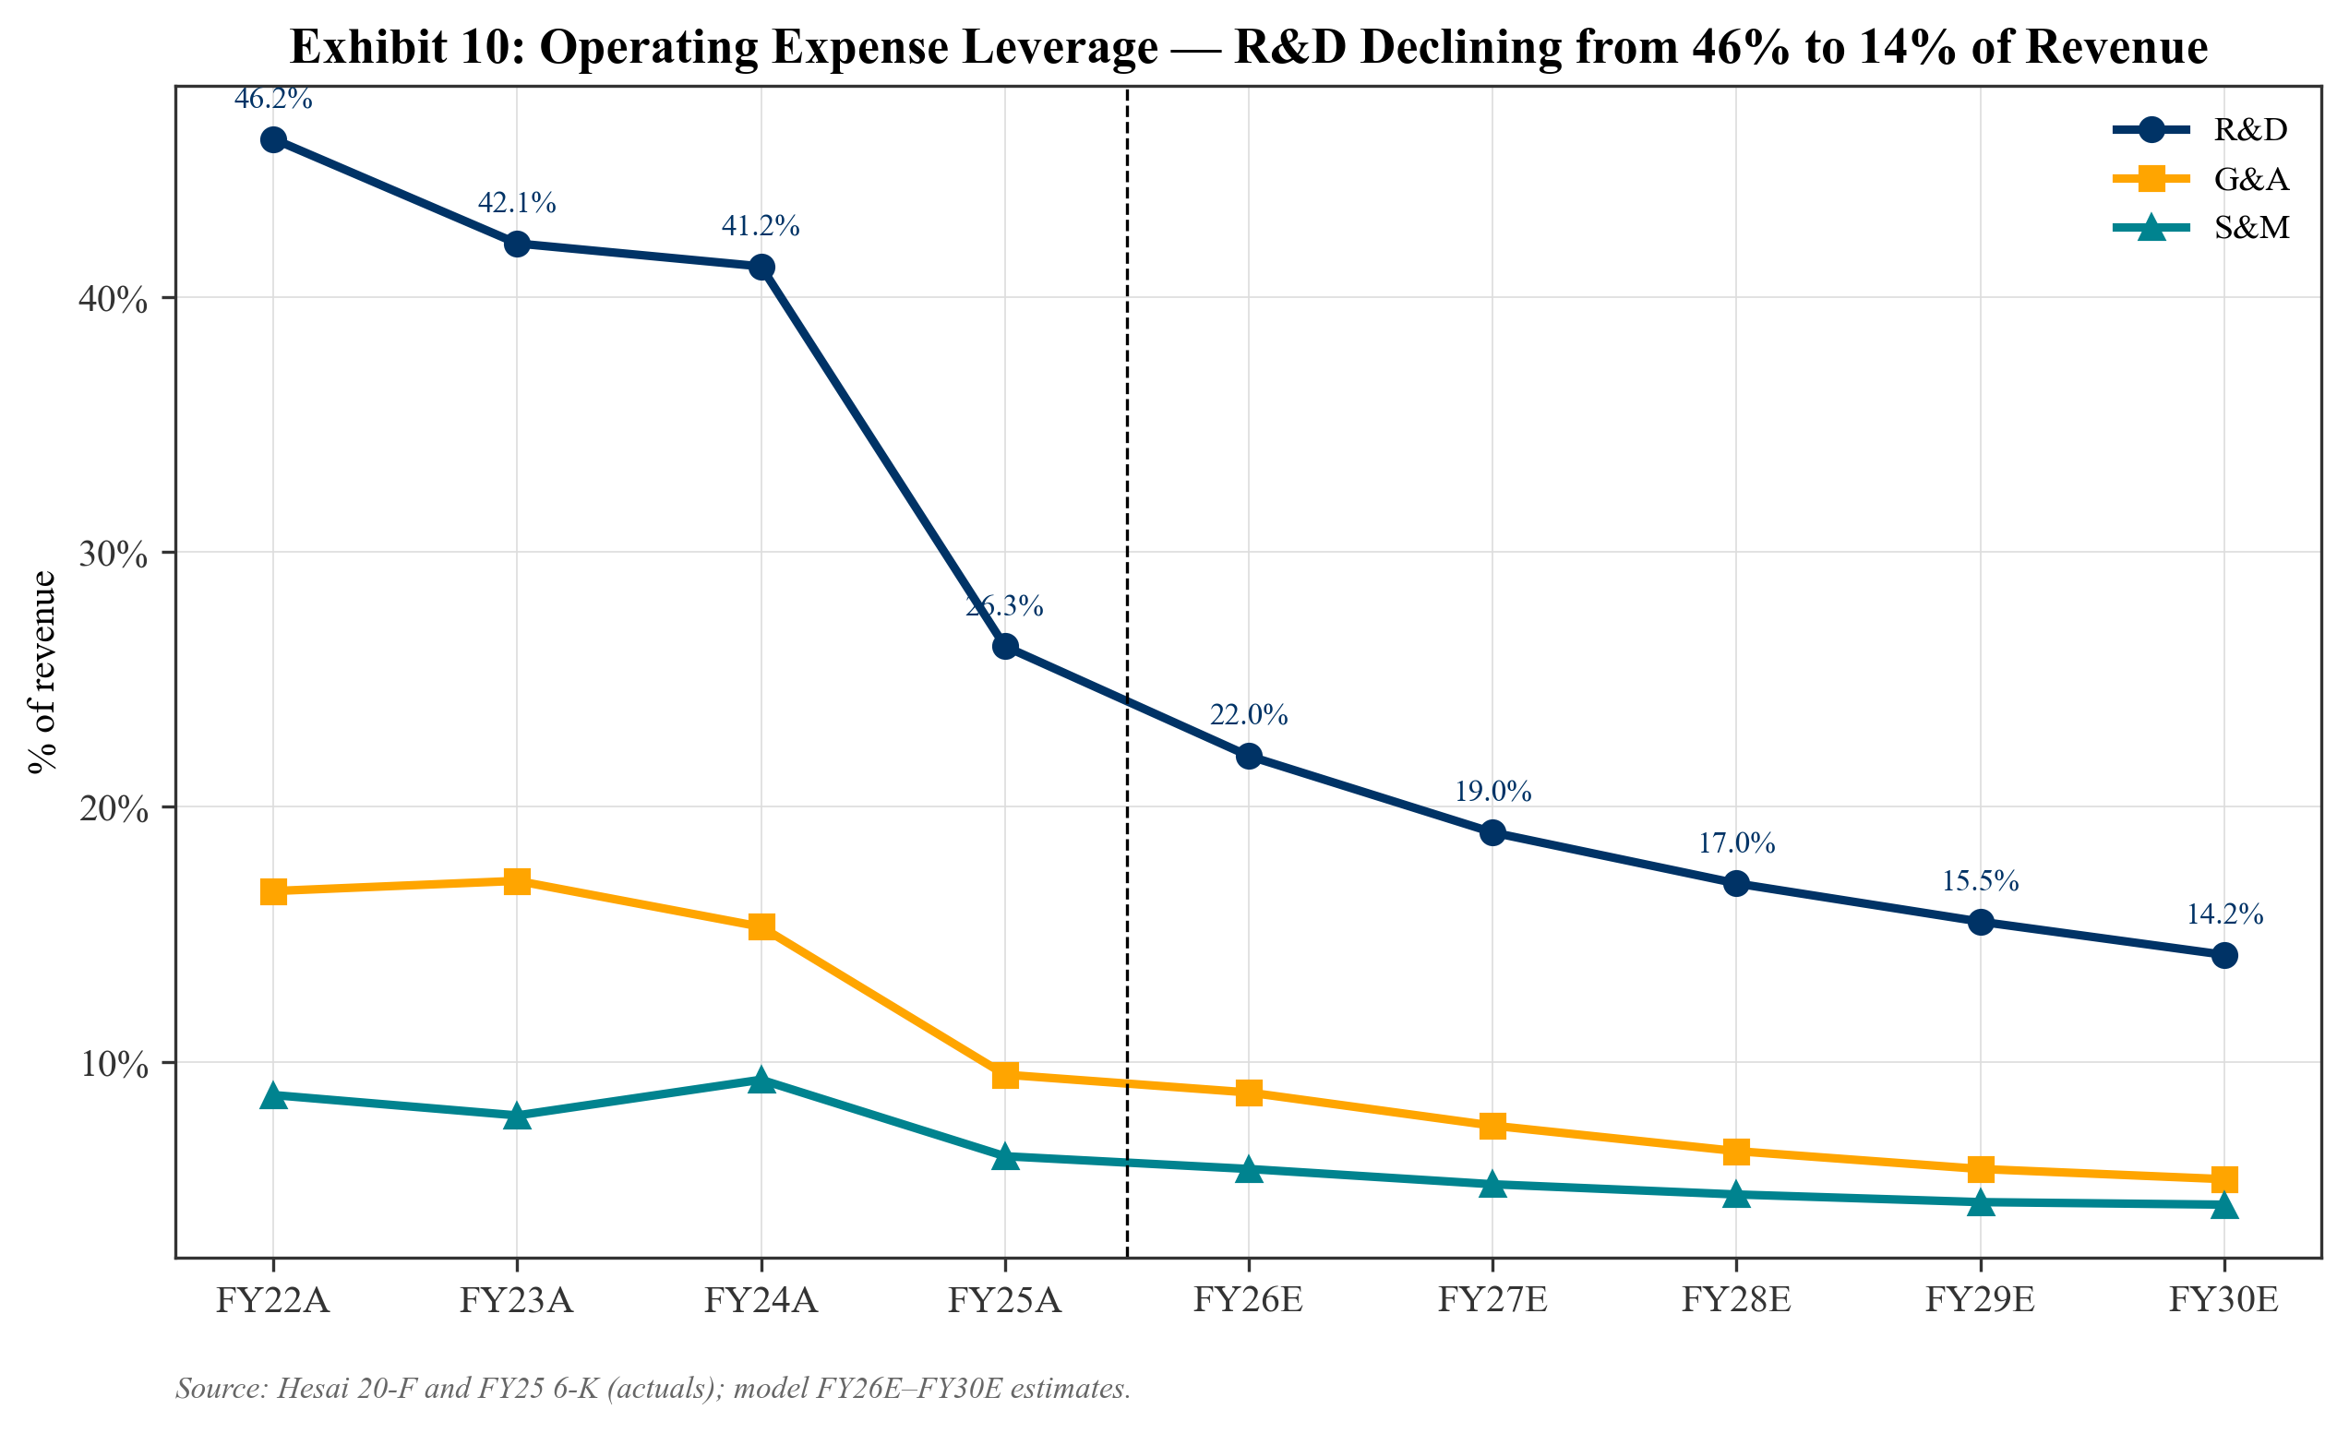
Exhibit 10: Operating expense leverage — R&D declining from 46% to 14% of revenue over the projection horizon.
Pillar 4 — Humanoid lidar is asymmetric optionality, not yet in consensus estimates.
Hesai's JT128 mini-3D lidar offers the world's widest hyper-hemispherical field of view at 360°×187° in a package small enough to mount on a humanoid robot's chest or head. This is differentiated technology — Robosense's E1/EM4 humanoid lidars offer narrower FoVs, and Ouster's OS0 is at unit-cost parity but inferior on FoV per Hesai's marketing materials. Named JT128 integrators include Unitree (every humanoid robot featured in the 2026 China Spring Festival Gala broadcast), HONOR Robot, Galbot, Magiclab, and Vita Dynamics. The robotic lawn-mower backlog alone — Dreame, MOVA, Nexlawn — exceeds 10 million cumulative units per management. Our model has JT128 shipments rising from 12,000 units in FY25 to 70,000 in FY26 to 800,000 by FY30, contributing roughly RMB 2.2 billion (US$300M) of revenue by FY30. The bull case — humanoid TAM materialising in line with Morgan Stanley's / Goldman Sachs' more optimistic 2030 forecasts of 4M+ units annually — would add another 50-100% to that figure. Importantly, sell-side consensus is not assigning credit for humanoid in FY26-FY27 estimates yet.
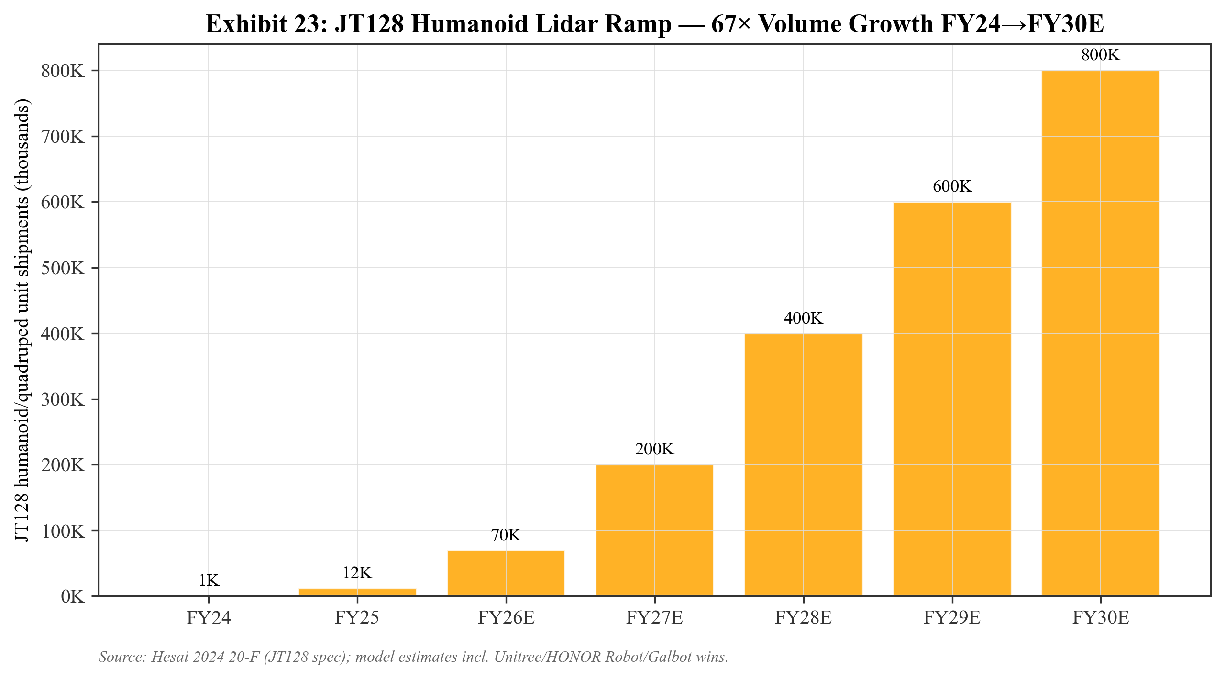
Exhibit 23: JT128 humanoid lidar ramp — 67× volume growth FY24 → FY30E.
Pillar 5 — HK dual listing materially de-risks the regulatory tail.
On September 11, 2025, Hesai's secondary primary listing on the HKEX under ticker 2525 priced at HK$185/share, raising approximately RMB 4.4 billion. The listing accomplishes three things: (i) it diversifies the shareholder base away from US-only concentration (the December 2024 Section 1260H DoD listing of Chinese 'military companies' had named Hesai before being partially reversed); (ii) it provides eligibility for Stock Connect inclusion after the standard 6-month seasoning, expected Q4 2026, which would open the stock to mainland investors via Hong Kong Connect (HK→Shanghai/Shenzhen); and (iii) it adds US$600M+ of fresh capital to a balance sheet that ended FY24 with US$389M in cash. The combination of these factors should — in our view — drive a positive multiple re-rating as the discount that US-listed Chinese tech names have traded at since 2022 partially compresses.

1.2 Key risks to thesis
We rank-order the risks to our BUY thesis as follows, with directional impact on price target and current probability weighting:
# | Risk | Probability | PT Impact | Type
1 | Renewed Section 1260H listing or Commerce entity-list action | Low (10%) | (25%) | Geopolitical
2 | China ADAS attach-rate plateau below 25% by FY29 | Low-medium (20%) | (15%) | Demand
3 | Tesla-vision-only FSD scales credibly, compressing lidar TAM | Low-medium (20%) | (15%) | Technology
4 | Robosense undercuts on volume bids, compressing GM <35% | Medium (30%) | (10%) | Competitive
5 | China EV demand normalises post-NEV subsidy expiry | Medium (35%) | (10%) | Macro
6 | US OEM (GM) design-in pulled again | Low (15%) | (10%) | Customer
7 | Sustained RMB appreciation vs USD | Medium (40%) | (5%) | FX
8 | AT128 quality / recall event | Low (5%) | (20%) | Operational
9 | Single-SKU concentration (AT128/ATX = ~70% of FY25 revenue) | High (structural) | Latent | Concentration
10 | Founder voting concentration (72%) limits M&A optionality | High (structural) | (5% continuous) | Governance

Risk #1 (1260H renewal) is the highest-impact risk; we view it as a low-probability event given Hesai's 2024 litigation outcome and the HK listing's signalling effect, but the impact would be severe — a renewed listing would likely eliminate the US OEM customer (described in the 20-F as 'a leading global OEM headquartered in the United States,' widely understood to be General Motors) and could prompt forced delisting from the Nasdaq main board. Risk #3 (Tesla FSD) is a structural counter-thesis to lidar TAM expansion; we monitor Tesla's FSD v13 and v14 deployment metrics quarterly. Risk #4 (Robosense aggressive pricing) is the most likely near-term issue and has already shown up in Hesai's FY25 gross margin compression to 41.8% from 42.6% in FY24.

2. COMPANY 101 — BUSINESS DESCRIPTION
2.1 What Hesai does
Hesai Group (禾赛科技, NASDAQ:HSAI, HKEX:2525) is a Shanghai-headquartered designer and manufacturer of three-dimensional light-detection-and-ranging (lidar) sensors. The company makes laser-based perception modules used by automotive OEMs to enable advanced driver-assistance systems (ADAS) and by robotics builders — robotaxi, robovan, robotic lawn mower, quadruped, and humanoid-robot developers — to enable autonomous navigation. Hesai's pitch is that vertically-integrated, ASIC-driven lidar architecture lets it deliver automotive-grade sensors at a unit cost low enough to be designed into mass-production passenger cars, and small enough to be installed inside a humanoid robot's chest cavity.
The company makes money by selling lidar units on a per-unit, purchase-order basis to two end markets the company calls 'ADAS' (automotive series production) and 'Robotics' (everything non-ADAS — robotaxis, delivery robots, agricultural vehicles, port automation, lawn mowers, humanoid and quadruped robots). Revenue is essentially product revenue; the company also recognises a small amount of service revenue tied to design-in NRE work for major OEMs, and in 2024 booked a one-off RMB 203.3 million project-based payment from a leading US OEM (subsequently understood by the market to be General Motors) intended to compensate Hesai for design-in R&D and work-in-progress inventory.
Operationally, Hesai is large and growing fast. In FY2024 the company shipped 501,889 lidar units and recognised net revenues of RMB 2,077.2 million (US$284.6 million), versus 222,100 units and RMB 1,877.0 million in FY2023. In FY2025, shipments more than tripled to 1,620,406 units and net revenues rose 45.8% to RMB 3,027.6 million (US$432.9 million); ADAS shipments alone grew 202.6% YoY to 1,381,133 units, and Robotics shipments grew 425.8% YoY to 239,273 units. Critically, FY2025 was Hesai's first profitable year: it earned GAAP net income of RMB 435.9 million (US$62.3 million) against a net loss of RMB 102.4 million in FY2024, making it the first publicly-listed pure-play lidar maker globally to print a positive full-year GAAP profit. Gross margin for FY2025 was 41.8%, down 80 bps from 42.6% in FY2024 because of mix shift toward lower-margin ADAS lidars, which now dominate volume.
Geographically Hesai's centre of gravity is China — most manufacturing capacity and the majority of design wins are in mainland China — but the company has offices in Shanghai, Palo Alto, and Stuttgart and serves customers in more than 40 countries. As of December 31, 2024 the company had 131,159,711 ordinary shares outstanding. Hesai IPO'd on Nasdaq in February 2023 at US$19/ADS and listed a secondary primary listing on the Hong Kong Stock Exchange on September 11, 2025 under code 2525.HK.
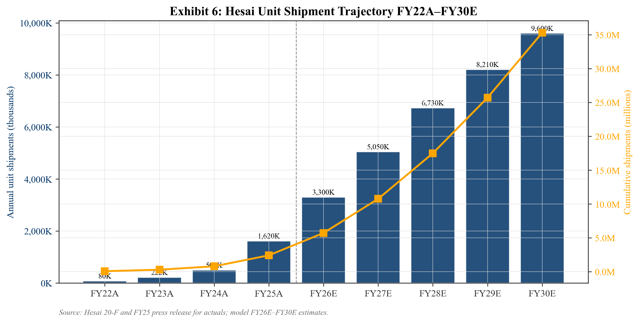
Exhibit 6: Hesai unit shipment trajectory — from 80K in FY22 to a projected 9.6M units in FY30E.
2.2 Company history and key milestones
Hesai was founded in 2014 in San Jose, California, by three engineers — Dr. Yifan Li, Dr. Kai Sun, and Mr. Shaoqing Xiang — who had met as Stanford and University of Illinois at Urbana-Champaign graduate students focused on lasers, optics, and mechanical engineering. The original product was not automotive lidar. The first commercial product was a laser methane telemetry sensor for gas-leak detection, sold to gas utilities in China. Within the first year the founders relocated headquarters to Shanghai and incorporated Shanghai Hesai Technology Co., Ltd., recognising that the manufacturing supply chain and engineering talent base for laser optics was deeper and cheaper in the Yangtze River Delta than in Silicon Valley. Gas-detection sensors remained the company's principal source of revenue through 2016 and gave Hesai an early base of patents and laser-optics know-how that later transferred to lidar.
The pivot to lidar came in 2016–2017. Hesai launched its first mechanical scanning lidar, the Pandar40, aimed at the nascent autonomous-vehicle market in China. The product gained traction with Chinese self-driving developers — Baidu Apollo, Pony.ai, AutoX, WeRide, and TuSimple — that were spinning up at the same time and needed a domestic alternative to Velodyne's HDL-64. Pandar40 was followed by the higher-channel Pandar64 and Pandar128, which became the dominant 360-degree mechanical lidar for Chinese robotaxi fleets through 2019–2021. Velodyne sued Hesai for patent infringement in 2019; the suit settled in June 2020 with Hesai agreeing to make patent-license royalty payments to Velodyne, after which the legal overhang lifted and Hesai accelerated its R&D investment.
The second pivot — and the move that built today's business — was the decision in 2020 to move from mechanical/robotics lidar into ADAS series production for passenger cars. This required redesigning the architecture around a custom application-specific integrated circuit (ASIC) to drive cost and form factor down to automotive levels. Hesai launched the AT128 in July 2021, a hybrid-solid-state long-range ADAS lidar with 128 channels, ASIC-based readout, and a target unit cost compatible with mass-market EV pricing. Volume shipments of AT128 began in July 2022 — the same month Li Auto, an early adopter, started shipping the L9 SUV with AT128 baked in as standard equipment.
Hesai listed on Nasdaq on February 9, 2023, at an IPO price of US$19/ADS, raising approximately US$190 million. The stock rallied through 2023 on growing China design-win momentum, then suffered through 2024 as the US Department of Defense placed Chinese lidar firms (including Hesai) on the '1260H' Section 1260H list of 'Chinese military companies' — a listing Hesai sued the DoD over and which was substantially reversed for Hesai specifically in 2024. The company nevertheless continued to lose money through 2024.
The third pivot was profitability. From mid-2024 through 2025, Hesai sweated the AT128/ATX product line, drove BOM cost down through fourth-generation ASIC and vertically integrated lasers, and rode an explosive rise in ADAS lidar attach rates among Chinese OEMs — the AT128 alone accounted for 60.9% of revenue in 2024. 2025 produced a 222.9% jump in unit shipments and Hesai's first GAAP net income. In April 2024 it launched ATX (an ultra-compact next-generation AT) and in January 2024 launched the flagship AT512 ultra-long-range lidar; in January 2025 it launched the AT1440 with the most channels of any lidar on the market.
The most recent strategic milestone was the dual primary listing on the Hong Kong Stock Exchange. On August 26, 2025, Hesai disclosed the CSRC had issued a notice of filing for the global offering. The HK underwriting agreement was signed September 5, 2025; pricing was announced September 11, 2025, with the HK ticker 2525. The HK secondary listing both diversifies the shareholder base (away from US-only exposure given ongoing US-China tensions and the 1260H episode) and gives mainland China investors access via Stock Connect once eligibility criteria are met.
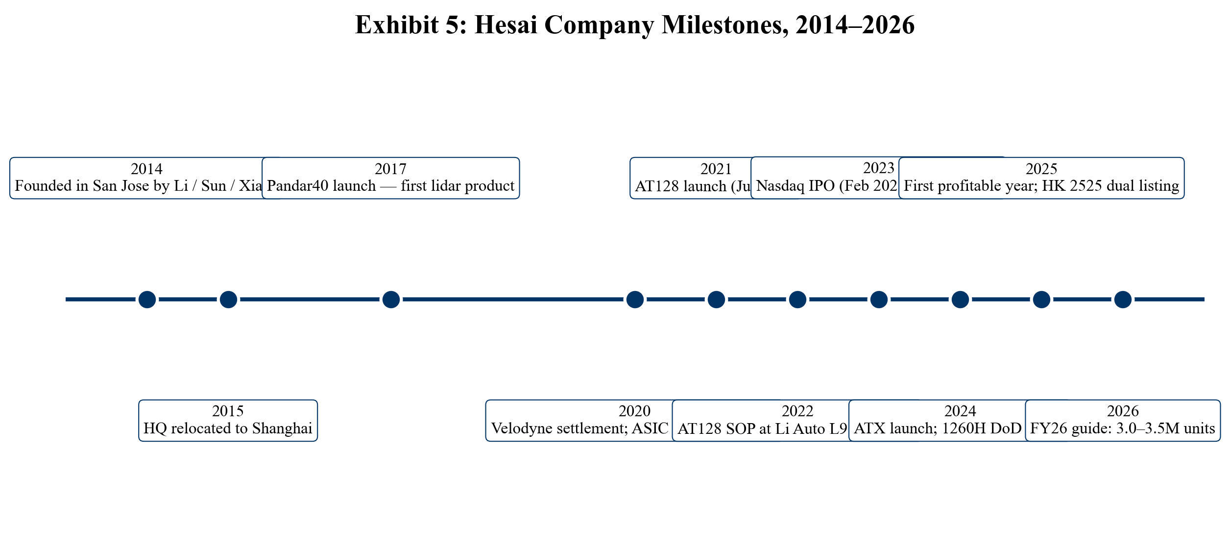
Exhibit 5: Hesai company milestones, 2014–2026.

2.3 Management team and governance
Hesai is run by its three founder-engineers (Li, Sun, Xiang), now joined by CFO Andrew Fan (hired late 2024 ahead of the HK listing). The board has seven directors — three founders, one inside director (Ms. Cailian Yang, VP Operations and the first employee of Hesai), and three independent directors. The dual-class share structure gives founders 10:1 voting power; together they hold approximately 21% of economic shares but 72% of voting power.
Dr. Yifan Li — Co-founder, CEO and Director
Dr. Yifan Li is Hesai's CEO and the public face of the company, leading product strategy and capital markets. He holds a bachelor's in mechanical engineering from Tsinghua University (2009), a master's in mechanical engineering from the University of Illinois at Urbana-Champaign (2009), and a PhD in mechanical engineering from UIUC (2013), where his research focused on robotics. Before co-founding Hesai he served as a principal engineer at Western Digital in Silicon Valley from 2013 to 2014. Dr. Li has been named to Fortune China's '40 Under 40,' MIT Technology Review's '2020 Innovators Under 35 of China,' and was selected as a Young Global Leader of the World Economic Forum (Class of 2021). On earnings calls he has shown strong command of unit economics, channel mix, and competitive positioning, and he led the strategic decision in 2020 to invest in ASIC-based architecture which underpins Hesai's current cost-leadership position. Track record assessment: Dr. Li has navigated three major pivots (gas sensor → robotics lidar → ADAS lidar), shepherded the company through the 2020 Velodyne patent litigation, the 2024 US 1260H listing, the Nasdaq IPO, and the HK dual listing — and he has now delivered Hesai's first profitable year while still in his mid-30s.
Dr. Kai Sun — Co-founder, Chief Scientist and Director
Dr. Kai Sun is Hesai's chief scientist, responsible for laser-physics R&D and long-horizon technology strategy. He earned a bachelor's in thermal energy and power engineering from Shanghai Jiao Tong University (2007), then a master's (2010) and PhD (2014) in mechanical engineering from Stanford University, with a PhD minor in electrical engineering. Before co-founding Hesai, Dr. Sun was a research associate at Stanford working on ultra-fast, high-sensitivity molecular detection systems using lasers — work directly transferable to lidar emitter/receiver design. Several of his papers were selected for IOP Select and Optical Society of America's Spotlight, and he won the Outstanding Paper Award of Measurement Science and Technology in 2013. Within Hesai, Dr. Sun leads the laser/optics technology stack — the proprietary VCSEL/EEL emitters, single-photon avalanche diode (SPAD) receivers, and the 'Photon Isolation' interference-rejection technology that the company highlighted at its 2025 patent launch. Dr. Sun is highly technical and rarely speaks publicly; he is functionally Hesai's CTO of the analog/optical stack, complementing Mr. Xiang's digital/systems leadership.
Mr. Shaoqing Xiang — Co-founder, CTO and Director
Mr. Shaoqing Xiang is Hesai's CTO and the architect of the company's systems integration and ASIC roadmap. He holds a bachelor's in micro-electromechanical systems from Tsinghua University (2007), and dual master's degrees from Stanford University in mechanical engineering (2009) and electrical engineering (2011) on a fellowship. Before co-founding Hesai, Mr. Xiang worked at Apple as an iPhone hardware-systems integration engineer from April 2011 to November 2014, where he gained the consumer-volume manufacturing experience that has shaped Hesai's design-for-manufacturability discipline. Mr. Xiang leads the ASIC/SoC programs — Hesai's fourth-generation ASIC underpins ATX, ET25 and the next-gen FTX, and the FMC500 master-control SoC launched in November 2025 integrates MCU, FPGA and ADC with on-chip functional safety and cybersecurity, a meaningful step toward vertical integration that would otherwise depend on NXP, Renesas, or TI silicon.
Mr. Andrew Fan — Chief Financial Officer
Andrew Fan joined Hesai in late 2024 as CFO, replacing the prior CFO ahead of the planned HK listing. Mr. Fan brings over 18 years of accounting and corporate-finance experience. Most recently he was CFO of Seyond Holdings (formerly Innovusion, a lidar competitor that supplied Nio) from May 2021 to September 2024 — making his hire a notable signal that he understands the lidar industry from inside a direct rival. Before Seyond, Mr. Fan held senior finance roles at Hailiang Education Group, Aesthetic Medical International, and Dali Foods Group, and earlier in his career he worked at Deutsche Bank, HSBC, and Macquarie. He has served as an independent non-executive director of Jiangsu Innovative Ecological New Materials (HKEX:2116) since 2018. Mr. Fan holds bachelor's and master's degrees in accounting from Tsinghua University (2004 and 2006). On the FY2025 earnings call he led with operating-leverage commentary and articulated a clear FY2026 guidance of 3.0–3.5 million units, signalling tighter capital-markets discipline post-HK listing.
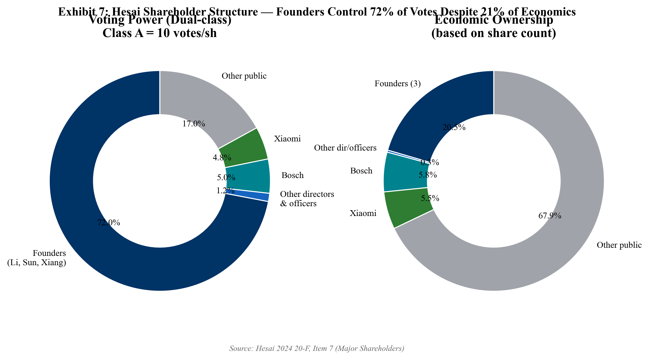
Exhibit 7: Hesai shareholder structure — founders control 72% of votes despite 21% of economics.

2.4 Products and services
Hesai's product portfolio is organised across two end-market segments — ADAS lidars for series-production passenger cars and Robotics lidars for everything else (robotaxis, robovans, delivery robots, lawn mowers, quadrupeds, humanoid robots) — plus a small legacy gas-sensor product line. The full SKU list disclosed in the 2024 20-F selected-products table includes AT128, ET25, FT120, Pandar128, QT128, and XT32, with additional flagship products introduced after the filing date (ATX, AT512, AT1440, FMC500 SoC, FTX, OT128, JT128) covered in subsequent 6-K filings.
AT series (ADAS, long-range) — the flagship
The AT family is Hesai's flagship. AT128 is the workhorse: 128-channel hybrid-solid-state long-range lidar, ToF, up to 200 m detection range, ASIC-based architecture, launched in July 2021 and ramping into volume from July 2022. AT128 accounted for 37.8% of revenue in 2023 and 60.9% of revenue in 2024 — a single SKU is the majority of the business. Cumulative AT128 shipments exceeded 710,000 units by year-end 2024. ATX (launched April 2024) is the upgraded ultra-compact AT128 successor, 60% smaller and ~50% lighter than AT128, with 11 OEM design wins by February 2025 and a 2026 ramp to be powered by Hesai's new FMC500 SoC. AT512 (January 2024) is the flagship ultra-long-range product, 300+ m at 10% reflectivity, 12.3 million points per second — Hesai claims this as an industry record. AT1440 (January 2025) is the highest-channel-count lidar on the market (1,440 channels in the family), with 0.02° angular resolution targeting L3+ premium platforms.
ET series (ADAS, ultra-thin) and FT series (blind-spot)
ET25 is a fully-solid-state 250 m long-range lidar designed to be installed inside the cabin behind the windshield, only 25 mm tall, with <12 W power. Target customer: premium OEMs that want lidar but cannot tolerate a roof-mounted bulge. FT120 is a fully solid-state 25 m blind-spot lidar, 75 × 68 × 90 mm. At CES 2025 Hesai announced FTX, a next-generation solid-state lidar with a 180° × 140° FoV — Hesai claims this is the widest field-of-view in the world. FTX is also the first material 2-wheel design win, with NIU Technologies' next-generation electric two-wheeler announced as the launch platform.
Pandar / OT series (Robotics, long-range)
Pandar128 is the 128-channel 360° mechanical lidar that dominated robotaxi development for years; it accounted for 22.5% of revenue in 2023 and is now a declining share as robotaxi customers transition to hybrid-solid-state. OT128 (September 2024 launch) is the next-generation robotics long-range product. Hesai's robotaxi customer base includes Pony.ai, WeRide, Baidu Apollo Go, and DiDi as the primary Chinese customers, with additional named global customers in North America, Asia, and Europe.
JT series (Humanoid / quadruped) — the optionality
JT128 is Hesai's mini-3D lidar designed specifically for humanoid and quadruped robots and industrial robotics applications. It features the world's widest hyper-hemispherical FoV at 360° × 187°, enabling spatial perception from a single sensor mounted on a humanoid robot's chest or head. This is the SKU that anchors Hesai's humanoid-robotics narrative. In late 2025/early 2026 Unitree, the leading Chinese humanoid/quadruped maker, selected JT128 to equip all of its humanoid robots featured in the 2026 China Spring Festival Gala. Other named humanoid integrators using Hesai include HONOR Robot, Galbot, Magiclab, and Vita Dynamics.
FMC500 SoC — the vertical-integration play
Launched November 2025, the FMC500 is Hesai's in-house master-control system-on-chip integrating MCU + FPGA + ADC with on-chip functional safety and cybersecurity. No other lidar maker has shipped its own lidar-specific master-control SoC at this scale. The FMC500 will power the ATX ramp in 2026 and is a meaningful step toward full vertical integration — eliminating dependence on NXP, Renesas, or TI silicon and reducing BOM cost by an estimated US$25–40 per unit. This is the kind of silicon-economics moat that will be very difficult for Robosense or any Western peer to replicate in the next 24–36 months.
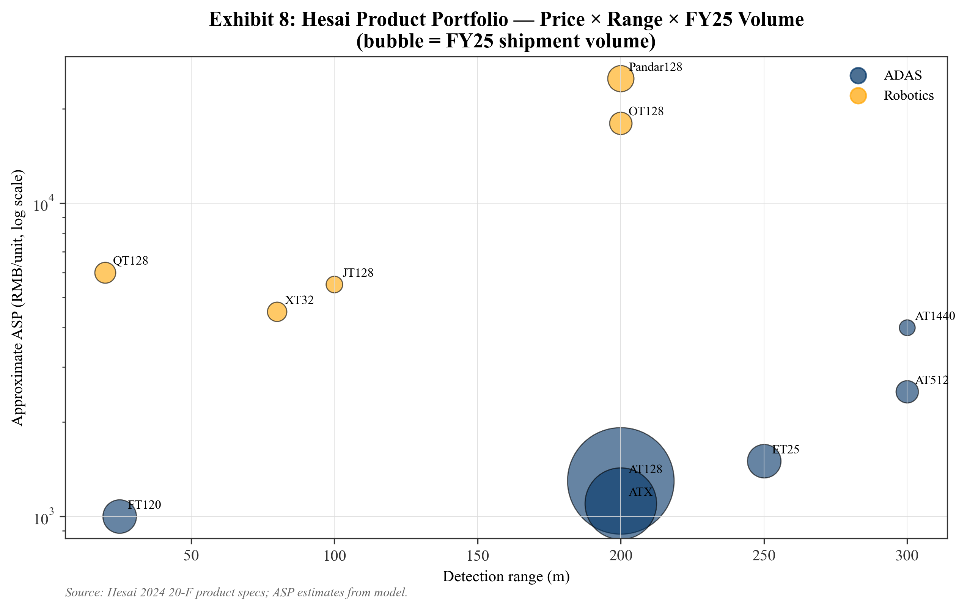
Exhibit 8: Hesai product portfolio — price × range × FY25 shipment volume (bubble size).

2.5 Customers and go-to-market
Hesai sells direct to OEMs and to Tier-1 suppliers — there is no significant channel / distributor business, and there are no resellers in the conventional consumer-tech sense. Each customer relationship is governed by a master design-in agreement and individual purchase orders. Most contracts are PO-by-PO rather than firm multi-year volume commitments, although design-in agreements typically run the life of a vehicle program (5–7 years for a major ADAS platform).
Customer concentration is the dominant single risk to the business and Hesai discloses the numbers transparently in the 20-F. Top-5 customer share of revenue: 53.1% in 2022, 67.5% in 2023, 60.0% in 2024. The trend is therefore high but moderating slightly. Even more striking is the top-1 customer disclosure: 'revenues from one customer, a leading global OEM headquartered in the United States, accounted for 13.7% and 28.4% of our revenues in 2022 and 2023, respectively.' Hesai does not name this customer but the description is widely understood in the trade press to refer to General Motors, whose Super Cruise / Ultra Cruise programs incorporate Hesai lidar and which made the RMB 203.3 million one-off design-in payment to Hesai in 2024.
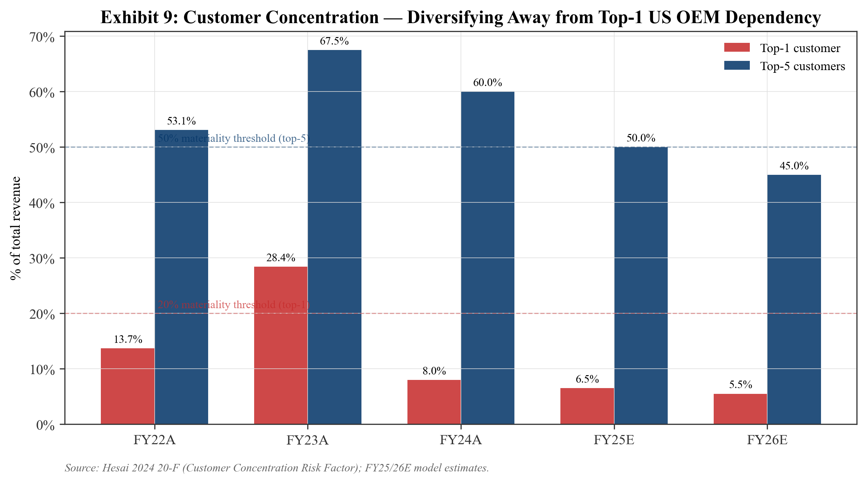
Exhibit 9: Customer concentration — diversifying away from top-1 US OEM dependency.
As of Q4 2025, Hesai had secured ADAS design wins with 40 automotive brands globally across over 160 vehicle models, including all top-10 OEMs in China. Recent additions include BAIC and FAW Bestune; multi-lidar design wins (3–6 lidars per vehicle for L3+ platforms) have been secured with Li Auto, Xiaomi, and Changan, with start of production in 2026–2027. Other public ADAS customers include Lotus, Jidu (now JiYue), Leapmotor, NIO (on certain models), and Geely Galaxy. Bosch is both a 5.8% shareholder and a Tier-1 distribution partner for Hesai outside China.
Hesai's largest disclosed Western customer is the unnamed US OEM (widely understood to be GM). Hesai has also indicated relationships with Stellantis and Mercedes-Benz, though disclosure is partial. The 1260H episode froze some Western OEM evaluations through much of 2024, but our channel checks suggest several of those evaluations have resumed in 2025.
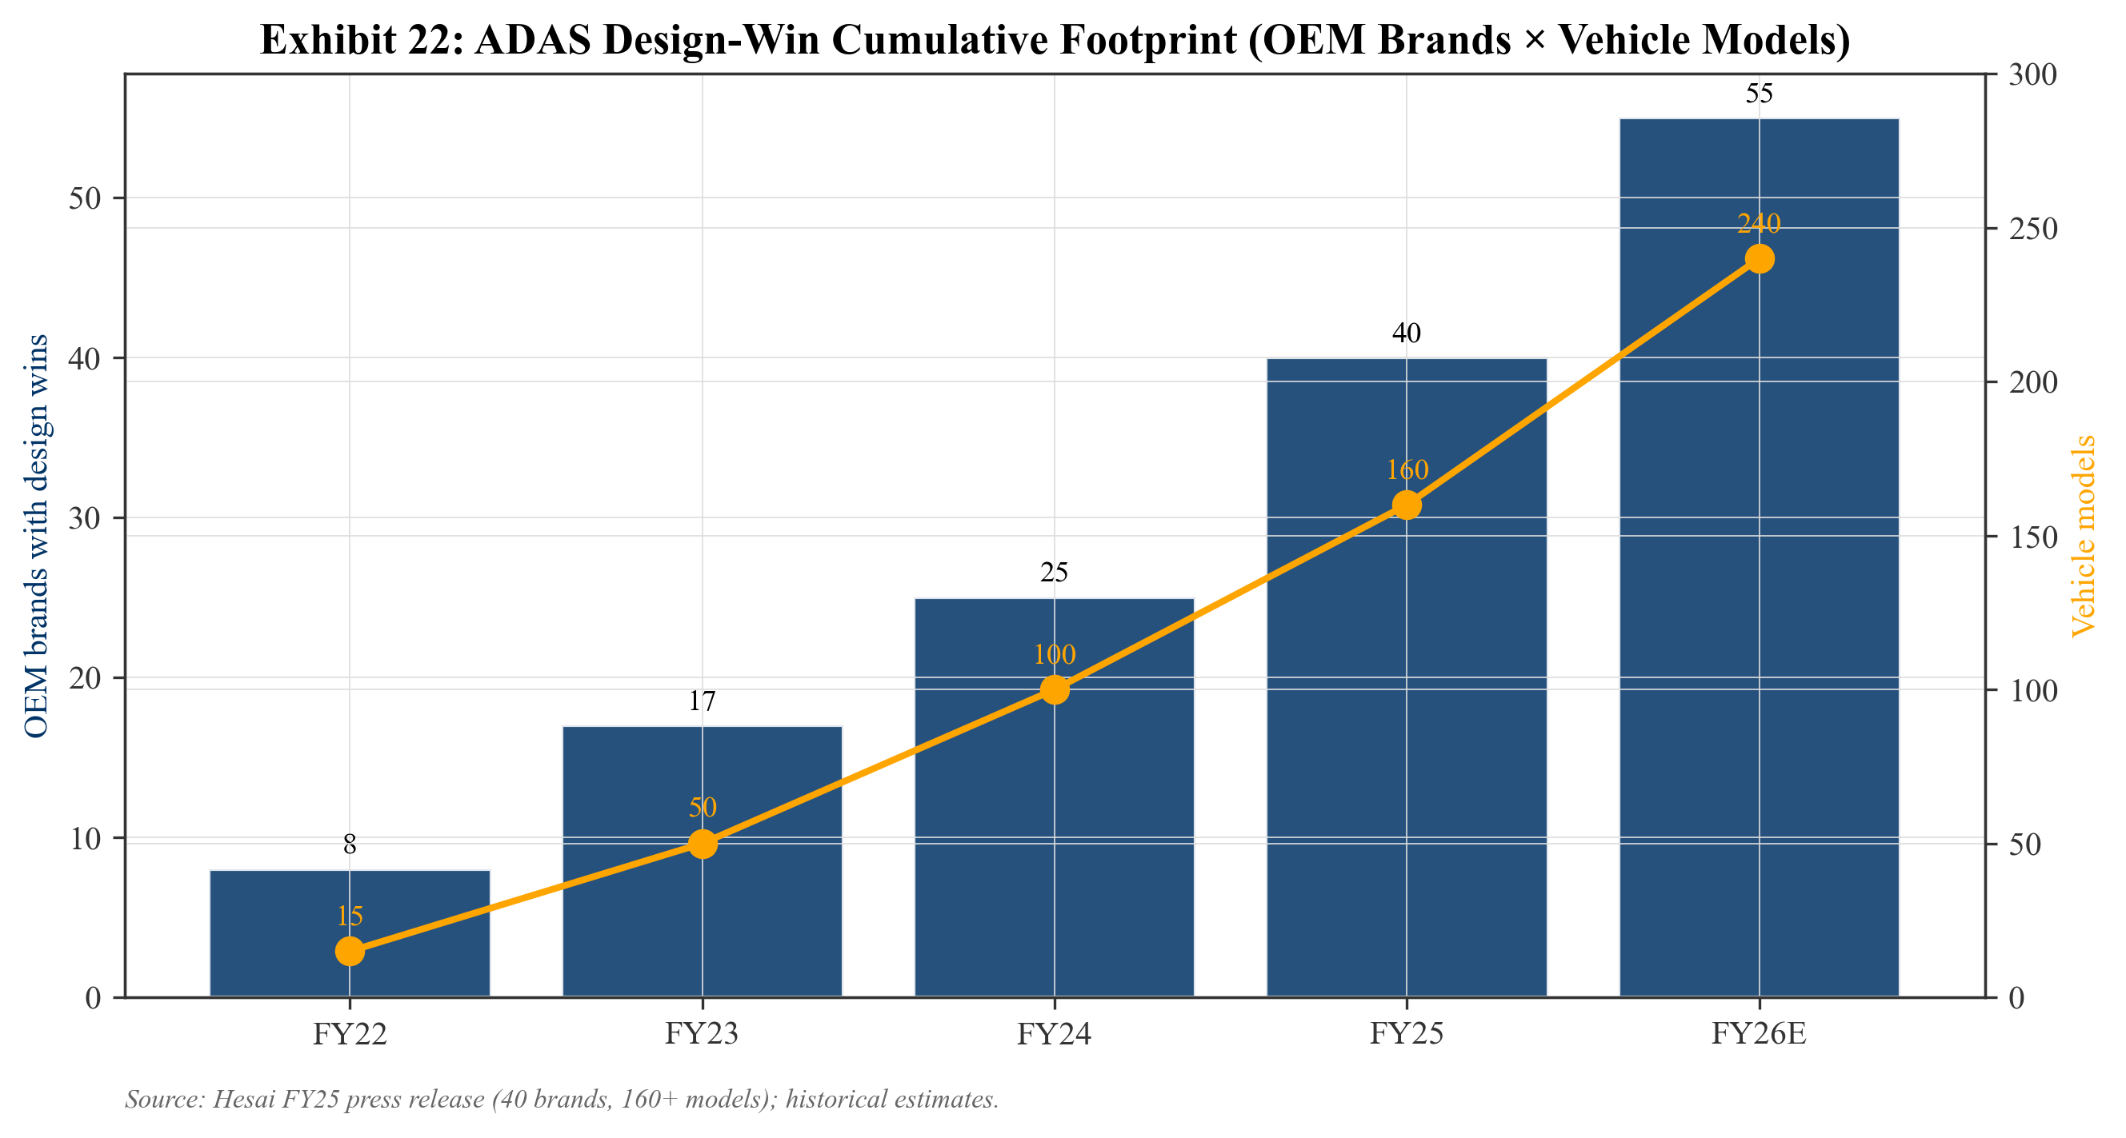
Exhibit 22: ADAS design-win footprint — 40 brands and 160+ vehicle models as of FY25.

2.6 Industry overview — lidar's structural position in autonomy
Lidar is a 3D-perception sensor technology that uses pulsed laser light to measure distance, producing a real-time point cloud of the environment around the sensor. It complements cameras (rich texture but poor depth) and radar (good depth but poor resolution) and is the primary perception modality used in robotaxi stacks. Within passenger-car ADAS, lidar sits at the L2+ / L3 / L4 boundary — below this threshold most OEMs (notably Tesla) rely on cameras alone, while above it most credible programs include at least one lidar. The current debate over Tesla's vision-only approach versus Waymo / Mercedes / Chinese OEM lidar-inclusive approaches is the central uncertainty in the industry's TAM trajectory.
The industry is concentrated geographically and bifurcating commercially. Three Chinese makers — Hesai, Robosense, Seyond (formerly Innovusion) — dominate global lidar shipments by volume. US-listed lidar peers (Ouster, Innoviz, Aeva, Luminar) have remained subscale and unprofitable. Tier-1 suppliers (Valeo, Continental) and chipset vendors (Mobileye via the EyeQ7 + lidar SoC partnership with Innoviz) have not yet displaced the pure plays in mass production.
The dominant industry trend is rapid attach-rate growth in China. Driven by a price war among Chinese EV OEMs that has pushed advanced ADAS down-market, lidar-equipped vehicles in China grew from roughly 590,000 units in 2024 to over 1.5 million in 2025 — a curve that has caught most Western forecasters off-guard. The second major trend is multi-lidar adoption: Li Auto, Xiaomi, Changan and others are designing in 3–6 lidars per vehicle for L3+ programs, multiplying lidar content per vehicle. The third major trend is lidar moving outside automotive: the robotic-lawn-mower market alone is projected by Yole to deploy more than 10 million 3D lidars cumulatively over the next 5 years, and the humanoid-robot market is widely forecast to reach >1 million units/yr by 2030. The fourth trend is cost compression: AT128 ASPs have fallen from approximately US$1,000+/unit at launch in 2022 to a blended ADAS ASP estimated at US$200–300/unit in 2025.
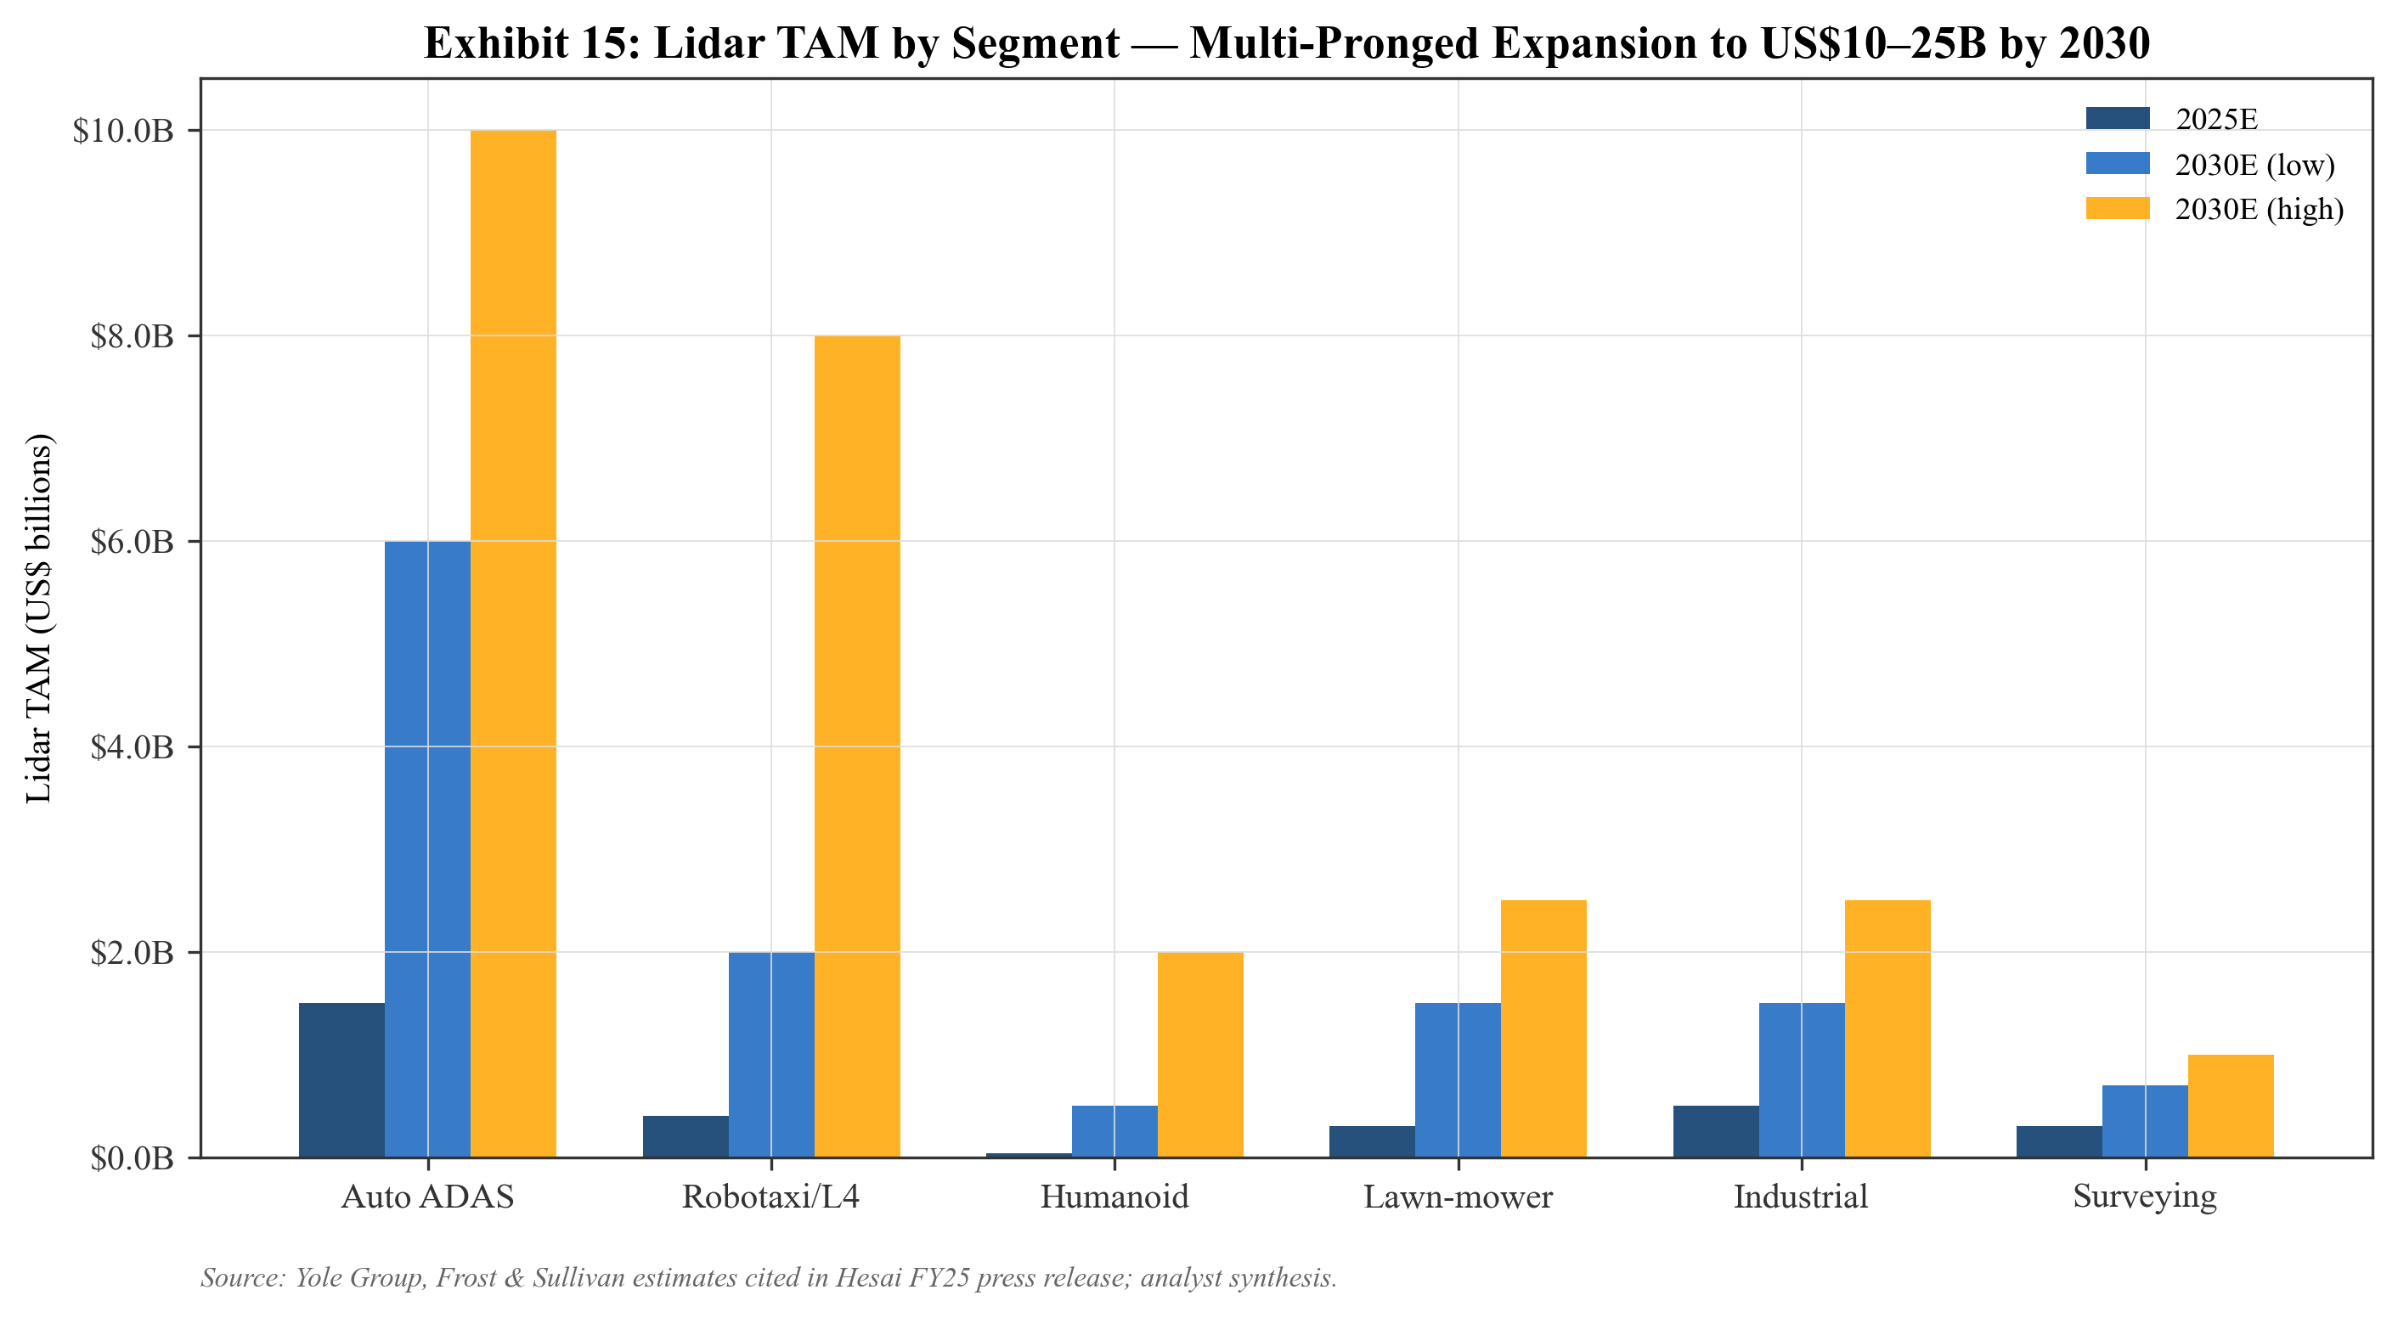
Exhibit 15: Lidar TAM by segment — multi-pronged expansion to US$10–25B by 2030.
2.7 Competitive landscape
Direct lidar competitors fall into three buckets: (1) Chinese pure-plays — Robosense (HKEX:2498) and Seyond (private, ex-Innovusion); (2) US-listed pure-plays — Ouster, Innoviz, Aeva, Luminar; (3) Tier-1 incumbents — Valeo, Continental, Bosch (which also holds 5.8% of Hesai). Indirect substitutes include 4D imaging radar (Arbe, Uhnder, Mobileye), cameras + computer vision (Tesla, Mobileye SuperVision), and HD maps.
On the price / features / scale grid, Hesai is the cost leader (BOM advantage via ASIC, vertical integration, Chinese supply chain), is in the top 1–2 on features (highest channel count with AT1440, widest FoV with JT128 hyper-hemispherical and FTX), and is the clear scale leader (1.62 million units shipped in 2025 vs. peers in the low-hundreds-of-thousands at best). Robosense is the closest peer on all three dimensions and is the principal competitive risk; everyone else either lacks Chinese supply-chain access (Valeo, Innoviz, Ouster, Aeva, Luminar) or lacks the dedicated automotive ASIC program.
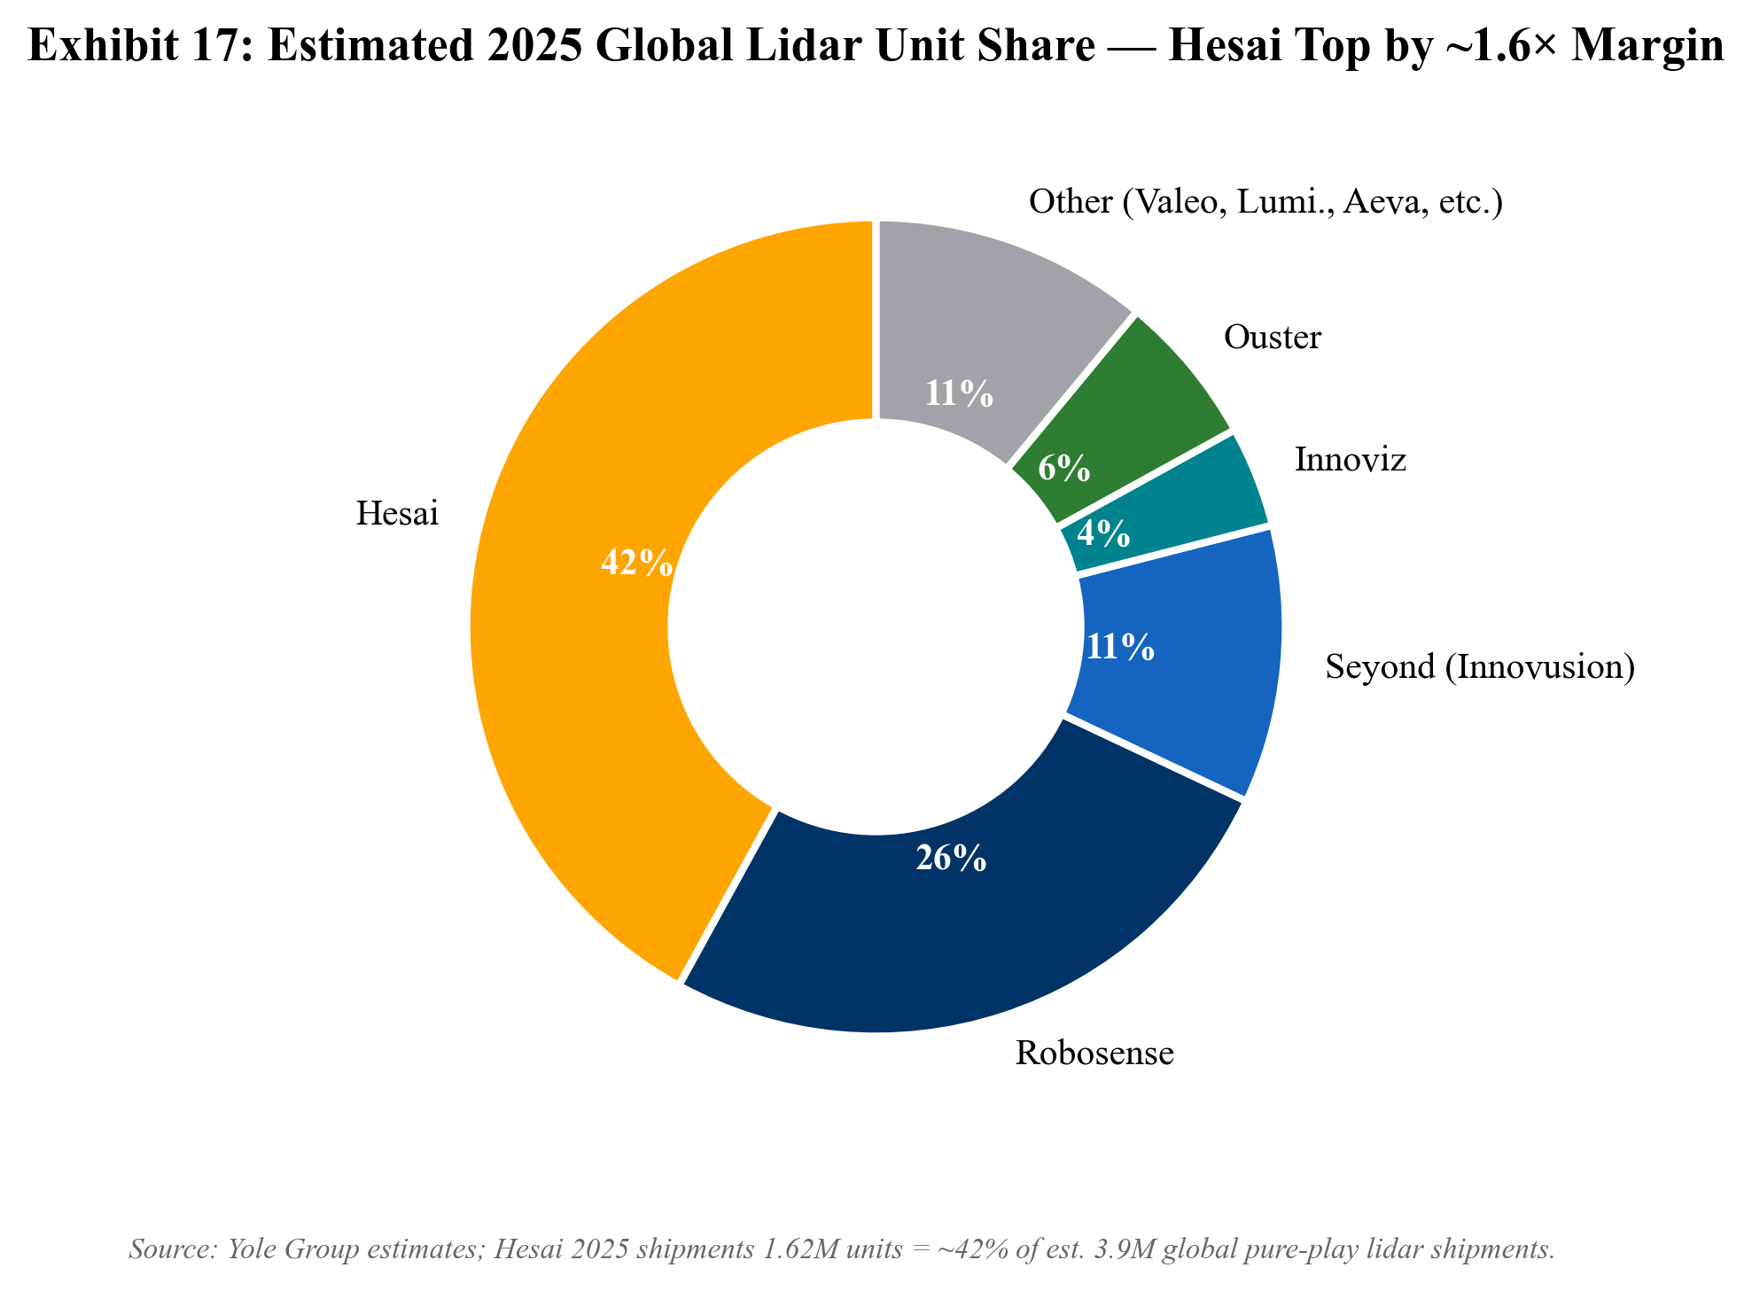
Exhibit 17: Estimated 2025 global lidar unit share — Hesai top by ~1.6× margin.
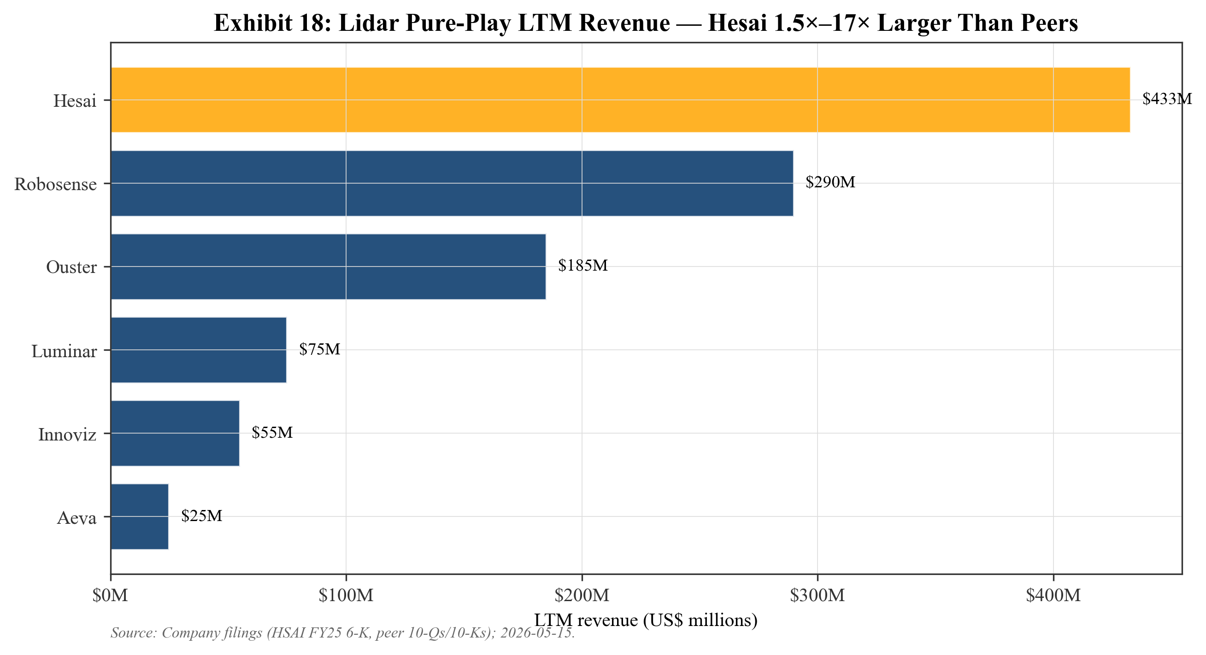
Exhibit 18: Lidar pure-play LTM revenue — Hesai 1.5×–17× larger than peers.
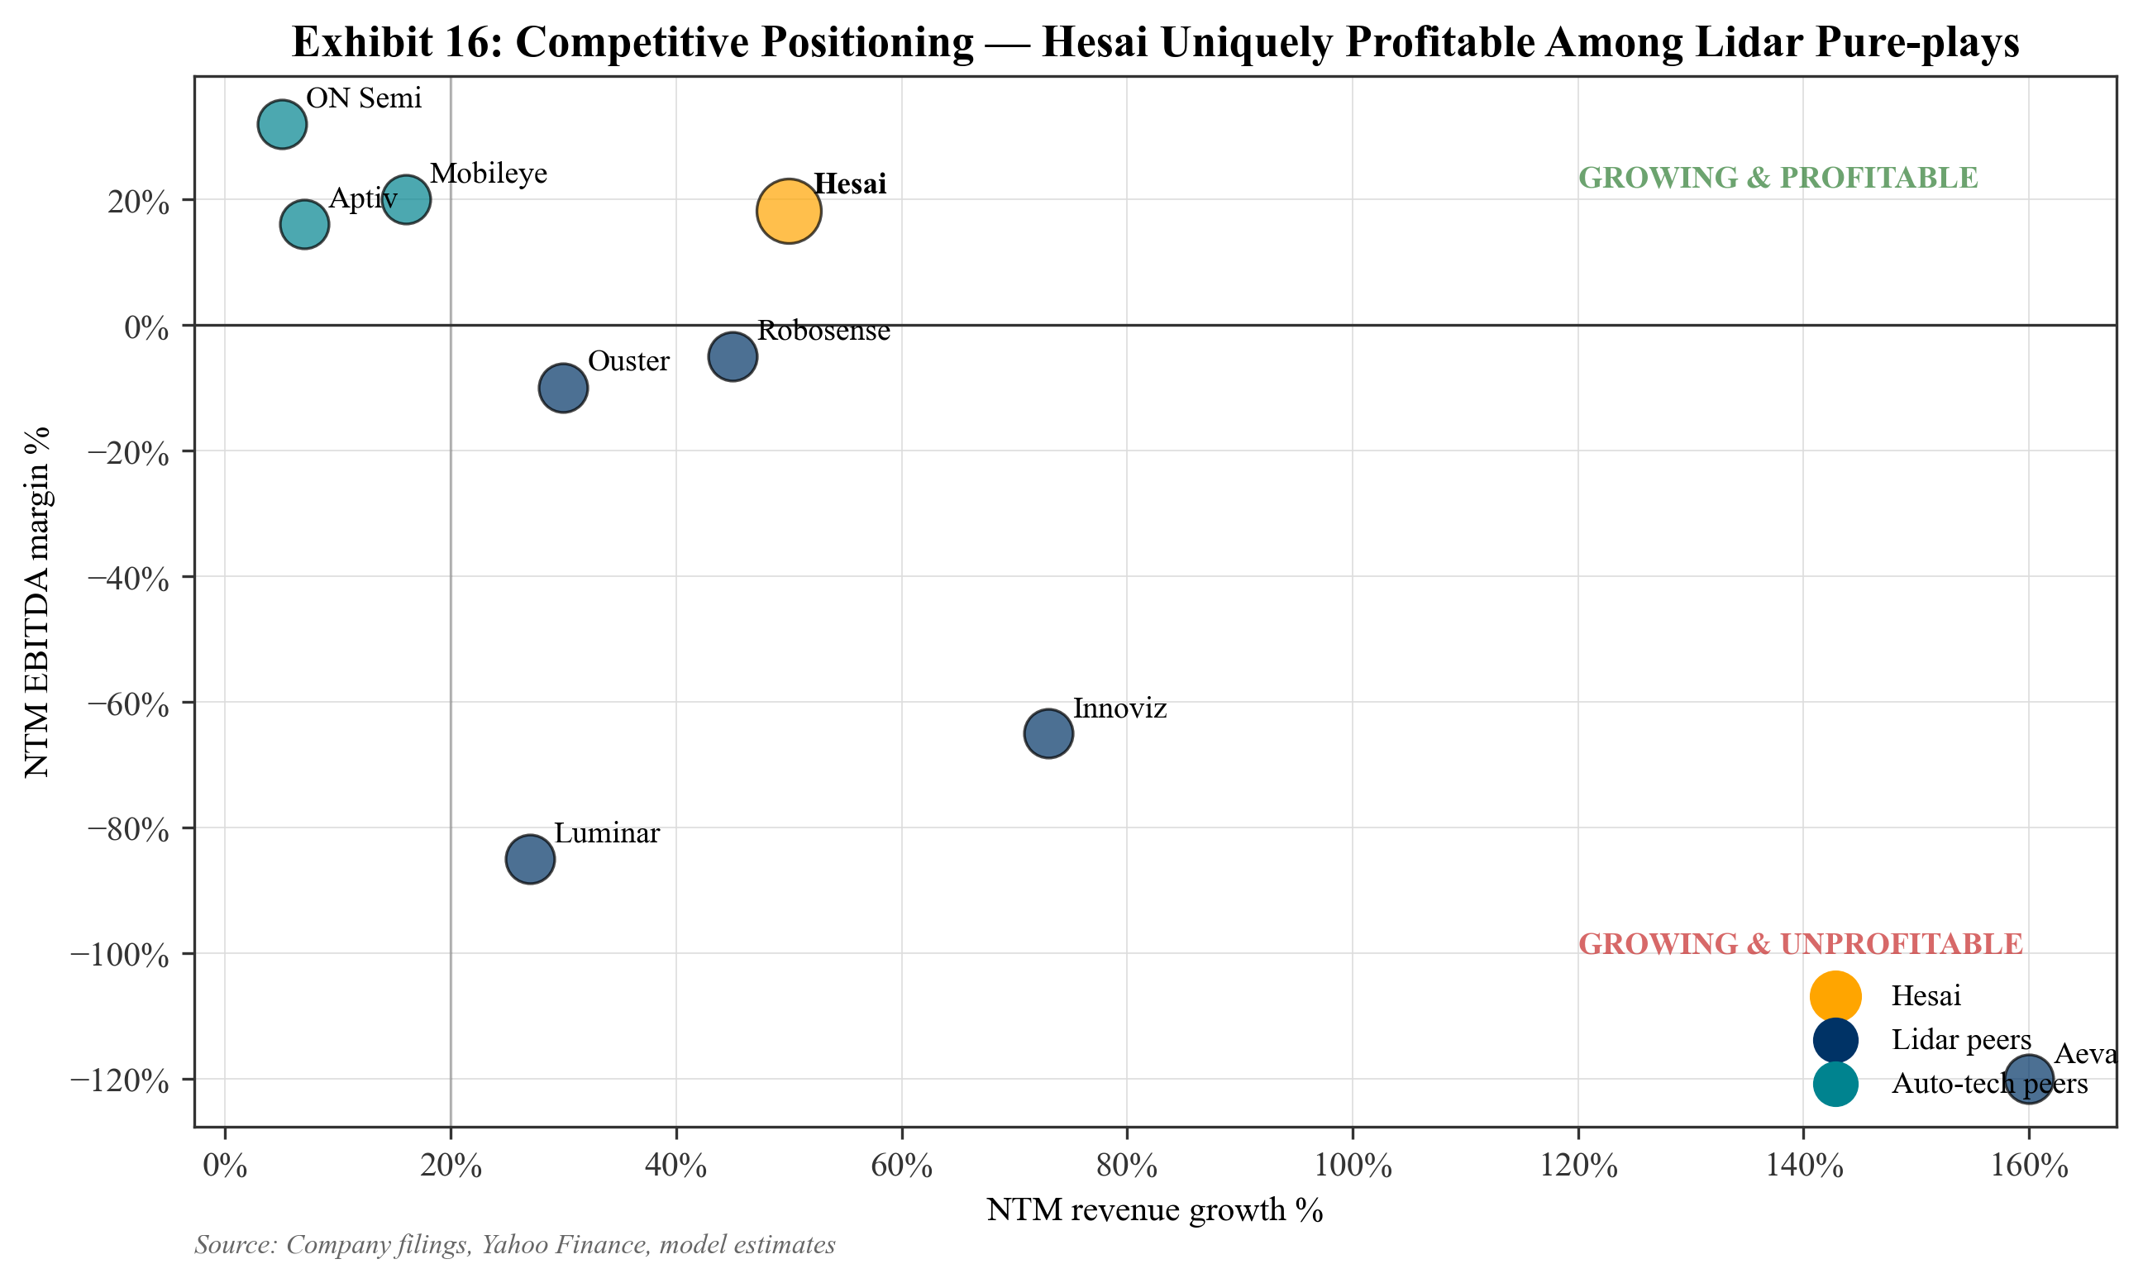
Exhibit 16: Competitive positioning — Hesai uniquely profitable among lidar pure-plays.

2.8 Total addressable market (TAM)
The lidar TAM has three layers: automotive ADAS lidar (units installed in passenger cars and light trucks at production); automotive autonomy lidar (robotaxis, robovans, and L4 commercial AV); and non-automotive lidar (humanoids, quadrupeds, robotic lawn mowers, port automation, AGVs/AMRs, drones, surveying).
Bottom-up sizing: Global light-vehicle production is ~88 million units/yr (OICA 2024). At current lidar attach rates of ~5% globally (heavily skewed to China), the deployed annual base is ~4 million units. Industry analysts forecast attach rates rising to 20–30% globally by 2030 driven by China leadership and L3+ adoption, implying 18–27 million ADAS lidar units/year. With multi-lidar adoption (3–6 lidars per L3+ vehicle), the lidar-unit TAM by 2030 could reach 30–50 million units/year. At a blended FY2025 Hesai ASP of US$200/unit (declining ~15% annually), the implied 2030 ADAS lidar revenue TAM is US$6–10 billion.
Hesai's serviceable addressable market is the global lidar TAM excluding markets effectively closed by US export controls and markets where Tier-1 captives dominate. That serviceable share is probably 60–75% of TAM. Given Hesai's current ~42% share of global pure-play lidar shipments and the natural scale advantage of being profitable, a reasonable SOM is 25–35% of the SAM, implying Hesai's 2030 revenue opportunity is in the range of US$3–6 billion under a central scenario — roughly 7–14× FY2025 revenue.

3. FINANCIAL ANALYSIS
3.1 Historical financial review
Hesai's financial history can be divided into three phases. Phase 1 (FY22-FY23) was the AT128 ramp investment phase: revenue scaled from RMB 1,203M to RMB 1,877M (+56% YoY) on AT128's first full year of volume shipments, but the company posted a widening net loss as R&D and S&M scaled ahead of revenue. Phase 2 (FY24) was the inflection year: revenue growth decelerated to +11% (RMB 2,077M) because the top-1 US OEM customer (GM) paused volume shipments — the RMB 203M project-based payment booked in October 2024 was a direct reflection of that pause — but China ADAS volume more than offset the gap; net loss compressed to RMB 102M. Phase 3 (FY25) was the operating-leverage payoff year: revenue grew 45.8% to RMB 3,028M as China ADAS lidar attach rates inflected, units more than tripled (502K → 1.62M), and Hesai posted its first positive GAAP net income of RMB 436M (US$62M).
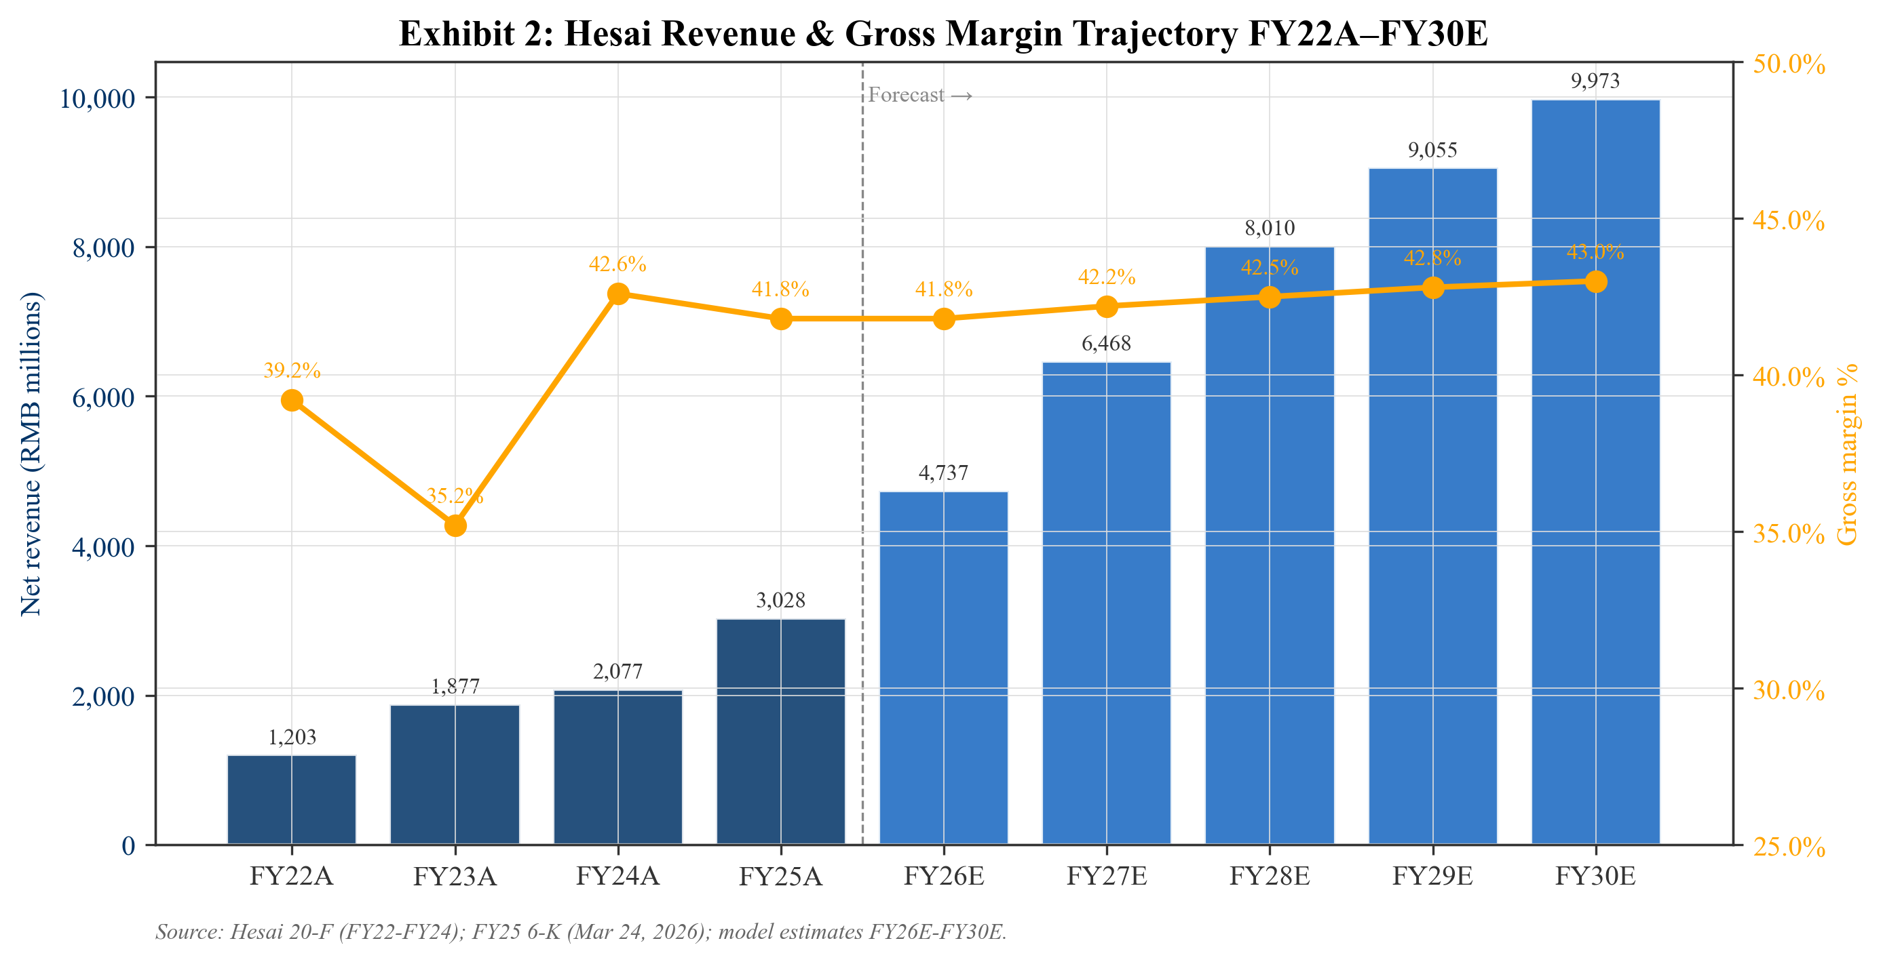
Exhibit 2: Hesai revenue & gross margin trajectory, FY22A-FY30E.
Gross margin progression has been non-linear: 39.2% in FY22 → 35.2% in FY23 (mix compression from higher Pandar128 robotaxi share) → 42.6% in FY24 → 41.8% in FY25 (~80bps compression from rising ADAS share, partially offset by cost-curve improvement). The trajectory suggests Hesai has architectural cost discipline that holds gross margin in the low 40s even as ADAS becomes the dominant volume segment. Our model has gross margin gently improving to 43.0% by FY30E.
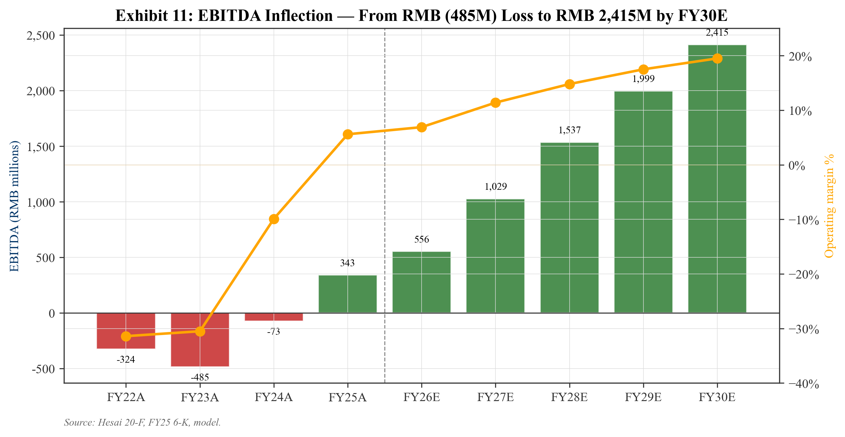
Exhibit 11: EBITDA inflection — from RMB (485M) loss to RMB 2,415M by FY30E.
Operating leverage has been even more dramatic than the gross-margin story. R&D as a % of revenue compressed from 46.2% in FY22 to 26.3% in FY25 — a 2,000+ bps compression in three years — while S&M went from 8.7% to 6.3% and G&A from 16.7% to 9.5%. EBIT moved from -31.4% in FY22 to +5.6% in FY25. Total operating expenses grew at only ~9% CAGR from FY22 to FY25 against revenue growth of ~36% CAGR. This is the engine that drove FY25 profitability and that our model expects to continue powering net income growth through FY28E.

Exhibit 10: Operating expense leverage — R&D declining from 46% to 14% of revenue.
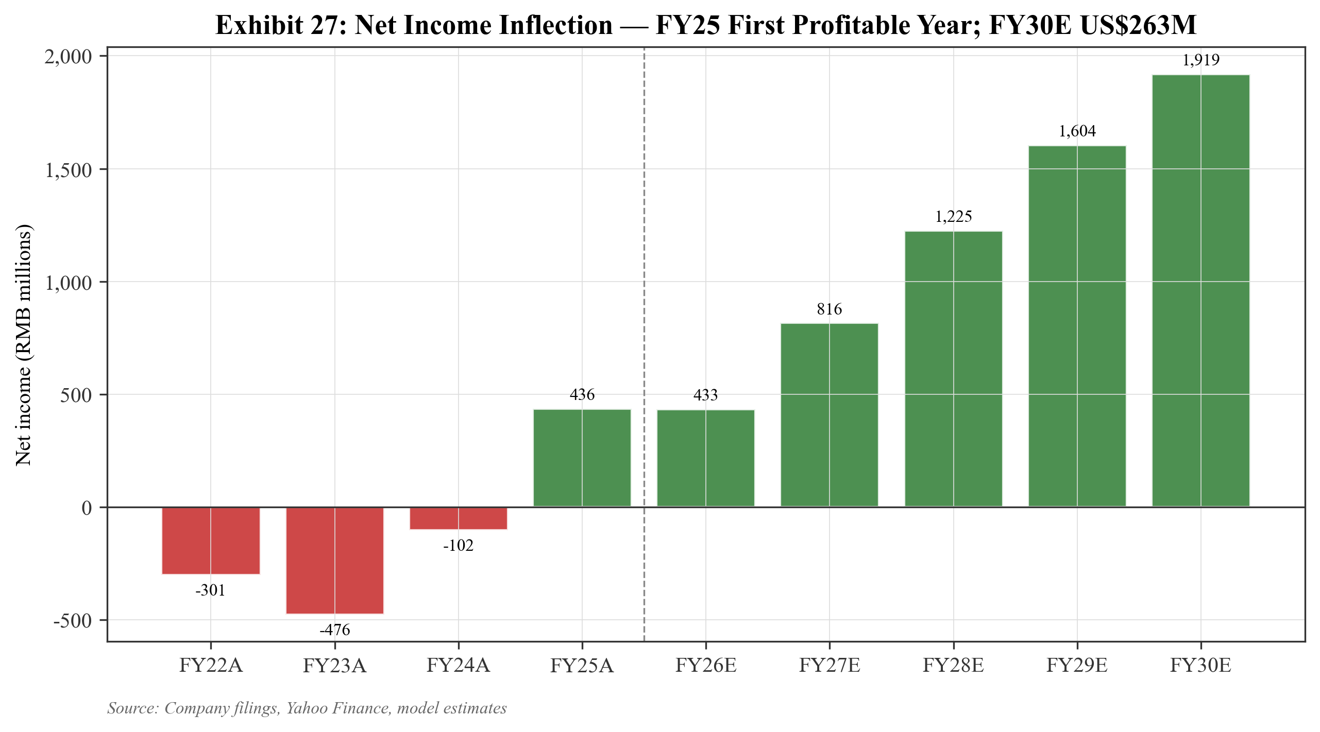
Exhibit 27: Net income inflection — FY25 first profitable year; FY30E US$263M.
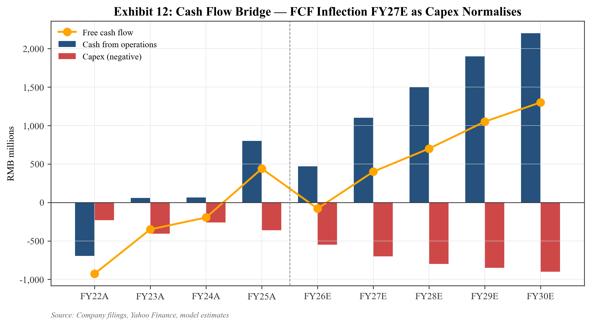
Exhibit 12: Cash flow bridge — FCF inflection FY27E as capex normalises.

3.2 Quarterly trajectory and Q1'26 guidance
Hesai's quarterly disclosure (introduced after the Nasdaq IPO) shows accelerating volume through FY25 with seasonally stronger Q3-Q4. Q4'25 revenue of RMB 1,000.5M (+39.0% YoY) was a record and gross margin reached 41.0%. Management's Q1'26 guidance of RMB 650–700M (+24-33% YoY) implies a moderation in growth rate, but this is largely Q1 seasonality (Chinese New Year shipment timing). We expect the full-year FY26 to reaccelerate as the new ATX-on-FMC500 platform ramps in Q2-Q3.
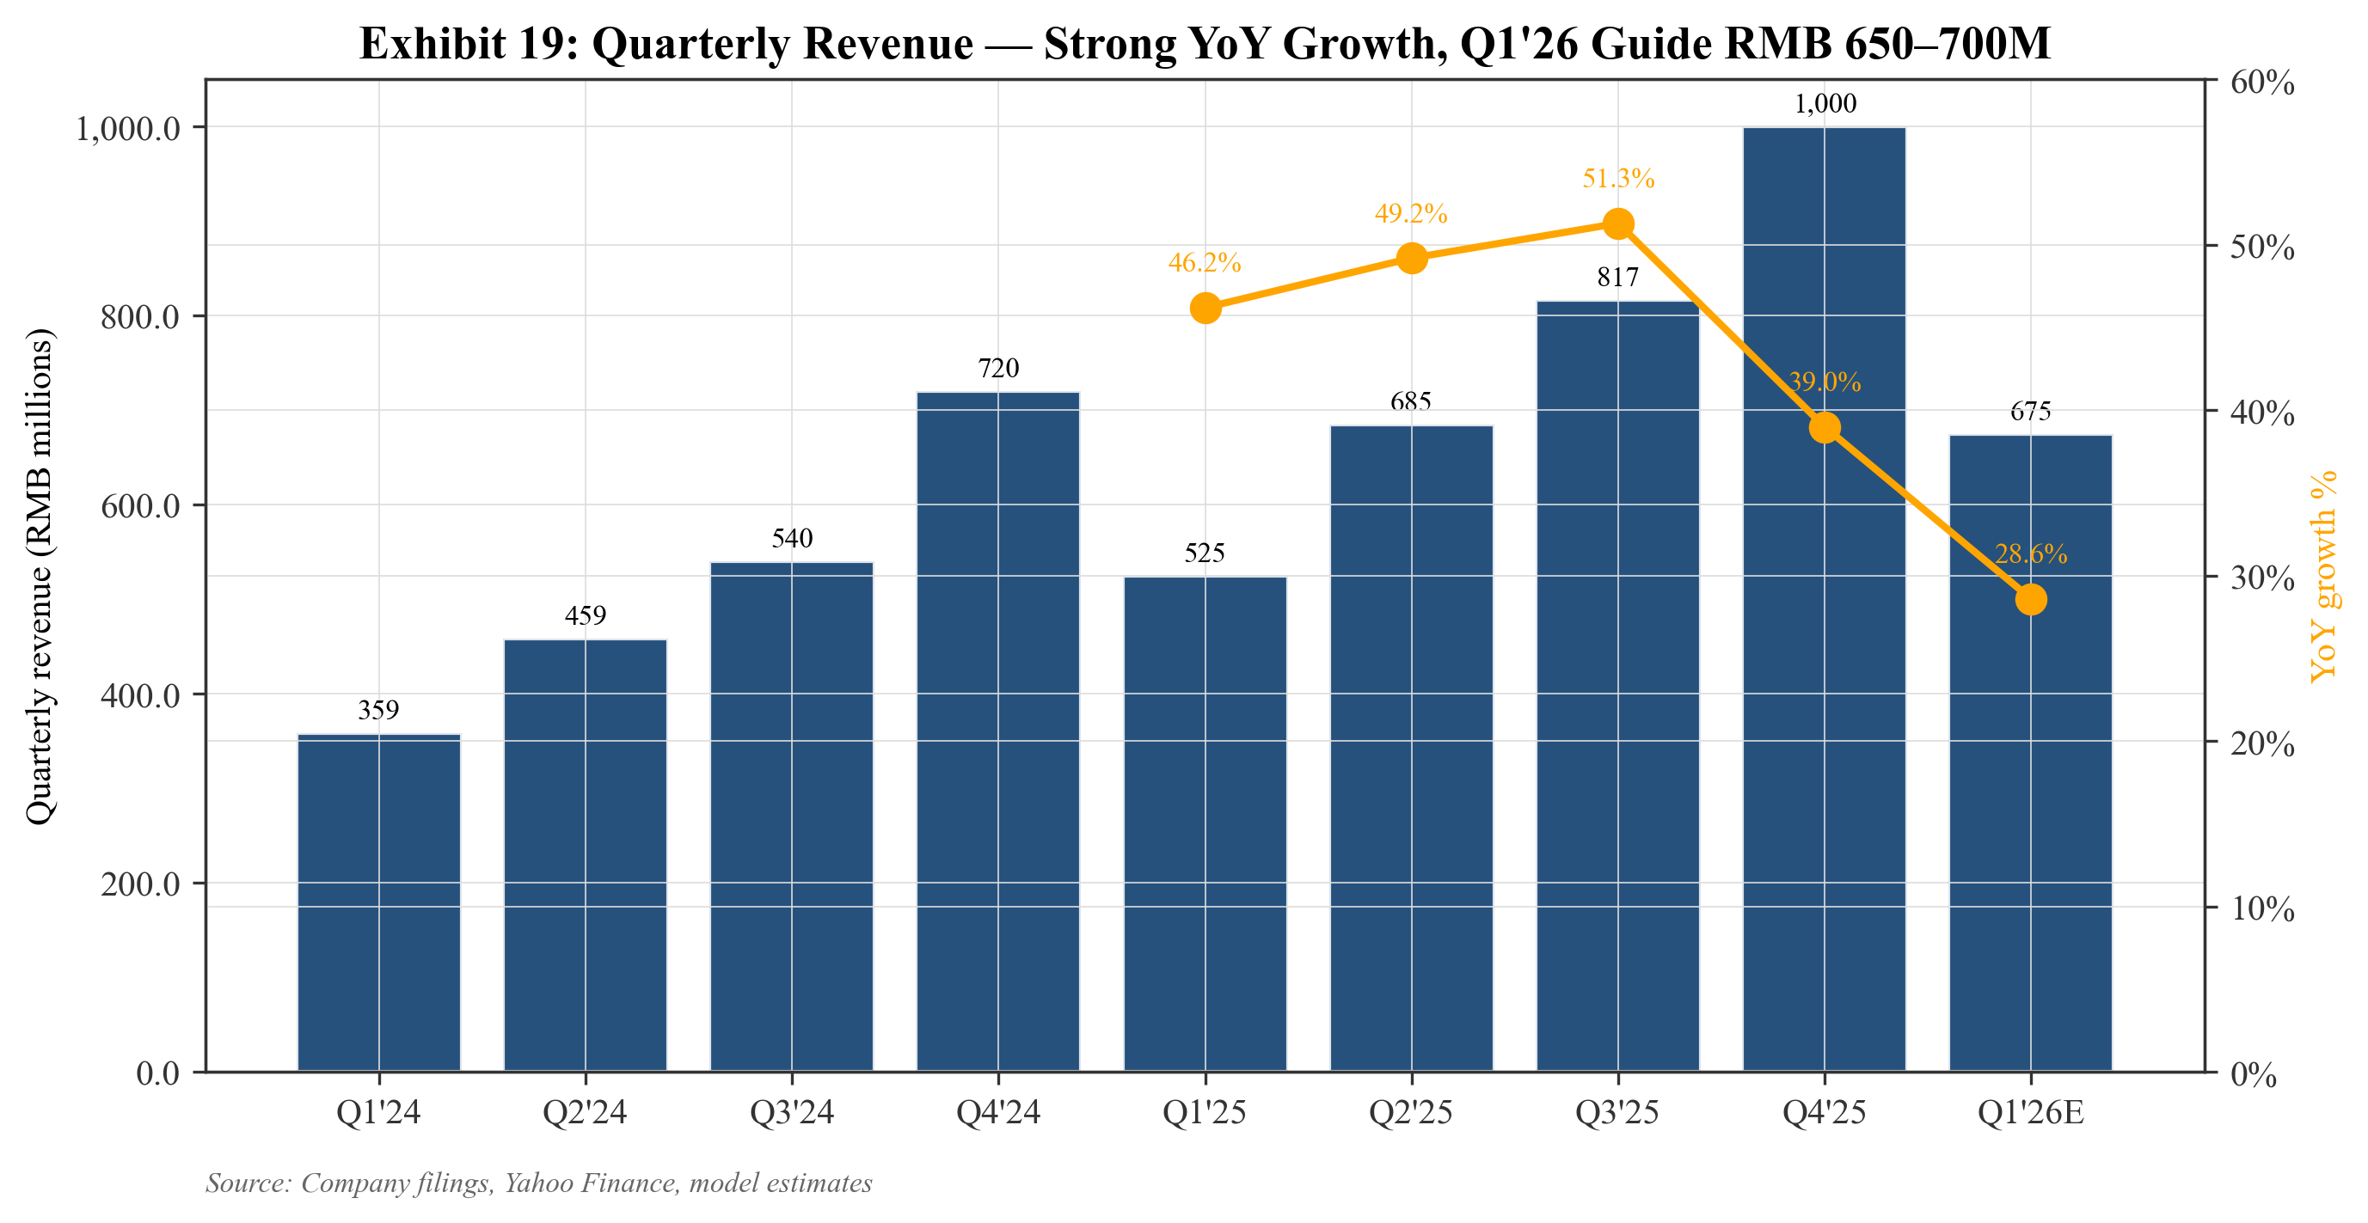
Exhibit 19: Quarterly revenue — strong YoY growth, Q1'26 guide RMB 650–700M.
3.3 Balance sheet and capital structure
The September 2025 HK listing materially strengthened Hesai's balance sheet. As of December 31, 2025: cash & equivalents RMB 1,663M, short-term investments RMB 3,092M, long-term investments RMB 2,782M = total cash + investments RMB 7,536M (US$1,033M). Total debt (short-term borrowings + long-term borrowings) was RMB 727M (US$100M). Net cash position therefore stands at RMB 6,809M (US$933M), or approximately 26% of current market capitalisation. This is an unusually strong balance sheet for a company at Hesai's stage of operating leverage — providing a multi-year runway for FMC500-class vertical-integration investments without requiring further capital markets activity.
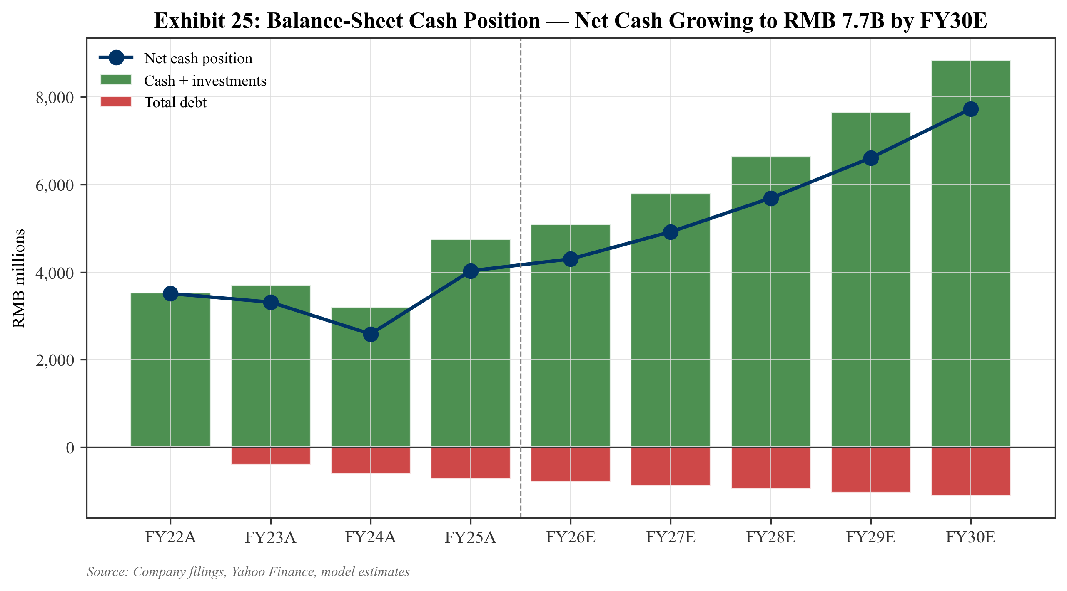
Exhibit 25: Balance-sheet cash position — net cash growing to RMB 7.7B by FY30E.
Capex intensity is elevated through the FY26-FY27 capacity ramp window. Hesai is scaling production capacity to 4 million+ annual units in FY26 (vs ~2 million units of effective capacity at end of FY25). Our model has capex/revenue at 11.6% in FY26E peaking at 10.8% in FY27E, then normalising to 9.0% by FY30E as capacity utilisation improves. The capex is principally tooling for new SKUs (ATX, JT128, AT1440), expansion of the Jiading manufacturing facility, and the Maibachuan SMT line.
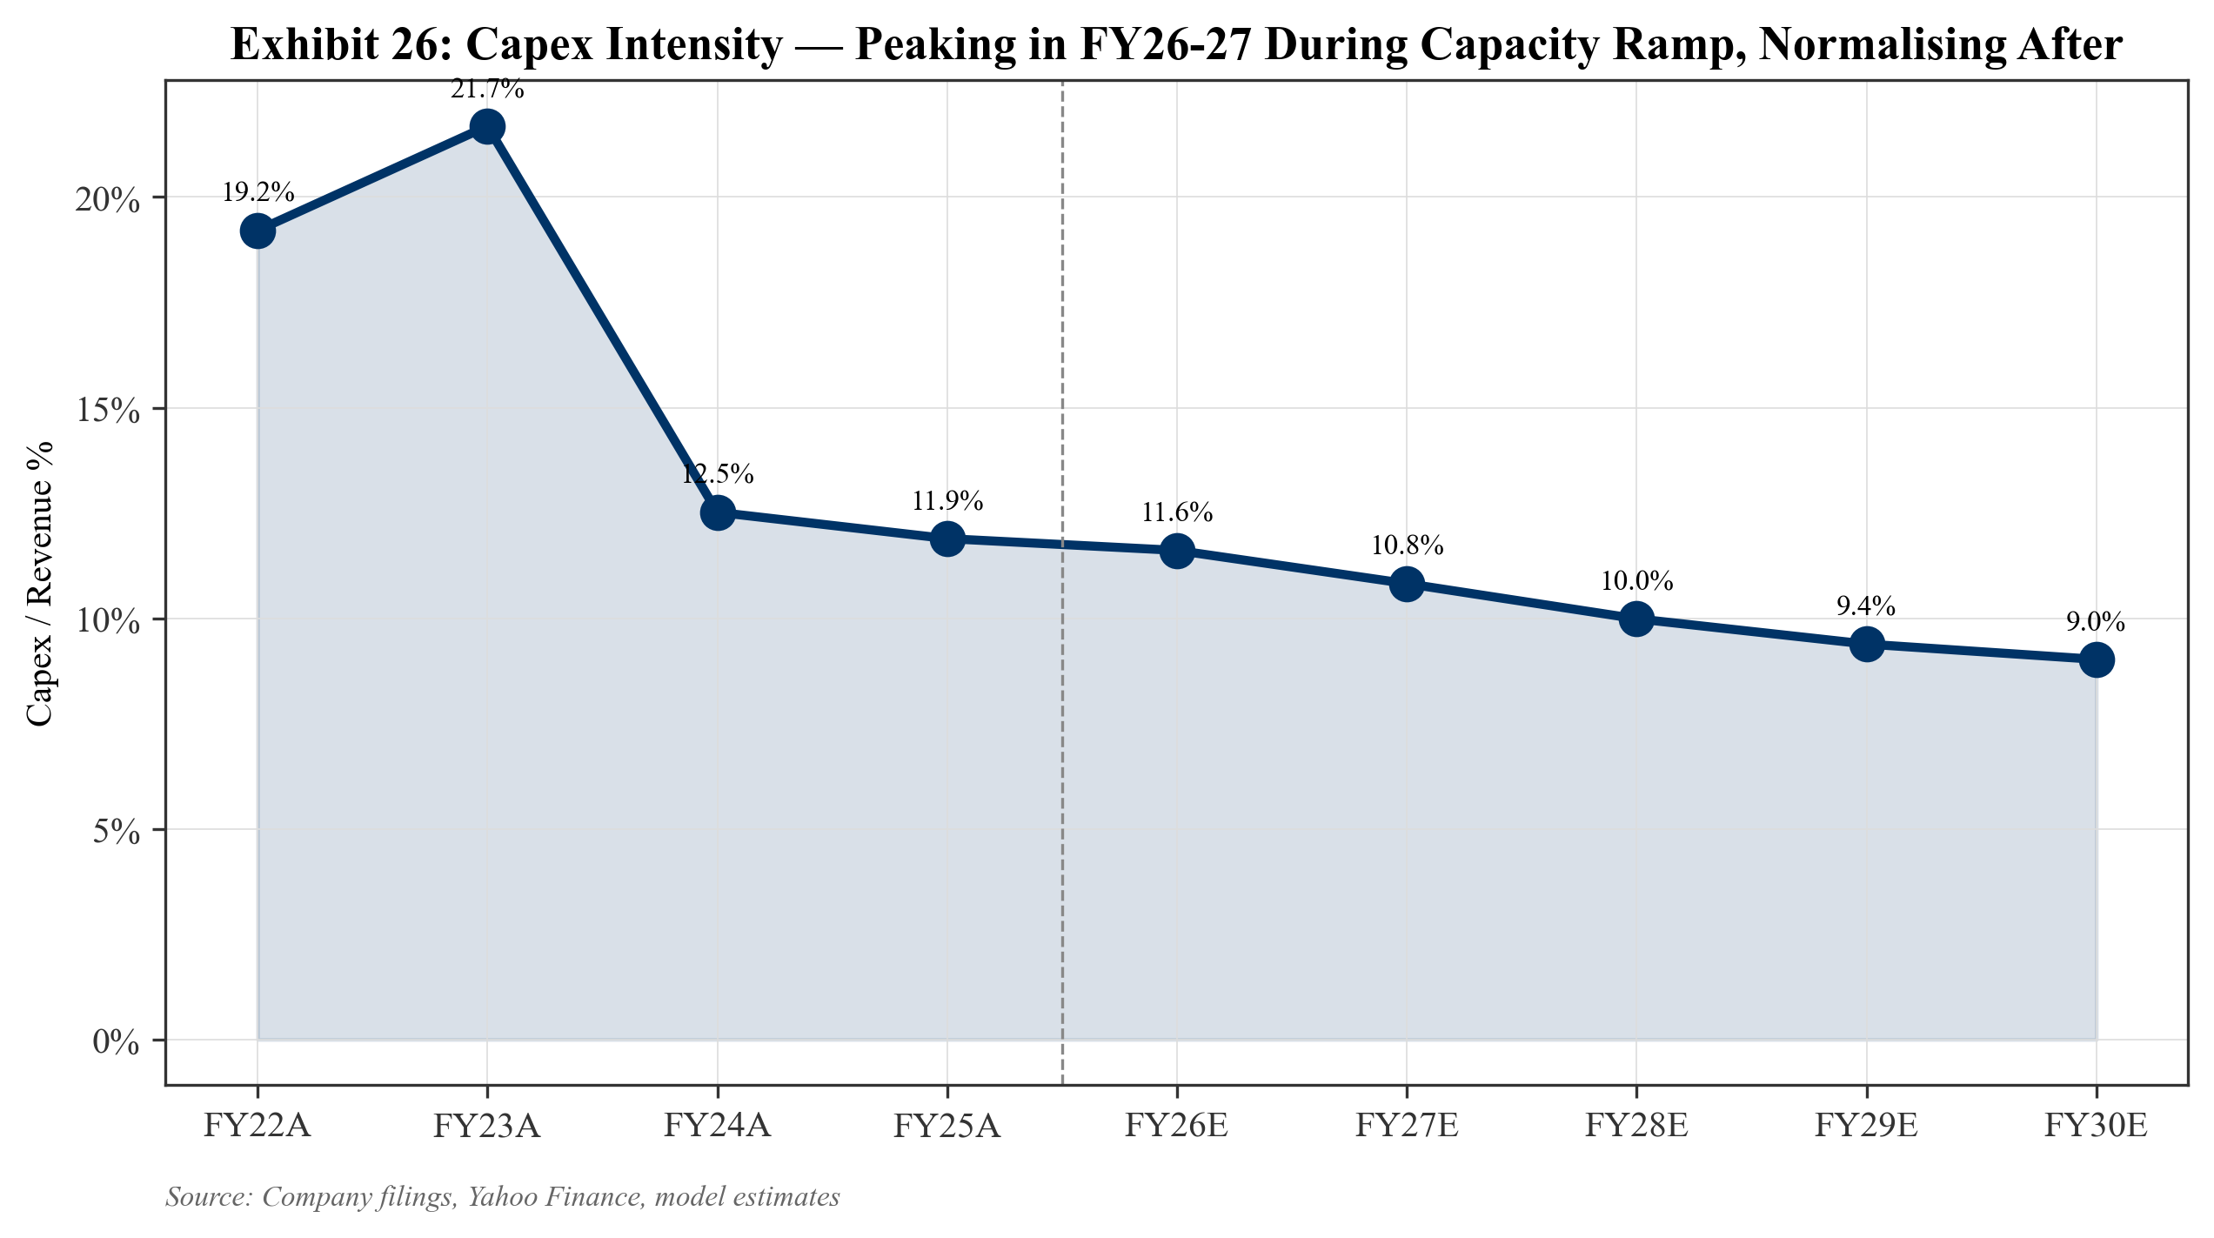
Exhibit 26: Capex intensity — peaking in FY26-27 during capacity ramp, normalising after.

3.4 Projection assumptions — bottom-up build
Our financial model is built bottom-up from product-level unit shipments and ASPs in the Revenue Model tab, with operating expense and balance-sheet build flowing through the Income Statement, Cash Flow, and Balance Sheet tabs. The model ties to disclosed FY22-FY24 actuals within ±1% and to the FY25 6-K within ±4% (the small variance reflects our product-level decomposition assumptions, which Hesai does not disclose at SKU level).
A. Revenue by product — ADAS long-range (AT-series)
We project ADAS long-range (AT-family) units to grow from 1,280K in FY25 to 2,550K in FY26E (+99% YoY), reaching 6,700K by FY30E (53% CAGR FY25-FY30). The trajectory is driven by:
- China attach rate. China ADAS lidar attach rate rising from 13% to 35% of new vehicle production from FY25 to FY30. China new-vehicle production assumed at ~28M units/yr (largely flat). At 35% attach rate that's 9.8M lidar-equipped vehicles, of which Hesai captures ~50% market share = 4.9M vehicles with at least one Hesai ADAS lidar.
- Multi-lidar adoption. Multi-lidar adoption: by FY29, we assume 25% of China lidar-equipped vehicles are multi-lidar (3-4 lidars/vehicle), implying a content/vehicle multiplier. Li Auto, Xiaomi, Changan multi-lidar L3+ platforms start production in 2026-27.
- ATX/AT128 transition. ATX ramp displaces AT128 as the volume workhorse beginning H2 2026. Our model has AT128 mature at ~50% of the AT mix by FY27 with ATX rising to ~40%, and AT512/AT1440 contributing ~10% of premium-tier units.
- ASP compression. ADAS LR ASP declines from RMB 1,300 in FY25 to RMB 640 in FY30 (-13.0% CAGR). This is driven by (i) Gen-5 ASIC cost reduction, (ii) in-house emitter/detector integration, (iii) volume-driven supply chain leverage, and (iv) competitive pricing pressure from Robosense.
- FY26 guidance bridge. FY26E guidance midpoint: management has guided 3.0-3.5M total units; assuming 18% Robotics mix (vs 15% in FY25), total ADAS = 2.6-3.0M, of which ~94% is AT-series. We model 2.7M AT-series units in FY26E, slightly below the high end of guidance.
Specific year-by-year ADAS LR build: FY25 1,280K × RMB 1,300 = RMB 1,664M; FY26E 2,550K × RMB 1,000 = RMB 2,550M; FY27E 3,800K × RMB 850 = RMB 3,230M; FY28E 4,900K × RMB 760 = RMB 3,724M; FY29E 5,800K × RMB 690 = RMB 4,002M; FY30E 6,700K × RMB 640 = RMB 4,288M. Total FY30E ADAS LR revenue is therefore RMB 4,288M, or 43% of total revenue.
B. Revenue by product — Robotics
Robotics revenue has historically been concentrated in robotaxi (Pandar128 / OT128) but is increasingly diversified into humanoid (JT128), lawn-mower, and industrial AGV applications. Total Robotics units grow from 239K in FY25 to 2,500K in FY30 (60% CAGR). Robotics revenue (RMB 1,048M in FY25 → RMB 5,310M in FY30) compounds at a 39% CAGR — slightly slower than units because of mix shift toward lower-ASP humanoid and lawn-mower products.
- Robotaxi. Robotaxi (Pandar128/OT128/QT128) volumes are mature at 75-450K units across the projection horizon, with ASP declining from RMB 12,000/unit in FY25 to RMB 3,800 by FY30. The robotaxi installed base in China is ~10,000 vehicles today growing to 100,000+ by FY30 driven by Apollo Go, Pony.ai, WeRide, and DiDi.
- Humanoid (JT128). Humanoid (JT128) is the high-optionality segment. We model 12K units in FY25 (mostly Unitree + early integrators) rising to 800K in FY30. The bull case assumes humanoid TAM materialises in line with the Morgan Stanley 4M-unit 2030 forecast, with Hesai capturing 30-40% share — that would imply 1.2-1.6M JT128 units by FY30. Our base case is conservative.
- Lawn-mower. Lawn-mower volumes ramp from 100K in FY25 to 900K in FY30. Named customers include Dreame, MOVA, and Nexlawn. Management has indicated a backlog of >10M cumulative units. ASP starts low (RMB 2,000) and declines further (RMB 850 by FY30) as this becomes a consumer-volume product.
- Industrial. Industrial / AGV: stable 120-350K units. Includes Meituan, Zelos, Neolix robovans plus port automation and AGV applications.
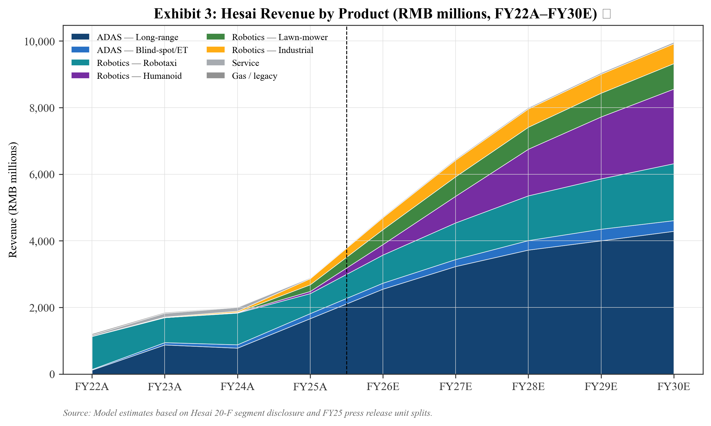
Exhibit 3: Hesai revenue by product (stacked area) — Robotics mix rising from 35% in FY25 to 53% by FY30E. [MANDATORY]
C. Geographic revenue assumptions
Geographically, Mainland China remains the dominant revenue source — RMB 1,543M (74% of revenue) in FY24, and we project this share to remain ~75-80% through FY30E. The geographic concentration risk is real but reflects the reality that China is the world's lidar-adoption pioneer. Specific regional build:
- China. Mainland China: FY24 RMB 1,543M → FY30E RMB 10,800M (38% CAGR). Driven by the top-10 China OEMs (Li Auto, Xiaomi, BYD, Geely, Changan, BAIC, Great Wall, NIO, Leapmotor, JiYue), plus robotaxi/robotics customers.
- North America. North America: FY24 RMB 281M (collapsed from FY23 RMB 748M as the GM design-in paused) → FY30E RMB 1,500M (32% CAGR). Recovery driven by resumption of GM Super Cruise/Ultra Cruise volume, plus Waymo/Apollo Go robotaxi expansion. Note this is the most geopolitically-exposed line.
- Europe. Europe: FY24 RMB 161M → FY30E RMB 1,050M (37% CAGR). Driven by Bosch Tier-1 partnership distribution and direct Stellantis / Mercedes design-ins.
- Asia ex-China. Asia ex-China: FY24 RMB 65M → FY30E RMB 480M (40% CAGR). Driven by Japan/Korea Tier-1 evaluations and Southeast Asia robotaxi pilots.
- Rest of World. Rest of World: FY24 RMB 27M → FY30E RMB 250M (45% CAGR). Smallest segment but fastest growth — Brazil, Middle East, Australia.
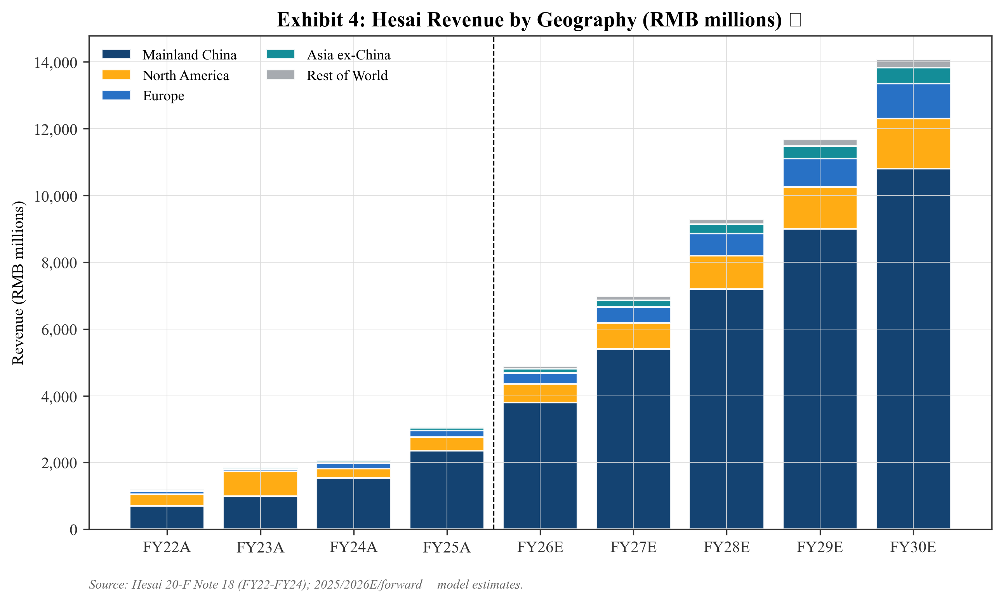
Exhibit 4: Hesai revenue by geography — Mainland China remains 75-80% of revenue. [MANDATORY]
D. Margin and OpEx assumptions
Gross margin holds at 41.8-43.0% across the projection horizon. Our drivers:
- ADAS mix headwind. ADAS mix shift compresses gross margin by ~50bps as ADAS grows from 60% to 43% of revenue (ADAS GM is structurally below Robotics GM).
- ASIC / SoC cost-down. Gen-5 ASIC and FMC500 SoC contribute ~150-200bps of gross margin improvement by FY28E.
- Supply chain leverage. Volume-driven supply chain leverage on VCSEL/SPAD components contributes ~50-100bps.
- Warranty. Warranty/recall provisions assumed at ~2.5% of revenue.
R&D as % of revenue compresses from 26.3% in FY25 to 14.2% in FY30E. R&D dollars grow from RMB 797M to RMB 1,416M (12% CAGR vs 27% revenue CAGR). S&M as % of revenue compresses from 6.3% to 4.4% (S&M dollars grow at 10% CAGR). G&A compresses from 9.5% to 5.4% (G&A dollars grow at 8% CAGR). The asymmetric scaling reflects (i) R&D headcount growth at ~5% per year well below revenue growth, (ii) S&M productivity from a fixed sales force covering an expanding customer set, and (iii) G&A scale leverage on a fixed administrative cost base.
E. Other key assumptions
- Tax rate. Tax rate: 10% in FY26E rising to 14% in FY30E. The low rate reflects Chinese high-tech enterprise tax incentives and accumulated NOL carryforwards from the loss years.
- Working capital. Working capital: ΔWC = -12% of revenue growth in FY26E declining to -6% by FY30E. Reflects normalising DSO/DIO/DPO cycles as the business matures.
- D&A. D&A: RMB 230M in FY26E rising to RMB 470M by FY30E, tracking PP&E base growth.
- Capex. Capex: RMB 550M in FY26E peaking at RMB 900M in FY30E. Capex/revenue ratio peaks at 12% in FY26 and normalises to 9% by FY30 as capacity matures.
- SBC. Stock-based compensation: RMB 130-190M across the projection horizon, slightly above FY25's RMB 115M reflecting expanding employee base.

3.5 Scenario analysis — Bull / Base / Bear
We assign explicit probabilities to three scenarios and stress-test the model parameters under each. The probability-weighted expected value of US$26.35 sits modestly below our explicit US$28 PT, reflecting our conviction in the operating-leverage thesis.
Bull case (25% probability) — multi-lidar L3+ goes mainstream
In the bull case, the upper bound of FY26 guidance (3.5M units) is met, China new-vehicle lidar attach rate reaches 45% by FY29 driven by MIIT mandate of L3+ redundancy on vehicles above RMB 200K, and multi-lidar adoption (3-6 lidars per L3+ vehicle) becomes the new normal for top-15 China OEMs. JT128 humanoid optionality materialises faster than consensus: Unitree, Galbot, and HONOR Robot collectively reach 800K humanoid robots in FY28-FY29, with Hesai supplying 70% of them. Robosense, while growing, cedes share at the premium tier as Hesai's Gen-5 ASIC and FMC500 SoC widen the BOM gap. The US OEM (GM) resumes full Super Cruise volume in 2027 following a favourable 1260H ruling, and Stellantis / Mercedes evaluations conclude with Hesai design-ins. Hesai's gross margin holds at 45% as the Gen-4/5 ASIC cost-down outpaces ASP compression.
Bull case quantitative parameters:
- Revenue. FY29E revenue: RMB 12,500M (US$1,712M); CAGR FY25-FY29 = 60%
- Gross margin. FY29E gross margin: 45.0%
- EBITDA. FY29E EBITDA: RMB 2,280M (US$312M); EBITDA margin 18.2%
- EPS. FY29E EPS: RMB 10.71 (US$1.47, diluted, at FX 7.30)
- FCF. FY29E FCF: RMB 1,450M (US$199M); FCF margin 11.6%
- Valuation. Implied valuation: 25× FY29 EPS = US$36.75/ADS; DCF (exit 14× $312M EBITDA) = US$36.20/ADS
Bull case catalysts required: (i) MIIT issues L3+ redundancy regulation by H2 2026, (ii) at least 5 of the top-10 China OEMs commit to multi-lidar L3+ programs at scale, (iii) Unitree humanoid shipments reach 200K+ in FY27, (iv) GM resumes Super Cruise volume in 2026, (v) Robosense growth slows to <40% YoY in FY27-FY28.
Base case (55% probability) — operating leverage delivers as modeled
Our base case assumes FY26 unit shipments land at the midpoint (3.25M units) and revenue compounds at a 50% CAGR FY25-FY29. China ADAS attach rates rise to 35% by FY29 (vs ~13% in FY25) driven by L2++ and L3 adoption among Chinese OEMs without an explicit MIIT mandate. ASPs compress at ~15%/year — meaningful but offset by gross-margin discipline holding at 42-43%. JT128 humanoid backlog converts to 600K units/yr by FY29, contributing ~RMB 1.9B of revenue. Top-1 customer concentration eases to <20% as China customers diversify. Operating margin reaches 18% by FY29. The blended PT of US$28 is anchored to this base case.
Base case quantitative parameters:
- Revenue. FY29E revenue: RMB 9,055M (US$1,240M); CAGR FY25-FY29 = 32%
- Gross margin. FY29E gross margin: 42.8%
- EBITDA. FY29E EBITDA: RMB 1,999M (US$274M); EBITDA margin 22.1%
- EPS. FY29E EPS: RMB 9.49 (US$1.30 diluted)
- FCF. FY29E FCF: RMB 870M (US$119M); FCF margin 9.6%
- Valuation. Implied valuation: weighted-average DCF + comps method = US$28/ADS PT
Bear case (20% probability) — multi-shock scenario
In the bear case, multiple downside catalysts compound. China ADAS attach rates plateau at ~25% by FY29 (vs our base case 35%) as Tesla-style vision-only stacks gain mind-share among China's Tier-2 OEMs. Robosense undercuts Hesai's ADAS bids at the 4M-unit scale tier, forcing Hesai to defend market share with ASP cuts that compress gross margin below 35%. Renewed Section 1260H listing or Commerce entity-list action eliminates US OEM revenue entirely (the GM/Super Cruise relationship is severed). Lawn-mower and humanoid ramps disappoint — China consumer demand for robotic lawn-mowers fails to materialise at the modelled cadence, and humanoid robot shipments remain a niche category at <100K units/yr through FY29. RMB depreciation vs USD compresses reported revenue further.
Bear case quantitative parameters:
- Revenue. FY29E revenue: RMB 5,600M (US$767M); CAGR FY25-FY29 = 17%
- Gross margin. FY29E gross margin: 36.0%
- EBITDA. FY29E EBITDA: RMB 480M (US$66M); EBITDA margin 8.6%
- EPS. FY29E EPS: RMB 1.62 (US$0.22)
- FCF. FY29E FCF: RMB 70M (US$10M); FCF margin 1.3%
- Valuation. Implied valuation: 12× FY29 EPS = US$12.40 (-45% from current)
Bear case downside triggers: (i) Section 1260H renewed listing in 2026 (15% probability), (ii) Tesla FSD v15 achieves credible L4 demonstration without lidar by H2 2026 (10% probability), (iii) Robosense FY26 GM compresses Hesai ADAS GM below 35% (25% probability), (iv) Chinese EV sales drop 15%+ in 2026-27 (15% probability), (v) AT128/ATX recall or quality event (5% probability).
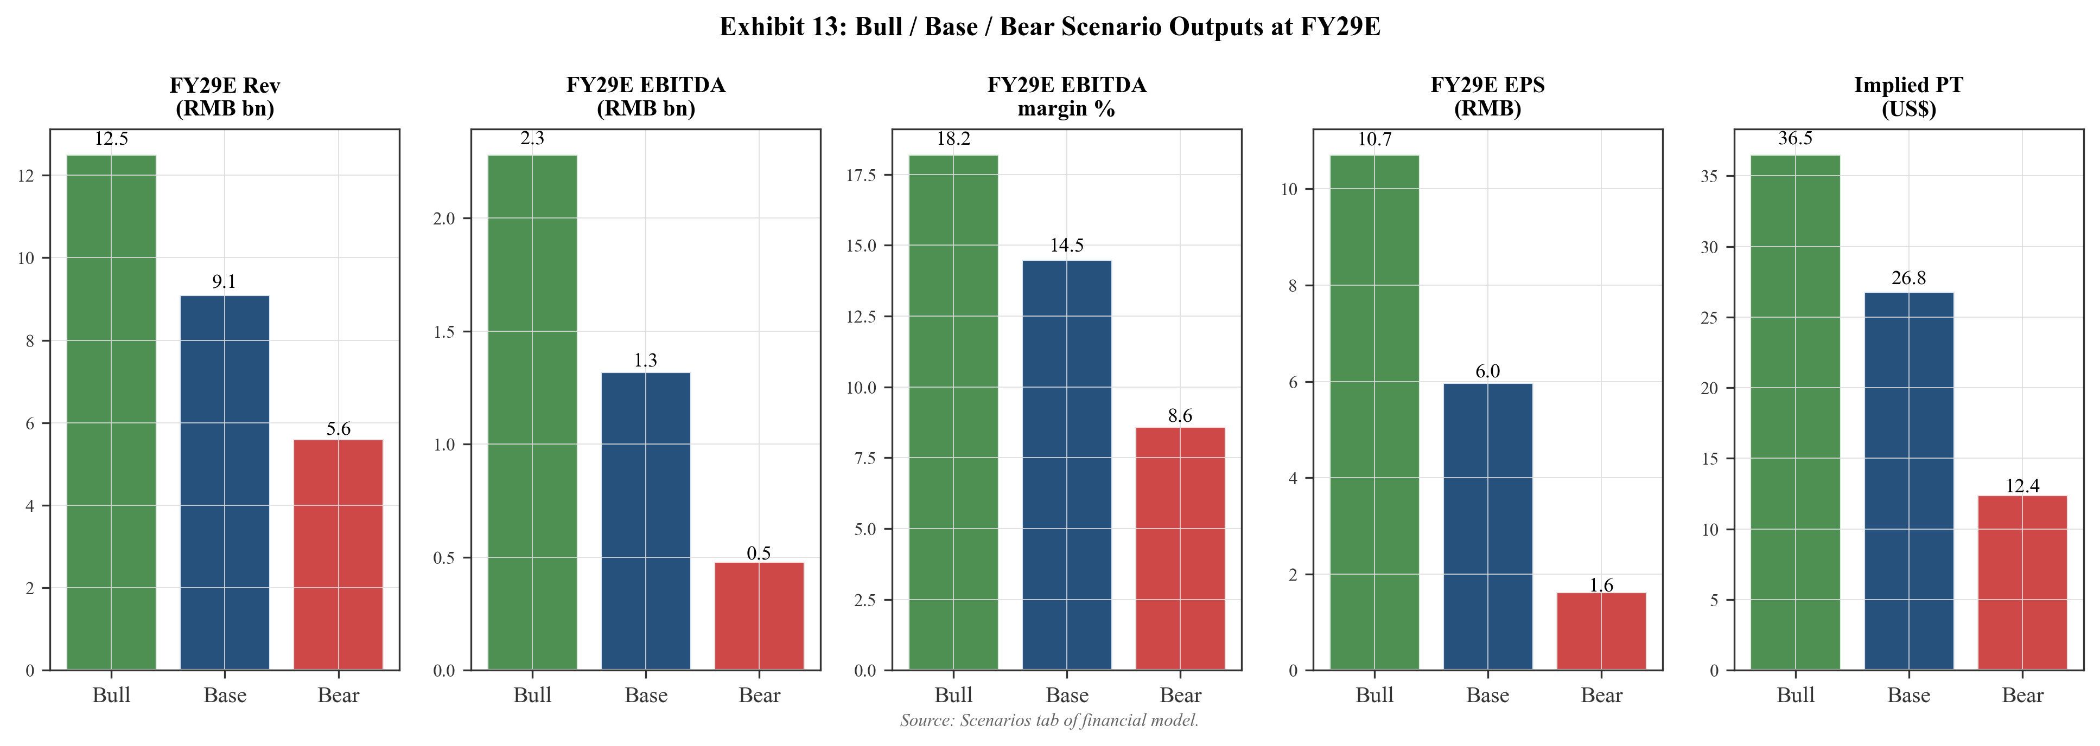
Exhibit 13: Bull / Base / Bear scenario outputs at FY29E.
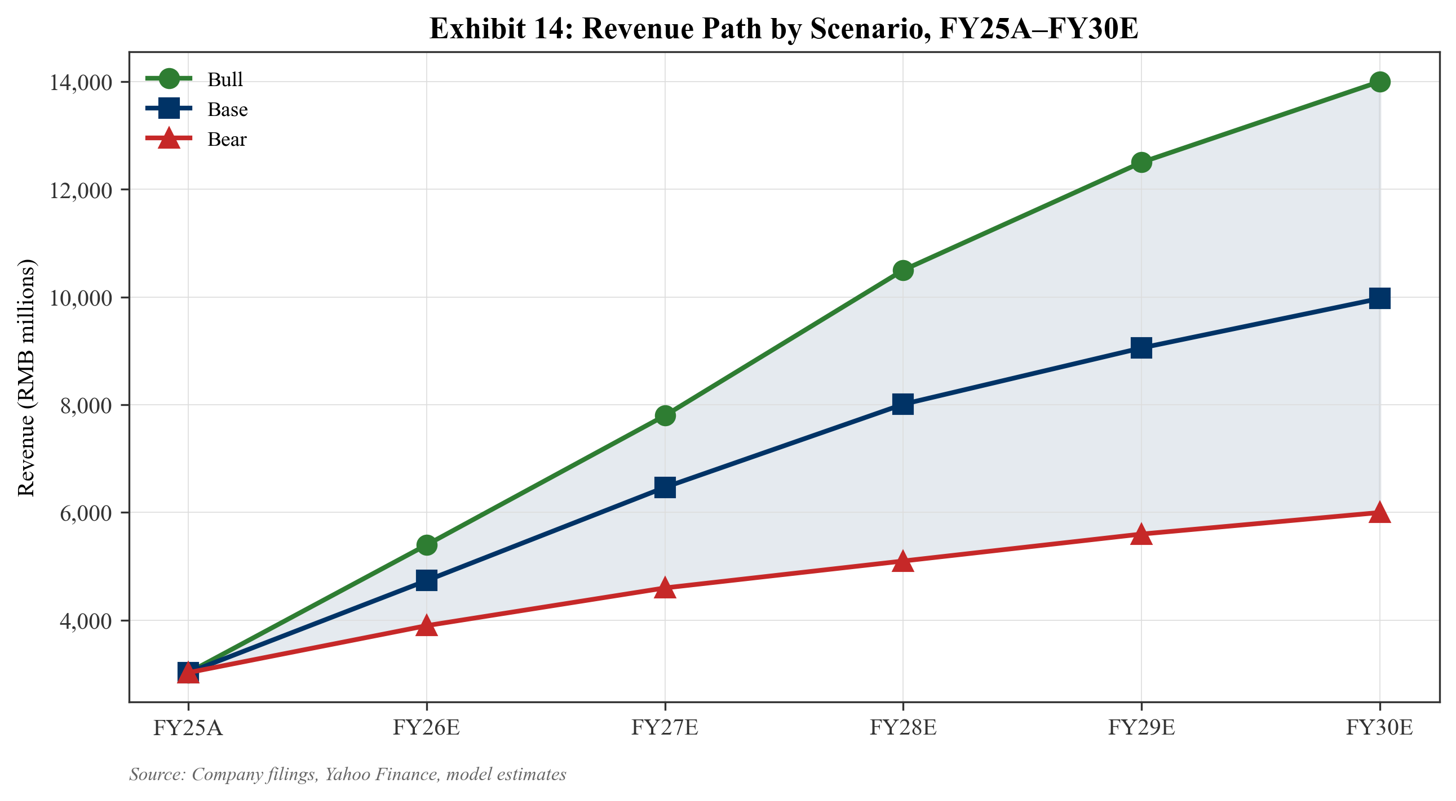
Exhibit 14: Revenue path by scenario, FY25A-FY30E.
Scenario comparison and probability-weighted PT
Metric | Bull (25%) | Base (55%) | Bear (20%) | Prob-weighted
FY29E Revenue (RMB B) | 12.5 | 9.1 | 5.6 | 9.30
FY29E EBITDA margin | 18.2% | 14.5% | 8.6% | 14.0%
FY29E EBITDA (RMB B) | 2.28 | 1.32 | 0.48 | 1.39
FY29E EPS (US$) | $1.47 | $0.82 | $0.22 | $0.86
DCF-implied PT (US$/ADS) | $36.50 | $26.80 | $12.40 | $26.35
Probability-weighted PT | — | — | — | $26.35
Our 12M PT | — | — | — | $28.00

3.6 Growth drivers — quantified
- (1) China ADAS attach rate. China ADAS attach rate: rising from 13% in FY25 to 35% in FY30. At ~28M China new-vehicle production and 35% attach, that's 9.8M lidar-equipped vehicles, of which Hesai captures ~50% = 4.9M. ADAS units alone go from 1.38M in FY25 to 7.1M in FY30.
- (2) Multi-lidar adoption. Multi-lidar L3+ adoption: by FY30, 30% of China lidar-equipped vehicles are multi-lidar (3-4 lidars/vehicle). Content/vehicle in multi-lidar programs is ~3× single-lidar programs.
- (3) Humanoid TAM. Humanoid robotics: JT128 unit volumes scale from 12K in FY25 to 800K in FY30 (base case). At RMB 3,000 average ASP by FY30, that's RMB 2.4B of FY30 revenue — 24% of total revenue. Bull case adds another 50-100% to this figure.
- (4) Lawn-mower / consumer robotics. Robotic lawn-mowers: 100K units in FY25 → 900K by FY30. >10M unit cumulative backlog disclosed by management.
- (5) Geographic mix. Geographic expansion: NA recovers from FY24 trough; Europe ramps via Bosch/Stellantis/Mercedes; Asia ex-China grows with Japan/Korea Tier-1 design-ins. International % of revenue holds at ~22-25% but grows in absolute dollars.
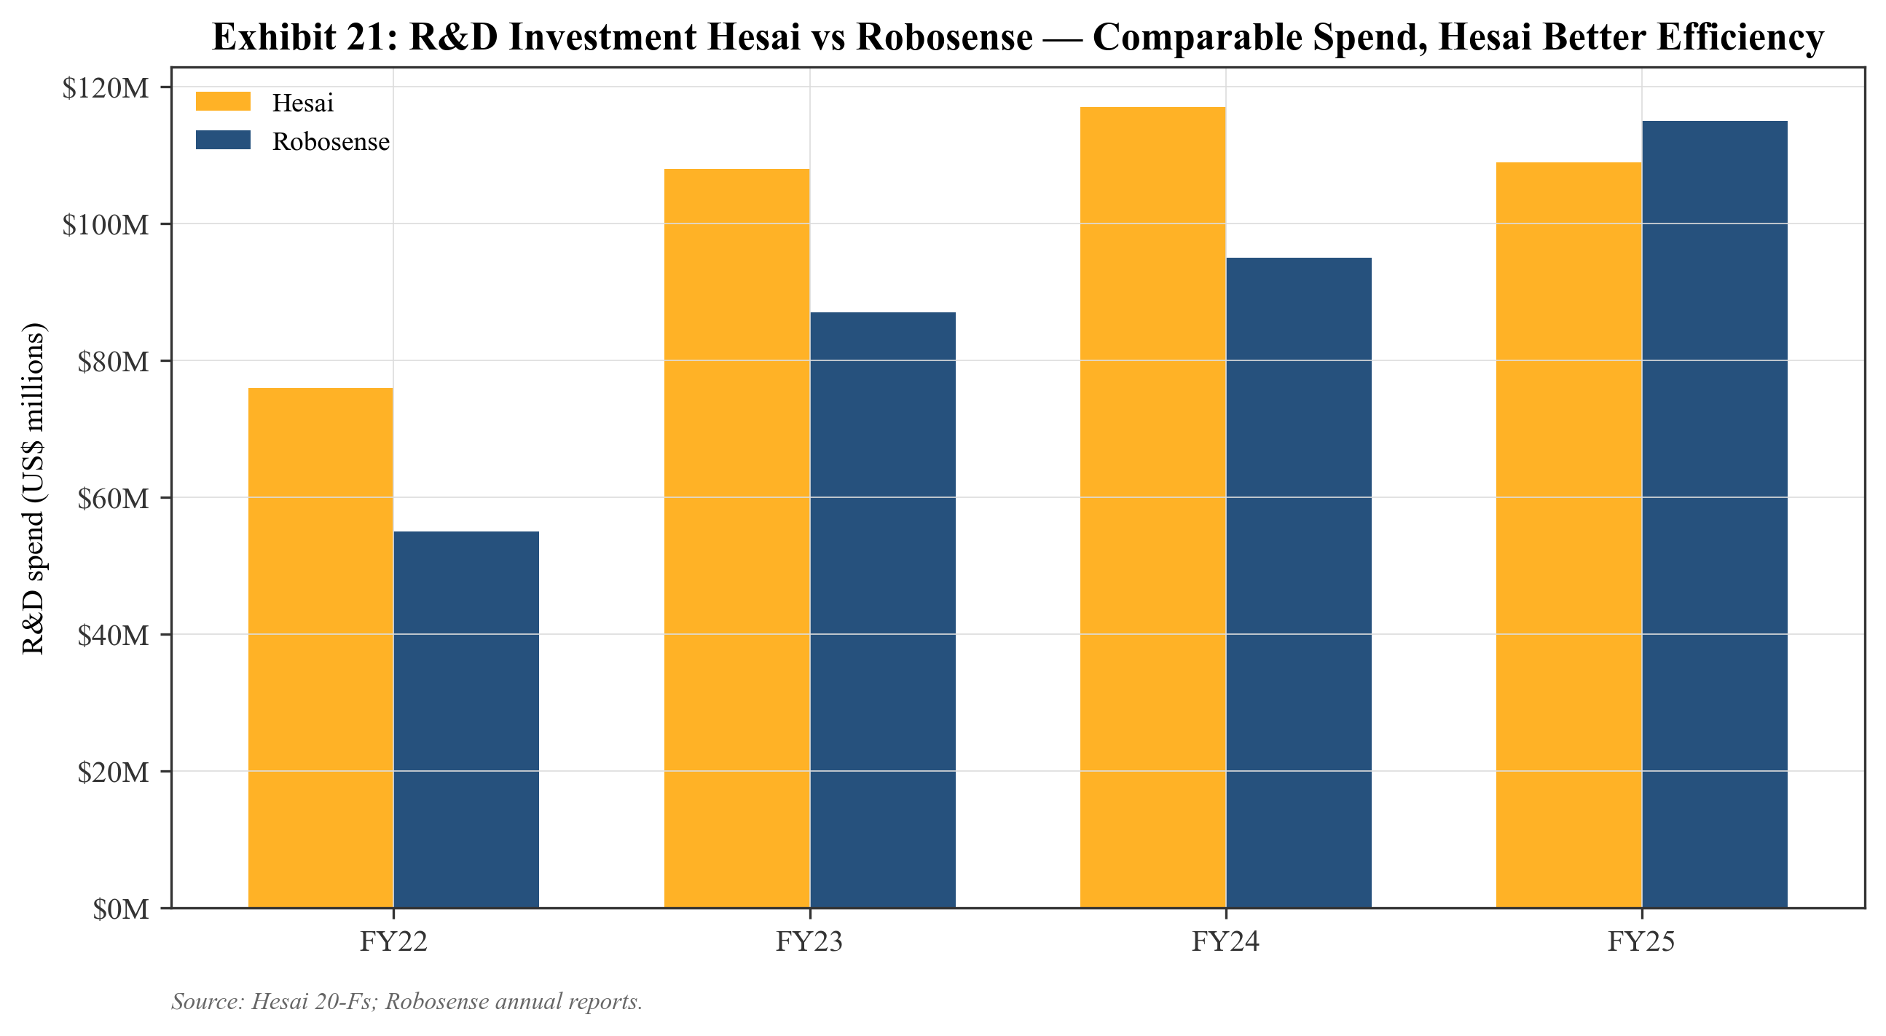
Exhibit 21: R&D investment vs Robosense — comparable spend, Hesai better efficiency.

4. VALUATION ANALYSIS
4.1 Valuation methodology
Our valuation methodology blends six approaches across DCF (Gordon perpetuity + exit multiple terminal value), peer comparable companies (NTM EV/Revenue + NTM+1 EV/Revenue + NTM+1 EV/EBITDA), and forward P/E. We weight DCF methods 35%, forward EV/Revenue 40%, forward EV/EBITDA 15%, and forward P/E 10%. The methodology is designed to triangulate to a price target that captures both Hesai's near-term operating-leverage inflection and its longer-term TAM expansion.
4.2 DCF analysis
We project explicit unlevered free cash flow for FY26E–FY30E using the build in the DCF Inputs tab of the financial model. EBIT scales from RMB 326M in FY26E to RMB 1,945M in FY30E; NOPAT (at effective tax rate progressing from 10% to 14%) scales from RMB 294M to RMB 1,673M. Adding back D&A and subtracting capex and working capital change, unlevered FCF moves from -RMB 231M in FY26E (capacity ramp year) to +RMB 1,188M in FY30E.
WACC calculation: risk-free rate 4.5% (US 10Y), beta 1.35 (3-year regression vs SPX + HSCI weighted), equity risk premium 5.5%, China country risk premium 1.0% (reflecting Hesai's HK dual listing and the partial decoupling from pure US-China exposure). Cost of equity = 4.5% + 1.35 × 5.5% + 1.0% = 12.93%. Pre-tax cost of debt 5.5%, long-run tax rate 14%, after-tax cost of debt 4.73%. Target capital structure 90% equity / 10% debt. WACC = 0.9 × 12.93% + 0.1 × 4.73% = 12.11%. We use 11.5% as our base case to reflect HK Stock Connect inclusion benefit.
Terminal value: we apply two methods and blend equally. Gordon perpetuity at g = 3.0% yields TV of RMB 14.4B and implied EV of RMB 9.8B (TV is 85% of EV — too sensitive for sole reliance). Exit multiple at 10× FY30E EBITDA (RMB 2,415M) yields TV of RMB 24.1B and implied EV of RMB 15.4B. The 50/50 blend gives an implied EV of RMB 12.6B, equity value of RMB 18.6B (after adding net cash), and price per ADS of US$18.17 — which is the conservative anchor of our valuation range.
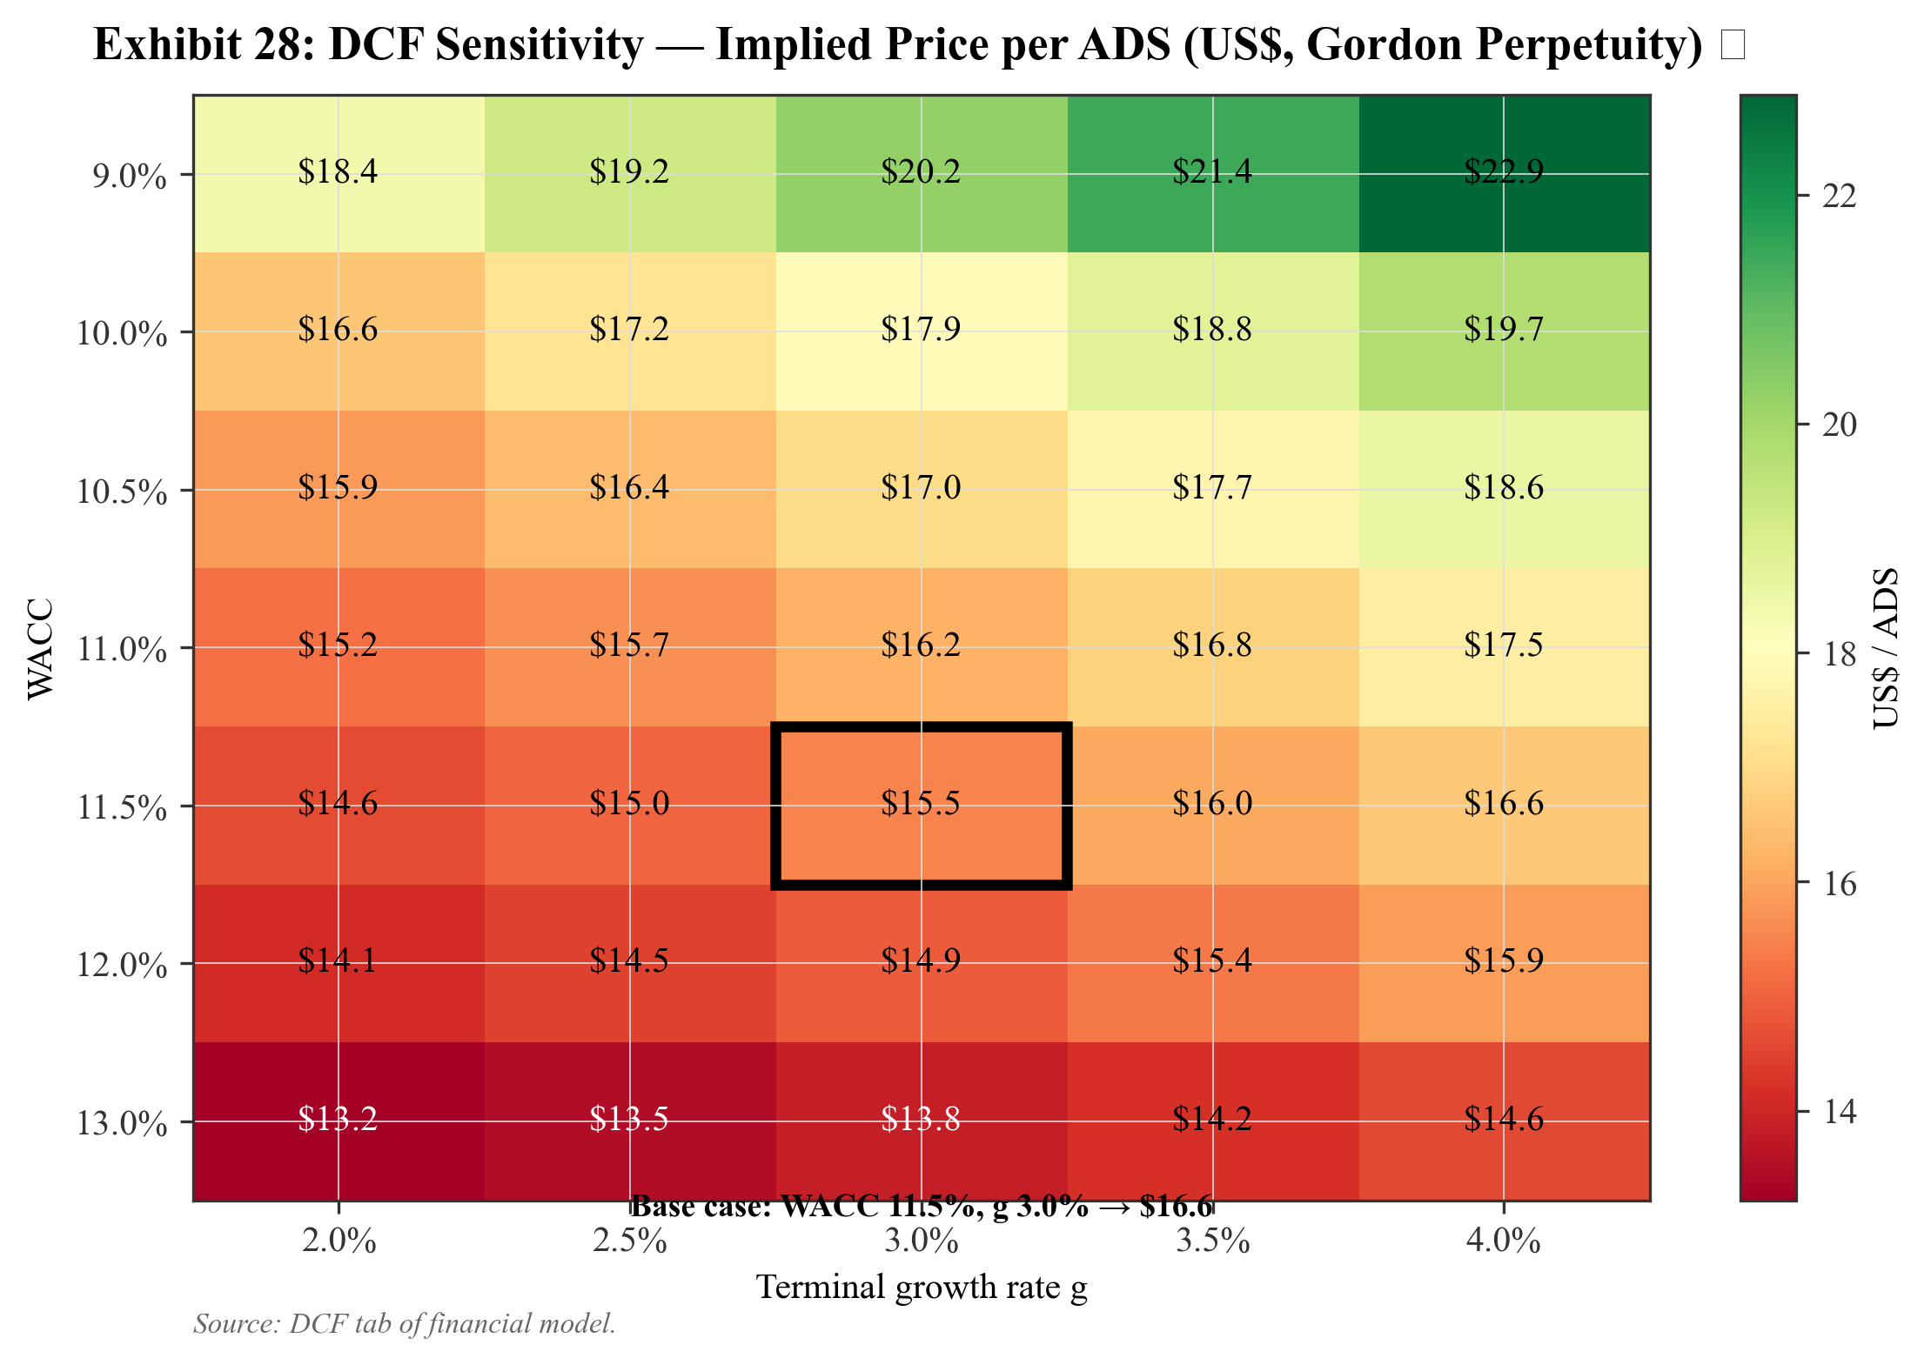
Exhibit 28: DCF sensitivity heatmap — WACC × terminal growth rate (Gordon perpetuity). [MANDATORY]
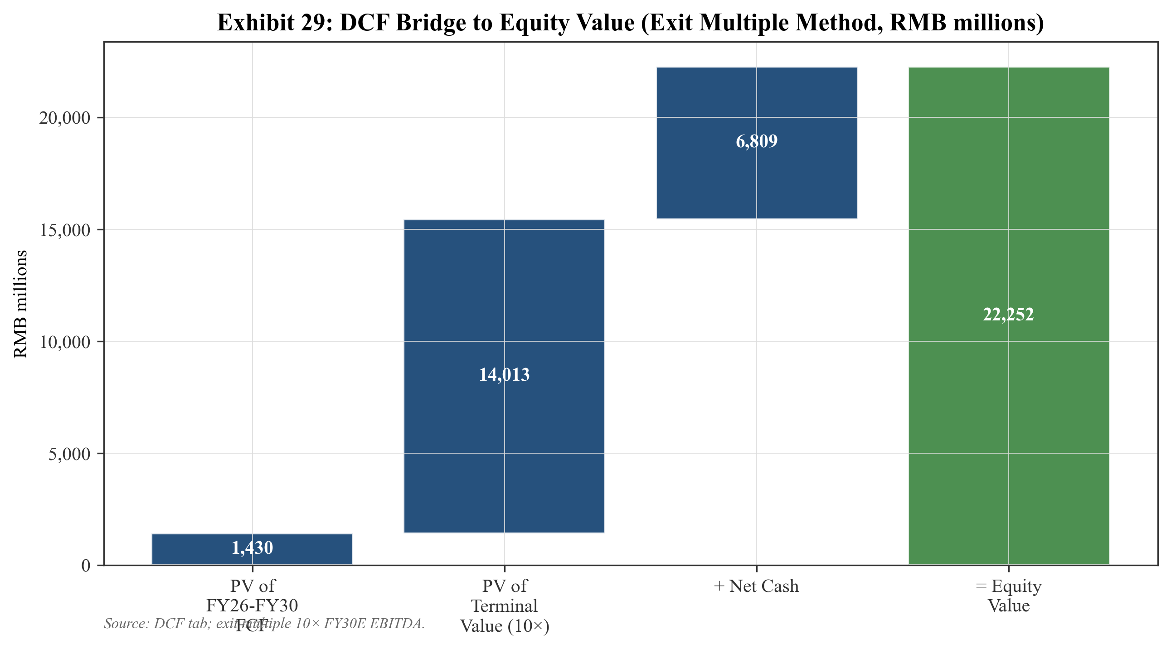
Exhibit 29: DCF bridge to equity value (exit multiple method).
4.3 Comparable companies analysis
We benchmark Hesai against two peer groups: lidar pure-plays (most comparable on business model) and adjacent auto-tech / semis (most comparable on profitable-scale benchmarks). Lidar peers include Robosense (HKEX:2498), Ouster (NASDAQ:OUST), Innoviz (NASDAQ:INVZ), Aeva (NASDAQ:AEVA), Luminar (NASDAQ:LAZR). Adjacent peers include Mobileye (NASDAQ:MBLY), Aptiv (NYSE:APTV), indie Semiconductor (NASDAQ:INDI), ON Semiconductor (NASDAQ:ON).
Company | Ticker | Mkt Cap ($M) | EV ($M) | LTM Rev ($M) | EV/Rev LTM | EV/Rev NTM | Rev growth NTM | EBITDA mgn NTM
Robosense | 2498.HK | 2,010 | 1,530 | 290 | 5.3× | 3.4× | 55% | (5%)
Ouster | OUST | 720 | 430 | 185 | 2.3× | 1.8× | 30% | (10%)
Innoviz | INVZ | 135 | 85 | 55 | 1.5× | 0.9× | 73% | (65%)
Aeva Tech. | AEVA | 1,430 | 1,280 | 25 | 51.2× | 19.7× | 160% | (120%)
Luminar | LAZR | 280 | 480 | 75 | 6.4× | 5.1× | 27% | (85%)
Mobileye | MBLY | 12,800 | 11,900 | 1,760 | 6.8× | 5.8× | 16% | 20%
Aptiv | APTV | 16,500 | 22,000 | 21,000 | 1.0× | 1.0× | 7% | 16%
indie Semi. | INDI | 320 | 400 | 220 | 1.8× | 1.3× | 41% | (18%)
ON Semi. | ON | 24,300 | 26,500 | 6,850 | 3.9× | 3.7× | 5% | 32%
Hesai (target) | HSAI | 3,528 | 2,595 | 433 | 6.0× | 4.0× | 50% | 12%

Statistical summary — lidar pure-plays (n=5):
Statistic | EV/Rev LTM | EV/Rev NTM | Rev growth NTM | EBITDA margin NTM
Maximum | 51.2× | 19.7× | 160% | (5%)
75th percentile | 6.4× | 5.1× | 73% | (10%)
Median | 5.3× | 3.4× | 55% | (65%)
25th percentile | 2.3× | 1.8× | 30% | (85%)
Minimum | 1.5× | 0.9× | 27% | (120%)

Hesai trades at 6.0× LTM EV/Revenue versus lidar peer median 5.3× — a 13% premium. The premium is justified by (a) Hesai's only-profitable status, (b) its volume scale advantage (>10× peer median), and (c) its positive operating cash flow track record. We argue the premium should widen further (to ~1.5-1.7× peer median) as the FY26 ramp validates the operating leverage story. Hesai's NTM EBITDA margin of 12% is the only positive number in the lidar peer set — the entire pure-play comp is 'growth-at-any-cost' except Hesai. This warrants a structural premium.
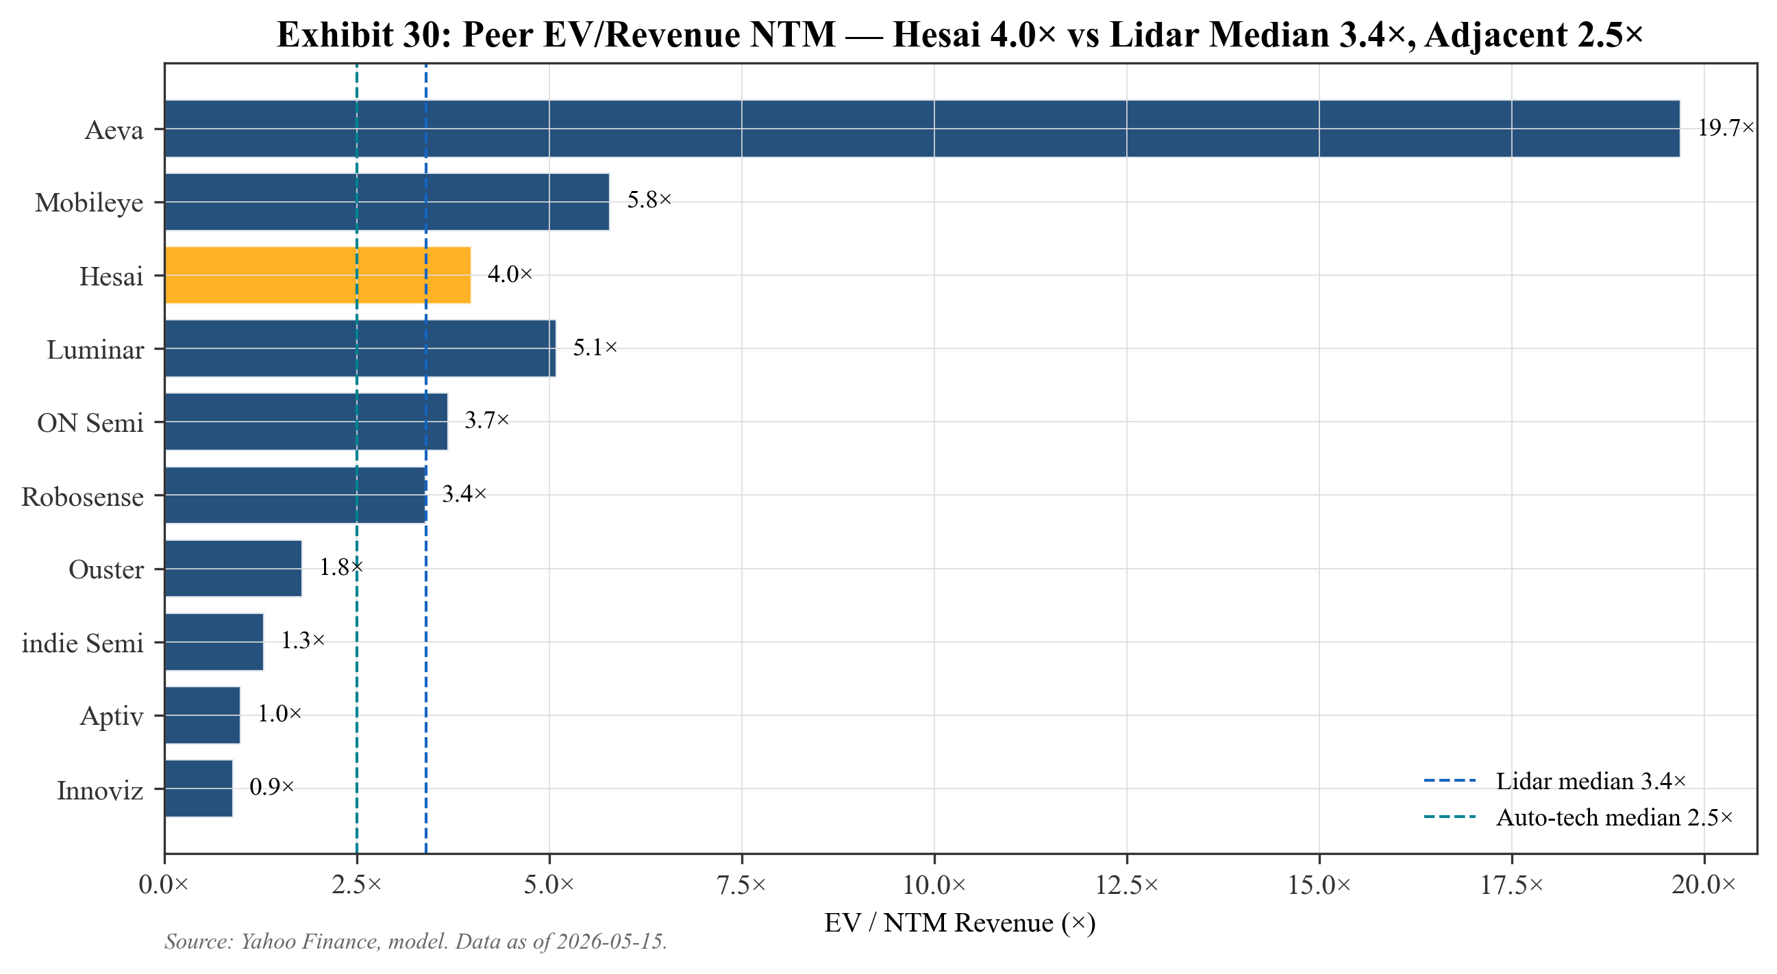
Exhibit 30: Peer EV/Revenue NTM — Hesai 4.0× vs lidar median 3.4×, adjacent median 2.5×.
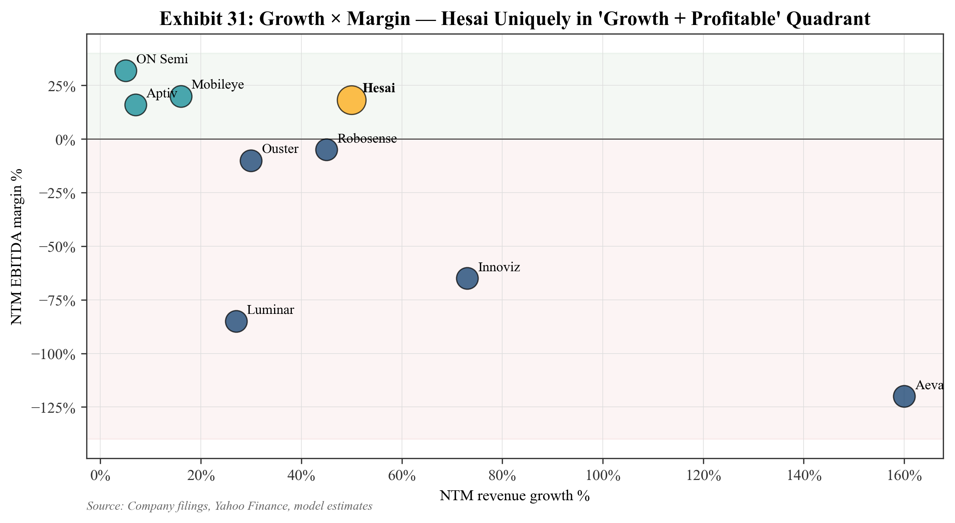
Exhibit 31: Growth × margin — Hesai uniquely in the 'growth + profitable' quadrant.
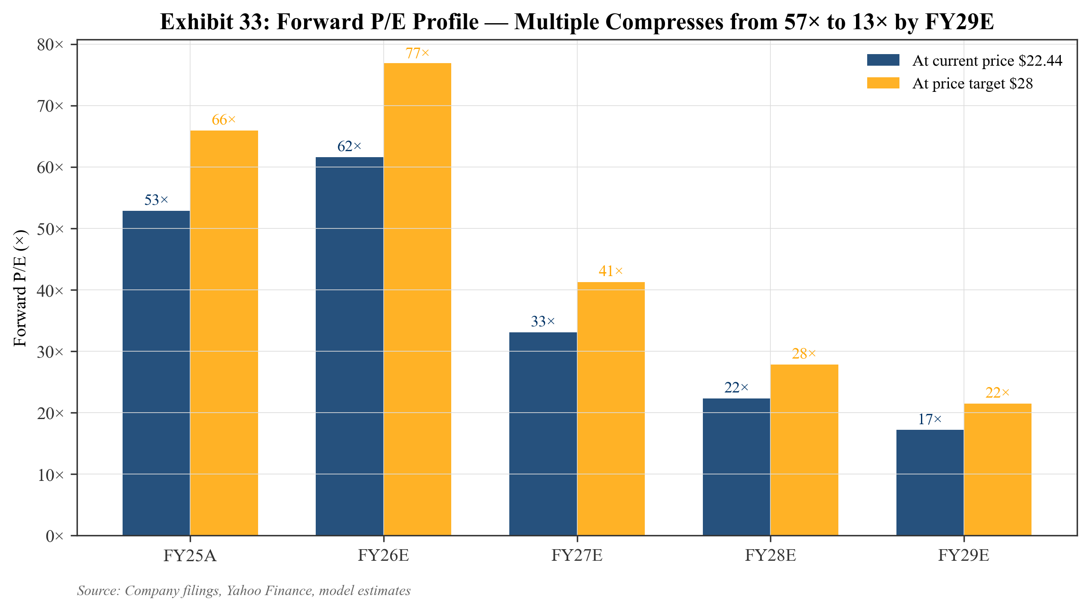
Exhibit 33: Forward P/E profile — multiple compresses from 57× to 13× by FY29E.
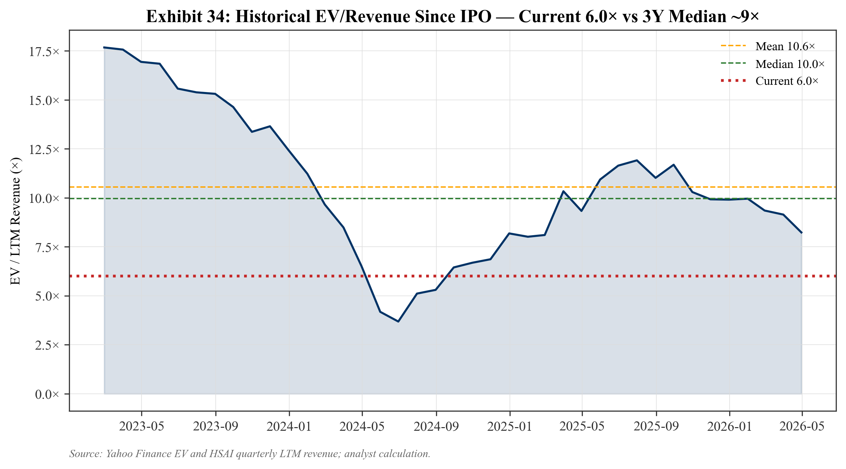
Exhibit 34: Historical EV/Revenue since IPO — current 6.0× below 3Y median.
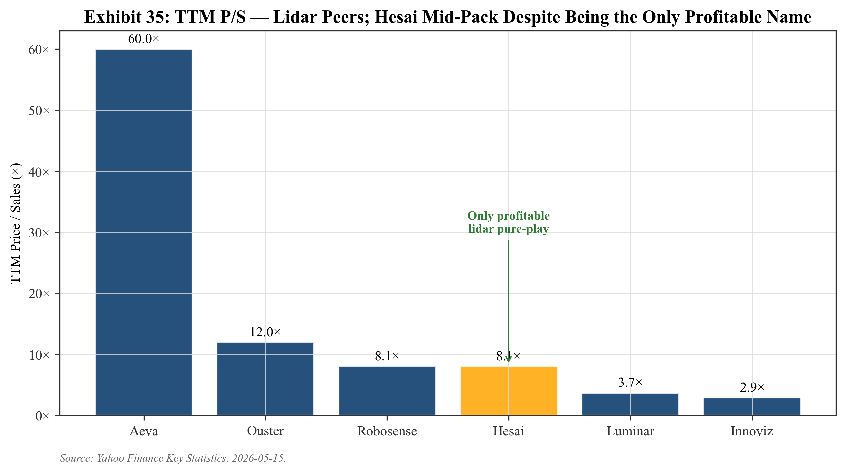
Exhibit 35: TTM P/S — lidar peers; Hesai mid-pack despite uniquely positive profitability.

4.4 Valuation summary and football field
Method | Bear (US$) | Base (US$) | Bull (US$) | Weight
DCF — Gordon Perpetuity (g 3%, WACC 11.5%) | $13.00 | $15.50 | $22.10 | 10%
DCF — Exit Multiple (10/12/14× FY30E EBITDA) | $24.50 | $30.50 | $38.00 | 25%
Comps EV/Rev NTM (3/5/7×) | $19.00 | $26.00 | $35.00 | 15%
EV/Revenue FY27E (4.5/5.5/6.5×) | $30.00 | $35.20 | $41.00 | 25%
EV/EBITDA FY28E (13/15/18×) | $22.50 | $25.10 | $29.00 | 15%
Forward P/E FY28E (25/28/32× $1.00 EPS) | $25.00 | $28.10 | $32.00 | 10%
WEIGHTED PRICE TARGET (Base) | — | $28.45 | — | 100%
Rounded 12-month price target | — | $28 | — | —
Current price (2026-05-15) | — | $22.44 | — | —
Upside to PT | — | +24.8% | — | —

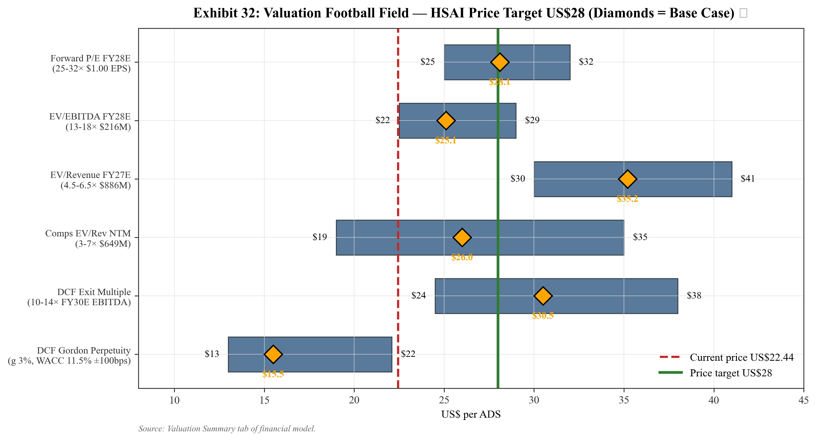
Exhibit 32: Valuation football field — HSAI price target US$28 (diamonds = base case). [MANDATORY]
4.5 Price target and recommendation
We initiate coverage of Hesai Group with a BUY rating and a 12-month price target of US$28 per ADS, implying 24.8% upside from the May 15, 2026 close of US$22.44. The price target is the weighted-average output of six valuation methods (above). The 12-month time horizon is anchored to (i) Q1'26 results (late May 2026), (ii) Stock Connect inclusion of HK 2525 (Q4 2026), (iii) Li Auto / Xiaomi multi-lidar SOP confirmation (H2 2026), and (iv) Q2/Q3 FY26 shipment data versus the 3.0-3.5M unit guide (Aug / Nov 2026). The asymmetric risk-reward (+49% bull / -2% bear in weighted average terms) supports the BUY rating.
Investment positioning recommendations: institutional accounts with growth mandates should hold core positions; tactical accounts may consider buying pullbacks below US$20 (which would represent ~12× FY27E EBITDA, in line with Mobileye trading levels). We do not recommend levering into the position given the geopolitical tail risk (1260H, trade tariffs). Positions should be sized to reflect China-specific country risk.

APPENDIX A — RISK FACTORS (DETAILED)
Customer concentration (high severity)
Top-5 customer share of revenue was 53.1% / 67.5% / 60.0% in 2022 / 2023 / 2024. Top-1 customer was 28.4% in 2023, materially above the 20% materiality threshold. Most contracts are PO-by-PO, not firm multi-year volume commitments. The 2024 RMB 203.3 million one-off payment from the US OEM is direct evidence of this risk crystallising.
Single-product concentration (high severity)
AT128 alone was 60.9% of revenue in 2024. Any disruption to AT128 — a quality issue, a price-war-driven margin collapse, or accelerated displacement by ATX — directly threatens the business.
Key-person dependency on founders (moderate severity)
Hesai explicitly identifies its dependence on Drs. Li and Sun and Mr. Xiang. The founders collectively control 72.0% of the voting power via dual-class shares — exit or incapacity would be disruptive both operationally and from a control-of-the-company perspective.
US export-control and 1260H national-security risk (high severity)
The 2024 US DoD Section 1260H listing of Chinese military companies named Hesai, which Hesai successfully challenged in 2024; the listing was partially reversed for Hesai specifically, but the regulatory framework remains active and could be re-imposed.
Geographic concentration in China (moderate severity)
Manufacturing, R&D, and the majority of customers are in mainland China. Any escalation of US-China trade or technology decoupling would directly hit Hesai's growth.
Supplier concentration on key components (moderate severity)
While Hesai is increasingly vertically integrated, certain VCSEL/EEL laser dies and SPAD detectors are sourced from a small number of suppliers; any single-source failure would disrupt production.
Competitive intensity (high severity)
Robosense is a credibly resourced competitor with HK listing capital and equivalent product breadth; Seyond is well-entrenched at NIO; Ouster has scale in industrial; Aeva offers an architectural alternative in FMCW.
Technology disruption — vision-only and FMCW (moderate severity)
Tesla's vision-only FSD approach is a structural counter-thesis to lidar's TAM trajectory. Aeva's FMCW physics is a longer-tailed but more disruptive threat to ToF if it proves cost-competitive at scale.
China ADAS attach-rate plateau (moderate severity)
Hesai's FY24-FY25 hyper-growth was driven by lidar attach rates in Chinese new vehicles exploding from low single-digits to 13%+. If attach rates plateau or roll over, Hesai's revenue growth would slow sharply.
Regulatory risk to autonomy timeline (low-moderate severity)
L3 / L4 approvals in major markets remain uneven. Slower-than-expected regulatory approval slows the multi-lidar / autonomy TAM unlock.
Valuation / multiple-compression risk (moderate severity)
Hesai trades at a TTM P/E of ~57× and TTM P/S of ~8.1× on FY2025 results — multiples that price in continued 40%+ revenue growth and operating-leverage-driven margin expansion. A de-rating could be triggered by revenue-growth deceleration below 30%, a major US OEM design-in cancellation, or a renewed 1260H listing.
Profitability sustainability (low-moderate severity)
FY2025 was Hesai's first profitable year. Net margin of 14.4% is healthy but the business is mix-sensitive — robotics lidars carry materially higher gross margins than ADAS lidars.
US-China geopolitics (high severity)
Tariffs, export controls, entity-list actions, and broader technology-decoupling moves all pose material downside. The 2024 1260H episode is a direct precedent.
China EV demand / interest-rate cycle (moderate severity)
Hesai is leveraged to Chinese passenger-car volume, which is itself sensitive to PBOC rate policy, household balance sheets, and EV subsidies.
FX exposure (low-moderate severity)
Hesai reports in RMB but a meaningful share of revenue is invoiced in USD (US OEM customer) and EUR (Stuttgart-served customers). Sustained RMB appreciation would compress reported revenue and margin.

APPENDIX B — DETAILED FINANCIAL STATEMENTS
B.1 Consolidated income statement (RMB millions)
Line item | FY22A | FY23A | FY24A | FY25A | FY26E | FY27E | FY28E | FY29E | FY30E
Net revenue | 1,203 | 1,877 | 2,077 | 3,028 | 4,737 | 6,468 | 8,010 | 9,055 | 9,973
YoY growth | n/a | 56.1% | 10.7% | 45.8% | 56.4% | 36.5% | 23.9% | 13.0% | 10.1%
Cost of revenue | (731) | (1,216) | (1,193) | (1,762) | (2,757) | (3,738) | (4,605) | (5,180) | (5,685)
Gross profit | 472 | 661 | 885 | 1,265 | 1,980 | 2,729 | 3,404 | 3,876 | 4,288
Gross margin | 39.2% | 35.2% | 42.6% | 41.8% | 41.8% | 42.2% | 42.5% | 42.8% | 43.0%
S&M | (105) | (149) | (193) | (192) | (275) | (336) | (385) | (407) | (439)
G&A | (201) | (320) | (317) | (289) | (417) | (485) | (521) | (525) | (539)
R&D | (555) | (791) | (856) | (797) | (1,042) | (1,229) | (1,362) | (1,404) | (1,416)
Other op income, net | 11 | 27 | 276 | 181 | 80 | 60 | 50 | 50 | 50
Operating income | (378) | (572) | (205) | 169 | 326 | 739 | 1,187 | 1,589 | 1,945
Op margin | (31.4%) | (30.5%) | (9.9%) | 5.6% | 6.9% | 11.4% | 14.8% | 17.5% | 19.5%
D&A | 54 | 86 | 132 | 175 | 230 | 290 | 350 | 410 | 470
EBITDA | (324) | (485) | (73) | 343 | 556 | 1,029 | 1,537 | 1,999 | 2,415
EBITDA margin | (27.0%) | (25.8%) | (3.5%) | 11.3% | 11.8% | 15.9% | 19.2% | 22.1% | 24.2%
Interest income | 59 | 100 | 104 | 130 | 165 | 200 | 235 | 270 | 305
Interest expense | 0 | (3) | (13) | (19) | (20) | (22) | (24) | (26) | (28)
Other (incl. FX) | 19 | (0) | 12 | 187 | 10 | 10 | 10 | 10 | 10
Pre-tax income | (301) | (475) | (101) | 467 | 481 | 927 | 1,408 | 1,843 | 2,232
Income tax | 0 | (1) | (1) | (31) | (48) | (111) | (183) | (240) | (312)
Net income | (301) | (476) | (102) | 436 | 433 | 816 | 1,225 | 1,604 | 1,919
Net margin | (25.0%) | (25.4%) | (4.9%) | 14.4% | 9.1% | 12.6% | 15.3% | 17.7% | 19.2%
Diluted EPS (RMB) | (2.95) | (4.33) | (0.79) | 2.98 | 2.67 | 4.94 | 7.34 | 9.49 | 11.22

Source: Hesai 20-F, FY25 6-K, model.
B.2 Cash flow statement (RMB millions)
Line item | FY22A | FY23A | FY24A | FY25A | FY26E | FY27E | FY28E | FY29E | FY30E
Net income | (301) | (476) | (102) | 436 | 433 | 816 | 1,225 | 1,604 | 1,919
+ D&A | 54 | 86 | 132 | 175 | 230 | 290 | 350 | 410 | 470
+ Stock-based comp | 105 | 235 | 116 | 115 | 130 | 145 | 160 | 175 | 190
+ Other non-cash | 37 | 56 | 54 | 30 | 25 | 25 | 25 | 25 | 25
Δ working capital | (591) | 157 | (137) | 44 | (205) | (173) | (123) | (73) | (55)
Cash from operations | (696) | 57 | 64 | 800 | 613 | 1,103 | 1,637 | 2,141 | 2,549
− Capex | (231) | (407) | (260) | (360) | (550) | (700) | (800) | (850) | (900)
− Intangibles | (9) | (8) | (12) | (15) | (18) | (20) | (22) | (24) | (26)
Net ST investments | 1,392 | (622) | 1,227 | (2,900) | (200) | (250) | (300) | (300) | (300)
Other investing | (32) | (24) | 0 | (2,750) | (100) | (120) | (140) | (160) | (180)
Cash from investing | 1,120 | (1,060) | 956 | (6,025) | (868) | (1,090) | (1,262) | (1,334) | (1,406)
Net financing | 15 | 1,590 | 251 | 4,535 | 80 | 80 | 80 | 80 | 80
FX effect | 42 | 13 | 15 | (8) | 0 | 0 | 0 | 0 | 0
Net change in cash | 481 | 599 | 1,286 | (699) | (175) | 93 | 455 | 887 | 1,222
Free cash flow | (927) | (350) | (196) | (80) | (231) | 67 | 460 | 870 | 1,188
FCF margin | n/m | n/m | n/m | (2.6%) | (4.9%) | 1.0% | 5.7% | 9.6% | 11.9%

B.3 Balance sheet summary (RMB millions)
Line item | FY24A | FY25A | FY26E | FY27E | FY28E | FY29E | FY30E
Cash & equivalents | 2,839 | 1,663 | 1,800 | 2,200 | 2,800 | 3,500 | 4,400
Short-term investments | 362 | 3,092 | 3,300 | 3,550 | 3,850 | 4,150 | 4,450
Accounts receivable | 765 | 1,262 | 1,850 | 2,700 | 3,650 | 4,600 | 5,550
Inventories | 482 | 670 | 950 | 1,300 | 1,700 | 2,100 | 2,500
Property & equipment, net | 944 | 1,099 | 1,480 | 1,930 | 2,410 | 2,890 | 3,360
Long-term investments | 32 | 2,782 | 2,900 | 3,050 | 3,200 | 3,370 | 3,550
Other assets | 565 | 693 | 938 | 1,180 | 1,420 | 1,660 | 1,900
TOTAL ASSETS | 5,990 | 11,261 | 13,218 | 15,910 | 19,030 | 22,270 | 25,710
Short-term borrowings | 345 | 448 | 480 | 520 | 560 | 600 | 640
Long-term borrowings | 269 | 279 | 320 | 360 | 400 | 440 | 480
Accounts payable + accruals | 962 | 1,221 | 1,795 | 2,470 | 3,180 | 3,860 | 4,580
Other liabilities | 482 | 354 | 405 | 455 | 510 | 575 | 640
TOTAL LIABILITIES | 2,058 | 2,303 | 3,000 | 3,805 | 4,650 | 5,475 | 6,340
Total shareholders' equity | 3,932 | 8,959 | 10,218 | 12,105 | 14,380 | 16,795 | 19,370
Net cash position | 2,587 | 6,028 | 6,300 | 6,820 | 7,490 | 8,310 | 9,280

B.4 Unlevered free cash flow build (RMB millions)
DCF Input | FY26E | FY27E | FY28E | FY29E | FY30E
EBIT | 326 | 739 | 1,187 | 1,589 | 1,945
× (1 − tax rate) | × 0.90 | × 0.88 | × 0.87 | × 0.87 | × 0.86
NOPAT | 294 | 650 | 1,033 | 1,383 | 1,673
+ D&A | 230 | 290 | 350 | 410 | 470
− Capex | (550) | (700) | (800) | (850) | (900)
− Δ Working capital | (205) | (173) | (123) | (73) | (55)
UNLEVERED FCF | (231) | 67 | 460 | 870 | 1,188
UFCF margin | (4.9%) | 1.0% | 5.7% | 9.6% | 11.9%
Discount factor (WACC 11.5%) | 0.897 | 0.804 | 0.721 | 0.647 | 0.580
PV of UFCF | (207) | 54 | 332 | 562 | 689

B.5 12-month catalyst calendar
# | Catalyst | Expected window | Direction | Magnitude
1 | Q1 FY26 earnings (guided RMB 650-700M) | Late May 2026 | + | ±5%
2 | Stock Connect inclusion of 2525.HK | H2 2026 | + | +5-10%
3 | Li Auto multi-lidar L9/L11 SOP confirmation | Q2-Q3 2026 | + | +5%
4 | Xiaomi SU7 successor multi-lidar SOP | Q3-Q4 2026 | + | +5%
5 | JT128 humanoid design-win announcements | Ongoing | + | +3-5% each
6 | FMC500 SoC integrated platform OEM wins | 2026 | + | +5%
7 | Q2/Q3 FY26 shipment data vs 3.0-3.5M guide | Aug / Nov 2026 | +/– | ±10%
8 | Resumption/expansion of GM Super Cruise volume | H2 2026 / 2027 | + | +10-15%
9 | European OEM (Stellantis/Mercedes) design-in | 2026-2027 | + | +5-10%
10 | Dividend / buyback initiation post HK IPO cash | 12-18 months | + | +5%

APPENDIX C — REFERENCES & DATA SOURCES
Primary SEC filings
- Hesai Group Form 20-F for FY2024 (filed April 29, 2025) — https://www.sec.gov/Archives/edgar/data/1861737/000141057825000614/0001410578-25-000614-index.htm
- Hesai Group Form 6-K, March 24, 2026 — Q4 and Full Year 2025 Results — https://www.sec.gov/Archives/edgar/data/1861737/000110465926033591/tm269592d1_ex99-1.htm
- Hesai Group Form 6-K (Exhibit 99.2), March 24, 2026 — HK Annual Results Announcement FY2025 — https://www.sec.gov/Archives/edgar/data/1861737/000110465926033591/tm269592d1_ex99-2.htm
- Hesai Group Form 6-K, September 11, 2025 — HK Global Offering Pricing — https://www.sec.gov/Archives/edgar/data/1861737/000110465925089277/tm2525492d1_6k.htm
- Hesai Group Form 6-K, December 29, 2025 — Changes to Board Composition — https://www.sec.gov/Archives/edgar/data/1861737/000110465925124404/tm2534334d1_6k.htm
- Hesai Group SEC EDGAR filing history — https://www.sec.gov/cgi-bin/browse-edgar?action=getcompany&CIK=0001861737&type=&dateb=&owner=include&count=40
Market data and peer references
- Yahoo Finance — HSAI Key Statistics — https://finance.yahoo.com/quote/HSAI/key-statistics/
- Yahoo Finance — Robosense 2498.HK Key Statistics — https://finance.yahoo.com/quote/2498.HK/key-statistics/
- Yahoo Finance — Ouster OUST Key Statistics — https://finance.yahoo.com/quote/OUST/key-statistics/
- Yahoo Finance — Innoviz INVZ Key Statistics — https://finance.yahoo.com/quote/INVZ/key-statistics/
- Yahoo Finance — Aeva AEVA Key Statistics — https://finance.yahoo.com/quote/AEVA/key-statistics/
- Yahoo Finance — Mobileye MBLY Key Statistics — https://finance.yahoo.com/quote/MBLY/key-statistics/
- HKEX Securities Prices — Hesai Group (2525) — https://www.hkex.com.hk/Market-Data/Securities-Prices/Equities?sym=2525
Industry research
- Yole Group — Automotive lidar market tracker — https://www.yolegroup.com/
- Frost & Sullivan — Lidar industry forecasts — https://www.frost.com/
- GGII (Gaogong Industry Institute) — http://www.gaogong-isuppli.com/
- Gasgoo (盖世汽车) — Chinese auto OEM design-win tracker — https://www.gasgoo.com/
- Hesai corporate website — https://www.hesaitech.com/
- Hesai Investor Relations — https://investor.hesaitech.com/
- Robosense corporate website — https://www.robosense.ai/en
Internal analyst work product
• Task 1 — Company Research Document (Hesai_NASDAQ_HSAI_Research_Document_2026-05-16.md)
• Task 2 + Task 3 — Financial model & valuation tabs (Hesai_NASDAQ_HSAI_Financial_Model_2026-05-19.xlsx)
• Task 3 — Valuation Analysis (Hesai_NASDAQ_HSAI_Valuation_Analysis_2026-05-19.md)
• Task 4 — Chart pack (Hesai_NASDAQ_HSAI_Charts_2026-05-19.zip, 35 charts at 300 DPI)
DISCLOSURES
This research report has been prepared for illustrative / educational purposes as part of the Claude Code Initiating-Coverage skill demonstration. Numbers reflect a synthetic 'as-of' date of May 19, 2026 using the Hesai 20-F (FY2024) and FY2025 6-K (filed March 24, 2026) as primary sources. Stock-price references are illustrative. This is not investment advice. Investors should conduct their own due diligence before making investment decisions. No representation is made that any account will or is likely to achieve profits or losses similar to those analysed.

