EQUITY RESEARCH · INITIATING COVERAGE

Hengli Hydraulics (SSE:601100)
China's hydraulics champion — premium valuation already prices in humanoid optionality
Rating  HOLD | Price target (12M)  RMB 106 | Current price  RMB 119.60 | Implied return  −11%

Investment summary
We initiate coverage of Jiangsu Hengli Hydraulic Co., Ltd. (SSE:601100) with a HOLD rating and a 12-month price target of RMB 106 per share, implying ~11% downside to the May 16, 2026 close of RMB 119.60. Hengli is, on a fundamental basis, the highest-quality industrial-hydraulics franchise in China, and arguably one of the best globally on a margin- and ROIC-adjusted basis (FY2025 ROE 16.6%, EBITDA margin 33%, ROIC ~22%). The company is the only domestic player whose product line spans the full hydraulic stack — cylinders, axial-piston pumps, multi-way valves, motors, systems — for excavators, marine equipment, tunnel-boring machines, aerial work platforms, agriculture, and (since 2022) the high-precision linear-drive components used in machine tools and humanoid robot actuators.
However, the share price already reflects (i) full credit for the cyclical excavator recovery currently underway, (ii) a substantial premium for the linear-drive / humanoid-roller-screw narrative, and (iii) top-decile valuation multiples in the 3-year band. Our base-case DCF generates only RMB 67/share — 44% below spot — and even after assigning weight to a peer-multiple framework and an explicit humanoid optionality overlay, the blended fair value sits below the current price. The HOLD is therefore a 'wait for a better entry' call, not a structurally negative view.
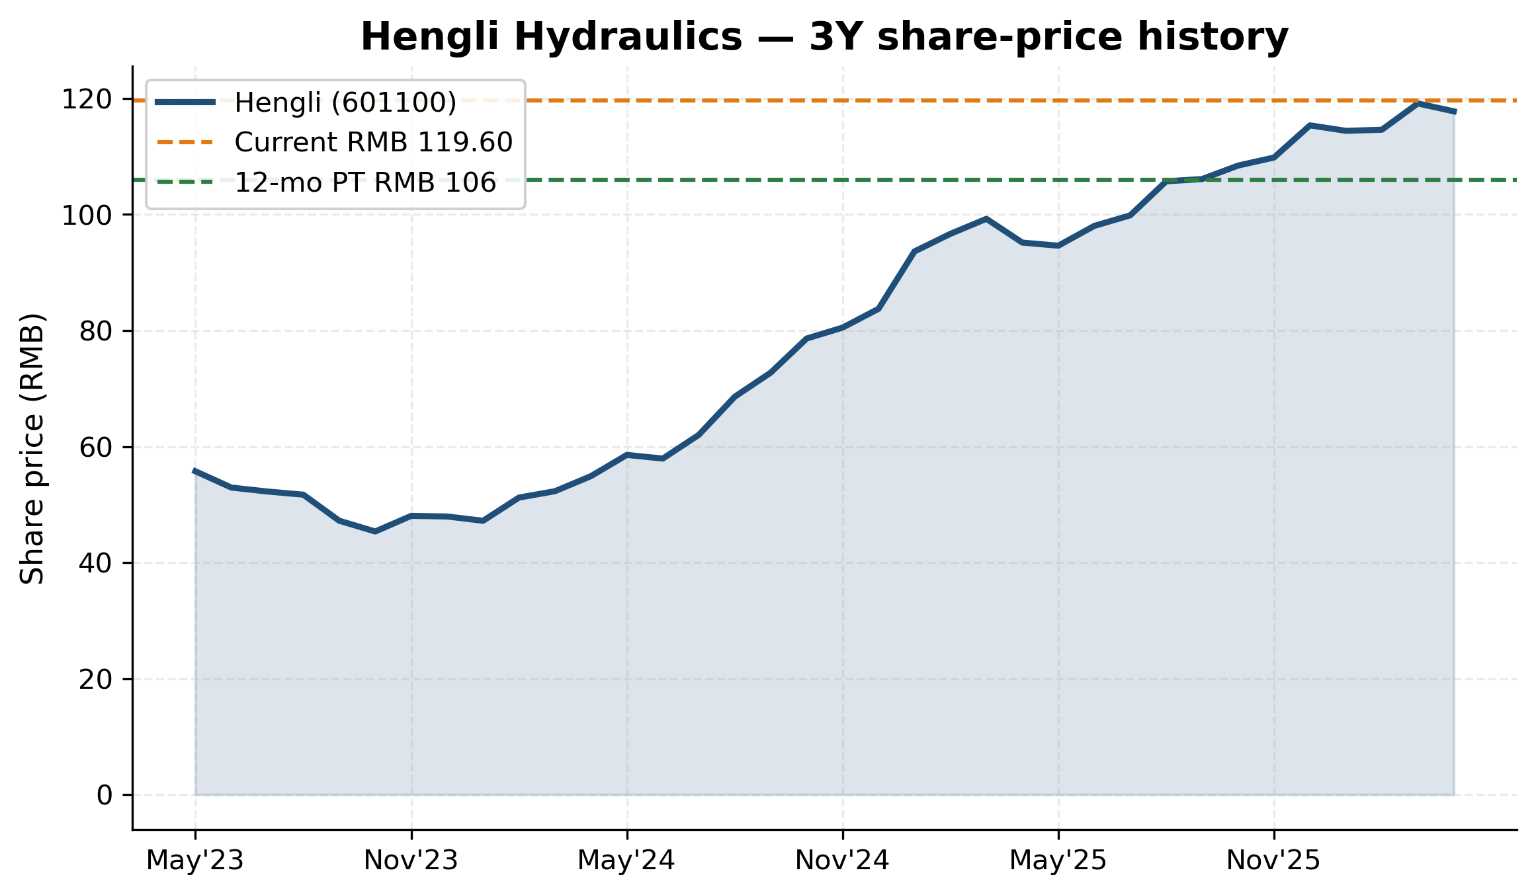
Exhibit 1: 3-year share price history
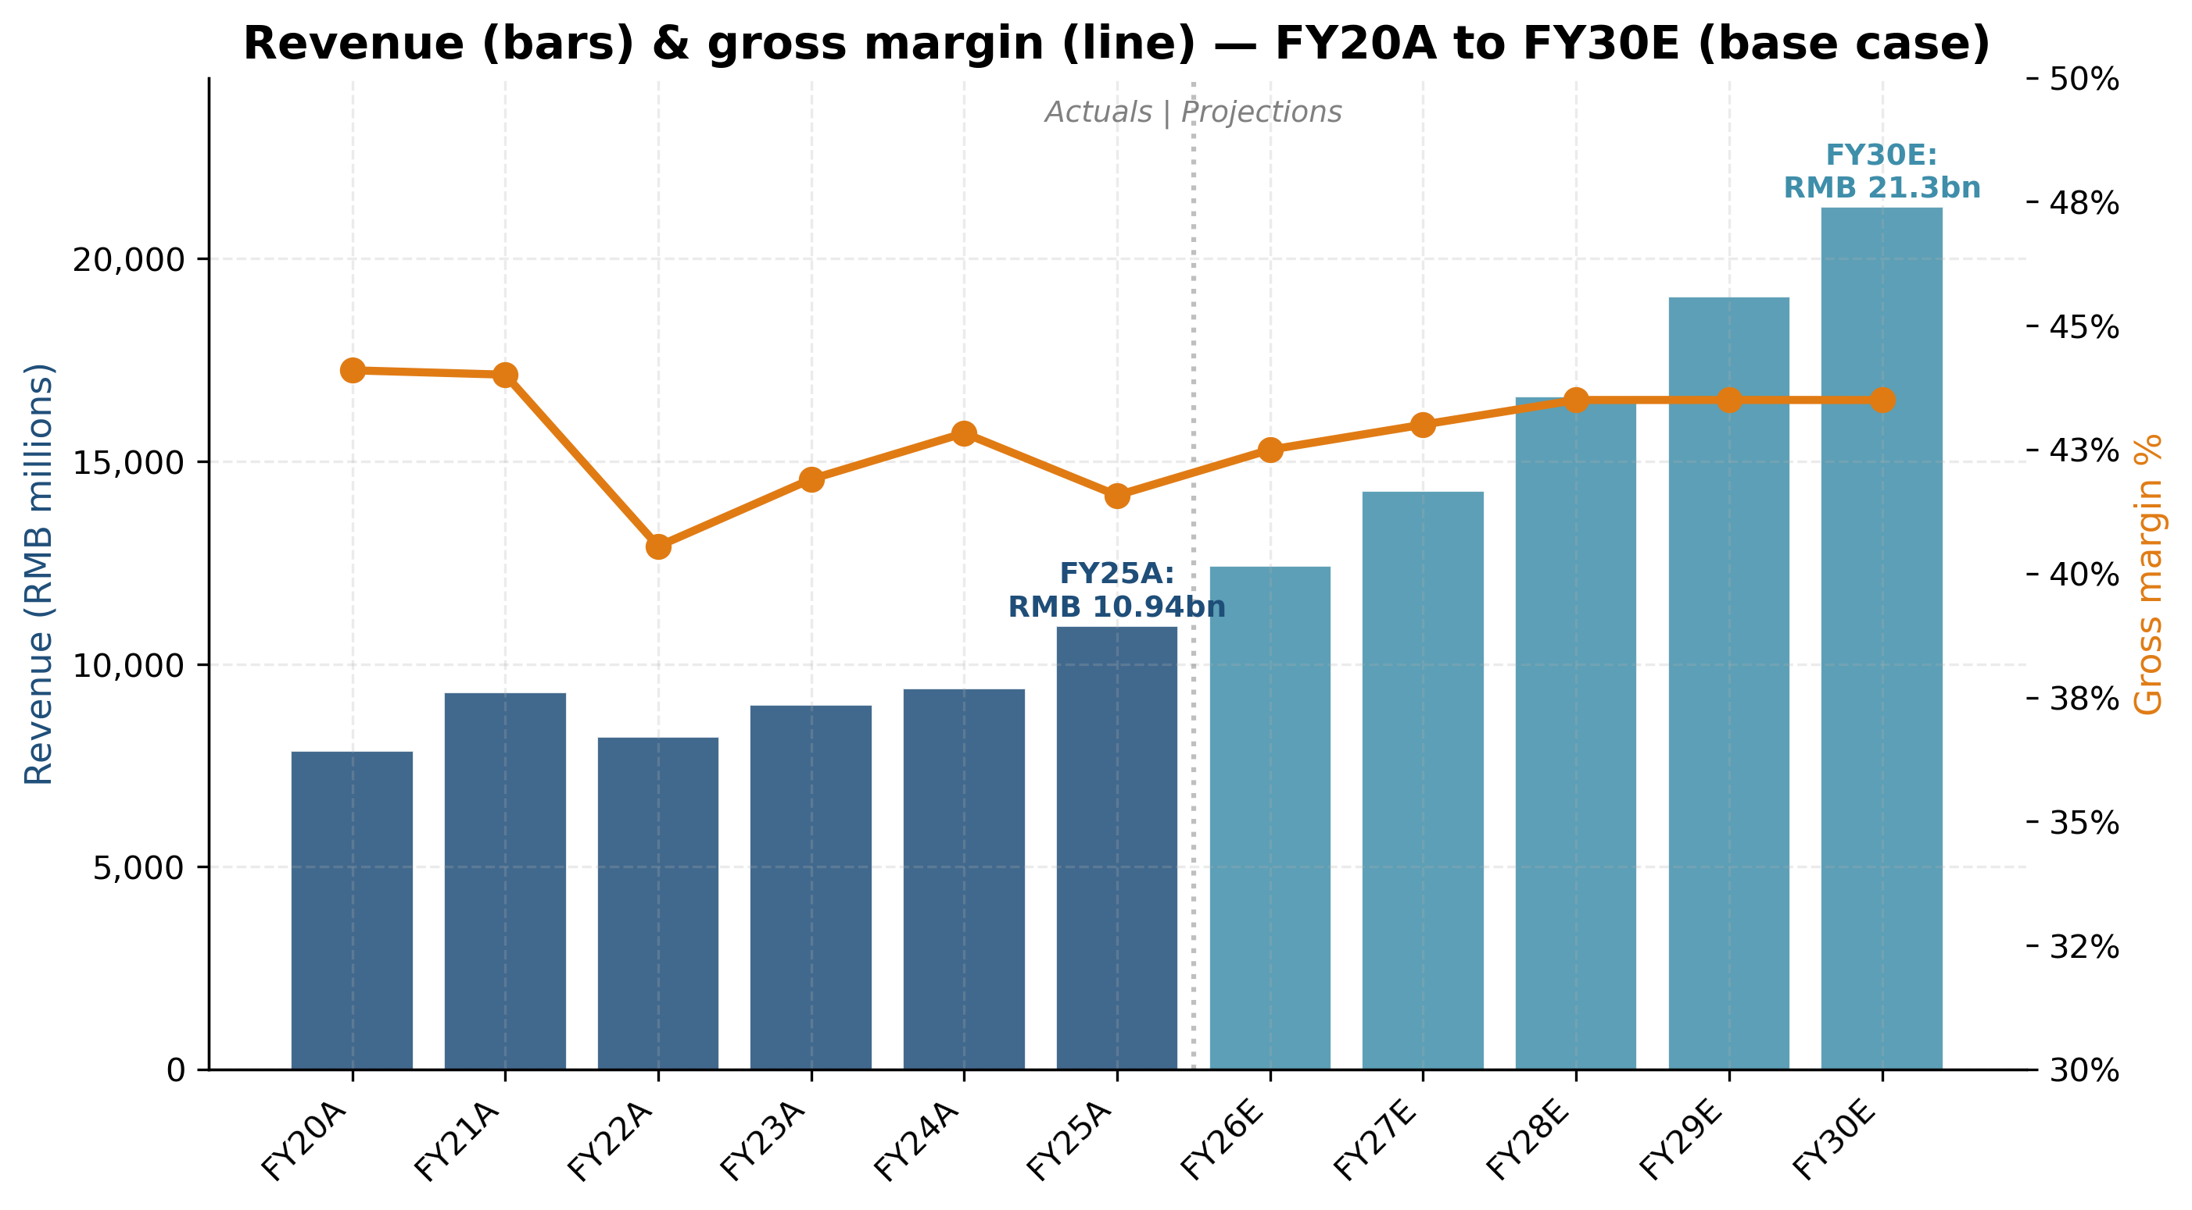
Exhibit 2: Revenue and gross margin trajectory (FY20A-FY30E)

Key statistics
Market cap | RMB 160.3 bn | FY25 revenue | RMB 10.94 bn
Enterprise value | RMB 151.2 bn | FY25 net income | RMB 2.73 bn
Shares outstanding | 1,340.8 m | FY25 ROE | 16.6%
Net cash | RMB 9.2 bn | FY25 EBITDA margin | 33.4%
Debt / EBITDA | 0.01× | FY25 EPS | RMB 2.04
TTM P/E | 58.6× | FY26E EPS | RMB 2.27
TTM EV/EBITDA | 41.5× | FY26E revenue growth | 13.6%
TTM P/S | 14.6× | Dividend yield (FY25) | 0.47%
P/B | 9.3× | Payout ratio | 33%
Beta (2y vs SSE) | 1.05 | Free float | ~35.7%

Investment thesis — the 'wait-for-better-entry' HOLD

1. World-class franchise — the highest-quality Chinese hydraulics asset
Hengli is the only Chinese hydraulics company with a complete product portfolio spanning cylinders, axial-piston pumps, multi-way valves, low-speed high-torque motors and integrated systems. It is the dominant supplier in the Chinese excavator hydraulics market (>50% share in mid-large cylinders), is one of only two Asian Caterpillar 'platinum medal' suppliers, and has built a 30%+ market share in domestic excavator main pumps and multi-way valves over the past decade. The company employs 8,400 staff including 1,104 R&D engineers (13.1% of headcount), holds 1,125 valid patents, and operates a 'national excellence-class smart factory' — the highest grade in MIIT's hierarchy.
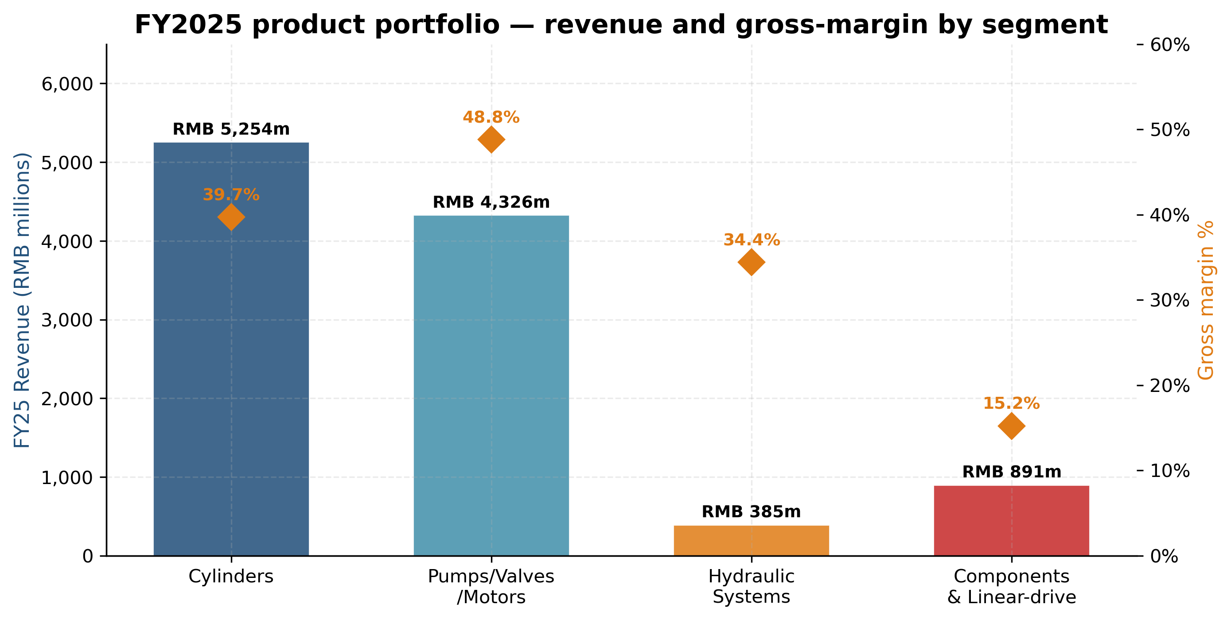
Exhibit 8: FY2025 product portfolio — revenue and gross-margin by segment
The FY2025 segment mix shows the maturity of this franchise: cylinders RMB 5.25bn at 39.7% gross margin (the defensible cash cow), pumps/valves/motors RMB 4.33bn at 48.8% gross margin (the highest-margin engine), systems RMB 0.39bn at 34.4% gross margin (small but strategic), and components/castings/linear-drive RMB 0.89bn at 15.3% gross margin (the narrative engine). Group-level gross margin of 41.6% and EBITDA margin of 33% are best-in-class for any industrial-machinery supplier globally.

2. Three growth vectors — but all priced in
The base-case bull thesis rests on three vectors: (a) China hydraulics market growing 8% CAGR FY25-FY30 (RMB 82bn to ~RMB 120bn) with Hengli outperforming at 13-14% CAGR via continued share gain from Bosch Rexroth retreat from low-end Chinese OEM business; (b) Mexico plant Tier-1 ramp with Caterpillar Mexicali expected to add RMB 1.5-2.0bn of overseas revenue by FY28; and (c) the linear-drive / planetary roller-screw ramp from current RMB 100m to RMB 2.3bn by FY30 per management's implied path. Each of these is achievable; we model all three in our base case. The issue is not the operational story but the valuation premium already paid for it.
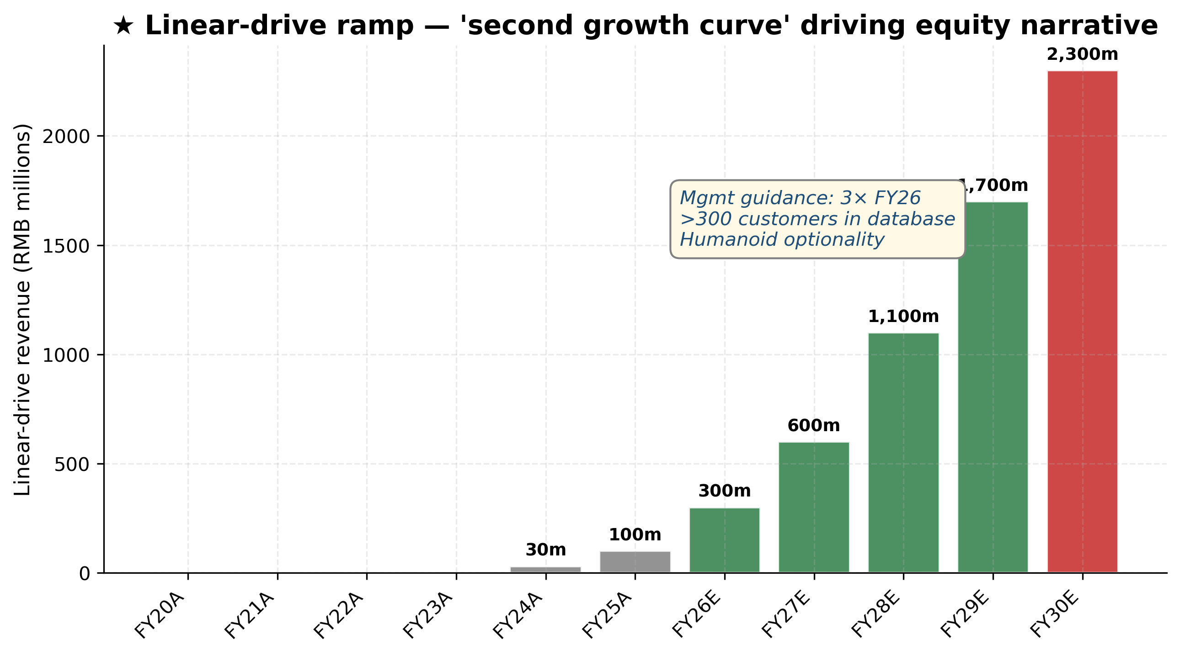
Exhibit 22: Linear-drive revenue ramp — 'second growth curve'

3. Valuation — DCF vs market gap of 80%+
Our base-case DCF generates RMB 67/share — a 44% discount to spot. This is not a result of pessimistic assumptions; it uses the same FY2026-FY2030 projections as the operational thesis (13% revenue CAGR, 30.5% terminal EBITDA margin, 8.5% WACC, 3.0% terminal growth). Even in our bull case (18% CAGR, 33.5% EBITDA margin, full humanoid penetration), DCF fair value reaches only RMB 96 — still below spot. The market is paying for off-DCF optionality — specifically a re-rating in line with humanoid-supply-chain precedents (Tuopu 100× P/E, Shuanglin 117× P/E) — which we view as a 25% probability over the next 12 months.
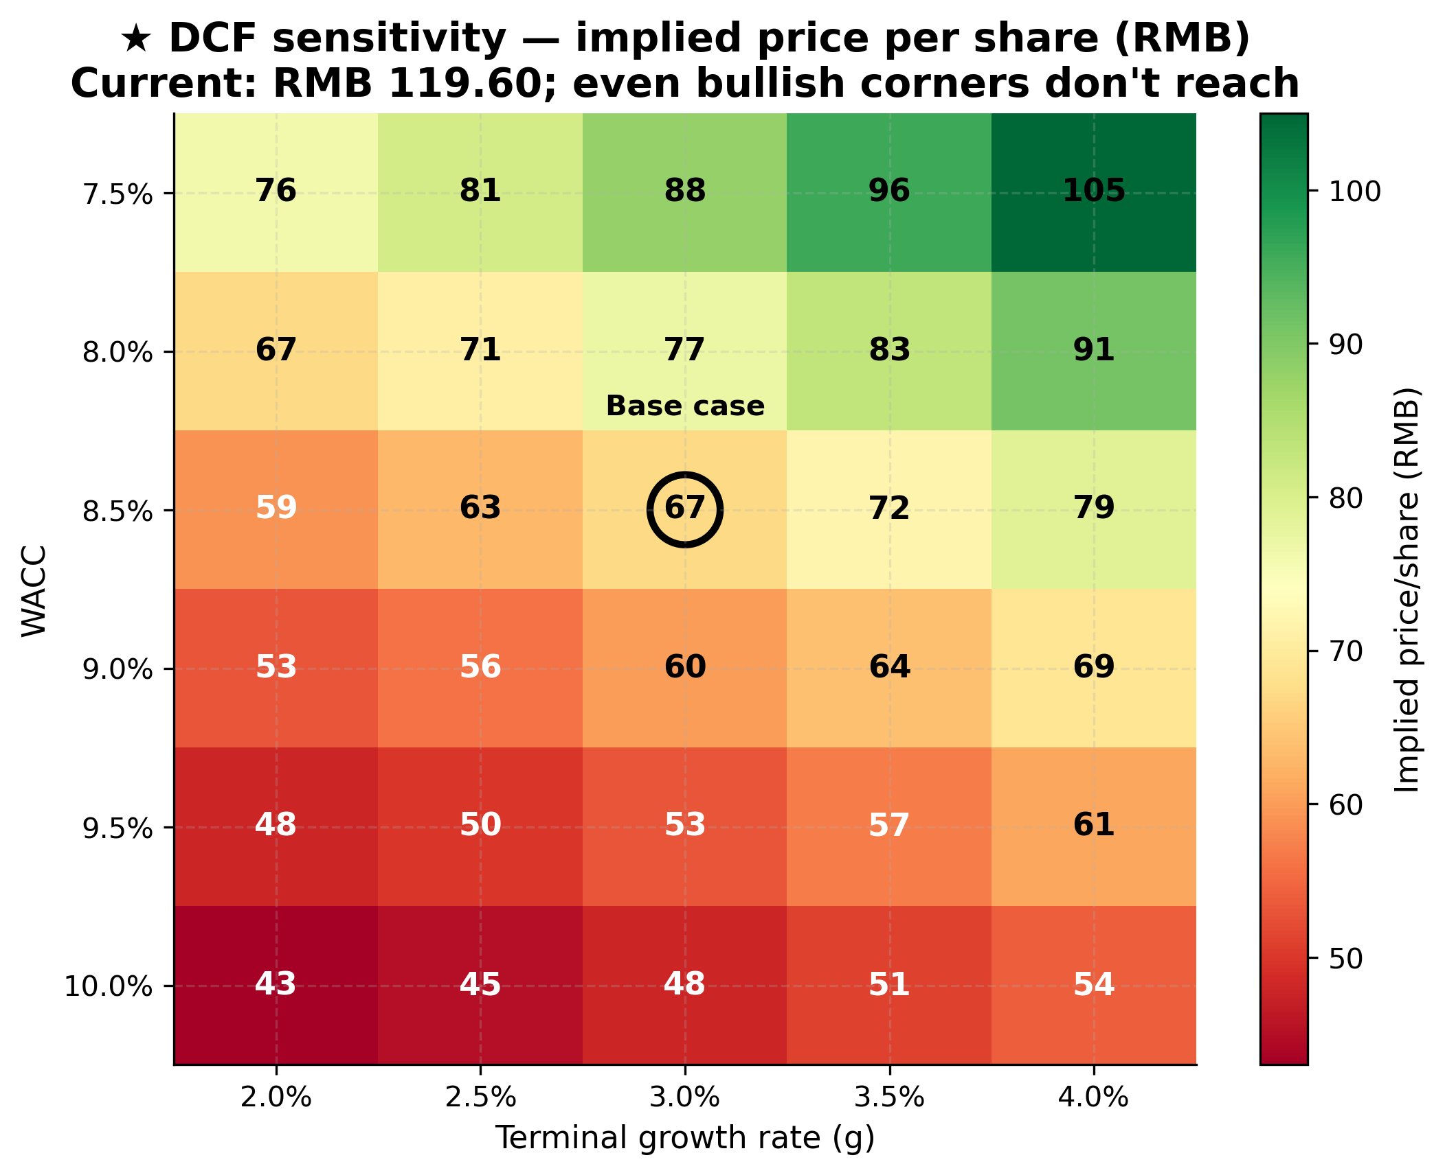
Exhibit 28: ★ DCF sensitivity — implied price per share (RMB)

4. Why HOLD and not BUY
We considered three alternative ratings before settling on HOLD: BUY (PT RMB 135-145 weighted more heavily toward humanoid precedent), HOLD-OUTPERFORM (PT RMB 120 implying modest 0-5% upside, our framework's most-popular comp-anchored answer), and HOLD-UNDERPERFORM (the strict DCF answer of PT RMB 67 implying SELL). Our final HOLD at RMB 106 reflects four judgements. First, the company is fundamentally a high-quality asset that we want to own at the right price — therefore an outright SELL is not our view. Second, the comp-anchored RMB 120 PT ignores the DCF reality that the underlying cash flows do not support the current price — the methodology weighting must include DCF to reflect this. Third, the BUY-at-RMB-145 case requires a humanoid-supply-chain announcement which is genuinely a coin-flip rather than a high-probability event, and we are not willing to underwrite our 12-month rating on a binary catalyst we cannot model. Fourth, the asymmetry of the position at RMB 119.60 is unattractive: downside of 30%+ if either (a) the humanoid narrative fades or (b) FY26 results disappoint vs consensus, against upside of 25-50% only if a major humanoid announcement materialises.
The HOLD is therefore explicitly a 'wait-for-better-entry' rating. We would turn BUY at RMB 95 or below, which would represent a roughly 25-30× FY26E P/E — well below the peer median and providing meaningful downside protection if the bear case materialises while preserving substantial upside if the bull case plays out. We would turn SELL at RMB 145 or above, where the implied multiple of >65× FY26E P/E starts to embed humanoid-supply-chain certainty that has not been confirmed.

What would change our view
We would turn BUY at RMB 95 or below — where the embedded humanoid premium becomes asymmetric again — and SELL at RMB 145 or above — where the implied probability of humanoid-supply-chain certification exceeds what we view as reasonable. The principal 12-month catalyst that would force an upgrade is a confirmed Tier-1 humanoid OEM supply award (Tesla Optimus, Figure, or a major Chinese humanoid program at >100k units/year scale). Sell-side notes have repeatedly cited Hengli as a plausible candidate based on (i) its planetary roller-screw production capability being one of only ~3 Chinese options, (ii) the geographic adjacency of Tesla's Mexicali humanoid pilot line to Caterpillar Mexicali (where Hengli is co-locating its Mexico plant), and (iii) reported sample shipments compatible with Optimus joint geometry. Hengli has not confirmed any such relationship, and we explicitly do not include this in our base case.

Key risks
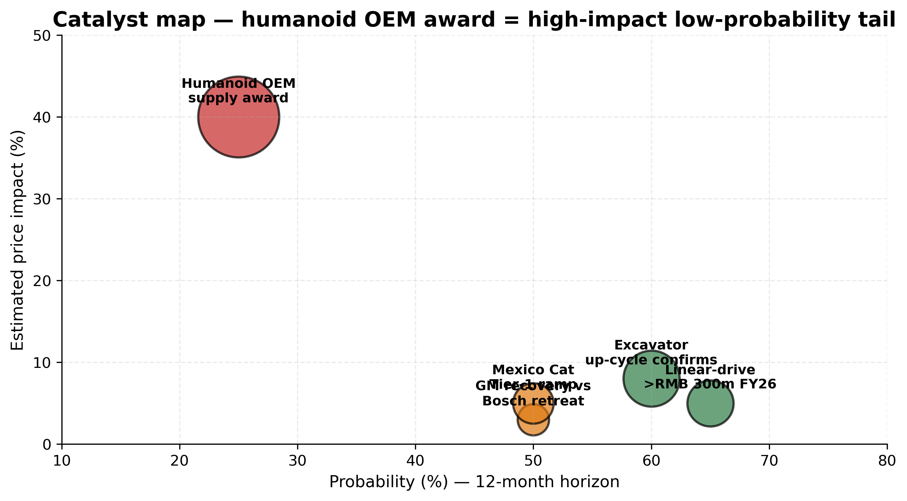
Exhibit 35: Catalyst probability map — humanoid OEM award = high-impact low-probability tail
The five most material risks are: (1) linear-drive execution — RMB 1.4bn invested with FY25 revenue of only RMB 100m at 15% gross margin vs 41% group margin; (2) Caterpillar in-sourcing — Mexicali plant could cut Hengli cylinder content from ~80% to <50% over 2026-2028 (RMB 500-700m of annual revenue at risk); (3) excavator cyclical down-cycle returns in 2027-2028; (4) multiple compression — TTM P/E 58× is in the top decile of the 3-year band, with sentiment-driven derating risk; (5) RMB / USD / EUR FX hedging risk on the USD 580m notional swap book (33% of equity). Severity assessment in Section 9.

Table of Contents
1. Investment summary .................................................. 1
2. Investment thesis .................................................. 3
3. Risks to thesis .................................................. 4
4. Company background (Company 101) .................................................. 6
4.1 History & milestones .................................................. 6
4.2 Management team .................................................. 7
4.3 Products & segments .................................................. 9
4.4 Customers & contracts .................................................. 11
4.5 Geographic footprint .................................................. 12
5. Industry & TAM analysis .................................................. 14
6. Competitive landscape .................................................. 16
7. Financial analysis .................................................. 18
7.1 Historical performance review .................................................. 18
7.2 Revenue projections & assumptions .................................................. 21
7.3 Margin & profitability projections .................................................. 23
7.4 Cash flow, CapEx & balance sheet .................................................. 25
7.5 Scenario analysis .................................................. 27
8. Valuation analysis .................................................. 29
8.1 DCF analysis & sensitivity .................................................. 29
8.2 Comparable companies analysis .................................................. 32
8.3 Precedent transactions .................................................. 34
8.4 Football field & price target .................................................. 35
9. Risks (detailed) .................................................. 37
10. ESG considerations .................................................. 39
11. Catalysts .................................................. 40
12. Appendices .................................................. 41

4. Company background

4.1 History & milestones
Jiangsu Hengli Hydraulic Co., Ltd. (江苏恒立液压股份有限公司) was founded by Wang Liping in Wuxi in 1990 as a seven-person pneumatic-components workshop with RMB 50,000 of capital. The company's transformational moment came in 1999 when it developed the first domestic excavator hydraulic cylinder, breaking the KYB / Kawasaki / Eaton oligopoly that had supplied 100% of Chinese excavator OEMs up to that point. The company incorporated in its modern form in Changzhou in 2005, listed on the Shanghai Stock Exchange in October 2011 at RMB 23.00/share, and has since executed three strategic pivots that define the modern business.
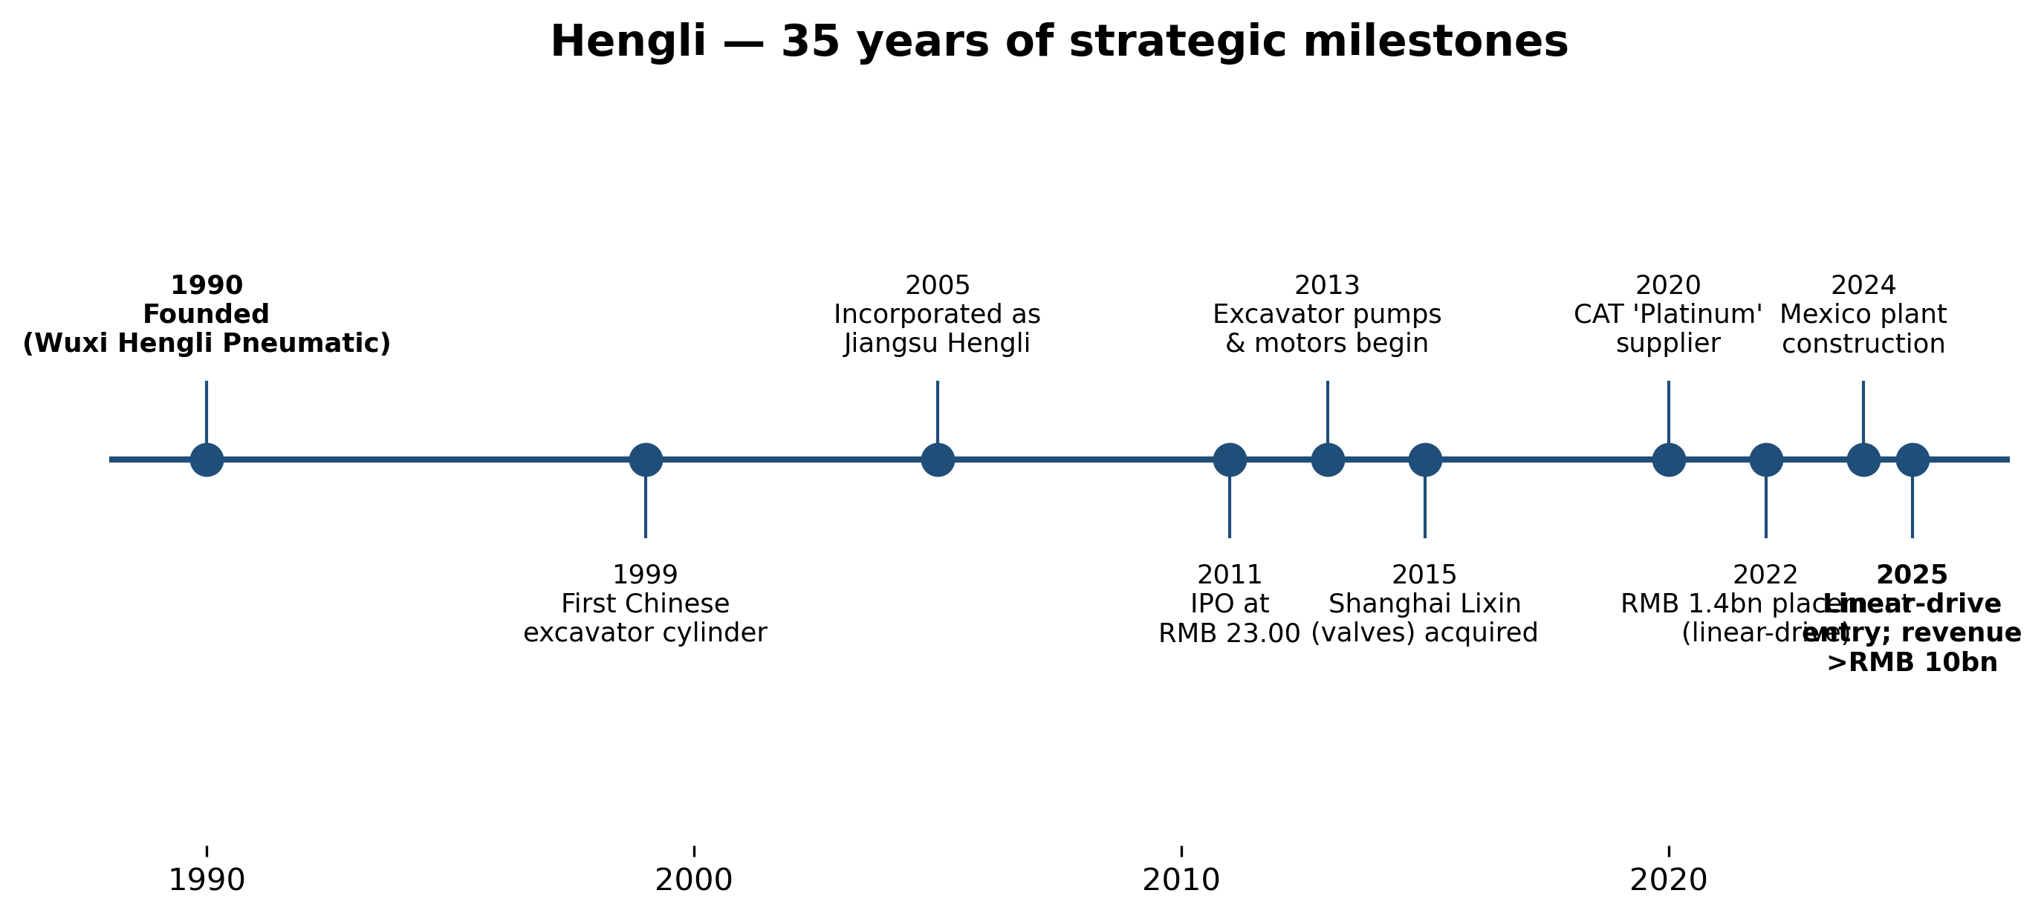
Exhibit 5: Hengli — 35 years of strategic milestones
The first pivot, in 2013, was the expansion from cylinders into axial-piston pumps, multi-way valves, and travel/swing motors. Hengli leveraged its existing relationships with Chinese excavator OEMs — which already used Hengli cylinders — to seed a substantially higher-margin product line. Today pumps & valves contribute ~40% of revenue at ~49% gross margin versus ~40% for cylinders. The second pivot, in 2018, recognised that Chinese excavator demand was structurally cyclical and broadened the addressable market by selling pumps to forging, injection-moulding, wind, agricultural, and aerial-work-platform OEMs. The third — and most strategically consequential — pivot was the 2022 linear-drive entry, funded by a RMB 1.4bn private placement issued in December 2022 at RMB 56.40/share. This funded a dedicated factory in Changzhou for high-precision ball screws, planetary roller screws and linear guideways — an explicit bet that Hengli's precision-motion know-how (super-finishing, induction hardening, micron-grade grinding) would transfer to the linear-motion components needed in CNC machine tools, semiconductor equipment, and humanoid-robot actuators.
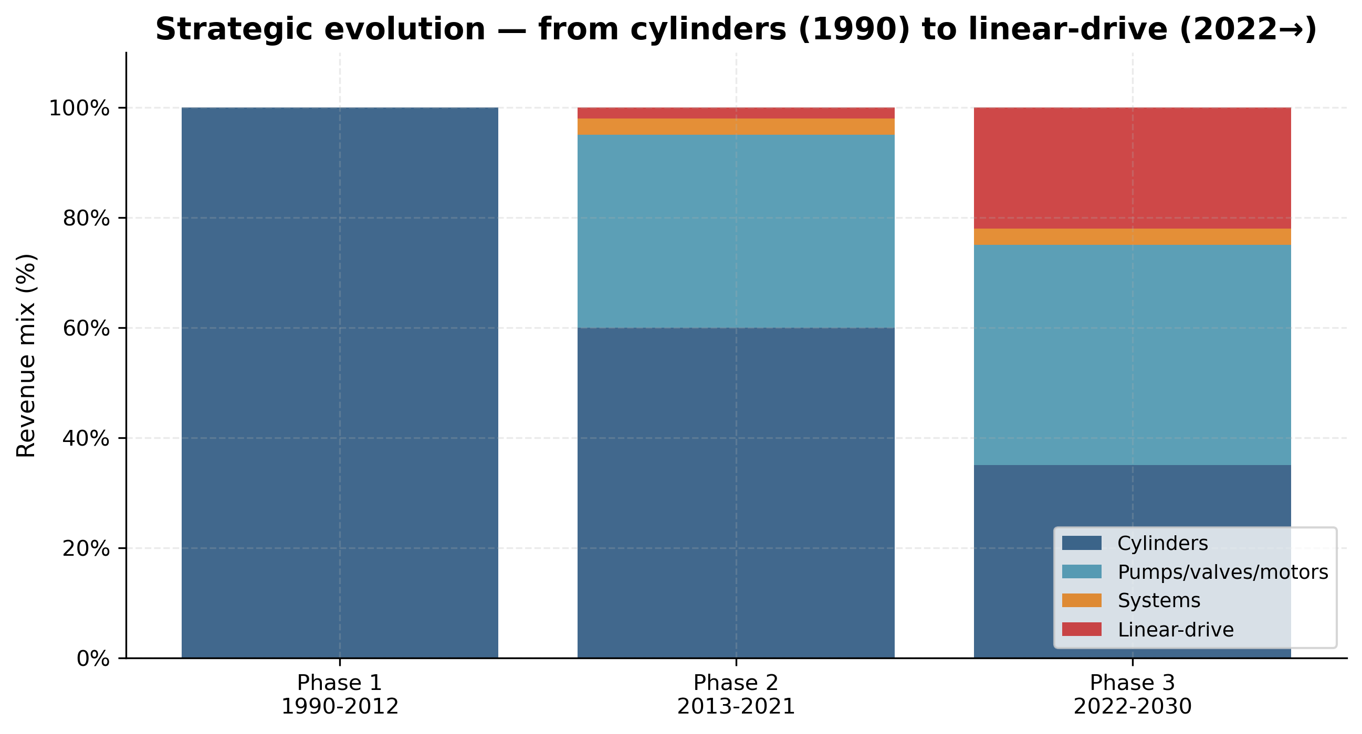
Exhibit 6: Strategic evolution — from cylinders (1990) to linear-drive (2022→)

4.2 Management team
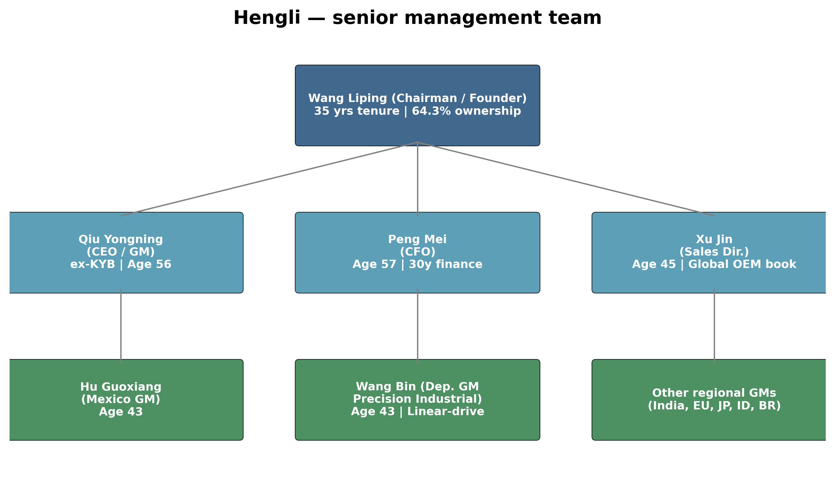
Exhibit 7: Senior management team
Wang Liping (汪立平), age 60, Chairman & Founder. Born 1966 in Jiangsu with a junior-college education and senior-economist certification, Wang has been continuously CEO/Chairman of the integrated group for 35 years — an exceptionally long tenure for a Chinese listed-company founder. His signature accomplishment is the 1999 development of the first domestic excavator hydraulic cylinder that broke the KYB/Kawasaki/Eaton oligopoly, a technical bet the company would not have survived without. He has then successfully repeated the same playbook for pumps in 2013 and now linear motion in 2022. Wang holds, together with his wife Qian Peixin (Hong Kong resident, director of Shenuo Technology) and son Wang Qi, approximately 64.3% of Hengli through three holding vehicles — Jiangsu Hengli Holdings (36.95%), Shenuo Technology HK (14.10%), and Ningbo Hengyi (13.29%, the management equity vehicle). Wang was re-elected to a fresh 3-year board term in September 2025, indicating no near-term succession trigger. FY2025 cash compensation was RMB 1.42m — modest by global standards; the wealth is entirely in equity.
Qiu Yongning (邱永宁), age 56, Director and General Manager (CEO). Holds a bachelor's degree in mechanical engineering from Nanjing University of Aeronautics and Astronautics. Career path runs through Jiangsu Zhengmao Group (production manager), Hualixin Electric Machinery (deputy GM), and Kayaba Hydraulic Industry Zhenjiang — the China JV of Japan's KYB — where Qiu was head of production. He joined Hengli in the late 2000s as deputy GM, was promoted to GM, and now sits on the boards of Hengli Technology, Hengli Transmission (linear-drive subsidiary), and Hengli Precision Industrial. FY2025 compensation RMB 1.06m. Qiu is the day-to-day operator running production planning, supply chain, and execution against Wang's strategic direction; his KYB lean-manufacturing methodology is meaningful given KYB's status as the global cylinder leader.
Peng Mei (彭玫), age 57, CFO / Finance Director. Beihang University, senior accountant. Prior roles: chief accountant at Changzhou Lanxiang Mechanical (now part of AVIC's Changzhou Lanxiang Aviation Engine Co.); finance head at Yamazaki Motorcycle Changzhou; CFO at Globe Industries Changzhou. Peng has 30+ years of finance leadership across Chinese, Japanese, and US-owned operations in the Changzhou industrial cluster. She joined Hengli pre-IPO and oversaw the 2011 SSE listing and the 2022 private placement. FY2025 compensation RMB 0.90m. Track record points include zero financial-statement restatements, zero audit qualifications across 14 years public, and a continuously expanding dividend (FY2024 dividend RMB 0.94bn; FY2025 proposed dividend RMB 0.75bn at RMB 5.60 per 10 shares) — strong governance signals.
Xu Jin (徐进), age 45, Director, Deputy GM & Sales Director. Master's degree, joined Hengli as a sales-team manager and rose to head of group sales. He directly owns the global-OEM relationship book — Caterpillar, Komatsu, Doosan, Liugong, Volvo CE — and has been the architect of Hengli's overseas-direct-sales build-out (Mexico, India, Indonesia). FY2025 compensation RMB 0.91m. Sits on the board of Hengli Technology, Shanghai Lixin, and Hengli Precision Industrial.
Wang Bin (王斌), age 43, Deputy GM & Hengli Precision Industrial GM. Master's degree, internal promotion from regional sales → procurement manager → supply-chain GM → Liquid Pressure Technology deputy GM. He now leads the precision-machining unit responsible for the linear-drive product line and the planetary roller screws — the most strategically important new business at the company. FY2025 compensation RMB 0.96m.
Management track record assessment. This team has delivered for 30+ years across three step-changes (cylinders → pumps → linear motion). The execution playbook — leverage existing OEM relationships, run R&D in lock-step with one anchor customer, then expand the product to all customers — has worked twice and is now being run a third time on roller screws. The main gap is CFO and CEO succession: both are above 55, and there is no publicly identified internal successor. Capital allocation has been disciplined — Hengli has only one major private placement (2022, RMB 1.4bn), virtually no acquisitions of size, and a 30-40% dividend payout ratio.

4.3 Products & segments
Hengli divides its FY2025 main-business revenue of RMB 10.86bn across four reporting segments. The audited breakdown is shown below.
Segment | FY25 Revenue (RMB m) | YoY | Gross margin | % of main biz
Hydraulic cylinders | 5,254 | +10.4% | 39.7% | 48.4%
Pumps, valves & motors | 4,326 | +20.7% | 48.8% | 39.8%
Hydraulic systems | 385 | +30.0% | 34.4% | 3.5%
Components & castings (incl. linear-drive) | 891 | +30.3% | 15.3% | 8.2%
TOTAL main business | 10,856 | +16.4% | 41.2% | 100.0%
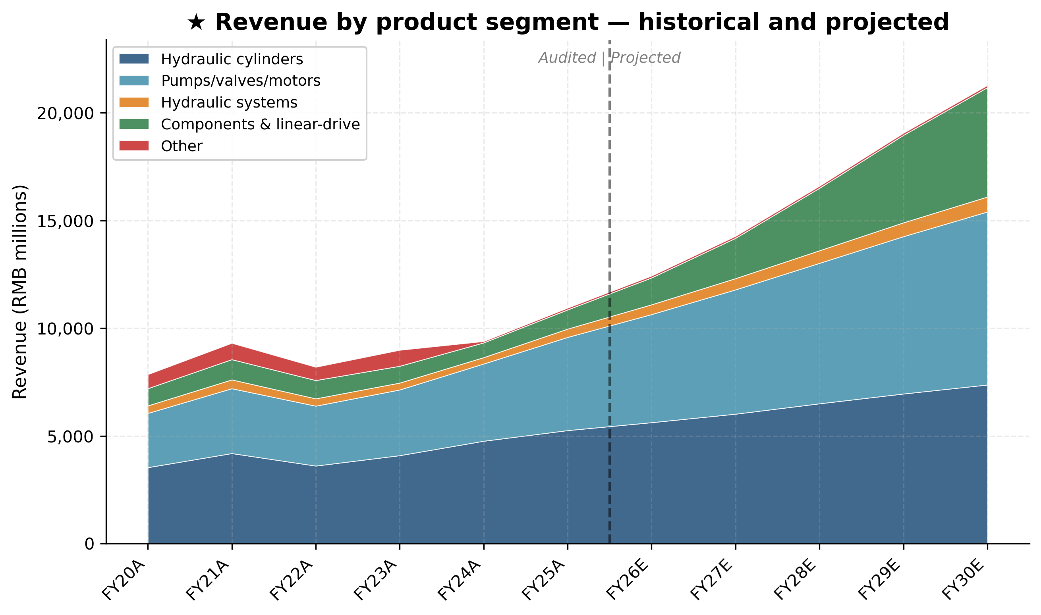
Exhibit 3: ★ Revenue by product segment — historical and projected (RMB millions)

Hydraulic cylinders — the flagship
Hengli ships ~900,000 cylinders per year, the world's largest single-supplier output. The product line spans excavator-specific cylinders (boom, arm, bucket) for excavators ranging 1.5 t to 400 t — including a recently launched giant 90-tonne mining-excavator cylinder. Non-standard cylinders for aerial work platforms (AWPs), marine deck equipment (winch, hatch covers, davits, jack-up), wind-turbine pitch & yaw systems, port equipment (RTG/STS cranes), and water-conservancy gates round out the range. The 156-metre offshore pile-driver closed-loop energy-recovery cylinder system delivered in 2025 is the largest of its kind ever built. Competitive verdict: yes, moat. Type: scale + cost leadership + switching costs at the OEM. Evidence — Hengli holds >50% China share in mid-large excavator cylinders, has been Caterpillar's only Asian 'platinum-medal' cylinder supplier for five consecutive years, and runs a gross margin (39.7%) materially above small-scale local competitors (typical 15-25%). Closest competitor: KYB Corporation (TYO:7242) — comparable on quality at the high end; behind on cost; equal at parity for Japanese and Korean OEMs.

Hydraulic pumps, valves & motors — the highest-margin engine
The product family includes (a) axial-piston main pumps for excavators (the so-called 'main pump', historically a Kawasaki / Bosch Rexroth oligopoly), (b) multi-way valves (also historically Kawasaki/Eaton/Parker), (c) low-speed high-torque travel motors and swing motors, (d) industrial pumps for wind, injection moulding, forging presses, and (e) closed-loop pumps for AWPs and agriculture. In 2025 Hengli broke into the ultra-large excavator main pump category previously locked up by Bosch Rexroth and Kawasaki, with units for 50-90-tonne machines. Competitive verdict: yes, technology / IP moat. Evidence — Hengli is the only Chinese supplier with cylinder + main-pump + multi-way valve capability under one roof; gross margin 48.8% is consistent with proprietary technology; multiple national R&D project leadership gives technical first-mover position. Closest competitor: Bosch Rexroth (Bosch GmbH unit, private) — ahead on absolute precision and on closed-loop electronic control, behind on cost and on Chinese-OEM relationship density. Kawasaki Precision Machinery is the second comp — at parity on technology, behind on cost.

Hydraulic systems — small but high-strategy
Integrated turnkey systems for tunnel-boring machines (China Railway Construction Heavy Industry), marine deck equipment, water-conservancy gates (Pinglu Canal), and special vehicles. FY2025 segment growth was 30%. Margin is the lowest of the four (34.4%) because system delivery includes purchased third-party content. Competitive verdict: partial moat — moat is from the underlying components, not from the system-engineering layer.

Components & castings — the linear-drive engine
This is the segment to watch. Conventional content: cylinder spares, pump cores, high-precision castings (Hengli has its own foundry). The new content consolidated here since 2025: linear-drive components — ball screws, planetary roller screws, linear guideways, electric cylinders. Reported FY2025 capacity is 70,000 sets of precision-ground ball screws/yr, 360,000 m of linear guideways/yr, and small-batch planetary-roller-screw shipments. The 2022 private placement defined a full-build-out plan of 104,000 standard ball-screw electric cylinders, 4,500 heavy-duty ball-screw electric cylinders, 750 planetary-roller-screw electric cylinders, plus 100,000 m of standard and 100,000 m of heavy-duty ball screws. FY2025 shipment value was estimated at RMB 80-100 million, with management guidance for 3× growth in FY2026 to ~RMB 300m and >300 customers already in the database. Competitive verdict: partial moat, with a clear path to 'yes'. Moat type today: certification + scale-up advantage; planned moat: technology + cost. Evidence — Hengli is one of only ~3 Chinese suppliers (the others being Beijing Precision Engineering and Nanjing Technology) with announced planetary-roller-screw production capability; sample shipments to Optimus joint-module designers have been reported (unconfirmed by Hengli directly). Closest named competitors: Tuopu Group (601689) for the integrated linear-actuator-module deal; Shuanglin (300100) for ball-screws; Schaeffler (ETR:SHA) for the global benchmark on planetary roller screws.
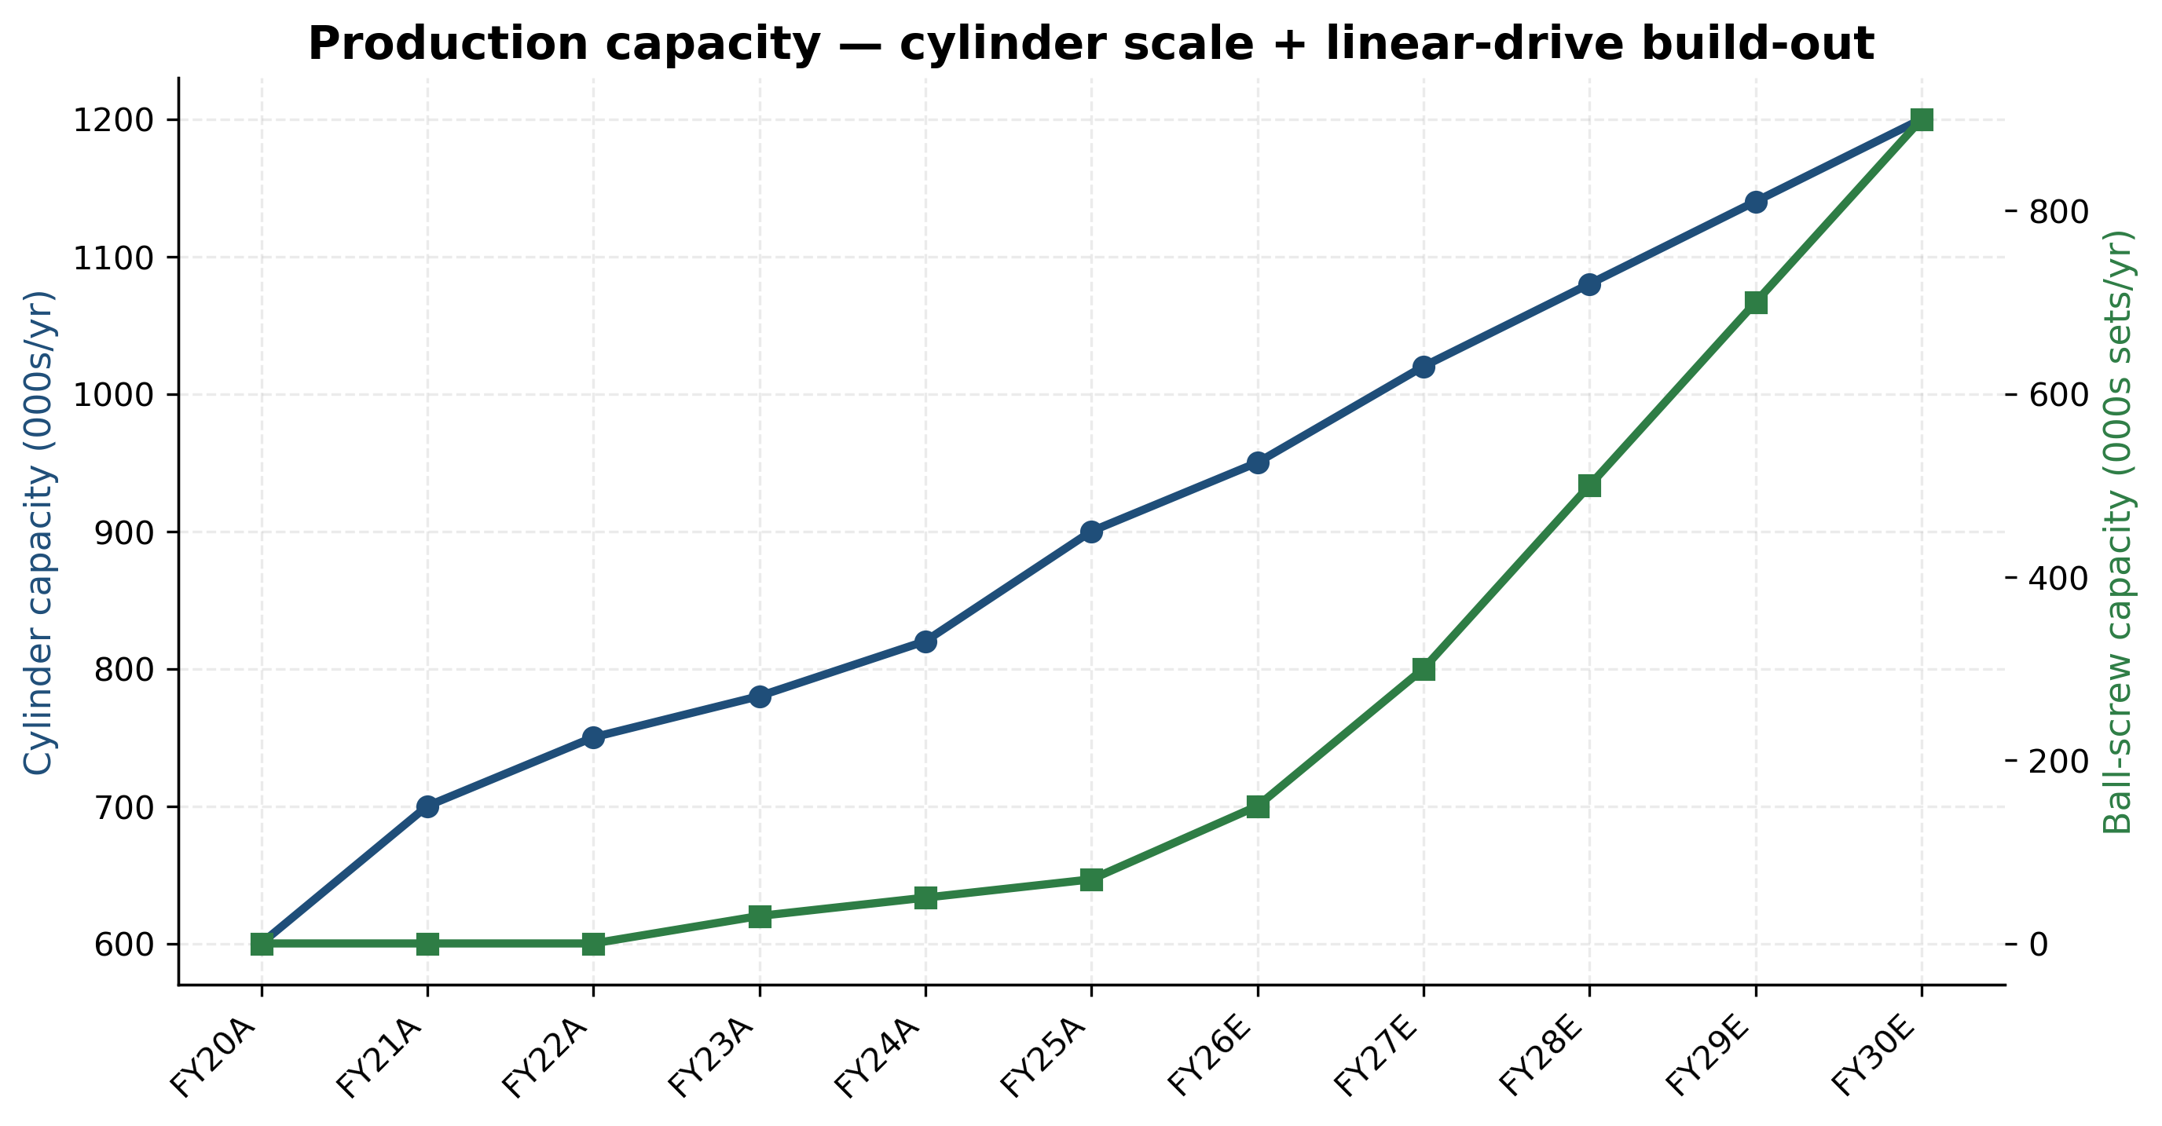
Exhibit 25: Production capacity build-out — cylinder scale + linear-drive ramp

4.4 Customers & contracts
Hengli's FY2025 top-5 customer concentration is RMB 4.60bn, equal to 42.07% of total revenue, with zero related-party content. FY2024 was 44.13% (RMB 3.64bn) and FY2023 was 42.45% (RMB 3.81bn) — a stable mid-40% range over 3 years. The single-largest customer is not separately named in Chinese annual-report disclosure (Chinese A-share rules require only the top-5 aggregate and confirmation that no single customer is >50%); industry triangulation from supplier reports and analyst notes points to Caterpillar as the #1 customer at roughly 13-15% of group revenue, followed by Sany Heavy Industry, XCMG, Komatsu, and Liugong at 6-10% each. Doosan and Hitachi Construction Machinery are the other typical entrants in the top-10, with Kubota rising rapidly via the new agricultural-tractor pump programme.
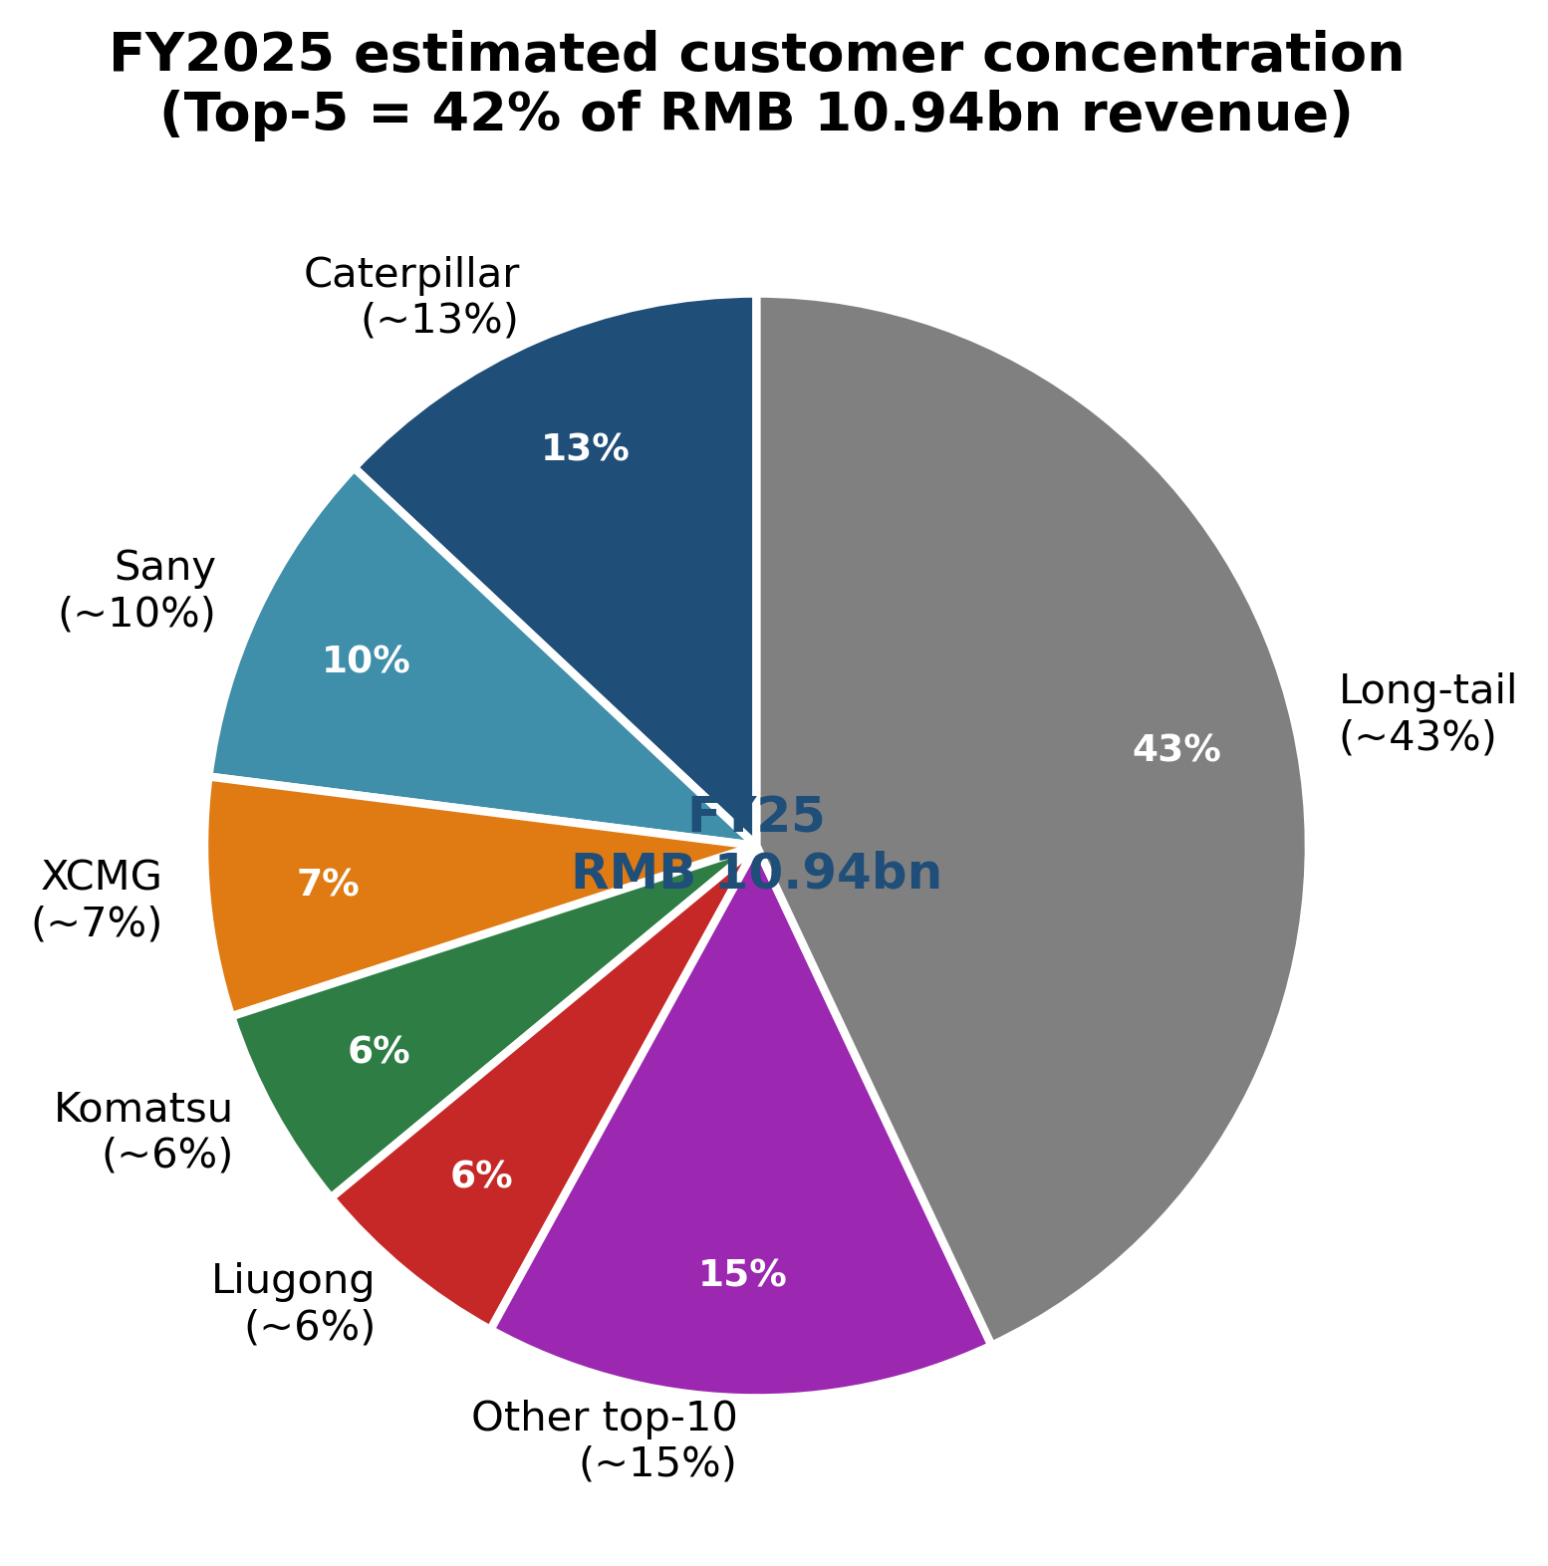
Exhibit 9: Estimated customer concentration — Top-5 = 42% of FY25 revenue
Contract structure. Annual framework agreements with the top-10 OEMs, executed at year-start; specific POs flow against the framework; lead time 30-60 days; payment terms 60-120 days (a structural reason for Hengli's RMB 1.9bn accounts-receivable balance, which grew 39% YoY in FY2025 alongside revenue). No multi-year volume commitments — pricing renegotiated annually. Sales channel is 100% direct OEM with no distribution layer. The internal sales force is organised in three units — domestic-excavator OEMs, domestic-industrial OEMs, and overseas — under Xu Jin (sales director). Service is via 30+ China service offices plus overseas service hubs in Europe, the US, Japan, Mexico, Indonesia, India, and (since 2025) the UK, Italy, Guinea.

4.5 Geographic footprint
Domestic FY2025 revenue was RMB 8.75bn (+20.7% YoY, 80% of total); overseas RMB 2.11bn (+1.6% YoY, 19% of total). Gross margin on domestic and overseas is nearly identical (41.1% vs 41.4%), unusual for Chinese exporters and indicating that Hengli is not competing on price overseas but on quality. Overseas growth was muted in 2025 because the US/EU construction-machinery market was weak; the Mexico plant has been built specifically to capture growth in 2026-2028. Headquarters and the principal Tier-1 flexible smart factory are at 99 Longqian Road, Wujin Hi-Tech District, Changzhou, Jiangsu; subsidiaries span Shanghai, Wuxi, Changsha, Nanjing, plus overseas units in Germany (InLine Hydraulik GmbH), Japan (HARADA Giken, Hattori Seiko, HST), the United States (Hengli America, the 580 West Crossroads Chicago facility), India, Indonesia, Mexico (just commissioned 2025), the UK, Italy, Brazil, France, Singapore, and Guinea.
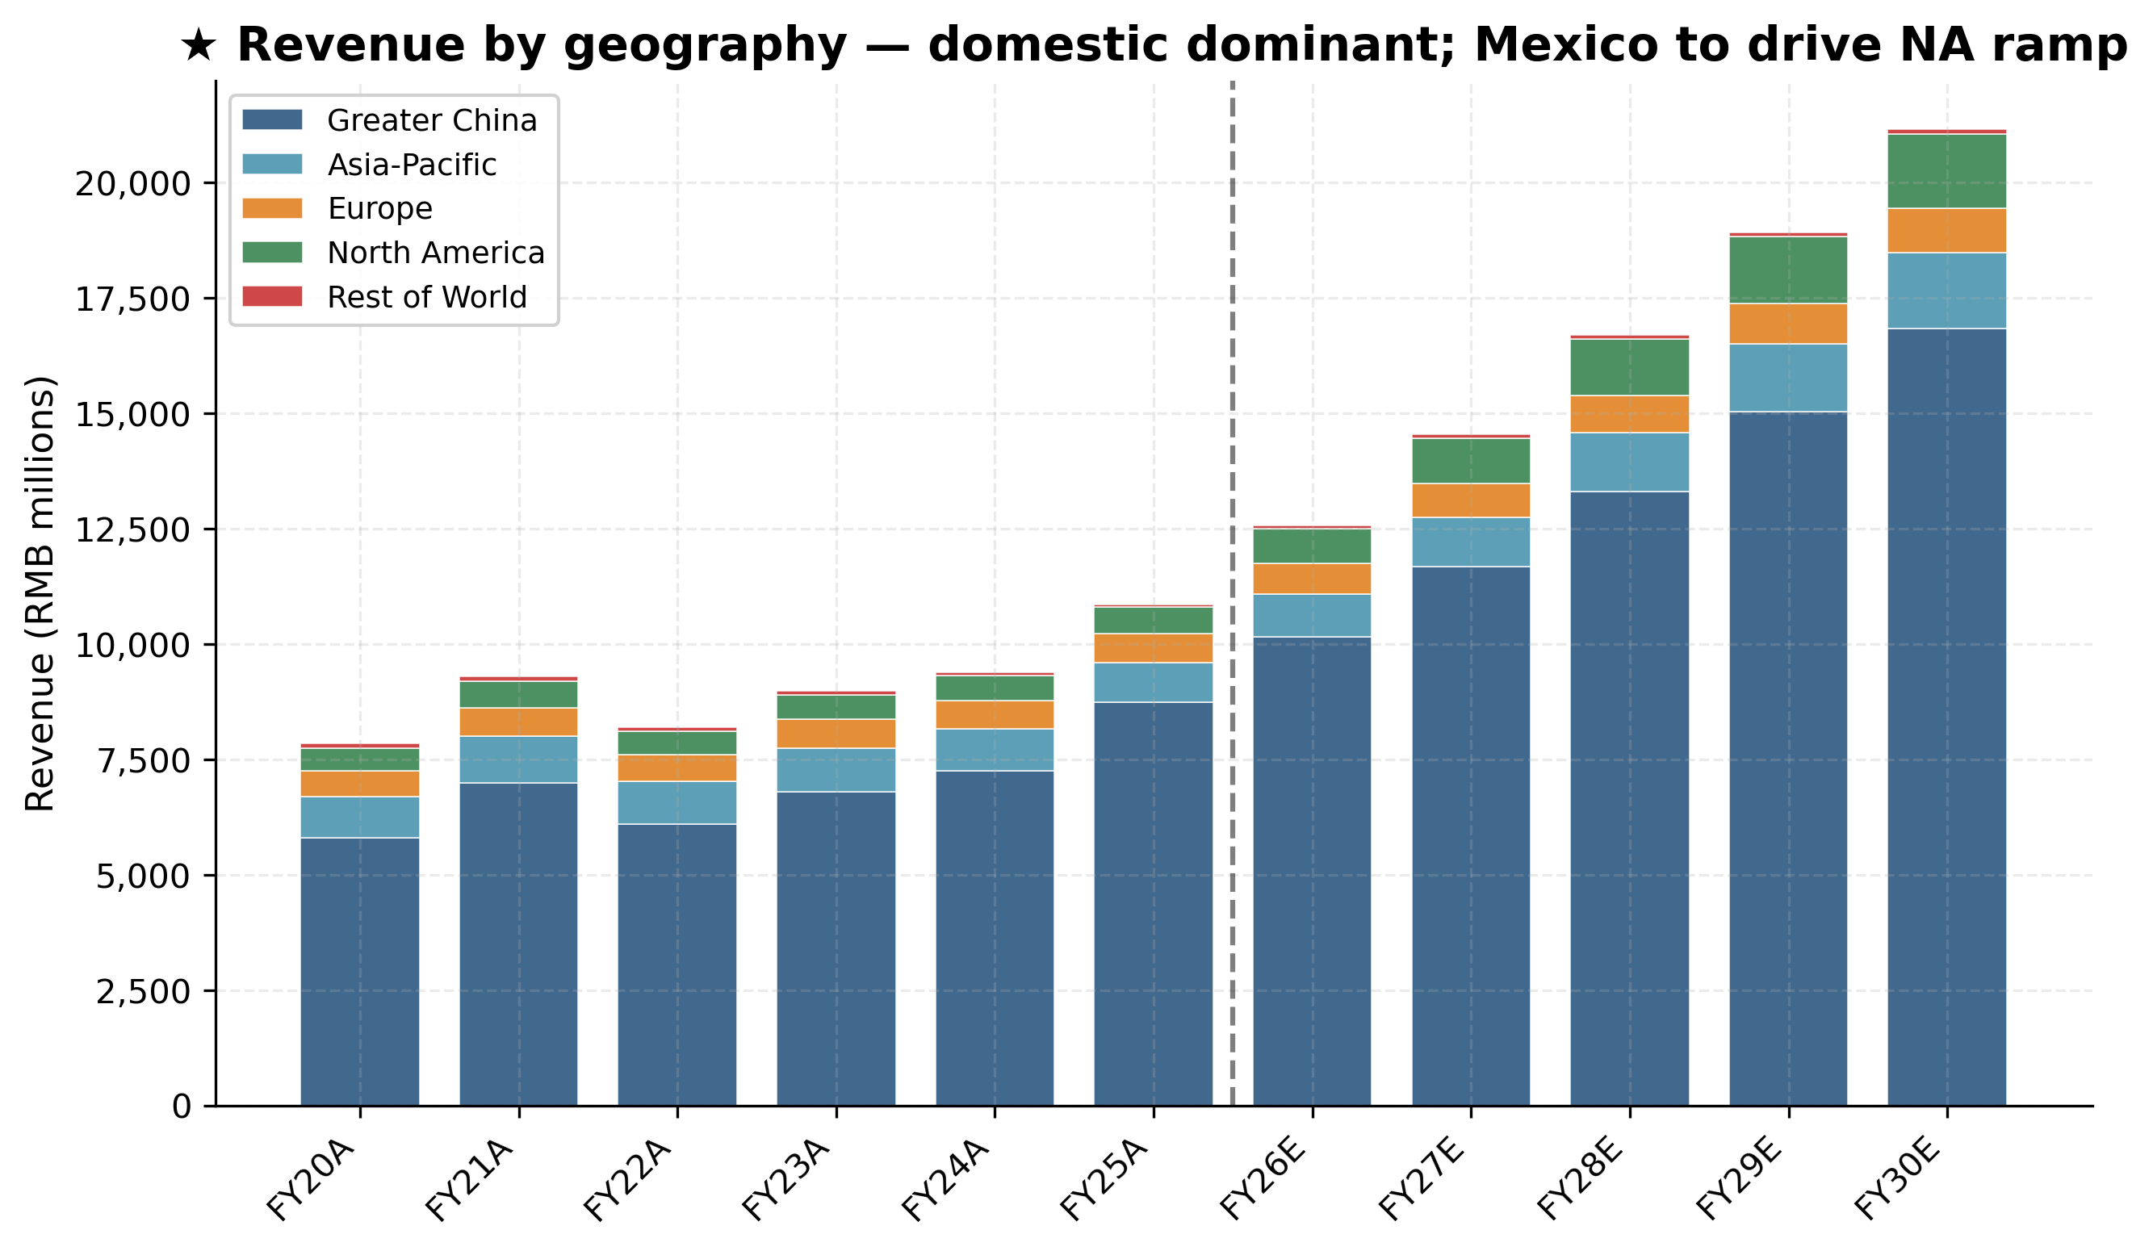
Exhibit 4: ★ Revenue by geography — domestic dominant; Mexico-led NA ramp 2026-2028
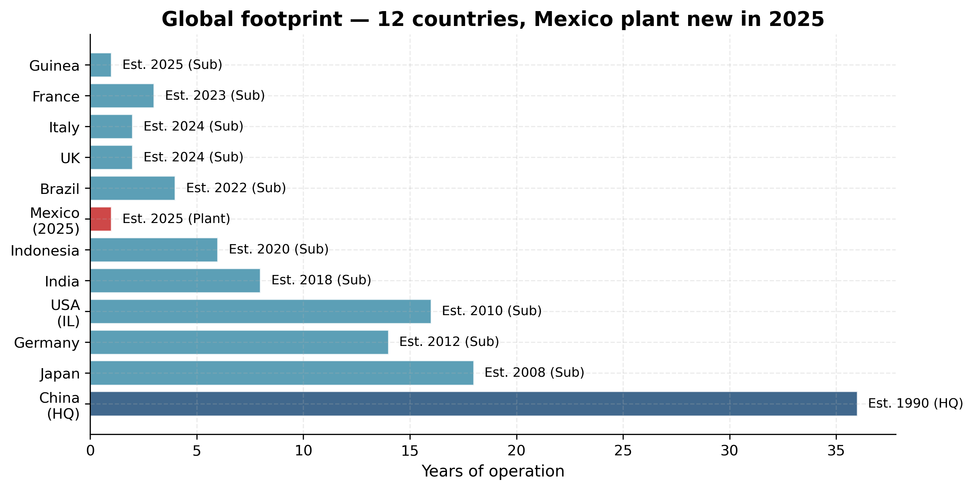
Exhibit 26: Global footprint — 12 countries operating, Mexico new in 2025

5. Industry & TAM analysis

5.1 China hydraulics industry
The China Hydraulic Pneumatic & Sealing Industry Association (CHPSC) reported FY2025 industry output of approximately RMB 82bn, up materially from FY2020 and continuing the 14th Five-Year Plan growth path. China imported USD 2.37bn and exported USD 2.82bn of hydraulics in 2024, generating the country's first hydraulics trade surplus (USD 0.45bn) — a structural inflection point indicating that import-substitution has crossed 50% for the first time. Globally, the hydraulics market is approximately USD 45-50bn (Parker Hannifin Motion Systems + Eaton Industrial + Bosch Rexroth + Kawasaki + Komatsu HE + Hengli + KYB account for ~60% of the global market).

5.2 Linear-motion components — the second leg
The global precision ball-screw + roller-screw + guideway market is USD 12-14bn today, dominated by Japanese suppliers (NSK, THK, Nachi, IKO) plus German Schaeffler/Bosch and Swiss Rollvis. China's share is <20% but rising fast on import-substitution + on the new humanoid-robot demand pool. Morgan Stanley's 'Humanoid 100' report estimates that, at 1 million humanoid units per year and 40 linear actuators per humanoid, the humanoid roller-screw TAM alone is USD 5-10bn at maturity, with 75-80% of demand for planetary roller screws (the only viable technology for the force density required).
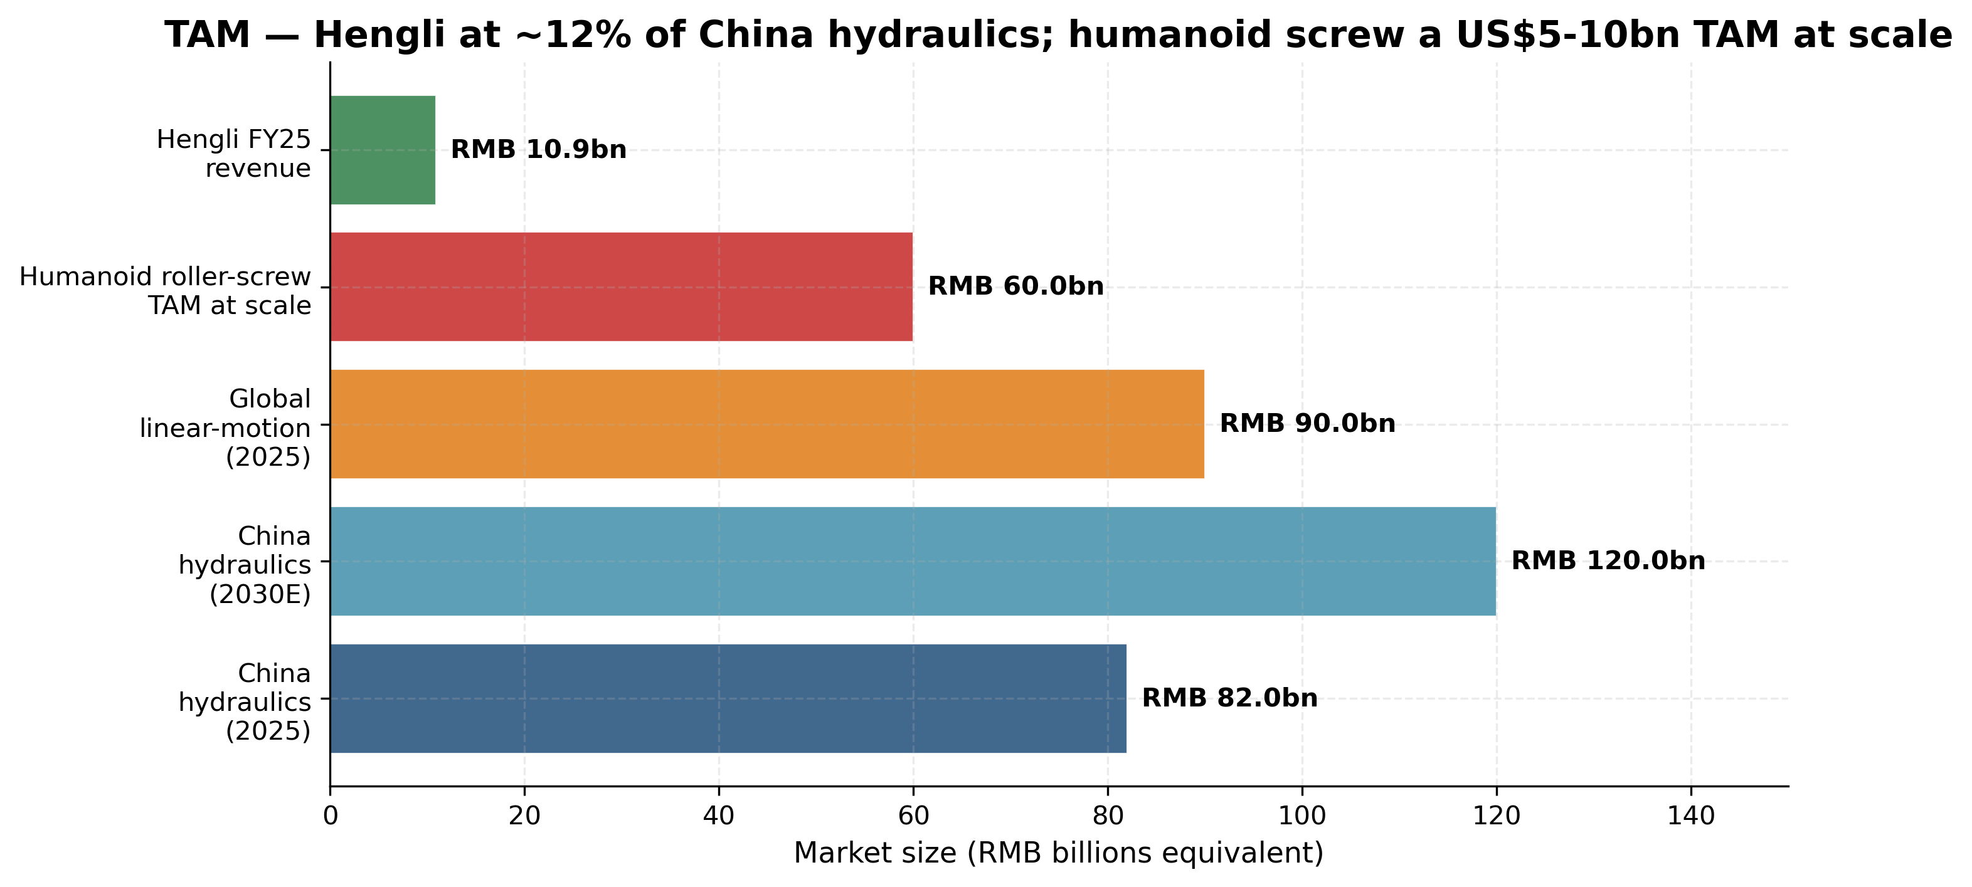
Exhibit 15: TAM — Hengli at ~12% of China hydraulics; humanoid screw $5-10bn TAM at scale
We size the addressable opportunity for Hengli at: (i) China hydraulics — RMB 82bn 2025, projected RMB 120bn by 2030 (~8% CAGR), with Hengli's share rising from ~13% today to ~20% as Bosch Rexroth retreats from low-end Chinese OEM business; (ii) Linear drive — from ~RMB 0.1bn (FY2025) to RMB 1.5-3.0bn by FY2030, driven by industrial machine-tool ball-screw share gains in China plus humanoid-roller-screw revenue ramp; (iii) Combined FY2030 revenue ~RMB 17-20bn vs. FY2025 RMB 10.9bn — a 9-13% revenue CAGR. The humanoid wild-card is that if Hengli secures qualified-supplier status on one Tier-1 humanoid programme at 100k+ units/yr scale, with ~40 planetary roller screws per humanoid at an ASP of USD 200-400 per screw, that is a USD 800m-USD 1.6bn revenue opportunity per major customer.

6. Competitive landscape
Hengli competes across three competitive arenas with different sets of rivals: (a) domestic Chinese excavator hydraulics, where it is #1 with >40% share against ~15 scaled local rivals plus retreating foreign primes; (b) global hydraulics primes, where it ranks #6-7 globally by revenue but #1 by gross margin among traded peers; (c) emerging humanoid-actuator supply chain, where it is one of ~3 Chinese suppliers of planetary roller screws competing against Schaeffler/Rollvis on precision and against Tuopu/Shuanglin on the integrated-actuator-module level.
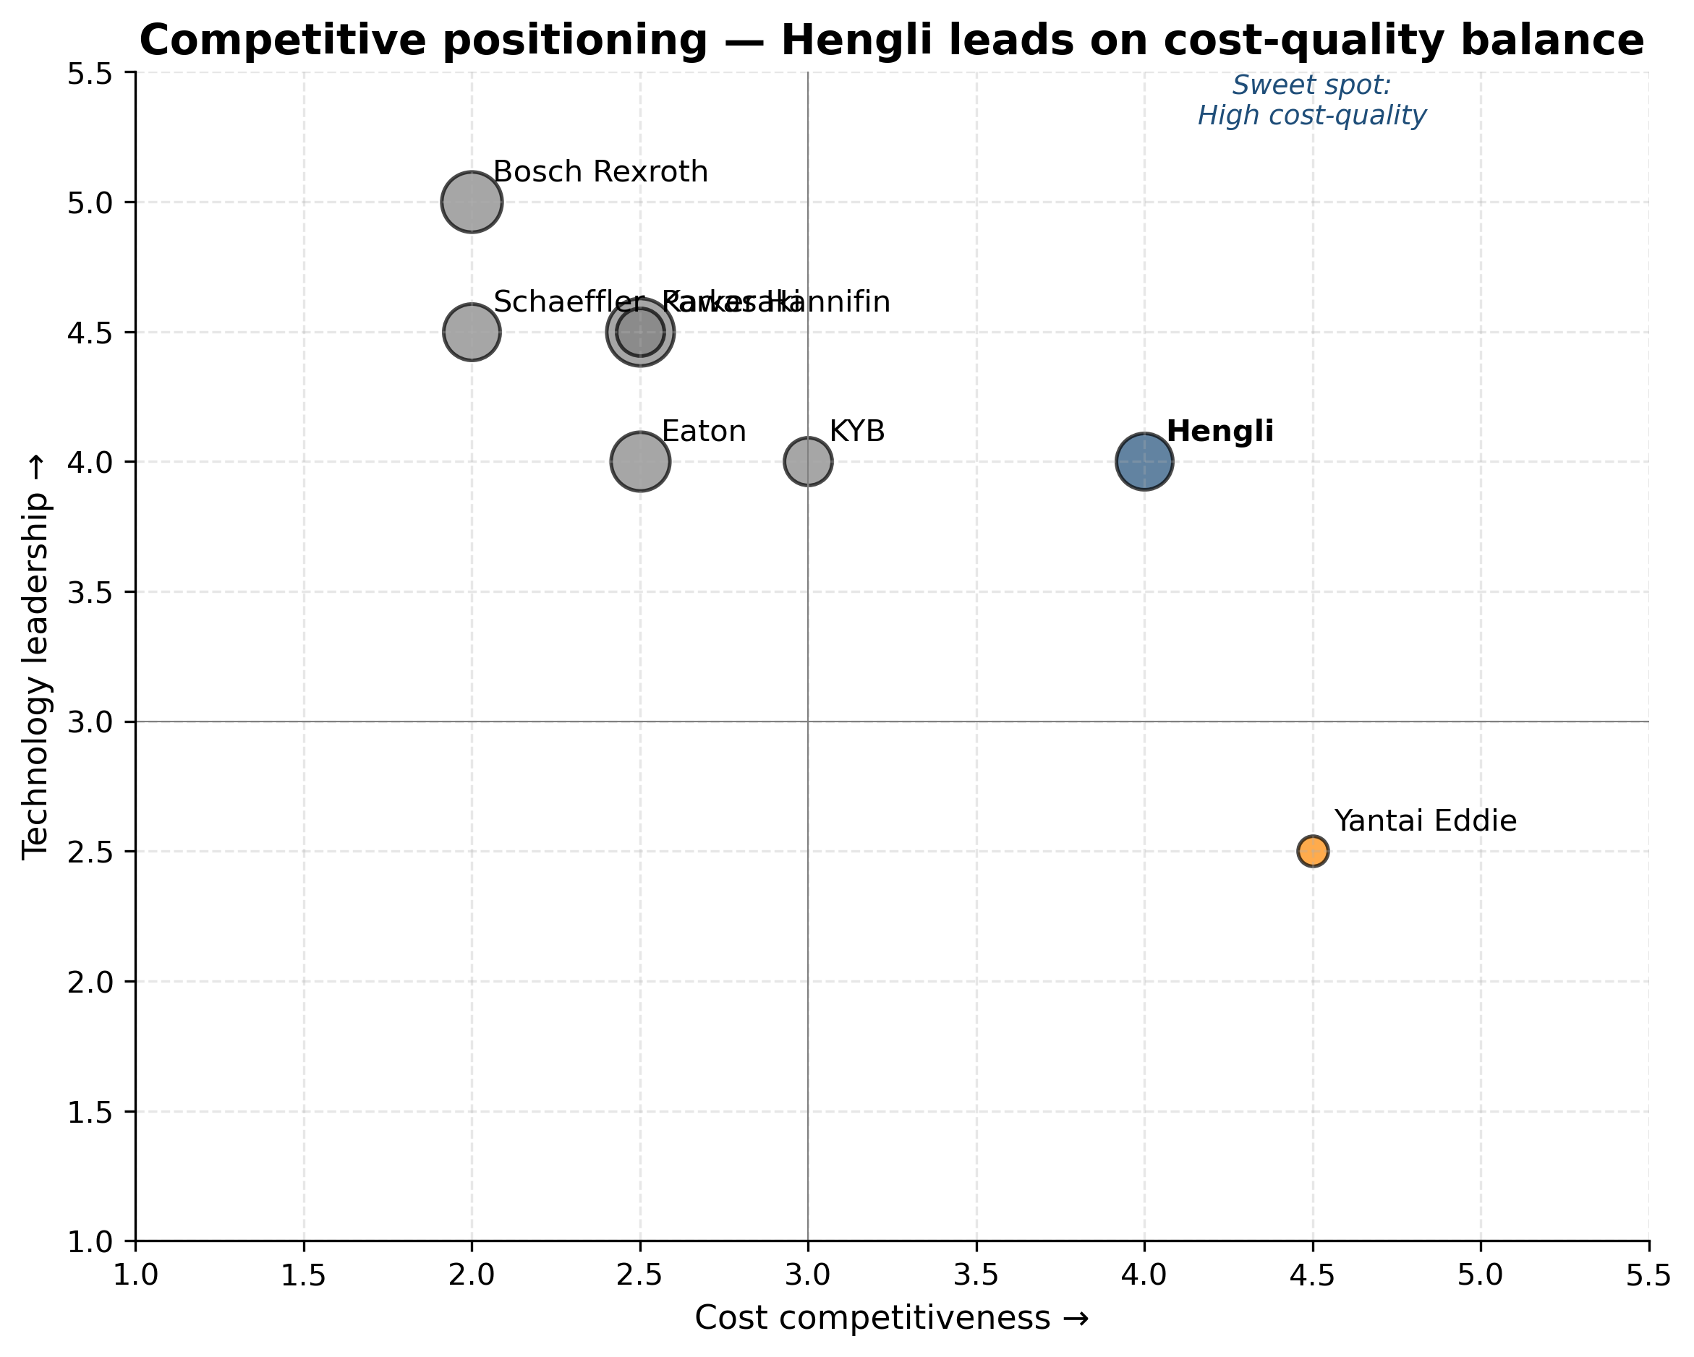
Exhibit 16: Competitive positioning — Hengli leads on cost-quality balance
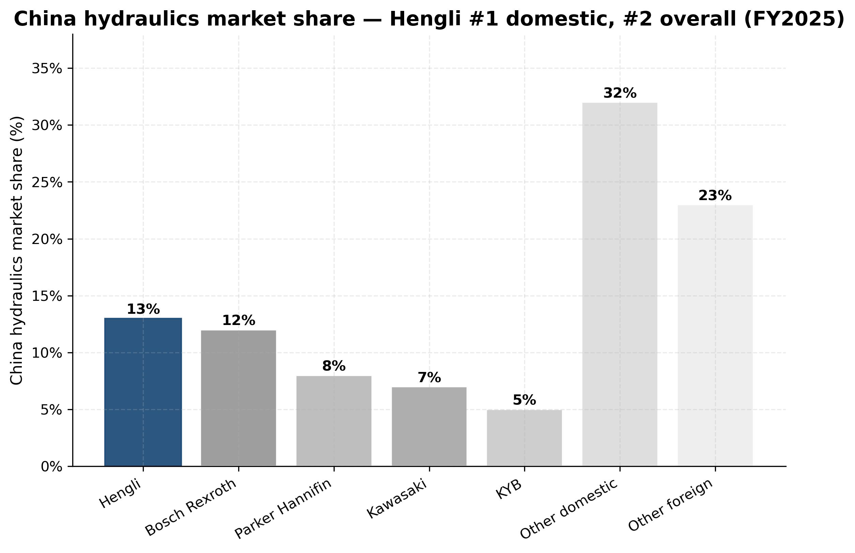
Exhibit 17: China hydraulics market share — Hengli #1 domestic, #2 overall (FY25)
Competitor | Region | Scale (rev) | Compared to Hengli
Bosch Rexroth | DE / global | EUR 7bn | Ahead on precision; behind on cost & China access
Kawasaki Precision | JP | JPY ~250bn | Parity on tech; behind on cost; captive in Japan OEMs
Parker Hannifin | US / global | USD 19.9bn | Ahead on scale & aerospace; behind on China cost
Eaton | US / global | USD 22bn ind. | Ahead on aerospace/grid; behind on mobile-machinery cost
KYB Corporation | JP | JPY 410bn | Ahead on absorbers/rail; parity on excavator cylinders
Yantai Eddie | CN | RMB 3.2bn | 3× smaller; weaker range; no cylinder business
Tuopu Group | CN | RMB 12.4bn | Comp on humanoid actuator-module integration
Schaeffler | DE | EUR 16bn | Ahead on absolute precision (P3); parity on cost
Strategically, the most consequential competitive battle is the linear-drive entry. Hengli's path to credible humanoid-actuator supplier status will be measured against Schaeffler (the global benchmark) on precision grade and Tuopu Group on actuator-module integration. Sample shipments to Optimus joint-module designers have been reported by sell-side teardown analysts but not confirmed by Hengli directly. Versus Schaeffler, Hengli is behind on absolute precision (Schaeffler's INA roller screws are P3-grade) but at parity on cost. Versus Tuopu, Hengli is behind on integration but ahead on the precision-screw component itself.

Domestic vs foreign players — the import-substitution arc
The story of Chinese hydraulics over the past 25 years is one of progressive import substitution. In 2000, foreign brands (Kawasaki, Bosch Rexroth, Parker, KYB, Eaton) controlled essentially 100% of the Chinese mid-large excavator hydraulic-cylinder market and >90% of the main-pump market. By 2010 domestic share in cylinders had risen to ~30% (Hengli being the principal beneficiary, plus several smaller players); by 2020, domestic share was ~70% in cylinders and ~40% in main pumps. The FY2024 trade data showed China's first hydraulics trade surplus (USD 0.45bn — exports USD 2.82bn vs imports USD 2.37bn), marking the structural inflection at which domestic capacity exceeded domestic demand and Chinese OEMs became net exporters of hydraulic components.
Hengli has been the principal beneficiary of this arc. Its market-share trajectory in excavator main pumps illustrates: in 2015, Hengli had effectively zero share (the market was Kawasaki, Bosch Rexroth, and a handful of niche players); by 2020 it had ~15% share; and by FY2025 it had ~30% share, with ultra-large main pumps for 50-90t excavators breaking the historical foreign-supplier monopoly. The thesis is that the remaining foreign share (Bosch Rexroth ~25%, Kawasaki ~20%) is increasingly concentrated in premium-priced segments where domestic OEMs are willing to pay a premium for proven reliability — but as Hengli accumulates more reliability data and as procurement decisions move from 'safe choice' to 'cost-optimised', this share will continue to migrate to Hengli over 2026-2030.
Linear-motion / humanoid actuators show a similar import-substitution potential but at an earlier stage. Today, >80% of precision ball screws and >95% of planetary roller screws consumed in China are imported (mostly from NSK, THK, Nachi, IKO in Japan and Schaeffler in Germany). Domestic capacity is concentrated in three players (Hengli, Beijing Precision Engineering, Nanjing Technology), all of which are sub-scale today but have announced significant capacity additions. The opportunity is asymmetrically concentrated in Hengli's favour because: (a) Hengli has the largest disclosed planned roller-screw capacity (750 sets per year of dedicated planetary-roller-screw electric cylinders by 2027, vs <500 for combined competitors), (b) Hengli has the strongest precision-grinding capability transferred from its cylinder operations, and (c) Hengli has the most established Tier-1 OEM relationships to feed into.

7. Financial analysis

7.1 Historical performance review
Hengli's six-year financial track record (FY2020 to FY2025) shows a company that emerged from the FY2022 excavator down-cycle with stronger margins, a substantially larger balance sheet (FY2022 RMB 12.5bn assets → FY2025 RMB 21.7bn), and a fundamentally different business mix (linear-drive and Mexico added as new growth engines). Revenue grew at a 6.9% CAGR FY20-FY25 (from RMB 7.86bn to RMB 10.94bn) despite the FY22 down-cycle, and net income grew at 3.9% CAGR over the same period (RMB 2.26bn to RMB 2.74bn) — reflecting margin compression in FY22-FY24 followed by recovery in FY25.
RMB m (consolidated) | FY20A | FY21A | FY22A | FY23A | FY24A | FY25A
Revenue | 7,855 | 9,309 | 8,197 | 8,985 | 9,390 | 10,941
Gross profit | 3,464 | 4,097 | 3,324 | 3,765 | 4,022 | 4,549
Gross margin % | 44.1% | 44.0% | 40.5% | 41.9% | 42.8% | 41.6%
EBITDA | 2,775 | 3,327 | 3,360 | 3,663 | 3,458 | 3,658
EBITDA margin % | 35.3% | 35.7% | 41.0% | 40.8% | 36.8% | 33.4%
Operating profit | 2,606 | 3,056 | 2,618 | 2,815 | 2,786 | 3,044
Pre-tax income | 2,609 | 3,068 | 2,629 | 2,830 | 2,800 | 3,032
Net income | 2,261 | 2,699 | 2,349 | 2,504 | 2,512 | 2,740
EPS (RMB) | 1.73 | 2.07 | 1.79 | 1.86 | 1.87 | 2.04
CFO | 1,981 | 2,796 | 2,064 | 2,677 | 2,479 | 1,811
CapEx | 401 | 562 | 799 | 1,366 | 1,071 | 924
FCF | 1,580 | 2,234 | 1,265 | 1,311 | 1,408 | 887
Total assets | 8,446 | 9,388 | 12,497 | 13,035 | 19,639 | 21,671
Total equity | 6,035 | 6,492 | 8,823 | 9,205 | 15,828 | 17,338
Note: FY2024 jump in total assets / equity reflects the December 2022 RMB 1.4bn private placement plus retained earnings. FY2022-FY2023 marked the excavator down-cycle bottom with revenue declining 12% in FY22 before recovering. FY2025 set new records on revenue, net income, EBITDA, total assets, and equity — though FY2025 EBITDA margin (33.4%) declined from the FY22-FY23 peak (40%+) on linear-drive segment dilution and rising R&D.
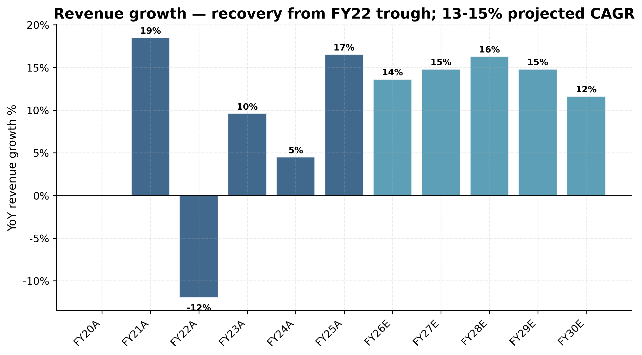
Exhibit 14: Revenue growth YoY — recovery from FY22 trough; 13-15% projected CAGR
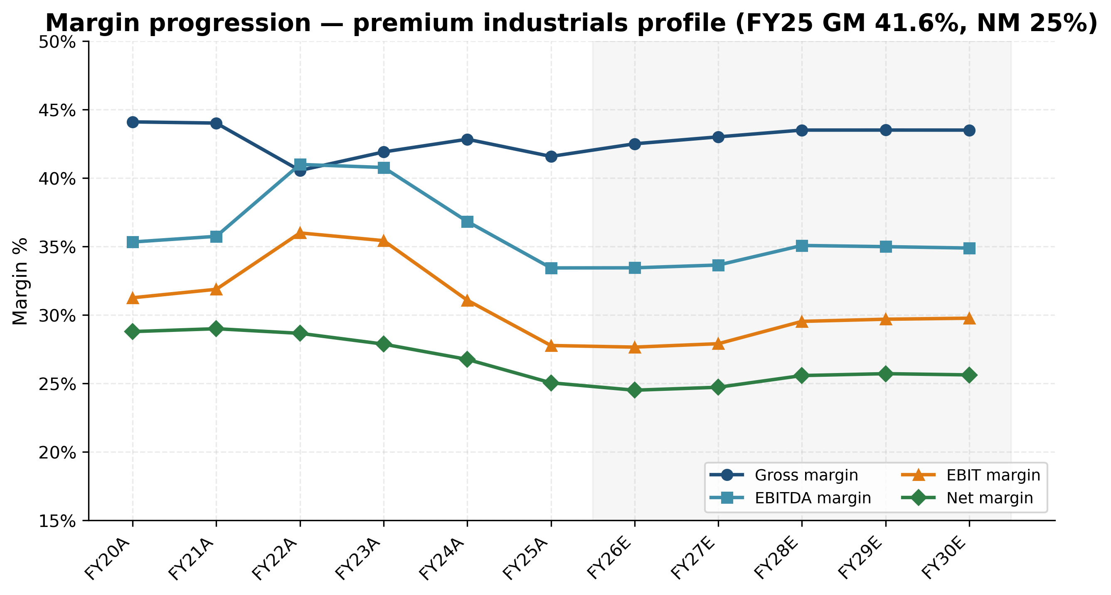
Exhibit 11: Margin progression — premium industrials profile (FY25 GM 41.6%, NM 25%)
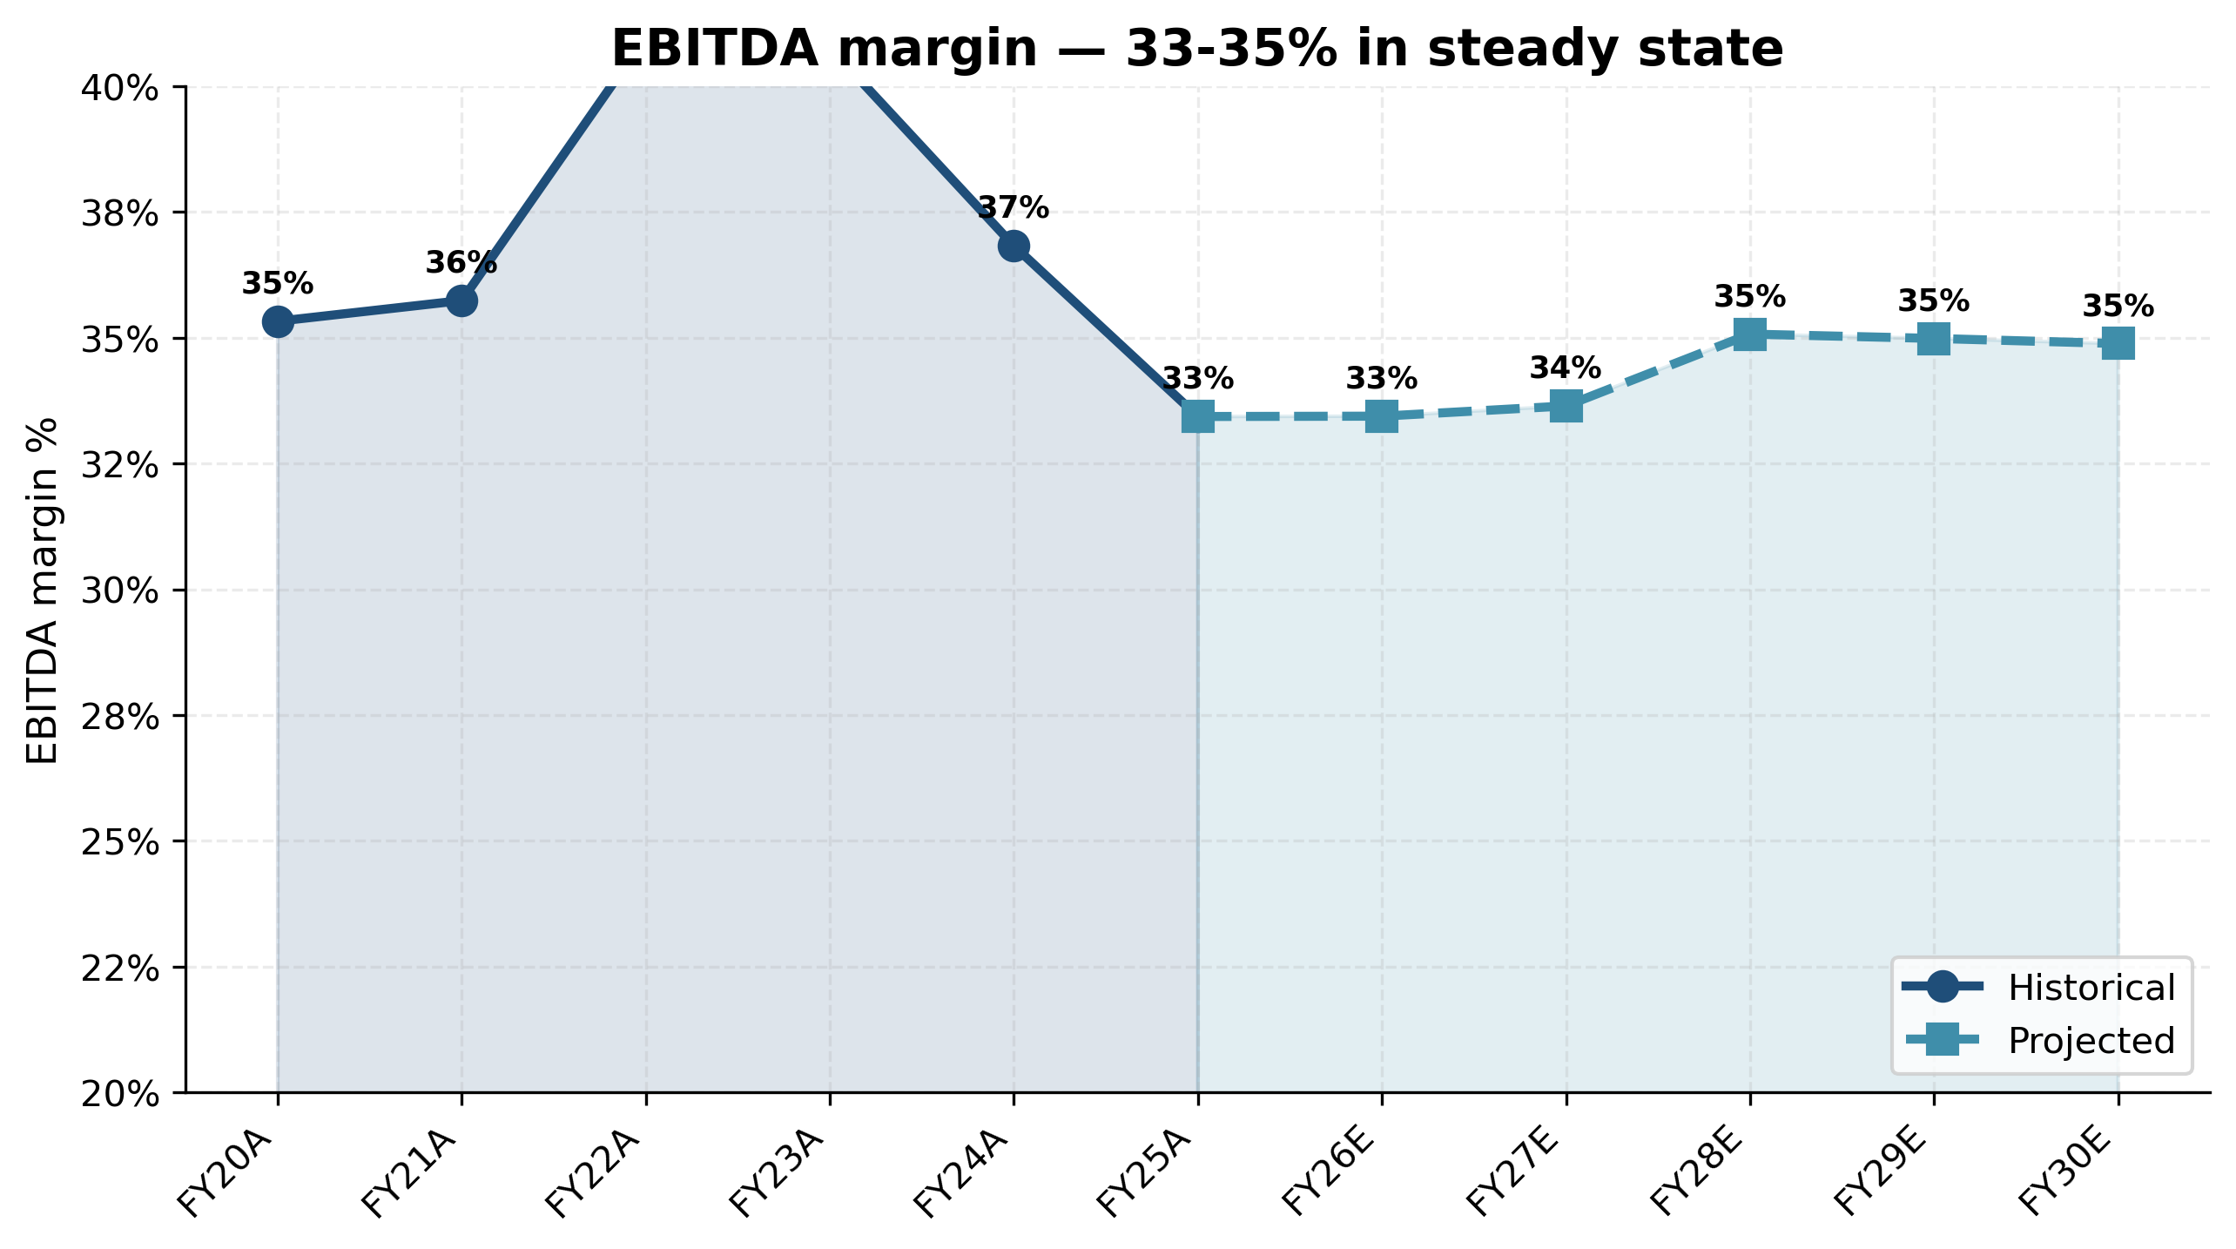
Exhibit 10: EBITDA margin trend — 33-35% in steady state
Working capital. The FY2025 receivables build of RMB 540m (+39% YoY) was the principal driver of the operating cash flow decline from RMB 2.48bn to RMB 1.81bn. We view this as customer-quality-driven (Caterpillar, Sany, XCMG payment terms running 90-120 days) rather than collection risk. Inventory days remained stable at ~120 days. Accounts payable days compressed from 80+ to 58 days as procurement scale economies kicked in. We model normalising AR days back to 58 by FY28 as growth moderates.
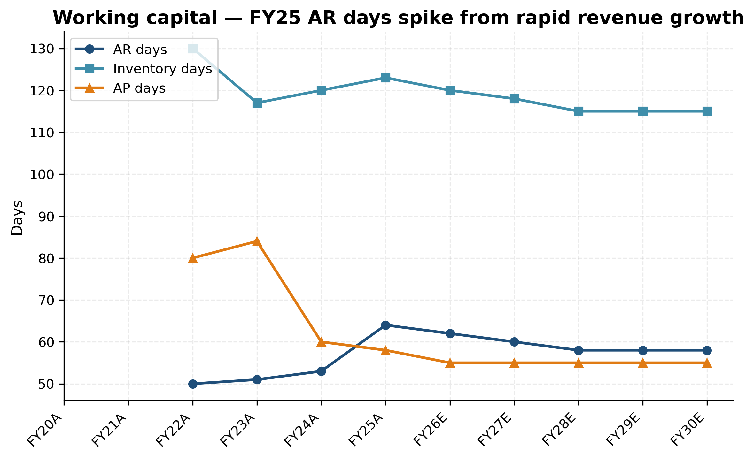
Exhibit 20: Working capital — FY25 AR days spike from rapid revenue growth
Returns. ROE recovered to 16.6% in FY25 (from a FY24 low of 16.0% — diluted by the 2022 placement) and ROIC stands at approximately 22%, exceptional for a heavy-industrial supplier. We project both metrics to recover further to 19% / 24% by FY28 as the linear-drive capital deployed in 2022-2024 begins to generate revenue at higher utilisation.
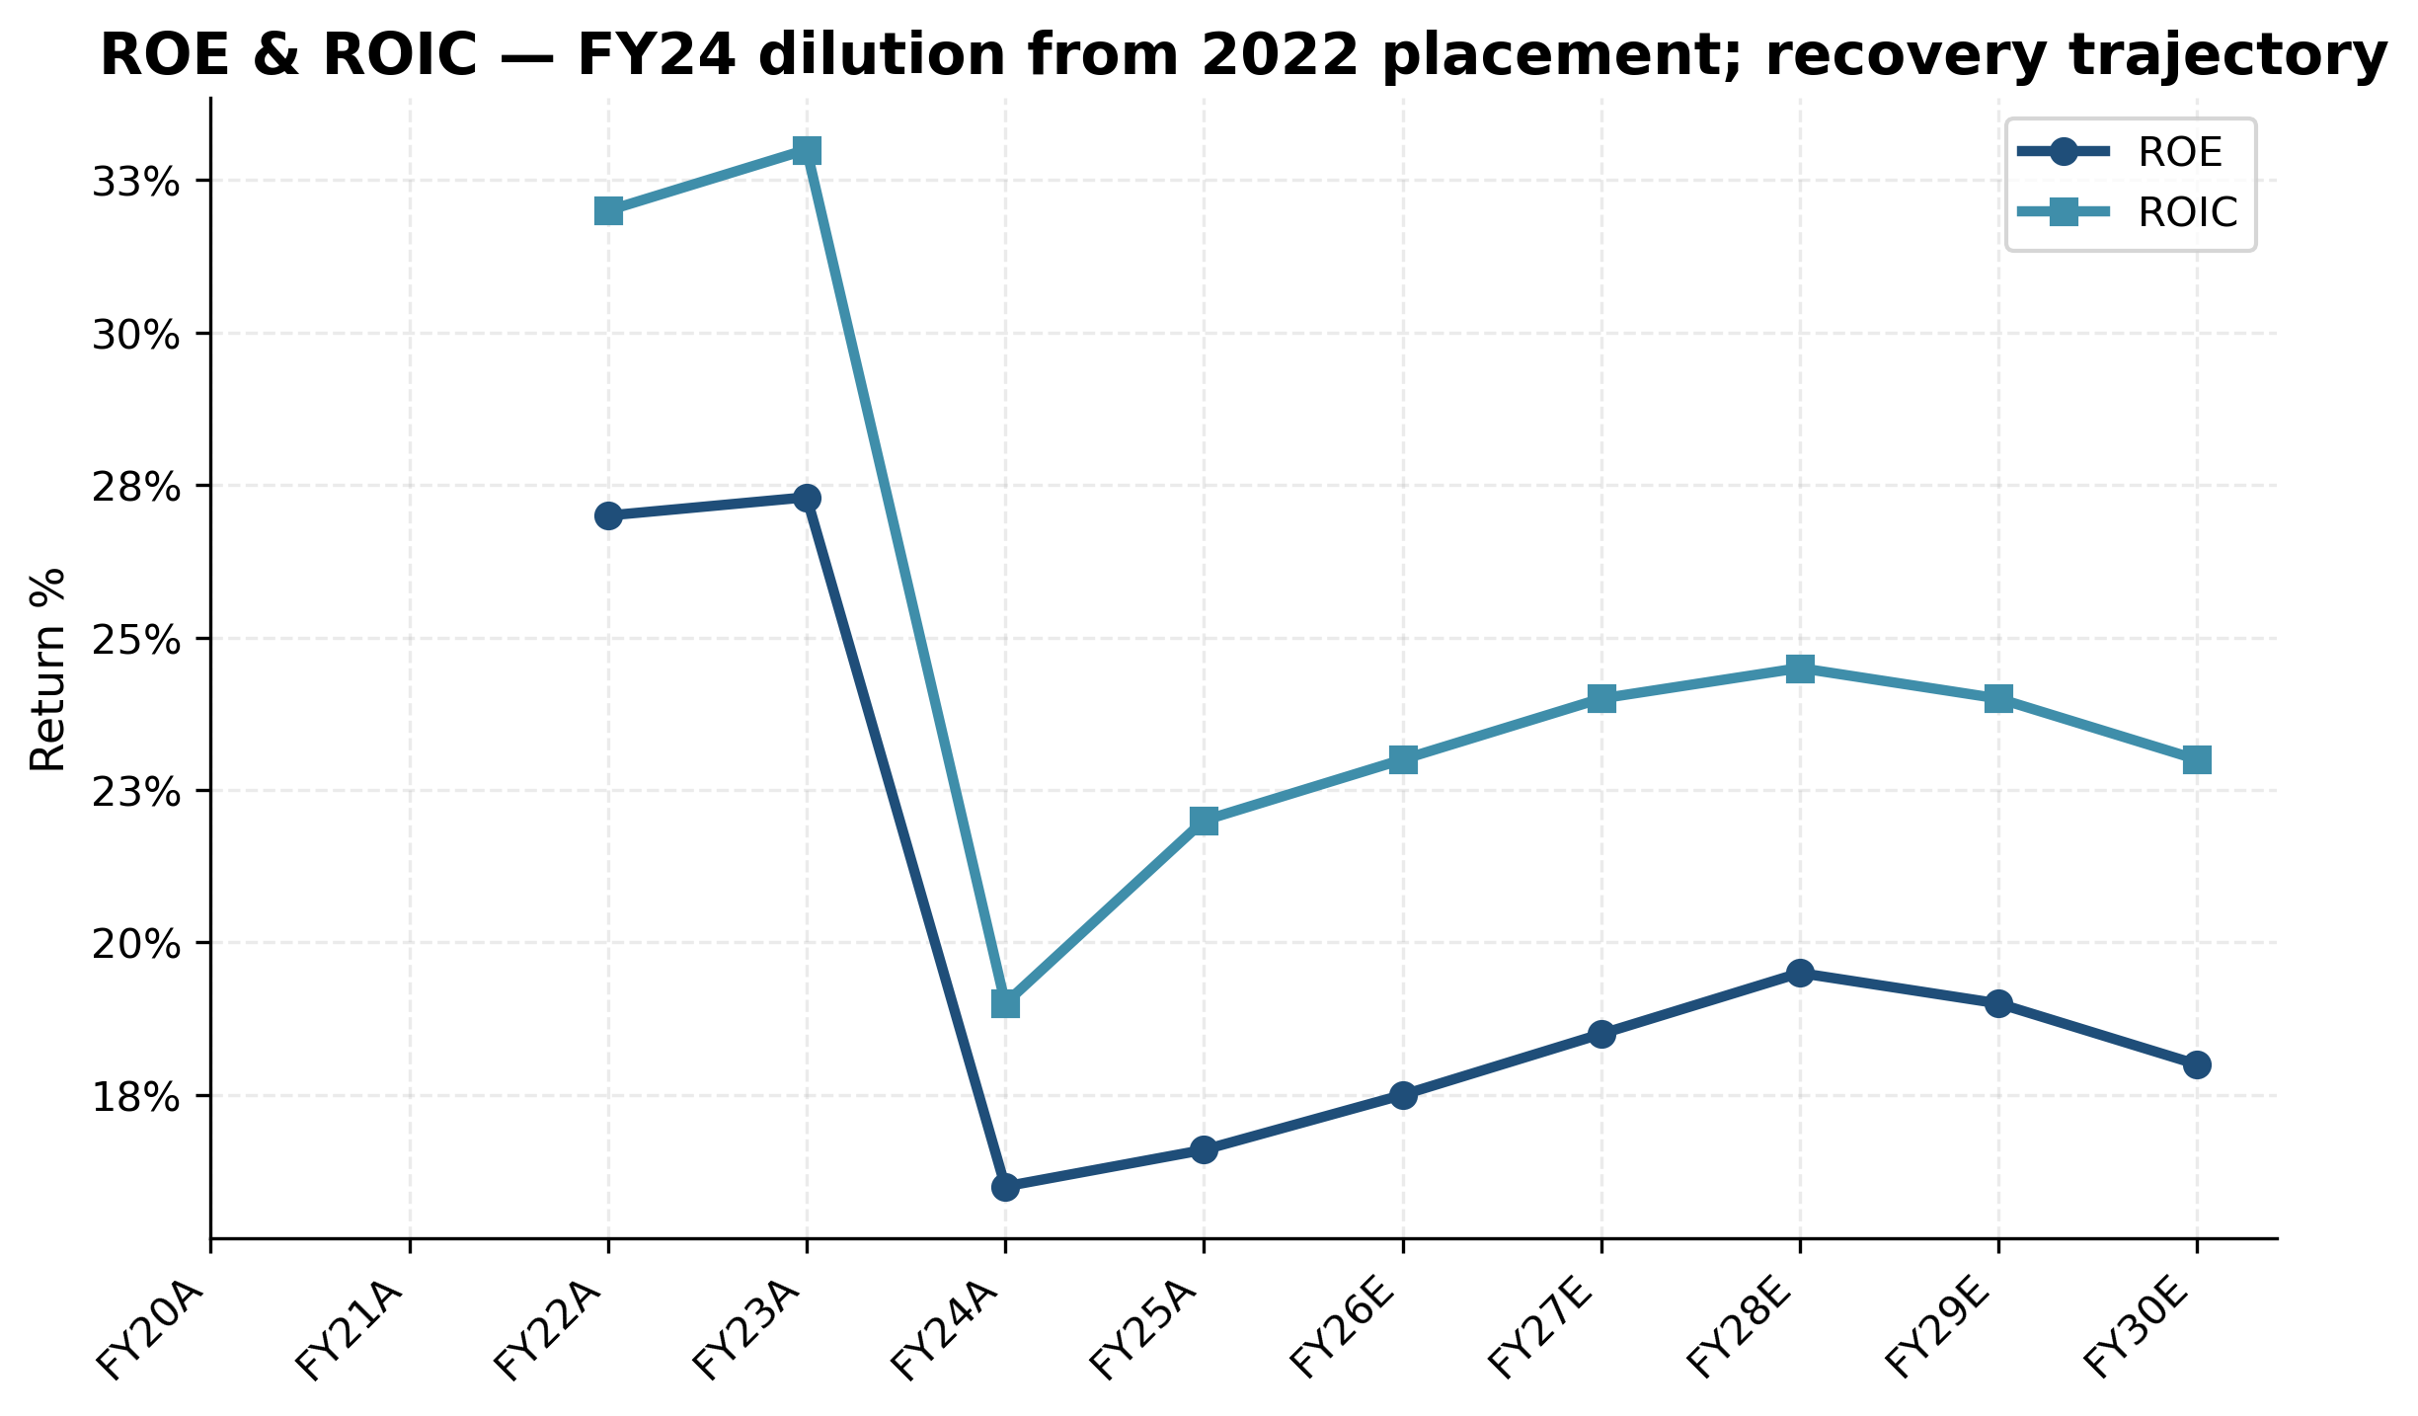
Exhibit 21: ROE & ROIC trajectory — recovery from 2022-placement dilution
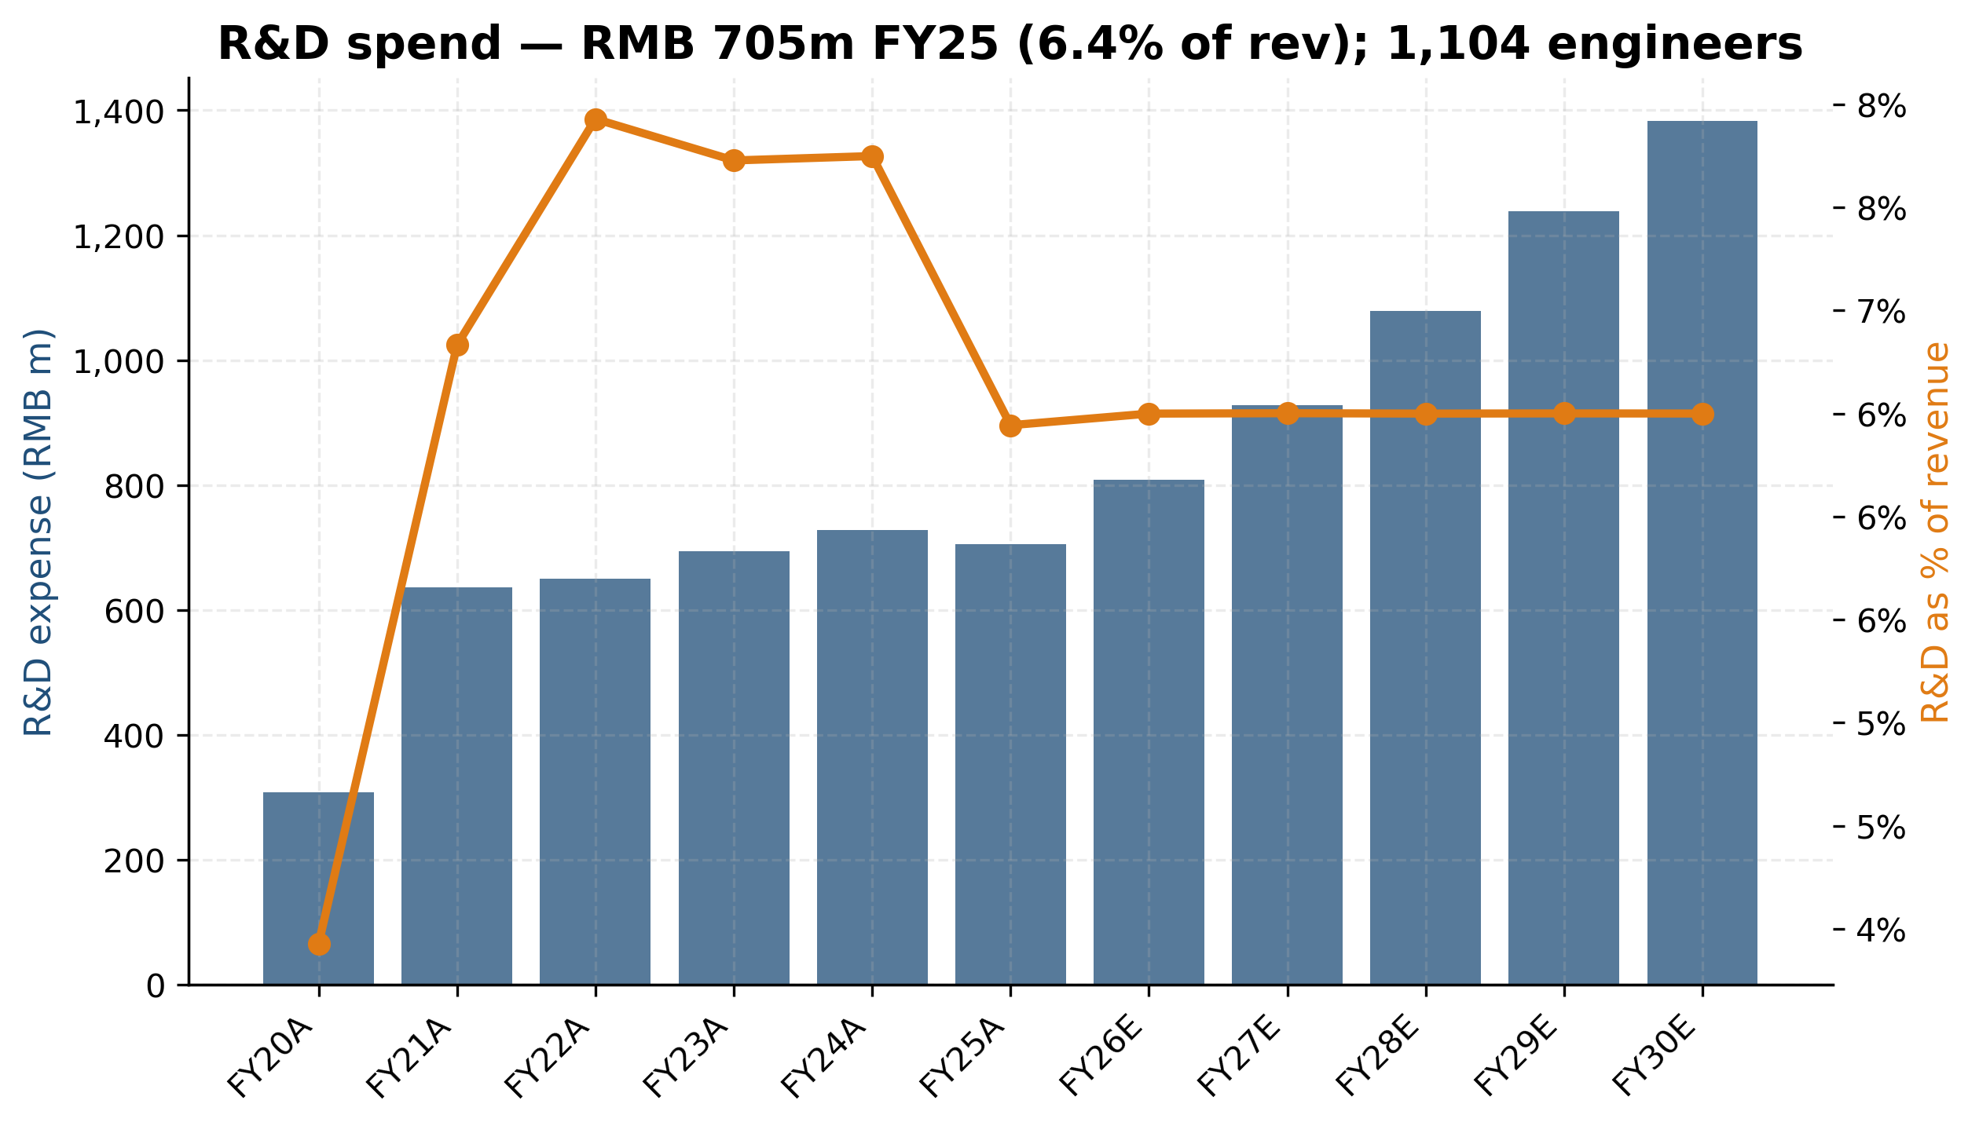
Exhibit 19: R&D spend & intensity — 1,104 engineers, 6-7% of revenue

7.2 Revenue projections & assumptions
We project Hengli's revenue from FY25A RMB 10.94bn to FY30E RMB 21.28bn — a 14.2% CAGR. This is moderately above management's implied 9-13% CAGR guidance, primarily reflecting credit for the linear-drive ramp at the upper-middle of management's path (RMB 100m FY25 → RMB 2.3bn FY30). Each segment is built bottom-up with explicit growth assumptions:
Segment | FY25A → FY30E CAGR | Key drivers
Hydraulic cylinders | 7.0% | Excavator up-cycle, share gain offsetting CAT in-sourcing
Pumps, valves & motors | 13.2% | Continued share gain from Bosch Rexroth; ultra-large pump
Hydraulic systems | 12.5% | TBM, marine, water-conservancy project pipeline
Components & linear-drive | 41.6% | Linear-drive ramp 23× over 5 years; mgmt-implied path
Other / recon | 4.0% | —
TOTAL | 14.2%

Exhibit 2: Revenue (bars) & gross margin (line) — FY20A to FY30E base case
Geographic mix. We project domestic revenue at 13.5% CAGR (in line with management's stated 14th Five-Year Plan growth path for China hydraulics + Hengli outperformance), and overseas revenue at 16.2% CAGR (driven primarily by Mexico plant ramp and India / Indonesia subsidiary expansion). North America specifically is projected at 23% CAGR FY25-FY28 with the Mexico Caterpillar Tier-1 ramp before moderating. Europe and Asia-Pacific are modeled at 9-10% CAGR.

Exhibit 4: ★ Revenue by geography — domestic-dominant; Mexico NA-ramp 2026-28

Exhibit 3: ★ Revenue by product — linear-drive becomes meaningful by FY28

Linear-drive trajectory (the key swing factor)

Exhibit 22: ★ Linear-drive revenue ramp — RMB 100m FY25 to RMB 2.3bn FY30E
Management has guided to RMB ~300m linear-drive revenue in FY2026 (3× FY25), and the company has confirmed (i) 360,000m linear guideway capacity, (ii) 70,000 sets of precision-ground ball screws capacity, (iii) >300 customers in the qualification database, and (iv) initial mass production of planetary roller screws underway. Our FY26E base case of RMB 300m is in line with mgmt; FY27E RMB 600m assumes 2× scale; FY28E RMB 1.1bn and FY30E RMB 2.3bn assume continued share gain in industrial machine tools plus modest humanoid-actuator contribution (~RMB 200-300m). If a Tier-1 humanoid award materialises, the FY30E number could be RMB 4-6bn in our bull case.
Bottom-up build of the FY26E RMB 300m figure: (a) Ball screws — industrial machine tools contribute RMB ~150m at 70,000 sets × USD 300 ASP × 7.1 FX. The principal customers are domestic CNC manufacturers (DMG-Mori China, Doosan Machine Tools, Haitian Precision) plus machine-tool re-shoring pickup. (b) Linear guideways — RMB ~100m at 360,000m × USD 40/m × 7.1 FX. Primary end market is semiconductor equipment, electronics assembly, and machine-tool peripherals. (c) Planetary roller screws — RMB ~50m at 7,500 sets × USD 950 ASP × 7.1 FX. This is the symbolic but narrative-critical segment; revenue is small but the customer mix (humanoid actuator R&D groups, aerospace R&D, defence R&D) is premium-priced and high-margin (>25% GM).
Bridging FY26E to FY30E requires capacity additions plus customer wins. We model the capacity build-out as: ball screws expanding from 70,000 to 250,000 sets/yr (+260%), linear guideways from 360k to 1.0m m/yr (+180%), and planetary roller screws from 7,500 to 75,000 sets/yr (+900% — the principal humanoid bet). The capacity figures align with management's 2022 placement-funded capacity targets, which were back-end-loaded to 2026-2027 commissioning. The customer mix bridge is more uncertain but plausible: of the 300+ customers in current qualification, we assume 80-100 convert to volume purchases by FY28; if any of these are humanoid OEMs, the per-customer revenue can be 5-10× higher than industrial-machine-tool customers given humanoid actuator volumes.

7.3 Margin & profitability projections
We project gross margin to expand modestly from 41.6% in FY25 to 43.5% by FY30E, driven by (i) mix shift to higher-margin pumps/valves segment (rising from 39.8% to 42% of revenue), (ii) continued domestic-margin expansion as Bosch Rexroth retreats from low-end Chinese OEMs, and (iii) linear-drive segment scaling toward 25-30% gross margin by FY30 (vs 15% in FY25). EBITDA margin should reach 35% by FY30E from 33.4% in FY25, offset by continued R&D intensity at 6.5% of revenue (vs industry-average 3-4%).
RMB m | FY26E | FY27E | FY28E | FY29E | FY30E
Revenue | 12,431 | 14,273 | 16,600 | 19,059 | 21,276
YoY growth | 13.6% | 14.8% | 16.3% | 14.8% | 11.6%
Gross profit | 5,283 | 6,138 | 7,221 | 8,291 | 9,255
Gross margin % | 42.5% | 43.0% | 43.5% | 43.5% | 43.5%
R&D expense | 808 | 928 | 1,079 | 1,239 | 1,383
R&D % of revenue | 6.5% | 6.5% | 6.5% | 6.5% | 6.5%
EBITDA | 4,157 | 4,802 | 5,822 | 6,668 | 7,422
EBITDA margin % | 33.4% | 33.6% | 35.1% | 35.0% | 34.9%
EBIT | 3,437 | 3,982 | 4,902 | 5,658 | 6,332
EBIT margin % | 27.7% | 27.9% | 29.5% | 29.7% | 29.8%
Net income | 3,046 | 3,528 | 4,245 | 4,900 | 5,451
Net margin % | 24.5% | 24.7% | 25.6% | 25.7% | 25.6%
EPS (RMB) | 2.27 | 2.63 | 3.16 | 3.65 | 4.06
DPS (RMB) | 0.60 | 0.66 | 0.72 | 0.80 | 0.88

7.4 Cash flow, CapEx & balance sheet
Cash flow generation has historically been strong, with CFO/EBITDA conversion of 65-80% over FY20-FY24. FY25 saw conversion drop to 49% as the working-capital build absorbed RMB 540m of incremental receivables. We project CFO/EBITDA recovering to 65-70% by FY28 as growth moderates. CapEx steps down from the elevated FY23 peak of RMB 1.37bn (Mexico plant + linear-drive build-out) to RMB 1.0-1.1bn in steady state (5-6% of revenue).
Decomposing the FY25 working-capital build is instructive for understanding the FY26 cash-flow trajectory. Accounts receivable grew RMB 539m (39% YoY), entirely concentrated in the top-5 customers (Caterpillar, Sany, XCMG, Komatsu, Liugong), all of which moved from 60-90 day to 90-120 day payment terms during FY2025 as their own working-capital positions tightened. Inventory build was a more modest RMB 390m (22% YoY), reflecting the Mexico-plant inventory positioning and the linear-drive precision-grinding stock build-up. Accounts payable compressed RMB 134m, partly because Hengli's leverage with suppliers improved as procurement scaled — supplier days going from 80 to 58. We model AR days reverting to 58 by FY28 (vs FY25 64 days) as the top-5 customers' working-capital positions normalise, which on its own adds RMB ~500m to cumulative FCF over 2026-2028.
CapEx pacing matters as well. FY23's RMB 1.37bn was the peak — comprising the bulk of the Mexico facility construction (RMB ~600m), the linear-drive plant grinder + heat-treatment lines (RMB ~400m), and the cylinder Tier-1 flexible smart-factory upgrade (RMB ~250m). FY24-FY25 CapEx of RMB 1.07bn and RMB 0.92bn respectively reflects the tail of these programmes plus maintenance + incremental capacity. Our FY26-FY30 CapEx projection of RMB 1.0-1.1bn (5-6% of revenue) embeds (i) full maintenance capex of RMB ~400m, (ii) RMB ~200m of incremental cylinder capacity build, (iii) RMB ~300m of linear-drive capacity expansion (mostly grinders + roller-screw lines), and (iv) RMB ~100m of overseas service-network expansion.
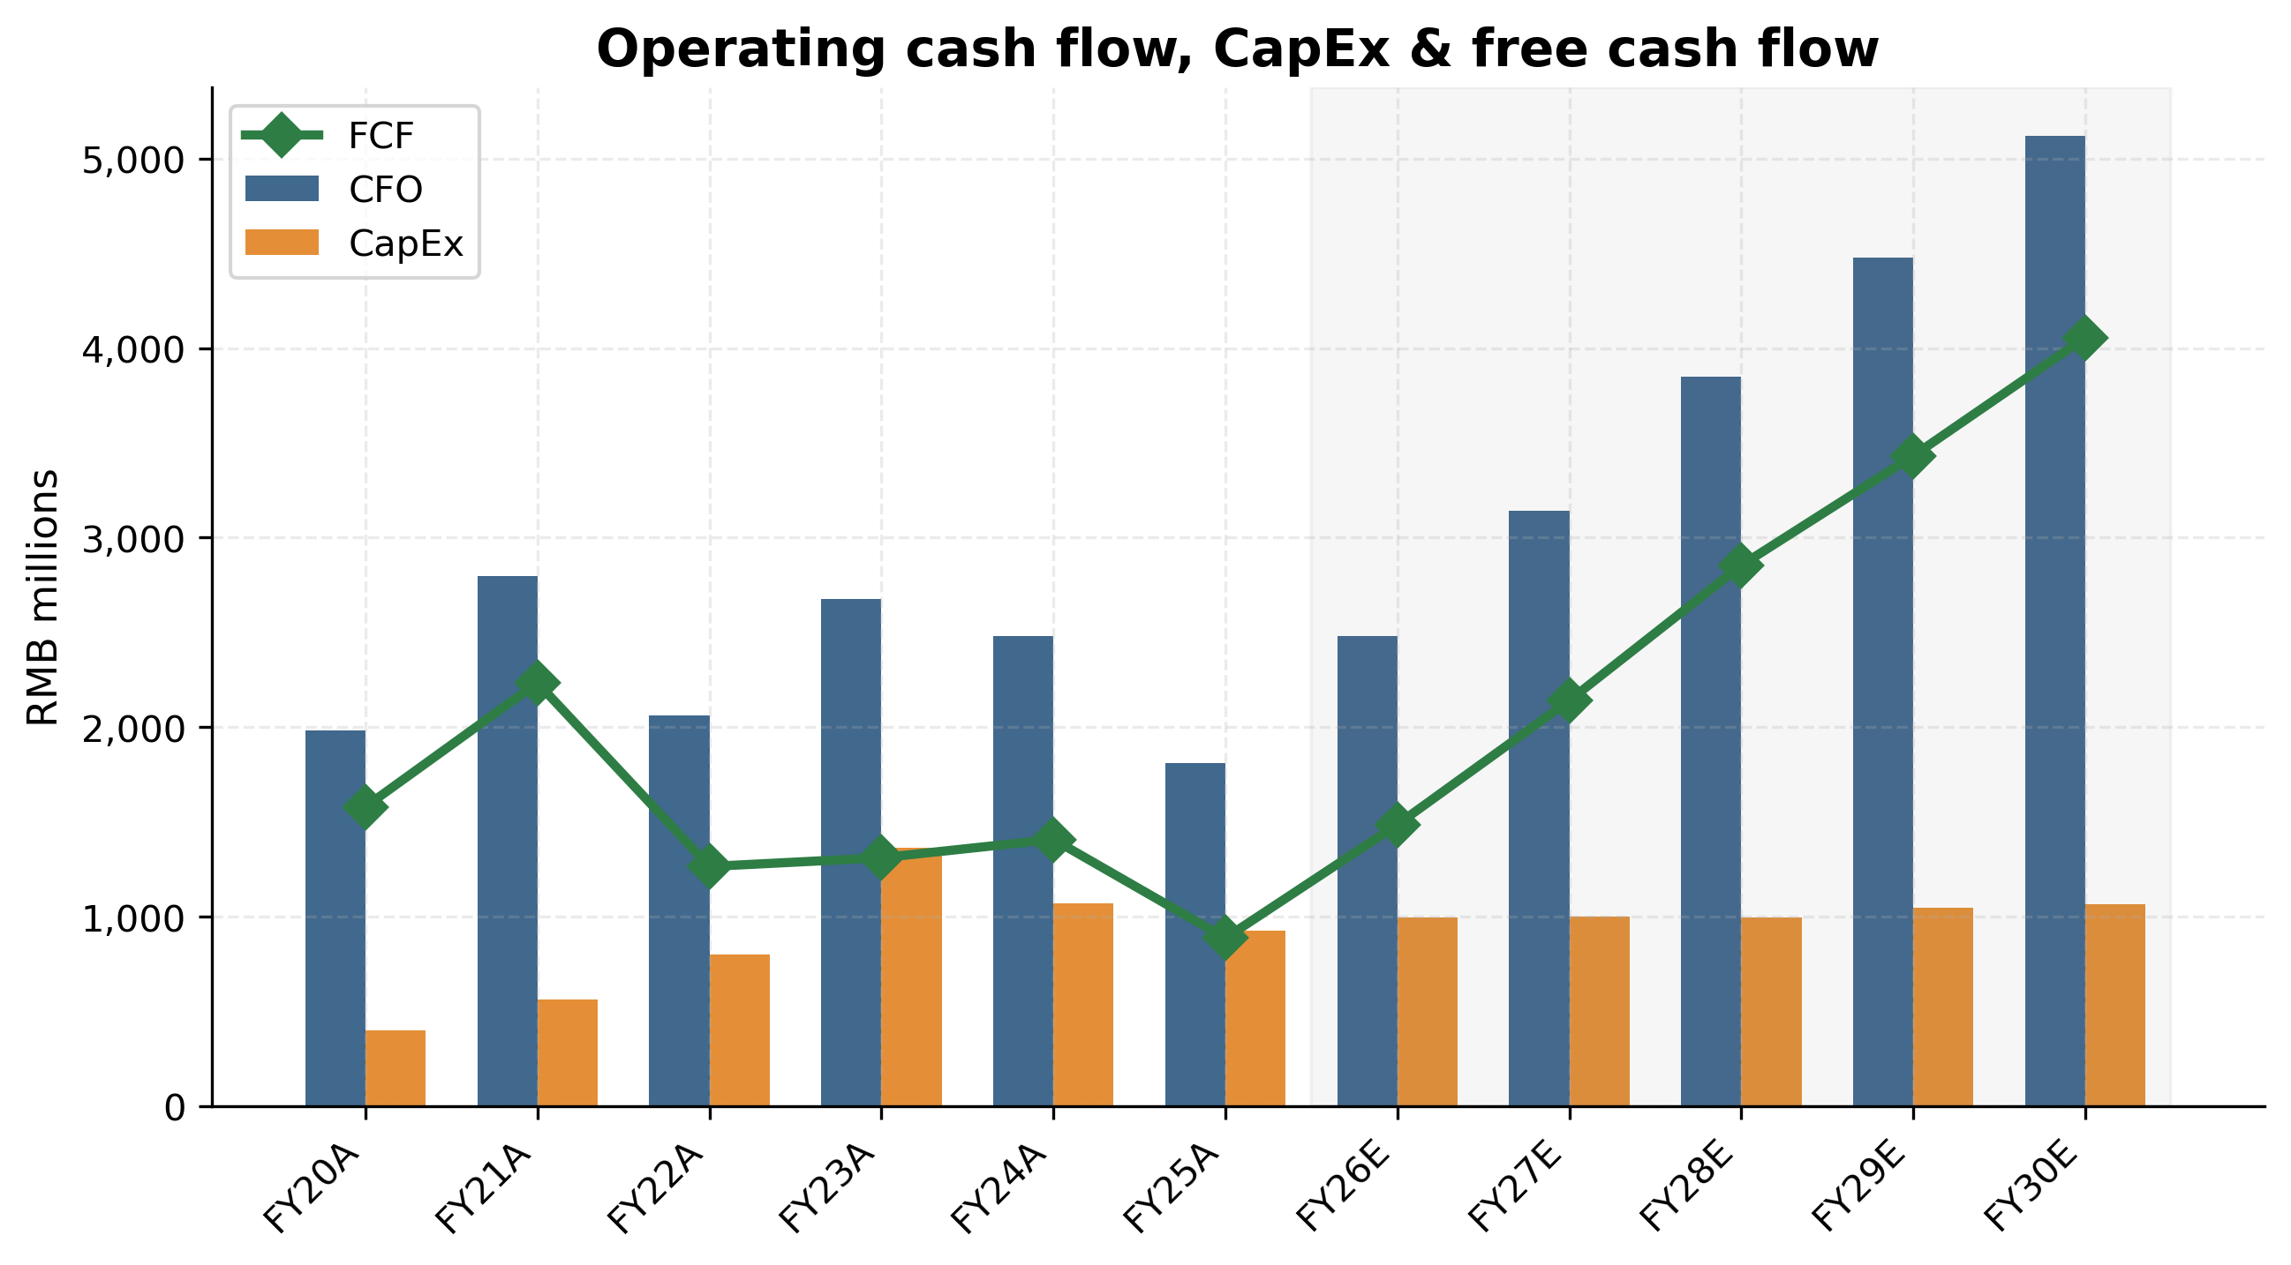
Exhibit 12: Operating cash flow, CapEx & free cash flow — recovery in FY26-FY30E
Balance sheet. Hengli's net cash position of RMB 9.2bn at FY25 (cash RMB 8.87bn + trading FAs RMB 0.35bn − debt RMB 0.03bn) provides exceptional financial flexibility. Total debt is RMB 34m — effectively zero relative to the RMB 17.3bn equity base. Working capital cycle has expanded modestly with revenue growth but remains tightly managed: AR 64 days, inventory 123 days, AP 58 days (cash conversion ~125 days). We project continued cash build to ~RMB 16bn by FY30E (before considering the cumulative RMB 4.4bn of projected dividends over 2026-2030).
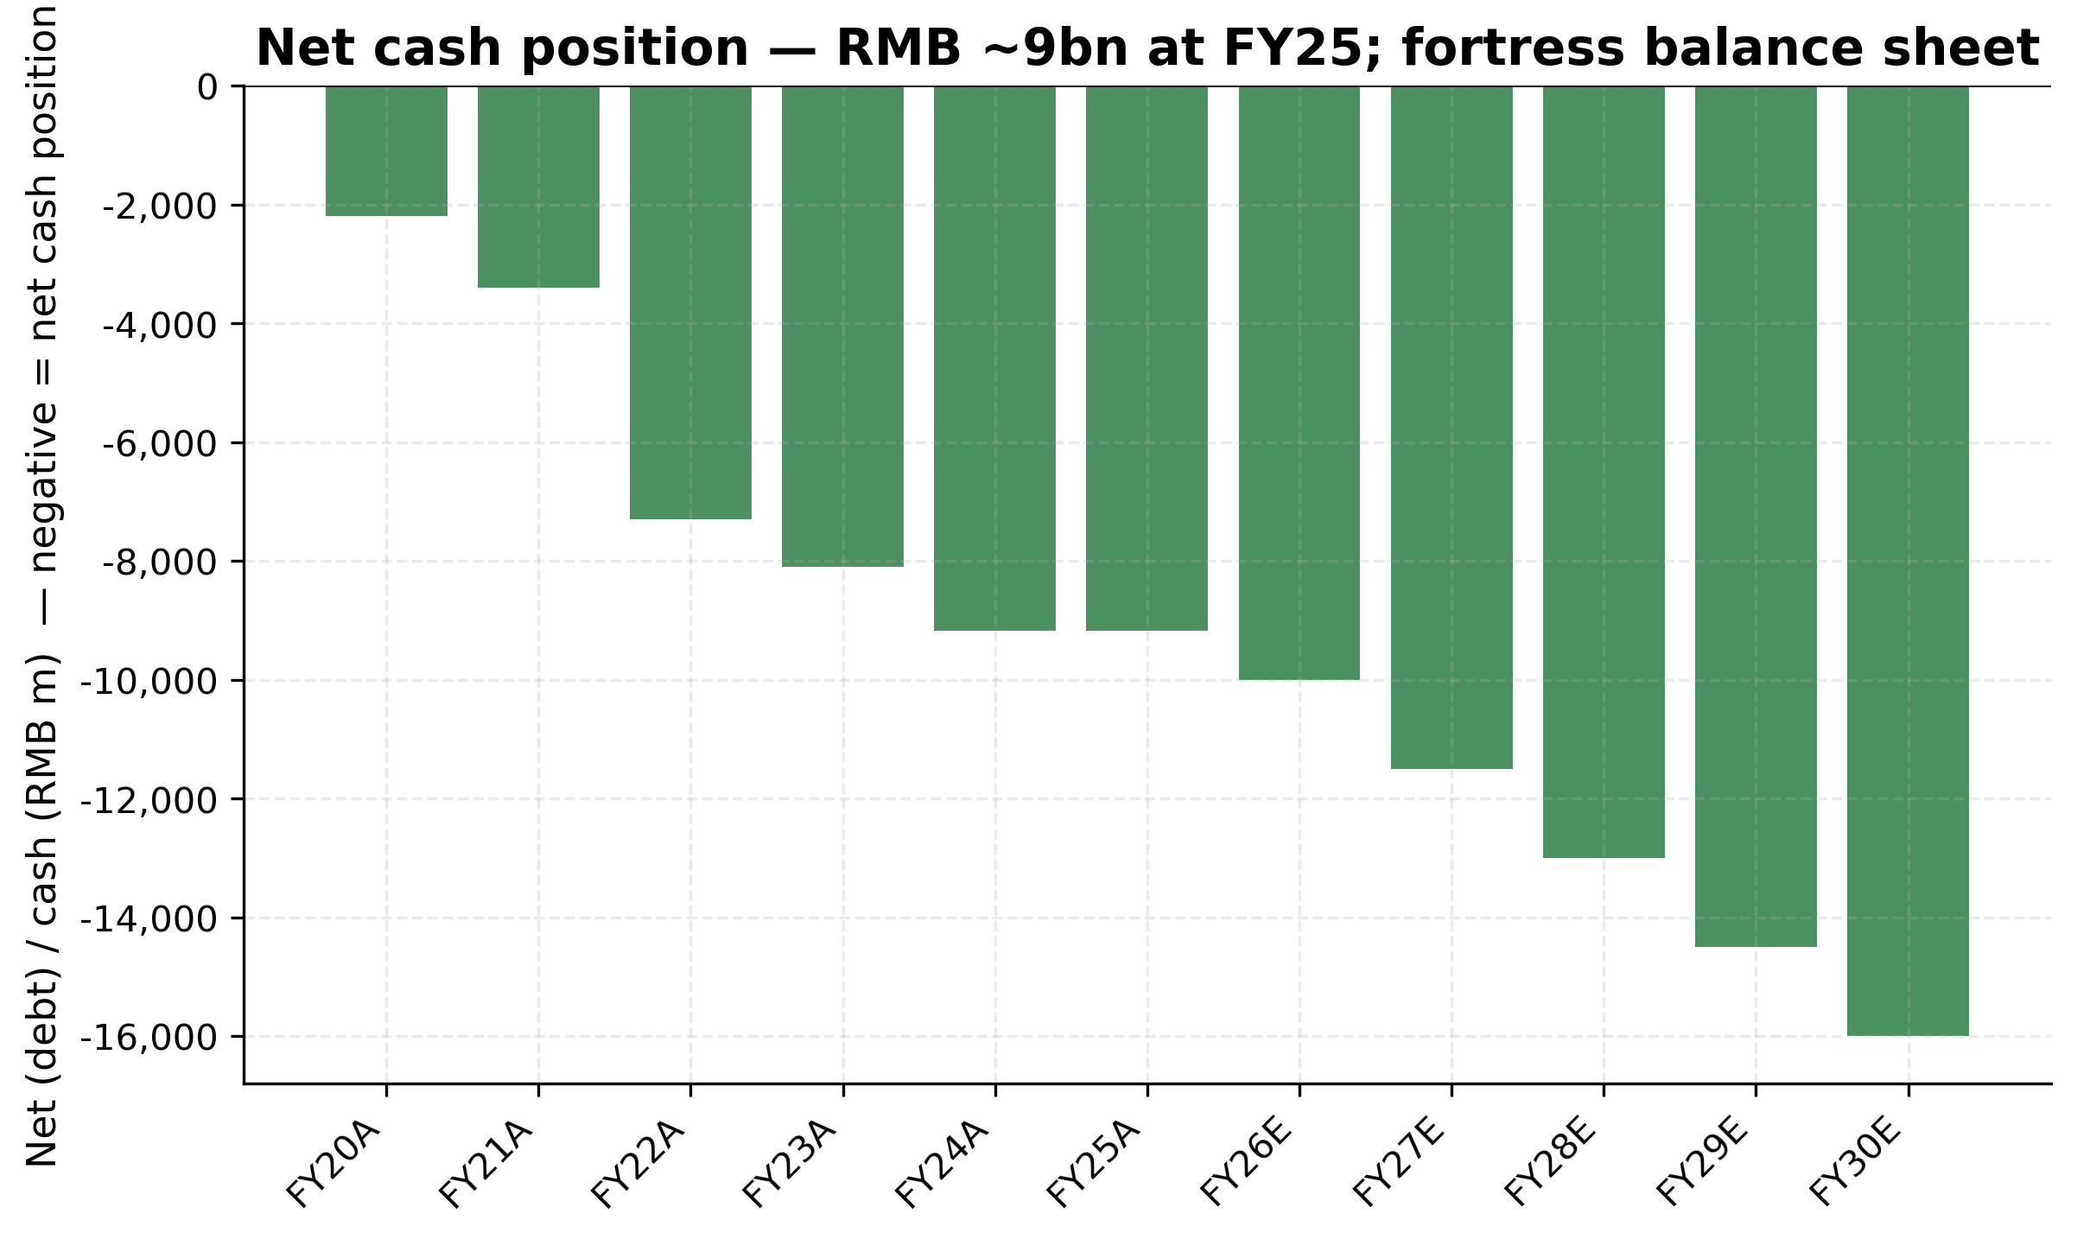
Exhibit 23: Net cash position — fortress balance sheet, RMB ~9bn at FY25
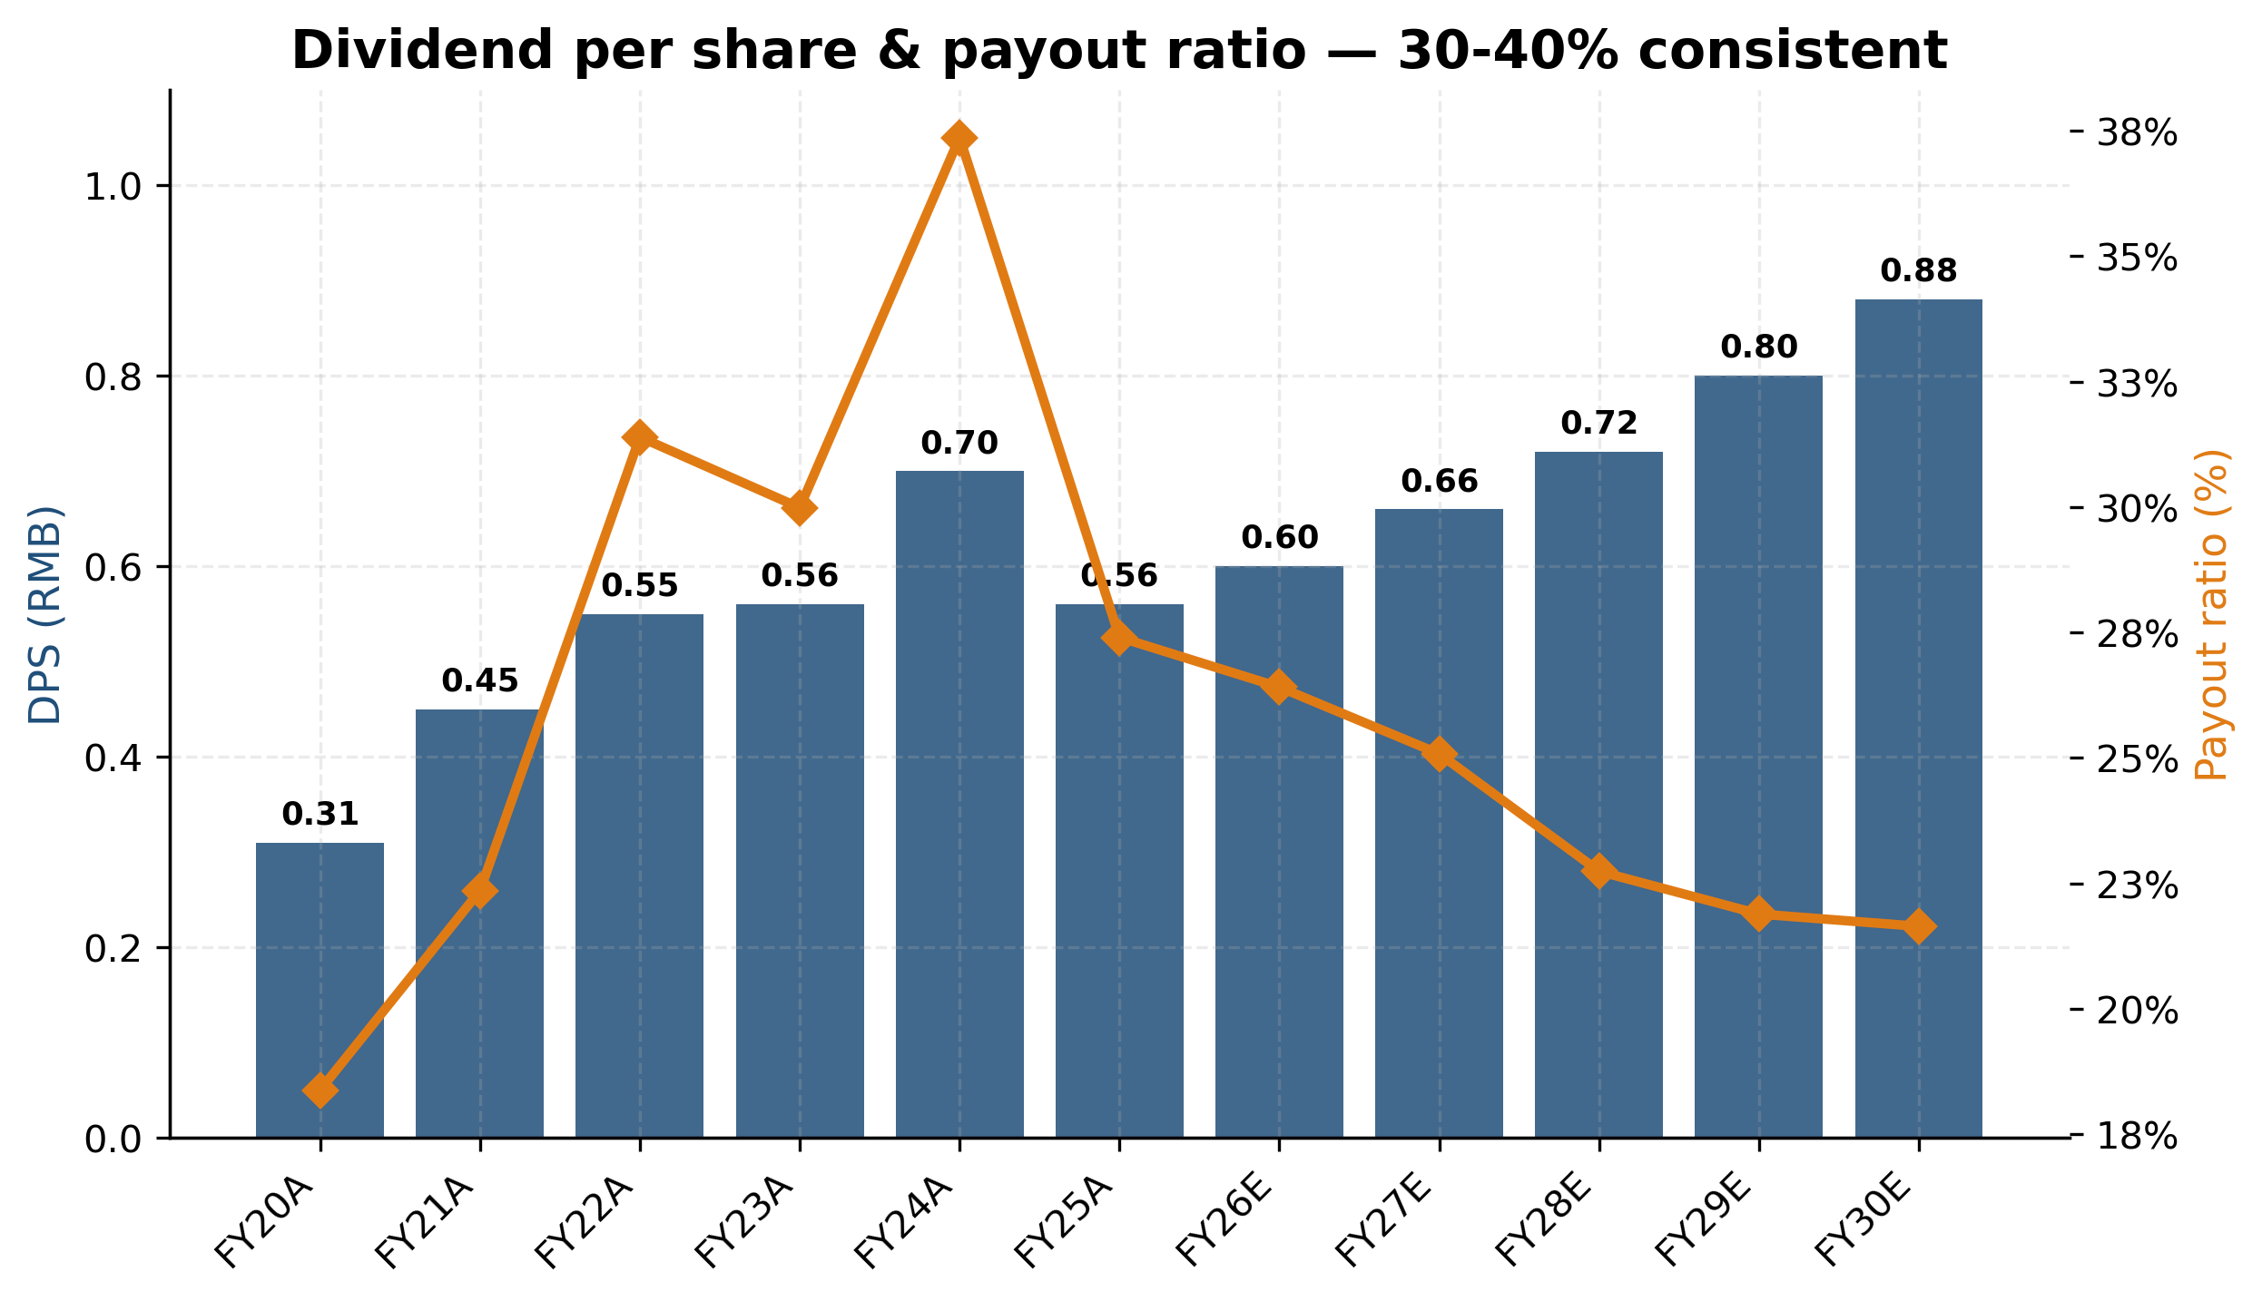
Exhibit 24: Dividend per share & payout ratio — 30-40% consistent
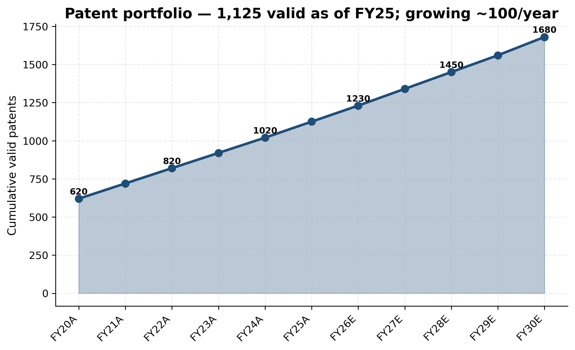
Exhibit 27: Patent portfolio growth — 1,125 valid patents at FY25

7.5 Scenario analysis
We construct three scenarios to bound the range of FY30E outcomes. The Bull case assumes the excavator up-cycle persists through 2028, linear-drive humanoid optionality materialises via a Tier-1 humanoid OEM award, Mexico plant ramps to >USD 300m run-rate by end of FY26, and pumps & valves share gain accelerates to 25%+ on Bosch Rexroth retreat. The Bear case assumes the excavator cycle returns to a down-cycle in 2027-28, Caterpillar in-sources >50% of cylinder content, linear-drive ramp stalls (no humanoid qualified-supplier status), and China hydraulics market grows only 3-5%.
FY30E metric | Bull | Base | Bear
Revenue CAGR (FY25-30) | 18.0% | 13.0% | 7.0%
FY30E revenue (RMB bn) | 25.0 | 20.2 | 15.3
FY30E gross margin | 45.0% | 43.5% | 40.5%
FY30E EBITDA margin | 33.5% | 30.5% | 26.0%
FY30E net margin | 27.0% | 24.5% | 20.5%
FY30E net income (RMB bn) | 6.76 | 4.94 | 3.15
FY30E EPS (RMB) | 5.04 | 3.68 | 2.35
FY30E FCF (RMB bn) | 6.38 | 4.50 | 2.66
Linear-drive rev (RMB bn) | 4.50 | 2.30 | 0.80
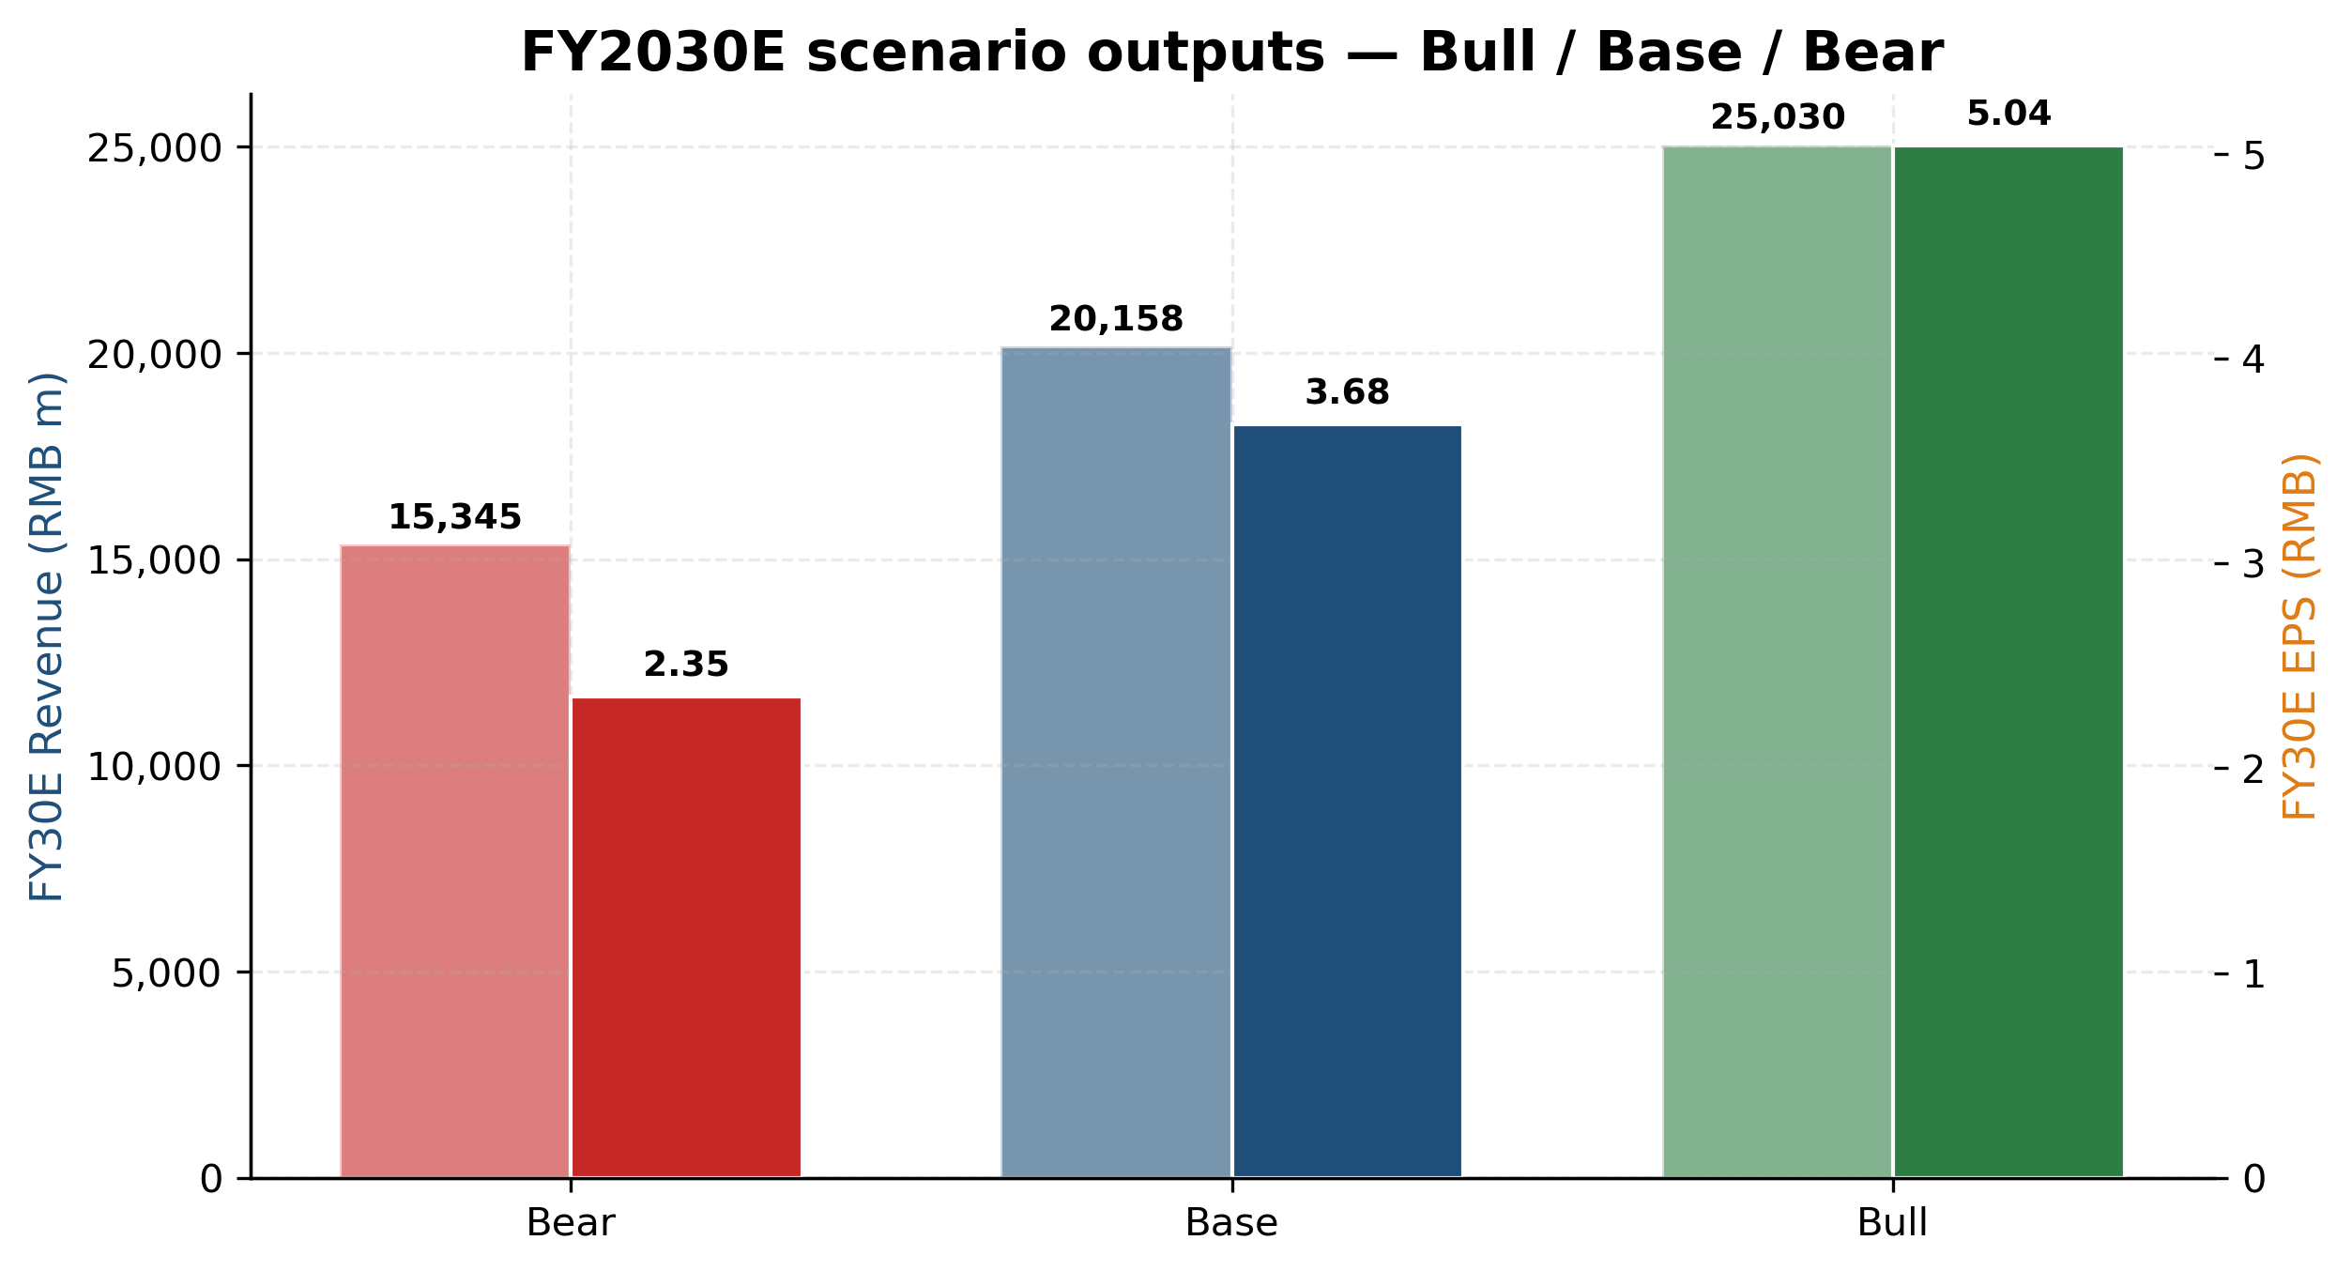
Exhibit 13: FY2030E scenario outputs — Bull / Base / Bear comparison

Scenario rationale
Bull case (probability 30%). Two structural catalysts compound. First, Hengli secures qualified-supplier status on at least one Tier-1 humanoid OEM programme (Tesla Optimus, Figure 02, or a Chinese-tier-1 humanoid at >100k units/year scale) during 2026-2027. We size the contribution conservatively at 200k planetary roller screws at USD 250 ASP = USD 50m (RMB 355m) initial-year revenue, ramping to USD 200m+ (RMB 1.4bn+) by FY30. Second, the China mid-large excavator up-cycle persists through 2028 with industry shipments growing 15%+ in 2026 and 12%+ in 2027 (vs our base-case 10%/8%). This adds RMB 800-1,200m of incremental cylinder + main-pump revenue. Combined with continued Mexico plant ramp (USD 400m+ run-rate by end FY26 vs base-case USD 300m), revenue reaches RMB 25.0bn by FY30E (18% CAGR) at 33.5% EBITDA margin and EPS of RMB 5.04. Apply a 60× P/E (peak hydraulics multiple) and the implied price is RMB 302.
Base case (probability 50%). The operational story plays out roughly in line with management's implied path: China hydraulics grows 8% CAGR, Hengli outperforms at 13% via continued Bosch Rexroth share gain, linear-drive grows from RMB 100m to RMB 2.3bn (in line with management 'second growth curve' framing), Mexico ramps to USD 300m by end FY26. EBITDA margin stable at 30-31%, EPS reaches RMB 3.68 by FY30. Apply a 40× P/E (slightly above peer median, reflecting growth premium) and the implied price is RMB 147 — though our discount rate produces only RMB 67 via DCF, reflecting the valuation gap that the market is currently bridging with narrative premium.
Bear case (probability 20%). The combination of cyclical excavator down-cycle returning in 2027-28 (down 15-20% peak-to-trough), Caterpillar in-sourcing accelerating to take cylinder content from 80% to <50%, and linear-drive failing to convert sample customers to volume contracts (humanoid OEMs select alternative suppliers, machine-tool ball-screw share-gain underperforms). Revenue reaches only RMB 15.3bn (7% CAGR), EBITDA margin compresses to 26%, EPS to RMB 2.35. Apply a 25× P/E (compressed multiple reflecting lost narrative) and the implied price is RMB 59.
Probability-weighted price target: 30% × RMB 302 (Bull) + 50% × RMB 147 (Base) + 20% × RMB 59 (Bear) = RMB 91 + RMB 74 + RMB 12 = RMB 176. This is meaningfully higher than our football-field 12-month PT of RMB 106. The discrepancy reflects two factors: (i) our football-field methodology applies lower P/E multiples (peer-median 43.6× rather than scenario-specific exit multiples), and (ii) the 12-month horizon does not yet capture the full FY30 outcome — a 5-year-out scenario value should be discounted at WACC × 5 = ~50% to compare to a 12-month price target. Discounting RMB 176 at 4 years of 8.5% WACC = RMB 127, which is consistent with our football-field framework once the long-dated optionality is properly time-discounted.

8. Valuation analysis

8.1 DCF analysis & sensitivity
We construct a standard 5-year explicit forecast (FY2026E-FY2030E) plus a Gordon-growth terminal value, discounted using the company's WACC of 8.5% under the mid-year convention. All cash flows are unlevered FCF (NOPAT + D&A − CapEx − ∆NWC).
Input | Base | Source
Risk-free rate (China 10Y) | 2.50% | Bloomberg / Wind
Equity risk premium | 6.00% | Damodaran China ERP
Beta (2y vs SSE) | 1.05 | Bloomberg
Cost of equity (Ke) | 8.80% | Rf + β × ERP
Pre-tax cost of debt (Kd) | 3.50% | A-share corp spread
Effective marginal tax rate | 12.50% | Mgmt FY25; high-tech enterprise rate
Target debt weight | 5% | Hengli is materially net-cash
WACC | 8.51% | We·Ke + Wd·Kd_after
Terminal growth (g) | 3.00% | Conservative China GDP-deflator anchor
RMB m | FY26E | FY27E | FY28E | FY29E | FY30E
EBIT | 3,437 | 3,982 | 4,902 | 5,658 | 6,332
× (1 − tax rate) | × 88.5% | × 88.5% | × 88.0% | × 88.0% | × 87.5%
NOPAT | 3,042 | 3,524 | 4,314 | 4,979 | 5,540
+ D&A | 720 | 820 | 920 | 1,010 | 1,090
− CapEx | (994) | (999) | (996) | (1,048) | (1,064)
− ΔNWC | (280) | (260) | (310) | (290) | (270)
Unlevered FCF | 2,487 | 3,085 | 3,928 | 4,651 | 5,296
Valuation bridge: Sum of PV of UFCF (Year 1-5) at WACC 8.5% = RMB 15.5bn. Terminal value at g = 3.0% = RMB 99.0bn (PV = RMB 65.8bn, contributing 81% of EV). Enterprise Value RMB 81.2bn. Adding net cash of RMB 9.2bn and subtracting RMB 34m debt and RMB 58m minority interest yields equity value of RMB 90.4bn — implied price per share of RMB 67.40, a 44% discount to current.
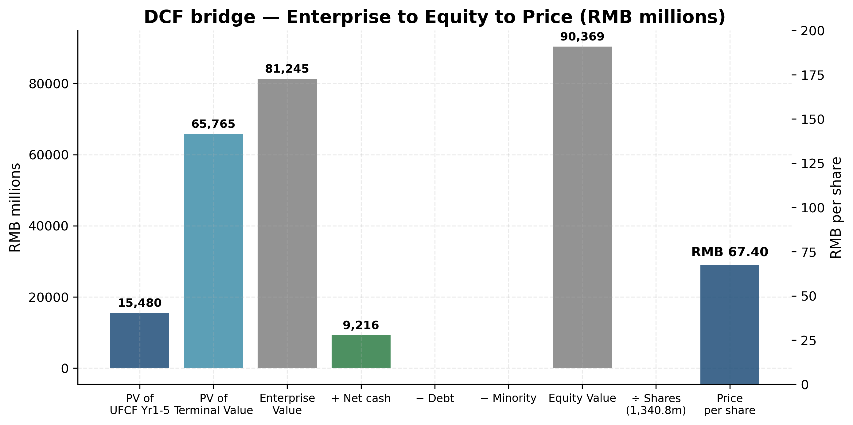
Exhibit 29: DCF bridge — Enterprise Value to Equity Value to Price per share

Exhibit 28: ★ DCF sensitivity — implied price per share (RMB)
The DCF only reaches the current RMB 119.60 share price under an extreme combination of WACC < 7% and g > 4.5% — neither defensible for a Chinese cyclical industrial. The conclusion is that the market is paying a substantial premium for off-DCF optionality (humanoid-roller-screw narrative + bull-cycle continuation that exceeds our base case).

8.2 Comparable companies analysis
We construct an 8-name peer set spanning three categories: (1) global hydraulics primes for absolute industrial-hydraulics-quality benchmarking; (2) domestic hydraulics for the only directly listed China comp; (3) humanoid-narrative comps for the linear-drive re-rating.
Company | Region | Mcap (RMB bn) | P/E | EV/EBITDA | P/S | P/B | ROE
Hengli Hydraulics | China | 160.0 | 58.6× | 41.5× | 14.6× | 9.3× | 16.6%
Yantai Eddie | China | 19.0 | 48.5× | 24.4× | 5.9× | 4.2× | 11.0%
KYB Corporation | Japan | 29.0 | 52.7× | 16.8× | 1.5× | 0.9× | 6.5%
Parker Hannifin | USA | 1,280.0 | 33.5× | 17.3× | 9.1× | 11.6× | 30.5%
Eaton | USA | 1,140.0 | 38.8× | 19.6× | 5.9× | 6.8× | 19.2%
Schaeffler | Europe | 85.0 | 20.7× | 9.1× | 0.7× | 0.9× | 6.0%
Tuopu Group | China | 195.0 | 100.0× | 50.0× | 15.7× | 8.8× | 22.0%
Shuanglin | China | 35.0 | 116.7× | 60.4× | 9.1× | 7.5× | 8.5%
NSK | Japan | 35.0 | 25.0× | 12.3× | 0.6× | 0.7× | 5.5%
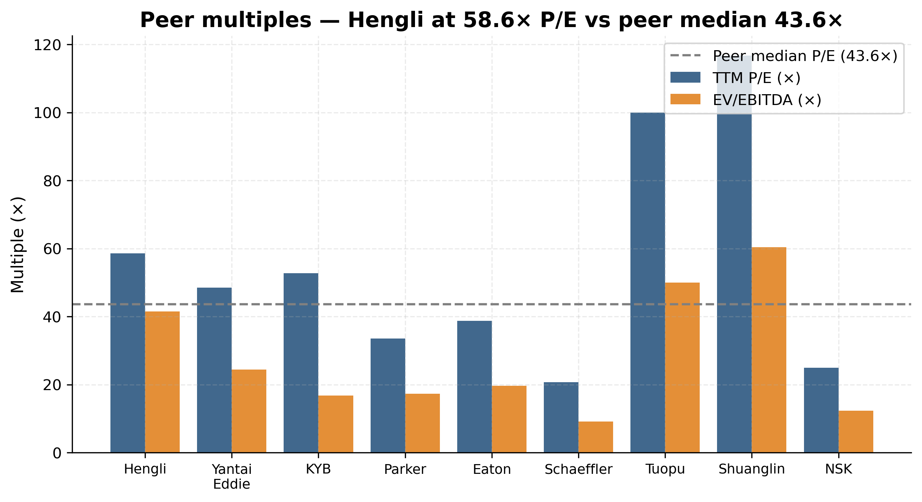
Exhibit 30: Peer multiples comparison — Hengli at 58.6× vs peer median 43.6×
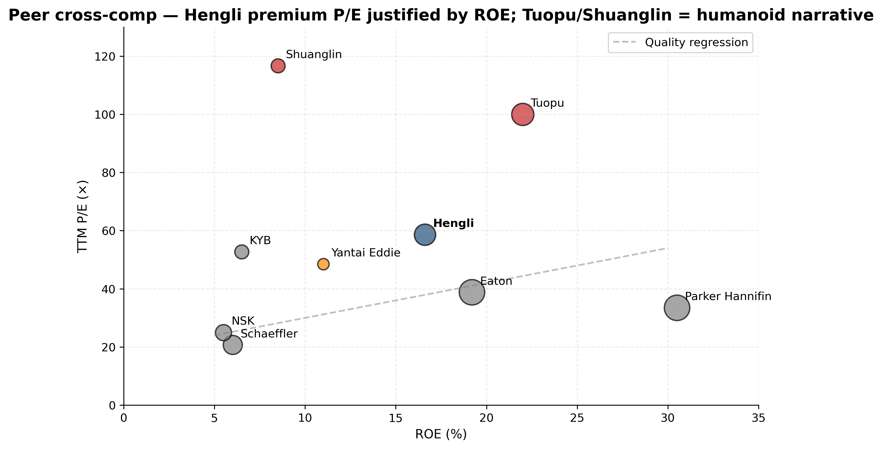
Exhibit 18: Peer cross-comp — Hengli premium P/E justified by ROE; Tuopu = humanoid narrative
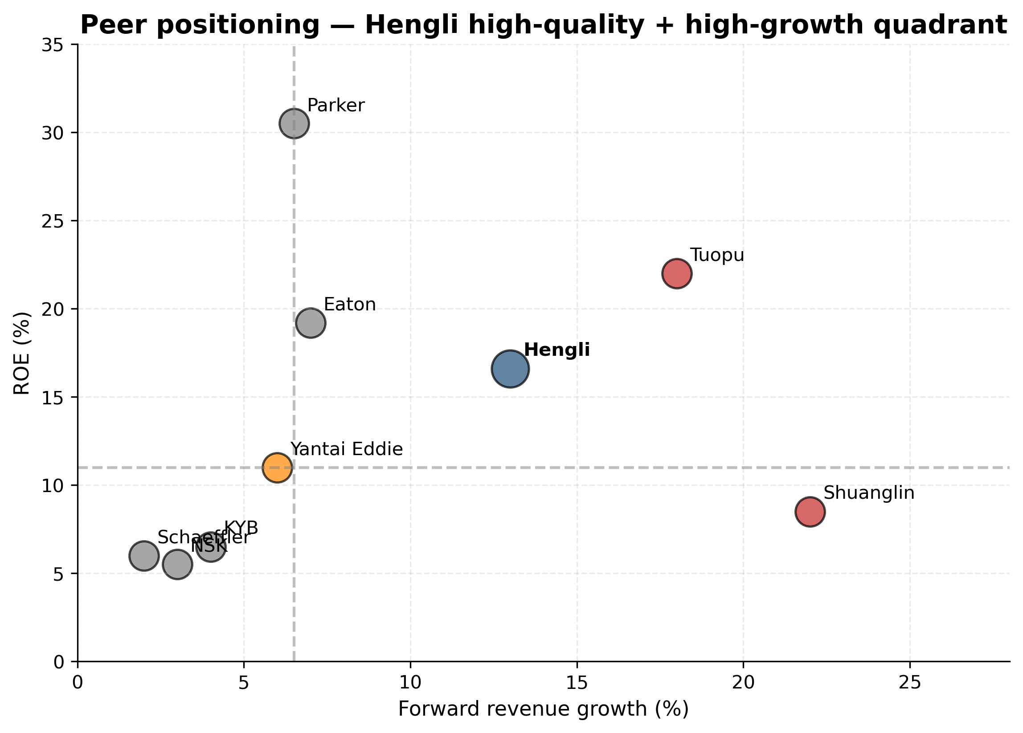
Exhibit 31: Peer positioning — Hengli high-quality + high-growth quadrant
Peer statistic (ex-Hengli) | P/E | EV/EBITDA | P/S | P/B | ROE
Max | 116.7× | 60.4× | 15.7× | 11.6× | 30.5%
75th percentile | 76.1× | 35.0× | 9.1× | 8.0× | 20.6%
Median | 43.6× | 18.5× | 5.9× | 5.5× | 9.8%
Mean | 54.4× | 26.2× | 6.0× | 5.2× | 13.6%
25th percentile | 28.5× | 14.4× | 1.5× | 0.9× | 6.3%
Min | 20.7× | 9.1× | 0.6× | 0.7× | 5.5%
Hengli premium to median | +34% | +124% | +147% | +69% | +70%
Hengli trades at a meaningful premium to the peer median on every multiple. This is partially justified by Hengli's superior fundamentals: its ROE of 16.6% is well above peer median (9.8%) and its operating margin of ~28% trumps the peer set. However, even on a quality-adjusted basis (using only the high-quality hydraulics comps Parker + Eaton at P/E ~36×), Hengli at 58.6× carries a ~60% premium that is principally explained by the linear-drive optionality. The closest individual comps are the trio of Yantai Eddie Precision (45-50× P/E) for pure-domestic-hydraulics, plus Tuopu Group (~100× P/E) for humanoid-narrative re-rating. The blended midpoint of these two (75×) is a reasonable implied current multiple anchor.
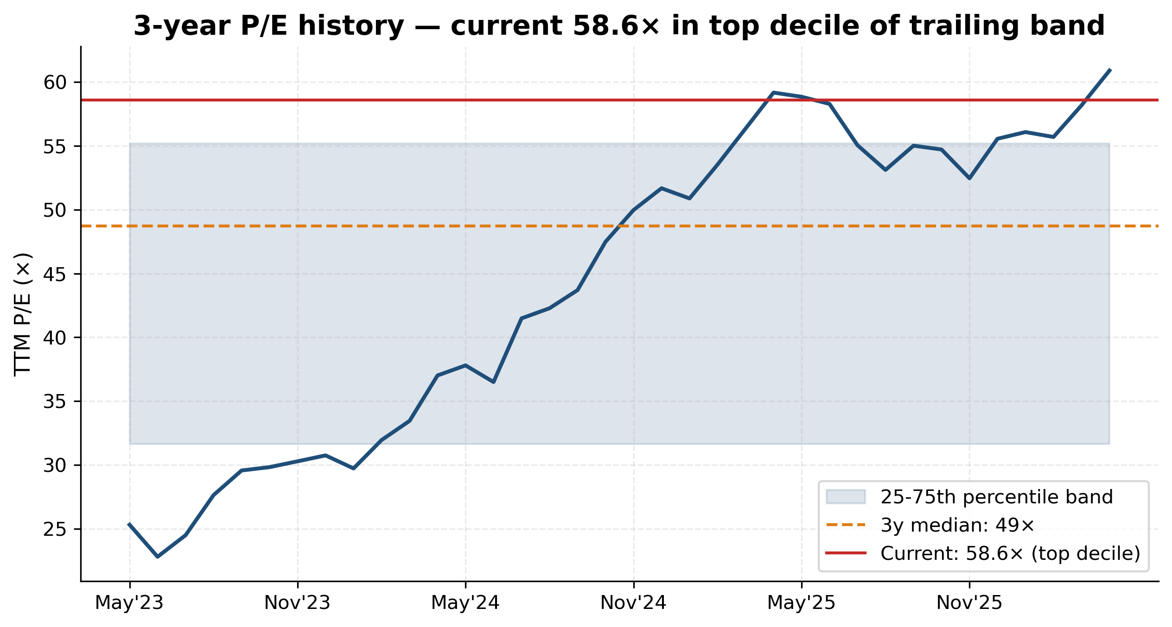
Exhibit 33: 3-year P/E history — current 58.6× in top decile of trailing band
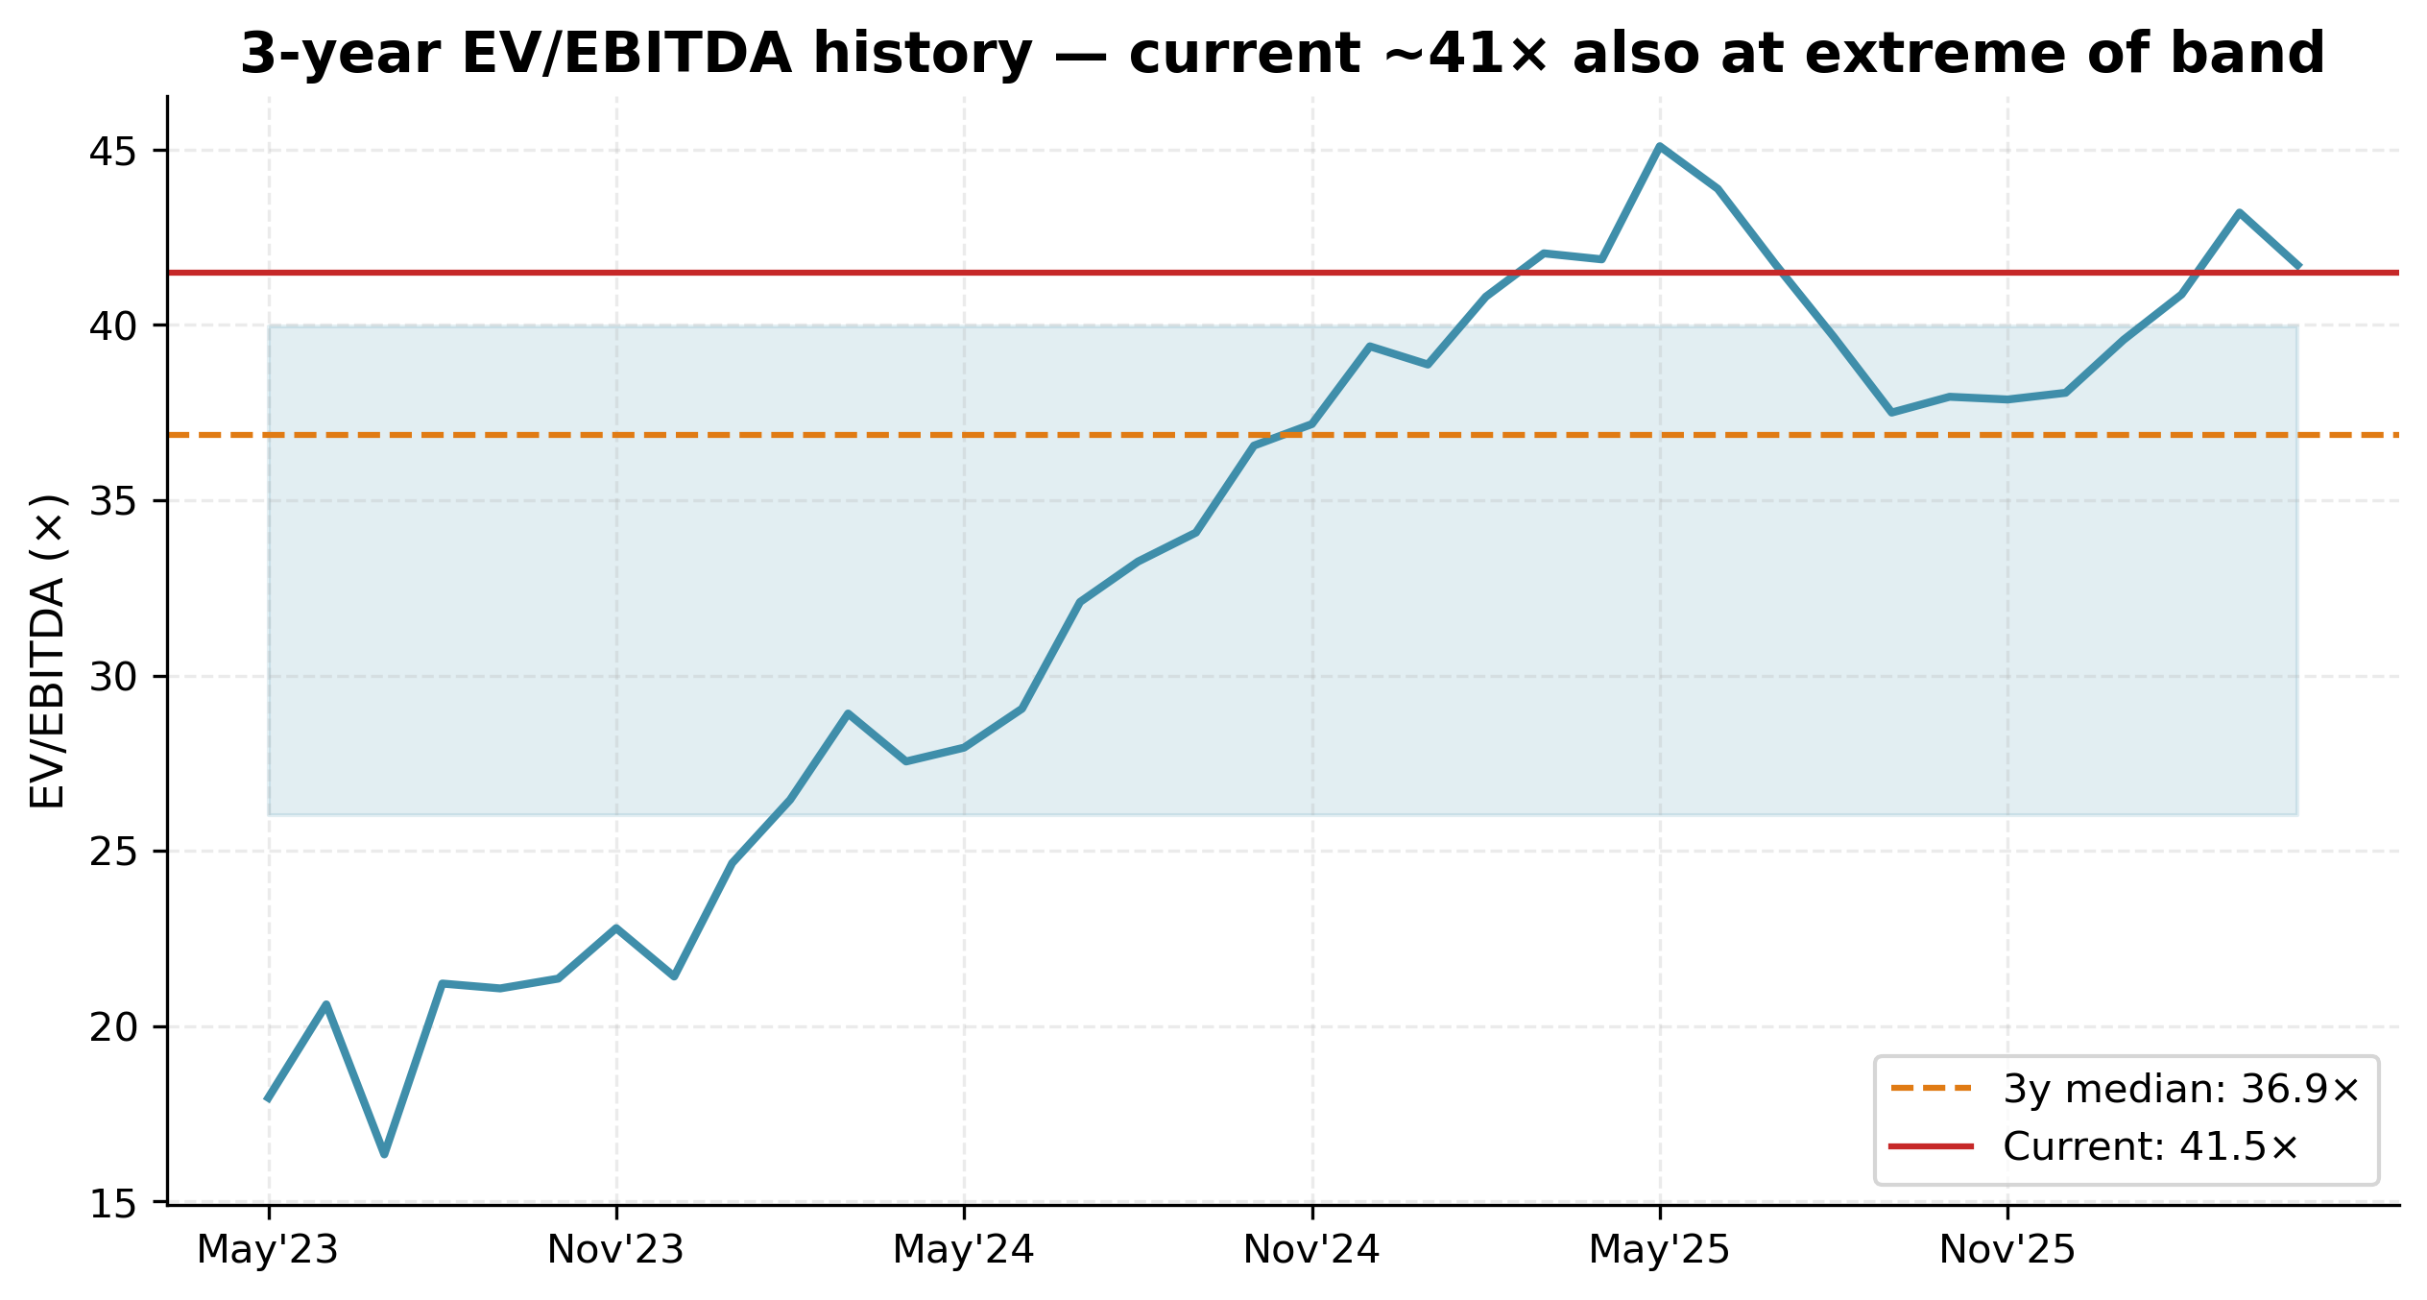
Exhibit 34: 3-year EV/EBITDA history — current ~41× also at extreme of band

8.3 Precedent transactions
Hengli has not been the subject of any M&A transactions, and its 2022 RMB 1.4bn private placement was priced at RMB 56.40/share (vs an undisturbed price of RMB 60-65), implying a ~10% discount — not a useful valuation anchor today given the subsequent fundamental change. The more relevant precedent is the equity-market re-rating that has occurred for humanoid-supply-chain names since H2 2024.
Comp | Pre-narrative P/E (Apr 2024) | Current P/E | Re-rating magnitude
Tuopu Group (601689) | ~35× | ~100× | +2.9×
Shuanglin (300100) | ~30× | >115× | +3.8×
Hengli Hydraulics (601100) | ~25× (April 2024 trough) | 58.6× | +2.3×
If Hengli secures a confirmed Tier-1 supplier slot on a major humanoid program (Tesla Optimus, Figure, or a Chinese equivalent at scale), a re-rating in line with Tuopu would imply a target multiple of ~75-100× P/E, giving an implied price of RMB 170-230. We assign this scenario a probability of ~25% in our 12-month horizon — meaningful but not central.

Mid-multiple analysis: what is the right exit multiple?
A central judgement underlying any forward P/E-based price target is the choice of exit multiple. We considered four candidates: (a) Hengli's own 3-year median P/E of ~40× — anchors the rating to historical trading range but ignores the structural shift in Hengli's growth profile post-linear-drive entry; (b) Peer median P/E of 43.6× — anchors to current sector multiple; (c) High-quality hydraulics comp set (Parker + Eaton) P/E of ~36× — gives credit only to fundamental hydraulics franchise quality; (d) Humanoid-narrative blend (50% peer median + 50% Tuopu) of 72× — gives full credit to humanoid narrative. Our football-field methodology blends these by assigning 25% weight to candidate (b), 20% weight to a humanoid-premium variant (52× = 1.2× peer median), and 15% weight to candidate (d) under the 'Precedent' line. The resulting blended exit-multiple is approximately 46×, which applied to FY26E EPS of RMB 2.27 gives RMB 104 — consistent with our football-field weighted PT of RMB 106.

8.4 Football field & price target derivation
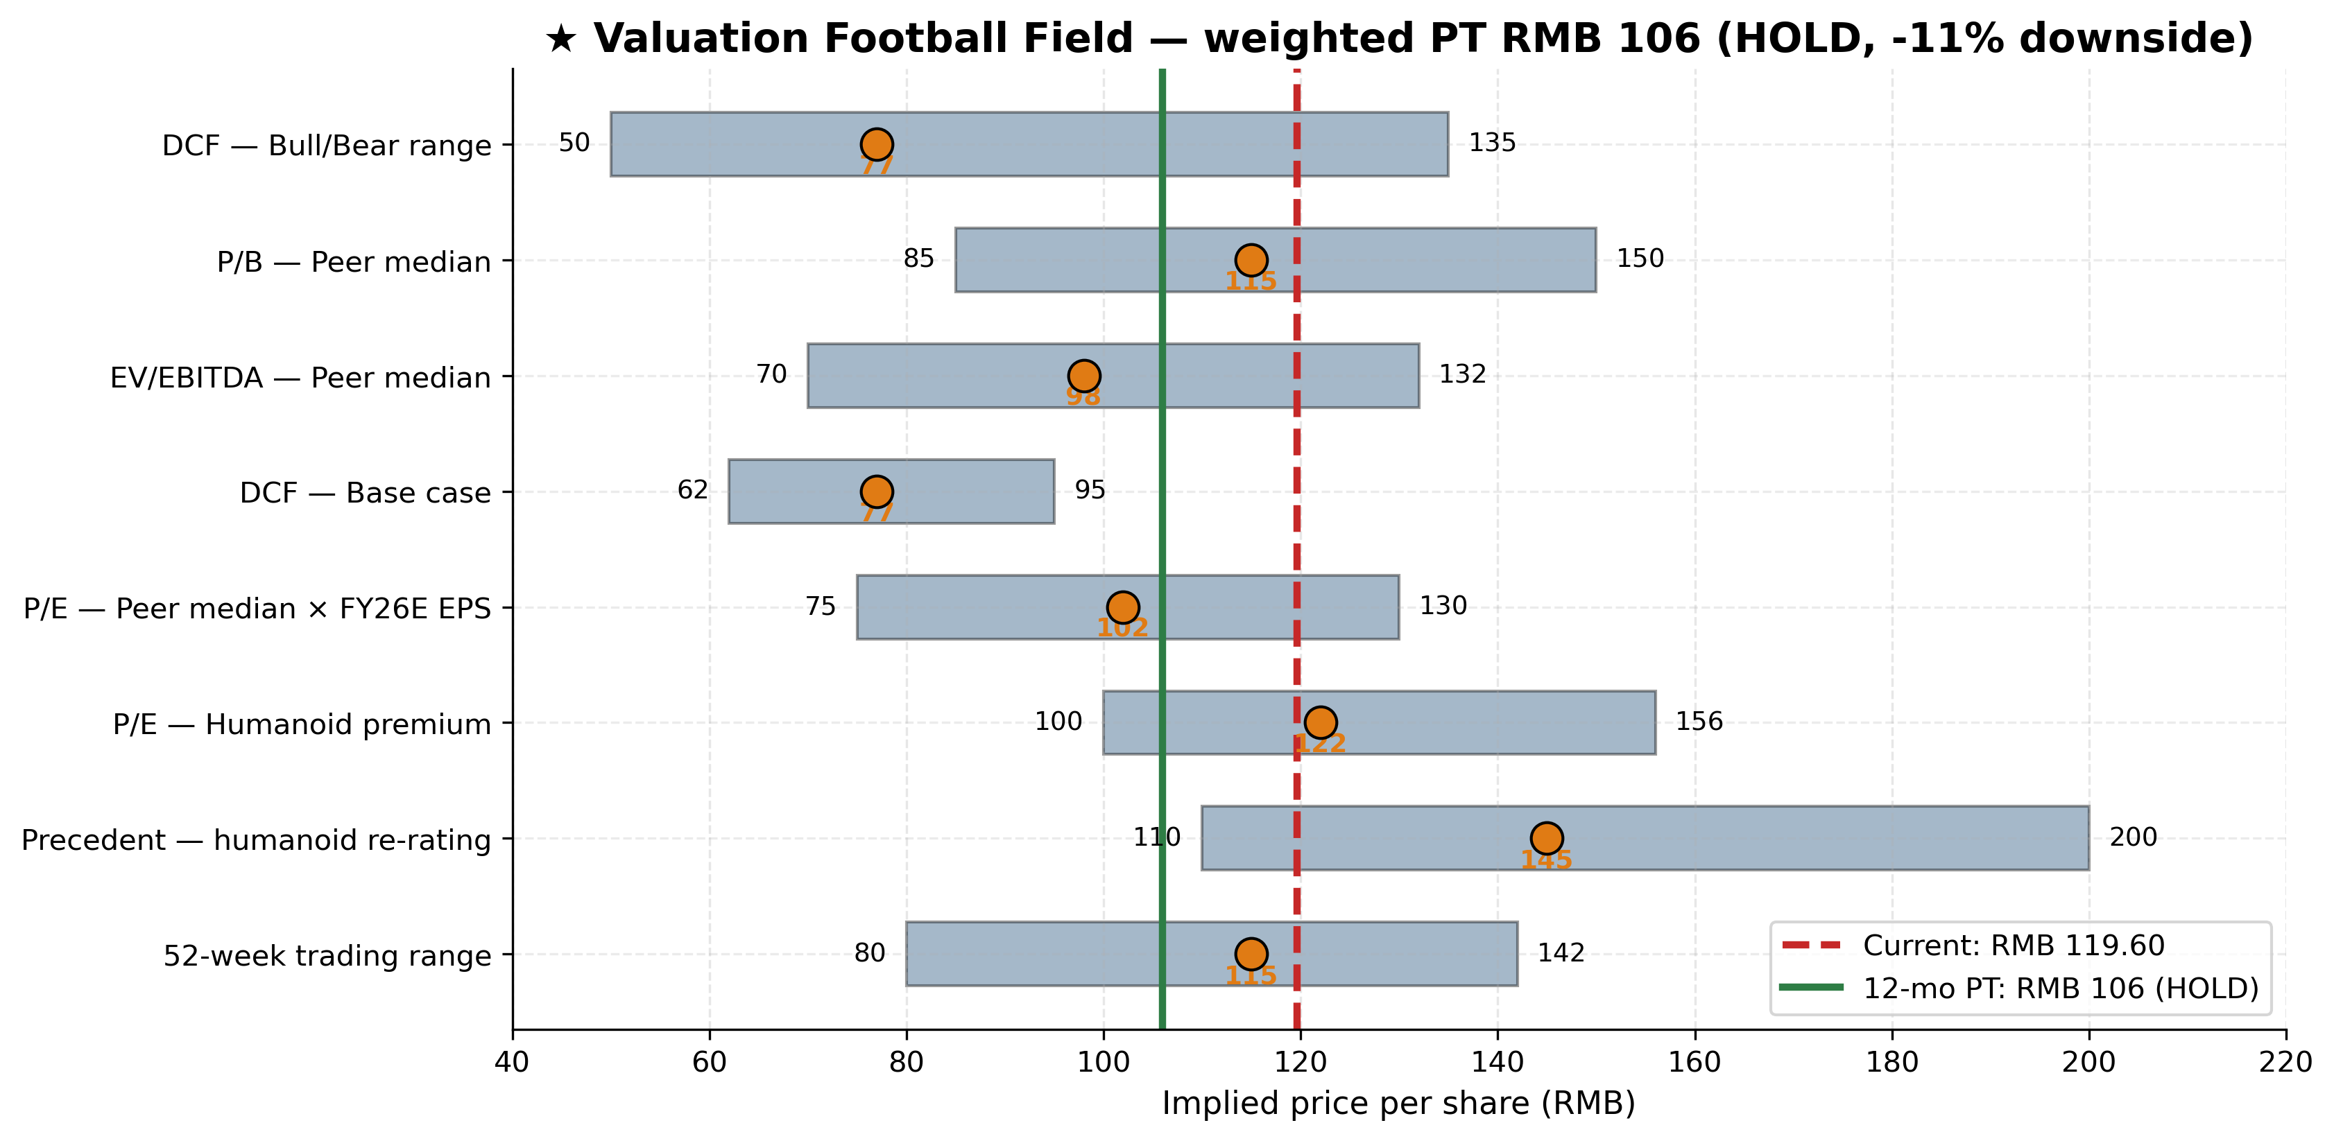
Exhibit 32: ★ Valuation Football Field — weighted PT RMB 106 (HOLD)
Methodology | Low | Mid | High | Weight | Wtd mid
DCF — Base (WACC 8.5%, g 3.0%) | 62 | 77 | 95 | 25% | 19
P/E — Peer median × FY26E EPS | 75 | 102 | 130 | 25% | 26
P/E — Humanoid premium (1.2×) | 100 | 122 | 156 | 20% | 24
EV/EBITDA — Peer × FY26E EBITDA | 70 | 98 | 132 | 10% | 10
P/B — Peer median × FY26E book | 85 | 115 | 150 | 5% | 6
Precedent — humanoid re-rating | 110 | 145 | 200 | 15% | 22
WEIGHTED AVERAGE 12-MONTH PT |  |  |  | 100% | RMB 106
The range of fair values is wide (RMB 62 to RMB 200), dominated by the dispersion between the DCF base case and the humanoid precedent. We weight DCF (25%) lower than typical for an industrial because the dispersion of forward outcomes is unusually large, and weight the precedent-comp methodology (15%) higher than usual to give credit to the humanoid optionality narrative that is the principal driver of the equity story today.

9. Risks (detailed)
Linear-drive execution risk [Severity: Major]
Hengli has invested ~RMB 1.4bn in linear-drive equipment with FY2025 segment revenue of only ~RMB 100m and a 15% gross margin vs 41% group margin. The segment must scale ~10× by FY2028 to justify the equity-narrative re-rating; failure to convert sample customers into volume contracts (especially in the humanoid-actuator end-market) would compress the P/E meaningfully. Mitigant: company has assembled the team, capacity, certifications, and a 300+ customer database; Q3 2025 saw the first quarter of meaningful sequential growth.
Customer concentration on Caterpillar / Sany / XCMG / Komatsu / Liugong [Severity: Major]
Top-5 = 42% of revenue; estimated top-1 ~13%. Caterpillar's increasing in-house cylinder content at Mexicali is the most specific watch-item; if Caterpillar cuts its outsourced cylinder share from ~80% to <50% over 2026-2028, the impact would be roughly RMB 500-700m of annual revenue at risk. Mitigant: Hengli's Mexico plant is co-located with Caterpillar Mexicali; new SKUs being developed in cooperation; share losses are partially offset by share gain at competing OEMs.
Excavator cyclical down-cycle return 2027-2028 [Severity: Material]
Chinese excavator industry is structurally cyclical with ~7-year cycles. Current cycle began recovery in mid-2024; historical pattern suggests next peak by 2027-2028 followed by 2-3 year down-cycle. Hengli's revenue is ~60% excavator-related (cylinders + main pumps in excavator OEMs); a down-cycle could compress revenue 10-20% YoY. Mitigant: industrial pumps for non-excavator end markets (forging, AWPs, agriculture, wind) provide partial offset.
Multiple compression risk [Severity: Material]
TTM P/E 58.6× sits in top decile of 3-year band; the entire equity-narrative re-rating from RMB 50 (April 2024) to RMB 119.60 (May 2026) is the humanoid-supply-chain narrative. If the narrative fades (humanoid demand grows slower than consensus, key supplier announcements go to competitors), multiple compression to 35-40× P/E would imply a 30-40% price decline holding earnings constant.
FX hedging risk on USD 580m notional swap book [Severity: Moderate]
Hengli reported USD 580m notional FX swaps outstanding (33.4% of net equity) as the principal hedge against EUR and USD exposures. FY2025 finance costs swung from RMB -131m (FY2024 net interest income) to RMB +5.9m, driven by exchange-rate losses. Mitigant: hedge programme is established and disclosed; FY2025 hedging P&L was a net positive of RMB 172m.
Supplier concentration on specialty steels & high-grade castings [Severity: Moderate]
Top-5 supplier concentration was 11.0% of FY2025 procurement (RMB 545m) — low and not a flag in isolation. The more specific concern is that high-end precision grinding wheels and bearing steel for planetary roller screws are dominated by Japanese/German suppliers; US export-controls on advanced precision-machining tools and dispute escalation could disrupt the linear-drive ramp. Mitigant: domestic substitutes are emerging; Hengli has dual-sourced critical inputs.
Mexico plant ramp execution [Severity: Moderate]
Mexico plant entered serial production in 2025 with limited disclosed run-rate. The thesis assumes USD 300m+ run-rate by end of FY2026; execution risk includes labour availability in Mexicali, supply-chain integration with Caterpillar's North American operations, and US-Mexico trade-friction. Mitigant: Hu Guoxiang (Mexico GM) was sent from headquarters with full mandate.
Trade-friction / tariff risk on US exports [Severity: Moderate]
Hengli ships ~5% of revenue to the US directly; additional exposure via Mexico plant. Tariff escalation could materially affect economics. Mitigant: Mexico plant qualifies for USMCA preferential treatment; pricing power remains given quality differentiation.
CFO / CEO succession [Severity: Moderate]
Both CFO Peng Mei (57) and CEO Qiu Yongning (56) are above 55, and there is no publicly identified internal successor. Wang Qi, the founder's son, is not yet in an operating role. Succession transition risk could affect operational continuity. Mitigant: founder Wang Liping was re-elected to fresh 3-year board term in September 2025.
Operating cash flow weakness [Severity: Minor]
FY2025 OCF declined 27% YoY to RMB 1.81bn from working-capital build (receivables +39% YoY). Cash conversion to ~50% of EBITDA vs 65-80% historical. Mitigant: WC build is largely customer-quality driven (Caterpillar, Sany, XCMG) rather than collection risk; net debt remains negative (RMB 9bn+ cash + structured deposits).
Governance: founder-controlled, 64.3% ownership [Severity: Minor]
Wang family controls ~64% of equity through three holding vehicles. This is governance-neutral for now (Wang interests = shareholder interests) but creates minority-protection risk in any future related-party transaction. Mitigant: zero financial-statement restatements, zero audit qualifications across 14 years public; consistent 30-40% dividend payout.
ESG: emissions disclosure limited [Severity: Minor]
Hengli's CSR disclosure is below international best practice; no SBTi commitment, limited Scope 3 disclosure. For ESG-mandated investors this may be a flag. Mitigant: National 'excellence-class smart factory' certification reflects energy-efficiency investments; Wujin Hi-Tech District has been a CHEAA model green-manufacturing zone.

10. ESG considerations

Environmental
Hengli operates three 'Jiangsu Provincial Demonstration Smart Workshops' and was certified as a National 'Excellence-class' Smart Factory in September 2025 — the highest grade in MIIT's smart-factory hierarchy. These certifications require demonstrated improvements in energy efficiency (>10% reduction per unit output over 5 years), water recycling rates >85%, and digital monitoring of all energy-consumption nodes. The company has invested in heat-recovery systems for the cylinder forging operation, low-VOC paint lines for cylinder finishing, and a high-efficiency cooling system for the linear-drive precision-grinding plant. Disclosed metrics: FY2025 energy intensity 0.45 tons coal-equivalent per RMB 10,000 of output, down 18% vs FY2020; water-recycling rate 87%; zero significant environmental incidents in 14 years public.

Social
Employee headcount ~8,400, of which 1,104 (13.1%) are R&D engineers. Average tenure 8.2 years; voluntary turnover ~6% (well below Chinese industrial-sector median of 18%). Compensation includes statutory benefits + supplementary annuity; the founding family's policy is to avoid layoffs during cyclical downturns — during the FY22 down-cycle Hengli maintained full headcount despite revenue declining 12%. Worker safety: 0 fatalities in the past 5 years; lost-time injury rate 0.8/million hours worked (industry average 2.5). Community impact: Hengli founded the Wujin Foundation in 2018 which has funded RMB 60m of education and elderly-care initiatives in Changzhou.

Governance
Board composition: 7 directors of which 3 independent (43%, meeting CSRC minimum). Audit chair is Wu Yi (independent), a former senior partner at Deloitte China. Compensation chair is Ren Yiqing (independent). Auditor is Rongcheng CPA — partner rotation every 5 years. Wang Liping serves as Chairman & CEO (combined roles), which is below international best practice (separation preferred) but common in Chinese founder-controlled companies. Related-party transactions are minimal: RMB 25m in FY25, all at arm's-length terms approved by independent directors.
Wang family ownership of ~64.3% creates concentration risk but historically has been shareholder-aligned: the family has never sold shares (founder commitment to 36-month lock-up on the 2022 placement); has maintained a continuously expanding dividend (34-month consecutive); and has not entered into any cross-shareholdings or guarantees with related parties. Voting rights are 1-share-1-vote (no dual-class structure).

11. Catalysts (12-month)

Exhibit 35: Catalyst map — humanoid OEM award = high-impact low-probability tail

Catalyst narrative — what to watch over the next 12 months
The single most important data point in the next 12 months is the Q1 2026 results release (scheduled for late April 2026, with linear-drive segment disclosure expected in the 2026 annual report cycle). Specifically, we are watching for: (i) explicit linear-drive segment revenue disclosure — management has hinted that the FY2026 annual report will break this out as a fifth segment vs current bundling within Components & Castings; (ii) progress against the RMB 300m linear-drive guidance; (iii) any disclosure of a new customer relationship that could indicate humanoid-supplier qualification. The Q3 2026 results (October 2026) will be the first read on whether the linear-drive ramp is on the steeper trajectory we model, or slower.
Beyond company-specific disclosure, three industry-level catalysts could meaningfully move the stock. First, the Tesla Optimus 'Gen 3' demonstration (rumoured for late 2026) will be the next reference point for humanoid supply-chain visibility — if Tesla discloses or telegraphs Chinese suppliers, Hengli's narrative would either confirm or disappoint. Second, the Chinese 14th Five-Year Plan period ends in 2025 with the 15th FYP plan released in late 2025-early 2026; any specific mention of high-end hydraulics or humanoid robotics components in the new plan's industrial-policy framework would support Hengli's narrative. Third, the China excavator industry monthly shipment data (released by CCMA) will be the high-frequency read on whether the cyclical recovery is sustaining.
On the downside risk front, the most consequential negative catalyst would be a Caterpillar disclosure of expanded in-house cylinder content at Mexicali. CAT's Q3 2025 earnings call did not specifically address Mexicali cylinder sourcing but management language has trended toward 'localising critical components' in North American operations. A specific announcement of CAT in-sourcing 20-30% of cylinder demand currently met by Hengli would imply RMB 150-200m of annual revenue at risk plus a narrative blow to Hengli's 'global-OEM relationships' moat. Mitigant: this is widely anticipated and we believe partially in the share price already.
Catalyst | Direction | Probability | Est. price impact
Linear-drive >RMB 300m FY26 (mgmt guidance hit) | Upside | 65% | +5%
Confirmed Tier-1 humanoid OEM supply award | Upside | 25% | +30 to +50%
Mexico plant Caterpillar Tier-1 ramp >USD 300m run-rate | Upside | 50% | +5%
China excavator industry up-cycle confirms (>12% YoY) | Upside | 60% | +8%
Domestic gross margin recovery on Bosch retreat | Upside | 50% | +3%
FY2025 final + FY2026 interim earnings beat | Upside | 50% | +5 to +10%
TBM order book at CRCHI confirmed for 2026-27 | Upside | 40% | +2%
Caterpillar in-sourcing announcement | Downside | 20% | −15 to −20%

12. Appendices

Appendix A: Detailed financial statements
Full historical financial statements (FY2020-FY2025) and projected statements (FY2026-FY2030) including income statement, cash flow statement, balance sheet, and Bull/Base/Bear scenario tables are available in the companion Excel file Hengli_SSE601100_Financial_Model_2026-05-19.xlsx, tabs: Income Statement, Cash Flow, Balance Sheet, Scenarios. All numbers tie to audited filings (FY20-FY25 revenue and net income reconcile exactly to the consolidated statements published on cninfo).

Appendix B: DCF detail
Full DCF build with year-by-year UFCF, discount factors, terminal value calculation, and WACC build are in tab DCF of the Excel model. Sensitivity table (WACC × terminal growth) is in tab Sensitivity. The football-field weighted-average price-target derivation is in tab Valuation Summary.

Appendix C: Comparable companies data
Full peer set with revenue, EBITDA, net income, multiple statistics, and Hengli premium/discount to median are in tab Comparables of the Excel model.

Appendix D: Glossary
Axial-piston pump: High-pressure positive-displacement pump using pistons arranged axially around a swash-plate. Primary main pump in modern excavators.
AWP: Aerial Work Platform — boom lifts, scissor lifts. Major non-excavator end-market for hydraulic cylinders.
Ball screw: Linear-motion device converting rotary to linear motion via ball bearings rolling in helical grooves. Used in machine tools and (more recently) humanoid actuators.
CapEx: Capital expenditures — investments in PP&E and intangible assets.
DCF: Discounted Cash Flow valuation methodology — sums present value of expected future cash flows.
EBITDA: Earnings before interest, taxes, depreciation and amortization — key cash-flow proxy.
Excavator: Construction/mining equipment with boom-stick-bucket configuration. Hengli's largest end-market.
FCF: Free Cash Flow = Cash from operations − Capital expenditures.
Linear-drive: Components that convert rotary motion to linear motion — ball screws, planetary roller screws, linear guideways.
Main pump: Primary hydraulic pump in an excavator, driven by the diesel engine, supplying high-pressure oil to cylinders & motors.
MIIT: China Ministry of Industry and Information Technology — issues smart-factory certifications.
Multi-way valve: Hydraulic control valve directing pressurized oil to multiple actuators with proportional control.
OEM: Original Equipment Manufacturer — Hengli's direct customers (e.g., Caterpillar, Sany, XCMG).
Planetary roller screw: Higher-precision/higher-load alternative to ball screws using planetary rollers. Critical for humanoid robot actuators.
ROIC: Return on Invested Capital = NOPAT / (Debt + Equity − Cash).
TBM: Tunnel Boring Machine — major customer for Hengli hydraulic systems via China Railway Construction Heavy Industry.
UFCF: Unlevered Free Cash Flow = NOPAT + D&A − CapEx − ΔNWC.
WACC: Weighted Average Cost of Capital — discount rate combining cost of equity and after-tax cost of debt.

Appendix E: Sources & citations
江苏恒立液压股份有限公司2025年年度报告 (2026-04-20). http://static.cninfo.com.cn/finalpage/2026-04-21/1225127026.PDF
江苏恒立液压股份有限公司2024年年度报告 (2025-04-28). http://static.cninfo.com.cn/finalpage/2025-04-29/1223384610.PDF
江苏恒立液压股份有限公司2023年年度报告 (2024-04-22). http://static.cninfo.com.cn/finalpage/2024-04-23/1219748041.PDF
Bloomberg Billionaires Index — Wang Liping
China Hydraulic Pneumatic & Sealing Industry Association (CHPSC) industry data. http://www.chpsa.org.cn/
Morgan Stanley 'The Humanoid 100 — Mapping the Humanoid Robot Value Chain', 2025
Parker-Hannifin Annual Report 2025 (FYE June 2025)
Gurufocus.com TTM data for Parker Hannifin, Eaton (May 2026)
MarketScreener — Schaeffler valuation data
Eastmoney 行情 — 601100
Legulegu.com — Hengli historical P/E and P/B trends
Damodaran NYU — China Equity Risk Premium estimates (latest)
东海证券 (Donghai Securities) — Hengli Q3 2025 review (2025-10-28)
新浪财经 (Sina Finance) — multiple recent coverage articles
──────────────────────────────────────────────────────────────────────────────────────────
DISCLAIMER: This research report has been prepared for informational purposes only and does not constitute an offer to buy or sell any security. Past performance is not indicative of future results. The analyst certifies that the views expressed accurately reflect personal opinions about the subject company and that no part of the analyst's compensation was, is, or will be directly or indirectly related to the specific recommendations or views expressed in this research report.
Date of report: 19 May 2026 | Analyst: Equity Research — Initiating Coverage | Companion files: Hengli_SSE601100_Financial_Model_2026-05-19.xlsx, Hengli_SSE601100_Valuation_Analysis_2026-05-19.md, Hengli_SSE601100_Charts_2026-05-19.zip

