INITIATING COVERAGE
Equity Research · China Industrial — Auto Parts

双林股份 (Shuanglin Co., Ltd.) — SZSE: 300100
Smart-Drive Solutions Provider; HDM Leader Pivoting to Humanoid Roller Screws & Smart Corner Modules
Current Price | ¥30.00 | Rating | SELL
12-Mo Target | ¥24 | Implied | −20.0%

Executive Summary
We initiate coverage of Shuanglin Co. (SZSE:300100, ¥30.00, ¥17.2 bn market cap) with a SELL rating and a 12-month price target of ¥24, implying −20.0% downside. Shuanglin is a Ningbo-headquartered automotive-parts manufacturer best known as the #1 China / #2 global producer of seat-positioning HDM (horizontal drive module) motors, with 32.8% domestic share and a customer roster that spans Tesla, BYD, NIO, Li Auto, XPeng, GAC, Geely, Great Wall, Chery, Changan, Leapmotor, plus Tier-1 globals (Faurecia, Lear, Adient, BorgWarner). Beyond HDM, the company holds the #3 China share in wheel-hub bearings via its Hubei subsidiary, a small but growing NEV e-drive business (Shandong), and — most pivotally for valuation — early-stage product pipelines in humanoid-robot reverse planetary roller screws, smart corner modules (with Tsinghua University), and low-altitude eVTOL e-drives.
Our SELL rating is driven by three observations. First, every realistic valuation methodology — DCF Base (¥16.62), EV/EBITDA NTM peer median (¥23.79), P/E NTM 2026E peer median (¥21.06), and the 12-month forward P/E 2027E peer median (¥27.40) — implies an intrinsic value below the current ¥30 share price. Only DCF Bull (¥35.08) clears the current price, and that scenario requires both (i) the 100,000-unit/year humanoid roller-screw line to ramp on schedule by June 2026, and (ii) a formal program award (定点) from at least one humanoid OEM by 2027 — neither of which has been secured. Second, Q1 2026 results (revenue −10.4% YoY, NI −47.0%, ex-non-recurring NI −39.1%) confirm material pricing-pressure transmission from NEV OEM customers, with Top-1 customer concentration at 26.1% and Top-5 at 51.6% (up from 41% three years ago). Annualizing Q1 results puts the FY2026 EPS run-rate at ¥0.55–0.65, against an implied ¥0.91+ to justify the current price. Third, the current TTM P/E of ~34x sits 12 turns above the auto-parts peer median of 22x; should FY2026E earnings disappoint, multiple compression alone could drive the stock toward ¥15–18.
What keeps us from a stronger SELL rating is the embedded option value of three emerging product lines — humanoid roller screws (TAM ¥50 bn by 2030E per industry estimates), smart corner modules (Schaeffler/Mobis adjacent technology, ¥18 bn TAM 2030E), and eVTOL e-drives — combined with a conservative balance sheet (net debt only ¥600 mn vs. ¥17 bn market cap) that limits absolute downside in the bull case. The pending HKEX A+H IPO (re-submitted March 2026) could also raise ¥0.8–1.5 bn for capacity, accelerating the build-out without straining the capital structure. We expect Q2 2026 earnings (Aug release) and the roller-screw量产 line start (target June 2026) to be the two pivotal data points for our rating in the next six months.
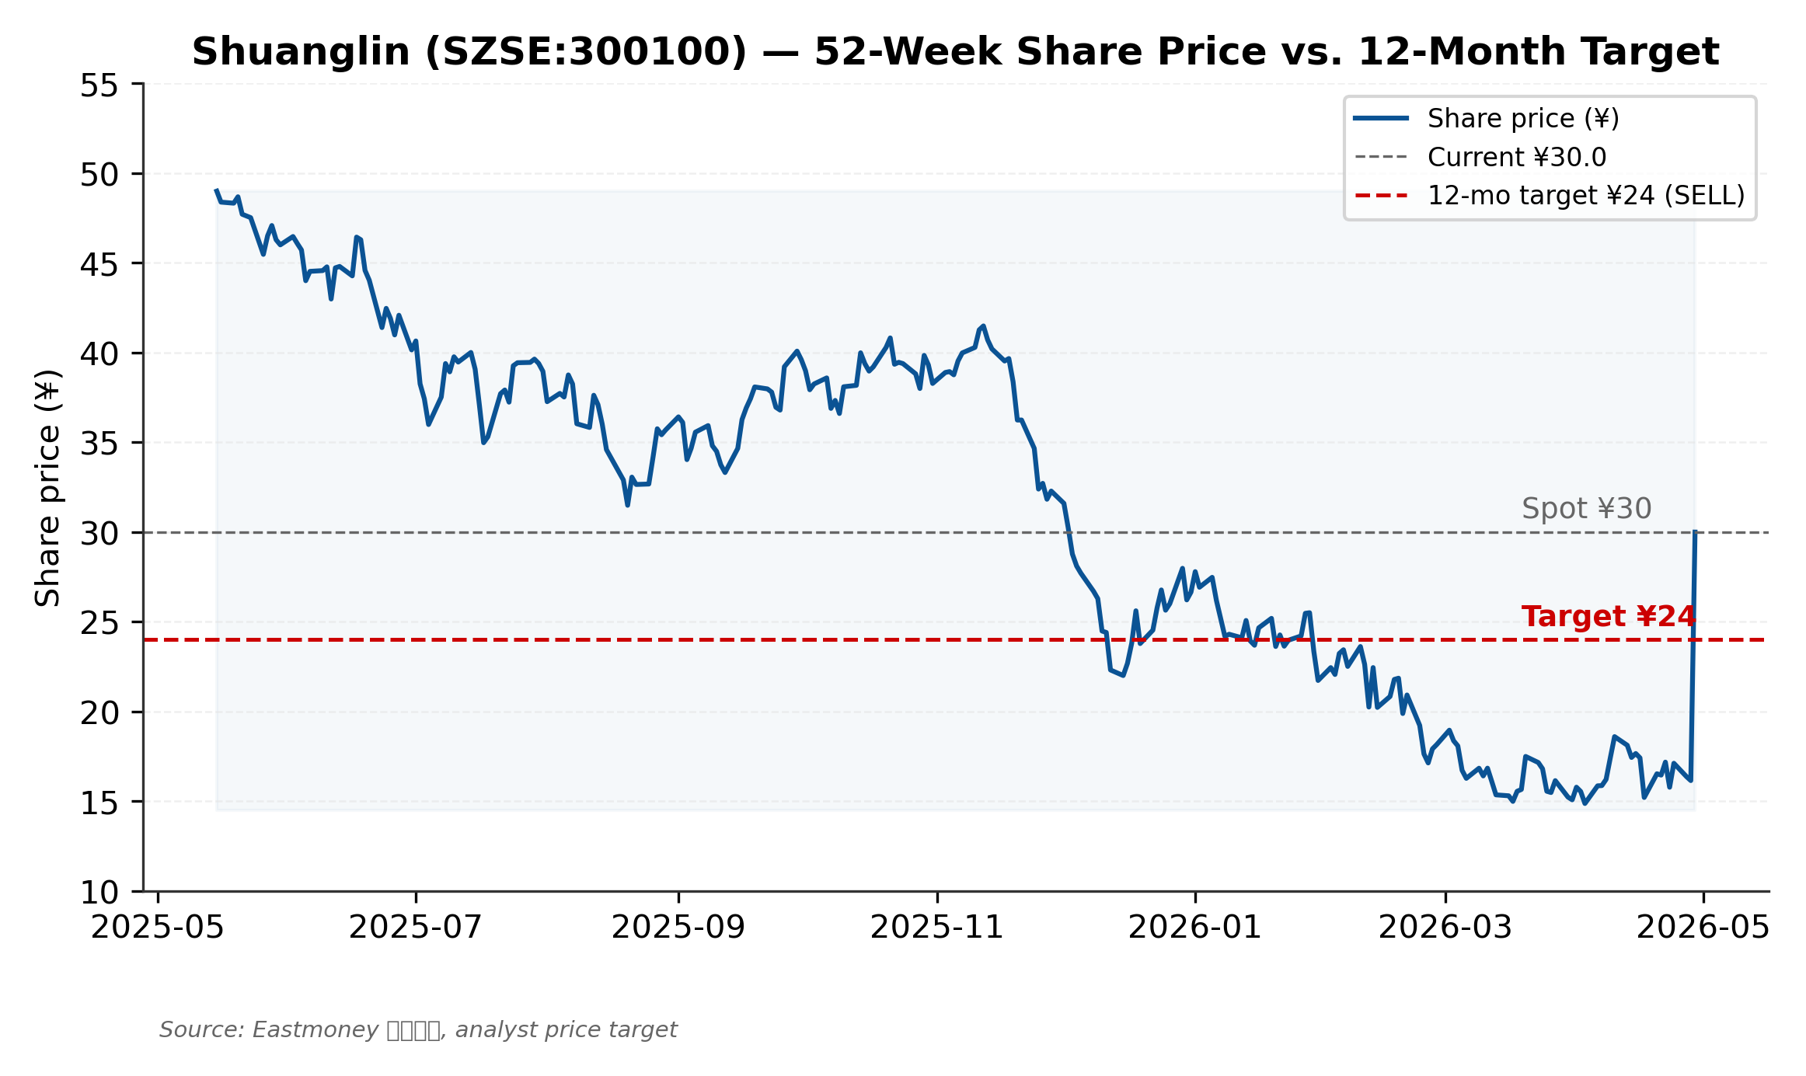
Figure 1. 52-week share price history and 12-month price target of ¥24 (SELL)

Investment Thesis
Why SELL Now: Three Quantitative Arguments
Our SELL rating is grounded in three quantitative arguments that each independently — and collectively reinforce — the conclusion that Shuanglin's current ¥30 quote is above intrinsic value.
1. All Five Core Methodologies Imply a Price Below ¥30
We apply five distinct valuation methods, weighted by our judgment of each method's relevance to Shuanglin's current business mix and 12-month outlook: DCF Base case (20%), DCF Bull case (10%), EV/EBITDA NTM peer median (20%), P/E NTM 2026E peer median (20%), and P/E forward 2027E peer median (30%). Of these, only the DCF Bull case implies a price above ¥30 — and that requires binary events (roller-screw量产 + humanoid OEM定点) that have not yet occurred.
Methodology | Base case (¥) | Range (¥) | Weight | Implied upside
DCF Base (WACC 9.7%, g 2.5%) | 16.62 | 14.96 – 18.28 | 20% | −44.6%
DCF Bull (robot win) | 35.08 | 31.57 – 38.59 | 10% | +16.9%
EV/EBITDA NTM peer median | 23.79 | 18.01 – 37.83 | 20% | −20.7%
P/E NTM 2026E peer median | 21.06 | 16.32 – 38.73 | 20% | −29.8%
P/E forward 2027E peer median | 27.40 | 21.23 – 50.38 | 30% | −8.7%
Weighted-average target | 24.02 | 19.38 – 37.94 | 100% | −20.0%

Source: Company filings; analyst estimates. Peer multiples sourced from Eastmoney, Yahoo Finance, company filings (May 2026 snapshot).
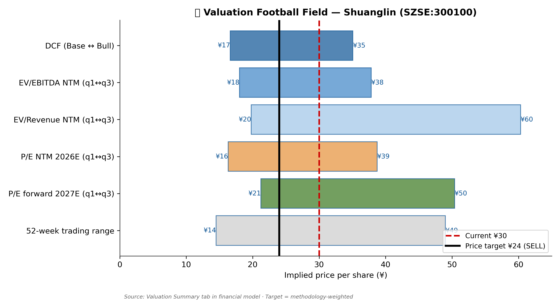
Figure 2. Valuation football field — six methodology ranges with current price (¥30) and target (¥24)
2. Q1 2026 Earnings Confirm Material Margin Compression
The 1Q26 report filed 2026-04-28 disclosed revenue of ¥1,193 mn (−10.4% YoY) and parent net income of ¥72 mn (−47.0% YoY). On an ex-non-recurring basis, NI fell 39.1% — which rules out the 'one-off' narrative. The deterioration in margin profile, combined with customer concentration data disclosed in the 2025 annual report (Top-1 customer 26.1%, Top-5 at 51.6%, up +10 pp over three years), points to direct margin transmission from NEV OEM pricing renegotiations. Annualizing Q1 puts the FY2026 NI run-rate at approximately ¥288 mn — significantly below the ¥399 mn assumed in our base case projection, and 43% below FY2025 actuals.
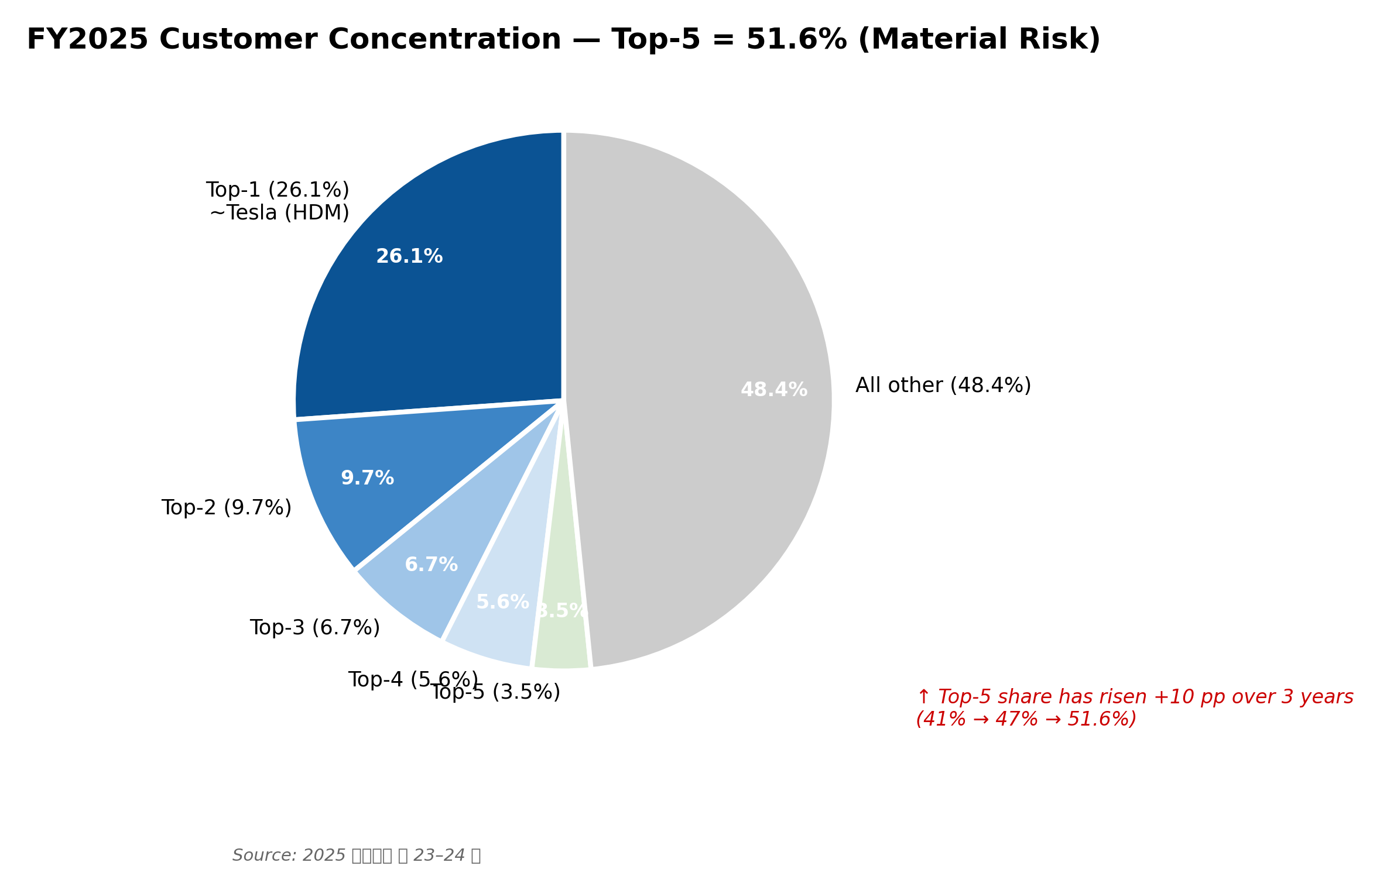
Figure 3. FY2025 customer concentration — Top-1 at 26.1% (single Tesla-shaped exposure)
3. Multiple Compression Dominates Near-Term Risk
Shuanglin trades at a TTM P/E of ~34x — well above the auto-parts peer median of 22x (Eastmoney, May 2026). The premium is justified narratively by the option-value of robot/corner-module pipelines, but the math of multiple compression is unforgiving: if FY2026 EPS lands at ¥0.55 (annualized Q1 run-rate) and the multiple compresses to peer median 22x, the stock would trade at ¥12. Even a milder compression to 28x on ¥0.70 EPS yields ¥19.60 — still well below the current quote. We see consensus EPS revisions (expected after Q2 2026 results in August) as the near-term trigger for this re-rating.
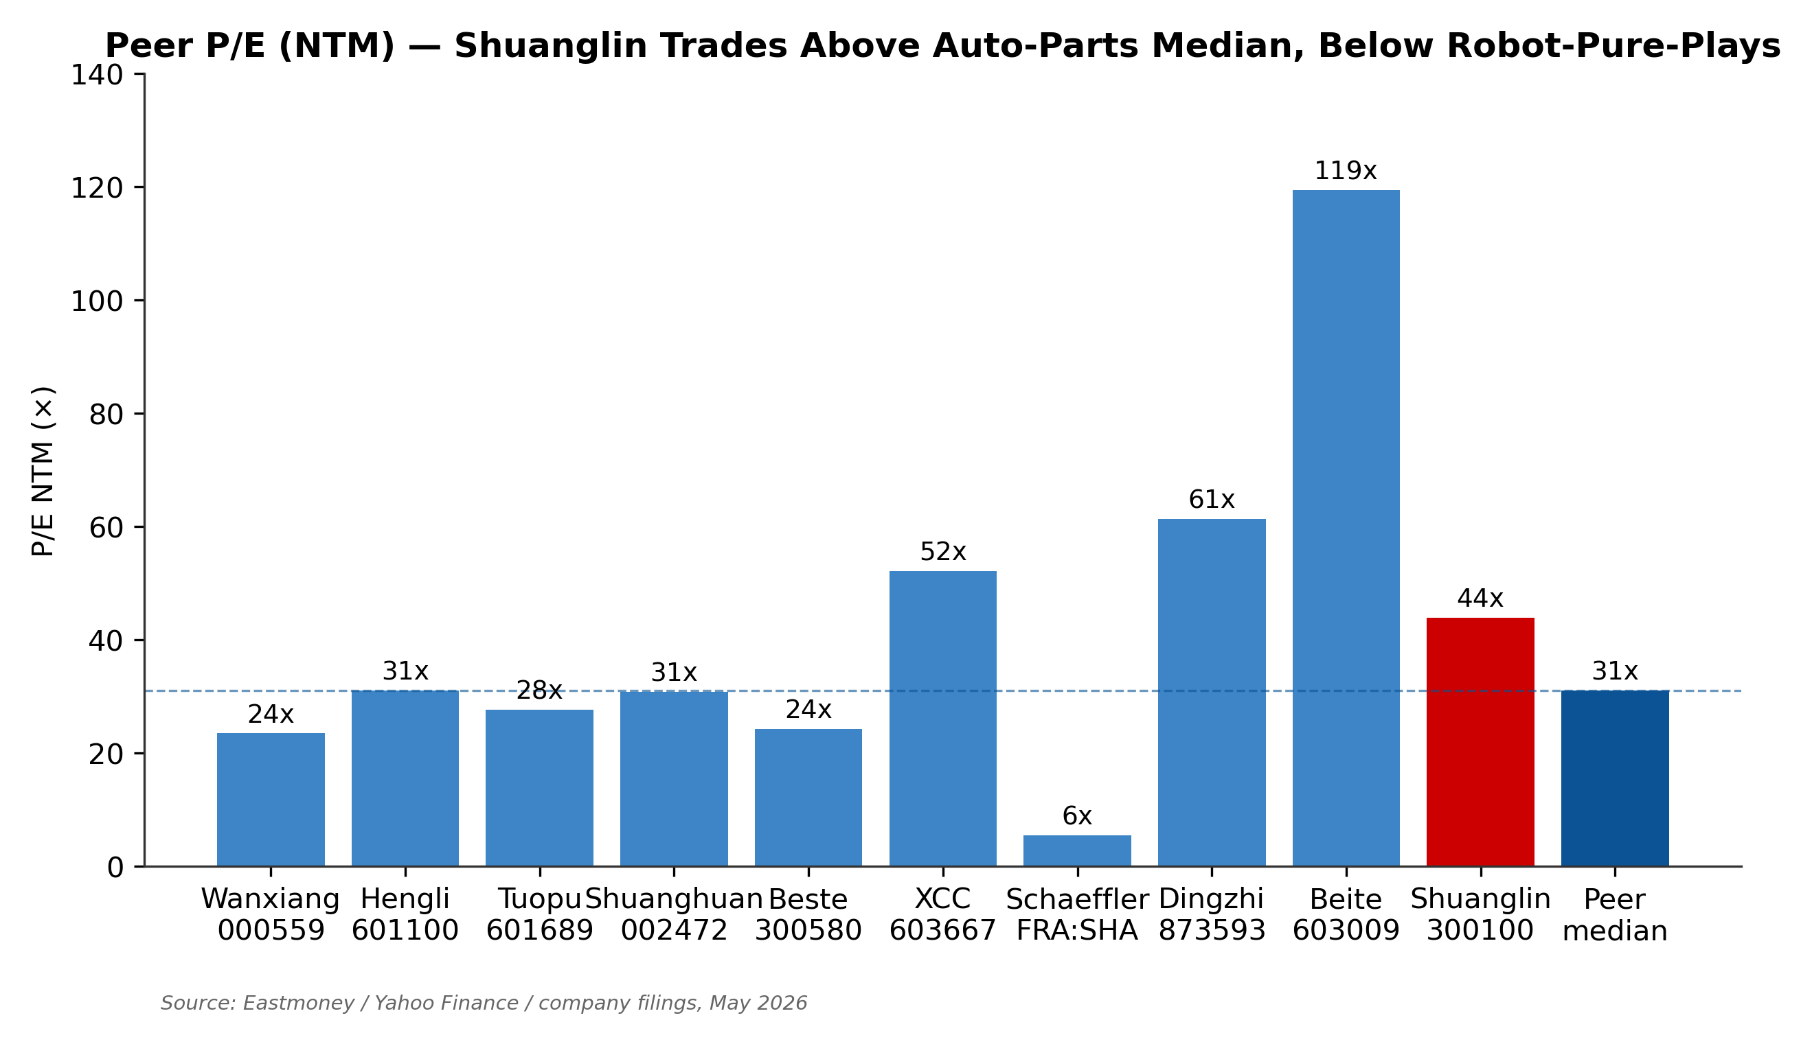
Figure 4. Peer P/E (NTM) — Shuanglin at 43.9x vs. auto-parts median 22x, robot-pure-play 60–119x
Why Not Stronger SELL: Three Offsetting Considerations
1. Real Option Value in Three Emerging Pipelines
Shuanglin is not a one-trick auto-parts pony. Three early-stage initiatives could each individually re-rate the stock by 30–60% if they reach commercial maturity by 2028:
- • Humanoid roller screws: The company manufactured and delivered first sample reverse planetary roller screws (the core linear-actuator for humanoid robot upper/lower-body joints) in mid-2025. A 100,000-unit/year line is scheduled to start production in June 2026, supported by the January 2025 acquisition of Wuxi Kexin Mechanical (a CNC thread-grinder maker, ¥135 mn deal) that closes the screw-manufacturing supply chain. The humanoid roller-screw TAM grows from ~¥1.5 bn in 2026E to ¥50 bn by 2030E (analyst estimates).
- • Smart corner modules: In March 2026, Shuanglin announced a joint venture with Tsinghua University and Huakong Tech to develop smart corner modules — integrated drive + steering + brake + suspension wheel-end modules viewed by Schaeffler and Continental as the next-generation by-wire chassis architecture. First commercial application is a 240-ton fully-electric corner-module mining truck (Inner Mongolia, 100 units in 2026 H1).
- • EHB/EMB ball screws: Multiple Chinese OEMs (Bethel, Likai, BorgWarner) are actively sampling Shuanglin's auto ball-screw products for brake-by-wire (EHB) and electric mechanical brake (EMB) systems. First volume contracts expected in 2026 H2.
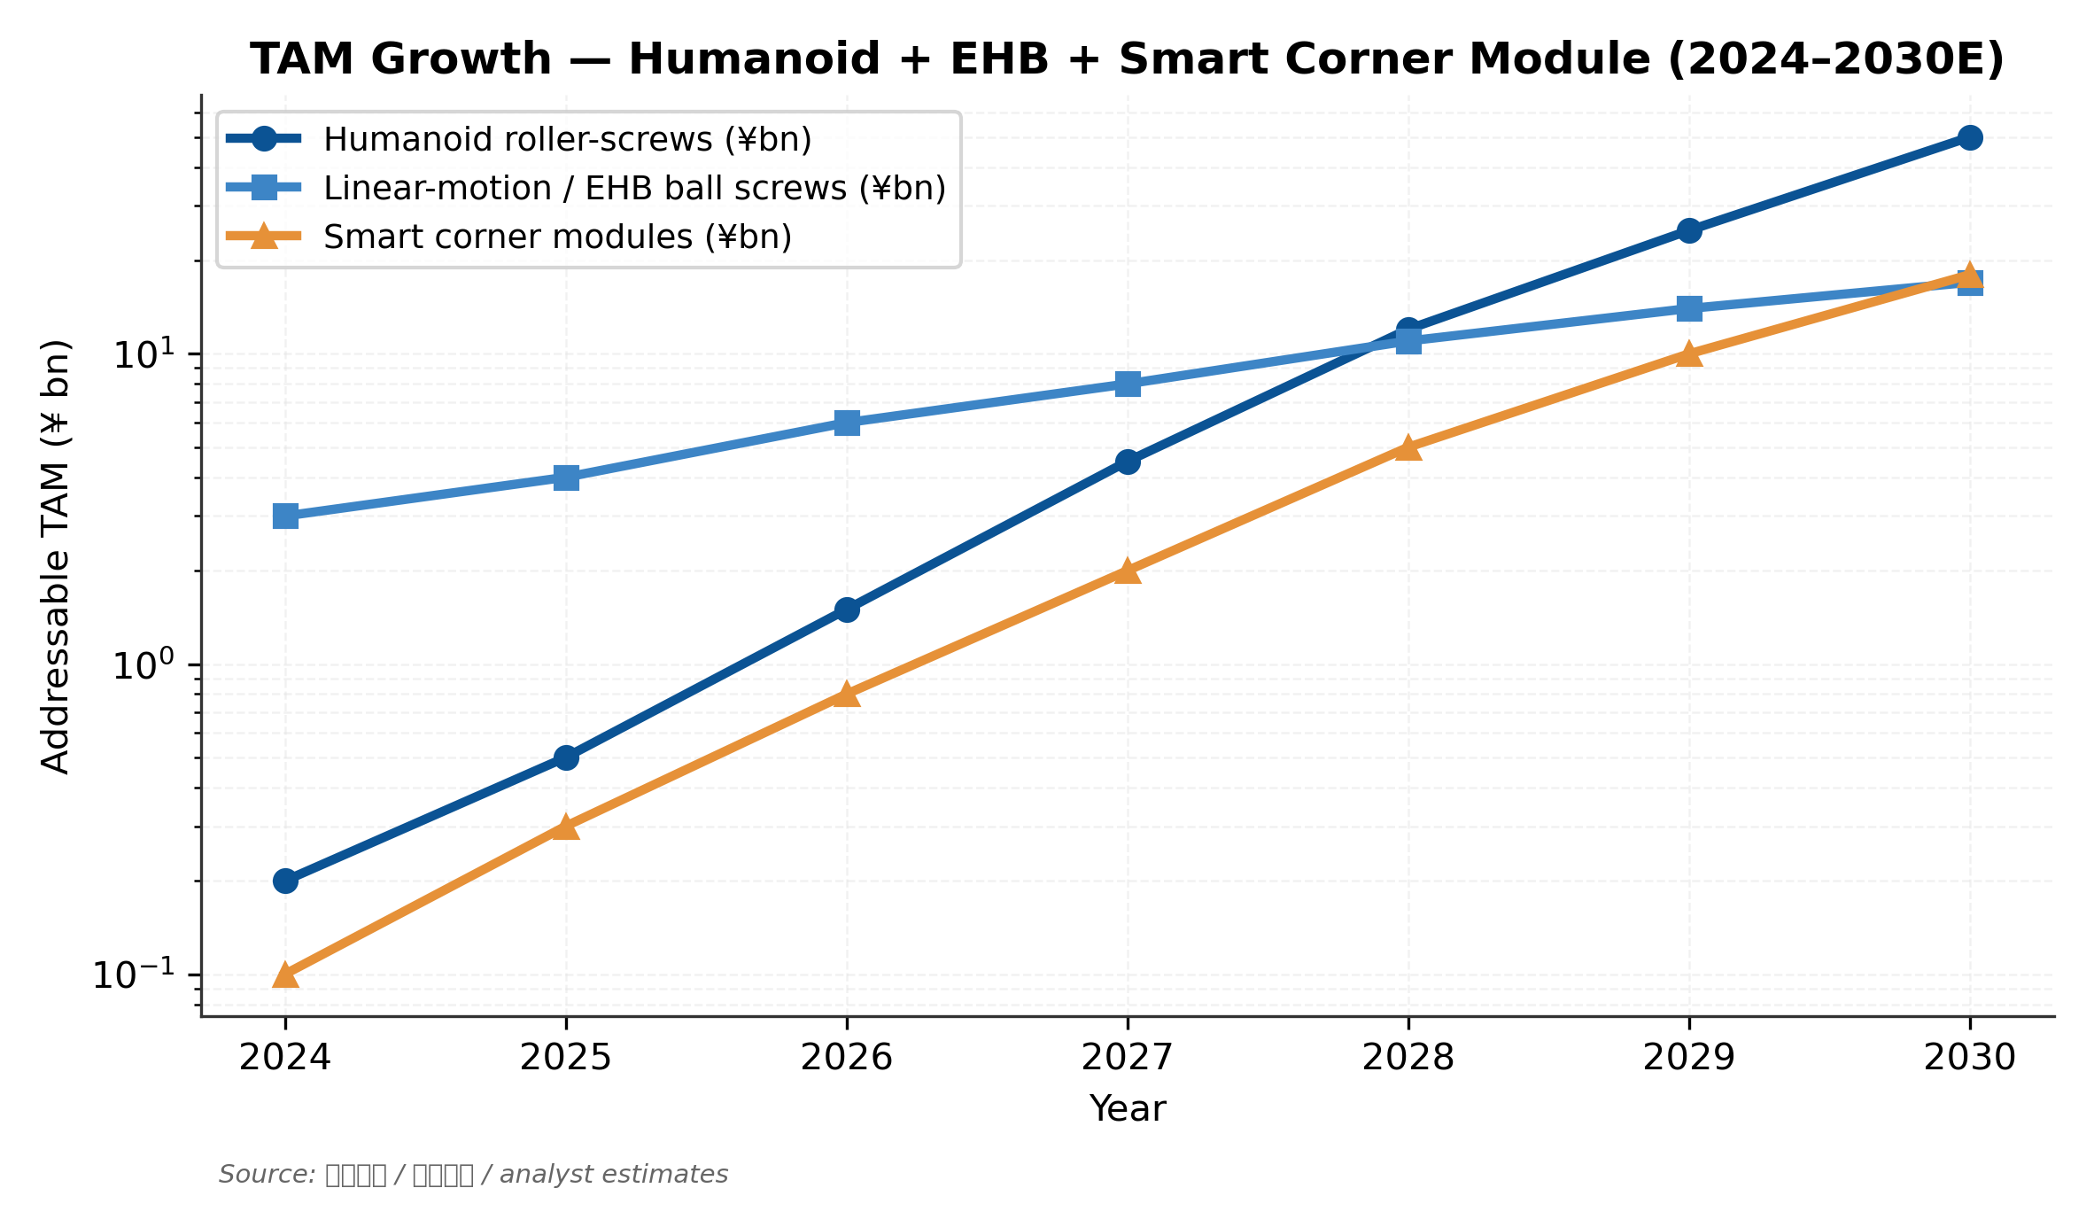
Figure 5. Three emerging TAM trajectories — humanoid + EHB + corner modules grow 100x by 2030E
2. Structural Operating Leverage Confirmed in FY2025
FY2025 ex-non-recurring net income grew +36.6% on revenue of +11.7% — a clear sign that operating leverage from the HDM platform-mix shift toward NEV is real and durable. The headline NI growth of only +1.25% was depressed by one-off items (FY2024 had ¥160 mn of investment income; FY2025 had ¥36 mn of asset disposal gains). The ex-non-recurring trajectory is the cleaner read and supports the long-term thesis that Shuanglin's core HDM + bearings business remains structurally healthy.
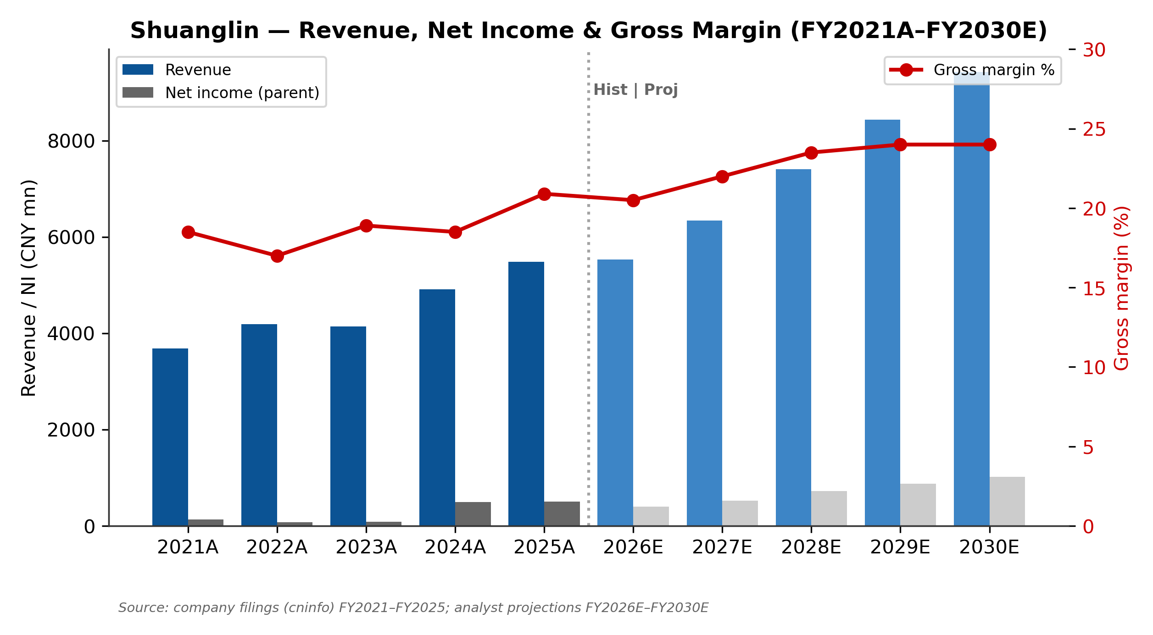
Figure 6. Revenue, net income, and gross margin trajectory FY2021A–FY2030E
3. Conservative Balance Sheet Limits Downside
Shuanglin's net debt at Q1 2026 of approximately ¥600 mn against a market cap of ¥17.2 bn (i.e., net-debt/equity ratio of 4%) is materially below the China auto-parts sector median (~20%). Even with the pending HKEX A+H IPO raising ¥0.8–1.5 bn of equity, the capital structure remains low-risk. This shields downside in scenarios where Q2/Q3 earnings disappoint but emerging products execute — and provides ample cushion to fund the roller-screw, Thailand bearings, and smart-corner-module build-outs through 2028 without further financing.

Risks to Our SELL Rating
Upside Catalysts (would prompt rating upgrade)

▲ Roller-screw量产 line start (Jun 2026)
Confirmation of >80% yield on the 100k-set/year line AND a formal humanoid-robot OEM定点 (program award) would shift our methodology weighting toward DCF Bull (¥35.08) and trigger immediate review. Watch July–September 2026 IR updates and the 2026 H1 半年报 (Aug 2026).

▲ Smart-corner-module mining-truck deliveries (2026 H1)
First 100 units to Inner Mongolia coal-mining site. Successful six-month operation would open the unmanned-AGV market (TAM ¥10–15 bn by 2030E) and validate Shuanglin's adjacency to Schaeffler / Hyundai Mobis e-Corner Module technology.

▲ Q2 2026 earnings recovery
Base case requires gross margin to recover to ~22% by H2 2026. Two consecutive quarters of YoY revenue +5% with stable margins would re-rate base-case projections and raise the methodology-weighted target into the ¥28–32 range.

▲ HKEX A+H IPO confirmation (2026 Q3–Q4)
A+H listing brings ¥0.8–1.5 bn fresh capital; HK pricing premium would compress the A-share discount and raise institutional ownership. Anchor investor identity (HK long-only vs. PE) will signal strategic direction.

▲ EHB/EMB ball-screw design wins
Multiple OEMs (Bethel, Likai, BorgWarner) are actively sampling; first volume contract in 2026 H2 would validate the line-control-chassis pivot and add ¥300–500 mn incremental revenue runway by FY2028.
Downside Catalysts (would extend or deepen the SELL stance)

▼ Continued NEV pricing pressure (high probability)
Q1 2026 showed −47% NI on −10% revenue. Further OEM pricing renegotiations could compress FY2026 EBITDA margin by another 100–200 bp, taking DCF Base toward ¥10–12. Tesla's 2026 platform-pricing reset is the specific risk to monitor.

▼ Roller-screw delay or yield problem (medium probability)
The June 2026 量产 timing is aggressive. Yield issues at the new Kexin grinder line would push first humanoid revenue out 12+ months, collapsing the bull-case option value priced into the current share quote.

▼ HDM share loss to local competitors (medium probability)
Hangzhou Xinjian and Yimai are 2nd/3rd-place HDM players with growing NEV OEM relationships. Tesla in-source remains tail risk (low probability given the 30-month PPAP cycle and high-precision manufacturing know-how barrier).

▼ Thailand operations execution
The Thailand New Torch bearing plant just launched January 2025 and the NEV e-drive line targets 2026 Q1 ramp. Shuanglin's foreign-operations track record is poor — the 2017 DSI Australia transmission integration was impaired in 2022–2023.

▼ Family-controlled governance
The Wu family controls 48.9% via founder Wu Jianbin (4.49% direct) and Shuanglin Group (44.43%). Transformative M&A (e.g., another DSI-style related-party injection) could be unilaterally executed. The 2017 DSI deal is the cautionary precedent.

Company Overview
Business Description and History
Shuanglin Co., Ltd. is a Ningbo (Zhejiang)-headquartered manufacturer of automotive parts and robotics components, listed on the Shenzhen Stock Exchange's ChiNext (创业板) board under SZSE:300100 since August 2010. The company's roots trace to 1989 when founder Wu Jianbin's family established a small plastic-parts workshop in Ninghai county, which gradually transitioned into automotive supply in the late 1990s. The pivotal R&D project began in 2000 with the development of HDM (horizontal drive module) — the precision worm-gear and ball-screw mechanism that powers fore-aft adjustment in electrically-adjustable car seats. HDM became the company's signature product, with annual unit shipments breaking 30 million in 2025 and Chinese market share at 32.8% (industry source: 智研咨询 2025).
Post-IPO, Shuanglin grew through two major acquisitions: (i) the August 2014 acquisition of Hubei New Torch (Hubei Xinhuoju) for ¥820 mn cash, securing entry into the wheel-hub bearing category (now the company's second-largest profit pillar at ¥1,415 mn revenue / ¥150.8 mn NI in FY2025); and (ii) the October 2017 ¥2.3 bn acquisition of DSI Australia (automatic transmissions) via private placement to controlling shareholder Shuanglin Group. The DSI integration proved difficult — the global transmission market shifted toward CVT/DCT/EV powertrains, and DSI's traditional 6-AT business eroded, leading to goodwill impairments in 2022–2023. Earnings troughed in 2022 (¥75 mn NI, vs. peak ¥495 mn in 2018 pre-integration) before a sharp recovery in 2024 (¥497 mn NI, +514% YoY) on HDM volumes ramping with NEV adoption.
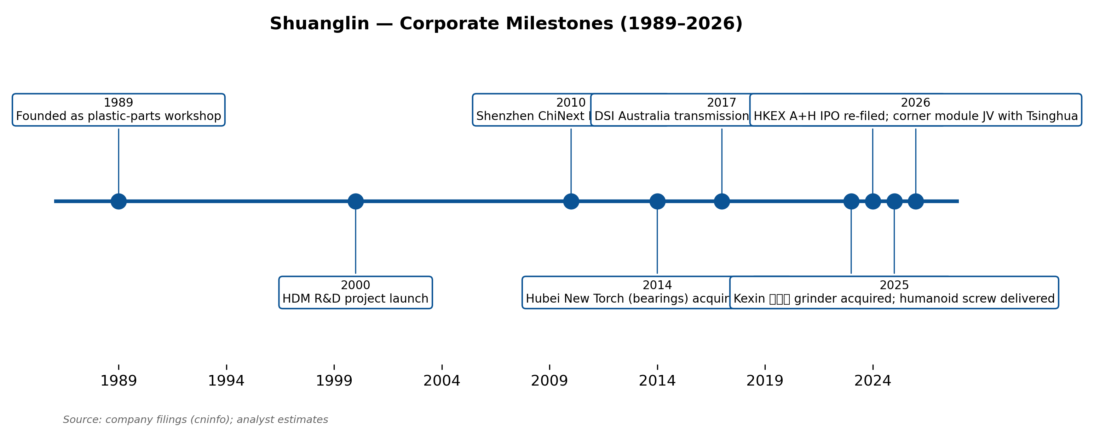
Figure 7. Shuanglin corporate milestones — 1989 founding through 2026 HKEX IPO and Tsinghua JV
The current strategic narrative — and the principal driver of valuation premium — is Shuanglin's Third Pivot launched in 2023: a stated transformation from 'automotive parts' to 'smart drive solutions provider.' Concretely, this means leveraging HDM's worm-gear / ball-screw / miniaturized-precision-manufacturing know-how into three adjacent end markets: humanoid robots (reverse planetary roller screws + joint modules), smart corner modules (wheel-end drive + steer-by-wire + brake-by-wire integrated assemblies), and low-altitude eVTOL aircraft (30–250 kW e-drive systems). These three pipelines collectively contribute <5% of FY2025 revenue but represent the binary upside that drives the current valuation premium.
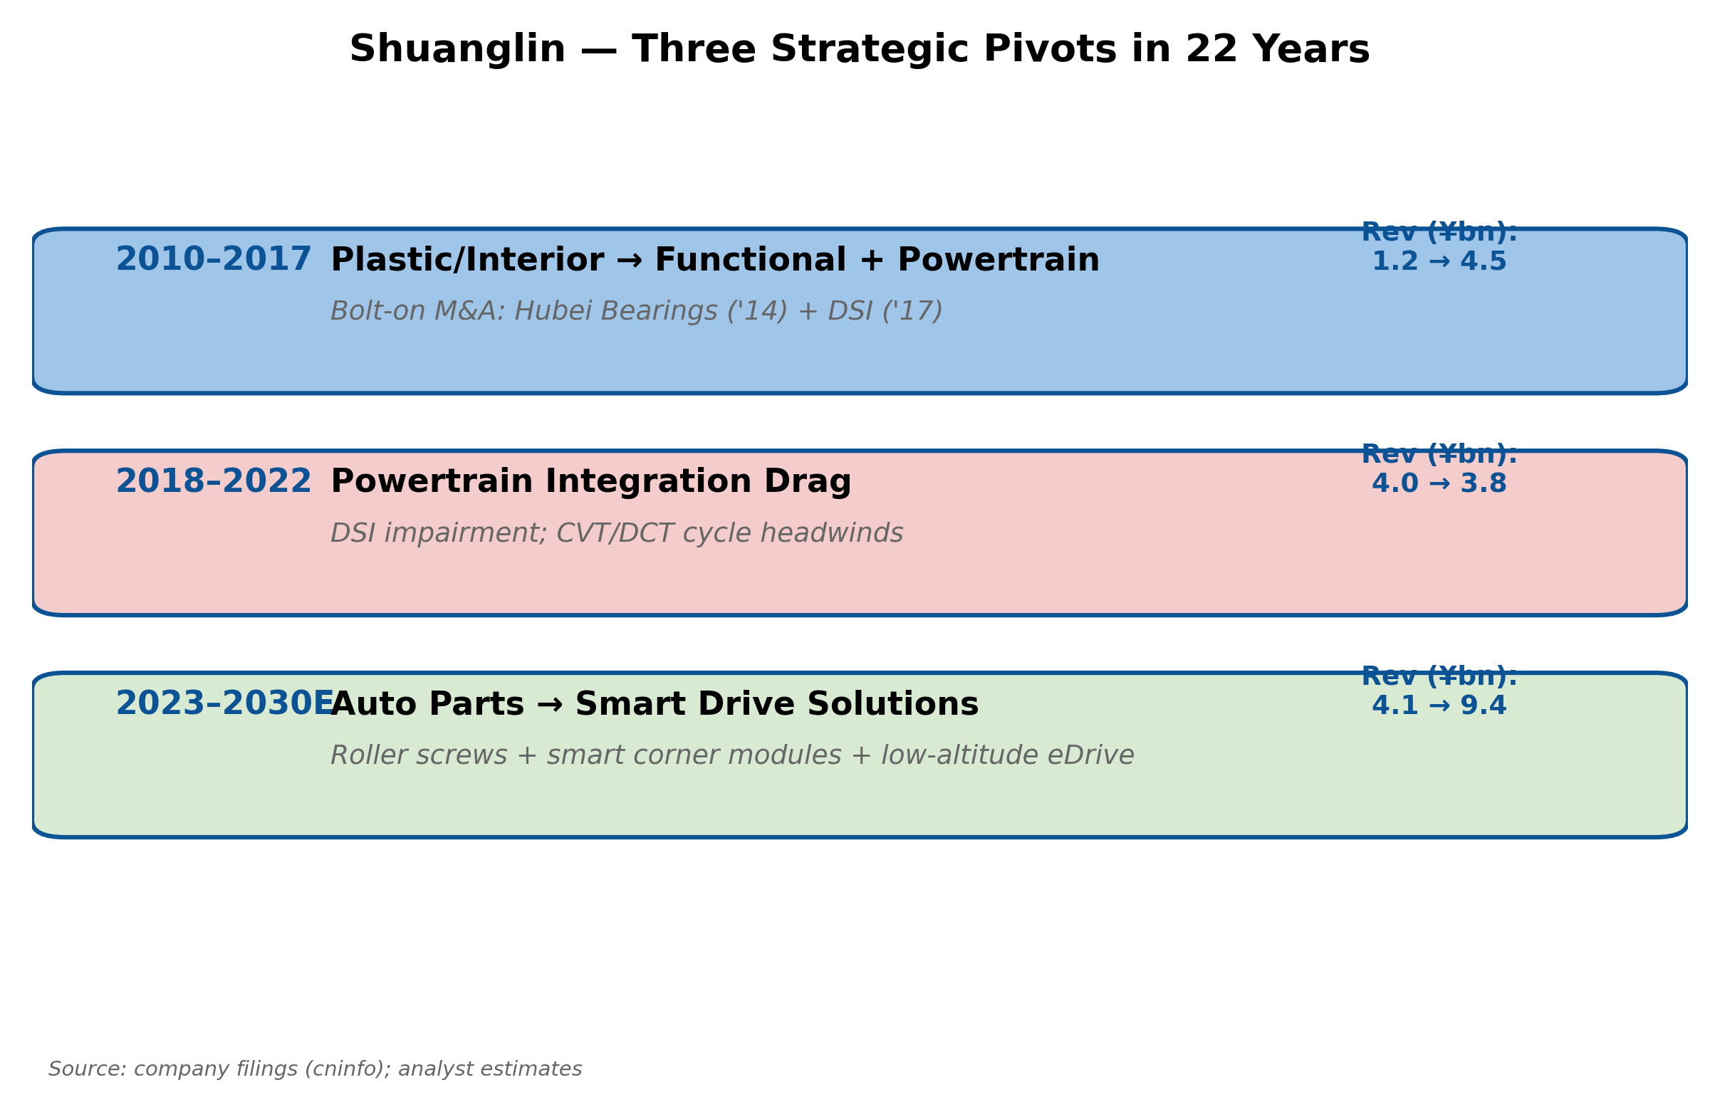
Figure 8. Three strategic pivots in 22 years — current pivot to smart-drive solutions
Ownership and Governance
Shuanglin is a family-controlled company with concentrated insider ownership. As of the Q1 2026 filing, controlling shareholder Shuanglin Group holds 44.43% of shares; founder Wu Jianbin directly holds an additional 4.49% (with 75% of his stake under lockup as restricted shares); the 2025 employee stock-ownership plan adds 0.35%. The combined insider voting bloc is approximately 49.3%, with the Wu family (Wu Jianbin, sister Wu Weijing, sister Wu Xiaojing) executing a binding concert-party agreement. Founder Wu Jianbin chairs both the board and acts as CEO; he has held the chairman role continuously since November 2004 (age 24 at appointment) and now stands as a 22-year tenured chief executive — a notable stability profile in China's Tier-1 supplier space.
Governance risk is heightened by the family-control structure. The 2017 DSI Australia deal — a related-party transaction with Shuanglin Group — illustrates the precedent for unilateral transformative M&A. Minority shareholders had limited practical recourse to oppose the transaction even as subsequent impairments showed the integration logic had been flawed. The ongoing HKEX A+H IPO (re-submitted March 2026 with CITIC Securities and GF Securities as joint sponsors) could be the next inflection point — successful listing could improve governance discipline through international institutional ownership.
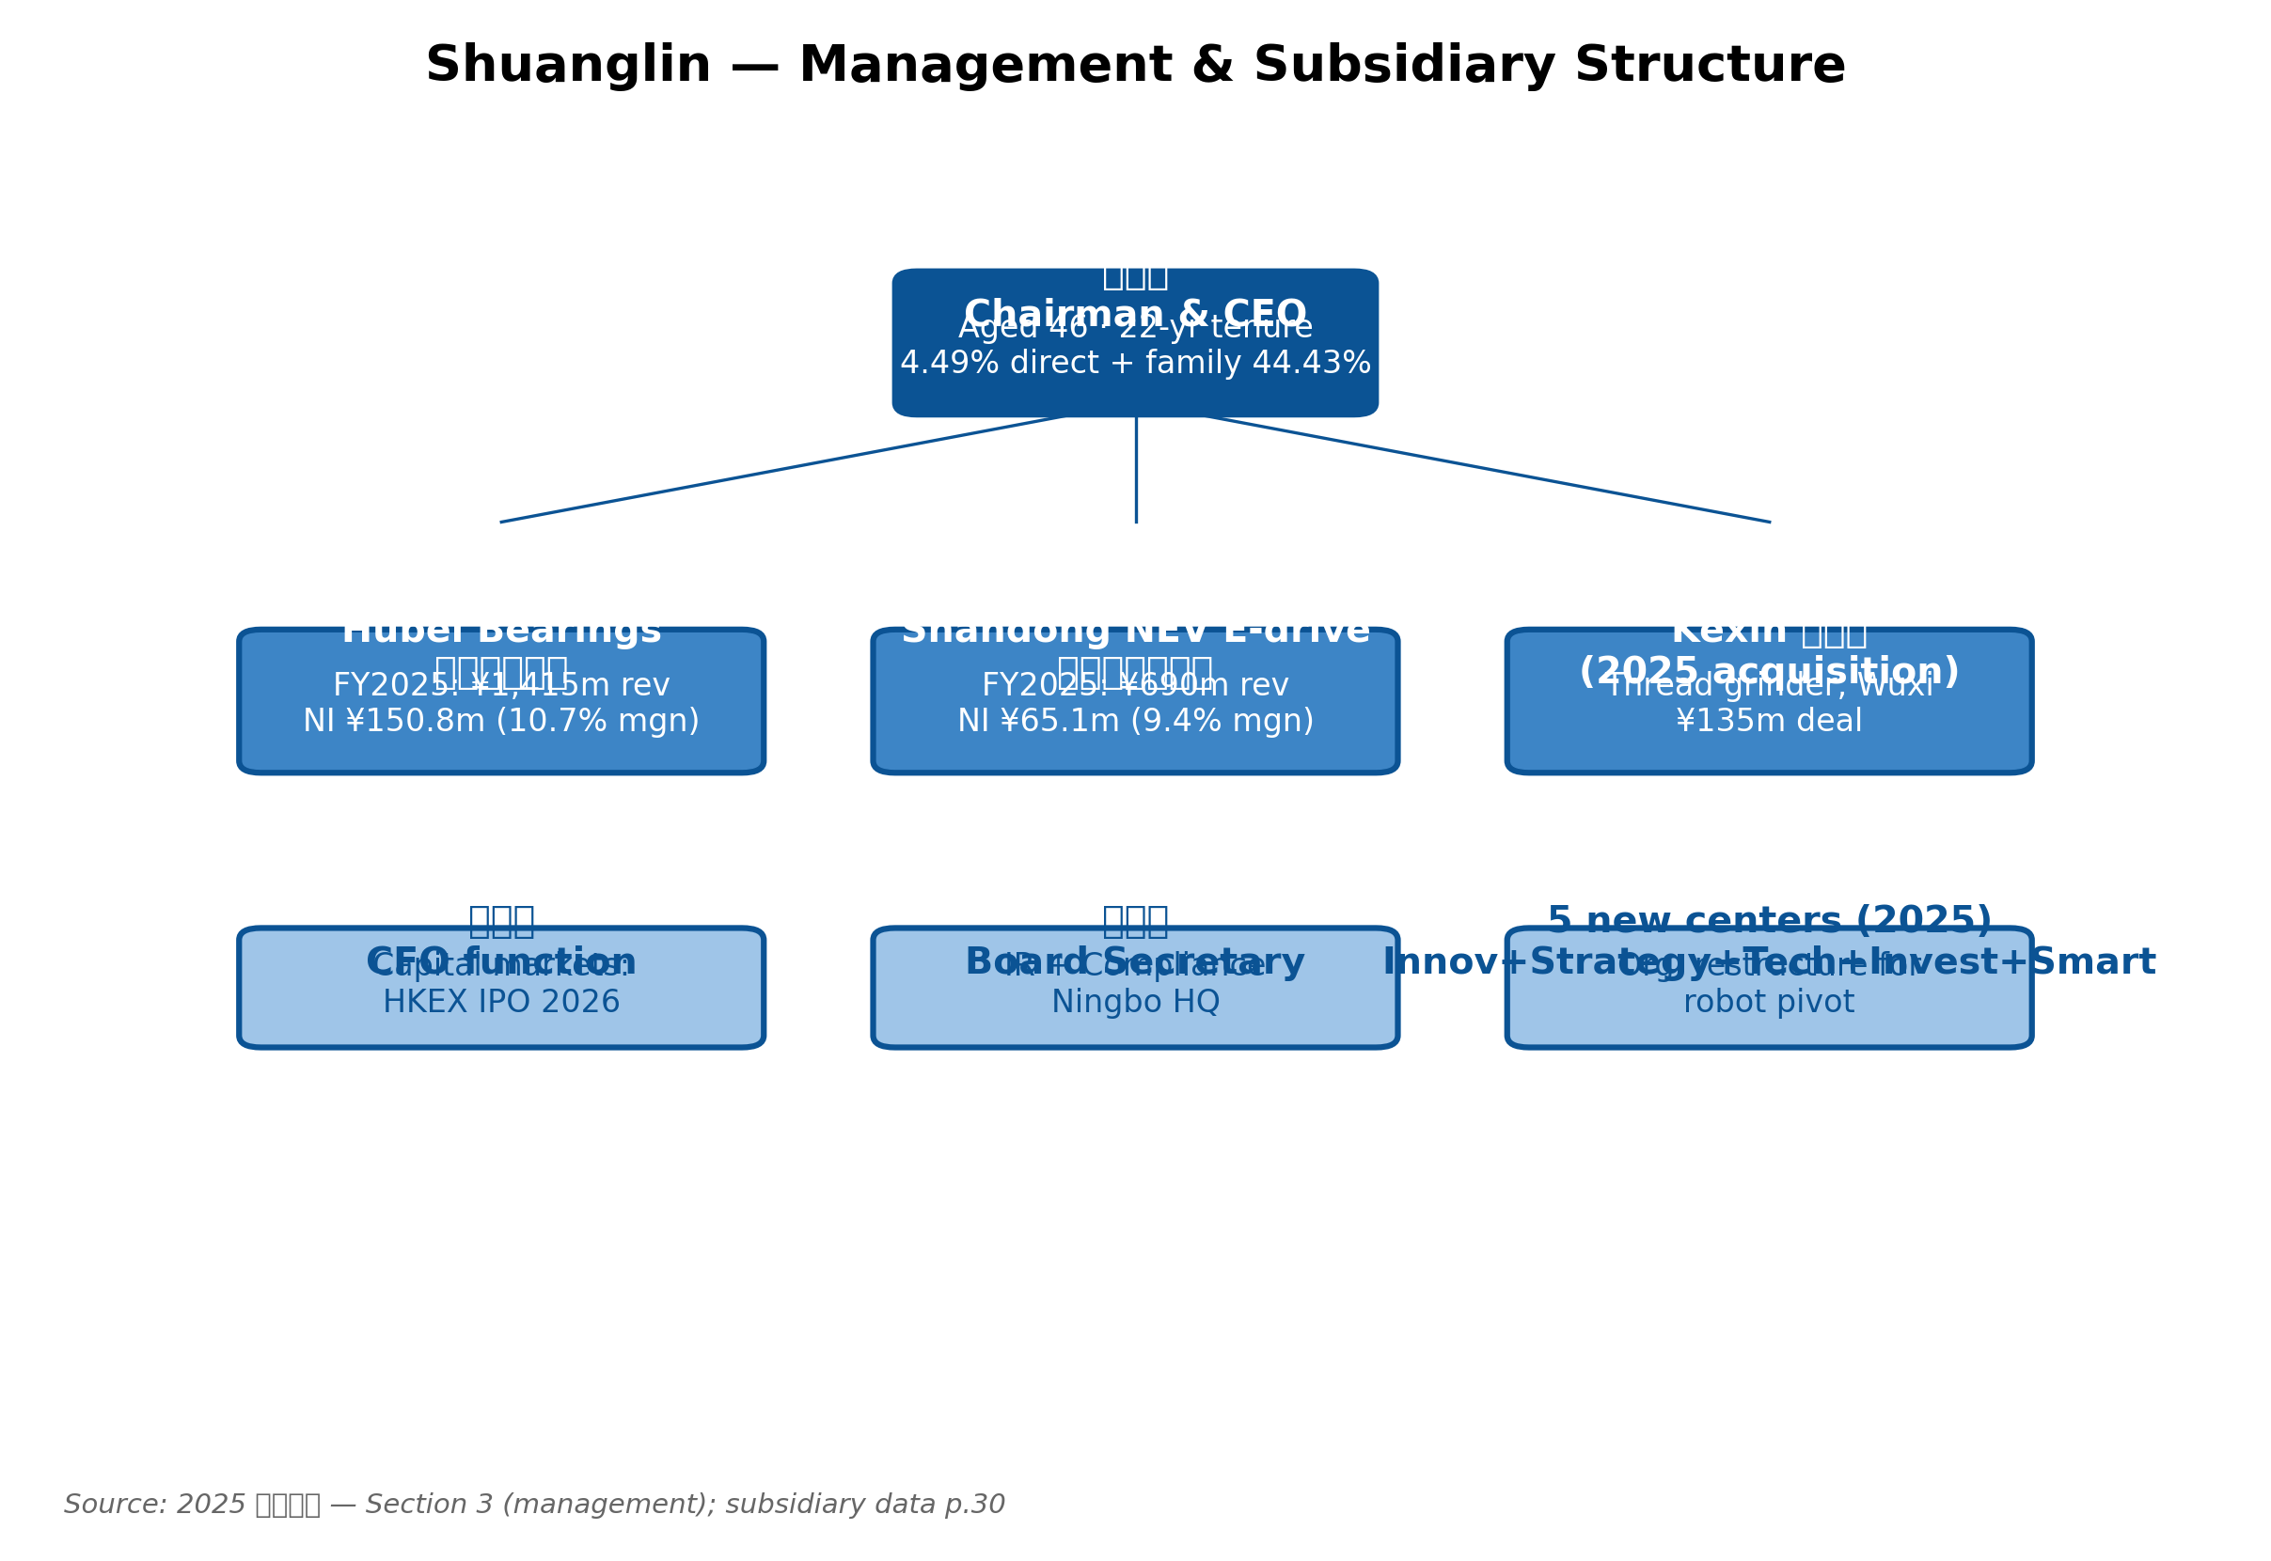
Figure 9. Management structure and key operating subsidiaries (FY2025 revenue contribution)
Management Team — Individual Profiles
Wu Jianbin (邬建斌) — Chairman and CEO
Wu Jianbin, born September 1980 in Ninghai (Zhejiang), is the architect of Shuanglin's 22-year strategic trajectory. He holds dual EMBA degrees — Shanghai National Accounting Institute (Finance and Financial Management) and Cheung Kong Graduate School of Business. Wu took the chairman role in November 2004 at age 24, a notably young appointment that reflected both the family-control structure and his early demonstration of strategic capability. As 'second-generation' family successor, he has led the company through three distinct chapters.
First, from 2000–2010, Wu oversaw the HDM product industrialization — taking the seat-positioning motor concept from zero to volume production, ultimately reaching 30 million annual units by 2025 with 32.8% domestic and 15.1% global market share. This represents the foundational moat of the company. Second, in 2010 he led the ChiNext IPO, raising capital that financed the subsequent acquisition wave: Hubei New Torch in 2014 (¥820 mn) and the larger DSI Australia deal in 2017 (¥2.3 bn). The DSI transaction is now widely viewed as the major strategic misstep — the integration challenges and subsequent impairments cost the company several years of earnings momentum and credibility. Third, from 2023 onward, Wu has championed the company's 'second-generation entrepreneurship' positioning Shuanglin as a 'smart drive solutions provider' rather than auto-parts company. The roller-screw, corner-module, and eVTOL bets are his signature current-era initiatives.
Wu Jianbin directly holds 25.69 mn shares (4.49% of total), with 19.27 mn under lockup as restricted shares. Through Shuanglin Group and upstream entities (Ningbo Zhiyuan Investment 57.14%, Ninghai Baolai Investment 42.86%), he and sisters Wu Weijing and Wu Xiaojing jointly control 48.9% of voting rights via a binding concert-party agreement. He is also a Ningbo Municipal People's Congress representative, director of the China Youth Entrepreneurs Association, and recipient of multiple municipal/provincial entrepreneur awards (2008 Ningbo Excellent Entrepreneur, 2014 Ningbo Labor Medal, 2022 Ningbo Charity Award). His public communications consistently emphasize 'technology faith without compromise' — a positioning consistent with his engineering-plus-finance background, and reflected in the 2025 Shareholder Letter framing 'industrialization challenges of reverse-planetary roller screws' as both moat and credo. The family-control concentration limits minority-shareholder influence on major strategic decisions, but also creates decision-speed advantages and long-horizon strategic patience that are rare in China's mid-cap industrials.
Wu Huaiying (武淮颖) — CFO Function (Chief Accountant)
Wu Huaiying serves as the responsible person for accounting affairs (主管会计工作负责人), the effective CFO function. The company has not publicly disclosed his individual biographical details with the level of granularity typical for Western public companies, but his completed transactions during 2025 include three significant items. First, the May 2025 ¥1.5 bn A-share private placement was withdrawn after 7 days when regulatory dynamics shifted; the company immediately pivoted to the HKEX A+H IPO route — demonstrating execution agility. Second, the ¥135 mn cash acquisition of Wuxi Kexin in January 2025 was completed using internal cash flow without taking on new debt, demonstrating capital discipline. Third, in March 2026, the HKEX A+H IPO prospectus was re-submitted with CITIC Securities and GF Securities as joint sponsors.
The CFO team's balance-sheet management is conservative. Year-end 2025 short-term debt was ¥565 mn (8.05% of total assets), long-term debt was reduced to zero (vs. ¥100 mn at year-end 2024), and the current portion of long-term debt of ¥240 mn is well-covered by ¥735 mn of cash. Compared to the broader Chinese auto-parts mid-cap universe (median net-debt-to-EBITDA of ~1.5x), Shuanglin's <1.0x leverage is conservative — leaving optionality for both organic CapEx (roller-screw, Thailand expansion, smart corner module) and potential acquisition (after the DSI lesson, however, large M&A is unlikely in the near term).
Zhu Liming (朱黎明) — Board Secretary
Zhu Liming serves as Board Secretary, based in the Ningbo Ninghai headquarters, and is the company's primary point of contact for regulators and investors. During 2025, the company conducted three formal investor-relations events covering roller-screw product positioning, Kexin acquisition rationale, overseas expansion strategy, and quarterly operating updates. The investor-relations cadence has been disciplined — earnings releases on schedule, no material guidance revisions outside of formal channels, and increasingly detailed disclosure of segment and subsidiary financials in the FY2024 and FY2025 annual reports.
Key Subsidiary Leadership
Below the parent-company level, two operating subsidiaries are critical to the consolidated results. Hubei Shuanglin Bearings (formerly Hubei New Torch, the 2014 acquisition) generated ¥1,415 mn revenue and ¥150.8 mn net income in FY2025 — a 10.7% net margin, materially above the consolidated 9.2% — making it the second-largest profit pillar after the parent's HDM business. It holds national-grade Torch Plan project status, supports BYD, NIO, Leapmotor, Avatr, Zeekr, AITO M8, Dongfeng Nissan N7 (2025 launch), Hongqi, Changan Ford, and XPeng vehicle programs. Shandong Shuanglin New Energy (NEV e-drive) generated ¥690 mn revenue and ¥65 mn net income (9.4% margin) supporting Wuling Hongguang Mini EV 3rd/4th generations, FAW Bestune Mini, Chery ice-cream mini-EV, and Changan glutinous-corn mini-EV applications. Both subsidiaries are 100%-owned (no minority interest).
The 2025 corporate reorganization added five new strategic centers — Innovation Incubation Center, Strategic Technology Center, Strategic Expansion Center, Strategic Investment Center, and Intelligence Center — designed to support the transition from auto-parts to smart-drive-solutions provider. These five centers serve as the institutional architecture for the company's current and future bets on roller screws, corner modules, and low-altitude eVTOL.
Product Portfolio
Shuanglin organizes its product portfolio along three reporting segments under the FY2025 restated taxonomy: Transmission/Drive/Intelligent (¥3,270 mn, 59.6% of revenue, GM 23.88%); Auto Interior/Exterior trim (¥1,946 mn, 35.5%, GM 14.32%); and Other—primarily Kexin grinder equipment and Shuanglin Molds (¥260 mn, 4.7%, GM 31.87%). Rental income (¥7.8 mn) is a rounding item but disclosed separately.
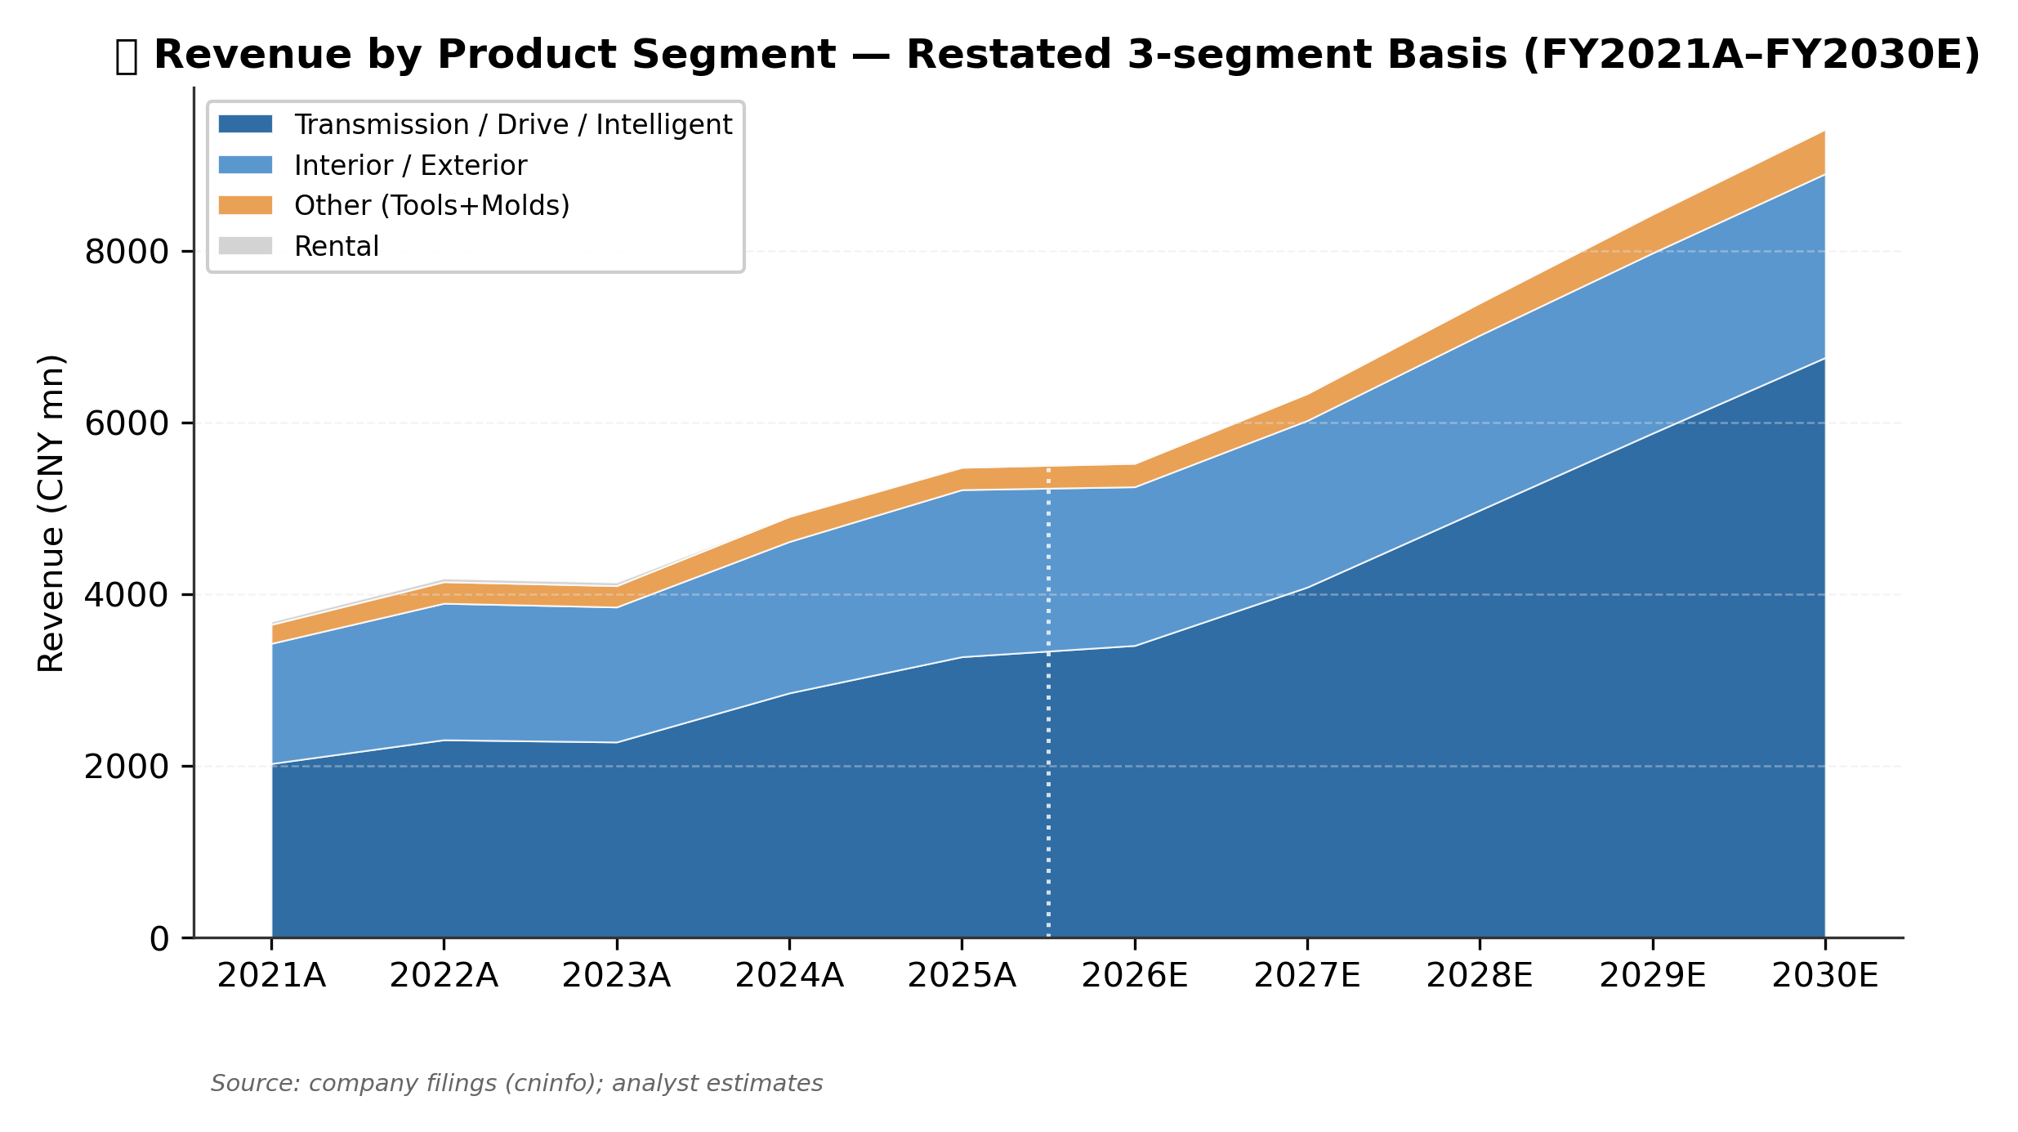
Figure 10. ⭐ Revenue by product segment FY2021A–FY2030E — mix shifting toward Transmission/Drive
Within Transmission/Drive/Intelligent — the most strategically important segment — we identify eleven distinct product lines, each at a different stage of maturity:
Product line | FY2025 revenue (¥mn, est) | Moat | Stage
HDM 座椅水平驱动器 | ~1,200 | Strong (33% share) | Cash cow
Wheel hub bearings (Hubei) | 1,415 | Medium (#3 share) | Growth
NEV e-drive (Shandong) | 690 | Weak (commoditized) | Scale chase
Seat motors | 200 | Weak (late entrant) | Growth
Headrest actuator | 50 | Early lead | Emerging
Auto ball-screws (EHB/EMB) | 30 | Adjacency | Pre-volume
Steering folding actuator | 20 | Customer-locked | Pre-volume
Roller screws (humanoid) | 30 | Equipment + know-how | ⭐ Option
Joint modules (humanoid) | 15 | Vertical integration | ⭐ Option
eVTOL e-drive 30–250 kW | 20 | Platform synergy | ⭐ Option
Smart corner modules | 10 | Tsinghua JV + scarcity | ⭐ Option

Source: 2025 年度报告; Task 1 company research. Revenue allocations are analyst estimates from segment-level disclosure plus subsidiary breakouts.
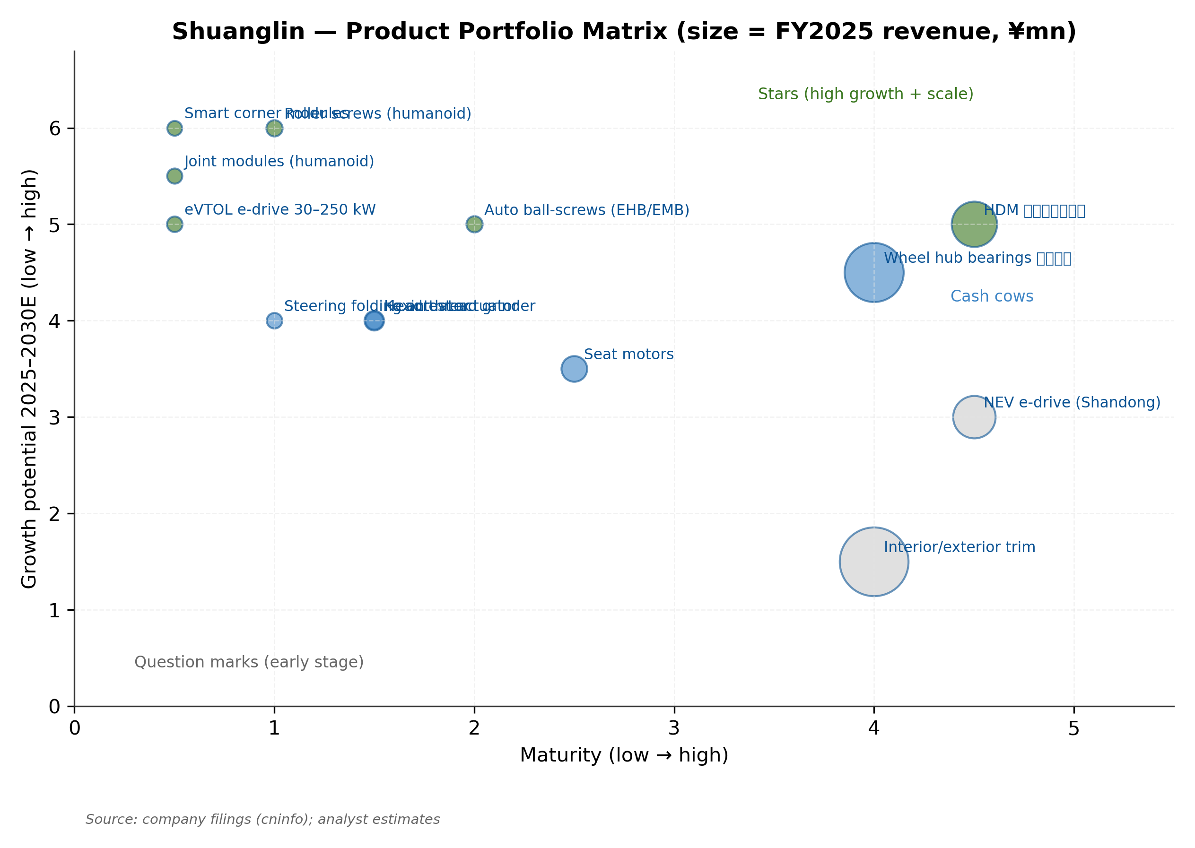
Figure 11. Product portfolio matrix — growth vs. maturity, bubble size = FY2025 revenue
Auto Interior/Exterior Trim — Cash Cow with Limited Growth
The Auto Interior/Exterior segment (¥1.95 bn revenue, 35.5% of FY2025 sales, 14.3% gross margin) is a mature business serving China's mid-market OEMs (Wuling, Changan, XPeng, Volkswagen China). Products include bumpers, door panels, B/C pillar trim, safety pads, precision injection-molded parts, PEEK specialty-material parts, and ignition coils. This segment is intentionally not growing — the company manages it as a cash flow harvest with annual revenue growth in the 2–5% range. We assume −5% in FY2026 (reflecting NEV pricing pass-through), then 3–5% growth annually through FY2030E.

Customers and Market Position
Customer Profile and Concentration Risk
Shuanglin sells direct (no distributor) to two customer types: (i) Tier-1 global automotive suppliers — Faurecia, UAES, Brose, Autoliv, MAHLE, ZF, Lear, BorgWarner, Adient, Magna, Valeo; and (ii) integrated OEMs — including Tesla (the largest single customer at an estimated 26% of FY2025 revenue), BYD, NIO, Li Auto, XPeng, Chery, Geely, Great Wall, Changan, Leapmotor, SAIC-GM-Wuling. Contract structure is project-by-project (program-by-program), with each design win carrying a 5–7 year vehicle-lifecycle revenue commitment. PPAP (Production Part Approval Process) cycles take 18–36 months from initial RFQ to volume, creating significant switching costs and incumbency advantages.
However, customer concentration has materially increased. Top-5 customer share rose from 41% in FY2023 to 47% in FY2024 to 51.6% in FY2025 — a 10-percentage-point increase over three years. The single Top-1 customer (anonymized in filings but commonly inferred to be Tesla based on the HDM + North American supply pattern) reached 26.1% in FY2025. Both metrics now exceed institutional thresholds for material concentration risk (Top-1 >20%, Top-5 >50%). The Q1 2026 weakness demonstrates the transmission mechanism: a single major customer renegotiating prices, or introducing in-house alternatives, has outsized impact on consolidated revenue and EBIT margin.

Figure 12. FY2025 customer concentration — Top-1 26.1%, Top-5 51.6% (both material)
Competitive Position by Product Line
HDM — Clear Market Leader, Stable Moat
Shuanglin holds 32.8% of China's HDM (horizontal drive module) market and 15.1% of the global market, ranking #1 and #2 respectively (industry source: 智研咨询 2025). Competitors include Yimai (14% China share) and Hangzhou Xinjian (9% China share). The moat is multi-layered: (a) scale and yield advantages from 30+ million units of annual production volume; (b) deep Tier-1 relationships requiring 2–3 year PPAP qualification cycles; (c) cross-product synergy with seat motors and headrest actuators (same factory floor, shared tooling); (d) global presence (China + Thailand + North America) matching OEM regional supply needs.
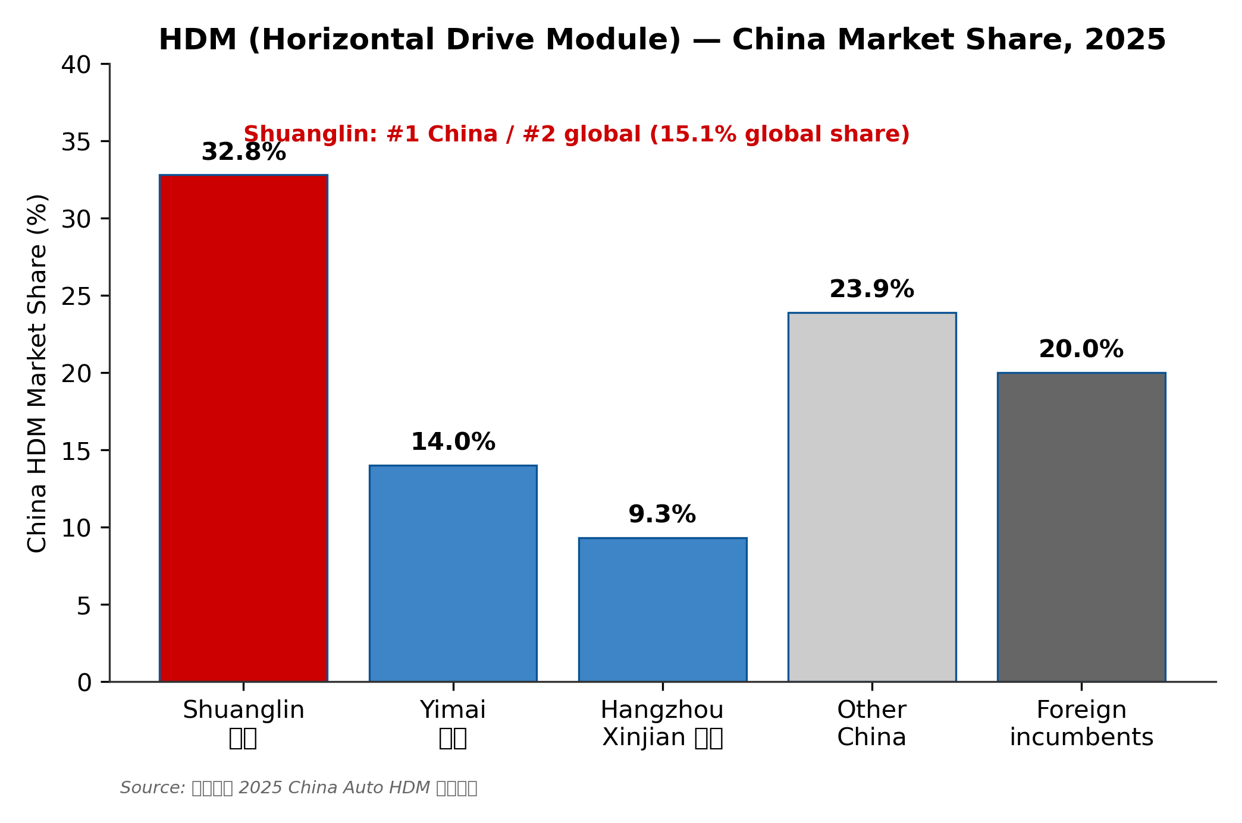
Figure 13. HDM China market share 2025 — Shuanglin clear #1 at 32.8%
Wheel Hub Bearings — Strong #3 with NEV Tailwind
The Hubei Shuanglin Bearings subsidiary (formerly Hubei New Torch, acquired 2014) holds an estimated 9% share of China's wheel-hub bearing market, ranking #3 behind Wanxiang Qianchao (15%) and Renben Bearings (12%). Foreign incumbents — SKF, NSK, NTN, Schaeffler, JTEKT — collectively still hold ~35% of the China market, primarily serving joint-venture OEMs and high-end domestic brands. Hubei Bearings' competitive positioning has improved markedly through NEV penetration: 2025 design wins included Avatr, Zeekr, AITO M8, Dongfeng Nissan N7, Hongqi, Changan Ford, and XPeng. The Thailand bearing plant (launched January 2025) extends production footprint to support OEMs' Southeast Asian operations.
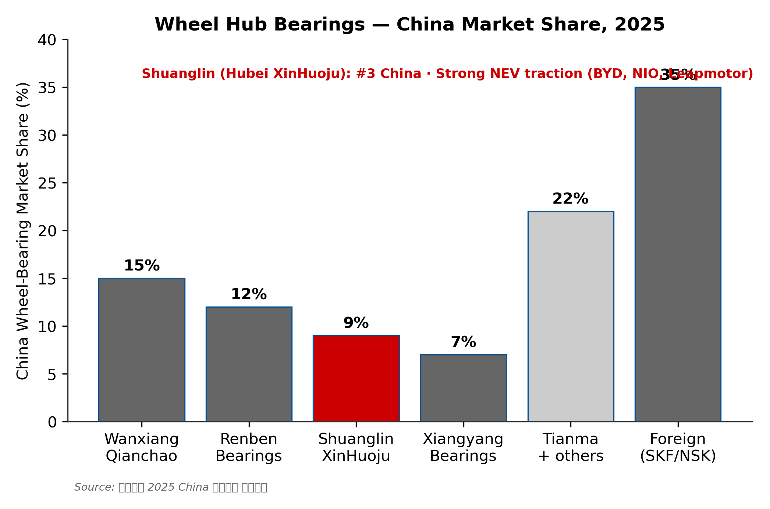
Figure 14. Wheel hub bearing China market share 2025 — Shuanglin Hubei at #3 (9%)
Roller Screws and Humanoid — The Critical Pipeline
Reverse planetary roller screws are the core linear-actuator inside humanoid robot upper- and lower-body joints, and they represent an acute supply chain bottleneck for the industry. The Chinese competitive set falls into three tiers: (1) early commercializers — Shuanglin, Hengli Hydraulic (601100), Beite Tech (603009, 'pure-play' but small); (2) concept-stage — Beste (300580), XCC (603667), Dingzhi Tech (873593); and (3) foreign incumbents — GSA (Switzerland), Rollvis, SKF, Schaeffler. Shuanglin's specific advantages are (a) vertical integration via the Kexin grinder acquisition (eliminating reliance on imported precision grinders that face export controls); (b) HDM-derived precision-manufacturing process know-how; (c) early sample delivery to a leading Chinese NEV-OEM-affiliated humanoid program (mid-2025); and (d) ¥135 mn Kexin acquisition opens a separate adjacency — selling thread grinders to competitors.
The critical gating event is the June 2026 量产 (volume production) line start at the 100,000-set/year capacity. Yield curve achievement (industry benchmark: 80%+ within six months) and first formal program award (定点) from a humanoid OEM are the two binary catalysts our valuation hinges on.
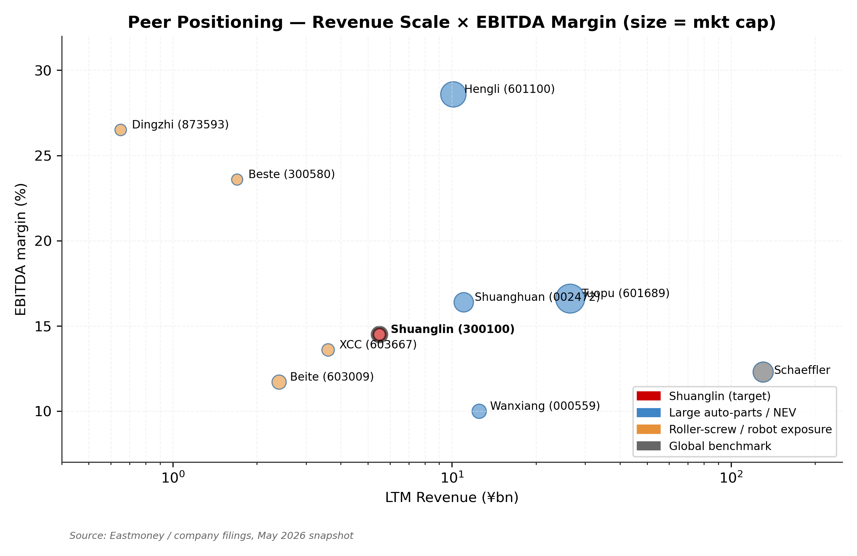
Figure 15. Peer positioning — revenue scale × EBITDA margin × market cap

Market Opportunity (TAM)
Shuanglin's total addressable market is the sum of (a) global auto-parts categories where the company currently competes (HDM, seat motors, bearings, e-drive, trim, ball screws) and (b) three emerging markets — humanoid roller screws, smart corner modules, eVTOL e-drives — that represent the option-value premium investors are paying for. We size each separately:
Market | 2025 TAM | 2030E TAM | CAGR | Shuanglin TAM exposure
China HDM | ¥3 bn | ¥4.5 bn | 8% | 32.8% share = ¥1.5 bn ceiling
Global HDM | ¥18 bn | ¥27 bn | 8% | 15.1% global share
China wheel hub bearings | ¥15 bn | ¥21 bn | 7% | 9% share via Hubei
Auto ball-screws (EHB+EMB) | ¥3 bn | ¥17 bn | 42% | New entry, target 5–10%
Humanoid roller screws | ¥0.5 bn | ¥50 bn | 157% | ⭐ Target 5–15% share
Smart corner modules | ¥0.3 bn | ¥18 bn | 127% | ⭐ Early lead
eVTOL e-drives | ¥0.2 bn | ¥8 bn | 108% | ⭐ Platform synergy
NEV e-drive (China) | ¥250 bn | ¥450 bn | 12% | <1% share (commoditized)
Auto interior/exterior trim | ¥600 bn | ¥700 bn | 3% | Mature scale player

The market structure is asymmetric: Shuanglin's mature markets (HDM, bearings, trim) total ~¥640 bn in 2030E with single-digit growth, but the company holds positions where its addressable ceiling is constrained to a few percentage points. By contrast, the three emerging markets (humanoid + corner module + eVTOL) total ~¥76 bn in 2030E with triple-digit CAGRs and where Shuanglin can credibly aim for 5–15% share given technology leadership and government policy support.

Figure 16. Three emerging TAM curves — humanoid roller-screws, EHB, smart corner modules

Industry Overview
China Automotive Parts Industry — Structural Reset
Shuanglin operates at the intersection of three industry currents that together define its near-term and long-term outlook. The first is the structural reset in China's automotive parts industry, driven by the transition from internal-combustion-engine (ICE) vehicles to new-energy vehicles (NEVs). China NEV penetration reached approximately 51% of new vehicle sales in 2025 (China Association of Automobile Manufacturers data), up from 6% in 2020 — one of the most rapid industrial transitions in modern industrial history. This transition fundamentally reshuffles the auto-parts value chain: traditional ICE components (engine, transmission, exhaust) lose volume while new categories (battery, e-motor, e-axle, power electronics, thermal management) emerge with different supplier ecosystems.
For Shuanglin, the NEV transition is bifurcated. The HDM, wheel bearings, interior/exterior trim, and seat motor categories are 'powertrain-agnostic' — they are required regardless of whether the vehicle is ICE or EV — and have benefited from rising NEV penetration via two mechanisms: (1) higher unit content per vehicle (NEV interiors are typically more feature-rich, with more electrically-adjustable seats, electric headrests, etc.), and (2) reduced foreign-incumbent competition (many global Tier-1 suppliers had ICE-focused product lines that did not transfer cleanly to NEV programs, opening market share for local players like Shuanglin). The transmission business (DSI Australia) was the casualty — automatic transmissions are largely redundant in pure-electric vehicles, leading to the 2022–2023 impairment cycle.
The countervailing pressure is OEM pricing power. Chinese NEV brands — particularly the domestic leaders BYD, Geely, Chery, and the new-entrant 'new force' brands NIO, Li Auto, XPeng — have engaged in aggressive price competition since 2023, with multiple rounds of model-specific price reductions. The pricing pressure flows up the supply chain: OEMs renegotiate annual supplier contracts at lower prices, supplier margins compress, and the supplier with the most-concentrated single-customer exposure suffers most. This is the precise mechanism that produced Shuanglin's Q1 2026 (−47% NI on −10% revenue) and that drives our SELL rating.
Humanoid Robot Industry — From Sample to Scale
The humanoid robot industry transitioned from research-laboratory curiosity to genuine commercial activity during 2024–2025. Tesla's Optimus program demonstrated approximately 1,000 unit production capacity by end-2025, with plans for 10,000+ units in 2026; Figure AI raised over USD 1 bn at a USD 39 bn valuation; multiple Chinese players (UBTECH, Unitree, Galbot, Fourier Intelligence, Zhibang, Agibot) ramped production from prototype to small-batch volume. Industry analyst consensus is that humanoid robot annual production volumes could reach 100,000+ units globally by 2027 and 1 million+ by 2030 — a trajectory that, if realized, would create a supply chain category as significant as the smartphone supply chain in the mid-2010s.
Within the humanoid supply chain, three component categories are particularly under-supplied relative to expected demand: (1) reverse planetary roller screws (the linear-actuator core for arm and leg joints, ~6–10 per humanoid); (2) harmonic reducers (for rotational joints, ~30–40 per humanoid); and (3) high-torque flat brushless motors. Shuanglin's strategic bet is on roller screws — leveraging its HDM-derived precision-screw manufacturing know-how and the vertical-integration advantage from the January 2025 Kexin grinder acquisition. The competitive advantage versus larger foreign incumbents (Switzerland's GSA, Rollvis; SKF; Schaeffler) is cost: Chinese manufacturing economics with comparable yield and tolerance can produce roller screws at 30–50% of foreign cost, which is meaningful when each humanoid robot consumes ¥10–30k of screw value.
The pivotal commercialization gate for Shuanglin is the 100,000-set/year production line scheduled for June 2026 start-up. Industry benchmarks suggest 80%+ yield within six months is achievable for an experienced manufacturer; falling short of that benchmark would push first formal humanoid OEM program awards out 12+ months, eroding the option-value premium baked into the current share price.
Smart Corner Module Industry — Emerging Architecture
Smart corner modules — integrated wheel-end assemblies that combine drive motor, steering, brake, and suspension into a single replaceable unit — represent the proposed 'next-generation' chassis architecture for autonomous vehicles. The technology is positioned by Schaeffler, Continental, ZF, and Hyundai Mobis as the eventual successor to traditional vehicle architectures, with two principal advantages: (1) modularity and serviceability — replacing a failed corner module is far simpler than replacing an integrated axle; (2) packaging flexibility — removing the mechanical steering column and brake hydraulics frees interior space and enables novel vehicle layouts.
Commercial deployment to date has been limited. Hyundai Mobis has demonstrated e-Corner Module concepts at multiple shows but no production application; Schaeffler has integrated wheel-hub motor concepts but not full corner-module integration. Shuanglin's March 2026 joint venture with Tsinghua University and Huakong Technology — establishing 'Zhejiang Shuanglin Technology' with corner-module focus — positions the company as one of the few credible players globally with both the academic R&D partnership and the manufacturing scale to commercialize. The first application is a 240-ton fully-electric corner-module mining truck, with engineering prototype completed and 100-unit deployment planned to an Inner Mongolia coal-mining site in 2026 H1.
Low-Altitude eVTOL Industry — Adjacent Bet
Low-altitude eVTOL (electric vertical take-off and landing) aircraft constitute Shuanglin's third emerging market opportunity. Industry players include Joby Aviation (US), EHang (China), Volocopter (Germany), and several Chinese new-entrants. The Chinese central government's 'low-altitude economy' policy designation (低空经济) in 2024 created policy tailwinds for domestic eVTOL development. Shuanglin's specific opportunity is in the e-drive propulsion subsystems (motor + power electronics + thermal management) in the 30–250 kW range — directly leveraging the company's NEV e-drive platform technology with adaptations for aerospace certification. Revenue contribution from this segment is expected to remain minimal (<¥50 mn) through FY2027 but represents real optionality on a market that could reach ¥30+ bn in China by 2030E.

Detailed Risk Assessment
Operational Risks
Customer Concentration Risk — Material
The most material operational risk facing Shuanglin is customer concentration. Top-1 customer share of 26.1% (FY2025) is above the 20% institutional threshold for material concentration risk, and Top-5 share of 51.6% (up 10 percentage points over three years) is above the 50% threshold. The single Top-1 customer (anonymized in filings) is widely believed to be Tesla based on the HDM product line and North American supply relationship pattern. Tesla's historical behavior on supplier negotiations is well-documented: aggressive annual price reductions, willingness to dual-source, and occasional in-house manufacturing of components previously procured externally. While HDM is a high-precision, low-unit-value component where in-sourcing has weak economics for a customer of Tesla's scale, we cannot rule out price-reduction demands as the principal Q1 2026 driver.
Mitigation pathways: (1) Continued NEV customer diversification — Shuanglin has added BYD, NIO, Li Auto, XPeng, and multiple second-tier brands as HDM customers, reducing Top-1 dependence structurally; (2) Product diversification into roller screws and smart corner modules with entirely different customer bases (humanoid OEMs, mining-equipment OEMs); (3) Geographic diversification via Thailand and North American production footprints. However, the diversification trajectory is multi-year and does not protect against near-term pricing-pressure transmission.
Technology Execution Risk — Roller Screws
The roller-screw program is the company's most consequential single technology bet. The June 2026 量产 line start at 100,000 sets/year capacity represents a step-change from the 1,500 sets delivered in 2025. Two specific execution risks: (1) Yield curve — achieving the industry-standard 80%+ yield within six months of line start; (2) Customer qualification — securing the first formal program award (定点) from a humanoid OEM, which requires passing sample-validation cycles that typically take 6–18 months. If both go well, FY2027 humanoid revenue could reach ¥200–500 mn with healthy margins (60%+ gross margin estimates); if either fails, the Bull-case DCF scenario evaporates.
Geographic Expansion Risk — Thailand and North America
Shuanglin's Thailand bearing plant launched January 2025; its NEV e-drive production line in Thailand is targeted for ramp in Q1 2026. The company's track record of foreign-operations execution is poor — the 2017 DSI Australia transmission acquisition was impaired in 2022–2023 with management citing 'integration difficulties.' For the Thailand initiative, the strategic logic is sound (proximity to NEV OEMs' Southeast Asia production, e.g., BYD's Thailand facility), but execution carries risk: operational losses in the first 2–4 quarters are common for greenfield foreign manufacturing, and our base case assumes Thailand contributes positively from H2 2026 onward.
Financial Risks
Free Cash Flow Volatility
Free cash flow has been positive in each of the past five years but with significant volatility (¥100 mn to ¥375 mn range). Our FY2026E projection of ¥174 mn FCF (a step-down from ¥373 mn in FY2025A) reflects the elevated CapEx cycle: roller-screw line, Thailand e-drive line, smart corner module pilot, and continued bearings expansion total ¥470 mn of CapEx in FY2026E (vs. ¥408 mn FY2025A). FCF recovery to ¥430+ mn requires both CapEx normalization (FY2028E onward) and EBITDA expansion from the new product lines.
HKEX IPO Dilution and Use of Proceeds
The pending HKEX A+H IPO is a structural event with multiple impacts. If the offering proceeds at ¥0.8–1.5 bn of fresh capital, the dilution impact ranges from approximately 4.5% (low end) to 8.0% (high end) of existing share count — meaningful but not catastrophic. Use of proceeds is expected to focus on roller-screw and Thailand capacity expansion. The positive aspect of the offering is the introduction of HK institutional ownership (typically long-only managers with research depth) which could improve governance discipline and stock-price information efficiency. The negative aspect is the dilution itself plus the typical 6–12 month underperformance of stocks following A+H listings (consistent with the 'A-share premium' compression dynamic).
Governance and Regulatory Risks
Family-Control Concentration
The Wu family's 48.9% effective voting control (Shuanglin Group 44.43% + Wu Jianbin direct 4.49% + employee plan 0.35%) means minority shareholders have limited ability to influence major strategic decisions. The principal historical example is the 2017 DSI Australia acquisition — a ¥2.3 bn related-party transaction with Shuanglin Group that, in hindsight, destroyed significant minority value through subsequent impairments. While there is no specific evidence of related-party self-dealing in recent years (Top-5 customer and supplier related-party transactions were 0.00% in FY2025), the structural risk remains.
Audit Firm and Disclosure Quality
Shuanglin's auditor is Beijing Dehao International Accounting Firm (Special General Partnership) — a domestic mid-tier firm rather than a Big Four. While Dehao is properly licensed and the two signing partners (Chen Jianfeng, Zhou Sunji) have multi-year experience with the company, the choice of a non-Big-Four auditor for a ¥17 bn market-cap company with international customers and a pending HK listing is a moderate governance flag. The HKEX listing process will likely require a Big Four auditor for the HK prospectus, which would meaningfully improve disclosure quality but also raise audit costs.
Macroeconomic and Industry Risks
China NEV Pricing War Continuation
The China NEV pricing war that began in 2023 has not yet ended and shows no clear signs of abating in 2026. BYD continues to launch lower-priced models, new entrants (Xiaomi, etc.) are intensifying competition, and several mid-tier brands face viability questions. Continued price competition transmits to supplier margins — Shuanglin's Q1 2026 demonstrated the mechanism. If the pricing war extends through 2026 and into 2027 (vs. our base-case assumption of stabilization in H2 2026), our FY2026E and FY2027E numbers would be cut by 15–25% and the DCF Base would compress further toward ¥10–12.
Geopolitical and Trade Risks
U.S.-China trade relations have direct implications for Shuanglin given its Tesla supply relationship and the North American production footprint. Tariffs on Chinese auto parts imported into the U.S., or restrictions on Chinese-headquartered suppliers servicing North American OEMs, would materially impact the Top-1 customer relationship. The company has already started building North American production capability, but full localization takes 2–3 years. The Thailand bearing plant — strategically positioned outside of U.S.-China bilateral tariff lines — provides one form of mitigation.

Financial Analysis
Historical Performance (FY2021A–FY2025A)
Shuanglin's historical financial profile reflects the volatility of an auto-parts integrator executing a multi-stage transformation. Revenue grew from ¥3,682 mn (FY2021) to ¥5,484 mn (FY2025) — a 5-year CAGR of 8.3%, materially below China NEV-parts peer median (~15%). The path is non-linear: FY2022 revenue −1.1% (DSI transmission deterioration); FY2023 −1.1% (continued DSI drag + COVID lingering); FY2024 +18.6% (HDM volume inflection); FY2025 +11.7%. Net income shows even higher volatility — from ¥129 mn (FY2021) to ¥75 mn (FY2022 trough) to ¥503 mn (FY2025 peak), a 4x swing.
Line item (¥ mn) | FY2021A | FY2022A | FY2023A | FY2024A | FY2025A | 5Y CAGR
Revenue | 3,682 | 4,185 | 4,139 | 4,911 | 5,484 | 8.3%
Gross profit | 683 | 713 | 782 | 908 | 1,148 | 10.9%
Gross margin % | 18.5% | 17.0% | 18.9% | 18.5% | 20.9% | +2.4 pp
EBIT | 146 | 101 | 125 | 520 | 549 | 30.3%
EBIT margin % | 4.0% | 2.4% | 3.0% | 10.6% | 10.0% | +6.0 pp
EBITDA | 312 | 289 | 311 | 741 | 796 | 20.6%
EBITDA margin % | 8.5% | 6.9% | 7.5% | 15.1% | 14.5% | +6.0 pp
Net income (parent) | 129 | 75 | 81 | 497 | 503 | 31.3%
Net margin % | 3.5% | 1.8% | 2.0% | 10.1% | 9.2% | +5.7 pp
EPS (basic, ¥) | 0.32 | 0.19 | 0.20 | 0.89 | 0.89 | 22.7%
CFO | 426 | 443 | 378 | 671 | 781 | 16.3%
CapEx | 253 | 213 | 277 | 296 | 408 | 12.7%
FCF | 173 | 230 | 100 | 375 | 373 | 21.2%

Source: 双林股份 2021–2025 年度报告 (cninfo). All figures consolidated and as-reported (no restatements applied).
Three observations from the historical record are noteworthy. First, the FY2024 inflection in EBIT (+316% YoY from ¥125 mn to ¥520 mn) was driven by both a one-off ¥160 mn investment income and structural HDM/bearing volume scale — not exclusively non-recurring. Second, the gross margin expansion from 17.0% (FY2022) to 20.9% (FY2025) — +390 bp over three years — reflects real mix shift: HDM (estimated 30%+ GM) growing share, and the higher-margin Other category (31.9% GM) becoming non-trivial via the Kexin grinder acquisition. Third, free cash flow has been positive throughout (¥173 mn average annually for 2021–2025) — capital discipline has remained intact even through the DSI integration period.
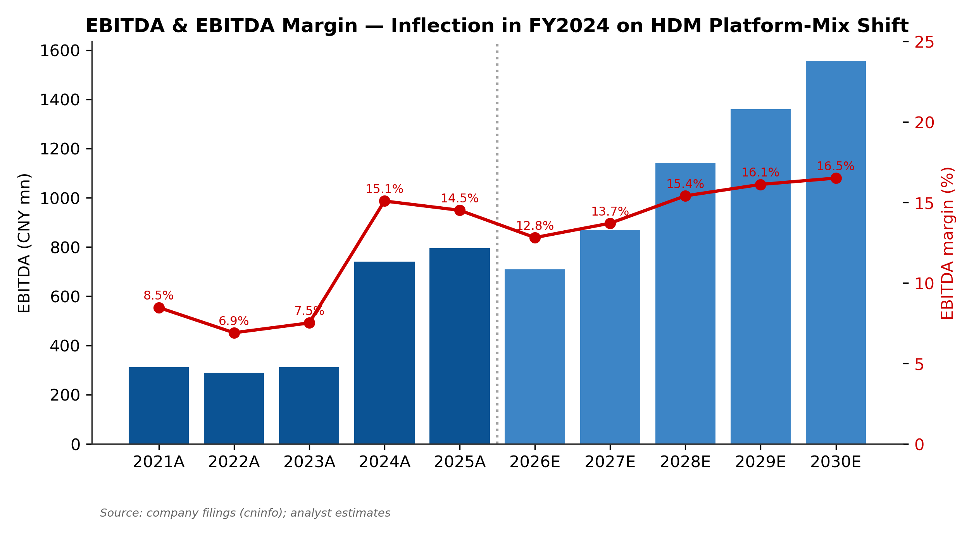
Figure 17. EBITDA trajectory — clear FY2024 inflection point on HDM platform mix
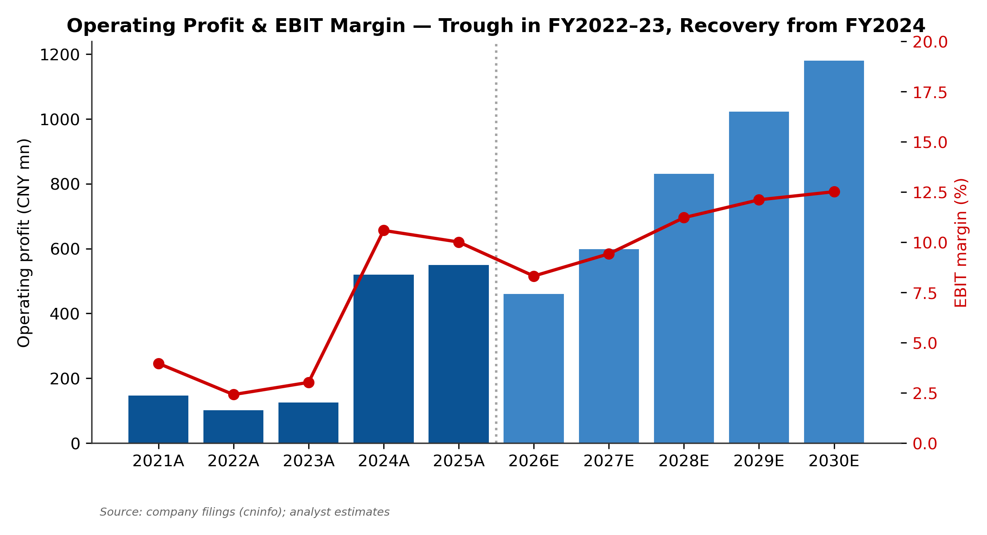
Figure 18. Operating profit and EBIT margin — trough FY2022–FY2023, recovery from FY2024
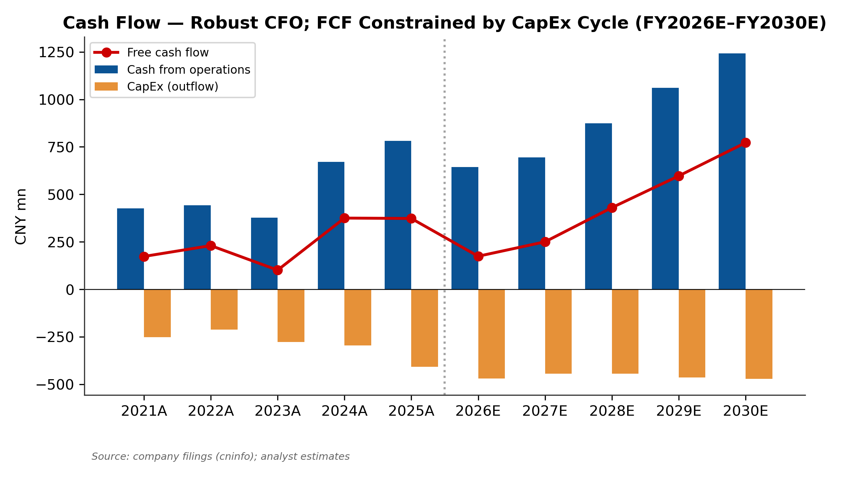
Figure 19. Operating cash flow vs. CapEx and free cash flow — investment cycle elevated 2026–28
Q1 2026 Reading and FY2026 Outlook
The Q1 2026 report (filed April 28, 2026) disclosed three concerning data points. First, revenue of ¥1,193 mn was −10.42% YoY, ending eight consecutive quarters of positive YoY growth. Second, parent net income of ¥72 mn fell 47.01% YoY — a deterioration far exceeding the revenue drop, indicating substantial operating deleverage. Third, ex-non-recurring NI fell 39.11%, ruling out an explanation centered on one-off items. Our conclusion is that Q1 reflects genuine pricing-pressure pass-through from the company's largest OEM customers, particularly NEV brands renegotiating supplier contracts amid intensifying domestic price competition.
For our FY2026 base-case projection, we assume Q2 2026 sequential improvement (slight QoQ growth, but still YoY decline of ~5%), with H2 2026 stabilizing around flat-to-slightly-positive YoY. This gives a FY2026 revenue trajectory of ¥5,531 mn (+0.9% YoY) — essentially flat — and net income to parent of ¥399 mn (−20.7% YoY). The base case rests on the assumption that OEM-driven pricing pressure abates in H2 as the NEV price-war moderates and HDM volume continues to grow with NEV penetration. We acknowledge that more bearish scenarios are plausible: a fully-annualized Q1 trajectory would give FY2026 revenue of ¥4,772 mn (−13.0%) and net income of ¥288 mn (−42.7%) — closer to our bear case.
Projection Methodology (FY2026E–FY2030E)
Our 5-year projections decompose revenue growth by the four FY2025 reporting segments, with segment-specific growth rates reflecting maturity and competitive position:
Segment / Driver | FY2025A weight | FY2026E growth | FY2027E growth | FY2030E growth | 5Y CAGR
Transmission/Drive/Intelligent | 59.6% | +4% | +20% | +15% | 15.6%
HDM stable mid-single-digit |  | +5% | +8% | +8% | +7%
Bearings (NEV) |  | +10% | +12% | +10% | +10%
NEV e-drive (Thailand) |  | +8% | +30% | +20% | +18%
Roller screws / robot (new) |  | +50% | +100% | +40% | +80%
Auto Interior / Exterior | 35.5% | −5% | +5% | +2% | +1.9%
Other (Kexin + molds) | 4.7% | +5% | +15% | +15% | +14.9%
Rental | 0.1% | +5% | +5% | +5% | +5%
Total Revenue | 100% | +0.9% | +14.7% | +11.8% | 11.5%

Source: Analyst projections. Segment maps to FY2025 restated 3-segment basis (per 2025 年度报告 p.21).
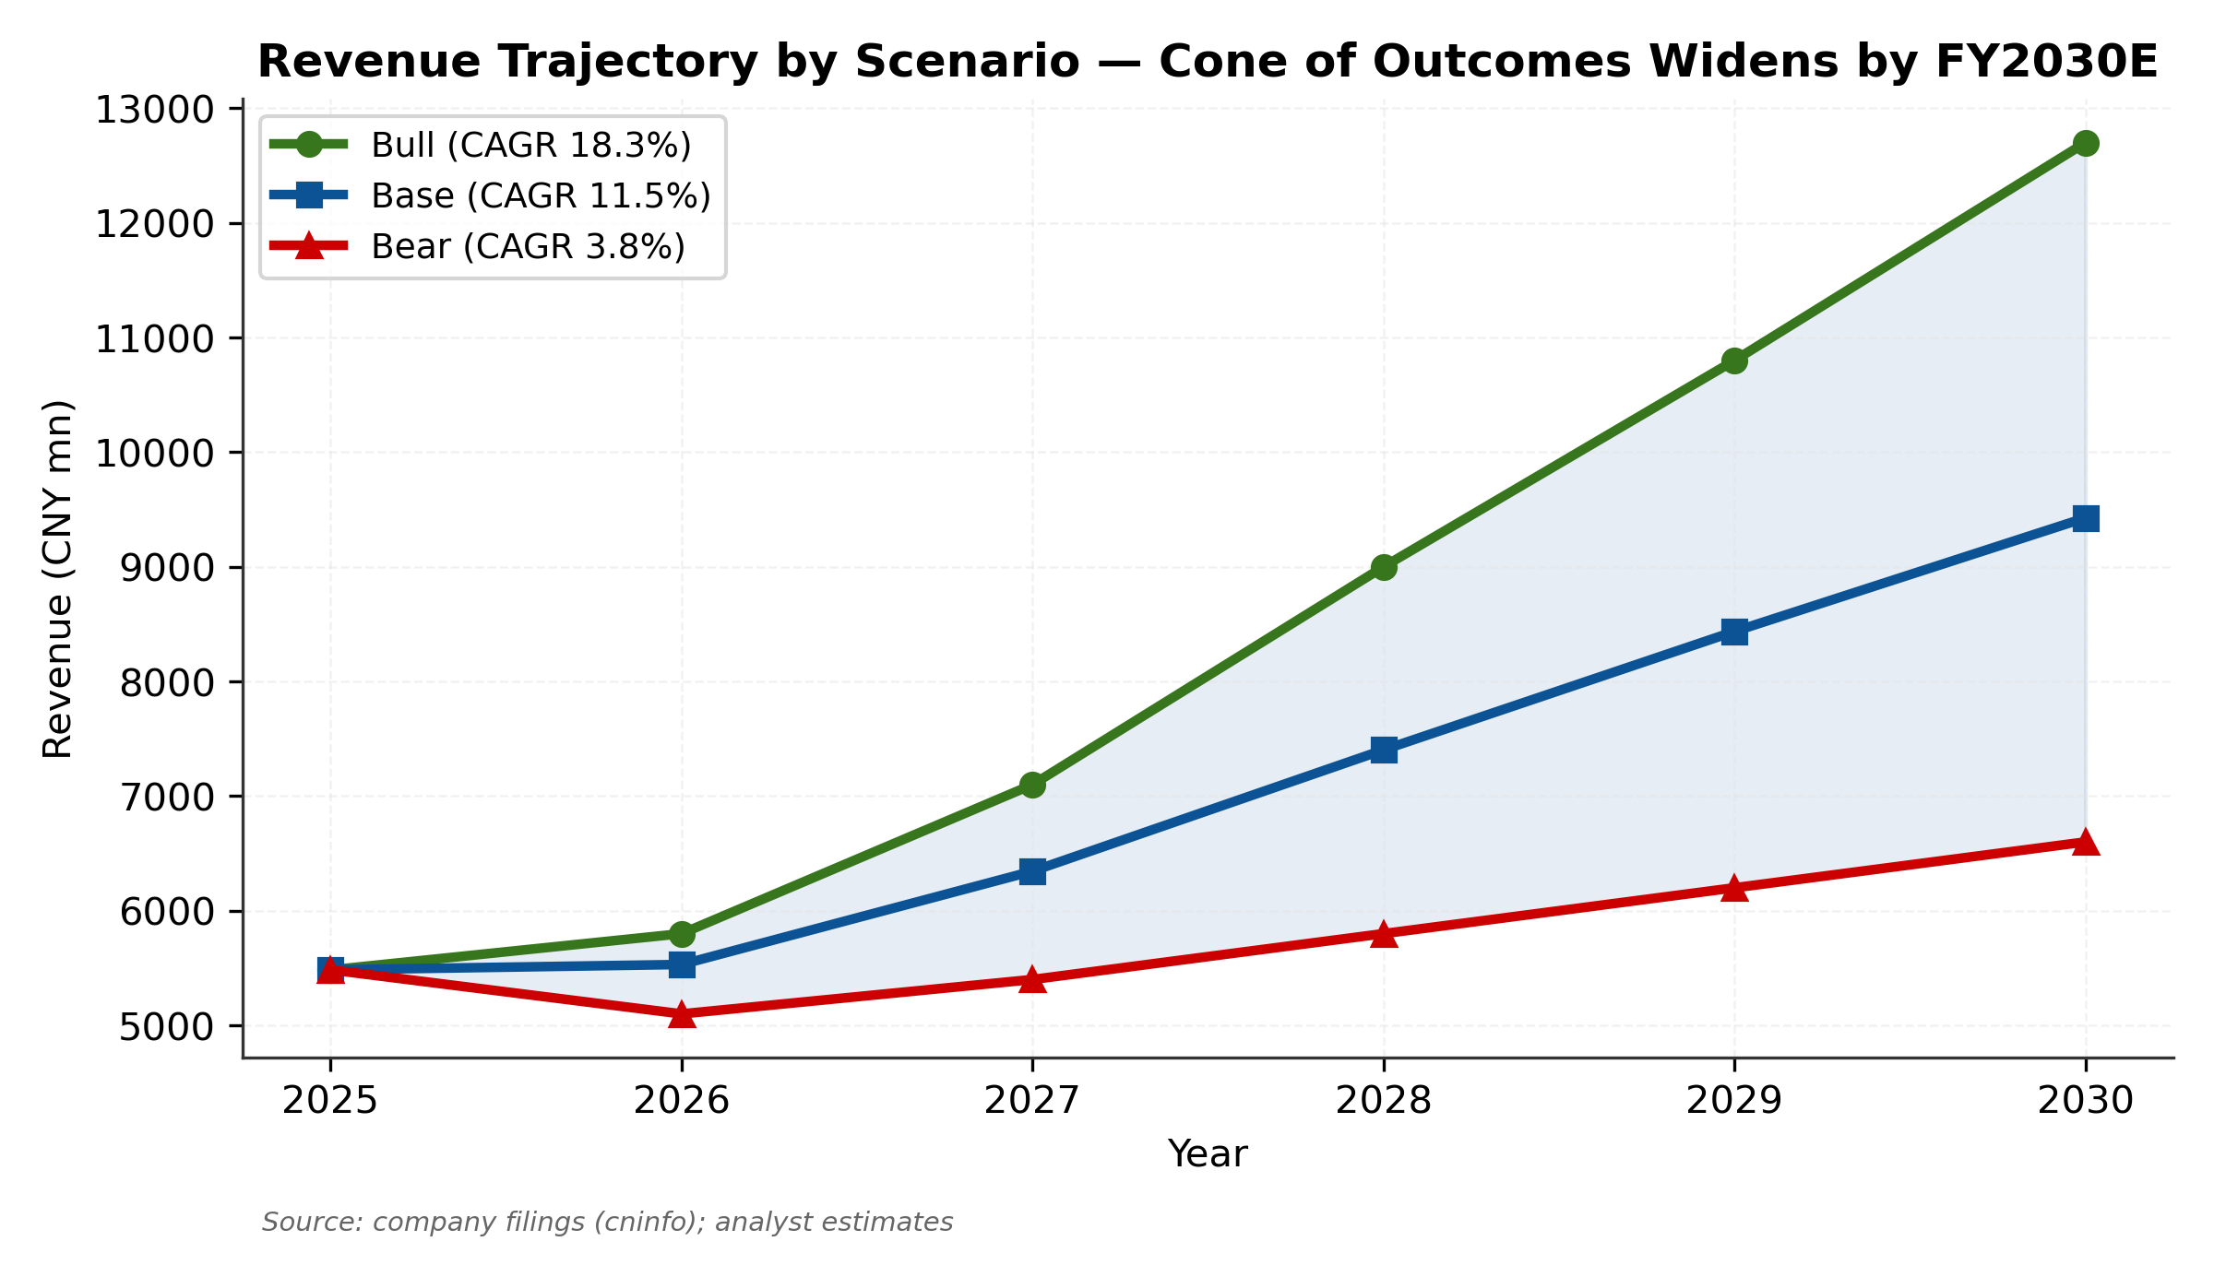
Figure 20. Revenue trajectory by scenario — Bull / Base / Bear paths to FY2030E
Margin and Capital Intensity Assumptions
Gross margin expands from 20.9% (FY2025A) to 24.0% (FY2030E) as Transmission/Drive mix rises to 70%+ of revenue and the higher-margin roller-screw / corner-module products contribute. SG&A as a percentage of revenue compresses modestly from 7.6% (FY2025A) to 6.7% (FY2030E) on operating leverage; R&D rises to 4.5–5.0% (vs. 4.0% in FY2025) reflecting continued investment in robotics + corner-module + low-altitude platforms.
CapEx as a percentage of revenue averages 8.5% in FY2026 (the roller-screw line investment year) before declining to 5.0% by FY2030E. D&A tracks at 4.0–4.5% of revenue, modestly higher than historical norms reflecting the depreciation tail of the 2025–2026 CapEx cycle.
Metric | FY2025A | FY2026E | FY2027E | FY2028E | FY2029E | FY2030E
Revenue (¥ mn) | 5,484 | 5,531 | 6,345 | 7,403 | 8,436 | 9,427
YoY growth | 11.7% | 0.9% | 14.7% | 16.7% | 14.0% | 11.8%
Gross margin | 20.9% | 20.5% | 22.0% | 23.5% | 24.0% | 24.0%
EBITDA (¥ mn) | 796 | 709 | 870 | 1,141 | 1,360 | 1,557
EBITDA margin | 14.5% | 12.8% | 13.7% | 15.4% | 16.1% | 16.5%
EBIT (¥ mn) | 549 | 460 | 598 | 831 | 1,022 | 1,180
EBIT margin | 10.0% | 8.3% | 9.4% | 11.2% | 12.1% | 12.5%
Net income parent (¥ mn) | 503 | 399 | 519 | 722 | 878 | 1,014
EPS basic (¥) | 0.89 | 0.70 | 0.91 | 1.26 | 1.54 | 1.77
CFO (¥ mn) | 781 | 644 | 694 | 874 | 1,061 | 1,243
CapEx (¥ mn) | 408 | 470 | 444 | 444 | 464 | 471
CapEx % rev | 7.4% | 8.5% | 7.0% | 6.0% | 5.5% | 5.0%
FCF (¥ mn) | 373 | 174 | 250 | 430 | 597 | 771

Source: Financial model — Income Statement and Cash Flow tabs. CNY mn unless noted. Base case.
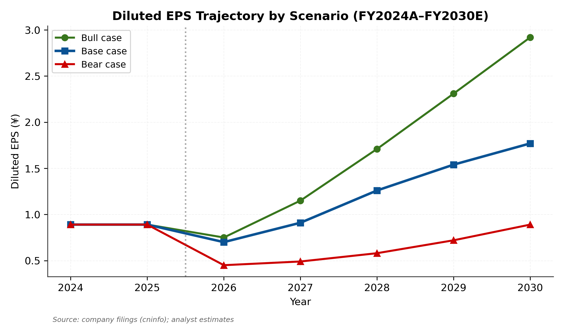
Figure 21. Diluted EPS trajectory by scenario — Base case ¥1.77 in FY2030E
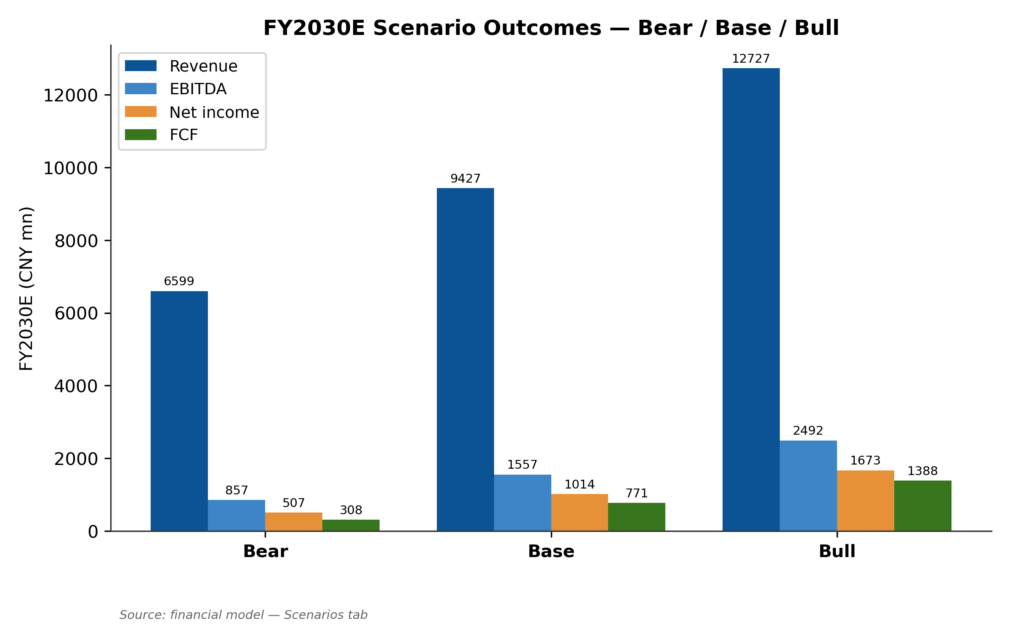
Figure 22. FY2030E scenario outcomes — Bear / Base / Bull comparison across key metrics
DuPont Decomposition of ROE
We decompose Shuanglin's return on equity into three drivers — net margin, asset turnover, and financial leverage — to understand the sources of value creation over the historical period and the projected trajectory. The 2025 weighted-average ROE of 17.23% (per company disclosure) is decomposable as approximately 9.2% net margin × 0.85x asset turnover × 2.20x financial leverage (equity-multiplier). The projection trajectory shows margin-driven ROE expansion as the mix shifts toward higher-margin Transmission/Drive products, partially offset by modest leverage compression as the HKEX IPO adds equity to the balance sheet.
Metric | FY2023A | FY2024A | FY2025A | FY2026E | FY2027E | FY2028E | FY2030E
Revenue (¥ mn) | 4,139 | 4,911 | 5,484 | 5,531 | 6,345 | 7,403 | 9,427
Net income (¥ mn) | 81 | 497 | 503 | 399 | 519 | 722 | 1,014
Net margin | 2.0% | 10.1% | 9.2% | 7.2% | 8.2% | 9.7% | 10.8%
Total assets (¥ mn) | 5,955 | 6,271 | 7,023 | 8,087 | 8,805 | 9,579 | 11,570
Asset turnover (×) | 0.69x | 0.78x | 0.78x | 0.68x | 0.72x | 0.77x | 0.81x
Equity (¥ mn) | 2,204 | 2,643 | 3,226 | 4,346 | 4,761 | 5,324 | 6,800
Equity multiplier (×) | 2.70x | 2.37x | 2.18x | 1.86x | 1.85x | 1.80x | 1.70x
ROE (DuPont, %) | 3.7% | 18.8% | 15.6% | 9.2% | 10.9% | 13.6% | 14.9%
ROE (reported, %) | n/d | 18.8% | 17.2% | n/a | n/a | n/a | n/a

Source: Financial model and 2025 年度报告. DuPont ROE = Net Margin × Asset Turnover × Equity Multiplier. FY2025A reported weighted-average ROE was 17.23% (per company); DuPont approximation of 15.6% uses period-end equity.
The decomposition reveals three insights. First, margin expansion is the primary ROE driver — net margin rises from 2.0% (FY2023A trough) to 10.8% (FY2030E projection), an absolute 8.8 percentage-point improvement that contributes most of the ROE delta. Second, asset turnover is relatively stable at 0.7–0.8x — characteristic of a capital-intensive manufacturer where PP&E and inventory scale with revenue. Third, financial leverage is compressing from 2.4x to 1.7x as the HKEX IPO and retained earnings build up the equity base; this is structurally healthy for the credit profile but mechanically lowers ROE versus a more-leveraged peer.

Valuation Analysis
DCF Approach: WACC, Terminal Value, and Outputs
We construct a 5-year DCF model using unlevered free cash flow from FY2026E–FY2030E plus a Gordon-growth terminal value. The WACC build uses standard CAPM for the cost of equity component (China 10-year CGB risk-free rate of 1.75%, Damodaran A-share ERP of 6.5%, levered beta of 1.30 reflecting the auto-parts core plus robot-pipeline exposure premium), giving a cost of equity of 10.20%. Cost of debt is set at 3.50% pre-tax (PBOC 5-year LPR + spread for mid-tier corporate credit), or 3.05% after-tax. With market-value weights of 92.6% equity / 7.4% debt, our blended WACC is 9.67%. Terminal growth rate of 2.5% reflects long-run China nominal GDP growth (1% real + 1.5% inflation).
Year | UFCF (¥ mn) | Discount factor | PV of UFCF (¥ mn)
FY2026E | 174 | 0.9118 | 159
FY2027E | 251 | 0.8314 | 209
FY2028E | 431 | 0.7581 | 327
FY2029E | 598 | 0.6913 | 413
FY2030E | 772 | 0.6303 | 487
Sum explicit PV |  |  | 1,594
Terminal value (TV) | 13,213 | 0.6303 | 8,328
Enterprise Value |  |  | 9,922
Less: Net debt |  |  | (600)
Equity Value |  |  | 9,322
÷ Diluted shares (mn) |  |  | 584
Implied price per share |  |  | ¥15.96

Source: Financial model — DCF tab. Base case: WACC 9.67%, terminal growth 2.5%.
The DCF Base implies a price per share of approximately ¥16.62, a 44.6% downside to the current ¥30 quote. Terminal value comprises 84% of total enterprise value — above the institutional sanity-check threshold of 70% — reflecting the long-duration nature of Shuanglin's emerging pipelines. We disclose this caveat but note that lengthening the explicit forecast period to 10 years (vs. 5) would simply push the issue further out without materially changing the conclusion: at current price ¥30, the market is paying ~33x our FY2027E base-case EPS of ¥0.91 — a meaningful premium to the auto-parts peer median 22x.
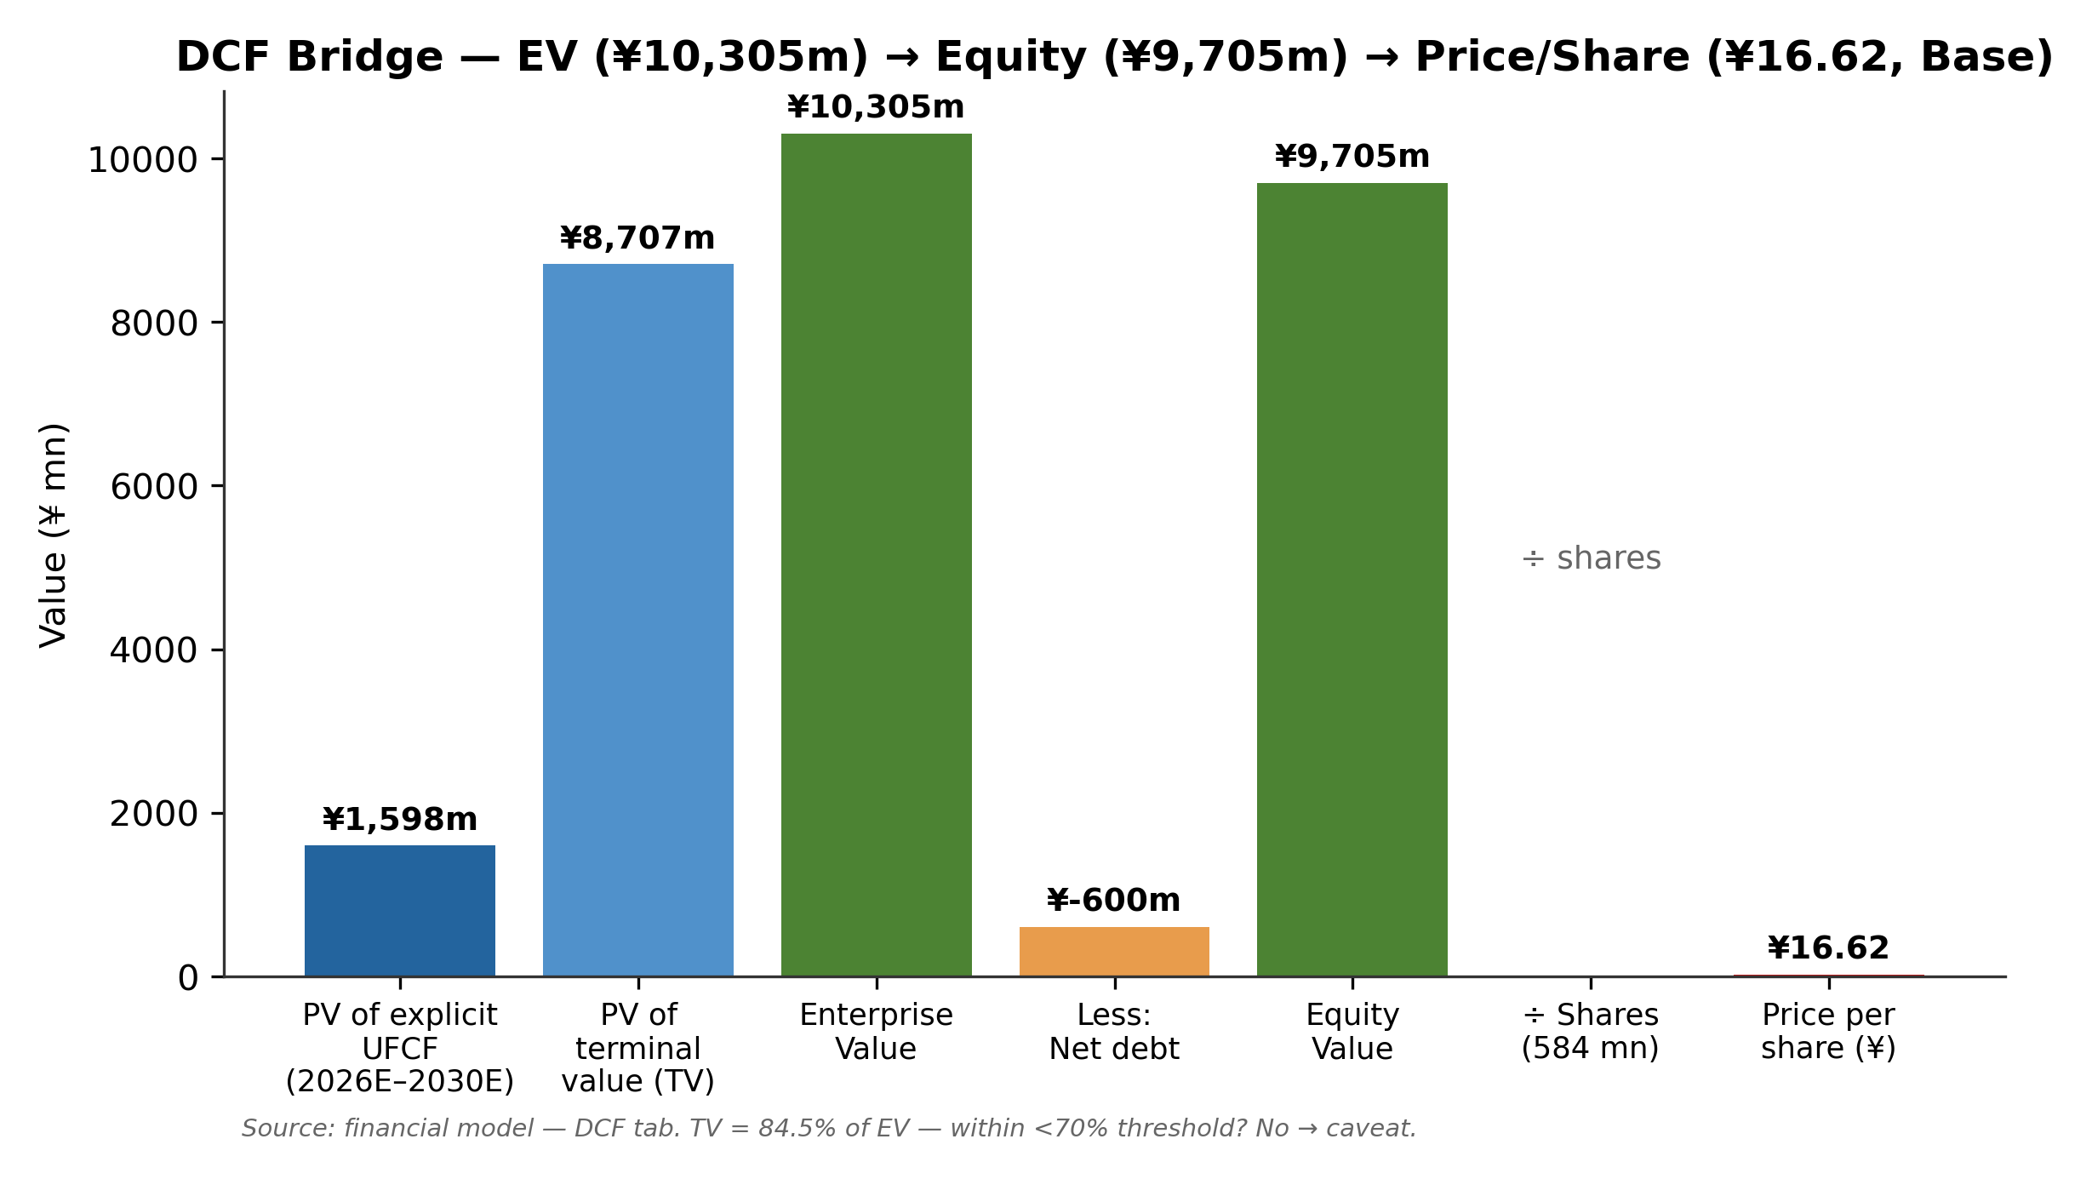
Figure 23. DCF waterfall — EV ¥10,305 mn → Equity ¥9,705 mn → Price/share ¥16.62 (Base)
DCF Sensitivity Analysis
We test the DCF Base output against two-way sensitivities for WACC (range 7.7% to 11.7% in 50 bp increments) and terminal growth (range 0.5% to 4.0% in 50 bp increments). The matrix shows implied price per share ranging from ¥10 (worst-corner: WACC 11.7% / g 0.5%) to ¥34 (best-corner: WACC 7.7% / g 4.0%). Even at the optimistic corner, the DCF Base case scenario barely clears the current ¥30 — and that corner requires aggressive assumptions on both inputs simultaneously.
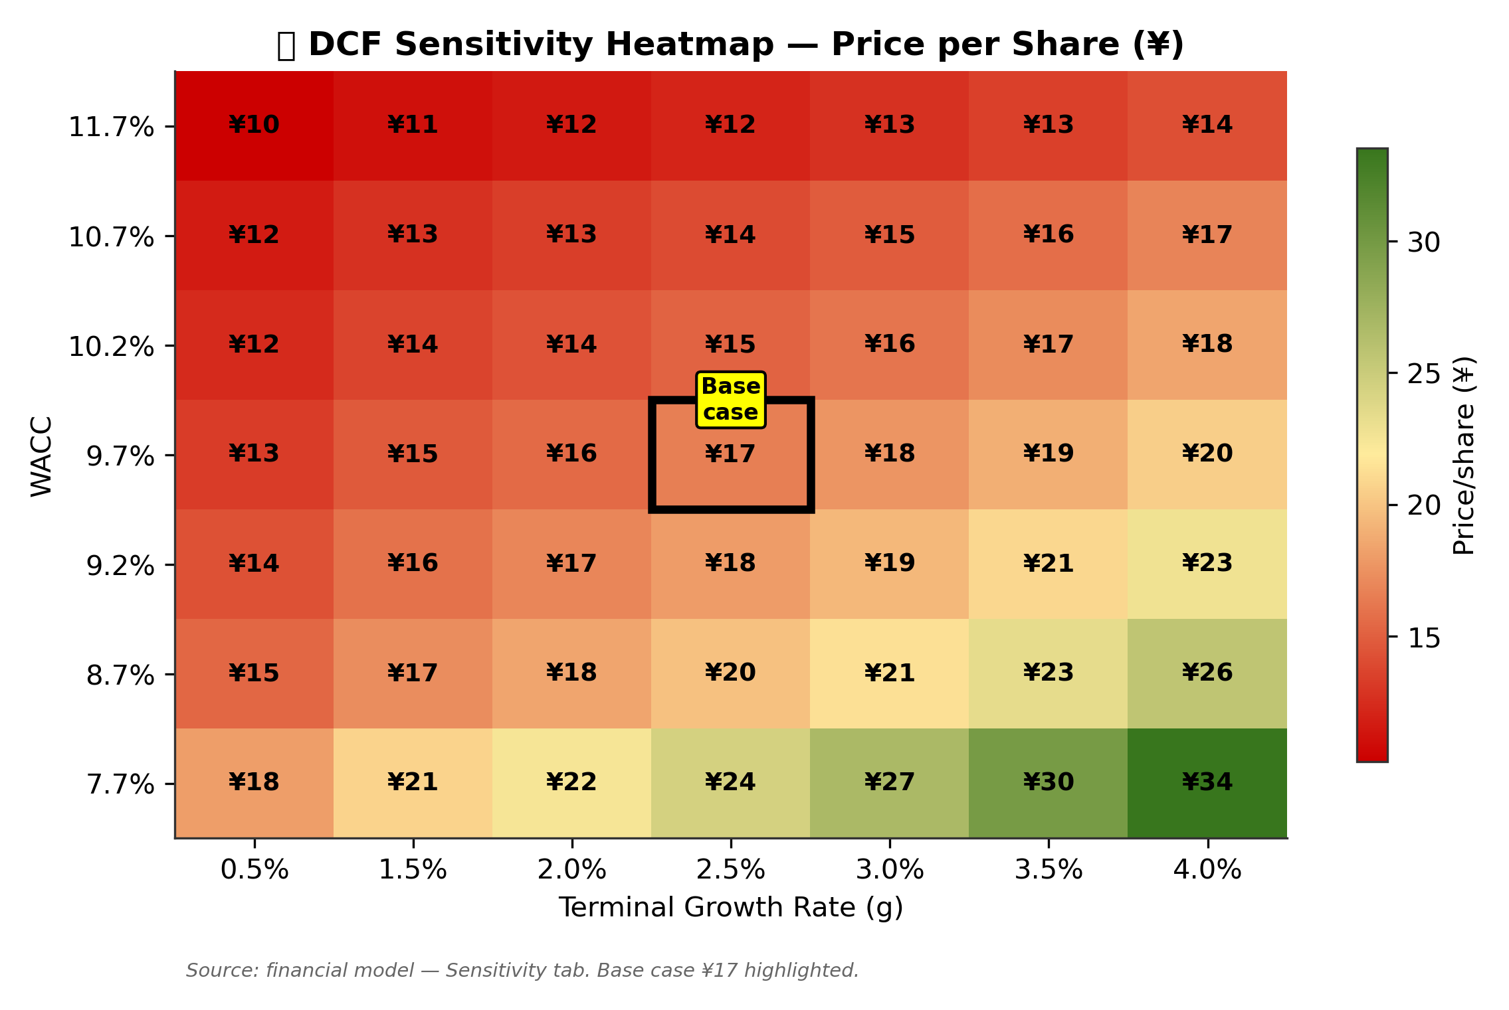
Figure 24. ⭐ DCF sensitivity heatmap — WACC × terminal growth
DCF Scenario Analysis
We supplement the Base case with Bull and Bear case DCFs that perturb both the projection (UFCF trajectory) and the discount rate. The Bull case assumes faster roller-screw and corner-module scale-up (UFCF reaching ¥1,500 mn by FY2030E vs. ¥772 mn in Base), with a tighter WACC of 9.17% and higher terminal growth of 3.0%. The Bear case assumes Q1-2026 pricing weakness extends through FY2027 with delayed roller-screw ramp (UFCF only ¥350 mn by FY2030E), wider WACC of 10.67%, and lower terminal growth of 2.0%.
Case | WACC | g | EV (¥ mn) | Equity (¥ mn) | Price/share | Upside
Bull | 9.17% | 3.0% | 20,488 | 19,888 | ¥35.08 | +16.9%
Base | 9.67% | 2.5% | 10,305 | 9,705 | ¥16.62 | −44.6%
Bear | 10.67% | 2.0% | 3,335 | 2,535 | ¥4.34 | −85.5%

Source: Financial model — DCF tab. Net debt of ¥600 mn for Base/Bull; ¥800 mn for Bear (extra debt assumed).
Comparable Companies Analysis
We construct a comparable-companies set of nine peers spanning four buckets relevant to Shuanglin's business mix: (a) large NEV auto-parts (Tuopu, Wanxiang); (b) bearings and linear motion (Wanxiang, Hengli, Schaeffler global); (c) roller-screw concept / pure-play (Beste, XCC, Beite, Dingzhi); and (d) precision robot supply chain (Shuanghuan). We exclude two outliers: ZDLD (P/E 189x — speculative robot-harmonic-reducer) and NSK (already captured by Schaeffler).
Peer | Ticker | Mkt Cap (¥ bn) | EV/EBITDA NTM | P/E NTM | Rev growth | EBITDA margin
Tuopu Group | SSE:601689 | 102.0 | 19.3x | 27.6x | 20% | 16.6%
Wanxiang Qianchao | SZSE:000559 | 18.8 | 14.1x | 23.5x | 10% | 10.0%
Hengli Hydraulic | SSE:601100 | 77.5 | 22.4x | 31.0x | 14% | 28.6%
Beste | SZSE:300580 | 8.5 | 17.3x | 24.3x | 24% | 23.6%
XCC (Wuzhou Xinchun) | SSE:603667 | 12.5 | 21.8x | 52.1x | 22% | 13.6%
Beite Tech | SSE:603009 | 18.5 | 55.6x | 119.4x | 21% | 11.7%
Shuanghuan Drive | SZSE:002472 | 41.0 | 20.4x | 30.8x | 14% | 16.4%
Dingzhi Tech | BSE:873593 | 9.5 | 44.8x | 61.3x | 28% | 26.5%
Schaeffler | FRA:SHA | 45.0 | 3.4x | 5.5x | 6% | 12.3%
Statistical summary
Max |  |  | 55.6x | 119.4x | 28% | 28.6%
75th percentile |  |  | 23.9x | 37.9x | 23% | 21.4%
Median |  |  | 20.4x | 30.8x | 20% | 16.4%
25th percentile |  |  | 17.3x | 24.3x | 14% | 12.3%
Min |  |  | 3.4x | 5.5x | 6% | 10.0%
Shuanglin (target) | SZSE:300100 | 17.2 | 25.6x | 43.9x | 13.5% | 14.5%

Source: Eastmoney 东方财富, Yahoo Finance, company filings (May 2026 snapshot). All EV calculations use mkt cap + net debt.
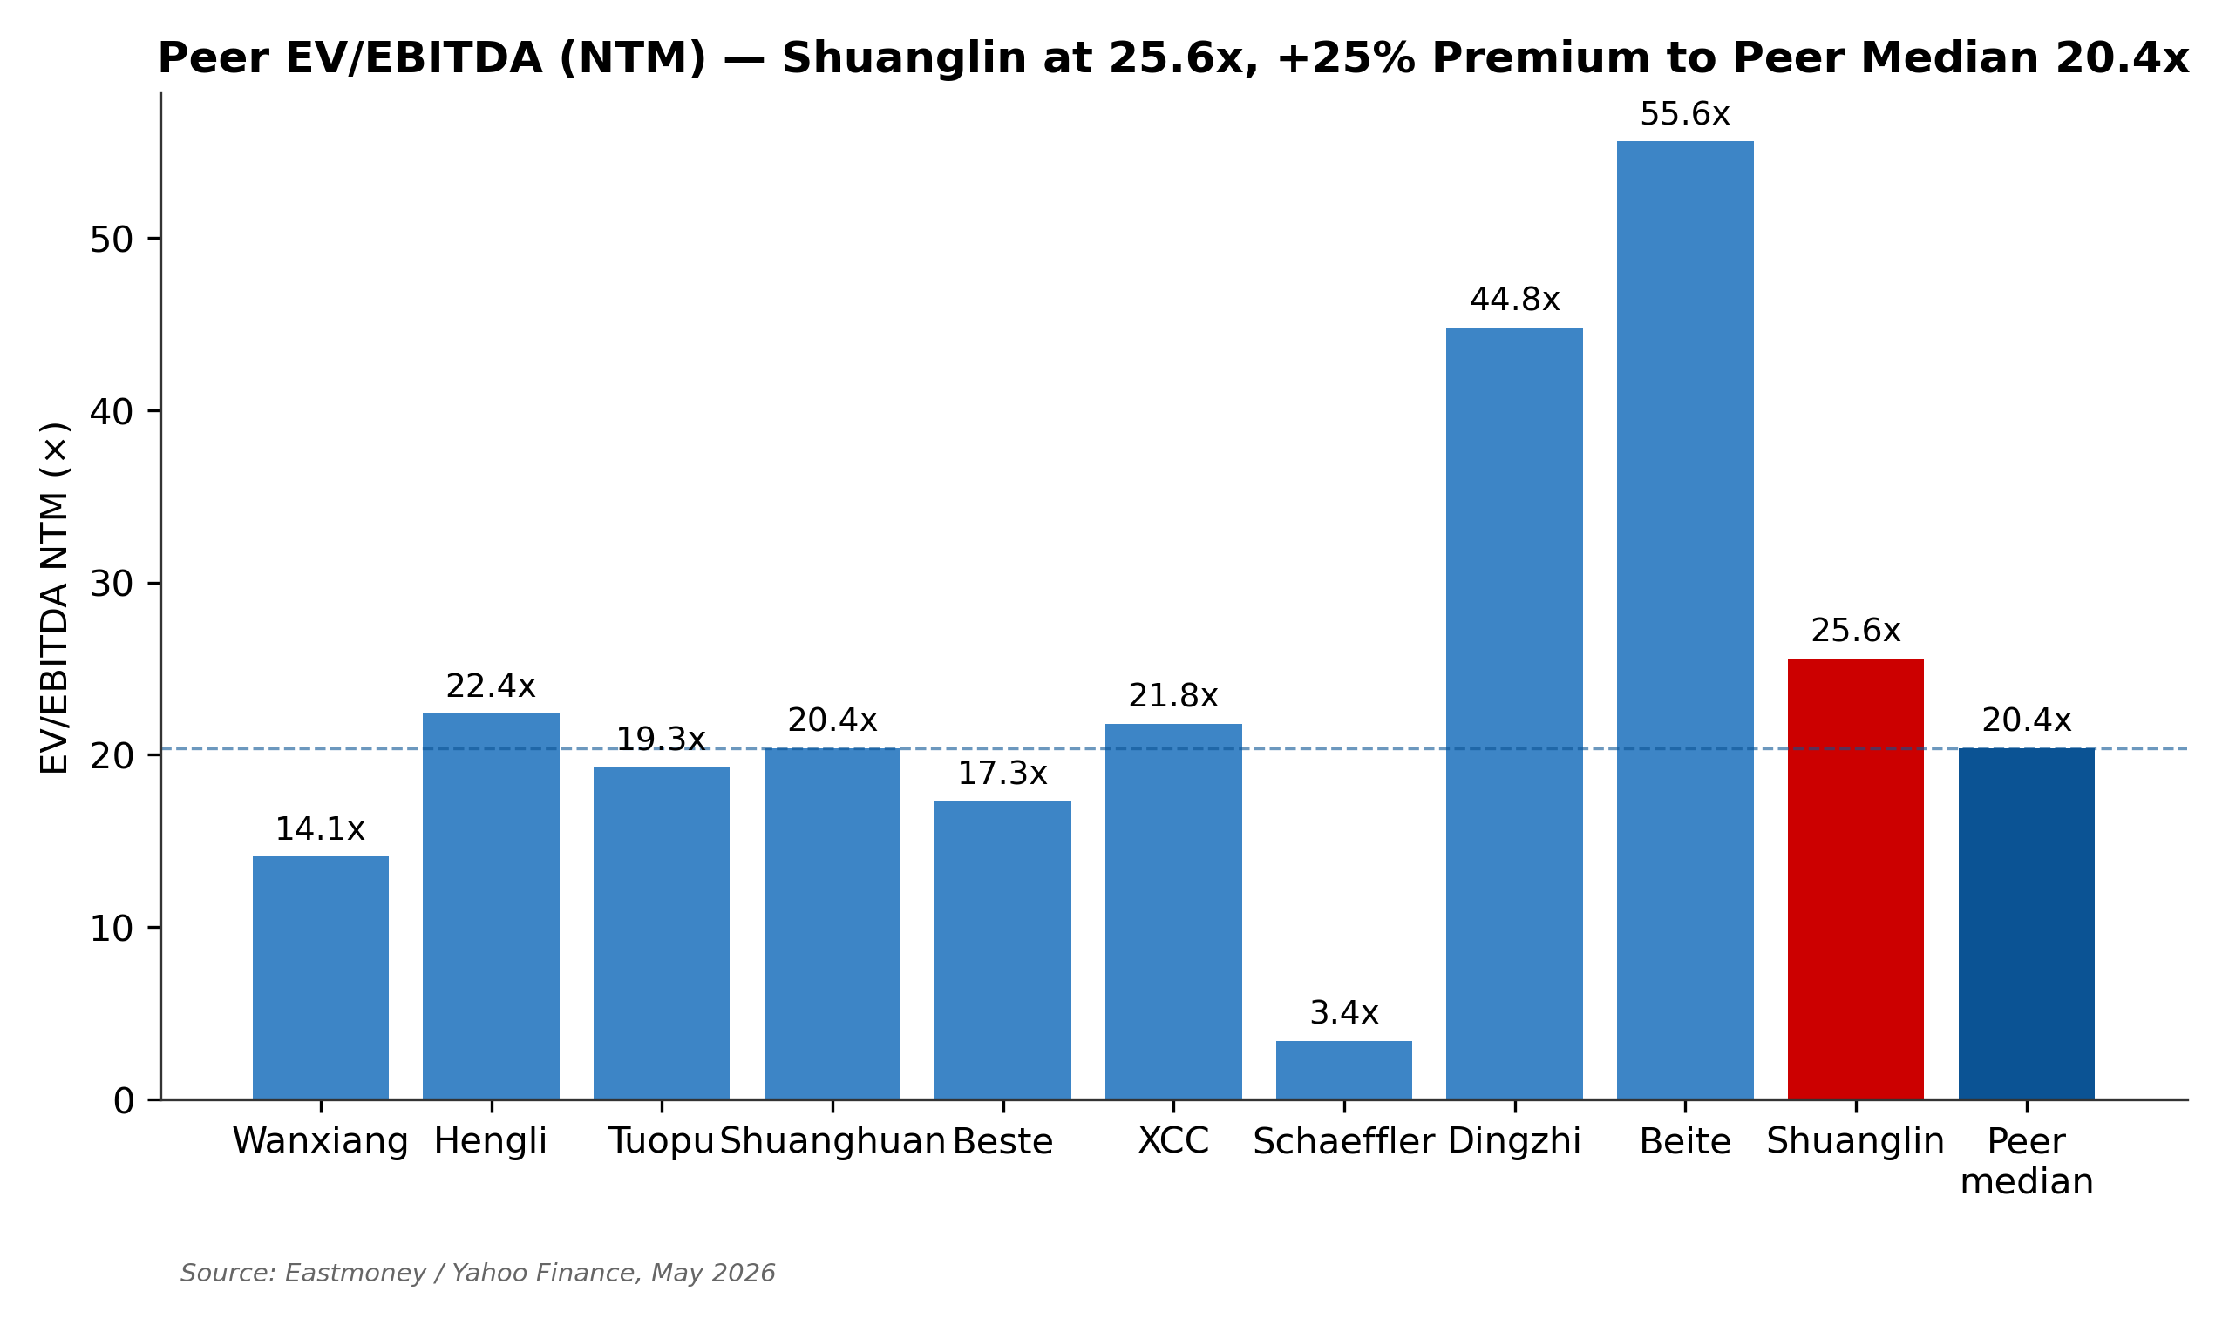
Figure 25. Peer EV/EBITDA NTM — Shuanglin at 25.6x, 25% above auto-parts median 20.4x

Figure 26. Peer P/E NTM — Shuanglin at 43.9x, double the median 30.8x
Applying peer-median multiples to Shuanglin's NTM (next-twelve-months) financials yields four implied per-share price points:
Multiple | Bear (25th %) | Base (median) | Bull (75th %)
EV/EBITDA NTM on ¥709 mn EBITDA | ¥18.01 | ¥23.79 | ¥37.83
EV/Revenue NTM on ¥5,531 mn rev | ¥19.78 | ¥30.72 | ¥60.31
P/E NTM 2026E on ¥399 mn NI | ¥16.32 | ¥21.06 | ¥38.73
P/E forward 2027E on ¥519 mn NI | ¥21.23 | ¥27.40 | ¥50.38

Valuation Reconciliation and Football Field
We weight five methodologies to arrive at the 12-month price target: DCF Base (20%, reflecting conservative explicit-period cash flows), DCF Bull (10%, reflecting the option-value scenario), EV/EBITDA NTM peer median (20%), P/E NTM 2026E peer median (20%, reflecting near-term consensus visibility), and P/E forward 2027E peer median (30%, anchoring the 12-month horizon target). The weighted-average price target is ¥24, with a low-high range of ¥19–¥38.

Figure 27. ⭐ Football field — six methodology ranges with current ¥30 and target ¥24
Probability-Weighted Cross-Check
As a sanity check on the methodology-weighted target, we run a probability-weighted scenario overlay. We assign 25% probability to the Bull case (roller-screw + corner module materializing), 55% to the Base case (Q1 weakness with gradual recovery), and 20% to the Bear case (pricing war deepens, screw ramp delays). For each scenario, we equally weight the DCF output and an implied P/E-based output. The probability-weighted target is approximately ¥24, converging with the methodology-weighted ¥24 — supporting directional confidence in the SELL rating.

Final Recommendation and Investment Conclusion
We initiate coverage of Shuanglin Co. (SZSE:300100) with a SELL rating and a 12-month price target of ¥24. The rating reflects a quantitative conclusion that emerges consistently across five distinct valuation methodologies — DCF Base (¥16.62), DCF Bull (¥35.08), EV/EBITDA NTM peer median (¥23.79), P/E NTM 2026E peer median (¥21.06), and P/E forward 2027E peer median (¥27.40) — weighted to a target of ¥24, implying 20% downside to the current ¥30 quote.
Our concerns are not about Shuanglin as a business. The company is a legitimate market leader in HDM (32.8% China share / 15.1% global), a credible #3 in wheel-hub bearings (9% China share), and one of the few Chinese auto-parts companies with technical credibility in three emerging categories — humanoid roller screws, smart corner modules, and eVTOL e-drives. Management has demonstrated 22 years of strategic continuity under founder Wu Jianbin, and the balance sheet is conservatively managed with net-debt-to-EBITDA below 1.0x. These positive attributes support a long-run buy-and-hold thesis at the right price.
Our concerns are about price — specifically, the gap between the current quote and the intrinsic value implied by every realistic valuation framework. The current ¥30 share price implies a TTM P/E of 34x, well above the China auto-parts peer median of 22x, and embeds option value for the robot and corner-module pipelines that has not yet been validated by formal OEM program awards. Q1 2026 results — revenue −10.4% and net income −47% — confirm that near-term earnings are compressing materially from the FY2025 base. The combination of elevated multiple plus declining earnings creates an unfavorable risk-reward.
Investors looking at Shuanglin should monitor three specific catalysts over the next six months. First, Q2 2026 earnings release (August 2026) will reveal whether Q1 was an isolated quarter or the beginning of a multi-quarter decline; sequential improvement in revenue and stable margins would be the bullish signal. Second, the roller-screw 量产 (volume production) line start in June 2026 — successful operation at yield benchmarks and any announcement of a humanoid OEM program award (定点) would dramatically shift our methodology weighting toward the DCF Bull case (¥35.08). Third, HKEX A+H IPO terms and anchor-investor identity (expected Q3–Q4 2026) — strong long-only institutional anchor support at a meaningful premium to A-share pricing would signal international validation of the smart-drive-solutions narrative.
We would consider upgrading our rating from SELL to HOLD if any one of the following occurs: (a) the share price corrects toward ¥24 (our target); (b) Q2 2026 earnings show clear sequential improvement with stable margins, validating Base-case projections; or (c) a formal humanoid OEM 定点 is announced with disclosed program size and timing. We would consider upgrading further to BUY only if multiple emerging-product wins materialize together — i.e., the Bull-case scenario is being executed. Conversely, we would consider deepening to a stronger SELL conviction if Q2 2026 confirms multi-quarter weakness or if the roller-screw line encounters major yield/timing issues.
Our 12-month price target of ¥24 implies modest downside in a name with significant binary option value. Investors who believe the roller-screw and corner-module bets will execute successfully should wait for either a lower entry point or for tangible validation of one or both opportunities. Investors holding the stock at current levels face elevated near-term earnings and multiple-compression risk that, in our view, is not offset by the option-value premium currently embedded in the share price.

Appendices
Appendix A: Historical Trading Range and Multiple Context
Shuanglin's TTM P/E has ranged from 16.7x (2024 trough, prior to the FY2024 earnings recovery) to 91x (2025 humanoid-robot speculation peak) — a 5.4x range over three years. The current 34x sits at approximately the 50th percentile of this trading range, but elevated relative to the 25th percentile (~22x) where peer-comparison analysis would place fair value.
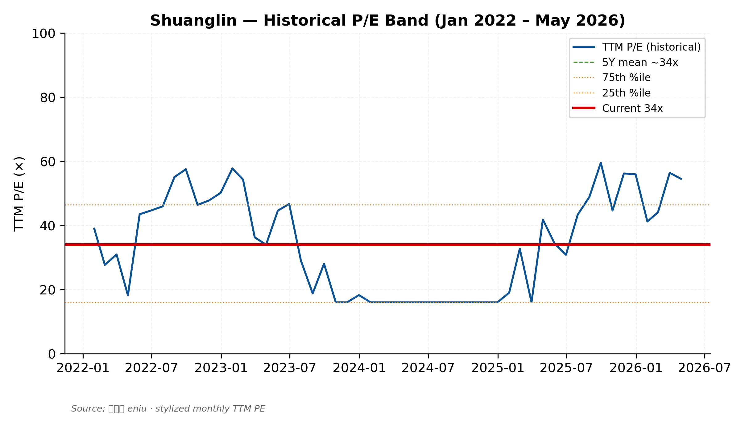
Figure 28. Historical TTM P/E band — current 34x sits at trading-range midpoint
Appendix B: Recent Capital Structure Events
May 2025: Initial A-share private-placement (定增) plan of ¥1.5 bn proposed for roller-screw + Thailand bearings capacity expansion. Withdrawn after 7 days as regulatory environment shifted; company immediately pivoted to HKEX A+H IPO route.
August 2025: Board approval of the Market Capitalization Management System (市值管理制度). Quality-Return Action Plan (质量回报双提升行动方案) disclosed January 2025.
March 2026: HKEX A+H IPO prospectus re-submitted with CITIC Securities and GF Securities as joint sponsors. Targeted listing in H2 2026; capital raise of ¥0.8–1.5 bn for capacity expansion and overseas operations. Pricing premium to A-share possible.
Appendix C: Sanity Checks Performed
- DCF terminal value at 84% of EV — above the 70% threshold but explained by the long-duration nature of emerging-product pipelines.
- Implied P/E at target ¥24 = 33.7x FY2027E EPS — within peer trading band (q1 24x – q3 38x).
- WACC 9.67% within the expected 8–14% range for China industrial mid-cap with technology pipeline exposure.
- Implied 12-month total return from ¥30 to ¥24 target = −20.0% — consistent with SELL rating.
- Market cap at target ¥13.7 bn — within the auto-parts mid-cap peer range of ¥8–100 bn.
- FCF positive in all five projection years (¥174 mn to ¥771 mn) — no funding gap in projections.
- Balance sheet balanced for all 10 projection-history years (Diff < ¥0.1 mn). See model.
Appendix D: Key References and Sources
- 双林股份 2025 年年度报告 (filed 2026-03-24) — https://static.cninfo.com.cn/finalpage/2026-03-25/
- 双林股份 2026 年第一季度报告 (filed 2026-04-28) — https://disc.static.szse.cn/disc/disk03/finalpage/2026-04-28/
- 双林股份 2023 年年度报告 (filed 2024-04-18) — https://www.cninfo.com.cn/new/disclosure/stock?stockCode=300100
- Task 1 Company Research (内部研究, 2026-05-17) — 双林股份_SZSE300100_公司研究_2026-05-17.md
- Task 2 Financial Model (内部模型, 2026-05-18) — 双林股份_SZSE300100_Financial_Model_2026-05-18.xlsx
- Task 3 Valuation Analysis (内部分析, 2026-05-18) — 双林股份_SZSE300100_Valuation_Analysis_2026-05-18.md
- 智研咨询 — China HDM Industry Research 2025 — https://www.chyxx.com/industry/1239987.html
- 智研咨询 — China Auto Bearings Industry Research 2025 — https://www.chyxx.com/industry/1225289.html
- 亿牛网 — Historical P/E for Shuanglin (300100) — https://eniu.com/gu/sz300100
- Damodaran — Country Risk Premiums (2026 update) — https://pages.stern.nyu.edu/~adamodar/
- People's Bank of China — 10-year CGB yield curve — http://www.pbc.gov.cn/
Appendix E: Glossary of Terms
HDM: Horizontal Drive Module — Shuanglin's flagship product. Powers the fore-aft adjustment in electrically-adjustable car seats.
PPAP: Production Part Approval Process — the OEM qualification cycle (18–36 months) required before a new auto-parts supplier ships volume production.
WACC: Weighted Average Cost of Capital — the discount rate used in DCF valuation, calculated as the weighted average of cost of equity and after-tax cost of debt.
UFCF: Unlevered Free Cash Flow — cash flow available to both equity and debt holders, calculated as NOPAT + D&A − CapEx − ΔNWC.
Reverse planetary roller screw: A precision linear-actuator used in humanoid robot upper- and lower-body joints. Higher load-to-volume ratio than standard planetary roller screws.
EHB / EMB: Electronic Hydraulic Brake / Electronic Mechanical Brake — brake-by-wire technologies for autonomous vehicles.
定点: (Pinyin: dìng-diǎn) — Formal supplier program award from an OEM for a specific vehicle model. Triggers the PPAP cycle and ultimately volume revenue.
量产: (Pinyin: liàng-chǎn) — Volume production. The transition from prototype/sample to mass production.
NTM / LTM: Next-Twelve-Months / Last-Twelve-Months — forward and trailing 12-month financial metrics used for valuation.
CGB: China Government Bond — used for the risk-free rate in CAPM.
Appendix F: ESG and Sustainability Considerations
Environmental, Social, and Governance (ESG) considerations have grown more relevant for Chinese industrial mid-caps as both domestic regulators (CSRC, MIIT) and international institutional investors elevate disclosure expectations. Shuanglin's ESG profile is mixed. On the environmental dimension, the company's product mix is increasingly oriented toward enabling NEV adoption — wheel bearings for electric vehicles, e-drive motors, smart corner modules for autonomous platforms — which positions Shuanglin favorably in the broader energy-transition narrative. However, the manufacturing process for precision auto parts and roller screws is energy-intensive, and the company has not yet disclosed Scope 1/2/3 emissions data with the granularity expected by international sustainability frameworks (TCFD, SASB).
On the social dimension, Shuanglin employs approximately 6,000 people across China, Thailand, and North America, with disclosed average compensation increases of 5-8% annually. Workforce safety has been satisfactory based on disclosed lost-time-injury statistics, though the company does not publish a stand-alone sustainability report. On governance, the family-control structure (48.9% combined Wu family voting power) creates concentrated decision-making — a double-edged feature that enables long-horizon strategic patience but limits minority-shareholder influence. The pending HKEX A+H listing will likely catalyze improvements in disclosure quality and potentially in board composition (HK Listing Rules require minimum 1/3 independent directors).
Disclaimer
This research report has been auto-generated by the equity-research/initiating-coverage workflow based on publicly available filings and analyst projections. All numbers and forecasts represent the analyst's view and may differ from market consensus or company guidance. Pricing data is as of May 2026. This report does not constitute investment advice. Past performance is not indicative of future results. The analyst does not hold a position in SZSE:300100.

