MPA 634  
Data Science and R for Administrators  
Combined Homework #2 and #3

Aesthetic Mappings and Facets

1. **Definitions, Concepts, and vocabulary**  
   *Explain how aesthetics, scaling, and mapping are related to each other within the context of the grammar of graphics and ggplot.*

Aesthetics control the appearance of the data and the figure that is made. Scaling is important since it defines a unique aesthetic to each unique variable. Finally, mapping takes one value and assigns it something else. For example, you can map color to the different values of a variable.

1. **Code Interpretation**

1 ggplot(data = mpg, mapping = aes(x = displ, y = hwy, color = class)) +

2 geom_point(position = "jitter", show.legend = FALSE) +

3 geom_smooth(method = "lm", se = FALSE, show.legend = FALSE,

4 color = "black",

5 size = 0.50) +

6 geom_smooth(se = FALSE, show.legend = FALSE) +

7 facet_wrap(vars(class))

Line 1: The ggplot function is called to create a figure. It uses the first argument, “data = mpg”, to define where the data that is coming from. The mapping argument defines the variable along the x-axis and the y-axis, “displ” and “hwy” respectively. The color of the data is based on the “class” variable. Finally, the “+” means the command continues on the next line.

Line 2: geom_point plots a scatter plot using the data loaded in ggplot. The “position= “jitter”” argument introduces a little bit of noise to each data point to reduce the negative effects from overlap of data points. The legend is turned off using the command “show.legend = FALSE”

Line 3: geom_smooth plots a fitted curve to the data. Here, the linear method is used and the confidence interval is turned off since “se = FALSE”. Again, the legend is turned off.

Line 4: Sets the color of the line to black

Line 5: Sets the size of the line to 0.5

Line 6: geom_smooth here plots a fitted curve using the LOESS method since that is the default method. The confidence interval is turned off and the legend is not shown.

Line 7: This command takes the plot and creates wrapped facets based on the variable “class”

1. **Code Creation**

Use ggplot to create a graph like the following:

CODE:

library(tidyverse)

data(mpg)

ggplot(data = mpg, mapping = aes(x=class, fill=drv))+

geom_bar(position = "fill")+

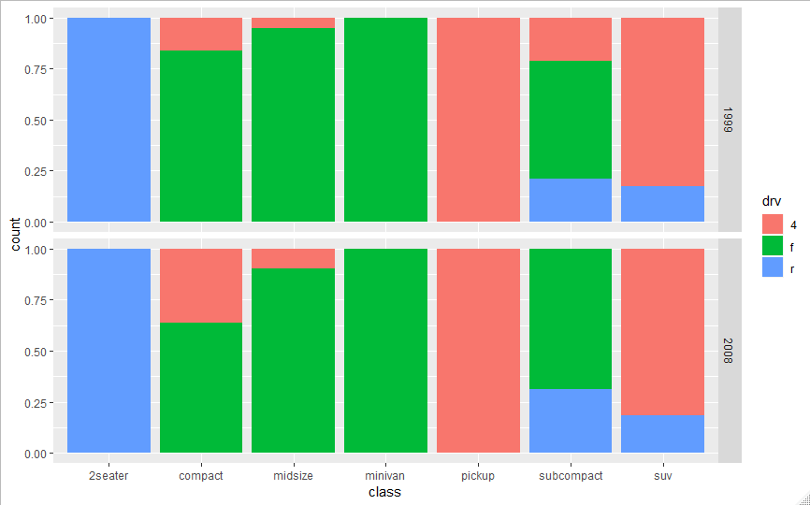 facet_grid(rows = vars(year))