MPA 634  
Data Science and R for Administrators  
Homework #3

Geometric Objects

1. Problem 6 from Exercises 3.6.1

*Recreate the R code necessary to generate the following graphs.*

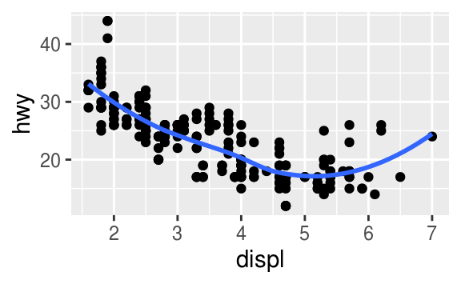Plot 1:

Code:

ggplot(data = mpg, mapping = aes(x = displ, y = hwy)) +

geom_point() +

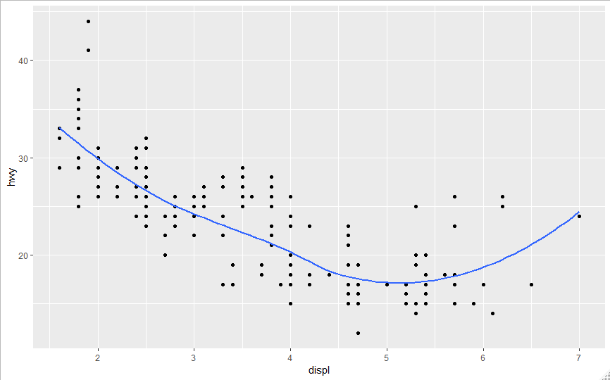 geom_smooth(method = 'loess', se= FALSE)

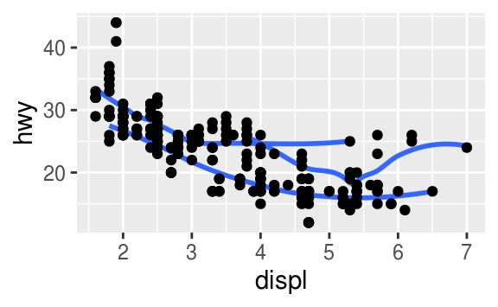

Plot 2:

Code:

ggplot(data = mpg, mapping = aes(x = displ, y = hwy)) +

geom_point() +

geom_smooth(method = 'loess',se= FALSE, mapping = aes(group = drv))

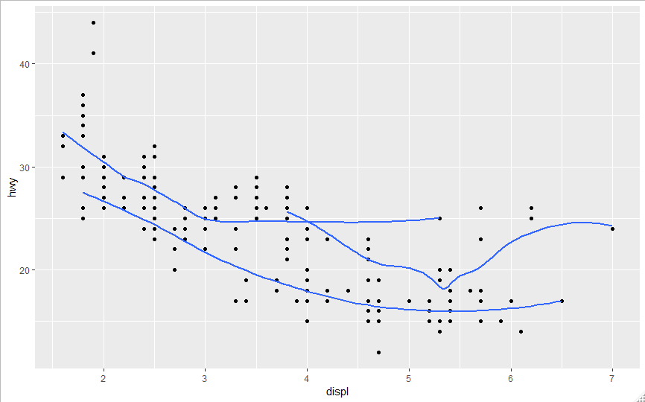

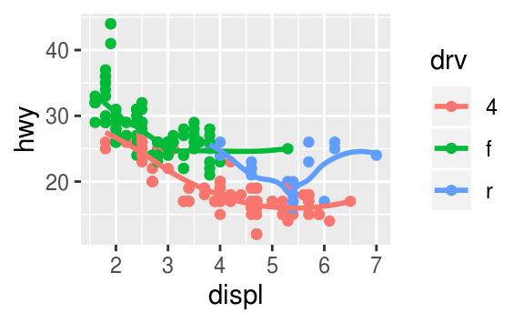Plot 3:

Code:

# Plot 3

ggplot(data = mpg, mapping = aes(x = displ, y = hwy, color = drv)) +

geom_point() +

geom_smooth(method = 'loess',se= FALSE, mapping = aes(group = drv))

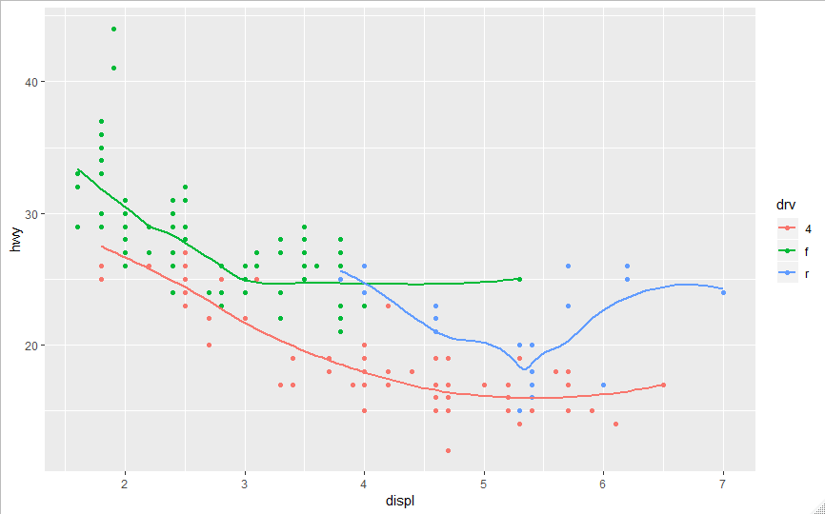

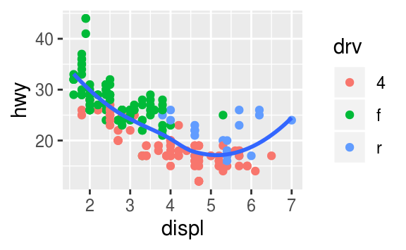

Plot 4:

Code:

# Plot 4

ggplot(data = mpg, mapping = aes(x = displ, y = hwy)) +

geom_point(mapping = aes(color = drv)) +

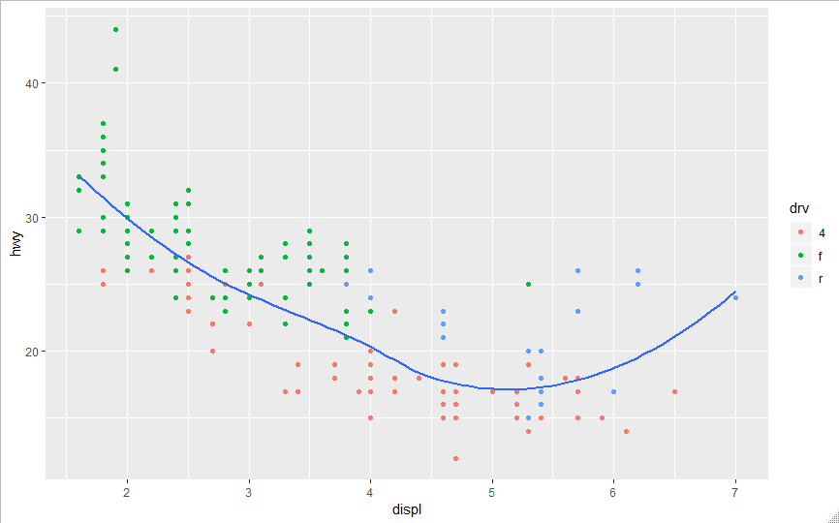 geom_smooth(method = 'loess',se= FALSE)

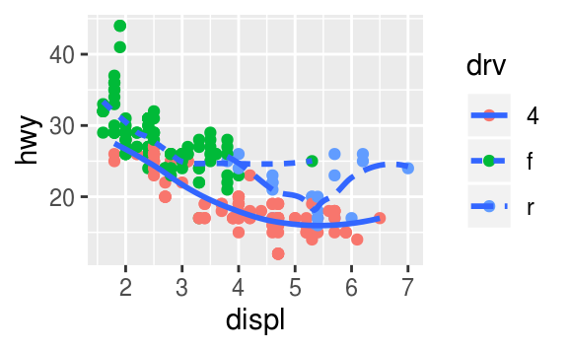Plot 5:

Code:

# Plot 5

ggplot(data = mpg, mapping = aes(x = displ, y = hwy)) +

geom_point(mapping = aes(color = drv)) +

geom_smooth(method = 'loess',se= FALSE, mapping = aes(linetype = drv))

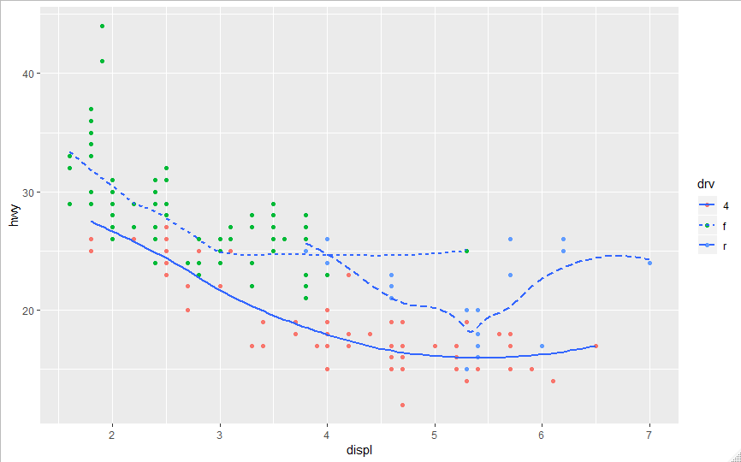

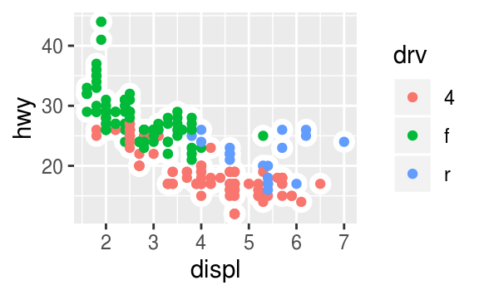Plot 6:

Code:

#Plot 6

ggplot(data = mpg, mapping = aes(x=displ, y = hwy))+

geom_point(color = "white", size = 7)+

geom_point(mapping = aes(color = drv), size = 4)

