Model:

P1

1. Position
2. Perspective A
3. Perspective B
4. Perspective C

P2

1. Perspective A

C1:

1. M=y
2. X=m
3. =>x=y

C2

1. –x=-y
2. Ex.
3. =>x=y

P3

1. Perspective B

D:

Cons:

1. !X=-y
2. Classify
3. Classify
4. !-Y=x
5. Classify
6. Ex

Pros

1. X=y

P4:

1. Perspective C

BBChar( x: -A/A y: Negative/Positive)

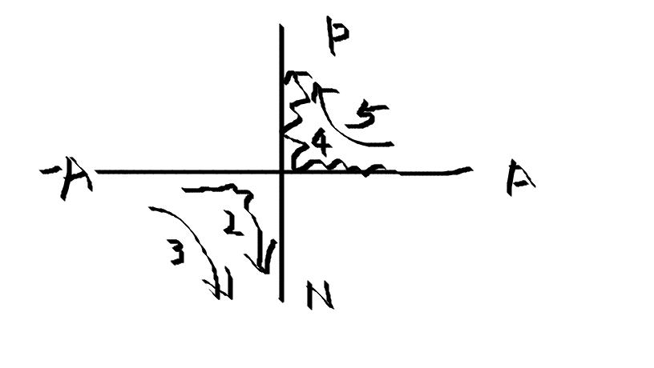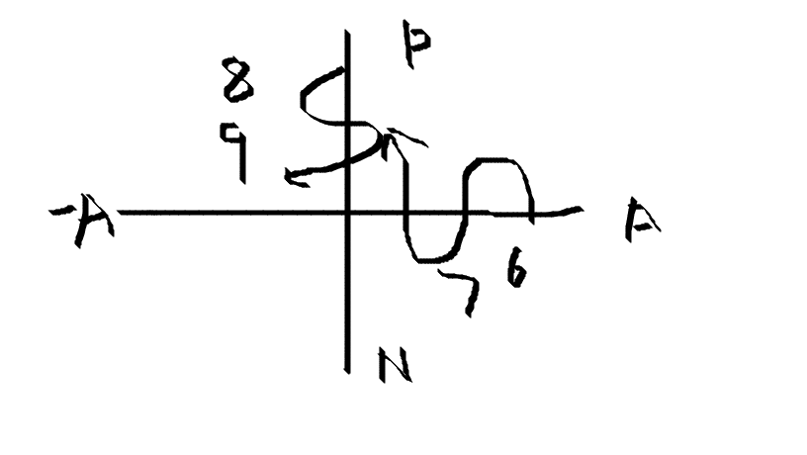

Ex:

A nation should require all of its students to study the same national curriculum until they enter college.

1. Creativity (ka)
2. Liberty (kv)
3. Students(kw)