Path = C:\Users\UsEr\project\belajar-git\peta_pikiran
https://chat.deepseek.com/
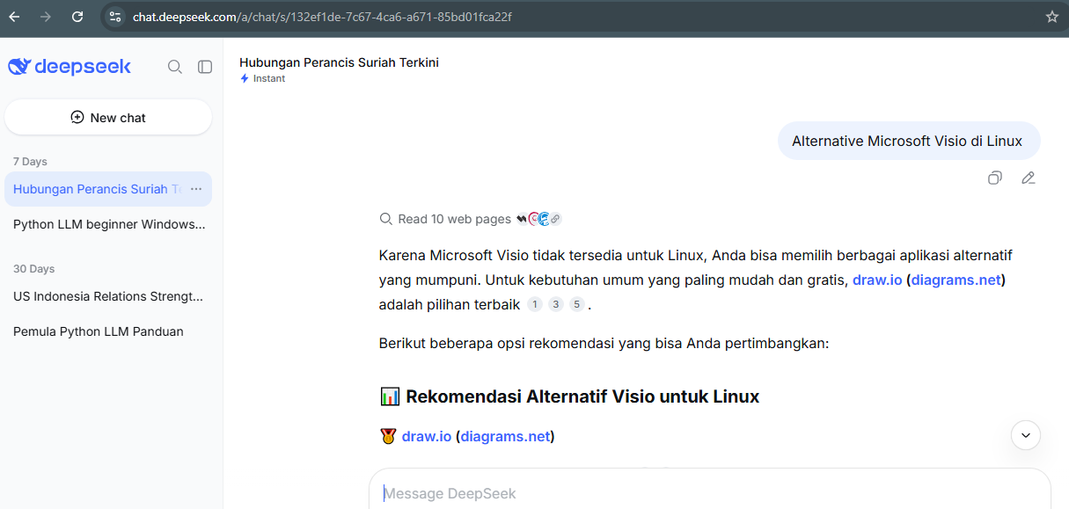
https://app.diagrams.net/

