Path = C:\Users\UsEr\dok\dadang

[OH GINI RASANYA LINUX | Efek samping migrasi ke Aurora (youtube.com)](https://www.youtube.com/watch?v=SqpyHRRQF0Y)

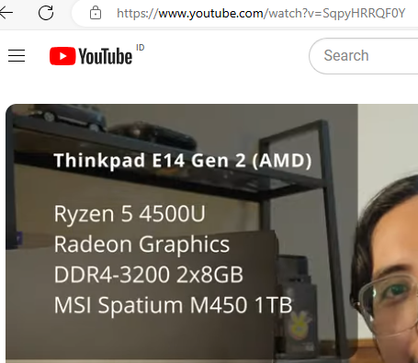

AMD Radeon Integrated