Path = C:\Users\UsEr\dok\dadang\hoby

Check winver

PS C:\Users\UsEr> where.exe winver.exe

C:\Windows\System32\winver.exe

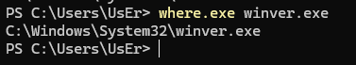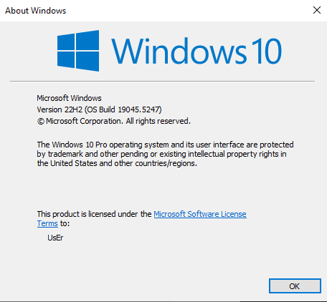

Check Grep.exe



Source = E:\dadang\source\java_compiler\netbeans

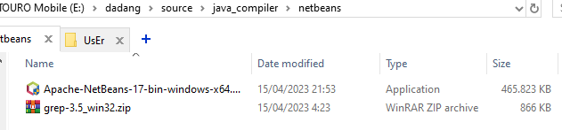

Implement di

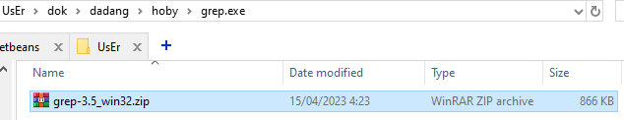

Check Java



Prepare Netbeans

Path = C:\Users\UsEr\dok\dadang\hoby\java\0_netbeans

winget list | ~\grep Apache

winget search Netbeans

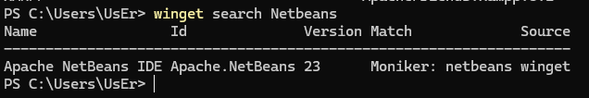

winget install Apache.NetBeans

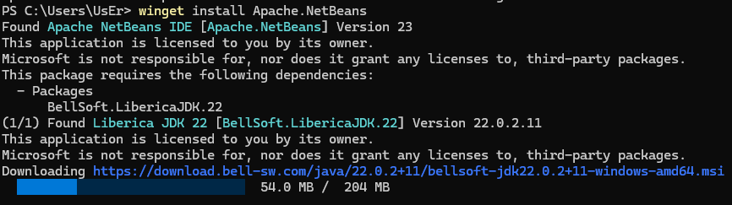

Check java

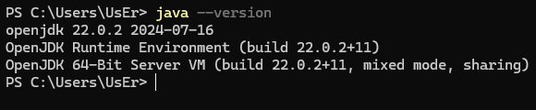

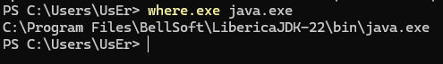

Implement E:\dadang\app\jetty-6.1.1 ke C:\Users\UsEr\app

Netbeans di winget belum update

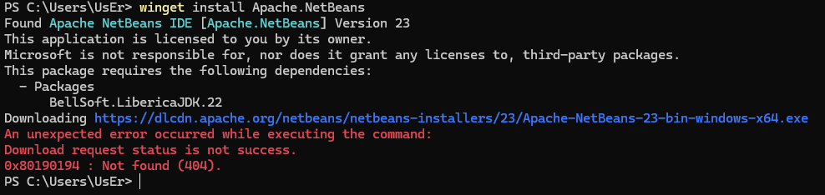

Ambil manual

