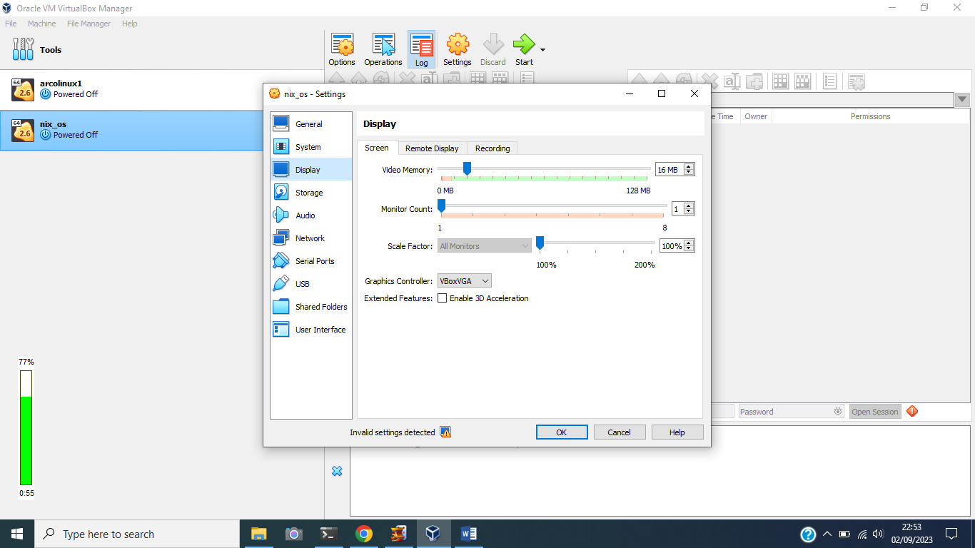

Nixos vboxvga

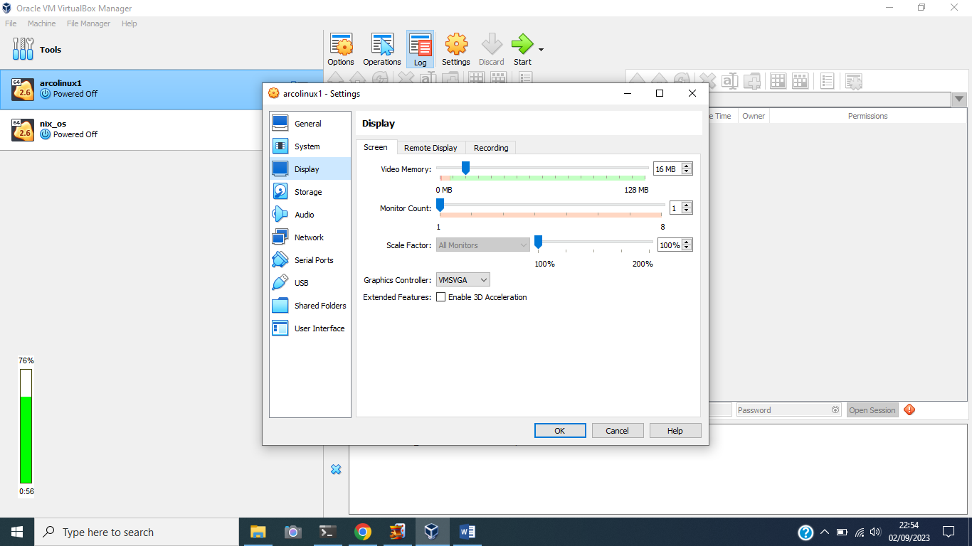arch vmsvga

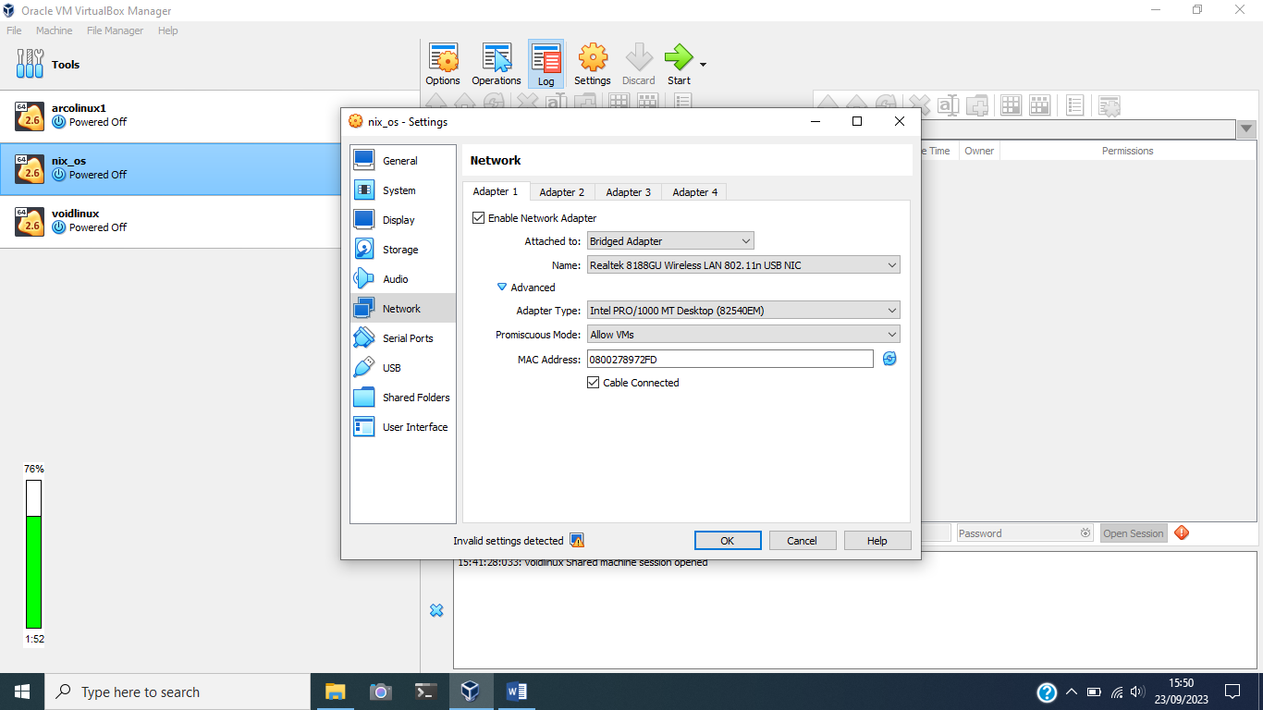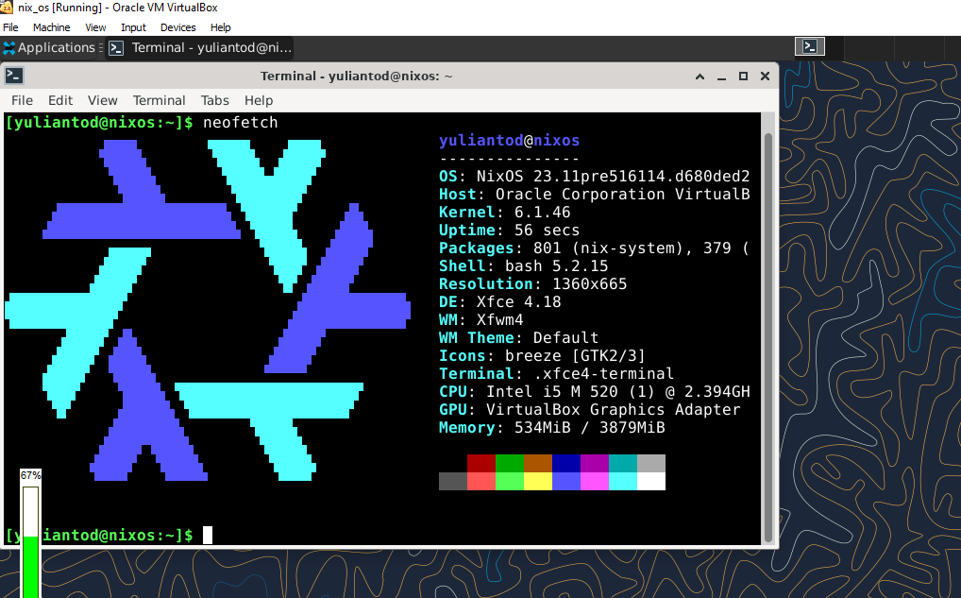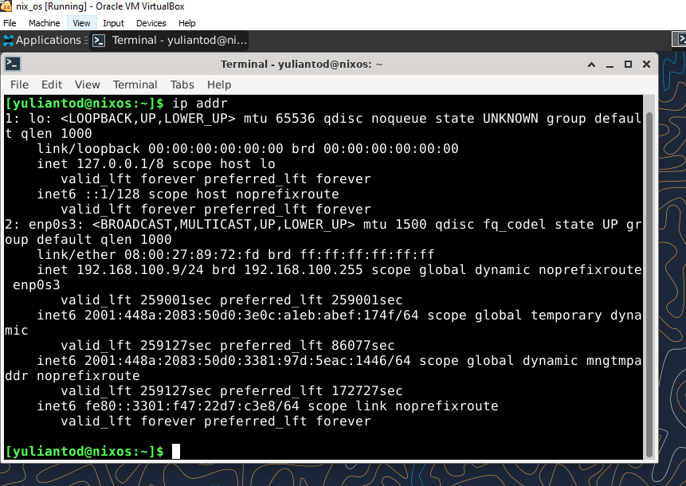

ssh-keygen -R 192.168.100.7

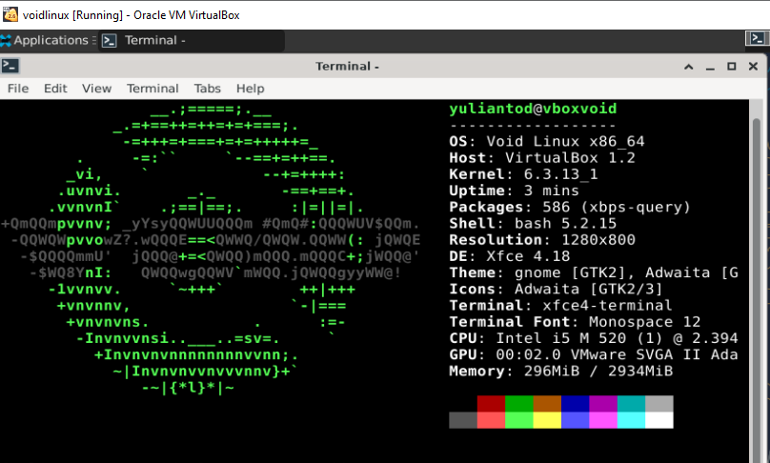

sudo xbps-install -S

sudo xbps-install -Suv

sudo xbps-query -l | wc -l

sudo xbps-query -Rs neofetch

sudo xbps-install neofetch

sudo xbps-remove neofetch

|  |
| --- |
| <https://gist.github.com/bastomiadi/abf27618341fc561735adfb17e586916>  1. Update all package system |
|  |
| sudo xbps-install -Suv |  |
|  |  |
| 2. add non-free repo |  |
| sudo xbps-install -Rs void-repo-nonfree |  |

sudo xbps-install git base-devel xtools

sudo git clone https://github.com/void-linux/void-packages

ipconfig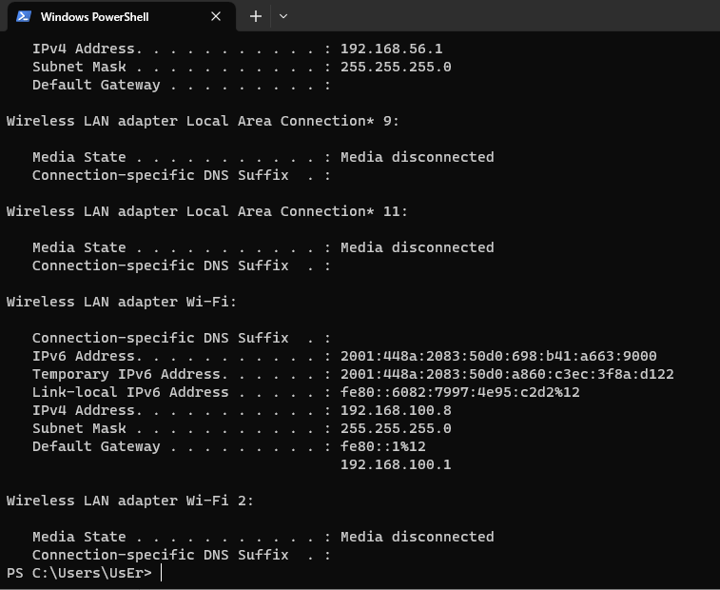

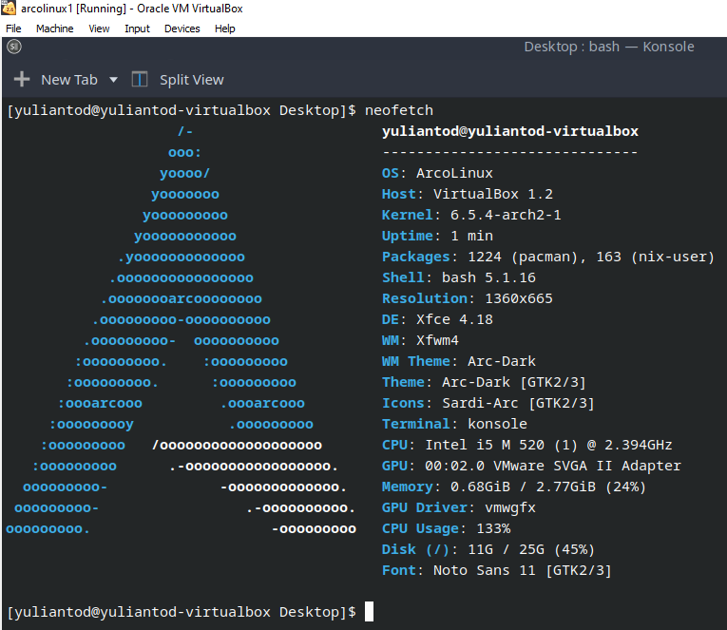

1360x665