**Create google cloud platform account**

1. Create free account available for 3 months (needs credit card for information, no amount deducted)
2. Use account provided by organization

**Create project**

1. Open google cloud console

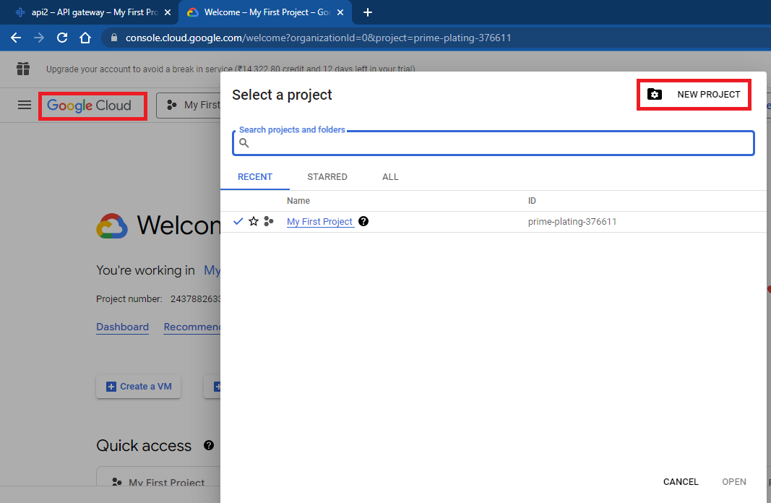

1. Mention name of GCP project

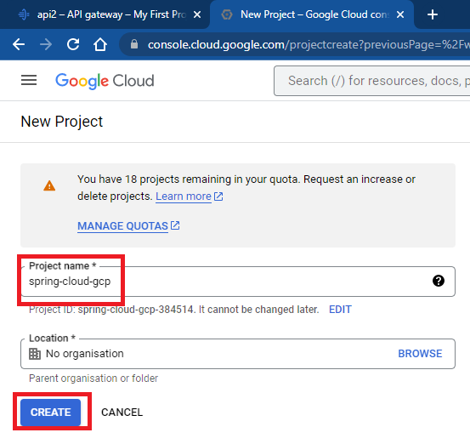

1. Wait for 2-3 minutes to create project
2. Note down project number and project id for future reference

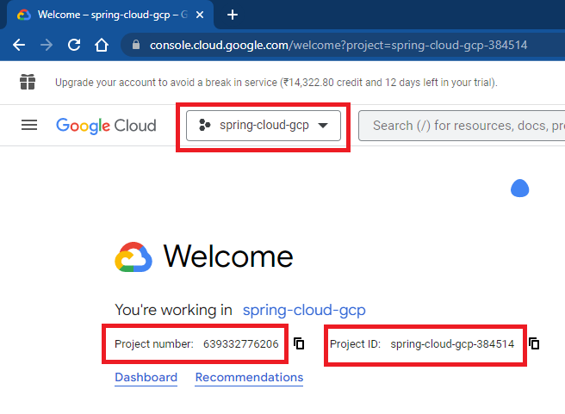­

**Enable API**

1. Compute Engine API
2. App Engine API
3. Stackdriver API
4. Stackdriver Monitoring API
5. Cloud Logging API
6. Cloud SQL Admin API
7. Cloud Run Admin API
8. Enable Identity-Aware Proxy
9. Artifact Repository API
10. API Gateway API
11. Service Control API
12. Service Management API

**Create cloud storage bucket**

1. Create bucket with name spring-cloud-gcp
2. Upload empapp-sql-script.sql file (can find this file in common-files folder)

**Create database in Cloud SQL**

1. D
2. D
3. D
4. D
5. D

**Setup glcoud sdk in local machine**

1. Search for gcloud sdk for windows (https://cloud.google.com/sdk/docs/install)
2. Go to installation instructions, choose windows
3. Click on Google cloud CLI installer (<https://dl.google.com/dl/cloudsdk/channels/rapid/GoogleCloudSDKInstaller.exe>)