**Create instance template**

1. Open google cloud console
2. Search for compute engine dashboard, select instance template

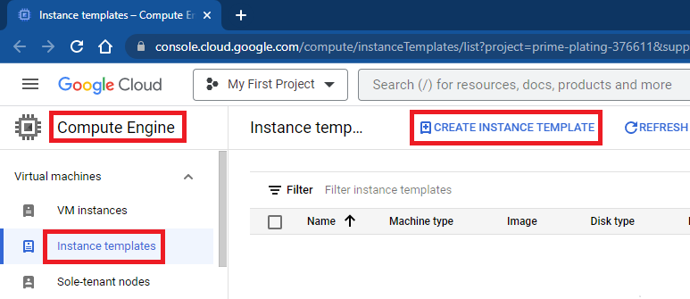

1. Mention name for instance template

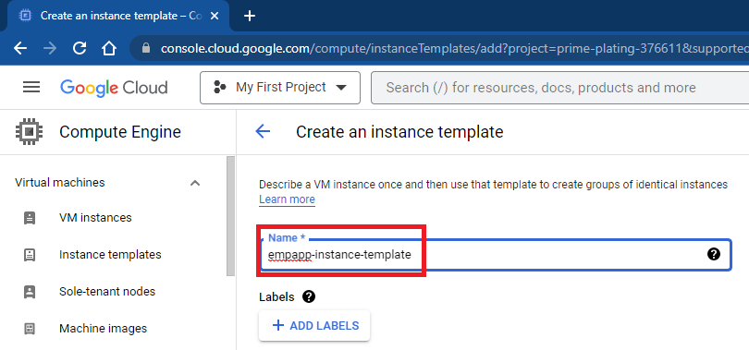

1. Change boot disk to centos

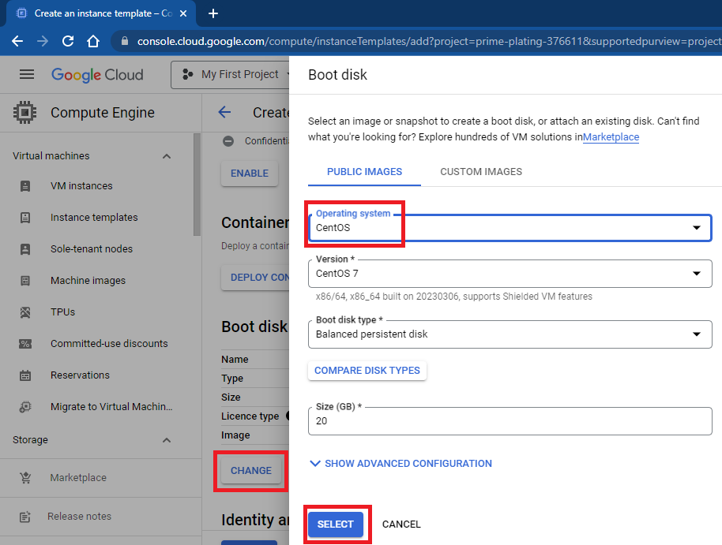

1. Select service account created earlier

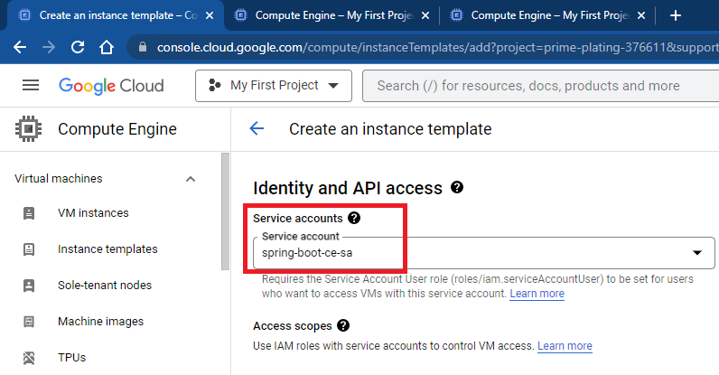

1. Add instance script and click on create

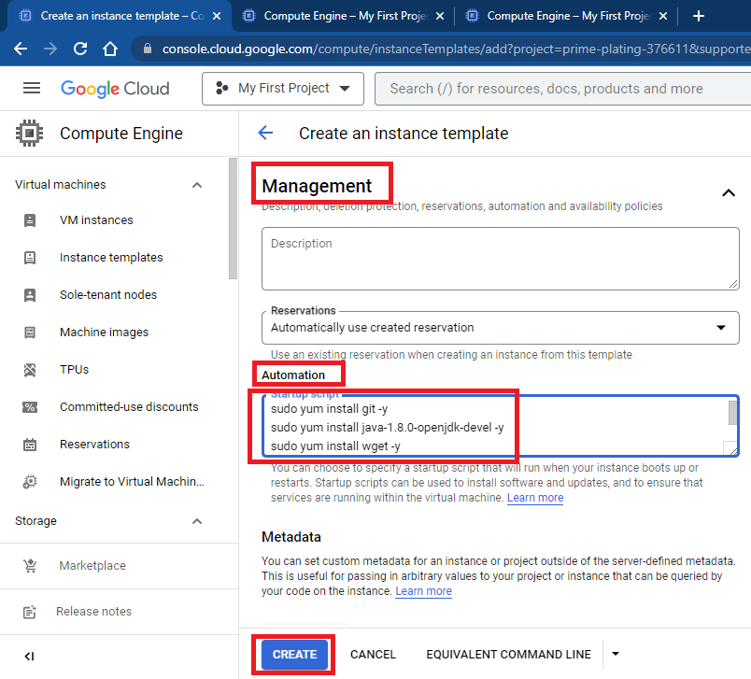

**Create health checks**

1. Open google cloud console
2. Search for compute engine
3. Create health checks

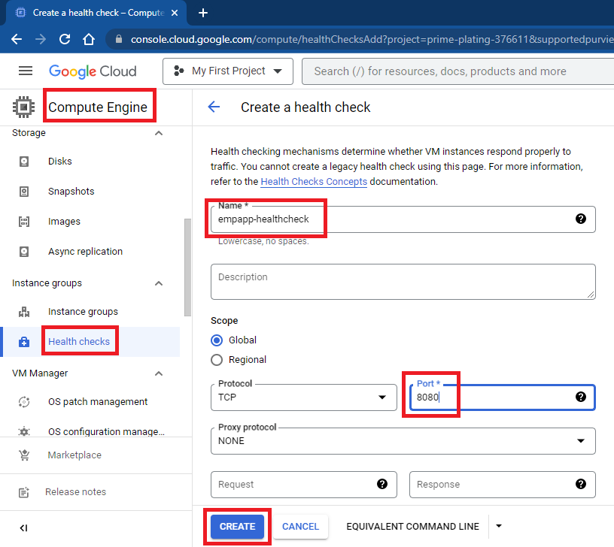

**Create instance group**

1. Go to compute engine dashboard

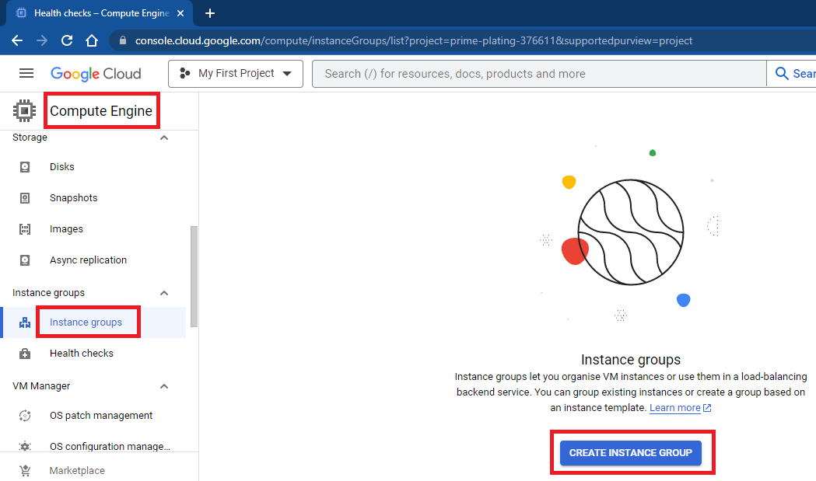

1. Mention name of instance group, select instance template created in earlier step

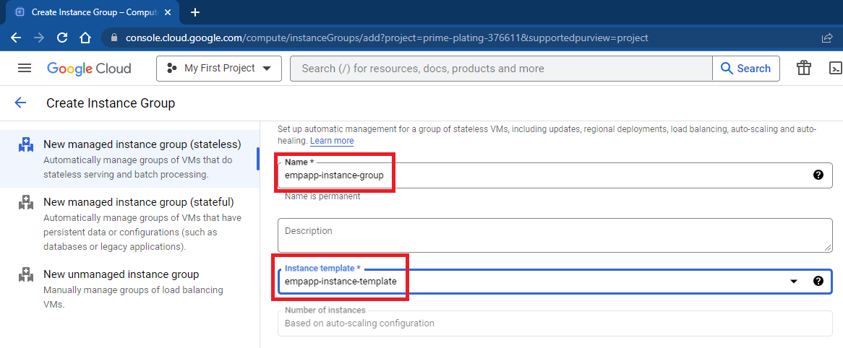

1. Go to autoscaling section, mention minimum and maximum instances, select autoscaling signals (CPU utilization as 60%), click on create

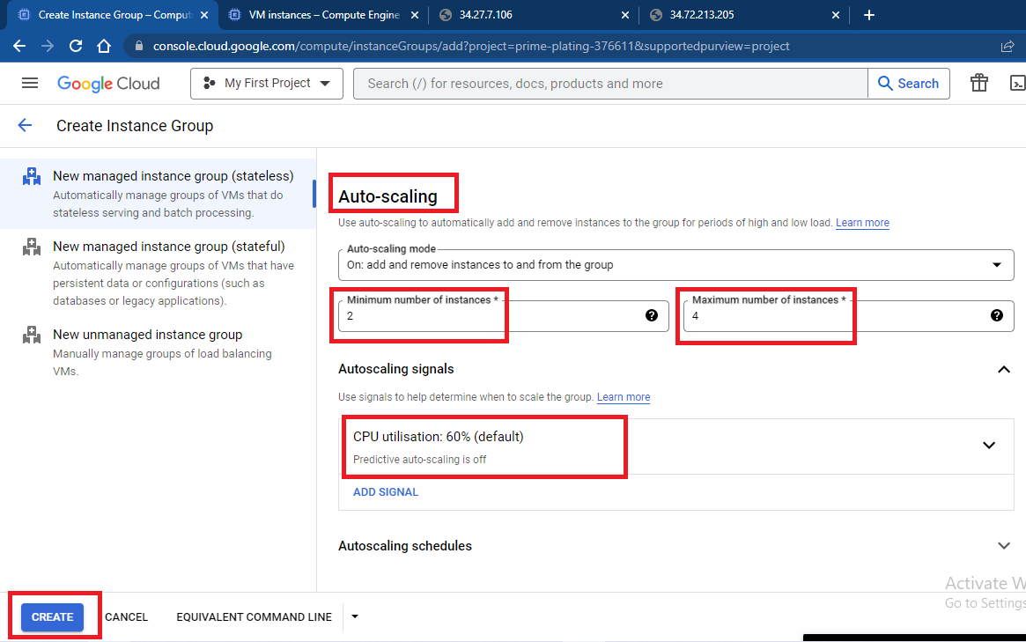

1. Wait for 5-7 minutes, instance group would be created

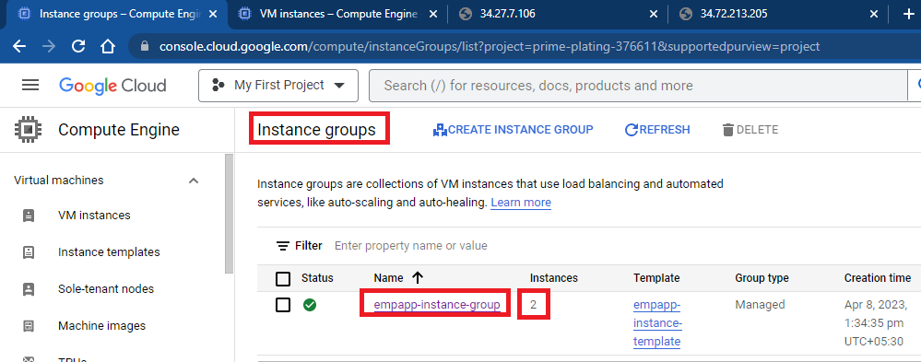

1. Can also check created instances in vm instances section

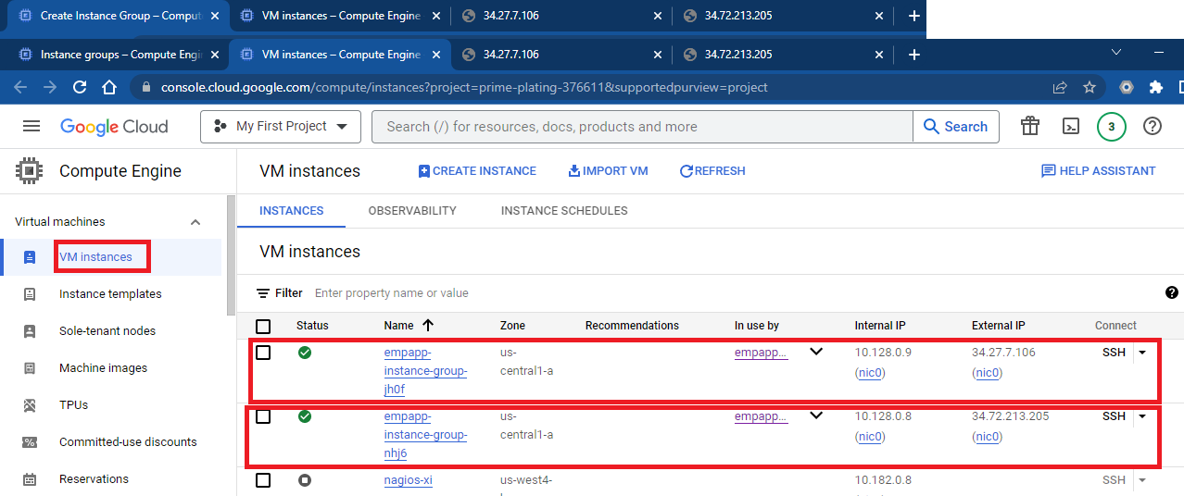

1. Can access application using ip and port number of vm instances
2. D
3. D