1. Open google cloud console
2. Search for load balancer, click on create load balancer

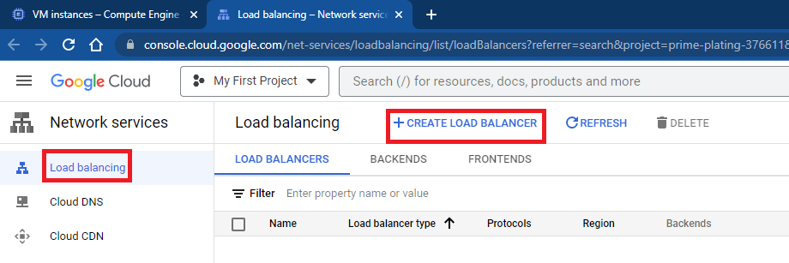

1. Select https load balancer , click on start configuration

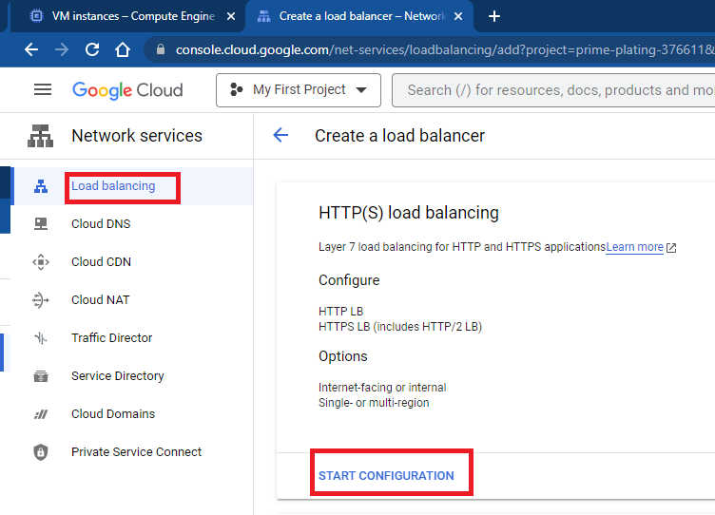

1. Click on continue

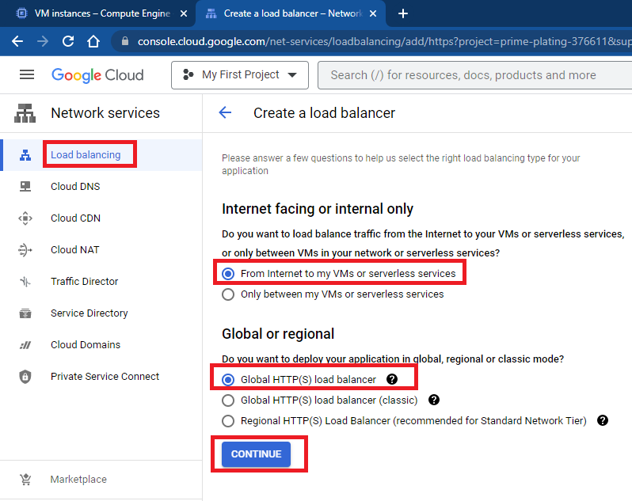

1. Configure frontend, mention name, click on done

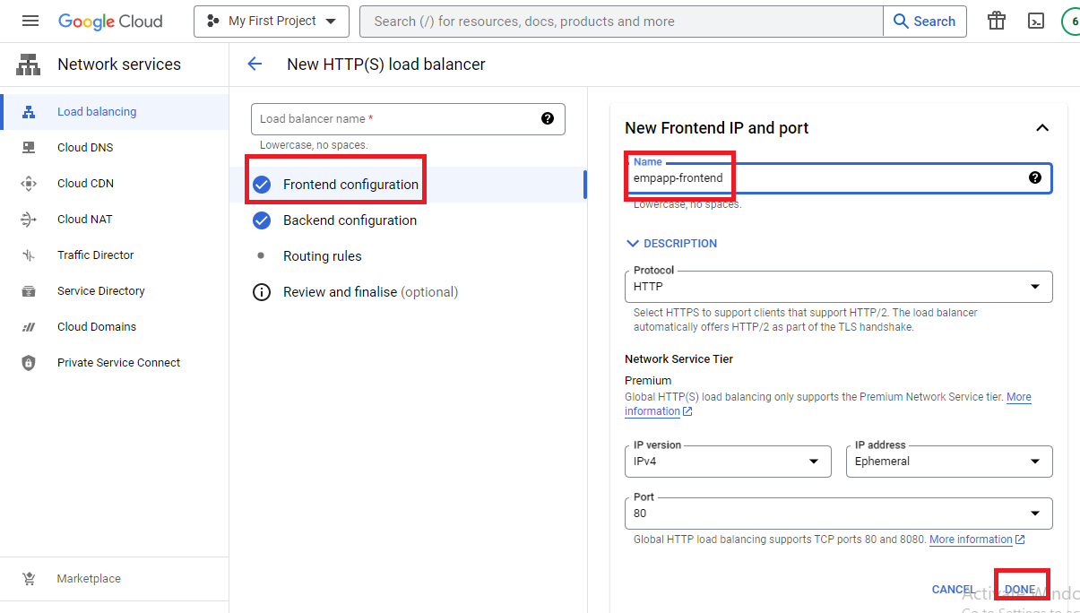

1. Configure backend, select instance group, mention port number 80, click on create

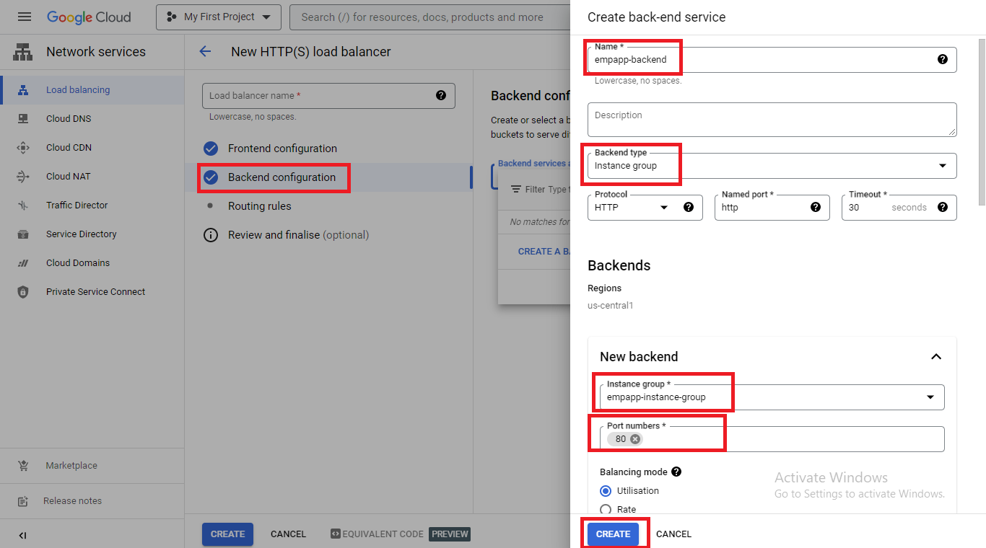

1. Mention load balancer name, click on create

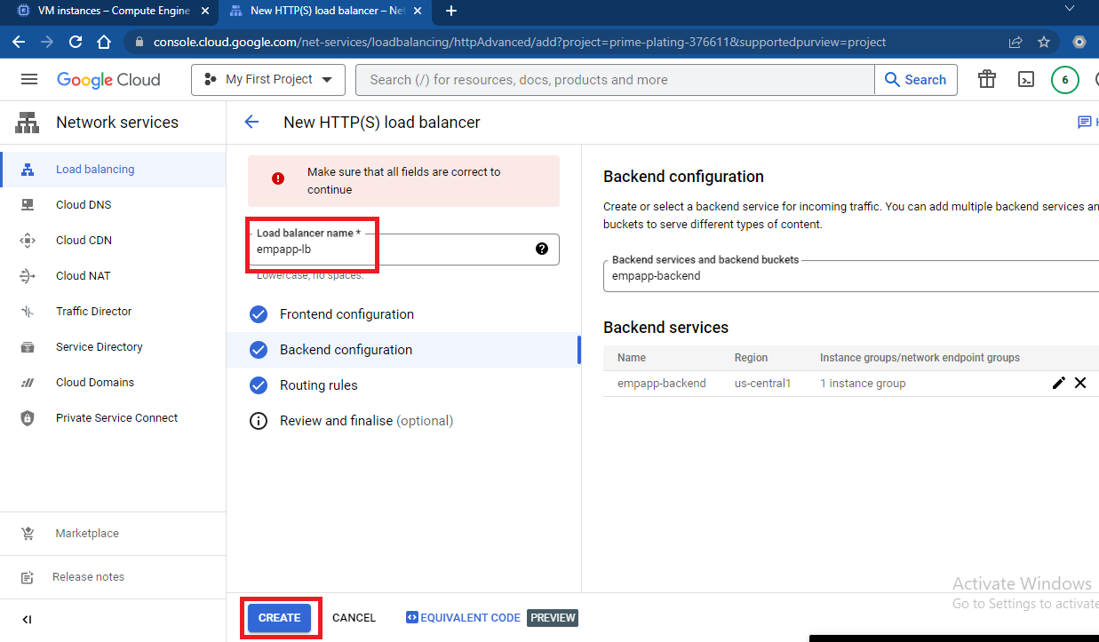

1. Access application using load balancer ip and port number
2. D