1. Open google cloud console
2. Search for app engine
3. Click on create application

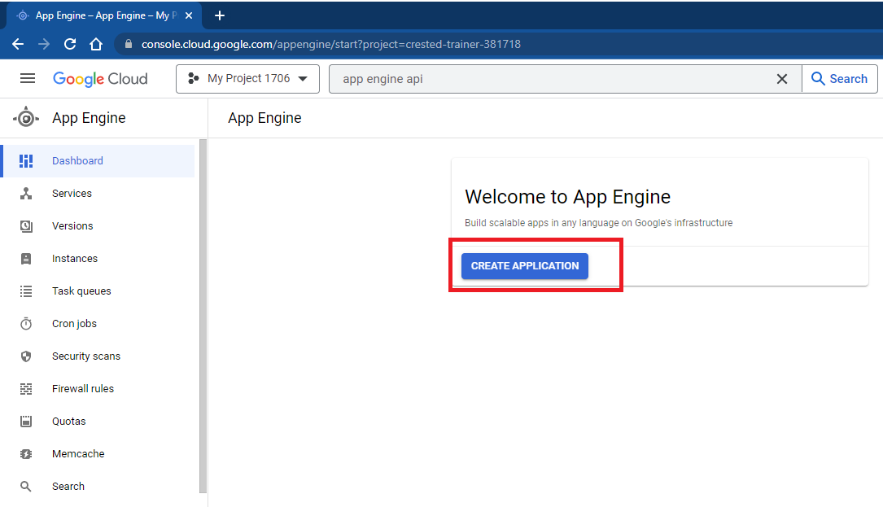

1. Assign different role to **“App Engine default service account”.** Default service account format is (<project_id>@appspot.gserviceaccount.com)
   1. Open IAM
   2. Locate **“App Engine default service account”** and click on edit (pencil icon)

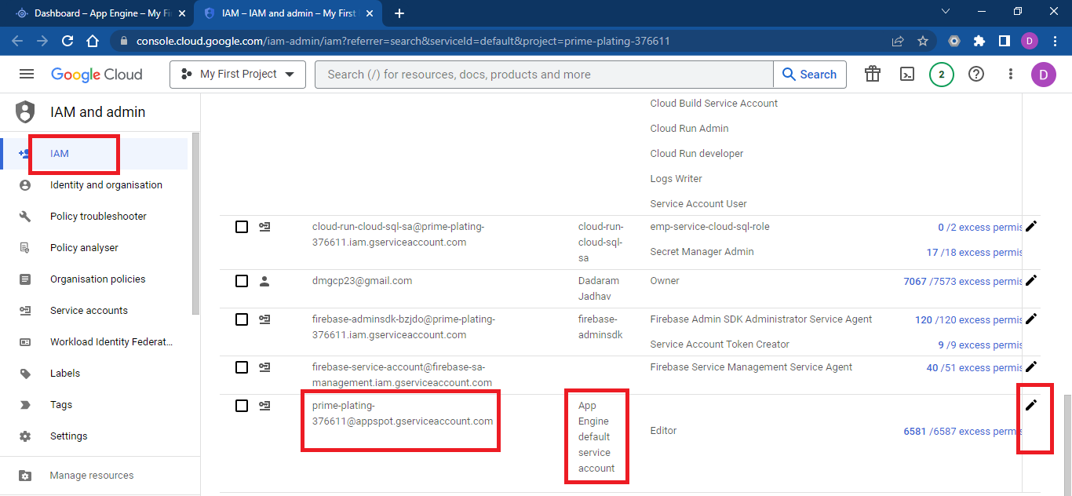

* 1. Add roles by click “**Add another role**”. Add following roles
     + - Cloud Logging Service Agent
       - Cloud SQL Client
       - Logs Writer
       - Monitoring Metric Writer
       - Secret Manager Secret Accessor

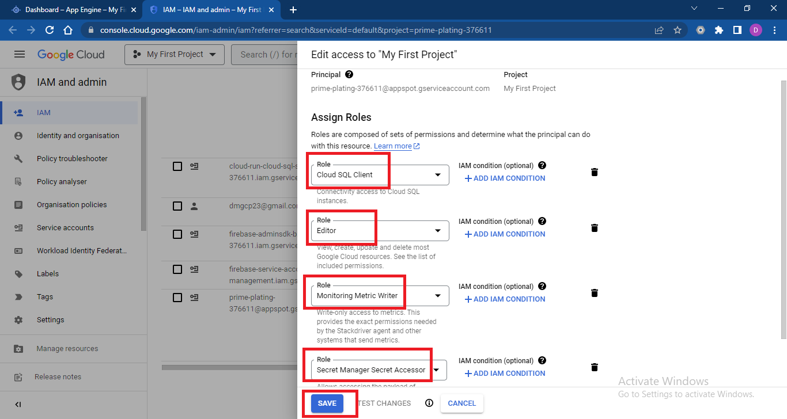

1. Go to root location of application (5002-spring-boot-app-engine-deployment)
2. Open gcloud SDK from local machine (open command prompt)
3. Login to gcloud SDK using following command

gcloud init

1. Set project

gcloud config set project <projectname>

1. App engine application created in step 3 can be created from glcoud SDK using following command

gcloud app create

1. Build application

mvn clean install

1. Modify app.yml file

|  |
| --- |
| **runtime:** java11  **instance_class:** F2  **env_variables:**  **PROJECT_ID:** <project_id> |

1. Deploy application

gcloud app deploy

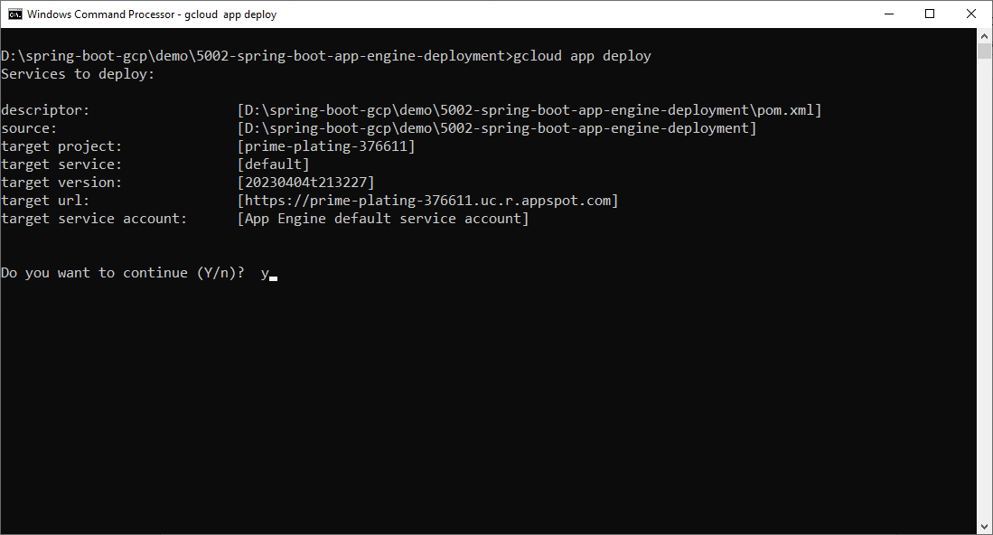

1. Press y to continue and wait for deployment to complete
2. Access application

gcloud app browse

1. Checking logs. You can access logs using various options. One of the options is as follows. Go to App engine dashboard, click on services and click on logs url.

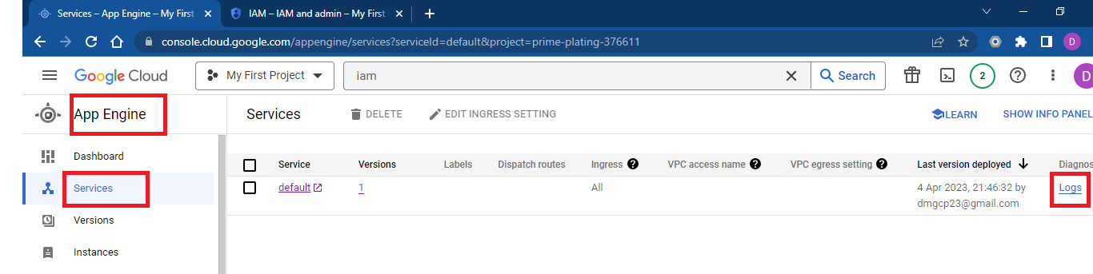

Can go to version specific logs from versions options from dashboard as well.

1. Scaling application
2. Default scaling can find under versions

