1. Open google cloud console
2. Search for load balancer (you will find it inside network services)

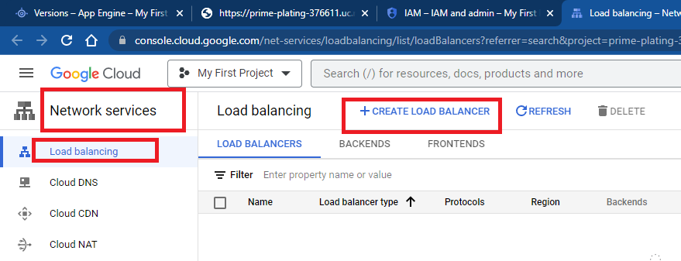

1. Choose Http(s) load balancing

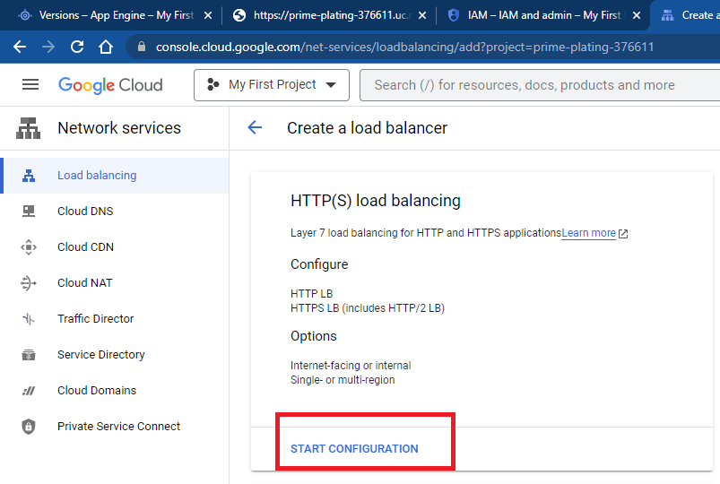

1. Choose From Internet to my VMs or serverless services and click on continue

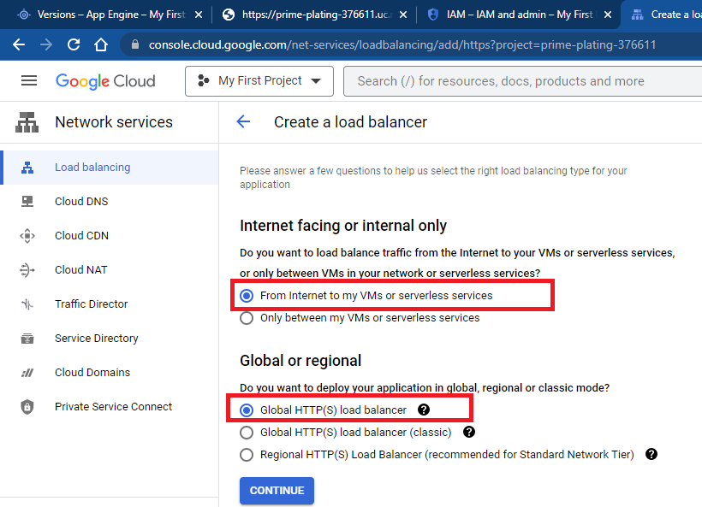

1. Configure frontend. Right now configure using http protocol. Can also configure for https by attaching ssl certificate.

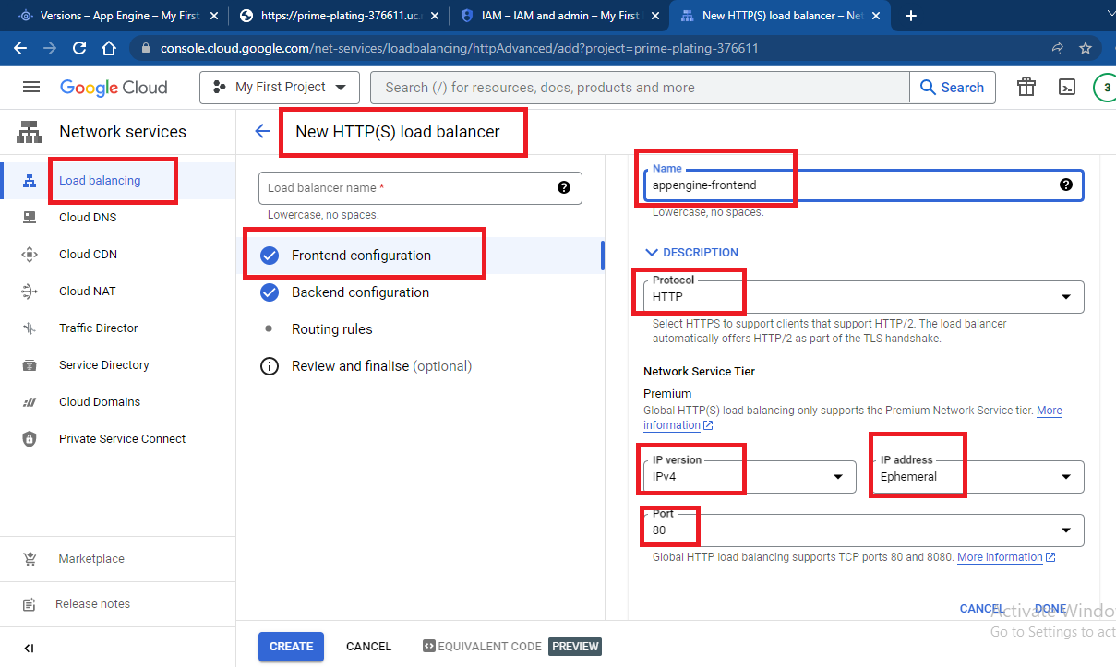

1. Configure backend

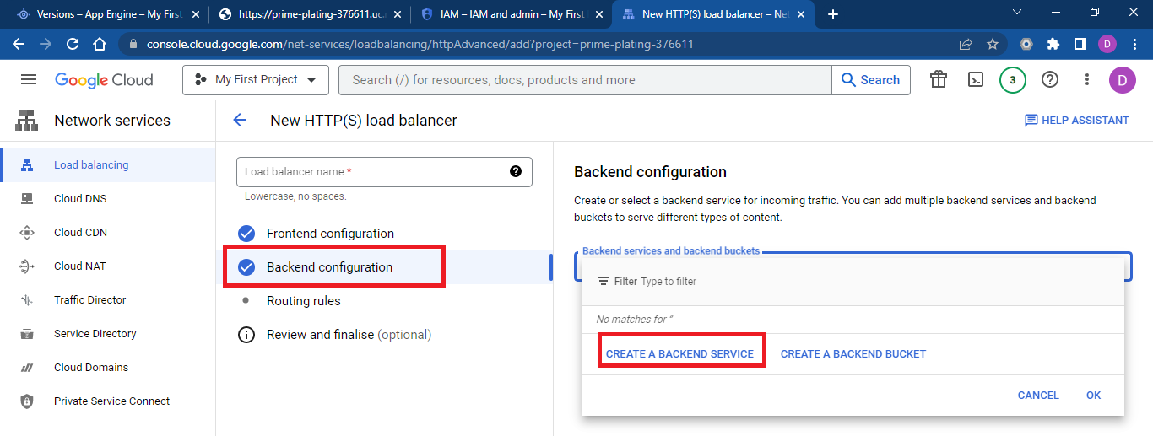

1. Mention name and choose backend type and click on add Backend

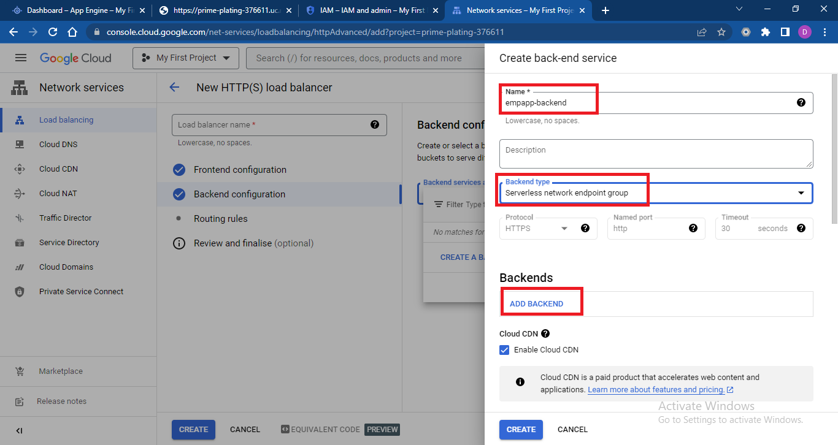

1. Click on **“Create serverless network endpoint group”**

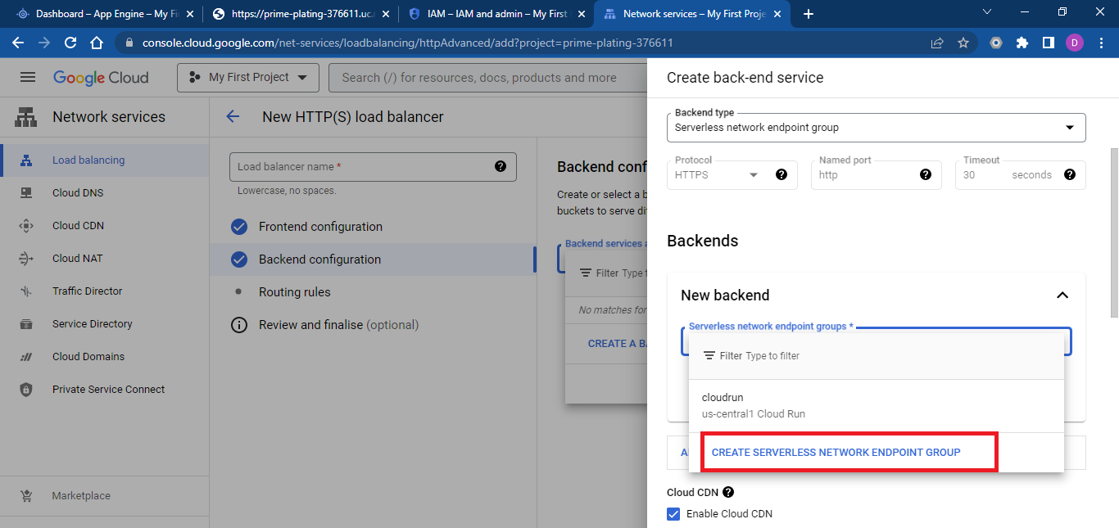

1. Mention name, select region, chose endpoint group type **“App Engine”,** choose default routing type and click on **create**

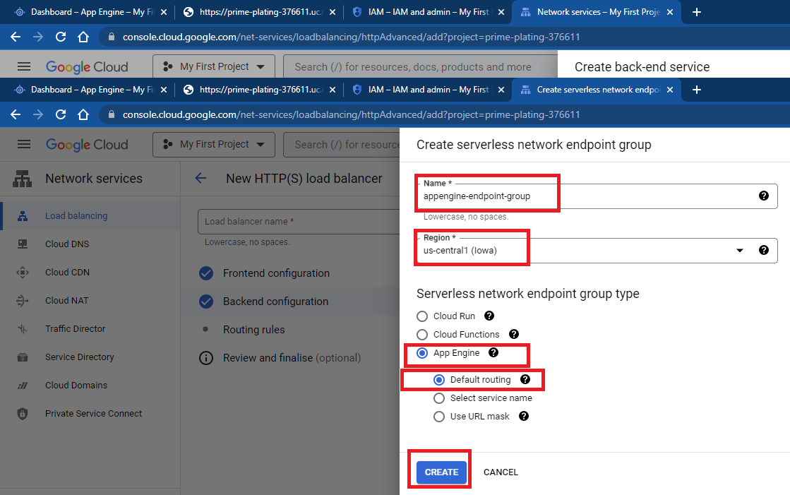

1. Click on create back end
2. Finally click on create load balancer

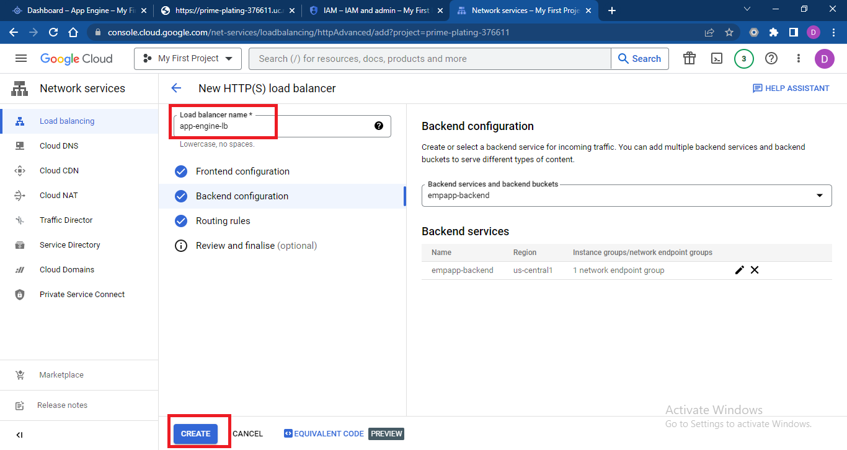

1. Wait for 8-10 minutes to full start load balancer.
2. Access load balancer using IP address.

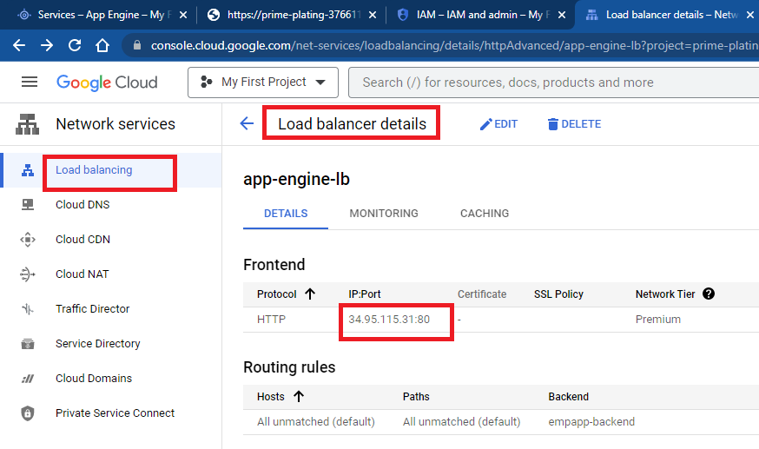

1. Disable direct access to app engine, allow access only through load balancer

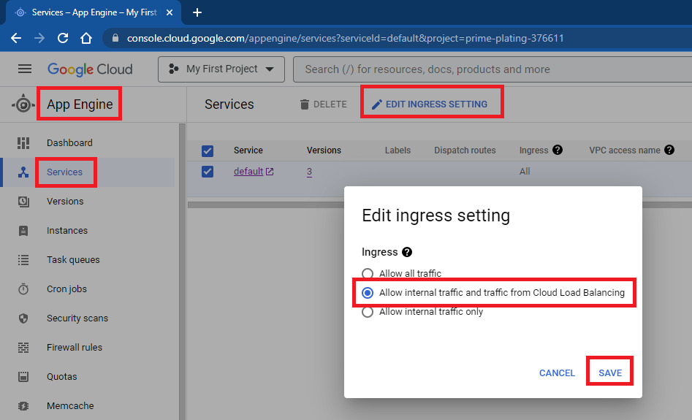

1. S
2. S
3. s