1. Open google cloud console
2. Open app engine, go to settings

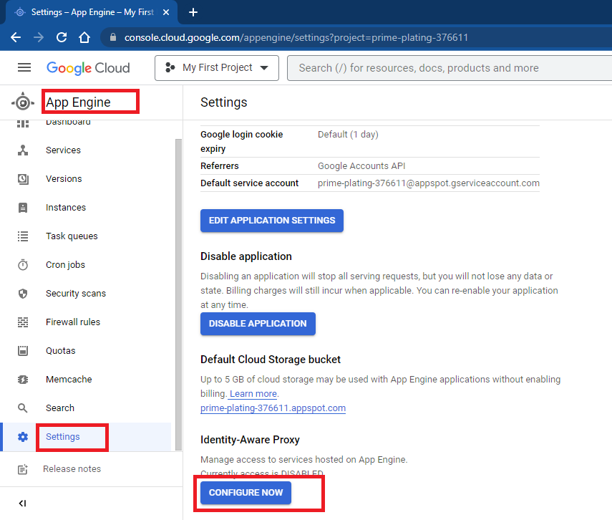

1. Select App Engine and enable IAP , click on add principal

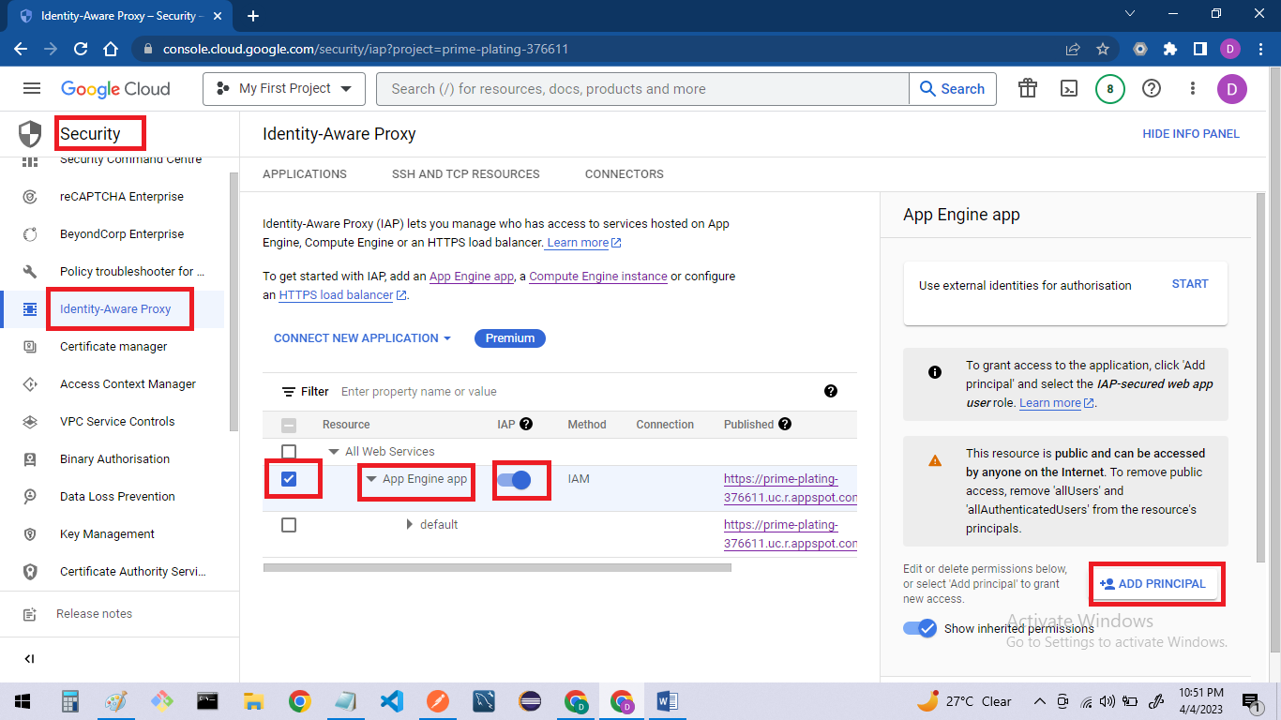

1. Add allAuthenticatedUsers and role as “**IAP-secured Web App User**” . It will pop up for public access, accept it.

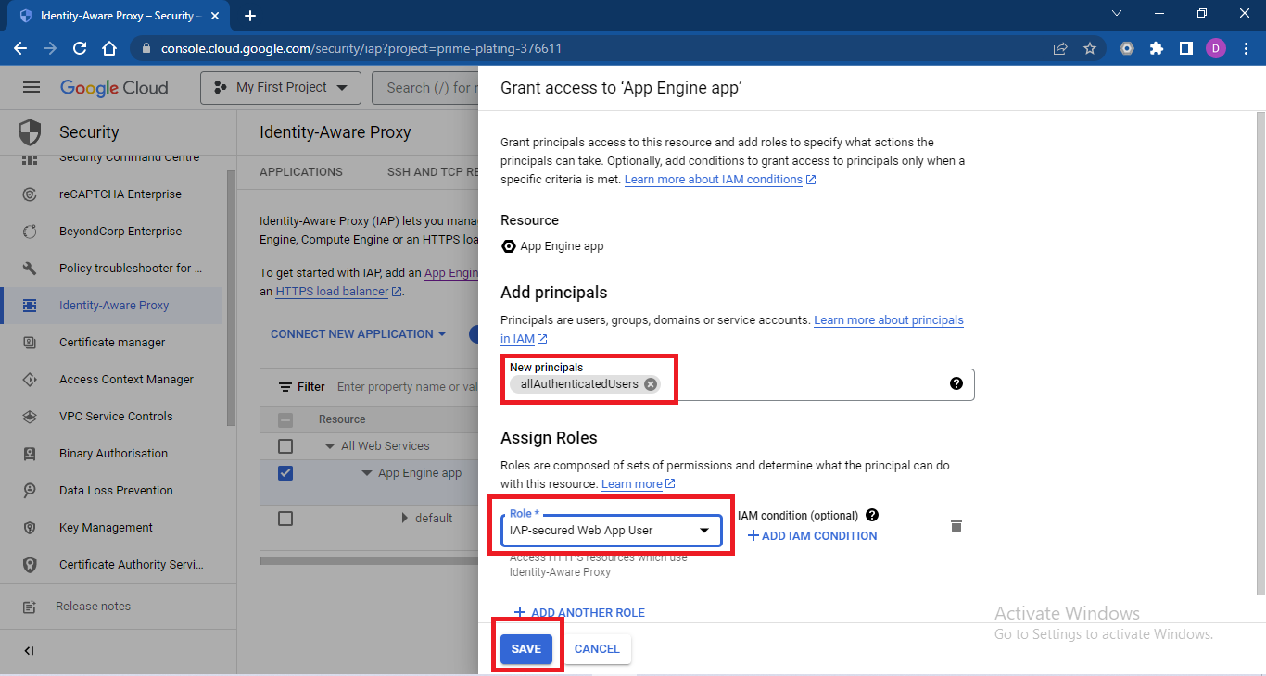

1. Now try to access application, it will redirect to google sign in page. After entering correct username password it will give access to application.

**Configure external identities**

1. Search for identity platform
2. Click on add provider

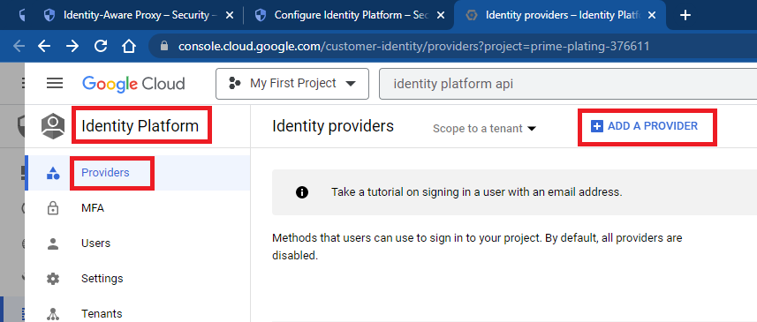

1. Choose sign-in method

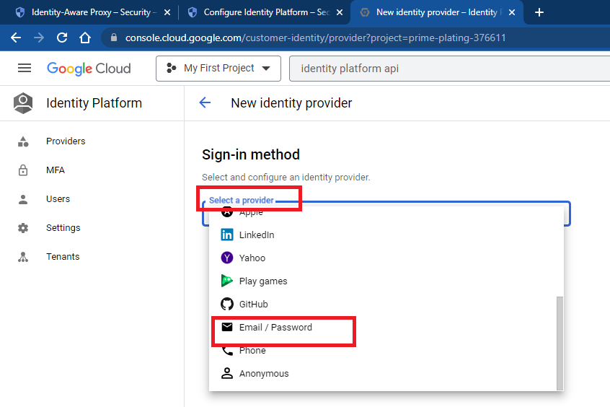

1. Keep other setting default and click on save

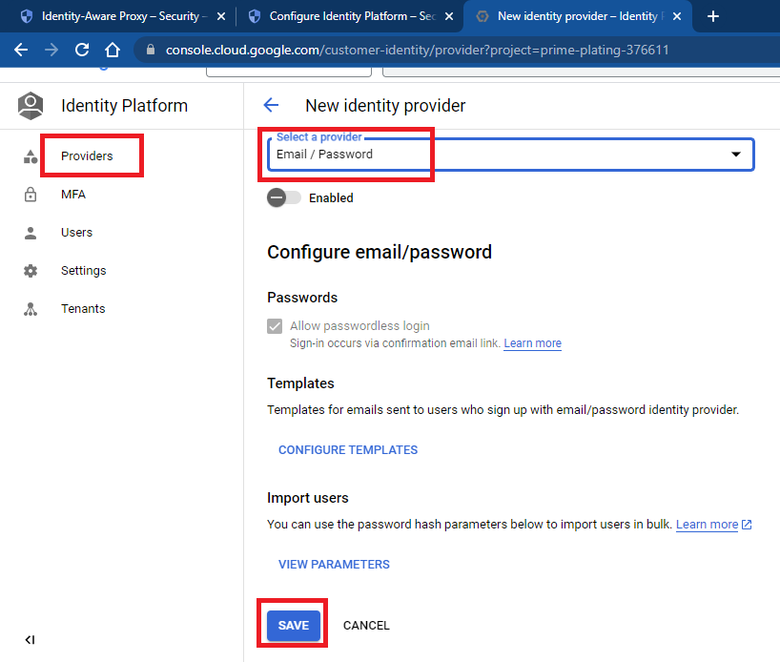

1. Enable email/password sign-in method created in earlier method

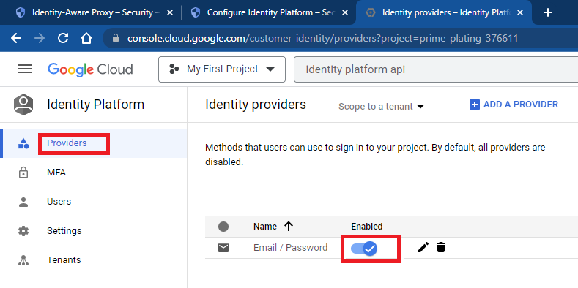

1. Now go to Identity Aware Proxy(IAP) page. Choose App Engine App. Click on start, it will prompt for change, click on change

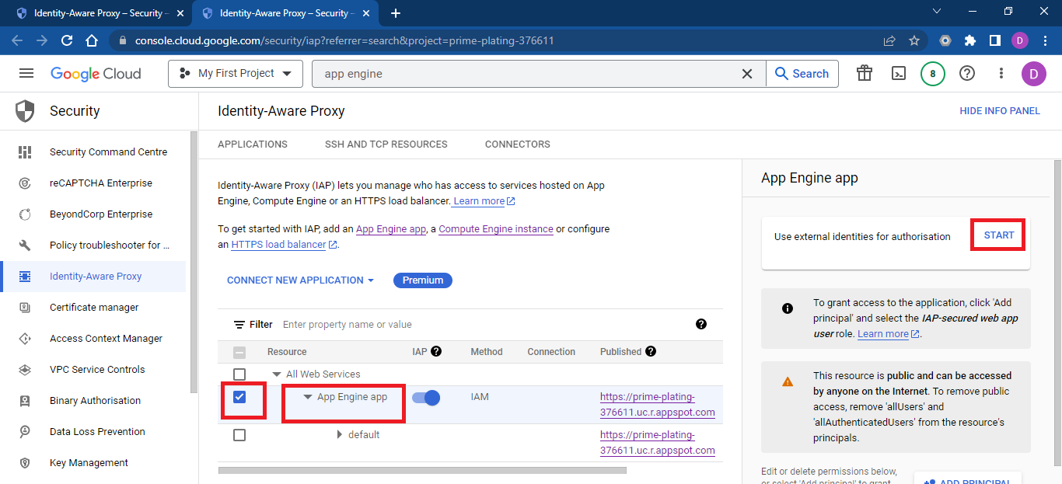

1. Choose Use an existing hosted sign-in page, enable permission, and click on Save

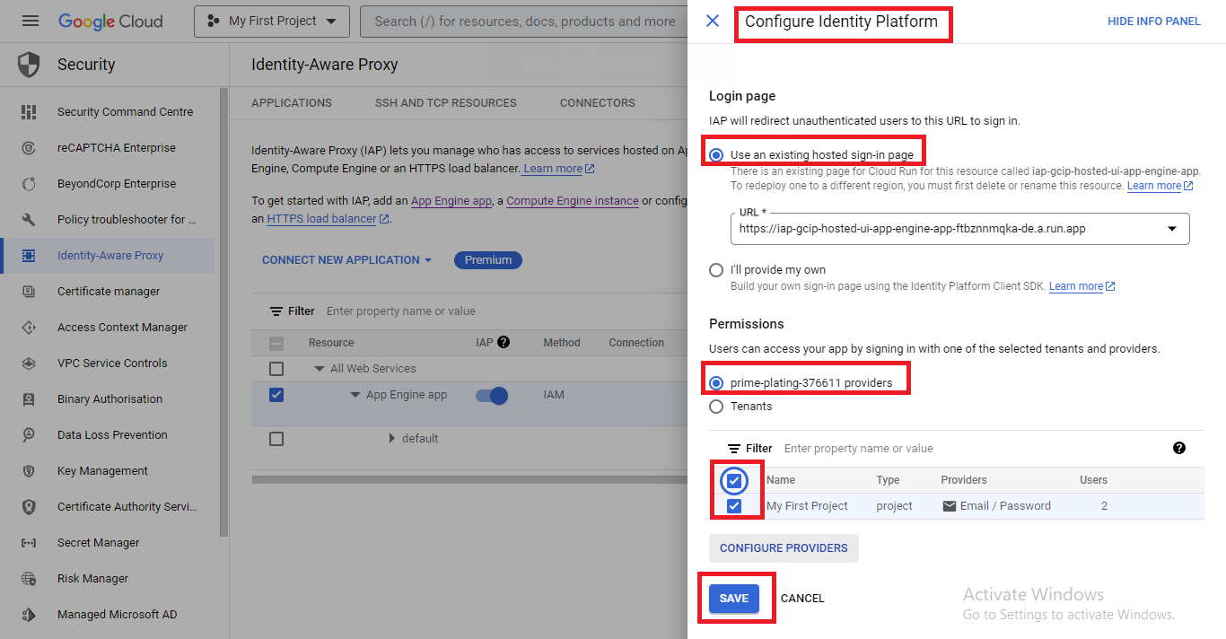

1. Now application can be accessed using registration.