1. Go to project 5004-spring-boot-docker-image
2. Create Dockerfile

|  |
| --- |
| FROM maven  ARG JAR_FILE=target/*.jar  COPY ${JAR_FILE} app.jar  ENV server.port=8080  ENTRYPOINT ["java","-jar","app.jar"] |

1. Now go to google cloud console
2. Search for artifact registry (enable API if not enabled)

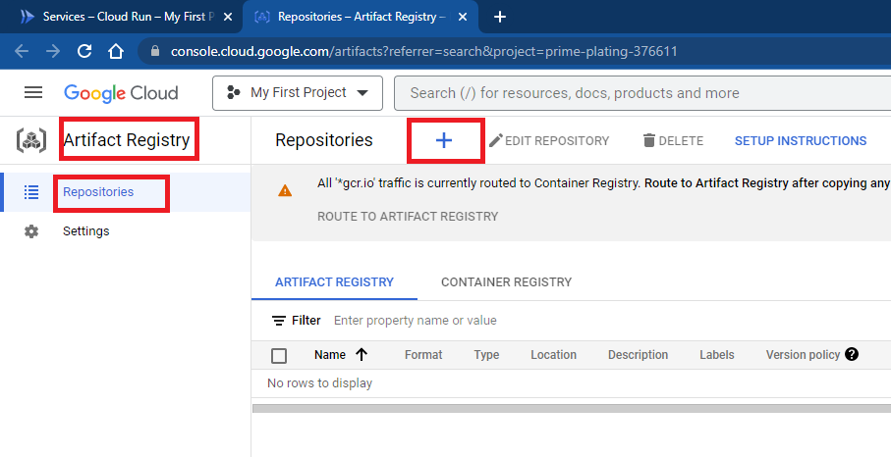

1. Create docker repository

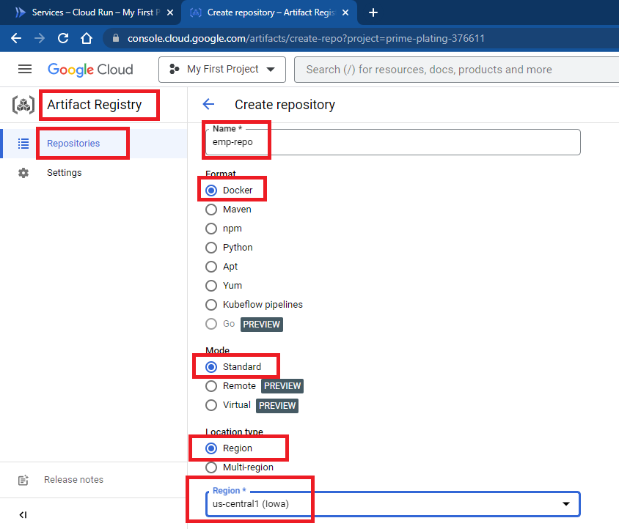

1. Get docker repository location

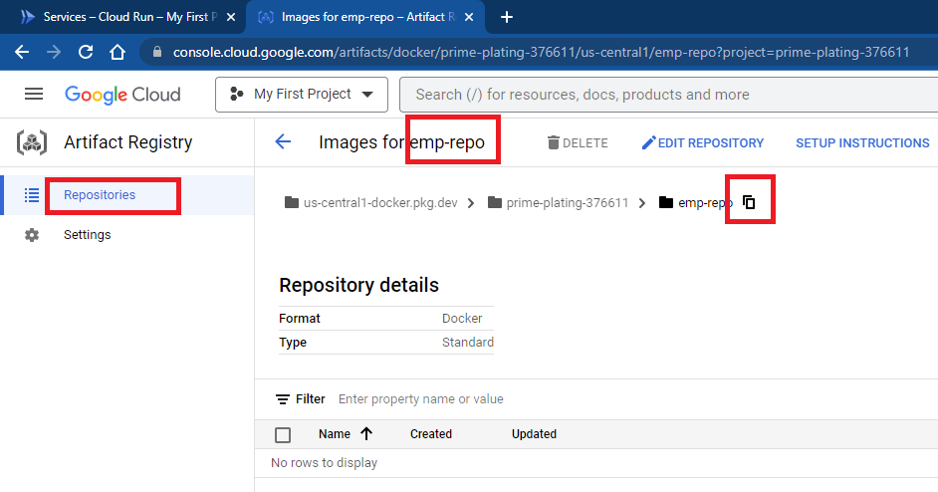

1. Go to location of project in local machine and execute following command.

mvn clean install

gcloud builds submit --tag us-central1-docker.pkg.dev/prime-plating-376611/emp-repo/empapp-image

**note**:

1. Highlighted part will get it from previous step.
2. Make sure /target is not added in .gitignore, .dockerignore, .gcloudignore
3. Can check created image on artifact registry

