1. Open google cloud console
2. Search for cloud run
3. Click on create service

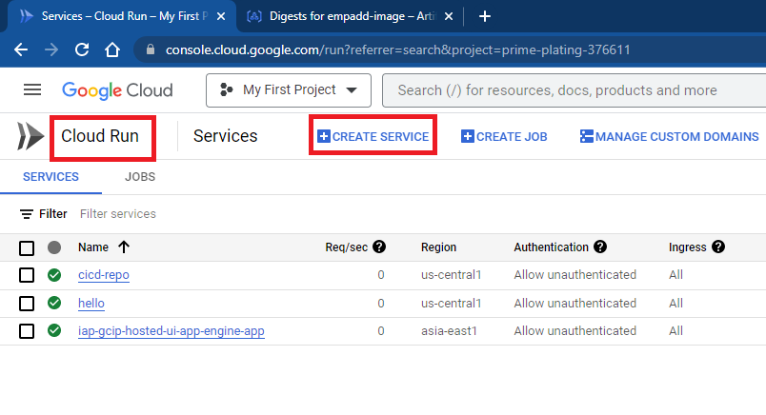

1. Select image from artifact registry

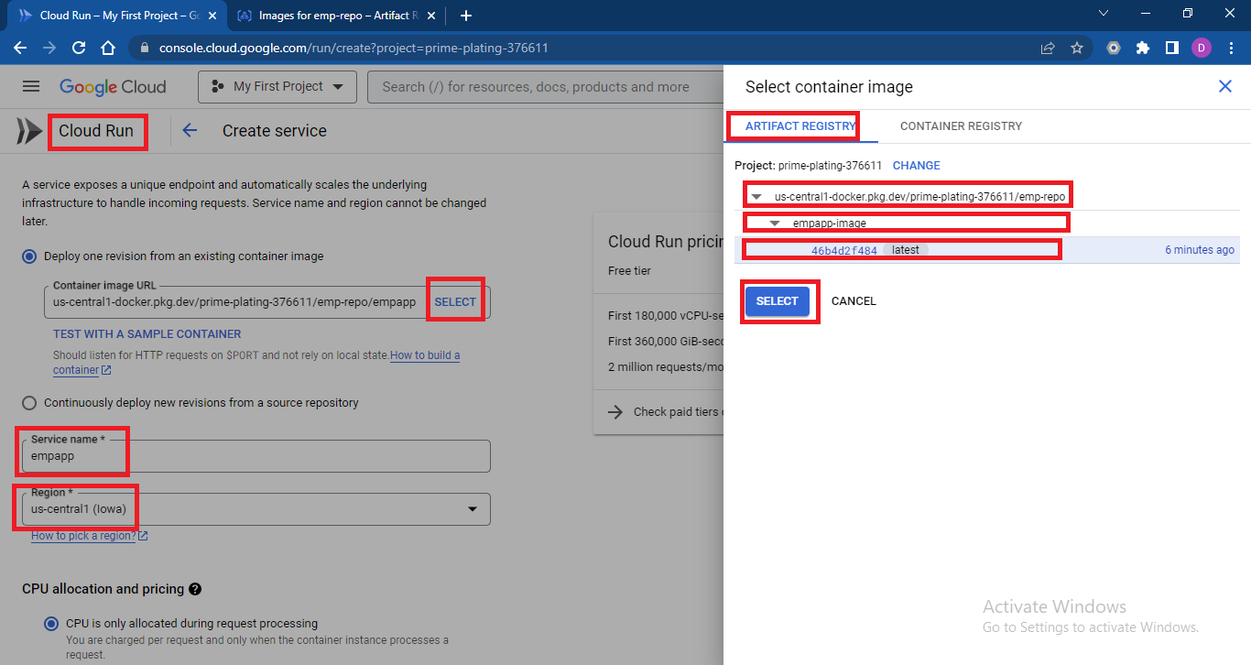

1. Select autoscaling as minimum 1 instance and maximum 5 instances, choose Authentication as Allow unauthenticated invocations

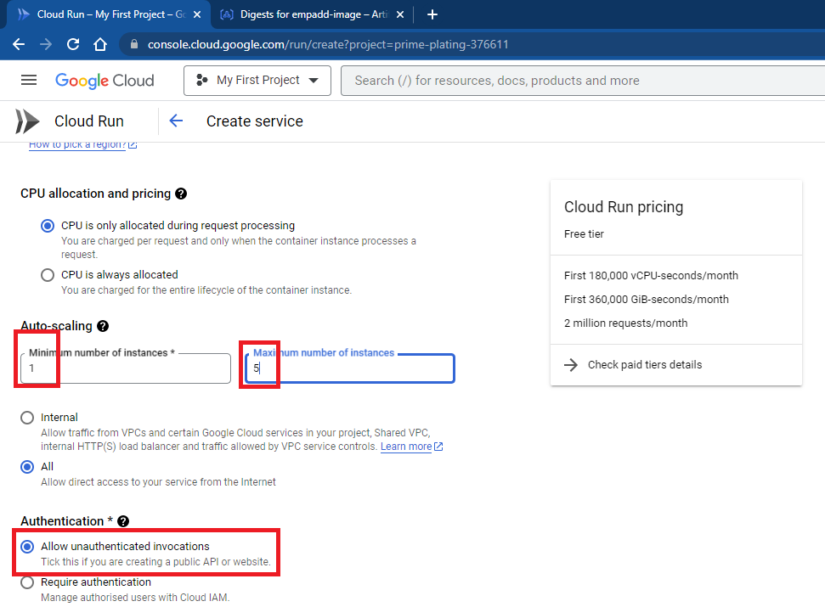

1. On same page click on container, networking, security

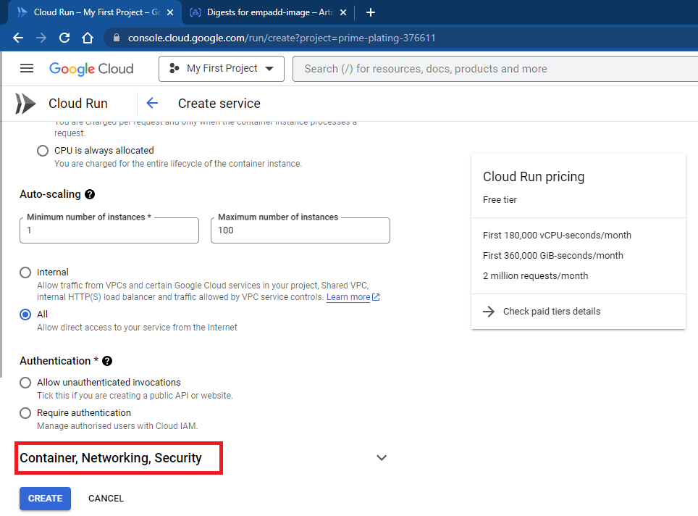

1. Scroll down and click on add variable

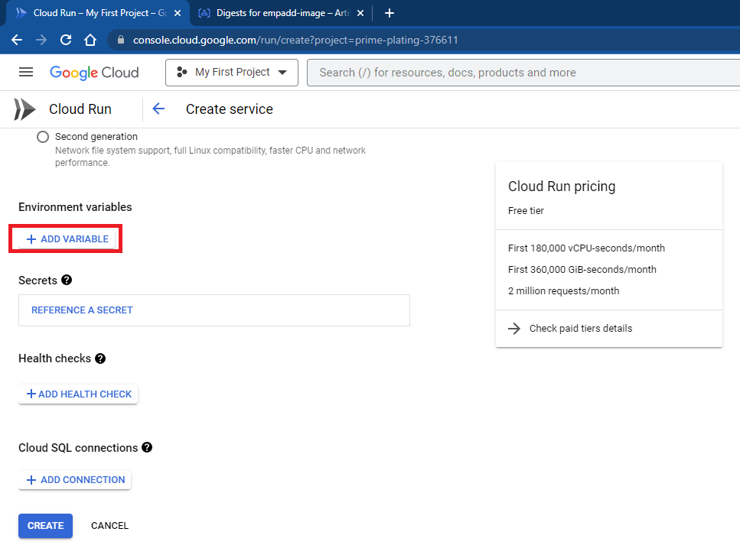

1. Add PROJECT_ID variable with value and click on create

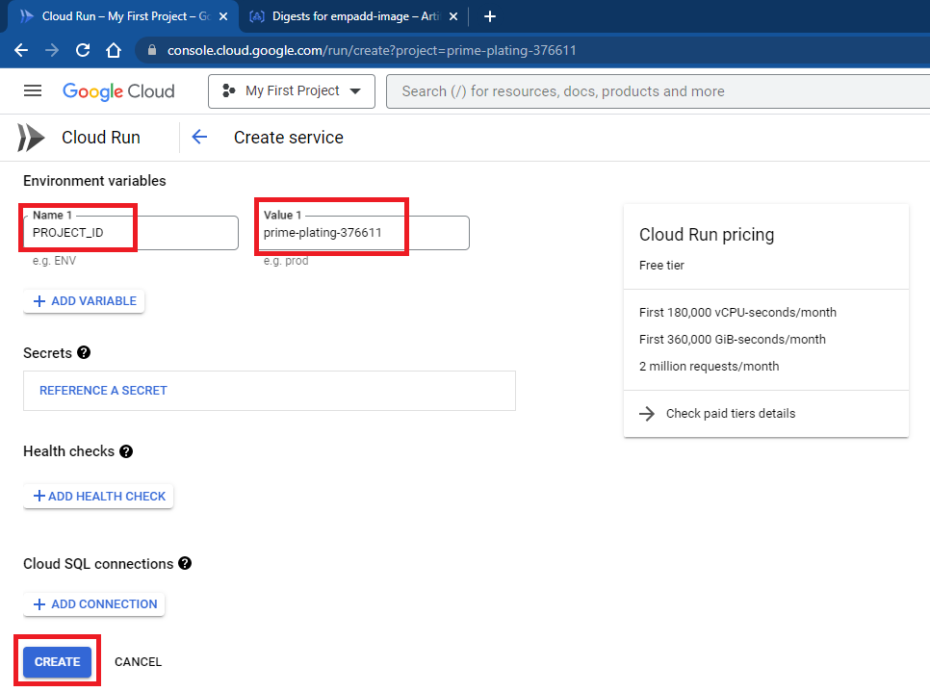

1. Select role created in earlier document from security section

