1. Open google cloud console
2. Create service account for app engine with following roles
   1. Cloud logging service agent
   2. Cloud SQL client
   3. Log writer
   4. Monitoring metric writer
   5. Secret manager secret accessor

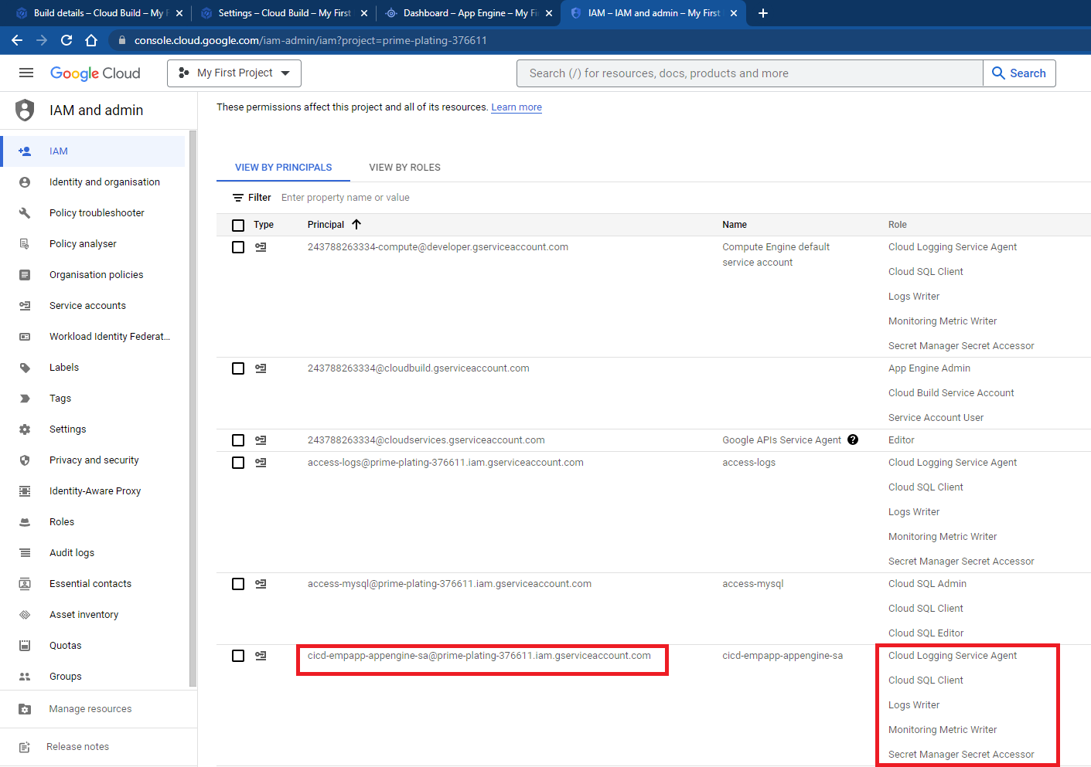

1. Create app engine from google cloud console

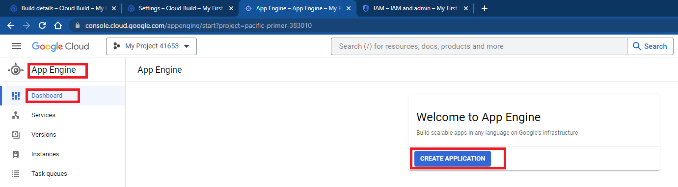

1. Change service account for app engine which created in earlier step

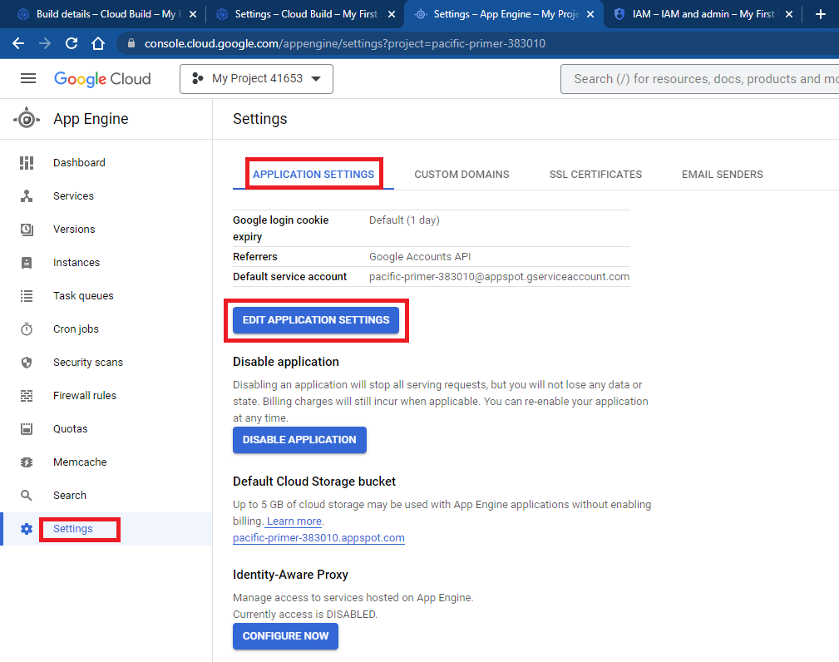

1. Add service account

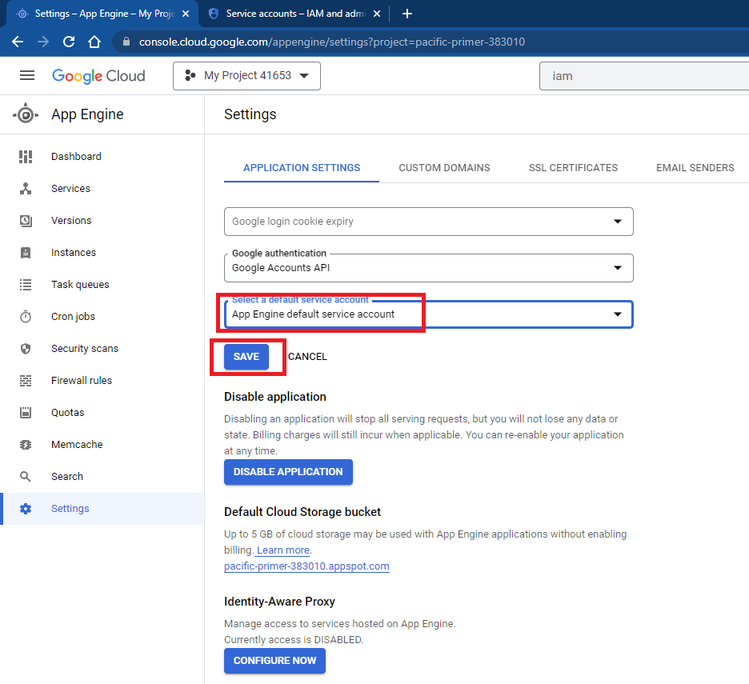

1. Locate cloud build service account and add following roles
   1. App engine admin
   2. Cloud build service agent
   3. Service account user

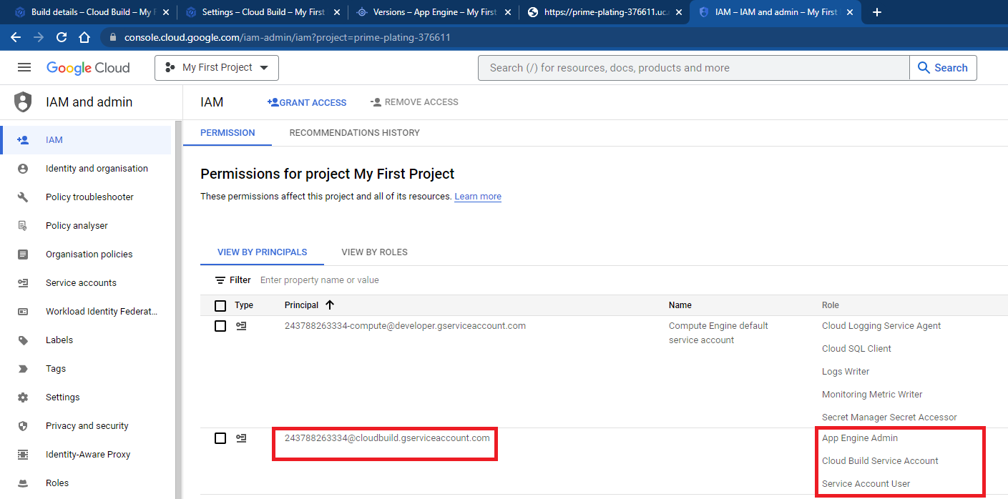

1. Search for cloud build

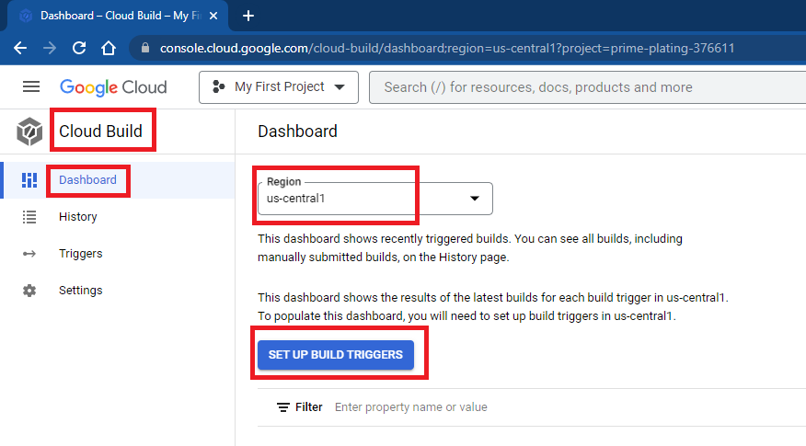

1. Mention name for trigger, select region, event type as push to branch, select repository, select branch as main

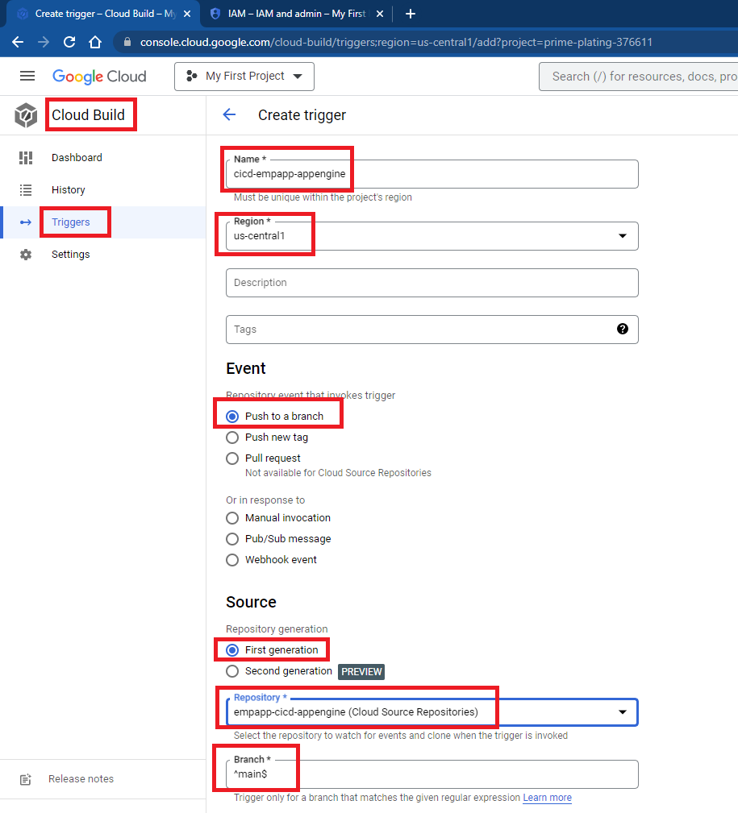

1. Select cloud build configuration, name of cloud build file

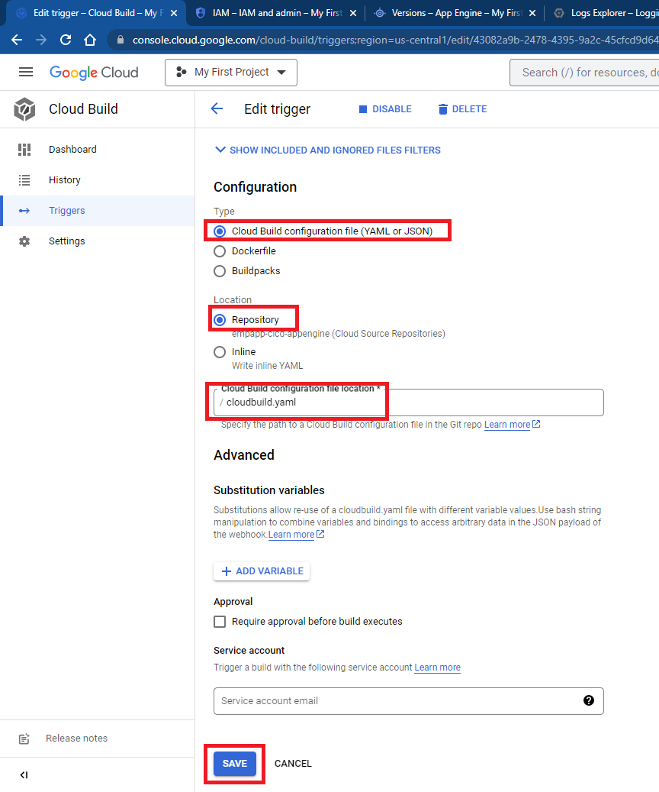

1. Run trigger

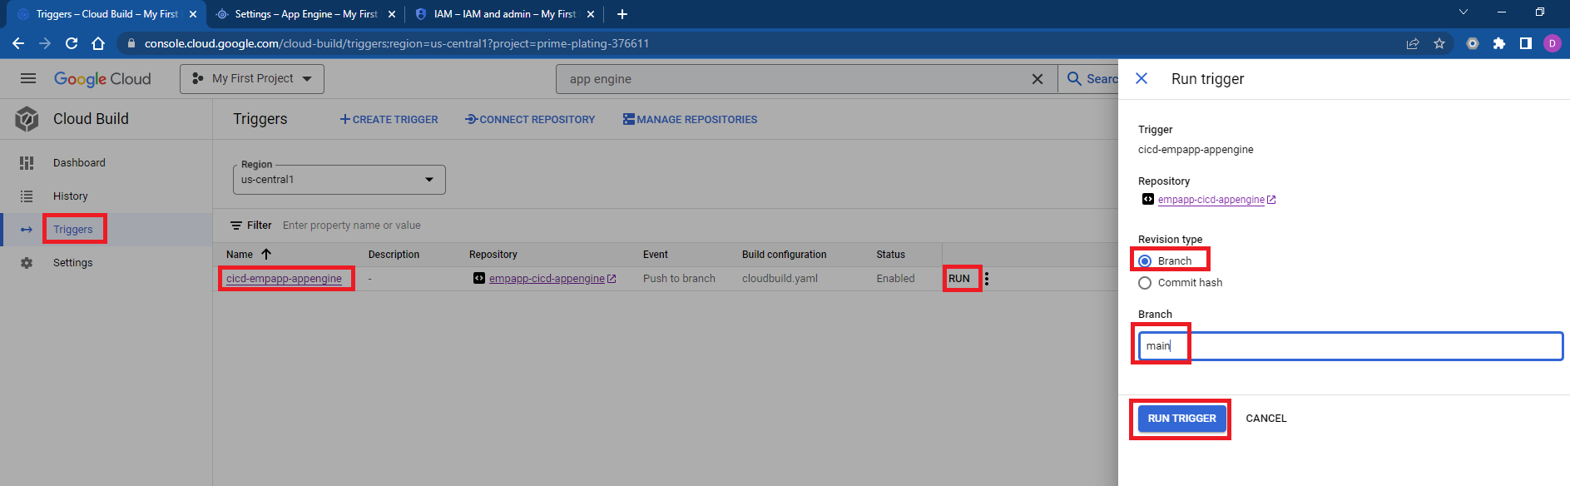

1. Accessing application, go to app engine, go to dashboard, access application using link

