1. Open google cloud console
2. Search for iam and select service account

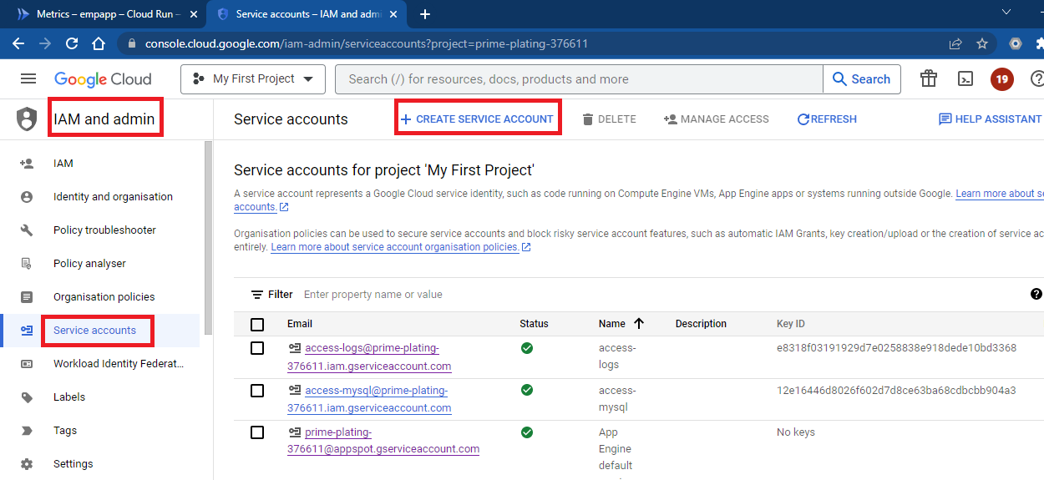

1. Mention name for service account and click on create and continue

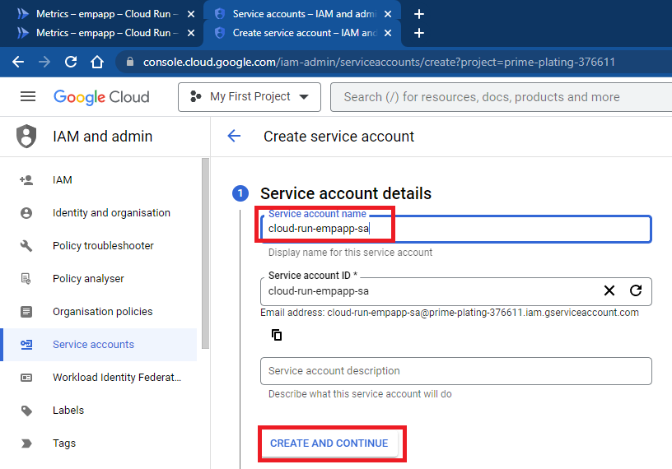

1. Add following roles by clicking add another role
   1. Cloud Logging Service Agent
   2. Cloud SQL Client
   3. Logs Writer
   4. Monitoring Metric Writer
   5. Secret Manager Admin
   6. Secret Manager Secret Accessor

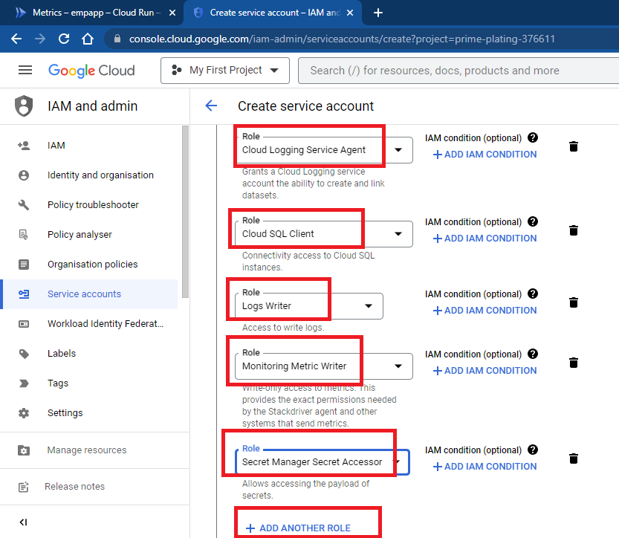

1. Click on done

