1. Open google cloud console
2. Search for source repositories

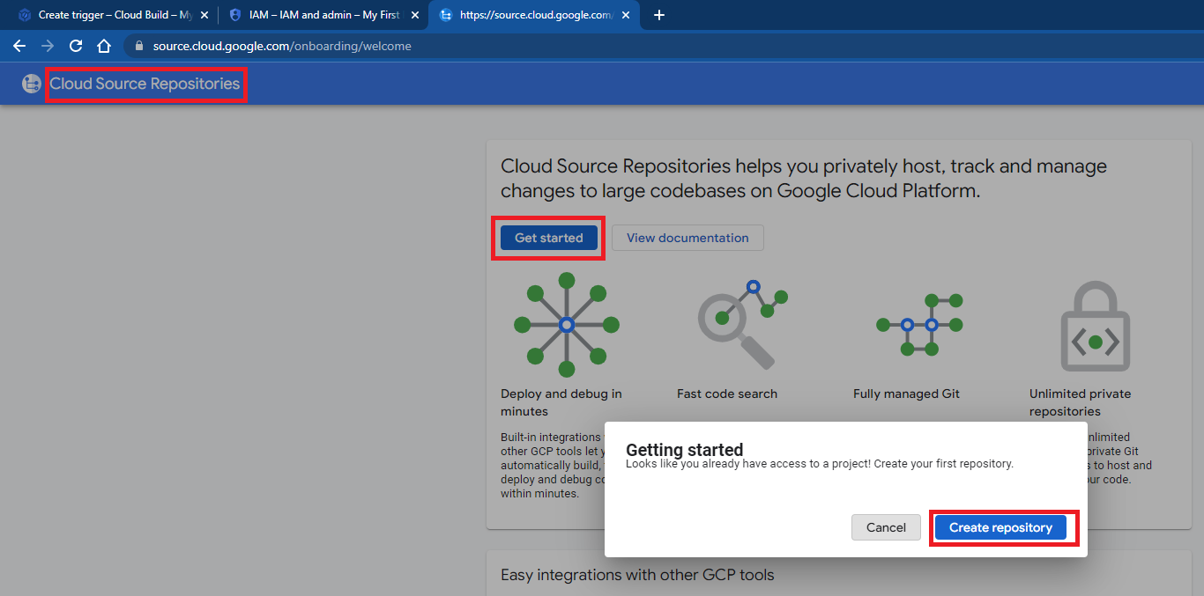

1. Click on create new repository and click on continue

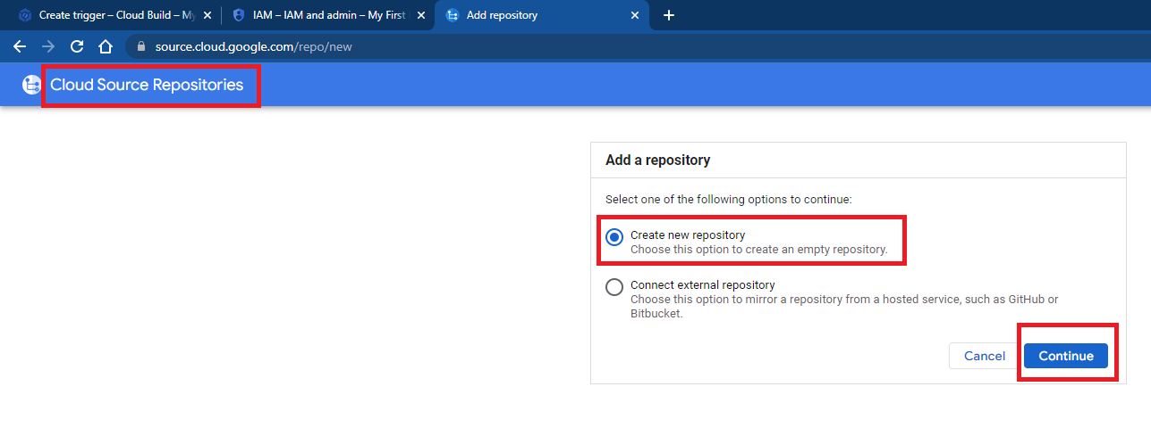

1. Mention name for repository, select project, click on create

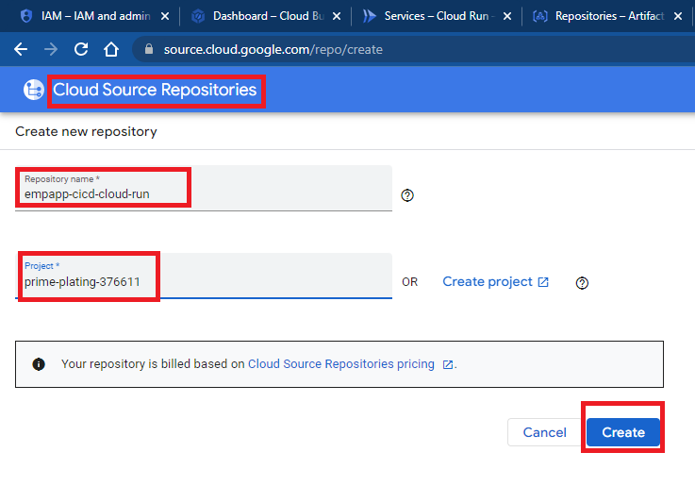

1. Select push code to your repository, Select your preferred authentication method as Google Cloud SDK, select windows

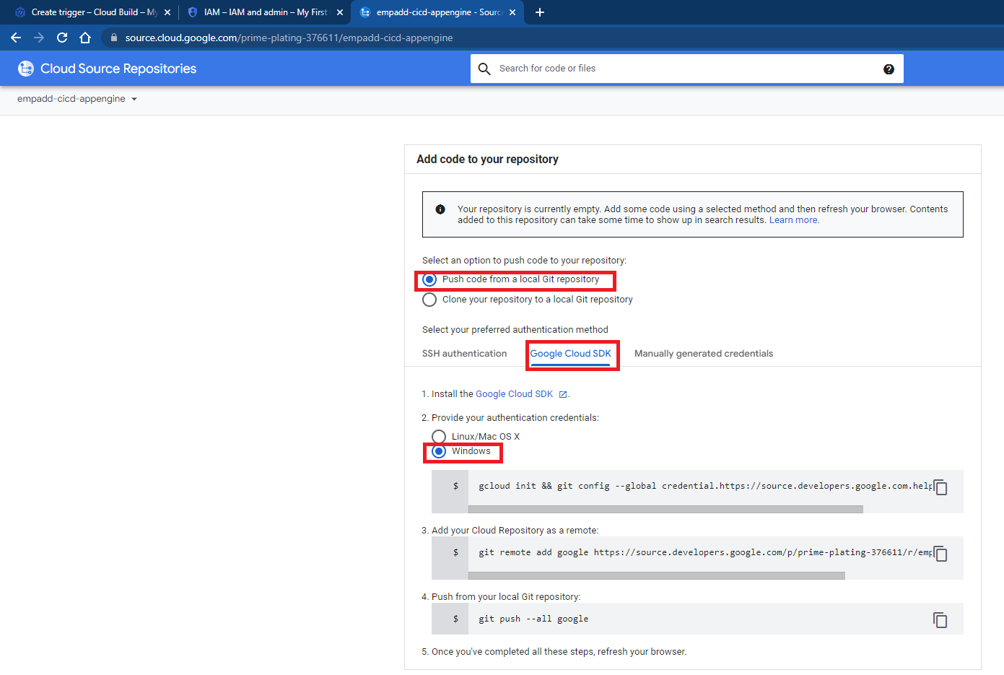

1. Go to location of project from local machine, open command prompt, execute gcloud init command and follow instructions

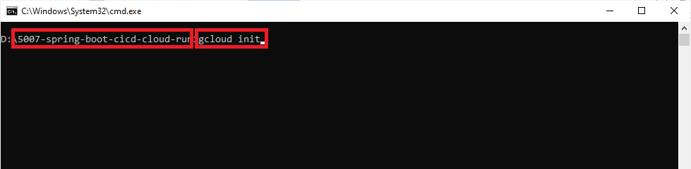

1. Execute following command from project location

git config --global credential.https://source.developers.google.com.helper gcloud.cmd

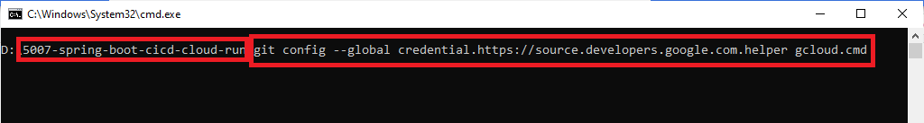

1. Execute following command from project location

git remote add google https://source.developers.google.com/p/prime-plating-376611/r/empadd-cicd-appengine

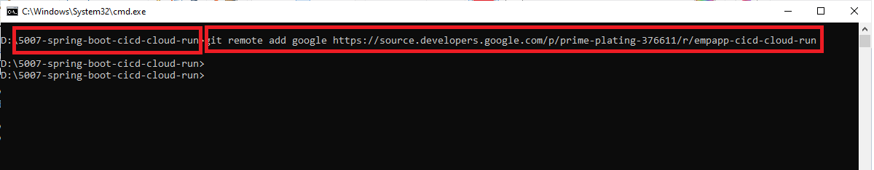

1. Execute following command from project location

git push --all google

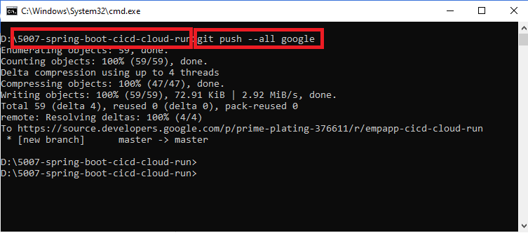

1. Check repository from source repositories

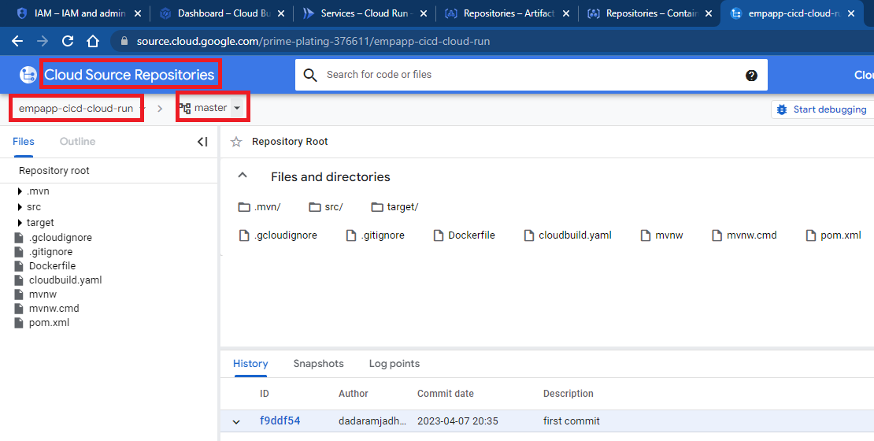s