1. Open google cloud console
2. Locate cloud build service account and add following roles
   1. Cloud run admin
   2. Cloud build service agent
   3. Service account user

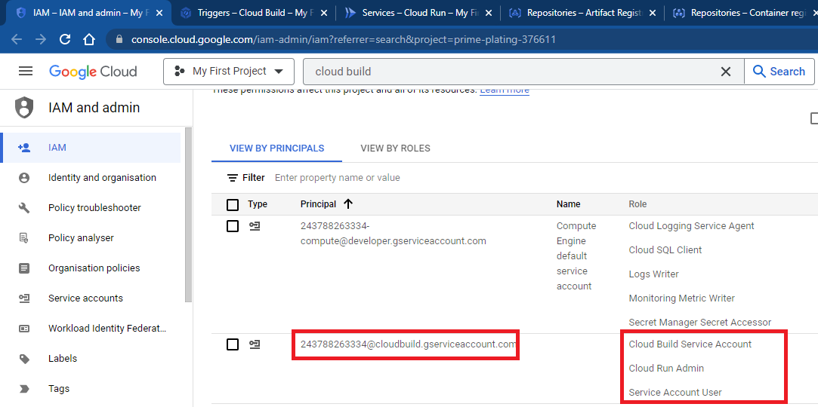

1. Search for cloud build

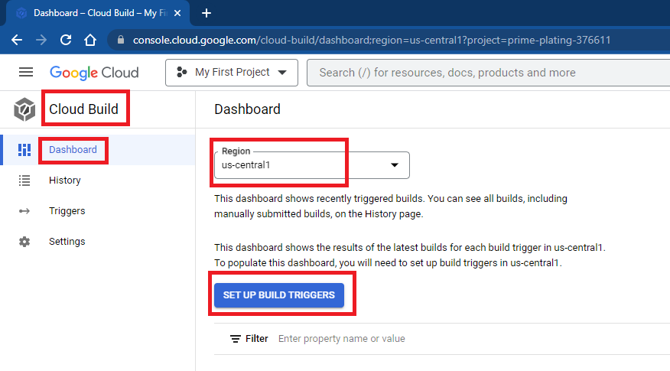

1. Mention name for trigger, select region, event type as push to branch, select repository, select branch as main

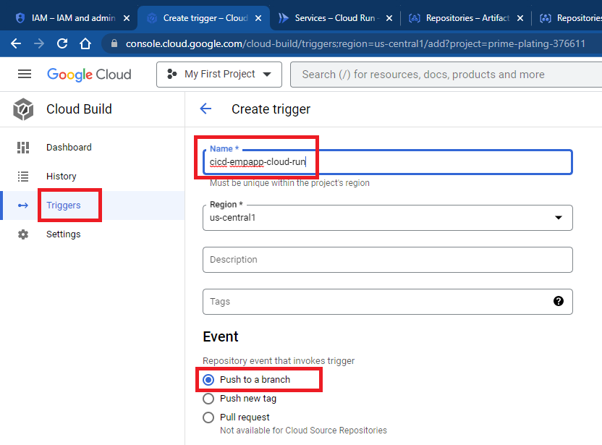

1. Select source, select cloud build configuration

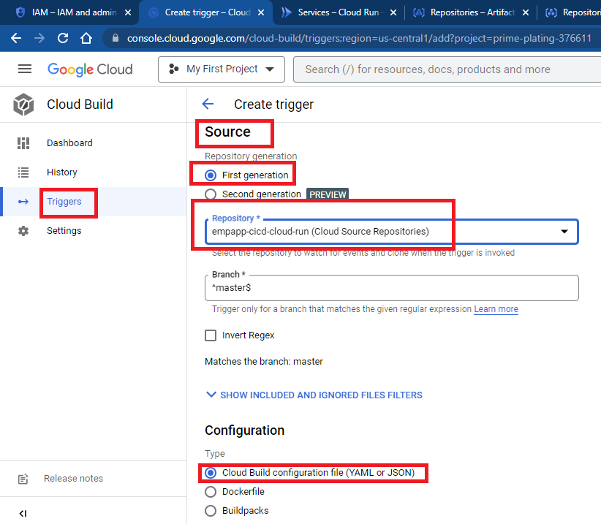

1. Ensure name of cloud build file and click on save

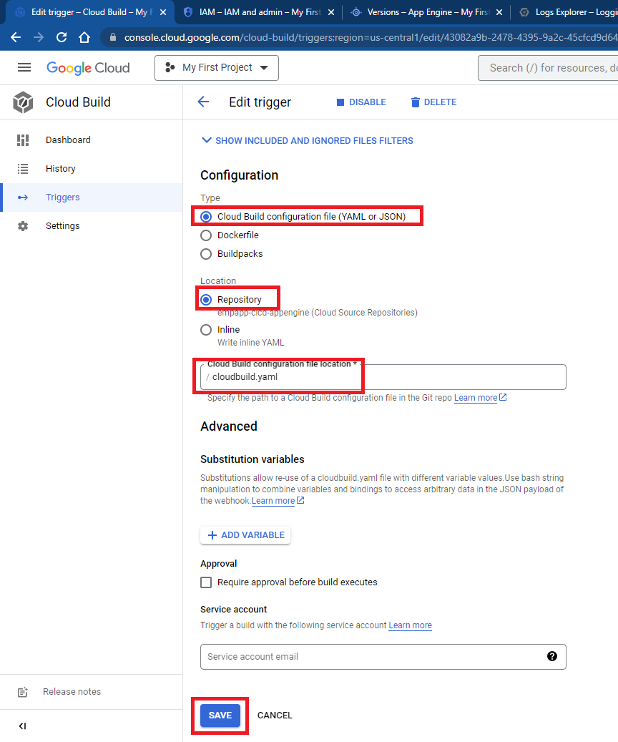

1. Run trigger

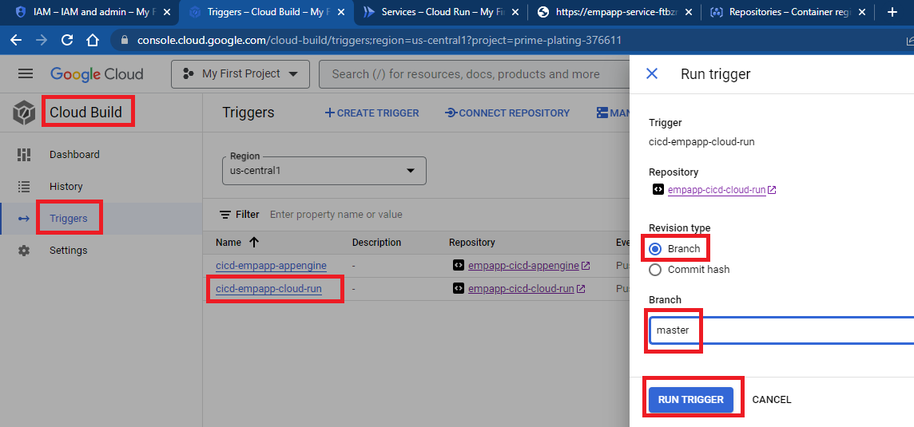

1. Accessing application, go to cloud run and select desired service

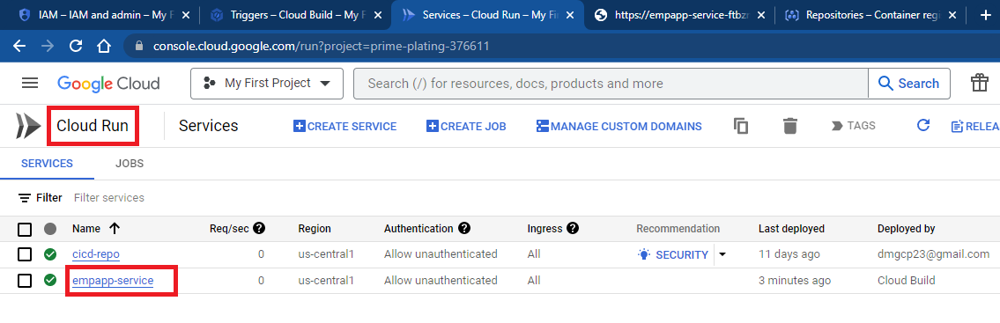

1. Click on link to access cloud run service

