1. Open cloud function
2. Click on create function

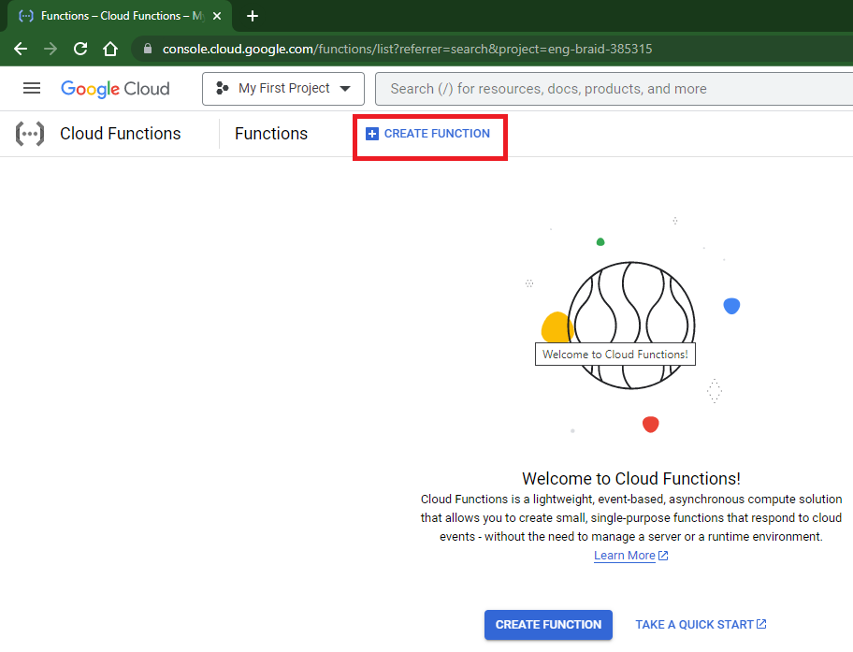

1. Mention name of cloud function

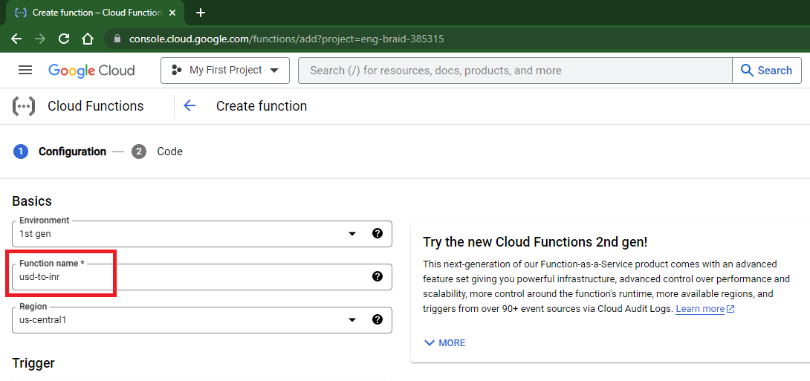

1. Select trigger type http, select Allow unauthenticated invocations, click on save

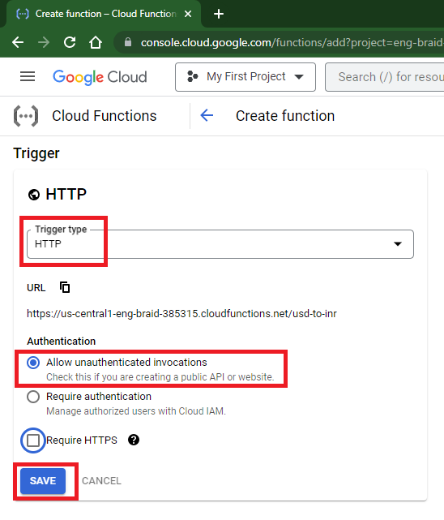

1. Click on next button

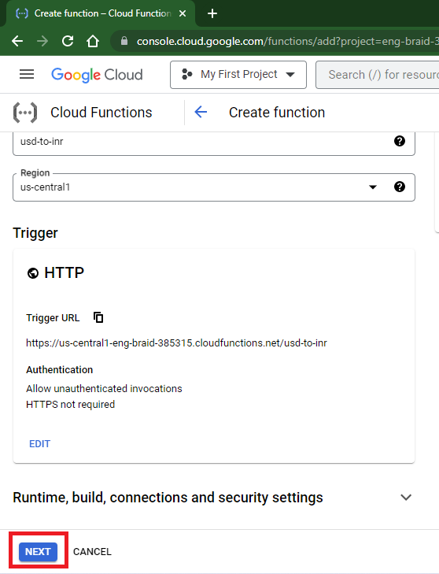

1. Select runtime as java 11, source code as Zip from cloud storage, entry point as com.accenture.Example, select zip file which uploaded into cloud storage bucket, click on deploy

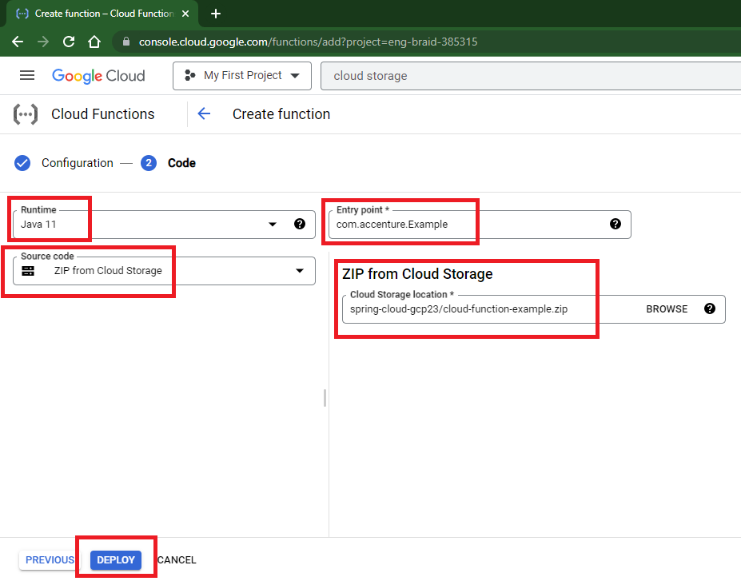

1. Wait for 2-3 minutes
2. Go to trigger section and get trigger url

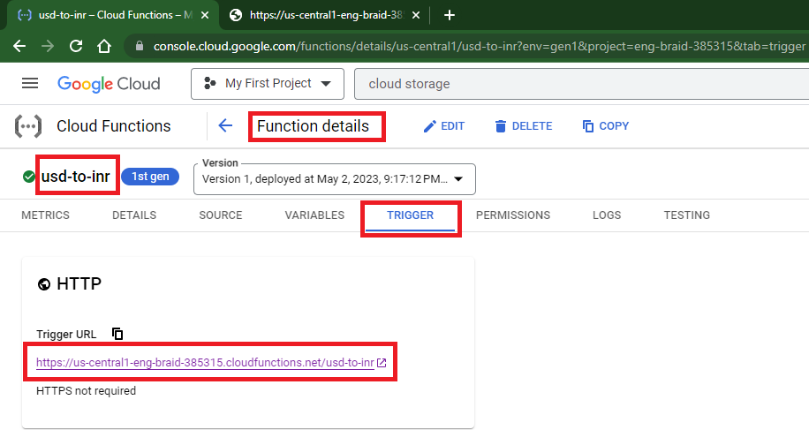

1. Trigger function using below url

<trigger-url>/usd-to-inr?amount=<any-amount>

e.g.

<https://us-central1-eng-braid-385315.cloudfunctions.net/usd-to-inr?amount=130>

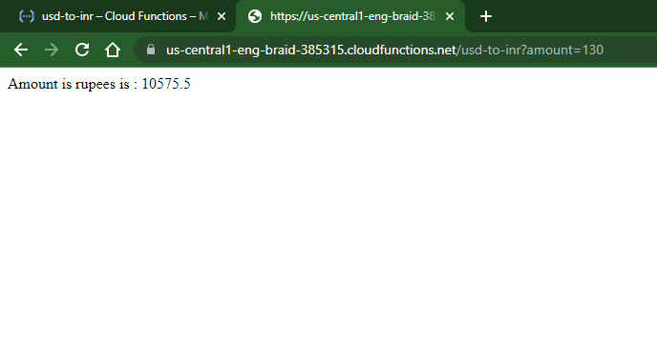

Deploy cloud function using gcloud commands

1. Open gcloud from local machine
2. Execute below command to deploy application into cloud function

|  |
| --- |
| gcloud functions deploy **usd-to-inr** --region=**us-central1** --runtime=**java11** --source=gs://**spring-cloud-gcp23**/**cloud-function-example.zip** --entry-point=**com.accenture.Example** --trigger-http |

Highlighted parts can replaced as applicable to you

1. Wait for 2-3 minutes
2. Trigger url will be displayed in console

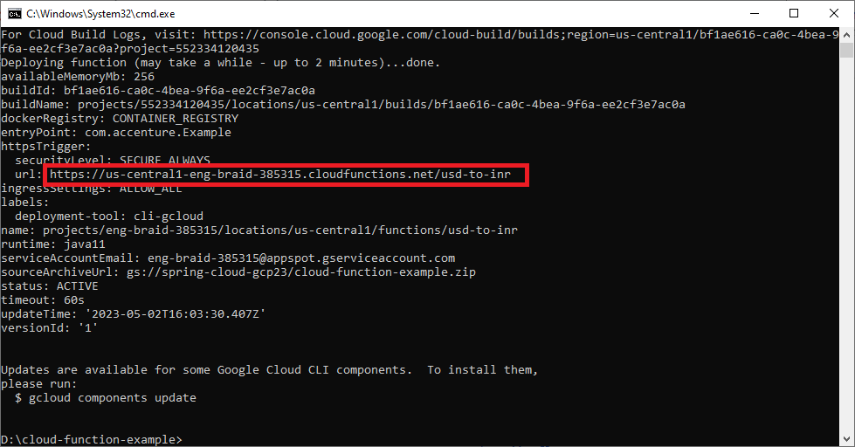

1. Trigger function using below url

<trigger-url>/usd-to-inr?amount=<any-amount>

e.g.

<https://us-central1-eng-braid-385315.cloudfunctions.net/usd-to-inr?amount=130>

